 | 
MADRAS INSTITUTE OF TECHNOLOGY
ANNA UNIVERSITY | DEPARTMENT OF COMPUTER TECHNOLOGY
MACHINE LEARNING OPERATIONS
AI-Powered Skincare Routine
Ingredient and Compatibility Checker
Mini Project Report
A modular application for product search, ingredient analysis, routine checks, OCR, and model monitoring
Submitted by | Project guide
Name: ______________________________  Register number: ____________________  Programme / semester: _______________ | Name: ______________________________  Designation: _________________________  Department: Computer Technology

Chennai, Tamil Nadu | October 2026

PROJECT OVERVIEW

Abstract and Project Summary
This report describes an academic software prototype that helps users inspect cosmetic product information and explore possible ingredient and routine concerns. The application combines a Streamlit dashboard with a FastAPI service. Its functions include product catalogue search, ingredient-list parsing and synonym normalization, ingredient-function classification, rule-based routine checks, packaging-label OCR, and MLOps-oriented model and API telemetry. The system is intended for demonstration and learning; it has not been clinically validated and does not determine whether a product is safe or suitable for an individual.
The product-category model is a Random Forest classifier evaluated on a held-out set of 289 records. The repository reports accuracy of 0.5467, macro F1 of 0.5536, and weighted F1 of 0.5488. The ingredient-function classifier is a Logistic Regression model trained on a curated 77-record taxonomy; its recorded validation accuracy is 0.45 and macro F1 is 0.3359. These results show that the software can execute end-to-end classification workflows, while also showing why predictions need uncertainty cues and additional reviewed data before stronger claims are made.
The supplied interface captures demonstrate the current application behavior rather than controlled experiments. In the routine view, an avoid-list term of alcohol is matched to cetyl alcohol, illustrating that a broad text match can over-flag related names. The ingredient analysis view reports 11 parsed tokens, four explicit concentrations, eight classified functions, and three unknown or low-confidence results. The OCR example returns text that needs human correction. The telemetry view includes small request counts, so its latency values are illustrative runtime observations, not a benchmark.
The repository includes Dockerfiles and a Compose definition for local two-service execution. This report documents that local container workflow and identifies additional work required before a public service could be considered, including secure ingress, access controls if user-specific data is introduced, data and model governance, operational monitoring, and a reviewed release process.

Keywords
MLOps; cosmetic ingredient parsing; product search; routine compatibility; TF-IDF; Logistic Regression; Random Forest; OCR; FastAPI; Streamlit; Docker Compose.

NAVIGATION

Contents and Abbreviations
Section | Report section
1 | Introduction and project context
2 | Problem definition, aim, and scope
3 | Technical background and design rationale
4 | Requirements and architecture
5 | Data and preprocessing
6 | Product catalogue search
7 | Ingredient-function classification
8 | Routine rules and formulation context
9 | API and dashboard implementation
10 | Observed application outputs
11 | Model evaluation
12 | MLOps lifecycle and release controls
13 | Docker execution and deployment readiness
14 | Verification, limitations, and future work
15 | Conclusion and references

Abbreviations
Term | Meaning
API | Application Programming Interface
CI | Continuous Integration
INCI | International Nomenclature of Cosmetic Ingredients
ML | Machine Learning
MLOps | Practices for developing, evaluating, deploying, and maintaining ML systems
OCR | Optical Character Recognition
TF-IDF | Term Frequency–Inverse Document Frequency
p50 / p95 | 50th / 95th percentile of observed response latency

PART I | PROJECT FOUNDATION

1. Introduction and Project Context
Cosmetic ingredient labels are written for standardized product communication, not necessarily for rapid consumer interpretation. Ingredient names can be unfamiliar, synonyms may appear across sources, and product catalogues often contain inconsistent names, brands, categories, or ingredient fields. A routine checker therefore needs to bring together several separate tasks: find the intended product, normalize its ingredient text, surface relevant information, and present uncertainty rather than imply that a simple lookup is a personal safety assessment.
This project approaches that need as a software engineering and MLOps exercise. The app has a browser-facing Streamlit dashboard and a FastAPI backend. The backend provides search, parsing, classification, OCR, routine analysis, model information, health checks, and telemetry. Supporting modules implement data preprocessing, a product lookup function, an ingredient-function model, a product-category model, and rule-based compatibility checks. Container files package the two application services for reproducible local execution.
The project’s central design choice is to use different methods for different tasks. Deterministic normalization and configured rules are suitable for reproducible transformations and explicit checks. Machine learning is used for classification where the repository has labeled examples. OCR is used to propose text from a package image, but its result is editable because printed labels, image quality, and chemical names can produce recognition errors. The interface brings these parts together, while the report distinguishes observed application output from evidence of real-world effectiveness.
The term production-ready is not used here as a conclusion. A working demo, passing software tests, model metrics, and container packaging are useful milestones, but they do not by themselves establish clinical validity, broad data coverage, operational security, service availability, or suitability for public use. The goal of the current report is to describe what the repository implements, what the supplied screenshots show, and what evidence is still needed.

Project context
The intended setting is an academic demonstration of a small end-to-end ML-enabled application. The system focuses on cosmetic product and ingredient information. It does not diagnose dermatological conditions, determine allergy status, prescribe treatment, or guarantee tolerability. This boundary is reflected in the project disclaimer and should remain visible wherever results are shown.

PART I | PROJECT FOUNDATION

2. Problem Definition, Aim, and Scope

Problem definition
The prototype addresses fragmented product and ingredient information. A user may know a brand or approximate product name but not the catalogue’s exact spelling. A product record may use an INCI term that differs from a familiar label name. A multi-product routine can also include repeated or configured active ingredients. Finally, a photograph of packaging may be easier to provide than a hand-typed ingredient list, but OCR can return incorrect tokens. The engineering problem is to connect these inputs to a consistent workflow without overstating what the results mean.

Aim
To implement and document an academic application that combines product lookup, ingredient normalization and classification, configurable routine checks, OCR-assisted text entry, API serving, and basic MLOps telemetry in a containerized development stack.

Objectives
- Validate and preprocess structured product data using repeatable scripts and recorded schemas.
- Normalize ingredient strings and extract explicitly supplied concentration values with their source.
- Support exact, partial, and fuzzy product lookup with an optional brand filter.
- Classify ingredient functions while retaining an unknown or insufficient-evidence outcome.
- Evaluate multi-product routines using explicit rules and present the triggered status to the user.
- Provide OCR-assisted label entry, with a human review step before analysis.
- Record model evaluation, version metadata, prediction distribution, unseen vocabulary, API health, and latency observations.
- Run the API and dashboard through Docker Compose for local demonstration and repeatable setup.

Scope boundaries
The current report covers the software and artifacts present in the repository and the seven screenshots supplied for this revision. It does not claim a representative consumer study, clinical trial, independent ingredient-label audit, production load test, security certification, or a public deployment. The catalog and model results are tied to their documented datasets and should not be generalized beyond them.

PART I | PROJECT FOUNDATION

3. Technical Background and Design Rationale

Ingredient naming and normalization
Product labels commonly present ingredients using standardized nomenclature. A search and analysis system must preserve the label’s original token while optionally mapping known variants to a canonical key. The project’s example mapping converts Aqua (Water) to water and Nicotinamide to niacinamide. Keeping both the original and normalized forms is important: normalization improves matching, but the source label is the traceable evidence for what the user entered. Safety reviews also distinguish an ingredient from a finished product; an ingredient-level review should not be treated as an evaluation of every product formulation [7].

Text features and classification
The ingredient classifier uses character n-gram TF-IDF features with Logistic Regression, according to the repository artifacts. Character fragments can help represent unfamiliar chemical strings and spelling variants. TF-IDF converts text into weighted numeric features for a conventional classifier. This is a practical baseline for a small academic dataset, but it depends heavily on representative labels, consistent annotation, class support, and separation between training and evaluation data [2].

Rules, OCR, and model operations
Rule-based checks make configured conditions explicit and repeatable. They still require careful definitions: a broad substring match may conflate a user’s intended avoid term with a related ingredient name. OCR systems such as Tesseract extract machine-readable text from images, but the text output is a recognition proposal rather than verified label data [3]. MLOps practices add run tracking, artifact versioning, evaluation records, promotion checks, and monitoring so model changes can be reviewed over time [4].

Design implication
The application should communicate the source and type of each result: catalog record, normalized token, explicit input concentration, configured rule, model prediction, or OCR suggestion. Clear provenance allows users and maintainers to distinguish observed data from inferred labels and from rule outcomes.

PART II | IMPLEMENTATION

4. Requirements and System Architecture

Functional requirements
Area | Expected behavior
Product search | Accept a query, optionally filter by brand, and return ranked catalogue matches.
Ingredient analysis | Parse a list, normalize known synonyms, retain explicit concentrations, classify supported tokens, and expose unknowns.
Routine analysis | Accept one or more product formulations and preferences; return configured conflicts, avoid-list matches, and available insights.
OCR | Accept a supported image, propose extracted text, allow review or correction, then pass the edited text to parsing.
MLOps view | Expose active model metadata and basic prediction, vocabulary, latency, and health information.

Service architecture
The application is divided into two containerized services. The Streamlit frontend presents five dashboard areas and calls the API using the internal Compose service name. The FastAPI backend loads model and data artifacts and exposes versioned operations through route handlers and Pydantic schemas. Shared project code under src contains preprocessing, lookup, feature, model, rule, and evaluation logic. The separation allows the interface and API to be started and inspected independently while using one repository and one local Compose network.

Technology map
Layer | Repository technology | Role
User interface | Streamlit | Interactive catalogue, ingredient, OCR, routine, and MLOps views.
Service API | FastAPI, Uvicorn, Pydantic | Request validation, routes, service orchestration, readiness and metrics.
ML and data | scikit-learn, pandas, NumPy, joblib | Feature construction, model training, evaluation, and serialized inference.
Search and OCR | RapidFuzz, Pillow, pytesseract, Tesseract | Fuzzy matching and image-to-text assistance.
Experiment tracking | MLflow and local registry metadata | Run metrics and model lineage artifacts as configured by the repository.
Packaging | Docker and Compose | Local multi-service build, startup order, port mapping, and health checks.

PART II | IMPLEMENTATION

5. Data Sources, Validation, and Preprocessing
The repository separates raw, interim, and processed data. The raw product catalogue is the starting point; preprocessing creates a cleaned catalogue and train, validation, and test splits. A separate ingredient taxonomy supplies labeled examples for the ingredient-function classifier. The project includes a data README and manifest for provenance and dataset notes. These records should be consulted before redistributing the dataset or refreshing it from an upstream source.

Validation workflow
The documented workflow validates required columns, nulls, data types, and numeric bounds before model training. A checksum on downloaded files can detect an unexpected file change, but checksum verification alone does not establish that a source is authoritative, current, licensed for the intended use, or correctly labeled. Provenance should travel with each dataset version: source URL or collection process, retrieval time, license or terms, transformation script version, row counts, and validation outcome.

Text normalization
Ingredient parsing strips surrounding punctuation and bracketed aliases where appropriate, converts recognized variants to canonical terms, and extracts concentrations only when they are explicitly present or supplied by a documented catalogue field. The application preserves a concentration-source label so that a value typed by a user can be distinguished from a value obtained from a record. When a concentration is absent, it should remain unknown rather than being inferred from a product name or the ingredient’s usual use.

Data quality controls
- Check duplicate product identifiers and near-duplicate product names before model splitting.
- Track missing ingredient lists separately from genuinely empty lists.
- Review canonical synonym mappings and retain the original display token.
- Check class counts before stratified splitting; report support by class.
- Keep the test set isolated from feature selection and threshold tuning.
- Record dataset hashes and preprocessing versions alongside model artifacts.
A future data refresh should be reviewed as a versioned change. If labels, product sources, or normalization rules change, the team should compare the new model with the prior model on an unchanged evaluation set and document any gains or regressions.

PART II | IMPLEMENTATION

6. Product Catalogue Search
Product search supports users who do not know a catalogue record’s exact spelling. The repository describes a three-stage matching strategy: exact match, partial text match, then fuzzy comparison using RapidFuzz. A brand filter can narrow candidates, and the interface allows the user to control the maximum number of results. The search service returns a score or match type so that candidates can be interpreted as ranked suggestions rather than guaranteed identification.

Matching stages
Stage | Purpose | Interpretation
Exact | Find a direct normalized name or identifier match. | Strongest text agreement; still verify brand and product variant.
Partial | Find names containing or sharing meaningful query text. | Useful for broad category searches; may return many similar items.
Fuzzy | Rank spelling variants using edit-distance similarity. | Candidate generation only; scores are not probabilities of correctness.

Search evaluation should measure more than response time. A small reviewed query set can check exact-match success, rank of the intended record, false matches, brand-filter behavior, and no-result behavior. Query classes should include common misspellings, partial product names, repeated catalogue variants, and ambiguous terms such as product type names. The supplied screenshot shows a query for face mask with 15 results and visible partial matches scored at 85%. It is a useful interface example, but it is not a search-quality benchmark.

Limitations
A similarity score does not show whether the returned product is current, correctly categorized, or has a complete ingredient list. Search results should show the product name, brand, category, and data completeness. Users should be able to inspect the underlying record before adding it to a routine. If a record lacks ingredients, the system should label that fact rather than treating absence as evidence that no relevant ingredient is present.

PART II | IMPLEMENTATION

7. Ingredient Function Classification
The ingredient-function model in the repository is a Logistic Regression classifier built from character n-gram TF-IDF features. It supports eight labels: antioxidant, emollient, exfoliating agent, humectant, occlusive, soothing, sunscreen active, and surfactant or cleanser. The classifier is separate from the product-category Random Forest. These models solve different classification tasks and must be evaluated and versioned independently.

Evaluation snapshot
Measure | Recorded value | Interpretation
Labeled taxonomy size | 77 records | Small, curated training resource; coverage is limited.
Validation accuracy | 0.45 | About 45% of validation examples received the correct class.
Validation macro F1 | 0.3359 | Uneven precision/recall across labels is reflected in the class-balanced measure.
Supported labels | 8 | Some ingredients or functions may not fit a supported label.

The dashboard includes an unknown or low-confidence category, which is an important safeguard for a small taxonomy. A low-confidence output means the model did not meet its configured decision threshold; it does not prove that the ingredient is unknown in chemistry or cosmetics. Conversely, a high model score is not a safety score. The user interface should consistently call this a predicted function and show the source and limitations.

Recommended model governance
- Publish the taxonomy definition and annotation source for every labeled example.
- Report per-class precision, recall, F1, support, and a confusion matrix.
- Keep validation and test data separate; tune abstention thresholds on validation data only.
- Measure calibration and abstention coverage before using confidence values as user-facing certainty.
- Add reviewed examples for currently unsupported and ambiguous ingredients.
The present model metrics support an educational demonstration, not an authoritative ingredient reference. The curated labels should be expanded and independently reviewed before the classifier is used to guide meaningful consumer decisions.

PART II | IMPLEMENTATION

8. Routine Rules and Formulation Context

Rule-based routine analysis
The routine workflow stages catalogue products or manually supplied formulations, collects routine timing and user preferences, and evaluates the combined ingredient set. The rule engine can report configured active conflicts, duplicate actives, and matches against the user’s avoid list. Rule outcomes are more interpretable than a model label because the triggering ingredients and status can be shown directly. Their reliability still depends on the quality of ingredient parsing, rule definitions, and product records.

Avoid-list matching
The supplied routine screenshot shows an avoid-list entry alcohol matching cetyl alcohol in a product. This is a concrete example of why matching should distinguish broad text containment from a user-defined preference. A person may intend to avoid a particular alcohol type, fragrance ingredient, or alcohol denat.; a generic term is not sufficiently precise to represent all those intentions. The report therefore treats the displayed result as an application match, not as an independent safety conclusion. A future improvement is to ask users to choose a canonical ingredient or a clearly scoped family, then display the exact matched label token.

Barrier-load and synergy features
The codebase and test inventory describe a heuristic barrier-load score and configured synergy rules. These are software calculations that combine ingredient or product attributes; they are not clinical measurements of barrier function or proof that a pairing benefits an individual. Any score should display its factors, assumptions, and missing inputs. The implementation should avoid terms such as clinical score unless it is supported by clinical validation and appropriate review.

Safer result language
- Name the exact tokens and rule identifiers that caused a flag.
- Use neutral labels such as configured warning, duplicate detected, or avoid-list text match.
- Show missing formulation details as unknown rather than assuming concentration or product use type.
- State that absence of a configured conflict does not guarantee tolerability.
- Keep diagnosis, treatment, allergy, and individual safety claims out of the product interface.

PART II | IMPLEMENTATION

9. API and Dashboard Implementation
FastAPI routes expose the main capabilities as a service. Pydantic schemas validate request and response fields; the service layer loads model artifacts and delegates domain logic to the shared source modules. The repository documents endpoints for health and readiness, model information, general metrics and drift, product search and detail, ingredient parsing and classification, OCR extraction, routine checking, and a secondary product-category prediction. The interactive frontend calls the backend using its service address when running in Compose.

User flow
- Select a dashboard view such as routine checking, catalogue search, ingredient analysis, OCR, or MLOps telemetry.
- Enter or choose the product information. For OCR, upload a package image and review the extracted text.
- Submit the request to the API and receive structured results, statuses, and available metadata.
- Inspect matched products, normalized tokens, rule findings, or model output before taking any action.
- Use the explicit academic disclaimer and uncertainty labels to understand the limits of the displayed result.

Operational endpoints
Endpoint group | Purpose
/health and /ready | Liveness and model readiness checks.
/model-info | Active model version and reported evaluation metadata.
/metrics and /drift | Operational counters and basic distribution / unseen-vocabulary observations.
/products/* | Catalogue lookup and product record retrieval.
/ingredients/* and /ocr/extract | Parsing, classification, and OCR-assisted entry.
/check-routine and /predict | Rule-oriented routine analysis and product-category inference.

For a public service, the API needs additional review for authentication and authorization where user data is stored, request limits, upload size limits, CORS configuration, log redaction, and endpoint-level abuse cases. OWASP’s API security guidance covers risks such as broken authorization, authentication weaknesses, and unrestricted resource use [8].

PART III | DEMONSTRATION RESULTS

10. Observed Application Outputs

10.1 Routine conflict checker and preferences
The first two supplied screenshots are separate crops from the routine workflow. The upper view shows the API status, one staged catalogue product, routine controls, and the result panels. The lower view continues the preference section and includes the application disclaimer. The captured routine time is both. A configured avoid-list entry is reported as matching cetyl alcohol in the staged Bobbi Brown product. Skin concern messages describe missing recognized high-potency actives; they do not establish that a concern is untreated or that a product is unsuitable.
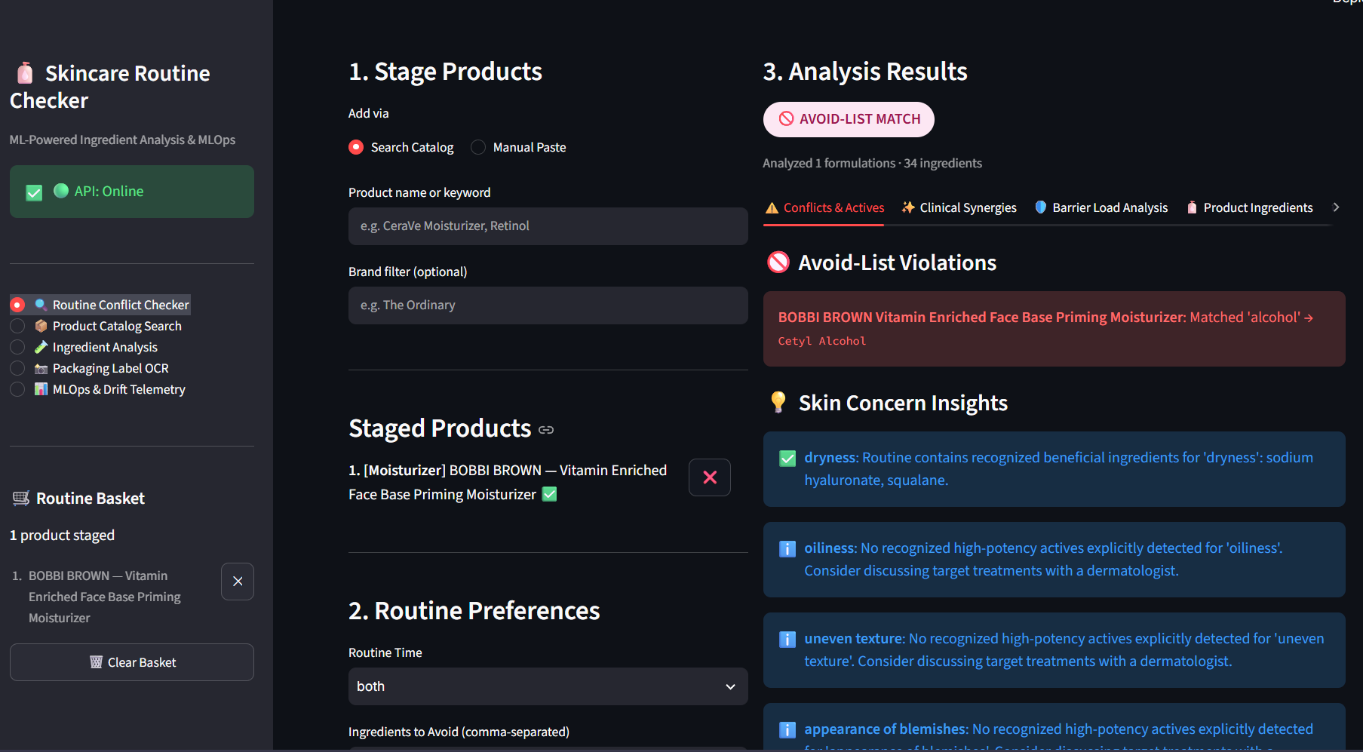
Figure 1. Routine checker output showing one staged product, an avoid-list text match, and displayed concern insights.
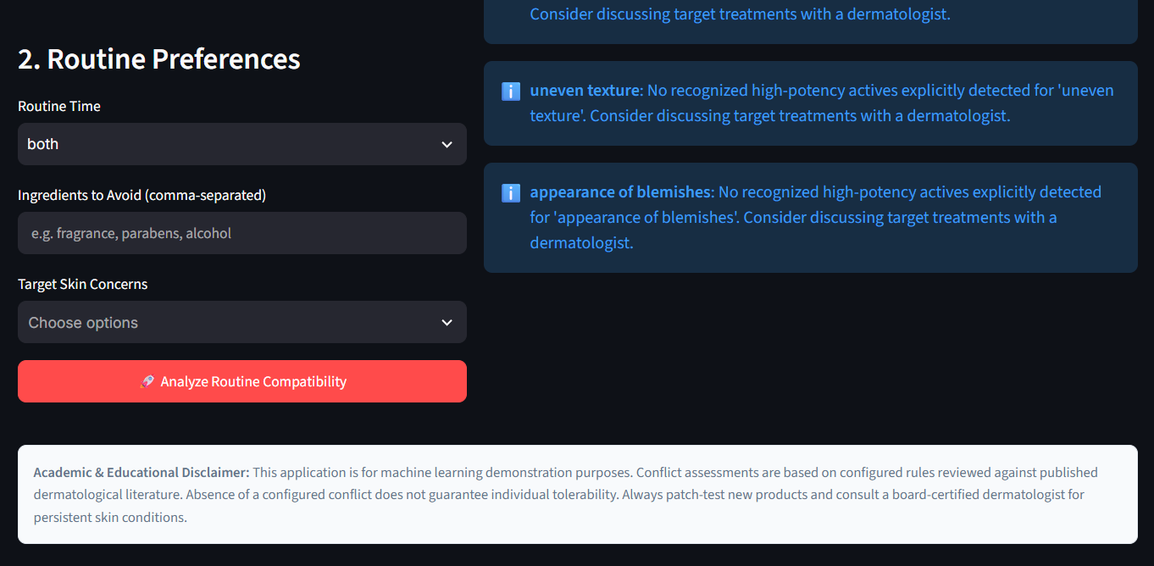
Figure 2. Lower portion of the routine workflow showing routine preferences, concern messages, and the educational disclaimer.
Interpretation: the screenshots document a single configured interaction. The broad alcohol-to-cetyl-alcohol match should be treated as a limitation of the matching semantics and reviewed before release. The disclaimer appropriately limits the interpretation of absence of conflict; future versions should also clarify how avoid-list matches are generated.

PART III | DEMONSTRATION RESULTS

10.2 Product Catalogue Search
The supplied catalogue screenshot searches for face mask and displays up to 15 results. Visible candidates include products from Fresh, Sephora Collection, Origins, and Sand & Sky. The displayed entries are marked as partial matches with a score of 85.0%. The score is a similarity indicator for this implementation; it is not a probability that the product is the user’s intended item. The screenshot also shows the optional brand filter and result-count control.
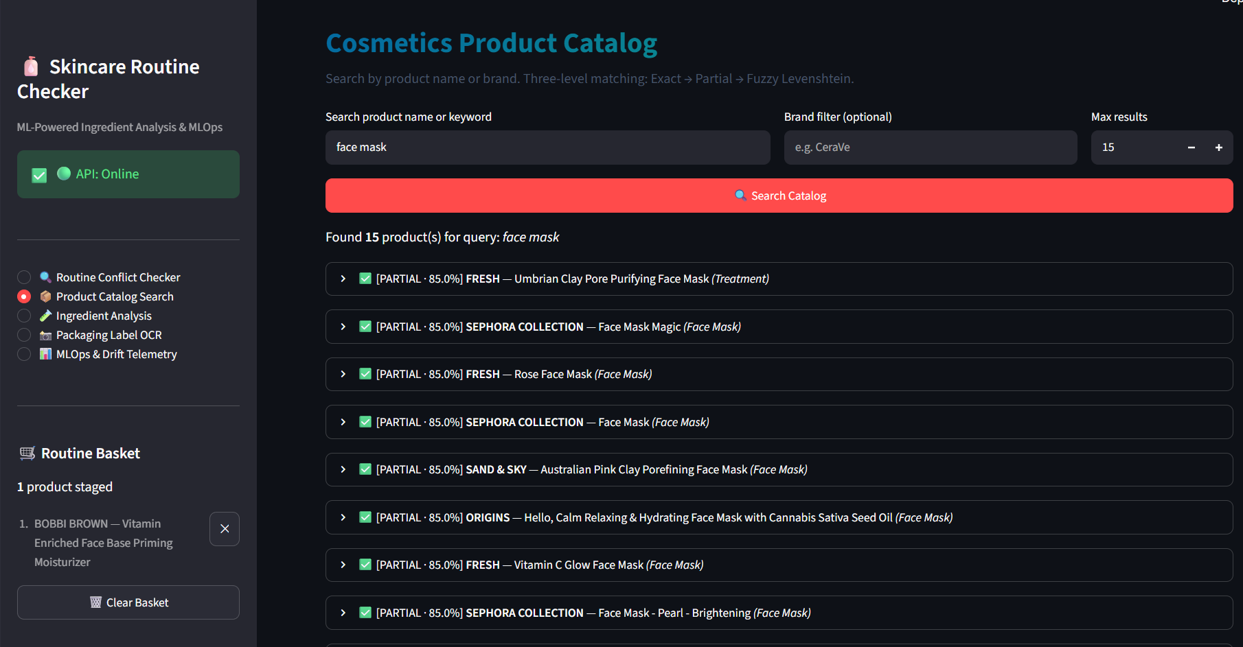
Figure 3. Product catalogue search for face mask with the visible result list and partial-match scores.

Result interpretation
A broad category query is useful for exploring the catalogue but may return many candidates. The screenshot shows that the interface exposes match type and score, which helps explain ordering. It does not show whether each record has current product data or a complete ingredient list. A production-quality search should add record completeness, product identity fields, and a way to flag stale or incorrect catalogue entries.

Evaluation opportunity
A reviewed query set could measure whether the intended product appears in the first five results, how often unrelated brands appear, and whether a brand filter removes other brands. No such benchmark is represented by this screenshot, so the report records it as an observed interface output only.

PART III | DEMONSTRATION RESULTS

10.3 Ingredient Parsing and Classification
The ingredient-analysis example supplies a comma-separated list containing 11 tokens, four explicit concentration values, and familiar synonyms. The summary reports eight classified functions and three unknown or low-confidence outcomes. The detailed table retains original tokens, canonical names, concentrations, concentration sources, and predicted functions. For example, Niacinamide 10% is normalized to niacinamide with the concentration attributed to explicit user input. Aqua (Water) is normalized to water, while the model marks its function as unknown in this captured output.
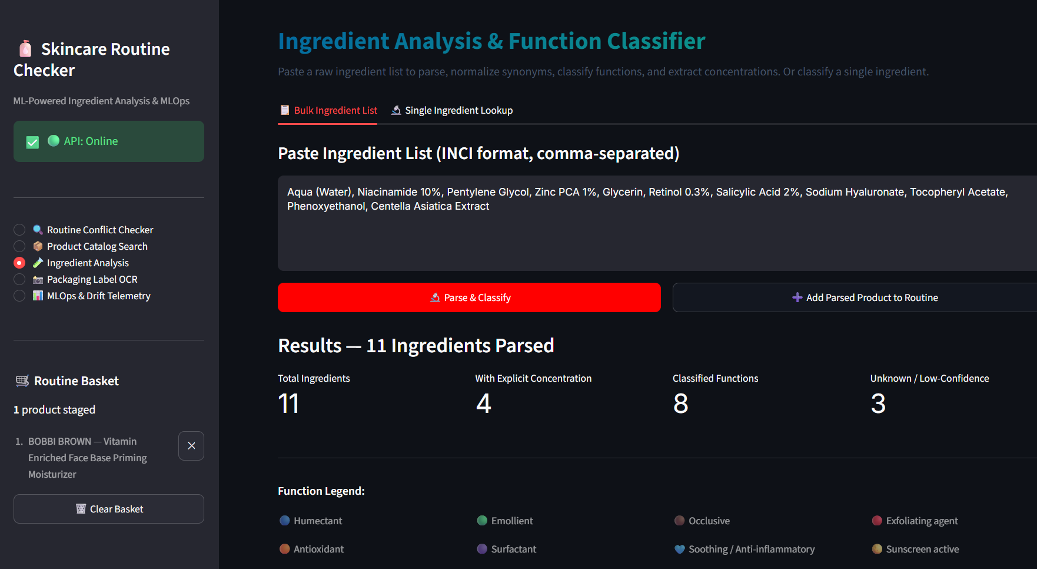
Figure 4. Ingredient-analysis summary showing parsed count, explicit concentrations, classified functions, and unknown results.
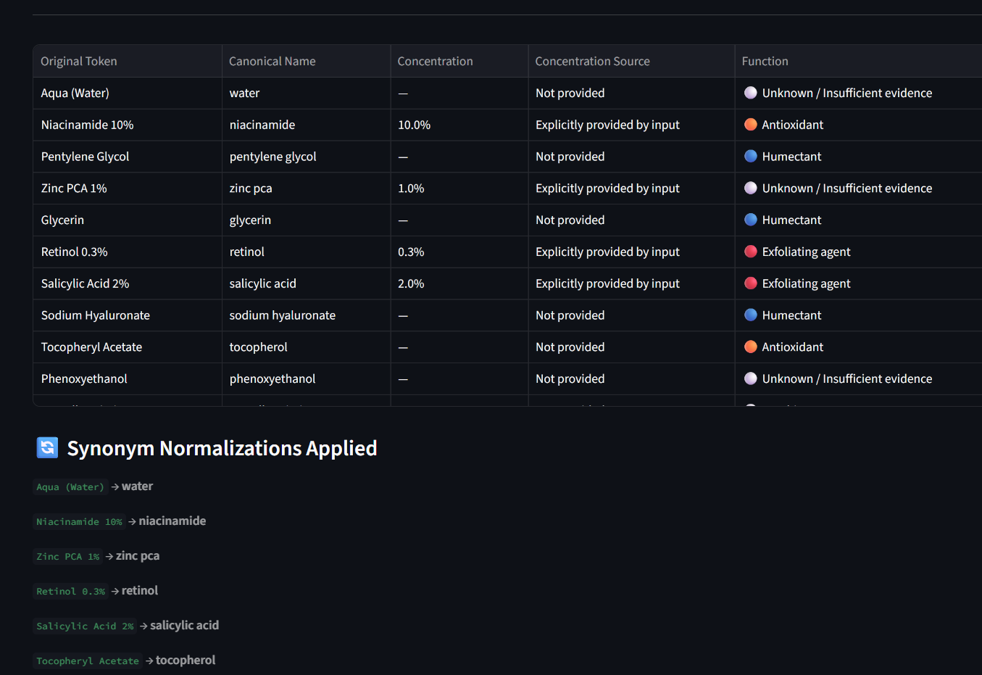
Figure 5. Detailed ingredient table and synonym-normalization display from the same analysis workflow.
The output demonstrates separation between parsing and classification: a token can be successfully normalized while its predicted function remains unknown. It also shows that a model label is a prediction, not a verified chemical property. The model’s low validation macro F1 and small taxonomy should be considered when interpreting these labels.

PART III | DEMONSTRATION RESULTS

10.4 Packaging Label OCR
The OCR view demonstrates image upload, editable extracted text, preview, and parsed output. In the supplied example, the text area contains alcohol, phenyladenine, coracan, and cerium, and the application reports four parsed ingredients. Several strings appear likely to require confirmation against the original package image. The screenshot is therefore evidence that the OCR workflow is connected to parsing; it is not evidence of OCR accuracy or correct ingredient recognition.
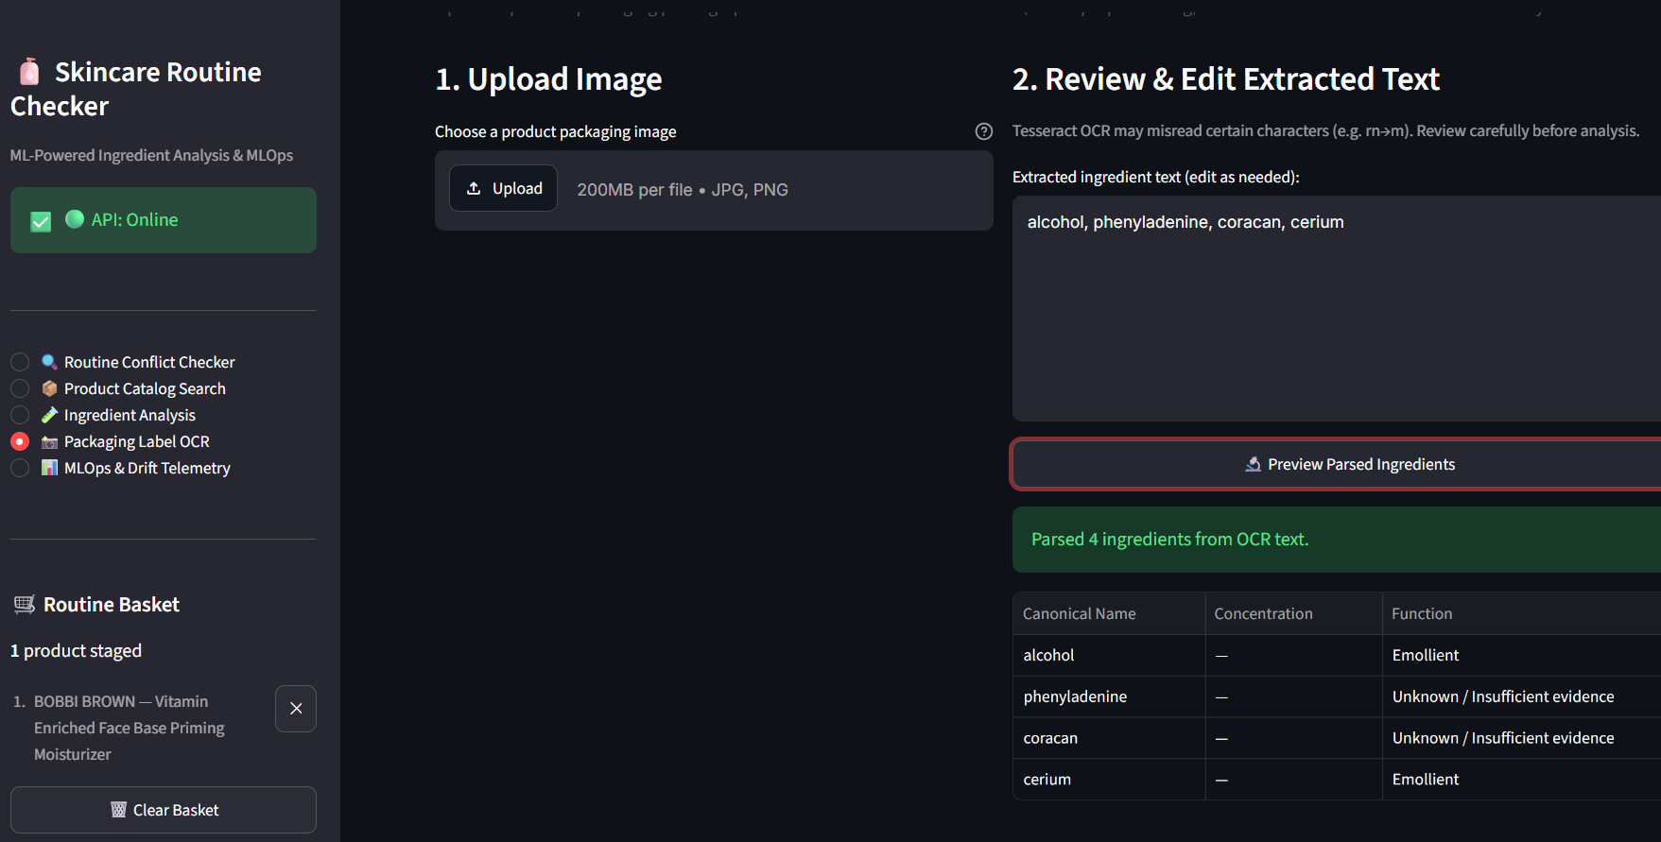
Figure 6. OCR-assisted label workflow with editable recognition output and parsed ingredient rows.

Human review requirement
The user should always review and correct OCR text before analysis. A recognition error can change a chemical name, split one token into several, or create a token that resembles a different ingredient. Future evaluation should use a set of labeled package images with representative fonts, glare, curved containers, low contrast, and multiple languages. Exact token accuracy and ingredient-level precision/recall would be more informative than a visual demonstration alone. Tesseract’s own documentation describes its supported input formats and OCR operation; the application still needs its own domain-specific accuracy assessment [3].

PART III | DEMONSTRATION RESULTS

10.5 MLOps Model and Drift Dashboard
This original project screenshot is retained because no replacement image was supplied for this dashboard view. It shows active model-version information, the Random Forest product-category result, the ingredient classifier’s recorded validation accuracy and class count, and summary drift indicators. The report retains the image unchanged, as requested. The values should be read as the state captured by that screenshot rather than assumed to represent a later run or current deployment.
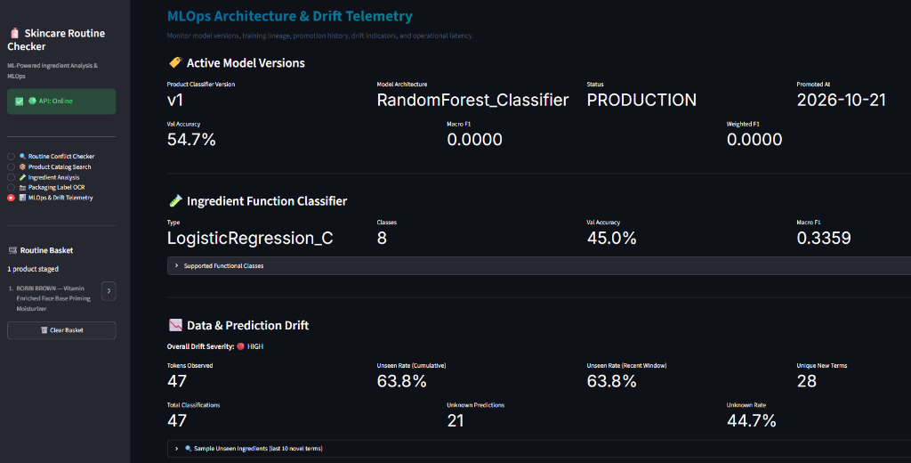
Figure 7. Existing MLOps dashboard screenshot retained unchanged because no replacement was supplied.

How to read the panel
The panel is intended to make model lineage and telemetry visible in the same application. Its usefulness depends on the definitions and time windows behind each indicator. A displayed unseen-vocabulary percentage is a monitoring signal, not a direct measure of model error. A model version label is meaningful only when it can be linked to an immutable artifact, training data version, code revision, evaluation results, and promotion decision.

PART III | DEMONSTRATION RESULTS

10.6 Prediction Distribution and API Latency
The new telemetry screenshot presents training and live class proportions with signed deltas, followed by API latency summaries. In the captured table, humectant is 15.6% in the training reference and 40.6% in live predictions, a displayed delta of +0.2504. Emollient is 18.2% versus 31.2%, while sunscreen-active and surfactant predictions are absent from the small live sample. The dashboard also shows endpoint-specific p50 and p95 values and request counts.
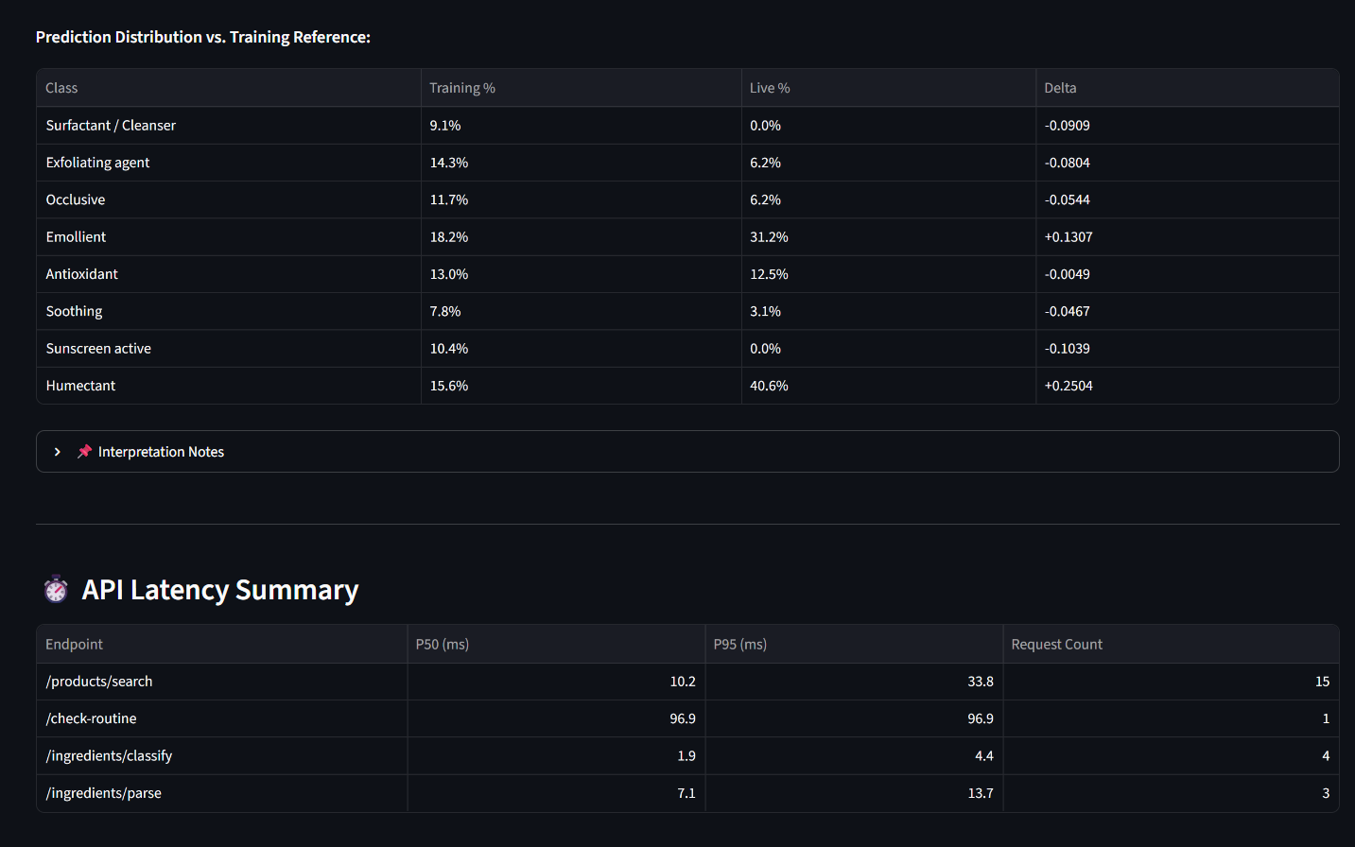
Figure 8. Prediction distribution comparison and API latency summary supplied for this report revision.
The displayed latency observations are: product search p50 10.2 ms and p95 33.8 ms across 15 requests; routine checking 96.9 ms for one request; ingredient classification p50 1.9 ms and p95 4.4 ms across four requests; parsing p50 7.1 ms and p95 13.7 ms across three requests. These small counts are insufficient for a stable performance claim. They are retained as a screenshot snapshot and should be replaced by a controlled benchmark for capacity planning.
Distribution comparison is a useful prompt for investigation, but a delta alone does not establish statistical significance, data quality, or a harmful outcome. A monitoring design should record sample size, time window, unknown prediction rate, and input source, then define thresholds and review procedures. It should also distinguish a real change in user inputs from changes caused by the classifier or catalog.

PART IV | EVALUATION AND OPERATIONS

11. Model Evaluation and Experimental Results

Product-category classifier
The repository evaluation artifacts identify the Random Forest model as the selected product-category classifier. The held-out test set contains 289 examples distributed across six labels. The reported overall accuracy is 0.5467; macro F1 is 0.5536 and weighted F1 is 0.5488. Validation results in the training summary show Logistic Regression accuracy 0.4483 and macro F1 0.4516, compared with Random Forest accuracy 0.4897 and macro F1 0.4652. The validation comparison supports selecting Random Forest within this experiment, while the held-out metrics remain the more appropriate estimate of generalization for the recorded split.
Product class | Precision | Recall | F1 | Support
Cleanser | 0.6600 | 0.6226 | 0.6408 | 53
Eye cream | 0.6452 | 0.4878 | 0.5556 | 41
Face Mask | 0.5370 | 0.5472 | 0.5421 | 53
Moisturizer | 0.4217 | 0.6034 | 0.4965 | 58
Sun protect | 0.6667 | 0.5882 | 0.6250 | 34
Treatment | 0.5122 | 0.4200 | 0.4615 | 50

Interpretation
Performance varies by class. Moisturizer recall is higher than its precision, while Treatment recall is lower. Macro F1 gives equal weight to each class and therefore helps reveal class-level variation that accuracy can obscure. The test support ratio between the largest and smallest class is recorded as 1.71. These values describe one dataset and one split; they do not indicate the quality of ingredient-function predictions or the correctness of rule-based checks.
The ingredient classifier has separate validation results: 45% accuracy and macro F1 0.3359 on a taxonomy with 77 records and eight functions. It is not directly comparable to the product classifier because the task, labels, data, and split differ.

PART IV | EVALUATION AND OPERATIONS

12. MLOps Lifecycle and Release Controls
The documented repository lifecycle begins with data acquisition and validation, proceeds through preprocessing and feature construction, trains and compares candidate models, applies a promotion gate, records model metadata, and serves the selected artifact. The project includes scripts for training, promotion, and retraining or rollback, as well as JSON model metadata and MLflow-related tracking. The exact behavior should be verified against the code and current artifacts whenever the workflow changes.
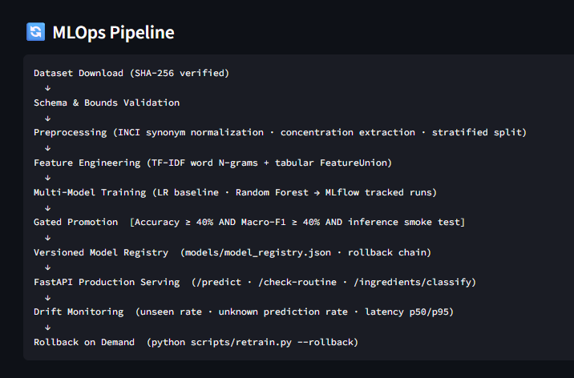
Figure 9. Original MLOps workflow diagram retained unchanged because no replacement was supplied.

Promotion and rollback
The README documents a promotion threshold of at least 0.40 accuracy and 0.40 macro F1. A threshold is a minimum gate, not a guarantee that a model is useful in every class or safe for a user-facing purpose. Promotion should also record the dataset and code versions, per-class results, evaluation split, reviewer, and model artifact hash. The rollback path should be exercised in a controlled environment and should restore a known approved artifact rather than simply selecting the most recent file.
MLflow can record run parameters, metrics, code versions, and artifacts; registry workflows can associate a model version with its source run and lifecycle metadata [4]. For durable collaborative registry use, storage and access configuration must be chosen deliberately and tested. A local SQLite tracking file is convenient for an academic prototype but should not be assumed to be a multi-user production registry.

PART IV | EVALUATION AND OPERATIONS

13. Docker Compose Execution and Deployment Readiness
The repository contains separate Dockerfiles for the API and dashboard and a docker-compose.yml that builds both services. The images use Python 3.11 slim as their base, install their service dependencies, copy required code and model/data artifacts, and expose ports 8000 and 8501. The Compose definition maps those ports to the host, sets the frontend backend URL to the internal service name, defines health checks, and makes the frontend wait for a healthy backend. This is a useful local demonstration setup; it should not be described as a complete public production deployment.

Local run procedure
- Install and start Docker Desktop, then open PowerShell at the repository root.
- Build and start both services with docker compose up --build.
- Open the Streamlit dashboard at http://localhost:8501 and the FastAPI docs at http://localhost:8000/docs.
- Inspect service output with docker compose logs -f; stop the foreground stack with Ctrl+C.
- Stop and remove containers with docker compose down. Preserve local source files and model artifacts when cleaning the environment.
Compose health checks and dependency conditions can coordinate service startup, but they do not provide HTTPS, authentication, rate limiting, a reverse proxy, durable backups, monitoring alerts, or deployment rollback. Docker documentation describes health-check-based dependency ordering as a startup coordination mechanism, not a replacement for broader operations work [5]. FastAPI’s deployment guidance similarly calls out HTTPS, startup, restart behavior, process replication, and resource limits as deployment concerns [6].

Before a public release
Use a private staging environment first. Put HTTPS termination and appropriate access controls in front of public traffic; restrict direct access to internal services; review upload limits and resource consumption; externalize secrets; define persistent storage and backup procedures where state must survive container replacement; pin and scan dependencies and images; and document a rollback procedure. The current Compose files should be reviewed for least privilege and non-root execution before being treated as hardened. The screenshots and repository documentation alone do not establish these deployment controls.

PART V | FINDINGS

14. Verification, Limitations, and Future Work

Verification snapshot
The repository README documents 28 automated tests: 24 scenario tests and four extended regression tests. It describes coverage across product search, parsing, normalization, classification, routine rules, OCR fallback, API validation, model loading, promotion and rollback, integration, and health checks. The README also describes a CI workflow. These are repository-documented results; the test suite was not re-executed as part of preparing this report revision. Before using the report as a release record, run the documented checks against the exact commit and record the command, date, and outcome.

Current limitations
- The ingredient-function taxonomy has only 77 records and recorded validation macro F1 of 0.3359.
- The product-category model’s held-out macro F1 is 0.5536, with visible variation across classes.
- The avoid-list screenshot shows generic substring matching can flag cetyl alcohol for the term alcohol.
- The OCR screenshot shows recognition output that requires manual checking; no OCR accuracy benchmark is supplied.
- Telemetry screenshots have small request counts and cannot support stable latency or drift conclusions.
- Barrier-load and synergy outputs are software heuristics, not clinically validated measures or personalized treatment guidance.
- The local Compose setup does not by itself establish security, public availability, backups, or production incident response.

Recommended next steps
Priority | Next work item | Evidence to produce
1 | Fix avoid-list semantics and display exact matched canonical tokens. | Reviewed cases for exact, family, and broad text matches.
2 | Expand and review ingredient-function labels. | Source and annotation notes, class counts, held-out per-class metrics.
3 | Build a labeled OCR and catalogue-search evaluation set. | Token accuracy and ranked-search measures on held-out examples.
4 | Harden the Compose deployment and document staging operations. | Image review, HTTPS ingress plan, secrets handling, restore and rollback procedure.

Release gates should be tied to evidence: data provenance is documented, no critical functional regression is known, uncertainty is visible, model comparisons use an untouched evaluation set, OCR requires user review, and deployment controls have been tested in staging. Additional features should wait until these foundations are stable.

PART V | FINDINGS

15. Conclusion and References

Conclusion
The project provides a substantial academic demonstration of how data processing, search, machine learning, rule-based checks, OCR, API serving, dashboard design, telemetry, and Docker Compose can be combined in one skincare-focused application. Its strongest contribution is the end-to-end software workflow and its separation of deterministic checks from learned predictions. The captured outputs also make important limitations visible: broad avoid-list text matching, OCR errors, uncertain ingredient labels, modest classifier performance, and small telemetry samples.
The next stage should prioritize data quality, calibrated uncertainty, transparent rule semantics, repeatable evaluation, and deployment hardening. The application should remain clearly educational until the data, evaluation, safety review, and operational controls justify a broader use. The current Docker setup is suitable for local development and demonstration; a public release requires additional security, availability, and maintenance work.

References
[1] Pinnell, S. R., Yang, H., Omar, M., et al. (2001). Topical L-ascorbic acid: percutaneous absorption studies. Dermatologic Surgery, 27(2), 137–142. https://doi.org/10.1046/j.1524-4725.2001.00264.x
[2] scikit-learn developers. Feature extraction from text. scikit-learn User Guide. https://scikit-learn.org/stable/modules/feature_extraction.html
[3] Tesseract OCR contributors. Tesseract User Manual and input-format documentation. https://github.com/tesseract-ocr/tessdoc
[4] MLflow contributors. MLflow Tracking and Model Registry documentation. https://mlflow.org/docs/latest/ml/
[5] Docker, Inc. Control startup and shutdown order in Compose. Docker Compose documentation. https://docs.docker.com/compose/how-tos/startup-order/
[6] FastAPI contributors. Deployment Concepts. FastAPI documentation. https://fastapi.tiangolo.com/deployment/concepts/
[7] Cosmetic Ingredient Review Expert Panel. Amended Safety Assessment of Salicylic Acid and Salicylates as Used in Cosmetics. CIR. https://cir-safety.org/supplementaldoc/amended-safety-assessment-salicylic-acid-and-salicylates-used-cosmetics-0
[8] OWASP Foundation. OWASP API Security Top 10 – 2023. https://owasp.org/www-project-api-security/
[9] Project repository documentation and artifacts: README.md, data/README.md, reports/model_metrics.json, reports/ingredient_classifier_metrics.json, reports/training_summary.md, models/model_registry.json, and tests/.

