**SE 306 Project 1**

**Project Plan**

**Team 4: NP-Easy**

**Benjamin Collins, Jacky Mai, Helen Zhao, Henry Wu, William Lin, Jay Gradon**

**Work Breakdown Structure**

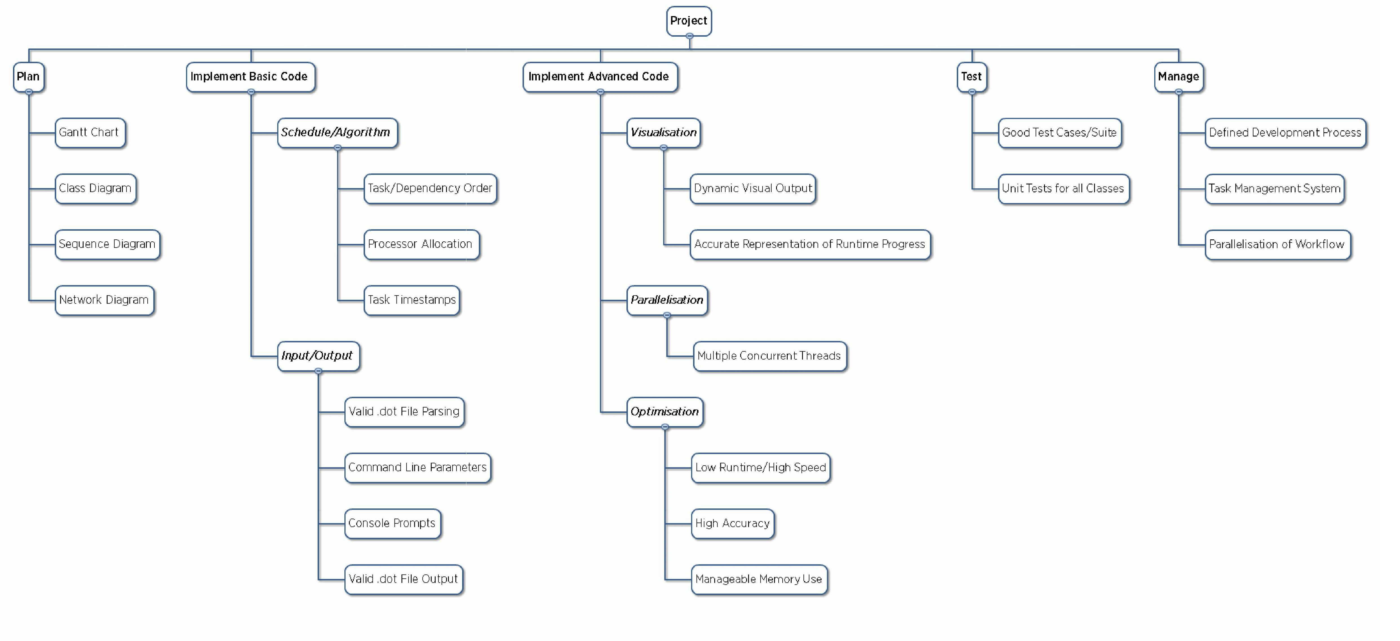

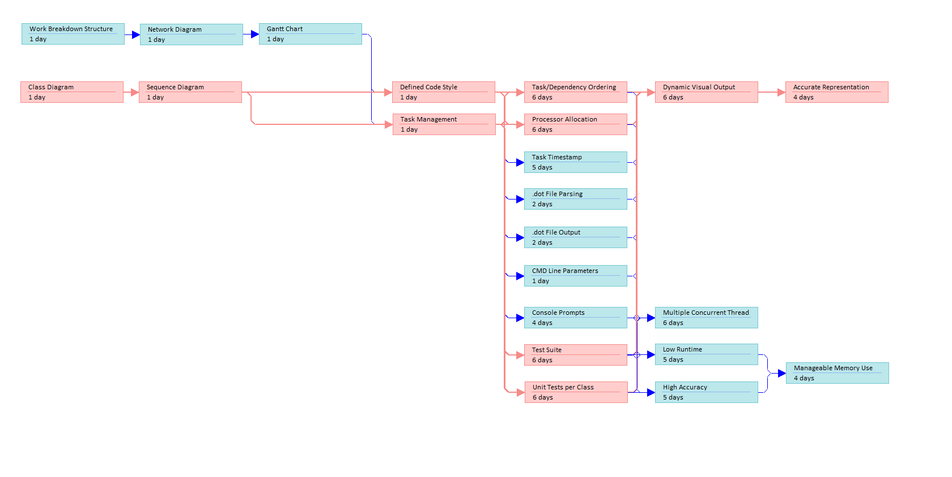

Note: Red boxes represent the **Critical Path** through the diagram

**Network Diagram**

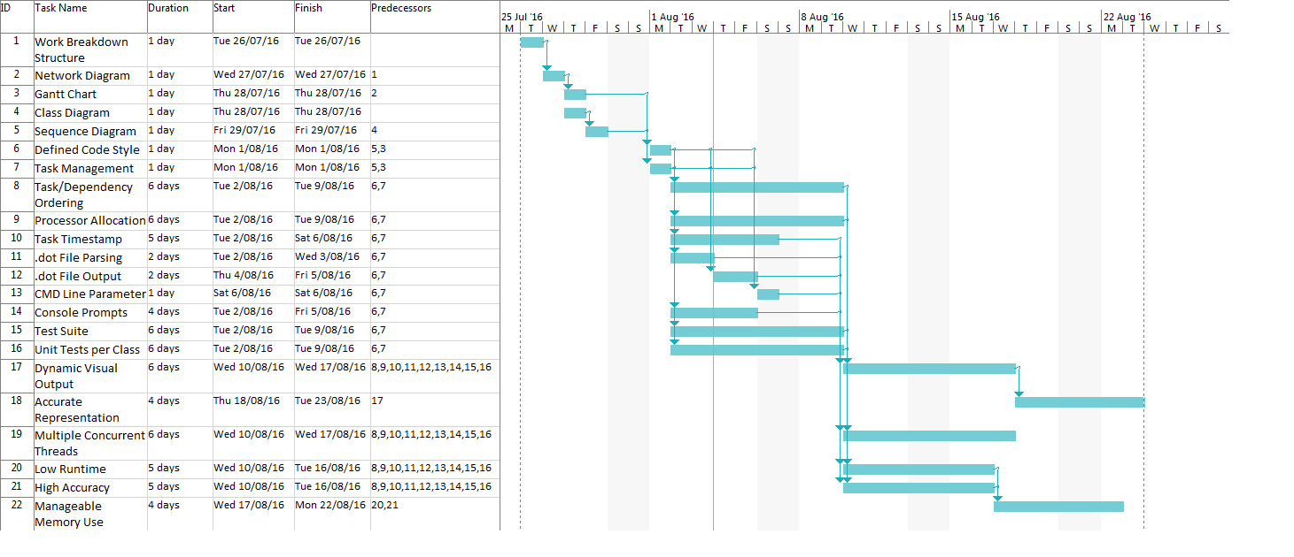

**Gantt Chart**