

Hands-On Lab

Authoring and Running Manual Tests using Microsoft Test Manager 2010

Lab version: 1.0.0

Last updated: 3/10/2011



Contents

Overview 3

Exercise 1: Authoring a Manual Test Plan 4

Exercise 2: Running a Manual Test Plan 7

Exercise 3: Analyzing Manual Test Results 14

Exercise 4: Creating Shared Steps 17

Overview

* 1. In this lab, you will learn how to use Microsoft Test Manager to author a manual test case and take advantage of test parameters. You will then run this test case using the Microsoft Test Runner. While running this test case you will capture an action recording which can be used to take advantage of Fast Forward for Manual Testing, to quickly re-run test steps or even entire test cases in the future. Finally you will explore how Shared Steps can be used to more effectively author common test steps which can then be reused across multiple test cases.

# System Requirements

* 1. In order to complete this lab you will need the Visual Studio 2010 virtual machine provided by Microsoft. For more information on acquiring and using this virtual machine, please see “Working with the Visual Studio 2010 RTM Virtual Machine”.

# Exercises

* 1. This Hands-On Lab comprises the following exercises:
  2. Authoring a Manual Test Plan
  3. Running a Manual Test Plan
  4. Analyzing Manual Test Results
  5. Creating Shared Steps
  6. Estimated time to complete this lab: **60 minutes**.

# Next Step

Exercise 1: Authoring a Manual Test Plan

Exercise 1: Authoring a Manual Test Plan

1. In this exercise, you will learn how to create a manual test plan and populate it with steps. The plan can later be run to confirm the expected behavior of your software.
   1. Log in as **Abu Obeida Bakhach (Dev)** if you have not already done so. The password is P2ssw0rd (capital letter P, the number two, the letter s, the letter s, the letter w, the number zero, the letter r, and the letter d). Please see “Working with the Visual Studio 2010 RTM Virtual Machine” for instructions on how to log into the VM.
   2. Open Microsoft Test Manager from **Start** | **All Programs** | **Microsoft Visual Studio 2010** | **Microsoft Test Manager 2010**. This is a new tool dedicated to manual software testing that has been built from the ground up for Visual Studio 2010.
   3. In this lab we’re going to focus on creating a new manual test case and running it. We will focus on the other aspects of managing test cases and test plans in another lab.
   4. Select the **Plan** activity button at the top of the Test Manager window.
   5. In the left pane, highlight **End-to-End Tests** and click the **New** button in the right pane.
      1. 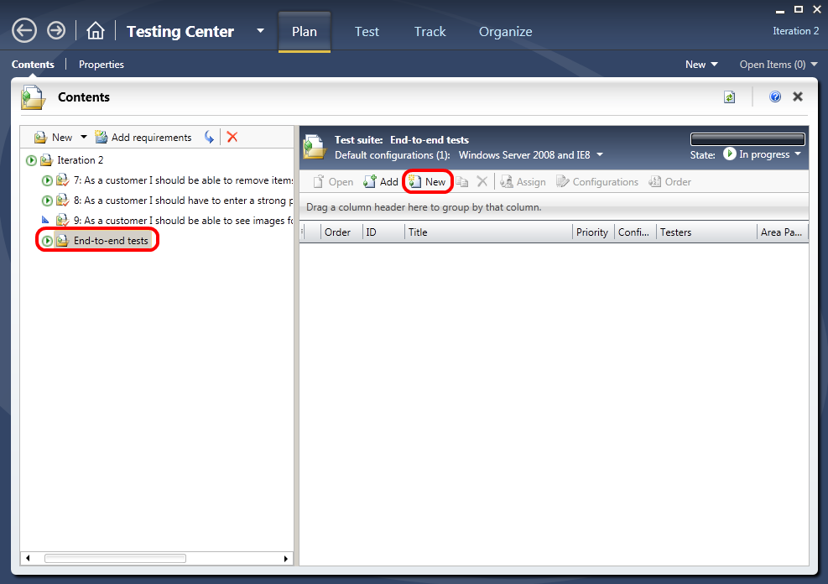
      2. Figure 1
      3. Creating a new manual test
   6. In the **Title** box, type “Confirm that receipt number appears after successful order”. Alternatively, you can open the “New Test Case.txt” file from the **Code Snippets** folder on the desktop of the VM and copy and paste the title from there.
   7. At this point, we’re ready to add steps to this manual test. Each step includes an **Action**, which describes the action the tester needs to perform. Optionally, a step can include an **Expected Result**, which describes the expected result of the given action.
   8. In the **Steps** panel, create a step for each of the following **Actions**, only one of which has an Expected Result. See the next paragraph for an alternate, faster way to add the actions.

|  |  |
| --- | --- |
| Action | Expected Result |
| Open http://WIN-GS9GMUJITS8:8000 |  |
| Click Model Airplanes |  |
| Click Northwind Trader |  |
| Click Add to Cart |  |
| Click Checkout |  |
| Enter @First, @Last, @Email, @Address, @City, @Country, @State, @PostalCode |  |
| Click Review Order |  |
| Click Place Order |  |
| Confirm order page has receipt # | Receipt # should appear at top of order confirmation page |
| Close Browser |  |

An alternative method to manual entry of each step is to copy and paste all steps from the “New Test Case.txt” file to add them all at once. In order to do this, select the first blank **Action** cell and press the **Escape** key so that the cell has dotted lines surrounding it, then paste in all steps.

* + 1. 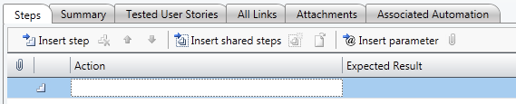
    2. Figure 2
    3. Steps are ready to be pasted
  1. At this point, the **Steps** panel should look similar to the following:
     1. 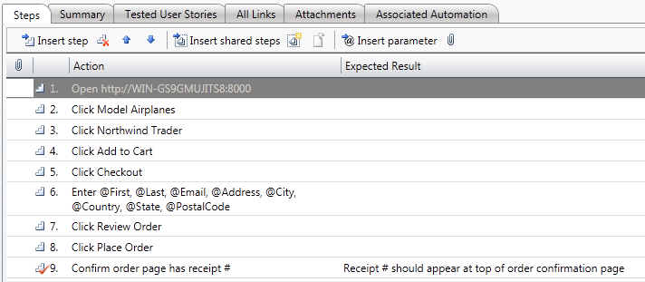
     2. Figure 3
     3. Steps for new manual test

**Note:** Adding a value in the Expected Result column for a manual test step adds a checkbox next to the step action so that the tester is required to manually validate that the test passed.

* 1. Note the “Enter @First, @Last, @Email, @Address, @City, @Country, @State, @PostalCode” step. In this step, we used the **@** sign to indicate that there were iteration-specific variables to be used during the manual test pass. We can define which variables to use by scrolling down to the **Parameter Values** section of this form and entering them for each iteration. Use the following table to set up values for three iterations (or use the copy and paste method from the “New Test Case.txt” file once again):

|  |  |  |  |
| --- | --- | --- | --- |
| First | Last | Email | Address |
| Michael | Affronti | Michael@Contoso.com | One Microsoft Way |
| Chris | Barry | Chris@Tailspin.com | Two Tailspin Trail |
| Robin | Wood | Robin@Northwind.com | Nine Northwind Street |

|  |  |  |  |
| --- | --- | --- | --- |
| City | Country | State | PostalCode |
| Redmond | USA | Washington | 98052 |
| Springfield | USA | Illinois | 11135 |
| North Wind | USA | North Dakota | 99909 |

* 1. The **Parameter Values** section should now look like this:
     1. 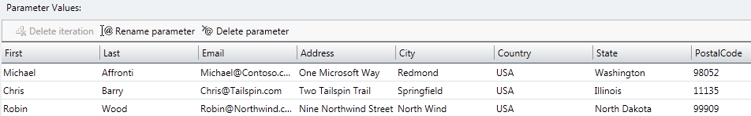
     2. Figure 4

Parameter values for manual test

* 1. Save test case by clicking the **Save** icon in the top-right corner of the window.
     1. **Note:** The test case is saved as a project work item.
     2. 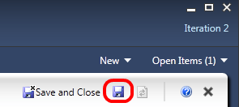
     3. Figure 5
     4. Save button location

# Next Step

Exercise 2: Running a Manual Test Plan

Exercise 2: Running a Manual Test Plan

* 1. In this exercise, you will learn how to run the manual test plan we created in the first exercise.
  2. From the top menu, click the **Test** button to enter test mode.
     1. 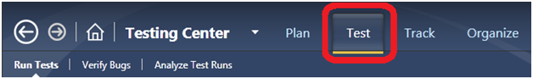
     2. Figure 6
     3. Test button location
  3. In the left pane, expand the tree to find the **End-to-End Tests** node and select it.
  4. In the right pane, select the test titled “Confirm that receipt number appears after successful order” and click the **Run** button.
     1. 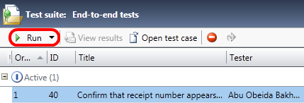
     2. Figure 7
     3. Run button location
  5. At this point, the Microsoft Test Runner is launched and provides the option to record the actions taken by the tester. This is a key feature as it enables “fast forwarding” for future test runs and records more details for reviewing tests later. Check the **Create action recording** box and click **Start Test**.
     1. 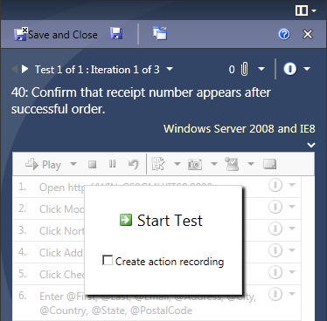
     2. Figure 8
     3. Running the manual test with action recording
  6. Wait until the Test Runner has completed initialization and then launch **Internet Explorer** from **Windows Quick Launch** bar.
     1. **Note:** There is a known bug that may result in the Internet Explorer process crashing on slower machines. This can be worked around by waiting an additional 15 seconds after initialization is complete before launching Internet Explorer.
  7. Copy and paste the <http://WIN-GS9GMUJITS8:8000> address from the “New Test Case.txt” file into the address bar in Internet Explorer and press **Enter**. It will take a few moments for the site to load and run.
  8. After the site has loaded, the first step of the test has been completed successfully. Click **Ctrl+Windows+Q** to indicate that the test has passed. Alternatively, you can select the **Pass** option from the test result dropdown next to the step itself. It’s not a requirement to pass or fail tests other than those that require validation (such as with “expected results”), but it does help when correlating tester actions with steps. Note that when you pass a test, it automatically sets the next step as active, so you don’t need to click back and forth between the runner and the browser.
     1. 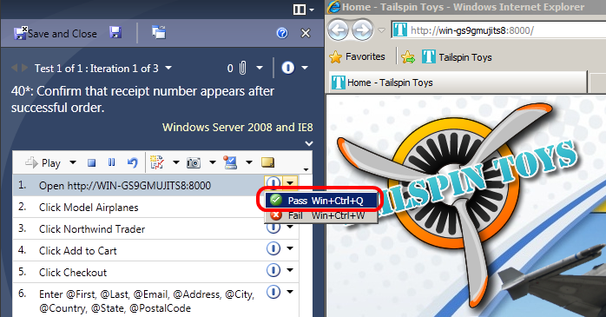
     2. Figure 9
     3. Manually passing a test step
     4. **Note:** To use the Ctrl+Windows+Q shortcut you may need to run the VM in full screen mode.
  9. In Internet Explorer, click the **Model Airplanes** button and press **Ctrl+Windows+Q** if successful.
  10. Click the **Northwind Trader** link and press **Ctrl+Windows+Q** if successful.
  11. Click the **Add To Cart** button and press **Ctrl+Windows+Q** if successful.
  12. Click the **Checkout** button and press **Ctrl+Windows+Q** if successful.
      1. **Note:** In the event that your action recording does not go according to plan, you can always reset and record again.
      2. 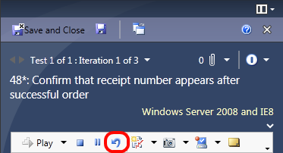
      3. Figure 10
      4. Location of Reset button
  13. Click in the “**First**” text box and press **Ctrl+V** to paste the first iteration’s **First** variable into the box. This action will bind the variable from the test with the text box in the website, as evidenced by the databound icon that is shown next to the variable. Future iterations of the test will be able to take advantage of this association.

**Note:** There is a known issue that can sometimes prevent focus from automatically returning to the text boxes in the website after databinding with test data. For example, after filling in a text box and pressing Tab, focus will not be set in the next textbox as you would expect. This issue occurs when running the virtual machine on slower hardware. To work around this issue, simply click a second time in the textbox you want to set focus to.

* 1. Repeat the process of pasting the variables for “Last”, “Email”, “Address”, and so on. Skip the Address 2 text box. In the end, each of the variables should be databound.

**Note:** You will have to select values from dropdown boxes for Country and State even though they may already display a value.

* + 1. 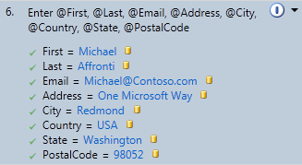
    2. Figure 11
    3. Databound test variables
  1. Press **Ctrl+Windows+Q** to indicate the order form step passed.
  2. Click the **Review Order** button and press **Ctrl+Windows+Q** if successful.
  3. Click the **Place Order** button and press **Ctrl+Windows+Q** if successful.
  4. Confirm that the order page has a receipt number. Press **Ctrl+Windows+Q** to indicate that the step passed.
     1. 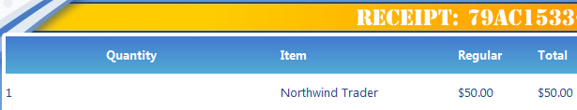
     2. Figure 12
     3. Order page showing receipt number
  5. Close the Internet Explorer window as instructed and press **Ctrl+Windows+Q** if successful.
  6. You are now at the end of the first test iteration. Click the **End iteration and move to next** link to move onto iteration 2.
     1. 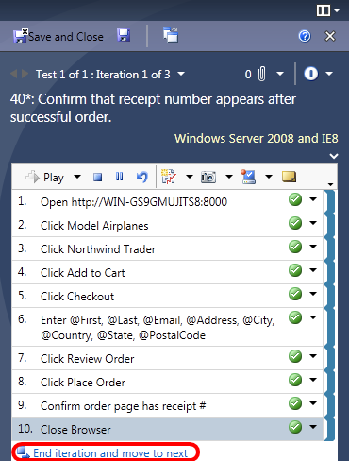
     2. Figure 13
     3. Location of “End iteration and move to next” link
  7. In this iteration, we will not create an action recording as it will overwrite the original one that we just created. Instead, we’re going to use the version that we just recorded to aid in the running of this iteration. Click the **Start Test** button to start iteration 2.
  8. Step 1 should already be selected. Hold down the **Shift** key and click the “**Click Place Order**” step to select all steps leading to it, inclusively.
     1. 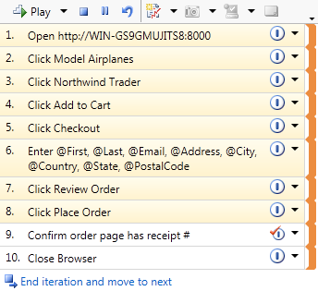
     2. Figure 14
     3. Selecting all steps up to “Click Place Order”, inclusively
  9. Click the **Play** button to automatically run the selected steps. Using the mouse or keyboard during test automation can interfere, so don’t use them again until the automation of the selected test steps is complete.
     1. **Note:** This automated process uses the data specified for the second test iteration of the test in order to complete the registration form.
  10. After the Test Runner finishes running the steps that you selected, it will stop on the “Confirm order page has receipt #” test so that you can manually verify. Press **Ctrl+Windows+Q** to indicate that step passed.
  11. You are now at the end of the second test iteration. Click the **End iteration and move to next** link to move onto iteration 3.
  12. Follow the same process that you did for iteration 2.
  13. Since we are on the last iteration, click the “**End iteration**” link shown after the last step.
  14. Click the **Save and Close** button to save the test results.
      1. 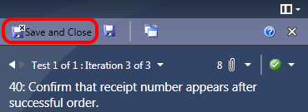
      2. Figure 15
      3. Location of “Save and Close” button

# Next Step

Exercise 3: Analyzing Manual Test Results

Exercise 3: Analyzing Manual Test Results

* 1. In this exercise, you will learn how to review the results of a manual test run.
  2. Click the **View results** button in the right pane.
     1. 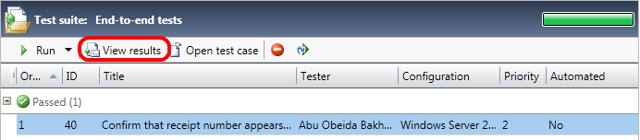
     2. Figure 16
     3. View Results button location
  3. In the test results view, you can see more details on the tests run, including details of the iterations, results, and associate attachments.
     1. 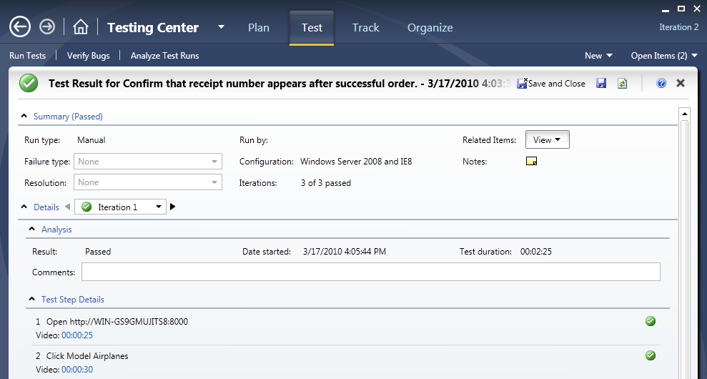
     2. Figure 17
     3. Test results view
  4. In the **Test Step Details** section, click on one of the video links. This will launch the test video replay for the specific time of this step.
     1. 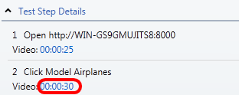
     2. Figure 18
     3. Video links for each step
     4. **Note:** The times will vary depending upon how long each step took during your test run. In addition, the entire run is stored in one video file and the times listed are actually offsets into that file.
  5. Close the video player.
  6. Expand the **Attachments** panel. This panel contains various attachments recorded during the test that can help with diagnostics.
  7. Select the **SystemInformation.xml** item and click **Open**. Click **Open** in the confirmation dialog. This file contains details about the system the tests were run on.
     1. 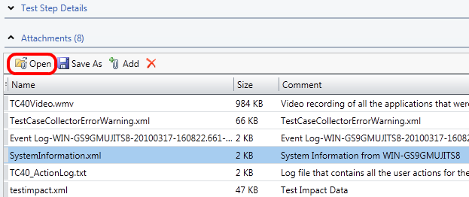
     2. Figure 19
     3. Location of SystemInformation.xml attachment from test run
  8. Close the Internet Explorer window that was opened for SystemInformation.xml.
  9. Click **Save and Close** to close the test results view.

# Next Step

Exercise 4: Creating Shared Steps

Exercise 4: Creating Shared Steps

* 1. In this exercise, you will learn how to create shared steps. A shared step combines multiple steps that are commonly performed in sequence into a single logical step, which can be shared across tests. If the process defined by the shared steps ever changes in the future, you can update the shared step in one place and it will be reflected in all tests that reference it.
  2. In the right pane, click **Open test case** to open the selected test.
     1. 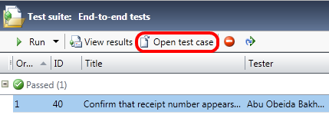
     2. Figure 20
     3. Location of “Open test case” button
  3. In the Steps panel, click on the second step “**Click Model Airplanes**” to select it. Next, hold the **Shift** key and then click the step “**Click Add to Cart**” so that steps 2 -4 are selected.
  4. **Right-click** the selection and select **Create shared steps** from the context menu that appears.
     1. 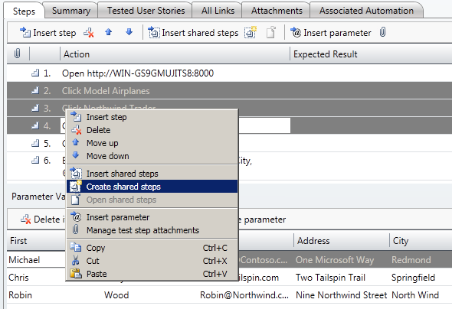
     2. Figure 21
     3. Creating shared steps
  5. In the **Create Shared Steps** dialog, enter “**Add Northwind Trader to Cart**” as the Title and then click the **OK** button.
     1. 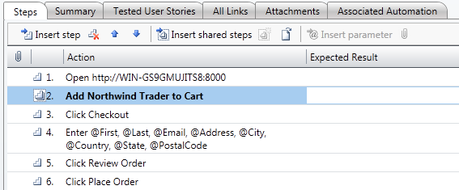
     2. Figure 22
     3. Step 2 now refers to the shared steps that we just created
  6. **Right-click** the shared step and select **Open shared steps**. You can now edit the shared steps as needed.
     1. 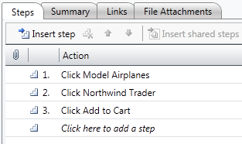
     2. Figure 23
     3. Viewing shared steps
  7. Click **Save and Close** to save the shared steps.
  8. Click **Save and Close** to save and close the test.

To give feedback please write to [VSKitFdbk@Microsoft.com](mailto:VSKitFdbk@Microsoft.com)

Copyright © 2010 by Microsoft Corporation. All rights reserved.