

Hands-On Lab

Branching and Merging Visualization with Team Foundation Server 2010

Lab version: 1.0.0

Last updated: 12/14/2010

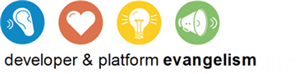

Contents

Overview 3

Exercise 1: Working with TFS 2010 Code Branches 4

Exercise 2: Branching and Merging Visualization 8

Overview

* 1. In this lab, you will be introduced to the new branching and merging visualization support in Team Foundation Server 2010. The improvements made in TFS 2010 make it much easier to understand a solution branch hierarchy and to propagate changes during the merge process.

# System Requirements

* 1. In order to complete this lab you will need the Visual Studio 2010 virtual machine provided by Microsoft. For more information on acquiring and using this virtual machine, please see “Working with the Visual Studio 2010 RTM Virtual Machine”.

# Exercises

* 1. This Hands-On Lab comprises the following exercises:
  2. Working with TFS 2010 Code Branches
  3. Branching and Merging Visualization
  4. Estimated time to complete this lab: 3**0 minutes**.

# Next Step

* 1. Exercise 1: Working with TFS 2010 Code Branches

Exercise 1: Working with TFS 2010 Code Branches

1. In this exercise, you will learn about some of the new code branch features in Team Foundation Server 2010 and how to open a solution that corresponds to a specific code branch. In addition, this exercise will serve as the setup for a scenario where production code needs to be updated and the changes ultimately merged through active branches in the system.
   1. Log in as **Abu Obeida Bakhach (Dev)** if you have not already done so. The password is P2ssw0rd (capital letter P, the number two, the letter s, the letter s, the letter w, the number zero, the letter r, and the letter d). Please see “Working with the Visual Studio 2010 RTM Virtual Machine” for instructions on how to log into the VM.
   2. Open Microsoft Visual Studio from **Start** | **All Programs** | **Microsoft Visual Studio 2010** | **Microsoft Visual Studio 2010**.
   3. Open the **Source Control Explorer** window from **View | Other Windows | Source Control Explorer**.
   4. The **Tailspin Toys** solution contains a Main code base as well as branches under development and release. In Team Foundation Server 2010, branches are now first-class objects that are represented with their own icon in Source Control Explorer.
      1. 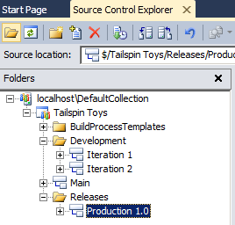
      2. Figure
      3. Source Code Explorer showing folder and branches
   5. **Right-click** on the **Production 1.0** branch node and select **Properties** from the context menu that appears. The Properties window provides general details like version and description, hierarchical relationship to other branches, and permissions.
      1. 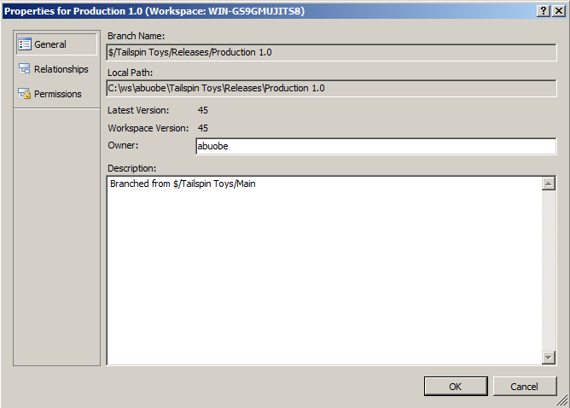
      2. Figure
      3. Properties window for code branch
   6. Select the **Cancel** button to return to Source Code Explorer.
   7. Select the **Production 1.0** branch node in the **Releases** folder and double-click on the **TailspinToys.sln** solution file to open it.
   8. Rebuild the solution (**Build | Rebuild Solution** from the main menu). This step may take a few minutes to complete.
   9. Ensure that the **Tailspin.Web** project is set as the startup project (right-click and select **Set as StartUp Project**).
   10. Press **Ctrl+F5** to launch the Tailspin Toys website.
       1. 
       2. Figure
       3. Default page for Tailspin Toys website
   11. Imagine a scenario where the Production 1.0 branch represents the code that is currently running on the production web server. Management has decided that the non-functional links in the page footer should be removed as soon as possible. We have decided to “fast track” this change by making the update directly to the Production 1.0 branch. Later, you will see how we can merge this change back to the branch for the current iteration (Iteration 2) so that it becomes a part of the changes we’re working on for the next release. You will now see how the new branching and merging capabilities in Team Foundation Server 2010 facilitate such a scenario. Close the Internet Explorer window and return to Visual Studio.
   12. Our first task is to update the production branch and deploy the changes to the production web server. From Solution Explorer, open **Template.Master** from the Tailspin.Web project under the Production 2.0 branch.
   13. Scroll to the bottom of the Template.Master page and locate the list item HTML for the footer links. Comment out the Careers link through the Shipping Options & Charges link as shown below.
       1. 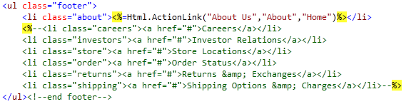
       2. Figure
       3. Modified Template.Master page
   14. Press **Ctrl+F5** to launch the website and verify that the non-functional links are no longer displayed. For the purposes of this demonstration, assume that at this point we have successfully deployed the updated change to the production server.
   15. Close the Internet Explorer window and return to Visual Studio.
   16. Open the **Pending Changes** window from **View | Other Windows | Pending Changes**.
   17. In the **Comment** field, enter “**removed non-functional links from footer**”, check the checkbox next to the Template.Master file, and select the **Check In** button.
       1. 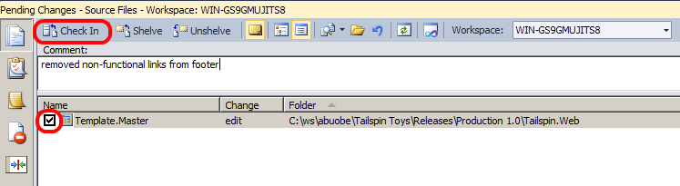
       2. Figure
       3. Checking in the change to the Production 1.0 branch
   18. In the next exercise we will merge the changes through other branches in the system.

# Next Step

* 1. Exercise 2: Branching and Merging Visualization

Exercise 2: Branching and Merging Visualization

* 1. In this exercise, you will learn how to visualize and track changesets while merging the changes that you made in the previous exercise.
  2. In **Source Control Explorer**, right-click on the **Production 1.0** branch and select **View History** from the context menu that appears.
     1. 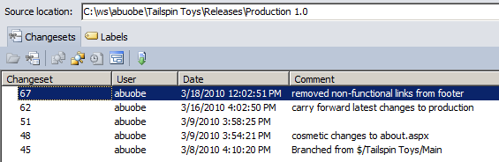
     2. Figure
     3. Changeset history for Production 1.0 branch
  3. **Right-click** on the changeset that you just checked in and select **Track Changeset** from the context menu that appears.
  4. In the **Select Branches** window, Production 1.0 will already be checked. **Check** the checkbox for **Iteration 2** and then select the **Visualize** button to see the current state of the changeset as it relates to the other branches.
     1. 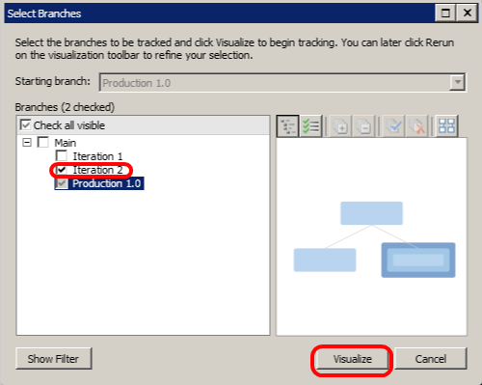
     2. Figure
     3. Selecting branches to visualize
  5. This visualization shows us that the changeset has been applied to Production 1.0 but not to Iteration 2. It also makes it clear that in order to merge our changes into Iteration 2 we will need to merge with the Main branch first.
     1. 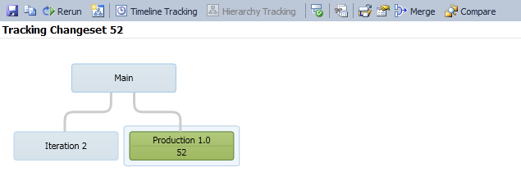
     2. Figure
     3. Tracking Changeset visualization in Hierarchy Tracking mode
     4. **Note:** Your changeset numbers will differ from those shown in the lab screenshots.
  6. To perform the merge of this changeset and the Main branch, **drag and drop** the green **Production 1.0** node onto the **Main** node. This will load the Source Control Merge Wizard.
     1. 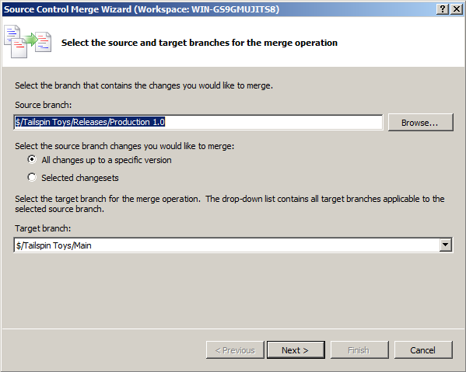
     2. Figure
     3. First screen of the Source Control Merge Wizard
  7. Ensure that the source branch to merge ends with “Production 1.0” and the target branch ends with “Main”. Select the **Next** button to continue.
  8. The next screen of the merge wizard specifies the version to merge. By default, you should see the changeset that you checked in already. Select the **Finish** button to perform the merge.
  9. After the merge is complete, open the **Pending Changes** window and note that Template.Master change status for the Main code branch is now “merge, edit”. The merge process is complete, but we still need to check in the changes.
  10. Add a **Comment** of “**Merging fast-tracked changes from Production to Main**”.
      1. 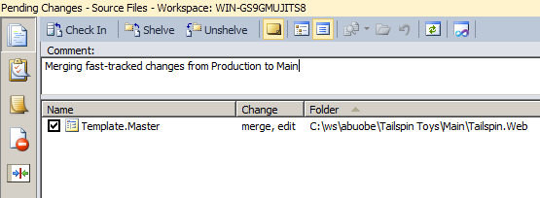
      2. Figure
      3. Insert Caption
  11. Click the **Check In** button to finalize the merge with the Main branch.
  12. In the **Tracking Changeset** window, click on the **Rerun** button to generate an updated view. You will need to click the **Visualize** button again when the **Select Branches** window appears.
      1. 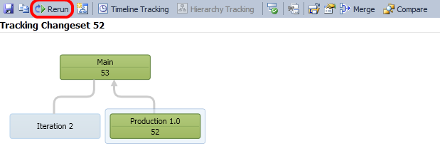
      2. Figure
      3. Changeset tracking view showing that merge with Main is complete
  13. Next, merge the changeset from the **Main** branch with the **Iteration 2** branch in the same manner as before by dragging and dropping to load the Source Control Merge Wizard.
  14. Select **Next** followed by **Finish** to perform the merge process.
  15. In the **Pending Changes** window, enter a **Comment** of “**Merged fast-tracked changes from Main to Iteration 2**”.
  16. Select the **Check In** button to finalize the merge with the Iteration 2 branch.
  17. In the **Tracking Changeset** window, click on the **Rerun** button to see the updated view.
      1. 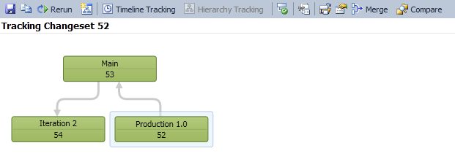
      2. Figure
      3. Tracking original changeset in Hierarchy Tracking mode
  18. Another useful view is the Timeline Tracking view. Select the **Timeline Tracking** button to the left of the Hierarchy Tracking button to switch to this view. This shows the order in which the original changeset was merged with the other branches.
      1. 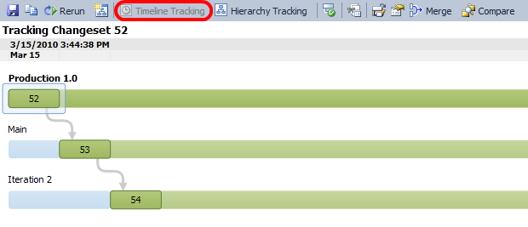
      2. Figure
      3. Tracking original changeset in Timeline Tracking mode
  19. In the **Source Control Explorer**, navigate to and **right-click** on the **Template.Master** file from the **Iteration 2** branch, selecting **Annotate** from the context menu that appears.
      1. 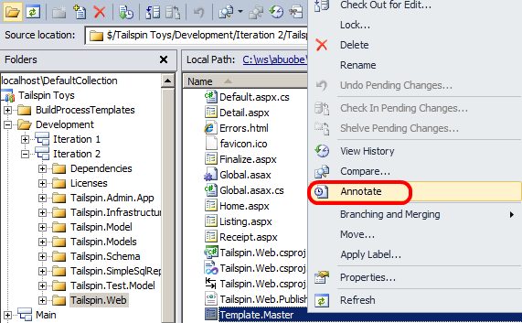
      2. Figure
      3. Location of Annotate option
  20. Scroll to the bottom of the annotated **Template.Master** file and locate the HTML that you previously commented out.
  21. In the annotation column on the left-hand side, mouse over the recent changeset (it should have today’s date on it). Note that the changeset path and comment refer to the Production branch where the change was originally made even though we annotated a file from the Iteration 2 branch.
      1. 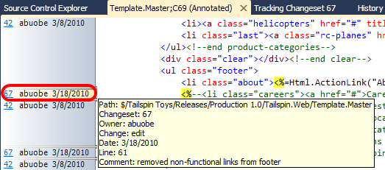
      2. Figure
      3. Changeset information for Template.Master file

To give feedback please write to [VSKitFdbk@Microsoft.com](mailto:VSKitFdbk@Microsoft.com)

Copyright © 2010 by Microsoft Corporation. All rights reserved.