

Hands-On Lab

Introduction to Coded UI Tests with Visual Studio 2010 Ultimate

Lab version: 1.0.0

Last updated: 12/14/2010



Contents

Overview 3

Exercise 1: Introduction to Code Generation from Action Recordings 4

Exercise 2: Introduction to Code Generation using Coded UI Test Builder 12

Exercise 3: Data Driven Demonstration for Coded UI Test 16

Overview

* 1. Coded UI tests are a new capability of Visual Studio 2010 which provide a way to create fully automated tests to validate the functionality and behavior of your application’s user interface. In this lab you will gain a basic understanding of coded UI tests by creating a new test and adding validation logic to it.

# System Requirements

* 1. In order to complete this lab you will need the Visual Studio 2010 virtual machine provided by Microsoft. For more information on acquiring and using this virtual machine, please see “Working with the Visual Studio 2010 RTM Virtual Machine”.

# Exercises

* 1. This Hands-On Lab comprises the following exercises:
  2. Introduction to Code Generation from Action Recordings
  3. Introduction to Code Generation using Coded UI Test Builder
  4. Data Driven Demonstration for Coded UI Test
  5. Estimated time to complete this lab: **60 minutes**.

# Next Step

Exercise 1: Introduction to Code Generation from Action Recordings

Exercise 1: Introduction to Code Generation from Action Recordings

1. In this exercise, you will be introduced to the Visual Studio 2010 code generation features that allow testers to quickly and easily create coded UI tests directly from existing action recordings. Action recordings contain the steps taken during manual testing of an application. To learn more about manual testing and action recordings, please see the “*Authoring and Running Manual Tests with Visual Studio 2010 using Microsoft Test Manager*” lab.
   1. Log in as **Abu Obeida Bakhach (Dev)** if you have not already done so. The password is P2ssw0rd (capital letter P, the number two, the letter s, the letter s, the letter w, the number zero, the letter r, and the letter d). Please see “Working with the Visual Studio 2010 RTM Virtual Machine” for instructions on how to log into the VM.
   2. Open Microsoft Visual Studio from **Start** | **All Programs** | **Microsoft Visual Studio 2010** | **Microsoft Visual Studio 2010**.
   3. Start a new testing project (**File | New | Project…**).
   4. In the New Project window, select the **Test Project** template from **Visual C# | Test** and select the **OK** button to create the test project.
      1. 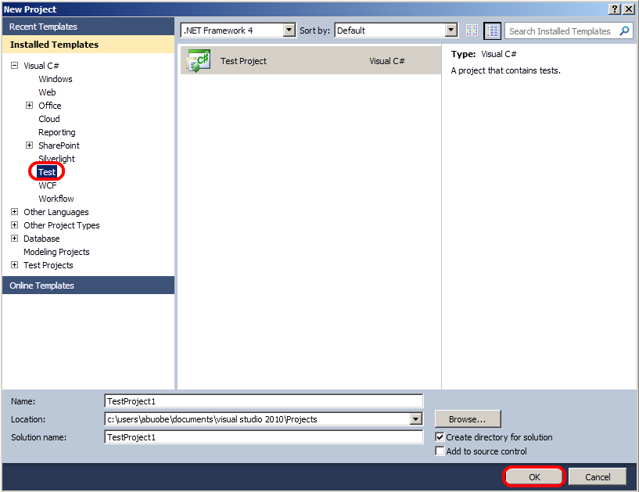
      2. Figure 1
      3. Creating a Test project
   5. Close the window showing UnitTest1.cs.
   6. In **Solution Explorer**, right-click on the **TestProject1** project node and select **Add | Coded UI Test…** from the context menu.
      1. 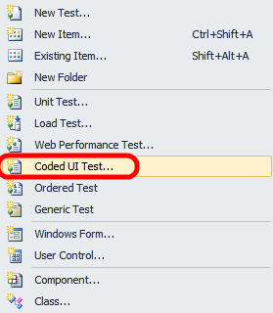
      2. Figure 2
      3. Creating a Coded UI Test
   7. There are two ways to generate code for this new coded UI test. The first and default option is to use the **Coded UI Test Builder**, which allows you to generate test code by manually walking through a test scenario. The second option is to use an **existing action recording**. Select the second option to use an existing action recording and select the **OK** button to continue.
      1. 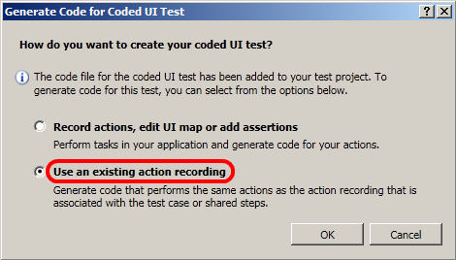
      2. Figure 3
      3. Using an existing action recording for test generation
   8. In the Work Items Picker window, select the **Tailspin Toys** project.
   9. In the Work Items Picker window, select the **IDs** radio button and enter **41**. This is the ID of a test case in the Tailspin Toys project that contains an action recording.
   10. Select the **Find** button to execute the work item query. Note that for the purposes of this lab, we assume that the ID is already known.
       1. 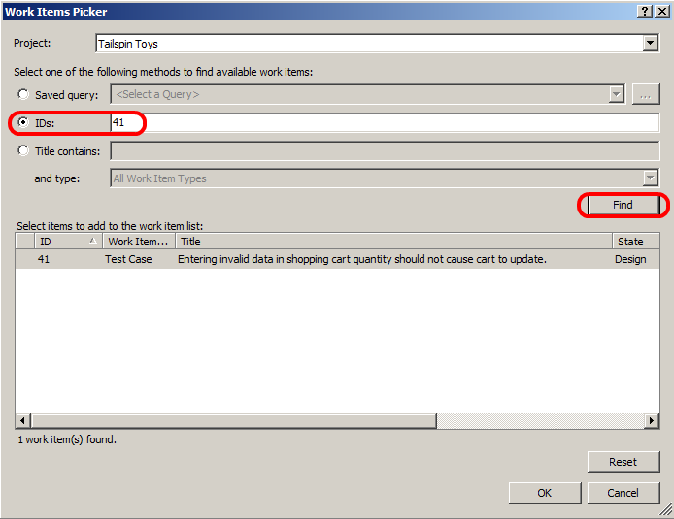
       2. Figure 4
       3. Finding a test case with action recording
   11. Select the **OK** button to generate a coded UI test from the test case action recording.
   12. Navigate to the **CodedUITestMethod1** method in the generated CodedUITest1.cs file. Each line represents a step from the action recording used during test generation.
   13. Right-click on the first method call in the CodedUITestMethod1 method and select **Go To Definition**. This will load the **UIMap** class from the UIMap.Designer.cs file which contains the generated test logic. This generated method launches Internet Explorer and navigates to a specified URL.
       1. 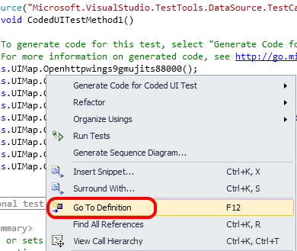
       2. Figure 5
       3. Navigating to test logic
   14. Scroll down to the **ClickFourthCoffeeFlyer** method within the UIMap class. This generated method tests clicking on a “Fourth Coffee Flyer” hyperlink that is in the Tailspin Toys Web application.
       1. 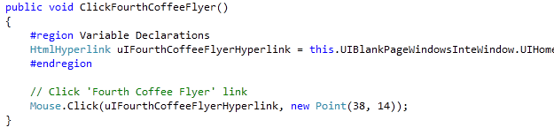
       2. Figure 6
       3. Generated test method example
   15. The **ClickFourthCoffeeFlyer** test method does not specify the hyperlink parameters directly, but rather refers to the “UIBlankPageWindowsInteWindow.UIHomeTailspinToysDocument1.UIFourthCoffeeFlyerHyperlink” property. **Navigate** to the definition of the **UIFourthCoffeeFlyerHyperlink** property to see how it is implemented.
       1. 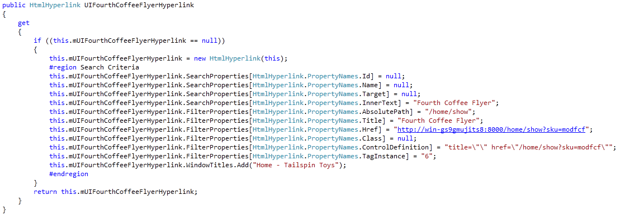
       2. Figure 7
       3. Definition of SignInHyperlink property
       4. **Note:** The HtmlHyperlink instance that is created for the UIFourthCoffeeFlyerHyperlink property has a number of search and filter properties applied that aid the test framework in locating the correct HTML hyperlink. In the event that the Web application changes some of the link properties, such as the inner text, the test harness may still be able to find the hyperlink using the remaining search properties.
   16. Close the UIMap.Designer.cs file to return to the CodedUITest1.cs file.
   17. **Right-click** somewhere within the CodedUITest1.cs source file and select **Run Tests**. Important: do not touch the mouse or keyboard during the tests.
       1. 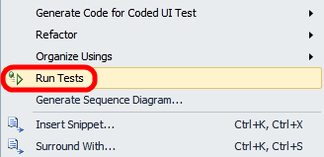
       2. Figure 8
       3. Location of Run Tests command
   18. As the tests run, an instance of Internet Explorer will be opened and actions automatically taken as they are defined in the coded UI test. The test will be run more than once because the original manual test that this coded UI test was generated from had multiple rows of test parameters.
       1. 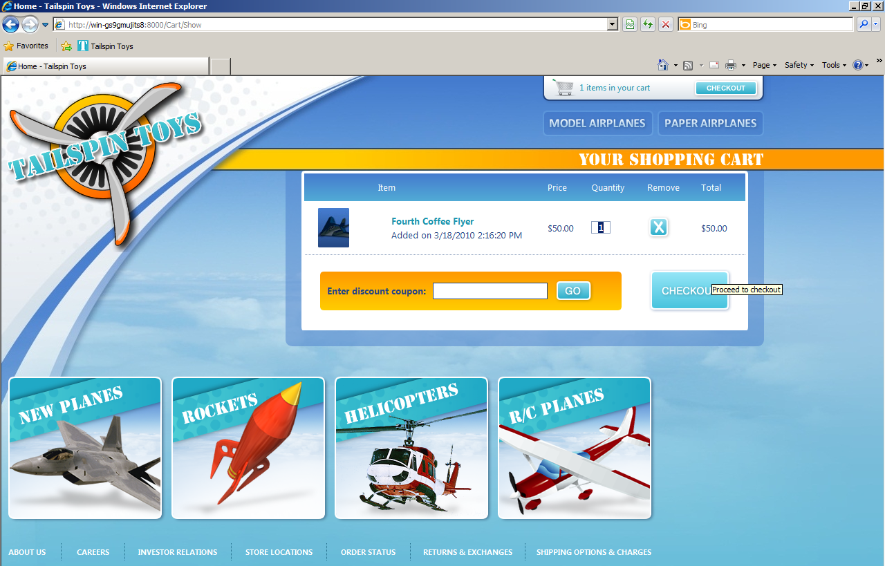
       2. Figure 9
       3. Example of coded UI test running
   19. Verify that the test passed by viewing the Test Results window. In this case, however, we are not performing any validation after any of the steps.
       1. 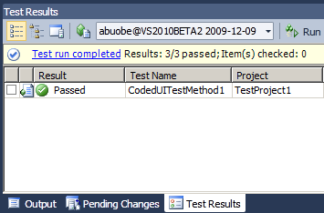
       2. Figure 10
       3. Test Results window showing Passed test

# Next Step

Exercise 2: Introduction to Code Generation using Coded UI Test Builder

Exercise 2: Introduction to Code Generation using Coded UI Test Builder

* 1. In this exercise, you will learn how to use the Coded UI Test Builder to generate test code for the Tailspin Toys Web application and modify the generated code in order to enable data driven testing.
  2. Open Internet Explorer and click on the Tailspin Toys button from the favorites bar.
     1. 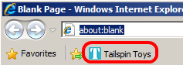
     2. Figure 11
     3. Tailspin Toys link
  3. Click on the Model Airplanes link.
  4. Click on the Fourth Coffee Flyer link.
  5. Click the Add To Cart link to load the shopping cart.
  6. Return to Visual Studio, locate the **CodedUITestMethod1** method in the CodedUITest1.cs file, and add a blank line after the call to the “this.UIMap.Clickonwhitespaceinwebsite” method.
     1. 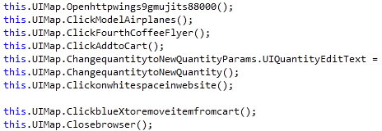
     2. Figure 12
     3. Adding blank line to test source
  7. Right-click at the location of the blank line and select **Generate Code for Coded UI Test | Use Coded UI Test Builder…** from the context menu. This will load the **Coded UI Test Builder** window (which is always displayed over other windows) and the Internet Explorer instance that we previously left open.
     1. 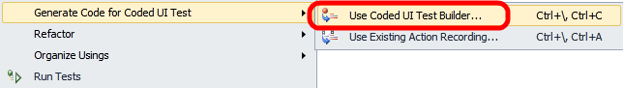
     2. Figure 13
     3. Starting the Coded UI Test Builder
     4. **Note:** The Coded UI Test Builder is used to record actions and assertions within the user interface which are then converted to code.
  8. Now we will add an assertion to verify that the Quantity textbox is equal to 1. Drag and drop the crosshair from the Coded UI Test Builder tool window onto the Quantity textbox in Internet Explorer. This action will load a window showing the control properties.
     1. 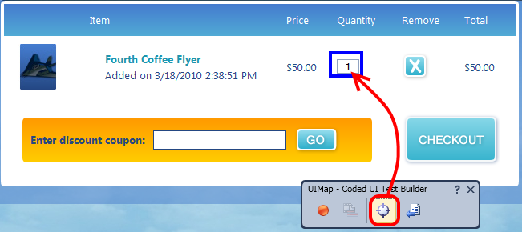
     2. Figure 14
     3. Selecting an element to use for assertion
  9. Select the **Text** property and click the **Add Assertion** button. This will load a dialog to finalize the assertion options to use.
  10. Verify that the Comparator to use is **AreEqual** and that the comparison value is ‘1’. Select the **OK** button to continue.
      1. 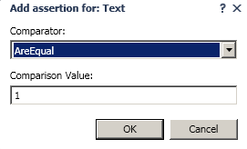
      2. Figure 15
      3. Selecting the comparator type and value
  11. Verify that a **checkbox** has been added to the Text property row in the Coded UI Test Builder window.
      1. 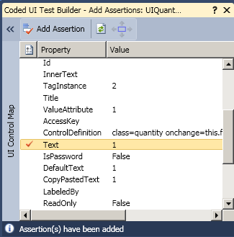
      2. Figure 16
      3. Text property showing assertion checkbox
  12. Click on the **Generate Code** button in the Coded UI Test Builder tool window.
      1. 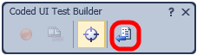
      2. Figure 17
      3. Generate Code button location
  13. In the Generate Code window, use **QuantityEqualsOne** for the Method Name and select the **Add and Generate** button to generate the validation code.
      1. 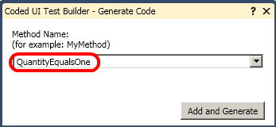
      2. Figure 18
      3. Generating assertion code
  14. Remove the “Fourth Coffee Flyer” item from the shopping cart.
  15. Close the Coded UI Test Builder.
  16. Close the Internet Explorer window and return to Visual Studio.
  17. Note that the assertion code generation has added the new validation step.
      1. 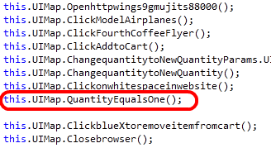
      2. Figure 19
      3. Newly created assertion step for coded UI test
  18. Right-click and select **Run Tests** to run the tests with the new validation steps.

# Next Step

Exercise 3: Data Driven Demonstration for Coded UI Test

Exercise 3: Data Driven Demonstration for Coded UI Test

* 1. In this exercise, you will add another set of test parameter values to the test case in order to demonstrate that these test parameters are hooked up to the coded UI test and that the validation that we recently added in is performing as expected.
  2. Open Microsoft Test Manager from **Start | All Programs | Microsoft Visual Studio 2010 | Microsoft Test Manager 2010**.
  3. Click the **Test** tab and select **test suite 7** “As a customer I should be able to remove items from my shopping cart”.
     1. 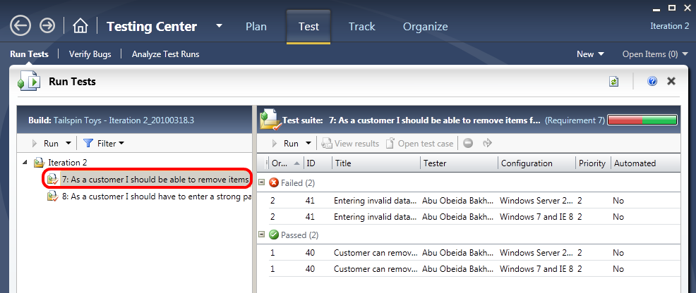
     2. Figure 20
     3. Test suite 7 has been selected
  4. Select the test case with **ID = 41** and select the **Open Test Case** button.
     1. 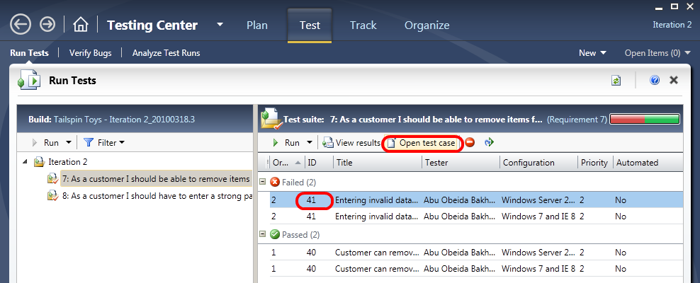
     2. Figure 21
     3. Opening test case with ID = 41
  5. In the **Parameter Values** section at the bottom, add a new row with quantity **10**.
     1. **Note:** A value of 10 is a legitimate value for the shopping cart, so the cart will refresh to show a quantity of 10 when this value is entered. But since the purpose of this exercise is to show what happens when a test iteration fails, we will pretend that this causes the test to fail in order to demonstrate a test case failure. Our assertion expects that the quantity will remain at 1.
  6. **Save** the changes to the test case and return to Visual Studio.
  7. **Run** the **tests** again and note that the test fails on the fourth iteration.
  8. Double-click on the **Failed** row within the Test Results window to open the test results. Under the section for **Data Driven Test Results** we are notified that 3 out of 4 tests passed and that the fourth data row failed.
     1. 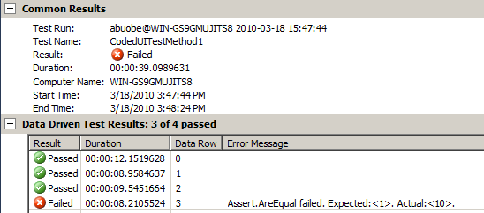
     2. Figure 22

Test results showing failed assertion

To give feedback please write to [VSKitFdbk@Microsoft.com](mailto:VSKitFdbk@Microsoft.com)

Copyright © 2010 by Microsoft Corporation. All rights reserved.