

Hands-On Lab

Introduction to Test Case Management with Microsoft Test Manager 2010

Lab version: 1.0.0

Last updated: 3/10/2011



Contents

Overview 3

Exercise 1: Managing Test Suites and Test Cases 4

Exercise 2: Analyzing Test Runs 13

Exercise 3: Selecting Builds to Test Against 17

Overview

* 1. In this lab, you will be introduced to working with Microsoft Test Manager. Microsoft Test Manager can be used to organize your test plans, author and manage your test cases, and run manual tests. This lab will provide you with a basic understanding of how Microsoft Test Manager can be used to perform these activities. Also be sure to see “Authoring and Running Manual Tests with Microsoft Test Manager” if you are interested in these aspects of Microsoft Test Manager.

# System Requirements

* 1. In order to complete this lab you will need the Visual Studio 2010 virtual machine provided by Microsoft. For more information on acquiring and using this virtual machine, please see “Working with the Visual Studio 2010 RTM Virtual Machine”.

# Exercises

* 1. This Hands-On Lab comprises the following exercises:
  2. Managing Test Suites and Test Cases
  3. Analyzing Test Runs
  4. Selecting Builds to Test Against
  5. Estimated time to complete this lab: **60 minutes**.

# Next Step

* 1. Exercise 1: Managing Test Suites and Test Cases

Exercise 1: Managing Test Suites and Test Cases

1. In this exercise, you will learn how to use the Microsoft Test Manager to manage test suites and test cases.
   1. Log in as **Abu Obeida Bakhach (Dev)** if you have not already done so. The password is P2ssw0rd (capital letter P, the number two, the letter s, the letter s, the letter w, the number zero, the letter r, and the letter d). Please see “Working with the Visual Studio 2010 RTM Virtual Machine” for instructions on how to log into the VM.
   2. Open Microsoft Test Manager from **Start** | **All Programs** | **Microsoft Visual Studio 2010** | **Microsoft Test Manager 2010**. This is a new tool dedicated to manual software testing that has been built from the ground up for Visual Studio 2010.
      1. **Note:** Microsoft Test Manager allows testers to work with test plans, author and organize manual test cases, execute test cases, file bugs, and post results back to Team Foundation Server.
      2. 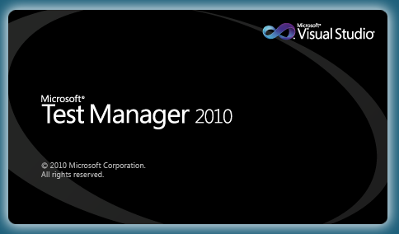
      3. Figure 1
      4. Microsoft Test Manager starting up
   3. Select the activity center drop down from the top menu that currently shows Testing Center. The **Testing Center** is used to work with manual test cases and other general test case management. **Lab Center** is used to work with physical or virtual testing labs. For this lab, we will focus on the Testing Center.
      1. 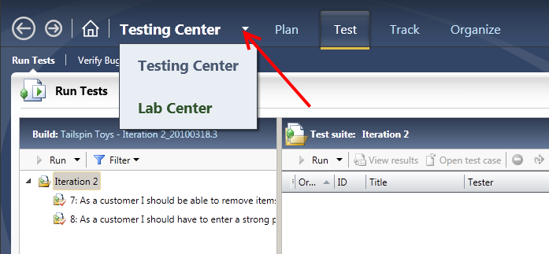
      2. Figure 2
      3. Choosing Activity Centers in Microsoft Test and Lab Manager
   4. Select the **Plan** tab from the Testing Center.
      1. 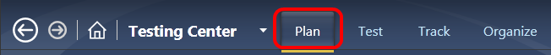
      2. Figure 3
      3. Location of Plan tab
   5. In the **Contents** panel under the Iteration 2 node, locate the nodes labeled 7, 8, and 9. These nodes are requirements-based **test suites** which contain test cases linked to requirements. Select **test suite 7** to see the list of linked test cases.
      1. 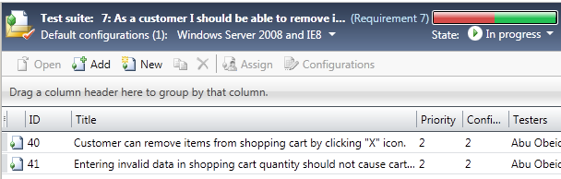
      2. Figure 4
      3. Test cases assigned as requirements for a test suite
   6. Open the test case with **ID = 41** by right-clicking on it and selecting **Open Test Case** from the context menu that appears.
      1. 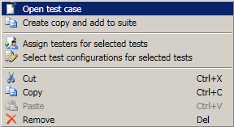
      2. Figure 5
      3. Opening a test case from within Test and Lab Manger
   7. Select the **Tested User Stories** tab and note that this test case links back to a user story.
      1. 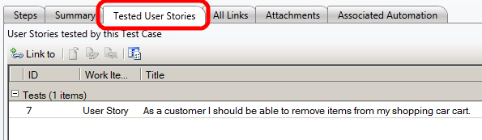
      2. Figure 6
      3. Tested User Stories tab
   8. Close the test case by selecting the **X** in the top-right corner of the test case window. Be careful not to close the Test Manager application.
      1. 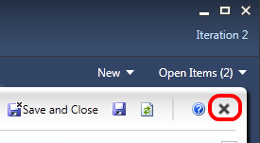
      2. Figure 7
      3. Location of Close button (X)
   9. Locate and select the test suite labeled **End-to-End Tests**. This **static test suite** contains arbitrary test cases and other test suites.
      1. **Note:** There may not be any items in the End-to-end tests suite.
   10. The third and final test suite type is the **query-based suite**. Although not represented in this lab, query-based test suites allow work item queries to be constructed in order to gather test cases. For example, imagine a scenario where you want to create a test suite that includes all priority 1 test cases from iteration 1’s test plan.
       1. 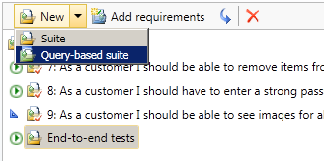
       2. Figure 8
       3. Query-based suite
   11. Locate and select **test suite 9** and note that its state is set to **In Planning**. The remaining two states are **In Progress** and **Completed**. Only test suites that are set to the In Progress state are shown on the Test activity tab.
       1. 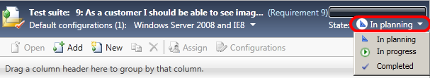
       2. Figure 9
       3. Test suite state selection
   12. Locate and select **test suite 7**. Note that you can open, add, create, and remove test cases from the right-hand side of the window.
       1. 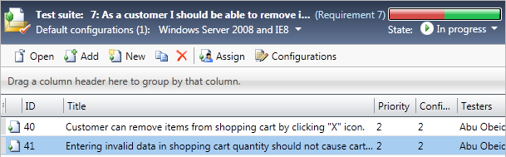
       2. Figure 10
       3. Working with test cases [your screen may look different]
       4. **Note:** To learn more about working with manual test cases, see the lab titled Authoring and Running Manual Tests using Microsoft Test Manager 2010.
   13. Select the test case with **ID = 41**.
   14. Select the **Configurations** button to load the **Select Test Configurations** window.
   15. Select the **All Configurations** button to show all configuration options that are available and select the **Vista and IE7** checkbox.
       1. 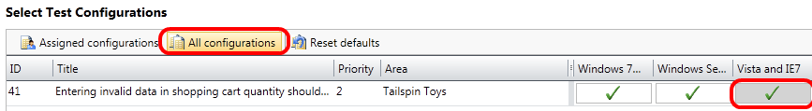
       2. Figure 11
       3. Working with test configurations
   16. Select the **Apply Changes** button to continue.
   17. Select the **Properties** link to load the test plan properties window. The first section of the test plan properties window allows you to edit the basic properties like name, description, area path, iteration, state, and so on. The **Run Settings** section allows you to specify how manual and automated test runs should be setup, what the test environment to use, and even the specific build to test.
       1. 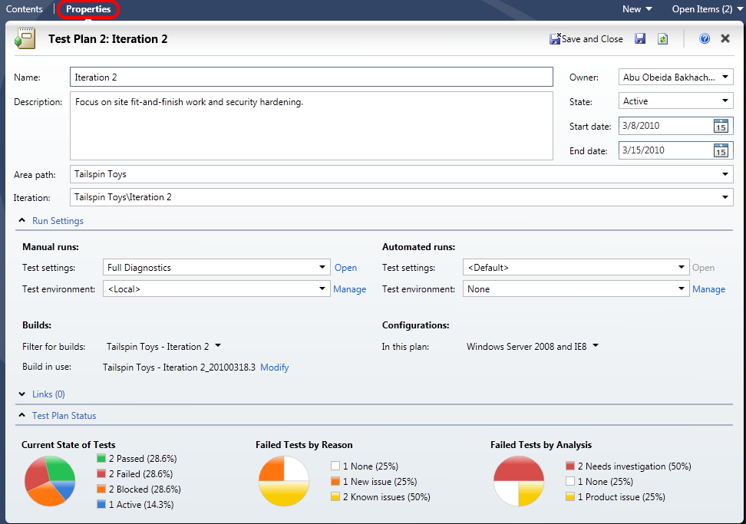
       2. Figure 12
       3. Test plan properties window
       4. **Note:** Test settings are particularly important as they specify how and what data will be collected during test runs. If bugs are found during a test run, this data will be used by developers to reproduce and better understand the problem
   18. Open the test settings for **Manual Runs** by selecting on the **Open** link.
       1. 
       2. Figure 13
       3. Location of Open link
   19. Select the **Data and Diagnostics** step from the left-hand side of the test settings window. This allows you to select which **Data Diagnostic Adapters** you want to utilize. For example, the Video Recorder will record the screen as seen by the tester during test runs.
       1. 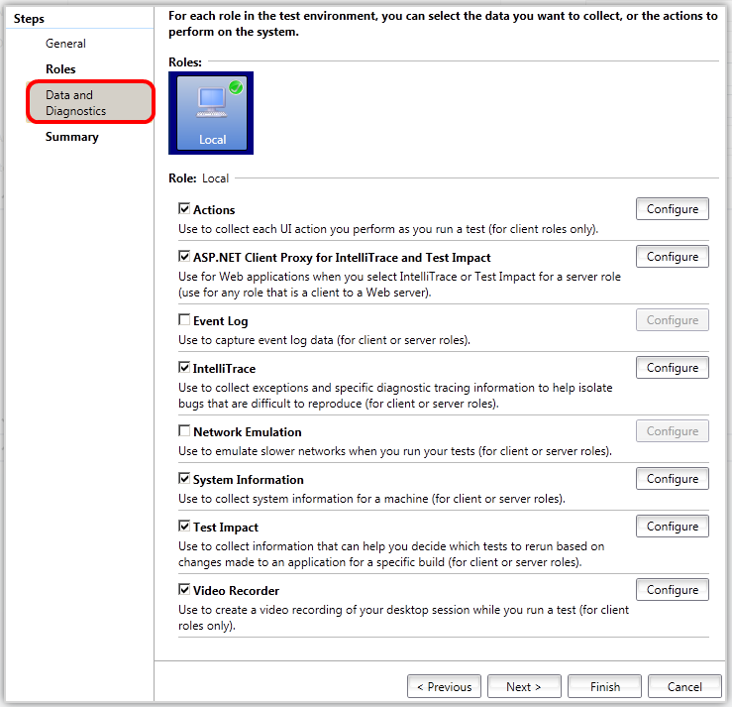
       2. Figure 14
       3. Data and Diagnostics options
   20. Enable the **Event Log** diagnostic adapter and select the **Configure** button.
       1. 
       2. Figure 15
       3. Event Log diagnostic adapter
   21. In the **Configure Diagnostic Data Adapter – Event Log** window, note that you can specify which event logs and event types to collect from. Select the **Save** button to continue.
       1. 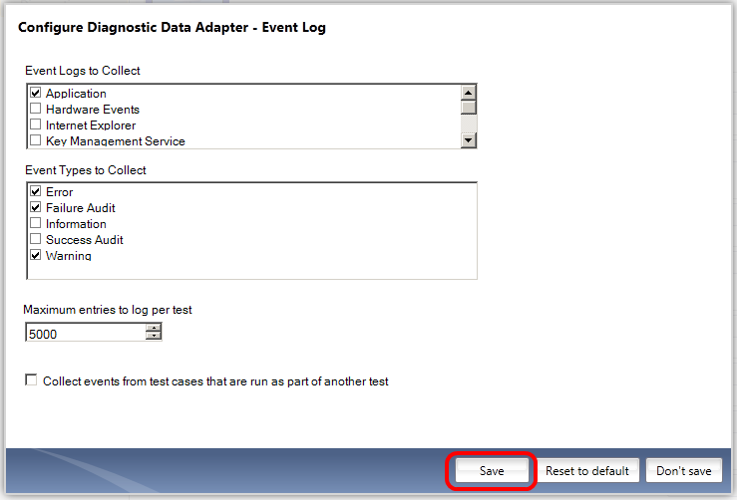
       2. Figure 16
       3. Configuring the Event Log diagnostic adapter
   22. Select the **Finish** button to return to the test plan properties window.
   23. **Test environments** are also managed from the test plan properties window. Test environments are either physical or virtual environments used to run tests against or to collect data. For example, when testing a Web application, it may be necessary to collect data from both the client and the server at the same time as components of that system reside in different environments. For this test plan, there is just one local test environment.
   24. **Test configurations** describe which platforms to test against during test runs. Select the drop down that currently has Windows Server 2008 and IE8 selected to see the options available. Select the **Don’t Apply** button when finished.
       1. 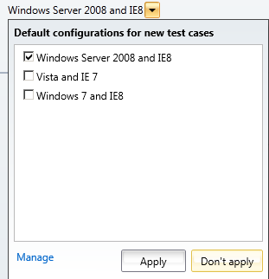
       2. Figure 17
       3. Specifying testing platforms
   25. The **Builds** section of the test plan properties window defines the build definition that test results and bugs will be filed against. Select the drop down labeled **Filter For Builds**.
       1. 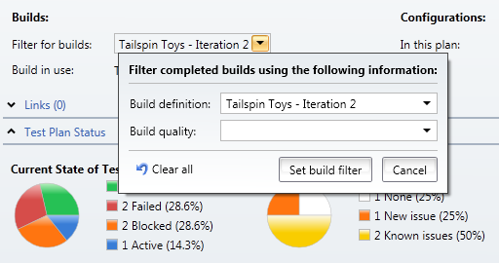
       2. Figure 18
       3. Build definition to use for testing
   26. Build quality can also be specified so that testers do not prematurely start the testing process. Select the **Build Quality** drop down to see the options available.
       1. 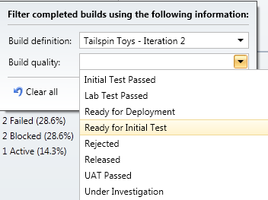
       2. Figure 19
       3. Build quality options
   27. Press the **Escape** key to cancel the selection of a build quality and select the **Cancel** button to return to the test plan properties window.
   28. Finally, note that a specific build is setup for test runs.
       1. 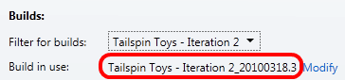
       2. Figure 20
       3. Build version specified for testing
   29. Close the test plan properties window by selecting the **X** in the top-right corner of the test plan properties window. Be careful not to close the Test Manager application.

# Next Step

* 1. Exercise 2: Analyzing Test Runs

Exercise 2: Analyzing Test Runs

* 1. In this exercise, you will learn how to use the Test activity to analyze test runs.
  2. In Microsoft Test Manager, select the **Test** tab to open the test activity used by testers. By default, the **Run Tests** window is loaded.
  3. Select the **test suite 7** node to view the test runs and their states. Note that the test case with ID = 41 is represented three times, one for each configuration that has been configured for it.
     1. 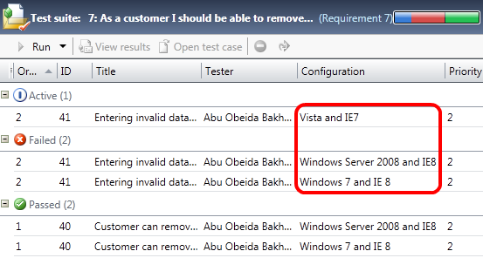
     2. Figure 21
     3. Viewing test runs for a test suite [your screen may look different]
  4. Select the **test suite 8** node to view its test runs. Note that two of the test cases are listed as being blocked. **Blocking** a test case is an action that can be performed by the tester to indicate that they are unable to perform the test case, perhaps due to something such as a user story not being implemented yet or a dependency requirement not working. For example, if the test case is to create an account on a Web application, and some other related component prevents the tester from even attempting the action, the tester can indicate that they are blocked.
     1. 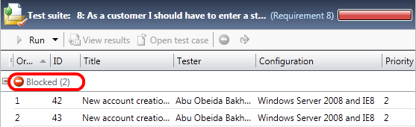
     2. Figure 22
     3. Blocked test case
  5. Select the **Analyze Test Runs** link and select the **Show Manual Runs** button to view the historical test runs for the current test plan. You may need to change the **Start date range** to **All** in order to see some test runs.
     1. 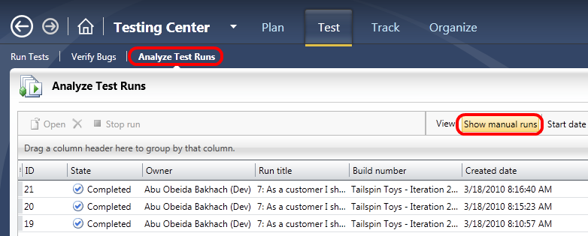
     2. Figure 23
     3. Analyze Test Runs window
  6. Open the test run with **ID = 21** by double-clicking on it. A summary shows start and completion timestamps, type, build version, and so on. Expand the **Tests** area to expose the results of the test run for the associated test cases.
     1. 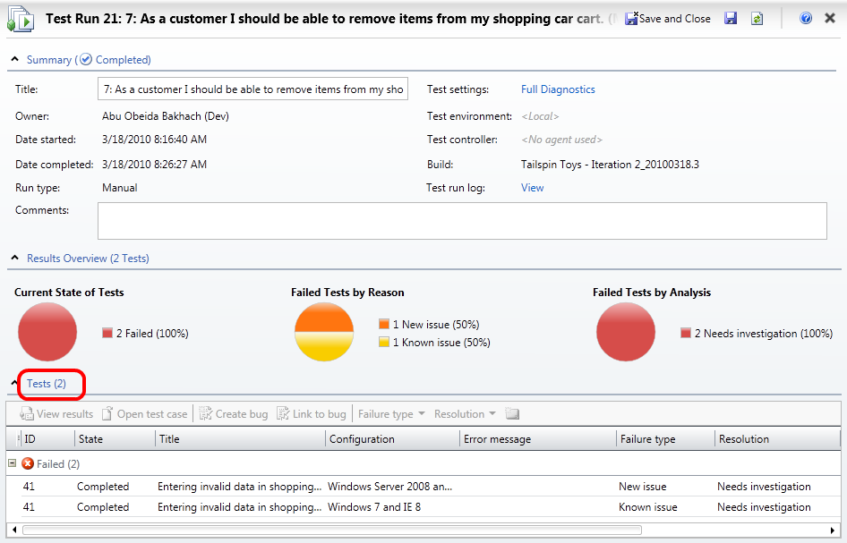
     2. Figure 24
     3. Results of a test run
  7. Open one of the test results for the test case with **ID = 41**. Note that there are a number of attachments that were collected during the test such as system information and a video of the manual test.
     1. 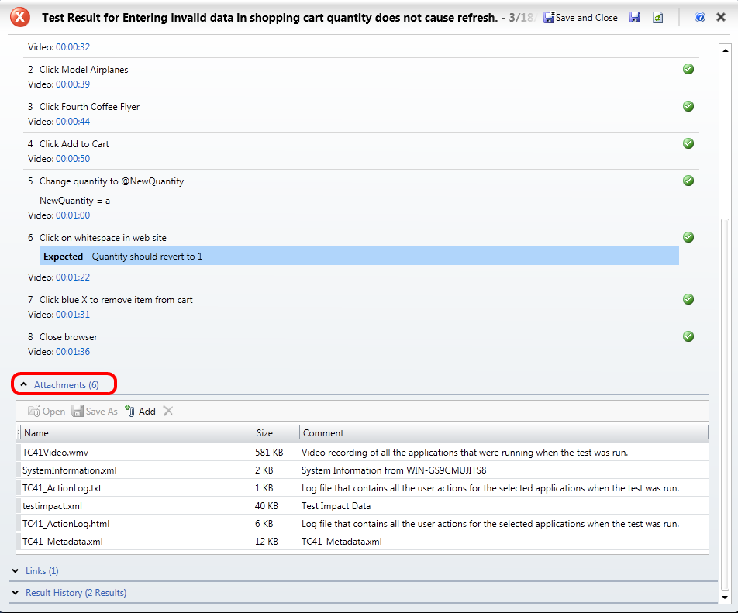
     2. Figure 25
     3. Test results example
  8. Close the test results window by selecting the **X** in the top-right corner of the test results window. Be careful not to close the Test Manager application.

# Next Step

* 1. Exercise 3: Selecting Builds to Test Against

Exercise 3: Selecting Builds to Test Against

* 1. In this exercise, you will learn how to use the Track activity to navigate and select the builds to test against.
  2. In Microsoft Test Manager, select the **Track** tab to open the track activity. By default, the **Queries** window is loaded.
  3. Select the **Assign Build** link to view the available builds and associated work items.
     1. 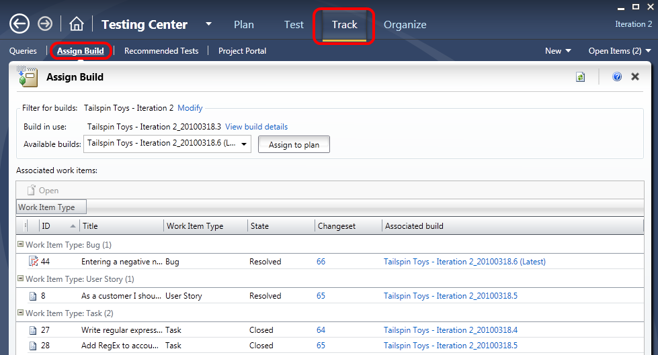
     2. Figure 26
     3. Assigning builds for testing
  4. In the **Available Builds** drop down, select the last build in the list (**Tailspin Toys – Iteration 2_20100318.4**).
     1. 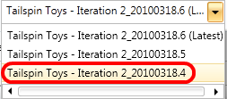
     2. Figure 27
     3. Selecting a build
  5. Look at the associated work items to see what work was done during the selected build. Note that a single work item to “Write regular expression for strong password” was completed.
     1. 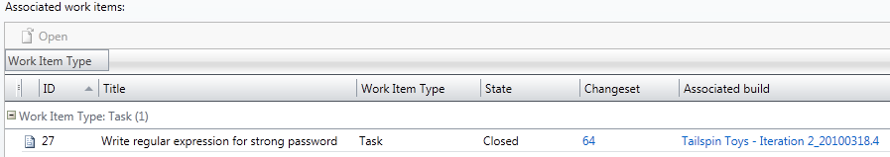
     2. Figure 28
     3. Associated work items
  6. Select the **Tailspin Toys – Iteration 2_20100318.5** build from the **Available Builds** drop down. There are three associated work items for this build, one of which is the same work item as before.
     1. **Note:** The Track activity can be used to help determine when it will be worthwhile to perform a test pass.
  7. Select the **Toys – Iteration 2_20100318.6** build from the **Available Builds** drop down and select the **Assign To Plan** button. This will help provide an indication to the testers that this build warrants doing a full test run. Future test runs will use the new build by default.
     1. 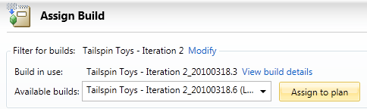
     2. Figure 29
     3. Assigning a new build to the test plan
  8. When notified that some tests may need to be run again based on code changes, choose to **view the recommended tests**.
     1. 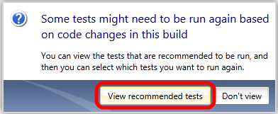
     2. Figure 30
     3. Option to view recommended tests
  9. These recommendations are made possible by a new feature called **Test Impact Analysis**, which is able to determine when code changes impact previously executed tests. For example, a test that was successfully executed against an earlier build may be recommended to be executed again if it is determined that (a), code has changed and (b), that it is in the code path exercised by that test.
     1. **Note:**  Test Impact Analysis can be configured to run in the background when the application being tested is written in managed code (.NET Framework 2.0 or higher).
  10. Select all recommended tests that are impacted by this latest build and select the **Reset To Active** button. This resets the state of test cases within the test plan to the Active state.
      1. 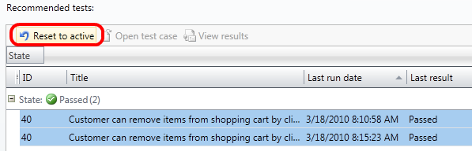
      2. Figure 31
      3. Resetting test case state to active for recommended tests
  11. Return to the **Test** activity window and select the **Run Tests** link.
      1. 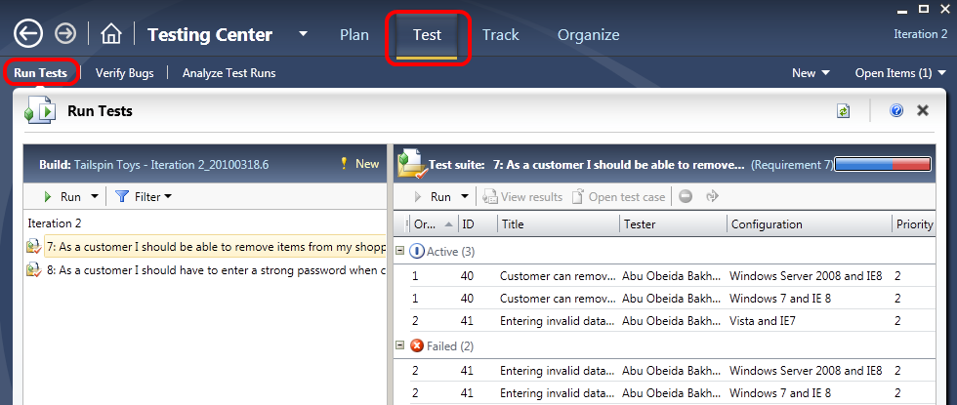
      2. Figure 32
      3. Return to Test activity
  12. Select **test suite 7**. Note that the two test cases there were previously in the Passing state are now Active again.
      1. 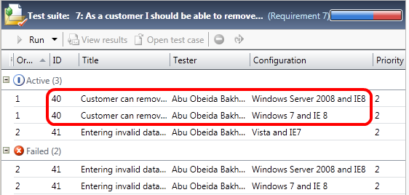
      2. Figure 33
      3. Test cases were reset to Active state
  13. Return to the **Track** activity window, select the **Recommended Tests** link, and select the **Related Work Items** button. Note that a number of work items that have been closed or resolved since build **Tailspin Toys – Iteration 2_20100318.3**, including a user story work item.
      1. 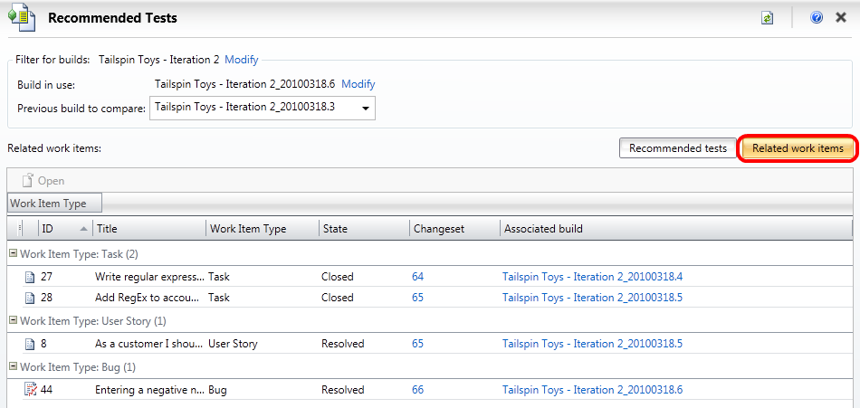
      2. Figure 34
      3. Related Work Items
  14. Return to the **Test** activity window and select **test suite 8**, which is associated with the impacted user story that we just looked at in the previous step.
  15. Select the blocked test cases and then select the **Reset** button to unblock them. Their state goes from Blocked to Active.
      1. 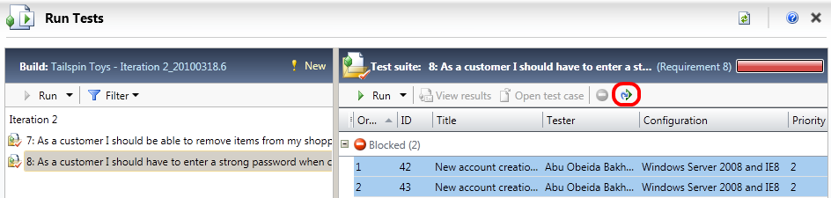
      2. Figure 35
      3. Location of Reset button
  16. Select the **Verify Bugs** link. Although we will not do so in this lab, this is where testers could select previously reported bugs and re-run the tests. If the tests do not pass, the testers would re-assign the bugs back to the developers.
      1. 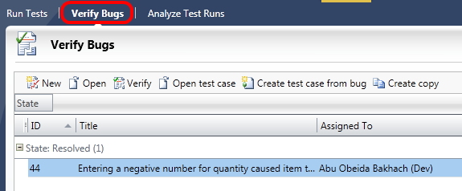
      2. Figure 36
      3. Verifying bugs

To give feedback please write to [VSKitFdbk@Microsoft.com](mailto:VSKitFdbk@Microsoft.com)

Copyright © 2010 by Microsoft Corporation. All rights reserved.