Global Connections — simple wireframe
Oct 5, 2026 · @Helen
Page 3 of the site, drawn top to bottom as a visitor scrolls it: where the video, photos, cards and buttons go.

Legend
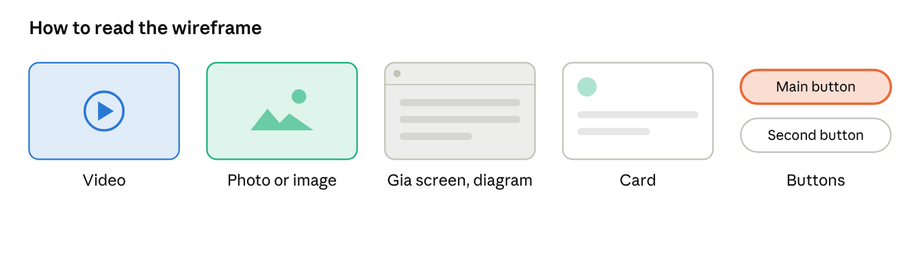
legend
Grey bars are body text. The orange button is the main action (gold on the site); the outlined button is secondary.

The page
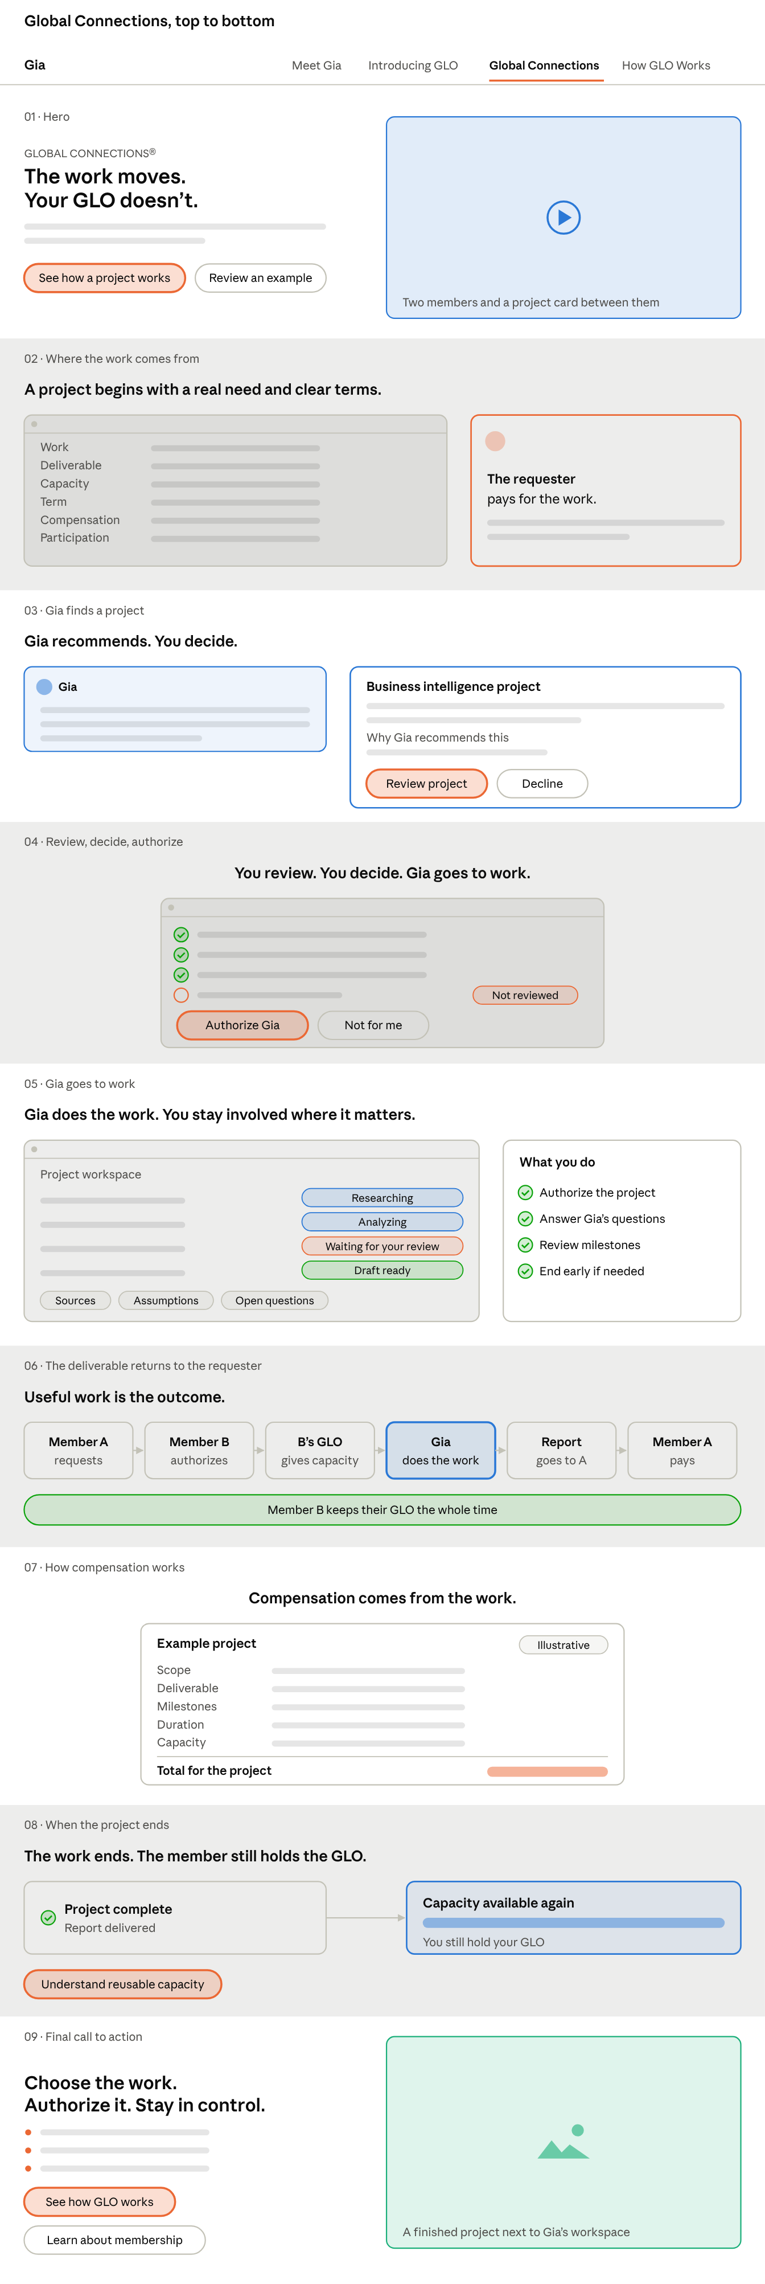
Global Connections · 9 sections
This page is built almost entirely from interface screens: the visitor sees the project through the member’s eyes. There is a video only in the hero and a photo only at the end.

