How GLO Works — simple wireframe
Oct 5, 2026 · @Helen
Page 4 of the site, drawn top to bottom as a visitor scrolls it: where the diagrams, photos, cards and buttons go.

Legend
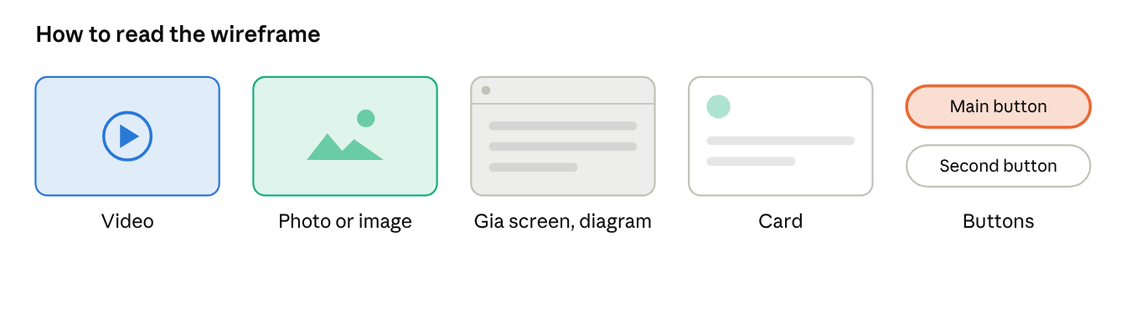
legend
Grey bars are body text. The orange button is the main action (gold on the site); the outlined button is secondary.

The page
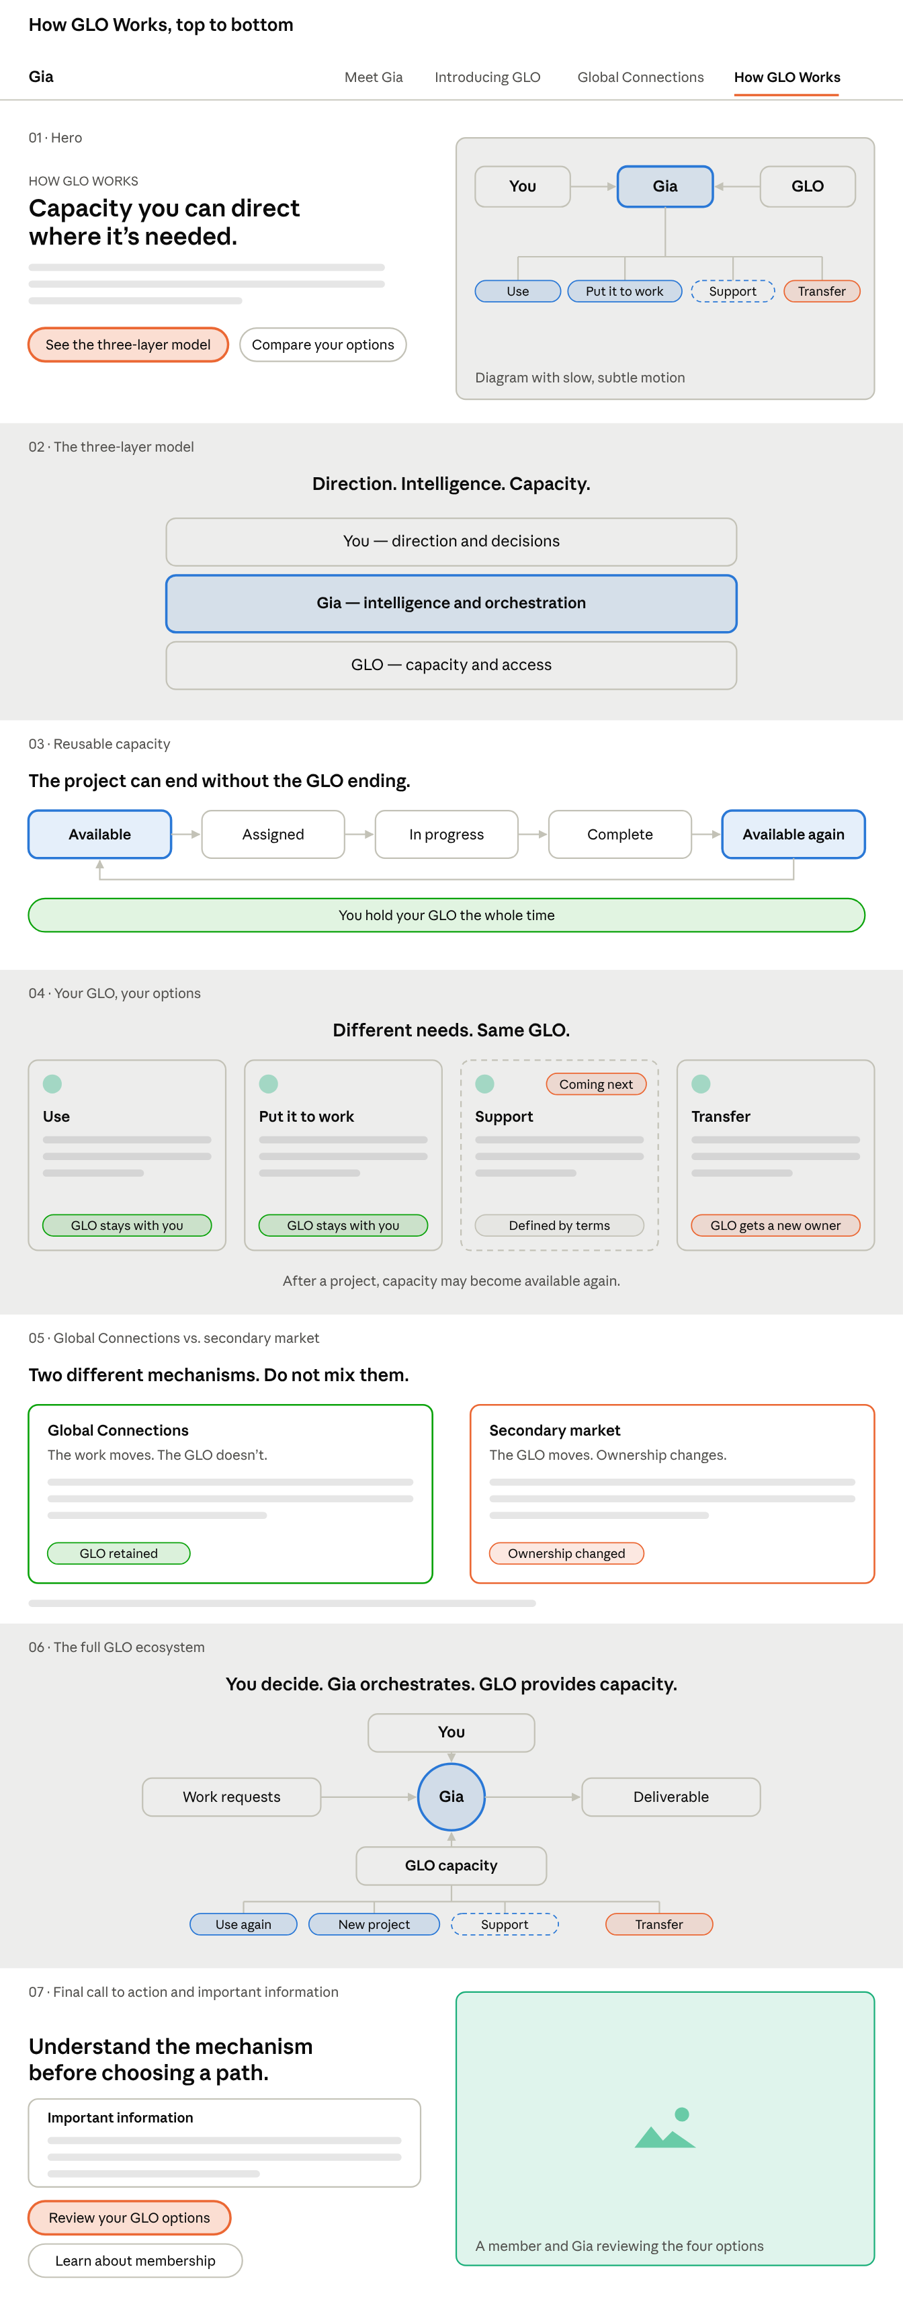
How GLO Works · 7 sections
This is the most diagram-driven page: instead of a video, the hero has a diagram with slow motion; after that come diagrams and cards, and a live photo appears only at the end.

