Introducing GLO — simple wireframe
Oct 5, 2026 · @Helen
Page 2 of the site, drawn top to bottom as a visitor scrolls it: where the video, photos, cards and buttons go.

Legend
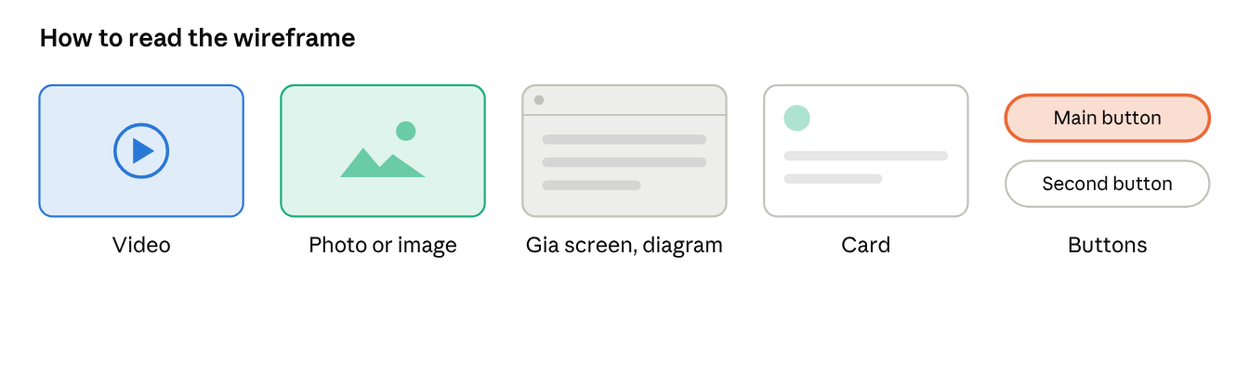
legend
Grey bars are body text. The orange button is the main action (gold on the site); the outlined button is secondary.

The page
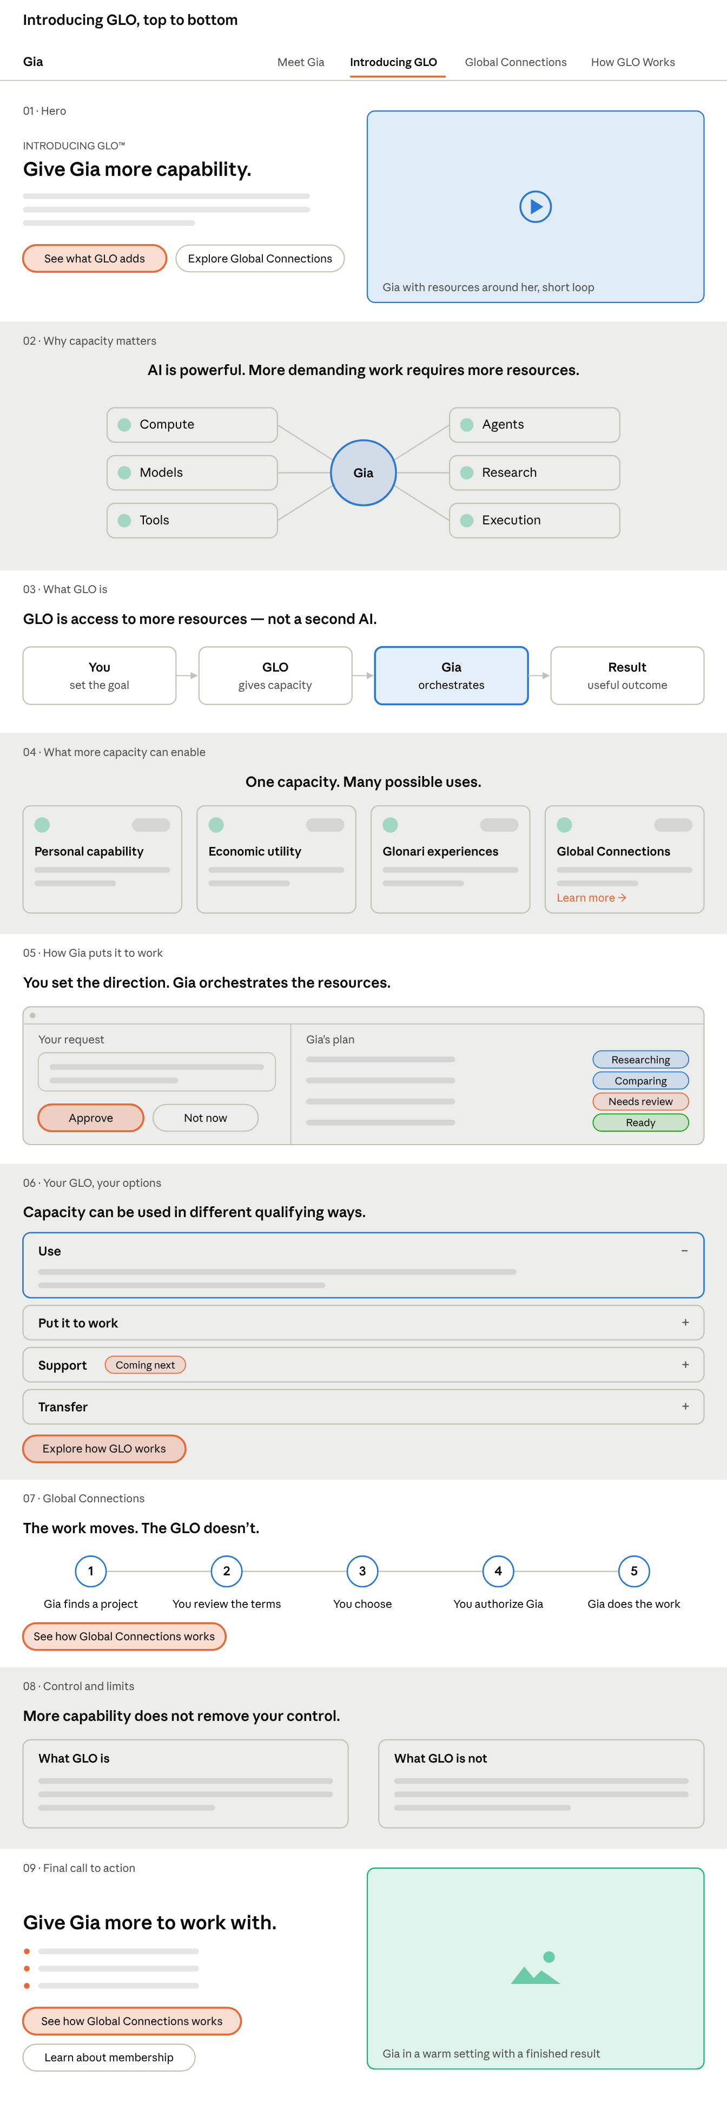
Introducing GLO · 9 sections
There is one video, in the hero. The rest of the page explains with diagrams and cards, then returns to a live photo of Gia at the end.

