# Criterion B: Design

Catalog

Overall functions needed to be achieved 1

Structure for the database 1

Different interfaces and the elements in them 2

Relationship between interfaces 5

Design of Specific functions 6

Test plan 8

Overall functions needed to be achieved

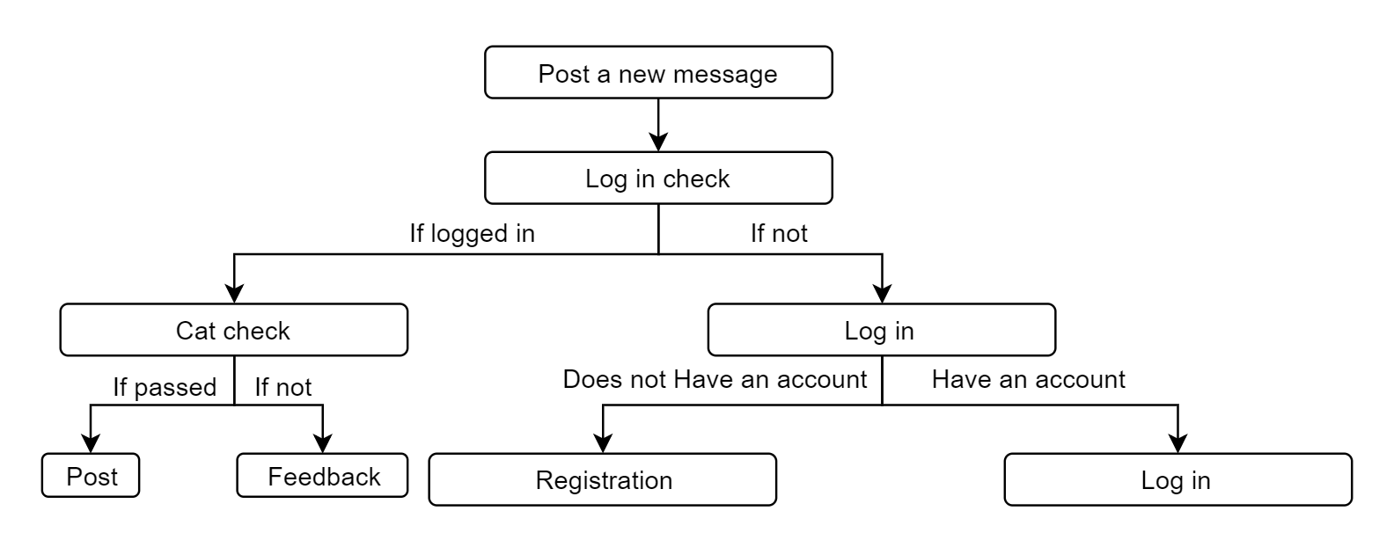

Figure 1: Function：Post a new message

Structure for the database

DATABASE：Catdb

Table1: Userinfo

|  |  |  |  |
| --- | --- | --- | --- |
| Username | password | contact | info |
| Varchar(40) | Varchar(100) | Varchar(200) | Varchar(200) |
| The nick name of the user | The corresponding password | Contact information | If any comment |

Table2: Posts

|  |  |  |  |  |  |  |
| --- | --- | --- | --- | --- | --- | --- |
|  | Sender | Title | Description | Image | Type | Date |
|  | Varchar(40) | Varchar(100) | Varchar(400) | Varchar(40) | Varchar(40) | Varchar(40) |
|  | The nickname of the user who sends it | The title of the post created by the user | The description of the posts by the user | The location that stores the figure | The breed of the cat | The date that sender upload/ change the posts |

Different interfaces and the elements in them

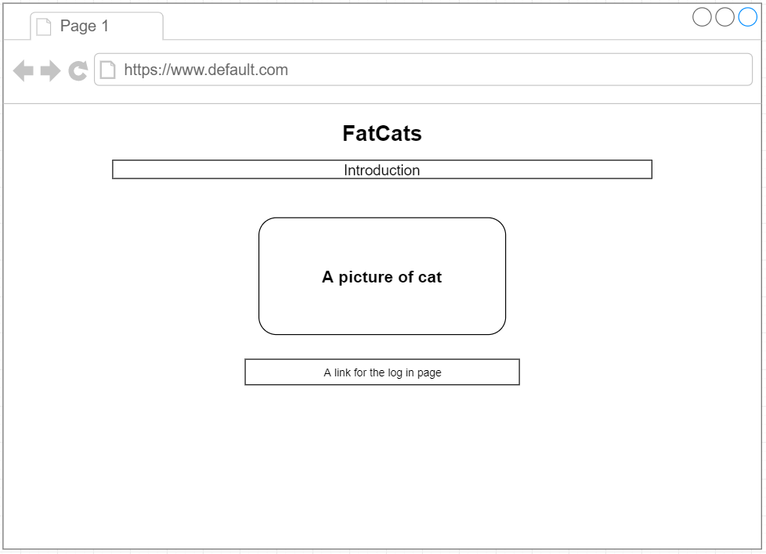

Figure 2: Interface for the layout

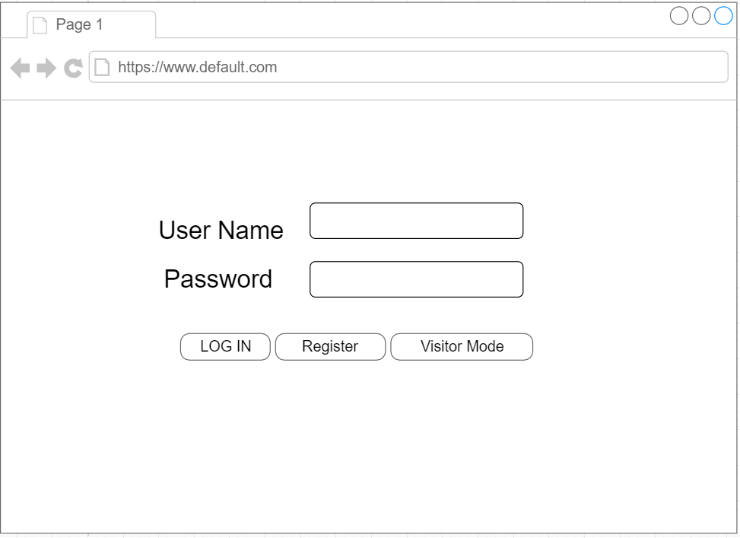

Figure 3: Interface for logging in

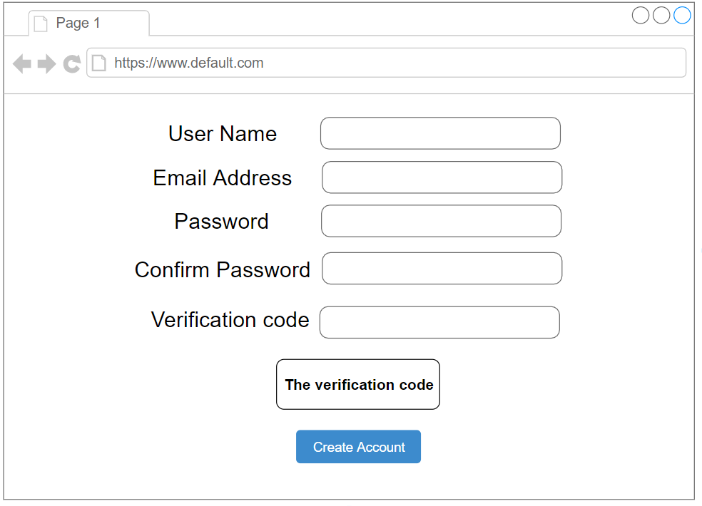

Figure 4: interface for registration

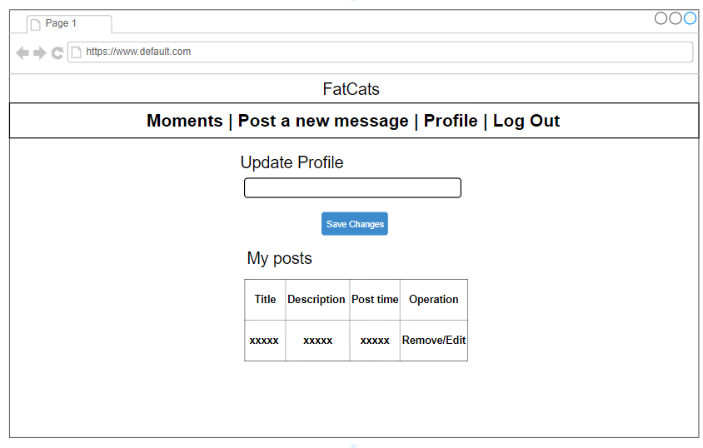

Figure 5: Interface for profile

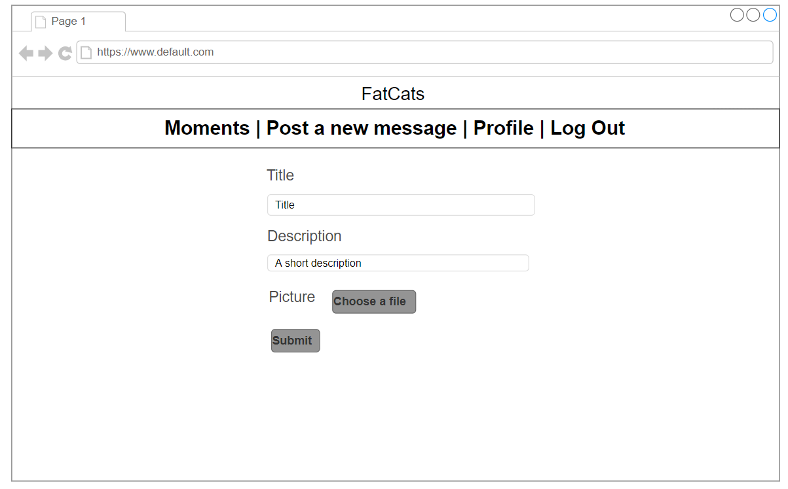

Figure 6: Interface for post a message

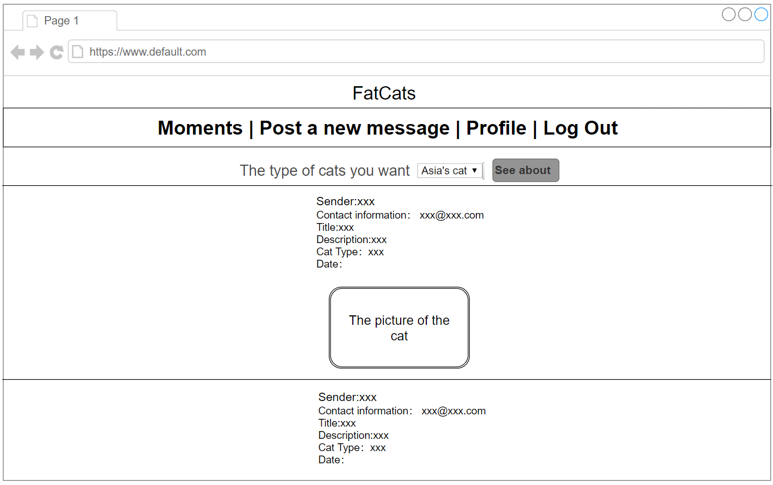

Figure 7: Interface for new moments

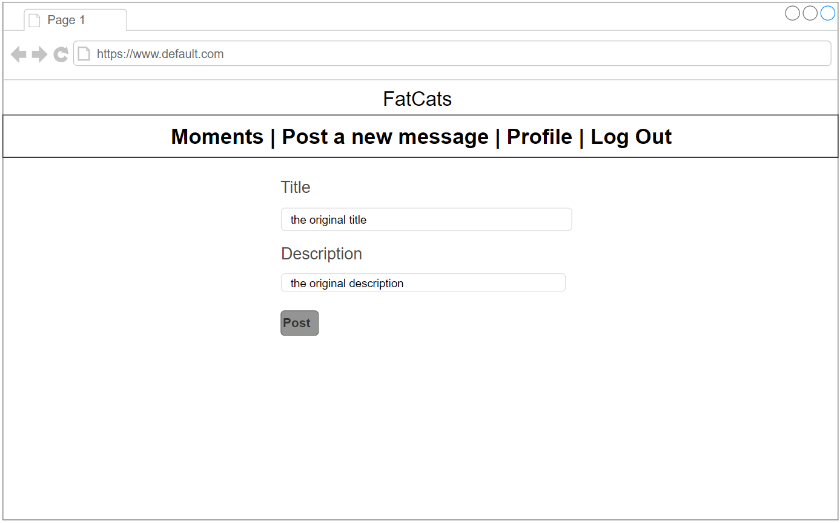

Figure 8: Interface for editing the posts

Relationship between interfaces

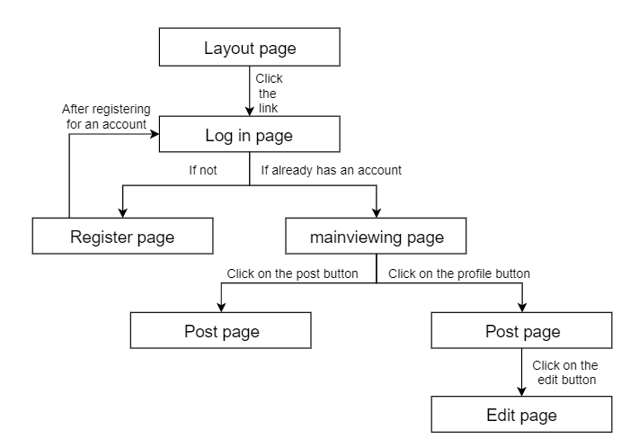

Figure 9: The relationship between each interface

Design of Specific functions

1. Register

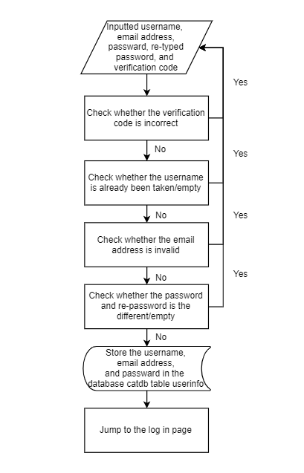

Figure 10: Process of register

1. Log in

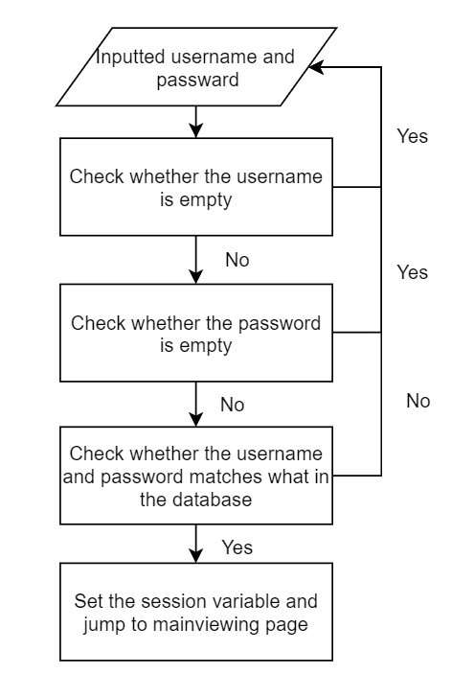

Figure 11: Process for log in

1. Post

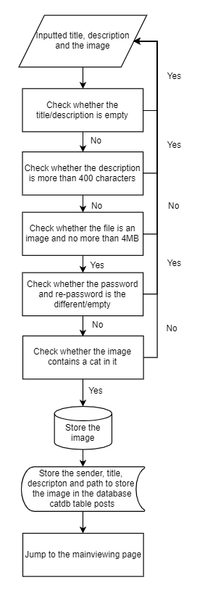

Figure 12: Process for posting

1. Edit

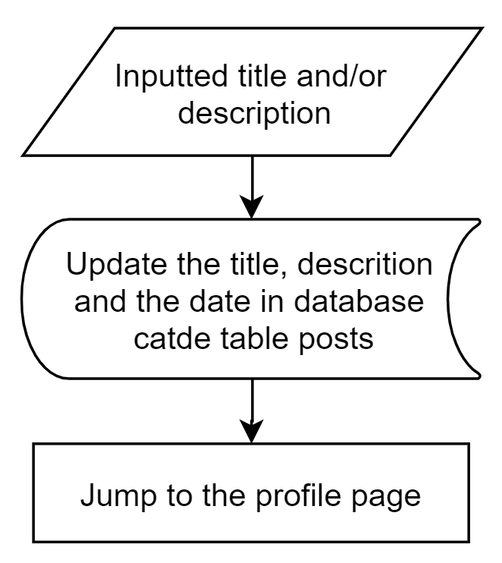

Figure 13: Process for editing the post

Test plan

|  |  |
| --- | --- |
| **Methods** | **Result should be yield** |
| Register same username | Cannot use same username notification |
| No password/contact info when registering | Password/contact can’t be empty notification |
| Password confirmation is different with the first one | Passwords are not the same notification |
| Wrong verification code | Can’t register |
| The username is not existing/can’t match with the password | Wrong username/ password notification |
| When posting, there is no picture/title | Picture/title can’t be empty notification |
| When posting, user not logged in | Log in notification and jump to log in page |
| When posting, file uploaded is not a figure | Only post figures notification |
| When posting, the picture does not contain a cat in it | Notification that there must be a cat in the picture uploaded. |
| After posting, see the mainviewing page | The posts should be shown on the page, with sender/title and description |
| After logging out, to post a message | Log in notification and jump to log in page |
| Change the email address in the profile page with an invalid email address | Notification for email address is in incorrect format |
| Change the email address in the profile page with valid email address | The email address is changed and can be seen in the |
| Click delete at the profile page | The posts is deleted from both profile page and the mainviewing page |
| Click edit at the profile page | Jump to the edit page to edit the posts |
| Modify the description/title on the edit page and click on the post button | Jump to the profile page and the post is changed in the profile and mainviewing page |