# Criterion C: Development

Overview:

This product is a linkage between database (mysql), HTML and PHP files. The basic structure is linkage between PHP files and HTML files, almost every page has a PHP file. However, there are pages only contain PHP file or HTML file. The main structure of the product is the linkage between different pages, which creates the website.

API Database

There is the use of different techniques. CSS in html is used to arrange the interface and create some artistic designing. The use of selective structure is used to determine the different output for different situations. The use of session is for checking whether the user is logged in or not. The use of regular expression is used for checking the format of inputting email address. The use of loops is for displaying the data from the database on the website. The use of JavaScript is for the pop-up windows which will provide the user with notifications.

|  |  |
| --- | --- |
| Folder/File name | Functionality |
| Figure | To store pictures uploaded by the users |
| CATforLAYOUT.png | The picture on the layout page |
| layout1.html | To arrange the elements in the layout page, an introduction to the use of this website and a picture serves as an advertisement |
| login.html | To arrange the elements in the login page, providing input space for use to type in and button for user to submit |
| post.html | To arrange the elements in the post page, providing input space for use to type in, place for user to submit files and button for user to submit |
| register.html | To arrange the elements in the register page, providing input space for use to type in and button for user to submit |
| del.php | To delete user’s posts from database |
| edit.php | To edit user’s posts and update in the database |
| login.php | Verify user’s username and password, if they are correct then sets a new session |
| logout.php | Clear the session of username |
| mainviewing.php | Display the posts stored in the database |
| post.php | Store the data of posts inputted by the user to the database, as well as the date and time |
| profile1.php | Links to the database for user to change their email address. A place where user can edit or delete their previous posts |
| register.php | Store the user’s name, contact information and password with hash in the database |
| select.php | Select the specific type inputted by the user and display the corresponding posts |
| teshphpdb.php | Connect to the database |
| Type.php | Find all types of breeds of cats that are posted |
| update.php | To update the user’s edition of posts in the database |
| verifycode.php | A method provided for use in other files to display a verification code |

Layout

It is the first page that I have done, and this is the page that everyone would view first and click into the domain name.

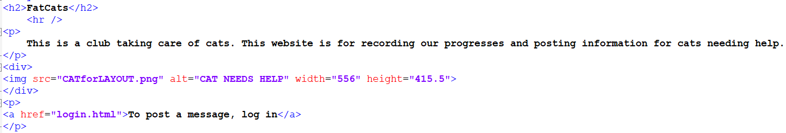

There is an image in the page and there is a link that users can click to log in, which would allow them to view all our users’ posts and to post messages.

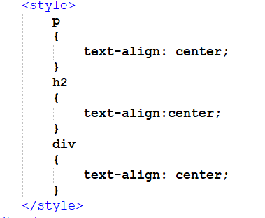This the simple style sheet I used, which is to maintain the whole page at the center of the screen.

Log in

After done the layout page, I think the next should be down is the log in, since the link in the layout page would jump to the log in page. It can be directly accessed from the layout page.

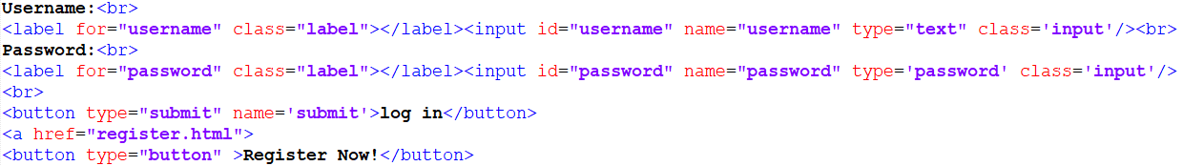

This is the coding for the log in page, which provides users with text box to input. In this coding, I used label button and label, which is to click to submit and to input.

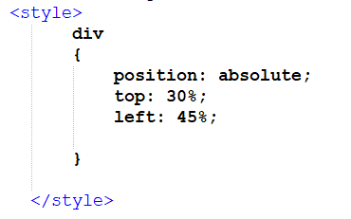

This the style sheet of the page, which is to ensure it is at the center of the screen.

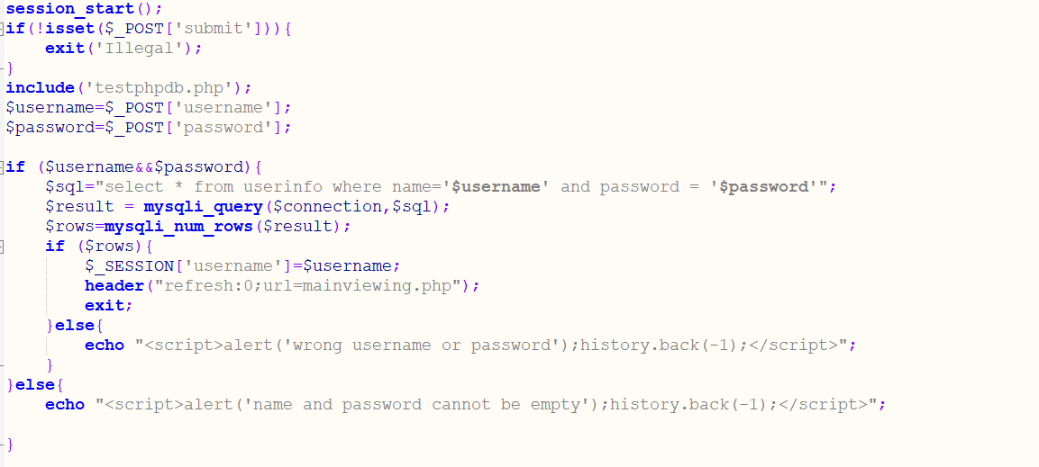

This is the PHP file of the log in page, the use of session is for farther use of checking whether the user if logged in or not. Include is for connecting to the database. The use of IF and ELSE, the selective structure, is for checking the validity of log in and the validity of input.

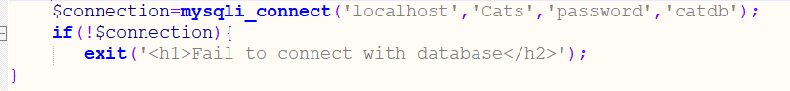

This is the testphpdb.php, which is for the database connection. The name of database is catdb, the name and password for login to the database.

Register

To log in, there should be a page for register, which is to store the username and password in the database for logging in to check.

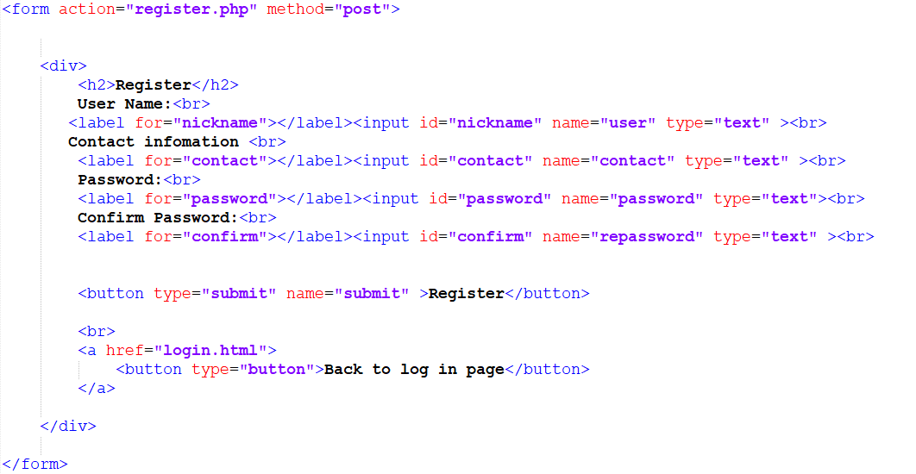

This is the HTML file for the register page. The labels, label and button, are used to create the space for user to input, and submit the form. The use of <form> is to connect the HTML file to the PHP file, and to get the input by the user.

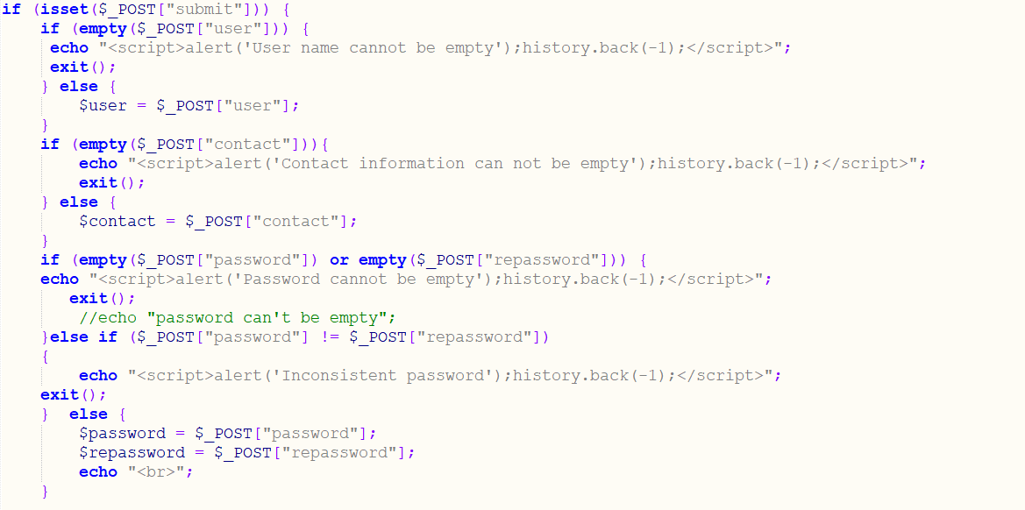

This part of the PHP file is to test whether this is an error in the username, password, and confirmation for the password. If there is an error, the webpage would jump out a window about it and let the user corrects and resubmits it. If there is not, the information inputted would be assigned to a variable for farther use.

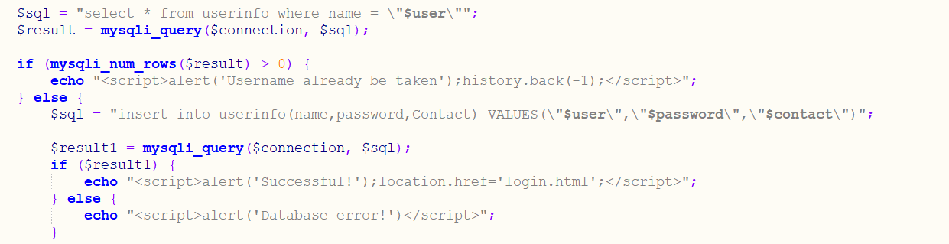

This is the part used to insert the username, password and contact information into the database. It can be used to tell whether there is an error in the database.

Log out

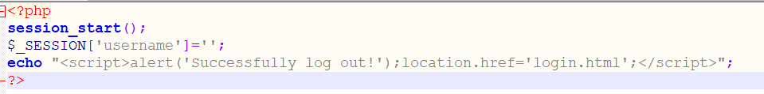

This is to clear the session variable, username, which is for the user to log in again using another username.

Post

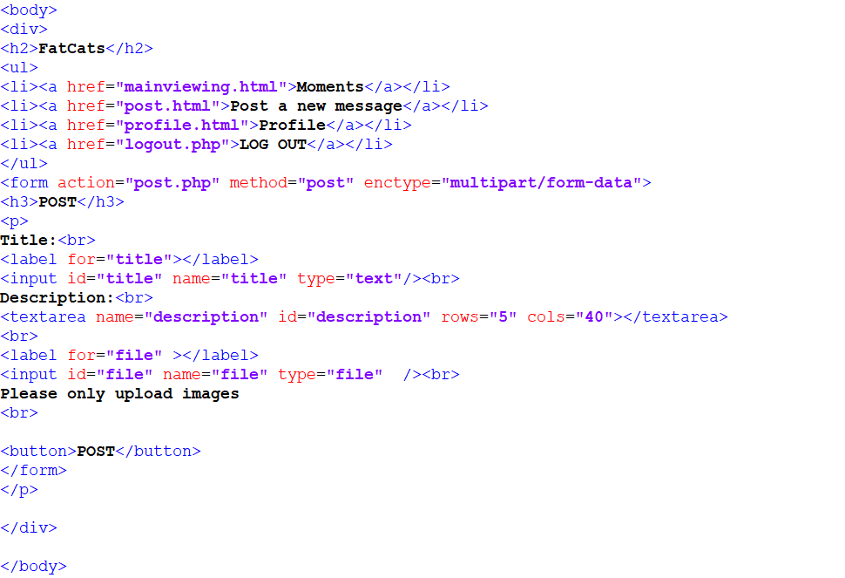

This is the HTML file of the post page, which not only allows users to input texts for title and description, but also allows users to upload the pictures. It contains the label, <li>, which is used for creating the menu bar, which allows user to jump to other pages by clicking.

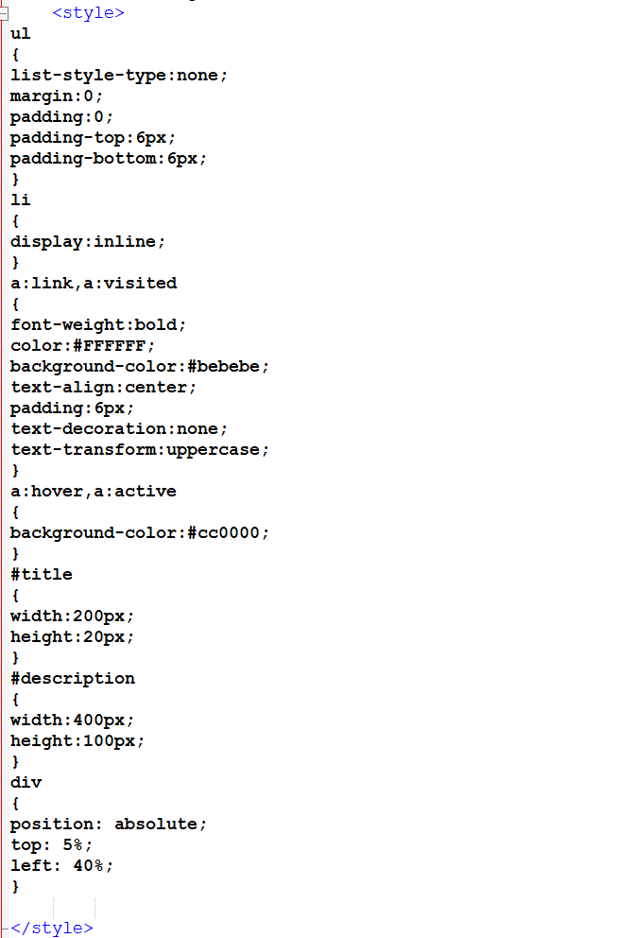

This is the CSS for the page. The main part is for the designing is for the menu bar, which makes the label changes color when the user puts his mouse on it.



This part of PHP file is used to check whether the user is logged in, if not, it would automatic jump to the log in page.

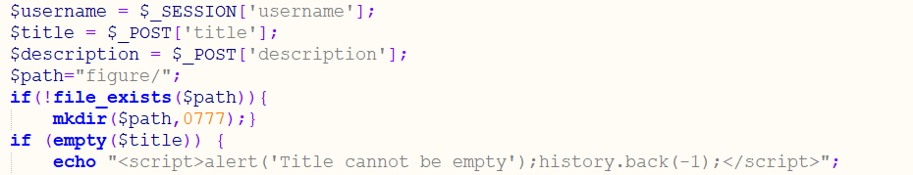

This part of the PHP file is to get the input by the user, including figure uploaded. It would also create a temporary path for the file. It also checks that whether there is a title inputted.



This part of the coding is for check whether there is an error in the file, which would then notify the user and make he/she upload the file again.

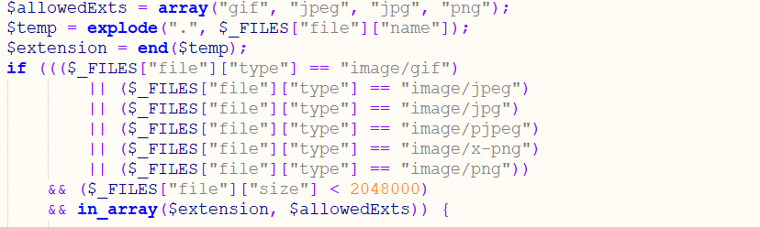



This part of coding is for checking whether the file is an image or not. The only allowance forms of the file are “gif”, “jpeg”, “jpg” and “png”. The check is done by checking the extension name of the file. It also check whether the file is too big by checking the [“file”][“size”] of it. If it is not valid, there would be a notification send to the user and let the user change the file.



This is used to create the filename for the picture. uniqid($username) is for creating different names, which can avoid duplication of name. Then it is to move the file to the folder created to store files.

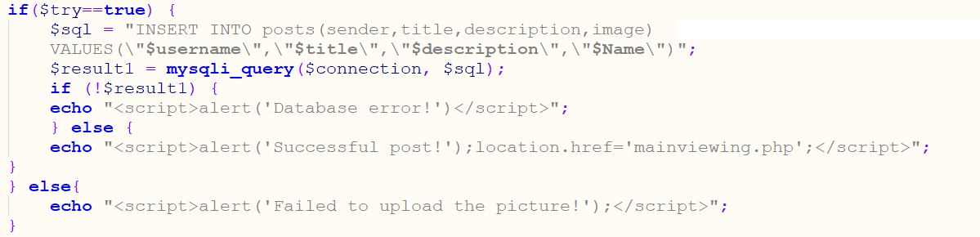

This is used to insert the sender’s name, title, description and the path of the file into the table, posts, of the database. If successful, then alert, successful post, would be shown. It not, user would be notified there is a data base error.

Mainviewing

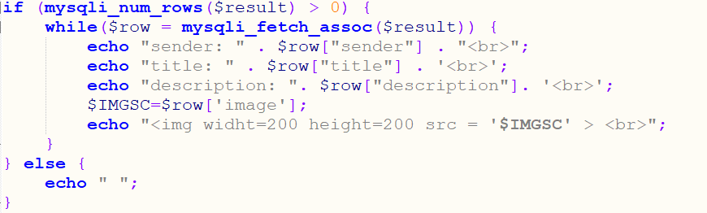

This is the part of the PHP file of the main viewing. It is used to show the content of passage, including who posts it and the title and description of the posts. It also includes the picture posts by the users.