# Criterion B: Design

Overall functions needed to be achieved

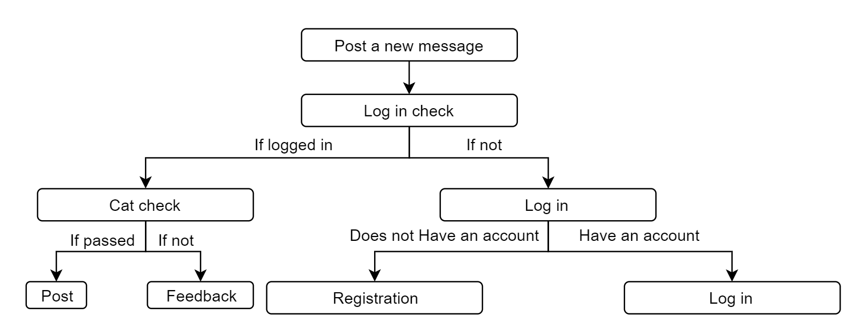

Figure 1：Function：Post a new message

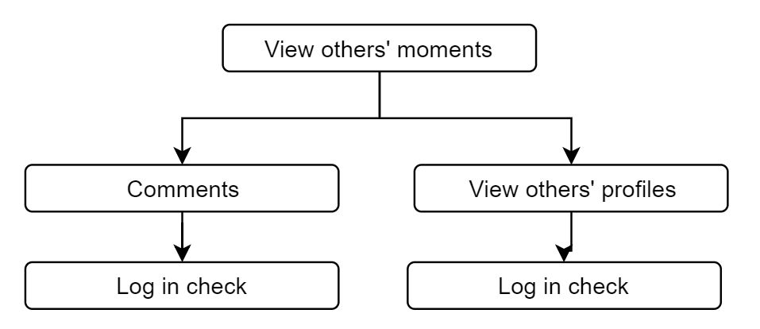

Figure 2：Function：View others’ moments

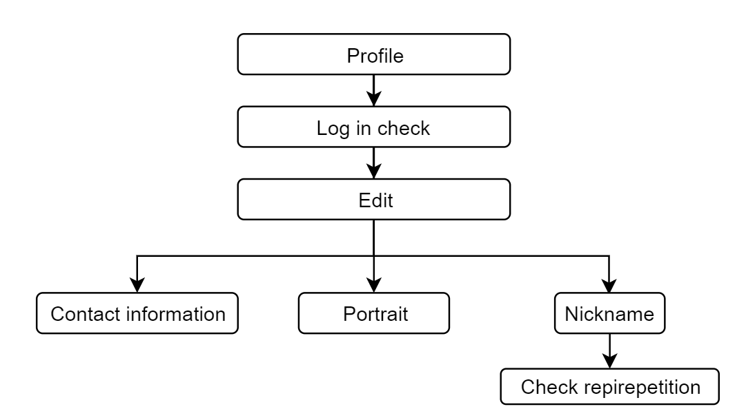

Figure 3: Function: Profile

User interfaces and the elements in them

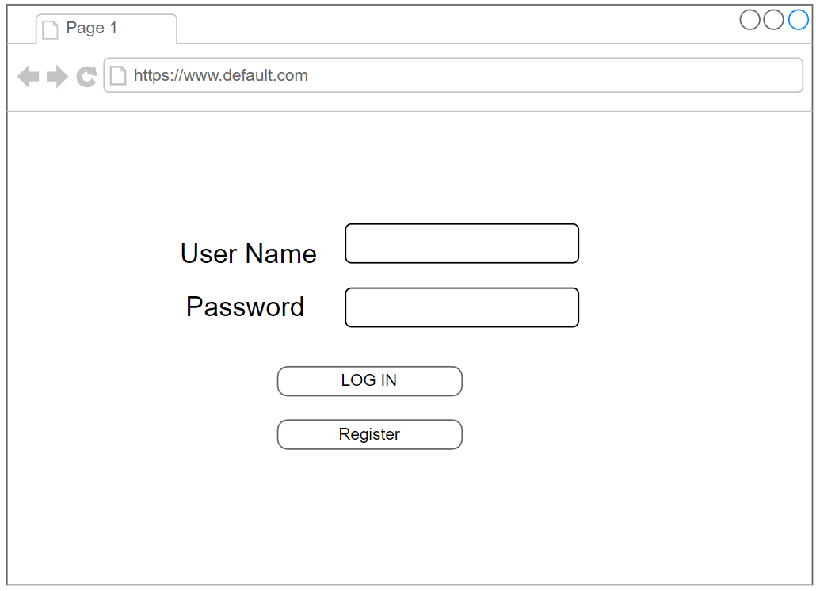

Figure 4：Interface for logging in

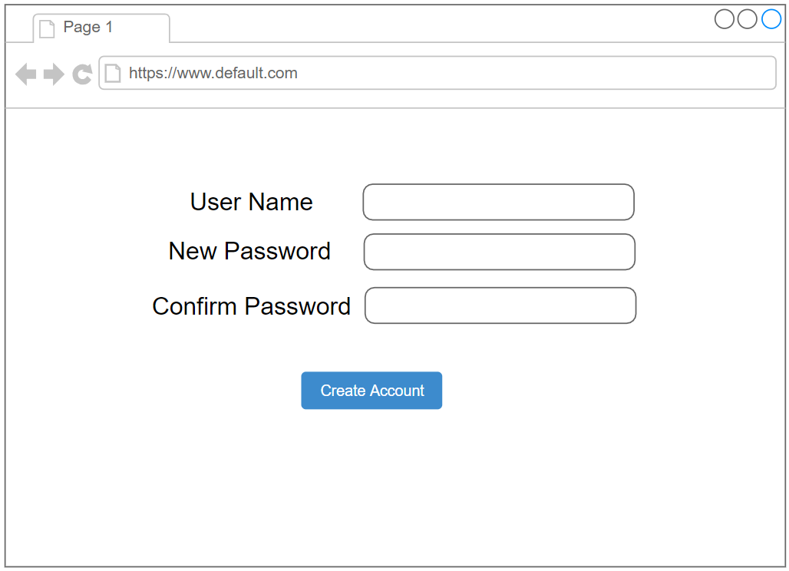

Figure 5：Interface for registration

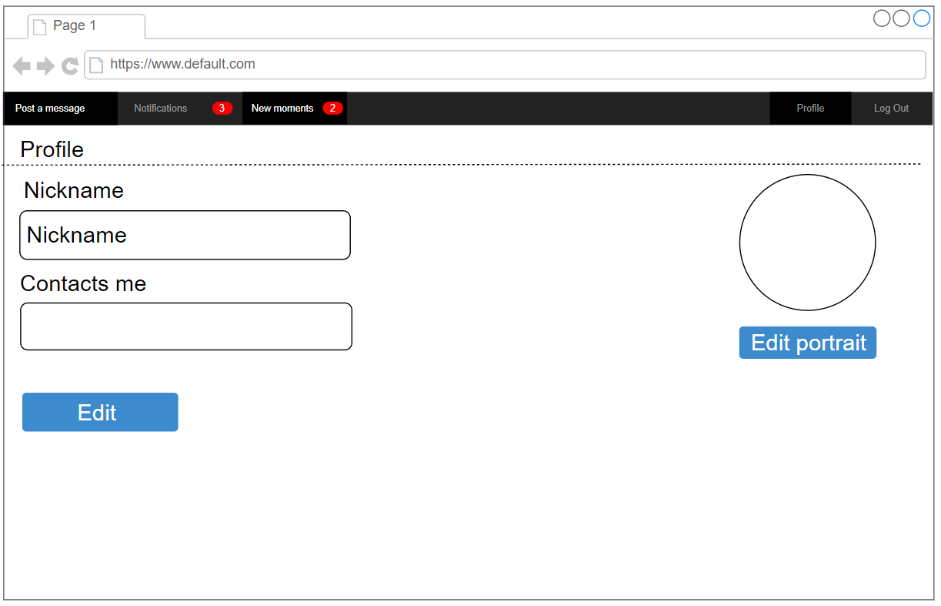

Figure 6：Interface for profile

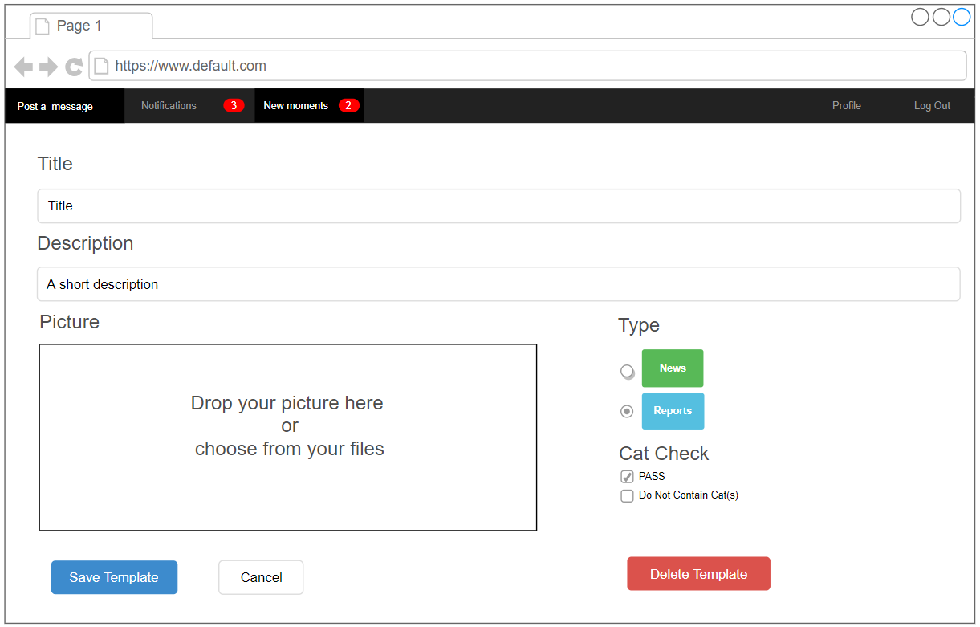

Figure 7：Interface for post a message

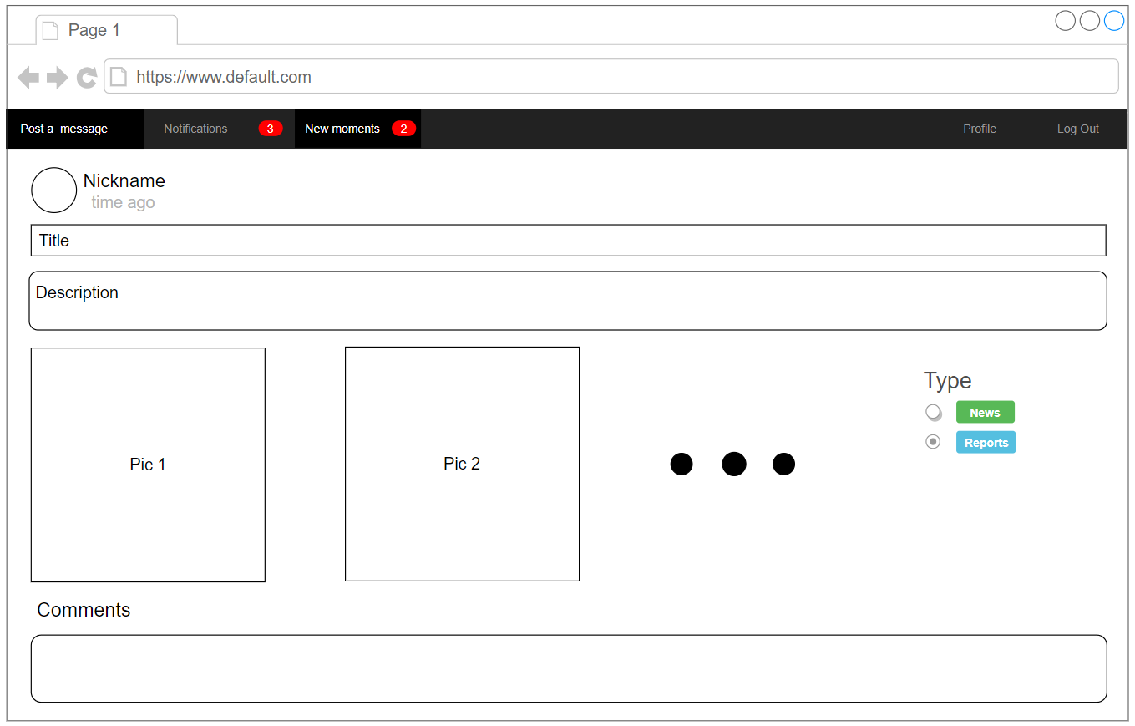

Figure 8：Interface for new moments

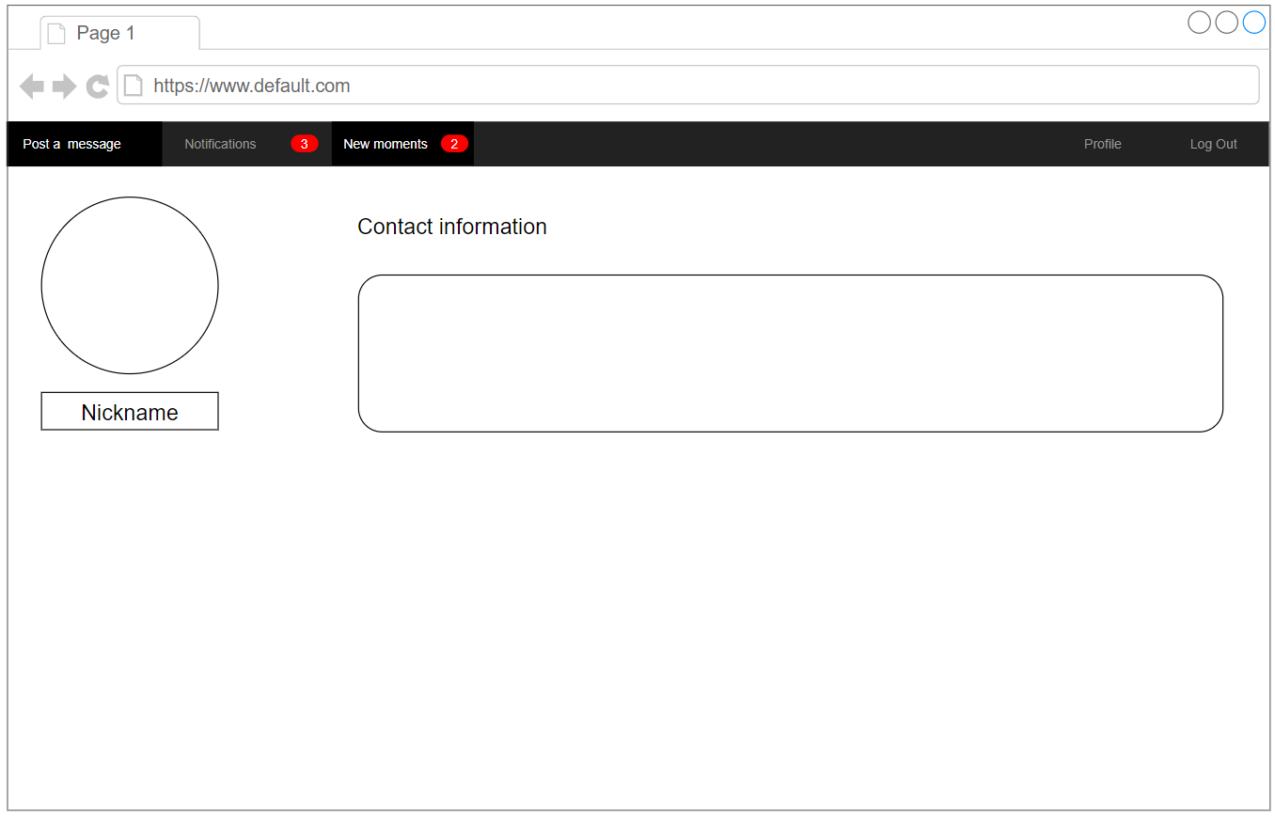

Figure 9：When browsing others’ profile

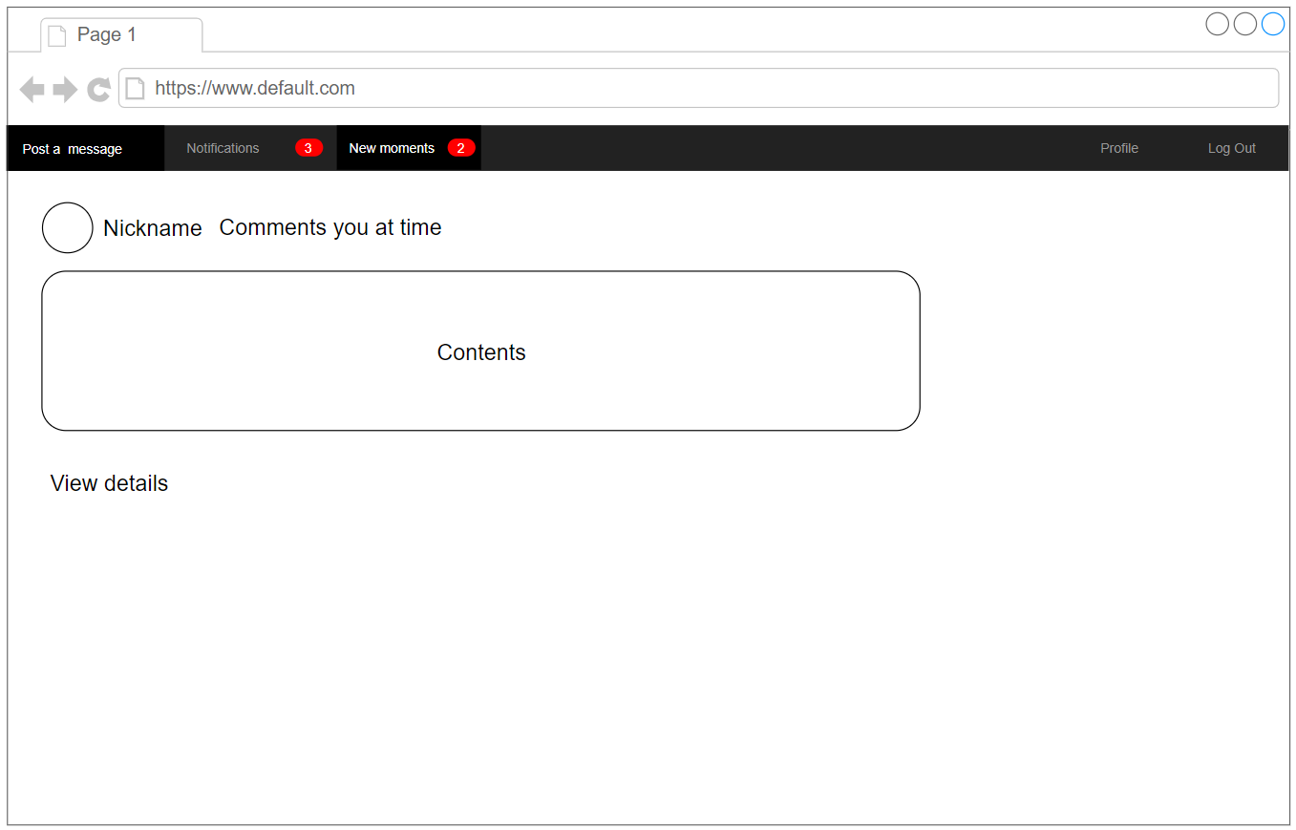

Figure 10：Interface for notification

Functions for each element

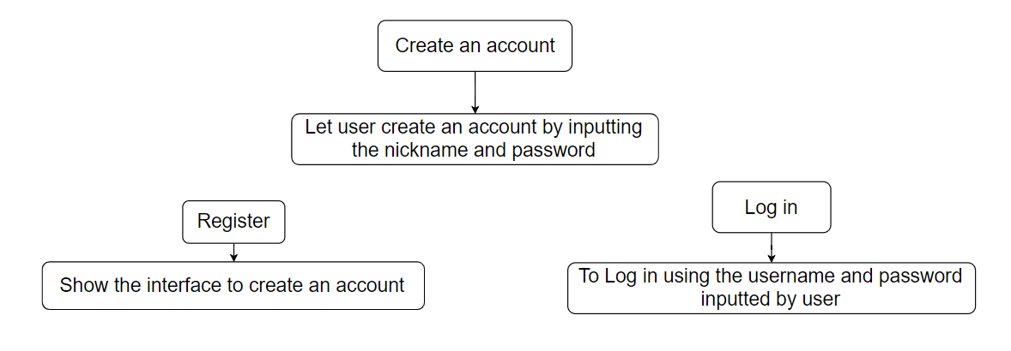

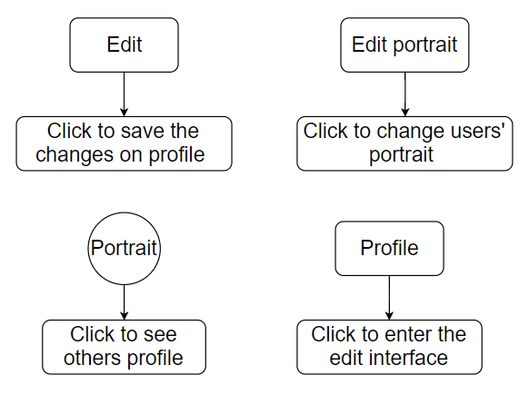Figure ：Account relevant elements function

Figure ：Profile relevant elements’ function

<Graphs illustrating the function of each element, e.g. what would happen when click on the button>

Relationship between each user interfaces

<Flowchart illustrating the connections between each user interface>

Use of functions

<Texts explain the function of each function, e.g. Verify——to test whether the username corresponds to its key being inputted>

How the program works

<Flowcharts demonstrate possible process and result when actually using the website, including input, compute, judge, output, etc.>

Test plan

<A table including action to be tested, the test methods and the result should be yielded>