**Criterion B: Design**

**Overall**

**System Design Overview:**

This is the relationship between each page and the database in the system. The solid line represents the connection relationship between each page, while the dotted line represented the relationship, extract data(red) or store data(blue), between the page and the database.

Figure : The relationship in the system

Database

Index

Profile

Login

Register

Mainview

Post

Edit

**Overall functions needed to be achieved:**

This is a chart for overviewing the overall functions in the system and the relationship between them.

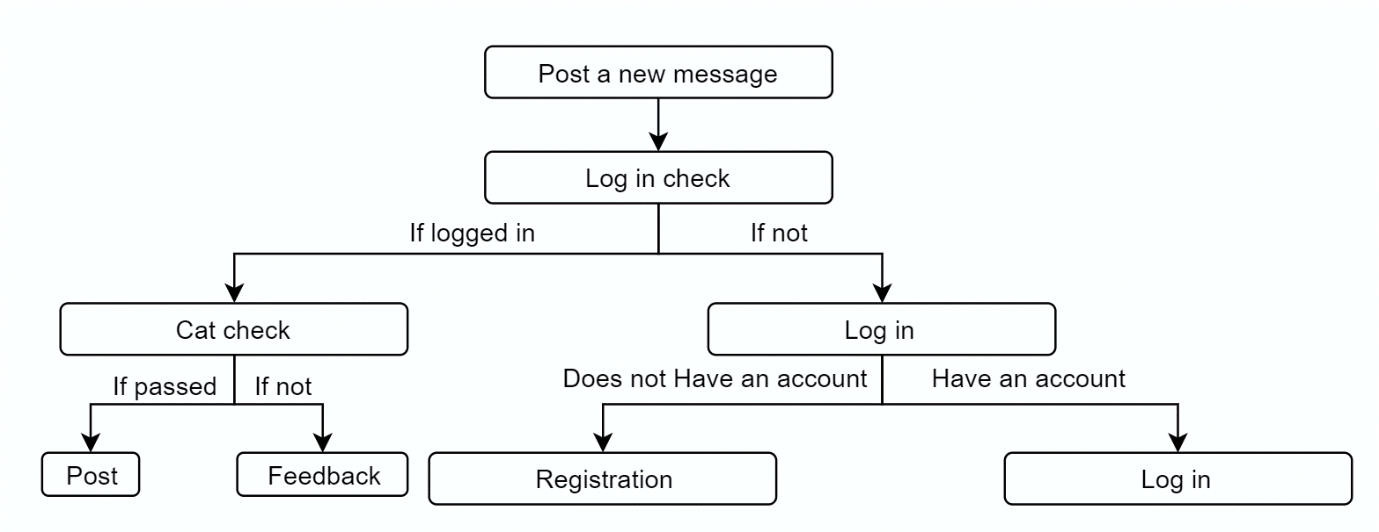

Figure 2: Function：Post a new message

**The name of files/folder and the function of each of them**

|  |  |
| --- | --- |
| Folder/File name | Functionality |
| Figure | To store pictures uploaded by the users |
| CATforLAYOUT.png | The picture on the layout page |
| layout1.html | To arrange the elements in the layout page, an introduction to the use of this website and a picture serves as an advertisement |
| login.html | To arrange the elements in the login page, providing input space for use to type in and button for user to submit |
| post.html | To arrange the elements in the post page, providing input space for use to type in, place for user to submit files and button for user to submit |
| register.html | To arrange the elements in the register page, providing input space for use to type in and button for user to submit |
| del.php | To delete user’s posts from database |
| edit.php | To edit user’s posts and update in the database |
| login.php | Verify user’s username and password, if they are correct then sets a new session |
| logout.php | Clear the session of username |
| mainviewing.php | Display the posts stored in the database |
| post.php | Store the data of posts inputted by the user to the database, as well as the date and time |
| profile.php | Links to the profile1.php, functioning to modify the contact information of the users |
| profile1.php | Links to the database for user to change their email address. A place where user can edit or delete their previous posts |
| register.php | Store the user’s name, contact information and password with hash in the database |
| select.php | Select the specific type inputted by the user and display the corresponding posts |
| teshphpdb.php | Connect to the database |
| Type.php | Find all types of breeds of cats that are posted |
| update.php | To update the user’s edition of posts in the database |
| verifycode.php | A method provided for use in other files to display a verification code |

**Part 1: Database**

For the website, I construct one database called Catdb and in it there are two tables, one called Userinfo, which is to store the users’ information, and the other is called posts, which is to store the data that the user posts, including the sender, title and description of the posts, the path of the image, the type of cat in the image and the time the posts was sent.

In Table1, username is set as a unique key to increase the efficiency of searching. Although the image is also unique, but it is not set as unique key because it won’t be used as searching.

**DATABASE：Catdb**

***Table1: Userinfo***

|  |  |  |  |
| --- | --- | --- | --- |
| Username | password | contact | info |
| Varchar(40) | Varchar(100) | Varchar(200) | Varchar(200) |
| The nick name of the user | The corresponding password | Contact information | If any comment |

*Table2: Posts*

|  |  |  |  |  |  |
| --- | --- | --- | --- | --- | --- |
| Sender | Title | Description | Image | Type | Date |
| Varchar(40) | Varchar(100) | Varchar(400) | Varchar(40) | Varchar(40) | Varchar(40) |
| The nickname of the user who sends it | The title of the post created by the user | The description of the posts by the user | The location that stores the figure | The breed of the cat | The date that sender upload/ change the posts |

**Part 2: The User System**

1. 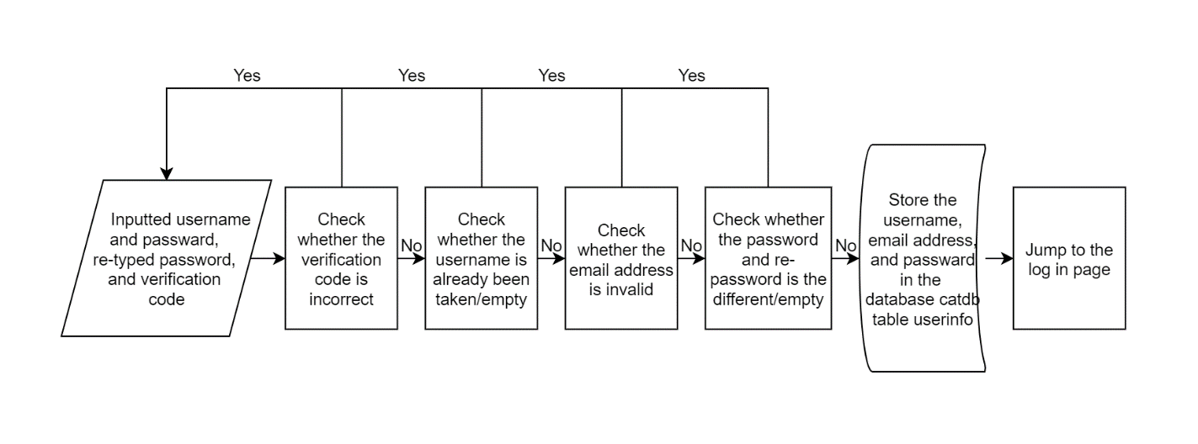Register

Figure : The process of registration

As users will need to show their contact information to others, they are required to fill in their contact information here. To prevent automatic registration request, the verification code, a combination of random generated letters and short lines, is used.

1. 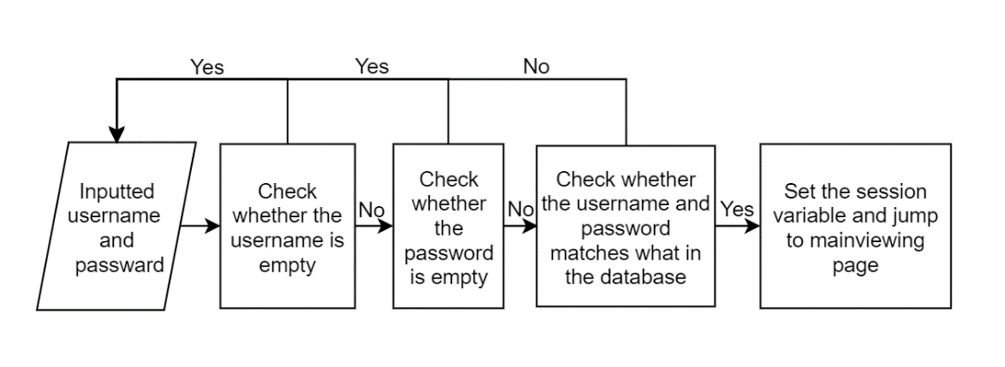Log in

Figure : The process of Log in

1. Modify Contact information

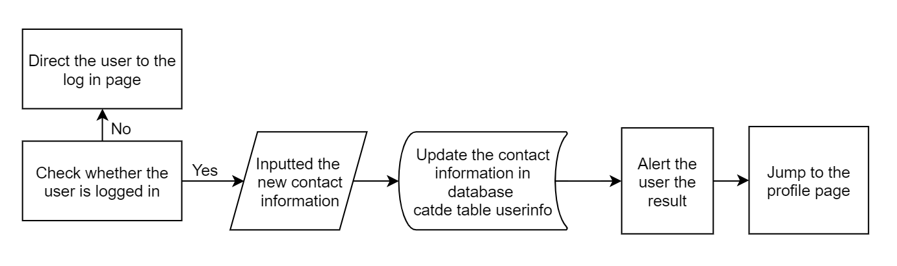

Figure 5: The process of modifying contact information

**Part 3: Functions**

1. Post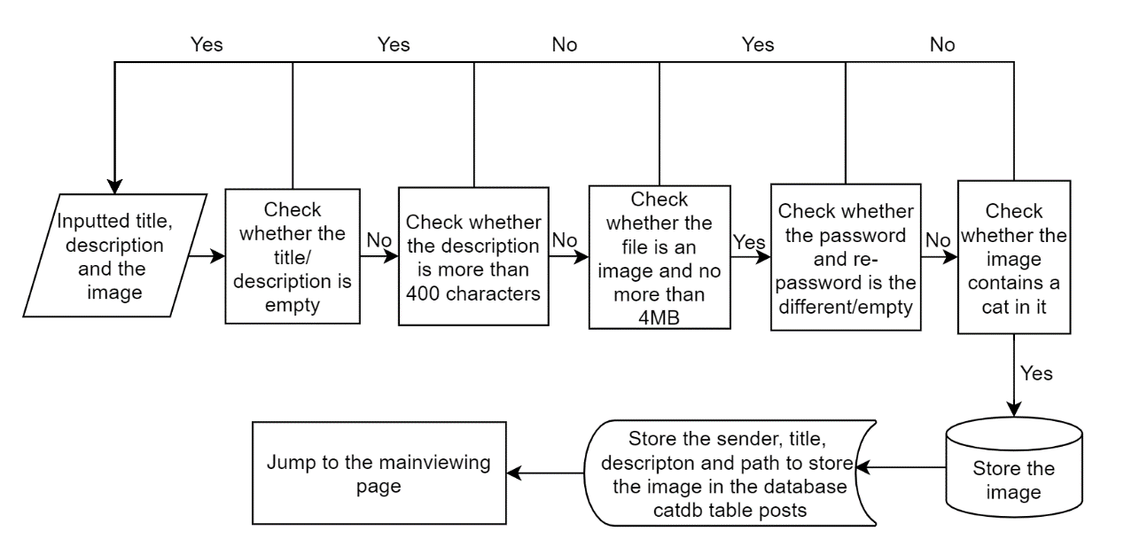

Figure : The process of post

To check a cat requires to send request to the server and get the response, but here to simplify I just write check, it will be fully explained in Criteria C.

1. Modify the post information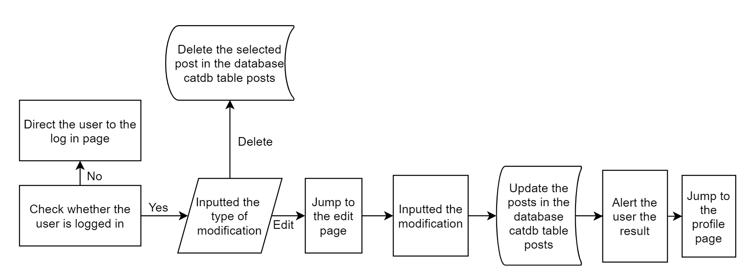

Figure 7: The process of modifying the posts

1. Searching according to the type of cats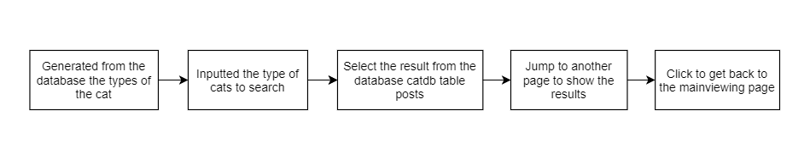

Figure 8: The process of searching

**Part 4: User Interfaces**

1. **Relationship between each page:**

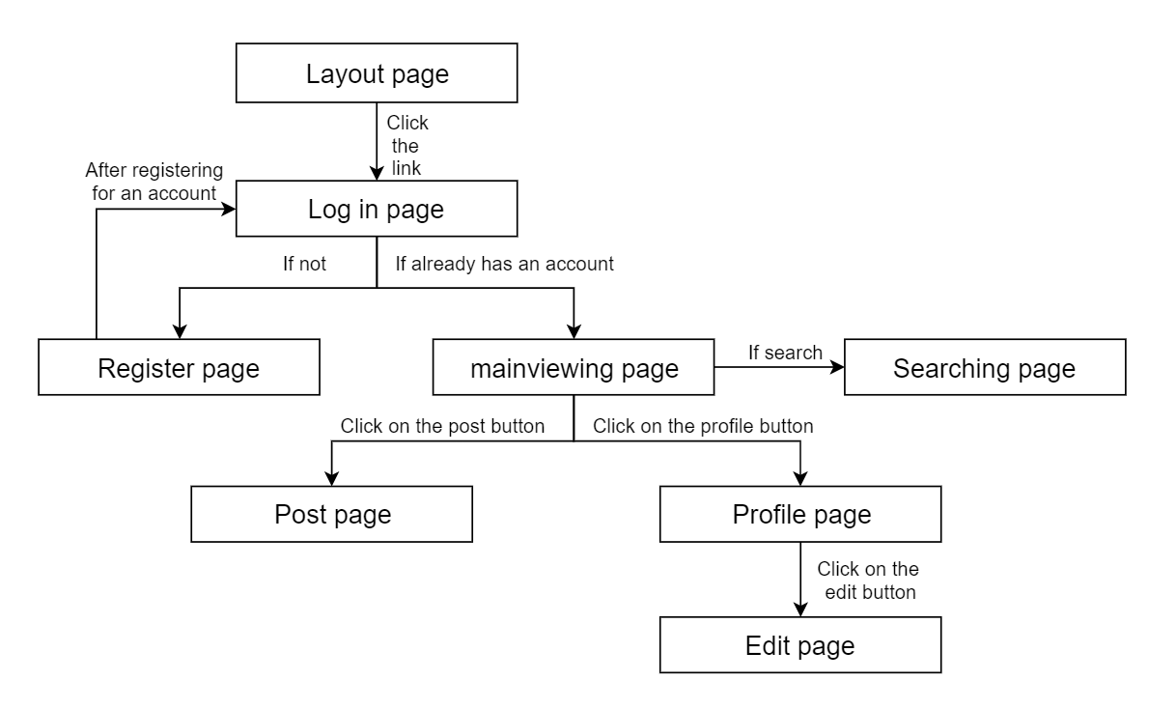

1. **Layout for specific sections**

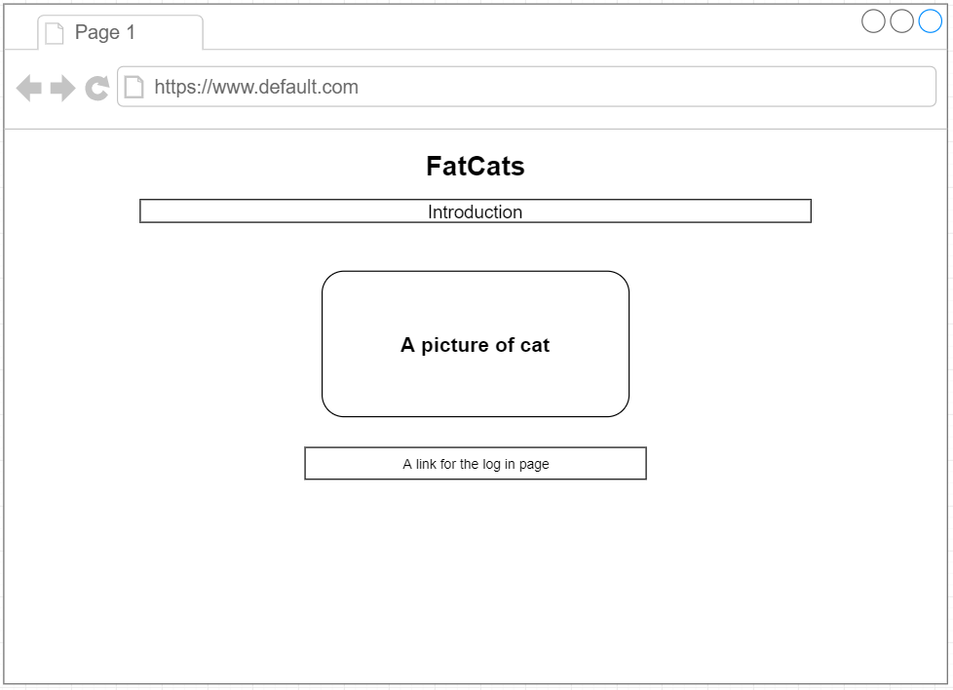

Figure 9: Layout for the layout page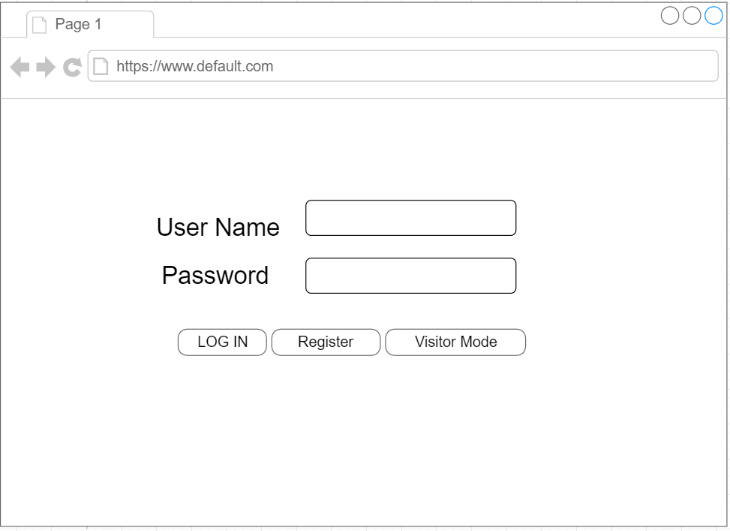

Figure 10: Layout for log in page

The visitor mode is used for those users who are not logged in to visit the information posted.

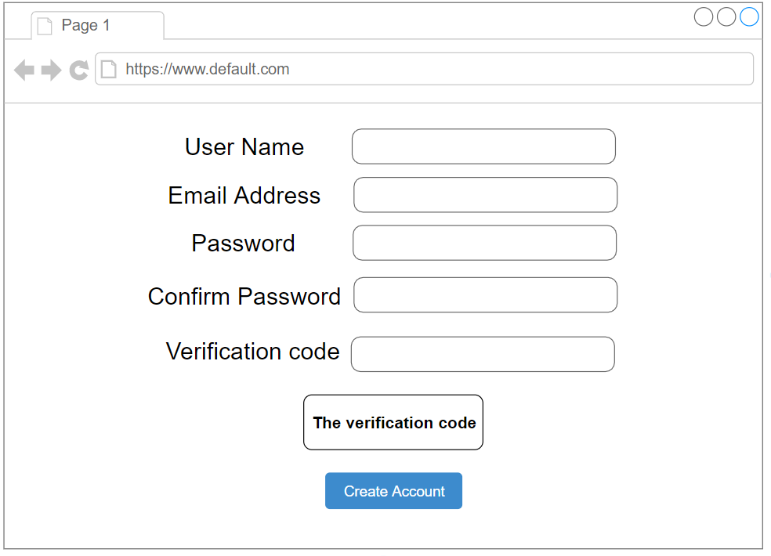

Figure 11: Layout for registration page

The verification code will be changed when click on itself.

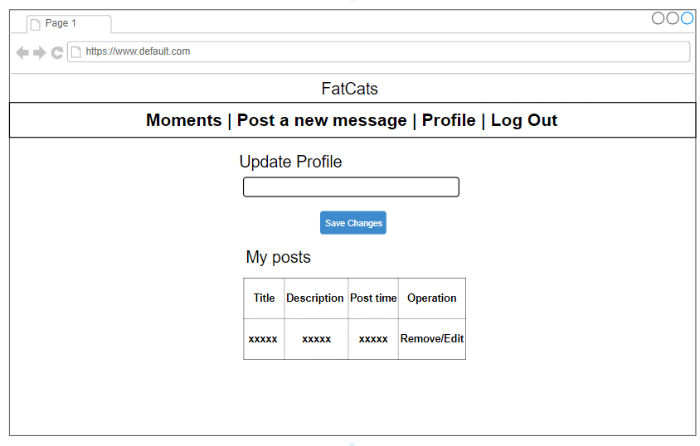

Figure 12: Layout for profile page

When the users click on edit, the page will jump to the editing page for the users to edit their own posts.

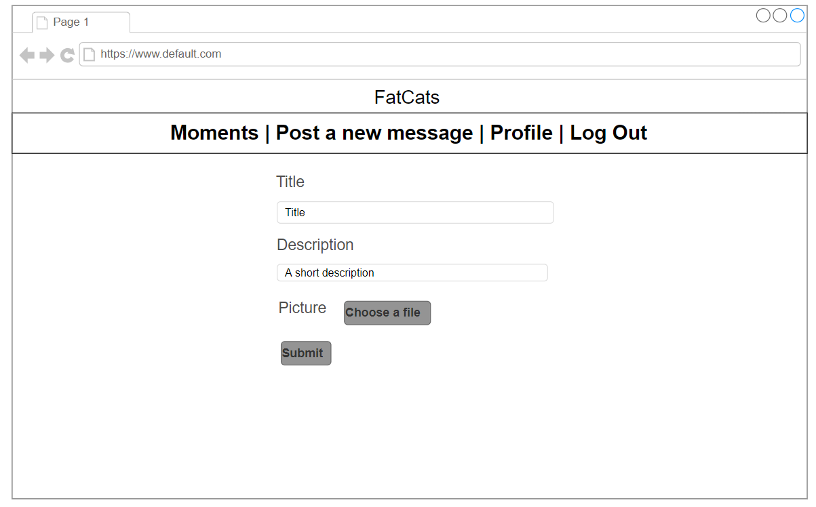

Figure 13: Layout for posting page

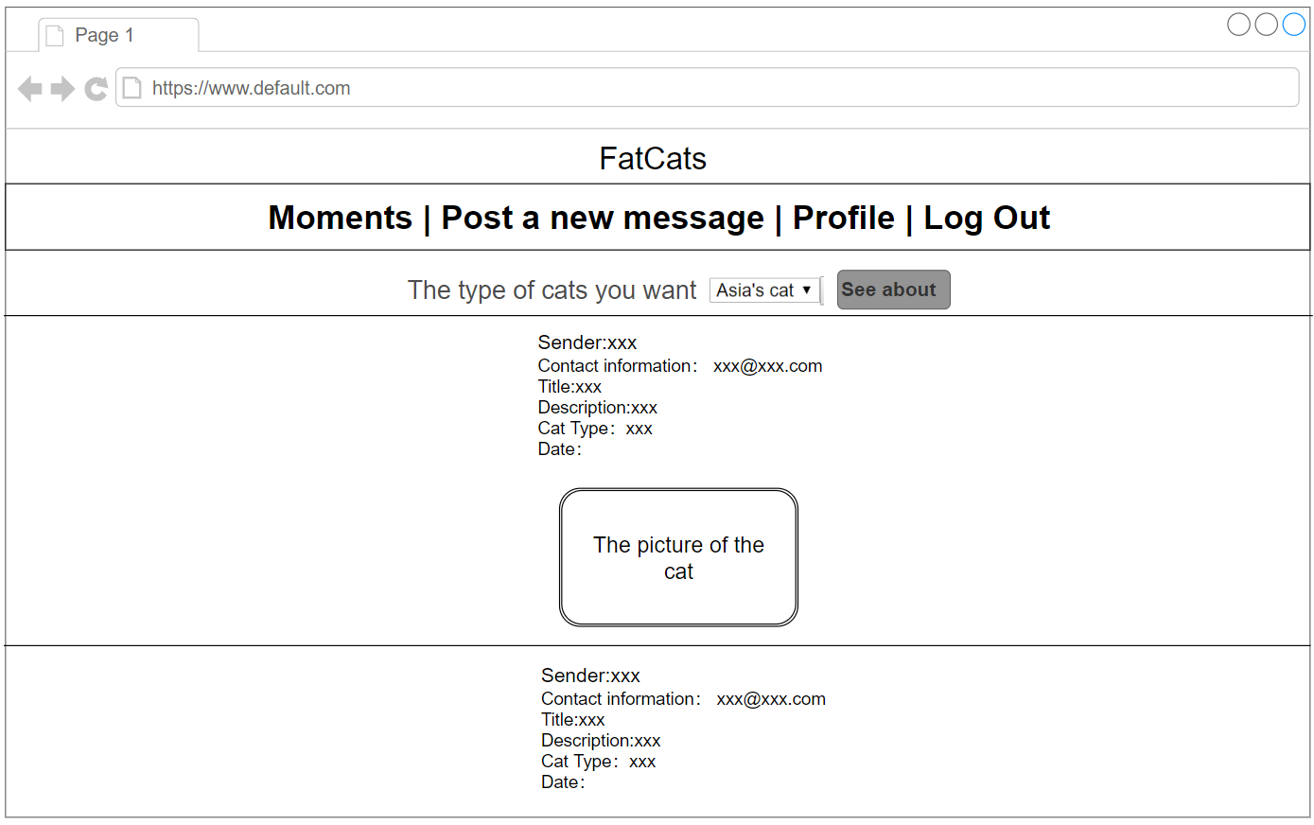

Figure 14: Layout for main viewing page

The searching page is like the main viewing page, except there is no menu bar on the top of the page. Instead, there is a link for go back to the main viewing page.

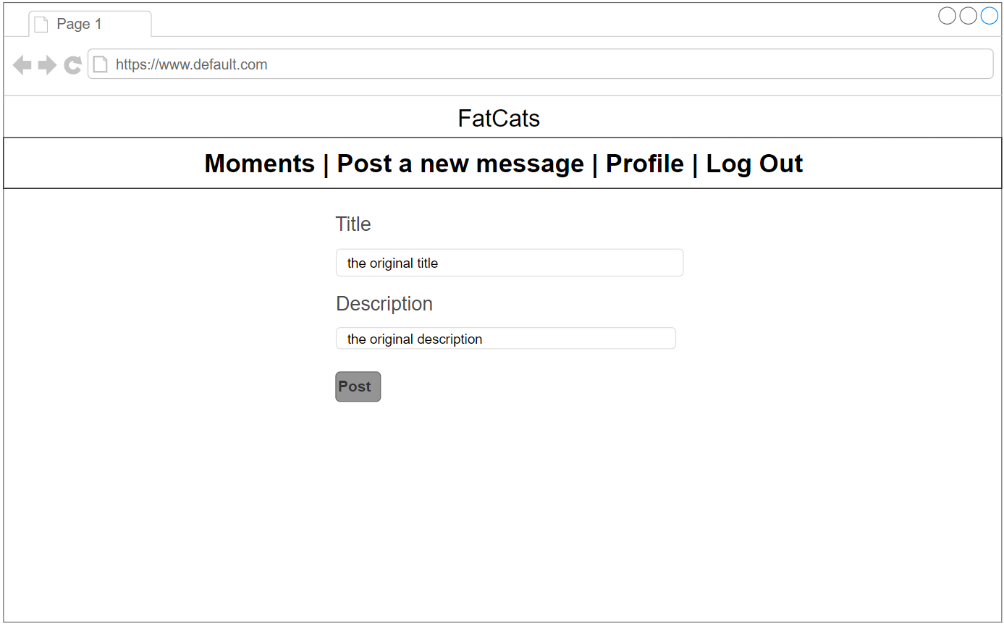

Figure 15: Layout for editing page

**Part 5: Test plan**

|  |  |  |
| --- | --- | --- |
| **Modules** | **Test Cases** | **Expected results** |
| User Interface | Click on each block of menu bar | The page will be redirected into the page shown on the menu bar I clicked |
| User Interface | Click on the link in the index page | The page will be redirected into the log in page |
| User Interface |  |  |
| User Interface |  |  |
| User Interface |  |  |
| User System | Register/log in with empty username or password | Pop up window showing username/password cannot be empty |
| User System | Register with wrong re-password | Pop up window showing password inconsistency |
| User System | Register with username that already been taken | Pop up window showing username already been taken |
| User System | Register with invalid email address | Pop up window showing invalid email address |
| User System | Register with username wrong verification code | Pop up window showing wrong verification code |
| User System | Register with username that already been taken | Pop up window showing username already been taken |
| User System |  |  |
| User System | Log in with wrong username/password | Pop up window showing username/password is wrong |
| User System | Log in with correct username and password |  |
|  |  |  |

|  |  |  |
| --- | --- | --- |
| **Modules** | Inpu |  |
| **User System** |  | 1. Users can freely register by providing a valid email address and have their username and password as they set 2. Users can change their contact information in the profile page 3. Users can modify or delete their posts in the profile page 4. Unauthorized users can only view exiting pictures and information, but cannot post new pictures 5. Authorized users can post new information |
| **Functions** |  | 1. The main viewing page can correctly show the pictures and information retrieved from the database 2. The breed of the cat should be shown beside the picture of the cat 3. Users can search from the posts according to the breed of the cat by selecting the breed and click on see about 4. Users can log out by simply click on log out 5. The contact information of the one who posts should be shown in the post on the main viewing page |
| **User Interfaces** |  | 1. Even a non-computer science student or specialist should be able to use the website easily 2. The menu bar can help to re-direct into each page |