Environmental Impact Analysis of Social Media Usage via
Eco-Impact Tracker

Prof. Jari Poras
LUT School of Engineering Sciences
Lappeenranta, Finland

Sakil Imran
LUT School of Engineering Sciences
Lappeenranta, Finland
Dr. Sanaul Haque
LUT School of Engineering Sciences
Lappeenranta, Finland
Helen Batuwantudawa,
LUT School of Engineering Sciences
Lappeenranta, Finland

Karoliina Aaltonen
LUT School of Engineering Sciences
Lappeenranta, Finland

Abstract— The spreading digitalization of society accounts for a growing share of global carbon emissions, largely driven by energy-intensive data centers, network infrastructure, and widespread use of mobile devices. Despite this, individuals have limited access to reliable feedback on the environmental impact of routine digital activities, such as social media use, video streaming, and online collaboration. This report presents the Eco-Impact Tracker, a mobile application developed during Climathon Lappeenranta 2024, designed to reduce digital carbon footprints by increasing user awareness and promoting sustainable digital practices. The application monitors users’ screen time and calculates their carbon footprint and battery usage for each social media platform. Built with Flutter and leveraging Greenspector’s 2021 carbon emissions model, it provides real-time insights through a user-friendly interface. Future releases will incorporate region-specific datasets, gamification, and AI-driven forecasting to further enhance personalization and impact. To evaluate its effectiveness, a controlled survey experiment was conducted with 20 participants, divided into a control group (using standard monitoring tools) and an experimental group (using Eco-Impact Tracker). Results demonstrated a statistically significant improvement in awareness of the environmental impact of digital use among experimental participants compared to controls (Mann–Whitney U = 18.0, p = 0.007). The findings confirm that eco-feedback in the digital domain can positively influence user awareness and attitudes toward sustainability. Eco-Impact Tracker thus represents not only a tool for personal behavior change but also a scalable model for bridging the gap between digital convenience and ecological responsibility.
Keywords— Digital carbon footprint, battery consumption, Flutter, social media impact, environmental sustainability, mobile application, user engagement, carbon tracking, gamification, sustainable software engineering

INTRODUCTION
Digital technologies are deeply rooted in everyday life, with social networking sites and mobile phones controlling communication, entertainment, and productivity. But this convenience has a confounding, and mostly hidden, environmental cost: the electricity consumed by devices, networks, and data centers is responsible for a significant proportion of greenhouse gas (GHG) emissions. Current estimates put the Information and Communication Technology (ICT) sector somewhere between 1.8% and 4% of worldwide CO2 emissions (IEA, 2021; Malmodin & Lundén, 2018). For more contextual knowledge, the carbon footprint of the ICT sector is equal to, or even surpassing, that of the aviation industry.
One of the dominant users of energy in this sector is use of social media. The continuous streaming of video, bottomless scrolling of feeds, and continuous uploading of photos all demand incredible amounts of data processing and transmission. An individual's social media use can surprisingly come with high ecological costs, with services like YouTube, Instagram, and TikTok accounting for much of this (Greenspector, 2021). It was found in one study that the social media activity of the typical user can amount to up to 60 kg of CO2 yearly carbon footprint (Carbon Literacy, 2023).

Despite the scale of these emissions, most users are not yet very conscious of the carbon imprint of their online activities. Applications such as Google's Digital Wellbeing or mobile phone Battery Usage Monitors provide details on screen time and energy usage, but they do not translate it into environmental impact measures. This consequently creates a massive gap in sustainability consciousness.

The Eco-Impact Tracker app was designed to address this information gap by enabling users to measure the carbon footprint of their social media app usage, as well as battery consumption. By linking users' digital activity explicitly and tangibly with its environmental impact, the app aims to raise awareness of sustainability and encourage more sustainable digital practices.

Fig. 1. Lifecycle and emission flows of ICT systems (Istrate et al., 2024)
Figure 1 illustrates how ICT emissions are distributed across manufacturing, internet networks, end-user devices, and digital content. Activities such as social media use and video streaming depend on this infrastructure, highlighting the hidden carbon footprint behind everyday digital behaviour. By visualizing the entire lifecycle, it becomes clear that user choices such as time spent on social media directly contribute to Scope 3 emissions. This project focuses on this stage, where the Eco-Impact Tracker app helps users understand and reduce their digital carbon footprint.

BACKGROUND AND RELATED WORKS
This chapter reviews the role of Information and Communication Technology (ICT) in sustainability, with particular emphasis on the carbon emissions of social media use. It explores existing tools for monitoring digital consumption, the concept of eco-feedback, and the research gap that motivates the development of the Eco-Impact Tracker.

The ICT Sector's Carbon Footprint
The Information and Communication Technology (ICT) sector's contribution to global greenhouse gas (GHG) emissions is a topic of ongoing research, with estimates varying based on the scope of the lifecycle assessment. One widely cited figure is that the ICT sector accounts for approximately 1.4% of global GHG emissions.

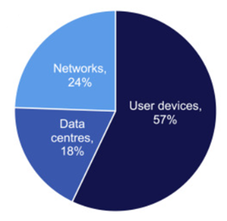
Fig. 2. Estimated ICT-related carbon emissions by component (Malmodin,2020)
ICT-related emissions are not evenly distributed across the sector. As shown in Figure 2, user devices are the dominant contributor, accounting for 57% of total emissions, while networks contribute 24% and data centres 18%. This estimate, which corresponds to a global total of approximately 690 MtCO₂e in 2020, emphasizes the disproportionate role of end-user devices such as smartphones, tablets, laptops, and televisions (Malmodin, 2020). The finding aligns with other studies highlighting that user behaviour and device usage patterns are critical levers in reducing ICT’s environmental impact.

However, some researchers suggest that a more inclusive approach, which accounts for the broader lifecycle stages such as manufacturing and end-of-life disposal, could raise this figure to between 2.1% and 3.9% of global emissions (Freitag et al., 2021).

The Carbon Impact of Digital Consumption
Recent research has quantified the environmental impact of digital content, including the use of social media. One study found that the annual carbon emissions from an individual's digital content consumption amount to approximately 229 kg of CO₂. This represents a significant portion—around 40% of the per-capita carbon budget—that aligns with the 1.5°C climate change target. This finding highlights the substantial, yet often hidden, carbon footprint of everyday online activities (Masanet et al., 2020).

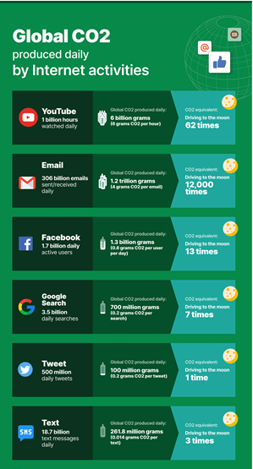
Fig.3. Global CO₂ emissions from daily internet activities
As shown in Figure 3, daily online behaviors such as streaming, emailing, and social media collectively result in substantial carbon emissions. Email alone is estimated to generate 1.2 trillion grams of CO₂ per day, equivalent to driving to the moon 12,000 times (WebFX, 2020). These statistics underline the fact that digital services are not “carbon free” but instead carry significant environmental costs. This reinforces the rationale for tools like the Eco-Impact Tracker, which aims to make such impacts visible to users.

The Hidden Cost of Social Media
While comprehensive estimates of social media's total emissions are still developing, there is growing recognition of its meaningful contribution to digital energy use. A key finding from the think tank The Shift Project highlights that approximately 80% of a smartphone's carbon footprint over two years is generated before its first minute of use (The Shift Project, 2019). This underscores the large, often invisible, embodied emissions associated with the manufacturing and distribution of digital devices, which are a critical part of the overall digital carbon footprint.

Eco-feedback and Behaviour Change
The use of eco-feedback strategies, where individuals receive data on their consumption (e.g., energy or water use), has been consistently shown to influence pro-environmental behaviors (Froehlich et al., 2010). Extending this feedback to digital carbon usage has strong potential to raise awareness and drive behavioral change, an area that remains largely underdeveloped in academic literature.

Sustainability Scope & User Behaviour
Lifecycle assessments emphasize the crucial role of user behavior in determining an individual's digital carbon footprint. The Eco-Impact Tracker app uniquely targets this level by helping users directly connect their digital habits to real-world environmental impact. This approach represents a relatively unexplored but critical lever for promoting sustainable digital consumption.

Summary
In summary, ICT contributes a measurable share of global GHG emissions, with social media and video streaming being significant drivers. While existing apps like Digital Wellbeing and battery monitors provide technical data, they lack sustainability-oriented feedback. The eco-feedback literature demonstrates that presenting environmental consequences can foster behavior change, but this approach is underdeveloped for digital usage. This gap highlights the need for a tool like the Eco-Impact Tracker, which translates app usage into carbon-equivalent emissions.

METHODOLOGY
This chapter outlines the design and development of the Eco-Impact Tracker. It describes the development environment, system architecture, and workflow, supported by diagrams and user interface screenshots. The methodology also highlights how sustainability principles were embedded into the app’s design.

Development Environment
The Eco-Impact Tracker was developed as an Android application using Dart and the Flutter framework, implemented in Visual Studio Code. Flutter was selected due to its cross-platform capabilities and efficient UI rendering, while Dart provided the reactive programming structure required for real-time data visualization.

System Architecture
The system design of the Eco-Impact Tracker is that it can best quantify and display the carbon footprint of energy consumption. It has four individual layers, each of which performs a specific activity, such that they create a seamless flow of data collection to user response.

1. Data Collection Layer
This is the base layer of the system. It gathers raw data straight from the user's device. Taking advantage of the APIs system on Android, the app retrieves detailed statistics on device usage like battery use, app use, and screen time. This data serves as the input to the whole system and provides the necessary metrics to calculate energy consumption and ultimately carbon emissions.

2. Processing Layer
The processing layer is the analytical brain of the system. It is essentially used to convert raw energy usage data into approximated CO₂ emissions. This is achieved by applying published emission factors, which are normalized values that correlate a unit of energy (e.g., kilowatt-hour, kWh) with a corresponding amount of CO₂ emissions (e.g., grams of CO₂ per kWh). This layer integrates the processed data from all the individual apps into a separate environmental profile for each.

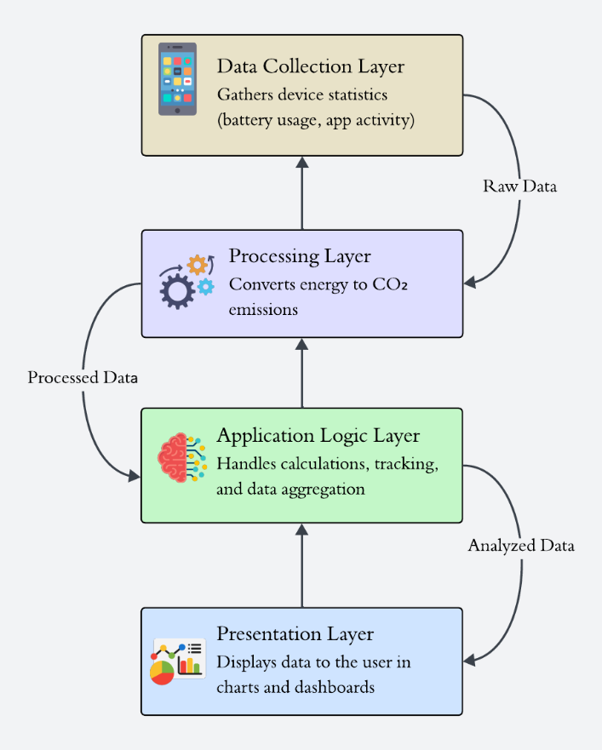
Fig.1. System Architecture of Eco Impact Tracker

3. Application Logic Layer
This layer is the "brain" of the application, responsible for internal processes and user-specific logic. It is charged with a variety of functions, including:

- App selection and calculation logic, determining which apps to track and how to apply the emission factors.

- Implementation of usage tracking, so that the system has the ability to track and store day-to-day, week-to-week, and month-to-month usage patterns.

- Data aggregation, collecting all the processed data in a form that can be easily reported to the user.

4. Presentation Layer (UI/UX)
The bottom rung of the architecture deals with the user interface. Its role is to display results clearly, intuitively, and interactively. It does so employ a range of visualization methods, such as:

- Bar charts and pie charts graphically display the carbon footprint of different apps.

- Summary dashboards that provide an at-a-glance overview of impact overall.

- Navigation menu (e.g., Home, Usage Stats, Total Impact, Analysis) that allows the user to change views and insights easily and get actionable feedback in order to encourage sustainable digital behavior.

System Design

Eco-Impact Tracker design revolves around an easy-to-use interface that translates advanced data into simple, easily comprehensible insights. The main operation of the app is organized into a clean, minimalist design that walks the user through several stages of analysis, from real-time tracking to long-term history of their virtual carbon footprint.

User Interface Design
The user interface (UI) was designed with simplicity and clarity at the forefront of priority so that the eco-impact data could be readily understood and reacted to.

Home Screen: The home dashboard gives a clean first impression. It displays instantaneous CO₂ emissions and battery usage for a selected social media application, providing the user with an idea of how their current action directly impacts it. This home screen is the main entry point to the other sections of the app's feature and analysis areas.

App List & Navigation: A maintained list of the available social media platforms is shown, with ease of selection and viewing the information of a specific app. A side navigation menu is minimal, yet it contains vital sections: Usage Stats, Total Impact, and Analysis. This design is convenient for comparison among several apps, where users can see which platform contributes to most of their carbon footprints.

Usage Statistics: This capability provides a more detailed analysis of historical app usage. Information is displayed graphically in the form of pie charts and bar charts to illustrate a breakdown of emissions and battery utilization by various intervals of time (e.g., daily, weekly, monthly). This feature makes the invisible emissions visible and makes individuals consider their long-term digital habits through an understandable eco-feedback system.

Total Impact View: This perspective aggregates the user's entire digital trace. It provides a single, overall figure of the environmental cost of their social media use. The rationale for this screen is to serve as a powerful behavior change driver by equating everyday behavior to overall sustainability targets.

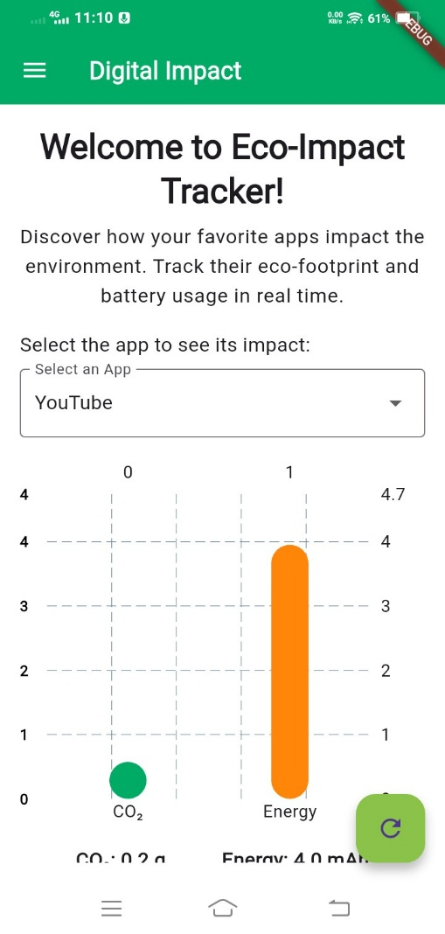
Fig.2. Home Screen

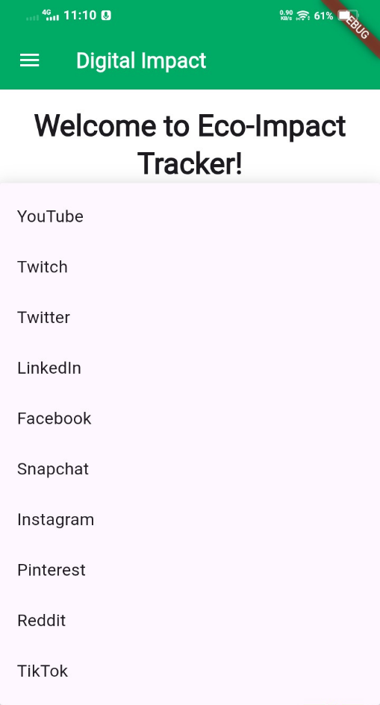
Fig.6. List of Social Media Apps

Total Impact View: This perspective aggregates the user's entire digital trace. It provides a single, overall figure of the environmental cost of their social media use. The rationale for this screen is to serve as a powerful behavior change driver by equating everyday behavior to overall sustainability targets.
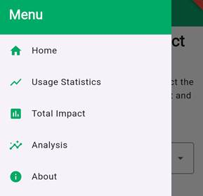
Fig.7. Main Menu

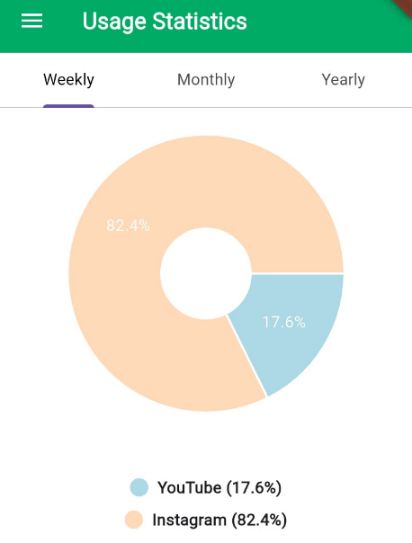
Fig.8. Usage Statics Screen

Code Implementation

Two main code components illustrate the app’s backend logic:
- Data Retrieval Function: Fetches real-time app usage from Android’s system APIs.
Future<List<Map<String, dynamic>>> getTodayUsage() async {
try {
debugPrint("Fetching today's usage data");
final String result = await channel.invokeMethod('getDailyUsage');

if (result.isEmpty || result == "no usage data available.") {
debugPrint("No usage data retrieved");
return [];
}

List<Map<String, dynamic>> usageList =
List<Map<String, dynamic>>.from(json.decode(result));
return usageList;
} catch (e) {
debugPrint("Error fetching usage data: $e");
return [];
}
}

- Data Visualization Component: Renders app-specific usage statistics in bar charts.
return Column (
children: [
SizedBox(
height: 300,
child: BarChart(
BarChartData(
alignment: BarChartAlignment.spaceAround,
barTouchData: BarTouchData(enabled: true),
titlesData: FlTitlesData(
leftTitles: AxisTitles(
sideTitles: SideTitles(
showTitles: true,
getTitlesWidget: (value, meta) => Text(
value.toInt().toString(),
style: TextStyle(
color: Colors.black,
fontSize: 12,
fontWeight: FontWeight.bold),
), ), ), ), ), ), ), ], );

Design Integration for Sustainability
The Eco-Impact Tracker was created with the explicit purpose of integrating sustainability values into its inherent functionality. The program is more than a simple monitoring system; it is a field for inspiring sustainable digital practice through making the environmental footprint of online activity real and visible to the user.
This is achieved by three design principles:
- Translating Digital Consumption into Environmental Cost - The central idea of the app is to render the abstract units of digital consumption screen time and battery life into something concrete, significant environmental cost, that is, CO₂ emissions. In this translation, users are then able to see their direct link between digital consumption and part of the global carbon footprint.
- Giving Feedback Loops - The design of the application is based on a feedback loop, an efficient method of promoting behavior change. Constantly providing users with feedback regarding their digital carbon footprint in real time as well as over time, the application creates a persistent cycle of awareness. This feedback gives consumers the power to make more informed decisions about their online consumption, whether through decreasing screen time on high-impact apps or simply being more aware of what they do online.

- Enabling Awareness Building - The design of the Eco-Impact Tracker supports UN Sustainable Development Goal (SDG) 12, Responsible Consumption and Production, directly. By encouraging awareness of the carbon price of online consumption, the app helps raise awareness among its users regarding the environmental cost of a modern lifestyle in today's digital age. Awareness building is a basic step towards creating a culture of sustainable digital living.

Data Collection
20 participants were recruited to the evaluation of the Eco-Impact Tracker. Participants were randomly assigned into two equal groups of 10:

- Control Group – employed existing monitoring tools (Android Digital Wellbeing and Battery Monitor).

- Experimental Group – employed the Eco-Impact Tracker app.

All participants were instructed to use the tool that was allotted to them for seven days and then complete an online, guided individual survey individually. The survey included Likert-scale items measuring usability, awareness, reflection, and motivation, as well as open comments.

Following the collection of responses, they were coded according to group assignment (Experimental or Control) to allow statistical comparison. The grouping ensured that variation in sustainability knowledge resulted from the app effect directly.

Summary
In summary, the Eco-Impact Tracker was developed using Flutter and Dart, designed around a four-layer architecture (data collection, processing, application logic, and presentation). The system transforms app usage into carbon emission estimates and delivers eco-feedback through user-friendly charts and dashboards. Sustainability considerations informed both the functional design and the overall user experience.

TESTING AND ANALYSIS
This chapter presents the testing and evaluation of the Eco-Impact Tracker application. The primary objective of this evaluation was to determine whether the app increased user awareness of the environmental impact of social media usage compared to conventional monitoring tools such as Android Digital Wellbeing and Battery Monitor. A controlled survey-based experiment was conducted with 20 participants, equally divided into a control group and an experimental group. Participants used their assigned tool for one week and completed a structured Google Form survey. Quantitative (Likert-scale) responses were collected and analysed.

Experimental Design and Data Collection
Participants were randomly allocated into two groups:

- Control Group (n = 10): Used Android’s built-in monitoring tools (Digital Wellbeing and Battery Monitor).
- Experimental Group (n = 10): Used the Eco-Impact Tracker app.
The survey instrument included:
Demographic measure: Daily average social media usage (<1 hour, 1–3 hours, 4–6 hours).

Six Likert-scale items (1 = strongly disagree, 5 = strongly agree):
- Ease of use
- Insights provided
- Awareness of environmental impact
- Reflection on digital carbon footprint
- Motivation to reduce usage
- Belief in sustainable digital practices

A total of 20 valid responses were collected between 1–13 August 2025. Each participant completed the survey individually after using their assigned tool for one week.
Once responses were collected, they were labelled according to group allocation (Control or Experimental). The first ten responses corresponded to participants in the control group, while the remaining ten corresponded to participants in the experimental group. This labelling allowed the dataset to be structured for statistical comparison between groups.

Descriptive Analysis

Descriptive analysis first examined participants' daily use of social media to offer a foundation for establishing between-group comparability. Results showed an equal distribution of usage levels across both the control and experimental groups. Specifically, 45% of participants reported using social media for 1–3 hours per day, and 40% reported more frequent use of 4–6 hours per day. A smaller proportion, 15%, reported minimal or less than one hour of use each day.

As both groups shared the same distribution of baseline social media usage, this allowed for survey results to be compared on an even basis, with differences in awareness or attitudes being confidently attributed to the Eco-Impact Tracker rather than to underlying differences in usage patterns.

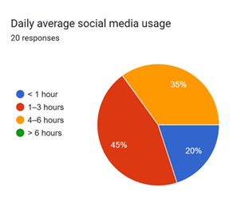
Fig.9. Daily Average Social Media Usage

Group-level patterns:

Control group (Digital Wellbeing/Battery Monitor): Most answers were around 2–3 on the 1–5 scale, meaning participants generally disagreed or felt neutral about gaining awareness from the tool. This shows they had limited improvement in sustainability awareness.
Experimental group (Eco-Impact Tracker): Most answers were around 4–5, meaning participants agreed or strongly agreed that the app made them more aware, reflective, and motivated about sustainable digital practices.

TABLE I. Descriptive Statistics of Awareness-related Items (n = 20)
Survey Item | Control Mean ± SD | Control Median | Experimental Mean ± SD | Experimental Median
Awareness | 3.1 ± 0.88 | 3.0 | 4.0 ± 0.47 | 4.0
Reflection | 3.2 ± 0.79 | 3.0 | 3.4 ± 0.70 | 3.5
Motivation | 3.1 ± 1.10 | 3.0 | 2.9 ± 0.74 | 3.0
Belief | 3.2 ± 0.63 | 3.0 | 3.8 ± 0.63 | 4.0

Descriptive statistics in Table 1 reveal significant differences between the control and experimental groups. Experimental group respondents achieved higher awareness scores (mean = 4.0, median = 4.0) than control group respondents (mean = 3.1, median = 3.0), implying that Eco-Impact Tracker effectively increased participants' awareness of social media usage's impact on the environment. Reflection scores were also largely similar across groups with a slight increase in the experimental group (mean = 3.4) compared to the control group (mean = 3.2). Motivation scores were very similar across groups (3.1 vs. 2.9) and suggest that while awareness was enhanced, short-term motivation to change behavior was not significantly different.
Finally, the experimental condition had stronger belief in sustainable digital behaviours (mean = 3.8, median = 4.0) than the control condition (mean = 3.2, median = 3.0), showing that participants who used the Eco-Impact Tracker were more convinced that the implementation of such tools has the potential to inspire sustainable practices.

Inferential Analysis
To determine whether the noted differences between the control and experimental groups were statistically different, a Mann–Whitney U test of the survey responses was conducted. This is because data collection was conducted through a Likert scale (ordinal data) and the sample population was relatively small (n = 20).
Null Hypothesis (H₀): There is no significant difference in sustainability awareness between the control and experimental groups.
Alternative Hypothesis (H₁): The Eco-Impact Tracker significantly increases sustainability awareness compared to existing tools.
The outcome showed that the experimental group reported more awareness (median = 4.0) compared to the control group (median = 3.0). The Mann–Whitney U value was 18.0 with p-value = 0.007, which is less than 0.05. Therefore, the null hypothesis is rejected, and it is confirmed that the Eco-Impact Tracker did have a positive impact in increasing awareness of the environmental impact of social media usage.
Applied to the remaining survey questions, there were inconsistent outcomes (Table 2). Greater belief in sustainable digital behavior existed in the experimental group (median = 4.0 vs 3.0), but the outcome was close to but not significant (p = 0.060). Motivation and reflection did not significantly differ by groups, which suggests that these effects may take longer-term use of an app or a larger sample to detect significant differences.
TABLE II. Mann–Whitney U Test Results (n=20)
Survey Item | Median (Control) | Median (Experimental) | U-value | p-value | Result
Awareness | 3.0 | 4.0 | 18.0 | 0.007 | Significant
Reflection | 3.0 | 3.5 | 43.0 | 0.593 | Not significant
Motivation | 3.0 | 3.0 | 54.0 | 0.780 | Not significant
Belief | 3.0 | 4.0 | 27.0 | 0.060 | (Borderline, not significant  at p<0.05)

Visual Results
This boxplot compares awareness scores (1–5 Likert scale) between the control group (using standard tools) and the experimental group (using Eco-Impact Tracker). The experimental group’s scores are centered around 4, while the control group’s are around 3, with more variation and a low outlier. This shows that participants using Eco-Impact Tracker generally reported higher awareness of environmental impacts compared to the control group.
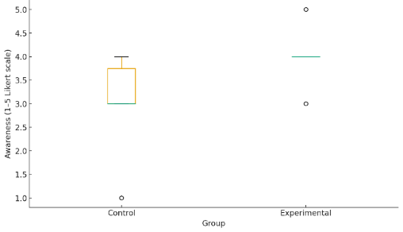Fig.10. Awareness score by group

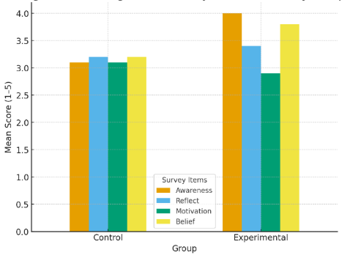
Fig.11. Average Sustainability-related Scores by Group

This bar chart shows the average scores (1–5 scale) for awareness, reflection, motivation, and belief in sustainable practices for both the control and experimental groups. The experimental group consistently scored higher for awareness and belief, while reflection scores were slightly higher and motivation remained similar across both groups. This highlights the Eco-Impact Tracker’s impact on raising awareness and positive attitudes toward sustainability, even in a short-term study.
The key result of the analysis is that experimental group awareness scores were significantly higher (median = 4.0) than those in the control group (median = 3.0; U = 18.0, p = 0.007). This confirms that the Eco-Impact Tracker effectively extended participants' knowledge of the environmental impacts of social media usage.

Summary
The pilot test testified that the Eco-Impact Tracker exhibited clear advantages over existing monitoring tools. The control group, utilizing the native apps of Android, demonstrated limited understanding of sustainability, whereas the individuals who were offered experimental treatment demonstrated higher awareness and stronger belief regarding the significance of sustainable digital practices.
Mann–Whitney U test (p = 0.007) also established the difference in awareness of groups to be statistically significant. Although differences in reflection and motivation were not found to be statistically significant over the short period of the study, the higher median scores observed in the experimental group suggest potential benefits that would be more evident with a larger population or long-term exposure.
Overall, the Eco-Impact Tracker had tremendous potential to serve as an effective digital intervention to heighten awareness for sustainability and make users reflect upon digital consumption and thus encourage more sustainable digital behavior.

Discussion
Discussion within this chapter explains the outcome of the Eco-Impact Tracker evaluation and contextualizes them against the research objectives and broader literature on digital tools with an environmental/sustainability focus. Analysis was expected to illuminate whether the app raised people's awareness of the environmental impact of their digital activities, stimulated thinking, and changed attitudes toward more sustainable digital practice.

Interpretation of Key Findings
The study demonstrated that the Eco-Impact Tracker significantly enhanced users' awareness of social media use environmental effects. Scores of awareness were significantly higher in the experimental group (median = 4.0) than in the control group (median = 3.0), with the Mann–Whitney U test confirming statistical significance (U = 18.0, p = 0.007). This indicates that even limited exposure to eco-feedback components, such as per-app CO₂ tracking and battery utilization data, influence user understanding of digital carbon footprint in a positive way.
While reflection and motivation scores were not statistically different between the two groups, this finding supports earlier research showing that behavior change will probably occur with longer exposure and reinforcement (e.g., gamification, nudges, or reward). In due course of time, motivation may be boosted as awareness gets converted into efficient habits.
Experimental participants believed more in the value of sustainability tools (median = 4.0) than controls (median = 3.0), and a p-value of 0.060, which is nearly but not quite significant. This trend suggests that Eco-Impact Tracker can generate trust and enthusiasm in online sustainability practices, yet this effect requires larger sample size or longer follow-up to be proven statistically

Comparison with Literature
Previous studies emphasize that dynamic interventions coupled with individualized feedback work better in raising awareness and engagement than static education campaigns. Home energy dashboards and carbon footprint calculators, which are eco-feedback systems, have been studied to determine that visualizing environmental data promotes early engagement but not necessarily immediate behavioral change (Froehlich et al., 2010; Buchanan et al., 2015). This agrees with current findings: Eco-Impact Tracker successfully increased awareness but not evidence of significant motivation change in a week.
Further, analogous evidence from mobile health (mHealth) and sustainability applications is that habit formation requires extended exposure for a number of weeks or months, occasionally facilitated by gamification or social comparison features (Mekler et al., 2017; Gomersall et al., 2019). The app's very good ability to enhance awareness indicates its potential as an entry point to longer-term sustainability interventions.

Implications for Sustainability and Digital Practices
The results indicate the necessity to embed sustainability into digital everyday life. Social media are high consumers of energy and carbon dioxide, but these are most often invisible in their impact from an end-user perspective (Malmodin & Lundén, 2020). By showing these figures in real-time, the Eco-Impact Tracker fills the critical awareness gap.
Although behavioral motivation was not discovered to vary much, consciousness is the gateway to behavior change (Prochaska & Velicer, 1997). The ability of the app to increase the users' belief in digital sustainability practices shows its scalability potential as a driver for sustainable consumption if accompanied by long-term engagement strategies.

Limitations
Some limitations may underline the constrained outcomes for motivation and reflection:
- Small sample size (n = 20): A larger sample would provide more statistical power to detect subtle differences.
- Short testing period (1 week): Users may take longer to form habits and learn behaviour.
- Lack of qualitative feedback: Open-ended feedback could have provided richer information on usability and emotional engagement.
- Homogeneous participant population: If participants were largely from the same demographic, the findings may not generalize across diverse populations.

Future Work
Future study must address:
- Scaling participant counts to confirm statistical analysis.
- Extending study duration to monitor long-term behaviour change.
- Including gamification, goal setting, and reminders for further motivation.
- Seamless integration with IoT devices (e.g., network analysis, smart plugs) for better and more detailed CO₂ calculations.
- Qualitative interviews or focus groups to augment survey responses.

Summary
The Eco-Impact Tracker successfully demonstrated its capability to raise awareness of the environmental impact of using social media, validating the effectiveness of eco-feedback functionality in applications. While reflection, motivation, and sustainability belief did not all reach statistical significance, upward trends suggest that with larger and more longitudinal studies, these could rise. Overall, the findings validate the usefulness of the app as a novel, user-centered way of promoting sustainable digital behavior.

CONCLUSION
The project introduced and evaluated the Eco-Impact Tracker; a mobile app aimed at raising awareness of the environmental footprint of social media usage and fostering sustainable digital habits. Built using Flutter, the app tracks screen time, battery drain, and estimates CO₂ emissions per app. There were 20 participants in the experiment, assigned randomly to a control group (using embedded monitoring tools) and an experimental group (using Eco-Impact Tracker) for one week. The user awareness, reflection, motivation, and belief regarding digital sustainability were evaluated using a close-ended survey.

Key Findings
The test revealed that the Eco-Impact Tracker was successful in raising digital environmental awareness (median = 4.0 vs. 3.0; U = 18.0, p = 0.007). Participants in the experiment also believed more in sustainability behaviours, even though the difference barely missed statistical significance (p = 0.060). There were no between-group differences for reflection and motivation, suggesting that awareness can be raised in a short period of time but behaviour change requires longer commitment.
These findings demonstrate that eco-feedback systems, and particularly per-app CO₂ tracking and usage summaries, are appropriate tools for closing the awareness gap of the digital carbon footprint.

Contribution and Impact
The Eco-Impact Tracker offers a scalable, user-friendly approach to bringing sustainability awareness to everyday digital practice. Unlike existing monitoring apps, which either measure time use alone or battery drain, this app emphasizes the environmental cost of digital practice, rendering sustainability data concrete and actionable at the level of end users.
This study contributes to the emerging field of digital sustainability as follows:
- Introducing a lightweight, data-driven carbon awareness tool.
- Demonstrating that awareness can be raised even in a short study.
- Informing a template for future interventions to foster sustainable digital behavior.

Limitations and Future Work
The limitations of the study are small sample size, short testing duration, and lack of qualitative feedback. These constrained the statistical power to detect more subtle effects on reflection and motivation. Future studies should:
- Test the app with a larger and more diverse sample.
- Perform longitudinal studies to track behavior change over time.
- Incorporate gamification, goal setting, and reminders to enhance motivation.
- Incorporate richer data sources, e.g., regional CO₂ intensity factors, for more precise feedback.
- Employ mixed quantitative and qualitative methods to explore emotional engagement and usability.

The Eco-Impact Tracker demonstrated strong potential as an innovative intervention for sustainability awareness in digital consumption. With the visualization and actionable framing of environmental effects, the application can be a driver of behavior change and informed choice in technology consumption. This study solidifies the argument for sustainability-driven digital interventions and provides the foundation for future research, with the eventual support of global efforts in reducing the environmental footprint of everyday digital activities.

ACKNOWLEDGEMENTS
We are grateful to the participants of Climathon Lappeenranta 2024 and the organizers and sponsors for fostering an environment of innovation. We thank Lappeenranta University of Technology for their assistance. Special thanks to the Climathon Lappeenranta 2024 winners and this application’s concept owners Otto Söderlund, Santeri Tenhunen, and Vilja Tallgren for coming up with the concept idea and allowing us to develop it further.

REFERENCES

- Carbon Literacy Project (2023). The carbon cost of social media. Available at: https://carbonliteracy.com/the-carbon-cost-of-social-media/ [Accessed 27 Aug. 2025].
- Froehlich, J., Findlater, L. & Landay, J. (2010). The design of eco-feedback technology. Proceedings of the SIGCHI Conference on Human Factors in Computing Systems, pp.1999–2008.
- GeSI (Global e-Sustainability Initiative) (2015). SMARTer 2030: ICT Solutions for 21st Century Challenges. Brussels: GeSI.
- Greenspector (2021). Environmental impact of the top 10 social media apps. Available at: https://greenspector.com/en/social-media-2021/ [Accessed 27 Aug. 2025].
- International Energy Agency (IEA) (2021). Digitalization and energy. Paris: IEA. Available at: https://www.iea.org/reports/digitalisation-and-energy [Accessed 27 Aug. 2025].
- Istrate, R., Tulus, V., Grass, R.N., Vanbever, L., Stark, W.J. & Guillén-Gosálbez, G. (2024). The environmental sustainability of digital content consumption. Nature Communications, 15, Article 3724. doi:10.1038/s41467-024-47621-w.
- Malmodin, J. (2020). The energy and carbon footprint of the global ICT and E&M sectors 2010–2015 and beyond. Presentation at the International Telecommunication Union (ITU).
- Malmodin, J. & Lundén, D. (2018). The energy and carbon footprint of the global ICT and E&M sectors 2010–2015. Sustainability, 10(9), p.3027.
- Walton, J. (2020). What is ICT’s global carbon footprint? Medium. Available at: https://medium.com/@jolindsaywalton/what-is-icts-global-carbon-footprint-1da8874ddc49 [Accessed 27 Aug. 2025].
- WebFX (2020). What is the carbon footprint of the internet? Available at: https://www.webfx.com/blog/marketing/carbon-footprint-internet/ [Accessed 28 Aug. 2025]
.

