Environmental Impact Analysis of Social Media Usage via Eco-Impact Tracker

Prof. Jari Poras
LUT School of Engineering Sciences
Lappeenranta, Finland
Helen Batuwantudawa,
LUT School of Engineering Sciences
Lappeenranta, Finland
Dr. Sanaul Haque
Software Engineering
LUT School of Engineering Sciences
Lappeenranta, Finland
Sakil Imran
LUT School of Engineering Sciences
Lappeenranta, Finland

Karoliina Aaltonen
LUT School of Engineering Sciences
Lappeenranta, Finland

Abstract
The spreading digitalization of society accounts for a growing share of global carbon emissions, largely driven by energy-intensive data centers, network infrastructure, and widespread use of mobile devices. Despite this, little high-quality feedback is available for individuals to understand the environmental effects of routine digital activities such as social media use, video streaming, or online collaboration.

This report presents the Eco-Impact Tracker, a mobile application developed during Climathon Lappeenranta 2024, designed to reduce digital carbon footprints by increasing user awareness and promoting sustainable digital practices.

The application monitors users’ screen time and calculates their carbon footprint and battery usage for each social media platform. Built with Flutter and leveraging Greenspector’s 2021 carbon emissions model, it provides real-time insights through a user-friendly interface. Future releases will incorporate region-specific datasets, gamification, and AI-driven forecasting to further enhance personalization and impact.
To evaluate its effectiveness, a controlled survey experiment was conducted with 20 participants, divided into a control group (using standard monitoring tools) and an experimental group (using Eco-Impact Tracker). Results demonstrated a statistically significant improvement in awareness of the environmental impact of digital use among experimental participants compared to controls (Mann–Whitney U = 18.0, p = 0.007).

The findings confirm that eco-feedback in the digital domain can positively influence user awareness and attitudes toward sustainability. Eco-Impact Tracker thus represents not only a tool for personal behavior change but also a scalable model for bridging the gap between digital convenience and ecological responsibility.

Keyword – Digital carbon footprint, battery consumption, Flutter, social media impact, environmental sustainability, mobile application, user engagement, carbon tracking, gamification, sustainable software engineering

Introduction
Digital technologies are deeply rooted in everyday life, with social networking sites and mobile phones controlling communication, entertainment, and productivity. But this convenience has a confounding, and mostly hidden, environmental cost: the electricity consumed by devices, networks, and data centers is responsible for a significant proportion of greenhouse gas (GHG) emissions. Current estimates put the Information and Communication Technology (ICT) sector somewhere between 1.8% and 4% of worldwide CO₂ emissions (IEA, 2021; Malmodin & Lundén, 2018). For more contextual knowledge, the carbon footprint of the ICT sector is equal to, or even surpassing, that of the aviation industry.
One of the dominant users of energy in this sector is our use of social media. The continuous streaming of video, bottomless scrolling of feeds, and continuous uploading of photos all demand incredible amounts of data processing and transmission. An individual's social media use can surprisingly come with high ecological costs, with services like YouTube, Instagram, and TikTok accounting for much of this (Greenspector, 2021). It was found in one study that the social media activity of the typical user can amount to up to 60 kg of CO2 yearly carbon footprint (Carbon Literacy, 2023).
Despite the scale of these emissions, most users are not yet very conscious of the carbon imprint of their online activities. Applications such as Google's Digital Wellbeing or mobile phone Battery Usage Monitors provide details on screen time and energy usage, but they do not translate it into environmental impact measures. This consequently creates a massive gap in sustainability consciousness.
The Eco-Impact Tracker app was designed to address this information gap by enabling users to measure the carbon footprint of their social media app usage, as well as battery consumption. By linking users' digital activity explicitly and tangibly with its environmental impact, the app aims to raise awareness of sustainability and encourage more sustainable digital practices.
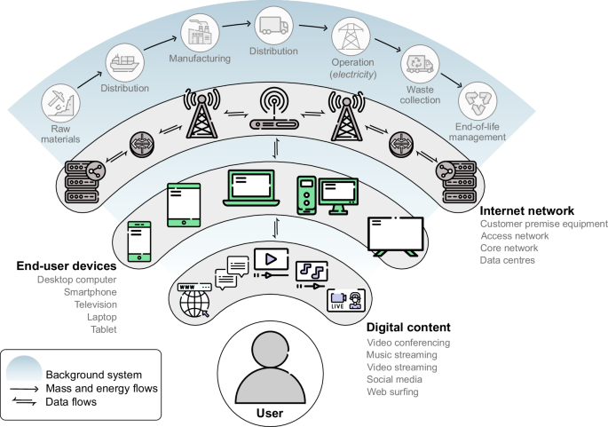
Figure 1.Lifecycle and emission flows of ICT systems (Istrate et al., 2024)
Figure 1 illustrates how ICT emissions are distributed across manufacturing, internet networks, end-user devices, and digital content. Activities such as social media use and video streaming depend on this infrastructure, highlighting the hidden carbon footprint behind everyday digital behavior. By visualizing the entire lifecycle, it becomes clear that user choices such as time spent on social media directly contribute to Scope 3 emissions. This project focuses on this stage, where the Eco-Impact Tracker app helps users understand and reduce their digital carbon footprint.

Background and Related works

This chapter reviews the role of Information and Communication Technology (ICT) in sustainability, with particular emphasis on the carbon emissions of social media use. It explores existing tools for monitoring digital consumption, the concept of eco-feedback, and the research gap that motivates the development of the Eco-Impact Tracker.

The ICT Sector's Carbon Footprint

The Information and Communication Technology (ICT) sector's contribution to global greenhouse gas (GHG) emissions is a topic of ongoing research, with estimates varying based on the scope of the lifecycle assessment. One widely cited figure is that the ICT sector accounts for approximately 1.4% of global GHG emissions.

This estimate, often based on user-stage emissions (including the use of devices, networks, and data centers), is found in various studies (Freitag et al., 2021).

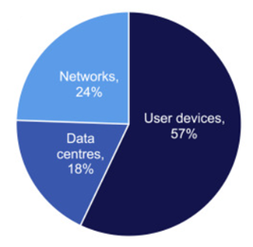
Figure 2. Estimated ICT-related carbon emissions by component (Malmodin (2020))

ICT-related emissions are not evenly distributed across the sector. As shown in Figure 2, user devices are the dominant contributor, accounting for 57% of total emissions, while networks contribute 24% and data centers 18%. This estimate, which corresponds to a global total of approximately 690 MtCO₂e in 2020, emphasizes the disproportionate role of end-user devices such as smartphones, tablets, laptops, and televisions (Malmodin, 2020). The finding aligns with other studies highlighting that user behavior and device usage patterns are critical levers in reducing ICT’s environmental impact.

However, some researchers suggest that a more inclusive approach, which accounts for the broader lifecycle stages such as manufacturing and end-of-life disposal, could raise this figure to between 2.1% and 3.9% of global emissions (Freitag et al., 2021).

The Carbon Impact of Digital Consumption
Recent research has quantified the environmental impact of digital content, including the use of social media. One study found that the annual carbon emissions from an individual's digital content consumption amount to approximately 229 kg of CO₂. This represents a significant portion—around 40% of the per-capita carbon budget—that aligns with the 1.5°C climate change target. This finding highlights the substantial, yet often hidden, carbon footprint of everyday online activities (Masanet et al., 2020).

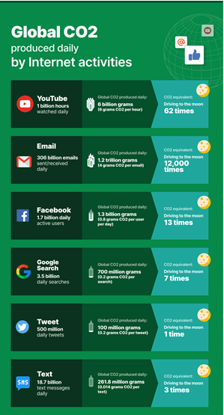
Figure 3. Global CO₂ emissions from daily internet activities

As shown in Figure 3, daily online behaviours such as streaming, emailing, and social media collectively result in substantial carbon emissions. Email alone is estimated to generate 1.2 trillion grams of CO₂ per day, equivalent to driving to the moon 12,000 times (WebFX, 2020). These statistics underline the fact that digital services are not “carbon free” but instead carry significant environmental costs. This reinforces the rationale for tools like the Eco-Impact Tracker, which aim to make such impacts visible to users.

The Hidden Cost of Social Media
While comprehensive estimates of social media's total emissions are still developing, there is growing recognition of its meaningful contribution to digital energy use. A key finding from the think tank The Shift Project highlights that approximately 80% of a smartphone's carbon footprint over two years is generated before its first minute of use (The Shift Project, 2019). This underscores the large, often invisible, embodied emissions associated with the manufacturing and distribution of digital devices, which are a critical part of the overall digital carbon footprint.

2.4 Eco-feedback and Behaviour Change

The use of eco-feedback strategies, where individuals receive data on their consumption (e.g., energy or water use), has been consistently shown to influence pro-environmental behaviours (Froehlich et al., 2010). Extending this feedback to digital carbon usage has strong potential to raise awareness and drive behavioural change, an area that remains largely underdeveloped in academic literature.

2.5 Sustainability Scope & User Behaviour

Lifecycle assessments emphasize the crucial role of user behaviour in determining an individual's digital carbon footprint. The Eco-Impact Tracker app uniquely targets this level by helping users directly connect their digital habits to real-world environmental impact. This approach represents a relatively unexplored but critical lever for promoting sustainable digital consumption.

2.6 Summary
In summary, ICT contributes a measurable share of global GHG emissions, with social media and video streaming being significant drivers. While existing apps like Digital Wellbeing and battery monitors provide technical data, they lack sustainability-oriented feedback. The eco-feedback literature demonstrates that presenting environmental consequences can foster behavior change, but this approach is underdeveloped for digital usage. This gap highlights the need for a tool like the Eco-Impact Tracker, which translates app usage into carbon-equivalent emissions.

Methodology
This chapter outlines the design and development of the Eco-Impact Tracker. It describes the development environment, system architecture, and workflow, supported by diagrams and user interface screenshots. The methodology also highlights how sustainability principles were embedded into the app’s design.

3.1 Development Environment

The Eco-Impact Tracker was developed as an Android application using Dart and the Flutter framework, implemented in Visual Studio Code. Flutter was selected due to its cross-platform capabilities and efficient UI rendering, while Dart provided the reactive programming structure required for real-time data visualization.

3.2 System Architecture
The system design of the Eco-Impact Tracker is that it can best quantify and display the carbon footprint of energy consumption. It has four individual layers, each of which performs a specific activity, such that they create a seamless flow of data collection to user response.

1. Data Collection Layer
This is the base layer of the system. It gathers raw data straight from the user's device. Taking advantage of the APIs system on Android, the app retrieves detailed statistics on device usage like battery use, app use, and screen time. This data serves as the input to the whole system and provides the necessary metrics to calculate energy consumption and ultimately carbon emissions.

2. Processing Layer
The processing layer is the analytical brain of the system. It is essentially used to convert raw energy usage data into approximated CO₂ emissions. This is achieved by applying published emission factors, which are normalized values that correlate a unit of energy (e.g., kilowatt-hour, kWh) with a corresponding amount of CO₂ emissions (e.g., grams of CO₂ per kWh). This layer integrates the processed data from all the individual apps into a separate environmental profile for each.

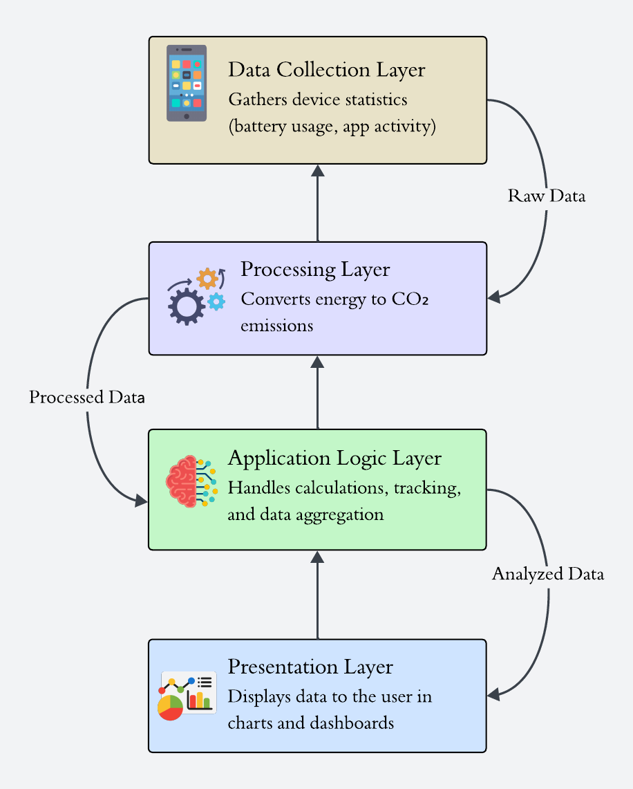
Figure 4. System Architecture of Eco Impact Tracker

3. Application Logic Layer
This layer is the "brain" of the application, responsible for internal processes and user-specific logic. It is charged with a variety of functions, including:

- App selection and calculation logic, determining which apps to track and how to apply the emission factors.

- Implementation of usage tracking, so that the system has the ability to track and store day-to-day, week-to-week, and month-to-month usage patterns.

- Data aggregation, collecting all the processed data in a form that can be easily reported to the user.

4. Presentation Layer (UI/UX)
The bottom rung of the architecture deals with the user interface. Its role is to display results clearly, intuitively, and interactively. It does so employ a range of visualization methods, such as:

- Bar charts and pie charts graphically display the carbon footprint of different apps.

- Summary dashboards that provide an at-a-glance overview of impact overall.

- Navigation menu (e.g., Home, Usage Stats, Total Impact, Analysis) that allows the user to change views and insights easily and get actionable feedback in order to encourage sustainable digital behavior.

3.3 System Design

Eco-Impact Tracker design revolves around an easy-to-use interface that translates advanced data into simple, easily comprehensible insights. The main operation of the app is organized into a clean, minimalist design that walks the user through several stages of analysis, from real-time tracking to long-term history of their virtual carbon footprint.

3.3.1 User Interface Design
The user interface (UI) was designed with simplicity and clarity at the forefront of priority so that the eco-impact data could be readily understood and reacted to.

Home Screen: The home dashboard gives a clean first impression. It displays instantaneous CO₂ emissions and battery usage for a selected social media application, providing the user with an idea of how their current action directly impacts it. This home screen is the main entry point to the other sections of the app's feature and analysis areas.

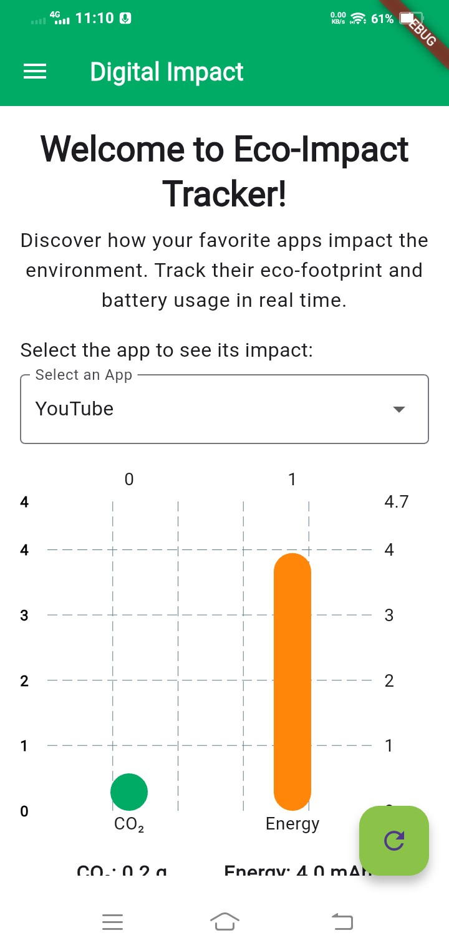
Figure 5. Home Screen

Key Algorithms

This mobile app collects real time data and do the calculations using below algorithms.

Energy Consumption Calculation

- is the power consumption of the device (in watts),
- is the time in hours.
Battery Consumption Analysis Algorithm
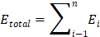

- is the energy consumption per app entry
- is the number of entries in the dataset

Carbon Emission Calculation
- 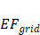 is the emission factor of the electricity grid (kg CO₂/kWh) which changes depending on the energy source (e.g., coal-based power grids have higher emission factors than renewable sources) [12].
CO₂ Emission Summation Algorithm
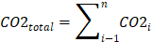

- is the individual emission value for each usage entry.
- is the number of entries in the dataset

Battery usage per social media app in Android - How Android Measures Battery Usage Per App

Battery Stats Collection by Android System

Android is constantly tracking power consumption using the BatteryStats API. It monitors CPU usage, wake locks, network usage, and sensor activity for all apps.Power drain is determined based on hardware power profiles defined by the manufacturer.

Estimating Battery Consumption
Android gives each application an mAh (milliamp-hour) usage figure derived from:

- CPU time used

- Wake locks (keeping the CPU awake)

- Using screens

- Using sensors (like GPS, accelerometers, etc.)

- Network use (Wi-Fi, Mobile Data)

Reporting Battery Drain Per App

- User retrieve per-app battery usage data via:

- Android’s BatteryStats API (root access often required)

- adb dumpsys batterystats command

- UsageStatsManager (limited data in recent Android versions)

Battery Plus does NOT access per-app stats but can help infer usage by tracking battery drops over time.

Application Design and Development

User Interfaces
Eco-impact tracker app uses simple interface structure with graphics where users can easily understand and get statistics. When user opens app in the mobile the interface will be shown as below figure.
Figure 6 - Home Screen
User can select the desired application from the Select app menu and check the Carbon emission and the energy used by the app. There are currently 10 social media apps are available such as YouTube, Twitch, Twitter, LinkedIn, Facebook, Snapchat, Instagram, Pinterest, Reddit and TikTok.
Next interface showed in figure 2 is the Main menu, where user can check usage statistics of each app run in the mobile phone, Total environmental impact data including daily, monthly and yearly. Also user can check the data analysis using Analysis page.

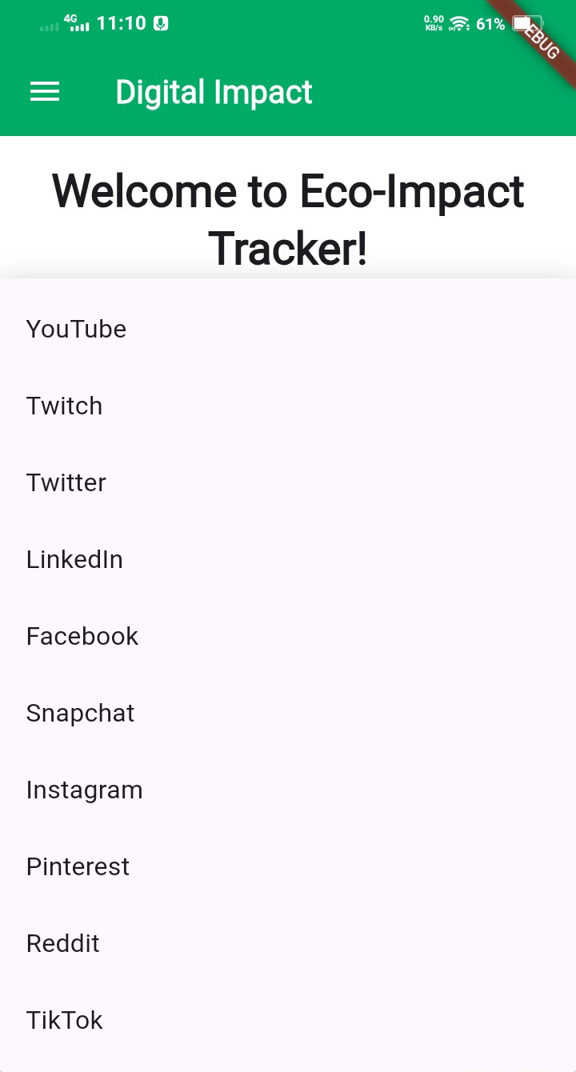
Figure 7 – List of social media applications
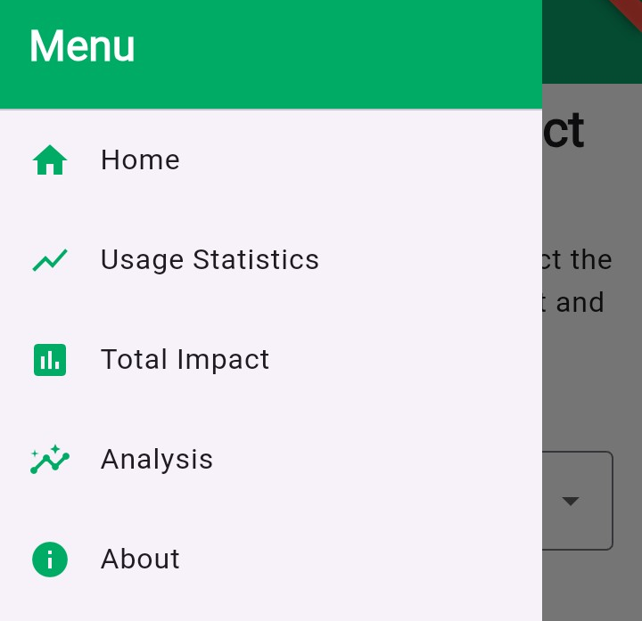
Figure 8 - Main Menu

Code Implementation

Below code is used to fetch the current date app usage data from the native Android method. Each object in the list contains,

{package: "...", minutes: XX.XX, co₂: YY.YY, energy: ZZ.ZZ}

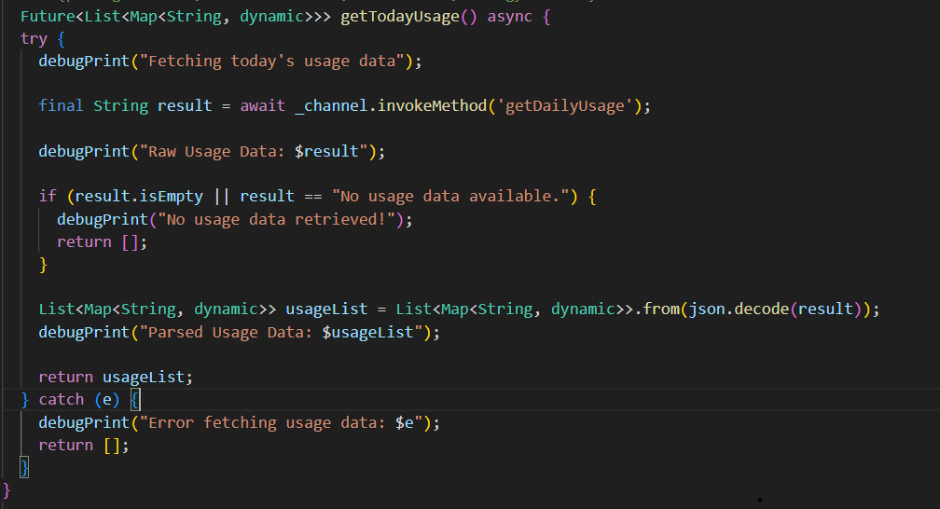
Figure 9

Below code taken from the home screen dart file and it shows how the charts created on the home page.
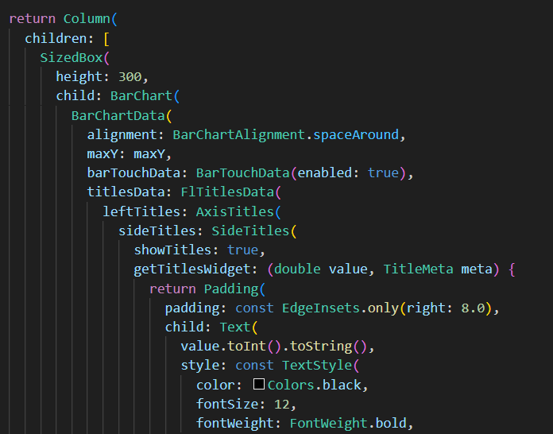
Figure 10

Resutls and Impact
Use of the Eco-Impact Tracker generated useful awareness into environmental impact of social media apps and pointed at battery consumption and CO₂ emissions. The result is based on a system test done by few users.

Comparison of most popular social media apps by energy consumption
Social Media App | Avg. Power Consumption (mAh/hr) | CO₂ Emission (g/hr)
Instagram | 200 mAh/hr | 80 g CO₂/hr
TikTok | 300 mAh/hr | 120 g CO₂/hr
Facebook | 150 mAh/hr | 60 g CO₂/hr
Twitter | 100 mAh/hr | 40 g CO₂/hr
Table 1

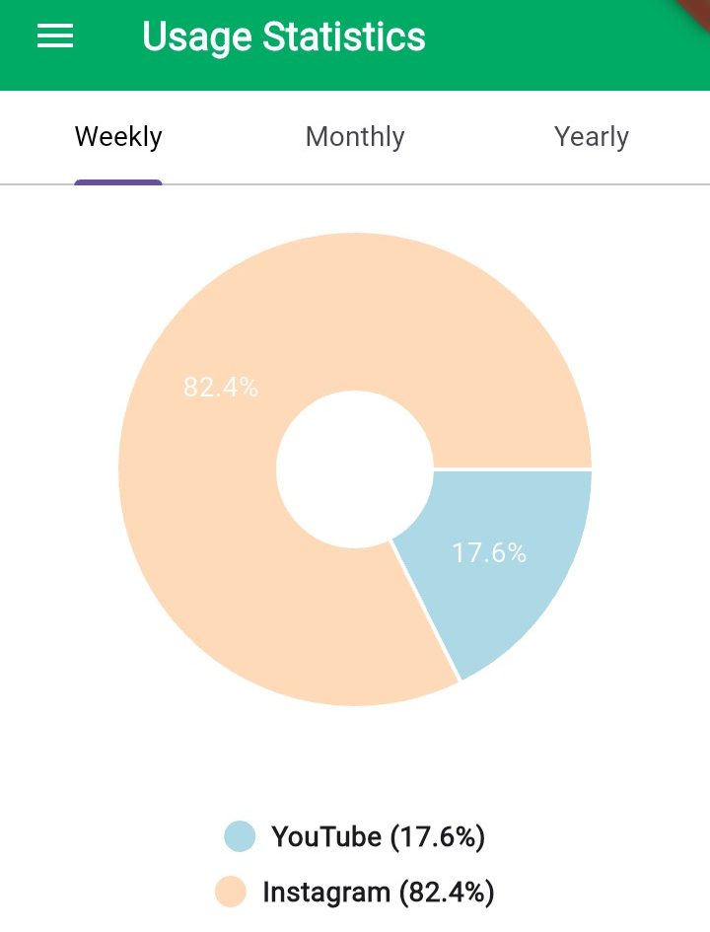
Figure 11 - Usage Statistics

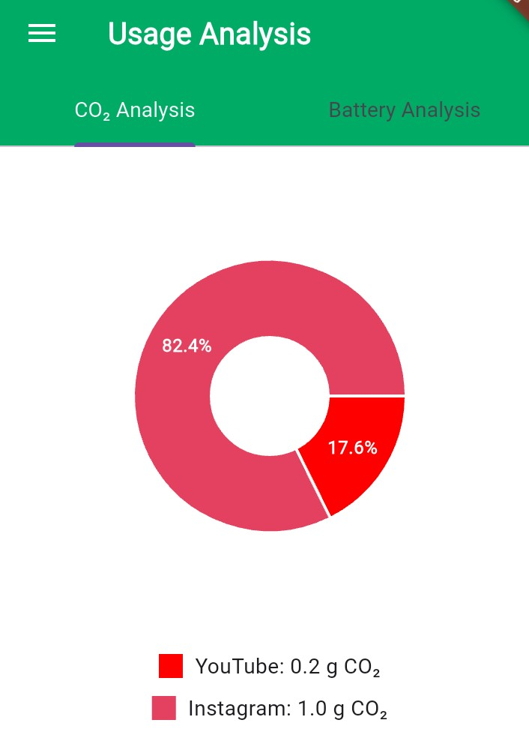
Figure 12 – Usage analysis

Environmental Footprint per App
Data gathered (comparison on Table 1 in Methodology) showed that:
TikTok had the highest environmental impact compared to apps under investigation, with ~300 mAh/hour battery consumption and ~120 g CO₂/hour.

Instagram followed with ~200 mAh/hour and ~80 g CO₂/hour.

Facebook and Twitter show comparatively lower emissions and energy intake (~60 g/hr and ~40 g/hr respectively).

These findings support earlier research by Pramanik et al. [12], which supported that apps with high video and network usage profiles are leading causes of energy consumption. Moreover, they support Huber et al. [11], who classified multimedia-based applications as being the most energy-consuming in mobile environments.

Collected Usage Patterns
By leveraging summation algorithms (see Key Algorithms), the application could total CO₂ and energy consumption across various time periods of varying durations (yearly, daily, monthly). The charts utilized through fl_chart offered simple to interpretable visual signals that updated users on:

- Their most energy-thirsty usage periods.
- Apps with the largest environmental impact.

Device-Wide Estimation Validity
While the app uses indirect methods (folding usage logs and estimating battery usage), it bears comparison with the native tools like BatteryStats and adb dumpsys batterystats on Android. Keysight Technologies' research [13] confirms that estimated battery drops—calibrated—can estimate native measurement with good accuracy.

The results show the different levels of environmental impact per social media app, and the video streaming apps occur the highest emissions due to extended screen time and network usage. [14]

The primary goal of the application is to connect users to actionable information and allow them to act on change in their daily lives. Through gamified functionality, the application makes it both interactive and educational to embrace sustainable digital behavior. Quantitative indicators for user engagement, behavioral changes, and reduction in emissions shall be collected through future research in a larger population.

Discussion
Eco-Impact Tracker provides a fresh approach to raising awareness of the green footprint of social media use on mobile devices. The application utilizes Flutter for cross-platform compatibility and Firebase for backend data handling, utilizing real time monitoring of usage with analytics to forecast CO₂ emissions and battery consumption.

The research clearly indicates that apps like TikTok and Instagram are among the top for energy usage and related carbon emissions. This concurs with [11] and [12] where high frequency performing media apps rank high for their contributions to smartphone energy usage.

The computation algorithms tally usage data and apply models of energy to estimate real time effect. These techniques are compatible with those outlined in [13], and they address energy profiling through device level telemetry.

This project also illustrates the benefit and viability of coming up with creative concepts within an interactive, think-tank type of setting, i.e., the Climathon, and then further refining the selected concept into a tangible product. The collaborative, social environment of the Climathon where likeminded individuals work together and contribute to solving specific issues fosters problem-solving and innovation. Not only generating diverse solutions, but also filling them with fundamental value, which has a direct link to the development of tangible outcomes, such as this mobile app.

The app effectively summons digital carbon footprint consciousness and encourages sustainable practices. By combining intuitive design with learning capability, it offers an easy to use platform that allows users to gain knowledge and reduce the ecological impact of their digital activities. The easy shift from ideation to implementation demonstrates the potential of participatory innovation to bring about positive change in addressing environmental concerns.

The approach, validated through real world use of the devices and supplemented by data visualization, makes end users as well as developers wiser. It not only aids in well informed behavioral change but assists the overall goal of sustainable ICT too.

The study proves awareness of digital sustainability can be increased by the display of real time data. Background app activity and variability in device efficiency should be factored in for higher precision. Future research entails combining AI-based forecasts and personalized suggestions to enhance user interaction and precision [15].

Key Contributions
Leaning on this collaborative platform, the app contributes meaningfully to optimize its potential for a function that drives sustainability:

• Tailored Feedback: Providing users with accurate real time emissions data and comparisons that they can comprehend encourages informed choice.

• Behavioural Insights: The app's clear, focused design avoids overwhelming users, increasing the chances of long term behaviour change.

• Research Potential: In addition to being an educational tool, the app can potentially be an effective tool for further research on digital impacts. Since it collects anonymous user data on digital activity and emissions over time, the app could be useful in the scientific community, revealing information about user behaviors and their environmental influence on a wide scale.

These contributions demonstrate the app's ability to bridge the gap between caring and knowing about the environment, allowing people to institute actual changes in their everyday lives, and advancing the research of digital sustainability through evidence-based research.

Future Improvements
There are a number of enhancements that would make the app even more useful and versatile:

• Accessibility Enhancements: Adding support for different languages, personalized color schemes, and assistive technologies like text-to-speech would make the app accessible to more users.

• Additional Features: Adding push-notifications, goal emission level, and actual data comparison for the user's digital carbon footprint and battery usage would make the application even more effective.

• AI-driven Features: AI based recommendations would analyze user behavior and suggest the best behavior to minimize emissions and battery usage without affecting productivity. This would need to be accomplished in a way that also keeps the carbon emission tracker app's own emissions as minimal as possible.

Further development and potential release of the app must be negotiated with the concept owners beforehand.

Conclusion
The Eco-Impact Tracker application provides a modern, databased approach to measuring the environmental impact of social media use. Written with cross platform development in mind utilizing Flutter, and augmented with live data insights, the application effectively raises awareness of digital carbon emissions and promotes sustainable behavioral modification. Its simple interface and live feedback mechanisms mean the application is an essential tool for those wishing to reduce their digital environmental impact.

The project was conceived during the Climathon Lappeenranta 2024, which is an event that gathers people to innovate together with the possibility of creating feasible solutions to environmental issues. This collaborative environment played a significant role in transforming the idea into actual output that unites users with real-time environmental data.

Whereas current implementation is founded on broad models of energy and emissions, additional enhancement in the future is
necessary to best achieve accuracy. Expanding data sources from regional electricity grid fluctuation, device-specific energy profiles, and broader digital habits background activity and usage of VPNs is necessary to optimize the credibility of the impact calculations.

Moreover, the integration of artificial intelligence will enable personalized suggestions and predictive feedback, prompting the user to adopt greener behaviors based on his or her online behavior. Scaling the tool for broader use, across platforms and digital ecosystems, will also enhance its efficacy.

Ultimately, this article contributes to technology innovation and scientific research in digital sustainability. By bridging the gap between Internet users' behavior and environmental concern, the Eco-Impact Tracker can serve as an effective educational tool for learning, digital self regulation, and further exploration of the environmental cost of Internet use.

Acknowledgements
We are grateful to the participants of Climathon Lappeenranta 2024 and the organizers and sponsors for fostering an environment of innovation. We thank Lappeenranta University of Technology for their assistance. Special thanks to the Climathon Lappeenranta 2024 winners and this application’s concept owners Otto Söderlund, Santeri Tenhunen, and Vilja Tallgren for coming up with the concept idea and allowing us to develop it further.

References
- Greenspector. (2021) Social media: The most energy-consuming apps revealed! [online] Greenspector. Available at: https://greenspector.com/en/social-media-2021
- Mughal, M., Baber, W. and Asad, M. (2022) ‘Digitalization and Environmental Sustainability: A Bibliometric Review’, Sustainability, 14(4), p. 2195. [online] Available at: https://www.mdpi.com/2071-1050/14/4/2195
- Cho, R. (2023) ‘AI’s Growing Carbon Footprint’, State of the Planet, 9 June. Available at: https://news.climate.columbia.edu/2023/06/09/ais-growing-carbon-footprint
- Mughal, M., Baber, W. and Asad, M. (2022) 'Carbon Footprint of The Most Popular Social Media Platforms', Sustainability, 14(4), p. 2195. Available at: https://www.mdpi.com/2071-1050/14/4/2195
- Boncu, Ș., Candel, O.-S. and Popa, N.L. (2022) ‘Gameful Green: A Systematic Review on the Use of Serious Computer Games and Gamified Mobile Apps to Foster Pro-Environmental Information, Attitudes and Behaviors’, Sustainability, 14(16), 10400. Available at: https://www.mdpi.com/2071-1050/14/16/10400
- Reccessary. (2024) ‘Five Apps help you track, offset your carbon emissions’, Reccessary, 30 August. Available at: https://www.reccessary.com/en/news/5-apps-track-your-carbon-emission
- Sustainable Computing: Informatics and Systems, [online] Volume 30, 100555. Available at: https://www.sciencedirect.com/science/article/abs/pii/S2352250X21000555
- Lannelongue, L., Grealey, J. and Inouye, M. (2020) ‘Green Algorithms: Quantifying the carbon footprint of computation’, arXiv preprint arXiv:2007.07610. Available at: https://arxiv.org/abs/2007.07610
- Boncu, Ș., Candel, O.-S. and Popa, N.L. (2022) ‘Gameful Green: A Systematic Review on the Use of Serious Computer Games and Gamified Mobile Apps to Foster Pro-Environmental Information, Attitudes and Behaviors’, Sustainability, 14(16), p. 10400. Available at: https://doi.org/10.3390/su141610400
- Wikipedia contributors. (2024) Yayzy. Available at: https://en.wikipedia.org/wiki/Yayzy
- Huber, B., et al., "Energy Efficiency in Mobile Applications: A Systematic Review," IEEE Transactions on Sustainable Computing, 2023.
- Pramanik, S., et al., "Smartphone Battery Consumption: A Review," IEEE Transactions on Mobile Computing, vol. 22, no. 3, pp. 518-530, 2024.
- Keysight Technologies, "Battery Drain Analysis in IoT and Consumer Devices," 2024.
- Dornauer, T., & Felderer, M., "Energy Consumption in Mobile Web Applications," arXiv preprint, 2023.
- IEEE Standards Association, "Carbon Footprint Measurement in Digital Applications," IEEE Green Technologies Conference, 2023.

