Environmental Impact Analysis of Social Media Usage via Eco-Impact

Prof. Jari Poras
LUT School of Engineering Sciences
Lappeenranta, Finland
Helen Batuwantudawa,
LUT School of Engineering Sciences
Lappeenranta, Finland
Dr. Sanaul Haque
Software Engineering
LUT School of Engineering Sciences
Lappeenranta, Finland
Sakil Imran
LUT School of Engineering Sciences
Lappeenranta, Finland

Karoliina Aaltonen
LUT School of Engineering Sciences
Lappeenranta, Finland

Abstract
The spreading digitalization of society accounts for much of the carbon emissions worldwide in the form of energy grabbing data centers, network equipment, and extensive mobile phones. Despite this, little good quality data is available for individuals to learn about the environmental effects of routine digital activities such as accessing social media, watching videos, or collaborating with AI technologies. This report presents the Eco-Impact Tracker, a mobile application developed at Climathon Lappeenranta 2024, as a response to the challenge of reducing digital carbon footprints by increasing awareness and being sustainable in one's digital activities.
The app monitors users' screen time and calculates their carbon footprint and battery usage per social media application on the phone. Developed with Flutter and driven by real time data analysis, the app displays environmental impact in an easy to use interface, giving consumers actionable advice and personalized suggestions. The approach used leverages Greenspector's 2021 carbon emissions model [1], and future releases are planned to use more specific and region-based data sets.
Initial reviews from Climathon participants highlight the app's potential to influence user behavior, enhance digital sustainability understanding, and promote environmental informatics practice. Upcoming efforts will focus on refining data accuracy, improving cross platform availability, and integrating richer functionalities such as AI driven behavior forecasting and gamification. Eco-Impact Tracker is not only an enabler of personal behavior change but also a scalable model for bridging the gap between digital convenience and ecological responsibility.
Carbon capture and storage (CCS) Concepts
- Human-centered computing → Mobile applications
- Computing methodologies → Sustainability
- Applied computing → Environmental sciences
Keyword – Digital carbon footprint, battery consumption, Flutter, social media impact, environmental sustainability. mobile application, user engagement, carbon tracking, gamification, sustainable software engineering

Introduction
Digital technologies have significantly increased global energy consumption and CO2 emissions. While large scale infrastructures like data centers are often studied for their environmental impact, individual user activities such as streaming videos, browsing social media, and utilizing AI tools also contribute substantially to the digital carbon footprint. For instance, streaming high-quality video content can consume between 220–370 watts per hour, resulting in approximately 100–175 grams of CO2 emissions per hour. [2]
This issue is further hindered by AI applications. Training large AI models, such as GPT-3, has been estimated to emit over 500 metric tons of CO₂, equivalent to the lifetime emissions of five average cars . Moreover, the inference phase where AI models generate responses demands significant energy, contributing to the growing energy requirements of data centers. [3]
Regardless of these figures, public awareness of the environmental impacts of everyday digital activities remains limited. This gap highlights the need for tools that can educate users and promote more sustainable digital lifestyles.
Mobile applications are a promising way to address this issue. Their widespread adoption and interactive capabilities make them an effective platform for reducing information and influencing behavior. Using gamification elements such as rewards, challenges, and progress tracking can enhance user engagement and motivation to adopt eco-friendly practices. [4]
This paper introduces the Eco-Impact Tracker, a mobile application developed during Climathon Lappeenranta 2024. The app monitors users' screen time on social media platforms and estimates the associated CO₂ emissions and battery consumption. By providing real-time feedback and visualizations, the application aims to raise awareness and encourage users to make more environmentally conscious decisions in their digital lives.
Through the integration of user-friendly design, educational content, and motivational features, the Eco-Impact Tracker seeks to bridge the gap between digital convenience and environmental responsibility, empowering individuals to contribute to a more sustainable digital ecosystem.

Background and Related works

2.1 Sustainable Mobile Applications and Energy Efficiency

Mobile applications offer a promising medium for addressing the challenge of digital sustainability. Their ubiquity and interactive potential make them effective vehicles for disseminating information and influencing behavior. Through the incorporation of gamification elements—such as rewards, contests, and monitoring progress—users can be better motivated and encouraged to adopt sustainable habits. [5][6]

2.1.1 Energy Chickens
the "Energy Chickens" app gamifies energy-saving actions by linking users' real-life energy usage to the health of virtual chickens and encouraging users to save energy in order to keep their chickens healthy.

2.2.2 Commons
Similarly, the "Commons" app tracks users' carbon footprint based on their lifestyle and rewards them with points and badges for taking green actions, which leads to a carbon emission reduction of 19% on average per year.

2.2 Gamification and User Participation in Sustainability
Gamification—the application of game design elements beyond games—has also proven effective in promoting pro-environmental behaviors. By incorporating elements such as points, badges, leaderboards, and challenges, gamified applications can maximize user engagement and motivation. Studies have shown that gamified interventions are able to achieve significant reductions in energy consumption. [7][8][9]

2.2.1 Energy Battles
For instance, the "Energy Battles" platform provided users with energy-saving advice and real-time consumption data, and this realized an average of 24% energy savings during the intervention period.

2.2.2 Power Explorer
Another is the "Power Explorer" game, which encouraged children to save energy at home and realized a 14% greater energy savings compared to a control group.

2.3 Social Media's Environmental Impact
Social media platforms are an integral component of modern communication but also facilitate digital carbon footprints. Continued usage of such platforms means data transmission and storage, which is energy-intensive and results in CO₂ emissions.

2.31 Yayzy
For example, the "Yayzy" app calculates the environmental price tag of users' spending, including their digital living, and suggests more environmentally friendly actions.
Creating greater environmental awareness of social media usage, the applications encourage users to be more thoughtful in their online activity decisions. [10]

Methodology

System Architecture
This mobile application is made using Flutter, which is a cross-platform framework. Firebase is used as the backend. This system retrieves app usage statistics and calculates energy consumption and CO₂ emission with the predefined algorithms.
Main components of the system includes,
Usage monitoring module: which extracts data from the mobile device to track screen time and the specific app interactions.
Computation Engine: This uses energy and CO₂ emission models to measure the impact [11]
User Interface: This will display data with charts to identify the impacts.
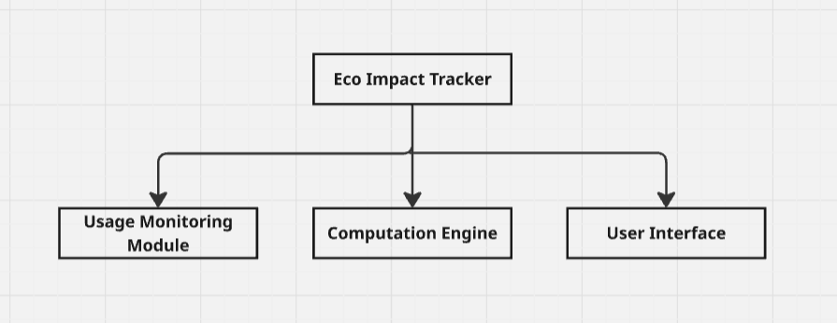
Figure 1 - System Architecture

Key Algorithms

This mobile app collects real time data and do the calculations using below algorithms.

Energy Consumption Calculation

- is the power consumption of the device (in watts),
- is the time in hours.
Battery Consumption Analysis Algorithm
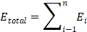

- is the energy consumption per app entry
- is the number of entries in the dataset

Carbon Emission Calculation
- 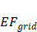 is the emission factor of the electricity grid (kg CO₂/kWh) which changes depending on the energy source (e.g., coal-based power grids have higher emission factors than renewable sources) [12].
CO₂ Emission Summation Algorithm
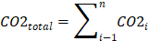

- is the individual emission value for each usage entry.
- is the number of entries in the dataset

Battery usage per social media app in Android - How Android Measures Battery Usage Per App

Battery Stats Collection by Android System

Android is constantly tracking power consumption using the BatteryStats API. It monitors CPU usage, wake locks, network usage, and sensor activity for all apps.Power drain is determined based on hardware power profiles defined by the manufacturer.

Estimating Battery Consumption
Android gives each application an mAh (milliamp-hour) usage figure derived from:

- CPU time used

- Wake locks (keeping the CPU awake)

- Using screens

- Using sensors (like GPS, accelerometers, etc.)

- Network use (Wi-Fi, Mobile Data)

Reporting Battery Drain Per App

- User retrieve per-app battery usage data via:

- Android’s BatteryStats API (root access often required)

- adb dumpsys batterystats command

- UsageStatsManager (limited data in recent Android versions)

Battery Plus does NOT access per-app stats but can help infer usage by tracking battery drops over time.

Application Design and Development

User Interfaces
Eco-impact tracker app uses simple interface structure with graphics where users can easily understand and get statistics. When user opens app in the mobile the interface will be shown as below figure.
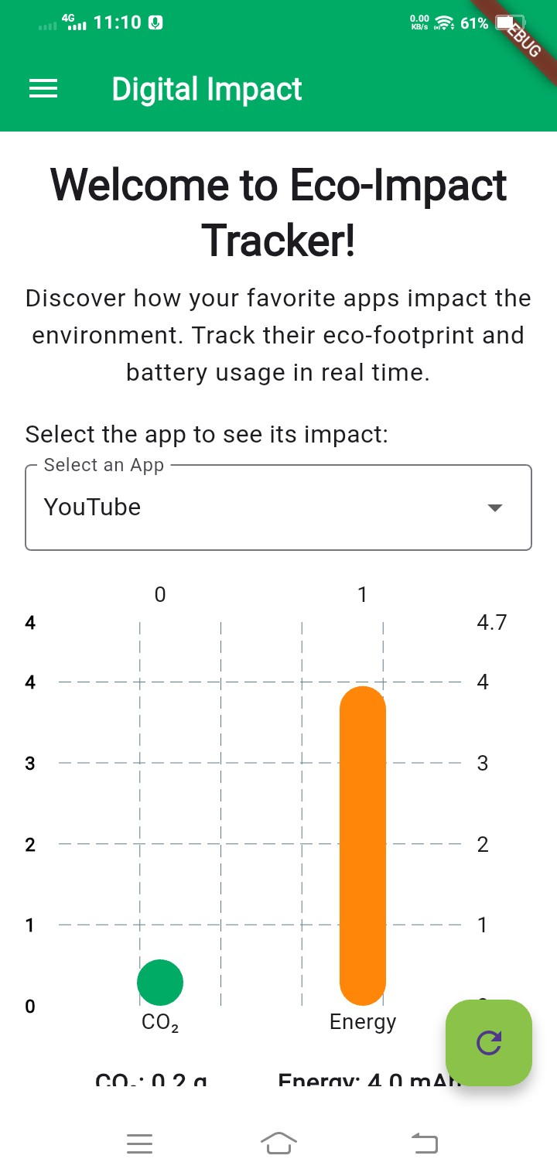
Figure 2 - Home Screen
User can select the desired application from the Select app menu and check the Carbon emission and the energy used by the app. There are currently 10 social media apps are available such as YouTube, Twitch, Twitter, LinkedIn, Facebook, Snapchat, Instagram, Pinterest, Reddit and TikTok.
Next interface showed in figure 2 is the Main menu, where user can check usage statistics of each app run in the mobile phone, Total environmental impact data including daily, monthly and yearly. Also user can check the data analysis using Analysis page.

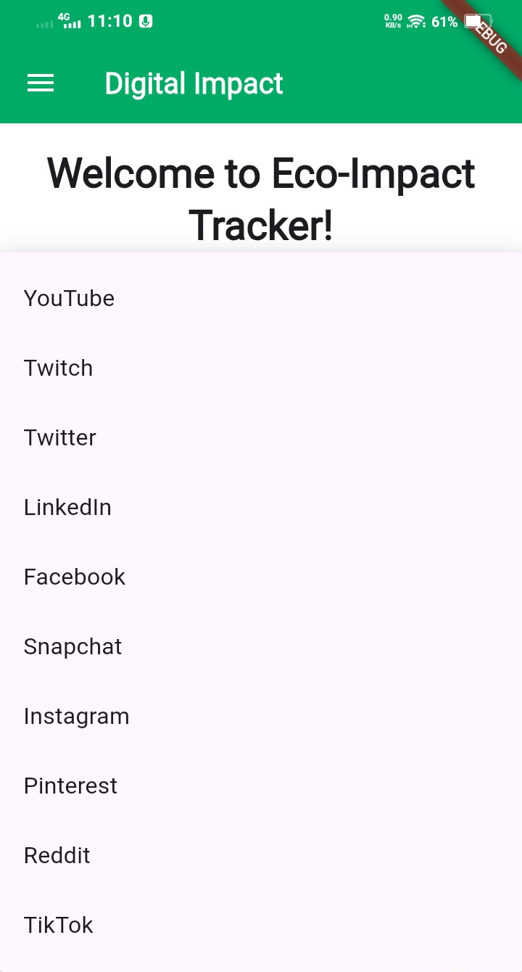
Figure 3 – List of social media applications
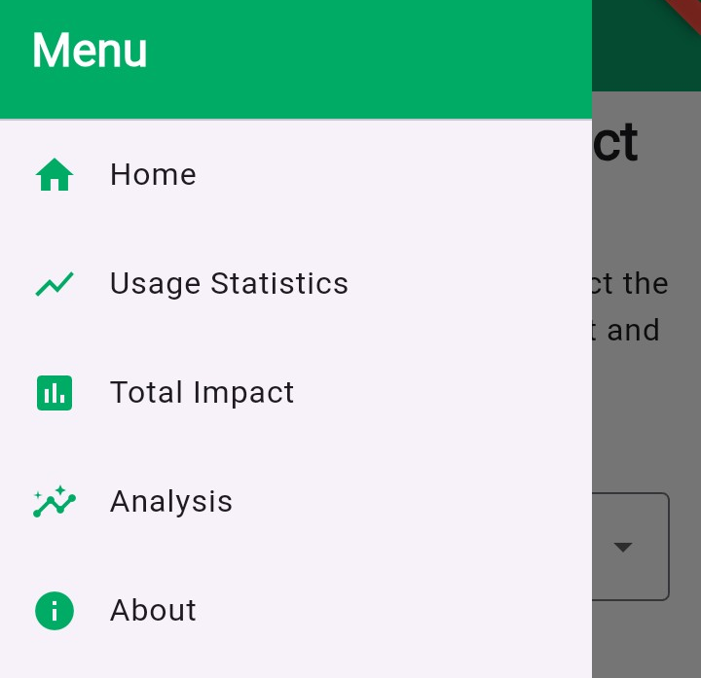
Figure 4 - Main Menu

Code Implementation

Below code is used to fetch the current date app usage data from the native Android method. Each object in the list contains,

{package: "...", minutes: XX.XX, co₂: YY.YY, energy: ZZ.ZZ}

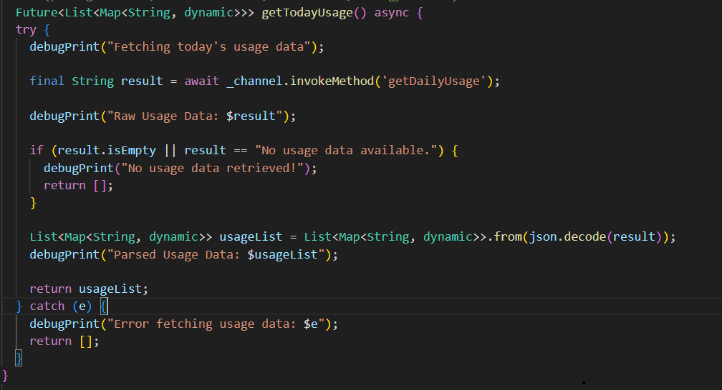
Figure 5

Below code taken from the home screen dart file and it shows how the charts created on the home page.
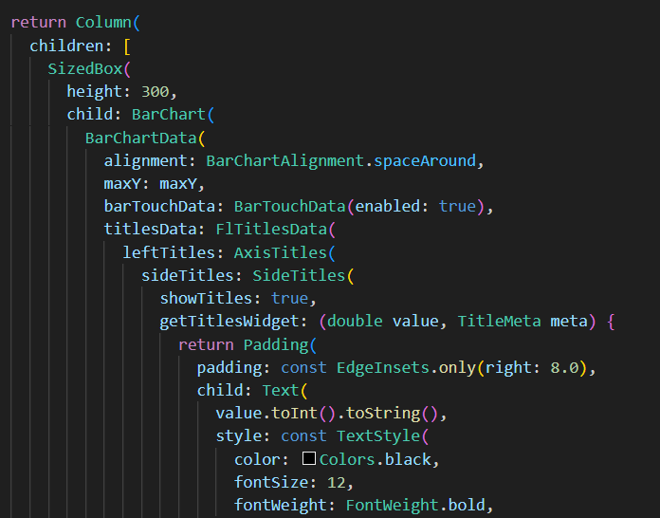
Figure 6

Resutls and Impact
Use of the Eco-Impact Tracker generated useful awareness into environmental impact of social media apps and pointed at battery consumption and CO₂ emissions. The result is based on a system test done by few users.

Comparison of most popular social media apps by energy consumption
Social Media App | Avg. Power Consumption (mAh/hr) | CO₂ Emission (g/hr)
Instagram | 200 mAh/hr | 80 g CO₂/hr
TikTok | 300 mAh/hr | 120 g CO₂/hr
Facebook | 150 mAh/hr | 60 g CO₂/hr
Twitter | 100 mAh/hr | 40 g CO₂/hr
Table 1

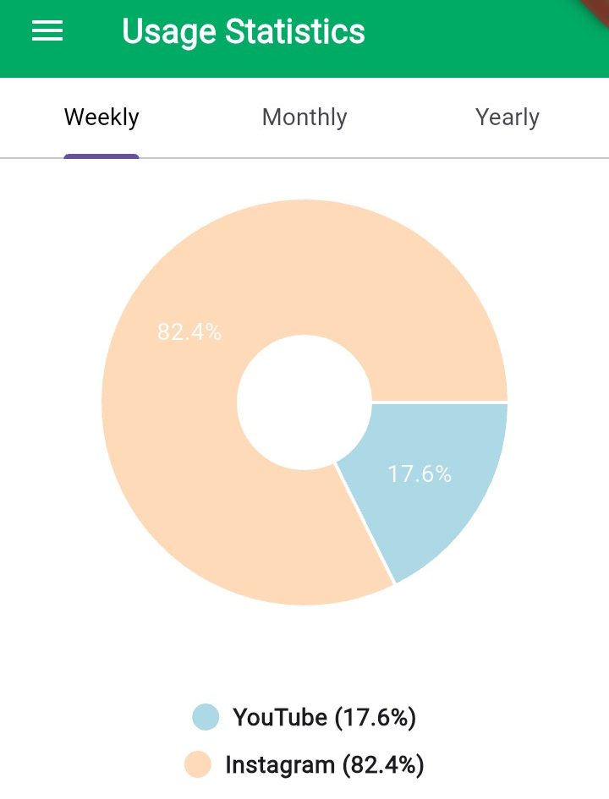
Figure 7 - Usage Statistics

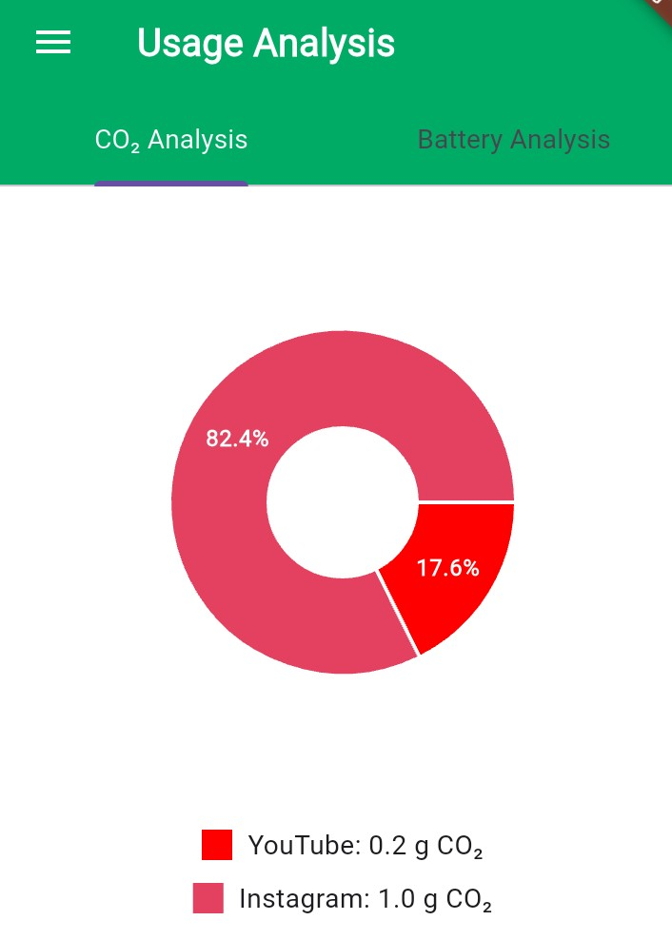
Figure 8 – Usage analysis

Environmental Footprint per App
Data gathered (comparison on Table 1 in Methodology) showed that:
TikTok had the highest environmental impact compared to apps under investigation, with ~300 mAh/hour battery consumption and ~120 g CO₂/hour.

Instagram followed with ~200 mAh/hour and ~80 g CO₂/hour.

Facebook and Twitter show comparatively lower emissions and energy intake (~60 g/hr and ~40 g/hr respectively).

These findings support earlier research by Pramanik et al. [12], which supported that apps with high video and network usage profiles are leading causes of energy consumption. Moreover, they support Huber et al. [11], who classified multimedia-based applications as being the most energy-consuming in mobile environments.

Collected Usage Patterns
By leveraging summation algorithms (see Key Algorithms), the application could total CO₂ and energy consumption across various time periods of varying durations (yearly, daily, monthly). The charts utilized through fl_chart offered simple to interpretable visual signals that updated users on:

- Their most energy-thirsty usage periods.
- Apps with the largest environmental impact.

Device-Wide Estimation Validity
While the app uses indirect methods (folding usage logs and estimating battery usage), it bears comparison with the native tools like BatteryStats and adb dumpsys batterystats on Android. Keysight Technologies' research [13] confirms that estimated battery drops—calibrated—can estimate native measurement with good accuracy.

The results show the different levels of environmental impact per social media app, and the video streaming apps occur the highest emissions due to extended screen time and network usage. [14]

The primary goal of the application is to connect users to actionable information and allow them to act on change in their daily lives. Through gamified functionality, the application makes it both interactive and educational to embrace sustainable digital behavior. Quantitative indicators for user engagement, behavioral changes, and reduction in emissions shall be collected through future research in a larger population.

Discussion
Eco-Impact Tracker provides a fresh approach to raising awareness of the green footprint of social media use on mobile devices. The application utilizes Flutter for cross-platform compatibility and Firebase for backend data handling, utilizing real time monitoring of usage with analytics to forecast CO₂ emissions and battery consumption.

The research clearly indicates that apps like TikTok and Instagram are among the top for energy usage and related carbon emissions. This concurs with [11] and [12] where high frequency performing media apps rank high for their contributions to smartphone energy usage.

The computation algorithms tally usage data and apply models of energy to estimate real time effect. These techniques are compatible with those outlined in [13], and they address energy profiling through device level telemetry.

This project also illustrates the benefit and viability of coming up with creative concepts within an interactive, think-tank type of setting, i.e., the Climathon, and then further refining the selected concept into a tangible product. The collaborative, social environment of the Climathon where likeminded individuals work together and contribute to solving specific issues fosters problem-solving and innovation. Not only generating diverse solutions, but also filling them with fundamental value, which has a direct link to the development of tangible outcomes, such as this mobile app.

The app effectively summons digital carbon footprint consciousness and encourages sustainable practices. By combining intuitive design with learning capability, it offers an easy to use platform that allows users to gain knowledge and reduce the ecological impact of their digital activities. The easy shift from ideation to implementation demonstrates the potential of participatory innovation to bring about positive change in addressing environmental concerns.

The approach, validated through real world use of the devices and supplemented by data visualization, makes end users as well as developers wiser. It not only aids in well informed behavioral change but assists the overall goal of sustainable ICT too.

The study proves awareness of digital sustainability can be increased by the display of real time data. Background app activity and variability in device efficiency should be factored in for higher precision. Future research entails combining AI-based forecasts and personalized suggestions to enhance user interaction and precision [15].

Key Contributions
Leaning on this collaborative platform, the app contributes meaningfully to optimize its potential for a function that drives sustainability:

• Tailored Feedback: Providing users with accurate real time emissions data and comparisons that they can comprehend encourages informed choice.

• Behavioural Insights: The app's clear, focused design avoids overwhelming users, increasing the chances of long term behaviour change.

• Research Potential: In addition to being an educational tool, the app can potentially be an effective tool for further research on digital impacts. Since it collects anonymous user data on digital activity and emissions over time, the app could be useful in the scientific community, revealing information about user behaviors and their environmental influence on a wide scale.

These contributions demonstrate the app's ability to bridge the gap between caring and knowing about the environment, allowing people to institute actual changes in their everyday lives, and advancing the research of digital sustainability through evidence-based research.

Future Improvements
There are a number of enhancements that would make the app even more useful and versatile:

• Accessibility Enhancements: Adding support for different languages, personalized color schemes, and assistive technologies like text-to-speech would make the app accessible to more users.

• Additional Features: Adding push-notifications, goal emission level, and actual data comparison for the user's digital carbon footprint and battery usage would make the application even more effective.

• AI-driven Features: AI based recommendations would analyze user behavior and suggest the best behavior to minimize emissions and battery usage without affecting productivity. This would need to be accomplished in a way that also keeps the carbon emission tracker app's own emissions as minimal as possible.

Further development and potential release of the app must be negotiated with the concept owners beforehand.

Conclusion
The Eco-Impact Tracker application provides a modern, databased approach to measuring the environmental impact of social media use. Written with cross platform development in mind utilizing Flutter, and augmented with live data insights, the application effectively raises awareness of digital carbon emissions and promotes sustainable behavioral modification. Its simple interface and live feedback mechanisms mean the application is an essential tool for those wishing to reduce their digital environmental impact.

The project was conceived during the Climathon Lappeenranta 2024, which is an event that gathers people to innovate together with the possibility of creating feasible solutions to environmental issues. This collaborative environment played a significant role in transforming the idea into actual output that unites users with real-time environmental data.

Whereas current implementation is founded on broad models of energy and emissions, additional enhancement in the future is
necessary to best achieve accuracy. Expanding data sources from regional electricity grid fluctuation, device-specific energy profiles, and broader digital habits background activity and usage of VPNs is necessary to optimize the credibility of the impact calculations.

Moreover, the integration of artificial intelligence will enable personalized suggestions and predictive feedback, prompting the user to adopt greener behaviors based on his or her online behavior. Scaling the tool for broader use, across platforms and digital ecosystems, will also enhance its efficacy.

Ultimately, this article contributes to technology innovation and scientific research in digital sustainability. By bridging the gap between Internet users' behavior and environmental concern, the Eco-Impact Tracker can serve as an effective educational tool for learning, digital self regulation, and further exploration of the environmental cost of Internet use.

Acknowledgements
We are grateful to the participants of Climathon Lappeenranta 2024 and the organizers and sponsors for fostering an environment of innovation. We thank Lappeenranta University of Technology for their assistance. Special thanks to the Climathon Lappeenranta 2024 winners and this application’s concept owners Otto Söderlund, Santeri Tenhunen, and Vilja Tallgren for coming up with the concept idea and allowing us to develop it further.

References
- Greenspector. (2021) Social media: The most energy-consuming apps revealed! [online] Greenspector. Available at: https://greenspector.com/en/social-media-2021
- Mughal, M., Baber, W. and Asad, M. (2022) ‘Digitalization and Environmental Sustainability: A Bibliometric Review’, Sustainability, 14(4), p. 2195. [online] Available at: https://www.mdpi.com/2071-1050/14/4/2195
- Cho, R. (2023) ‘AI’s Growing Carbon Footprint’, State of the Planet, 9 June. Available at: https://news.climate.columbia.edu/2023/06/09/ais-growing-carbon-footprint
- Mughal, M., Baber, W. and Asad, M. (2022) 'Carbon Footprint of The Most Popular Social Media Platforms', Sustainability, 14(4), p. 2195. Available at: https://www.mdpi.com/2071-1050/14/4/2195
- Boncu, Ș., Candel, O.-S. and Popa, N.L. (2022) ‘Gameful Green: A Systematic Review on the Use of Serious Computer Games and Gamified Mobile Apps to Foster Pro-Environmental Information, Attitudes and Behaviors’, Sustainability, 14(16), 10400. Available at: https://www.mdpi.com/2071-1050/14/16/10400
- Reccessary. (2024) ‘Five Apps help you track, offset your carbon emissions’, Reccessary, 30 August. Available at: https://www.reccessary.com/en/news/5-apps-track-your-carbon-emission
- Sustainable Computing: Informatics and Systems, [online] Volume 30, 100555. Available at: https://www.sciencedirect.com/science/article/abs/pii/S2352250X21000555
- Lannelongue, L., Grealey, J. and Inouye, M. (2020) ‘Green Algorithms: Quantifying the carbon footprint of computation’, arXiv preprint arXiv:2007.07610. Available at: https://arxiv.org/abs/2007.07610
- Boncu, Ș., Candel, O.-S. and Popa, N.L. (2022) ‘Gameful Green: A Systematic Review on the Use of Serious Computer Games and Gamified Mobile Apps to Foster Pro-Environmental Information, Attitudes and Behaviors’, Sustainability, 14(16), p. 10400. Available at: https://doi.org/10.3390/su141610400
- Wikipedia contributors. (2024) Yayzy. Available at: https://en.wikipedia.org/wiki/Yayzy
- Huber, B., et al., "Energy Efficiency in Mobile Applications: A Systematic Review," IEEE Transactions on Sustainable Computing, 2023.
- Pramanik, S., et al., "Smartphone Battery Consumption: A Review," IEEE Transactions on Mobile Computing, vol. 22, no. 3, pp. 518-530, 2024.
- Keysight Technologies, "Battery Drain Analysis in IoT and Consumer Devices," 2024.
- Dornauer, T., & Felderer, M., "Energy Consumption in Mobile Web Applications," arXiv preprint, 2023.
- IEEE Standards Association, "Carbon Footprint Measurement in Digital Applications," IEEE Green Technologies Conference, 2023.

