Integration of facial recognition for banking transactions

through Digital Wallet

SECTS ZG628T DISSERTATION

by

Helen Sathya J

BITS ID No. 2021ct93021

Project Work carried out at

Chennai

BIRLA INSTITUTE OF TECHNOLOGY& SCIENCE, PILANI

WORK-INTEGRATED LEARNING PROGRAMMES DIVISION

Second Semester 2022-2023

August, 2023

SECTS ZG628T **DISSERTATION**

Integration of facial recognition for banking transactions

through Digital Wallet

Submitted in partial fulfilment of the requirements of

M. Tech. Software Engineering Degree Program

by

Helen Sathya J

ID No. 2021ct93021

Under the supervision of

Nilesh Amle

Engineering Manager

Project Work carried out at

Chennai

BIRLA INSTITUTE OF TECHNOLOGY& SCIENCE, PILANI

WORK-INTEGRATED LEARNING PROGRAMMES DIVISION

Second Semester 2022-2023

August, 2023

**BIRLA INSTITUTE OF TECHNOLOGY AND SCIENCE, PILANI**

**CERTIFICATE**

This is to certify that the Project Work entitled **Integration of facial recognition for banking transactions through Digital Wallet** and submitted by **HELEN SATHYA J** ID No. **2021ct93021**

in partial fulfillment of the requirements of SECTS ZG628T Dissertation, embodies the work done by him/her under my supervision.

Signature of the Supervisor

Name Nilesh Amle

Designation Engineering Manager

Date: 05-AUG-2023

**BIRLA INSTITUTE OF TECHNOLOGY & SCIENCE, PILANI**

**DSECS ZG628T DISSERTATION**

**SECOND SEMESTER 2021- 2022**

Project Work Title : Integration of facial recognition for banking

transactions through Digital Wallet

Name of Supervisor : Nilesh Amle

Name of Student : Helen Sathya J

BITS ID No. of Student : 2021ct93021

# Abstract*:*

This paper presents a digital general-purpose wallet with face recognition for login authentication and payments, to enhance security and user convenience and user experience. The paramount need of secure and user-friendly wallet systems is necessary in order to enhance the rapid growth of digital transactions. Authentication types like PINs and passwords are more prone to security risks which includes hacking and phishing. Passwords and PINs should be strong in order to avoid hacking and phishing attacks and it will not be easy to remember. Addressing all these challenges, we have proposed face recognition technology as the authentication mechanism. The user’s facial features are captured, cropped, compressed, coverted to base64 string and saved in cloud database. During login and payment processes, digital wallet will utilize the google ml kit algorithms to compare captured facial features with the stored faces. This allows to access the respective user’s account securely. This method of login using facial recognition will enhance the security of the digital wallet by reducing the risk of unauthorized access and simplify the authentication process and improves the user experience. Digital wallet supports payment options like payment using UPI Id, mobile number and QR code. The face recognition integration improves the transaction time of this fast-moving world.

Signature of Supervisor Signature of Student

Nilesh Amle Helen Sathya J

*Note: The Abstract should NOT be longer than one page i.e., it can be around 250 words.*

*The Abstract in the above format should be included in the bound Report, after the Acknowledgements and immediately before the Table of Contents.*

Contents

Abstract*:* 4

Introduction: 8

Goals: 8

Scope : 10

Technologies 10

Tools 11

Modules Covered 11

Login Page: 11

Profile Page: 13

Bank Details Page: 14

Payee Details Screen: 15

Payment Screen: 16

Reports: 17

Logout: 18

User Manual 20

Login and Sign-up using Face Recognition 20

Prerequisites: 20

To register: 20

To log in: 20

Tips for successful face recognition: 20

Troubleshooting: 21

Safety: 21

Limitations: 21

Payee Screen: 22

View your profile: 22

Edit personal information: 22

To add a bank account: 22

To remove a bank account: 22

Safety Tips: 22

Payment Screen 23

Steps to Make a Payment 23

Detailed Steps 23

Payee Screen: 24

Steps to Add a Payee 24

Detailed Steps 24

Steps to Edit or Delete a Payee 25

Bank Details: 25

Steps to Add a Bank Detail 25

Detailed Steps: 25

Steps to Edit or Delete a Bank Detail: 27

Reports 27

Widget Tree: 27

Login Page: 27

Home Landing Page: 28

Add Bank Details: 29

My Profile Details Page 30

Payment Screen: 31

Screenshots : 32

Login Page : 32

Payee Details Screen 32

Home Landing Page 33

Profile Page 35

Add Bank Details Page 36

View Bank Details 37

# Introduction:

Digital wallets, also known as e-wallets or mobile wallets, are virtual platforms that allow users to store, manage, and conduct various financial transactions digitally. They have become increasingly popular as a convenient and secure way to handle money, making them an integral part of the digital payment landscape.

# Goals:

The purpose of a digital wallet is to provide a secure and convenient platform for users to store and manage various financial transactions digitally.

Different payment methods can be used in the digital wallet. The purpose of the digital wallet includes,

Payment Convenience: Digital wallets eliminate the need to carry physical cash or multiple credit/debit cards. Users can make payments quickly and conveniently using their smartphones making it easier to complete transactions in physical stores, online shops, or through mobile apps.

Safety and Security: Digital wallets provides security measures, such as face recognition. This helps protect sensitive financial data and reduces the risk of unauthorized access.

* **Financial Management:** Users can keep track of their transaction histories.
* **Contactless Payments:** Digital wallets enable contactless payments at point-of-sale terminals. This is especially useful for quick and hygienic transactions, which have become increasingly important in modern times.
* **User-Friendly Experience:** User-friendly interface that simplifies the payment process using Face recognition and it eliminates to type the user credentials.
* **Speed and Efficiency:** It reduces the transaction times and enhances the overall efficiency of the payment process.
* **Privacy and Data Protection:** It minimizes the risk of unauthorized transaction using face recognition system.
* **Cross-Platform Integration:** The goal is to integrate face recognition technology across various platforms like android & iOS.
* **Continuous Improvement:** Digital wallet providers continually work on refining and enhancing their face recognition algorithms to improve accuracy and performance.

# Scope :

The digital wallet with face recognition, has various modules like Login, profile, Settings, Bank details, Reports, Analytics, Payment systems, Payees, and recently paid payees, offers a scope of functionalities and benefits for both users and businesses. Here's an overview of the scope of each module:

* **Login:** The face recognition-based login module ensures secure and convenient access to the digital wallet. Users can authenticate themselves by simply showing their face to the device's camera, eliminating the need for passwords or PINs.
* **Profile:** The profile module allows users to manage their personal information, contact details, and preferences. Users can update their profile information, such as name, email address, and communication preferences, as needed.
* **Bank Details:** Users can link and manage their bank accounts within the digital wallet, allowing them to conduct transactions.
* **Reports:** This module provides users to summarize the transaction history.
* **Payment Systems:** The payment systems module handles different payment methods, such as credit/debit cards making it easy for users to choose their preferred payment option.

# Technologies

Flutter, Firebase Firestore

# Tools

VS Code, Android Studio, Android Mobile device.

# Modules Covered

## Login Page:

Login process using **Google ML Kit Face recognition algorithm** and 10-digit generated Face ID authentication system.

* **Sign – up using Real-time Face Recognition:**
  + On the Sign-up page, the system will allow to scan the face using the in-built camera in the android device and it will be registered in the cloud firestore system. Internally the scanned face will be cropped. It will be converted into Base64 image string and compressed before storing into cloud DB. On successful insertion, a 10 digit FaceID will be generated which will be used as alternate way of authentication.
* **Login using Real-time Face Recognition:**
  + On the Login page, the system will be allowed to scan the face using the in-built camera in the android device and it will be validated against the stored biometric facial data in the system. If the perfect match is found in the system the user will be allowed to login to the system and the Landing page will be loaded.
* **Login using FaceID:**
  + On the login page, there will be an option to enter the 10 digit FaceID to validate against the already registered FaceID in the cloud firestore DB. After the successful validation the user will be forward to the Landing page.
* **Security Features in Login Authentication System:**
  + Digital wallet relies on the uniqueness of the facial features provides a very higher level of security. The captured face will be encoded to base64 image string and compressed before storing in the Cloud firestore DB. This prevents unauthorized access.
* **Improved User Experience:** 
  + The use of Face ID offers a seamless and user-friendly login experience. Users can access their digital wallet quickly by merely looking at the camera, eliminating the need to enter lengthy passwords or PINs.
* **Continuous Improvement:** 
  + The face recognition system continually learns and adapts to improve accuracy and performance over time by updating different face recognition algorithm libraries.

## Profile Page:

The profile page allows to manage personal information and sensitive details like bank accounts.

Here's a brief introduction to the key elements of the profile page:

* **Personal Information:** This section displays the essential details associated with your account, such as your name, contact information. It allows you to review and update your information as needed to ensure accurate details.
* **Manage Bank accounts:** The profile page has an option to manage bank accounts. New accounts can be added and existing accounts can be deleted and updated.

The profile page in the digital wallet is a secure and confidential area. Always exercise caution and avoid sharing sensitive information with anyone to maintain the safety of your funds and personal data.

## Bank Details Page:

In this page we can manage and link bank accounts to your wallet, facilitating seamless financial transactions. The key elements and functionalities on the Bank Details page:

* **Linked Bank Accounts:** This section displays a list of the bank accounts that has been linked to the digital wallet. It shows the name of the bank, the account number (partially masked for security), and the account type (e.g., checking or savings). Multiple bank accounts can be added to the digital wallet for added flexibility.
* **Add New Bank Account:** New bank account can be added to the digital wallet, through this option. You'll be prompted to enter the necessary details, such as the bank name, account number, and account type.
* **Remove Bank Account:** Bank accounts can be deleted if it was no longer needed. However, it's essential to ensure that you don't have any pending transactions or obligations associated with the account before removing it.
* **Set Default Bank Account:** Default account can be set for transactions and fund transfers. This account will be automatically selected whenever we perform any financial transactions, but you can change it as needed during the transaction.

## Payee Details Screen:

**Add Payee Screen:**

The "Add Payee" screen is a part of a payment app where users can add new payees to their list of contacts. It contains the following fields:

* **Name:** The user has to enter the name of the payee whom the owner of the digital wallet would initiate transaction to send money.
* **Mobile Number:** The user has to enter the mobile number of the payee. This field is an alternative to UPI IDs.
* **UPI ID:** The UPI ID is a unique identifier associated with the payee's bank account. This is helpful to initiate UPI transactions. Users can enter the payee's UPI ID to add them to their list of payees.
* **Save/Submit Button:** Once the user has filled in the required information, they will click the "Save" or "Submit" button to add the payee to their list.

**View Payee Screen:**

The "View Payee" screen can be used to view the list of all the payees that has been added via the Add Payee screen. It provides the users to make changes such as update or remove the payees. Below details can be viewed in the screen,

* **Name:** Displays the name of the payee.
* **Mobile Number:** Shows the mobile number associated with the payee.
* **UPI ID:** Displays the UPI ID of the payee.

Below options are also available in "View Payee" screen,

* **Edit:** Users can click an "Edit" icon to update their information.
* **Remove/Delete:** Users can choose to remove a payee from their list by clicking a "Remove" or "Delete" button. This action removes the payee's details from their account.

## Payment Screen:

Payments in digital wallets using mobile numbers or UPI IDs offer a convenient and efficient way for individuals to make transactions and send money.

**Mobile Number-Based Payments:**

**Sending Money:** To make a payment in their contact list, users simply select the recipient's mobile number from their list and enter the amount they want to send. The digital wallet app facilitates the transfer, and the recipient is notified of the transaction.

**Security:** Mobile number-based payments are typically secured through PINs, biometrics, or other authentication methods to ensure the safety of transactions.

**UPI ID-Based Payments:**

**Sending Money:** To make a payment using UPI ID, users enter the recipient's UPI ID into their wallet app, along with the payment amount. The app facilitates the transaction, and funds are transferred securely between bank accounts associated with the UPI IDs.

**Security:** UPI ID-based payments are highly secure, relying on multi-factor authentication and encryption to protect sensitive information and transactions.

## Reports:

Reports will be generated in PDF format by selecting a start date and end date and details such as Serial Number, Transaction Date, UPI ID/Mobile, Transaction Note, and Amount will be fetched from a Cloud Firebase database.

**PDF Report Generation Process:**

The report generation process will be initiated when the user selects the start date and end date. When the user clicks the ‘Generate’ button, the transaction details data which contains Serial Number, Transaction Date, UPI ID/Mobile, Transaction Note, and Amount will be fetched from the Cloud Firebase database.

The report typically includes the following information:

* + **Serial Number:** A unique identifier for each transaction.
  + **Transaction Date:** The date and time when the transaction occurred.
  + **UPI ID/Mobile:** The recipient's UPI ID or mobile number associated with the transaction.
  + **Transaction Note:** Any additional notes or comments related to the transaction.
  + **Amount:** The transaction amount.

Once the PDF report is generated, it will be downloaded automatically and the user can able to view the report. Only the logged-in users can able to generate and view the reports.

## Logout:

Logout page will let the user to securely logout of the page using ten-digit FaceID. We have not implemented face recognition for logout feature. This prevents the unauthorized access to the logout feature. Session will be terminated once the user will be logged out. All the sensitive data will be removed from their session including the facial biometric data.

# User Manual

# Login and Sign-up using Face Recognition

## Prerequisites:

* A device with a front-facing camera.
* An internet connection.

## To register:

* Open the app and select the "Register" option.
* Allow the app to access your camera.
* Scan your face by holding the device in front of your face and Crop the face using the cropper. The preferred aspect ratio is 1:1.
* Once your face is successfully scanned, a ten-digit face ID will be generated.
* Take note of your face ID and it can be used for alternate way of login mechanism.

## To log in:

* Open the app and select the "Login" option.
* Allow the app to access your camera.
* Scan your face by holding the device in front of your face and Crop the face using the cropper. The preferred aspect ratio is 1:1.
* If your face is successfully recognized, you will be logged in to your account.

## Tips for successful face recognition:

* Make sure your face is well-lit.
* Avoid wearing sunglasses, hats, or other accessories that may obscure your face.
* Look directly at the camera.
* Keep your face still while it is being scanned.

## Troubleshooting:

If you are having trouble logging in or registering using face recognition, try the following:

* Make sure your device's camera is working properly.
* Make sure you have a good internet connection.
* Try restarting your device.
* Try scanning your face in a different environment.
* If you are still having trouble, please contact customer support.

## Safety:

* Your face ID is a unique identifier and should be kept confidential.
* Do not share your face ID with anyone else.

## Limitations:

* Factors such as poor lighting, facial expressions, and accessories can affect the accuracy of face recognition.

# **Payee Screen:**

## View profile:

* Open your mobile wallet app.
* Tap on the profile icon in the top right corner of the screen.
* You will be redirected to your profile page.

## Edit Profile:

* Tap on the "Edit Profile" button.
* Make the necessary changes to your personal information.
* Tap on the "Save" button to confirm your changes.

## View bank account:

* Tap on the "Bank A/C Details" button to add/view the bank details.

# **Payment Screen**

## Steps to Make a Payment

* Enter the UPI ID or mobile number of the beneficiary.
* Enter a transaction note (optional).
* Enter the amount to.
* Review the payment details.
* Tap on the "Pay" button.
* Enter your UPI PIN.
* Confirm the payment.

## Detailed Steps

* Enter the UPI ID or mobile number of the beneficiary.
* If you are entering the UPI ID, make sure to enter it correctly. UPI IDs are unique identifiers and a single mistake can result in the payment being sent to the wrong person.
* If you are entering the mobile number, make sure to enter the number of the beneficiary's bank account.
* Enter a transaction note (optional).
* A transaction note is a short description of the payment. It is optional, but it is recommended to enter a transaction note so that you can easily track your payments later.
* Enter the amount to be paid.
* Enter the amount to be paid in the field. Make sure to enter the correct amount, including any applicable taxes or fees.
* Review the payment details.
* Before you tap on the "Pay" button, review the payment details carefully to make sure that everything is correct. This includes the UPI ID or mobile number of the beneficiary, the transaction note, and the amount to be paid.
* Tap on the "Pay" button.
* Once you are satisfied with the payment details, tap on the "Pay" button.
* Enter your UPI PIN.
* You will be prompted to enter your UPI PIN to authenticate the payment. Enter your UPI PIN carefully and tap on the "Submit" button.
* Confirm the payment.
* Once you have entered your UPI PIN, you will be prompted to confirm the payment. Tap on the "Confirm" button to complete the payment.

# **Payee Screen:**

## Steps to Add a Payee

* Enter the receiver's name.
* Enter the receiver's UPI ID.
* Enter the receiver's mobile number (optional).
* Tap on the "Save" button.

## Detailed Steps

* Enter the receiver's name.
* Enter the receiver's name in the field. This will help you to easily identify the payee when you are making a payment.
* Enter the receiver's UPI ID.
* Enter the receiver's UPI ID in the field. The UPI ID is a unique identifier for each UPI user. It is important to enter the UPI ID correctly to avoid sending the payment to the wrong person.
* Enter the receiver's mobile number (optional).
* Entering the receiver's mobile number is optional, but it is recommended. This is because you can use the mobile number to send a payment request to the receiver, even if you do not know their UPI ID.
* Tap on the "Save" button.
* Once you have entered the payee's details, tap on the "Save" button to add the payee to your list.

## Steps to Edit or Delete a Payee

* Tap on the name of the payee you want to edit or delete.
* To edit the payee's details, tap on the "Edit" button.
* To delete the payee, tap on the "Delete" button.

# **Bank Details:**

## Steps to Add a Bank Detail

* Enter the beneficiary's name.
* Enter the beneficiary's account number.
* Enter the beneficiary's bank name.
* Enter the beneficiary's branch name.
* Enter the beneficiary's IFSC code.
* Enter the beneficiary's MMID (optional).
* Enter the beneficiary's mobile number (optional).
* Tap on the "Save" button.

## Detailed Steps:

* Enter the beneficiary's name.
* Enter the beneficiary's name in the field. This will help you to easily identify the payee when you are making a payment.
* Enter the beneficiary's account number.
* Enter the beneficiary's account number in the field. The account number is a unique identifier for each bank account. It is important to enter the account number correctly to avoid sending the payment to the wrong person.
* Enter the beneficiary's bank name.
* Enter the beneficiary's bank name in the field. This is the name of the bank where the beneficiary has their account.
* Enter the beneficiary's branch name.
* Enter the beneficiary's branch name in the field. This is the name of the branch of the bank where the beneficiary has their account.
* Enter the beneficiary's IFSC code.
* Enter the beneficiary's IFSC code in the field. The IFSC code is a unique identifier for each bank branch. It is important to enter the IFSC code correctly to avoid sending the payment to the wrong bank branch.
* Enter the beneficiary's MMID (optional).
* Entering the beneficiary's MMID is optional, but it is recommended. This is because you can use the MMID to send a payment request to the receiver, even if you do not know their IFSC code.
* Enter the beneficiary's mobile number (optional).
* Entering the beneficiary's mobile number is also optional, but it is recommended. This is because you can use the mobile number to send a payment request to the receiver, even if you do not know their IFSC code or MMID.
* Tap on the "Save" button.
* Once you have entered all of the required details, tap on the "Save" button to add the bank detail to your list.

## Steps to Edit or Delete a Bank Detail:

* Tap on the name of the bank detail you want to edit or delete.
* To edit the bank detail, tap on the "Edit" button.
* To delete the bank detail, tap on the "Delete" button.

# Reports

## View your reports:

* Open your mobile wallet app.
* Tap on the "Reports" icon in the bottom navigation bar.
* You will be redirected to the reports screen.

## Download your reports:

* Tap on the "Download" button.
* Select the format in which you want to download your reports (PDF or CSV).
* Tap on the "Download" button.

## Safety Tips:

* Be careful when sharing your transaction history with anyone. Only share your transaction history with trusted individuals or organizations.

# Widget Tree:

## Login Page:

TextFormField

Button

Text

## Home Landing Page:

## Add Bank Details:

TextFormField

TextFormField

TextFormField

TextFormField

TextFormField

View Bank Details :

## My Profile Details Page

DataCell

DataCell

DataCell

DataCell

DataCell

My Profile Page:

## Payment Screen:

**Save**

**TextformField**

**TextformField**

**TextformField**

# Screenshots :

## Login Page :

## Payee Details Screen

**Button**

**TextformField**

**TextformField**

**TextformField**

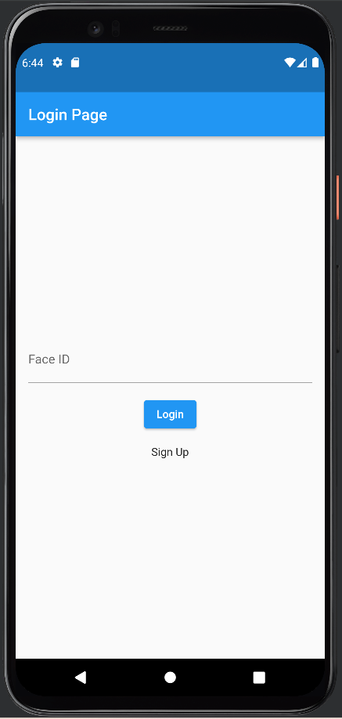

## Home Landing Page

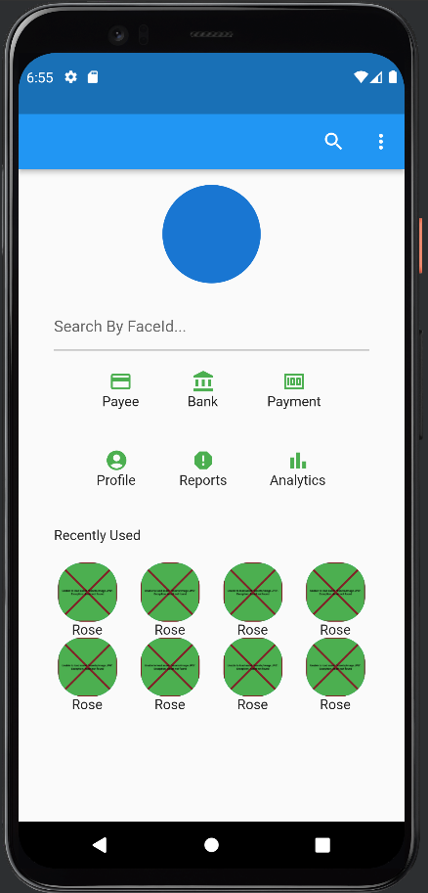

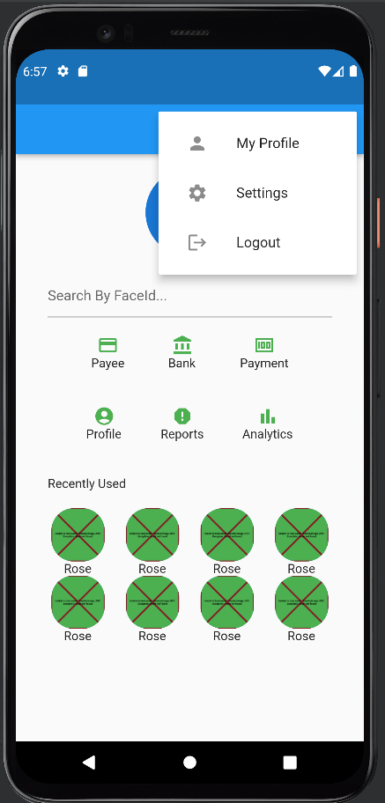

## Profile Page

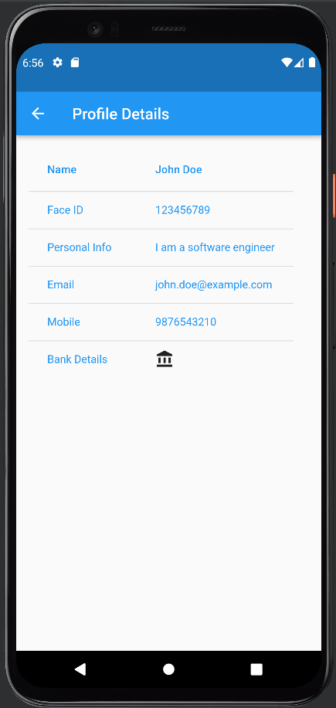

## Add Bank Details Page

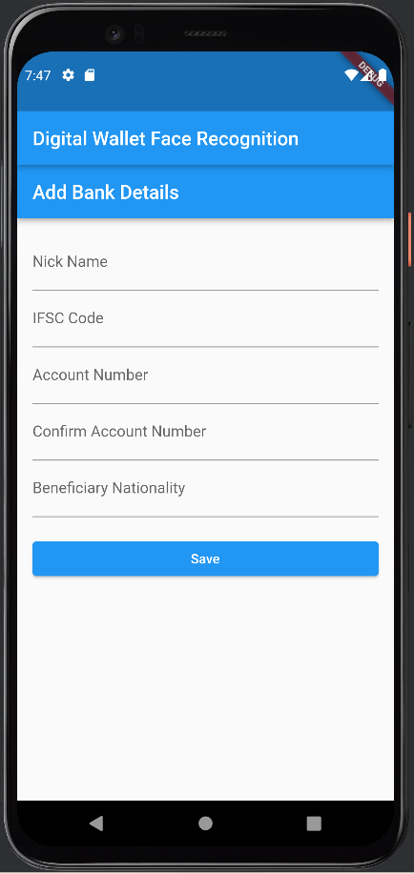

## View Bank Details

