Your name \_\_\_\_\_\_\_\_\_\_\_\_\_\_\_\_\_\_\_\_\_\_\_Voitovich Helen\_\_\_\_\_\_\_\_\_\_\_\_\_\_\_\_\_ Date \_\_\_\_\_\_20.02.2023\_\_\_\_\_\_\_\_\_\_

**Good luck!**

**Introduction to the project:**

|  |  |
| --- | --- |
| Imagine that you are assigned to a new project as a tester.  Testing team: you and test team lead Mike.  This is a small mobile project for iOS.  “Canteen menu” application is developed for a huge company located all over the world. Application is targeted on company’s canteens stuff. It will be used for week menu management (creation, edition, etc).  Canteen employees are equipped with iPads or iPhones X.  After login to the application user (canteen employee) is redirected to “Menu List” screen with the list of menus for different company’s canteens (in different locations), “Country”, “City”, “Canteen” filters.  **New feature “Menu Editor” will be implemented during the upcoming iteration.**  Your task is:   1. Review the requirements for the new feature provided by BA Barbara 2. In case of any questions you have to write email to Barbara with request to clarify your questions 3. Write test cases for the feature 4. Review provided screens with the implemented feature 5. Find and submit bugs in case of any 6. Send test results and your decision about quality of the feature to Mike (\*optional)   **Below you will find requirements for the feature and templates for emails, test cases, bug reports, etc. Please fill in only those templates that you think reasonable in scope of this feature. You can write any additional information if required.** | E:\lectures\Test 3\1.png |
| **Requirements for the new feature:**  AS an administrator  I CAN **create menu**:   1. I am in “Menu List” screen 2. I click “create” button - “Menu Editor” screen opens 3. I type canteen name in “Menu name” field 4. I choose canteen from list and click it 5. I select “To” date from date picker 6. I select “From” date from date picker 7. I click “save” button – “Menu List” screen opens, new menu is added to the list | E:\lectures\Test 3\2crop.png |
| AS an administrator  I CAN **edit menu**:   1. I am in “Menu List” screen 2. I click edit icon C:\Users\Lidziya_Smirnova\Desktop\Icons\89031-200.png - “Menu Editor” screen opens 3. From the dates panel I choose date I want to add dish offers to 4. In dish categories list I choose category I want to add dish offers to 5. If there are no dishes in the category – empty field is displayed 6. If the number of dishes exceeds the screen – the list can be scrolled 7. I can remove dish from the list 8. “Add dish” feature will be implemented later | |
| E:\lectures\Test 3\2.png | E:\lectures\Test 3\2a.png |

**Clarification letter to BA regarding new feature:**

|  |  |
| --- | --- |
| **To:** | Barbara Smith |
| **CC:** | Mike |
| **Subject:** | Clarification of requirements new feature “Menu Editor” |
| Good afternoon, Barbara. My name is Helen. I am an engineer QA of a project developed for you  Need clarification on new feature “Menu Editor”.  Please answer the questions below:   1. can the app work on other devices? 2. what versions of android should the app support 3. whether the application should display correctly on the selected devices 4. Case sensitivity? 5. The need to filter by only 1 parameter? 6. The need to filter by 2 parameters? 7. The need to filter by 3 parameters? 8. Whether it is necessary to change the color scheme of the application? 9. Do I need to highlight active buttons in a different color? 10. Ability to use Cyrillic in the application 11. How should an application respond to interrupts? 12. Can multiple menus be selected at the same time? 13. Should menu names be changed? 14. What should be in the menu editor? 15. Is it possible to search for multiple eateries 16. Do I need a signature for the dining room selection field? 17. The choice of the dining room comes from the drop-down list? 18. Do I need to separate the date windows and label them separately? 19. Whether it is necessary to add the function of manually entering the date, or is the calendar enough? 20. Do you need a calculation of dishes? 21. Do I need to register on the app? 22. Is it possible to change the menu? 23. whether it is necessary that the dining room is searched for by the first letters in the name? 24. How long does it take to implement the "add dish" function? 25. match the name of the fields and buttons   Sincerely, Voitovich H.  [h.voitovich@gmail.com](mailto:h.voitovich@gmail.com) +375445898788 | |

**Test cases for new feature:**

|  |  |  |  |  |  |  |  |
| --- | --- | --- | --- | --- | --- | --- | --- |
| **ID** | **Module** | **Sub-module** | **Summary** | **Steps** | **Expected results** | **Result** | **Comments** |
| AS-1 | Menu | Create menu | Creating a new menu | **Precondition:** 1. “Menu List” opened **Steps:** 1. Press the create button  2. Enter a name in the "Menu Name" field  3. Select the name of the canteen in the canteen selection field 4.select “To” date from date picker  5.select “From” date from date picker  6.press save button | 1.“Menu Editor” screen opens  2.Menu name title is displayed correctly 3. Dining room name displayed in the field 4. The date is selected, it is displayed correctly 5. The date is selected, it is displayed correctly 6. Added menu name, but instead of the weekly menu, an error is displayed | Failed |  |
| **ID** | **Module** | **Sub-module** | **Summary** | **Steps** | **Expected results** | **Result** | **Comments** |
| AS-2 | menu | Create menu | Create a new menu with a date picker | **Precondition:** 1. “Menu List” opened 2.Canteen and menu name selected and displayed correctly **Steps:**  1.select “To” date from date picker  2.select “From” date from date picker  3.press save button | 1.. The date is selected, it is displayed correctly 2. The date is selected, it is displayed correctly 3. Added menu name, but instead of the weekly menu, an error is displayed | Failed |  |
| **ID** | **Module** | **Sub-module** | **Summary** | **Steps** | **Expected results** | **Result** | **Comments** |
| AS-3 | menu | edit menu | Select a menu category to which you can add a dish | **Precondition:** 1. “Menu List” opened  **Steps:**  1. Press the menu name  2. Select a dining room from the drop-down list  3.choose the date for which you want to add food suggestions  4. Click save  5. scroll to the desired dish and click 6.Select the category in the list of dish categories to which you want to add dish suggestions  7. Click add | 1. menu name selected 2. The dining room is selected in the drop-down list  3. .Date selected  4. canteen confirmed 5.The save button is clickable, the data has been saved  6. Category selected  7. The button is clickable, the transition to the page with an error | Failed |  |
| **ID** | **Module** | **Sub-module** | **Summary** | **Steps** | **Expected results** | **Result** | **Comments** |
| AS-4 | menu | edit menu | Remove a dish from the list | **Precondition:** 1. “Menu List” opened  **Steps:**  1. Press the menu name  2. Select a dining room from the drop-down list  3.choose the date for which you want to add food suggestions  4. Click save  5. scroll to the desired dish and click 6.Select the category in the list of dish categories to which you want to add dish suggestions 7. Click on the delete menu button in the menu selection field  8. Click add | 1. menu name selected 2. The dining room is selected in the drop-down list  3. .Date selected  4. canteen confirmed 5.The save button is clickable, the data has been saved  6. Category selected  7. The dish has been deleted, the field is empty 8. The button is clickable, the transition to the page with an error | Failed |  |

**“Menu Editor” feature is ready for testing:**

Developers have finished implementation of “Menu Editor” feature. Build with the feature is released and successfully installed.

When editing the menu you see the following screen:

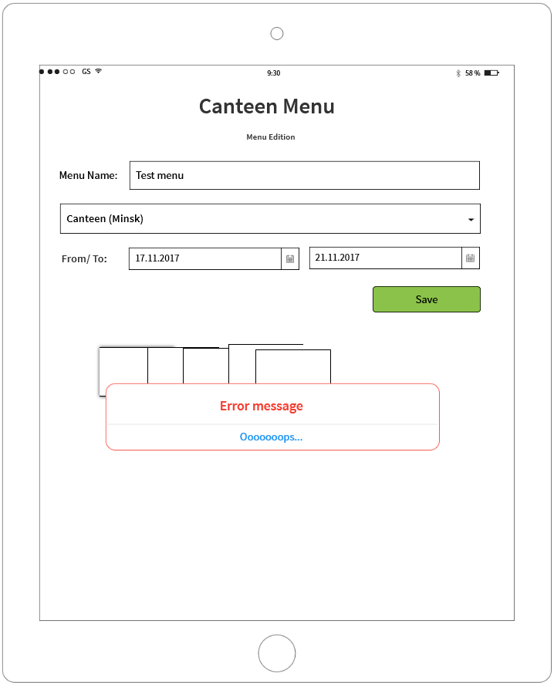

**If you see any bugs in this screen, you can post them below:**

**Bug reports:**

|  |  |
| --- | --- |
| **Bug ID** | **AS-1** |
| **Summary** | Error message when creating a new menu on the Menu List screen |
| **Description** | when creating a new menu on the "menu list" screen, an error occurred, instead of the weekly menu, the user sees an error message |
| **Steps to reproduce** | **Precondition:** 1. “Menu List” opened 2.Canteen and menu name selected and displayed correctly **Steps:**  1.select “To” date from date picker  2.select “From” date from date picker  3.press save button |
| **Severity/Priority** | Critical/ASAP |
| **screenshot** | E:\lectures\Test 3\4.png |
| **environment** | WIN 10 v21H2, GOOGLE chrome v. 1080.5359.99. 1280\*1024 |
| **Reproducible** | Always |
| **workaround** | no |
| **Bug ID** | **AS-2** |
| **Summary** | when saving the selected dates in the list |
| **Description** | When the administrator saves the required menu dates, an overlay of windows and an error window appear |
| **Steps to reproduce** | **Preconditions**: 1.administrator logged into the application  2.“Menu List” opened Steps: 1. 1. Press the create button  2. Enter a name in the "Menu Name" field  3. Select the name of the canteen in the canteen selection field 4.select “To” date from date picker  5.select “From” date from date picker  6.press save button  **Actual result:** Added menu name, but instead of the weekly menu, an error is displayed **Expected result:** The menu on the page is displayed correctly |
| **Severity/Priority** | Critical/ASAP |
| **screenshot** | E:\lectures\Test 3\4.png |
| **environment** | WIN 10 v21H2, GOOGLE chrome v. 1080.5359.99. 1280\*1024 |
| **Reproducible** | Always |
| **workaround** | no |
| **Bug ID** | **AS-3** |
| **Summary** | When saving an edited dish category list on the menu list page, an error is displayed |
| **Description** | when the administrator saves the edited menu (added dishes to the right category), the transition page shows an error |
| **Steps to reproduce** | **Precondition:** 1. “Menu List” opened  **Steps:**  1. Press the menu name  2. Select a dining room from the drop-down list 3.scroll to the desired dish and click  4. choose the date for which you want to add food suggestions  5. Click save  6. Select the category in the list of dish categories to which you want to add dish suggestions  7. Click add **Actual result:** Going to an error page **Expected result:** The offer of dishes has been added, the page is displayed correctly |
| **Severity/Priority** | Critical/ASAP |
| **screenshot** | E:\lectures\Test 3\4.png |
| **environment** | WIN 10 v21H2, GOOGLE chrome v. 1080.5359.99. 1280\*1024 |
| **Reproducible** | Always |
| **workaround** | no |
| **Bug ID** | **AS-4** |
| **Summary** | when deleting a dish from a category and going to the menu page, an error and overlapping windows are displayed |
| **Description** | when the administrator deleted the dish and goes to the application page with the edited menu - error and layering of windows |
| **Steps to reproduce** | **Precondition:** 1. “Menu List” opened  **Steps:**  1. Press the menu name  2. Select a dining room from the drop-down list 3.scroll to the desired dish and click  4. choose the date for which you want to add food suggestions  5. Click save  6. Select the category in the list of dish categories to which you want to add dish suggestions  7. Click on the delete menu button in the menu selection field  8. Click add **Actual result:** Going to an error page **Expected result:** The dish has been deleted, it is not displayed when further scrolling the drop-down list |
| **Severity/Priority** | Always |
| **screenshot** | E:\lectures\Test 3\4.png |
| **environment** | WIN 10 v21H2, GOOGLE chrome v. 1080.5359.99. 1280\*1024 |
| **Reproducible** | Always |
| **workaround** | no |

**Test result report to Test team lead:**

|  |  |
| --- | --- |
| **To:** | Mike |
| **CC:** | Barbara Smith |
| **Subject:** | Test result report new feature “Menu Editor” |
|  | Good afternoon, colleagues.  Below is the test report new feature “Menu Editor”  For the reporting period from 15.12.2022, tasks done: 1. Created Test cases for new feature 2. Test-cases writing - 4: 2.1. Menu – 4  4. Bags found - 4:  4.1 Critical - 4  Plans for next week: continue execution tests  Thank you for your attention, I look forward to your feedback  Sincerely, Voitovich H.  [h.voitovich@gmail.com](mailto:h.voitovich@gmail.com) +375445898788 |

**Thank you!**