**ChatGPT Suff: Non related**

When the sun came up, the town started moving. People went to work or school, and you could smell coffee in the air. Birds sang happily. It was a calm and quiet morning, with lots of things waiting to happen.

In the morning, the town woke up. People went to work or school. The air smelled like coffee. Birds sang. It was a peaceful start to the day, with lots of things to do and explore.

**Funny Jokes**

One morning, he hears a voice in his head.

The voice says, "Quit your job, sell your house, take all your money, and go to Las Vegas." He ignores the voice.

Later in the day, he hears the voice again. "Quit your job, sell your house, take all your money, and go to Las Vegas." Again, he ignores the voice.

Soon he hears the voice every minute of the day. "Quit your job, sell your house, take all your money, and go to Las Vegas."

He can't take it anymore. He believes the voice. He quits his job, sells his house, takes all his money, and flies to Las Vegas.

He sits down, the barber takes his scissors and gets to work. Right before he starts, he asks "How are matters in Ukraine, Mr. President?" Then, a minute later "Is the army fighting well?" Then "How are the Navy operations?" A few more questions like that... at last, Putin snaps:

**Putin**: Listen, what's with all the Ukraine questions?! Does the war really interest you so much?!

**Barber**: No, not really. It's just so much easier to cut your hair while it stands up.

**Not Funny Jokes**

The man looks around, seemingly troubled, and enters the confessional. The priest enters the other side, and waits.

He can hear the man breathing heavily and sighing, but not saying anything. Finally, the priest clears his throat to let him know he's there and can begin. At that, he hears "Sorry man, there's no toilet paper over here either."

So, there's this fella named Joe, right? Now, Joe, he's not your ordinary Joe, no sir. Joe's the kind of guy who walks into a room and everyone goes, "Hey, there's Joe! What's he doing here?" Anyway, Joe decides he wants to be a magician. Not just any magician, mind you, but the greatest magician the world has ever seen. So, he starts practicing his tricks day and night, pulling rabbits out of hats, sawing people in half, you name it.

Well, after years of practice, Joe finally feels ready to unveil his masterpiece: The Vanishing Elephant trick. He rents out the biggest theater in town, hires a bunch of assistants, and invites everyone he knows, plus a few folks he doesn't, because, you know, the more the merrier.

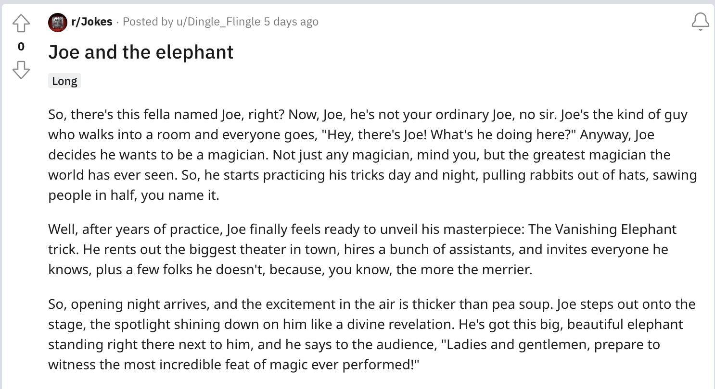

**ChatGPT Doesn’t Work**



Which make sense…