**TASK**

Create new Database called PARTS.

The Database should contain four tables, which must store the following data.

**TABLE – PART**

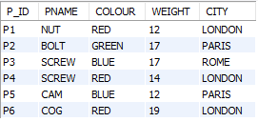

**TABLE – PROJECT**

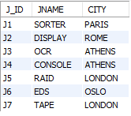

**TABLE -- SUPPLIER**

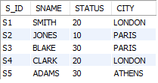

**TABLE – SUPPLY**

