# **QCP population PK report template for LaTeX**

## Settings for RStudio server

The automatic setup for RStudio is to use ‘sweave’ to compile .Rnw files. You need to go in and update these settings to knitr. Further, the typesetting should be XeLaTeX, otherwise the fonts will not work and the file will not compile.

(Tools: Global options)

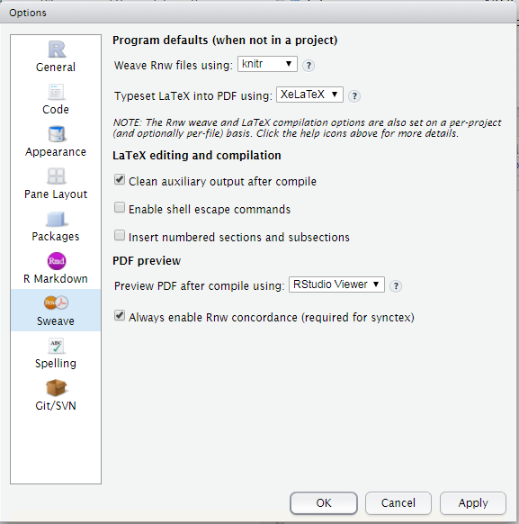

## Explanation of folder structure and how to generate report

### Report

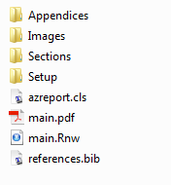

The report is compiled from *main.Rnw* using knitr. This file knits all separate parts (given in Sections, Appendices, Images and Setup) and combines it in to one document. Compilation of the separate sections does not work as they lack important LaTeX information about type of document etc.

Technically, you do *not* need to change anything in *main.Rnw*, changes and writing of text are done in the respective sections/appendices files. If, e.g. for the sake of time, you only want to compile parts of the document, you can comment out some of the ‘knit_child” statements in *main.Rnw*.

*main.pdf* is the generated pdf.

*azreport.cls* is the file generating the right formatting of the document and needs to be in the same folder as *main.Rnw* (described in more detail below)

*references.bib* should contain all the information for citations made in the report. You can easily add new references to the list by copying them into the file. If working with Mendeley you can export a (group of) reference as a bibtex file to automatically get them in the right structure.

### Images

This folder should include the *AZlogo.png*. You can also add other figures here e.g. an analysis overview or other figures that are project non-specific. Project specific graphs should be placed within the Results folder



### Setup

This folder includes two files for setting up the environment.



*setup.Rnw* contains information about the report such as title, author, version, date etc that will be printed on the title page.

*environmentPrep.R* is an R script that loads the project paths etc. that are defined within scripts of the Script directory.

### Sections

This folder contains all the child documents, which build up the sections of the main report. They are automatically numbered and added to the table of content. Tables and figures are automatically added to the list of tables and list of figures when defined as such (\begin{figure} etc.).

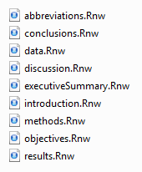

### Appendices

This folder contains all the child documents that produces the appendices. They are automatically numbered and added to the list of appendices. Some of them, which are expected to have many tables and figures have their own table of contents etc. If an appendix is deemed not needed they can just be commented out in *main.Rnw*. If a new appendix is needed use the 0_appendixTemplate.Rnw to set it up.

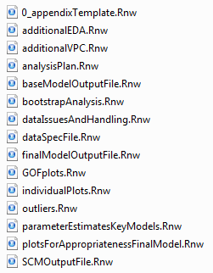

### R environment and knitting of child documents

When compiling/knitting a .Rnw file a *new R session* is opened and the working directory is set to where the file is located. This is true also for the compilation of the child documents.

Hence, all paths in "main" should be relative to the Report folder and all paths given in the different sections and appendices should be relative to Sections and Appendices, respectively. Do ***not*** use setwd() within the script, it will not work.

### General LaTeX and knitr recommendations

To write certain characters such as % or & one need precede it with an escape character, which in LaTeX is backslash. To have R to handle strings with a backslash, it also needs to be proceeded with an escape character (same as in LaTeX). Hence, to get knitr to print a % (in e.g. the table column head), you need to write \\%. That is, \\% if you write it in an R string to be passed to LaTeX and \% if you write directly in LaTeX text mode.

To ensure that the page numbers and hyperlinks for tables and figures are correct, define the \label within the \caption statement.

Using the packages “underscore” makes it possible to use underscores in the text without having to use the escape character \ in front of it. However, this generates issues for inclusion of figures where the file name includes underscores (file not found). To get around this you have to use \string before the underscore in the file name, e.g.

Resources for Latex and knitr:

<https://en.wikibooks.org/wiki/LaTeX>

<https://tobi.oetiker.ch/lshort/lshort.pdf>

<https://www.sharelatex.com/learn/> (don’t go to <https://www.sharelatex.com>, it will prompt you to subscribe…)

<https://yihui.name/knitr/>

### Align to submission ready standards

* Sometimes LaTeX prints text in the margins. The class file avoids it as much as possible but it can still occur. However, this is not accepted by publishing standards. Solution: when done with the report, check the margins and if anything is printed outside (usually very long words, urls or paths) “help” LaTeX by manually adding a hyphen or a space to allow a line-break.
* Available sizes for text.
* Acceptable options for the enumerate environment includes:
  + \begin{enumerate}[1.]
  + \begin{enumerate}[(a)]
  + \begin{enumerate}[(i)]
* Check that fonts are embedded (should occur automatically): Open the pdf in adobe and check that time new roman is an embedded font. If not see here: <https://www.karlrupp.net/2016/01/embed-all-fonts-in-pdfs-latex-pdflatex/>

## Explanation of the azreport.cls

azreport.cls is a latex document class file built upon the article class to match AstraZenecas publishing requirements (4-S5-cv-X Submission Ready Standards.pdf, version 2).

The titlepage, margins, fonts, table of contents, etc has been modified to be aligned with these requirements. Any deviations from the house style has been accepted by publishing representative (pending). In addition, a few functions have been defined to ease the report writing.

### Available functions

|  |  |  |
| --- | --- | --- |
| Function | Purpose | Comments |
| **Document setup** | | |
| \reporttype | Defines the type of documents, which is printed on the title page | Set in setup.Rnw. Defaults to Population PK report |
| \drugname | Defines the name of the drug in use, which prints on the title page | Set in setup.Rnw.  Note, does not work for printing the drug name in the document. Use \Sexpr(drugname) for that |
| \studycode | Defines the study code, which prints on the title page | Set in setup.Rnw. |
| \reportversion | Defines the version, which prints on the title page | Set in setup.Rnw. |
| \reportdate | Defines the date of the report, which prints on the title page | Set in setup.Rnw. |
| \subtitle | Defines the subtitle (commonly clinical studies included), which prints on the title page | Set in setup.Rnw. |
| \reviewers | Defines who reviewed the report, which prints on the title page | Set in setup.Rnw. |
| \approverone | Defines who approved the report, which prints on the title page | Set in setup.Rnw. |
| \approvertwo | Defines who approved the report, which prints on the title page | Set in setup.Rnw. Can be left empty |
| \affiliations | Defines the affiliations, which prints on the title page | Set in setup.Rnw. |
| **Functions to ease cross referencing** | | |
| \fref | Wrapper around \ref which will print “Figure X” instead of just “X” |  |
| \tref | See \fref but for “Table X” |  |
| \eref | See \fref but for “Equation X” |  |
| \sref | See \fref but for “Section” |  |
| \aref | See \fref but for “Appendix X” |  |
| **Other** | | |
| \fnote | Function to add footnotes to figures (and tables?) | Wrapper around unnumbered caption |
| \azappendix | Starts an appendix section and adds it to the list of appendices | Wrapper around section and added to the created list “app”\”loa” |

### Packages loaded within class file:

|  |  |
| --- | --- |
| {Package} and [loaded package options] | Purpose |
| **Packages to deal with toc, lof, lot and loa** | |
| {titletoc} | To enable partial tocs in one documents (needed for appendices) |
| {tocloft} | Needed for customizing the tocs (font size etc) |
| {tocbibind} [numbib,notlot,notlof] | Numbered section bibliography in toc. Excludes the mentioning of lot and lof from the toc |
| **Packages to handle page\paper setup, fonts, and hyperlinks** | |
| {geometry} | Controls the size of headers, footers and margins |
| {fancyhdr} | Better control over content in header/footer |
| {appendix} [title] | Better appendix environment |
| {chngcntr} | Handles counters in appendices |
| {lastpage} | Calculates the total number of pages (used in footer) |
| {fontspec} [Times new roman] | Sets the font to the required TNR |
| {babel} [UKenglish] | Handles languages (in e.g. captions etc.) |
| {amsmath} | Fonts for equations |
| {hyperref} [blue hyperlinks] | Automatically creates active links to all referenced items (sections, figures, tables, etc) |
| {pdflandscape} | To be able to change to landscape |
| {placeins}[section] | Better control over positioning of floats. Loaded with “sections” forces all floats from one section to be printed before the start of a new section. |
| **Packages for external pdfs figures and tables** | |
| pdfpages | To enable inclusion of external pdfs |
| graphicx | For loading of external figures |
| tabularx | Needed? |
| longtable | Multipage spanning tables |
| multirow | Multi-row statements in table |
| hhline | Better control over lines in tables |
| caption | Better functionality of figure and table captions |
|  |  |
| **Other** | |
| enumerate | Numbered lists (AZ allowed versions are “1”, “(a)” and “(i)”) |
| underscore | Underscore is not a special character in text mode |
| natbib | Citations and bibliography |