2018

Helena Vemba

Assignment 1

6/4/2018

Unit 16 – Automated Systems

[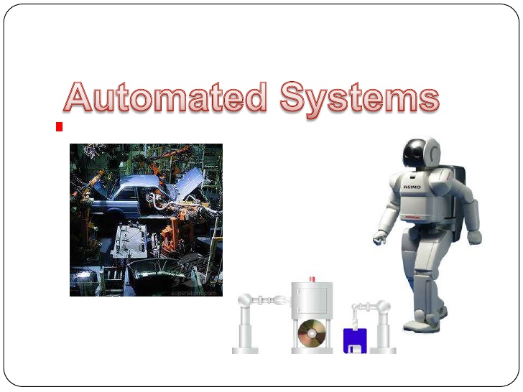](https://www.google.co.uk/url?sa=i&source=images&cd=&cad=rja&uact=8&ved=2ahUKEwi0gNGp1LnbAhWFOBQKHSs-Cg8QjRx6BAgBEAU&url=https://www.slideshare.net/ReinaVino/automated-systems&psig=AOvVaw1hHV_nN_VUvnF828-VEYcu&ust=1528189676795360)

Contents

Introduction 1

Scenario: 2

Automated systems 3

Features and characteristics of automated systems 4

The benefits of automated systems 4

How automated systems work 5

Why automated systems are used 5

Use flow charts to represent processes within basic control programs. 7

Discuss the strengths and weaknesses automated systems. 8

# Introduction

This assignment is aimed investigate two different automated systems also to explain/Understand features and characteristics of automated systems , identify the benefits , how automated systems work and why automated systems are used to gain knowledge about the automated systems which may be useful in the future and. As you can clearly see I choose to write about self-driving cars and traffic lights.

# Scenario:

You have been employed by an electronics company that specialise in developing automated systems for use in a domestic setting.

Your role within this company is to plan, develop and test a prototype home automation system that will allow the user to do the following things:

• Detect the temperature and set an alert to go off when it drops below a specified point

• Use smart lighting where lights will turn on when a sensor detects that the room has become too dark

• Set an intruder alert where a light will turn on when a sensor has been disturbed

The purpose of this automated system is to demonstrate how common domestic features can be automated using technology.

This system has the potential to be aimed at elderly or disabled individuals who would have difficulty in manually performing the automated tasks.

You will have a set timeframe of one academic college term to complete the practical task of setting up and testing the system.

There are no costs attached to this project as you will be working within a controlled environment.

Your automated system will be designed to work in an internal, dry environment.

# Automated systems

A computerized statistics device (AIS) is a meeting of laptop hardware, software, firmware, or any aggregate of these, configured to accomplish specific information-handling operations, such as communication, computation, dissemination, processing, and storage of information. Automated systems contain hardware devices that are controlled by software programs that undertake specific activities based on inputs and outputs. The images below show examples of automated systems that I choose to talk about in this assignment.

[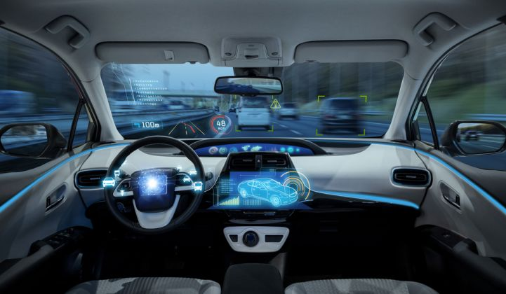](https://www.google.co.uk/url?sa=i&source=images&cd=&cad=rja&uact=8&ved=2ahUKEwjfs4WZjrvbAhXKchQKHRHyC-kQjRx6BAgBEAU&url=https://www.greentechmedia.com/articles/read/fully-autonomous-vehicles-decade-away-experts&psig=AOvVaw00Ej8JgOIyhgSiX7PWU-eG&ust=1528239560653343)[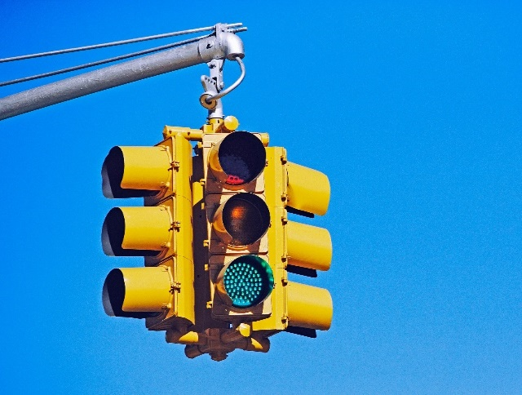](https://www.google.co.uk/url?sa=i&source=images&cd=&cad=rja&uact=8&ved=2ahUKEwjZ8Ln73rnbAhUHOxQKHad9AiEQjRx6BAgBEAU&url=https://www.wired.com/2016/10/enlighten-app-uses-ai-predict-lights-will-turn-green/&psig=AOvVaw2xBdZPXC7P7lD4lHdazaP5&ust=1528190717456982)

# Features and characteristics of automated systems

Traffic light:

Sensors allows people to stop having accidents by using red – stop, Green to proceed with caution, amber to stop if it is unsafe to do so, indicating it will turn green some of them have sound sensors as well to let

Autonomous cars:

Self-cars have sensors such as radar sensors, [autonomous cars have bumper-mounted radar sensor](http://www.mouser.com/applications/autonomous-car-sensors-drive-performance/)  to help the vehicle detect road such as traffic delays, accidents (collisions) and other type of obstacles that it may happen also radar determinates the location, with artificial intelligence, there is no need of human because the vehicle is programmed to drive itself , laser sensors that sends to the car's brain to precede . Camera is used to identify road and traffic signals to help the driver to drive safely during their journey also the technology that is behind of the cameras function are like the human eye also have mini-computers (central computers) on board to. GPS navigational software that shows all the roads, chooses the best path for the driver.

# The benefits of automated systems

Traffic Lights: The benefit of traffic light is to control and prevent accidents for example at many of busiest streets in the world and dual carriageway intersections, yellow for warning as the lights change, crimson for stop in that way everyone will be aware of that, the purpose is to facilitate the protected movement of cars, to avoid collisions even for pedestrians and cars.

Autonomous cars:

The self-driving cars have speed sensors to detect the speed of the car when it is driving it is which are connected to the pump valve. Automated cars can perform all driving tasks under certain circumstances like pre-safe systems, such as stopping the car or parking the car. In these circumstances, the driver must be prepared to re-take control and is still required to be the most driver of the vehicle also automated cars is that there is a anti brake lock system that does the braking for the driver. Traffics signals have been found to extend activity dealing by with capacity. They can be introduced different conditions also they are valuable devices that improves efficiency and safety of both vehicular and pedestrian traffic. In most cases, these devices reduce accidents such as broadside collisions.

# How automated systems work

Autonomous cars: Self-cars are developed by complex systems that allows cars to drive themselves, gps determinates the car position and the location, camera detects the traffic light so in that way will let the car know if it has to proceed or stop or also let the car know that are other objects (cars, pedestrians) moving and the radars in the cars is to make sure that it maintains the distance from other cars.

Traffic Lights: Rather than timers, "smart" or "intelligent" sensor-based site visitors’ signals remember upon a device of sensors to discover when vehicles are present. ... When a car on a side avenue arrives at the intersection, a sensor will notice it and cycle the lights to permit visitors on the facet road to skip through.

# Why automated systems are used

Traffic Lights: this type of automated systems are used to prevent/avoid collisions between cars and cars or pedestrians.

Autonomous cars:

To help people drive more safety without too much concerns and it has more befits than a non-driverless car such in terms of gps chooses the best path for the driver also lets the driver know where is traffic or accidents..

# Use flow charts to represent processes within basic control programs.

Autonomous cars:

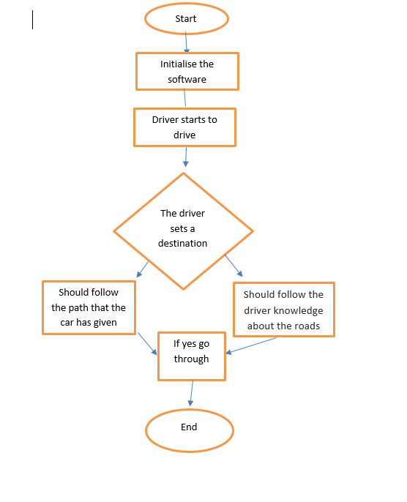

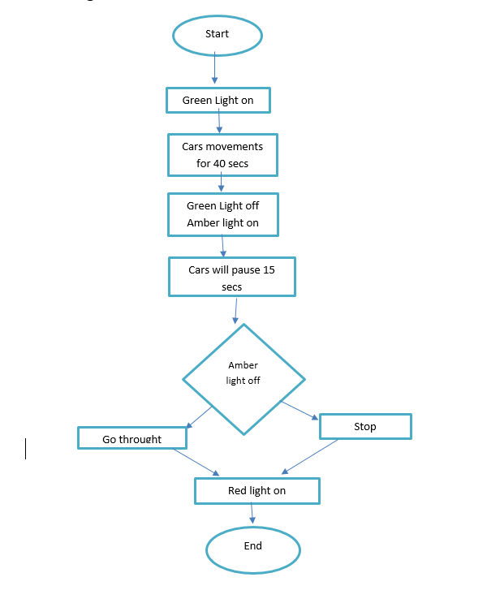Traffic Lights:

# Discuss the strengths and weaknesses automated systems.

***Strengths and Weaknesses* of Traffic lights**

Traffic lights relay messages on what motorists and pedestrians should do and what they should not to avoid accidents. The major function of a traffic signal is to aim to the way to avoid conflicting traffic movements at intersections also is a technique of time separation also some people don’t concentrate when they are on the road because they are too busy doing different things when they are driving so with automated car there would be a lot less accidents on the road because people would not have to drive. The essential objective of the activity build is to accomplish the most secure and most productive by and large activity stream conceivable. In other hand a disadvantage of traffic light is the fact that hackers can hack into the system and find out your location, where you have driven to and they can control the system. In addition to an increase in rear-end accident frequency, unjustified traffic signals can also cause delays .Traffic light are 24/7 switched on which is a high cost of electrical power that is consumed to operate

**Strengths and Weaknesses of Autonomous cars**

Speed limits could be increased to reflect the safer driving during journey times, there is entertainment technology, such as video screens, could be used for long journeys but could be bad because can distract the driver. Traffic can be coordinated more easily in urban areas to prevent long traffic at busy times. It reduces tiredness from driving, parking the vehicle is easier and less stressful because helps you parking and the driver which there is no need of parking skills. This also can be good opportunity for people with difficulties with driving such as disabled people and older people to drive. Efficient travel requires fuel savings, it reduces the need for safety gaps means that road capacities for vehicles would be increased also self-aware cars leads to a reduction in car theft. One of the weaknesses is the fact that will reduce services such as truck drivers and taxi drivers will lose their jobs because as autonomous cars will take over in few years. If the vehicle has a glitch can cause crashes also hackers can hack the systems and take over the car control and it can use for good or bad way such as causing accidents to the driver or could just be software designer issue. Autonomous cars operative systems can face problems as well with weather for example with heavy rain or snow which can interfere with the car camera. Drivers become lazier and get used to not driving which is bad for their proficiency they will forget how to drive with normal cars. If the vehicle software is not update in terms of new road, traffic and street lights drivers may get lose or take longer to get in the destination that they want.