Machine Learning Methods for Continuous Glucose Monitoring Data and their Potential in Cardiovascular Risk Assessment
Helene Bei Thomsen
2026
Table of contents

Supervisors and Assessment Committee

Cover Page

PhD Dissertation
Department of Public Health
Faculty of Health
Aarhus University


Disclosures and Notes

Financial Disclosures
This PhD project was supported by a research grant from the Danish Diabetes and Endocrine Academy (NNF22SA0079901) and the Danish Cardiovascular Academy (NNF20SA0067242), which are funded by the Novo Nordisk Foundation. Furthermore, the project was supported by the main supervisor’s Data Science Emerging Investigator grant from the Novo Nordisk Foundation (NNF22OC0076725),
Logoes from funders are not shown in rendered pdf on github. Even though the official dissertation contains them due to technical issues

Acknowledgements
Completing this PhD dissertation would not have been possible without the guidance, support, and encouragement of many people. I would therefore like to express my sincere gratitude to everyone who contributed to this work and supported me throughout my PhD journey.
First and foremost, I would like to thank my main supervisor, Adam Hulman. Your guidance and support have been invaluable throughout the past three years. Your creative ideas and extensive knowledge of both epidemiology and data science have strengthened this project and equipped me with valuable skills that I will carry into the next stage of my career. Thank you for giving me this opportunity, for believing in me, and for securing the funding that made part of this PhD possible.
I am also deeply grateful to the other members of my supervisory team. When changes in my original supervisory team disrupted the initial plans for the project during the first month of my PhD, Anders Aasted Isaksen, Guy Fagherazzi, and Signe Toft Andersen generously stepped in to help guide the project forward. Anders, I am sincerely grateful for the time, effort, and support you contributed to the scoping review. Your exceptional technical abilities, combined with your clinical expertise, have made you an important source of advice and inspiration. I am equally grateful for the welcoming and accepting atmosphere you helped create in the research environment at Steno Diabetes Center Aarhus and your awesome quarto template for the PhD dissertation. Guy, thank you for your insightful comments and for welcoming me into your research group during my stay at the Luxembourg Institute of Health. I am particularly grateful for the opportunity to meet and work alongside your wonderful team, participate in the team retreat, and feel so genuinely included throughout my visit. Signe, thank you for giving me the opportunity to work with the CANCAN data after access to the originally planned data was lost. Your clinical expertise, thorough explanations, and consistently positive attitude have been both encouraging and inspiring. Our discussions have been among the most enjoyable and eye-opening parts of my PhD.
I would also like to thank Ole Nørgaard and Tue Helms Andersen for their expertise and assistance in developing the literature-search strategy. Your guidance greatly improved the quality of this dissertation and taught me how to conduct literature searches in a more systematic and rigorous manner. Thank you to Benjamin Lebiecka-Johansen and Livie Yumeng Li for their technical assistance with GenomeDK, and to William P. T. M. van Doorn for providing coding support and generously offering help when needed. Thank you to Sanne Fisker for allowing me to accompany her in the clinic and for showing me how the Steno T1D Risk Engine can be used in conversations with patients. Observing these consultations gave me valuable insight into the complex and challenging task of supporting people with diabetes in making decisions about their health. I am also grateful to Tibor V. Varga for welcoming me to visit his research group at the University of Copenhagen and for sharing his expertise in algorithmic fairness.
I feel fortunate to have met so many wonderful people at Steno Diabetes Center Aarhus (SDCA) and through the Graduate School of Health at Aarhus University. You made me feel welcome, and I never felt isolated or alone during this project. Through the PhD Association at Health, I had the opportunity to meet fellow PhD students from many different research fields, exchange experiences, and find support in navigating the practical and administrative aspects of PhD life. I am equally grateful to my colleagues and office mates at SDCA, who ensured that there was always someone with whom to share a conversation or a lunch break. Livie, Nina, Manu, Jonas, Jie, Thien, and many others. Your company has meant more to me than you may realize.
I would also like to express my sincere gratitude to the Danish Diabetes and Endocrine Academy and the Danish Cardiovascular Academy for funding this PhD project, believing in its potential, and providing valuable courses and opportunities to develop professional networks. The communities created by the academies have enriched my PhD experience and made this project possible. I am also grateful to Julie and Inger for always responding quickly and patiently whenever the administrative aspects of travel and other practical matters became confusing.
Finally, I would like to thank my friends and family for supporting me beyond my academic work. Getting an eight-week-old puppy in the middle of a PhD may have been a slightly ambitious decision, but it all worked out, with a great deal of help. Above all, thank you to my parents for the many hours of puppy-sitting and for always stepping in when I needed to travel or when work became particularly demanding. I am also deeply grateful to Astrid, Anna, Livie, Nina, Yasmina and Daniel for bringing food, looking after my puppy, giving feedback and helping me whenever I needed it. Thank you all for being there for me and for supporting me throughout this journey. Lastly, thank you to my dog Bonnie for bringing joy and balance to my life and for always making even the most difficult working days a little brighter.

Papers in the Dissertation

Study I
Thomsen, H. B., Lebiecka-Johansen, B., Nørgaard, O., Andersen, T. H., Andersen, S. T., Fagherazzi, G., Hulman, A., & Isaksen, A. A. (2026). Continuous Glucose Monitoring–Derived Metrics and Cardiovascular Risk Among People With Diabetes: Systematic Scoping Review. JMIR Diabetes, 11(1), e89374. https://doi.org/10.2196/89374

Study II
Thomsen, H. B., Andersen, S. T., Fagherazzi, G., Isaksen, A. A. & Hulman, A. (2026). Foundation model–derived representations of continuous glucose monitoring data: relation to glycemic patterns and cardiovascular risk. (Submitted to JMIR Diabetes on July 14, 2026.)

Study III
Thomsen, H. B., Li, L. Y., Isaksen, A. A., Lebiecka-Johansen, B., Bour, C., Fagherazzi, G., Doorn, W. P. T. M. van, Varga, T. V., & Hulman, A. (2025). Racial disparities in continuous glucose monitoring-based 60-min glucose predictions among people with type 1 diabetes. PLOS Digital Health, 4(6), e0000918. https://doi.org/10.1371/journal.pdig.0000918

Abbreviations
AGP: ambulatory glucose profile
AID: automated insulin delivery
AUROC: area under the receiver operating characteristic curve
CGM: continuous glucose monitoring
CV: coefficient of variation
CVD: cardiovascular disease
eGFR: estimated glomerular filtration rate
GMI: glucose management indicator
HbA1c: hemoglobin A1c
HDL cholesterol: high-density lipoprotein cholesterol
IGLU: Interpreting Glucose Data from Continuous Glucose Monitors
LDL cholesterol: low-density lipoprotein cholesterol
LMEM: linear mixed effect model
LOCF: last observation carried forward
LSTM: long short-term memory model
MAGE: mean amplitude of glycemic excursions
MBG: mean glucose
NT-proBNP: N-terminal pro-B-type natriuretic peptide
RMSE: root mean square error
SCORE2-Diabetes: Systematic Coronary Risk Evaluation 2-Diabetes
SD: standard deviation
SEG: Surveillance Error Grid
SMBG: self-monitoring blood glucose
T1D: type 1 diabetes
T1DX: T1D Exchange
T2D: type 2 diabetes
TAR: time above range
TBR: time below range
TIR: time in range
UMAP: uniform manifold approximation and projection

1. Introduction

1.1 Diabetes
Diabetes is a metabolic disease characterized by high blood glucose levels known as hyperglycemia.^{1,2} The most common forms of chronic diabetes are type 1 diabetes (T1D) and type 2 diabetes (T2D).¹ T1D is an autoimmune disease characterized by the destruction of the pancreatic islet $β$-cells, leading to an absolute insulin deficiency.³ T2D is the most common form of diabetes and in contrast to T1D it generally begins with insulin resistance in which the body’s cells become less responsive to insulin.^{1,4} Insulin lowers blood glucose by promoting glucose uptake in insulin-sensitive tissues, particularly skeletal muscle and adipose tissue, and by stimulating glycogen synthesis in the liver. As an anabolic hormone, insulin also promotes energy storage and may contribute to weight gain.⁵ Initially, the pancreas compensates by increasing insulin secretion, however over time progressive $β$-cell dysfunction results in inadequate insulin production to meet the body’s demands.^{1,2,4} Despite their distinct underlying pathophysiology, both T1D and T2D are characterized by chronic hyperglycemia.
Diabetes can be diagnosed based on a bloodtest to check hemoglobin A1c (HbA1c) levels or through plasma glucose criteria (?@tbl-diagnosis_criteria).^{3,6}
Although both plasma glucose tests and HbA1c measurements are appropriate for diabetes screening, the HbA1c measurement has several advantages.³ Some of the benefits are that it requires no fasting and it is less sensitive to stress and changes in nutrition.³ HbA1c is an indirect measure of blood glucose levels because glucose binds to hemoglobin over $∼$ 120 days lifespan of erythrocytes (red blood cells).³ However HbA1c testing is not always accessible, affordable or suitable (e.g., for people with anemia or under HIV-treatment).³

1.2 Blood Glucose Monitoring
A common treatment goal for non-pregnant adults with diabetes is for HbA1c to be below 53 mmol/mol and not have any hyperglycemia or hypoglycemia (low blood glucose levels).^{7,8} This corresponds to an estimated average glucose of 8.6 mmol/L.⁷ However HbA1c goals should be individualized to fit each individual’s specific situation and may be higher or lower than 53 mmol/mol.^{7,8} There are two tools available for self-assessment of glycemia, the self-monitoring blood glucose (SMBG) device measuring capillary blood with finger-sticks, and the continuous glucose monitoring (CGM) device measuring interstitial fluid (fluid around and between cells) continuously.^{8,9} Both monitoring devices have shown to improve glycemic control in people with diabetes, however the CGM devices are superior when it comes to immediate information and alerts on asymptomatic hypo- and hyperglycemic events and provide a comprehensive glucose profile including both pre- and postprandial blood glucose measurements.^{8,10,11}

Continuous Glucose Monitoring and Automated Insulin Delivery
The CGM devices measure the glucose in the interstitial fluid, which corresponds with plasma glucose although a lag can appear when glucose levels rise or fall rapidly.¹² Use of CGM devices has shown to improve glycemic control in both T1D and T2D with improvements in HbA1c levels and more time spent in target range (standard: 3.9-10 mmol/L) regardless of age, sex, eduction and income.^{7,12} CGM devices focus on monitoring and it is possible to get an ambulatory glucose profile (AGP) report from the devices (Figure 1.1). The AGP report shows summary statistics over all data (usually a two weeks period) including CGM-derived metrics as shown in (Table 1.1).¹⁰ Besides monitoring, data from CGM devices are now used in combination with insulin delivery systems to automate the process of administering insulin.¹² automated insulin delivery (AID) systems typically use data from CGM devices to determine or adjust insulin delivery. The simplest AIDs are threshold-based low-glucose suspend systems in which insulin delivery is automatically suspended when blood glucose levels drop below a predefined threshold.¹³ AID systems are becoming increasingly sophisticated, with the long-term goal of approximating the physiological regulation of glucose by a healthy pancreas. However, the delayed onset and peak action of subcutaneously administered insulin limit the ability of these systems to respond rapidly to changing glucose concentrations.¹⁴ Consequently, accurate short-term glucose forecasting has become increasingly important, particularly for anticipating postprandial glucose excursions and enabling earlier insulin adjustments to reduce the risk of both hyper- and hypoglycemia.¹⁴ More advanced systems are beginning to utilize additional information such as carbohydrate intake and physical activity to optimize insulin delivery.^{15,16}
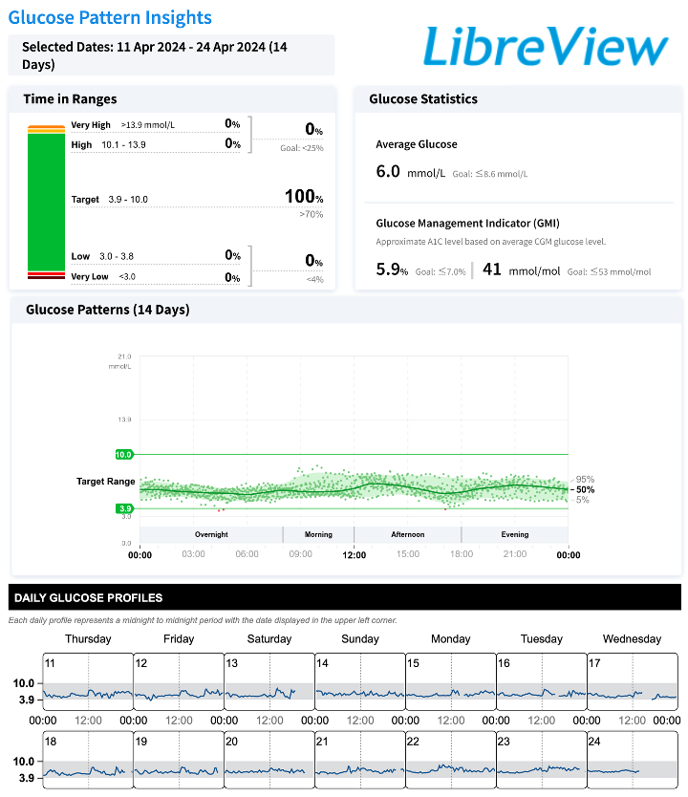
Figure 1.1: Ambulatory glucose profile report from female without diabetes. Data points are from the author herself using an intermittently-scanned (Manuel data upload) FreeStyle LibreLink sensor.

1.3 Glycemic Control and Variability
A challenge in achieving good glycemic control is keeping blood glucose levels low enough to reduce the risk of long-term complications, while avoiding hypoglycemia, which can cause acute symptoms and, in insulin-treated individuals, may be life-threatening.¹⁷ The variability in the blood glucose fluctuations needs to be reduced in order to lower the average blood glucose levels while still avoiding hypoglycemia.¹⁷ Advances in CGM technology have enabled the quantification of glucose variability, a measure of the extent of fluctuations in blood glucose levels over time, including both peaks and nadirs.¹⁸ Describing the variability is important because two individuals with similar HbA1c levels may exhibit different glycemic variability profiles.¹⁷ Numerous metrics have been developed to characterize different aspects of glucose variability, but no single measure captures all of its dimensions. Although international consensus recommendations advocate the routine reporting of glucose variability using coefficient of variation (CV), mean amplitude of glycemic excursions (MAGE), and standard deviation (SD), with particular emphasis on CV,¹⁰ glucose variability encompasses multiple dimensions, including within- and between-day variability, the amplitude of glucose excursions, and temporal glucose patterns.¹⁷ As a result, no single metric has been shown to comprehensively capture all aspects of glucose variability, and no consensus currently exists regarding the optimal measure.^{17,18}

1.4 Cardiovascular Diseases and Heart Failure
Although advances in diabetes management have reduced the incidence of several diabetes-related complications, cardiovascular disease (CVD) remains a major cause of morbidity and mortality in people with diabetes.^{19–21} Chronic hyperglycemia can lead to long-term complications such as atherosclerotic CVD, although the progression and manifestation of these complications vary between individuals.³ Identifying individuals at increased risk of CVD or heart failure before clinical disease develops is therefore an important component of diabetes care.²⁰
Heart failure is at least twice as prevalent among people with diabetes as in the general population.^{20,22} It is characterized by symptoms such as breathlessness, fatigue, and ankle swelling, which may be accompanied by clinical signs such as elevated jugular venous pressure, pulmonary crackles, and peripheral oedema.²³ Heart failure may present as either acute or chronic, with acute heart failure typically involving rapid onset or worsening of symptoms and signs.²³ In individuals with suspected chronic heart failure based on risk factors, symptoms, clinical findings, and supporting investigations such as electrocardiography, measurement of natriuretic peptides, including N-terminal pro-B-type natriuretic peptide (NT-proBNP), is recommended as part of the diagnostic work-up.²³ An NT-proBNP concentration of ≥125 pg/mL or higher indicates the need for further cardiac evaluation, whereas concentrations below this threshold make chronic heart failure unlikely and alternative diagnoses should be considered.²³ Although NT-proBNP levels may be influenced by non-cardiac factors, including age, ischemic stroke, and renal dysfunction,²³ it remains clinically useful in the assessment of individuals at increased risk of chronic heart failure.

1.5 Cardiovascular Risk Prediction Models
To facilitate early identification of individuals at increased cardiovascular risk, several clinical prediction models have been developed.^{21,24–26} By estimating the probability of a CVD event within a specified time horizon, these models can increase awareness of cardiovascular risk, encourage adherence to recommended lifestyle changes and medical treatment, and help identify individuals who are most likely to benefit from preventive interventions.²⁷ Among these, the Systematic Coronary Risk Evaluation 2-Diabetes (SCORE2-Diabetes) model estimates the 10-year risk of CVD in individuals with T2D. It was developed and calibrated using European cohorts, making it particularly relevant for the Danish cohort included in this dissertation.²¹ However, the SCORE2-Diabetes model relies solely on traditional clinical variables, including age, sex, smoking status, systolic blood pressure, high-density lipoprotein cholesterol (HDL cholesterol), age at diabetes diagnosis, HbA1c, and estimated glomerular filtration rate (eGFR), and does not incorporate information on glucose dynamics beyond the long-term glycemic exposure reflected by HbA1c.²¹ HbA1c has been independently associated with risk of heart failure,²⁸ however it does not capture the short-term glucose fluctuations, which may be associated with the progression of vascular complications in diabetes.²⁹

1.6 Association vs Prediction
Association and prediction are distinct analytical objectives, although the terms are sometimes used interchangeably in the medical literature. However the distinction is necessary because associations do not necessarily imply predictive utility.³⁰ Association studies aim to identify relationships between variables and an outcome at group level, whereas prediction models are developed to estimate future outcomes for individual patients.³⁰
Traditional statistical association modelling is often used to test hypotheses regarding associations between exposures, $X$ and outcomes, $Y$.³¹ Regression models applied to observational data are commonly used to evaluate hypotheses derived from prior knowledge, where the choice of exposures is guided by existing theory.³¹ These approaches are based on the premise that the chosen statistical model adequately represents the underlying data-generating mechanism, allowing conclusions to be drawn from the estimated model parameters.³² Results from association studies are typically summarized using estimated effect measures, such as regression coefficients, odds ratios, hazard ratios, or risk ratios, together with confidence intervals and significance tests.³⁰
In contrast, prediction modelling applies statistical models to predict future outcomes, $Y$ based on a set of predictors, $X$.³² Prediction models may be implemented using a wide range of approaches, including regression models, decision trees, and machine learning algorithms.^{31,32} The prediction models are fitted to data (the predictors) and the predicted output, $Y´$ is evaluated based on the outcome, $Y$.³² Evaluation metrics on prediction studies often include classification metrics such as area under the receiver operating characteristic curve (AUROC), sensitivity, specificity and calibration plots for binary outcomes³³ and root mean square error (RMSE), for continuous outcomes.³⁴

1.7 Machine Learning
The widespread adoption of CGM has generated large volumes of glucose data, enabling the application of machine learning methods in diabetes care.^{15,35} Machine learning is often associated with complex algorithms that are hard to interpret, however many machine learning methods are closely related to familiar statistical approaches.³⁶ Similarly, linear regression can be applied in a data-driven modelling framework and are among the most interpretable machine learning methods.³⁶ Machine learning models can in general be divided into supervised and unsupervised machine learning.³⁶ Supervised machine learning uses labelled data where each sample (e.g., age and sex from one individual) has a label or an outcome (e.g., elevated NT-proBNP) to predict new outcomes for previously unseen data. Unsupervised machine learning on the other hand uses data without labels to explore underlying structures or clusters in data.³⁶
Among supervised learning methods, deep neural networks are particularly notable because they can automatically extract information directly from raw data for tasks such as prediction or classification, reducing the need for manual feature engineering such as calculating CGM-derived metrics by hand.^{15,37} Consequently, deep neural networks offer an alternative to relying on predefined CGM-derived metrics. Since CGM data are collected continuously over time, methods that can account for temporal dependencies are particularly relevant. A long short-term memory model (LSTM) is a type of recurrent neural network, which have been designed for time-series data and used for glucose prediction tasks as illustrated in Figure 1.2.^{15,36,38} These models can use previous glucose values to inform predictions of future glucose levels, making them suitable for short-term forecasting.
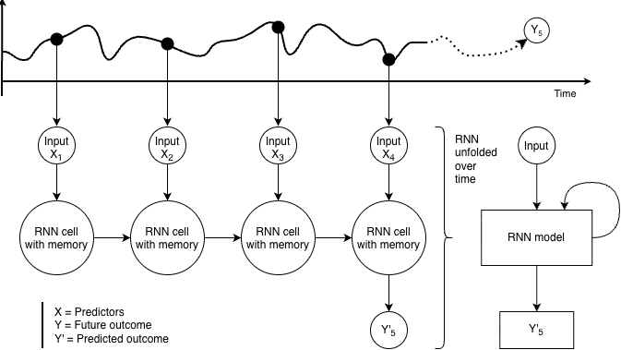
Figure 1.2: Schematic illustration of a recurrent neural network for prediction. Previous values are processed sequentially, allowing information from earlier time points (X) to be retained and updated over time. The learned temporal representation is then used to predict a future outcome (Y’). Figure created by the author. The visual design was inspired by explanatory videos by StatQuest with Josh Starmer.³⁹

1.8 Foundation Models and Transfer Learning
In recent years, machine learning models have grown substantially in scale, complexity, and applicability. This development has led to the emergence of foundation models, which are defined as “any model that is trained on broad data (generally using self-supervision at scale) that can be adapted (e.g., fine-tuned) to a wide range of downstream tasks”.⁴⁰ Two CGM specialized foundation models exist in the literature which both uses self-supervised machine learning.^{41,42} Self-supervised machine learning is a technique used to train models on unlabelled data through different techniques, one of them including masked learning (e.g., predicting manually masked words in text or values in time-series signals).^{40–42} A foundation model is first pretrained on a general task, such as predicting masked values in CGM data, allowing it to learn representations of glucose dynamics. These representations can subsequently be adapted to a downstream task, such as predicting cardiovascular outcomes, through transfer learning.^{40,42} A foundation model can be conceptualized as comprising a pretrained backbone and a task-specific head (Figure 1.3).⁴³ The backbone extracts representations from the input data, whereas the head uses the representations to perform the downstream task. Transfer-learning strategies differ primarily in how the pretrained backbone is used. It may remain fixed and serve as a feature extractor, with only a downstream model or task-specific head being trained, or some or all of the model may be updated through fine-tuning.^{43,44} The choice of strategy depends partly on the similarity between the pretraining and downstream tasks.⁴⁴ Transfer learning addresses the need for large amounts of data in deep neural networks by reusing knowledge learned from large datasets and applying it to related tasks with limited labelled data. This is particularly relevant in clinical risk prediction, where labelled data are often scarce, especially for minority populations.^{43,45,46}
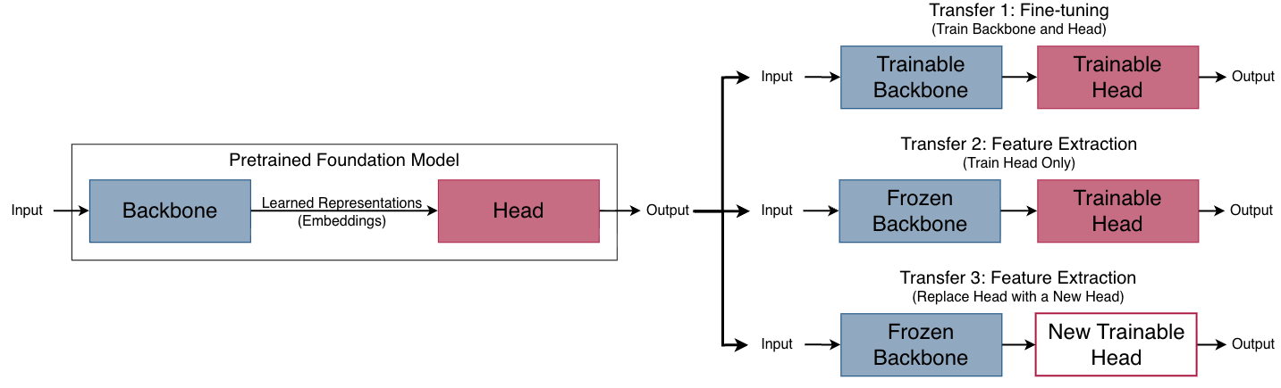
Figure 1.3: Overview of transfer learning strategies. Inspired by Deng et al.⁴³ under the Creative Commons Attribution 4.0 International (CC BY 4.0) licence.

1.9 Health Disparities and Bias in Machine Learning
Fairness is being integrated more and more into reporting guidelines for clinical prediction models, because unequal model performance across population strata defined by sensitive attributes, such as race, sex, and socioeconomic status, may contribute to or reinforce societal inequalities.^{47,48} In clinical prediction modelling, fairness implies that models should perform accurately, equitably, and reliably across diverse populations. This requires transparent model development, evaluation, and monitoring, so that potential disparities can be identified and addressed.⁴⁷ There is however still a lack of reporting on race and ethnicity in trials even though diabetes affects individuals across all racial and ethnic groups and differences have been reported in glycemic response, glycemic control, insulin resistance and the burden of diabetes-related complications between populations.⁵⁴ A study by Turner et al.⁴⁹ showed that among 20,692 US-based clinical trials, only 43% reported participants’ race or ethnicity. Although the reporting of race and ethnicity increased between 2010 and 2020, racial and ethnic minority groups remained underrepresented relative to their proportions in the US population.⁴⁹ Furthermore, this lack of information is not only present in clinical trials but also in reportings of FDA-approved AI medical devices.^{46,49} A study by Muralidharan et al.⁴⁶ found that only 3.6% of the FDA approval documents (Summary of Safety and Effectiveness Data Documents) provided information on race and/or ethnicity of the intended or testet users.⁴⁶ Lack of ethnic and racial information in datasets problematic in data-driven models such as machine learning models since they reflect the populations represented in their training data and when minority groups are underrepresented, the resulting models may not generalize equally well to all patients.^{46,55} Consequently, models developed predominantly using one population may not achieve comparable predictive performance in others and potentially reinforcing existing healthcare disparities.⁵⁵ For example, risk prediction models have been shown to underestimate the risk of T2D among non-Hispanic Black individuals,⁵⁵ and algorithmic bias has been demonstrated to substantially influence the allocation of healthcare resources.⁵⁶ Developing equitable prediction models therefore requires both representative data and careful evaluation of model performance across demographic groups. Transfer learning becomes particularly relevant in such cases where labelled data are often scarce, especially for minority populations.^{43,45,46,49}

2. Aims
Continuous glucose monitoring (CGM) provides detailed information on glucose patterns that is not captured by HbA1c alone and may contribute to cardiovascular risk assessment. Machine learning offers opportunities to extract additional information directly from CGM time-series, but the predictive value and generalizability of these approaches remain uncertain. Moreover, models may perform differently across populations if demographic groups are inadequately represented in the training data. Evaluating the clinical potential of CGM data therefore requires consideration of predictive value, generalizability, and fairness. These knowledge gaps formed the basis for the aims of this dissertation.

2.1 Overall Aim
The overall aim of this PhD dissertation was to investigate the potential of continuous glucose monitoring (CGM) data to improve cardiovascular risk assessment and to evaluate the role of machine learning in extracting clinically relevant information from CGM data across different diabetes populations, including the evaluation of racial disparities in model performance.

2.2 Specific Aims
Aim 1: To identify and summarize the existing literature on associations between glycemic control and cardiovascular outcomes, and the use of CGM-derived metrics for cardiovascular risk prediction. (Study I)
Aim 2: To determine whether a CGM foundation model learns meaningful glucose representations in individuals with type 1 and type 2 diabetes. (Study II)
Aim 3: To evaluate whether traditional CGM-derived metrics and learned glucose representations improve prediction of elevated NT-proBNP beyond established clinical risk factors in individuals with type 2 diabetes. (Study II)
Aim 4: To evaluate the fairness of machine learning models for glucose prediction by assessing model performance across non-Hispanic Black and non-Hispanic White populations. (Study III)

3. Methods
In this chapter the three studies included in this PhD are presented together with a description of the datasets and methods used in the studies.

3.1 Study I: Scoping Review Methodology
A scoping review was conducted to investigate current knowledge of CGM-data and its possible connection and predictive power to clinical and subclinical cardiovascular outcomes. Given the expected heterogeneity between studies and the broad exploratory nature of the research question, a scoping review was considered the most appropriate methodology, as the aim was to map the existing evidence within this field.⁵⁷ The scoping review followed the Manual for Evidence Synthesis (Chapter 10 - Scoping reviews) from the Joanna Briggs Institute (JBI) and reported according to the Preferred Reporting Items for Systematic Reviews and Meta-analyzes extension for scoping review (PRISMA-ScR) guidelines.^{57,58}

Concepts and Definitions
The review focused exclusively on studies using CGM data as input for analyzes of associations with, or prediction of, CVD. This meant that studies only investigating self-monitored blood glucose with finger-prick measurements or blood sample measurements such as HbA1c were not considered in this review. CVD outcomes were divided into subclinical or clinical. For the clinical CVD, the following outcomes were considered: cardiovascular mortality, major adverse cardiovascular events, coronary artery disease, heart failure, stroke, and peripheral artery disease with synonymous terms included (e.g., ischemic heart diseases) and clinical events (e.g., undergoing coronary artery bypass surgery). Subclinical CVD was grouped into six subcategories: arterial stiffness, flow resistance, arterial wall thickness, arterial wall composition, cardiac and pulse-related measures, and arterial lumen. CVD outcomes did not include broader risk factors nonspecific to cardiovascular risk (e.g., age or sex). Eligibility criterias for the scoping review⁵⁹ can be found in Table 3.1.

Search and Selection of Sources
MEDLINE and Embase were searched from inception to March 11, 2025. The two databases were selected because they are core databases for biomedical literature. The search was not extended to additional databases because of the resources available to the review team. The search strategy was developed in collaboration with information specialists. An exploratory search was conducted and 13 studies within the field was identified and used to test the search strategy with, by ensuring the 13 identified studies were included in the final search.^{38,60–71}. The search strategy was wished to be kept broad as it was known beforehand that the field contained inconsistent terminology and overlapping search categories (e.g., ‘blood glucose monitoring’ and ‘glycemic control’ both encompass finger-prick measurements) in order to ensure identification of all the relevant studies in MEDLINE and Embase. The full search strategy can be found in Appendix A.
All identified records were uploaded into the software tool EPPI reviewer 6 and duplicates were removed.⁷² Titles and abstracts were screened by at least two independent reviewers and a meeting was held after ~5% of the titles and abstracts had been screened, to resolve disagreements and ensure consistency between reviewers. Afterwards full-text screening was performed by two independent reviewers and held up against eligibility criteria. Disagreements were resolved through discussion at physical meetings between reviewers.
Backward and forward citation searching was performed on all the included studies after the screening process using citationchaser⁷³ and the screening process was repeated until no further new studies were identified through citationchaser.

Data Charting Process and Data Items
Research questions were defined before the screening process and data was extracted based on the research questions in Note 3.1.
 Note 3.1: Research Questions (Study 1)
- Is there an association between glycemic control and CVD risk?
- Can CGM-derived metrics predict CVD risk?
- What CGM-derived metrics are used in the literature?
- Which cardiovascular markers and diseases are included as outcomes in the studies?
- What characterizes study populations (age, sex, ethnicity, geographic location)?
- What study designs are used (e.g., longitudinal cohort studies, randomized controlled trials, cross-sectional studies)?
- How was data collected (e.g., clinical trial, epidemiological study, routinely collected data)?
- What CGM devices were used?
- What statistical models were used in the studies?
- Is the data openly available?
- Is the code openly available?

Synthesis of Results
Study characteristics were synthesized using descriptive statistics and supplemented by a narrative summary. Only the most adjusted models in the main population for each study was considered in this review. This approach was necessary as several studies reported numerous estimates across varying adjustments, different combinations of CGM-derived metrics and CVD outcomes, and/or distinct subgroup stratifications. Given the large volume of literature, studies investigating clinical cardiovascular outcomes were prioritized in the main synthesis. While subclinical markers offer valuable insight into early vascular changes and disease progression, clinical outcomes are more directly relevant to cardiovascular risk prediction and clinical decision-making. The main synthesis of clinical outcomes included both effect estimates and measures of statistical significance whereas the supplementary synthesis on subclinical CVD focused primarily on creating an overview of the chosen CGM-derived metrics and the statistical significance of reported associations. All evaluation metrics mentioned in the studies doing prediction analyzes were reported based on what the studies reported.

3.2 Datasets used in this dissertation
Two datasets were used in this PhD project and are described in the following sections. The datasets were obtained from studies that were conducted independently of this PhD project. Both studies were conducted in accordance with the principles of the Declaration of Helsinki and were approved by the relevant institutional review boards or ethics committees. For the T1DX dataset, ethical approval is documented in Bergenstal et al.⁵² and for the CANCAN study, approval was obtained from the Committee on Health Research Ethics in the Central Denmark Region(#93931 and #1-10-72-221-21). Oral and written informed consent was obtained from all participants.

CANCAN Data
The CANCAN dataset was collected in an observational case-control study from two hospital outpatient clinics (Denmark). The aim of the CANCAN study was to investigate if cardiac autonomic neuropathy (CAN) assessments, CGM and heart failure indicators could be used in risk stratification for people with T2D. Participants were included if they were adults (> 18 years old) and had T2D for at least a year. Exclusion criteria were atrial fibrillation or laser-treated eye disease within the past three months, were pregnant or lactating, had a life-threatening disease (expected survival < 1 year), or had cognitive disabilities rendering them unable to understand and give consent. Data were collected during a clinical examination, during which blood samples to obtain NT-proBNP was collected together with urine samples, and a blinded CGM sensor was inserted.(Figure 3.1). In total, 159 participants were included since the rest were missing age, sex, HbA1c, BMI, NT-proBNP, HDL, total cholesterol, or eGFR, which were needed for the analyzes in Study II.

T1D Exchange Data
The publicly available T1D Exchange (T1DX) dataset, distributed by the Jaeb Center for Health Research under the protocol “Racial Differences in Mean CGM Glucose in Relation to HbA1c”, was collected in 10 diabetes centers (US).⁷⁴ The data was collected to determine if there is a racial difference in the association between mean glucose and HbA1c between non-Hispanic Black (Black) and non-Hispanic White (White) people with T1D. In the T1DX study ethnicity and race was defined through self-identified and self-reported ethnicity/race verification forms where ethnicity was defined as Hispanic or Latino as: “a person of Cuban, Mexican, Puerto Rican, South or Central American, or other Spanish culture or origin, regardless of race. The term “Spanish origin” could be used in addition to “Hispanic” or “Latino”“.^{52 in Supplementary Material} For race a participant defined as White was “a person having origins in any of the original peoples of Europe, the Middle East or North Africa.” and Black or African American people were defined as “a person having origins in any of the Black racial groups of Africa. Terms such as “Haitian” or “Negro” can be used in addition to “Black” or “African American””.^{52 in Supplementary Material} In this dissertation, the term race will be used moving forward, as it aligns with the terminology used by Bergenstal et al.⁵². However, I acknowledge that it is difficult to define race.⁷⁵ Of the 205 participants included in the study⁵², 101 were White and 104 were Black. For each race, two age groups were sampled 8 to <18 years old and >18. Each participant wore a blinded modified investigational version of Abbott Diabetes Care’s Flash Glucose Monitoring System (CGM) as continuously as possible for 12 weeks (Figure 3.2). CGM data was sampled every 15 minutes in a range between 2.21 - 27.65 mmol/L (40 and 498 mg/dL). Blood samples were taken at enrollment, at some of the follow-up visits, and at the end of enrollment.
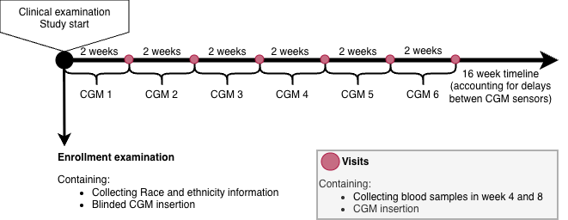
Figure 3.2: Data collection timeline for the T1DX study.

3.3 Study II: Foundation Models and Predictive Utility of CGM data
The second study investigated whether a CGM foundation model could learn meaningful representations of CGM data and compared these learned representations with conventional CGM-derived metrics identified in Study I.⁵⁹

Data and Participant Selection
Both the CANCAN and the T1DX dataset were used for Study II. Participants with missing age, sex, HbA1c or BMI were excluded from both cohorts and in addition, CANCAN participants with missing NT-proBNP, HDL, total cholesterol, and eGFR were also removed, since those are necessary to calculate the SCORE2-Diabetes risk score with. T1DX participants with missing race data were also removed. Days with less than 70% of CGM data were removed in addition to participants with less than one day of data from both datasets to ensure sufficient data for the analyzes. Values exceeding the measurable range of the CGM devices were retained as the device’s upper and lower measurement limits. For the CANCAN data, this range was 2.2 - 27.8 mmol/L and for the T1DX data, the range was 2.21 - 27.65 mmol/L.

Transfer Learning, Foundation Models and Embeddings
Of the two CGM-specific foundation models based on self-supervised learning currently described in the literature (CGMformer by Lu et al., 2025⁴¹ and GLUformer by Lutsker et al., 2026⁴²), only the pretrained weights from the CGMformer were made publicly available, enabling reuse of the model for downstream tasks. The CGMformer was therefore chosen and the data was organized in 24-hour long-format input to match the input requirements of the CGMformer. The output of the foundation model is learned representations of the input data, also known as embeddings and the head of the CGMformer were not available for retraining (Figure 3.3). By only having the backbone, the transfer learning strategy being used had to be replacing the head with a new, as shown in Figure 1.3 as transfer three.
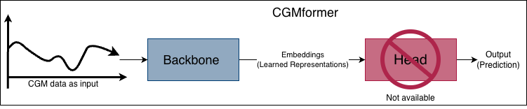
Figure 3.3: Illustration of how CGMformer is used in this analyzis.
The CGMformer gives a 128-dimensional embedding vector for each 24-hour CGM data input. Embeddings are numerical vectors that summarize the characteristics of the input glucose profile. A simple vector can be drawn as an arrow in a 2-dimensional and a 3-dimensional space as shown in Figure 3.4.
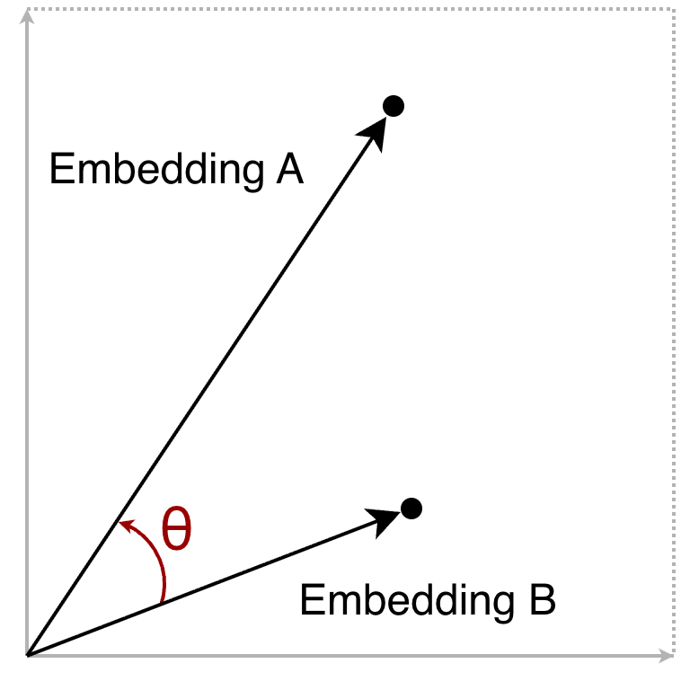 | 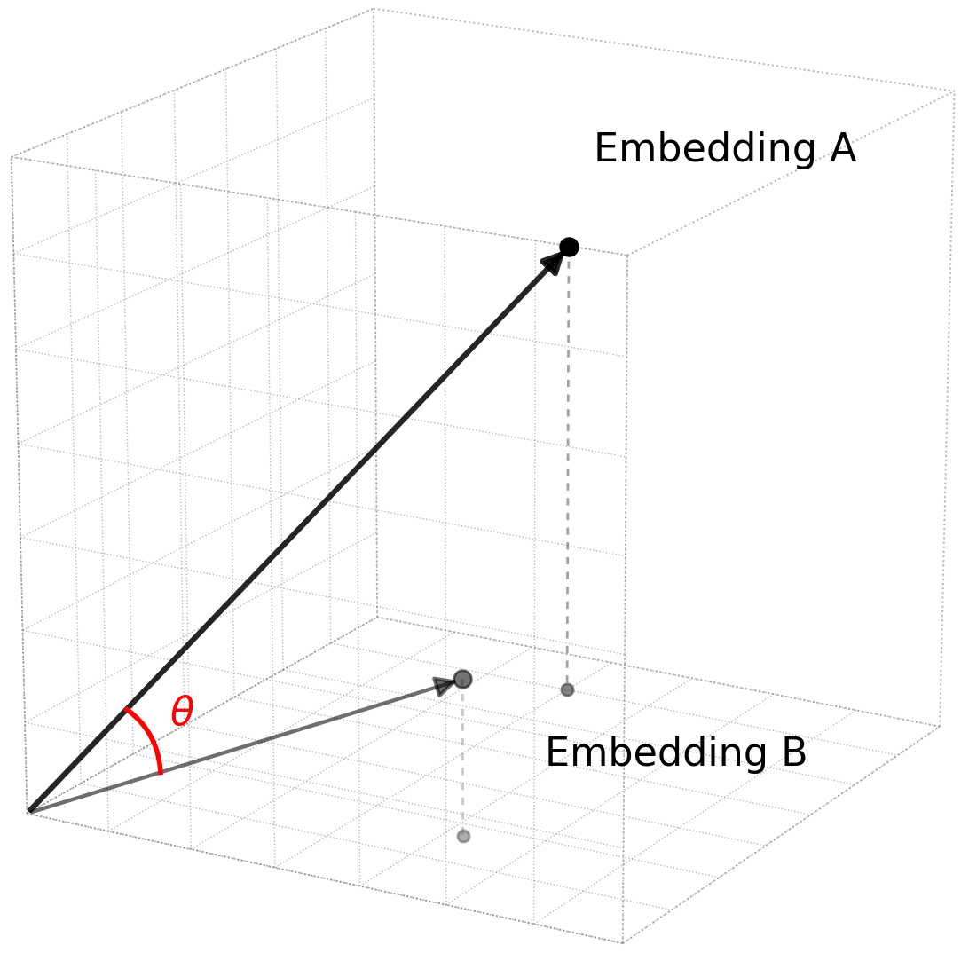
Figure 3.4: Embeddings shown as 2-dimensional and 3-dimensional vectors with the angle $θ$ between the two embeddings.
Because embeddings are numerical vectors, they can be compared to quantify the similarity between glucose profiles, as demonstrated by Lutsker et al.⁴² We therefore adopted a similar approach to assess the similarity between CGM-derived embeddings. Cosine similarity was calculated and it measures the angle between two embedding vectors independent of their magnitude (the length of the vectors). The cosine similarity is calculated by measuring the cosine angle between two vectors as shown by $θ$ in Figure 3.4. The cosine similarity is a number between -1 and 1, where 1 means the two vectors are identical, 0 means they are unrelated, and -1 means that they are pointing in opposite directions (Figure 3.5). For the analyzes in this study, cosine distance, calculated as 1 − cosine similarity, was used because it expresses similarity as a distance measure, allowing embeddings with similar orientations to have small distances and facilitating downstream analyzes and visualizations. The cosine distances range from 0 to 2 where 0 means the two vectors are pointing in the same direction, 1 means they are unrelated, and 2 means that they are pointing in opposite directions.
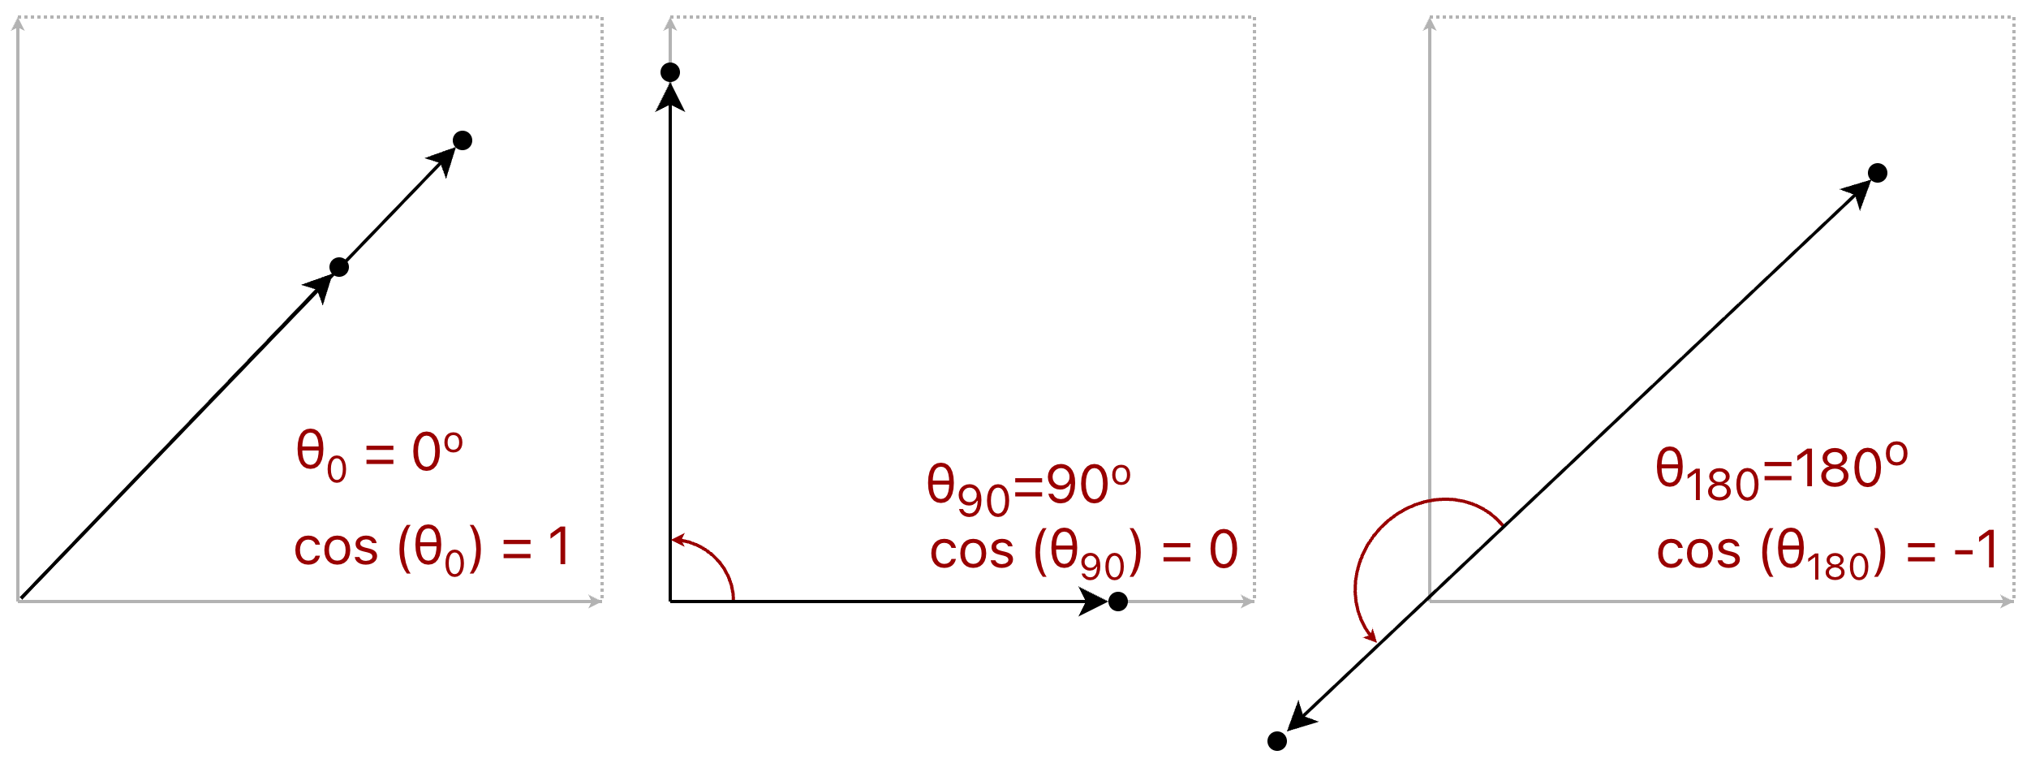
Figure 3.5: Embeddings shown with different cosine similarities. The cosine similarity is calculated as the cosine of the angle ($θ$) between two embeddings.
Kernel density plots were used to visualize the distribution of cosine distances within specific clinical strata and across differing participants (Figure 3.6). Groupings were made based on days from the same participant (within-participant comparison), days from different participants with the same clinical strata (between-participant comparison), and days from different participants with different clinical strata (between-participant comparison) (Figure 3.6).
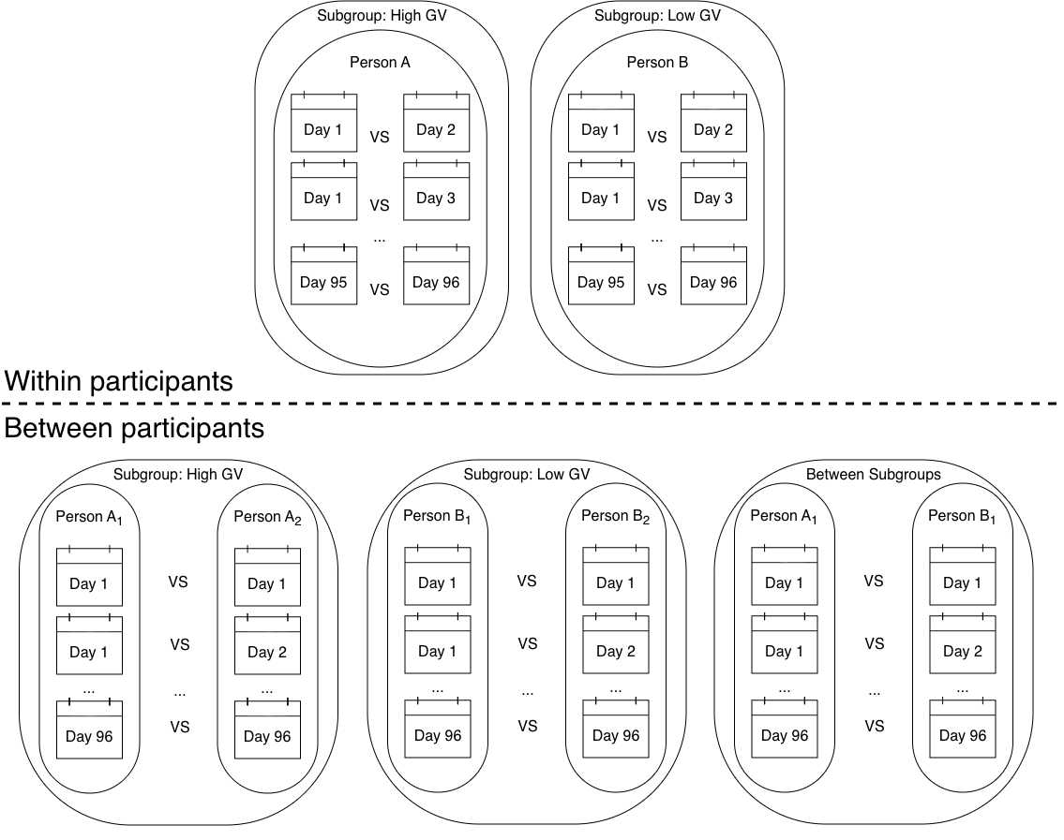
Figure 3.6: Glucose variability strata is used as an example to illustrate the cosine distance analyzis of the within and between cosine distance pairs.
The main focus for the participant comparisons were TIR and HbA1c. The thresholds were as followed: TIR ≥ 70% (70–180 mg/dL, 3.9–10.0 mmol/L) and HbA1c <7.0 % (< 53 mmol/mol).^{10,12} Furthermore, a uniform manifold approximation and projection (UMAP) algorithm was used to reduce the dimensionality of the embeddings to two dimensions since a 128-dimensional vector is not easily visualized. UMAP visualizations were generated by coloring participants according to race, MAGE (< 70 mg/dL ( < 3.9 mmol/L )),¹⁰ and NT-proBNP (NT-proBNP ≤ 125 pg/mL).^{76,77} The threshold-based categorizations for TIR, MAGE, and HbA1c were used solely for the cosine distance analyzes and to facilitate interpretation of the UMAP visualizations and were not incorporated into model development or any statistical analyzes. The concept of dimensionality reduction is illustrated in Figure 3.7. The UMAPs were first used for visualization and comparison with existing literature and were subsequently included in prediction models.^{41,42,78} This dimensionality reduction step was used because the original 128-dimensional embeddings would provide too many predictors for a simple logistic regression model. The UMAPs were colored by TIR, and MAGE to investigate if the embeddings were able to capture relevant information about glycemic patterns. Elevated NT-proBNP for the CANCAN embeddings were also used to color the UMAPs to investigate if the embeddings were able to capture relevant information about cardiovascular risk and race was used to color the T1DX embeddings to investigate if the embeddings were able to capture relevant information about racial differences in glycemic patterns. Pearson correlations were calculated between the UMAP dimensions and HbA1c, TIR, MAGE, and log-transformed NT-proBNP.
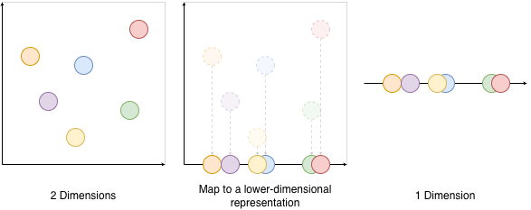
Figure 3.7: Conceptual illustration of dimensionality reduction, read from left to right. High-dimensional information can be represented in fewer dimensions while preserving important structure, however not all information is retained. The illustration does not show how UMAP works specifically, but conveys the general idea of reducing complex data to a lower-dimensional representation.

3.4 Study II: Cardiovascular Risk Assessment
The following section describes the cardiovascular risk assessment analyzes, in which NT-proBNP was predicted as a binary outcome using a >125 pg/mL threshold.^{23,76,77} Only the cross-sectional CANCAN dataset was used for the cardiovascular risk assessment. The focus was to test the predictive power of CGM data both as represented as embeddings and as well-established CGM-derived metrics. Some models also included clinical predictors to compare up against baseline models. Prediction models integrated clinical, standard CGM-derived, and learned representations.

Predictors
Initial testing showed that the numbers of predictors had to be limited due to the small sample size and the SCORE2-Diabetes risk score was chosen as another way to represent the clinical predictor set while keeping the number of predictors down.²¹ This resulted in the following clinical predictors: age, sex, smoking status, systolic blood pressure, total cholesterol, HDL cholesterol, age at diabetes diagnosis, eGFR and HbA1c. The SCORE2-Diabetes risk score was tested as a predictor in itself as well. Additionally, age was tested as a predictor on its own to see if it was a strong predictor of elevated NT-proBNP, since NT-proBNP is known to increase with age.^{23,79} TIR and MAGE were chosen as they were the CGM-derived metrics most commonly used in the literature based on the findings from Study I.⁵⁹ All CGM-derived metrics in this dissertationwere calculated using the Interpreting Glucose Data from Continuous Glucose Monitors (IGLU) package^{80,81} in R (default settings). TIR was calculated as the percentage of time spent in the range of 3.9–10.0 mmol/L (70–180 mg/dL).¹⁰ MAGE was calculated as the mean amplitude of glucose excursions, where the included excursions were consecutive peak-to-nadir (or nadir-to-peak) glucose differences exceeding one standard deviation of the individual’s glucose measurements. The IGLU implementation computationally reproduces the original manual procedure proposed by Service et al.⁸² The CGMformer generated one 128-dimensional embedding for each 24-hour CGM recording. Because NT-proBNP was measured at the participant level, a single embedding was required for each participant. Therefore, embeddings from multiple recording days were aggregated using pooling to obtain one participant-level embedding. Both minimum, maximum, and mean pooling were explored to determine the most effective aggregation method. Maximum pooling was considered the default based on existing literature.⁴² The resulting 128-dimensional embeddings were subsequently reduced to two dimensions using UMAP, thereby enabling their use in the prediction models while minimising the number of predictors.

Model Development and Evaluation
Prediction models were developed using logistic regression to predict elevated NT-proBNP (>125 pg/mL) as a binary outcome. The models were evaluated using the AUROC as the primary metric. Bootstrap with optimism correction was employed for internal validation because of the limited sample size and the absence of an external validation cohort.^{48,83,84} The method repeatedly sampled bootstrap samples by sampling with replacement from the original dataset (Figure 3.8). Sampling with replacement means that the same observation can be selected more than once in the new sample. For each bootstrap sample, the prediction model is fitted and its performance is evaluated both in the bootstrap sample (apparent performance) and in the original dataset (test performance). The difference between these two performance estimates represents the optimism due to overfitting (overfitting occurs when a model learns overly specific patterns in the training data, causing it to perform well on training data but poorly on new data). Averaging the optimism across all bootstrap samples and subtracting it from the apparent performance of the model fitted to the full dataset yields an optimism-corrected estimate of model performance. Internal validation was performed using 500 bootstrap resamples.^{48,84} Prediction stability plots were reported for each model to evaluate the stability of predictions produced by a specific model strategy when the training data changes.⁸⁴
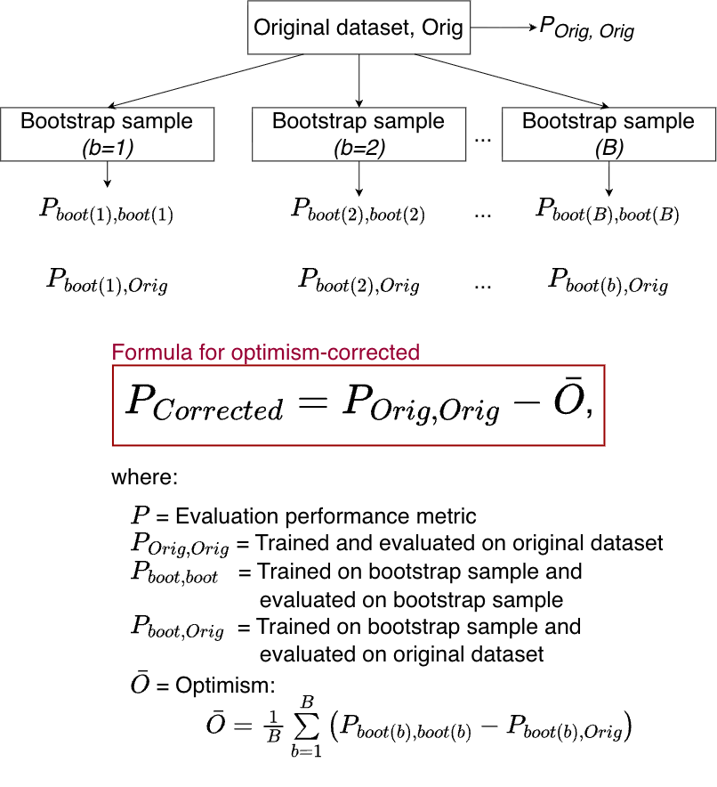
Figure 3.8: Bootstrap with opimism correction. Redrawn and adapted from Wahl et al.⁸³ under the Creative Commons Attribution 4.0 International License CC BY 4.0.

Prediction Scheme Overview
The prediction models were structured hierarchically based on clinical variables (Model A) and the calculated SCORE2-Diabetes score (Model B) in the configurations shown in Table 3.2.
Table 3.2: Overview of models and predictors.
Model family | Model | Baseline predictors | Additional predictors
Clinical | A0 | Age | –
Clinical | A1 | Clinical variables* | –
Clinical | A2 | Clinical variables* | TIR + MAGE
Clinical | A3 | Clinical variables* | UMAP dimensions
SCORE2-Diabetes | B1 | SCORE2-Diabetes score | –
SCORE2-Diabetes | B2 | SCORE2-Diabetes score | TIR + MAGE
SCORE2-Diabetes | B3 | SCORE2-Diabetes score | UMAP dimensions
CGM only | C1 | TIR + MAGE | –
Embeddings only | D1 | Pooled UMAP dimensions

3.5 Study III: Algorithmic Fairness and Blood Glucose Prediction
The third study investigated racial bias strictly based on blood glucose measurements from a CGM device. Although the primary focus of this dissertationis cardiovascular risk assessment, glucose forecasting provides an appropriate setting for investigating algorithmic fairness in CGM-based machine learning. In contrast to participant-level cardiovascular prediction, glucose forecasting is trained on a continuous stream of CGM measurements, allowing each participant to contribute numerous samples over the recording period rather than a single outcome. This results in substantially more training examples, enabling the development and evaluation of more complex machine learning models. Consequently, glucose forecasting provides a suitable framework for studying how training data composition influences model performance across racial groups.

Preprocessing of CGM data for Forecasting
A prediction horizon of 60 minutes was chosen as it provides sufficient time for preventive interventions for hypo- and hyperglycemia, such as insulin dose adjustments or carbohydrate intake, while accounting for the 15-minute sampling interval of the CGM device and the physiological delay between blood and interstitial glucose measurements.¹² Accordingly, the CGM data was divided into consecutive 60-minute windows containing four glucose measurements to predict glucose levels 60 minutes into the future, as illustrated in Figure 3.9. Prediction windows containing missing CGM values were excluded.
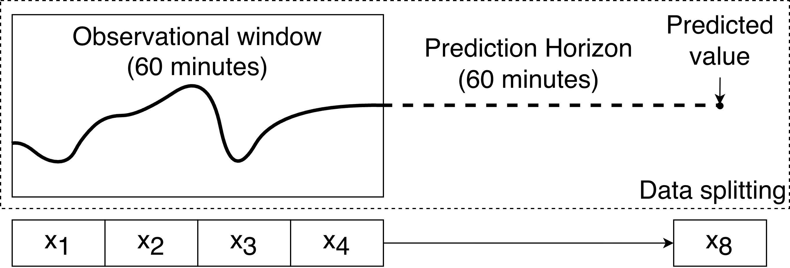
Figure 3.9: The prediction horizon and overview of the creation of samples (predictors and outcomes).

Partitioning of the Dataset
The T1DX dataset was randomly resampled without replacement at the participant level to avoid data leakage and to evaluate model performance on independent participants. As illustrated in Figure 3.10, training subsets with varying proportions of Black and White participants were generated by randomly selecting participants from the original dataset while keeping the train-test split at the participant level. Eleven training set compositions were created, ranging from 100% White and 0% Black to 0% White and 100% Black participants in 10% increments.
Because some training subsets consisted entirely of participants from a single racial group, the maximum training set size on participant level was constrained by the size of the smaller racial group minus the participants kept for testing. Consequently, each training subset contained approximately half the number of participants in the original T1DX dataset. Repeating this procedure for each participant resulted in 2,255 training datasets (205 participants × 11 training set compositions) and 205 independent test sets. Throughout all resampling procedures, all CGM recordings from a participant were kept together to prevent data leakage between the training and test sets.
Figure 3.10: The prediction horizon and overview of the creation of subsets for training.
Eleven subsets were created for each of the participants and the last week’s data was chosen to test on as illustrated in Figure 3.11. To preserve sample size, one week was chosen because participants had varying amount of CGM data and the participant with the least amount of data had ~ 2 weeks. The remaining data was used for training the models.
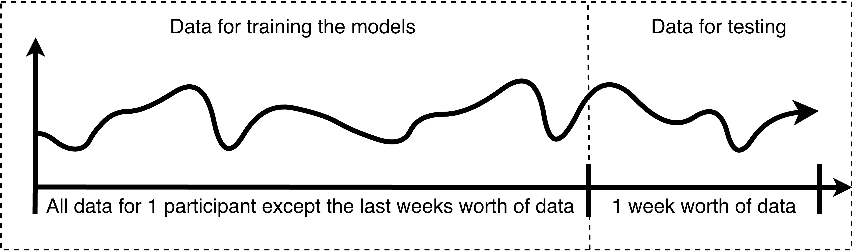
Figure 3.11: The splitting of a participants data to create training and test sets.

Model Selection and Training Approaches
A LSTM network architecture based on van Doorn et al.³⁴ was used (two LSTM layers followed by a dense layer). All the training data was scaled to be within the range of zero to one. Hyperparameters were optimized once prior to the repeated model development using grid search and data from all participants except the last week. The gridsearch included the number of neurons in the LSTM layers, activation function, dropout rate, batch size, learning rate, learning rate decay, and early stopping patience. The selected hyperparameter configuration was subsequently fixed and applied to all LSTM models. The complete hyperparameter tuning procedure and implementation are available in the accompanying GitHub repository.⁸⁵ Four training approaches were used when the models for each participant were developed as described below and illustrated in Figure 3.12.
Additionally, Three LSTM models and the last observation carried forward (LOCF) as a naive baseline.
- LOCF: In the LOCF model, a given CGM measurement (x₄) was used to predict blood glucose values 60 minutes in advance (x₈) in the test set by assuming no change in the last 60 minutes.
- Base-Individual: In the Base-Individual model, each participant’s complete CGM data (except for the last week, which was used for the testing data) was used for training.
- Base-Generalized: Here, for each participant, the 11 corresponding training datasets described above were used to generate 11 separate models, which were all subsequently tested on the given participant’s last week of CGM data.
- Transfer Learned: This model mirrored the Base-Generalized Model’s setup. However, the 11 trained models for each participant were subsequently tailored to the given participant’s complete CGM data (except for the last week, which was used for the testing data). The transfer learning technique used is described as transfer 2 in Figure 1.3.
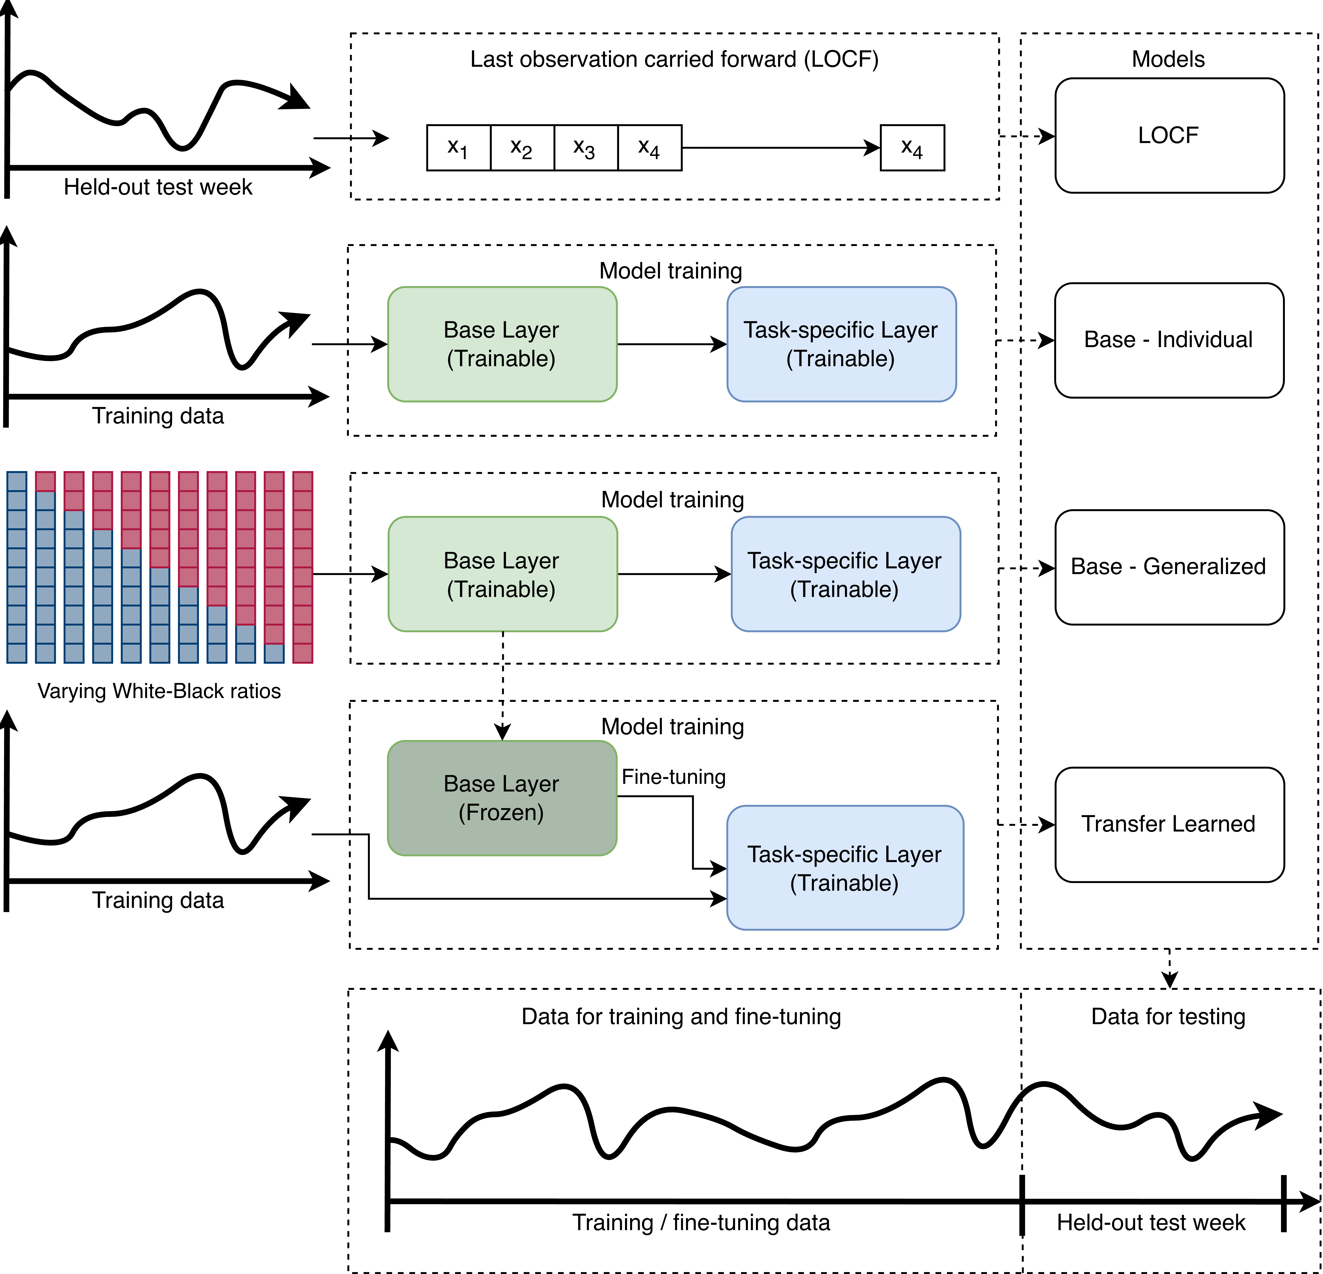
Figure 3.12: The four training approaches. The Base-Individual, Base-Generalized, and Transfer Learned models were based on an LSTM architecture. The base layer (green) consisted of two LSTM layers, while the task-specific layer (blue) consisted of a single dense layer. Abbreviation: LOCF, last observation carried forward.

Model Evaluation
To evaluate model performance, each participant’s last week’s data (672 measurements) was reserved for internal testing (Figure 3.11). Model accuracy was assessed by calculating the root mean squared error (RMSE) for each participant across all four modeling approaches. For the LOCF and Base-Individual models, this yielded one RMSE value for each of the 101 White participants and 104 Black participants. For the Base-Generalized and Transfer Learned models, RMSE values were calculated for each participant across 11 data subsets, each representing a unique proportion of White and Black participants. Performance was summarized as the mean RMSE with corresponding 95% confidence intervals (CIs) for each racial group. It was further assumed that the varying proportions of Black and White participants in the training data subsets would affect the performance and an interaction term was therefore added. The interaction term allowed for different slopes in the LMEM which allowed us to test the hypotheses. It was hypothesized that when plotting the proportion of White participants in the training data against the RMSE, the slope would be negative for White participants and positive for Black participants (Figure 3.13). This would indicate that as the proportion of White participants in the training data increased, the RMSE decreased for White participants and increased for Black participants, indicating racial bias in the model. The Base-Individual model would perform the worst since it was trained on the least amount of data and the Transfer Learned model would remove the slopes that were expected to be seen in the Base-Generalized models.
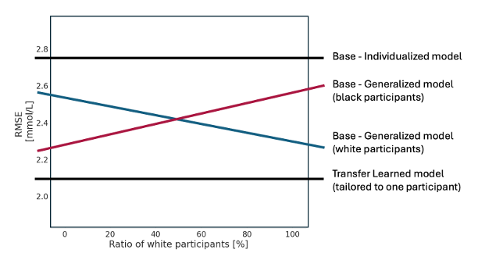
Figure 3.13: The hypotheses for the results of the linear mixed effect models.
Surveillance error grids (SEG) were used to get a general idea of the clinical risk of the prediction models.⁸⁶ The error grids are originally developed for the regulatory bodies to asses clinical accuracy of blood glucose monitoring in post-surveillance before the wide spread use of CGM devices.^{86,87} and the results should therefore be interpreted with caution when using CGM data. The SEG is a 600x600 grid assigned an individual risk score to each datapoint with 15 colored zones, each indicating severity of a monitoring error that is acted upon in regards to risk of hypoglycemia or hyperglycemia (Figure 3.14).⁸⁷ To facilitate interpretation, the 15 surveillance error grid zones were collapsed into the five broader risk zones (“No”, “Slight”, “Moderate”, “High”, and “Extreme”), as previously suggested in the literature.⁸⁶ Predictions outside of 0–33 mmol/L were changed to 0 or 33 mmol/L to keep within the upper and lower bounds of the surveillance error grid.
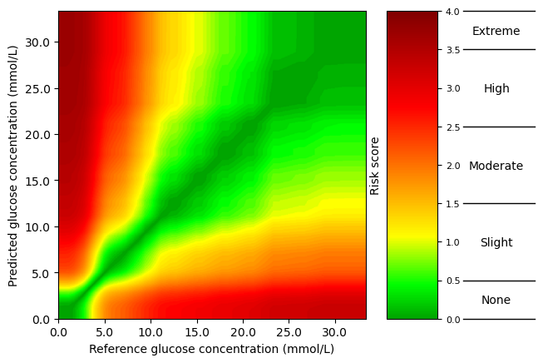
Figure 3.14: Surveillance error grid showing the clinical risk associated with prediction errors. The green region indicates no clinical risk, whereas yellow, orange, and red regions represent increasing levels of clinical risk. Generated from the methcomp package.⁸⁸

4. Results

4.1 Study I: Scoping Review Results
The study selection process is summarized in Figure 4.1. The MEDLINE and Embase search resulted in 4884 records screened on title and abstract, and 81 reports were assessed for eligibility based on full-text review by two independent reviewers. The citation search on the included 51 reports identified 2 additional reports, which finally resulted in 53 included reports in total. All included and excluded reports are reported in Appendix B.
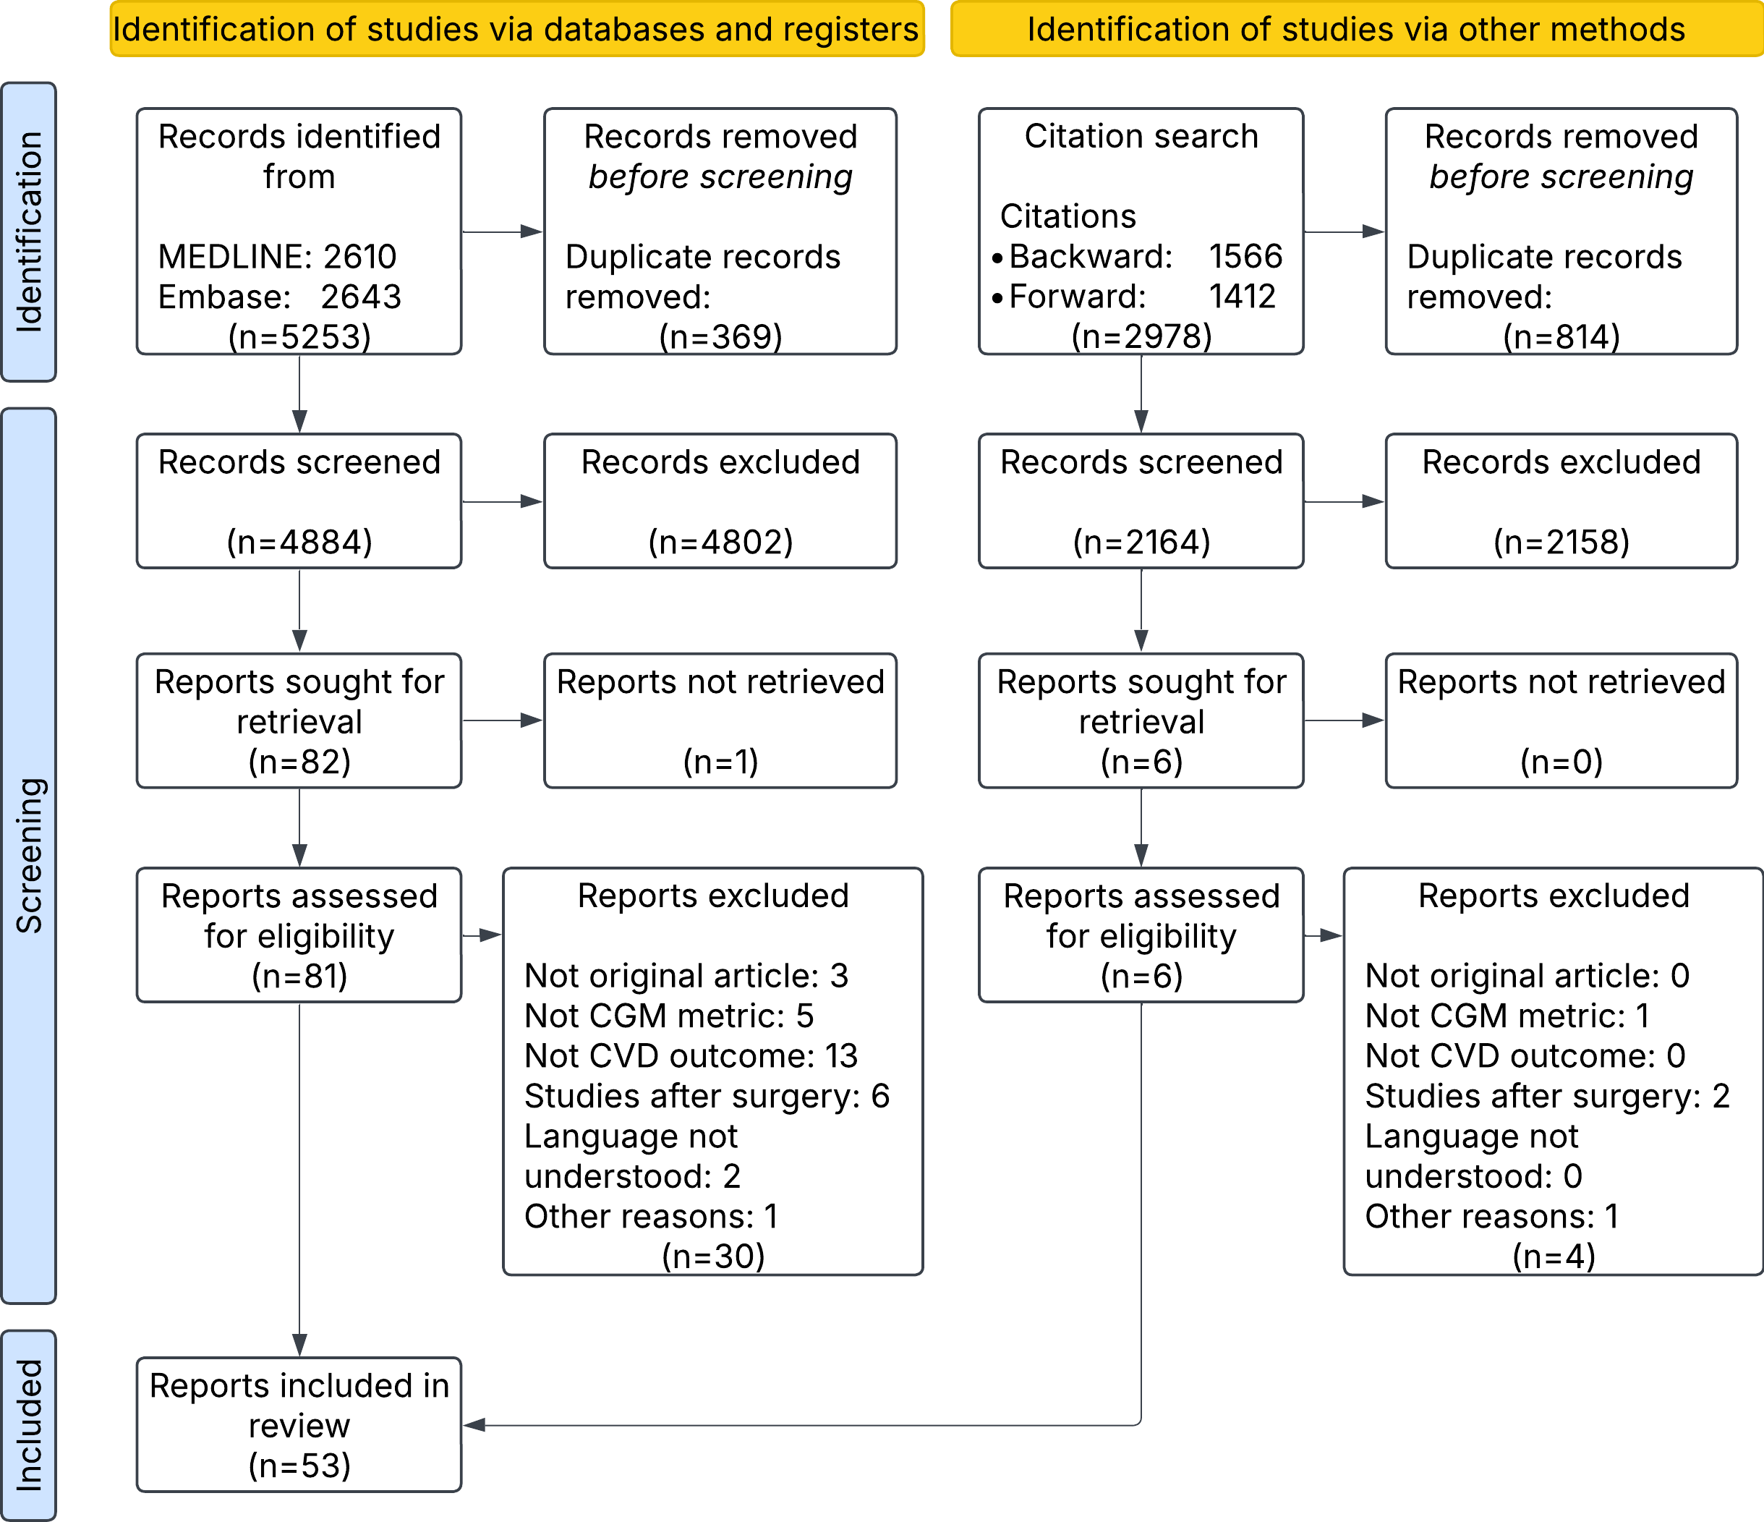
Figure 4.1: Flow diagram of study selection.
Reproduced from Thomsen et al.⁵⁹, originally published in JMIR Diabetes, under the Creative Commons Attribution License (CC BY 4.0).

Study Populations
The study population most common was people with T2D (34 of studies), then people with T1D (20 of 53) and lastly prediabetes (4 of 53). Most studies included adult participants, whereas seven focused on children younger than 18 years. Two studies included only male participants, whereas the remaining studies included both male and female participants.
The geographic distribution was found based on the hospitals and centers where data was collected or by the first author’s affiliation when the other options were not available. The distribution was uneven as shown in Figure 4.2. Most studies were conducted in Asia (27 of 53) or Europe (22 of 53). Three studies included data from North America, one was conducted in Australia, and only one included data from an African country, although its study population was predominantly White.⁸⁹ No data was included from South America (Appendix C).
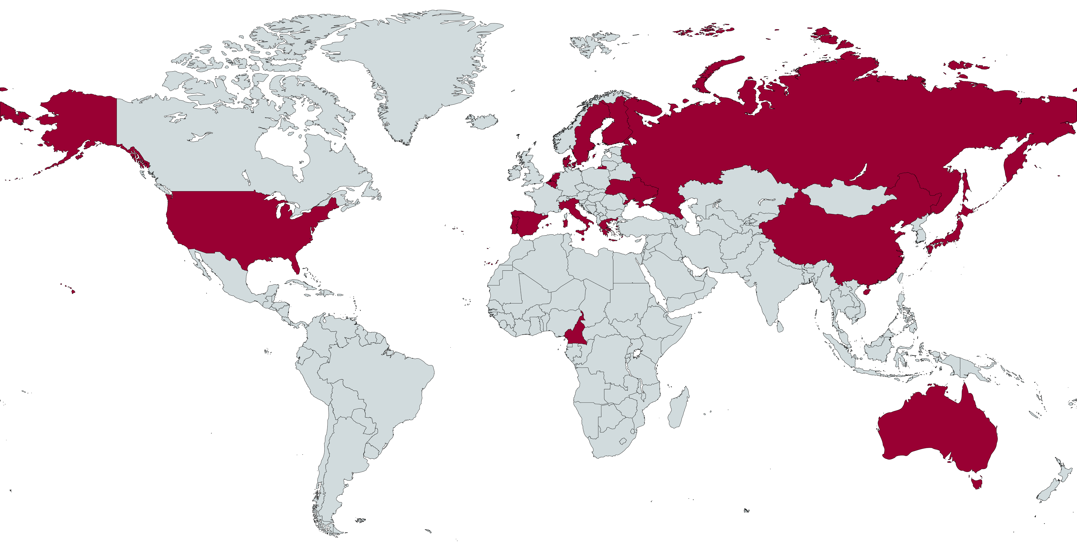
Figure 4.2: Geographical location of the studies. Countries colored in red indicate the geographical locations where the studies were conducted. Figure was created using MapChart https://www.mapchart.net/.

Study Designs and Demographics
Only one study was a randomized controlled trial,⁹⁰ and the remaining studies were observational. Most studies used a cross-sectional design, with the cardiovascular outcome assessed at the same time as the CGM sensor was given. Only six studies performed longitudinal analyzes. Study sample sizes varied considerably, ranging from 17⁹¹ to 6,225⁶² participants, with a median of 152. CGM data were obtained either from participants’ own devices (11 studies) or from CGM devices provided as part of the study (42 studies). Statistical analyzes most commonly included linear regression (22 studies) and logistic regression (22 studies), followed by Spearman or Pearson correlation analyzes (11 studies) and Cox proportional hazards regression (3 studies). Several studies performed additional exploratory analyzes, such as correlation analyzes, to identify relevant covariates for inclusion in regression models.
All included studies primarily investigated associations between CGM-derived measures and cardiovascular outcomes. Only three studies reported predictive performance measures as part of secondary analyzes,^{69,92,93} and none applied machine learning methods. Furthermore, none of the included studies provided openly available data or source code. Instead, availability was either not addressed or limited to access upon reasonable request from the corresponding author.

Continuous Glucose Monitoring
Medtronic CGM devices were the most frequently used (28 of 53 studies), followed by Abbott (9 of 53) and Dexcom (5 of 53). Other manufacturers included Menarini, Meiqi Company, and SIBIONICS. Sampling intervals ranged from 3 to 15 minutes but were reported in only a minority of studies (21 of 53). TIR (22 studies) and MAGE (23 studies) were the most frequently investigated CGM-derived metrics (Table 4.1). When stratified by T1D and T2D then TIR was the most frequently investigated metric in T1D populations (10 of 23 studies), whereas MAGE was less commonly investigated (5 of 22 studies). In T2D populations, TIR and MAGE were investigated in 11 of 23 and 14 of 22 studies, respectively. Studies conducted in T2D populations also tended to include larger sample sizes than those in T1D populations (median [IQR]: TIR, 510 [405–600] vs. 214 [119–547]; MAGE, 251 [89–411] vs. 57 [30–215]).
Table 4.1: Summary of the frequency of the seven most used CGM-derived metrics
CGM-derived Metrics: | TIR | MAGE | MBG | SD | CV | TBR | TAR
Number of Studies, n | 23 | 22 | 21 | 19 | 19 | 16 | 15
T1D, n | 10 | 5 | 9 | 7 | 8 | 9 | 8
T2D, n | 11 | 14 | 8 | 10 | 8 | 7 | 7
Mixed$​^{*}$ | 2 | 3 | 4 | 2 | 3 | 0 | 0
Total study
size for the CGM-derived metrics$​^{**}$ | 445 [157-577] | 156 [63-344] | 105 [71-427] | 267 [77-480] | 342 [98-577] | 123 [77-312] | 152 [77-425]
T1D$​^{**}$ | 214 [119-547] | 57 [30-215] | 105 [31-347] | 267 [54-515] | 152 [91-515] | 124 [102-161] | 138 [98-188]
T2D$​^{**}$ | 510 [405-600] | 251 [89-411] | 405 [77-499] | 371 [95-484] | 499 [358-632] | 121 [75-499] | 405 [75-499]

Prediction Studies
Only three studies evaluated the predictive performance of CGM-derived metrics for cardiovascular outcomes, all using logistic regression models with MAGE as the predictor. Two studies reported AUROC values of 0.61 and 0.62, respectively,^{69,92} and both found MAGE to outperform HbA1c (AUROC: 0.55 and 0.58, respectively). The third study used receiver operating characteristic analyzis to determine the optimal threshold for dichotomizing MAGE during variable selection but did not report the AUROC.⁹³ Instead, a threshold of MAGE ≥ 3.4 mmol/L was identified as a risk factor for stenosis and/or occlusion, with a sensitivity of 0.60 and a specificity of 0.61.

Association Studies
There were a variety of different CVD outcomes as presented in Table 4.2.

Clinical Association Studies
Most studies focused exclusively on subclinical cardiovascular outcomes (37 of 53 studies, 70%), whereas 13 studies (25%) investigated only clinical cardiovascular outcomes and three studies (6%) included both clinical and subclinical outcomes. An overview of all the studies is provided in Appendix D.
Adjustment for potential confounders varied considerably across studies. Demographic factors were most frequently included (n = 36), followed by medical history and biochemical factors (n = 32 each), anthropometric factors (n = 29), and physiological factors (n = 24). Lifestyle factors were included in 20 studies, whereas adjustment for medication, CGM-derived metrics, and CVD markers was less common. Adjustment was not applicable in 12 studies, and six studies did not report whether or how the analyses were adjusted (Table 4.3). Because studies could adjust for variables from several domains, the categories are not mutually exclusive.
An overview of the most frequently used CGM-derived metrics stratified based on clinical and subclinical cardiovascular outcomes are shown in Table 4.4. Outcomes related to subclinical cardiovascular outcomes were more frequently studied (59 studies) compared to clinical outcomes (26 studies) and studies were predominantly done among people with T2D. Among clinical cardiovascular outcomes, coronary artery disease was examined most frequently (6 studies), followed by macrovascular complications (5 studies) and the Gensini score (4 studies) and for subclinical cardiovascular outcomes, particularly arterial wall thickness were frequently investigated (19 studies), arterial stiffness (12 studies), cardiac and pulse-related measures (10 studies), and flow resistance (9 studies).
TIR was the most commonly reported CGM-derived metric across most arterial-stiffness outcomes, followed by MAGE, MBG, SD, and CV. MAGE was reported most frequently in studies evaluating coronary artery disease, Gensini score, and Syntax score. By contrast, relatively few CGM-derived metrics were reported for mortality, major adverse cardiovascular events, stroke, peripheral artery disease, and lower-extremity arterial disease. A more detailed extraction table of the CVD outcomes for the 53 studies can be found in Appendix D.

4.2 Study II and III: Baseline Characteristics Tables of the Datasets
The CANCAN dataset presented below was used in Study II (Table 4.5). The total number of included participants were 159 and 67 (42%) had elevated NT-proBNP values. Participants with elevated NT-proBNP tended to be older, have a longer duration of diabetes, and more frequently have cardiovascular disease. They also tended to have lower BMI and lower LDL and total cholesterol concentrations, while exhibiting modestly better overall glycemic control however with slightly higher glycemic variability.
Table 4.5: Baseline table for CANCAN data.
Variable | Total | NT-proBNP $≤125$ pg/mL | NT-proBNP >125 pg/mL
N | 159 | 92 | 67
Age (years) | 65 [56, 71] | 60 [53, 68] | 68 [64, 76]
Sex
– Male | 99 (62%) | 55 (60%) | 44 (66%)
– Female | 60 (38%) | 37 (40%) | 23 (34%)
Smoking status
– Never or former | 135 (85%) | 77 (84%) | 58 (87%)
– Current | 24 (15%) | 15 (16%) | 9 (13%)
Diabetes duration (years) | 16 [11, 24] | 14 [9, 22] | 19 [14, 25]
SCORE2-Diabetes (%) | 14.8 [9.1, 20.9] | 11.9 [7.8, 17.2] | 19.0 [13.4, 25.4]
HbA1c (mmol/mol) | 64 [55, 80] | 66 [56, 86] | 60 [54, 72]
Systolic blood pressure (mmHg) | 132 [123, 143] | 132 [123, 143] | 131 [122, 142]
HDL (mmol/L) | 1.0 [0.9, 1.2] | 1.0 [0.9, 1.2] | 1.0 [0.9, 1.3]
Total cholesterol (mmol/L) | 3.9 [3.2, 4.8] | 4.1 [3.5, 4.9] | 3.6 [3.0, 4.2]
eGFR (mL/min/1.73 m²) | 57 [39, 74] | 68 [52, 82] | 48 [27, 63]
CGM-derived metrics
– CGM days (n/participant) | 13 [10, 13] | 13 [9, 13] | 13 [10, 13]
– Glucose management | 7.3 [6.8, 8.4] | 7.5 [6.8, 8.6] | 7.2 [6.7, 8.0]
indicator (%)
– Time in range (%) | 59.6 [31.9, 78.9] | 58.2 [20.2, 78.6] | 62.1 [40.8, 81.0]
– Time below range (%) | 0.0 [0.0, 1.5] | 0.0 [0.0, 0.8] | 0.2 [0.0, 2.0]
– Time above range (%) | 36.6 [17.6, 68.1] | 41.8 [19.8, 79.5] | 33.1 [14.1, 58.2]
– Coefficient of variation (%) | 27.3 [22.5, 31.9] | 25.3 [21.2, 30.3] | 28.3[24.8, 34.2]
– Mean amplitude of | 6.3 [5.0, 7.9] | 6.0 [4.9, 7.7] | 6.7 [5.1, 8.5]
glycemic excursions (mmol/L)

The T1DX dataset presented below was used in Study II and Study III (Table 4.6). A total of 205 participants were included, of whom 101 (49%) were White. Compared with Black participants, White participants tended to have lower HbA1c levels (63 mmol/mol vs. 72 mmol/mol ) and a higher proportion of children (49% vs. 32%). Females constituted the majority of both racial groups (54% and 60%).
Table 4.6: Baseline table for T1DX data.
Characteristics | Total | Race: White | Race: Black
N | 205 | 101 | 104
Race (White) | 101 (49%) | 101 (100%) | 0 (0%)
Sex (male) | 88 (43%) | 46 (46%) | 42 (40%)
Age (years) | 28 [15, 47] | 22 [13, 46] | 32 [16, 47]
Age group (child, < 18 yrs) | 82 (40%) | 49 (49%) | 33 (32%)
Age at T1D diagnosis (years) | 11 [7, 22] | 9 [6, 16] | 14 [8, 25]
BMI (${\text{kg/m}}^{2}$) | 25.1 [21.7, 29.2] | 24.0 [20.7, 28.6] | 26.7 [22.3, 30.0]
HbA1c (mmol/mol) | 67 [57, 78] | 63 [55, 73] | 72 [60, 85]
CGM-derived metrics
– CGM days (n/participant) | 58 [46, 69] | 63 [47, 71] | 56 [45, 66]
– Glucose management | 7.5 [7.0, 8.2] | 7.4 [6.9, 7.9] | 7.7 [7.0, 8.5]
indicator (%)
– Time in range (%) | 47 [35, 57] | 49 [39, 60] | 42 [31, 54]
– Time above range (%) | 45 [30, 56] | 42 [28, 53] | 48 [32, 60]
– Time below range (%) | 8 [4, 14] | 6 [4, 10] | 11 [5, 15]
– Coefficient of variation (%) | 43.3 [39.6, 48.6] | 42.2 [38.6, 46.5] | 46.7 [40.4, 51.9]
– Mean amplitude of | 9.9 [8.2, 12.1] | 9.6 [8.1, 11.2] | 10.6 [8.5, 13.0]
glycemic excursions (mmol/L)

4.3 Study II: Foundation Model Embedding Analysis
The following section contains UMAP visualizations and cosine distance analyzes results including kernel density plots and the median and interquartile ranges of the distances.

UMAPs and Glycemic Control
UMAP projections of the learned CGM representations showed one main cluster in both datasets (Figure 4.3). When colored by glycemic metrics, the projections showed smooth gradients for TIR and HbA1c, indicating that the learned representations captured variation in glycemic control. The gradient was less distinct for MAGE, particularly in the T1DX cohort, where all participants except one had MAGE values above 3.9 mmol/L.
Correlations between the UMAP dimensions and glycemic metrics supported these visual patterns (Table 4.7). In the CANCAN dataset, UMAP dimensions were strongly linearly correlated with TIR ($r$:0.71 and 0.81, p<0.001) and moderately to strongly correlated with HbA1c and MAGE. In the T1DX dataset, UMAP dimensions were moderately correlated with TIR, HbA1c, and MAGE (Absolute range, $r$: 0.30 to 0.59, p<0.001).

Cosine Distances
Within-participant pairs had lower median cosine distances than between-participant pairs in both CANCAN and T1DX, indicating greater similarity between CGM representations from the same participant (Figure 4.4). This pattern was observed in CANCAN (0.058 [IQR: 0.040–0.084] vs. 0.117 [IQR: 0.076–0.182]) and T1DX (0.064 [IQR: 0.047–0.090] vs. 0.082 [IQR: 0.057–0.122]) (Table 4.8).
Figure 4.4: Cosine distance distributions for within- and between-participant pairs in CANCAN (A) and T1DX (B). Dashed lines show medians; shaded bands show interquartile ranges.

Cosine Distances and Glycemic Targets
When stratified by clinical thresholds participants who met glycemic targets, defined as HbA1c <53 mmol/mol, TIR $≥70\%$ or MAGE $≤3.9$ mmol/L, tended to have lower and more narrowly distributed cosine distances (Figure 4.5 and Figure 4.6). For between-participant comparisons, distances among individuals within target ranges shifted downward and partly overlapped with the range observed within participants. The largest distances were observed between participants from opposing TIR groups (Table 4.9 and Table 4.10).

Cosine Distances, NT-proBNP and Race
UMAP visualizations and cosine distance analyzes stratified by NT-proBNP > 125 pg/mL or race appeared to show no clear clusterings in the colors upon visual inspection of the UMAPs (Figure 4.7). The cosine distance analyzes stratified by these variables showed similar patterns to those observed for glycemic control measurements, with within-participant pairs being more similar than between-participant pairs. The medians and interquartile ranges can be found in Appendix F.

4.4 Study II: Prediction of NT-proBNP Results
Results from the prediction analyzis are shown in Table 4.11. The highest optimism-corrected AUROC was achieved by Model A2 which included all nine clinical variables from the SCORE2-Diabetes input predictors and the CGM-derived metrics TIR and MAGE (AUROC: 0.81 [0.77–0.88]). Optimism-corrected AUROCs for the models with fewer predictors had modest performance (AUROC: 0.72 to 77 ), however the optimism-correction was smaller and the prediction stability was more stable the fewer predictors were included in the models (Models: B1, B2, and B3) (Appendix G). The models including only CGM-data either as derived metrics (Model C1) or as UMAP dimensions (Model D1a, D1b, D1c) performed the worst (AUROC: 0.53 to 0.69). Age seemed a better predictor for elevated NT-proBNP (AUROC: 0.73 [0.65 - 0.80])

4.5 Study III: Algorithmic Fairness in Prediction Models
In Study III, bias in CGM trained machine learning models for forecasting in the T1DX cohort was evaluated.

Bias in Machine Learning Models
The RMSE of the models are shown in Table 4.12 and Table 4.13. Base-Generalized and Transfer Learned models achieved lower prediction errors (RMSE: 2.00 to 2.06 mmol/L) than the naive last observation carried forward (LOCF)(RMSE: 2.41 and 2.45 mmol/L) and Base-Individual models (RMSE: 2.54 to 2.63 mmol/L) for both White and Black participants (Table 4.12 and Table 4.13).
Table 4.12: Root mean squared errors with 95% CIs for the different models evaluated on White participants.
Ratio | LOCF | Base-Individual | Base-Generalized | Transfer Learned
0 |  |  | 2.04 [1.95, 2.13] | 2.02 [1.94, 2.11]
10 |  |  | 2.04 [1.95, 2.13] | 2.02 [1.94, 2.11]
20 |  |  | 2.04 [1.95, 2.12] | 2.02 [1.94, 2.10]
30 |  |  | 2.03 [1.94, 2.12] | 2.02 [1.94, 2.10]
40 | 2.45 [2.32, 2.57] | 2.54 [2.38, 2.70] | 2.03 [1.94, 2.12] | 2.02 [1.94, 2.10]
50 | (independent | (independent | 2.03 [1.94, 2.11] | 2.02 [1.93, 2.10]
60 | of ratio) | of ratio) | 2.02 [1.94, 2.11] | 2.02 [1.93, 2.10]
70 |  |  | 2.02 [1.93, 2.11] | 2.01 [1.93, 2.10]
80 |  |  | 2.02 [1.93, 2.11] | 2.01 [1.93, 2.10]
90 |  |  | 2.01 [1.92, 2.10] | 2.01 [1.93, 2.10]
100 |  |  | 2.01 [1.92, 2.10] | 2.01 [1.92, 2.10]

Table 4.13: Root mean squared errors with 95% CIs for the different models evaluated on Black participants.
Ratio | LOCF | Base-Individual | Base-Generalized | Transfer Learned
0 |  |  | 2.05 [1.96, 2.14] | 2.00 [1.91, 2.08]
10 |  |  | 2.05 [1.96, 2.14] | 2.00 [1.91, 2.08]
20 |  |  | 2.05 [1.96, 2.14] | 2.00 [1.92, 2.08]
30 |  |  | 2.05 [1.97, 2.14] | 2.00 [1.92, 2.08]
40 | 2.41 [2.28, 2.53] | 2.63 [2.47, 2.79] | 2.05 [1.97, 2.14] | 2.00 [1.92, 2.08]
50 | (independent | (independent | 2.05 [1.97, 2.14] | 2.00 [1.92, 2.08]
60 | of ratio) | of ratio) | 2.06 [1.97, 2.14] | 2.00 [1.92, 2.08]
70 |  |  | 2.06 [1.97, 2.14] | 2.00 [1.92, 2.08]
80 |  |  | 2.06 [1.97, 2.14] | 2.00 [1.92, 2.09]
90 |  |  | 2.06 [1.97, 2.15] | 2.00 [1.92, 2.09]
100 |  |  | 2.06 [1.97, 2.15] | 2.00 [1.92, 2.09]

For the Base-Generalized models, prediction performance gradually diverged between White and Black participants as the proportion of White participants in the training data increased (Figure 4.8). For example, when the training data changed from 0% to 100% White participants, the difference in RMSE between the racial groups increased by 0.04 mmol/L [95% CI: 0.001 to 0.008], $p$=0.02, indicating that training data composition affected the two groups differently (Table 4.14). This divergence was not observed after transfer learning (0.002 mmol/L[95% CI: -0.001 to 0.005], $p$=0.20) (Table 4.15). A statistically significant differences were however found in both the Base-Generalized and the Transfer Learned models for age groups (Table 4.14: 0.482 [0.355 to 0.610], $p$ < 0.001 and Table 4.15: 0.411 [0.290 to 0.533], $p$ < 0.001). The differences in age groups showed a lower error when forecasting blood glucose values for adults compared to children. Larger sample sizes available for transfer learning were associated with lower prediction error ($β$ = -0.111 mmol/L [-0.161 to -0.061] mmol/L, $p$ < 0.001) for every additional 1,000 samples used for fine-tuning (Table 4.15). In contrast, the size of the dataset used to train the Base-Generalized model was not significantly associated with prediction error, suggesting that increasing the amount of training data did not meaningfully change RMSE in this analyzis.

Table 4.14: Model coefficients from linear mixed effects models for root mean squared errors of the Base-Generalized models.
Predictor | Coefficient | 95% CI | $p$-value
Intercept | 1.893 | [ 1.762, 2.024] | <0.001
Race
White | Reference
Black | 0.007 | [-0.118, 0.132] | 0.91
Age
Adult | Reference
Child | 0.482 | [ 0.355, 0.610] | <0.001
Sex
Male | Reference
Female | -0.076 | [-0.201, 0.048] | 0.23
Training size Base-Generalized* | 0.019 | [-0.055, 0.093] | 0.62
Ratio (per 10%) | -0.003 | [-0.007, 0.001] | 0.12
Ratio · Race | 0.004 | [0.001, 0.008] | 0.02

Table 4.15: Model coefficients from linear mixed effects models for root mean squared errors of the Transfer Learned models.
Predictor | Coefficient | 95% CI | $p$-value
Intercept | 1.890 | [ 1.768, 2.015] | <0.001
Race
White | Reference
Black | -0.028 | [-0.147, 0.092] | 0.65
Age
Adult | Reference
Child | 0.411 | [ 0.290, 0.533] | <0.001
Sex
Male | Reference
Female | -0.057 | [-0.173, 0.060] | 0.34
Training size Base-Generalized* | 0.011 | [-0.060, 0.081] | 0.77
Training size transfer learned** | -0.111 | [-0.161, -0.061] | <0.001
Ratio (per 10 units) | -0.001 | [-0.003, 0.001] | 0.46
Ratio · Race | 0.002 | [-0.001, 0.005] | 0.20

The Surveillance Error Grid
Surveillance Error Grid analyzis showed minimal differences between models and training data compositions. Across all models, racial groups, and training data ratios, almost all predictions fell within the “None” or “Slight” risk zones, while approximately 3–6% were classified as “Moderate” risk and no predictions were classified as “High” or “Extreme” risk (Appendix H). These findings indicate that the small differences in RMSE observed between models were unlikely to be clinically meaningful.

5. Discussion
The overall aim of this dissertation was to investigate the potential of CGM data and machine learning methods for cardiovascular risk assessment. To address this aim, the dissertation combined a systematic evaluation of the existing literature with the assessment of learned representations from a foundation model and an investigation of algorithmic fairness in glucose prediction. The following discussion integrates the findings of these three studies, and considers their methods and results in relation to existing literature.

5.1 Study I: Evidence for CGM in Cardiovascular Risk Assessment
Through the literature 53 studies investigating the link between CGM-data and CVD outcomes were identified. There were very inconsistent findings across the literature. A wide range of CGM-derived metrics were investigated in relation to both clinical and subclinical cardiovascular outcomes, and the statistical adjustment strategies varied considerably between studies. It was observed that studies focusing on people with T2D had bigger study populations and more consistently found evidence for associations compared to studies focusing on people with T1D which may indicate a lack of statistical power in the studies with T1D, which may explain some of the inconsistencies across the studies uncovered in the scoping review. The current evidence base is also limited by its geographical concentration mainly in Asia and Europe and by its almost exclusive focus on association analyzes. Only three studies evaluated the predictive value of MAGE, indicating that its potential for cardiovascular risk prediction remains insufficiently investigated.

TIR, MAGE and Cardiovascular Outcomes
TIR was the most frequently investigated CGM-derived metric, particularly for clinical CVD outcomes, although associations were inconsistent across studies, as also reported in a previous review.⁶⁰ The second most frequently investigated CGM-derived metric was MAGE. It seemed more consistently associated with coronary artery disease and severity scores, despite the smaller sample size compared to TIR however this is strictly based on a small section of the included studies. Furthermore, MAGE was the only CGM-derived metric evaluated for its predictive performance, and this was limited to coronary artery disease and subclinical peripheral artery disease. Although MAGE outperformed HbA1c as a predictor in these studies,^{69,92} the prediction models demonstrated only modest discriminative ability. This may indicate that within-day glucose variability is a relevant cardiovascular risk factor. However, MAGE is not a complete measure of glucose variability and is biased toward detecting hyperglycemic excursions.¹⁷ Consequently, MAGE may underestimate the contribution of hypoglycemia to cardiovascular risk. However, the literature remains inconclusive regarding the relative importance of hyperglycemia and hypoglycemia in relation to cardiovascular outcomes. Some studies have reported associations between hyperglycemia-focused CGM-derived metrics and cardiovascular outcomes,^{67,92} others have reported associations between hypoglycemia-related CGM-derived metrics and cardiovascular outcomes,^{68,94–98} with some concluding that hypoglycemic excursions are associated with macrovascular complications, whereas hyperglycemic excursions are associated with microvascular complications.^{68,97} Together, these findings suggest that although within-day glucose variability may be an important cardiovascular risk factor, both hyperglycemia and hypoglycemia may contribute to cardiovascular risk and should be considered when evaluating CGM-derived metrics.

Study Designs
Another component contributing to the heterogeneity were the difference in how the statistical analyzes were performed across studies. CGM-derived metrics were defined over different time periods or split up into ranges and thresholds were changed for TIR, time below range (TBR) and time above range (TAR) across different studies. Adjustment strategies varied substantially between studies, reflecting differences in study objectives and analytical approaches. The covariates varied between studies even though most studies adjusted for established cardiovascular risk factors, particularly demographic characteristics, medical history, biochemical variables, and anthropometric measures, limiting direct comparability of the reported associations. Only a minority of studies adjusted for additional CGM-derived metrics. Whether such adjustment is appropriate depends on the research question, as many CGM-derived metrics capture overlapping aspects of glycemic control. Furthermore, no substantial differences were observed between unadjusted and the most extensively adjusted estimates, suggesting that adjustment for additional covariates generally had only a modest influence on the reported associations.
The heterogeneity of the literature and the challenges of describing glucose variability through CGM-derived metrics provided part of the rationale for evaluating foundation model-derived representations in the subsequent study, as the complete CGM time-series can be used directly without first reducing it to manually engineered CGM-derived metrics. As a result, information on hypoglycemia, hyperglycemia, mean glucose, glucose variability within and between days, and temporal glucose patterns can all be incorporated simultaneously.

5.2 Study II: Learning Meaningful Representations from CGM data
Study II showed that CGMformer, the foundation model developed by Lu et al.,⁴¹ captured both long- and short-term glucose fluctuations, as assessed using traditional CGM-derived metrics, in individuals with T1D and T2D. However, the learned representations (embeddings) did not show clear patterns when stratified by CVD-related variables or race. Nevertheless, these findings suggest that CGMformer can generalize beyond its original training population of Chinese individuals with normal glucose tolerance, impaired glucose regulation, and T2D, because it captured clinically meaningful glycemic patterns in both the Danish CANCAN cohort of people with advanced T2D and the US T1DX cohort of people with T1D.
In Study II, cosine distances were lower within-participants than between-participants, indicating that the CGM embeddings captured participant-specific patterns. Similar findings have been reported by Lu et al,⁴¹ who observed higher within-participant cosine similarity (1-cosine distance), and by Lutsker et al.,⁴² who found lower within-participant cosine distances using the GLUFormer foundation model trained on an Israeli cohort from the Human Phenotype Project.⁹⁹ Collectively, these findings support that CGM foundation models learn stable, individualized representations of glucose dynamics while also capturing common glycemic characteristics shared among individuals with similar glucose control as well as generalize across independent populations and diabetes types. By learning directly from the complete CGM time-series, these representations provide an alternative to manually engineered CGM-derived metrics and establish a reusable foundation for downstream clinical applications. Similar transitions from manually extracted metrics to learned representations have driven performance improvements in fields such as computer vision and natural language processing, where pretrained foundation models have become the standard approach for downstream prediction tasks.⁴⁰ Whether these learned representations translate into improved predictive performance was subsequently investigated in Study II.

5.3 Study II: Incremental Value of CGM-derived Information for NT-proBNP Prediction
Although previous studies^{41,42} have successfully used foundation models to predict CVD-related outcomes, the learned representations in the Study II did not improve prediction of elevated NT-proBNP beyond established clinical predictors and were associated with increased model complexity. The optimism-corrected performance estimates indicate that the more complex models were susceptible to overfitting, reinforcing the conclusion that the learned representations did not provide robust improvements beyond established clinical predictors. This does not necessarily indicate that foundation model-derived representations are unsuitable for cardiovascular prediction. Rather, their performance may depend on the downstream modeling strategy. In Study II, the embeddings were incorporated as fixed predictors in logistic regression models, whereas Lu et al.⁴¹ fine-tuned (Figure 1.3, Transfer 1) the CGMformer and achieved an AUROC above 0.70 for predicting macrovascular complications. Similarly, Lutsker et al.⁴² demonstrated that a GLUFormer-derived risk score outperformed HbA1c in stratifying individuals according to cardiovascular-related mortality risk. However, the limited sample size and the lack of datasets containing both CGM data and cardiovascular outcomes precluded the use of more complex downstream models and task-specific fine-tuning as performed in Lu et al.⁴¹ and Lutsker et al.⁴² Furthermore, reducing the embeddings to UMAP dimensions in Study II may have resulted in the loss of predictive information, which could partly explain the limited performance of the prediction models. The different findings may also reflect differences in the predicted outcomes. Whereas previous studies predicted clinical cardiovascular events or mortality, Study II focused on elevated NT-proBNP, a biomarker that is affected by cardiac dysfunction in addition to non-cardiac factors such as age and renal function.^{23,100} Consequently, glucose-derived embeddings may have a weaker relationship with NT-proBNP than with clinical cardiovascular outcomes although this remains speculative. Together, these findings suggest that the successful application of foundation model representations to complex clinical outcomes may depend on the downstream modelling strategy and subsequently having access to substantially larger datasets than what was available in Study II.

Learned representations as predictors
While learned representations did not translate into improved prediction of elevated NT-proBNP, TIR and MAGE as standalone predictors did. In Study II, when adding TIR and MAGE to the clinical prediction model resulted in a higher optimism-corrected AUROC compared with the model based on clinical variables alone. However, the performance of these models was also considered relative to a simpler benchmark model based on age alone. The simpler baseline model showed substantial predictive ability, consistent with the well-established association between increasing age and NT-proBNP concentrations in both healthy populations and individuals with T2D.¹⁰¹ Together, these findings suggest that although readily available clinical variables capture much of the information relevant for predicting elevated NT-proBNP, CGM-data may still provide information that could contribute to future cardiovascular risk assessment.

CGM-derived metrics and CVD
Traditional CGM-derived metrics remain highly relevant for clinical prediction. Metrics such as TIR quantify well-established aspects of glycemic control, are readily understood by clinicians, and are already incorporated into routine diabetes management. Their simplicity and established clinical interpretation make them useful reference measures when assessing whether more complex learned representations provide additional predictive information. Previous studies have similarly demonstrated prognostic value for MAGE in individuals with acute coronary syndrome^{102,103}, and greater glucose variability has been associated with higher NT-proBNP concentrations in this population¹⁰³. Participants with elevated NT-proBNP in the CANCAN cohort exhibited characteristics consistent with more advanced disease but also had lower BMI and more favorable glycemic profiles. Although these findings may appear counterintuitive, lower BMI has previously been associated with poorer outcomes in patients with established heart failure, while obesity is associated with lower circulating NT-proBNP concentrations¹⁰⁴. Overall, these findings further illustrates the complex relationship between glycemic control, body composition, and cardiovascular.

5.4 Study III: Fairness of CGM-based Machine Learning Models
While Studies I and II focused on whether learned representations and traditional CGM-derived metrics improved cardiovascular risk prediction, the final aim of the dissertation considered another important aspect of clinical prediction models: whether their performance is equitable across population subgroups.
Study III demonstrated that the racial composition of the training data influenced glucose-forecasting performance across racial groups. Although the observed differences were statistically significant, their magnitude was small and unlikely to be clinically meaningful. These differences were no longer evident after transfer learning, suggesting that adapting models to participant-specific data may reduce performance disparities associated with imbalanced training data. Overall, although training-data composition had only a limited effect on glucose prediction performance in this study, its potential influence should still be assessed when developing and evaluating machine-learning models for clinical use.
Previous studies have demonstrated the potential of transfer learning to improve model performance across various healthcare applications. In multi-ethnic cancer-omics datasets, transfer learning reduced performance disparities, suggesting that it may help mitigate some consequences of imbalanced training data.¹⁶ Benefits have also been reported in personalized glucose forecasting, where transfer learning improved performance across several prediction tasks.^{105,106} Overall, the present findings are largely consistent with the existing literature, as the transfer learned models achieved the best overall performance while also reducing the performance differences observed between racial groups.

5.5 Methodological Considerations
The following section discusses methodological considerations related to the studies included in this dissertation. Particular attention is given to the use of previously collected datasets, the processing and representation of CGM data, model evaluation, dimensionality reduction, and fairness assessment. These considerations provide important context for interpreting the findings and for understanding the strengths and limitations of the methods applied throughout the dissertation.

Study I: The Scoping Review
Study I was a comprehensive mapping of the literature and to the best of my knowledge, identified more relevant studies than any previous review on the topic together with differentiation between association and prediction studies.^{60,107} The study found methodological heterogeneity, which limited the feasibility of synthesizing effect estimates consistently across studies. The findings were therefore presented descriptively by mapping the number of studies investigating different CGM-derived metrics and cardiovascular outcomes. Although this approach provides an overview of the scope and distribution of the existing evidence, it does not allow definitive conclusions to be drawn about the strength or consistency of associations between specific CGM-derived metrics and cardiovascular outcomes. Furthermore, the predominance of cross-sectional studies found in the scoping review limited the clinical interpretation of the evidence identified. Without temporal separation between CGM exposure and cardiovascular outcomes, it is unclear whether the observed glucose patterns preceded cardiovascular disease or resulted from the disease itself, associated behavioural changes, or intensified treatment. Reverse causality could therefore either produce apparent associations that emerged only after the development of CVD or reduce measurable pre-existing associations through subsequent treatment and behavioural changes. Lastly, only searching two databases might have led to missing relevant studies in other databases, however MEDLINE and Embase were deemed the most relevant biomedical databases and a broad search strategy was prioritized over searching other databases due to the mixed terminology in both CGM-derived metrics and cardiovascular outcomes.

Study II: The CGMformer and Cosine Distances
By externally evaluating CGMformer, developed by Lu et al.,⁴¹ Study II contributes to the validation of existing models, as recommended by Efthimiou et al.¹⁰⁸ and provides evidence regarding the foundation model’s generalizability. For the evaluation of the foundation model, by combining comparisons with established CGM-derived metrics, cosine-distance analyzes, and visualizations, the study assessed both whether the representations captured clinically interpretable glycemic patterns and participant-specific glycemic characteristics. This provided greater insight into the content and potential utility of the learned representations. A limitation of the cosine-distance analyzes was the complex dependence structure of the observations. Participants contributed multiple days of CGM data and could therefore be represented in multiple distance comparisons. Consequently, the observations were not independent, making a conventional Mann–Whitney U test inappropriate. Statistical significance would also be difficult to interpret because treating all pairwise distances as independent would overstate the effective sample size and could produce misleadingly small $p$-values. In addition, the very large number of participant pairs would make even small differences statistically significant, further limiting the interpretability of conventional $p$-values. The cosine-distance results were therefore evaluated descriptively and visually, enabling exploration of potential group differences but not formal statistical inference.

Study II: Prediction of NT-proBNP
The use of bootstrapping with optimism correction allowed for robust internal validation, thereby reducing the risk of overfitting and overestimating the results which are important factors to take into consideration when working with limited real-world data. The relatively small sample size restricted the analyzes because the available data was deemed insufficient for task-specific fine-tuning of CGMformer, and the embeddings were instead incorporated as fixed predictors in comparatively simple downstream models. Reducing the embeddings to UMAP dimensions made the number of predictors manageable relative to the sample size but may have discarded information relevant to NT-proBNP. Consequently, the available data did not permit evaluation of the embeddings under task-specific fine-tuning, and their potential prognostic value therefore remains undetermined. Furthermore, dichotomizing NT-proBNP at 125 pg/mL may be an imperfect replacement for cardiovascular risk and heart failure, limiting the extent to which the analyzis could assess the relationship between CGM-derived representations and clinical cardiovascular outcomes. A more definitive evaluation would require substantially larger longitudinal datasets containing temporally aligned CGM measurements, relevant clinical covariates, and subsequent cardiovascular outcomes. However, such datasets remain rare, therefore limiting opportunities for task-specific fine-tuning or the development of more complex prediction models. Access to these data would enable assessment of whether the embeddings provide prognostic information beyond established cardiovascular risk factors and traditional CGM-derived metrics.

Study III: Fairness in Clinical Prediction Models
A key strength of Study III is its systematic evaluation of how the racial composition of training data influences predictive performance across groups. By examining multiple training strategies and varying group representation in the training data, the study provides a framework that could in addition be applied to fairness evaluations involving other populations, outcomes, and data modalities. The use of openly available data, together with publicly shared analytical code, further enhances the transparency and reproducibility of the study and facilitates extension of the approach in future research. However, the study included only non-Hispanic White and Black participants from the United States. Future studies should evaluate potential disparities across additional racial and ethnic groups and in other geographical settings. Fairness evaluations could also consider other demographic characteristics, such as age, given that glycemic control varies across the lifespan.¹⁰⁹ Although algorithmic fairness is most commonly evaluated for binary classification using evaluation metrics such as demographic parity and equalized odds,¹¹⁰ comparable approaches for prediction of continuous outcomes remain less developed. Study III therefore provides a novel framework for evaluating disparities in glucose forecasting. However, the analyzis was computationally intensive even though only a shallow neural network was evaluated, because models were repeatedly trained across multiple racial compositions and training strategies for each participant. The computational requirements may therefore limit the feasibility of applying this framework to more complex models without access to considerable computing resources. The findings may also depend on the selected prediction horizon. Although a 60-minute horizon was chosen to allow time for potential preventive action, shorter forecasting horizons generally yield greater predictive accuracy. Future studies should determine whether the observed effects of racial composition and transfer learning are consistent across prediction horizons. In addition, the framework was evaluated using only a single US dataset and was not replicated in an independent cohort. Because the forecasting models were trained separately for each participant, external validation of the fitted models themselves was not directly applicable.

6. Conclusion
This dissertation investigated the potential of CGM data and machine learning methods to improve cardiovascular risk assessment. Overall, the findings demonstrate both the opportunities and current limitations of using CGM data for this purpose. Although previous studies have reported associations between CGM-derived metrics and cardiovascular outcomes, the additional predictive value of traditional CGM-derived metrics and learned representations beyond established clinical predictors was limited in the present work. The dissertation further showed that foundation model-derived representations capture meaningful glycemic patterns and highlighted the importance of evaluating machine learning models across demographic groups. Together, these findings suggest that CGM may have a future role in cardiovascular risk prediction, but larger prospective studies are needed to determine whether both traditionally CGM-derived metrics and more complex methods to extract information from CGM data can meaningfully improve cardiovascular risk stratification in clinical practice.
These conclusions are supported by the findings corresponding to the four specific aims.
Aim 1: The scoping review identified a heterogeneous evidence base characterized by numerous studies of associations between glycemic control and cardiovascular outcomes but few studies evaluating the predictive value of CGM-derived metrics.
Aim 2: The external evaluation of CGMformer showed that its representations captured meaningful glycemic and participant-specific patterns in individuals with T1D and T2D, providing evidence of generalizability beyond the population in which the model was developed on.
Aim 3: Traditional CGM-derived metrics and learned representations from the foundation model provided limited additional value for identifying elevated NT-proBNP beyond established clinical predictors in individuals with T2D.
Aim 4: Glucose-forecasting performance differed between non-Hispanic Black and non-Hispanic White participants. These disparities were influenced by the racial composition of the training data and the modelling strategy, while transfer learning showed potential as an approach for reducing some performance differences.

7. Future perspectives
The findings of this thesis do not currently support direct changes to clinical practice but identify several directions for future research.

7.1 CGM in future Cardiovascular Risk Prediction
Foundation models trained on CGM data may eventually enable more comprehensive use of glucose dynamics for cardiovascular risk assessment than traditional CGM-derived metrics. As machine learning methods continue to advance, alongside rapid developments in continuous glucose monitoring and automated insulin delivery technologies, the potential clinical value of CGM-derived information is likely to increase. This is particularly relevant given the increasing global prevalence of diabetes and its associated cardiovascular burden.
Although traditional CGM-derived metrics provided some predictive value for elevated NT-proBNP, age alone performed similarly while being substantially easier, less expensive, and non-invasive to obtain. Consequently, the additional clinical value of CGM-derived information must outweigh the increased burden and cost associated with collecting CGM data. However, for individuals who already use CGM as part of routine diabetes management, glucose-derived information may provide complementary insights into cardiovascular risk without requiring additional data collection. Unlike age, CGM-derived metrics reflect an individual’s temporal glucose variability, which may capture aspects of metabolic health that are potentially modifiable.

7.2 Future Research on CGM Data and Prediction of Cardiovascular Outcomes
The potential relevance of CGM data for cardiovascular risk assessment is increasingly recognized, as reflected by the ongoing longitudinal FACULTY study, which includes approximately 70,000 participants using CGM devices.¹¹¹ This study may provide an important opportunity to determine whether CGM-derived information adds prognostic value beyond established clinical predictors. However, studies of this scale are not always feasible, and progress in the field will also depend on the ability to synthesize evidence across smaller studies. In this regard, the heterogeneity identified in Study I highlights the need for greater methodological consistency. Wider adherence to consensus recommendations,¹⁰ could promote more consistent calculation and reporting of CGM-derived metrics. This should be accompanied by prespecified approaches to covariate adjustment, harmonized definitions of cardiovascular outcomes, and transparent documentation of analytical decisions. Greater consistency across these areas would facilitate meaningful comparisons between studies and provide a stronger basis for future systematic reviews and meta-analyzes.
In addition to methodological alignment, greater use of routinely collected CGM data could support larger and more cost-efficient studies that more closely reflect populations currently using CGM devices. Study I demonstrated that such data remain underused in research on cardiovascular complications. This may partly reflect restricted access to proprietary manufacturer platforms and difficulties linking CGM measurements with individual-level clinical records. In other fields, including medical image analyzis, progress has been accelerated by large, publicly available datasets.^{112–114} However, no equivalent resource currently combines CGM time series with information on diabetes-related complications although efforts have been made to gather an overview of publicly available datasets containing CGM data.^{74,115,116} Developing shared research resources or making existing databases more findable, accessible, interoperable, and reusable in accordance with the FAIR principles could support reproducible research and accelerate progress in this field.¹¹⁷
Greater availability of large, well-characterized datasets would also make it more feasible to train and fine-tune CGM foundation models for cardiovascular applications. In particular, multimodal models could integrate CGM time series with established cardiovascular risk factors, laboratory measurements, treatment information, and data from other wearable devices. This may allow models to capture complementary information across data sources rather than relying solely on predefined CGM-derived metrics. Shared datasets would further enable standardized benchmarking and independent external evaluation of such models. However, future studies should determine whether the additional complexity provides clinically meaningful improvements beyond simpler and more interpretable approaches. Openly available models and reusable glucose representations could further reduce the resources required to investigate these approaches and enable researchers to adapt pretrained models to smaller, task-specific datasets. Nevertheless, open access alone does not ensure generalizability, particularly if the underlying training data do not adequately represent the populations in which the models are intended to be used in.

7.3 Fairness in Future Clinical Risk Prediction
Future efforts to develop and implement models for cardiovascular risk prediction should consider the diversity of the intended target population from the beginning. Adequate representation of racial, ethnic, and other minority groups is important not only during model development and external validation but also when evaluating clinical impact. A model exhibiting performance disparities across groups may reinforce existing healthcare inequities, particularly when underrepresentation in the training data reflects unequal access to care or health technologies. In such cases, the model may perform least effectively for groups that are already underserved, further limiting their opportunity to benefit from its implementation. Fairness assessments should therefore consider not only whether predictive performance differs across groups but also whether all groups can access and benefit from the intervention and whether its implementation reduces or reinforces existing healthcare inequities. These considerations should be guided by the characteristics and healthcare context of the intended population and revisited throughout model development, external evaluation, implementation, and post-deployment monitoring.

References
1. Sacks DB, Arnold M, Bakris GL, et al. Guidelines and recommendations for laboratory analysis in the diagnosis and management of diabetes mellitus. Diabetes care 2023;46(10):e151–99.
2. Deshpande AD, Harris-Hayes M, Schootman M. Epidemiology of diabetes and diabetes-related complications. Physical therapy 2008;88(11):1254–64.
3. American Diabetes Association Professional Practice Committee for Diabetes*. 2. Diagnosis and Classification of Diabetes: Standards of Care in Diabetes—2026. Diabetes Care [Internet] 2025 [cited 2026 July 8];49(Supplement_1):S27–49. Available from: https://doi.org/10.2337/dc26-S002
4. Hall ME, Hall JE. Guyton and hall textbook of medical physiology. Elsevier; 2020.
5. Rahman MS, Hossain KS, Das S, et al. Role of insulin in health and disease: An update. International Journal of Molecular Sciences [Internet] 2021;22(12). Available from: https://www.mdpi.com/1422-0067/22/12/6403
6. American Diabetes Association Professional Practice Committee. 6. Glycemic Goals and Hypoglycemia: Standards of Care in Diabetes—2024. Diabetes Care [Internet] 2023 [cited 2024 May 17];47(Supplement_1):Suppl 1:S111–S125. Available from: https://doi.org/10.2337/dc24-S006
7. American Diabetes Association Professional Practice Committee for Diabetes*. 6. Glycemic Goals, Hypoglycemia, and Hyperglycemic Crises: Standards of Care in Diabetes—2026. Diabetes Care [Internet] 2025 [cited 2026 July 9];49(Supplement_1):S132–49. Available from: https://doi.org/10.2337/dc26-S006
8. International Diabetes Federation. IDF global clinical practice recommendations for managing type 2 diabetes [Internet]. Brussels, Belgium: International Diabetes Federation; 2025. Available from: https://idf.org/download-global-clinical-practice-recommendations/
9. Buscemi S, Re A, Batsis J A, et al. Glycaemic variability using continuous glucose monitoring and endothelial function in the metabolic syndrome and in Type 2 diabetes. Comment in: Diabet Med 2011 Jan;28(1):125-6; author reply 127-8 PMID: 21166857 [https://wwwncbinlmnihgov/pubmed/21166857] Comment in: Diabet Med 2011 Jan;28(1):126; author reply 127-8 PMID: 21166858 [https://wwwncbinlmnihgov/pubmed/21166858] [Internet] 2010;27(8):872–8. Available from: http://ovidsp.ovid.com/ovidweb.cgi?T=JS&PAGE=reference&D=med8&NEWS=N&AN=20653743
10. Danne T, Nimri R, Battelino T, et al. International consensus on use of continuous glucose monitoring. Diabetes care 2017;40(12):1631–40.
11. Freckmann G, Schauer S, Beltzer A, et al. Continuous Glucose Profiles in Healthy People With Fixed Meal Times and Under Everyday Life Conditions. Journal of Diabetes Science and Technology 2024;18(2):407–13.
12. American Diabetes Association Professional Practice Committee for Diabetes*. 7. Diabetes Technology: Standards of Care in Diabetes—2026. Diabetes Care [Internet] 2026 [cited 2026 July 13];49(Supplement_1):S150–65. Available from: https://doi.org/10.2337/dc26-S007
13. Templer S. Closed-Loop Insulin Delivery Systems: Past, Present, and Future Directions. Frontiers in Endocrinology [Internet] 2022 [cited 2024 Oct 31];13:1–9. Available from: https://www.frontiersin.org/articles/10.3389/fendo.2022.919942/full
14. Rimon MTI, Hasan MW, Hassan MF, Cesmeci S. Advancements in insulin pumps: A comprehensive exploration of insulin pump systems, technologies, and future directions. Pharmaceutics [Internet] 2024;16(7). Available from: https://www.mdpi.com/1999-4923/16/7/944
15. Jaloli M, Cescon M. Long-Term Prediction of Blood Glucose Levels in Type 1 Diabetes Using a CNN-LSTM-Based Deep Neural Network. Journal of Diabetes Science and Technology [Internet] 2023 [cited 2025 Jan 28];17(6):1590–601. Available from: http://journals.sagepub.com/doi/10.1177/19322968221092785
16. Gao Y, Cui Y. Deep transfer learning for reducing health care disparities arising from biomedical data inequality. Nature Communications [Internet] 2020;11(1):1–8. Available from: https://doi.org/10.1038/s41467-020-18918-3 https://www.nature.com/articles/s41467-020-18918-3.pdf
17. Kovatchev B, Cobelli C. Glucose Variability: Timing, Risk Analysis, and Relationship to Hypoglycemia in Diabetes. Diabetes Care [Internet] 2016 [cited 2024 Dec 20];39(4):502–10. Available from: https://doi.org/10.2337/dc15-2035
18. Mo Y, Lu J, Zhou J. Glycemic variability: Measurement, target, impact on complications of diabetes and does it really matter? Journal of Diabetes Investigation [Internet] 2024 [cited 2026 July 13];15(1):5–14. Available from: https://onlinelibrary.wiley.com/doi/10.1111/jdi.14112
19. Rawshani A, Rawshani A, Franz én S, et al. Mortality and Cardiovascular Disease in Type 1 and Type 2 Diabetes. New England Journal of Medicine [Internet] 2017 [cited 2026 July 13];376(15):1407–18. Available from: https://www.nejm.org/doi/full/10.1056/NEJMoa1608664
20. Bajaj M, McCoy RG, Balapattabi K, et al. 10. Cardiovascular disease and risk management: Standards of care in diabetes-2026. Diabetes care 2026;49(Supplement_1):S216–45.
21. Pennells L, Kaptoge S, Østergaard HB, et al. SCORE2-diabetes: 10-year cardiovascular risk estimation in type 2 diabetes in europe. European heart journal 2023;44(28):2544–56.
22. Hoek AG, Dal Canto E, Wenker E, et al. Epidemiology of heart failure in diabetes: A disease in disguise. Diabetologia [Internet] 2024 [cited 2026 July 13];67(4):574–601. Available from: https://doi.org/10.1007/s00125-023-06068-2
23. McDonagh TA, Metra M, Adamo M, et al. 2021 ESC Guidelines for the diagnosis and treatment of acute and chronic heart failure: Developed by the Task Force for the diagnosis and treatment of acute and chronic heart failure of the European Society of Cardiology (ESC) With the special contribution of the Heart Failure Association (HFA) of the ESC. European Heart Journal [Internet] 2021 [cited 2026 July 13];42(36):3599–726. Available from: https://doi.org/10.1093/eurheartj/ehab368
24. Hemann BA, Bimson WF, Taylor AJ. The framingham risk score: An appraisal of its benefits and limitations. American Heart Hospital Journal [Internet] 2007;5(2):91–6. Available from: https://onlinelibrary.wiley.com/doi/abs/10.1111/j.1541-9215.2007.06350.x
25. Hippisley-Cox J, Coupland C, Vinogradova Y, Robson J, May M, Brindle P. Derivation and validation of QRISK, a new cardiovascular disease risk score for the United Kingdom: Prospective open cohort study. BMJ : British Medical Journal [Internet] 2007 [cited 2026 July 13];335(7611):136. Available from: https://pmc.ncbi.nlm.nih.gov/articles/PMC1925200/
26. Segar MW, Vaduganathan M, Patel KV, et al. Machine Learning to Predict the Risk of Incident Heart Failure Hospitalization Among Patients With Diabetes: The WATCH-DM Risk Score. Diabetes Care [Internet] 2019 [cited 2026 July 13];42(12):2298–306. Available from: https://doi.org/10.2337/dc19-0587
27. Lloyd-Jones DM. Cardiovascular risk prediction. Circulation [Internet] 2010;121(15):1768–77. Available from: https://www.ahajournals.org/doi/abs/10.1161/CIRCULATIONAHA.109.849166
28. Hsiao F-C, Lin C-P, Hsu T-J, et al. Glycohemoglobin variations and long-term risk of incident heart failure in patients with type 2 diabetes. Mayo Clinic proceedings 2025;100(8):1332–44.
29. Belli M, Bellia A, Sergi D, Barone L, Lauro D, Barillà F. Glucose variability: A new risk factor for cardiovascular disease. Acta diabetologica 2023;60(10):1291–9.
30. Varga TV, Niss K, Estampador AC, Collin CB, Moseley PL. Association is not prediction: A landscape of confused reporting in diabetes – A systematic review. Diabetes Research and Clinical Practice [Internet] 2020 [cited 2025 Aug 6];170:108497. Available from: https://www.sciencedirect.com/science/article/pii/S0168822720307518
31. Shmueli G. To Explain or to Predict? Statistical Science [Internet] 2010 [cited 2026 July 14];25(3):289–310. Available from: https://www.jstor.org/stable/41058949
32. Breiman L. Statistical Modeling: The Two Cultures (with comments and a rejoinder by the author). Statistical Science [Internet] 2001 [cited 2026 July 14];16(3):199–231. Available from: https://projecteuclid.org/journals/statistical-science/volume-16/issue-3/Statistical-Modeling--The-Two-Cultures-with-comments-and-a/10.1214/ss/1009213726.full
33. Van Calster B, Collins GS, Vickers AJ, et al. Evaluation of performance measures in predictive artificial intelligence models to support medical decisions: Overview and guidance. The Lancet Digital Health [Internet] 2025;7(12):100916. Available from: https://www.sciencedirect.com/science/article/pii/S2589750025000986
34. Doorn WPTM van, Foreman YD, Schaper NC, et al. Machine learning-based glucose prediction with use of continuous glucose and physical activity monitoring data: The maastricht study. PloS one 2021;16(6):e0253125–.
35. Ellahham S. Artificial Intelligence: The Future for Diabetes Care. The American Journal of Medicine [Internet] 2020 [cited 2026 July 14];133(8):895–900. Available from: https://linkinghub.elsevier.com/retrieve/pii/S0002934320303399
36. Badillo S, Banfai B, Birzele F, et al. An Introduction to Machine Learning. Clinical Pharmacology & Therapeutics [Internet] 2020 [cited 2026 July 14];107(4):871–85. Available from: https://ascpt.onlinelibrary.wiley.com/doi/10.1002/cpt.1796
37. Bengio Y, Courville A, Vincent P. Representation Learning: A Review and New Perspectives. IEEE Transactions on Pattern Analysis and Machine Intelligence [Internet] 2013 [cited 2026 July 14];35(8):1798–828. Available from: https://ieeexplore.ieee.org/abstract/document/6472238
38. Foreman YD, Doorn WPTM van, Schaper NC, et al. Greater daily glucose variability and lower time in range assessed with continuous glucose monitoring are associated with greater aortic stiffness: The maastricht study. Diabetologia 2021;64(8):1880–92.
39. StatQuest with Josh Starmer. StatQuest with Josh Starmer.
40. Bommasani R, Hudson DA, Adeli E, et al. On the opportunities and risks of foundation models [Internet]. 2022;Available from: https://arxiv.org/abs/2108.07258
41. Lu Y, Liu D, Liang Z, et al. A pretrained transformer model for decoding individual glucose dynamics from continuous glucose monitoring data. National science review 2025;12(5):nwaf039–.
42. Lutsker G, Sapir G, Shilo S, et al. A foundation model for continuous glucose monitoring data. Nature (London) 2026;650(8103):978–86.
43. Deng Y, Lu L, Aponte L, et al. Deep transfer learning and data augmentation improve glucose levels prediction in type 2 diabetes patients. NPJ digital medicine 2021;4(1):109–13.
44. Peters ME, Ruder S, Smith NA. To tune or not to tune? Adapting pretrained representations to diverse tasks [Internet]. In: Augenstein I, Gella S, Ruder S, et al., editors. Proceedings of the 4th workshop on representation learning for NLP (RepL4NLP-2019). Florence, Italy: Association for Computational Linguistics; 2019. p. 7–14.Available from: https://aclanthology.org/W19-4302/
45. Haw JS, Shah M, Turbow S, Egeolu M, Umpierrez G. Diabetes Complications in Racial and Ethnic Minority Populations in the USA. Current Diabetes Reports [Internet] 2021 [cited 2024 Oct 31];21(1):1–8. Available from: https://link.springer.com/10.1007/s11892-020-01369-x
46. Muralidharan V, Adewale BA, Huang CJ, et al. A scoping review of reporting gaps in FDA-approved AI medical devices. NPJ Digital Medicine [Internet] 2024 [cited 2024 Dec 16];7:1–9. Available from: https://www.ncbi.nlm.nih.gov/pmc/articles/PMC11450195/
47. Chakradeo K, Huynh I, Balaganeshan SB, et al. Navigating fairness aspects of clinical prediction models. BMC Medicine [Internet] 2025 [cited 2025 Nov 7];23(1):567. Available from: https://bmcmedicine.biomedcentral.com/articles/10.1186/s12916-025-04340-3
48. Collins GS, Moons KGM, Dhiman P, et al. TRIPOD+AI statement: Updated guidance for reporting clinical prediction models that use regression or machine learning methods. BMJ [Internet] 2024;385. Available from: https://www.bmj.com/content/385/bmj-2023-078378
49. Turner BE, Steinberg JR, Weeks BT, Rodriguez F, Cullen MR. Race/ethnicity reporting and representation in US clinical trials: A cohort study. The Lancet Regional Health – Americas [Internet] 2022 [cited 2024 Apr 4];11:1–12. Available from: https://doi.org/10.1016/j.lana.2022.100252 https://www.sciencedirect.com/science/article/pii/S2667193X22000692?via%3Dihub
50. Danielson KK, Drum ML, Estrada CL, Lipton RB. Racial and Ethnic Differences in an Estimated Measure of Insulin Resistance Among Individuals With Type 1 Diabetes. Diabetes Care [Internet] 2010 [cited 2024 Oct 31];33(3):614–9. Available from: https://diabetesjournals.org/care/article/33/3/614/39028/Racial-and-Ethnic-Differences-in-an-Estimated
51. Do Vale Moreira NC, Ceriello A, Basit A, et al. Race/ethnicity and challenges for optimal insulin therapy. Diabetes Research and Clinical Practice [Internet] 2021 [cited 2024 Oct 31];175:1–11. Available from: https://linkinghub.elsevier.com/retrieve/pii/S0168822721001820
52. Bergenstal RM, Gal RL, Connor CG, et al. Racial differences in the relationship of glucose concentrations and hemoglobin A1c levels. Annals of Internal Medicine 2017;167(2):95–102.
53. Kirk JK, D’Agostino RB, Bell RA, et al. Disparities in HbA1c Levels Between African-American and Non-Hispanic White Adults With Diabetes. Diabetes care [Internet] 2006 [cited 2026 July 9];29(9):2130–6. Available from: https://pmc.ncbi.nlm.nih.gov/articles/PMC3557948/
54. Selvin E, Rawlings AM, Bergenstal RM, Coresh J, Brancati FL. No Racial Differences in the Association of Glycated Hemoglobin With Kidney Disease and Cardiovascular Outcomes. Diabetes Care [Internet] 2013 [cited 2026 July 9];36(10):2995–3001. Available from: https://doi.org/10.2337/dc12-2715
55. Cronjé HT, Katsiferis A, Elsenburg LK, et al. Assessing racial bias in type 2 diabetes risk prediction algorithms. PLOS Global Public Health [Internet] 2023 [cited 2025 Jan 28];3(5):e0001556. Available from: https://dx.plos.org/10.1371/journal.pgph.0001556
56. Obermeyer Z, Powers B, Vogeli C, Mullainathan S. Dissecting racial bias in an algorithm used to manage the health of populations. Science 2019;366(6464):447–53.
57. Tricco AC, Lillie E, Zarin W, et al. PRISMA extension for scoping reviews (PRISMA-ScR): Checklist and explanation. Annals of internal medicine 2018;169(7):467–7.
58. Peters MDJ, Godfrey C, McInerney P, Munn Z, Tricco AC, Khalil H. Chapter 10: Scoping reviews [Internet]. In: Aromataris E, Lockwood C, Porritt K, Pilla B, Jordan Z, editors. JBI manual for evidence synthesis. JBI; 2024. Available from: https://jbi-global-wiki.refined.site/space/MANUAL/355862497/10.+Scoping+reviews
59. Thomsen HB, Lebiecka-Johansen B, Nørgaard O, et al. Continuous glucose monitoring–derived metrics and cardiovascular risk among people with diabetes: Systematic scoping review. JMIR Diabetes [Internet] 2026;11:e89374. Available from: https://doi.org/10.2196/89374
60. Yapanis M, James S, Craig ME, O’Neal D, Ekinci EI. Complications of diabetes and metrics of glycemic management derived from continuous glucose monitoring. The journal of clinical endocrinology and metabolism 2022;107(6):e2221–36.
61. Helleputte S, Calders P, Rodenbach A, et al. Time-varying parameters of glycemic control and glycation in relation to arterial stiffness in patients with type 1 diabetes. Cardiovascular diabetology 2022;21(1):277–10.
62. Lu J, Wang C, Shen Y, et al. Time in range in relation to all-cause and cardiovascular mortality in patients with type 2 diabetes: A prospective cohort study. Diabetes care 2021;44(2):549–55.
63. Martinez M, Santamarina J, Pavesi A, Musso C, Umpierrez GE. Glycemic variability and cardiovascular disease in patients with type 2 diabetes. BMJ open diabetes research & care 2021;9(1):e002032–.
64. Mita T, Katakami N, Okada Y, et al. Continuous glucose monitoring-derived time in range and CV are associated with altered tissue characteristics of the carotid artery wall in people with type 2 diabetes. Diabetologia 2023;66(12):2356–67.
65. Lu J, Ma X, Shen Y, et al. Time in range is associated with carotid intima-media thickness in type 2 diabetes. Diabetes technology & therapeutics 2020;22(2):72–8.
66. Mo Y, Zhou J, Li M, et al. Glycemic variability is associated with subclinical atherosclerosis in chinese type 2 diabetic patients. Cardiovascular diabetology 2013;12(1):15–5.
67. Wakasugi S, Mita T, Katakami N, et al. Associations between continuous glucose monitoring-derived metrics and arterial stiffness in japanese patients with type 2 diabetes. Cardiovascular diabetology 2021;20(1):15–2.
68. Magri CJ, Mintoff D, Camilleri L, Xuereb RG, Galea J, Fava S. Relationship of hyperglycaemia, hypoglycaemia, and glucose variability to atherosclerotic disease in type 2 diabetes. Journal of Diabetes Research [Internet] 2018;2018(1):7464320. Available from: https://onlinelibrary.wiley.com/doi/abs/10.1155/2018/7464320
69. Su G, Mi S, Tao H, et al. Association of glycemic variability and the presence and severity of coronary artery disease in patients with type 2 diabetes. Cardiovascular diabetology 2011;10(1):19–9.
70. Tang X, Li S, Wang Y, et al. Glycemic variability evaluated by continuous glucose monitoring system is associated with the 10-y cardiovascular risk of diabetic patients with well-controlled HbA1c. Clinica chimica acta 2016;461:146–50.
71. Zhang Xingguang, Xu Xiuping, Jiao Xiumin, Wu Jinxiao, Zhou Shujing, Lv Xiaofeng. The effects of glucose fluctuation on the severity of coronary artery disease in type 2 diabetes mellitus. Journal of diabetes research [Internet] 2013;2013:576916. Available from: http://ovidsp.ovid.com/ovidweb.cgi?T=JS&PAGE=reference&D=med10&NEWS=N&AN=23936867
72. Thomas J, Graziosi S, Brunton J, et al. EPPI-Reviewer: Advanced software for systematic reviews, maps and evidence synthesis [Internet]. University College London; EPPI Centre, UCL Social Research Institute; 2023. Available from: https://eppi.ioe.ac.uk/cms/er4/
73. Haddaway NR, Grainger M, Gray CT. Citationchaser: A tool for transparent and efficient forward and backward citation chasing in systematic searching. Research synthesis methods 2022;13(4):533–45.
74. Jaeb Center for Health Research. Jaeb center for health research: Datasets & documents [Internet]. 2016 [cited 2024 Feb 20];Available from: https://public.jaeb.org/datasets/diabetes
75. Kaneshiro B, Geling O, Gellert K, Millar L. The challenges of collecting data on race and ethnicity in a diverse, multiethnic state. Hawaii medical journal (1962) 2011;70(8):168–71.
76. Heidenreich PA, Bozkurt B, Aguilar D, et al. 2022 AHA/ACC/HFSA guideline for the management of heart failure: A report of the american college of cardiology/american heart association joint committee on clinical practice guidelines. Journal of the American College of Cardiology [Internet] 2022;79(17):e263–421. Available from: https://www.sciencedirect.com/science/article/pii/S0735109721083959
77. Welsh P, Campbell RT, Mooney L, et al. Reference ranges for NT-proBNP (n-terminal pro-b-type natriuretic peptide) and risk factors for higher NT-proBNP concentrations in a large general population cohort. Circulation: Heart Failure [Internet] 2022;15(10):e009427. Available from: https://www.ahajournals.org/doi/abs/10.1161/CIRCHEARTFAILURE.121.009427
78. McInnes L, Healy J, Melville J. UMAP: Uniform manifold approximation and projection for dimension reduction. arXiv preprint arXiv:180203426 [Internet] 2018;Available from: https://arxiv.org/abs/1802.03426
79. National Guideline Centre (UK). Chronic heart failure in adults: Diagnosis and management [Internet]. London, UK: National Institute for Health; Care Excellence (NICE); 2018. Available from: https://www.ncbi.nlm.nih.gov/books/NBK536098/
80. Chun E, Broll S, Buchanan D, et al. iglu: Interpreting glucose data from continuous glucose monitors. 2023.
81. Broll S, Urbanek J, Buchanan D, et al. Interpreting blood glucose data with R package iglu. PloS One 2021;16(4):e0248560.
82. Service FJ, Molnar GD, Rosevear JW, Ackerman E, Gatewood LC, Taylor WF. Mean amplitude of glycemic excursions, a measure of diabetic instability. Diabetes (New York, NY) 1970;19(9):644–55.
83. Wahl S, Boulesteix A-L, Zierer A, Thorand B, Wiel MA van de. Assessment of predictive performance in incomplete data by combining internal validation and multiple imputation. BMC Medical Research Methodology [Internet] 2016 [cited 2026 Feb 11];16(1):144. Available from: https://doi.org/10.1186/s12874-016-0239-7
84. Riley RD, Pate A, Dhiman P, Archer L, Martin GP, Collins GS. Clinical prediction models and the multiverse of madness. BMC medicine 2023;21(1):502–9.
85. Thomsen HB. Jchr_racial_diff: Code and data repository. GitHub repository. 2023;
86. Tian T, Aaron RE, Kohn MA, Klonoff DC. The need for a modern error grid for clinical accuracy of blood glucose monitors and continuous glucose monitors. Journal of diabetes science and technology 2024;18(1):3–9.
87. Klonoff DC, Lias C, Vigersky R, et al. The surveillance error grid. Journal of diabetes science and technology 2014;8(4):658–72.
88. Doorn W van. Wptmdoorn/methcomp [Internet]. 2026 [cited 2026 July 31];Available from: https://github.com/wptmdoorn/methcomp
89. Borg R, Kuenen J C, Carstensen B, et al. HbA1(c) and mean blood glucose show stronger associations with cardiovascular disease risk factors than do postprandial glycaemia or glucose variability in persons with diabetes: The A1C-Derived Average Glucose (ADAG) study. Diabetologia [Internet] 2011;54(1):69–72. Available from: http://ovidsp.ovid.com/ovidweb.cgi?T=JS&PAGE=reference&D=med8&NEWS=N&AN=20886203
90. Pulkkinen Mari-Anne, Tuomaala Anna-Kaisa, Hero Matti, Gordin Daniel, Sarkola Taisto. Motivational Interview to improve vascular health in Adolescents with poorly controlled type 1 Diabetes (MIAD): A randomized controlled trial. BMJ open diabetes research & care [Internet] 2020;8(1). Available from: http://ovidsp.ovid.com/ovidweb.cgi?T=JS&PAGE=reference&D=med18&NEWS=N&AN=32723754
91. Hoffman Robert P, Dye Amanda S, Huang Hong, Bauer John A. Effects of glucose control and variability on endothelial function and repair in adolescents with type 1 diabetes. ISRN endocrinology [Internet] 2013;2013:876547. Available from: http://ovidsp.ovid.com/ovidweb.cgi?T=JS&PAGE=reference&D=pmnm3&NEWS=N&AN=24490081
92. Mi Shu-Hua, Su Gong, Li Zhao, et al. Comparison of glycemic variability and glycated hemoglobin as risk factors of coronary artery disease in patients with undiagnosed diabetes. Chinese medical journal [Internet] 2012;125(1):38–43. Available from: http://ovidsp.ovid.com/ovidweb.cgi?T=JS&PAGE=reference&D=med9&NEWS=N&AN=22340463
93. Koroleva EA, Korbut AI, Bulumbaeva DM, Klimontov VV. Modeling of Risk Factors for Peripheral Artery Disease in Patients with Type 2 Diabetes [Internet]. In: 2022 IEEE International Multi-Conference on Engineering, Computer and Information Sciences (SIBIRCON). Yekaterinburg, Russian Federation: IEEE; 2022 [cited 2025 July 15]. p. 200–5.Available from: https://ieeexplore.ieee.org/document/10017018/
94. Pena Alexia S, Couper Jennifer J, Harrington Jennifer, et al. Hypoglycemia, but not glucose variability, relates to vascular function in children with type 1 diabetes. Diabetes technology & therapeutics [Internet] 2012;14(6):457–62. Available from: http://ovidsp.ovid.com/ovidweb.cgi?T=JS&PAGE=reference&D=med9&NEWS=N&AN=22313018
95. Wei Wei, Zhao Shi, Fu Sha-Li, et al. The Association of Hypoglycemia Assessed by Continuous Glucose Monitoring With Cardiovascular Outcomes and Mortality in Patients With Type 2 Diabetes. Frontiers in endocrinology [Internet] 2019;10:536. Available from: http://ovidsp.ovid.com/ovidweb.cgi?T=JS&PAGE=reference&D=pmnm4&NEWS=N&AN=31447782
96. Castaldo Ersilia, Sabato Donata, Lauro Davide, Sesti Giorgio, Marini Maria Adelaide. Hypoglycemia assessed by continuous glucose monitoring is associated with preclinical atherosclerosis in individuals with impaired glucose tolerance. PloS one [Internet] 2011;6(12):e28312. Available from: http://ovidsp.ovid.com/ovidweb.cgi?T=JS&PAGE=reference&D=med8&NEWS=N&AN=22164268
97. Mesa Alex, Gimenez Marga, Pueyo Irene, et al. Hyperglycemia and hypoglycemia exposure are differentially associated with micro- and macrovascular complications in adults with Type 1 Diabetes. Diabetes research and clinical practice [Internet] 2022;189:109938. Available from: http://ovidsp.ovid.com/ovidweb.cgi?T=JS&PAGE=reference&D=med22&NEWS=N&AN=35662616
98. Johnston SS, Conner C, Aagren M, Smith DM, Bouchard J, Brett J. Evidence linking hypoglycemic events to an increased risk of acute cardiovascular events in patients with type 2 diabetes. Diabetes Care 2011;34(5):1164–70.
99. Shilo S, Bar N, Keshet A, et al. 10 K: A large‐scale prospective longitudinal study in Israel. European Journal of Epidemiology [Internet] 2021 [cited 2026 July 18];36(11):1187–94. Available from: https://doi.org/10.1007/s10654-021-00753-5
100. Balion CM, Santaguida P, McKelvie R, et al. Physiological, pathological, pharmacological, biochemical and hematological factors affecting BNP and NT-proBNP. Clinical Biochemistry [Internet] 2008;41(4):231–9. Available from: https://www.sciencedirect.com/science/article/pii/S0009912007003918
101. Sabbatinelli J, Giuliani A, Bonfigli AR, et al. Prognostic value of soluble ST2, high-sensitivity cardiac troponin, and NT-proBNP in type 2 diabetes: A 15-year retrospective study. Cardiovascular diabetology 2022;21(1):1–15.
102. Takahashi H, Iwahashi N, Kirigaya J, et al. Glycemic variability determined with a continuous glucose monitoring system can predict prognosis after acute coronary syndrome. Cardiovascular diabetology 2018;17(1):116–0.
103. Miyoshi M, Uzui H, Shimizu T, et al. Significance of day-to-day glucose variability in patients after acute coronary syndrome. BMC Cardiovascular Disorders 2021;21(1):490–6.
104. Marcks N, Aimo A, Januzzi JL, et al. Re-appraisal of the obesity paradox in heart failure: A meta-analysis of individual data. Clinical Research in Cardiology 2021;110(8):1280–91.
105. Kushner T, Breton MD, Sankaranarayanan S. Multi-Hour Blood Glucose Prediction in Type 1 Diabetes: A Patient-Specific Approach Using Shallow Neural Network Models. Diabetes Technol Ther [Internet] 2020;22(12):883–91. Available from: https://www.ncbi.nlm.nih.gov/pubmed/32324062 https://www.liebertpub.com/doi/pdf/10.1089/dia.2020.0061?download=true
106. Seo W, Park SW, Kim N, Jin SM, Park SM. A personalized blood glucose level prediction model with a fine-tuning strategy: A proof-of-concept study. Comput Methods Programs Biomed [Internet] 2021;211:106424. Available from: https://www.ncbi.nlm.nih.gov/pubmed/34598081 https://www.sciencedirect.com/science/article/pii/S0169260721004983?via%3Dihub
107. Zhang L, Sun X-X, Tian Q. Research progress on the association between glycemic variability index derived from CGM and cardiovascular disease complications. Acta Diabetologica [Internet] 2024 [cited 2025 Nov 24];61(6):679–92. Available from: https://link.springer.com/10.1007/s00592-024-02241-0
108. Efthimiou O, Seo M, Chalkou K, Debray T, Egger M, Salanti G. Developing clinical prediction models: A step-by-step guide. BMJ (Online) 2024;386:e078276–.
109. Clements MA, Foster NC, Maahs DM, et al. Hemoglobin A1c (HbA1c) changes over time among adolescent and young adult participants in the T1D exchange clinic registry. Pediatric Diabetes [Internet] 2016 [cited 2026 July 21];17(5):327–36. Available from: https://onlinelibrary.wiley.com/doi/abs/10.1111/pedi.12295
110. Husfeldt T. Six Ways of Fairness [Internet]. In: Gunnemyr M, Jönsson ML, editors. Post Hoc Interventions. the Department of Philosophy, Lund University; 2023 [cited 2026 July 21]. p. 167–89.Available from: https://books.lub.lu.se/catalog/book/184
111. Ajjan RA, Battelino T, Seufert J, et al. Do continuous glucose monitoring (CGM) metrics predict macrovascular and microvascular complications in diabetes? The FACULTY protocol of a retrospective real-world cohort study. BMJ Open [Internet] 2025 [cited 2025 Aug 18];15(1):e085961. Available from: https://bmjopen.bmj.com/content/15/1/e085961
112. (APTOS) APT-OS. APTOS 2019 Blindness Detection [Internet]. Kaggle. 2019 [cited 2025 July 16];Available from: https://www.kaggle.com/competitions/aptos2019-blindness-detection
113. group SM. CheXpert: A Large Dataset of Chest X-Rays and Competition for Automated Chest X-Ray Interpretation. [Internet]. [cited 2025 July 16];Available from: https://stanfordmlgroup.github.io/competitions/chexpert/
114. Health Chest X-Ray Dataset NI of. NIH Chest X-rays [Internet]. Kaggle. 2018 [cited 2025 July 16];Available from: https://www.kaggle.com/datasets/nih-chest-xrays/data
115. IrinaStatsLab/Awesome-CGM [Internet]. 2024 [cited 2026 July 22];Available from: https://github.com/IrinaStatsLab/Awesome-CGM
116. Sergazinov R, Chun E, Rogovchenko V, Fernandes N, Kasman N, Gaynanova I. GlucoBench: Curated List of Continuous Glucose Monitoring Datasets with Prediction Benchmarks [Internet]. 2024 [cited 2026 July 22];Available from: http://arxiv.org/abs/2410.05780
117. Wilkinson MD, Dumontier M, Aalbersberg IjJ, et al. The FAIR Guiding Principles for scientific data management and stewardship. Scientific Data [Internet] 2016 [cited 2025 July 16];3(1):160018. Available from: https://www.nature.com/articles/sdata201618

English Abstract

Background
Diabetes is characterized by chronic high blood glucose levels and is associated with an increased risk of cardiovascular disease (CVD). Current CVD risk prediction in diabetes relies largely on traditional risk factors and HbA1c, although these measures may not fully capture clinically relevant glucose dynamics. Continuous glucose monitoring (CGM) provides detailed information on glucose variability, time in range (TIR), and short-term glucose fluctuations, and recent advances in machine learning offer new opportunities to learn directly from CGM data.

Aim
The aim was to evaluate the role of CGM data and machine learning approaches in cardiovascular risk assessment and examined potential fairness concerns in CGM-based prediction models.

Methods
The dissertation comprised three studies. Study I was a scoping review of the literature on CGM-derived metrics and CVD risk assessment. Study II investigated representations from the CGMformer foundation model and assessed whether CGM data could improve prediction of NT-proBNP, a biomarker indicative of heart failure risk. Study III examined racial group fairness in 60-minute blood glucose forecasting using long-short term memory models and CGM data from an American cohort.

Results
Study I found that the current evidence was inconsistent and heterogeneous. Most studies investigated subclinical cardiovascular outcomes. Studies including people with T2D were more frequent than studies including people with T1D (34/53 vs. 20/53), and the T2D study populations were generally larger. This pattern was observed both for TIR (median [IQR]: 510 [405–600] vs. 214 [119–547]) and mean amplitude of glycemic excursions (MAGE) (251 [89–411] vs. 57 [30–215]). Although TIR and MAGE were the most frequently studied CGM-derived metrics, only MAGE had been evaluated for CVD prediction, showing modest discriminatory performance (AUROC: ~0.61).
Study II showed that embeddings from the CGMformer foundation model captured both long-term and short-term glycemic patterns, related to HbA1c and TIR. Cosine distances further indicated that CGM embeddings from days belonging to the same participant were more similar to each other than embeddings from different participants. This was observed in both CANCAN (median [IQR]: within-participant, 0.058 [0.040–0.084] vs. between-participant, 0.117 [0.076–0.182]) and T1DX (within-participant, 0.064 [0.047–0.090] vs. between-participant, 0.082 [0.057–0.122]). However, the CGMformer embeddings did not improve prediction of NT-proBNP when added to a model including clinical variables selected based on the SCORE2-Diabetes risk score. Similarly, adding TIR and MAGE only modestly changed performance (corrected AUROC [95% CI]: SCORE2-Diabetes, 0.79 [0.76–0.87] vs. SCORE2-Diabetes + TIR + MAGE, 0.81 [0.77–0.88]). A simpler model including age alone already showed good discriminatory performance (corrected AUROC 0.73 [95% CI: 0.65–0.80]).
Study III found performance differences across racial groups in 60-minute blood glucose forecasting, even though the models were developed using only CGM data. Although the RMSE slope across training-set compositions was not statistically significant within either racial group, the difference in slopes between groups was statistically significant ($p$ = 0.02). Meaning that when the training data composition changed from 0% White and 100% Black participants to 100% White and 0% Black participants, RMSE increased by 0.04 [95% CI: 0.01, 0.08] mmol/L more for Black participants than for White participants. After transfer learning, this difference was attenuated and no longer statistically significant (0.02 [95% CI: -0.01 to 0.05] mmol/L, $p$ = 0.20).

Conclusion
Overall, the findings suggest that CGM data contains clinically meaningful information and may contribute to cardiovascular risk assessment for people with diabetes in the future. However, its current predictive value appears limited, particularly when compared with established demographic and clinical markers. While CGM-derived metrics such as TIR and MAGE may provide useful information, CGM foundation model embeddings did not improve prediction of NT-proBNP despite capturing relevant glycemic structure. Larger and more diverse datasets may provide better opportunities to use machine learning methods to fully exploit the temporal information contained in CGM data. Finally, the dissertation highlights the importance of evaluating generalizability and fairness when developing machine learning models based on CGM data, particularly for models intended for clinical use.

Dansk Resumé

Introduktion
Diabetes er karakteriseret ved kronisk forhøjede glukoseniveauer og er associeret med en øget risiko for udvikling af hjertekarsygdomme. Nuværende modeller til prædiktion af hjertekarsygdomme bygger hovedsageligt på traditionelle risikofaktorer og HbA1c, selvom disse mål ikke fuldt ud fanger klinisk relevante glukosefluktuationer. Kontinuerlige glukosemålere (CGM) giver en detaljeret beskrivelse af glukosevariabilitet, tid i målområdet (TIR) og kortsigtede glukoseudsving. Samtidig har udviklingen inden for maskinlæring åbnet nye muligheder for at lære direkte fra CGM-data.

Formål
Formålet med denne afhandling var at evaluere rollen af CGM-data og maskinlæringsmetoder i prædiktion af kardiovaskulær risiko samt at undersøge potentielle fairness-udfordringer i CGM-baserede prædiktionsmodeller.

Metode
Afhandlingen består af tre studier. Studie I var et scoping review om CGM-afledte mål og kardiovaskulær risiko og prædiktion. Studie II undersøgte lærte repræsentationer fra foundation-modellen CGMformer og evaluerede, om CGM-data kunne forbedre prædiktionen af NT-proBNP. Studie III undersøgte, om en model til prædiktion af glukoseniveauet 60 minutter frem i tiden havde forskellig prædiktiv ydeevne på tværs af to grupper baseret på race.

Resultater.
Studie I viste, at den nuværende evidens var inkonsistent og heterogen. De fleste studier undersøgte CGM-data i relation til subkliniske hjertekarsygdomme. Studier med personer med T2D var hyppigere end studier med personer med T1D (34/53 vs. 20/53), og T2D-studiepopulationerne var generelt større. Dette mønster blev observeret for både tid i målområdet (TIR) (median [IQR]: 510 [405–600] vs. 214 [119–547]) og mean amplitude of glycemic excursions (MAGE; gennemsnitlig amplitude af glykæmiske udsving) (251 [89–411] vs. 57 [30–215]). Kun MAGE var blevet undersøgt som prædiktor for hjertekarsygdomme, og den prædiktive ydeevne var beskeden (AUROC: ca. 0.61).
Studie II viste, at lærte repræsentationer fra CGMformer kunne opfange både langsigtede og kortsigtede glukosemønstre relateret til HbA1c og TIR. Cosineafstandene indikerede desuden, at lærte repræsentationer fra dage tilhørende samme deltager var mere ens end repræsentationer fra dage tilhørende forskellige deltagere. Dette mønster blev observeret i både CANCAN-datasættet (median [IQR]: samme deltager, 0.058 [0.040–0.084] vs. forskellige deltagere, 0.117 [0.076–0.182]) og T1DX-datasættet (samme deltager, 0.064 [0.047–0.090] vs. forskellige deltagere, 0.082 [0.057–0.122]).
De lærte repræsentationer forbedrede ikke prædiktionen af NT-proBNP, når de blev tilføjet til modeller, der allerede inkluderede kliniske variable udvalgt på baggrund af SCORE2-Diabetes modellen. Tilsvarende gav tilføjelsen af TIR og MAGE kun en beskeden ændring i resultaterne (korrigeret AUROC [95% CI]: SCORE2-Diabetes, 0.79 [0.76–0.87] vs. SCORE2-Diabetes + TIR + MAGE, 0.81 [0.77–0.88]). Allerede før CGM-data blev tilføjet, havde modeller baseret på kliniske variable god prædiktiv ydeevne. En simpel model, der kun inkluderede alder, havde en korrigeret AUROC på 0.73 [95% CI: 0.65–0.80].
Studie III viste forskelle i prædiktiv ydeevne på tværs af racemæssige grupper ved prædiktion af glukoseniveauet 60 minutter frem i tiden, selvom modellerne udelukkende var trænet på CGM-data. Forskellen mellem grupperne var statistisk signifikant ($p$ = 0.02), selvom RMSE-hældningen på tværs af træningssæt med forskellig racemæssig sammensætning ikke var statistisk signifikant inden for hver gruppe. Det vil sige at når træningsdatasammensætningen ændrede sig fra 0% ikke-hispanisk hvide deltagere og 100% ikke-hispanisk sorte deltagere til 100% ikke-hispanisk hvide deltagere og 0% ikke-hispanisk sorte deltagere, steg RMSE med 0.04 mmol/L mere for ikke-hispanisk sorte deltagere end for ikke-hispanisk hvide deltagere (95% CI: 0.01, 0.08). Efter transfer learning var denne signifikante forskel i prædiktiv ydeevne ikke længere til stede (0.02 mmol/L [95% CI: -0.01, 0.05], $p$ = 0.20).

Konklusion
Samlet set tyder fundene på, at CGM-data indeholder klinisk meningsfuld information og potentielt kan bidrage til fremtidig prædiktion af kardiovaskulær risiko hos personer med diabetes. Den nuværende diskriminative ydeevne er dog beskeden sammenlignet med etablerede demografiske og kliniske markører. TIR og MAGE kan bidrage med relevant information, men lærte repræsentationer fra foundation-modellen CGMformer forbedrede ikke prædiktionen af NT-proBNP, selvom repræsentationerne indeholdt relevante glukosemønstre.
Større og mere diverse datasæt kan muligvis forbedre anvendelsen af maskinlæring og dermed udnytte det fulde potentiale i temporale CGM-data. Endelig fremhæver afhandlingen vigtigheden af at evaluere generaliserbarhed og fairness under udviklingen af CGM-baserede maskinlæringsmodeller, særligt når modellerne er tiltænkt klinisk anvendelse.

Appendix A — Study I: Search Strings
Table A.1: Search in Ovid MEDLINE (Search date: 22 January 2024).

Table A.2: Search strategy in Embase (Ovid) (Search date: 22 January 2024).

Appendix A — Study I: Included and Excluded Reports
Table B.1: Included studies.
Authors | Year | Full title | Journal | Volume | Issue | Pages | DOI
Bergdahl Ebba ; Forsander Gun ; Sundberg Frida ; Milkovic Linda ; Dangardt Frida ; | 2025 | Investigating the presence and detectability of structural peripheral arterial changes in children with well-regulated type 1 diabetes versus healthy controls using ultra-high frequency ultrasound: a single-centre cross-sectional and case-control study. | EClinicalMedicine | 81 |  | 103097 | 10.1016/j. eclinm.2025. 103097
Bezerra Marta Fernandes; Neves Celestino ; Neves Joao Sergio; Carvalho Davide ; | 2023 | Time in range and complications of diabetes: a cross-sectional analysis of patients with Type 1 diabetes. | Diabetology & metabolic syndrome | 15 | 1 | 244 | 10.1186 /s13098 -023-01 219-2
Borg R ; Kuenen J C; Carstensen B ; Zheng H ; Nathan D M; Heine R J; Nerup J ; Borch-Johnsen K ; Witte D R; | 2011 | HbA1(c) and mean blood glucose show stronger associations with cardiovascular disease risk factors than do postprandial glycaemia or glucose variability in persons with diabetes: the A1C-Derived Average Glucose (ADAG) study. | Diabetologia | 54 | 1 | 69-72 | 10.1007 /s0012 5-010- 1918-2
Buscemi S ; Re A ; Batsis J A; Arnone M ; Mattina A ; Cerasola G ; Verga S ; | 2010 | Glycaemic variability using continuous glucose monitoring and endothelial function in the metabolic syndrome and in Type 2 diabetes. | Comment in: Diabet Med. 2011 Jan;28(1):125-6; author reply 127-8 PMID: 21166857 [https://www.ncbi. nlm.nih.gov/ pubmed/211 66857] Comment in: Diabet Med. 2011 Jan;28(1):126; author reply 127-8 PMID: 21166858 [https://www.ncbi. nlm.nih.gov/pubmed /21166858] | 27 | 8 | 872-8 | 10.1111/ j.1464-5491. 2010 .03059.x
Cai Lingli ; Shen Wenqi ; Li Jiang ; Wang Bin ; Sun Ying ; Chen Yi ; Gao Ling ; Xu Fei ; Xiao Xinhua ; Wang Ningjian ; Lu Yingli ; | 2024 | Association between glycemia risk index and arterial stiffness in type 2 diabetes. | Journal of diabetes investigation | 15 | 5 | 614-622 | 10.1111 /jdi.1 4153
Castaldo Ersilia ; Sabato Donata ; Lauro Davide ; Sesti Giorgio ; Marini Maria Adelaide; | 2011 | Hypoglycemia assessed by continuous glucose monitoring is associated with preclinical atherosclerosis in individuals with impaired glucose tolerance. | PloS one | 6 | 12 | e28312 | 10.1371/ journal. pone.0028 312
Cesana Francesca ; Giannattasio Cristina ; Nava Stefano ; Soriano Francesco ; Brambilla Gianmaria ; Baroni Matteo ; Meani Paolo ; Varrenti Marisa ; Paleari Felice ; Gamba Pierluigi ; Facchetti Rita ; Alloni Marta ; Grassi Guido ; Mancia Giuseppe ; | 2013 | Impact of blood glucose variability on carotid artery intima media thickness and distensibility in type 1 diabetes mellitus. | Blood pressure | 22 | 6 | 355-61 | 10.31 09/080 37051. 2013. 791413
Chen Xiao-min ; Zhang Yan ; Shen Xing-ping ; Huang Qun ; Ma Hong ; Huang Yang-Ling ; Zhang Wen-Qiang ; Wu Hao-Jie ; | 2010 | Correlation between glucose fluctuations and carotid intima-media thickness in type 2 diabetes. | Diabetes research and clinical practice | 90 | 1 | 95-9 | 10.1016 /j.diab res.2010. 05.004
Chen Y ; Jia T ; Yan X ; Dai L ; | 2020 | Blood glucose fluctuations in patients with coronary heart disease and diabetes mellitus correlates with heart rate variability: A retrospective analysis of 210 cases. | Nigerian journal of clinical practice | 23 | 9 | 1194-1200 | 10.41 03/nj cp.njc p_529_ 19
Cutruzzola Antonio ; Parise Martina ; Scavelli Faustina B; Barone Milena ; Gnasso Agostino ; Irace Concetta ; | 2022 | Time in Range Does Not Associate With Carotid Artery Wall Thickness and Endothelial Function in Type 1 Diabetes. | Journal of diabetes science and technology | 16 | 4 | 904-911 | 10.117 7/193 2296 82199 3178
De Meulemeester Jolien ; Charleer Sara ; Visser Margaretha M; De Block Christophe ; Mathieu Chantal ; Gillard Pieter ; | 2024 | The association of chronic complications with time in tight range and time in range in people with type 1 diabetes: a retrospective cross-sectional real-world study. | Diabetologia | 67 | 8 | 1527-1535 | 10.100 7/s001 25-024 -0617 1-y
Deng Zixuan ; Wang Shiyun ; Lu Jingyi ; Zhang Rong ; Zhang Lei ; Lu Wei ; Zhu Wei ; Bao Yuqian ; Zhou Jian ; Hu Cheng ; | 2023 | Interaction between haptoglobin genotype and glycemic variability on diabetic macroangiopathy: a population-based cross-sectional study. | Endocrine | 82 | 2 | 311-318 | 10.10 07/s1 2020-0 23-0 3484-7
Di Flaviani Alessandra ; Picconi Fabiana ; Di Stefano Paola ; Giordani Ilaria ; Malandrucco Ilaria ; Maggio Paola ; Palazzo Paola ; Sgreccia Fabrizio ; Peraldo Carlo ; Farina Fabrizio ; Frajese Gaetano ; Frontoni Simona ; | 2011 | Impact of glycemic and blood pressure variability on surrogate measures of cardiovascular outcomes in type 2 diabetic patients. | Diabetes care | 34 | 7 | 1605-9 | 10.233 7/dc 11-00 34
Dzhun Yana ; Mankovsky Georgy ; Rudenko Nadiya ; Marushko Yevgen ; Saienko Yanina ; Mankovsky Borys ; | 2023 | Glycemic variability is associated with diastolic dysfunction in patients with type 2 diabetes. | Journal of diabetes and its complications | 37 | 11 | 108519 | 10.10 16/j.jd iacomp.202 3.108519
El Malahi Anass ; Van Elsen Michiel ; Charleer Sara ; Dirinck Eveline ; Ledeganck Kristien ; Keymeulen Bart ; Crenier Laurent ; Radermecker Regis ; Taes Youri ; Vercammen Chris ; Nobels Frank ; Mathieu Chantal ; Gillard Pieter ; De Block Christophe ; | 2022 | Relationship Between Time in Range, Glycemic Variability, HbA1c, and Complications in Adults With Type 1 Diabetes Mellitus. | The Journal of clinical endocrinology and metabolism | 107 | 2 | e570-e581 | 10.1210 /clinem /dgab688
Foreman Yuri D; van Doorn William P T M; Schaper Nicolaas C; van Greevenbroek Marleen M J; van der Kallen Carla J H; Henry Ronald M A; Koster Annemarie ; Eussen Simone J P M; Wesselius Anke ; Reesink Koen D; Schram Miranda T; Dagnelie Pieter C; Kroon Abraham A; Brouwers Martijn C G J; Stehouwer Coen D A; | 2021 | Greater daily glucose variability and lower time in range assessed with continuous glucose monitoring are associated with greater aortic stiffness: The Maastricht Study. | Diabetologia | 64 | 8 | 1880-1892 | 10.1007/s001 25-0 21-05 474-8
Georeli Eirini ; Stamati Athina ; Dimitriadou Meropi ; Chainoglou Athanasia ; Tsinopoulou Assimina Galli; Stabouli Stella ; Christoforidis Athanasios ; | 2024 | Assessment of arterial stiffness in paediatric patients with type 1 diabetes mellitus. | Journal of diabetes and its complications | 38 | 8 | 108782 | 10.1016/j.jdiacomp.2024.108782
Gimenez Marga ; Gilabert Rosa ; Lara Merce ; Conget Ignacio ; | 2011 | Preclinical arterial disease in patients with type 1 diabetes without other major cardiovascular risk factors or micro-/ macrovascular disease. | Diabetes & vascular disease research | 8 | 1 | 05/Nov | 10.11 77/14 79164 11038 8674
Gordin D ; Ronnback M ; Forsblom C ; Makinen V ; Saraheimo M ; Groop P-H ; | 2008 | Glucose variability, blood pressure and arterial stiffness in type 1 diabetes. | Diabetes research and clinical practice | 80 | 3 | e4-7 | 10.1016 /j.dia bres.2008 .01. 010
Guo Jinhui ; Wang Juan ; Zhao Zepeng ; Yu Lifang ; | 2021 | Association between glycemic control assessed by continuous glucose monitoring and stroke in patients with atrial fibrillation and diabetes mellitus. | Annals of palliative medicine | 10 | 8 | 9157-9164 | 10.2 1037/ap m-21- 2198
He Ruibin ; Xuan Yingli ; Zhu Lingling ; Pang Shiqing ; Qin Li ; Tian Jingyan ; Yuan Jiangzi ; | 2023 | Low Blood Glucose Index Associated with Cardiovascular Events in Diabetic Hemodialysis Patients. | Blood purification | 52 | #### | 824-834 | 10.11 59/00 05319 64
Helleputte Simon ; Calders Patrick ; Rodenbach Arthur ; Marlier Joke ; Verroken Charlotte ; De Backer Tine ; Lapauw Bruno ; | 2022 | Time-varying parameters of glycemic control and glycation in relation to arterial stiffness in patients with type 1 diabetes. | Cardiovascular diabetology | 21 | 1 | 277 | 10.1 186/s1 2933 -022-0 1717-z
Hoffman Robert P; Dye Amanda S; Huang Hong ; Bauer John A; | 2013 | Effects of glucose control and variability on endothelial function and repair in adolescents with type 1 diabetes. | ISRN endocrinology | 2013 |  | 876547 | 10.11 55/20 13/87 6547
Kakuta Kentaro ; Dohi Kaoru ; Miyoshi Miho ; Yamanaka Takashi ; Kawamura Masaki ; Masuda Jun ; Kurita Tairo ; Ogura Toru ; Yamada Norikazu ; Sumida Yasuhiro ; Ito Masaaki ; | 2017 | Impact of renal function on the underlying pathophysiology of coronary plaque composition in patients with type 2 diabetes mellitus. | Cardiovascular diabetology | 16 | 1 | 131 | 10.1186 /s1293 3-017-0 618-3
Koroleva Elena A; Korbut Anton I; Bulumbaeva Dinara M; Klimontov Vadim V; | 2022 | Modeling of Risk Factors for Peripheral Artery Disease in Patients with Type 2 Diabetes | 2022 IEEE International Multi-Conference on Engineering, Computer and Information Sciences (SIBIRCON) | NA | NA | 200-205 | 10.11 09/sibi rcon5 6155. 2022. 10017 018
Li Jinfeng ; Li Ya ; Ma Weiguo ; Liu Yishan ; Yin Xiaohong ; Xie Chuanqing ; Bai Jiao ; Zhang Min ; | 2020 | Association of Time in Range levels with Lower Extremity Arterial Disease in patients with type 2 diabetes. | Diabetes & metabolic syndrome | 14 | 6 | 2081-2085 | 10.10 16/j. dsx.2020. 09.028
Lu Jingyi ; Ma Xiaojing ; Shen Yun ; Wu Qiang ; Wang Ren ; Zhang Lei ; Mo Yifei ; Lu Wei ; Zhu Wei ; Bao Yuqian ; Vigersky Robert A; Jia Weiping ; Zhou Jian ; | 2020 | Time in Range Is Associated with Carotid Intima-Media Thickness in Type 2 Diabetes. | Diabetes technology & therapeutics | 22 | 2 | 72-78 | 10.1 089/di a.20 19.0251
Lu Jingyi ; Wang Chunfang ; Shen Yun ; Chen Lei ; Zhang Lei ; Cai Jinghao ; Lu Wei ; Zhu Wei ; Hu Gang ; Xia Tian ; Zhou Jian ; | 2021 | Time in Range in Relation to All-Cause and Cardiovascular Mortality in Patients With Type 2 Diabetes: A Prospective Cohort Study. | Comment in: Diabetes Care. 2021 Feb;44(2):319-320 PMID: 33472967 [https://www.ncbi.nlm.nih.gov/pubmed/33472967] | 44 | 2 | 549-555 | 10.2 337/ dc2 0-1862
Magri Caroline Jane; Mintoff Dillon ; Camilleri Liberato ; Xuereb Robert G; Galea Joseph ; Fava Stephen ; | 2018 | Relationship of Hyperglycaemia, Hypoglycaemia, and Glucose Variability to Atherosclerotic Disease in Type 2 Diabetes. | Journal of diabetes research | 2018 |  | 7464320 | 10.11 55/2 018/ 74643 20
Mesa Alex ; Gimenez Marga ; Pueyo Irene ; Perea Veronica ; Vinals Clara ; Blanco Jesus ; Vinagre Irene ; Seres-Noriega Tonet ; Boswell Laura ; Esmatjes Enric ; Conget Ignacio ; Amor Antonio J; | 2022 | Hyperglycemia and hypoglycemia exposure are differentially associated with micro- and macrovascular complications in adults with Type 1 Diabetes. | Diabetes research and clinical practice | 189 |  | 109938 | 10.1 016/ j.di bres.20 22.10 9938
Mi Shu-Hua ; Su Gong ; Li Zhao ; Yang Hong-Xia ; Zheng Hong ; Tao Hong ; Zhou Yun ; Tian Lei ; | 2012 | Comparison of glycemic variability and glycated hemoglobin as risk factors of coronary artery disease in patients with undiagnosed diabetes. | Chinese medical journal | 125 | 1 | 38-43 | 10.376 0/c ma.j.iss n.0366- 6999 .2012. 01.008
Mita Tomoya ; Katakami Naoto ; Okada Yosuke ; Yoshii Hidenori ; Osonoi Takeshi ; Nishida Keiko ; Shiraiwa Toshihiko ; Kurozumi Akira ; Taya Naohiro ; Wakasugi Satomi ; Sato Fumiya ; Ishii Ryota ; Gosho Masahiko ; Shimomura Iichiro ; Watada Hirotaka ; | 2023 | Continuous glucose monitoring-derived time in range and CV are associated with altered tissue characteristics of the carotid artery wall in people with type 2 diabetes. | Diabetologia | 66 | 12 | 2356-2367 | 10.1 007/s0 0125 -023-0 6013-3
Mo Yifei ; Zhou Jian ; Li Mei ; Wang Yuwei ; Bao Yuqian ; Ma Xiaojing ; Li Ding ; Lu Wei ; Hu Cheng ; Li Minghua ; Jia Weiping ; | 2013 | Glycemic variability is associated with subclinical atherosclerosis in Chinese type 2 diabetic patients. | Cardiovascular diabetology | 12 |  | 15 | 10.118 6/1 475 -2840- 12-15
Morandi Anita ; Piona Claudia ; Corradi Massimiliano ; Marigliano Marco ; Giontella Alice ; Orsi Silvia ; Emiliani Federica ; Tagetti Angela ; Marcon Denise ; Fava Cristiano ; Maffeis Claudio ; | 2023 | Risk factors for pre-clinical atherosclerosis in adolescents with type 1 diabetes. | Diabetes research and clinical practice | 198 |  | 110618 | 10.1016/ j.dia bres.2023. 110618
Pena Alexia S; Couper Jennifer J; Harrington Jennifer ; Gent Roger ; Fairchild Jan ; Tham Elaine ; Baghurst Peter ; | 2012 | Hypoglycemia, but not glucose variability, relates to vascular function in children with type 1 diabetes. | Diabetes technology & therapeutics | 14 | 6 | 457-62 | 10.10 89/dia. 2011. 0229
Pertseva N ; Moshenets K ; | 2023 | Definition of the relationships between ambulatory blood pressure characteristics and blood glucose levels in type 2 diabetes patients with well-controlled arterial hypertension | Romanian Journal of Diabetes, Nutrition and Metabolic Diseases | 30 | 2 | 215-221 | 10.463 89/ rjd-20 23-12 90
Piona Claudia ; Marigliano Marco ; Mancioppi Valentina ; Mozzillo Enza ; Occhiati Luisa ; Zanfardino Angela ; Iafusco Dario ; Maltoni Giulio ; Zucchini Stefano ; Delvecchio Maurizio ; Passanisi Stefano ; Lombardo Fortunato ; Maffeis Claudio ; | 2023 | Glycemic variability and Time in range are associated with the risk of overweight and high LDL-cholesterol in children and youths with Type 1 Diabetes. | Hormone research in paediatrics |  |  |  | 10.11 59/000 5355 54
Pulkkinen Mari-Anne ; Tuomaala Anna-Kaisa ; Hero Matti ; Gordin Daniel ; Sarkola Taisto ; | 2020 | Motivational Interview to improve vascular health in Adolescents with poorly controlled type 1 Diabetes (MIAD): a randomized controlled trial. | BMJ open diabetes research & care | 8 | 1 |  | 10.113 6/bmj drc-2 020-001 216
Sheng Xia ; Li Ting ; Hu Yi ; Xiong Cheng-Shun ; Hu Ling ; | 2023 | Correlation Between Blood Glucose Indexes Generated by the Flash Glucose Monitoring System and Diabetic Vascular Complications. | Diabetes, metabolic syndrome and obesity : targets and therapy | 16 |  | 2447-2456 | 10.21 47/DMS O.S418 224
Snell-Bergeon J K; Roman R ; Rodbard D ; Garg S ; Maahs D M; Schauer I E; Bergman B C; Kinney G L; Rewers M ; | 2010 | Glycaemic variability is associated with coronary artery calcium in men with Type 1 diabetes: the Coronary Artery Calcification in Type 1 Diabetes study. | Diabetic medicine : a journal of the British Diabetic Association | 27 | 12 | 1436-42 | 10.111 1/j.146 4-549 1.201 0.031 27.x
Su Gong ; Mi Shuhua ; Tao Hong ; Li Zhao ; Yang Hongxia ; Zheng Hong ; Zhou Yun ; Ma Changsheng ; | 2011 | Association of glycemic variability and the presence and severity of coronary artery disease in patients with type 2 diabetes. | Cardiovascular diabetology | 10 |  | 19 | 10.11 86/14 75-2 840-10 -19
Taya Naohiro ; Katakami Naoto ; Mita Tomoya ; Okada Yosuke ; Wakasugi Satomi ; Yoshii Hidenori ; Shiraiwa Toshihiko ; Otsuka Akihito ; Umayahara Yutaka ; Ryomoto Kayoko ; Hatazaki Masahiro ; Yasuda Tetsuyuki ; Yamamoto Tsunehiko ; Gosho Masahiko ; Shimomura Iichiro ; Watada Hirotaka ; | 2021 | Associations of continuous glucose monitoring-assessed glucose variability with intima-media thickness and ultrasonic tissue characteristics of the carotid arteries: a cross-sectional analysis in patients with type 2 diabetes. | Cardiovascular diabetology | 20 | 1 | 95 | 10.11 86/s1 2933- 021- 0128 8-5
Torimoto Keiichi ; Okada Yosuke ; Mita Tomoya ; Tanaka Kenichi ; Sato Fumiya ; Katakami Naoto ; Yoshii Hidenori ; Nishida Keiko ; Tanaka Yoshiya ; Ishii Ryota ; Gosho Masahiko ; Shimomura Iichiro ; Watada Hirotaka ; | 2025 | Association of Glycaemia Risk Index With Indices of Atherosclerosis: A Cross-Sectional Study. | Journal of diabetes | 17 | 3 | e70065 | 10.1111/ 1753- 0407. 70065
Wakasugi Satomi ; Mita Tomoya ; Katakami Naoto ; Okada Yosuke ; Yoshii Hidenori ; Osonoi Takeshi ; Kuribayashi Nobuichi ; Taneda Yoshinobu ; Kojima Yuichi ; Gosho Masahiko ; Shimomura Iichiro ; Watada Hirotaka ; | 2021 | Associations between continuous glucose monitoring-derived metrics and arterial stiffness in Japanese patients with type 2 diabetes. | Cardiovascular diabetology | 20 | 1 | 15 | 10.118 6/s129 33-020- 011 94-2
Watanabe Makoto ; Kawai Yasuyuki ; Kitayama Michihiko ; Akao Hironubu ; Motoyama Atsushi ; Wakasa Minoru ; Saito Ryuhei ; Aoki Hirofumi ; Fujibayashi Kousuke ; Tsuchiya Taketsugu ; Nakanishi Hiroaki ; Saito Kazuyuki ; Takeuchi Masayoshi ; Kajinami Kouji ; | 2017 | Diurnal glycemic fluctuation is associated with severity of coronary artery disease in prediabetic patients: Possible role of nitrotyrosine and glyceraldehyde-derived advanced glycation end products. | Journal of cardiology | 69 | 4 | 625-631 | 10.101 6/j.j jcc.2 016.07. 001
Wei Wei ; Zhao Shi ; Fu Sha-Li ; Yi Lan ; Mao Hong ; Tan Qin ; Xu Pan ; Yang Guo-Liang ; | 2019 | The Association of Hypoglycemia Assessed by Continuous Glucose Monitoring With Cardiovascular Outcomes and Mortality in Patients With Type 2 Diabetes. | Frontiers in endocrinology | 10 |  | 536 | 10.33 89/fe ndo.2 019.00 536
Wei Yinghua ; Liu Chunyan ; Liu Yanyu ; Zhang Zhen ; Feng Zhouqin ; Yang Xinyi ; Liu Juan ; Lei Haiyan ; Zhou Hui ; Shen Qiuyue ; Lu Bin ; Gu Ping ; Shao Jiaqing ; | 2022 | The association between time in the glucose target range and abnormal ankle-brachial index: a cross-sectional analysis. | Cardiovascular diabetology | 21 | 1 | 281 | 10.1186/s12 933-022 -0171 8-y
Yano Yuichiro ; Hayakawa Manabu ; Kuroki Kazuo ; Ueno Hiroaki ; Yamagishi Sho-ichi ; Takeuchi Masayoshi ; Eto Takuma ; Nagata Naoto ; Nakazato Masamitsu ; Shimada Kazuyuki ; Kario Kazuomi ; | 2013 | Nighttime blood pressure, nighttime glucose values, and target-organ damages in treated type 2 diabetes patients. | Atherosclerosis | 227 | 1 | 135-9 | 10.10 16/j. athe roscl erosis. 2012.12. 006
Yokota Shun ; Tanaka Hidekazu ; Mochizuki Yasuhide ; Soga Fumitaka ; Yamashita Kentaro ; Tanaka Yusuke ; Shono Ayu ; Suzuki Makiko ; Sumimoto Keiko ; Mukai Jun ; Suto Makiko ; Takada Hiroki ; Matsumoto Kensuke ; Hirota Yushi ; Ogawa Wataru ; Hirata Ken-Ichi ; | 2019 | Association of glycemic variability with left ventricular diastolic function in type 2 diabetes mellitus. | Cardiovascular diabetology | 18 | 1 | 166 | 10.11 86/s12 933-01 9-0971 -5
Zhang Xingguang ; Xu Xiuping ; Jiao Xiumin ; Wu Jinxiao ; Zhou Shujing ; Lv Xiaofeng ; | 2013 | The effects of glucose fluctuation on the severity of coronary artery disease in type 2 diabetes mellitus. | Journal of diabetes research | 2013 |  | 576916 | 10.11 55/201 3/576 916
Zhang X-G ; Zhang Y-Q ; Zhao D-K ; Wu J-X ; Zhao J ; Jiao X-M ; Chen B ; Lv X-F ; | 2014 | Relationship between blood glucose fluctuation and macrovascular endothelial dysfunction in type 2 diabetic patients with coronary heart disease. | European review for medical and pharmacological sciences | 18 | 23 | 3593-600 | https:// www.europe anreview .org/wp /wp-conte nt/uplo ads/3593- 3600.pdf
Zhang Chuangbiao ; Tang Meili ; Lu Xiaohua ; Zhou Yan ; Zhao Wane ; Liu Yu ; Liu Yan ; Guo Xiujie ; | 2020 | Relationship of ankle-brachial index, vibration perception threshold, and current perception threshold to glycemic variability in type 2 diabetes. | Medicine | 99 | 12 | e19374 | 10.1 097/M D.0000 00000 0019374
Zhou Hui ; Wang Wei ; Shen Qiuyue ; Feng Zhouqin ; Zhang Zhen ; Lei Haiyan ; Yang Xinyi ; Liu Jun ; Lu Bin ; Shao Jiaqing ; Gu Ping ; | 2022 | Time in range, assessed with continuous glucose monitoring, is associated with brachial-ankle pulse wave velocity in type 2 diabetes: A retrospective single-center analysis. | Frontiers in endocrinology | 13 |  | 1014568 | 10.3389/ fendo. 2022.101 4568
Note. Table shows included studies identified in the review. Ovid export links and reference type fields were omitted to improve readability. DOI values are shown where available.

Table B.2: Excluded records from database searches.
Reference | Reason for exclusion
Barbieri M, Rizzo MR, Marfella R, Boccardi V, Esposito A, Pansini A, Paolisso G. Decreased carotid atherosclerotic process by control of daily acute glucose fluctuations in diabetic patients treated by DPP-IV inhibitors. Atherosclerosis. 2013 Apr;227(2):349-54. | Not CGM metric
Cai J, Liu J, Lu J, Ni J, Wang C, Chen L, Lu W, Zhu W, Xia T, Zhou J. Impact of time in tight range on all-cause and cardiovascular mortality in type 2 diabetes: A prospective cohort study. Diabetes Obes Metab. 2025 Apr;27(4):2154-62. | Studies post-surgery
Catargi B, Gerbaud E. Glucose fluctuations and hypoglycemia as new cardiovascular risk factors in diabetes. Ann Endocrinol (Paris). 2021 Jun;82(3-4):144-5. | Not original article
Chernikova NA, Kamynina LL, Ametov AS. [The сardiometabolic assessment of the glycemic variability in patients with diabetes mellitus: the role of the glucocardiomonitoring]. Kardiologiia. 2020 Jun 3;60(5):902. | Not CVD outcome
Costantino S, Paneni F, Battista R, Castello L, Capretti G, Chiandotto S, Tanese L, Russo G, Pitocco D, Lanza GA, Volpe M, Lüscher TF, Cosentino F. Impact of Glycemic Variability on Chromatin Remodeling, Oxidative Stress, and Endothelial Dysfunction in Patients With Type 2 Diabetes and With Target HbA1c Levels. Diabetes. 2017 Sep;66(9):2472-82. | Not CVD outcome
Ehrmann D, Chatwin H, Schmitt A, Soeholm U, Kulzer B, Axelsen JL, Broadley M, Haak T, Pouwer F, Hermanns N. Reduced heart rate variability in people with type 1 diabetes and elevated diabetes distress: Results from the longitudinal observational DIA-LINK1 study. Diabet Med. 2023 Apr;40(4):e15040. | Not CVD outcome
Howsawi AA, Alem MM. Clinical implications and pharmacological considerations of glycemic variability in patients with type 2 diabetes mellitus. Sci Rep. 2024 Oct 14;14(1):24062. | Not CGM metric
Huang J, Zhang X, Li J, Tang L, Jiao X, Lv X. Impact of glucose fluctuation on acute cerebral infarction in type 2 diabetes. Can J Neurol Sci. 2014 Jul;41(4):486-92. | Studies post-surgery
Inaba Y, Tsutsumi C, Haseda F, Fujisawa R, Mitsui S, Sano H, Terasaki J, Hanafusa T, Imagawa A. Impact of glycemic variability on the levels of endothelial progenitor cells in patients with type 1 diabetes. Diabetol Int. 2017 Sep 4;9(2):113-20. | Not CVD outcome
Ito T, Ichihashi T, Fujita H, Sugiura T, Yamamoto J, Kitada S, Nakasuka K, Kawada Y, Ohte N. The impact of intraday glucose variability on coronary artery spasm in patients with dysglycemia. Heart Vessels. 2019 Aug;34(8):1250-7. | Studies post-surgery
Karnebeek K, Rijks JM, Dorenbos E, Gerver WM, Plat J, Vreugdenhil ACE. Changes in Free-Living Glycemic Profiles after 12 Months of Lifestyle Intervention in Children with Overweight and with Obesity. Nutrients. 2020 Apr 26;12(5):1228. | Not CVD outcome
Kietsiriroje N, Pearson SM, O’Mahoney LL, West DJ, Ariëns RA, Ajjan RA, Campbell MD. Glucose variability is associated with an adverse vascular profile but only in the presence of insulin resistance in individuals with type 1 diabetes: An observational study. Diab Vasc Dis Res. 2022 May-Jun;19(3):14791641221103217. | Not CVD outcome
Klimontov VV, Koroleva EA, Khapaev RS, Korbut AI, Lykov AP. Carotid Artery Disease in Subjects with Type 2 Diabetes: Risk Factors and Biomarkers. J Clin Med. 2021 Dec 24;11(1):72. | Not CGM metric
Koroleva EA, Khapaev RS, Lykov AP, Korbut AI, Klimontov VV. Association of carotid atherosclerosis and peripheral artery disease in patients with type 2 diabetes: risk factors and biomarkers. Diabetes Mellitus. 2023;26(2):172-81. Russian. | Language not understood
Maiorino MI, Della Volpe E, Olita L, Bellastella G, Giugliano D, Esposito K. Glucose variability inversely associates with endothelial progenitor cells in type 1 diabetes. Endocrine. 2015 Feb;48(1):342-5. | Not CVD outcome
Musurakis C, Poudel B, Chitrakar S, Qureshi F, Gilden JL. Evaluation Of Glucose Variability By Continuous Glucose Monitoring In Patients With Diabetes Mellitus And History Of Stroke. J Endocr Soc. 2023 Oct-Nov;7(Suppl 1): bvad114.970. | Not original article
Singh S, Singh DP, Singh SS, Srivastava AK. High Glycaemic Variability is a Pro-arrhythmic Factor in Patient of Type-2 Diabetes Mellitus With Heart Failure. Int J Diabetes Dev Ctries. 2019 Nov;39(Suppl 1):S1-S42. | Not original article
Stahn A, Pistrosch F, Ganz X, Teige M, Koehler C, Bornstein S, Hanefeld M. Relationship between hypoglycemic episodes and ventricular arrhythmias in patients with type 2 diabetes and cardiovascular diseases: silent hypoglycemias and silent arrhythmias. Diabetes Care. 2014 Feb;37(2):516-20. | Not CVD outcome
Sugimoto T, Saji N, Omura T, Tokuda H, Miura H, Kawashima S, Ando T, Nakamura A, Uchida K, Matsumoto N, Fujita K, Kuroda Y, Crane PK, Sakurai T. Cross-sectional association of continuous glucose monitoring-derived metrics with cerebral small vessel disease in older adults with type 2 diabetes. Diabetes Obes Metab. 2024 Aug;26(8):3318-27. | Not CVD outcome
Tang X, Li S, Wang Y, Wang M, Yin Q, Mu P, Lin S, Qian X, Ye X, Chen Y. Glycemic variability evaluated by continuous glucose monitoring system is associated with the 10-y cardiovascular risk of diabetic patients with well-controlled HbA1c. Clin Chim Acta. 2016 Oct 1;461:146-50. | Not CVD outcome
Tateishi K, Saito Y, Kitahara H, Kobayashi Y. Impact of glycemic variability on coronary and peripheral endothelial dysfunction in patients with coronary artery disease. J Cardiol. 2022 Jan;79(1):65-70. | Not CVD outcome
Tong L, Chi C, Zhang Z. Association of various glycemic variability indices and vascular outcomes in type-2 diabetes patients: A retrospective study. Medicine (Baltimore). 2018 May;97(21):e10860. | Not CGM metric
Wang X, Zhao X, Dorje T, Yan H, Qian J, Ge J. Glycemic variability predicts cardiovascular complications in acute myocardial infarction patients with type 2 diabetes mellitus. Int J Cardiol. 2014 Mar 15;172(2):498-500. | Studies post-surgery
Xia J, Xu J, Hu S, Hao H, Yin C, Xu D. Impact of glycemic variability on the occurrence of periprocedural myocardial infarction and major adverse cardiovascular events (MACE) after coronary intervention in patients with stable angina pectoris at 6months follow-up. Clin Chim Acta. 2017 Aug;471:196-200. | Not CGM metric
Yamamoto K, Ito T, Nagasato T, Shinnakasu A, Kurano M, Arimura A, Arimura H, Hashiguchi H, Deguchi T, Maruyama I, Nishio Y. Effects of glycemic control and hypoglycemia on Thrombus formation assessed using automated microchip flow chamber system: an exploratory observational study. Thromb J. 2019 Sep 2;17:17. | Not CVD outcome
Yang XJ, He H, Lü XF, Wen XR, Wang C, Chen DW, Li XJ, Ran XW. [Association of glycaemic variability and carotid intima-media thickness in patients with type 2 diabetes mellitus]. Sichuan Da Xue Xue Bao Yi Xue Ban. 2012 Sep;43(5):734-8. Chinese. | Language not understood
Yang X, Su G, Zhang T, Yang H, Tao H, Du X, Dong J. Comparison of admission glycemic variability and glycosylated hemoglobin in predicting major adverse cardiac events among type 2 diabetes patients with heart failure following acute ST-segment elevation myocardial infarction. J Transl Int Med. 2024 May 21;12(2):188-196. | Studies post-surgery
Yu MG, Jangolla SVT, Ziemniak N, Viebranz E, Chokshi T, Park K, Wu IH, Shah H, King GL. Cardiac Imaging And Metabolomics Studies Suggest Differential Risk And Protective Biomarkers For Cardiovascular Disease In Renoprotected, Long-Duration Type 1 Diabetes. J Endocr Soc. 2024 Oct-Nov;8(Suppl 1):bvae163.691. | Other reason (not yet published)
Zhang J, Li L, Zhai H, Chen H, Wang L, Li N, Liu R, Xia Y. Impact of blood glucose fluctuation on endothelial dysfunction and severity of stenosis in aged acute coronary syndrome patients. Int J Clin Exp Med. 2016;9(11):2210-9. | Studies post-surgery
Zhang J, Yang J, Liu L, Li L, Cui J, Wu S, Tang K. Significant abnormal glycemic variability increased the risk for arrhythmias in elderly type 2 diabetic patients. BMC Endocr Disord. 2021 Apr 27;21(1):83. | Not CVD outcome

Table B.3: Excluded records from citation search
Reference | Reason for exclusion
Gohbara M, Hibi K, Mitsuhashi T, Maejima N, Iwahashi N, Kataoka S, Akiyama E, Tsukahara K, Kosuge M, Ebina T, Umemura S, Kimura K. Glycemic Variability on Continuous Glucose Monitoring System Correlates With Non-Culprit Vessel Coronary Plaque Vulnerability in Patients With First-Episode Acute Coronary Syndrome - Optical Coherence Tomography Study. Circ J. 2016;80(1):202-10. | Studies post-surgery
Jin SM, Kim TH, Bae JC, Hur KY, Lee MS, Lee MK, Kim JH. Clinical factors associated with absolute and relative measures of glycemic variability determined by continuous glucose monitoring: an analysis of 480 subjects. Diabetes Res Clin Pract. 2014 May;104(2):266-72. | CGM metric as outcome
Kataoka S, Gohbara M, Iwahashi N, Sakamaki K, Nakachi T, Akiyama E, Maejima N, Tsukahara K, Hibi K, Kosuge M, Ebina T, Umemura S, Kimura K. Glycemic Variability on Continuous Glucose Monitoring System Predicts Rapid Progression of Non-Culprit Lesions in Patients With Acute Coronary Syndrome. Circ J. 2015;79(10):2246-54. | Studies post-surgery
Sugimoto H, Hironaka K, Yamada T, Otowa-Suematsu N, Hirota Y, Otake H, Hirata K, Sakaguchi K, Ogawa W, Kuroda S. Three components of glucose dynamics – value, variability, and autocorrelation – are independently associated with coronary plaque vulnerability. medRxiv 2023.11.21.23298816. | Other reason (preprint)

Appendix A — Study I: Geographical Location
Asia (n=27)
- China (n=19)
- Japan (n=8)
Europe (n=22)
- Italy (n=7)
- Belgium (n=3)
- Ukraine (n=2)
- Finland (n=2)
- Spain (n=2)
- Greece (n=1)
- Malta (n=1)
- Sweden (n=1)
- The Netherlands (n=1)
- Portugal (n=1)
- Russia (n=1)
North America (n=2)
- USA (n=2)
Australia / Oceania (n=1)
- Australia (n=1)
Borg 2011(ADAG study) had study centers in:
- Europe: Netherlands, Denmark, Italy
- Africa: 2011
- North America: USA
Borg R, Kuenen J C, Carstensen B, Zheng H, Nathan D M, Heine R J, et al. HbA1(c) and mean blood glucose show stronger associations with cardiovascular disease risk factors than do postprandial glycaemia or glucose variability in persons with diabetes: the A1C-Derived Average Glucose (ADAG) study. 2011; ADAG Study Group, editor. Diabetologia. 54: 69–72. doi:10.1007/s00125-010-1918-2

Appendix A — Study I: Clinical and Subclinical Results
Table D.1: Study design and demographics of the clinical outcome studies.
Author, year | Study Design | Population | Size | Age (Years) | Diabetes duration (Years) | HbA1c, mmol/mol (%) | CGM duration
Chen, 2020$​^{†}$ | Longitudinal (prospective) and cross-sectional (retrospective)FU: in-hospital or within 3 months after discharge from hospital | T2D with CAD (Only male)BG control, n = 90BG fluctuation, n = 120 | 210 | BG controls: 55.53 $±$ 7.30BG fluctuation: 56.41 $±$ 7.67 | BG controls: 6.59 $±$ 2.30BG fluctuation group: 6.92 $±$ 2.25 | nr | 2 days
He, 2023 | Longitudinal (prospective)FU: 1 year | T2D with kidney disease on hemodialysisHigh TIR, n = 12Low TIR, n = 15 | 27 | High TIR: 66 [63, 73]Low TIR: 70 [64, 75] | High TIR: 2 [1.7, 10]Low TIR: 5 [0.75, 20] | High TIR: 43 [37, 51] mmol/mol (6.1 [5.5, 6.8]%)Low TIR: 66 [46, 70] mmol/mol (8.2 [6.4, 8.6]%) | 14 days
Lu, 2021 | Longitudinal (prospective)FU: until death occurred or 3–13 yearsMedian: 6.9 years | T2D, hospitalized | 6225 | mean age = 61.7 years | mean: 9.7 years | 74.0 $±$ 24.0 mmol/mol (8.9 $±$ 2.2%) | 72 hours
Wei, 2019 | Longitudinal (prospective)Median FU [IQR]: 31 months (22, 56) | T2D Divided into three groups:1) No hypo, n = 11732) Mild hypo (lvl1), n = 3233) Severe hypo (lvl3), n = 24 | 1520 | No hypoglycemia: 58.59 $±$ 11.26Hypoglycemia: 62.27 $±$ 11.58 | No hypoglycemia: 6.46 $±$ 6.00Hypoglycemia: 7.78 $±$ 7.37 | No hypoglycemia: (8.19 $±$ 2.10%)Hypoglycemia: (7.73 $±$ 1.96%) | 3 days
Bezerra, 2023 | Cross-sectional | T1D | 161 | 37.4 $±$ 13.4 | 17.7 $±$ 10.6 | (7.5 $±$ 1.1%) | 14 days
De Meulemeester, 2024$​^{†}$ | Cross-sectional | T1D | 808 | 44.8 $±$ 15.2 | 23.1 $±$ 13.6 | 63 $±$ 13 mmol/mol (7.9 $±$ 1.2%) | 2 weeks
Deng, 2023 | Cross-sectional | T2D | 860 | HP 1 carriers: 53.5 $±$ 13.3HP 2-2: 51.7 $±$ 14.6 | HP 1 carriers: 8.6 $±$ 6.4HP 2-2: 8.6 $±$ 6.7 | HP1 carriers: 73.0 $±$ 24.0 mmol/mol (8.8 $±$ 2.2%)Hp2-2: 72.0 $±$ 23.0 mmol/mol (8.7 $±$ 2.1) | 3 days
El Malahi, 2022 | Cross-sectional | T1D starting on sensor-augmented pump therapy | 515 | Mean $±$ SD [years]:42.2 $±$ 12.5 | 22.3 $±$ 11.6 | 60 $±$ 9.8 mmol/mol (7.6 $±$ 0.9 %) | 2 weeks
Guo, 2021 | Cross-sectional | T1D or T2D with atrial fibrillationWith Stroke, n = 48Without Stroke, n = 462 | 510 | Stroke: 70.3 $±$ 12.1No stroke: 68.1 $±$ 9.4 | nr | No Stroke: 7.4 $±$ 2.1Stroke: 8.2 $±$ 1.7 | 72 hour
Li, 2020 | Cross-sectional | T2D with LEAD, n = 179T2D without LEAD, n = 157 | 336 | Without LEAD: 55.94 $±$ 12.45With LEAD: 65.56 $±$ 11.99 | Without LEAD: 6.92 $±$ 3.54With LEAD: 10.32 $±$ 4.14 | Without LEAD: 7.85 $±$ 1.41%With LEAD: 8.97 $±$ 1.63% | 72 hours
Magri, 2018$​^{†}$ | Cross-sectional | T2D | 121 | 64 [57, 68] | 3 [2, 5] | median: 45 mmol/mol (6.8%) | 72 hours
Mi, 2012 | Cross-sectional | T2D with chest painWithout CAD, n = 202With CAD, n = 84 | 286 | Without CAD: 62.8 $±$ 8.7With CAD: 66.6 $±$ 9.2 | nr | Non-CAD: 7.51 $±$ 0.80%CAD: 7.75 $±$ 0.92% | 72 hours (Only intermediate 48 hours were used)
Sheng, 2023 | Cross-sectional | T2D, hospitalized | 545 | mean age of (61.22 $±$ 11.21) years | nr | 8.51 $±$ 1.85% | 7-14 days
Su, 2011 | Cross-sectional | T2D with chest painWithout CAD, n = 92With CAD, n = 252 | 344 | Without CAD: 61 $±$ 9With CAD: 65 $±$ 9 | Without CAD: 4.8 $±$ 5.7With CAD: 6.5 $±$ 6.4 | non-CAD: 7.5 $±$ 1.4%CAD: 7.6 $±$ 1.5% | 72 hours (only 48 hours used)
Watanabe, 2017 | Cross-sectional | Prediabetes, hospitalized | 28 | 64.3 $±$ 12.8 | nr | 5.41 $±$ 0.35% | 72 hours (Only used the middle 48 hours)
Zhang, 2013 | Cross-sectional | T2D with cardiovascular complicationsGroup A: healthy individualsGroup B: T2D without cardiovascular complicationsGroup C: T2D with cardiovascular complications | 92 | Group A: 56.3 $±$ 6.1Group B: 56.1 $±$ 6.6Group C: 61.7 $±$ 7.2 | nr | Group A: 5.3 $±$ 0.3%Group B: 6.6 $±$ 1.2%Group C: 7.5 $±$ 1.4% | 72 hours

Table D.2: Study design, demographics, and adjustments of the subclinical outcome studies.
Author, year | Study Design | Population + age [years] | Size of population | CGM duration | Adjusted
Chen, 2020† | Longitudinal and cross-sectional FU: within 3 months | T2D + CAD,Only maleAge: 45-70 | 210 | 3rd and 5th day of the study | Univariate
Mita, 2023 | Longitudinal FU: 104 weeks | T2D Age: 30-80 | 553 | 14 days at baseline and at week 104 | DemographicAnthropometric LifestyleMedical HistoryPhysiologicalBiochemicalMedicationCVD marker
Bergdahl, 2025 | Cross-sectional | T1D, n = 50 Normal controls, n = 41 Age 6-15.99 | 91 |  | DemographicAnthropometricPhysiologicalBiochemicalCGM/GV metrics
Borg, 2011 | Cross-sectional | T1D = 268 T2D = 159 Age: 18-70 | 427 | 48 hours *3 times | DemographicLifestyle Medical History
Buscemi, 2010 | Cross-sectional | Metabolic syndrome = 23Withhout metabolic syndrome = 30 T2D not diagnosed prior to study = 22 Age: 30-65 | 75 | 46-48 hours | nr
Cai, 2024 | Cross-sectional | T2D Age ≥ 18 year | 342 | 14 days | Demographic AnthropometricLifestyle Medical History Physiological Biochemical
Castaldo, 2011 | Cross-sectional | Normal glucose tolerance = 36 Impaired glucose tolerance = 43 Age: 23–70 | 79 | 72 hours | Demographic Anthropometric Lifestyle Physiological Biochemical CGM/GV metrics
Cesana, 2013 | Cross-sectional | T1D, free of CVD Mean age±SD: 40.8 ± 7.6 | 17 | 24 hours | Univariate
Chen, 2010 | Cross-sectional | T2D with CVD = 16 T2D without CVD = 20 Normal controls = 10 Age: 33–86 | 46 | 72 hours | Univariate
Cutruzzola, 2022 | Cross-sectional | T1D = 70 Mean age: 35 ± 13 Controls, n = 35 comparable on sex and age Mean age±SD: 32 ± 13 | 105 | 6 months | nr
De Meulemeester, 2024† | Cross-sectional | T1D Mean age±SD: 44.8 ± 15.2 | 808 | 2 weeks | Demographic Anthropometric Lifestyle Medical History Biochemical Medication
Di Flaviani, 2011 | Cross-sectional | T2D Mean age±SD: 59.2 ± 10.6 | 26 | 24 hours | Demographic Physiological Biochemical CGM/GV metrics CVD marker
Dzhun, 2023 | Cross-sectional | T2D without coronary artery diseaseMean age±SD: 47.5 ± 4 | 78 | 6 days | Demographic Anthropometric Medical History Physiological Biochemical CVD marker
Foreman, 2021 | Cross-sectional | Euglycemia, n = 454 Prediabetes, n = 175 T1D, n = 2 T2D, n = 185 Age: 40-75 | 643-816 | 7 days | Demographic Anthropometric Lifestyle PhysiologicalBiochemical Medication CGM/GV metrics
Georeli, 2024 | Cross-sectional | T1D Age: 4-21 | 124 | 24 hours | Demographic Anthropometric
Gimenez, 2011 | Cross-sectional | T1D = 38 Normal controls = 22 Age- and sex-matched Age > 18 years | 60 | 72 hours | Univariate
Gordin, 2008 | Cross-sectional | T1D, males only Age: 25.9 ± 5.6 | 22 | 72 hours | ct
Helleputte, 2022 | Cross-sectional | T1D free of CVD Age > 18 | 54 | 7 days | Univariate
Hoffman, 2013 | Cross-sectional | T1D Age: 13.1 ± 1.6 | 17 | 3 days | Univariate
Kakuta, 2017 | Cross-sectional | T2D with coronary artery disease or suspected coronary artery disease Age >20 | 71 | 7 days | nr
Koroleva, 2022 | Cross-sectional | T2D on antihyperglycemic therapy Age>40 | 194 | 3 days | Demographic Medical History Biochemical
Lu, 2020 | Cross-sectional | T2D Age ≥ 18 | 2215 | 3 days | Demographic Anthropometric Lifestyle Medical History Physiological Biochemical Medication
Magri, 2018† | Cross-sectional | T2D Median age (IQR): 64 (57–68) | 121 | 72 hours | Anthropometric Lifestyle Biochemical CGM/GV metrics
Mesa, 2022 | Cross-sectional | T1D Age ≥ 40 | 152 | 14 days | Demographic Medical History Physiological Biochemical Medication
Mo, 2013 | Cross-sectional | T2D Age: 40-86 | 216 | 72 hours | Demographic Anthropometric Lifestyle Medical History Physiological Biochemical Medication CGM/GV metrics
Morandi, 2023 | Cross-sectional | T1D Age: 9-23 | 267 | 4 weeks | nr
Pena, 2012 | Cross-sectional | T1D =52 Mean age±SD: 14±2.7 Normal controls = 50 (Age and sex matched) Mean age(SD): 14.8±3.3 | 102 | 4 days Days 0 and 3 where not used (Results in 48 hours used for calculations) | Anthropometric Medical History
Pertseva 2023 | Cross-sectional | T2D, n = 53 Normal control, n = 10 Age, sex and BMI matched Age: 51-65 | 63 | 24 hours | Univariate
Piona, 2023 | Cross-sectional | T1D Age: 2-18 years | 895 | 2 weeks previsit and 4 weeks previsit | DemographicAnthropometric Medical HistoryBiochemical Medication CGM/GV metrics
Pulkkinen, 2020 | Cross-sectional | T1D Age:12-15.9 | 39 | 6 days for baseline + 12 months | Univariate
Snell, Bergeon, 201031 | Cross-sectional | T1D, no history of coronary artery disease Age 19-56 years | 75 | 5 days | Demographic Medical History CGM/GV metrics CVD marker
Taya, 2021 | Cross-sectional | T2D , no history of CVD age 30-80 | 600 | 3-10 days | Demographic AnthropometricLifestyle Medical History Physiological Biochemical
Torimoto, 2025 | Cross-sectional | T2D no history of CVD Age: 30–80 | 999 |  | DemographicAnthropometric Lifestyle Medical History Physiological Biochemical Medication
Wakasugi, 2021 | Cross-sectional | T2D, no history of CVDAge 30-80 | 445 | 14 days | Demographic Anthropometric Lifestyle Medical History Physiological Biochemical Medication
Wei, 2022 | Cross-sectional | T2D Median age(IQR): 55.0 (47 - 65) | 405 | 72 hours | Demographic Anthropometric Medical History Physiological Biochemical CGM/GV metrics
Yano, 2013 | Cross-sectional | T2D Age ≥ 20 | 49 | 72 hours | Physiological
Yokota, 2019 | Cross-sectional | T2D, free of CVD Mean age±: 60 ± 14 | 100 | 72 hours | Demographic AnthropometricMedical History Biochemical MedicationCVD marker
Zhang, 2014 | Cross-sectional | T2D - With CAD, n=52 - Without CAD, n = 36 Healthy controls, n=30 Age: 50-70 | 118 | 72 hours | Physiological Biochemical
Zhang, 2020 | Cross-sectional | T2DAge: 25-75 | 78 | 72 hours | Univariate
Zhou, 2022 | Cross-sectional | T2D, hospitalized,no history of CVD Median age(IQR): 55 (47,64) | 469 | 72 hours | Demographic Anthropometric Medical HistoryPhysiological Biochemical

Clinical cardiovascular outcomes comprised cardiovascular mortality, major adverse cardiovascular events, macrovascular complications, coronary artery disease, stroke, and peripheral artery disease. Most studies were observational and differed substantially in study populations, CGM-derived metrics, outcome definitions, and adjustment strategies. Consequently, direct comparison across studies was challenging. The reported effect estimates from the least and most adjusted analyses are summarized in Table D.3.
Table D.3: Main findings of the included studies on clinical cardiovascular outcomes.
Outcome, Reference, and Continuous Glucose Monitoring Metrics | Unadjusted or Least Adjusted | p-value for Least Adjusted | Most Adjusted | p-value for Most Adjusted | Adjustments
Cardiovascular Mortality
Lu, 2021
TIR >85%: | HR: 1.00 | p trend: <0.001 | HR: 1.00 | p trend: 0.015 | Model 1:
TIR: 71–85% | HR: 1.43 (0.95–2.14) | p trend: <0.001 | HR: 1.35 (0.90, 2.04) | p trend: 0.015 | Demographic
TIR: 51–70% | HR: 1.66 (1.12–2.45) | p trend: <0.001 | HR: 1.47 (0.99, 2.19) | p trend: 0.015
TIR ≥50% | HR: 2.15 (1.47–3.13) | p trend: <0.001 | HR: 1.85 (1.25, 2.72) | p trend: 0.015 | Model 2:
TIR as a continuous variable each 10% decrease | HR: 1.08 (1.03–1.13) | - | HR: 1.05 (1.00–1.11) | - | Demographic Anthropometric
 |  |  |  |  | Lifestyle
 |  |  |  |  | Medical History
 |  |  |  |  | Physiological
 |  |  |  |  | Biochemical
 |  |  |  |  | Medication
Wei, 2019*
Hypoglycemic events | HR: 2.03 (1.21, 3.41) | nr | HR: 2.64 (1.40, 4.99) | nr | Least Adjusted:
 |  |  |  |  | Unadjusted
 |  |  |  |  | Most Adjusted:
 |  |  |  |  | Demographic
 |  |  |  |  | Anthropometric
 |  |  |  |  | Lifestyle
 |  |  |  |  | Medical History
 |  |  |  |  | Biochemical
 |  |  |  |  | Medication
Major Adverse Cardiovascular Events
He, 2023 |  |  |  |  | Least Adjusted:
BGRI | HR: 0.97 (0.85, 1.10) | 0.607 | HR: 0.98 (0.85, 1.13) | 0.746 | Unadjusted
LBGI | HR: 2.37 (1.16, 4.83) | 0.018 | HR: 2.73 (1.21, 6.16) | 0.016
HBGI | HR: 0.94 (0.81, 1.08) | 0.381 | HR: 0.94 (0.81, 1.09) | 0.436 | Most Adjusted:
ADRR | HR: 1.00 (0.93, 1.07) | 0.995 | HR: 1.01 (0.93, 1.09) | 0.801 | Demographic
GMI | HR: 0.98 (0.91, 1.06) | 0.651 | HR: 0.99 (0.91, 1.07) | 0.775 | Anthropometric
M-value | HR: 0.98 (0.91, 1.05) | 0.535 | HR: 0.98 (0.91, 1.06) | 0.644 | Medical History
Wei, 2019*
Hypoglycemic events | HR: 1.50 (1.21, 1.87) | nr | HR: 1.62 (1.24, 2.11) | <0.001 | Least Adjusted:
 |  |  |  |  | Unadjusted
 |  |  |  |  | Most Adjusted:
 |  |  |  |  | Demographic
 |  |  |  |  | Anthropometric
 |  |  |  |  | Lifestyle
 |  |  |  |  | Medical History
 |  |  |  |  | Biochemical
 |  |  |  |  | Medication
Macrovascular Complications
De Meulemeester, 2024†*
TIR | OR: 0.94 (0.83, 1.06) | p > 0.05 | OR: 0.90 (0.74, 1.09) | p > 0.05 | Least Adjusted:
TITR | OR: 0.90 (0.78, 1.05) | p > 0.05 | OR: 0.93 (0.75, 1.17) | p > 0.05 | Unadjusted
 |  |  |  |  | Most Adjusted:
 |  |  |  |  | Demographic
 |  |  |  |  | Anthropometric
 |  |  |  |  | Lifestyle
 |  |  |  |  | Medical History
 |  |  |  |  | Physiological
 |  |  |  |  | Biochemical
 |  |  |  |  | Medication
Bezerra, 2023
TIR | OR: 0.66 (0.46–0.93) | 0.019 | OR: 0.68 (0.39, 1.16), | 0.152 | Least Adjusted:
TB54 | OR: 1.10 (0.88–1.38) | 0.388 | OR: 0.92 (0.62, 1.34) | 0.652 | Unadjusted
TBR | OR: 0.93 (0.80–1.09) | 0.393 | OR: 0.77 (0.54, 1.11) | 0.166
TAR | OR: 1.04 (1.01–1.08) | 0.01 | OR: 1.04 (0.99, 1.10) | 0.083 | Most Adjusted:
TA250 | OR: 1.04 (1.00-1.08) | 0.029 | OR: 1.03 (0.97, 1.09) | 0.286 | Demographic
CV | OR: 1.03 (0.95–1.11) | 0.524 | OR: 0.92 (0.81, 1.06) | 0.252 | Medical History
GMI | OR: 2.17 (1.14–4.11) | 0.018 | OR: 2.03 (0.77, 5.37) | 0.154
Deng, 2023
%CV Tertile 1 | Hp 1, OR: 1.000 | p-value for | Hp 1, OR: 1.000 | p-value for interaction: 0.008 | Least Adjusted:
 | (Reference) | interaction: 0.071 | (Reference) |  | Unadjusted
 | Hp 2-2, OR: 1.000 | p-value for | Hp 2-2, OR: 1.000
 | (Reference) | interaction: 0.071 | (Reference) |  | Most Adjusted:
%CV Tertile 2 | Hp 1, | 0.116 | Hp 1, | 0.89 | Demographic
 | OR: 48 (0.91, 2.43) |  | OR: 1.05 (0.53, 2.08) |  | Anthropometric
 | Hp 2-2 , | 0.208 | Hp 2-2 , | 0.306 | Medical History
 | OR: 1.40 (0.83, 2.36) |  | OR: 0.66 (0.30, 1.47) |  | Physiological
%CV Tertile 3 | Hp 1, | 0.001 | Hp 1, | 0.016 | Biochemical
 | OR: 2.35 (1.39, 3.96) |  | OR: 2.46 (1.18, 5.12)
 | Hp 2-2, | 0.451 | Hp 2-2, | 0.127
 | OR: 1.22 (0.73, 2.03) |  | OR: 0.54 (0.25, 1.19)
El Malahi, 2022
TIR | nr | nr | nr | p > 0.05 | Demographic
SD | nr | nr | nr | p > 0.05 | Medical History
CV | nr | nr | nr | p > 0.05 | CGM/GV metrics
Magri, 2018†
TBR | nr | nr | OR: 1.12 (1.01–1.23) | 0.024 | Anthropometric
Lowest BG value | nr | nr | nr | ns | Lifestyle
AUC under TBR | nr | nr | nr | ns | Medical History
 |  |  |  |  | Biochemical
 |  |  |  |  | CGM/GV metrics
Coronary Artery Disease
De Meulemeester, 2024†*
TITR | OR: 1.04 (0.81, 1.33) | p > 0.05 | OR: 1.255 (0.87, 1.80) | p > 0.05 | Least Adjusted:
TIR | OR: 1.07 (0.87, 1.33) | p > 0.05 | OR: 1.164 (0.84, 1.61) | p > 0.05 | Unadjusted
 |  |  |  |  | Most Adjusted:
 |  |  |  |  | Demographic
 |  |  |  |  | Anthropometric
 |  |  |  |  | Lifestyle
 |  |  |  |  | Medical History
 |  |  |  |  | Physiological
 |  |  |  |  | Biochemical
 |  |  |  |  | Medication
Sheng, 2023
TIR(%): <20 | nr | nr | OR: 2.143 (1.55–3.29) | nr | Study states
TIR(%): 20–40 | nr | nr | OR: 1.05 (0.95–2.02) | nr | that they adjust
TIR(%): 40–60 | nr | nr | OR: 0.85 (0.495–1.47) | nr | for confounders
TIR(%): 60–80 | nr | nr | OR: 0.62 (0.42–1.31) | nr | (The confounders
TIR(%): >80 | nr | nr | OR: 0.47 (0.14–1.55) | nr | are not reported)
Chen, 2020†*
Controls with: | N/A | N/A | Myocardial Infarction, 𝜒^2: 5.797 | 0.016 | N/A
SD<1.40 mmol/L
MAGE<3.90 mmol/L
LAGE<4.40 mmol/L
MODD<0.83 mmol/L
vs High BG
fluctuations
 | N/A | N/A | Angina pectoris, 𝜒^2: 7.49 | 0.006 | N/A
Wei, 2019*
Hypoglycemic events | MI, HR: 1.90 (1.07, 3.39) | nr | MI, HR: 1.55 (0.77, 3.13) | 0.03 | Least Adjusted:
Hypoglycemic events | Unstable angina pectoris, HR: 1.23 (0.86, 1.75) | nr | Unstable angina pectoris, HR: 1.22 (0.79, 1.87) | 0.3 | Unadjusted
 |  |  |  |  | Most Adjusted:
 |  |  |  |  | Demographic
 |  |  |  |  | Anthropometric
 |  |  |  |  | Lifestyle
 |  |  |  |  | Medical History
 |  |  |  |  | Biochemical
 |  |  |  |  | Medication
Mi, 2012†*
MAGE level (≥3.4 mmol/L): | nr | nr | OR: 2.29 (1.18, 4.45), | 0.015 | Demographic
 |  |  |  |  | Lifestyle
 |  |  |  |  | Medical History
 |  |  |  |  | Biochemical
 |  |  |  |  | CGM/GV metrics
Su, 2011†*
MAGE≥3.4 mmol/L | nr | nr | OR: 2.61 (1.42, 4.83) | 0.002 | Demographic
 |  |  |  |  | Lifestyle
 |  |  |  |  | Medical History
 |  |  |  |  | Biochemical
 |  |  |  |  | Medication
MAGE | nr | nr | AUC: 0.618 (0.555, 0.680) | 0.001 | N/A
Gensini score
Chen, 2020†*
Controls with: SD <1.40 mmol/L MAGE <3.90 mmol/L LAGE <4.40 mmol/L MODD <0.83 mmol/L vs high BG fluctuations | N/A | N/A | 𝘵: 6.210 | p < 0.001 | N/A
Watanabe, 2017*
MAGE | N/A | N/A | r = 0.742 | p < 0.001 | N/A
Mi, 2012†*
MAGE | nr | nr | Unstandardized coefficients beta: 4.817, SE: 1.614 Standardized coefficients beta: 0.170, t = 2.984 | 0.003 | Demographic
 |  |  |  |  | Anthropometric
 |  |  |  |  | Physiological
 |  |  |  |  | Biochemical
Su, 2011†*
MAGE | nr | nr | Unstandardized beta: 7.010, SE: 1.466 Standardized beta: 0.237, t = 4.783 | <0.001 | Demographic
 |  |  |  |  | Medical History
 |  |  |  |  | Physiological
 |  |  |  |  | Biochemical
 |  |  |  |  | CGM/GV metrics
Syntax score
Watanabe, 2017*
MAGE | N/A | N/A | r = 0.776 | p < 0.001 | N/A
Zhang, 2013*
MAGE | N/A | N/A | r = 0.518 | 0.011 | N/A
BG fluctuations at 00:00 - 03:00 | N/A | N/A | r = −0.442 | 0.035 | N/A
BG fluctuations at 03:00 - 06:00 | N/A | N/A | r = −0.208 | 0.34 | N/A
BG fluctuations at 06:00 - 08:00 | N/A | N/A | r = 0.678 | <0.001 | N/A
BG fluctuations at 08:00 - 11:00 | N/A | N/A | r = 0.115 | 0.6 | N/A
BG fluctuations at 11:00 - 13:00 | N/A | N/A | r = 0.523 | 0.011 | N/A
BG fluctuations at 13:00 - 17:00 | N/A | N/A | r = 0.257 | 0.237 | N/A
BG fluctuations at 17:00 - 19:00 | N/A | N/A | r = 0.358 | 0.094 | N/A
BG fluctuations at 19:00 - 24:00 | N/A | N/A | r = −0.018 | 0.933 | N/A
Stroke
De Meulemeester, 2024†*
TITR | OR: 0.65 (0.47, 0.90) | p < 0.05 | OR: 0.55 (0.35, 0.86) | p < 0.01 | Least Adjusted:
TIR | OR: 0.75 (0.59, 0.96) | p < 0.05 | OR: 0.62 (0.44, 0.87) | p < 0.01 | Unadjusted
 |  |  |  |  | Most adjusted:
 |  |  |  |  | Demographic
 |  |  |  |  | Anthropometric
 |  |  |  |  | Lifestyle
 |  |  |  |  | Medical History
 |  |  |  |  | Physiological
 |  |  |  |  | Biochemical
 |  |  |  |  | Medication
Guo, 2021
TIR: Q1 (≤46%) | OR: 1.00 (Reference) | p < 0.001 | OR: 1.00 (Reference) | p < 0.001 | Least adjusted:
TIR: Q2 (46-65%) | 0.86 (0.72, 0.95) | p < 0.001 | OR: 0.80 (0.68, 0.92) | p < 0.001 | Univariate
TIR: Q3 (65-81%) | 0.71 (0.61, 0.81) | p < 0.001 | OR: 0.64 (0.53, 0.79) | p < 0.001
TIR: Q4 (>81%) | 0.66 (0.58, 0.80) | p < 0.001 | OR: 0.59 (0.50, 0.74) | p < 0.001 | Most Adjusted:
 |  |  |  |  | Demographic
 |  |  |  |  | Anthropometric
 |  |  |  |  | Medical History
 |  |  |  |  | Biochemical
 |  |  |  |  | Medication
 |  |  |  |  | CVD marker
TIR, per 10% increase | 0.93 (0.85, 0.98) 0.008 | 0.008 | OR: 0.89 (0.82, 0.95) | p = 0.001 | Model 1:
 |  |  |  |  | Demographic
 |  |  |  |  | Anthropometric
 |  |  |  |  | Model 3:
 |  |  |  |  | Demographic
 |  |  |  |  | Anthropometric
 |  |  |  |  | Medical History
 |  |  |  |  | Biochemical
 |  |  |  |  | Medication
 |  |  |  |  | CVD marker
Wei, 2019*
Hypoglycemic events | HR: 1.691 (1.144, 2.499) | nr | HR: 1.813 (1.110, 2.960) | 0.06 | Least Adjusted:
 |  |  |  |  | Unadjusted
 |  |  |  |  | Most Adjusted:
 |  |  |  |  | Demographic
 |  |  |  |  | Anthropometric
 |  |  |  |  | Lifestyle
 |  |  |  |  | Medical History
 |  |  |  |  | Biochemical Medication
Peripheral Artery Disease
De Meulemeester, 2024†*
TITR | OR: 0.680 (0.426, 1.085) | p > 0.05 | OR: 0.807 (0.382, 1.703) | p > 0.05 | Least Adjusted:
TIR | OR: 0.736 (0.520, 1.042) | p > 0.05 | OR: 0.811 (0.470, 1.398) | p > 0.05 | Unadjusted
 |  |  |  |  | Most Adjusted:
 |  |  |  |  | Demographic
 |  |  |  |  | Anthropometric
 |  |  |  |  | Lifestyle
 |  |  |  |  | Medical History
 |  |  |  |  | Physiological
 |  |  |  |  | Biochemical
 |  |  |  |  | Medication
Lower extremity arterial disease
Li, 2020
TIR | OR: 0.98 (0.97,0.99) | p < 0.001 | OR: 0.979 (0.97,0.99) | 0.002 | Least Adjusted:
CV | OR: 1.04 (1.00,1.08) | 0.035 | OR: 1.04 (1.00,1.08) | 0.075 | Unadjusted
SD | OR: 1.33 (1.04,1.69) | 0.024 | OR: 1.16 (0.82,1.63) | 0.399
 |  |  |  |  | Model 3:
 |  |  |  |  | Demographic
 |  |  |  |  | Anthropometric
 |  |  |  |  | Lifestyle
 |  |  |  |  | Medical History
 |  |  |  |  | Physiological
 |  |  |  |  | Biochemical Medication
TIR -> without LEAD | OR: 1.00 | Reference | OR: 1.00 | Reference | Model 1:
TIR -> mild LEAD | OR: 0.98 (0.97,1.00) | 0.142 | OR: 0.99 (0.97,1.01) | 0.25 | Demographic
TIR -> moderate LEAD | OR: 0.97 (0.95,0.99) | 0.007 | OR: 0.97 (0.95,0.99) | 0.013 | Anthropometric
TIR -> without severe | OR: 0.96 (0.94,0.98) | 0.002 | OR: 0.96 (0.94,0.98) | 0.003 | Medical History
CV -> without LEAD | N/A | N/A | OR: 1.00 | Reference | Physiological
CV -> mild LEAD | N/A | N/A | OR: 1.03 (0.98,1.07) | 0.28 | Biochemical
CV -> moderate LEAD | N/A | N/A | OR: 1.02 (0.96,1.09) | 0.478
CV -> without severe | N/A | N/A | OR: 1.02 (0.95,1.09) | 0.598 | Model 2:
 |  |  |  |  | Demographic
 |  |  |  |  | Anthropometric
 |  |  |  |  | Medical History
 |  |  |  |  | Physiological
 |  |  |  |  | Biochemical
 |  |  |  |  | SD metric
TIR -> without LEAD | N/A | N/A | OR: 1.00 | Reference | Model 3:
TIR -> mild LEAD | N/A | N/A | OR: 0.97 (0.96,1.08) | 0.06 | Demographic
TIR -> moderate LEAD | N/A | N/A | OR: 0.98 (0.95,0.99) | 0.013 | Anthropometric
TIR -> without severe | N/A | N/A | OR: 0.97 (0.95,0.99) | 0.024 | Medical History
SD -> without LEAD | N/A | N/A | OR: 1.00 | Reference | Physiological
SD -> mild LEAD | N/A | N/A | OR: 0.88 (0.47,1.64) | 0.69 | Biochemical
SD -> moderate LEAD | N/A | N/A | OR: 1.28 (0.58,3.07) | 0.582 | CV metric
SD -> without severe | N/A | N/A | OR: 1.52 (0.92,2.41) | 0.1

Table D.4: Main findings of the included studies on subclinical cardiovascular outcomes.
Author, year | Outcomes | MBG | CV | SD | TIR | TBR | TAR | MAGE | MODD | Other
Arterial stiffness
Morandi, 2023* | cf-PWV | X |  | X | X | X | X | X |  | CONGA
Helleputte, 2022 | cf-PWV |  | X | X | X | X | X | X | X
Foreman, 2021* | cf-PWV |  | X | X | X
Pulkkinen, 2020* | cf-PWV | X | X | X | X
 | cr-PWV | X | X | X | X
Torimoto, 2025*33 | ba-PWV |  |  |  |  |  |  |  |  | GRI
Cai, 2024 | ba-PWV |  | X |  | X |  |  | X |  | GRI
Zhou, 2022 | High ba-PWV ≥ 1800 cm/s Low ba-PWV |  |  |  | X
Wakasugi, 2021 | ba-PWV | X | X | X | X | X | X | X | X | HBGI, LBGI, IQR
 | High ba-PWV ≥ 1800 cm/s | X | X | X | X | X | X X | X | X | HBGI, LBGI, IQR
Yano, 2013* | ba-PWV | X |  |  |  |  |  |  |  | PPGE
Georeli, 2024 | PWV |  |  |  | X | X | X
Gordin, 2008* | Aortic PWV | X |  |  |  |  |  | X
Gordin, 2008* | Augmentation index | X |  |  |  |  |  | X
Cesana, 2013* | Carotid artery distensibility | X |  | X |  |  |  | X
Foreman, 2021* | Carotid distensibility coefficient |  | X | X | X
Flow resistance
Cutruzzola, 2022* | FMD | X | X |  | X | X | X
Zhang, 2014 | FMD |  |  |  |  |  |  | X
Pena, 2012 | FMD |  |  |  |  | X |  |  |  | Hypoglycemia, LBGI
Gimenez, 2011* | FMD |  |  |  |  |  |  | X
Buscemi, 2010*5 | FMD | X | X |  |  |  |  | X |  | AUC X
Foreman, 2021* | ABI |  | X | X | X X
Wei, 2022 | ABI ≤ 0.9 ABI ≥ 1.3 | X | X | X | X |  | X | X | X | M-value, ADRR
Zhang, 2020 | ABI | X |  | X |  | X | X | X | X | LAGE X
Hoffman, 2013 | Forearm vascular resistance | X
 | Forearm Blood Flow | X
Arterial wall thickness
Bergdahl, 2025 | intima thickness, media thickness, and IMT of the radial, dorsal pedal, and carotid arteries. |  | X |  |  |  |  |  |  | TITR
Pulkkinen, 2020* | Femoral IMT | X | X | X | X
Lu, 2020* | CCA-IMT |  | X | X | X |  |  | X
Yano, 2013* | CCA-IMT | X
Taya, 2021* | CCA-max-IMT | X | X | X | X | X | X | X | X | Median, IQR, HBGI, LBGI
Mita, 2023* | CCA-max-IMT change | X | X |  | X | X | X
Torimoto, 2025* | mean CIMT |  |  |  |  |  |  |  |  | GRI
Mita, 2023* | Mean CIMT change | X | X |  | X | X | X
Morandi, 2023* | CIMT | X |  | X | X | X | X | X |  | CONGA
Cutruzzola, 2022* | CIMT | X | X |  | X | X | X
Koroleva, 2022* | CIMT/plaques |  |  |  |  |  |  | X
Foreman, 2021* | CIMT |  | X | X | X
Taya, 2021* | CIMT | X | X | X | X | X | X | X | X | Median, IQR, HBGI, LBGI
Lu, 2020* | Mean CIMT |  | X | X | X |  |  | X
 | Abnormal CIMT: CIMT ≥1.0 mm |  | X | X | X |  |  | X
Pulkkinen, 2020* | CIMT | X | X | X | X
Magri, 2018$​^{†}$ | CIMT (Abnormal) | X |  | X | X | X | X |  |  | AUC, min.value, max.value,
 |  |  |  |  |  |  |  |  |  | Number of highest excursions, Number of lowest excursions
Cesana, 2013* | CIMT | X |  | X |  |  |  | X
Mo, 2013 | CIMT | X |  | X |  |  |  | X
Castaldo, 2011 | CIMT | X | X |  |  |  |  |  |  | Duration in hypoglycemia [min/day]
Gimenez, 2011* | CIMT |  |  |  |  |  |  | X
Buscemi, 2010* | CIMT | X | X |  |  |  |  | X |  | AUC
Chen, 2010 | CIMT |  |  |  |  |  |  | X |  | LAGE
Arterial wall composition
Torimoto, 2025* | Mean GSM |  |  |  |  |  |  |  |  | GRI
Mita, 2023 | Mean GSM | X | X |  | X | X | X
 | Thickened GSM change | X | X |  | X | X | X
Taya, 2021* | Mean GSM | X | X | X | X | X | X X | X | X | Median, IQR, HBGI, LBGI
Mesa, 2022 | Carotid plaque | X | X |  | X | X | X |  |  | GMI
Snell Bergeon, 2010 | Coronary artery calcification | X |  | X |  | X | X |  |  | time outside of target range
Kakuta, 2017 | lipidic volume (%) fibrotic volume (%) percent necrotic volume (%) percent calcified volume (%) … in coronary plaques | X |  |  |  | X | X | X X
Cardiac and pulse related measures
Foreman, 2021* | Mean circumferential wall stress |  | X | X | X
 | Pulsatile circumferential wall stress |  | X | X | X
Borg, 2011 | - CVD risk factor Z-score | X |  | X |  |  |  | X |  | AUC, PPGE, CONGA
Chen, 2020 $​^{†}$ | Statistical difference between normal BG group and high BG fluctuation group on all Heartrate variability parameters |  |  |  |  |  |  |  |  | High and low BG fluctuations by own definition using SD, MAGE, MODD and LAGE
Dzhun, 2023 | SD ≥ 2 -> Left Ventricular Diastylic Dysfunction |  |  | X
Di Flaviani, 2011 | Left ventricular mass index |  |  |  |  |  |  |  |  | CONGA
Yokota, 2019 | Left ventricular diastolic function |  |  | X
Yano, 2013* | Left ventricular mass index | X |  |  |  |  |  |  |  | PPGE
Pertseva, 2023 | Average variability |  |  | X | X | X | X
 | Average Pulse blood pressure Pulse blood pressure variability |  |  | X | X | X | X
 | Average SBP,SBP variability,, |  |  | X | X | X | X
 | Average DBP DBP variability |  |  | X | X | X | X
Piona, 2023 | Systolic and diastolic blood pressure | X | X | X | X | X | X
Pulkkinen, 2020* | Systolic and diastolic blood pressure | X | X | X | X
Arterial lumen
De Meulemeester, 2024 $​^{†}$ | Stenosis of the carotid artery |  |  |  | X |  |  |  |  | TITR
Cutruzzola, 2022* | Baseline brachial artery ID (mm) | X | X |  | X | X | X
Koroleva, 2022* | stenosis and/or occlusion |  |  |  |  |  |  | X

Appendix A — Study I: Adjustment List
List over how adjusted variables were grouped for the adjusted column in the results tables in Study I
Demographic
- Age
- Sex
- Gender
- Age ≥ 65
- Education level
Anthropometric (Variables that describe body size or composition)
- Height z-score
- Weight (if it appears)
- BMI
- BMI z-score
- Body mass index (BMI)
- Waist circumference
- Body surface area
Lifestyle
- Smoking/ Smoking status/ Smoking pack years
- Alcohol use/ Alcohol history
- Physical activity (if it had appeared)
Medical History
- Diabetes duration
- Duration of pump therapy
- History of cancer
- Hypertension
- Dyslipidemia
- Diabetic retinopathy
- Use of ACEi or ARBs
- Past medical history
- Chronic heart failure
- Presence of retinopathy
- 3P MACE history
- Hypoglycemia unawareness
- Hyperlipidemia
- Atrial fibrillation (AF) type
Physiological (Vital signs or systemic functions)
- Blood pressure
- Systolic blood pressure
- Diastolic blood pressure
- SBP and DBP z-score
- Mean arterial pressure
- Heart rate
- Office systolic BP or brachial pulse pressure
Biochemical (Blood/urine analytes, metabolic markers)
- HbA1c
- Fasting plasma glucose (FPG)
- Fasting insulin
- Triglycerides
- HDL-C
- LDL-C
- Total cholesterol
- Uric acid
- eGFR
- Urinary albumin-to-creatinine ratio
- Serum uric acid
- ALT, AST
- HOMA-IR, HOMA-β
- Log-transformed urine albumin
- ACR
- 5 Anhydroglucitol
- 2-h PG/insulin from OGTT
- hs-CRP
- Mean HbA1c over last 5 years
- Erythrocyte sedimentation rate
Medication
- Antiplatelet agents
- Metformin
- Use of antihypertensive drugs
- Use of statins
- Statin exposure
- Insulin therapy
- Insulin type
- anticoagulant use
CGM/GV metrics (Variables related to CGM data)
- MAGE, TIR, TBR, MODD, SDBG, SD, CV
- AUC for BG < 3.9 mmol/L
- Lowest blood glucose
- M-value
- Number of days between CGM and CAC
CVD marker
- CHA2DS2-VASc score
- Index values for carotid atherosclerosis
- LVEF
- LVMI

Appendix A — Study II: Cosine Distances
Table F.1: Cosim distances for within and between participants for NT-proBNP and race.

Appendix A — Study II: Prediction Stability
Prediction stability plots revealed more stability the fewer predictors.
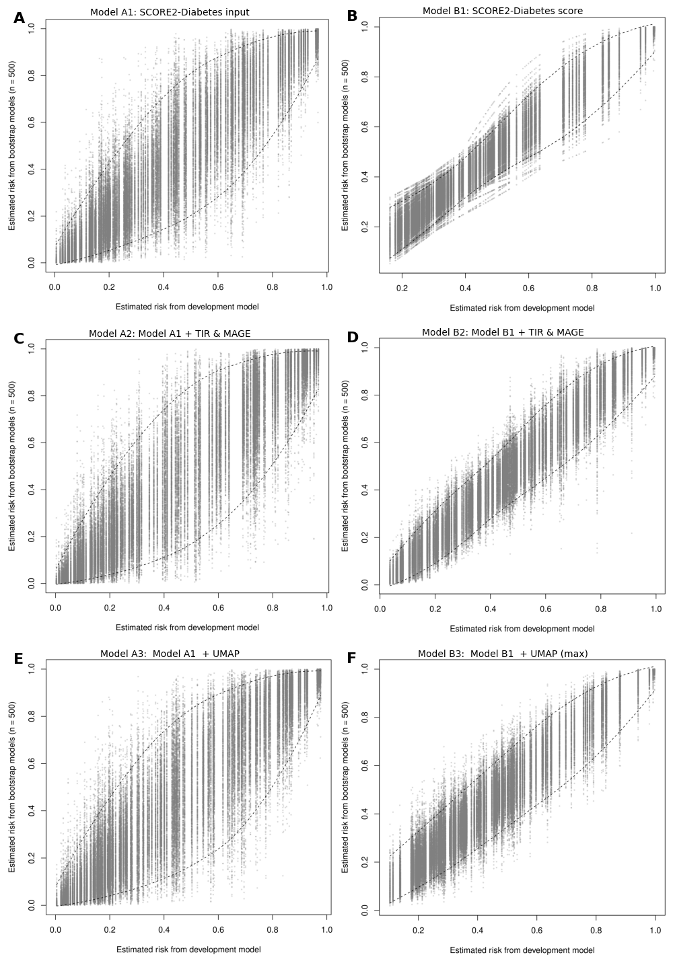
Figure G.1: Prediction stability plots show the predictions (estimated risk) for the full dataset from the development model (equivalent to the apparent model) on the x-axis, and the predictions from all bootstrap models on the y-axis. Tight alignment along the diagonal indicates higher prediction stability.

Appendix A — Study III: Surveillance Error Grid
Table H.1: Results from the Surveillance Error Grid for White participants. Values are reported as percentages.
Group | Model | Zone | 0 | 20 | 40 | 60 | 80 | 100
White | LOCF | None | 69% | 69% | 69% | 69% | 69% | 69%
 |  | Slight | 26% | 26% | 26% | 26% | 26% | 26%
 |  | Moderate | 4% | 4% | 4% | 4% | 4% | 4%
 |  | High | 0% | 0% | 0% | 0% | 0% | 0%
 |  | Extreme | 0% | 0% | 0% | 0% | 0% | 0%
 | Base- | None | 66% | 66% | 66% | 66% | 66% | 66%
 | Individual | Slight | 28% | 28% | 28% | 28% | 28% | 28%
 |  | Moderate | 6% | 6% | 6% | 6% | 6% | 6%
 |  | High | 0% | 0% | 0% | 0% | 0% | 0%
 |  | Extreme | 0% | 0% | 0% | 0% | 0% | 0%
 | Base- | None | 72% | 73% | 73% | 73% | 73% | 73%
 | Generalized | Slight | 25% | 25% | 25% | 24% | 24% | 24%
 |  | Moderate | 3% | 3% | 3% | 3% | 3% | 3%
 |  | High | 0% | 0% | 0% | 0% | 0% | 0%
 |  | Extreme | 0% | 0% | 0% | 0% | 0% | 0%
 | Transfer | None | 72% | 72% | 73% | 73% | 73% | 73%
 | Learned | Slight | 25% | 24% | 24% | 24% | 24% | 24%
 |  | Moderate | 3% | 3% | 3% | 3% | 3% | 3%
 |  | High | 0% | 0% | 0% | 0% | 0% | 0%
 |  | Extreme | 0% | 0% | 0% | 0% | 0% | 0%

Table H.2: Results from the Surveillance Error Grid for Black participants. Values are reported as percentages.
Group | Model | Zone | 0 | 20 | 40 | 60 | 80 | 100
Black | LOCF | None | 71% | 71% | 71% | 71% | 71% | 71%
 |  | Slight | 24% | 24% | 24% | 24% | 24% | 24%
 |  | Moderate | 4% | 4% | 4% | 4% | 4% | 4%
 |  | High | 0% | 0% | 0% | 0% | 0% | 0%
 |  | Extreme | 0% | 0% | 0% | 0% | 0% | 0%
 | Base- | None | 66% | 66% | 66% | 66% | 66% | 66%
 | Individual | Slight | 27% | 27% | 27% | 27% | 27% | 27%
 |  | Moderate | 6% | 6% | 6% | 6% | 6% | 6%
 |  | High | 0% | 0% | 0% | 0% | 0% | 0%
 |  | Extreme | 0% | 0% | 0% | 0% | 0% | 0%
 | Base | None | 75% | 74% | 75% | 75% | 74% | 75%
 | -Generalized | Slight | 23% | 23% | 22% | 22% | 22% | 22%
 |  | Moderate | 3% | 3% | 3% | 3% | 3% | 3%
 |  | High | 0% | 0% | 0% | 0% | 0% | 0%
 |  | Extreme | 0% | 0% | 0% | 0% | 0% | 0%
 | Transfer | None | 75% | 74% | 75% | 75% | 74% | 75%
 | Learned | Slight | 22% | 23% | 22% | 22% | 22% | 22%
 |  | Moderate | 3% | 3% | 3% | 3% | 3% | 3%
 |  | High | 0% | 0% | 0% | 0% | 0% | 0%
 |  | Extreme | 0% | 0% | 0% | 0% | 0% | 0%

