XinYi Liu

Liuxin88

#1003792773

Prelab 1

# Part Ⅰ

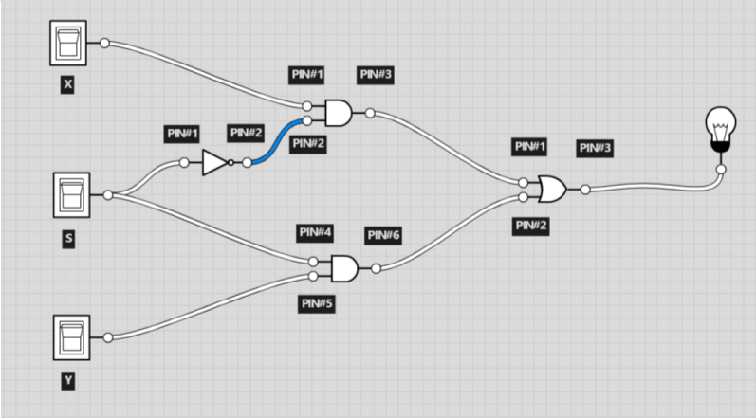1.

74LS08

and2

OUT

74LS04

not1

74LS32

or2

74LS08

and2

2.

|  |  |  |  |
| --- | --- | --- | --- |
| X | S | Y | OUT |
| 0 | 0 | 0 | 0 |
| 0 | 0 | 1 | 0 |
| 0 | 1 | 0 | 0 |
| 0 | 1 | 1 | 1 |
| 1 | 0 | 0 | 1 |
| 1 | 0 | 1 | 1 |
| 1 | 1 | 0 | 0 |
| 1 | 1 | 1 | 1 |

# Part Ⅱ

1.

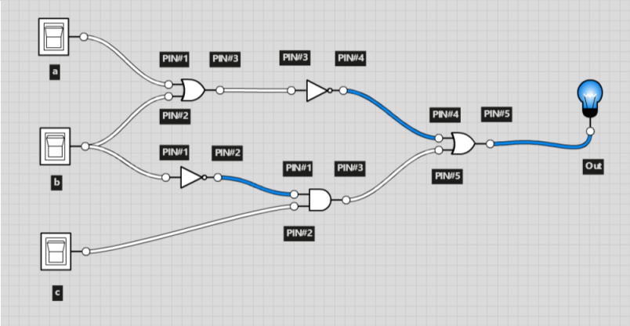

74LS04

not1

74LS32

or2

74LS32

or2

74LS04

not1

74LS08

and2

2.

|  |  |  |  |
| --- | --- | --- | --- |
| a | b | c | OUT |
| 0 | 0 | 0 | 1 |
| 0 | 0 | 1 | 1 |
| 0 | 1 | 0 | 0 |
| 0 | 1 | 1 | 0 |
| 1 | 0 | 0 | 0 |
| 1 | 0 | 1 | 1 |
| 1 | 1 | 0 | 0 |
| 1 | 1 | 1 | 0 |

3.

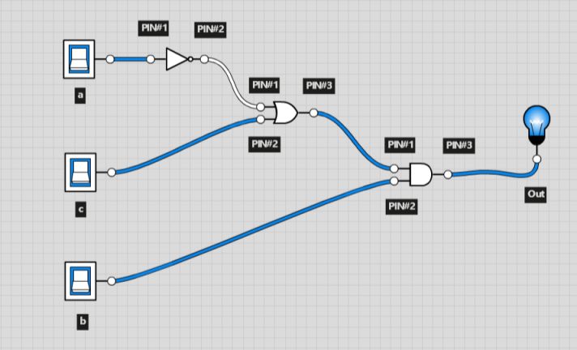Yes, there is a simpler implementation since the boolean function can be simplified to f = (a’ + c)b’

74LS04

not1

74LS32

or2

74LS08

and2