XinYi Liu

Liuxin88

#1003792773

Prelab 2

# Part Ⅰ

1.

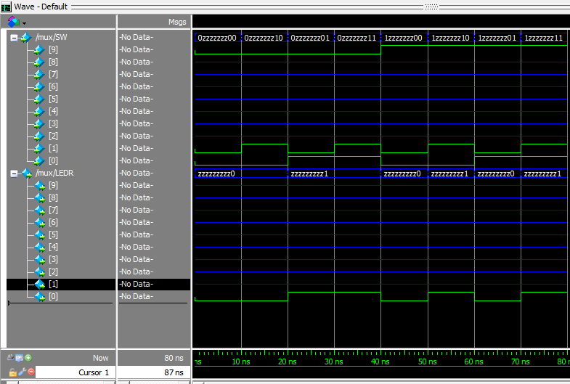

# Part Ⅱ

1. There are 64 rows.

2.

u

v

w

x

x

y

x

y

s0

s0

s

s

Connection1

Connection2

x

y

m

m

s1

module mux2to1(x, y, m);

m

m

module mux2to1(x, y, m);

s

5.

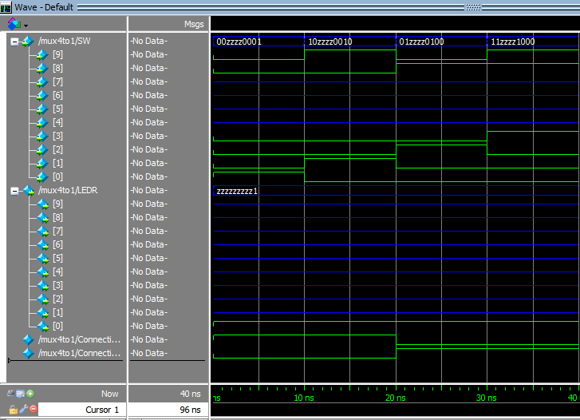

# Part Ⅲ

|  |  |  |  |  |
| --- | --- | --- | --- | --- |
|  | · | ·x0 | x1·x0 | x1· |
| · | 0 | 1 | 0 | 0 |
| ·x2 | 1 | 0 | 0 | 0 |
| x3·x2 | 0 | 1 | 0 | 0 |
| x3· | 0 | 0 | 1 | 0 |

1. **Segment 0**: activate for values 0, 2, 3, 5, 6, 7, 8, 9, A, C, E, F

Truth table Karnaugh maps

|  |  |  |  |  |
| --- | --- | --- | --- | --- |
| X3 | X2 | X1 | X0 | HEX00 |
| 0 | 0 | 0 | 0 | 0 |
| 0 | 0 | 0 | 1 | 1 |
| 0 | 0 | 1 | 0 | 0 |
| 0 | 0 | 1 | 1 | 0 |
| 0 | 1 | 0 | 0 | 1 |
| 0 | 1 | 0 | 1 | 0 |
| 0 | 1 | 1 | 0 | 0 |
| 0 | 1 | 1 | 1 | 0 |
| 1 | 0 | 0 | 0 | 0 |
| 1 | 0 | 0 | 1 | 0 |
| 1 | 0 | 1 | 0 | 0 |
| 1 | 0 | 1 | 1 | 1 |
| 1 | 1 | 0 | 0 | 0 |
| 1 | 1 | 0 | 1 | 1 |
| 1 | 1 | 1 | 0 | 0 |
| 1 | 1 | 1 | 1 | 0 |

Boolean functions

HEX00 = ···x0 + ·x2·· + x3·x2··x0 +x3··x1·x0

**Segment 1**: activate for values 0, 1, 2, 3 ,4 ,7, 8, 9, A, d

|  |  |  |  |  |
| --- | --- | --- | --- | --- |
|  | · | ·x0 | x1·x0 | x1· |
| · | 0 | 0 | 0 | 0 |
| ·x2 | 0 | 1 | 0 | 1 |
| x3·x2 | 1 | 0 | 1 | 1 |
| x3· | 0 | 0 | 1 | 0 |

Truth table Karnaugh maps

|  |  |  |  |  |
| --- | --- | --- | --- | --- |
| X3 | X2 | X1 | X0 | HEX01 |
| 0 | 0 | 0 | 0 | 0 |
| 0 | 0 | 0 | 1 | 0 |
| 0 | 0 | 1 | 0 | 0 |
| 0 | 0 | 1 | 1 | 0 |
| 0 | 1 | 0 | 0 | 0 |
| 0 | 1 | 0 | 1 | 1 |
| 0 | 1 | 1 | 0 | 1 |
| 0 | 1 | 1 | 1 | 0 |
| 1 | 0 | 0 | 0 | 0 |
| 1 | 0 | 0 | 1 | 0 |
| 1 | 0 | 1 | 0 | 0 |
| 1 | 0 | 1 | 1 | 1 |
| 1 | 1 | 0 | 0 | 1 |
| 1 | 1 | 0 | 1 | 0 |
| 1 | 1 | 1 | 0 | 1 |
| 1 | 1 | 1 | 1 | 1 |

Boolean functions

HEX01 = ·x2··x0 + x2·x1· + x3·x2·+ x3·x1·x0

**Segment 2**: activate for values 0, 1, 3 ,4 ,5, 6, 7, 8, 9, A, b, d

|  |  |  |  |  |
| --- | --- | --- | --- | --- |
|  | · | ·x0 | x1·x0 | x1· |
| · | 0 | 0 | 0 | 1 |
| ·x2 | 0 | 0 | 0 | 0 |
| x3·x2 | 1 | 0 | 1 | 1 |
| x3· | 0 | 0 | 0 | 0 |

Truth table Karnaugh maps

|  |  |  |  |  |
| --- | --- | --- | --- | --- |
| X3 | X2 | X1 | X0 | HEX02 |
| 0 | 0 | 0 | 0 | 0 |
| 0 | 0 | 0 | 1 | 0 |
| 0 | 0 | 1 | 0 | 1 |
| 0 | 0 | 1 | 1 | 0 |
| 0 | 1 | 0 | 0 | 0 |
| 0 | 1 | 0 | 1 | 0 |
| 0 | 1 | 1 | 0 | 0 |
| 0 | 1 | 1 | 1 | 0 |
| 1 | 0 | 0 | 0 | 0 |
| 1 | 0 | 0 | 1 | 0 |
| 1 | 0 | 1 | 0 | 0 |
| 1 | 0 | 1 | 1 | 0 |
| 1 | 1 | 0 | 0 | 1 |
| 1 | 1 | 0 | 1 | 0 |
| 1 | 1 | 1 | 0 | 1 |
| 1 | 1 | 1 | 1 | 1 |

Boolean functions

HEX02 = ··x1· + x3·x2·x1 + x3·x2·

**Segment 3**: activate for values 0, 2, 3 ,5, 6, 8, 9, b, C, d, E

|  |  |  |  |  |
| --- | --- | --- | --- | --- |
|  | · | ·x0 | x1·x0 | x1· |
| · | 0 | 1 | 0 | 0 |
| ·x2 | 1 | 0 | 1 | 0 |
| x3·x2 | 0 | 0 | 1 | 0 |
| x3· | 0 | 0 | 0 | 1 |

Truth table Karnaugh maps

|  |  |  |  |  |
| --- | --- | --- | --- | --- |
| X3 | X2 | X1 | X0 | HEX03 |
| 0 | 0 | 0 | 0 | 0 |
| 0 | 0 | 0 | 1 | 1 |
| 0 | 0 | 1 | 0 | 0 |
| 0 | 0 | 1 | 1 | 0 |
| 0 | 1 | 0 | 0 | 1 |
| 0 | 1 | 0 | 1 | 0 |
| 0 | 1 | 1 | 0 | 0 |
| 0 | 1 | 1 | 1 | 1 |
| 1 | 0 | 0 | 0 | 0 |
| 1 | 0 | 0 | 1 | 0 |
| 1 | 0 | 1 | 0 | 1 |
| 1 | 0 | 1 | 1 | 0 |
| 1 | 1 | 0 | 0 | 0 |
| 1 | 1 | 0 | 1 | 0 |
| 1 | 1 | 1 | 0 | 0 |
| 1 | 1 | 1 | 1 | 1 |

Boolean functions

HEX03 = ···x0 + ·x2·· + x2·x1·x0 + x3··x1·

**Segment 4**: activate for values 0, 2, 6, 8, A, b, C, d, E, F

|  |  |  |  |  |
| --- | --- | --- | --- | --- |
|  | · | ·x0 | x1·x0 | x1· |
| · | 0 | 1 | 1 | 0 |
| ·x2 | 1 | 1 | 1 | 0 |
| x3·x2 | 0 | 0 | 0 | 0 |
| x3· | 0 | 1 | 0 | 0 |

Truth table Karnaugh maps

|  |  |  |  |  |
| --- | --- | --- | --- | --- |
| X3 | X2 | X1 | X0 | HEX04 |
| 0 | 0 | 0 | 0 | 0 |
| 0 | 0 | 0 | 1 | 1 |
| 0 | 0 | 1 | 0 | 0 |
| 0 | 0 | 1 | 1 | 1 |
| 0 | 1 | 0 | 0 | 1 |
| 0 | 1 | 0 | 1 | 1 |
| 0 | 1 | 1 | 0 | 0 |
| 0 | 1 | 1 | 1 | 1 |
| 1 | 0 | 0 | 0 | 0 |
| 1 | 0 | 0 | 1 | 1 |
| 1 | 0 | 1 | 0 | 0 |
| 1 | 0 | 1 | 1 | 0 |
| 1 | 1 | 0 | 0 | 0 |
| 1 | 1 | 0 | 1 | 0 |
| 1 | 1 | 1 | 0 | 0 |
| 1 | 1 | 1 | 1 | 0 |

Boolean functions

HEX04 = ·x0 + ··x0 + ·x2·

**Segment 5**: activate for values 0, 4, 5, 6, 8, 9, A, b, C, E, F

|  |  |  |  |  |
| --- | --- | --- | --- | --- |
|  | · | ·x0 | x1·x0 | x1· |
| · | 0 | 1 | 1 | 1 |
| ·x2 | 0 | 0 | 1 | 0 |
| x3·x2 | 0 | 1 | 0 | 0 |
| x3· | 0 | 0 | 0 | 0 |

Truth table Karnaugh maps

|  |  |  |  |  |
| --- | --- | --- | --- | --- |
| X3 | X2 | X1 | X0 | HEX05 |
| 0 | 0 | 0 | 0 | 0 |
| 0 | 0 | 0 | 1 | 1 |
| 0 | 0 | 1 | 0 | 1 |
| 0 | 0 | 1 | 1 | 1 |
| 0 | 1 | 0 | 0 | 0 |
| 0 | 1 | 0 | 1 | 0 |
| 0 | 1 | 1 | 0 | 0 |
| 0 | 1 | 1 | 1 | 1 |
| 1 | 0 | 0 | 0 | 0 |
| 1 | 0 | 0 | 1 | 0 |
| 1 | 0 | 1 | 0 | 0 |
| 1 | 0 | 1 | 1 | 0 |
| 1 | 1 | 0 | 0 | 0 |
| 1 | 1 | 0 | 1 | 1 |
| 1 | 1 | 1 | 0 | 0 |
| 1 | 1 | 1 | 1 | 0 |

Boolean functions

HEX05 = ··x0 + ··x1 +·x1·x0 + x3·x2··x0

**Segment 6**: activate for values 2, 3, 4, 5, 6, 8, 9, A, b, d, E, F

|  |  |  |  |  |
| --- | --- | --- | --- | --- |
|  | · | ·x0 | x1·x0 | x1· |
| · | 1 | 1 | 0 | 0 |
| ·x2 | 0 | 0 | 1 | 0 |
| x3·x2 | 1 | 0 | 0 | 0 |
| x3· | 0 | 0 | 0 | 0 |

Truth table Karnaugh maps

|  |  |  |  |  |
| --- | --- | --- | --- | --- |
| X3 | X2 | X1 | X0 | HEX06 |
| 0 | 0 | 0 | 0 | 1 |
| 0 | 0 | 0 | 1 | 1 |
| 0 | 0 | 1 | 0 | 0 |
| 0 | 0 | 1 | 1 | 0 |
| 0 | 1 | 0 | 0 | 0 |
| 0 | 1 | 0 | 1 | 0 |
| 0 | 1 | 1 | 0 | 0 |
| 0 | 1 | 1 | 1 | 1 |
| 1 | 0 | 0 | 0 | 0 |
| 1 | 0 | 0 | 1 | 0 |
| 1 | 0 | 1 | 0 | 0 |
| 1 | 0 | 1 | 1 | 0 |
| 1 | 1 | 0 | 0 | 1 |
| 1 | 1 | 0 | 1 | 0 |
| 1 | 1 | 1 | 0 | 0 |
| 1 | 1 | 1 | 1 | 0 |

Boolean functions

HEX06 = ·· + x3·x2·· + ·x2·x1·x0

3.

