# Part Ⅰ

1.

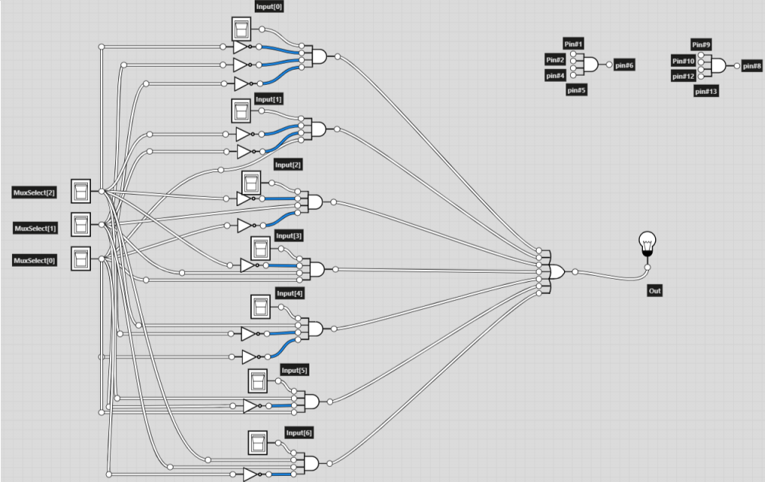

Out = I0M2’M1’M0’ + I1M2’M1’M0 + I2M2’M1M0’ + I3M2’M1M0 + I4M2M1’M0’ + I5M2M1’M0 + I6M2M1M0’

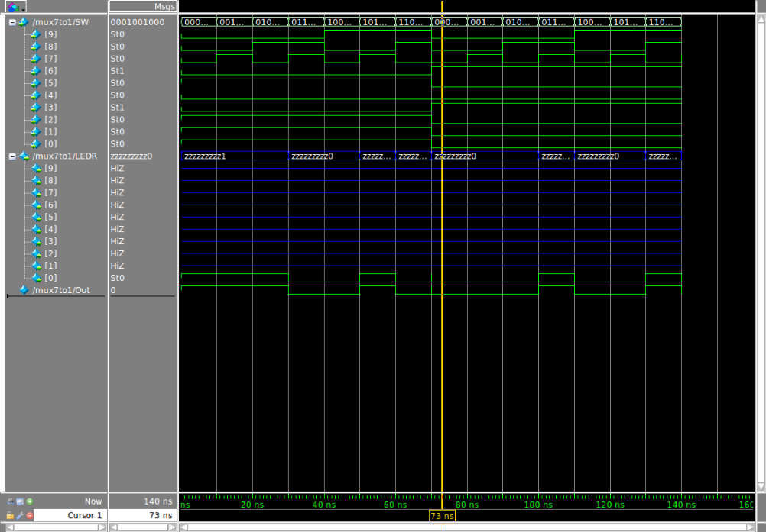

# Part Ⅱ

1.

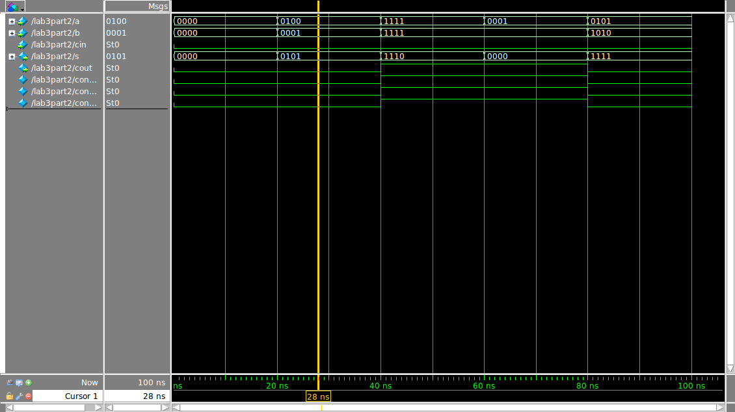

a0

b0

cin

x

y

z

u

v

s0

a1

b1

z

y

x

u

v

s1

a2

b2

z

y

x

u

v

s2

a3

b3

z

y

x

u

v

s3

Cout

connect1

connect2

connect3

FA1

FA2

FA3

FA4

# Part Ⅲ

1.

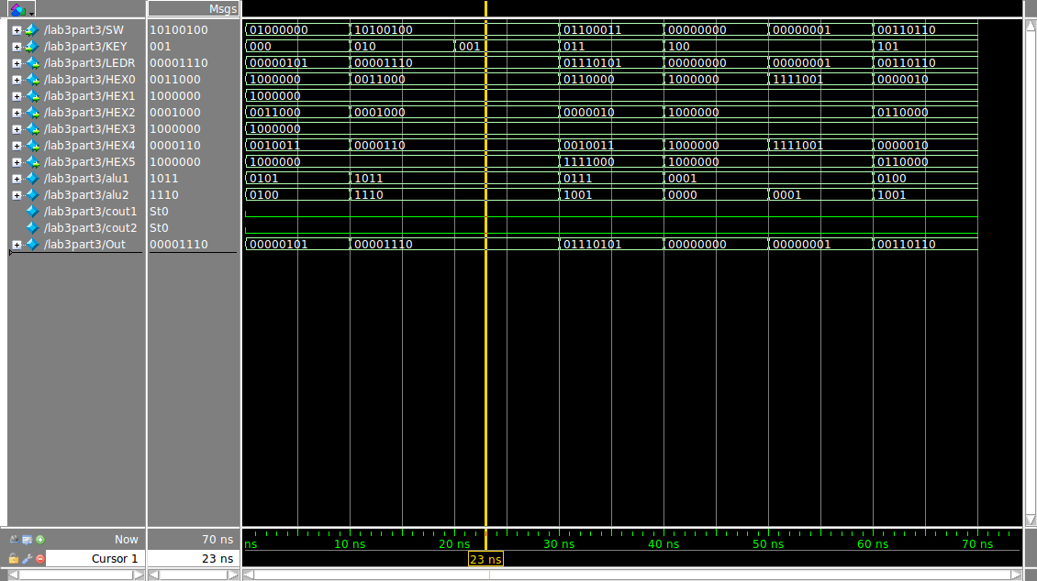

SW[0]

SW[1]

SW[2]

SW[3]

SW[4]

SW[5]

SW[6]

SW[7]

A

B

HEX[0]

HEX[2]

0001

0

4 digits full adder

0

4 digits full adder

function1

function2

function3

function4

default

7 to 1 mux

KEY[0]

KEY[1]

KEY[2]

HEX[4]

HEX[5]

LEDR[7:0]