Part Ⅰ

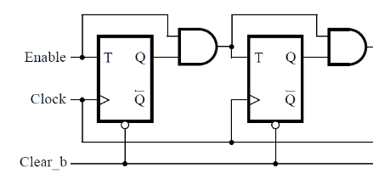1.

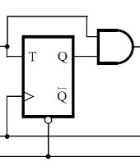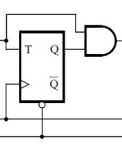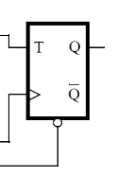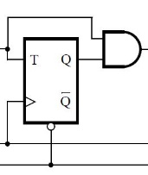

KEY[0]

SW[1]

SW[0]

Q7 Q6 Q5 Q4 Q3 Q2 Q1 Q0

HEX1

HEX0

4.

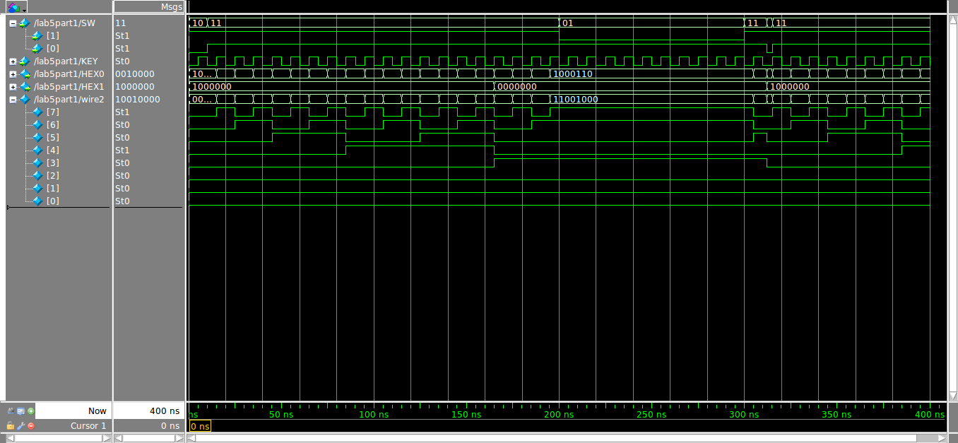

6.

(a)<1%

(b)621.89MHz

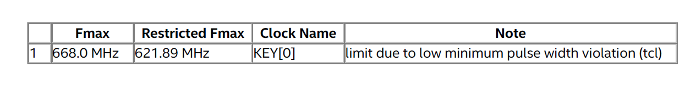

7.

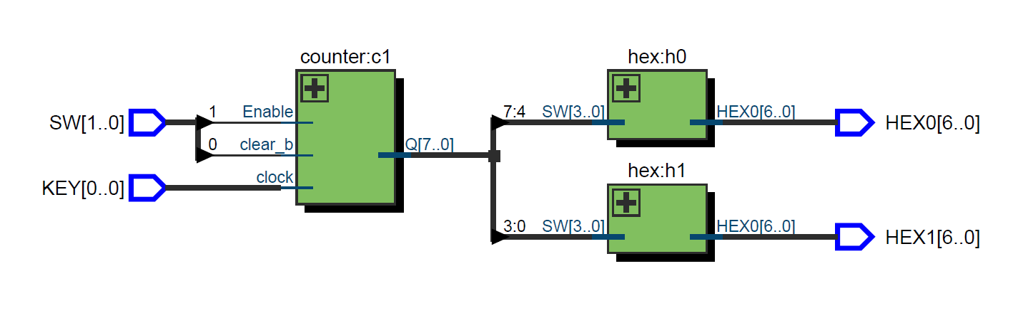

It doesn’t show all the T-type flip-flops.

Part Ⅱ

1. Because 1111 + 1 = 10000 and since q is 4-bits, it will become 0000.

2. i f ( q == 4 ' b1111 ) => i f ( q == 4 ' b1001 )

3.Can’t see anything since each period is 1/(50\*10^6) s

4. 26 T flip-flops

5. log2(50+10^6) = 26

Schematic:

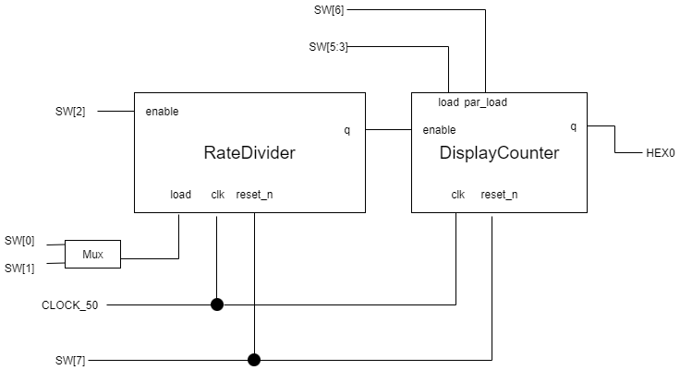

Simulation:

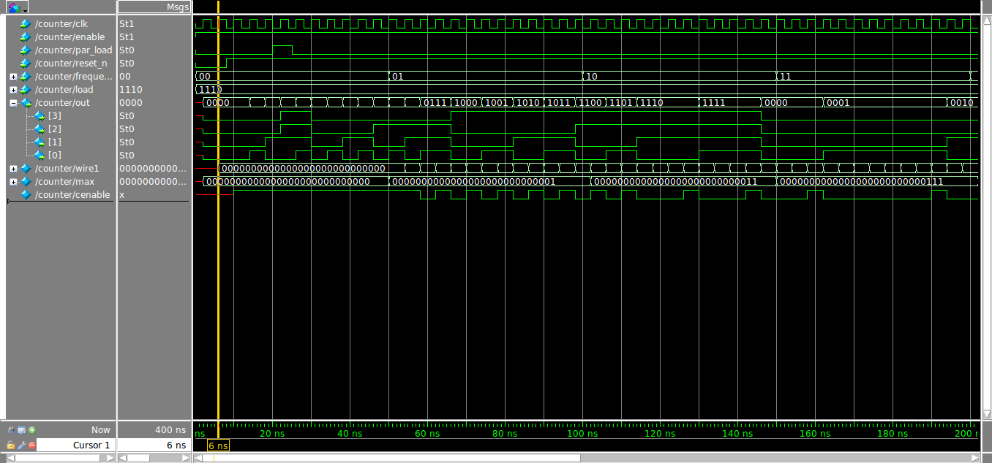

Part 3

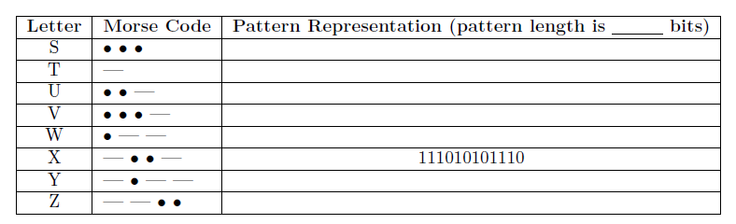1.

16

1010100000000000

1110000000000000

1010111000000000

1010101110000000

1011101110000000

0000

1110101110111000

1110111010100000

2.

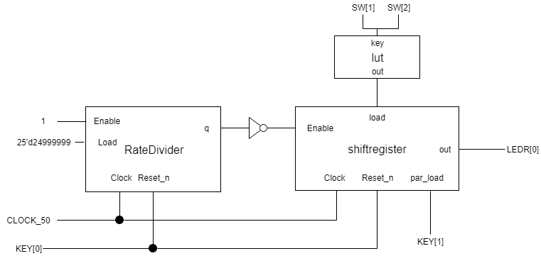

3.

