Part 1

2. resetn is asynchronous and active_low. To reset we have to set resetn to 0 and clock from 0 to 1.

3.

|  |  |  |  |
| --- | --- | --- | --- |
| y_Q | w | Y_D | z |
| A | 0 | A | 0 |
| A | 1 | B | 0 |
| B | 0 | A | 0 |
| B | 1 | C | 0 |
| C | 0 | E | 0 |
| C | 1 | D | 0 |
| D | 0 | E | 0 |
| D | 1 | F | 0 |
| E | 0 | A | 0 |
| E | 1 | G | 0 |
| F | 0 | E | 1 |
| F | 1 | F | 1 |
| G | 0 | A | 1 |
| G | 1 | C | 1 |

4.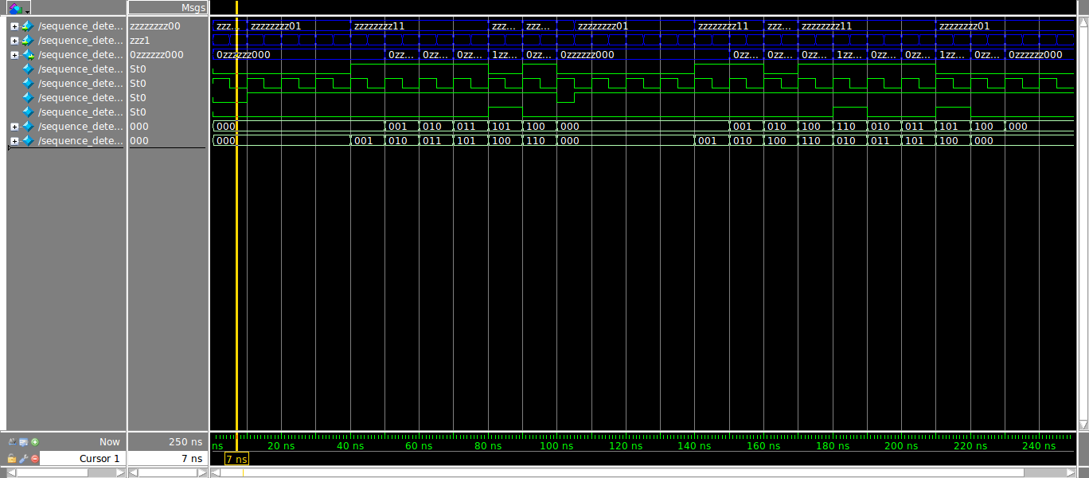

Part 2

2.

Load A to register A

data_in = A, ld_alu_out = 0, ld_a = 1, ld_b = 0, ld_c = 0, ld_x = 0, ld_r = 0

alu_select_a = 00, alu_select_b = 00, alu_op = 0

registerA = A, registerB = 8’d0, registerC = 8’d0, registerX = 8’d0

Load B to register B

data_in = B, ld_alu_out = 0, ld_a = 0, ld_b = 1, ld_c = 0, ld_x = 0, ld_r = 0

alu_select_a = 00, alu_select_b = 00, alu_op = 0

registerA = A, registerB = B, registerC = 8’d0, registerX = 8’d0

Load C to register C

data_in = C, ld_alu_out = 0, ld_a = 0, ld_b = 0, ld_c = 1, ld_x = 0, ld_r = 0

alu_select_a = 00, alu_select_b = 00, alu_op = 0

registerA = A, registerB = B, registerC = C, registerX = 8’d0

Load X to register X

data_in = X, ld_alu_out = 0, ld_a = 0, ld_b = 0, ld_c = 0, ld_x = 1, ld_r = 0

alu_select_a = 00, alu_select_b = 00, alu_op = 0

registerA = A, registerB = B, registerC = C, registerX = X

Multiply AX and store in registerA

ld_alu_out = 1, ld_a = 1, ld_b = 0, ld_c = 0, ld_x = 0, ld_r = 0

alu_select_a = 00, alu_select_b = 11, alu_op = 1

registerA = AX, registerB = B, registerC = C, registerX = X

Multiply AX² and store in registerA

ld_alu_out = 1, ld_a = 1, ld_b = 0, ld_c = 0, ld_x = 0, ld_r = 0

alu_select_a = 00, alu_select_b = 11, alu_op = 1

registerA = AX², registerB = B, registerC = C, registerX = X

Multiply BX and store in registerB

ld_alu_out = 1, ld_a = 0, ld_b = 1, ld_c = 0, ld_x = 0, ld_r = 0

alu_select_a = 01, alu_select_b = 11, alu_op = 1

registerA = AX², registerB = BX, registerC = C, registerX = X

Add AX²+BX and store in registerB

ld_alu_out = 1, ld_a = 0, ld_b = 1, ld_c = 0, ld_x = 0, ld_r = 0

alu_select_a = 00, alu_select_b = 01, alu_op = 0

registerA = AX², registerB = AX²+BX, registerC = C, registerX = X

n

Add C to AX²+BX

ld_alu_out = 0, ld_a = 0, ld_b = 0, ld_c = 0, ld_x = 0, ld_r = 1

alu_select_a = 10, alu_select_b = 01, alu_op = 0

registerA = AX², registerB = AX²+BX, registerC = C, registerX = X

3.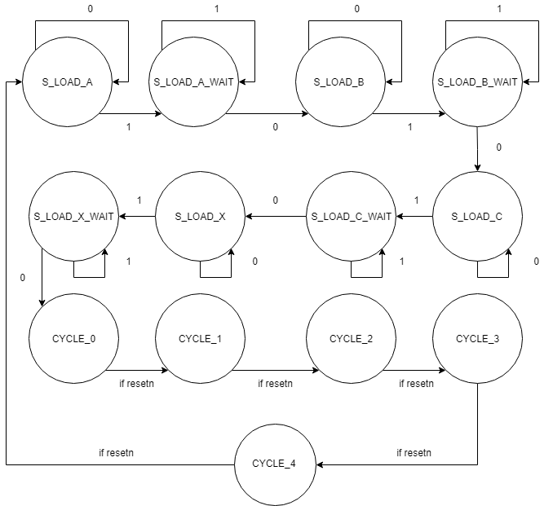

4.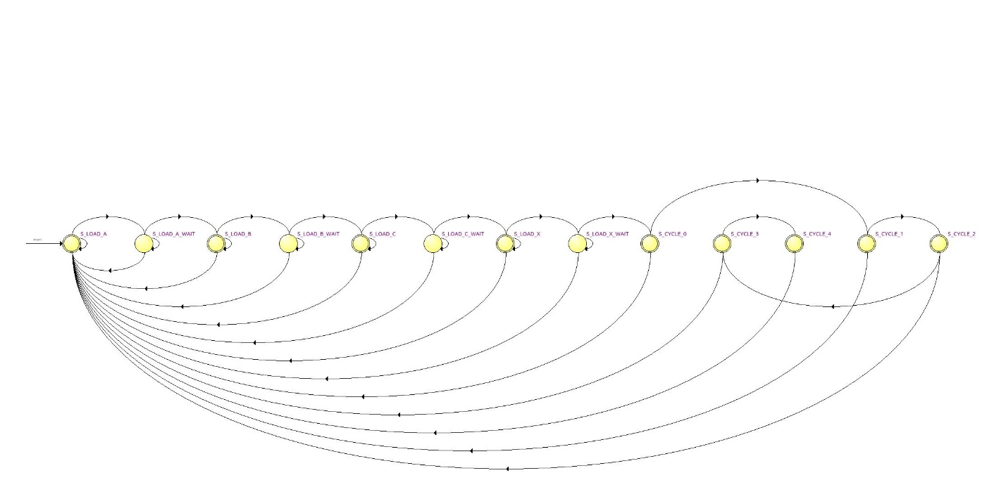

5.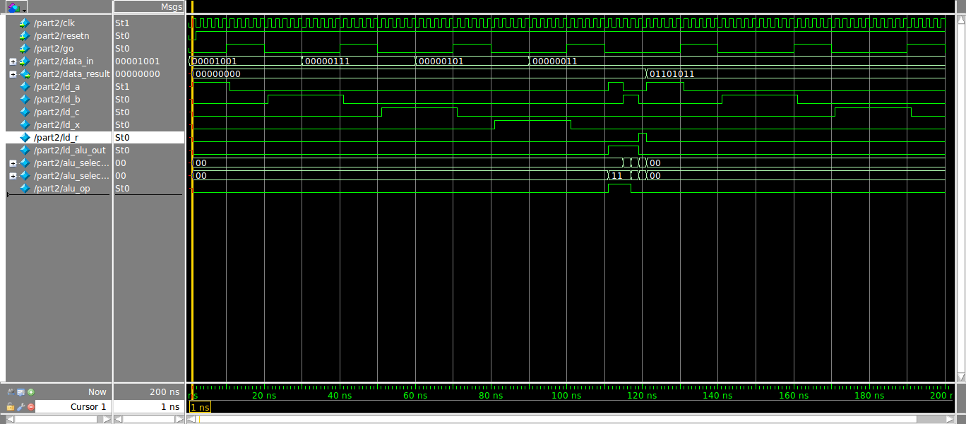

Part3

1.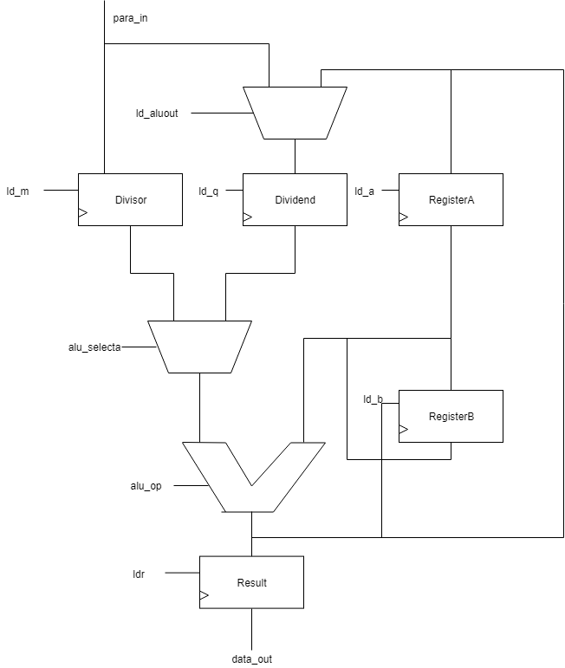

2.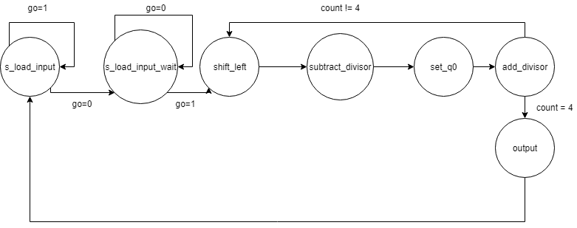

3.

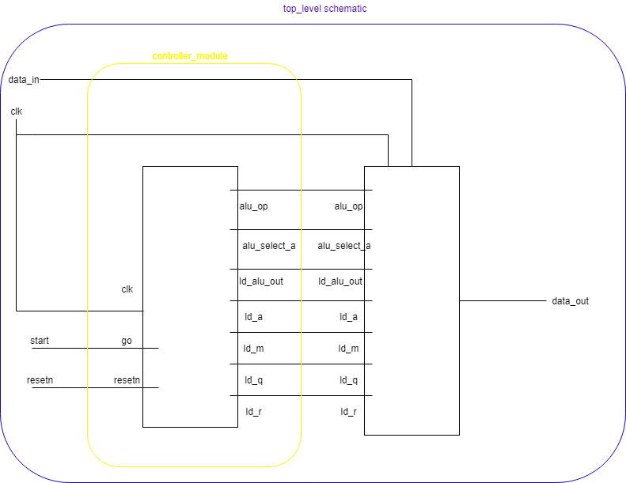

4.

