Part1

1.

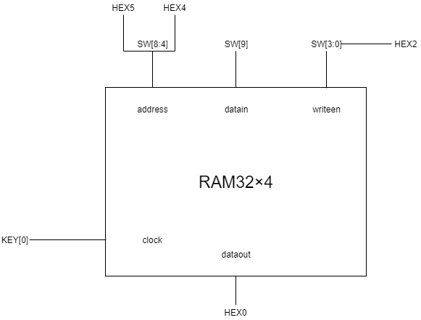

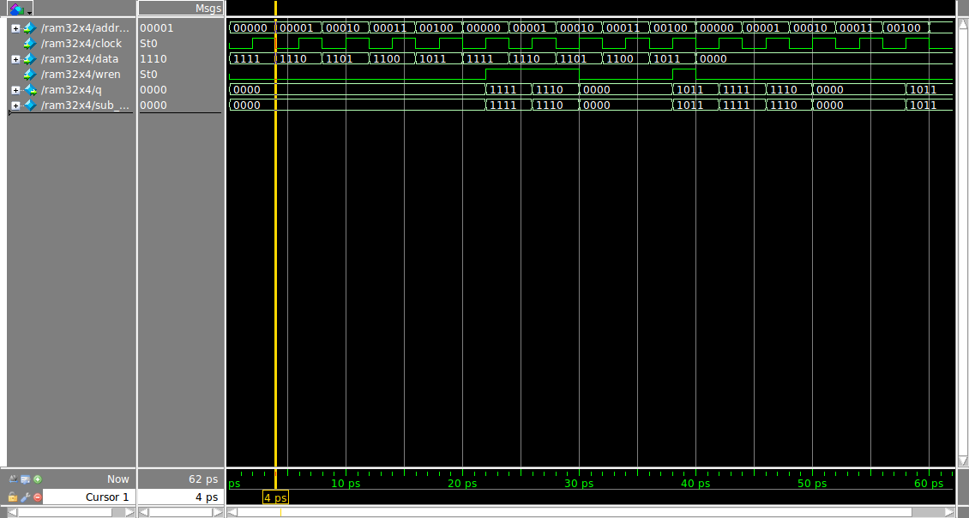

Part2

1.

DATAPATH SCHEMATIC

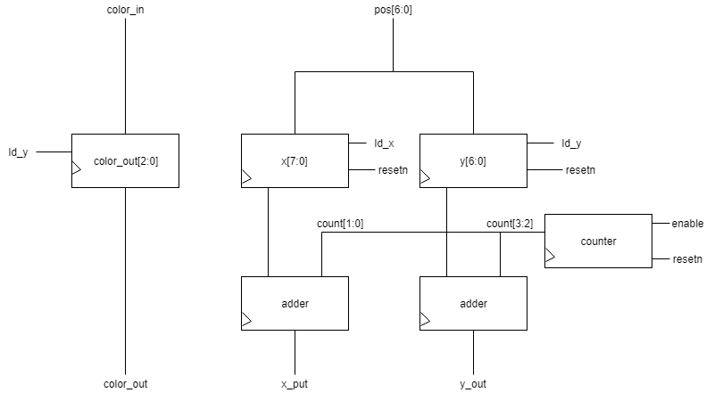

DATAPATH SIMULATION

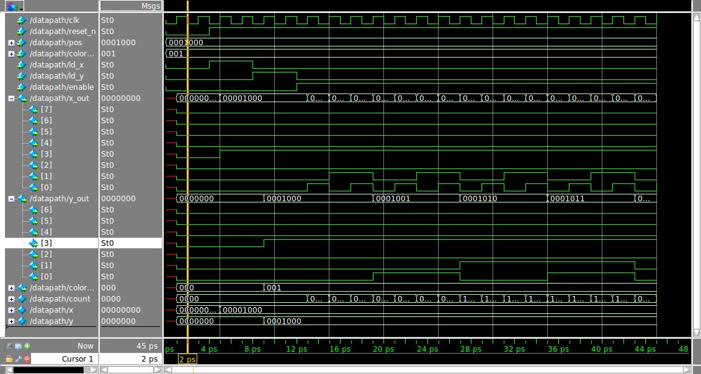

2.

STATE DIAGRAM

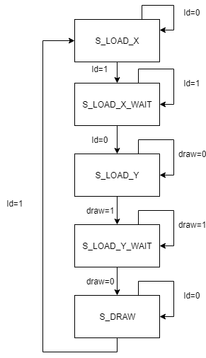

STATE TABLE

|  |  |  |  |
| --- | --- | --- | --- |
| Current state | ld | draw | Next state |
| S_LOAD_X | 0 | Z | S_LOAD_X |
| S_LOAD_X | 1 | Z | S_LOAD_X_WAIT |
| S_LOAD_X_WAIT | 1 | Z | S_LOAD_X_WAIT |
| S_LOAD_X_WAIT | 0 | Z | S_LOAD_Y |
| S_LOAD_Y | Z | 0 | S_LOAD_Y |
| S_LOAD_Y | Z | 1 | S_LOAD_Y_WAIT |
| S_LOAD_Y_WAIT | Z | 1 | S_LOAD_Y_WAIT |
| S_LOAD_Y_WAIT | Z | 0 | S_DRAW |
| S_DRAW | 0 | Z | S_DRAW |
| S_DRAW | 1 | Z | S_LOAD_X |

CONTROL SIMULATION

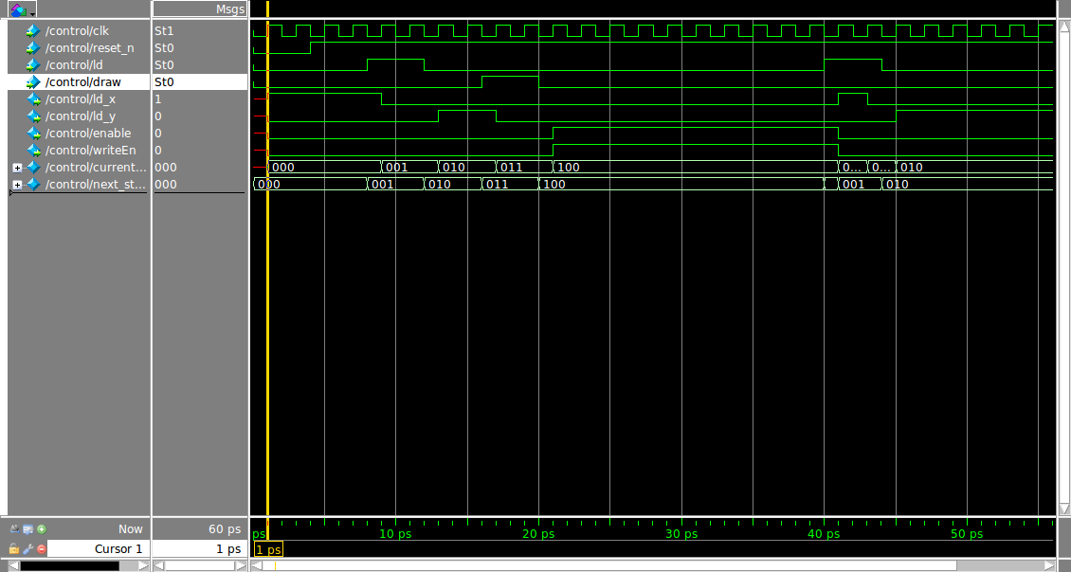

3.

COMBINED SIMULATION

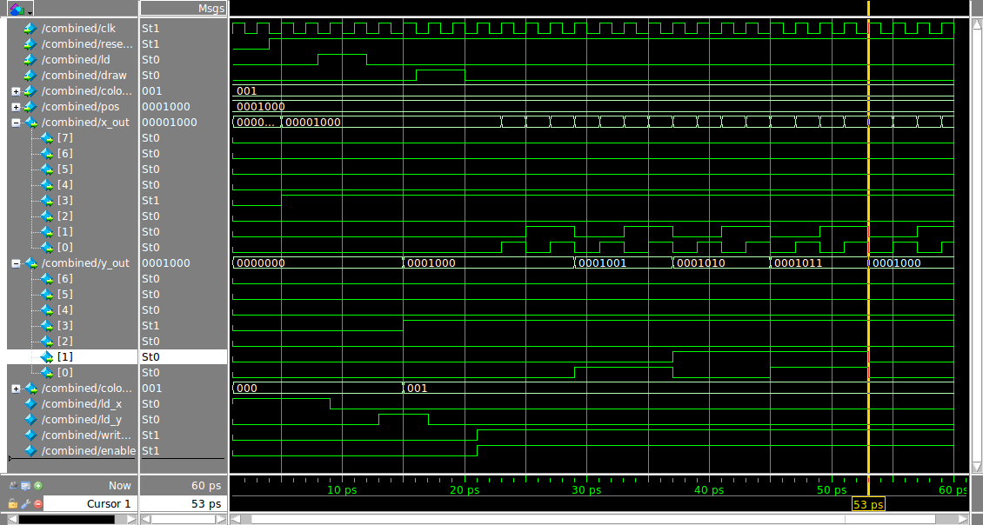

3.

