Proposal for Chinese New Year Party

By Lianyin, Jiayin, Michael, Ani, Richa, Laura, Ishita, Jyoti, Faizan

# Introduction

Chinese legend describes of a ferocious, long taloned monster called Year who resided in the deep sea. Once each Chinese New Year’s Eve, Year will come out of hiding to attack people and their livestocks. To survive the attacks, one village discovered that the Year monster fears the color red, fires, and explosions. They hung red couplets on their gates, lit fireworks, and left lights on throughout the night; Year never attacked the village again. Over time the custom of hanging red couplets, lighting fireworks, and leaving lights on spread to become the most important festival in China.

For 2014, Chinese New Year falls between January 31 through February 14; we have two classes during period. These classes will provide a convenient time to gather and celebrate Chinese New Year with our colleagues with traditional food and entertainment.

# Vision

We intend to acquaint ourselves with our colleagues by allocating an hour of our class time and sharing information about the most important Chinese festival. During the hour we intend to provide food, activities, and enjoyable conversation.

Our vision is to build career connections by celebrating the cultural traditions of today with the future leaders of tomorrow.

# Scope Definitions

In scope:

* The party shall be held on February 10 2014 from 18:00 until 19:00 at Seattle University, Banner Building, Room 503.
* Chinese Festival Food, including:
  + Dumplings
  + Sticky rice ball
  + Spring rolls
  + Oranges
  + Snacks
  + Sparkling beverage
* View a video clip about Chinese New Year and Chinese Zodiac Story .
* Play Zodiac game and declare two winners.
* Play Mahjong

Out of scope:

* Drugs of any kind including but not limited to smoke, alcohol, or non prescribed medication.
* Traditional food from other countries
* Betting in Mahjong game

# Schedule

February 10 2014

|  |  |
| --- | --- |
| 17:30 ~18:00 | Set up: decorating, warm food, set the table and server food by Helen, Laura, Mike and Jiayin. |
| 18:00 ~18:10 | Chinese New Year introduction by Helen and Jiayin. |
| 18:10 ~ 8:30 | Chinese New Year video played by Jiayin. |
| 18:00 ~18:45 | Enjoy the food and play Mahjong by all of classmates and Professor Koenig. |
| 18:45~19:00 | Zodiac video and game by all classmates and Professor and Luck Draw by Professor Koenig. |
| 19:00 | Party End and clean up by all classmates. |

Mahjong game procedure:

* Watch an instruction video.
* Everyone will receive a hard copy of instructions
* Play the game.

Zodiac game instruction:

* Everyone will get a picture about Zodiac and a piece of blank paper.
* Everyone looks the Zodiac picture and find which animal belongs the year you born.
* Write down your name and Zodiac you are, fold it and put in a box.
* Professor Koenig will draw twice to determine two winners.
* Winners will get surprise.

# Persona

* 1. Persona 1: Student Audience Participant - Smitha Nair  
     

Smitha Nair is a 25 year old Indian lady who lives with her husband Venu Nair in Seattle, WA. She joined Seattle University’s MS in Software Engineering program in Winter 2014 as both a full time student and a part time employee on school campus. Her life these days is all about going to school, doing assignments and projects. Being new to US education system, she finds it difficult to cope up with three courses a quarter and her part time job and household chores. She looks forward to the end of quarter so that she can get some free time to relax.

In Smitha’s Project Planning class, her instructor presented an opportunity for her class to earn extra credit by creating a party plan for the course. The idea of getting extra credit for partaking in festivities excites Smitha. She finds her Project Planning class the highlight of the week; her Project Planning instructor has an intriguing teaching methodology which resonates well with her.

The theme of the party is New Year celebration – Chinese style. Originally from India, Smitha is excited that she has been invited to celebrate Lunar New Year with her other international classmates. Smitha is ready to enjoy some authentic Chinese food, games, and conversation with her classmates. Finally her dream of partying during class is coming true.

* 1. Persona 2: Chinese New Year Student Presenter - May Li Tung

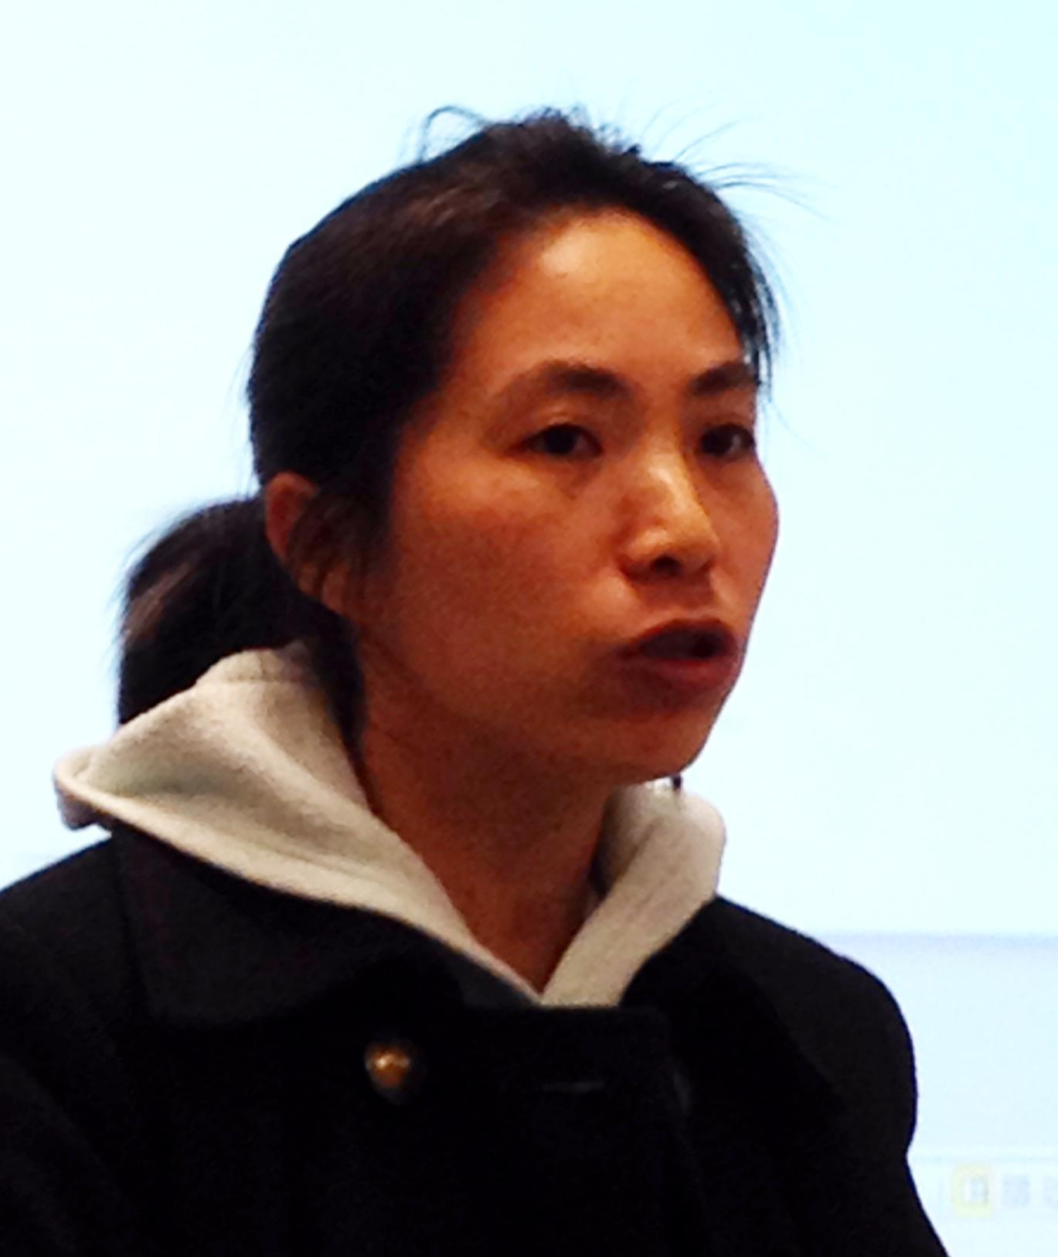

May is a 31 year old software developer at Ciber Technologies Inc. She moved here five years ago with her husband and four year old daughter because of a job offer. Every Sunday May and her family attend Chinese school, where she and her husband participates in Tai Chi class and her daughter attends Kindergarten. May enjoys her job and she wishes to further her technical knowledge of software engineering; the ability to recognize software development patterns is a skill that she wishes to acquire and apply at her current job. She makes the trek every Monday night from her Bothell workplace to Seattle University to quench her insatiable curiosity. After class, she returns home and enjoys listening to her husband’s day and playing with her daughter before heading to bed for the night.

* 1. Persona 3: Instructor - Michael Koenig



Mike is an adjunct lecturer who teaches Software Project Planning to MSE students at Seattle University. He works as a Principal Program Manager Lead at Microsoft. He is married and loving father of two kids. He loves jogging and taking his two dogs for walks on the weekends in Marymoor dog park. When he has time, he will drop by the velodrome and watch cyclists participating in Keirin races.Other than English he speaks fluent Japanese, and is learning Spanish. He is passionate about travelling, food and exploring and learning about different cultures.

He brings with him a lot of experience to the class and often brings up real life use cases that he has come across during his many years in the industry. His students appreciate his teaching style and he has consistently got good reviews from them because of his non-textbook centric approach and his ability to engage the entire class throughout his lectures. He wants his student to organize a class party, his goal is to to get his students introduced to various tenets of project planning and organizing events, albeit on a smaller stage.

# Scenarios

* **Indian girl interested in Chinese culture plays the Zodiac game**

Smitha, full of spring rolls, sticky buns, and dumplings, drops her name into the “Horse” hat and waddles back to her seat. Through the Chinese New Year presentation, Smitha has learned that she was born the year of the Horse. May calls the instructor to come up and pick out a name. With great flair, Mike twirls his hands in the air, and places it in a hat. The air is heavy with anticipation as all students fall silent, watching the drawing of the name. Despite her bloated belly, Smitha finds herself leaning forward as well, peering at the piece of paper in the instructor’s hand. He unfolds the paper, widens his eyes, and with great flourish, announces the first winner’s name - “Smitha!” The class turn to her, patting her back in congratulations for her good luck. She laughs and claps her hands in delight, eagerly awaiting her surprise prize. “What a fantastic festival Chinese New Year is!” she thinks to herself. “What fantastic classmates I have!”

* **Chinese New Year Presenter arrives and begins presentation preparation**

May Li Tung, one of the Chinese New Year Presenters, is driving into class. She is nervous and excited to present her part of her presentation to the class - the video of Chinese New Year festivities. She parks her car, grabs her fully charged laptop, and runs into the BANN engineering building. She jumps into the elevator, exits at the fifth floor, walks over to BANN 503, and sees that the door is closed. She peeks in and sees two of her classmates are already there and hanging decorations. She opens the door, walks in, and begins plugging in her computer into the projector. The laptop turns on and the projector flawlessly detects the connection and flickers to life with the laptop in perfect display behind her. She pulls up the presentation, turns behind her to check that it displays correctly, and nods in approval. She quietly begins rehearsing the first few slides.

* **Class Instructor looking for some fun time**

Mike had a long day at work. He is feeling so tired that he actually wants to skip the class of Software project plan that he teaches at Seattle University. Nevertheless, he has to be there before the class starts as there is going to be a party in the class for the Chinese New Year. This is going to be the only good thing Mike is expecting from that day. He just wants to be there, sit back, enjoy some good food and watch a wonderful video to relax himself a bit. He is also looking forward to have a fun time with his students while playing some Chinese games that will actually drain out his frustration after a tiring day at Microsoft.

# 7. User stores

1. As a Student Audience Participant, I would like to learn more about the Chinese culture, significance of the Chinese New Year and try some authentic chinese food.
2. As a Chinese New Year Student Presenter, I want a small room to hold our party so that everyone will be in closer proximity and will have the ability to hear me speak.
3. As a Chinese New Year Student Presenter, I want the projector and laptop to work because I can display examples of Chinese New Year celebrations.
4. As a Chinese New Year Student Presenter, I want to have the room available to me at 5:30pm so that I properly prepare for the presentation.
5. As an instructor of the Software Project Plan class, Mike wants to enjoy some quality time with his students in form of a party so that he can get some change from his boring work routine and also socialize more with his students to strengthen the student-teacher relationship.
6. As a Chinese New Year Presenter, I want to have game of Chinese Zodiac, so that everyone in the party can enjoy and have fun.
7. As a Chinese New Year Presenter, I want to have Red banners , stickers, Lanterns, so that the party room looks decorated.

# 8. Deliverables

* Video clip
* Chinese New Year tradition: <http://www.youtube.com/watch?v=2EUsmbqnuw8>

Chinese Zodiac Story: [http://www.youtube.com/watch?v=T0fgAFe-h0](http://www.youtube.com/watch?v=Ty0fgAFe-h0)

* Food and drinks
* Game of Chinese Zodiac
* Mahjong Instruction/video

<http://www.howcast.com/videos/206827-How-to-Play-Mahjongg>

* Background Music

<http://www.youtube.com/watch?v=-ojJsctMAqU>

* Stove
* Red banners, stickers, Lanterns…
* Food label
* Mahjong set

9. B[ud](http://www.google.com/url?q=http%3A%2F%2Ftrendsimages.com%2Fwp-content%2Fuploads%2F2013%2F12%2Fchinese-animal-year_1388110420.jpg&sa=D&sntz=1&usg=AFQjCNFQ5ROPzWd_hZpBjji_5UimDEVWGg)get

Dumplings (~40): $30

Sticky rice balls (12~24): $30

Spring rolls (10): $16

Orange: $ 10

Champagne: $8

Dishware: $4

Napkin:$2

Red banners:$10

Stickers:$5

Lanterns:$10

Total :$125