User Guide – Dashboard on Trichinella
© European Food Safety Authority, 2024

Table Of Contents

1. Introduction 3
2. Structure of the dashboard 3
3. Functionalities of the dashboard 6
3.1 Filtering 6
3.1.1 Filtering in the filter area 6
3.2 Interaction with graphs 7
3.2.1 Graph types 7
3.2.2 Tooltip information 9
3.2.3 Graph legend 9
3.2.4 Maximize graphs 11
3.2.5 Sorting data 11
3.2.6 Data feature menu 13
3.2.7 Visualize data in tabular form (‘show data’ option) 16
3.2.8 Export of data and graphs 18

1. Introduction
This user guide describes the content and functionalities of the dashboard on Trichinella pathogen and provides detailed indications to make full use of this interactive tool. The dashboard is designed to interactively visualise the Trichinella data reported each year to EFSA by EU Member States and other reporting countries. It shows metric values such as number of reporting countries, number of animals tested and positive animals, grouped by one or more attributes. Information on the following seven attributes is available in the dashboard: reporting year, EU and non-EU, reporting country, housing condition of animal, animal species, animal species detail. To optimize the data visualisation in the dashboard, different levels of aggregation are defined for some of these attributes; specific filters on different attribute (e.g. Reporting country status and Animal species) can be applied to visualize specific set of information.
In the EFSA dashboard, the Trichinella data (since 2019) and related statistics can be displayed interactively using charts, graphs, and maps. The main statistics can also be visualised (and downloaded) in a tabular format.

2. Structure of the dashboard
The dashboard on Trichinella is composed of the following six pages on:
- Cover page.
- Number of tested domestic pigs.
- Number of tested wild boars and foxes.
- Occurrence in domestic pigs.
- Occurrence in wild boars and foxes.
- Occurrence in other animals.
The user can browse the different pages using the tabs located at the top of the dashboard (Figure 1) or using the index section on the cover page. The selected tab is highlighted in bold, as shown in Figure 1.
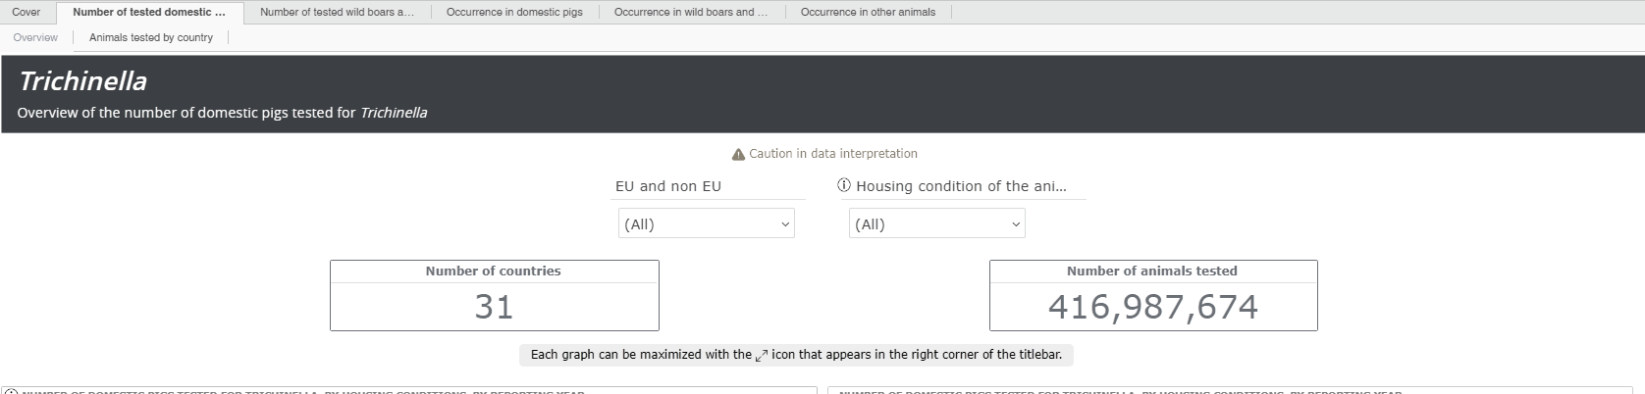 Figure 1: Screenshot of tabs of the dashboard pages

All the dashboard pages (except for the cover page) have a common structure, consisting of the title (Figure 2) and the caution icon (Figure 3), the filter area (Figure 4), the main statistics area (Figure 5), the graphical area (Figure 6), and the footer area (Figure 7).
The page title is located at the top side of each dashboard page (Figure 2), just below the main dashboard title.

Figure 2: Screenshot of dashboard page title

Under the page title, there might be a ‘caution’ icon (Figure 3), to show relevant information about data interpretation. Users can access the detailed message clicking on the icon  , or on the “Caution in data interpretation” text.
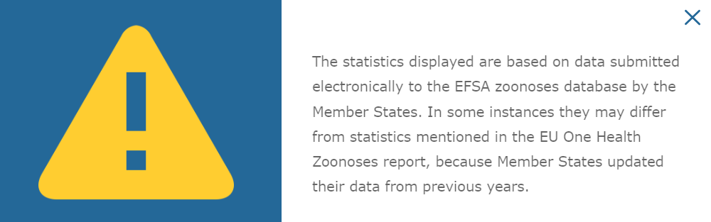
Figure 3: Screenshot of ‘caution’ icon

Figure 4 shows a screenshot of the filter area located under the page title. Users can select one or more terms in each filter to retrieve a particular set of data. Some filters (i.e. Reporting year) available in the different pages are associated with an ‘information’ icon, which provides information about the specific filters. Users can access the detailed message clicking on the ‘information’ icon.
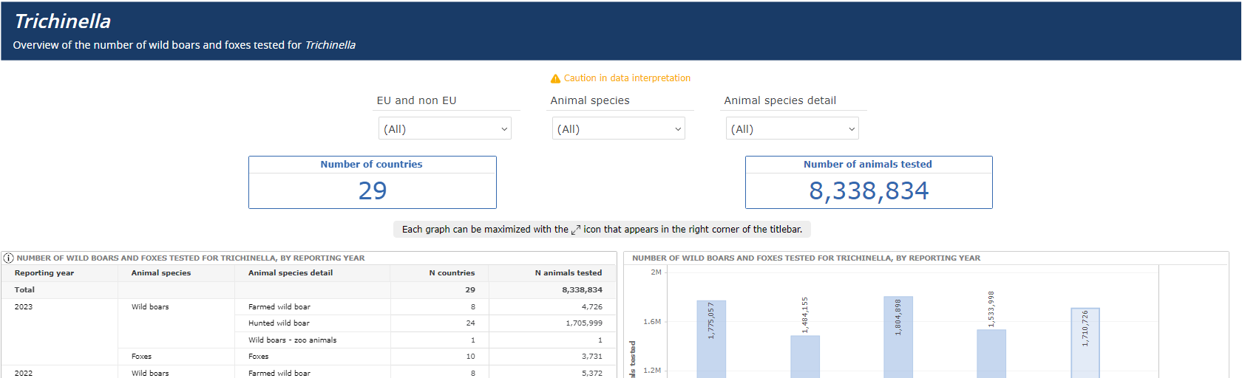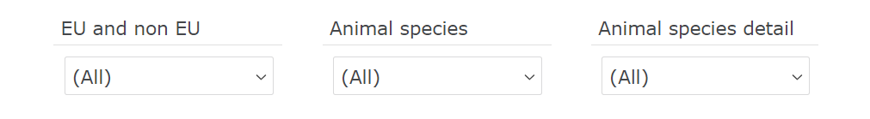
Figure 4: Screenshot of the filter area showing some of the filters included.

Figure 5 shows a screenshot of the main statistics area (e.g. the number of countries, number of animals tested and number of positive animals). These values depend on the filters applied in the page.
Figure 5: Screenshot of the main statistics area

The central part of each dashboard page is dedicated to the tabular/graphical area (Figure 6), which contains different types of charts and may also contain summary tables of the relevant statistics. Data visualised in the graphs (and tables) depends on the filters’ selection. The user can select one or more terms in each filter, to retrieve a particular set of data. All graphs provide some interaction tools that are described in detail in this manual.
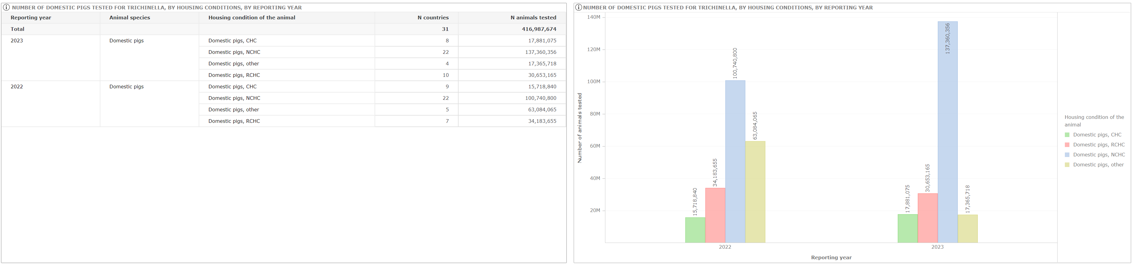
Figure 6: Screenshot of the tabular/graphical area

At the bottom of the dashboard page there is the footer area (Figure 7), which contains additional information, as well as the icons with links to the EU One Health Zoonoses Report, to the user guide, and to the story map.
Figure 7: Screenshot of the footer area

3. Functionalities of the dashboard

3.1 Filtering
Different filters can be selected to retrieve a particular set of data. The selected filters work only within each dashboard page.
The user can do a single or multiple selection of the filter items. When one or more filter options are selected, the page refreshes and graphs report only data satisfying the selected filters. If no data are available for the selected filters, the graphical area shows the following message: “Filter excludes all data”.

3.1.1 Filtering in the filter area
In the filter area of each dashboard page the user finds drop-down filters (Figure 8); by clicking on the icon of each filter, a list of terms is visualised; one or more options can be selected; by clicking the OK button the user confirms the selection and the drop-down list will be closed.
Figure 8 shows a screenshot of the drop-down list available for the filter ‘Reporting year’.
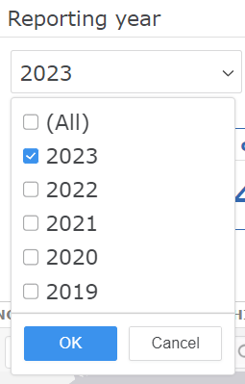
Figure 8: Screenshot of the drop-down list available for the filter ‘reporting year’

Figure 9 shows in green the filters available in each dashboard page.
Filters | Dashboard pages
 | Cover page | Number of tested domestic pigs |  |  | Number of tested wild boars and foxes |  | Occurrence in domestic pigs |  | Occurrence in wild boars and foxes |  | Occurrence in other animals
 |  | Overview | Animals tested by country | Overview |  | Animals tested by country | Overview | Time trends | Overview | Time trends | Overview | Time trends
Reporting year
EU and non-EU
Reporting country
Housing condition of animal
Animal species
Animal species detail
Animal category
Animal category detail
Green: filter available.
Figure 9: Filters available in each of the dashboard page

3.2 Interaction with graphs

3.2.1 Graph types
Several types of graphs are available in the graphical area of the different dashboard’s pages, as listed and described below.

The vertical stacked bar chart shows a multi-variable graph where multiple data series are represented as vertical bars stacked. Each bar in the chart represents a total value broken down into sub-categories, with each segment of the bar indicating the contribution of a specific category to the total.
Figure 10 shows the vertical stacked bar chart included in the dashboard page ‘Animal tested - Overview’, where each coloured stack represents the number of animals tested, by animal species and reporting country.

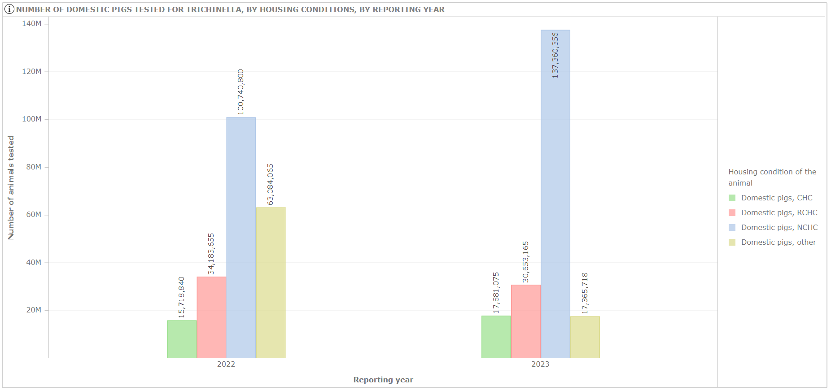
Figure 10: Example of vertical stacked bar chart
The map included in the dashboard, shows the geographic distribution of the number of sample units positive in EU Member States and other reporting countries (Figure 11).
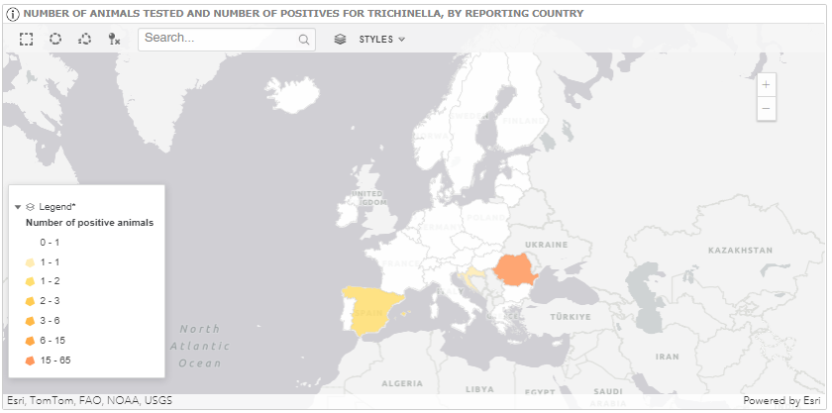
Figure 11: Map of the number of animals tested and positives, for Trichinella in domestic pigs, by reporting country.

Users can select one or multiple countries using three different selection tools 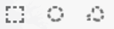, placed on the top left side of the map; additionally, a country can be also search just typing the name in the search area 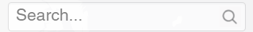

Zoom-in and zoom-out tools are available on the right side of the map (plus/minus icon) 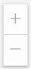

3.2.2 Tooltip information
Several types of interaction/functionalities are available in the graphical area of the different dashboard’s pages, as listed and described in the next sections of the document.
The tooltip information is visible when the mouse pointer is placed on graph element and shows more detailed data (e.g. Reporting year, Number of animals tested and Number of reporting countries).
An Example of tooltip message is shown in Figure 12.

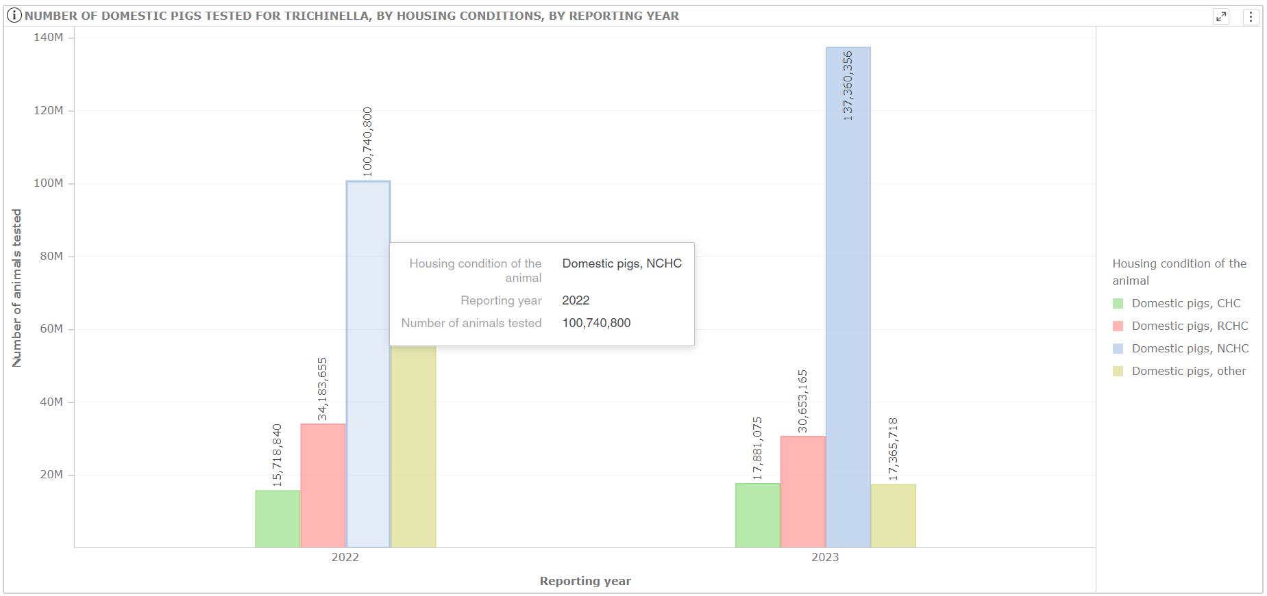
Figure 12: Example of the tooltip functionality in a vertical stacked bar chart

3.2.3 Graph legend
The legend, placed on the right or bottom side of the graphs, describes the variables shown (see Figure 13 and 14).

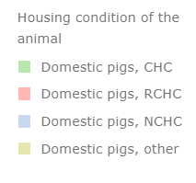
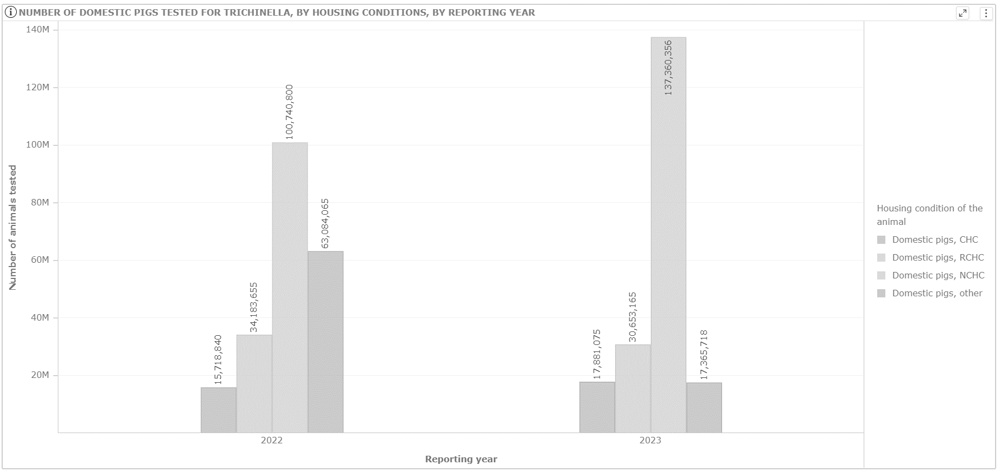
Figure 13: Example of a legend in a vertical stacked bar chart

Users can minimize or hide the legend of a graph, by clicking on the following icons (also shown in Figure 14):

to minimize the legend
to hide the legend

When the legend is hidden, users must right click on graphical area and select the Show Legend option, to display the legend again.
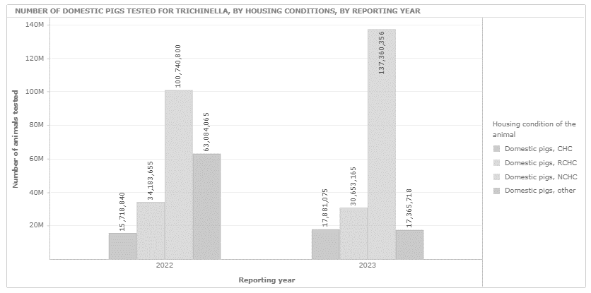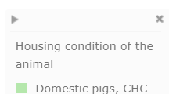
Figure 14: Example of interaction with legend options

3.2.4 Maximize graphs
On the upper right side of each graph the user can find two important icons, which allow maximizing the graph (Figure 14) and showing the data in a tabular form (Section 3.2.7, Figures 24 and 25).
The Maximize option can be enabled by clicking the icon (see Figure 15). After the selection, the graph will be shown in full-page mode. Please note that the icon becomes visible only when the mouse pointer is moved over the graph.
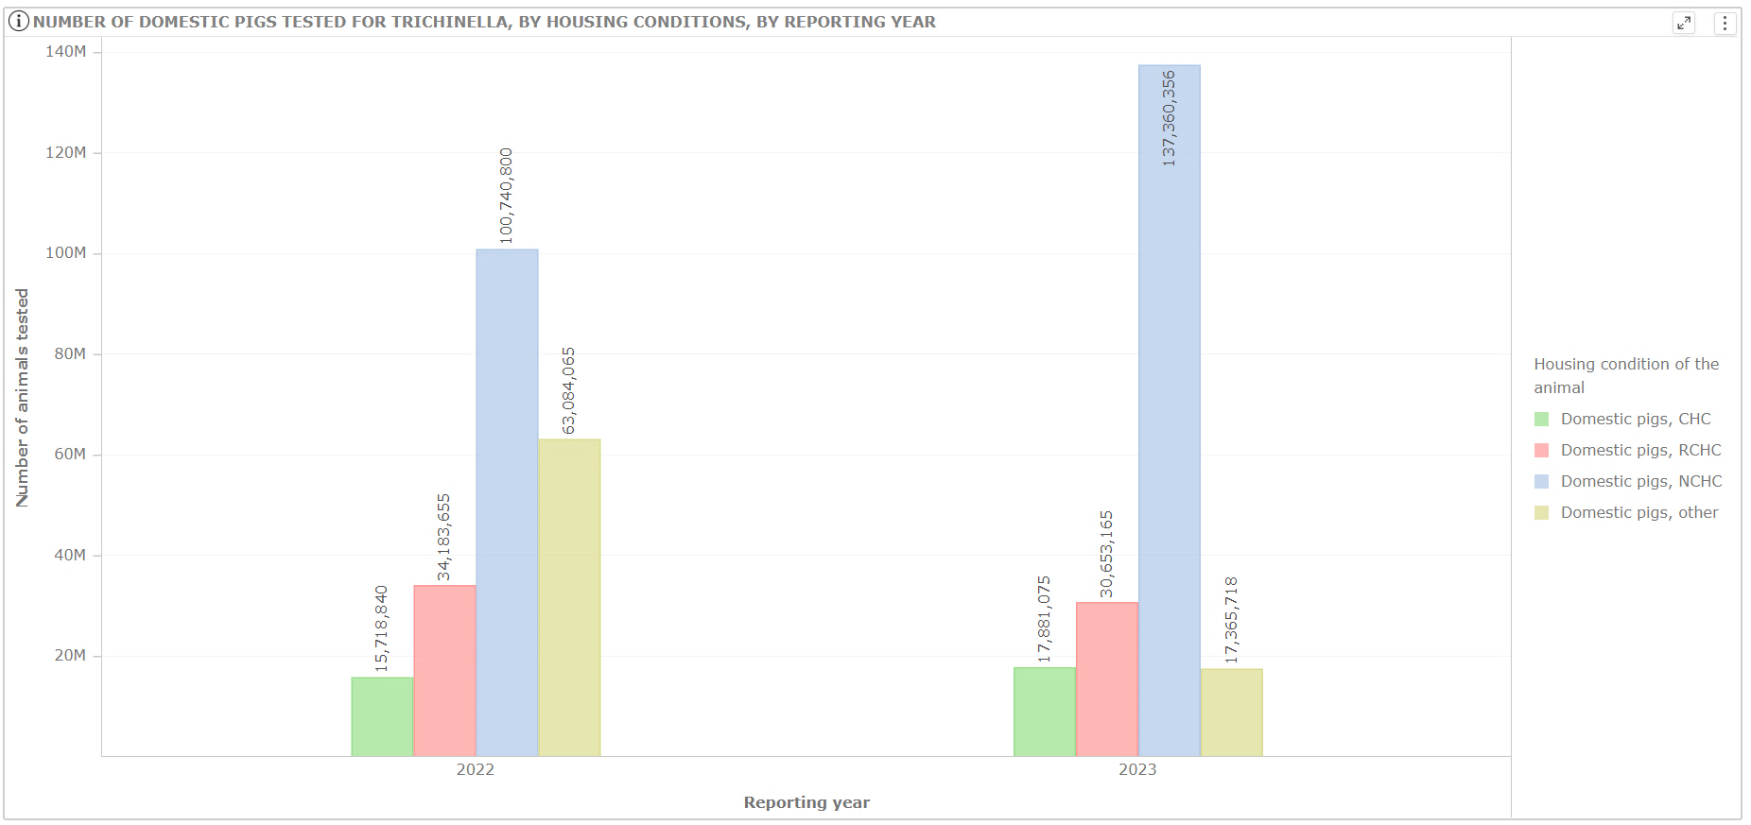
Figure 15: Example of maximise option.

3.2.5 Sorting data
The sorting data option can be activated on X or Y axes, to show data in ascending or descending mode. The graph visualisation will change depending on the sorting option selected.
Users can order the information shown in the x-axis, using the sorting menu by right clicking on the x-axis label.
Figures 16 and 17 show an example of the ascending and descending ordering, respectively, applied on number of animals tested shown in the x-axis.
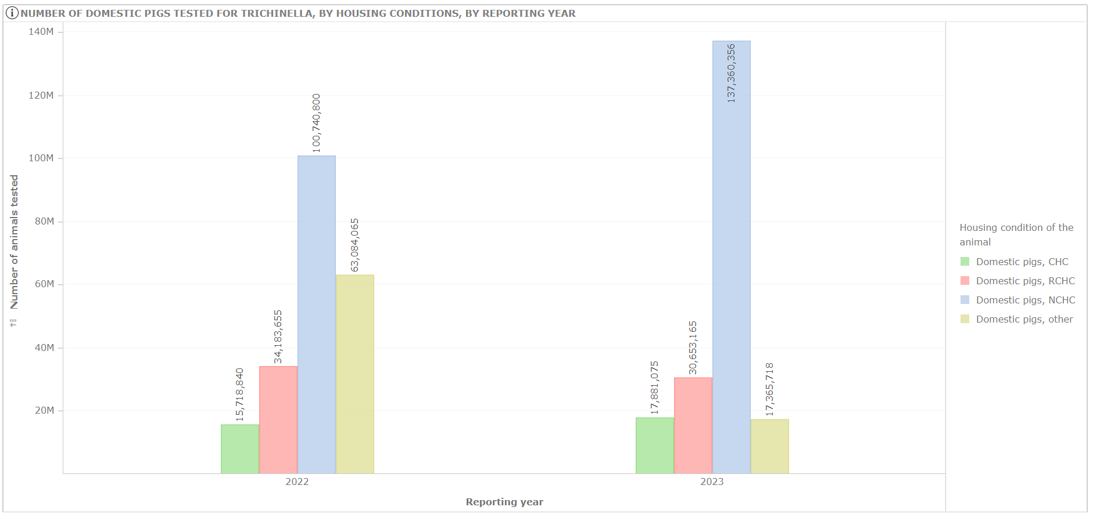
Figure 16: Example of x-axis ascending sorting

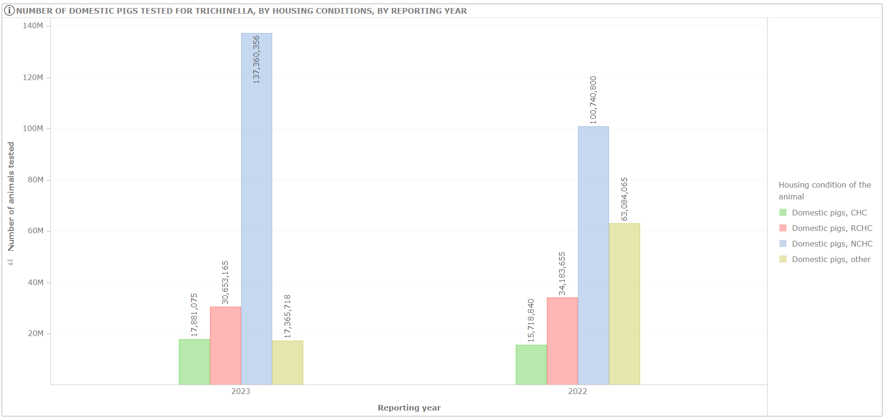
Figure 17: Example of x-axis descending sorting

In the same way, users can order the information shown in the y-axis, using the sorting option by right clicking on the y-axis label. Figure 18 shows an example of ascending order applied to Reporting country. In this case, the descending order will order values from highest to lowest.

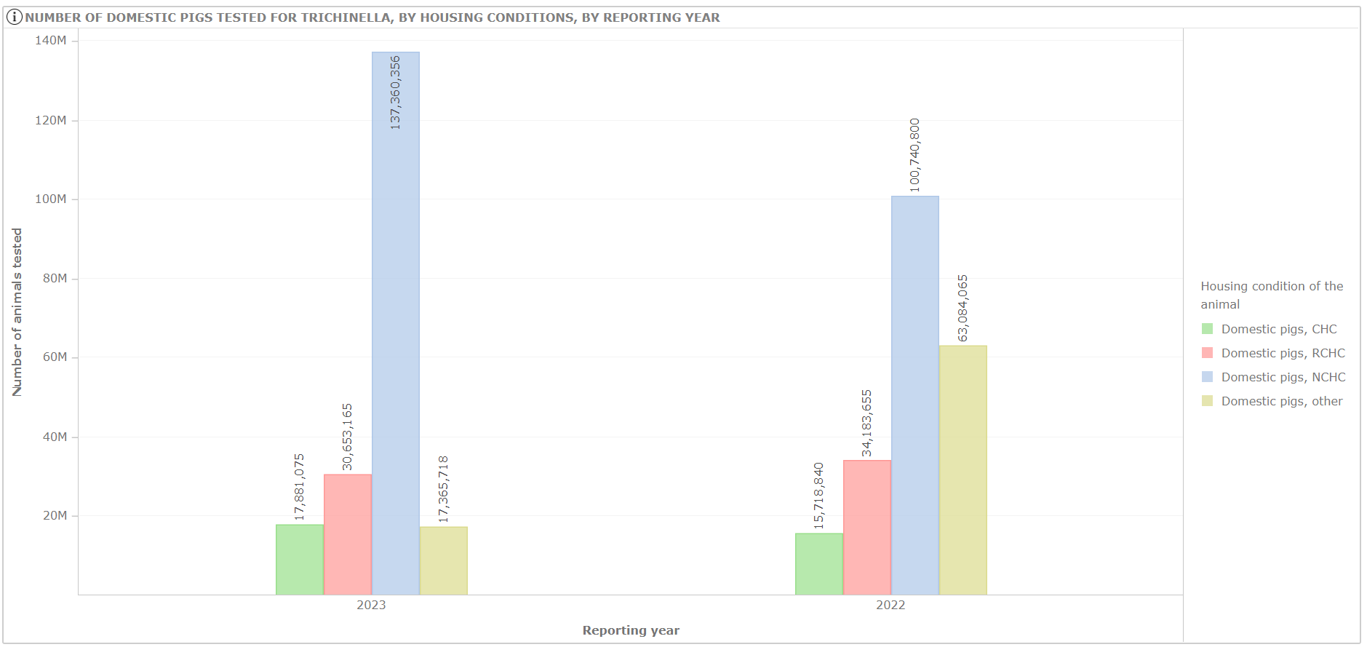
Figure 18: Example of y-axis sorting applied on Reporting year.

It's important to note that when the chart displays values grouped by an attribute (for example, the number of animals tested, grouped by animal species), the ascending or descending order feature is applied only to the first value of the attribute in the grouping (for example, the first animal species).

3.2.6 Data feature menu
Users can access the data feature menu, by right clicking on one of the elements in bar or line charts. The data feature menu allows selecting the ‘Keep only’, ‘Exclude’, ‘Show data’ or ‘Data labels’ options.
Figure 19 shows an example of data feature menu in a vertical stacked bar chart.

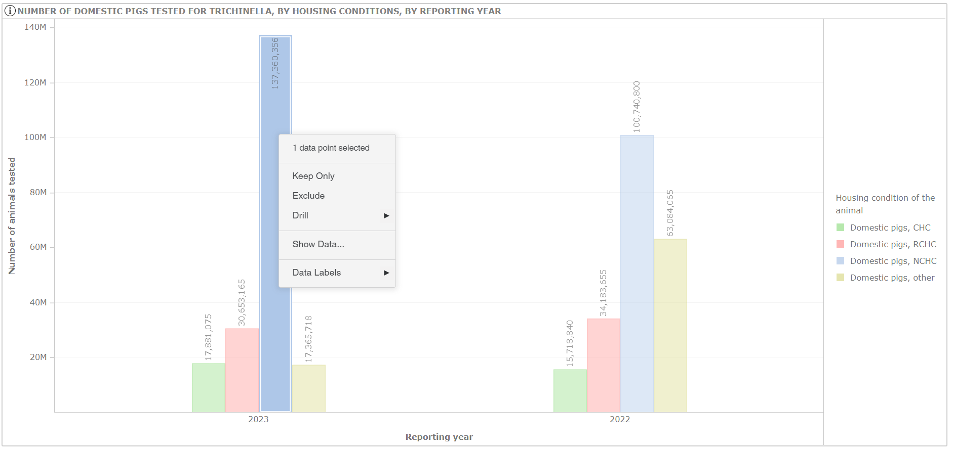
Figure 19: Example of data feature menu in a vertical bar chart.

The ‘Keep only’ option excludes all items in the graph, except the one selected (see Figure 20).

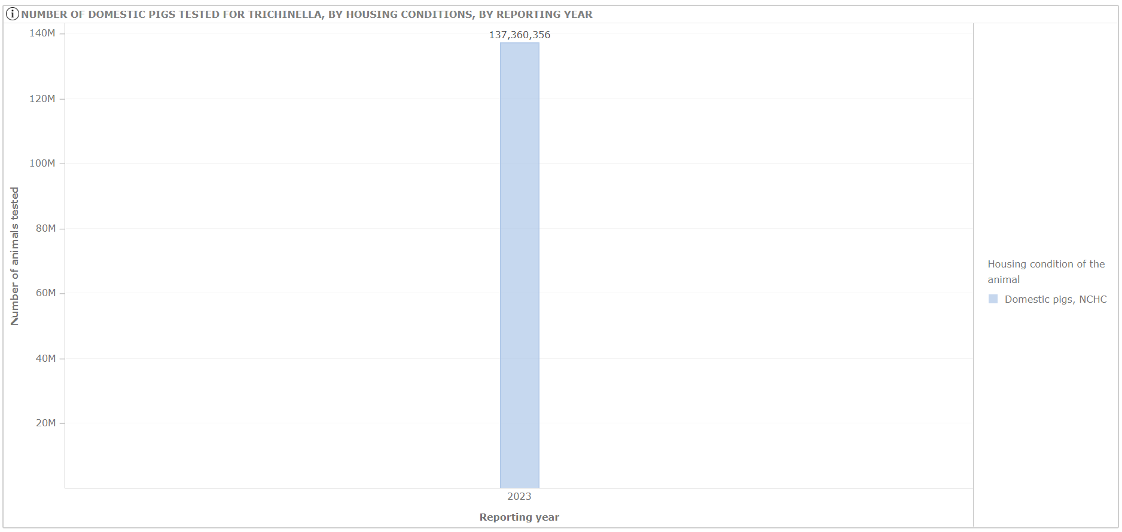Figure 20: Example of ‘keep only’ option applied to “Domestic pigs, NCHC” for 2023

The ‘Exclude’ option excludes the selected item from the graph (see Figure 20 where the “Animal species” items Wildlife were excluded).

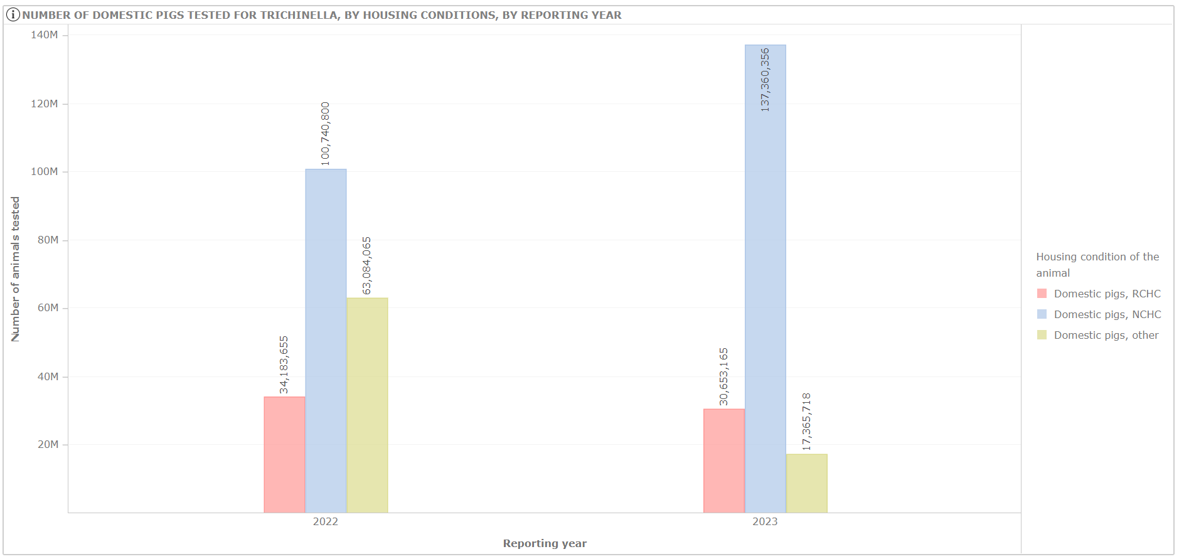
Figure 21: Example of ‘exclude’ option applied to “Domestic pigs, CHC”.

To cancel the filters applied using “exclude” or “keep only” options, use the icon available on the upper left side of the graph, and then select one of the “clear” options listed. Please note that the icon becomes visible only when the mouse pointer is moved over the graph. See Figure 22 for more details.

Figure 22: Example of filters removal

The ‘Show data’ option opens a pop-up window showing data related to the item selected, which can be exported.
Figure 23 shows an example of data option applied to the “Domestic pigs, NCHC” data.
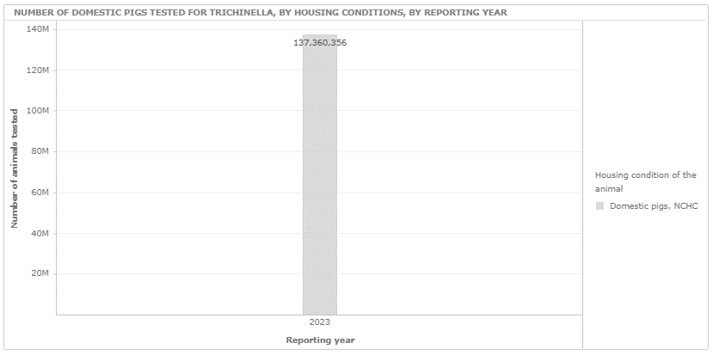
Figure 23: Example of show data applied to the “Domestic pigs, NCHC” data (graph available in the dashboard page “Units tested of domestic pigs”).
The ‘Data labels’ option shows the numeric values for each item in the graph. This option is enabled by default when the data are loaded.

3.2.7 Visualize data in tabular form (‘show data’ option)
The ‘show data’ option can be enabled by clicking the  icon visible on the upper right side of the graph (see Figure 24).
This option will return a tabular form of the data visualized in the graph (see Figure 25); the data shown are affected by the filter selection applied on the dashboard pages.
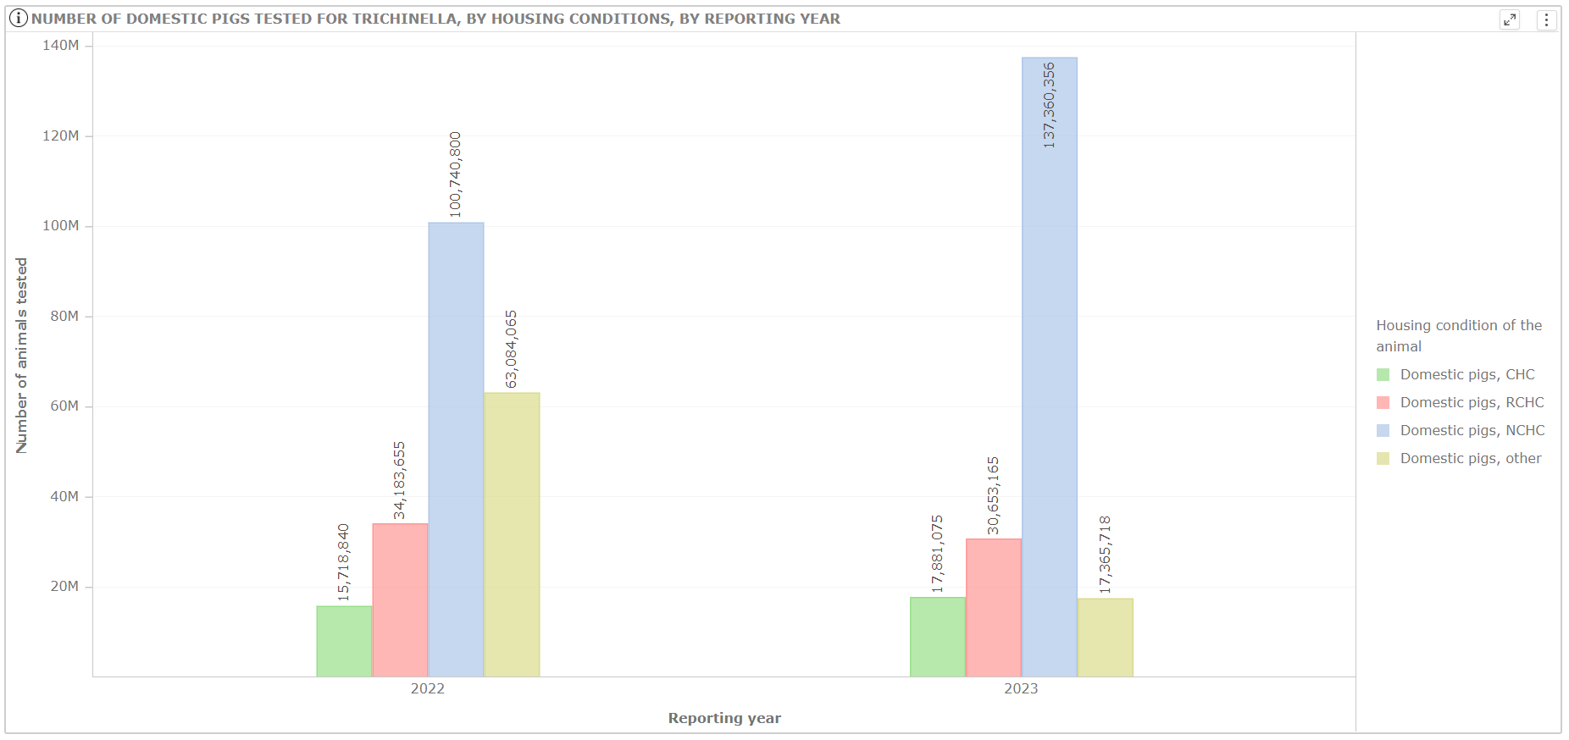
Figure 24: Example of ‘show data’ option (icon)
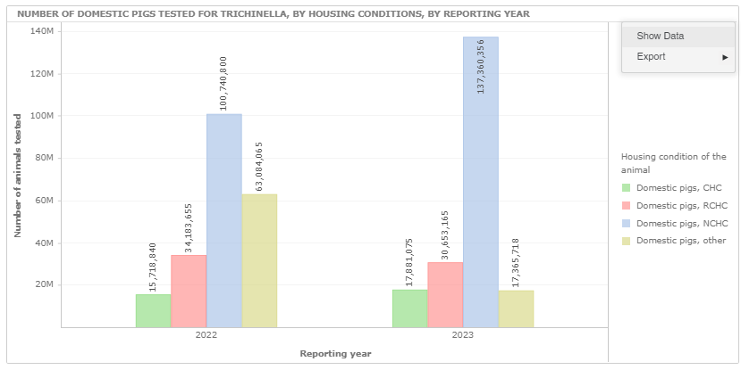
Figure 25: Example of ‘Show Data’ option (tabular form)

After the selection of the “Show Data” option and the visualisation of the data in a tabular form, data can be ordered by clicking on the column’s name. A triangle icon will indicate the type of ordering (ascending or descending). Figure 26 shows an example of ordering applied to the second column of the data table.
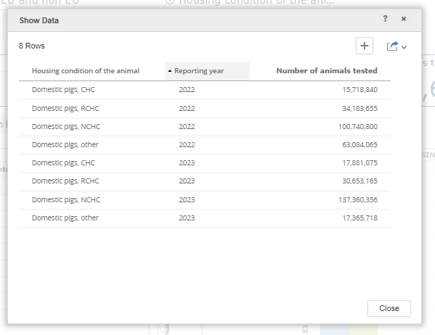
Figure 26: Example of data ordering

3.2.8 Export of data and graphs
Several types of data export are available in the graphical area of the different dashboard’s pages. Users can download data as described below.
After the selection of ‘Show Data’ option (see Figure 26), data can be exported in three different formats:
• Excel
• Pdf
• CSV (option labelled “Data”)
The export data option includes all the attributes originally shown in the table and any information added by the user. Please note that the export action depends on the filter terms selected in the dashboard page.

Figure 27 shows an example of data export.


Figure 27: Example of data export

After the selection of the data export function, users can save information selecting the target output file (Excel, pdf, CSV).

