Summary for policymakers of the thematic assessment of invasive alien species and their control

Authors

Helen E. Roy (Co-Chair, United Kingdom of Great Britain and Northern Ireland), Aníbal Pauchard (Co-Chair, Chile, Switzerland/Chile), Peter Stoett (Co-Chair, Canada), Tanara Renard Truong (IPBES), Sven Bacher (Switzerland, Germany/Switzerland), Bella S. Galil (Israel), Philip E. Hulme (New Zealand), Tohru Ikeda (Japan), Sankaran Kavileveettil (India), Melodie A. McGeoch (Australia, South Africa/Australia), Laura A. Meyerson (United States of America), Martin A. Nuñez (Argentina/United States of America, Argentina), Alejandro Ordonez (Colombia, Netherlands [Kingdom of the]/Denmark), Sebataolo J. Rahlao (Lesotho/South Africa), Evangelina Schwindt (Argentina), Hanno Seebens (Germany), Andy W. Sheppard (Australia, United Kingdom of Great Britain and Northern Ireland, Canada, France/Australia), Vigdis Vandvik (Norway)

Members of the management committee who provided guidance for the preparation of this assessment

Eric Fokam, Shizuka Hashimoto, Rizwan Irshad, Ruslan Novitsky, Rashad Allahverdiyev, Vinod Bihari Mathur, Youngbae Suh

Review editors
Piero Genovesi (Italy/Switzerland, Italy), John R. Wilson (United Kingdom of Great Britain and Northern Ireland/South Africa)

Disclaimer

The designations employed and the presentation of material on the maps used in the present report do not imply the expression of any opinion whatsoever on the part of the Intergovernmental Science-Policy Platform on Biodiversity and Ecosystem Services concerning the legal status of any country, territory, city or area or of its authorities, or concerning the delimitation of its frontiers or boundaries. These maps have been prepared for the sole purpose of facilitating the assessment of the broad biogeographical areas represented therein.
Definitions, concepts and the context of the assessment
The thematic assessment of invasive alien species and their control produced by the Intergovernmental Science-Policy Platform on Biodiversity and Ecosystem Services (IPBES) critically evaluates evidence on biological invasions and the impacts of invasive alien species. In alignment with the United Nations Sustainable Development Goals and the Kunming-Montreal Global Biodiversity Framework adopted by the Conference of the Parties of the Convention on Biological Diversity, the assessment outlines key responses and policy options for prevention, early detection and effective control of invasive alien species and mitigation of their impacts in order to safeguard nature, nature’s contributions to people, and good quality of life.
For the purposes of this assessment, the terms “native species”, “alien species”, “established alien species”, “invasive alien species”, “impacts”, “introduction pathways” and “drivers” are represented and defined in figure SPM.1.
The term “biological invasion” is used to describe the process involving the intentional or unintentional transport or movement of a species outside its natural range by human activities and its introduction to new regions, where it may become established and spread.
Species introduced to new regions through human activities are termed alien species. Invasive alien species represent a subset of alien species, being animals, plants and other organisms known to have established and spread with negative impacts on biodiversity, local ecosystems and species. Many invasive alien species also have impacts on nature’s contributions to people (embodying different concepts such as ecosystem goods and services and nature's gifts) and good quality of life. Some of the most problematic invasive alien species arrive through multiple introduction pathways and repeated introduction.
Invasive alien species are recognized as one of the five major direct drivers of change in nature globally, alongside land- and sea-use change, direct exploitation of organisms, climate change, and pollution. This assessment considers how biological invasions are facilitated by all those direct anthropogenic drivers, noting that interactions among invasive alien species can enable further biological invasions. The assessment also considers how biological invasions can be influenced by indirect drivers, as identified in the IPBES Global Assessment Report on Biodiversity and Ecosystem Services: these include demographic, economic, sociocultural and technological drivers, as well as those relating to institutions and governance. Finally, the assessment considers how biological invasions, and ultimately the impacts of invasive alien species, can be facilitated by natural drivers of change, in particular natural hazards (such as floods, storms and wildfires) and by biodiversity loss itself.
In the context of this assessment, management of biological invasions includes the development of decision support tools; prevention (supported by regulation) and preparedness planning and actions; eradication, containment and control of invasive alien species; site- and ecosystem-based management; and ecosystem restoration.
Other important concepts associated with biological invasion are defined in the glossary of the assessment report. The conceptual basis underpinning the assessment, including the IPBES conceptual framework, and the methodology for reviewing literature are outlined in chapter 1 of the assessment report.
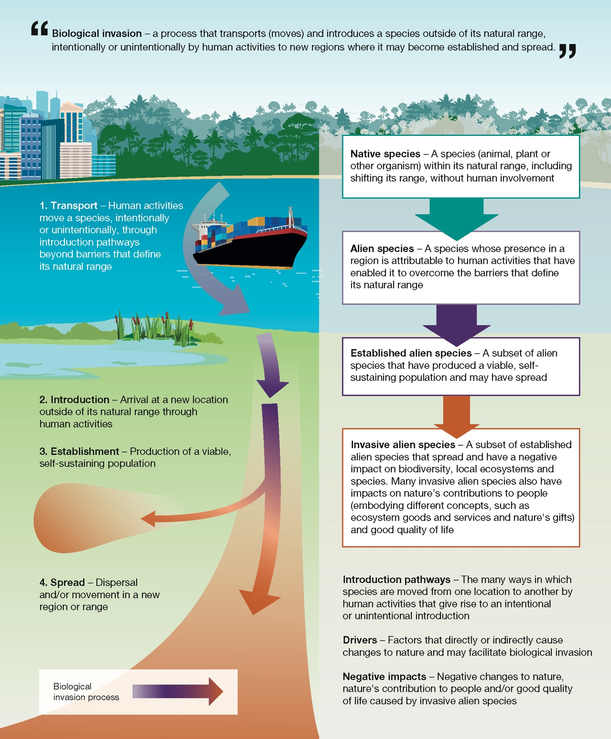

Figure SPM.1. Key concepts within the biological invasion process. Invasive alien species are one of the main direct drivers of change in nature. The biological invasion process comprises the following stages: transport, introduction, establishment and spread (or dispersal). Definitions of native, alien, established alien and invasive alien species are provided. Indirect and other direct drivers of change facilitate biological invasion.

KEY MESSAGES
- Invasive alien species are a major threat to nature, nature’s contributions to people, and good quality of life
Alien species are being introduced by human activities to all regions and biomes of the world at unprecedented rates. Some become invasive, causing negative and in some cases irreversible impacts on nature, including loss of uniqueness of biological communities, contributing to the unparalleled degree of deterioration of the biosphere upon which humanity depends.

KM-A1. People and nature are threatened by invasive alien species in all regions of Earth {A1} (figure SPM.2). More than 37,000 established alien species have been introduced by human activities across all regions and biomes of Earth, with new alien species presently being recorded at an unprecedented rate of approximately 200 annually. Studies with evidence of negative impacts exist for more than 3,500 of these species, which are categorized as invasive alien species. The proportion of established alien species known to be invasive varies among taxonomic groups, ranging from 6 per cent of all alien plants to 22 per cent of all alien invertebrates. Twenty per cent of all impacts are reported from islands. A disproportionate number of documented negative impacts have been reported in terrestrial realms, especially in temperate and boreal forests and woodlands and cultivated areas (including agricultural land). About one quarter of documented negative impacts have been reported from aquatic realms, especially from inland surface waters/waterbodies and shelf ecosystems. In addition to their impacts on nature, about 16 per cent of invasive alien species have negative impacts on nature’s contributions to people, and about 7 per cent on good quality of life.

KM-A2. Invasive alien species cause dramatic and, in some cases, irreversible changes to biodiversity and ecosystems, resulting in adverse and complex outcomes across all regions of Earth, including local and global species extinctions {A2, A3} (figure SPM.3). Invasive alien species have contributed solely or alongside other drivers to 60 per cent of recorded global extinctions, and are the only driver in 16 per cent of the documented global animal and plant extinctions. Biotic homogenization, whereby biological communities around the world become more similar, is a major negative impact of invasive alien species, with consequences for the structure and functioning of ecosystems. Changes in the properties of ecosystems, such as soil and water characteristics, account for more than a quarter of documented impacts. The magnitude and types of impacts vary for different invasive alien species and across ecosystems and regions. The majority of documented global extinctions attributed mainly to invasive alien species have occurred on islands (90 per cent), and local extinctions account for 9 per cent of documented impacts of invasive alien species on islands. Some areas, despite being protected for nature conservation or being remote, are also vulnerable to the negative impacts of invasive alien species.

KM-A3. The economy, food security, water security and human health are profoundly and negatively affected by invasive alien species {A4, A5} (figure SPM.3). In 2019, global annual costs of biological invasions were estimated to exceed $423 billion. The vast majority of global costs (92 per cent) accrue from the negative impacts of invasive alien species on nature’s contributions to people or on good quality of life, while only 8 per cent of that sum is related to management expenditures of biological invasions. The benefits to people that some invasive alien species provide do not mitigate or undo their negative impacts, which include harm to human health (such as disease transmission), livelihoods, water security and food security, with reduction in food supply being by far the most frequently reported impact (more than 66 per cent).

KM-A4. Invasive alien species can add to marginalization and inequity, including, in some contexts, gender- and age-differentiated impacts {A5, A6}. People with the greatest direct dependence on nature, including those involved in gender- and age-specific activities, such as fishing or weeding, may be disproportionately affected by invasive alien species. More than 2,300 invasive alien species are found on lands managed, used and/or owned by Indigenous Peoples across all regions of Earth, threatening their quality of life and often leading to general feelings of despair, sadness and stress. Indigenous Peoples and local communities, ethnic minorities, migrants, and poor rural and urban communities are disproportionately impacted by invasive alien vector-borne diseases. Biological invasions negatively affect the autonomy, rights and cultural identities of Indigenous Peoples and local communities through the loss of traditional livelihoods and knowledge, reduced mobility and access to land, and increased labour to manage the invasive alien species. Impact reports by some Indigenous Peoples and local communities document 92 per cent negative impacts and 8 per cent positive impacts on nature caused by invasive alien species.

KM-A5. Overall, policies and their implementation have been insufficient in managing biological invasions and preventing and controlling invasive alien species {A7, A8}. Up to 2020, only partial progress was made towards international goals and targets (e.g., Aichi Biodiversity Target 9 and Sustainable Development Goal Target 15.8). While most countries have targets related to the management of biological invasions within their national biodiversity strategies and action plans, effective policies are often lacking or inadequately implemented. Eighty-three per cent of countries do not have national legislation or regulations directed specifically toward the prevention and control of invasive alien species. Policy relevant to biological invasions is also fragmented within countries and across sectors. To date, capacity to respond to biological invasions has varied widely across regions, with nearly half of all countries (45 per cent) not investing in management of invasive alien species (SDG indicator 15.8.1). Differences in perception, including conflicting interests and values, of the importance and urgency of the threat of invasive alien species, coupled with lack of awareness of the need for a collective and coordinated response, as well as gaps in data and knowledge, can hinder the management of invasive alien species. Economic development policies and those aiming to manage other drivers of change sometimes facilitate biological invasions. Demographic drivers also facilitate the introduction and spread of invasive alien species while acknowledging that drivers differ across regions and level of impact. The lack of border biosecurity (such as inspections undertaken by quarantine officers of commodities, goods and people) in one country weakens the efficacy of such measures in other countries.
B. Globally, invasive alien species and their impacts are increasing rapidly and are predicted to continue rising in the future
The threats from invasive alien species are increasing in all regions of Earth and are predicted to do so in the future. Even without the introduction of new species, existing populations of invasive alien species will continue spreading through all ecosystems. Amplification of and interactions among direct and indirect drivers of change will profoundly shape and exacerbate the future threats from invasive alien species.

KM-B1. Many human activities facilitate the transport, introduction, establishment and spread of invasive alien species {B9, B11, B12, B14} (figure SPM.5). Many invasive alien species have been intentionally introduced outside their natural range around the world for their perceived benefits without consideration or knowledge of their negative impacts, but there have also been many unintentional introductions, including as contaminants of traded goods and stowaways in shipments. Indirect drivers of change, particularly those associated with economic activities, of which international trade is the most important, are increasingly facilitating transport and introduction, the early stages of biological invasion. Direct drivers, particularly land- and sea-use change and climate change, are increasingly important later in the biological invasion process, facilitating the establishment and spread of invasive alien species, with fragmented ecosystems being more vulnerable to invasive alien species. Transport and utility infrastructures in terrestrial and aquatic environments can create corridors that facilitate the spread of invasive alien species, including into remote, undisturbed and protected areas. For some invasive alien species, the spread is immediate, but others only begin to spread long after first introduction, meaning that currently observed threats of invasive alien species can lead to underestimation of the magnitude of the future impact. Invasive alien species may increase in numbers after a long period at low density as a result of changes in interactions with other species, for example as a result of the introduction of a missing dispersal agent or the removal of a competitor.

KM-B2. The threats from invasive alien species are increasing markedly in all regions of Earth, with the current unparalleled high rate of introductions predicted to rise even higher in the future {B10} (figure SPM.4). The number of alien species has been rising continuously for centuries in all regions, and the global economic costs of invasive alien species have quadrupled every decade since 1970. Even without the introduction of new species, already established alien species given the opportunity, may continue to expand their geographic ranges into new countries, regions and ecosystems, including remote environments. Under a “business-as-usual” scenario, which assumes that trends of drivers will continue as observed in the past, by 2050 the total number of alien species globally is expected to be about one-third higher than in 2005. However, the number of alien species worldwide is expected to increase faster than predicted under the business-as-usual scenario.

KM-B3. The ongoing amplification of drivers of change in nature may substantially increase the number of invasive alien species and their impacts in the future {B9, B11, B12, B14}. The causal links between indirect and direct drivers imply that ongoing and future amplification of these drivers will increase the frequency and extent of biological invasions and the impacts of invasive alien species, which, in some cases, may exacerbate the impacts of other drivers. At a global scale, the number of invasive alien species and their negative impacts are likely to increase due to the amplification of multiple drivers including but not limited to demographic, economic and land-use and sea-use change while noting regional variation. Additionally, climate change will further exacerbate the establishment of some invasive alien species and will be a major cause of future establishment and spread. Delays in the response of invasive alien species to drivers of change may result in a long legacy of future biological invasions due to past and present amplification of drivers.

KM-B4. The magnitude of the future threat from invasive alien species is difficult to predict because of complex interactions and feedback among direct and indirect drivers of change in nature {B10, B13, B14}. Climate change interacting with land- and sea-use change is predicted to profoundly shape and amplify the future threat from invasive alien species. Interactions among climate change, land-use change and invasive alien species can alter and intensify natural disturbance regimes, such as wildfires. Variations in human perceptions and values add yet another level of complexity, as sociocultural drivers interact with other indirect drivers and influence direct drivers. Such interactions may lead to unprecedented numbers of invasive alien species, with the consequent amplification of their impacts.
C. Invasive alien species and their negative impacts can be prevented and mitigated through effective management
Curbing the rising number of invasive alien species and reducing their spread and impacts are achievable through management actions in the short as well as long term. There are many decision frameworks and approaches for supporting management of invasive alien species at all stages of the biological invasion process. Prevention is the best option, but early detection, eradication, containment and control are also effective in specific contexts. Management of biological invasions benefits from engagement with stakeholders and Indigenous Peoples and local communities.

KM-C1. The number and impacts of invasive alien species can be reduced through management of biological invasions {C15, C16, C17, C18, C22, C23} (figure SPM.6, table SPM.1). There are decision-making frameworks and tools for inclusively identifying and supporting management goals related to (a) management of pathways of introduction and spread of invasive alien species; (b) management of target invasive alien species at either local or landscape scales; and (c) site-based or ecosystem-based management. There are many sources of accessible literature and information, tools, and novel and emerging technologies, including biotechnology, bioinformatics, eDNA, remote sensing and data analytics, for supporting the management of biological invasions. Consideration of both potential benefits and risks of the management of biological invasions can improve outcomes. A risk assessment and a risk management framework in line with a precautionary approach, as appropriate, can be effective to guide management actions, including the use of novel and emerging and environmentally sound technologies. The success of any management programme depends on the availability of adequate, sustained resources, including for building capacity, which is sometimes lacking, especially in some developing countries. Multi-stakeholder engagement, including risk communication and context-specific application, can improve public acceptability and adoption of new tools and technologies for managing biological invasions.

KM-C2. Prevention and preparedness are the most cost-effective options and thus crucial for managing the threats from invasive alien species {C15, C17, C18}. Prevention can be achieved through pathway management, including strictly enforced import controls, pre-border, border and post-border biosecurity, and measures to address escape from confinement. Prevention is particularly critical in marine and connected water systems, where most attempts at eradicating or containing invasive alien species have mostly failed. Prevention has been particularly effective on islands. Preparedness includes border surveillance, early detection and rapid response planning, and is critical to reduce rates of establishment. Horizon scanning and risk analysis can support prevention and preparedness by prioritizing emerging invasive alien species. Sustained and adequate funding, capacity-building, technical and scientific cooperation, transfer of technology, monitoring, relevant and appropriate biosecurity legislation and enforcement, and quarantine and inspection facilities are necessary for effective prevention measures.

KM-C3. Eradication has been successful, especially for small and slow-spreading populations of invasive alien species in isolated ecosystems {C19}. Over the last 100 years, 88 per cent of eradication attempts on 998 islands have proven successful, especially for invasive alien vertebrates. Large-scale eradications have been achieved but in many cases are likely to be infeasible. There are also examples of eradication of invasive alien plants and invertebrates, particularly for those with limited distribution. Adoption of appropriate tools and technologies and involvement of relevant stakeholders underpin and improve the success of eradication programmes. Sustained investment is required for eradication programmes but they are generally more cost-effective than long term and permanent control or the costs incurred through inaction.

KM-C4. Containment and control can be an effective option for invasive alien species that cannot be eradicated for various reasons from terrestrial and closed water systems, but most attempts in marine and connected water systems have been largely ineffective {C20}. Physical control alongside chemical control options in terrestrial and closed water systems are generally only effective at a local scale and can have non-target effects. Biological control can be applied for widely distributed invasive alien species and has been successful in managing some invasive alien plants, invertebrates and, to a lesser extent, plant pathogenic microbes and vertebrates, but it may also have non-target effects if not well regulated. International standards and risk-based regulatory frameworks for biological control have been used in many countries to manage risks, and continue to be successfully applied. Integrated management, where more than one containment or control option are used, can improve outcomes.

KM-C5. The recovery of ecosystem functions and nature’s contributions to people can be achieved through adaptive management, including ecosystem restoration in terrestrial and closed water systems {C21}. Management outcomes can be improved by the integration of site- and/or ecosystem-based management options that enhance ecosystem function and resilience. Frequent long-term monitoring of sites ensures early detection of invasive alien species, including re-invasions, and can inform further management actions. In marine and connected water systems, ecosystem restoration has so far proved to be largely ineffective. Adaptive management, possibly combining multiple options, will improve management of biological invasions under ongoing climate and land-use change. Integrating site and/or ecosystem-based approaches can improve management outcomes of biological invasions and also enhance ecosystem functioning under ongoing climate and land-use change.

KM-C6. Engagement and collaboration with stakeholders and Indigenous Peoples and local communities improve outcomes of management actions for biological invasions {C23, C24}. Engaging stakeholders, including the private sector, and Indigenous Peoples and local communities in the collaborative management of biological invasions is important for social acceptability and improving environmental, social and economic outcomes, particularly where there are conflicting perceptions of the value of invasive alien species and the ethics of management options. Management actions also benefit from sharing and collaboration across knowledge systems. Recognizing Indigenous Peoples’ and local communities’ knowledge, rights and customary governance systems in accordance with national legislation also helps to improve long-term management.
D. Ambitious progress to manage biological invasions can be achieved with integrated governance
One of the greatest threats to biodiversity, invasive alien species can be overcome through a context-specific integrated governance approach to biological invasions, including well-resourced, coordinated and sustained strategic actions, with closer collaboration across sectors and countries. Managing biological invasions is realistic and achievable, with substantial benefits for nature and people.

KM-D1. Through a complementary set of strategic actions, integrated governance can limit the global problem of invasive alien species throughout the biological invasion process and at local, national and regional scales {D25}. Strategic actions to prevent the introduction and impact of invasive alien species include: enhancing coordination and collaboration across international and regional mechanisms; developing and adopting effective and achievable national strategies; sharing efforts and commitment and understanding the specific role of all actors; improving policy coherence; broad engagement across all stakeholders and Indigenous Peoples and local communities; resourcing innovation, research and technology; and supporting information systems, infrastructures and data sharing.

KM-D2. The threat of invasive alien species could be reduced with closer collaboration and coordination across sectors and countries to support the management of biological invasions {D26, D30} (figure SPM.7). International, national and local agencies involved in developing policies for the environment, agriculture, aquaculture, fishing, forestry, horticulture, border control, shipping (including biofouling), tourism, trade (including online trade in animals, plants, and other organisms), community and regional development (including infrastructure), transportation and the health sector can all play a role in developing a coherent approach to managing biological invasions and preventing and controlling invasive alien species. Enhancing coordination and collaboration across international and regional mechanisms is one of the key strategic actions for rapid and transformative progress. International and regional partnerships can improve management of biological invasions. Collaboration and co-development with Indigenous Peoples and local communities can increase the effectiveness of implemented strategies.

KM-D3. The Kunming-Montreal Global Biodiversity Framework provides an opportunity for national governments to develop or update aspirational, ambitious and realistic approaches to prevent and control invasive alien species {D27, D28} (figure SPM.7). Implementation-focused national biodiversity strategies and action plans can help to spur strategic actions and establish the properties of the governance systems required for the successful prevention and control of invasive alien species and the management of biological invasions, and work towards delivering Target 6. Coordinated efforts to strengthen national regulatory instruments are also priorities, including those for online trading and the creation of appropriate policies for the development and use of environmentally sound technologies, as well as making available data and information accessible. Market-based instruments such as tax relief and subsidization can be used to incentivize action and spur relevant investment. Sharing efforts and commitment, understanding the specific roles of all actors and encouraging engagement across sectors on prevention, control and environmental liability are integral to the effective management of biological invasions.

KM-D4. Preventing and controlling invasive alien species can strengthen the effectiveness of policies designed to respond to other threats to biodiversity and contribute to achieving several Sustainable Development Goals {D26, D33}. Awareness of the risks of biological invasions will contribute to the effective delivery of several of the Sustainable Development Goals, especially those addressing the conservation of marine biodiversity (Goal 14) and terrestrial biodiversity (Goal 15, including but not restricted to Target 15.8), food security (Goal 2), sustainable economic growth (Goal 8) and sustainable cities (Goal 11), as well as climate change (Goal 13) and health and wellbeing (Goal 3). Existing collaborative and multisectoral approaches (e.g., One Health) could provide frameworks for cross-disciplinary thinking and could contribute to the management of biological invasions.

KM-D5. Open and interoperable information systems will improve the coordination and effectiveness of the management of biological invasions, within and across countries {D31, D32}. By delivering current data to relevant actors, information systems can facilitate the prioritization of actions and allow for early detection and rapid response. Information systems can also support improved governance and help develop indicators of biological invasions, which in turn feed into policy support tools. Collaboration between biological invasion experts and across knowledge systems in all regions, and enhancement of research capacity where needed, can improve data and information availability and the understanding of the context-specific features of biological invasions and their impacts.

KM-D6. Public awareness, commitment and engagement, and capacity-building, are crucial for the prevention and control of invasive alien species {D29, D31, D32} (table SPM.2). Advances can be achieved through adequately and sustainably resourced public awareness campaigns, education, citizen science, and targeted investment in research innovation and environmentally sound technology. Public engagement with citizen science platforms and community-driven eradication campaigns can raise awareness and contribute to actions that reduce the threat of invasive alien species. This can also be aligned with efforts to share efforts and commitment and understand the specific roles of all actors. Communication strategies based on evidence can help to bring about community action on biological invasions by supporting the co-design of management actions, knowledge exchange and enhanced partnerships among stakeholders.

KM-D7. There is compelling evidence for immediate and sustained action to manage biological invasions and mitigate the negative impacts of invasive alien species {D32, D33} (table SPM.2). With sufficient resources, political will and long-term commitment, preventing and controlling invasive alien species are attainable goals that will yield significant long-term benefits for people and nature. Increasing the availability and accessibility of information and means of implementation and addressing major knowledge gaps on biological invasions, particularly in developing countries, would result in more robust and effective policy instruments and management actions. Additional efforts and cooperation are particularly needed to improve data collection in Africa, Latin America and the Caribbean and Asia.

BACKGROUND
A. Invasive alien species are a major threat to nature, nature’s contributions to people, and good quality of life

A1. More than 37,000 established alien species, including more than 3,500 invasive alien species with documented impacts, have been recorded worldwide (well established) {2.1.4, 4.2}. Alien species (plants, animals, fungi and microorganisms, including pathogens) are being introduced globally at an unprecedented rate; currently, approximately 200 new alien species are recorded every year (well established) {2.2.1}. Invasive alien species represent a subset of alien species, consisting of those that have established and spread and are known to have a negative impact on nature and, in some cases, people (figure SPM.1). Although their numbers are likely to be underestimated and expected to increase, to date 1,061 alien plants (6 per cent of all established alien plants), 1,852 alien invertebrates (22 per cent), 461 alien vertebrates (14 per cent) and 141 alien microbes (11 per cent) are known to be invasive globally (established but incomplete) {4.2}. Although some invasive alien species can provide benefits for people (e.g., through provision of food and fibre), those benefits do not mitigate or undo their negative impacts on nature, nature’s contributions to people, and good quality of life across all regions and taxa globally (well established) {1.3.4, 4.1.2, 4.3, 4.4, 4.5}. In addition to their impacts on nature, about 16 per cent of invasive alien species have negative impacts on nature’s contributions to people, and about 7 per cent on good quality of life (figure SPM.2) (established but incomplete) {4.2}. Based on data and information included in this assessment, most impacts are reported in the Americas (34 per cent), Europe and Central Asia (31 per cent) and Asia-Pacific (25 per cent), with fewer reported in Africa (7 per cent) (established but incomplete) {4.2}. Twenty per cent of all impacts are reported from islands (established but incomplete) {4.2}. A disproportionate number of documented negative impacts have been reported from the terrestrial realm (75 per cent), especially temperate and boreal forests and woodlands and cultivated areas (including agricultural land) (established but incomplete) {table 4.2}. About one quarter of the documented negative impacts have been reported from aquatic realms (freshwater: 14 per cent; marine: 10 per cent), especially from inland surface waters/waterbodies and shelf ecosystems (established but incomplete) {table 4.2}.

A2. Invasive alien species are a major direct driver of change, causing biodiversity loss, including local and global species extinctions (figures SPM.2 and 3) (well established) {4.3.1}. Invasive alien species have contributed solely or alongside other drivers of change to 60 per cent of recorded global animal and plant extinctions (established but incomplete) {box 4.4, 4.3.1}, while invasive alien species are the only driver attributed to 16 per cent of documented global extinctions (established but incomplete) {box 4.4}. The majority of documented global extinctions (90 per cent) with invasive alien species as one of the major causes are reported from islands (established but incomplete) {box 4.4}. At least 218 invasive alien species have caused 1,215 documented local extinctions of native species across all taxa (figure SPM.3) (established but incomplete) {4.3.1}. Invasive alien species harm native species most often by changing ecosystem properties (27 per cent), for example soil and water characteristics, and through competition between species (24 per cent), predation (18 per cent) and herbivory (12 per cent) (established but incomplete) {4.3.1.3}. The majority of reports of the impacts of invasive alien species on native species document negative effects (85 per cent), primarily negatively impacting the growth, survival and reproduction of individuals, which lead to local population declines and local and global extinctions (well established) {4.3.1}. Some invasive alien species have a profound ecological impact that spans various levels, from individual species and communities to whole ecosystems, resulting in complex, undesirable and in some cases irreversible outcomes when the system has crossed a threshold beyond which ecosystem restoration is not possible (well established) {box 1.5, box 4.12, 4.3.3}. For example, Castor canadensis (North American beaver) and Magallana gigas (Pacific oyster) change ecosystem properties by transforming habitats, with cascading effects on a myriad of native species (well established) {4.3.2.1, box 4.11}. On Christmas Island, the arrival of the invasive alien Anoplolepis gracilipes (yellow crazy ant) caused the decline of the native Christmas Island Gecarcoidea natalis (red crabs), which resulted in the population explosion of the invasive alien Lissachatina fulica (giant African land snail) (well established) {3.3.5.1}. Increased biotic homogenization (or loss of uniqueness) of biological communities is a major negative impact of invasive alien species (well established) {1.3.4}. The magnitude of the negative impacts of invasive alien species on nature depends on the context, and the factors that determine the highest magnitudes of impact are not well understood (established but incomplete) {box 4.9, 4.3.2.1, 4.7.1}. For example, the ctenophore Mnemiopsis leidyi (sea walnut) has depleted zooplankton, the main food source of the anchovy, and consequently contributed to the collapse of anchovy populations in the Black Sea, but this has not occurred in the Mediterranean Sea, the Baltic Sea or the North Sea (well established) {4.3.2.3}.
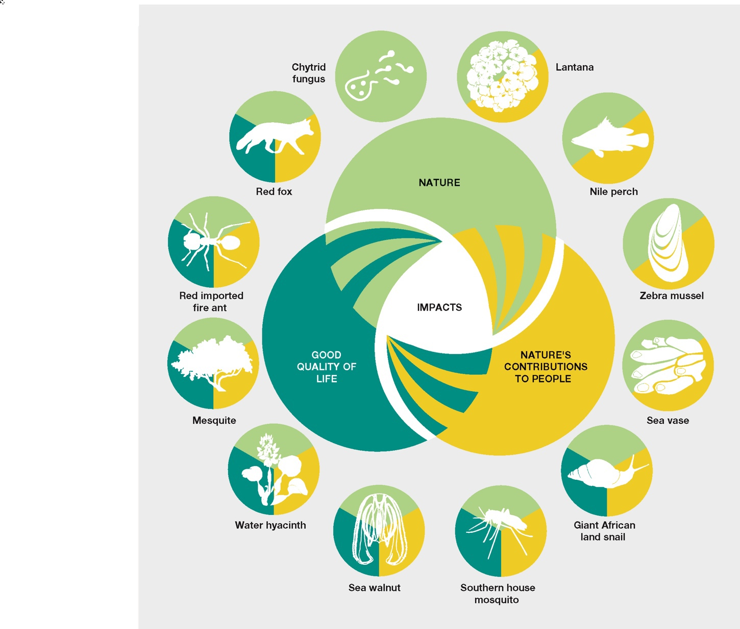
Figure SPM.2. Examples of invasive alien species with a negative impact on nature (green) and, in some cases, nature’s contributions to people (yellow) and/or good quality of life (teal). Many invasive alien species have documented negative cross-cutting impacts, indicated by multiple colours in the examples: 16 per cent of invasive alien species have a negative impact on both nature and nature’s contributions to people; 7 per cent on both nature and good quality of life; and 5 per cent on nature, nature’s contributions to people and good quality of life {4.2}. The scientific names of the example species are Lantana camara (lantana); Lates niloticus (Nile perch); Dreissena polymorpha (zebra mussel); Ciona intestinalis (sea vase); Lissachatina fulica (giant African land snail); Culex quinquefasciatus (southern house mosquito); Mnemiopsis leidyi (sea walnut); Pontederia crassipes (water hyacinth); Prosopis juliflora (mesquite); Solenopsis invicta (red imported fire ant); Vulpes vulpes (red fox); and Batrachochytrium dendrobatidis (chytrid fungus).

A3. On islands, invasive alien species are a major cause of biodiversity loss (well established) {box 2.5, 4.3.1.1, box 4.4}. Islands, and particularly remote islands with high endemism, are more susceptible to impacts from invasive alien species than mainlands (well established) {1.6.8, 4.3.1.1}. Indeed, in addition to the majority of documented global extinctions attributed mainly to invasive alien species occurring on islands, local extinctions account for 9 per cent of documented impacts of invasive alien species on islands, in contrast to 4 per cent on mainlands (well established) {4.3.1.1}. For example, Boiga irregularis (brown tree snake) caused the global extinction of Myiagra freycineti (Guam flycatcher) and local extinction or serious population reduction for many other resident bird species in Guam (well established) {4.3.1}. Islands are also vulnerable to climate change, which can increase the rate of establishment and spread of many invasive alien species (well established) {box 2.5}. Many invasive alien species on islands only occupy a small portion of their predicted range and are likely to expand further (established but incomplete) {box 2.5}. The number of alien plants exceeds the total number of native plants on more than one quarter of islands (well established) {box 2.5}. Invasive alien species have been reported in areas protected for nature conservation, some remote areas (e.g., high mountains), and also in tundra and deserts, which emphasizes that these areas, despite being protected for nature conservation or remote, are also vulnerable to the negative impacts of invasive alien species (well established) {box 2.4, 4.3.1.2, 4.3.2.1}. Fifty-three invasive alien species have caused the local extinctions of 240 native species in protected areas globally (established but incomplete) {4.3.1.2}. The invasive alien Rattus rattus (black rat) has been documented as the only cause of the global extinction of Nesoryzomys darwini and Nesoryzomys indefessus (rice rats), which were endemic to the protected areas of the Galapagos Islands (well established) {4.3.1}.

A4. Invasive alien species adversely affect the full range of nature’s contributions to people, imposing an economic burden (well established) {4.4.1}. Some alien species have been intentionally introduced for their benefits to people, often without consideration or knowledge of their negative impacts (well established) {3.3.1}. However, nearly 80 per cent of the documented impacts of invasive alien species on nature’s contributions to people are negative (well established) {4.4.1}. Reduction in food supply is by far the most frequently reported impact across all taxa and regions (well established) {4.4.1, 4.6.2}. In terrestrial systems, invasive alien plants are the taxonomic group most frequently reported as having a negative impact, particularly in cultivated areas and temperate and boreal forests (well established) {4.4.2.1}. For example, in north-western Europe Picea sitchensis (Sitka spruce) severely alters habitats such as coastal heathlands and mires, which are important habitats for threatened and endangered plants, birds and other species, and for local cultural heritage (well established) {4.3.2.1}. In coastal areas, invasive alien invertebrates are the most frequently reported taxonomic group with an impact on nature’s contributions to people, particularly provision of food (well established) {4.4.2.3}. For example, Carcinus maenas (European shore crab) has had an impact on commercial shellfish beds in New England and Canada, Asterias amurensis (northern Pacific seastar) and Ciona intestinalis (sea vase) have negatively affected mariculture and fisheries along the Korean coast, and Mytilopsis sallei (Caribbean false mussel) has displaced native clams and oysters that are locally important fishery resources in India (well established) {4.4.2.3}. In 2019, global annual costs of biological invasions were estimated to exceed US$423 billion, with variations across regions, but this is likely to be a gross underestimate (figure SPM.3) (established but incomplete) {box 4.13}. Ninety-two per cent of this cost is attributed to the damage that the invasive alien species have caused to nature’s contributions to people and good quality of life; only 8 per cent is related to the management expenditures for biological invasions (established but incomplete) {box 4.13}. Economic benefits are often gained by a few people or sectors while costs, often long-term ones, are borne by many others (established but incomplete) {3.2.3.5, 4.2.1, 6.2.2(6)}.

A5. Invasive alien species overwhelmingly undermine good quality of life (established but incomplete) {4.5, 4.6.3}. Invasive alien species can threaten livelihoods, water and food security, economies and human health (e.g., causing diseases, allergies and physical injuries) (figure SPM.3) (well established) {4.5.1, 4.5.1.3}, with 85 per cent of the documented impacts of invasive alien species on good quality of life being negative (figure SPM.3) (well established) {4.5.1}. Invasive alien species can also serve as vectors for infectious zoonotic diseases that can lead to epidemics, such as malaria, dengue fever, chikungunya, Zika, yellow fever and West Nile fever, which are transmitted by invasive mosquito species (e.g., Aedes albopictus and Aedes aegyptii) (well established) {box 1.14, 4.5.1.3}. Invasive alien plants can impact human health directly, particularly through the production of highly allergenic pollen, for example, Prosopis juliflora (mesquite) and Ambrosia artemisiifolia (common ragweed) (well established) {4.5.1.3}. Indigenous Peoples and local communities, ethnic minorities, migrants, poor rural and urban communities are disproportionately impacted by invasive alien vector-borne diseases (established but incomplete) {4.5.1}. Although there is limited research on the interplay between gender relations and invasive alien species (established but incomplete) {4.5.1, 4.7.2}, there is some evidence of inequities and marginalization in gender- and age-specific activities where invasive alien species impede access to natural resources or require management (established but incomplete) {4.5.1, 5.2, 5.2.1, 5.5.5}. For example, in Lake Victoria artisanal fisheries mainly involving men have declined following the introduction, establishment and spread of the invasive alien plant Pontederia crassipes (water hyacinth), which has led to the depletion of tilapia (established but incomplete) {4.5.1}. In East Africa, management of the invasive alien plant Opuntia spp. (prickly pear) requires repeated weeding by hand, which is often undertaken by women and children and has in many cases become their most time-consuming activity (established but incomplete) {5.5.5}. Invasive alien species may be introduced for economic development, for example through financing large-scale infrastructures (well established) {3.2.5, 3.3.1.3, 3.3.1.4, box 3.11, 3.3.1.1, 3.3.2.1.1}. In some cases, invasive alien species have been unintentionally transported and introduced through emergency relief and aid (e.g., seeds of the invasive alien plant Parthenium hysterophorus (parthenium weed) arrived with grain in aid shipments in several countries) (well established) {3.2.2.3}, increasing the risk of possible negative impacts on quality of life (established but incomplete) {4.5.1, 4.6.3}.

A6. Many invasive alien species have been documented on lands managed, used and/or owned by Indigenous Peoples and local communities (established but incomplete) {box 2.6; 4.6}. More than 2,300 invasive alien species have been documented on lands managed, used and/or owned by Indigenous Peoples, with some negatively affecting their quality of life and cultural identities. Indigenous lands in Oceania and North America have particularly high numbers of recorded invasive alien species (established but incomplete) {box 2.6}. However, numbers of invasive alien species are, on average, consistently lower on Indigenous lands compared to other lands (established but incomplete) {box 2.6}. Many Indigenous Peoples and local communities emphasize the inter-relatedness of the land, water and humans and other species, which can lead to a range of diverse perceptions of specific invasive alien species (well established) {1.6.7.1}. In some cases, Indigenous Peoples and local communities may consider an invasive alien species a valued part of their nature (established but incomplete) {1.6.7.1}. There are also examples where Indigenous Peoples and local communities have created new income sources by relying on invasive alien species (well established) {4.5.1, 4.6.2}, but that often occurs through necessity rather than choice. However, impact reports by some Indigenous Peoples and local communities document 68 per cent negative impacts and 32 per cent positive impacts on their good quality of life caused by invasive alien species (established but incomplete) {4.6.1, 4.6.3.2, table 4.33}. Indigenous Peoples and local communities often have a good understanding of how the complex interactions among drivers facilitate the introduction and spread of invasive alien species on their lands (established but incomplete) {3.2.3.6, box 3.15}. For example, Indigenous Peoples and local communities recognize that the use of invasive alien species for food, fibre, income generation or medicinal purposes can cause negative impacts on nature’s contributions to people and their good quality of life (well established) {3.2.3.6, box 3.6}, especially in situations where the native species they traditionally depended on for those benefits have declined (established but incomplete) {3.2.3.6; 3.2.5}. Impact reports by some Indigenous Peoples and local communities document 92 per cent negative impacts and 8 per cent positive impacts on nature caused by invasive alien species (established but incomplete) {table 4.31}. Negative impact reports include water security and human and livestock health, as well as acknowledging that invasive alien species limit access to traditional lands, reduce mobility and require increased labour to manage (established but incomplete) {box 4.9, 4.5.1, 4.5.1.4, 4.6.3.1, 4.6.3.2, 5.5.5}. Invasive alien species can also adversely affect the autonomy, rights and cultural identity of Indigenous Peoples and local communities (established but incomplete) {box 4.15} through the loss of traditional livelihoods, knowledge and cultural practices (well established) {4.6.3.2}, often leading to general feelings of despair, sadness and stress (established but incomplete) {4.6.3.2}.
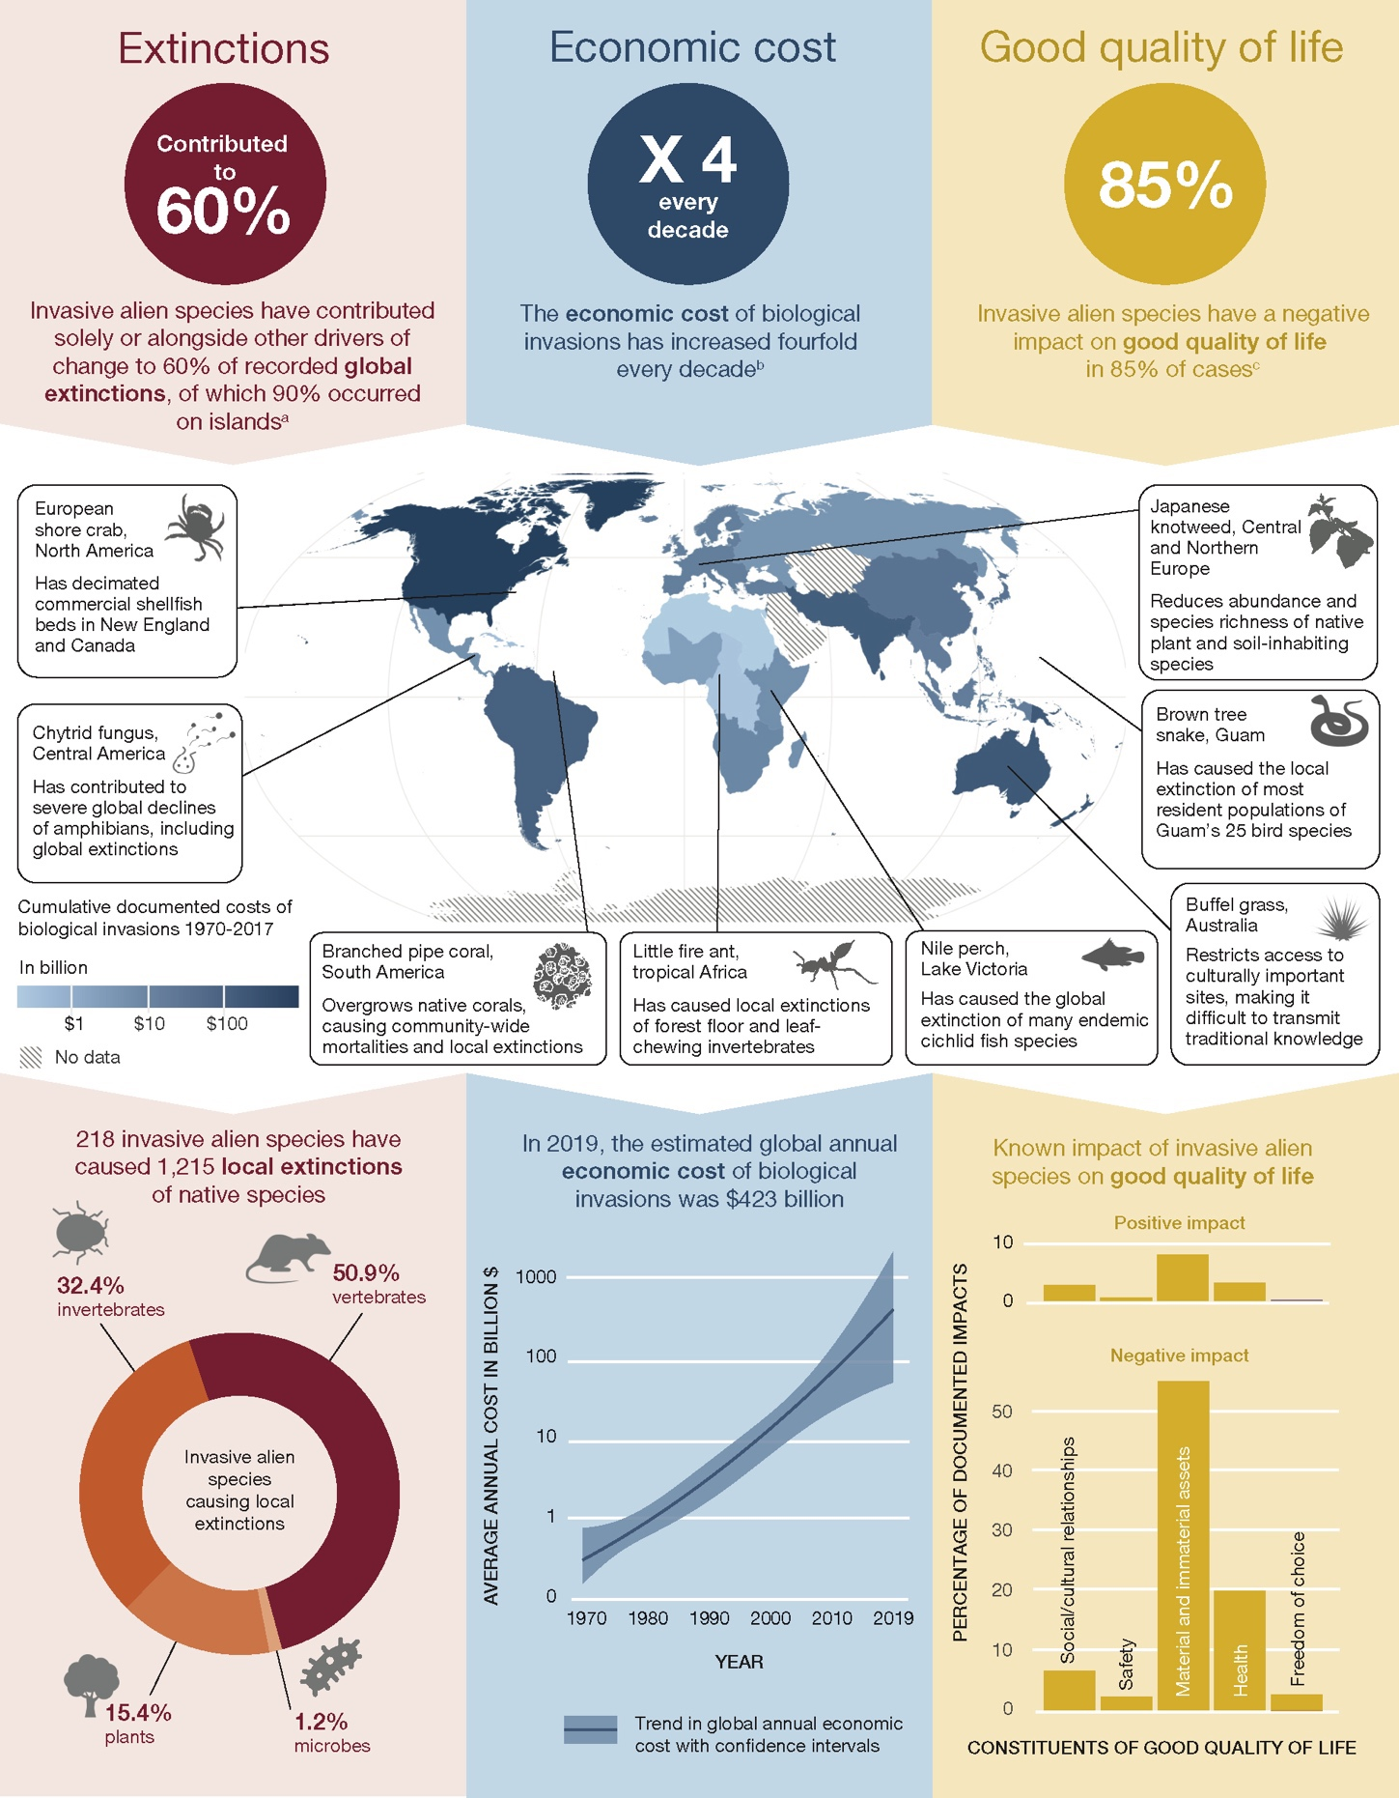
0
10
Figure SPM.3. Extent of the problems caused by invasive alien species. Illustrative examples of the impacts of invasive alien species on native species (red; left column), on the economy (blue; centre column) and on good quality of life (yellow; right column). The top row illustrates the documented numbers of global and local extinctions of native species to which invasive alien species have contributed (left); the rate of increase in the economic cost of biological invasions per decade (centre); and the percentage of cases where the impact of invasive alien species on good quality of life is reported as negative (right). The map in the centre row shows the documented cumulative economic cost of invasive alien species per IPBES subregion from 1970 to 2017. The case studies illustrate a variety of impacts of invasive alien species on both nature and good quality of life in different geographic regions, taxonomic groups and realms, but are not meant to be representative. The bottom row shows the taxonomic distribution (i.e., plants, invertebrates, vertebrates and microbes, including fungi) of the percentage of invasive alien species documented as causing local extinctions of native species (left); the estimated global annual average economic cost of biological invasions in billions of United States dollars (centre); and the percentage of the number of documented positive and negative impacts of invasive alien species on the constituents of good quality of life (i.e., freedom of choice, health, material and immaterial assets, safety, social and cultural relationships) (right). a: {4.3.1, table 4.3}; b: {4.4.1, box 4.13}; c: {4.5.1, table 4.20}. The scientific names of the example species are Carcinus maenas (European shore crab); Batrachochytrium dendrobatidis (chytrid fungus); Carijoa riisei (branched pipe coral); Wasmannia auropunctata (little fire ant); Lates niloticus (Nile perch); Cenchrus ciliaris (buffel grass); Boiga irregularis (brown tree snake); and Reynoutria japonica (Japanese knotweed).

A7. Perceptions of the threat of invasive alien species can vary depending on different human perspectives (well established) {1.5.2}. Perceptions of specific invasive alien species and their value differ among and within stakeholder groups and Indigenous Peoples and local communities, as different community members can experience different impacts depending on gender, age, livelihood and a multitude of other factors (established but incomplete) {1.5.2, 1.6.7.1, 3.2.1, 5.6.1.2}. Value conflicts arise when invasive alien species are considered to be a major threat by some stakeholders and beneficial by others (well established) {5.6.1.2}. An invasive alien species may have been intentionally introduced for a particular purpose, including to mitigate other drivers of change (well established) {box 3.9}, but can have negative impacts on other sectors (well established) {3.3.1.1, 3.2.5, 5.6.1.2}. For example, introduced pigs are important culturally in Hawaii and are hunted for subsistence, ceremony and recreation, despite causing severe negative impacts by driving and maintaining the spread of invasive alien plants within Hawaiian rainforest (established but incomplete) {5.6.1.2}. Divergence of perceptions of invasive alien species can prevent effective decision-making and management (established but incomplete) {5.6.1.2, 6.2.2(9)}. The management of invasive alien species can, in some cases, raise multiple ethical debates about animal welfare and rights (well established) {1.5.3, 5.6.2.1, box 6.13} (e.g., the challenges of effectively managing the biological invasion of Hippopotamus amphibius (African hippopotamus) in Colombia due to it being considered a charismatic species) (established but incomplete) {5.4.3.1}.

A8. Current policy instruments for biological invasions have led to only partial progress towards international targets on invasive alien species, including Aichi Biodiversity Target 9 and Sustainable Development Goal Target 15.8 (well established) {6.1.2, 6.1.3}. Most countries (80 per cent, 156 out of 196) have targets for the management of biological invasions within their national biodiversity strategies and action plans, 74 per cent (145) of which are aligned with Aichi Biodiversity Target 9 (well established) {6.1.2}. Assessment of the progress towards meeting Aichi Biodiversity Target 9 concluded that there was still a considerable gap between the development and adoption of invasive alien species policy and implementation at national levels (well established) {6.1.2}. Although the number of countries with national invasive alien species checklists, including databases, has more than doubled in the last decade (196 countries in 2022) (table SPM.A3) {6.1.3}, 83 per cent do not have national legislation or regulations specifically on invasive alien species (well established) {6.1.3}, which also increases the risk of biological invasions for neighbouring countries (well established) {6.3.2.1}. Only 17 per cent of countries have national legislation for biological invasions, whereas an estimated 69 per cent have biological invasions-specific legislation as part of legislation in other sectors (well established) {6.1.2, 6.1.3}. Although many agribusinesses do not manage the risk of the plants they trade (established but incomplete) {5.6.2.1}, in some cases the business sector has developed voluntary codes of conduct in tandem with government regulations (box SPM.1) (well established) {5.4.1, 6.3.1.4(4), box 6.7}. It should be noted, however, that voluntary codes of conduct are intended to complement, not replace, obligations within national legislation that regulate activities that transport, sell or use alien species (well established) {6.3.1.4(4)}. The transport of invasive alien species along trade supply chains (e.g., in shipping containers) may be poorly managed and consequently may constitute a biosecurity risk (well established) {5.6.2.2}. There are many reasons for the limited adoption, implementation and efficacy of policy instruments, including varying capacity and resources across regions (well established) {6.2.2(7), 5.6.2.2} and lack of coordination, with unclear roles and responsibilities among government agencies, stakeholders and Indigenous Peoples and local communities (well established) {6.2.2(3), 6.2.2(7), 6.2.3, 6.7.2.5}. Nearly half of all countries (45 per cent) do not invest in management of biological invasions (Sustainable Development Goal indicator 15.8.1) (established but incomplete) {6.1.3}. Lack of awareness of the need for collective and coordinated responses can also hinder implementation {6.1.1, 6.2.2(9)}.

Box SPM.1. Voluntary codes of conduct can complement legislation for managing the risks of transport and the introduction of invasive alien species through trade
Voluntary codes of conduct have limits, but they provide practical and concise guidance in establishing common standards of good practice and sustainable attitudes and behaviours for managing the risks of transport and the introduction of invasive alien species through trade. For example, awareness of horticulture as a major pathway for the introduction of many (46 per cent) invasive alien plants worldwide {3.2.3.2} has led to industry–government collaboration that has resulted in the implementation of voluntary codes of conduct for the horticultural industry, complementing legislation to ban the sales of invasive alien plants considered to be high risk {box 6.6}. When designed in a collaborative manner, codes of conduct can help producers and consumers make informed choices. The adoption of voluntary codes of conduct can encourage e-commerce platforms to adopt better practices by screening their lists for invasive alien species, complying with relevant legislation and providing information on the species, including taxonomy, potential invasiveness and appropriate measures that a buyer could use to prevent escape. Codes of conduct have also been developed in Europe for other activities that can facilitate the introduction of invasive alien species, including boating, botanic gardens, horticulture, hunting, international travel, plantation forestry, pets, protected areas, e-commerce, recreational fishing, zoological gardens and aquaria.

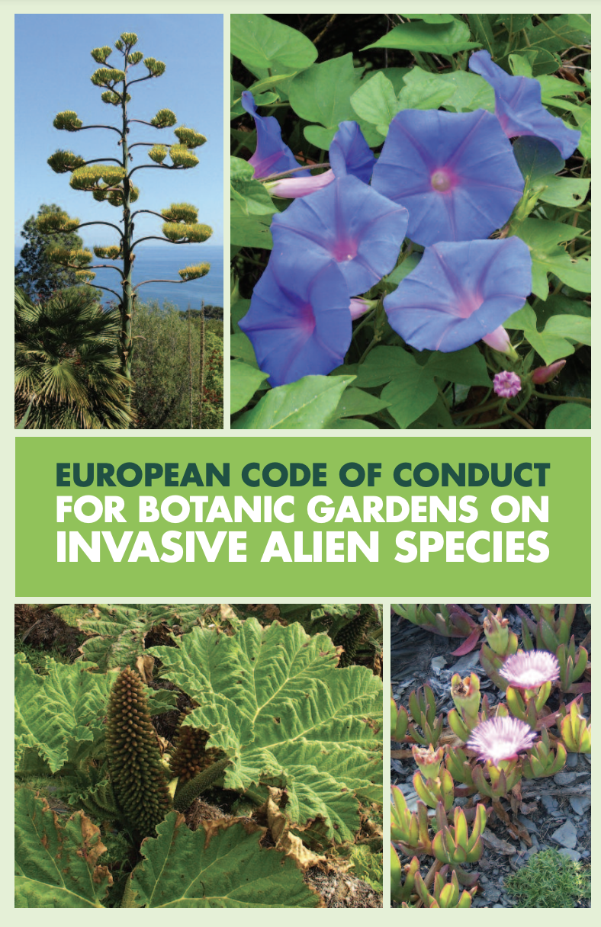
Published in 2013 by the Council of Europe, the European Code of Conduct for Botanic Gardens on Invasive Alien Species outlines voluntary principles for all botanic garden personnel to support them in protecting ecosystems from the impacts of invasive alien species.
See: Heywood, V. H., & Sharrock, S. (2013). European Code of Conduct for Botanic Gardens on Invasive Alien Species. Council of Europe Publishing, F-67075 Strasbourg www.coe.int/Biodiversity.
B. Globally, invasive alien species and their impacts are increasing rapidly and are predicted to continue rising in the future

B9. Intentionally or not, many human activities facilitate biological invasions globally (well established) {3.1.1, 3.2, 3.3, 3.4}. The transport and introduction of an invasive alien species can be intentional or unintentional, or in some cases both (well established) {3.2, 3.3}. Historically, many invasive alien species have been intentionally introduced outside their natural range around the world for their perceived benefits to people, without consideration or knowledge of their negative impacts (well established) {3.2.1, 3.2.3, 3.3.1, 3.3.2}. For example, invasive alien species are often used in forestry, agriculture, horticulture, aquaculture and as pets (well established) {3.2.3.2, 3.3.1.1}. In the Mediterranean basin alone, more than 35 per cent of alien freshwater fish have arisen from aquaculture (well established) {3.3.1.1.1}. Invasive alien species have also been intentionally introduced for recreation and amenity (well established) {3.2.1, 3.2.3.3} and for soil stabilization (well established) {3.3.1.1.2, 3.3.1.6, 3.3.4.6}. Many invasive alien species have also been introduced unintentionally, including as contaminants of soils and traded goods, stowaways in shipments (well established) {3.2.3.1, 3.2.3.2, 3.2.3.4}, stowaways in ballast water and sediments, and as biofouling organisms that attach themselves to ships’ hulls and other surfaces on vessels (well established) {3.2.3.1, 3.2.5, 3.3.2.3, box 3.7}. Additionally, online trade in animals, plants and other organisms is contributing to the introduction of invasive alien species worldwide (well established) {2.1.2, 3.2.4.2}. Progressive degradation of nature, including from pollution and fragmentation of ecosystems, has facilitated the establishment and spread of invasive alien species (well established) {3.3.1.2, 3.3.1.3, 3.3.1.5, 3.3.1.6, 3.3.3}. Demographic drivers also facilitate the introduction and spread of invasive alien species, although it is acknowledged that drivers differ across regions (well established) {3.2.2}. In the last 50 years, the number of people in the world has more than doubled, consumption has tripled, and global trade has grown nearly tenfold, with shifting patterns across regions (well established) {3.1.1}. This acceleration of the world economy is increasing the rate and magnitude of many direct and indirect drivers, particularly those related to trade, travel and land- and sea-use change, leading to further biological invasions (well established) {3.1.1, 3.2.2}.

B10. The number of alien species is rising globally at unprecedented and increasing rates (figure SPM.4) (well established) {2.2.1}. Thirty-seven per cent of all known alien species have been reported since 1970 (figure SPM.3) (established but incomplete) {2.2.1}. The number of alien species has been rising continuously for centuries in all regions (well established) {2.2.1} and is expected to continue increasing in the future (well established) {2.6.1}. Global exploration and colonialism beginning in 1500, with the associated movement of people and goods, and industrialization from 1850 resulted in the transport and introduction of alien species and were historically important. Increases in global trade since 1950 have resulted in unprecedentedly high and increasing numbers of alien species being introduced (figure SPM.4). Some of these have become invasive (well established) {2.1, 3.2.3}. Even without the introduction of new species, given the opportunity, many already-established alien species in a region may continue to expand their geographic ranges and spread into new countries and regions (well established) {2.6.1}, including into remote environments such as mountain, polar (i.e., Antarctica and the Arctic) and desert ecosystems (well established) {2.5.2.8, 2.5.2.7, Box 2.7, box 3.11}. Under a “business-as-usual” scenario, which assumes the continuation of past trends in drivers, the total number of alien species is projected to further increase globally, and by 2050 is expected to be approximately 36 per cent higher than in 2005 (established but incomplete) {2.6.1}. As trends in major drivers are predicted to accelerate in the future (well established) {3.1.1}, the number of alien species worldwide is expected to increase faster than predicted under the “business-as-usual” scenario (established but incomplete) {2.6.1}. There is a lack of quantified projections for invasive alien species under different scenarios (table SPM.A1), which impedes a comparison of trends for alternative futures (well established) {2.6.5}. Projections of long-term trends for invasive alien species numbers are not available but they are expected to be similar to those for established alien species (established but incomplete) {2.2.1}. The documented global economic cost of biological invasions has increased fourfold every 10 years since 1970 (figure SPM.3) and is anticipated to continue rising (established but incomplete) {box 4.13}.
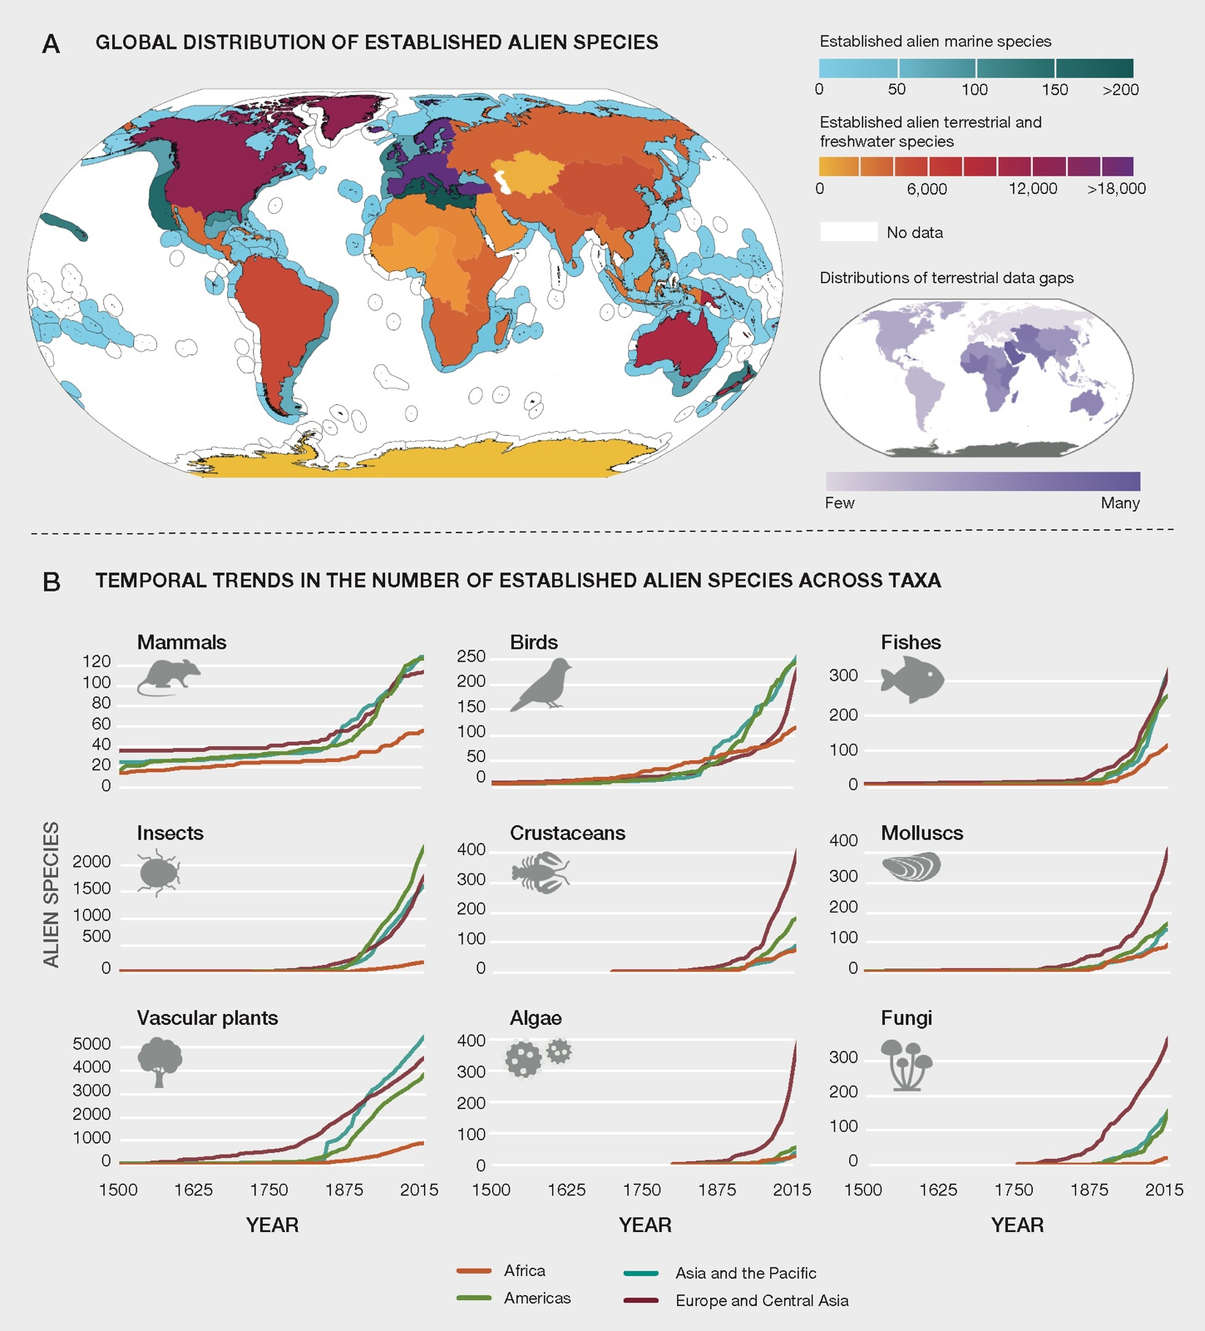
300

200

100

0
Figure SPM.4. Global distribution and temporal trends in established alien species. (A) Total numbers of established alien species (terrestrial and freshwater) in the 18 IPBES subregions and marine ecoregions (marine) are indicated. White denotes missing information {2.2}. A gap analysis was conducted to identify data gaps for terrestrial regions, which are indicated in the inset {2.1.4, 2.2.3}. The data gap analysis could not be done for marine regions (white) and Antarctica (grey). (B) The temporal trends in the number of established alien species from 1500 to 2015 are shown for mammals, birds, fishes, insects, crustaceans, molluscs, vascular plants, algae and fungi, for the four IPBES regions {2.1.4, 2.4.1}.

B11. The increase in the transport and introduction of invasive alien species worldwide is primarily influenced by economic drivers, especially the expansion of global trade and human travel (figure SPM.5) (well established) {2.1.2, 3.1.1, 3.2.3}. There has been a fivefold increase in the size of the global economy over the last 50 years (well established) {3.1.1}. International trade, which has increased nearly tenfold over the same period, represents the most important pathway through which invasive alien species are transported worldwide (figure SPM.5) (well established) {3.1.1, 3.2.3.1}. There is a strong link between the volume of commodity imports and the number of invasive alien species in a region, and patterns in the global spread of species mirror shipping and air traffic networks (well established) {3.2.3.1}. The construction of shipping canals (e.g., Suez, Panama) has connected previously separated marine and freshwater regions, facilitating the spread of invasive alien species through species migration, ballast water transfers (box SPM.2) and biofouling (well established) {3.2.3.1, 3.3.1.3}. For example, 150 years after the opening of the Suez Canal, marine alien species are still being newly recorded in the Mediterranean Sea (well established) {box 3.7}. Biosecurity measures at international borders have not kept pace with the growing volume, diversity and origins of global trade (including e-trade) and travel (well established) {3.2.4.2, 3.2.3.4, 5.6.2.2}. Projected growth in international trade and the movement of people, including tourism, will lead to further pressure on border inspection regimes and could soon overwhelm the biosecurity capability of most countries (well established) {3.2.3.1, 6.3.1.4}.
Box SPM.2. The International Convention for the Control and Management of Ships’ Ballast Water and Sediments: an example of international collaboration to prevent biological invasions
Many invasive alien species have been introduced to coastal and inland water ecosystems globally through ballast water discharges {3.2.3.1}. For example, following its introduction via ballast water discharge, Dreissena polymorpha (zebra mussel) has become widespread in the Great Lakes of North America {box 2.9}. Dreissena polymorpha has been implicated in the transfer of botulinum toxin to higher trophic levels, which has been further facilitated by climate change, specifically by increased water temperatures, leading to mortality of waterfowl in the Great Lakes {box 4.5}. Furthermore, the shells of Dreissena polymorpha can cause skin injuries to recreational swimmers and commercial fishers {box 4.15}. The International Maritime Organization has developed an international instrument to address the transfer of harmful aquatic organisms and pathogens in ballast water of maritime vessels {5.5.1}. The International Convention for the Control and Management of Ships’ Ballast Water and Sediments was adopted by the International Maritime Organization in 2004 and came into force in 2017 {5.5.1}. It is the first international legally binding legislation requiring ships to manage their ballast water so that aquatic organisms and pathogens are eliminated before the ballast water is released in a new location {3.2.3.1, 5.5.1, 6.1.3, 6.31}. While the global efficacy of ballast water management cannot be assessed yet, there is evidence that it has reduced invasive alien species introductions in the Great Lakes of North America {5.5.1}: between 1959 and 2006, one new alien species was discovered every seven months, but there was an abrupt shift (85 per cent decline) in the number of newly established alien species following the implementation of the ballast water regulations by Canada and the United States of America in 2006 and 2008 respectively {box 2.9}.
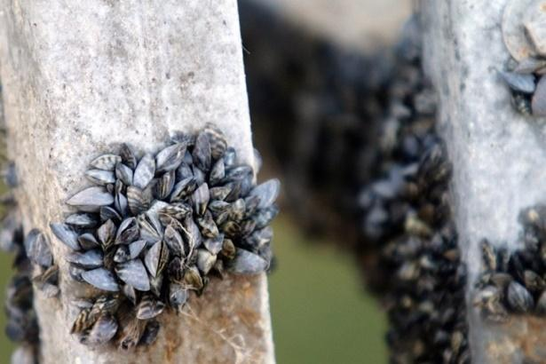
Dreissena polymorpha (zebra mussel) was introduced through ballast water discharge in the Great Lakes of North America, causing a negative impact on nature, nature’s contributions to people, and good quality of life.
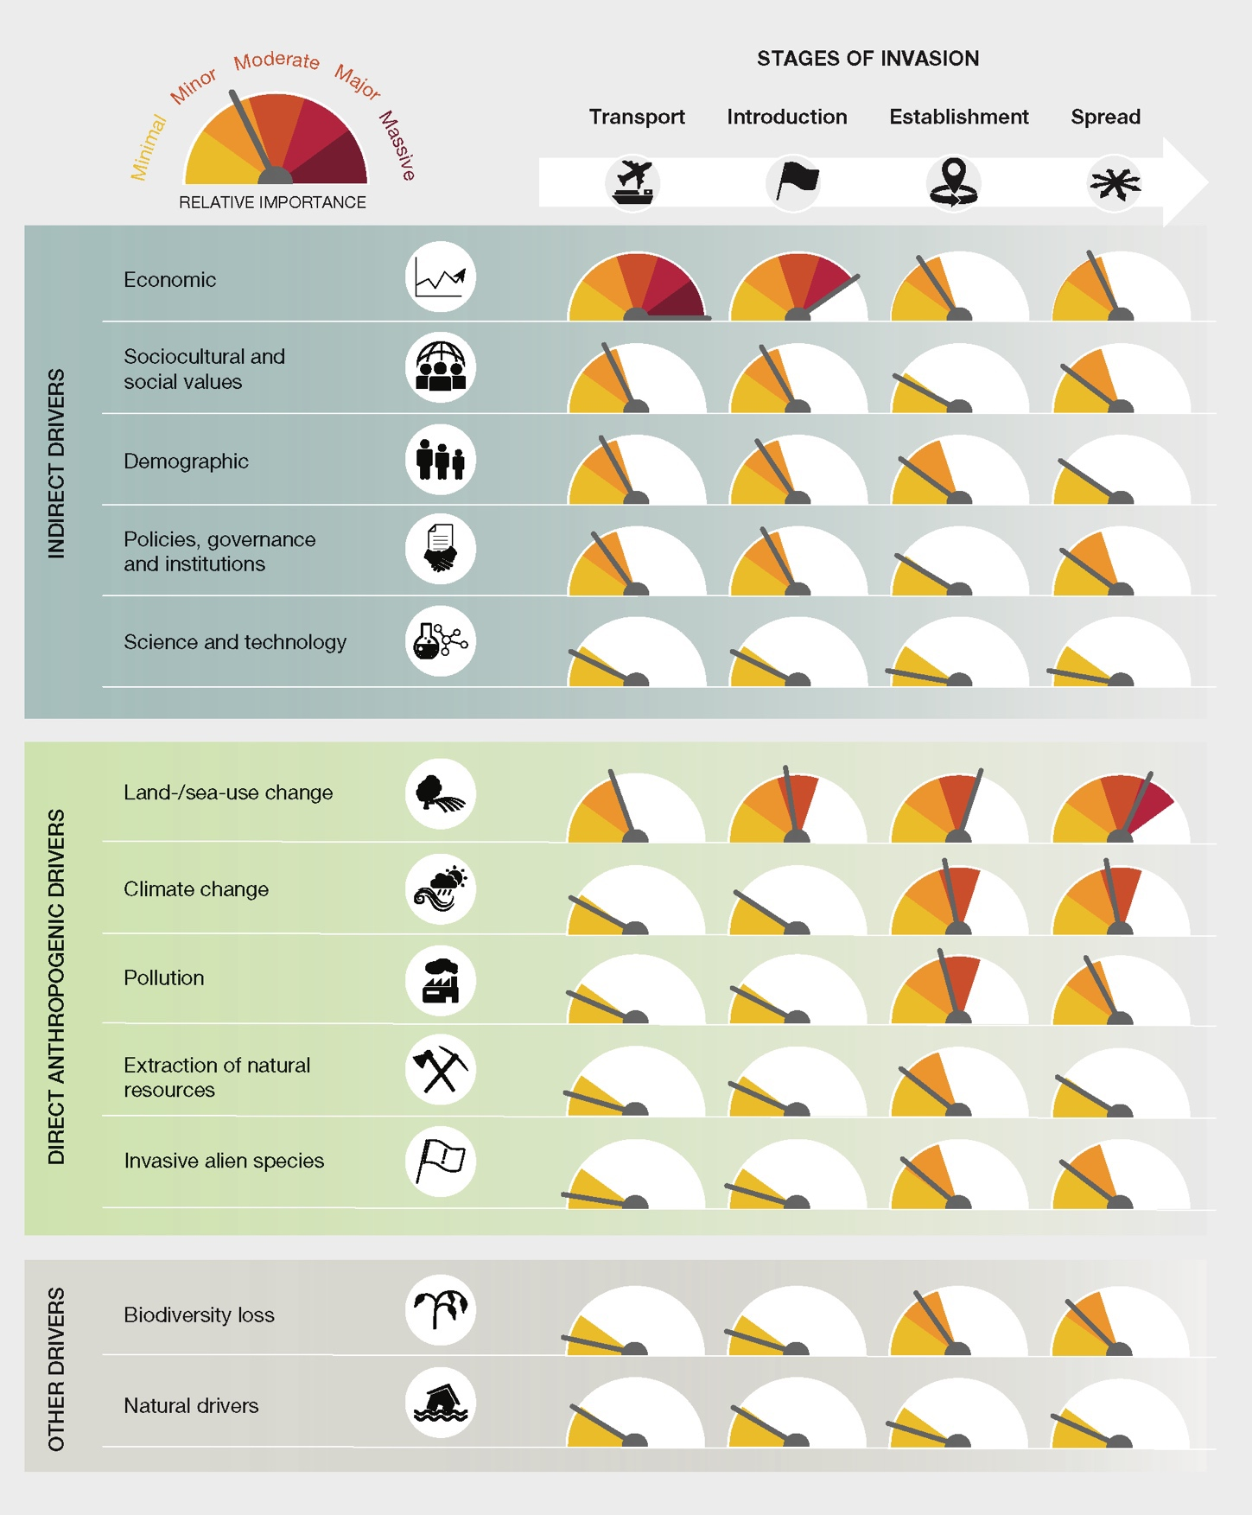
Figure SPM.5. Relative importance of different drivers of change in nature in facilitating biological invasions across biomes per different stages of the biological invasion process (transport, introduction, establishment and spread), as determined through expert assessment, based on the evidence in chapter 3 {3.6.2}. These estimates are summarized across ecosystems and terrestrial biomes at the global scale. Drivers are classified according to the IPBES conceptual framework as direct or indirect drivers {3.1.3, table 3.1}. Additionally, other drivers are included, namely biodiversity loss and natural drivers, as they can increase native ecosystem vulnerability or in other ways facilitate biological invasions {3.1.3}. Note that the role of invasive alien species as a driver refers to their role in facilitating other invasive alien species {3.3.5} and that this analysis focuses on the unintended consequences of policies, governance, institutions and technologies in facilitating biological invasions {3.2.4, 3.2.5}. The relative importance of drivers for each stage of the biological invasion process accounts for multiple, interacting, and non-additive effects of drivers, with differences in the overall importance of drivers across stages. While all drivers can potentially influence each biological invasion stage, indirect drivers, particularly those associated with economic growth, are more important in facilitating the transport and introduction stages {3.6.2}. In contrast, direct drivers, particularly land- and sea-use and climate change, are proportionally more important in facilitating the later stages of biological invasion {3.6.2}.

B12. Accelerated establishment and spread of invasive alien species within countries are primarily driven by direct drivers, notably changes in land- and sea-use (figure SPM.5) (well established) {2.2.1, 3.3.1, 3.6.2}. Land- and sea-use changes may increase the vulnerability of natural ecosystems to the establishment and spread of invasive alien species through increasing fragmentation and habitat disturbance, for example by changing grazing, fire regimes, soil disturbance, or watershed flow (well established) {3.3.1.2, 3.3.1.5}. Transportation and utility infrastructures such as roads, tracks, railways, pipelines, canals and bridges, among others, can create corridors that facilitate the spread of invasive alien species, including into remote, undisturbed and protected areas (well established) {3.3.1.3, box 2.7, box 3.7}. Marine and aquatic infrastructure may alter seascapes and the functioning of marine ecosystems, facilitating the spread of invasive alien species (established but incomplete) {3.2.2.4, 3.3.1.4, 5.6.1.4}. The numbers of invasive alien species were reported to be 1.5 to 2.5 times higher on pontoons and pilings than on natural rocky reefs (established but incomplete) {3.3.1.4}. More generally, land-use change can facilitate biological invasions through alteration of processes that cause natural disturbance of landscapes, such as wildfire or grazing regimes (established but incomplete) {3.3.1.5}. In several regions of the world, grazing by feral alien ungulates (horses, camels, buffalo, pigs) facilitates the spread of invasive alien plants, sometimes through complex species interactions involving the suppression of native species and the facilitation of other alien species (well established) {3.3.1.5.1}. As a specific example, invasive alien ungulates (wild boar, deer) can transport invasive ectomycorrhizal (root associated symbiotic) fungi, which are beneficial for the establishment and spread of alien pine trees, over long distances, rendering habitats susceptible to pine invasion (well established) {box 3.10}. Climate change, along with the continued intensification and expansion of land-use change may lead to future increases in the establishment and spread of invasive alien species in disturbed habitats and in nearby natural habitats (established but incomplete) {3.3.4}.

B13. No driver acts in isolation, and interactions among drivers are amplifying biological invasions, leading to outcomes that can be difficult to predict (well established) {2.6.1, 3.1.5, 3.5}. The outcomes of interactions among multiple drivers, including feedback, are complex and varied (well established) {1.3.3, 3.1.5, 3.5}. Some of the highest current rates and greatest magnitudes of biological invasion occur where land-use change interacts with one or more additional drivers (established but incomplete) {3.5.1, 3.5.2, 3.5.3}. For example, interactions among land-use change, climate change and nutrient pollution have driven the introduction, establishment and spread of Pontederia crassipes (water hyacinth) across Africa (well established) {box 3.12}. Extraction of natural resources is closely linked with major economic and demographic drivers and can lead to a range of wider ecosystem impacts, including habitat degradation and loss, which facilitates invasive alien species (well established) {3.3.2, 3.4.2}. Climate change is predicted to lead to major changes in land- and sea-use and, in some regions, in human migration patterns (established but incomplete) {3.3.4}, but also to more extreme events among natural drivers, such as droughts, floods, wildfires, tropical storms and oceanic storm waves (established but incomplete) {3.3.4.3}. Additionally, invasive alien plants, especially trees and grasses, can sometimes be highly flammable and therefore promote more intense and frequent fire regimes, causing increased risks to nature and people and increased carbon release into the atmosphere (well established) {box 1.4}. Climate change is also predicted to enhance the competitive ability of some invasive alien species and to extend areas suitable for them, thus offering new opportunities for introductions and establishment (established but incomplete) {3.3.4}. Invasive alien species can facilitate the establishment and spread of other invasive alien species, resulting in positive feedback that increases impacts through a process known as “invasional meltdown” (well established) {3.3.5.1}. Biodiversity loss can reduce the resilience of ecosystems to invasive alien species, with subsequent feedback facilitating the establishment and spread of other invasive alien species (well established) {3.4.2}. Indirect drivers also interact with one another. For example, sociocultural changes may lead to increased rates of infrastructure development through urbanisation, and these interactions may further influence the rate and magnitude of change in land- and sea-use and other direct drivers that may in turn facilitate biological invasions (well established) {3.2.1}. Feedback and non-linear relationships among interacting drivers are likely to be exacerbated with ongoing and concurrent amplification of drivers (established but incomplete) {3.1.1, 3.5, 3.6.3, box 4.5}, potentially leading to numbers of invasive alien species never previously encountered (established but incomplete) {2.6.1}.

B14. Negative impacts of invasive alien species can occur long after first introduction, and currently observed threats from invasive alien species can lead to an underestimation of the magnitude of the future impact (well established) {1.4.4, 2.2.1}. There are often time lags in detection and reporting of newly introduced invasive alien species (well established) {2.2.1}. Some invasive alien species spread very rapidly, while others take longer to spread and fully occupy their potential ranges (well established) {2.2.1, 2.2.3}. For some invasive alien species, the impact is immediate and continues into the long-term (e.g., fast-spreading pathogens such as Zika virus and Batrachochytrium dendrobatidis (chytrid fungus), and fast-spreading predators such as lionfish), while for others there may be a considerable time lag, spanning decades in some cases, before the impact is apparent (e.g., many invasive alien trees) (well established) {1.5}. Such time lags can lead to people not perceiving the ongoing slow changes in their environment, including the impacts of invasive alien species (well established) {1.5.2}. There can also be significant time lags in the response of invasive alien species to various drivers because the underlying processes that facilitate biological invasions operate at varying temporal scales (short- to long-term) (well established) {1.5, 3.2.3.1, 3.6.3}. Invasive alien species may increase in numbers after a long period at low density as a result of changes in interactions with other species, for example as a result of the introduction of a missing dispersal agent or the removal of a competitor (3.3.5.1). For example, in the western United States, the invasive alien Carcinus maenas (European shore crab) reduced the abundance of a native clam, releasing another alien species, Gemma gemma (the amethyst gem clam), from competition, allowing it to become superabundant and to spread, after having been locally distributed and at low abundance for over 50 years (well established) {3.3.5.1}. Patterns in the numbers of alien species seen today reflect the drivers of decades ago (i.e., invasion debt) (established but incomplete) {3.1.1, 3.1.5}. Consequently, past and ongoing amplification of drivers may lead to a long legacy of future invasive alien species as, for example, the number of new alien species that become invasive increases over time (i.e., invasion debt) (established but incomplete) {2.3.1.5, 3.1.5, 3.6.3}.
C. Invasive alien species and their negative impacts can be prevented and mitigated through effective management

C15. Management of invasive alien species has been successful in many contexts (figure SPM.6, table SPM.1) (well established) {5.5.1, 5.5.2, 5.5.3, 5.5.4, 5.5.5, 5.5.6}. There are three options for preventing or reducing the number and negative impacts of invasive alien species:
- Pathway management, based on the analysis of pre-border, border and post-border risks, can prevent the movement and spread of invasive alien species through surveillance and the implementation of biosecurity response measures (well established) {5.3.1.1, 5.5.1, 5.5.2}.
- Species-based management at a local or landscape level, which includes surveillance, early detection and rapid response, eradication, containment and widespread control (including biological control), and can be applied throughout the biological invasion process (well established) {5.3.1.2, 5.5.2, 5.5.3, 5.5.4, 5.5.5}.
- Site- or ecosystem-based management, which can both protect and restore native species and ecosystems (well established) {5.3.1.3, 5.5.6}.
The use of individual species-based and site-based approaches for the management of multiple invasive alien species has been both successful and cost-effective for terrestrial and closed water systems, especially in biogeographically isolated areas such as small islands and lakes (well established) {5.3.1, 5.3.2, 5.5.4}. While some management approaches can be applied at multiple scales across terrestrial and closed water systems (well established) {5.1.1, 5.3.1.4.}, pathway management (e.g., ballast water and biofouling; box SPM.2) is by far the most effective option for managing biological invasions in marine and connected water systems, and can be achieved by enhanced international and regional cooperation (well established) {5.5.1, 6.3.2.2}.

C16. There are effective decision-making frameworks and tools that can support management of biological invasions (table SPM.1) (well established) {5.2.1, 5.2.2}. Frameworks and tools have been developed based on evidence from practice, science and other knowledge systems, including those of Indigenous Peoples and local communities. These can underpin impact assessment, monitoring and prioritization of intentional and unintentional introduction pathways, species and sites for the successful management of biological invasions (well established) {5.2.2}. Although many knowledge and data gaps exist (table SPM.A1), the tools enable management actions to proceed under a risk assessment and risk management framework in line with a precautionary approach, as appropriate, using inclusive decision-making that leads to the review of all the measures (well established) {5.2.2.1, 5.2.2.3, 5.2.2.4, 5.3.3, 6.4.1}. Decision-making may be challenged by multiple sources of uncertainty, such as projections in other drivers of change, which can be recognized, quantified and documented to contextualize decisions (well established) {5.6.2.5}. Many sources of accessible literature and information (including open-access data), analytical tools and other types of knowledge can be used to support decision-making for all countries, which could lead to coordinated management outcomes globally (table SPM.A3) (established but incomplete) {6.6.1.5}.
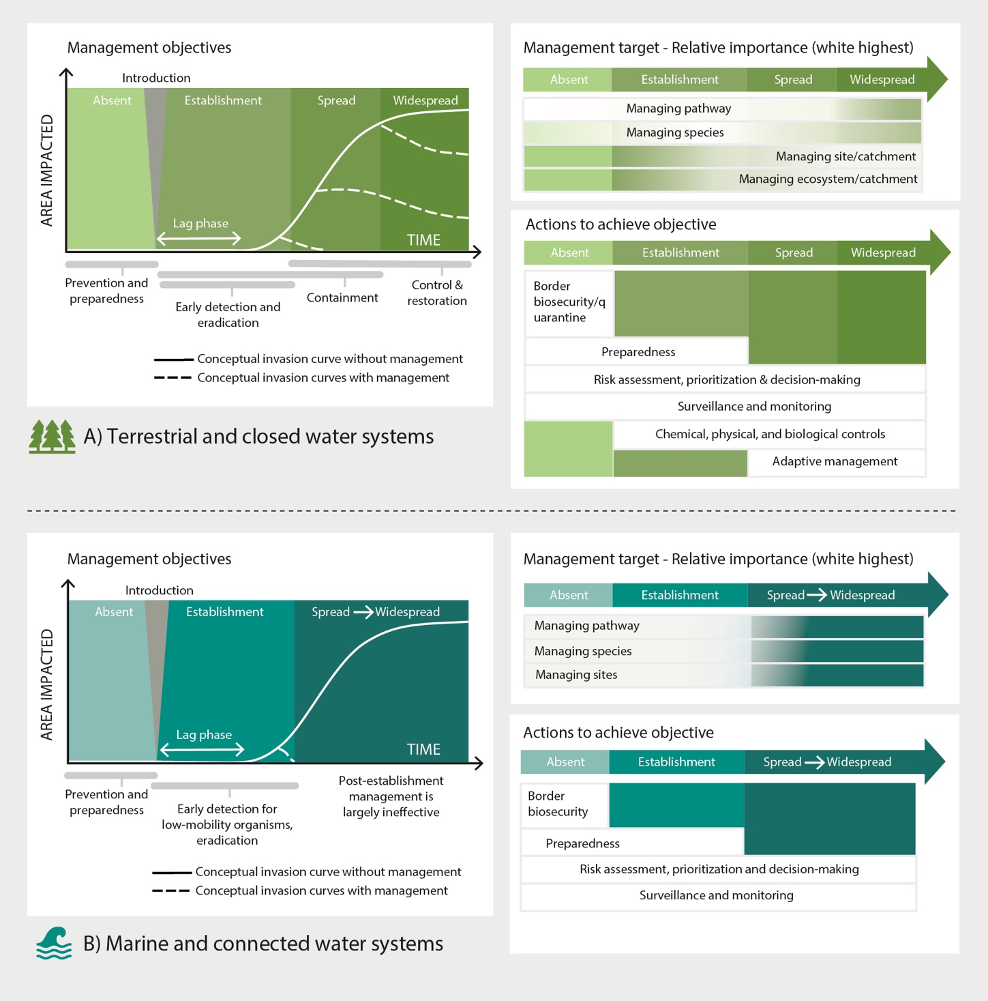
Figure SPM.6. Conceptual diagram of management–invasion continuum. Management objectives panels A and B show the generalized invasion curve without management and the expected changes in the trajectory of the invasion curve with appropriate management actions in (A) terrestrial and closed water systems (including lakes and coastal systems such as salt marshes) and (B) marine and connected water systems (including rivers). Post-establishment management actions (such as containment and control) are not shown in panel B as they are generally not achievable in such systems. In a management context, the first detection (introduction point), lag phase and exponential spread phase are important points at which to implement an early detection and rapid response management plan. This figure is conceptual and the curves do not represent actual population dynamics of invasive alien species. In the Management target panels, the white boxes indicate the optimal management options at each stage of the biological invasion process. The colour gradient of the managing pathway, managing species, managing site and managing ecosystem boxes show how the relative importance of each changes as a biological invasion progresses (managing ecosystems is not applicable in marine and connected water systems). In the Actions to achieve objective panels, the white boxes indicate the typical management actions needed to achieve each management objective.
Table SPM.1. Objectives and actions for managing biological invasions
Objectives and actions for managing biological invasions within terrestrial and closed water systems or marine and connected water systems and the level (high, medium, low) of their (a) current availability (availability of target-specific tools for implementing management); (b) ease of use (ease of implementation or specialist or technological expertise to implement); and (c) effectiveness (likely long-term efficacy and outcomes of implementation). Hashed boxes indicate responses with a low level of confidence and crossed boxes indicate there was no data available to perform an assessment. Actions are aligned with figure SPM.6 and encompass pathway management, species-, site- and ecosystem-based management targets. All management approaches may have non-target impacts, as indicated by superscript a.
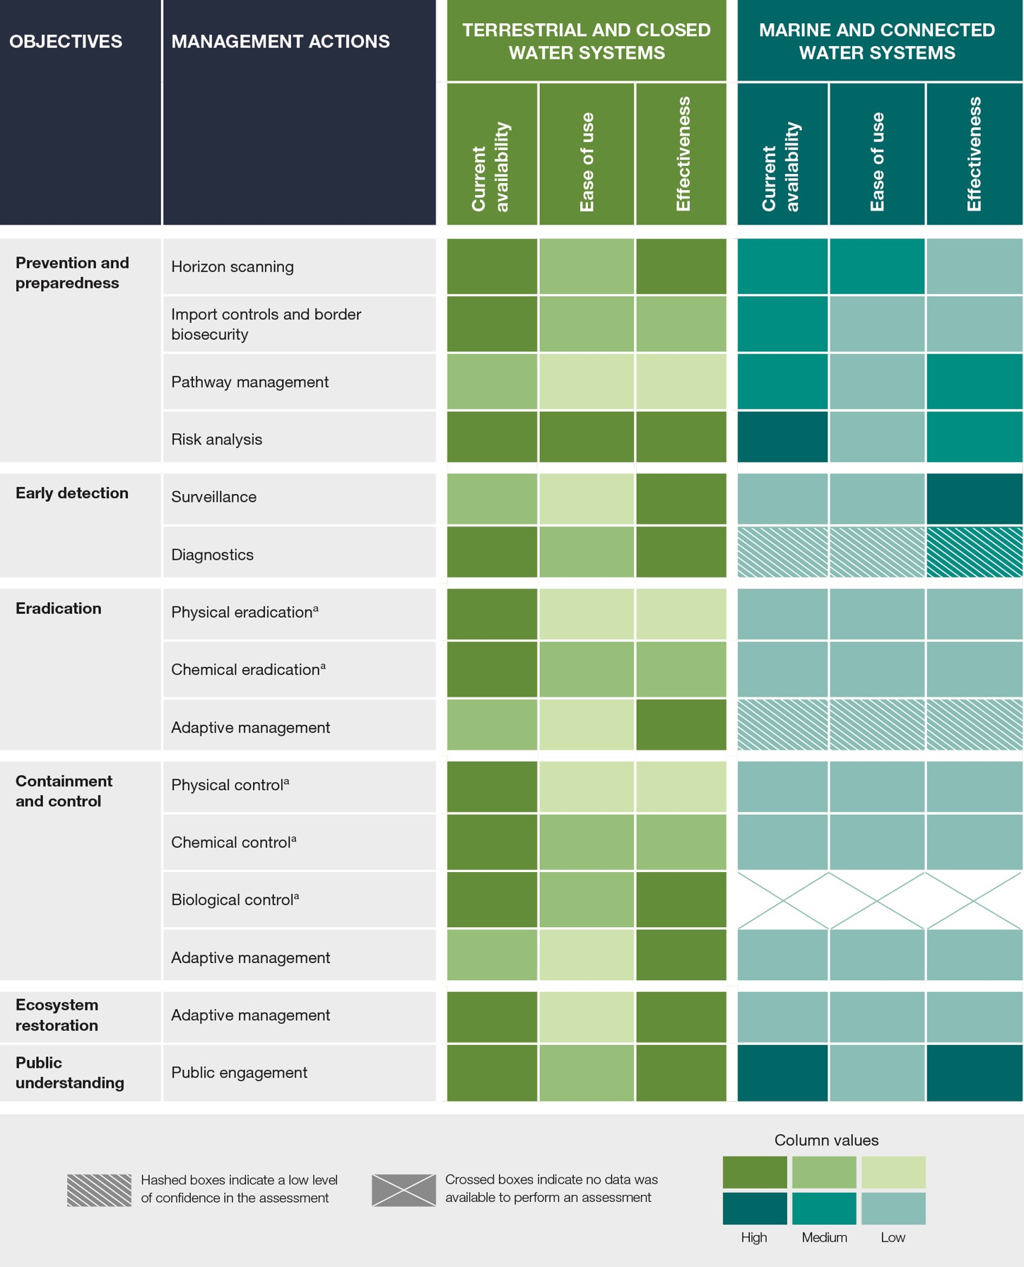

C17. Preventing the introduction of invasive alien species is the most cost-effective management option (figure SPM.6) (well established) {5.5.1}. Prevention measures through pathway management, including strictly enforced pre-border quarantine, import controls and border biosecurity, have increased interception rates and slowed the rate of invasive alien species arriving and establishing globally (well established) {5.4.3.1, 5.5.1}. For example, in Australasia, the number of interceptions of Halyomorpha halys (brown marmorated stink bug), recognized as a major threat in the agricultural sector, have declined following implementation of a systems-based pathway management approach (well established) {5.5.1}. Measures to address escape from confinement are also necessary (established but incomplete) {5.3.1.1}. It is, however, difficult to prevent further natural dispersal of invasive alien species from a previously invaded range (well established) {5.5.1, box 1.6}. Prevention is important on islands and in ecosystems where eradication poses significant technical challenges (well established) {5.3.2}. Effective prevention measures depend on adequate and sustained funding, capacity-building, technical and scientific cooperation, transfer of technology, monitoring, and relevant and appropriate biosecurity legislation and enforcement, which is supported by strong infrastructure, quarantine and inspection facilities, including diagnostic support services (well established) {5.4.2, 5.6.2, 5.6.2.2, 5.7}. Risk assessment could be used by businesses to engage different sectors in the prevention and management of biological invasions (established but incomplete) {5.6.2.1}. Adoption of regulated species lists with explicit prohibition of or permission for the importing of specific alien species, underpinned by risk analysis, has been an effective prevention strategy (well established) {5.6.2.1, 6.3.1.4}. It is estimated that nearly 70 per cent of marine invasive alien species established worldwide were introduced via biofouling (established but incomplete) {5.5.1}.

C18. When prevention fails or is not possible, preparedness, early detection and rapid response are effective at reducing rates of invasive alien species establishment in terrestrial and closed water systems, and critical for marine and connected water systems (well established) {5.4.2, 5.5.1, 5.5.3, 5.5.2, 5.6.3.3}. Horizon scanning and risk analysis are examples of the many decision-support tools used to identify and prioritize emerging invasive alien species to support preparedness (well established) {5.2}. Such tools can inform the development of rapid response plans in advance of an incursion to guide action effectively following the detection of priority invasive alien species (well established) {5.2.2.1.a, 5.2.2.1.b, 5.5.1}. Early detection of invasive alien species can enable rapid intervention to contain and eradicate invasive alien species before they spread (well established) {5.1.1, 5.3.1.1, 5.5.2}. General surveillance strategies (e.g., through citizen science, sentinel sites, and remote sensing) for detecting new invasive alien species can also underpin effective preparedness (established but incomplete) {5.3.1.1, 5.4.2.1.a, 5.4.2.2.a, 5.5.2, box 6.20}. For example, in Africa, Asia and Latin America, the PlantwisePlus programme assists smallholder farmers with the identification of pests and damaged crops, contributing to early detection of invasive alien species outbreaks (well established) {5.5.2}.

C19. Eradication has been successful and cost-effective for some invasive alien species, especially when their populations are small and slow-spreading in isolated ecosystems such as islands (established but incomplete) {5.5.3}. Over the last 100 years, there have been 1,550 documented examples of eradication on 998 islands, with success cited in 88 per cent of cases (well established) {5.5.3}. One of the many examples is French Polynesia, where Rattus rattus (black rat), Felis catus (cat), Oryctolagus cuniculus (rabbit) and Capra hircus (goat) have been successfully eradicated (well established) {box 5.8}. Eradication of invasive alien plants is particularly difficult because of the longevity of dormant seeds that can persist in soil (i.e., soil seed bank), although there are examples of successful eradication of invasive alien plant species with limited distributions (well established) {5.5.3}. Also, rapid response to incursions, detected early, of some invertebrates have been successful, for example, eradication of Solenopsis invicta (red imported fire ant) in New Zealand (well established) {box 5.14}. There are examples of larger-scale eradications, such as Ondatra zibethicus (muskrat) and Myocastor coypus (coypu) from the United Kingdom (well established) {5.5.3}. However, large-scale eradications are difficult and unlikely to be feasible in many cases (well established) {5.5.3}. In addition to the extent of the area invaded, the success of eradication programmes depends on the support and engagement of relevant stakeholders and Indigenous Peoples and local communities (well established) {5.4.2.2.a, 5.5.3, 5.6.2.1, 5.6.2.2}. Eradication programmes are aided by a rapid flow of information on the extent and location of invasive alien species, which can be provided by people who live nearby (well established) {5.4.2.2.a, 5.5.3}. Evidence suggests that there have been no fully successful eradication programmes for established invasive alien species in marine ecosystems (well established) {5.5.3}. While eradication programmes can only be achieved with access to upfront cost, they are generally cheaper than long-term and permanent control cost and impacts (well established) {5.5.3}.

C20. When eradication is not possible for different reasons, invasive alien species can be contained and controlled, particularly in terrestrial and closed water systems (well established) {5.4.3, 5.4.4, 5.5.4, 5.5.5}. There are many examples of successful containment and control of invasive alien species in terrestrial and closed water systems and aquaculture (e.g., containment of Styela clava (Asian tunicate) invading the aqua-cultured blue mussel in Canada) (well established) {5.5.4}, but most attempts in marine and open water ecosystems have been largely ineffective (established but incomplete) {5.5.4, 5.5.5}. Containment of invasive alien species can be achieved with physical, chemical and biological control actions or in combination (table SPM.1) (well established) {5.4.3.2, 5.5.4}. Physical and chemical control options are mostly effective at a local scale but can also be effective at larger scales; these control options are limited by labour costs and generally provide short-term suppression but not sustained control (well established) {5.4.3.2.a}. Furthermore, chemical control may have non-target impacts, needs to be implemented under regulatory compliance requirements and has decreasing societal acceptability (well established) {5.4.3.2.b}. Biological control has been very effective in controlling some invasive alien plants, invertebrates and, to a lesser extent, plant microbes and a few invasive alien vertebrates, but it may have non-target impacts if not well regulated (well established) {5.5.5.3}. To reduce the risks of unintended consequences, including non-target impacts, from biological control, international standards and risk-based regulatory frameworks (developed under the International Plant Protection Convention) have been applied and continue to be effective across many countries (well established) {5.5.2}. The use of biological control for invasive alien plants and invertebrates has been successful in more than 60 per cent of documented cases (box SPM.3), with one third of the alien plant species requiring no further form of control, while also leading to benefits to biodiversity and ecosystem resilience (well established) {5.5.5.3}. Classical biological control to suppress invasive alien species populations at landscape scales has been effectively practised for more than 100 years (well established) {5.5.5.3}.
Box SPM.3. Classical biological control of Mikania micrantha (bitter vine): an example of effective suppression of a widespread invasive alien species
Classical biological control uses host-specific natural enemies (biological control agents) of invasive alien species (target) to suppress and control such species. Mikania micrantha (bitter vine), a native species of Central and South America, is one of the highest-impact fast-growing {2.5.2.1} invasive alien plants within the agricultural systems and natural and planted forests of the Asia-Pacific region {box 5.21}, affecting the livelihoods of farmers and rural communities, including women {4.5.1, 4.6.1}. In the native range of Mikania micrantha, a rust fungus (Puccinia spegazzinii) specific to this invasive alien plant causes necrosis of leaves and cankers on the stem and petioles {box 5.21}. Starting in 2006, Puccinia spegazzinii was introduced as a classical biological control agent and established in five countries in the Asia-Pacific region, where it has provided effective control of Mikania micrantha {box 5.21}. However, in India the rust fungus failed to survive in the field following introduction {box 5.21}.

C21. Adaptive management, including ecosystem restoration, can improve the management of invasive alien species and support the recovery of nature’s contributions to people in terrestrial and closed water systems (well established) {5.3.3, 5.4.4.3a, 5.5.6, 5.7}. The integration of site- and/or ecosystem-based management, including ecosystem restoration, can improve management outcomes, enhancing ecosystem function and resilience to environmental change, including future invasive alien species, especially under climate and land-use change (box SPM.4) (well established) {5.3.1, 5.3.2, 5.4.3, 5.5.6, 5.6.1.3}. The success of any applied adaptive site- or ecosystem-based management approach, including ecosystem restoration, depends on long-term monitoring to assess management efficacy using ecological and social indicators (established but incomplete) {5.5.2, 6.6.3}. Long-term monitoring of sites ensures early detection of new introductions, reintroductions and re-emergence of invasive alien species (e.g., from a seed bank that includes invasive alien plants) and can inform further management actions (well established) {5.4.3.3.b, 5.5.6}. However, most studies failed to quantify the effectiveness of ecosystem restoration since they failed to measure the initial status of native vegetation. This has led to inconsistent conclusions regarding the best invasive alien plant control option which may lead to the most effective ecosystem restoration {5.4.3.3b; 5.5.6}. Regarding freshwater ecosystems, monitoring biodiversity using macroinvertebrate-based indices is a widely used method globally. However, knowledge is lacking on how invasive alien species may affect the metric scores and therefore classification of a river's status (established but incomplete) {5.6.2.3}. In marine and connected water systems, ecosystem restoration has so far proved to be largely ineffective because the systems are open, leading to difficulties in implementing and evaluating management actions (established but incomplete) {5.5.6, 5.6.1.1}.
Box SPM.4. Working for Water programme: an example of management of invasive alien species leading to recovery of nature’s contributions to people
Control of widespread invasive alien species requires sustained, large-scale efforts but can lead to improvement in the provision of a range of nature’s contributions to people {box 5.19}. Certain invasive alien plants, such as shrubs and trees, can reduce water availability, especially in scenarios of increasing drought caused by climate change {box 5.4}. In South Africa, the Working for Water programme, an Expanded Public Works Programme, was introduced in 1995 and targeted historically disadvantaged communities, primarily women, youth and disabled people, creating jobs to reduce poverty nationally through the removal of widespread woody invasive alien species threatening water conservation {box 5.19}. The programme generated 20,000 jobs per year over the first 15 years and has helped to improve nature’s contributions to people by improving water security {box 5.19}. It has contributed to rural development by providing training in entrepreneurial and management skills while encouraging a sense of community and dignity among workers, especially women. The Working for Water programme shows how partnerships with rural communities to manage invasive alien species can bring both ecological and social benefits {box 5.19}.

C22. Tools and technologies increase efficiencies when managing biological invasions and controlling invasive alien species, with many new options emerging (established but incomplete) {5.4}. The development of tools and technologies ranging from biotechnology to bioinformatics and data analytics is ongoing for managing pathways, surveillance and detection, rapid response and eradication, local containment and control of widespread invasive alien species (well established) {5.4.1, 5.4.2, 5.4.3}. eDNA-based approaches have been used for detection and identification of invasive alien, mostly aquatic, species such as Orconectes rusticus (rusty crayfish) (well established) {5.4.2.1}. New approaches can be integrated with existing management actions to support site- and ecosystem-based management and restoration (established but incomplete) {5.4}. Multi-stakeholder engagement, including risk communication and context-specific application of approaches through local communities, can improve public acceptability and adoption of new tools and technologies for managing biological invasions and the control of invasive alien species (well established) {5.2.1, 5.4.3, 5.6.2.1, 6.4.1}. Potential benefits and risks of novel technologies can be assessed using a risk assessment and risk management framework in line with a precautionary approach, as appropriate (well established) {5.4.3.2.f}. Using this framework in consultation with regulators, stakeholders and Indigenous Peoples and local communities can limit the potential for unintended consequences (well established) {5.4.3.2}. However, most countries do not have the regulatory frameworks and/or technical capabilities needed to guide and support development and implementation of new tools and technologies (established but incomplete) {5.4.3.2, 6.3.3.4}. Access to modern tools and technologies and the ability to utilize them can be limited, particularly in developing countries, meaning greater capacity-building is required and improved technical and scientific cooperation (well established) {5.6.2.4, 6.7.2.7}.

C23. Stakeholder engagement, capacity-building and sustained resourcing are critical to the success of adaptive management (well established) {5.2.1, 5.6.2.1, 5.6.2.2, 5.6.2.4, 6.4.1, 6.5.3, 6.5.6, 6.5.7}. Access to adequate and sustained financial and other resources, including international funding to support developing countries, underpins and improves the effectiveness of actions for long-term management of biological invasions, including eradication, control and ongoing monitoring, by, for example, providing access to modern tools and enhancing capacity to deploy them (well established) {5.3.1, 5.5.7, 5.6.2.1, 5.6.2.2, 5.6.2.4, 6.5, 6.5.7}. Engagement by all stakeholders, governments and the private sector helps to optimize management of biological invasions in terms of economic, environmental and social outcomes, particularly when resources are limited (well established) {5.2.1, 6.5.1}. Societal support is important for eradication and control of some invasive alien species, particularly vertebrates, for which there are ethical considerations {5.3.1.4, 5.4.3.2, 5.6.2.1}. A lack of stakeholder participation in adaptive management can lead to negative consequences for good quality of life, especially for Indigenous Peoples and local communities who have adapted by using invasive alien species, that include loss of livelihoods, marginalization and/or gender inequity (well established) {box 4.18, 5.2.1, 5.4.3.3.a, 5.5.3, 5.6.1.2, 6.4.1}. The involvement of all stakeholders can be achieved by using an adaptive co-management approach to the process, from decision-making to the implementation of management actions (well established) {5.4.3.3.a, 5.6.2.5}. Adaptive co-management includes capacity-building; co-creation, co-design, co-development and co-implementation; social learning; and broad partnerships (established but incomplete) {5.7, 6.4.2, 6.4.3.2, 6.4.4}. Collaboratively addressing the management of biological invasions around which there are conflicting values among different sectors, stakeholders and Indigenous Peoples and local communities is a significant global policy challenge (well established) {5.6.1.2}.

C24. The knowledge, practices, values and customary governance systems of Indigenous Peoples and local communities can improve management outcomes (established but incomplete) {5.2.1, 5.5.2, 5.5.4, 5.5.5, 5.6.1.2, 6.4.3}. Many communities successfully manage invasive alien species on their lands (established but incomplete) {box 5.6, 5.5.2, 5.5.4, 5.5.5}, leading to increases in nature’s contributions to people (box SPM.4) (established but incomplete) {5.5.4, 5.5.5}. Consultation with Indigenous Peoples and local communities, through their free, prior and informed consent, by applying co-design principles for decision-making and actions helps to ensure efficacy of management outcomes at the local level (established but incomplete) {5.2.1, 6.4.3}. Co-delivered biocultural management plans based on shared scientific, technical and Indigenous and local knowledge systems have assisted surveillance and detection, eradication, containment and control of invasive alien species (established but incomplete) {5.5.3, 5.6.1.2, 6.4.3.2}. Such co-governance structures improve quality of life for Indigenous Peoples and local communities (established but incomplete) {6.4.3}.
D. Ambitious progress to manage biological invasions can be achieved with integrated governance

D25. Management of biological invasions and prevention and control of invasive alien species can be achieved through a context-specific integrated governance approach with a set of complementary strategic actions (figure SPM.7) (established but incomplete) {6.2.3, 6.7.1, 6.7.2, 6.7.3}. Integrated governance for biological invasions consists of establishing the relationships between the roles of actors, institutions and instruments. This involves all those elements of the interactions between people and nature that act on biological invasion and their management, in order to identify the strategic interventions needed to improve outcomes of prevention and control of invasive alien species {box 6.5}. A context-specific integrated governance approach provides flexibility for countries to identify which strategic actions should be prioritized and can help in managing trade-offs and policy conflicts and in avoiding unintended policy consequences and inefficient expenditure (established but incomplete) {6.2.3, 6.7.1}. Strategic actions to prevent the introduction and impact of invasive alien species include:
- Enhance coordination and collaboration across international and regional mechanisms (established but incomplete) {6.2.3.4, 6.7.2.1};
- Develop and adopt effective and achievable national implementation strategies (well established) {6.2.3.2, 6.3.3.1, 6.7.2.3};
- Share efforts and commitments and understanding of the specific roles of all actors (established but incomplete) {6.7.2.5};
- Improve policy coherence (well established) {6.3.1.1, 6.3.2, 6.3.3.1, 6.7.2.2};
- Engage broadly across governmental sectors, industry, the scientific community, Indigenous Peoples and local communities and the wider public (established but incomplete) {6.4.2, 6.4.3, 6.7.2.4};
- Support, fund and mobilize resources for innovation, research and environmentally sound technology (established but incomplete) {6.3.3.4, 6.7.2.7};
- Support information systems, infrastructures and data sharing (established but incomplete) {6.6.2.3, 6.7.2.6}.
Effective implementation, robustness of relevant institutions, responsiveness and equitability are key properties of governance systems that enable integrated governance (figure SPM.7), while the importance of context-appropriate solutions is acknowledged (established but incomplete) {6.2.3, 6.7.3}.

D26. One of the most effective ways to manage biological invasions is to develop coherent policy instruments that reinforce strategic actions across sectors and scales (established but incomplete) {6.3.1, 6.3.2, 6.5.4}. Many policy instruments aimed at preventing the introduction of invasive alien species have been adopted, including multilateral agreements, national laws, multi-level regulations and voluntary codes of conduct (well established) {6.1.2, 6.3.1}. They have jointly contributed to reducing the impacts of invasive alien species on nature, nature’s contributions to people, and good quality of life (established but incomplete) {5.5.1, 6.1.3}. The work under various relevant international organizations, partnerships and multilateral environmental agreements (e.g., the Convention on Biological Diversity, the World Trade Organization, the International Maritime Organization, the International Plant Protection Convention, the World Organisation for Animal Health, the Convention on the Conservation of Migratory Species of Wild Animals and the Convention on International Trade in Endangered Species of Wild Fauna and Flora) is not adequately aligned to address the problem posed by invasive alien species (well established) {6.3.1.3, 6.3.1.4}. Enhanced coordination and collaboration across international and regional mechanisms are key strategic actions for rapid and transformative progress (established but incomplete) {6.7.2.1} and could help international, national and local agencies that implement policies for the environment, agriculture, aquaculture, fishing, forestry, horticulture, border control, tourism and trade (e.g., in wildlife, but also including online trade in other animals, plants and other organisms), community and regional development (including infrastructure), transportation and health deliver a coherent approach to biological invasions (well established) {6.3.1.1}. Such coordination and collaboration efforts would consider the trade-offs across sectors {6.3.1.1(2), 6.3.1.3}, stakeholders and Indigenous Peoples and local communities {1.5.1}, and the interdependence between invasive alien species and other drivers (established but incomplete) {3.1.1, 3.1.5, 6.2.3.2, 6.7.2.2}. Collaborative, multisectoral and transdisciplinary approaches (such as One Health) provide frameworks to prevent and control invasive alien species by strengthening the interconnections between the human, animal, plant and environmental health sectors, including biosecurity (e.g., as outlined in the One Biosecurity framework among others) (established but incomplete) {1.6.7.2, 6.3.1, 6.7.2.2}.

D27. National-scale strategies and action plans are instrumental to successfully managing biological invasions as part of a context-specific integrated governance approach (well established) {6.2.3.2, 6.3.2.1, 6.7.2.3}. The national strategies and action plans could be developed or updated to align with and implement the Kunming-Montreal Global Biodiversity Framework, particularly target 6, as well as other relevant international guidelines for sustainable development, through aspirational, ambitious and realistic approaches (well established) {6.1.2, 6.2.3.2, 6.3.2.1, 6.6.3, 6.7.2.3}. Coordinated efforts to strengthen national regulatory instruments, including for the regulation of online trade {6.3.1.4(3)}, are key to reducing the transport and introduction of invasive alien species (established but incomplete) {6.3.1.1, 6.7.2.1}. Voluntary codes of conduct (box SPM.1) have limitations but they can be a valuable part of integrated systems to reduce the risk of biological invasions, when in line with relevant international obligations and national legislations (established but incomplete) {6.3.1.4(4)}. Adequately designed and implemented national biodiversity strategies and action plans are instruments to help manage biological invasions and mitigate the impacts of invasive alien species (established but incomplete) {6.1.2, 6.3.3.1}. Implementation of strategies could be accelerated by measuring and monitoring resourcing of actions, implementation processes, outputs and outcomes of policy management (established but incomplete) {table 6.5, box 6.3, 6.6.3}, which could also create a conducive policy environment for the utilization of environmentally sound technologies (established but incomplete) {6.3.3.4}.

D28. Long-term commitment and resourcing from governments and institutions will support the implementation of strategic actions to underpin the integrated governance of biological invasions (established but incomplete) {6.2.3.2, 6.5.1, 6.5.3, 6.5.7}. With adequate levels of sustained investment and resources (table SPM.2), including support to developing countries {6.5.7}, specific options that address the gaps and inconsistencies in current policy instruments and coordination can be implemented over appropriate timeframes (established but incomplete) {6.7.2.2, 6.7.2.3}. Regulatory and market-based instruments such as tax relief and subsidization can be used to incentivize action on and investment in prevention and control of invasive alien species (established but incomplete) {6.3.1, 6.5.1, 6.5.2}, especially when responsibility for the burden of biological invasions, including environmental liability, is shared (figure SPM.7). These instruments may be non-market mechanisms or voluntary codes of conduct (box SPM.1) {6.3.1.4}, transparent and conducive regulatory settings for new technologies {6.3.3.4, 6.7.2.7}, information-sharing {6.6.2, 6.7.3}, product labelling {6.3.1.4} or direct regulatory intervention {6.3.3.1, 6.3.3.3}. Regulations could be enforced with economic penalties and tariffs (established but incomplete) {6.5.1, 6.5.2}. However, taxation incentives, international standards and cost-sharing mechanisms are generally the preferable policy instruments for encouraging entities to participate in prevention and control activities (established but incomplete) {5.6.2.1, 6.5.1, 6.5.2, 6.5.4, 6.5.5, 6.5.6}. Efforts to overcome the asymmetries and differences in resource capacity among stakeholders and the potential unequal burden and responsibilities of addressing the causes and impacts of invasive alien species can be embedded in policies (established but incomplete) {6.2.3.3, 6.4.4.3}. Cost-benefit and “willingness to pay” analyses and stakeholder consultation can support the development of national policies to assist in justifying the use of public resources and developing the most appropriate incentives (established but incomplete) {5.2.2.1.i, 6.2.3.1(2), 6.2.3.4}.

Table SPM.2. Options for strengthening the governance of biological invasions at national, regional and global scales. Indication of the duration of investment needed to implement different options. The contribution of each of these options, together forming integrated governance, are given in figure SPM.7. This table presents concrete options for action. 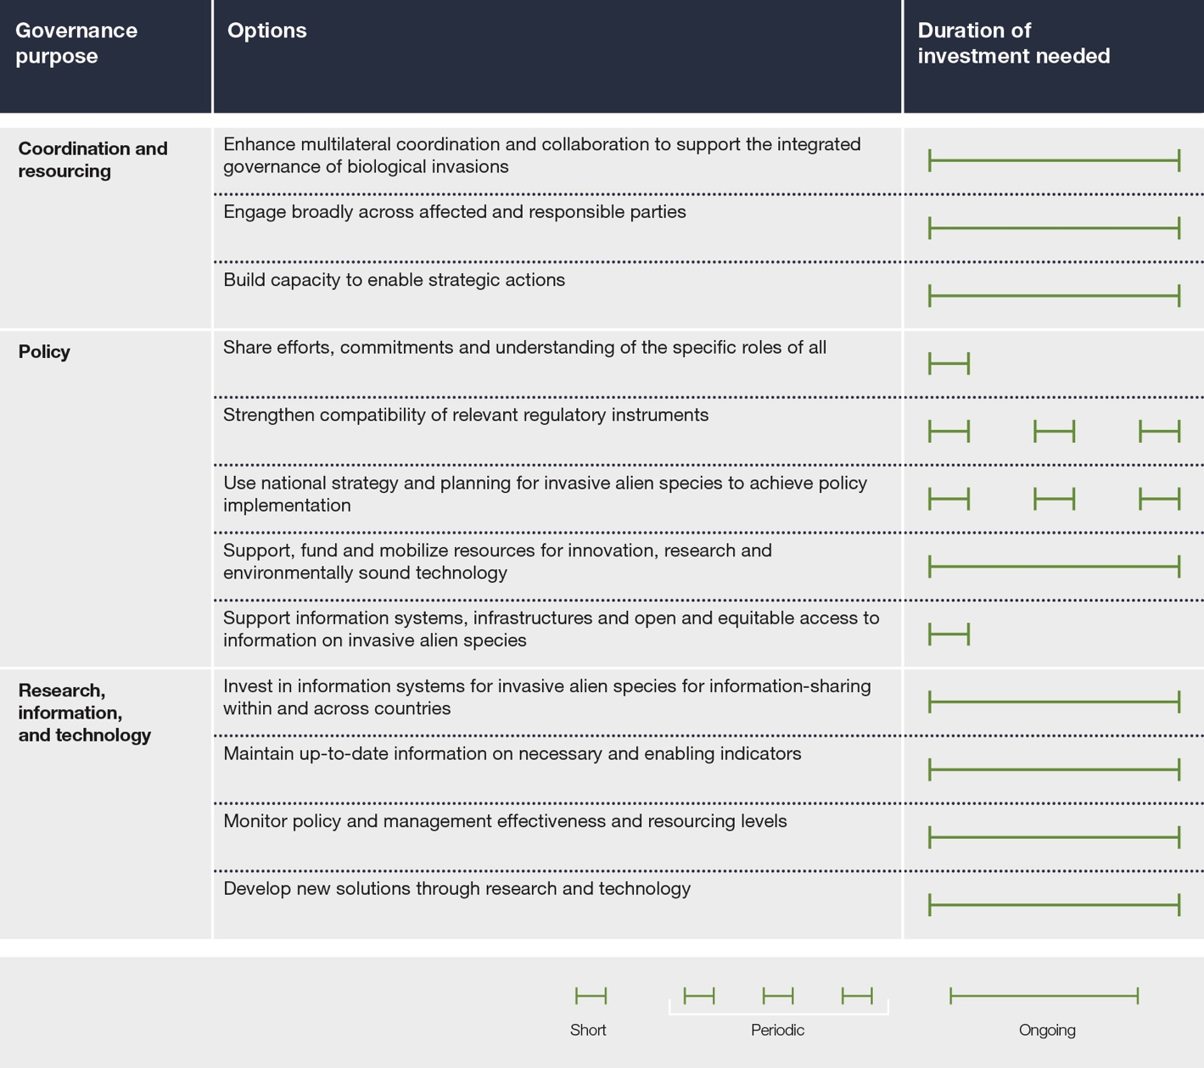

D29. Public awareness and engagement contribute to the effective management of biological invasions (well established) {5.6.2.1, 6.2.2(9), 6.3.1.4, 6.4.1, 6.6.2.1, 6.7}. Public understanding of the risks associated with invasive alien species is particularly important for preventing new introductions (well established) {6.2.2(9), 6.4.1}. Increased understanding of possible biological invasions and the negative impacts of invasive alien species can be achieved through public awareness campaigns {box 6.11, 6.7.2.5}, education across all age groups {6.7.2.4} and citizen science (established but incomplete) {5.4.2.2.a, 6.6.2.1}. Engagement of the general public via citizen science platforms, awareness campaigns and community-driven eradication campaigns also contributes to establishing shared responsibilities for managing biological invasions (established but incomplete) {6.7.2.5}. Surveillance for detecting invasive alien species through citizen science and social media provides broader security by empowering and engaging the public (established but incomplete) {5.4.2.1.a, 5.4.2.2.a, 6.6.2.1}. Communication is an effective tool for inspiring collective action to monitor and control invasive alien species {6.2.3.1(4), 6.2.3.4, 6.4.4.4} by supporting the co-design of management actions, knowledge exchange and enhanced partnerships among stakeholders and researchers (established but incomplete) {6.2.3.3, 6.4.4.3}. It can also enable alignment of resource managers’ responses with national plans and policy priorities (well established) {6.3.1.3, 6.3.2.1}. An effective communications strategy considers the most appropriate timing, media and channels/interfaces for the target audience (established but incomplete) {box 6.13, 6.6.2.6}.

D30. Indigenous Peoples and local communities have invaluable knowledge systems that could contribute to addressing biological invasions (established but incomplete) {box 4.18, 5.5.3, 5.5.4, 6.4.3.2}, yet their lack of land tenure and access rights can limit the extent to which they are able to take action (well established) {3.2.5, 6.4.3.1}. Indigenous Peoples and local communities can be partners in co-developing policies and strategies to address biological invasions while giving consideration to the challenge of conflicting perceptions and values in order to achieve consensus on management actions (established but incomplete) {5.6.1.2, 6.2.3.3, 6.4.3.1}. Participation of Indigenous Peoples and local communities can be enhanced with sufficient legal, political and financial support (well established) {6.4.3, box 6.16}. Successful strategies respect the knowledge, priorities and rights of Indigenous Peoples and local communities, including customary governance systems, in accordance with national legislation (established but incomplete) {5.1.3, 5.2.1, 5.6.2, 6.4.3}. In cases where the impact of invasive alien species on the quality of life of Indigenous Peoples and local communities is unavoidable, those communities need ongoing support and adequate resources to respond to the challenges of living with invasive alien species (established but incomplete) {1.6.7.2, 6.2.3.2, 6.2.3.5}.

D31. Open and interoperable information systems, supported by international cooperation, play a critical role in tackling biological invasions (established but incomplete) {6.2.3.1(3), 6.6.2.2, 6.7.2.6}. Strengthening existing open information systems can facilitate the management of biological invasions, including prioritization of actions, early detection and rapid response, and can improve the effectiveness of regulations (established but incomplete) {5.4.1, 6.6.2.3}. Open information systems can substantially reduce the costs of management by ensuring targeted and appropriate responses, avoiding duplication of efforts and facilitating the evaluation of the effectiveness of policy instruments using indicators (table SPM.2) (well established) {6.6.2.4, 6.6.2.6, 6.6.3}. The “rate of invasive alien species establishment” headline indicator adopted for monitoring progress towards target 6 of the Kunming-Montreal Global Biodiversity Framework provides opportunities to build on existing indicators of biological invasions (table SPM.A1) {6.6.3}. Collaboration and networking among stakeholders and governments can ensure equitable knowledge access (established but incomplete) {6.2.3.3, 6.2.3.4} and improve understanding of the context-specific features of biological invasions. It can also improve the availability of data and knowledge across geographic regions, habitats and taxonomic groups and reduce the wide variation in response capability (established but incomplete) {6.2.3.3, 6.4.1, 6.7.2.6}. Through citizen science, information systems have the potential to engage people, raise awareness and increase the availability of data (established but incomplete) {6.6.2.1}.

D32. Existing evidence of the magnitude and extent of the impacts of invasive alien species supports immediate, strategic and sustained action to successfully address biological invasions (well established) {1.1, 2.2, 3.6.3, 4.3.1, 4.4.1, 4.5.1, 5.6.2.5, 6.7.2}. The available data and knowledge reviewed for this assessment vary across regions, units of analyses, taxonomic groups and time because of language barriers, lack of targeted policies and legislation, lack of resources, uneven research capacity, data accessibility and other factors (table SPM.A1), contributing to gaps in data and knowledge (well established) {2.7, 3.6.1, box 3.12, box 3.13, 4.7.2, 6.6, table 6.10}. Nonetheless, filling knowledge and data gaps, particularly at local scales, can bring about important improvements in the cost-effectiveness and success of prevention and management actions (well established) {6.6.1, 6.6.2}. For example, it would be particularly beneficial to increase the availability of information on invasive alien invertebrates and microorganisms; improve knowledge of the impacts of invasive alien species in parts of Africa, Central Asia and Latin America; gain a better understanding of the role of indirect and interacting drivers; develop management options for invasive microorganisms and marine species; and establish the effectiveness of different policy instruments (established but incomplete) (see table SPM.A1 for a comprehensive presentation of knowledge gaps). Enhancing research capacity in some regions and collaboration between biological invasion experts in the developed and developing world and across knowledge systems could improve data and information availability as well as understanding of the context-specific features of invasive alien species and their impacts (established but incomplete) {6.2.4, 6.6.1.1(3)}. With political will, strategic long-term commitment and sufficient resources, management of biological invasions is an attainable goal (well established) {boxes 5.2, 5.4, 5.5, 5.6, 5.7, 5.8, 5.9, 5.11, 5.12, 5.14, 5.15, 5.16, 5.17, 5.19, 5.21, 6.7.3}.

D33. Successfully addressing biological invasions can also strengthen the effectiveness of policies designed to respond to other drivers (established but incomplete) {5.6.1.3, 6.3, 6.7.2.2}. Mitigating the risks of invasive alien species will contribute to the effective delivery of the 2030 Agenda for Sustainable Development, including the Sustainable Development Goals, especially those addressing the conservation of marine (Goal 14) and terrestrial biodiversity (Goal 15 including, but not restricted to, Target 15.8), food security (Goal 2), sustainable economic growth (Goal 8), sustainable cities (Goal 11), climate change (Goal 13), and good health and well-being (Goal 3) (established but incomplete) {6.7}. An integrated governance approach that acknowledges the interactions between invasive alien species and other drivers, including climate change, direct exploitation of natural resources, pollution and land- and sea-use, alongside human, animal and plant health, can identify where to best direct policy alignment and mutually supportive efforts (established but incomplete) {3.1.5, 6.2.4, 6.7.2.1, 6.7.2.2, 6.7.2.5}. Evidence-based policy planning can reflect the interconnectedness of the drivers so that efforts to solve one problem do not exacerbate the magnitude of others and may even have multiple benefits (established but incomplete) {3.2.5, box 3.9, 5.6.1.3, 6.2.4, 6.3.1.1(1), 6.7.2.2}.
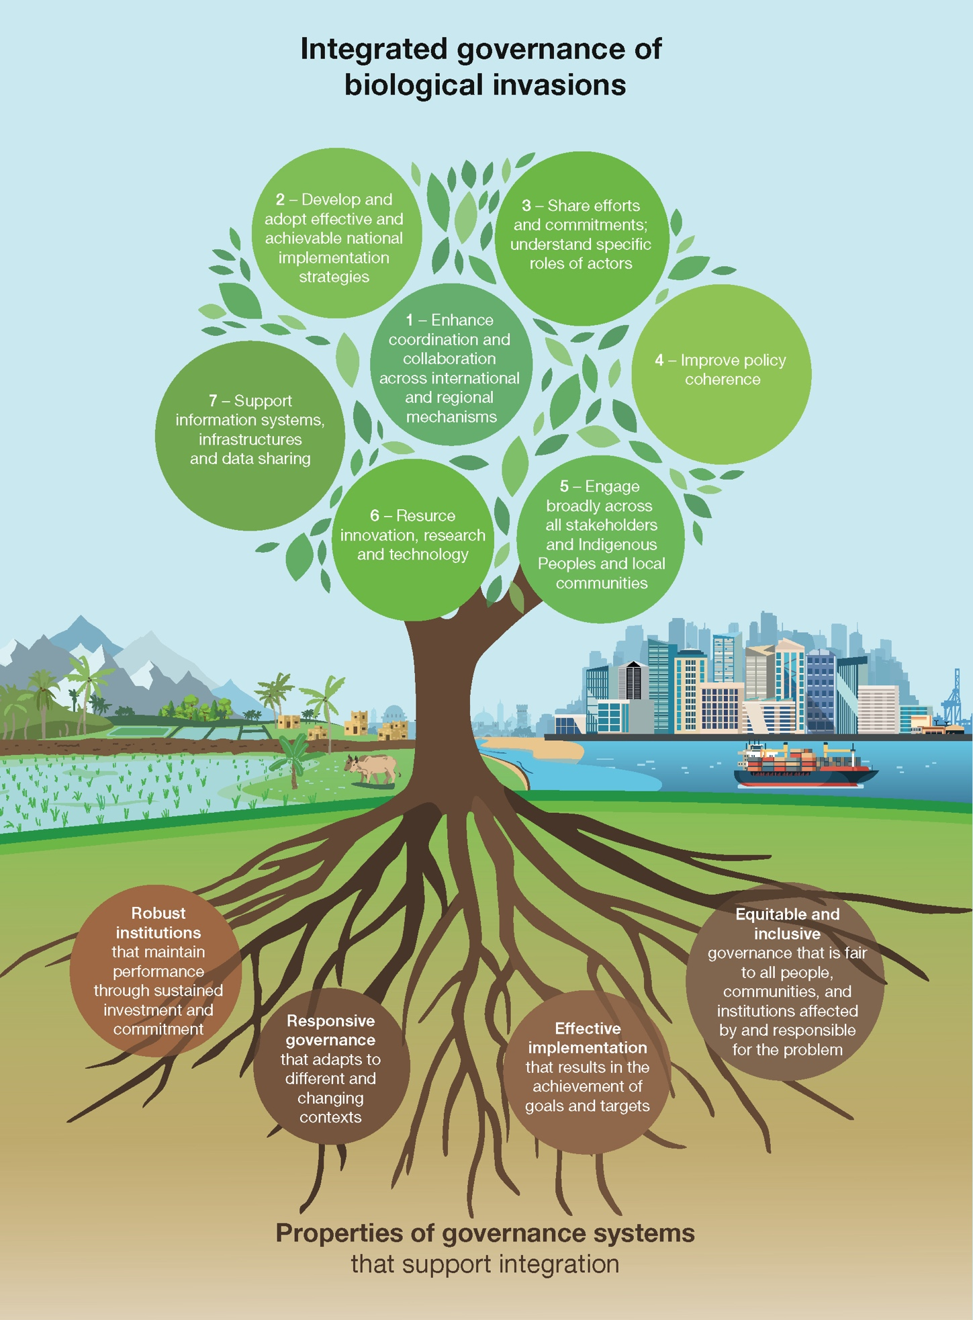
Figure SPM.7. Integrated governance of biological invasions. A context-specific integrated governance approach to biological invasions is enabled by a governance system with properties that support integration, and a set of strategic actions that together are designed to bring about the progress needed to meet national and international goals and targets for biological invasions. Integrated governance is rooted in four essential properties of governance systems (tree roots) that support the strategic actions (branches) to be achieved. Together, the properties and actions will bring about the step change needed for effective and sustainable management of biological invasions. Integrated governance for biological invasions reinforces the enabling conditions identified as necessary to fulfil the 2030 mission of the Kunming-Montreal Global Biodiversity Framework. An integrated governance approach activates specific strategic actions that promote transformative change to meet the goals of preventing and controlling biological invasions.
The strategic actions are:
- Enhance coordination and collaboration across international and regional mechanisms.
- Develop and adopt effective and achievable national implementation strategies.
- Share efforts, commitments and understanding of the specific roles of all actors.
- Improve policy coherence.
- Engage broadly across governmental sectors, industry, the scientific community, Indigenous Peoples and local communities and the wider public.
- Support, fund and mobilize resources for innovation, research and environmentally sound technology.
- Support information systems, infrastructures and data sharing.
The proposed strategic actions are enabled when the system-wide properties of governance (roots) are robust, equitable and inclusive, responsive and focused on effective implementation. The numbers on the branches do not imply a ranking.

APPENDICES
Appendix I: Communication of the degree of confidence
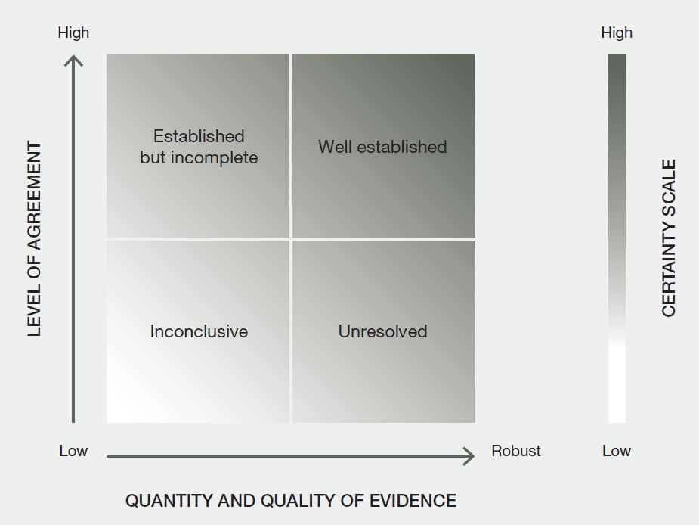
Figure SPM.A1. The four-box model for quantitative communication of confidence. Confidence increases towards the top-right corner, as suggested by the increasing strength of shading. Source: IPBES (2016). Further details of the approach are documented in the IPBES Guide on the Production of Assessments.
In this assessment, the degree of confidence in each main finding is based on the quantity and quality of evidence and the level of agreement regarding that evidence (figure SPM.A1). The evidence includes data, theory, models and expert judgement.
- Well established: There is a comprehensive meta-analysis or other synthesis or multiple independent studies that agree.
- Established but incomplete: There is general agreement, although only a limited number of studies exist; there is no comprehensive synthesis and/or the studies that exist address the question imprecisely.
- Unresolved: Multiple independent studies exist but their conclusions do not agree.
- Inconclusive: There is limited evidence and a recognition of major knowledge gaps.

Appendix II: Synthesis of knowledge and data gaps
Table SPM.A1. Table of knowledge and data gaps
Synthesis of the most important knowledge and data gaps identified and collated through the assessment. Confidence levels in the summary for policymakers were allocated with full consideration of the gaps listed in the table; closing those gaps would strengthen the understanding of biological invasions. Experts have assessed the estimated cost and scientific challenge of closing these gaps, as well as the potential gain in increasing understanding of and successfully tackling biological invasions globally (from very low to very high). The listed gaps may not be relevant at local or regional scales.
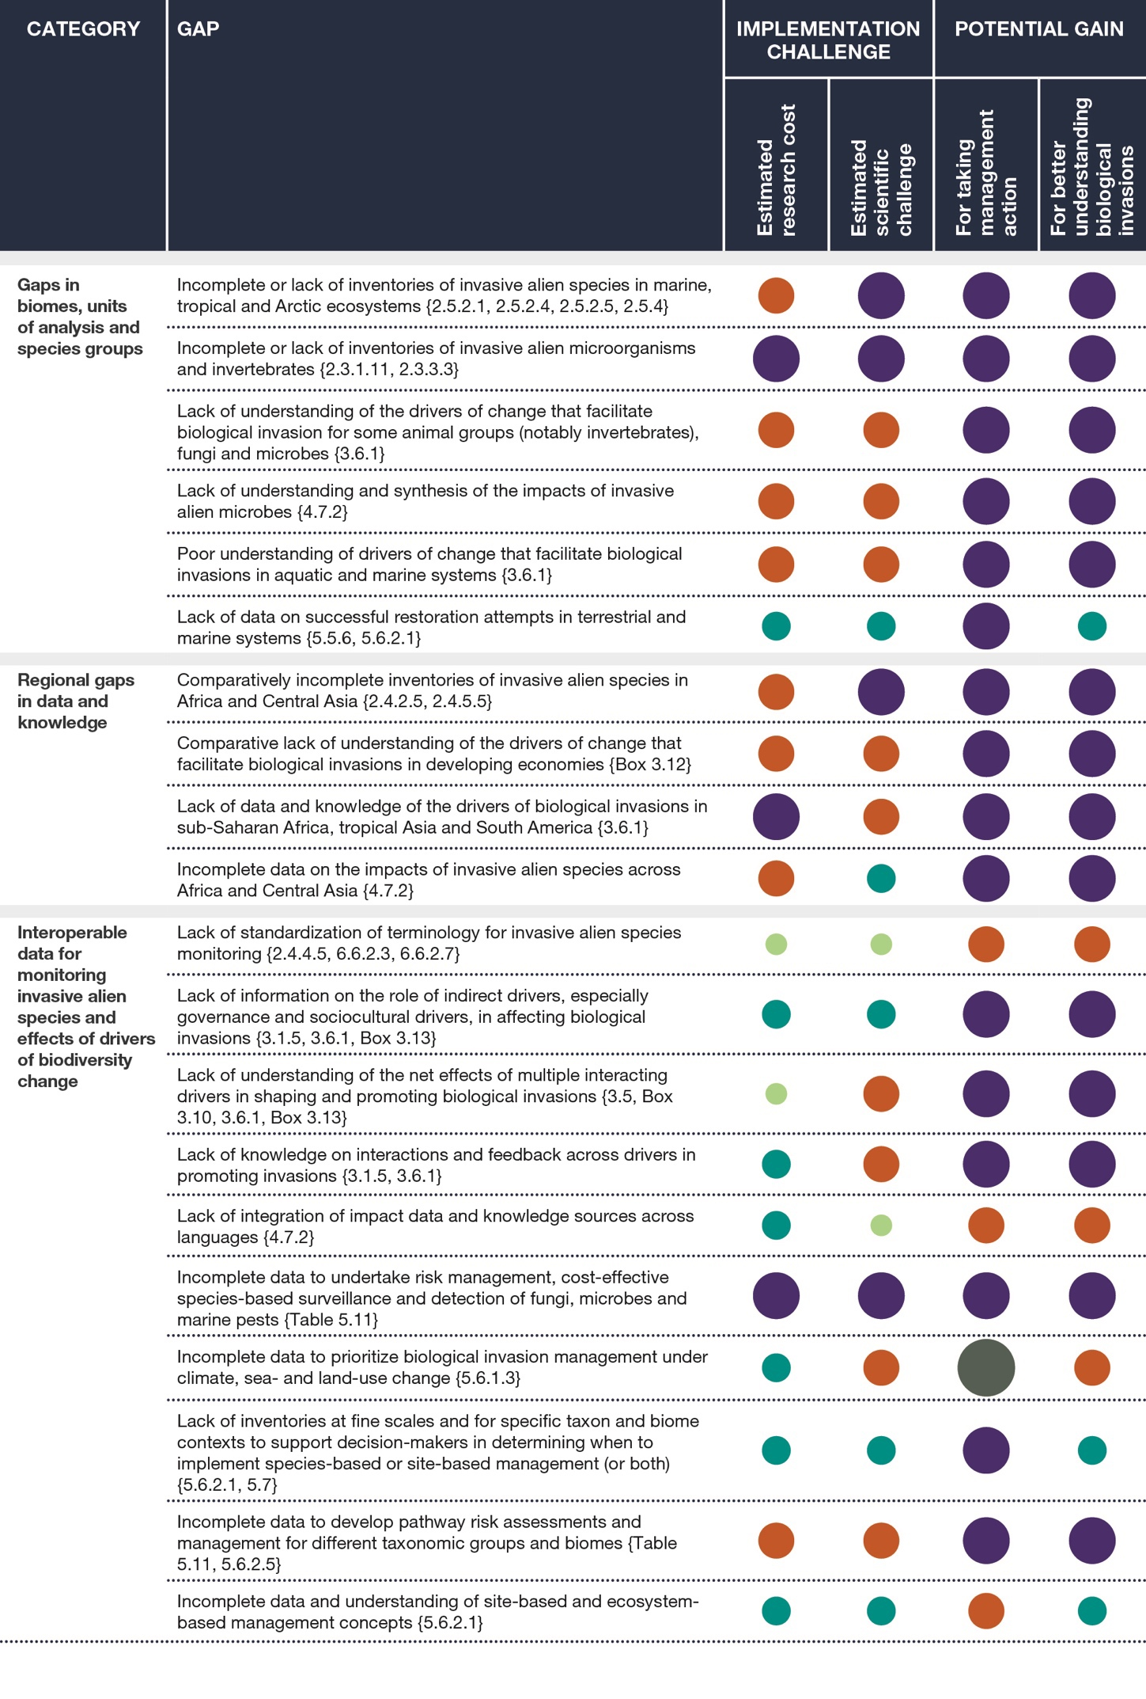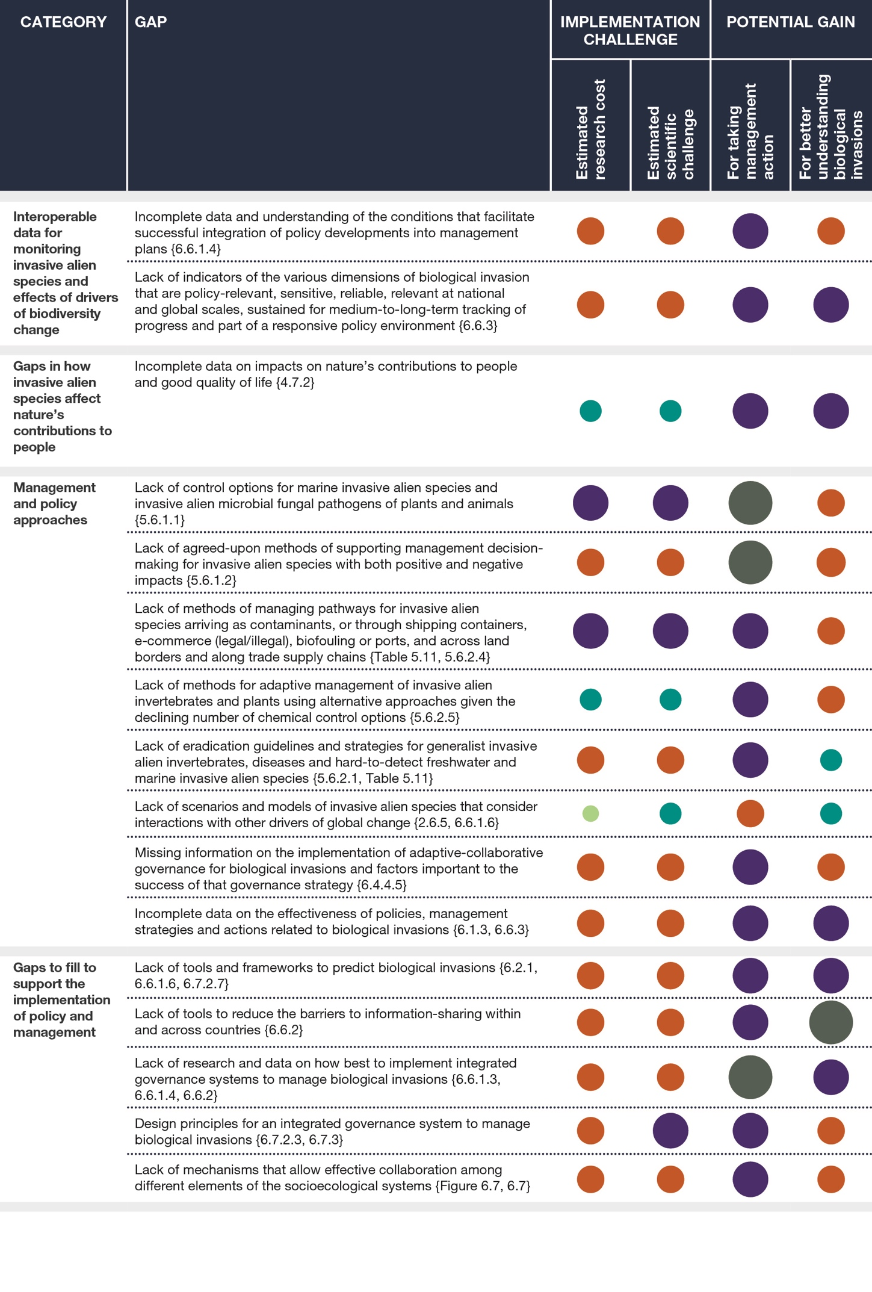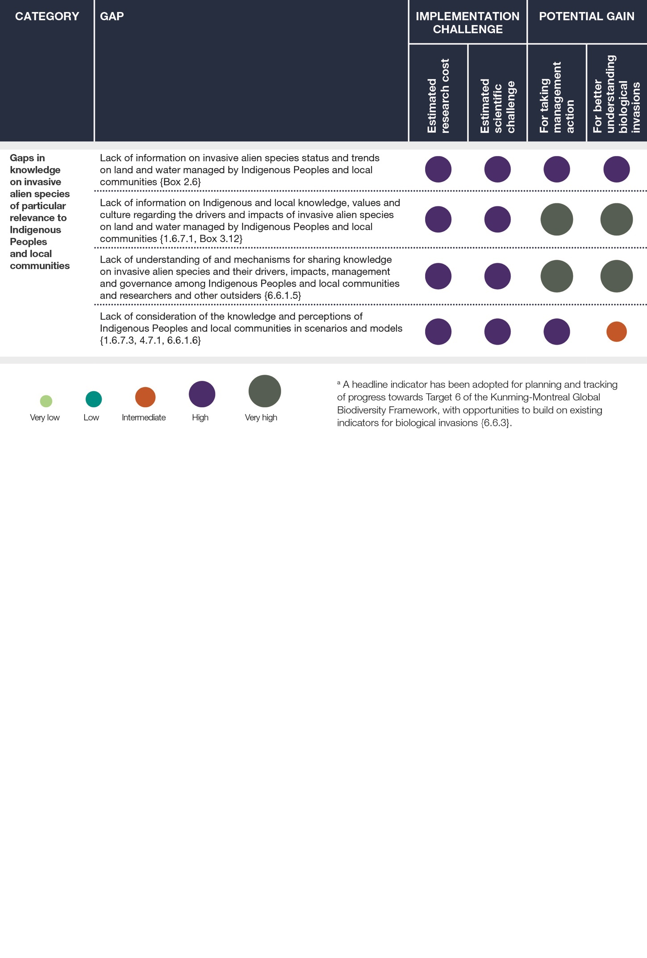

Appendix III: Examples of data and knowledge products
Information components including description and importance of the information for documenting and managing biological invasions of existing invasive alien species databases that may provide relevant information.
Websites are provided at the first mention of each database (see chapter 2 for databases relevant for status and trends and chapter 6, section 6.6.3 for databases supporting policy options). Gaps identified within the data and knowledge products are also given {table 5.4}.
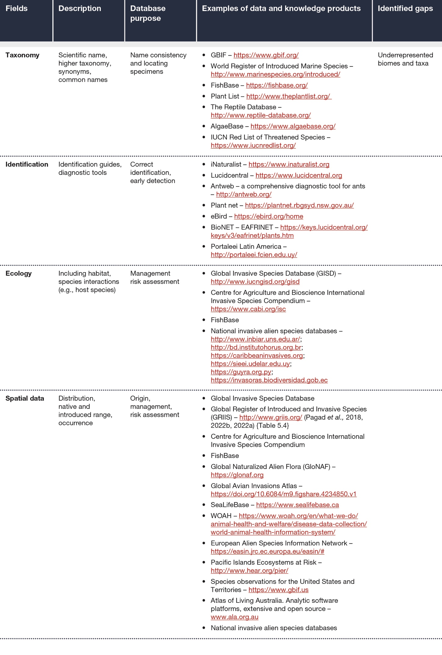
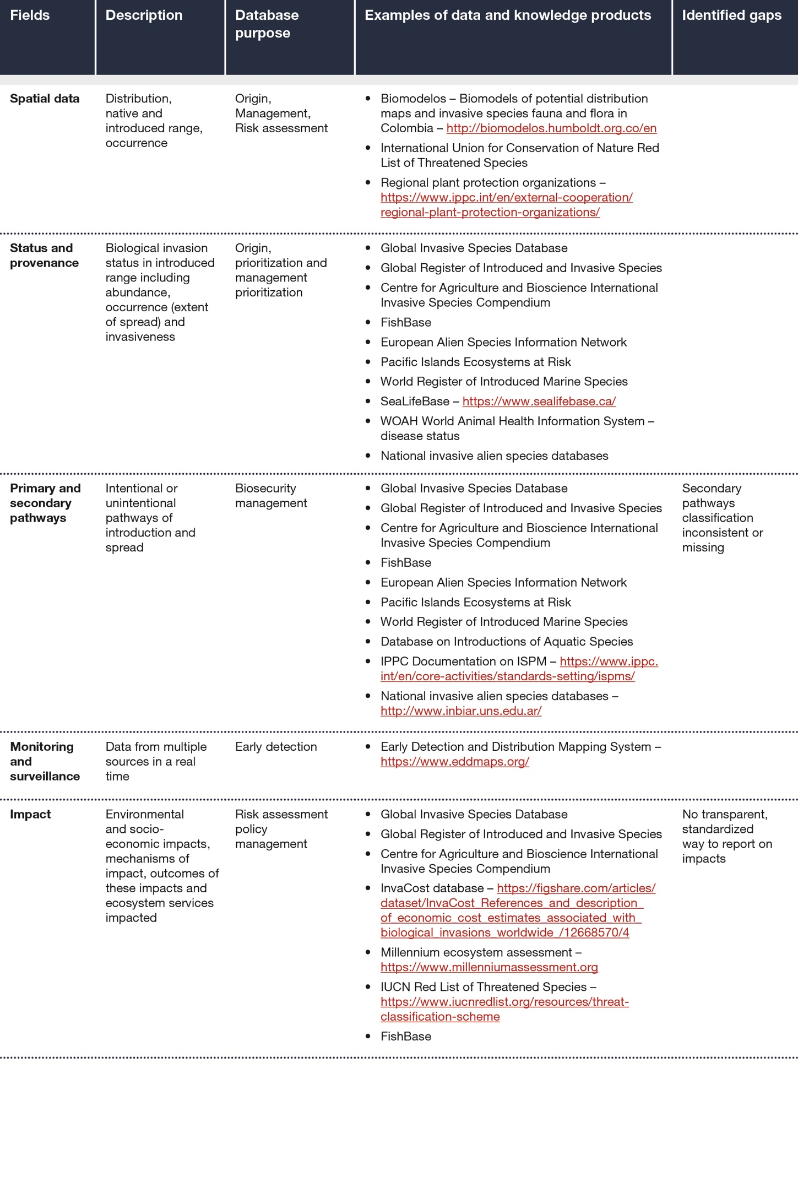
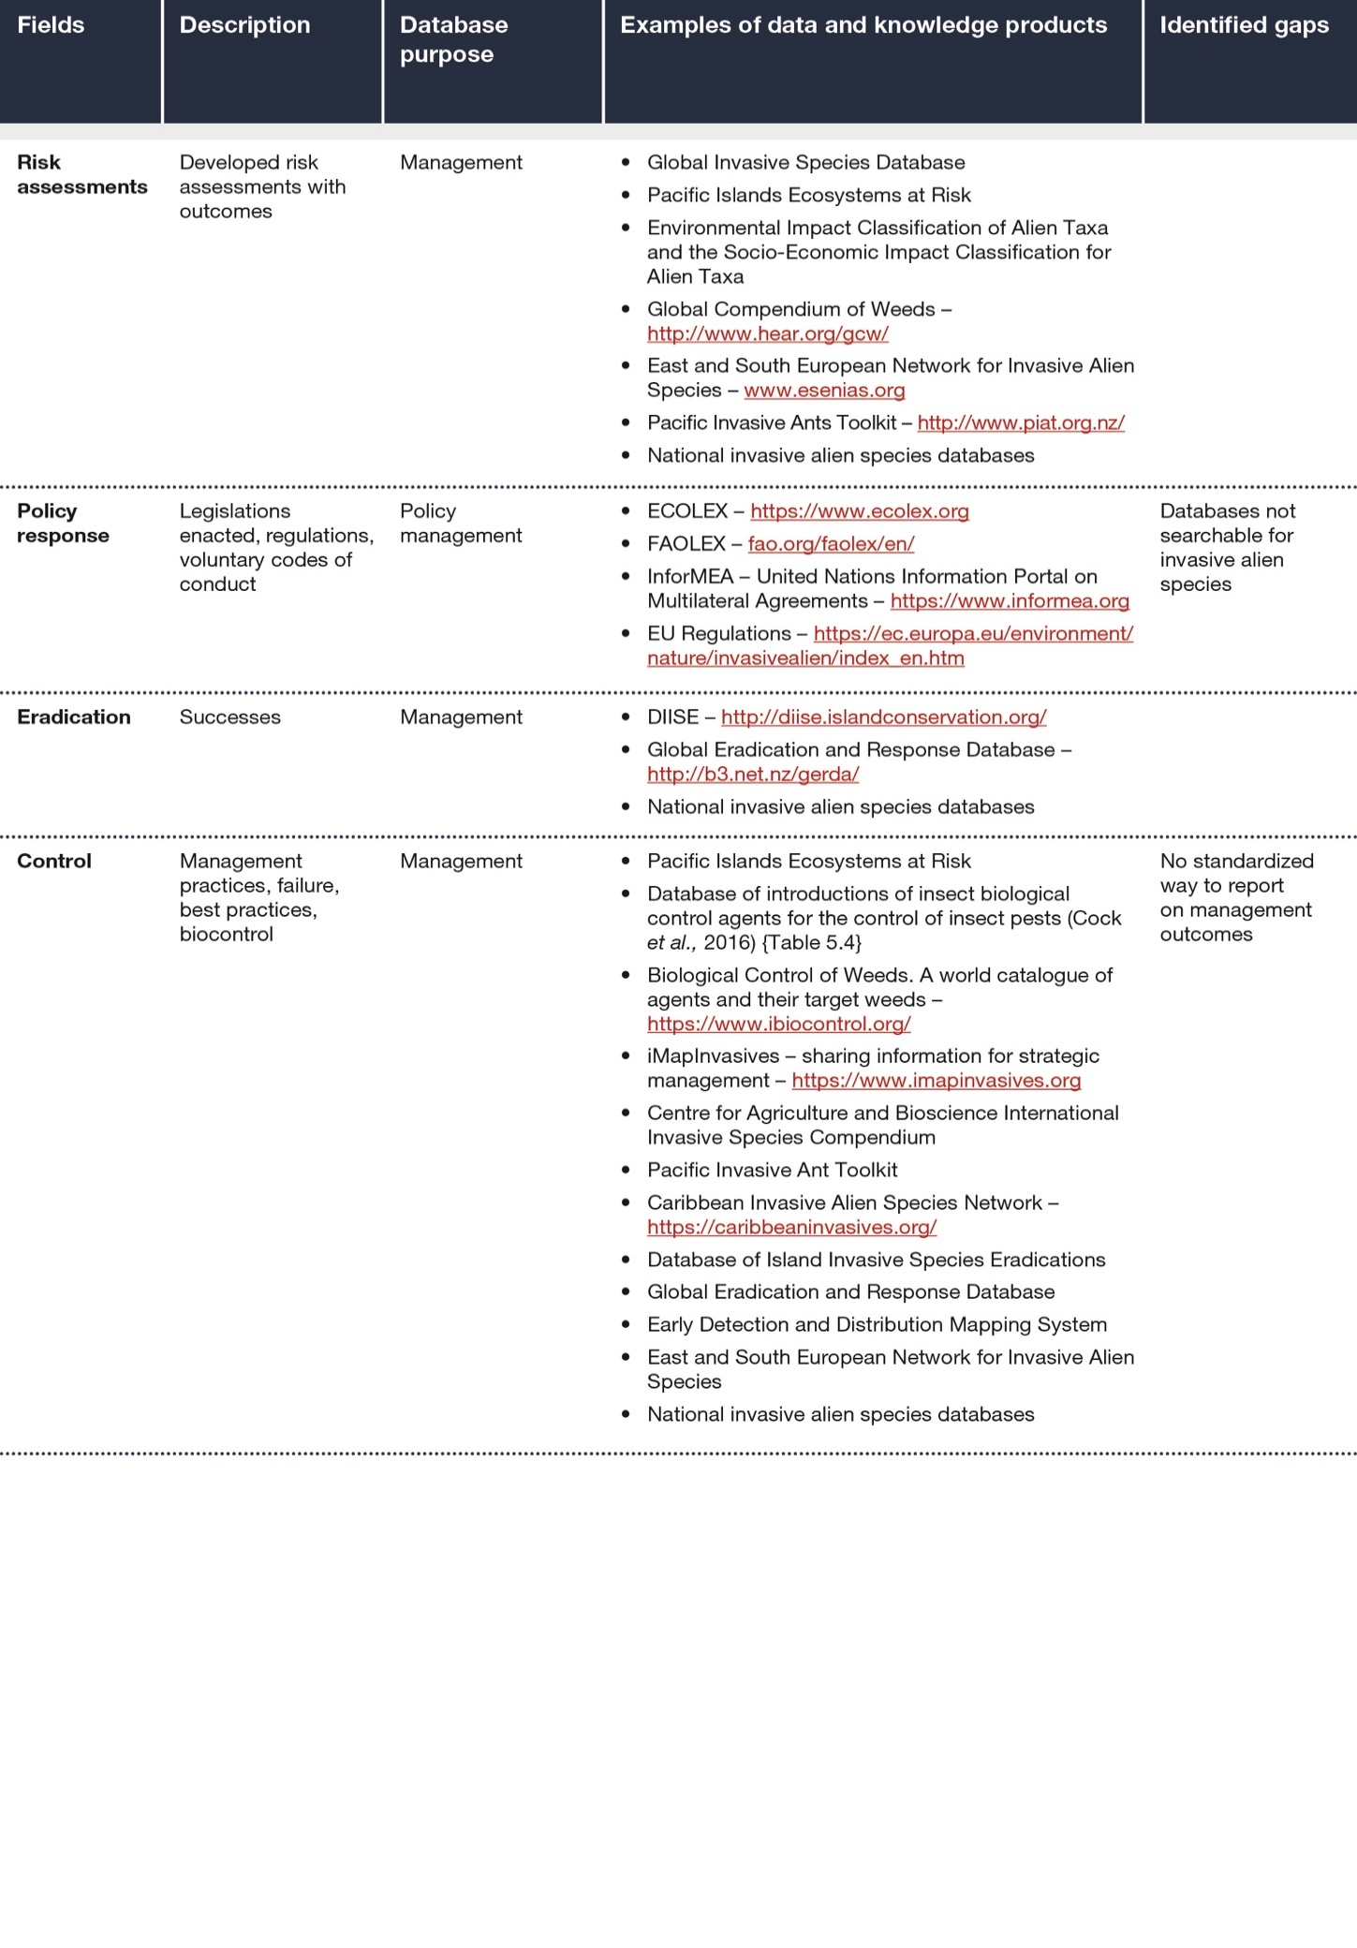

Authors are listed with, in parentheses, their country or countries of citizenship, separated by a comma when they have more than one; and, following a slash, their country of affiliation, if different from that or those of their citizenship, or their organization if they belong to an international organization. The countries and organizations having nominated the experts are listed on the IPBES website.
This assessment acknowledges that national and local legislation to address biological invasions differ between countries and may include different definitions appropriate to specific national and local contexts.
Multiple alternative terms exist to refer to alien species.
Annex III to decision IPBES-4/1.
IPBES (2019): The Global Assessment Report on Biodiversity and Ecosystem Services of the Intergovernmental Science-Policy Platform on Biodiversity and Ecosystem Services. Brondizio, E. S., Settele, J., Díaz, S. and Ngo, H. T. (eds.). IPBES secretariat, Bonn, Germany. https://doi.org/10.5281/zenodo.3831673
The conceptual framework for the Intergovernmental Science-Policy Platform on Biodiversity and Ecosystem Services was approved by the Plenary in decision IPBES-2/4 (2013) and updated in decision IPBES-5/1 (2017).
This assessment acknowledges that national and local legislation to address biological invasions differ between countries and may include different definitions appropriate to specific national and local contexts.
This assessment acknowledges that national and local legislation to address biological invasions differ between countries and may include different definitions appropriate to specific national and local contexts.
IUCN (2017). Guidance for interpretation of CBD categories on introduction pathways. Technical note prepared by IUCN for the European Commission. Available at: https://www.cbd.int/doc/c/9d85/3bc5/d640f059d03acd717602cd76/sbstta-22-inf-09-en.pdf
Demographic drivers have been identified by the IPBES Global Assessment Report on Biodiversity and Ecosystem Services of the Intergovernmental Science-Policy Platform on Biodiversity and Ecosystem Services as one of the indirect drivers of change in nature, as described in table 3.1
IPBES (2022). The Thematic Assessment Report on the Sustainable Use of Wild Species of the Intergovernmental Science-Policy Platform on Biodiversity and Ecosystem Services. Fromentin, J.M., Emery, M.R., Donaldson, J., Danner, M.C., Hallosserie, A., Kieling, D., Balachander, G., Barron, E.S., Chaudhary, R.P., Gasalla, M., Halmy, M., Hicks, C., Park, M.S., Parlee, B., Rice, J., Ticktin, T., and Tittensor, D. (eds.). IPBES secretariat, Bonn, Germany. https://doi.org/10.5281/zenodo.6425599
IPBES (2016): Summary for policymakers of the Assessment Report on Pollinators, Pollination and Food Production of the Intergovernmental Science-Policy Platform on Biodiversity and Ecosystem Services. Potts, S. G., Imperatriz-Fonseca, V. L., Ngo, H. T., Biesmeijer, J. C., Breeze, T. D., Dicks, L. V., Garibaldi, L. A., Hill, R., Settele, J., Vanbergen, A. J., Aizen, M. A., Cunningham, S. A., Eardley, C., Freitas, B. M., Gallai, N., Kevan, P. G., Kovács-Hostyánszki, A., Kwapong, P. K., Li, J., Li, X., Martins, D. J., Nates-Parra, G., Pettis, J. S., Rader, R., and Viana, B. F. (eds.). IPBES secretariat, Bonn, Germany. http://doi.org/10.5281/zenodo.2616458
IPBES (2018): IPBES Guide on the Production of Assessments. Secretariat of the Intergovernmental Science-Policy Platform on Biodiversity and Ecosystem Services, Bonn, Germany. https://ipbes.net/guide-production-assessments

