- Least-cost technology analysis for electricity access in Ecuador
- Alexandra Falcón, Montebello Academy, Ecuador
- 29/01/2024

- Keywords
OnSSET, Energy, Generation, Least cost, Ecuador.
*Acknowledgements*

This report was produced during the EMP-LAC 24 capacity building event organized by the Climate Compatible Growth Programme (CCG). Training was provided by instructors from CCG, Universidade Federal de Juiz de Fora, and Universidade Federal Fluminense. The event received funding from CCG, the World Bank Group (WBG), and the 2050 Pathways Platform. I want to express my appreciation to Montebello Academy for their continued support. Your support has been fundamental in my preparation and academic enrichment. Finally, thank the teacher in charge of this course Andreas Sahlberg for his contribution of knowledge and for the preparation he has given us.

**Executive Summary

The Open Source Spatial Electrification Toolkit (OnSSET) plays a vital role in shaping Ecuador's optimal electrification strategy, aligning with sustainable development goals. Utilizing geospatial tools and a comprehensive dataset, OnSSET models cost-effective electrification options for urban and rural areas by 2030 and 2050. Results highlight significant growth in technology, emphasizing the importance of the existing electrical grid and extensions, with a focus on PV-based mini-grids in unserved areas. In the Galápagos Islands, where 83.6% of energy relies on fossil fuels, the study recommends exploring diverse electricity generation systems and addressing implementation challenges. OnSSET emerges as a crucial resource for informed decision-making, bridging energy research with global planning and guiding Ecuador toward a sustainable energy future.

**1. Introduction

The Open Source Spatial Electrification Toolkit (OnSSET) plays a crucial role in determining Ecuador's optimal electrification approach, aligning with the nation's commitment to affordable, reliable, sustainable, and modern energy access (SDG 7). Serving as a bridge between energy research and global planning, OnSSET contributes significantly to estimating the most cost-effective electrification option (Dimitrios Mentis, 2017).

Ecuador, renowned for excellence in exports, gastronomy, and biodiversity, strategically aligns its clean energy production with demand, optimizing resource utilization. OnSSET utilizes geospatial tools to create scenarios tailored to Ecuador's unique geographical features. Proposed scenarios for 2030 and 2050, based on Ministry of Energy data, outline technologies to develop and sectors to optimize at both national and provincial levels.

This study specifically aims to identify the most cost-effective electrification options in Ecuador's urban and rural areas by 2030 and 2050 respectively. Additionally, it seeks to pinpoint technologies warranting further development, considering both grid and off-grid technologies evaluated using the levelized cost of energy (LCOE). The focus is on enhancing electrical infrastructure and prioritizing technologies for optimal future electrification.

Ecuador's total energy production, reported by the national electricity operator (CENACE) in June 2022, stands at 55,674 MWh. Notably, water resources constitute 93.2% of the total energy mix, with historic lows in fossil fuel usage in 2021. Ecuador is actively engaged in environmental conservation initiatives, including projects like "Galápagos Verde 2050" and "Galápagos Energy Transition 2050." The energy landscape includes 16 hydroelectric plants, three solar energy collection sites, and three smaller wind utilization locations.

**2. Methodology

OnSSET is utilized to model effective electrification options in Ecuador, requiring both GIS (Geographic Information System) and non-GIS data. GIS data encompasses details about the Transmission and Distribution network (T & D network), substations, road network, Global Horizontal Irradiance (GHI), wind speed, hydro resources, population clusters, nighttime light, land cover, elevation, and travel time (Eogdata, 2023).

Dataset | Source
Land cover Ecuador | GLC2000
Night-time lights | VIIRS
Substations | NV EBS
WindSpeed | Global Solar Atlas
Roads | Global Wind Atlas
Elevation | OpenStreetMap
HV (existing) | CGIAR-SRTM
MV (existing) | OpenStreetMap
Travel time | Malaria Atlas Project

Additionally, non-GIS data is collected, including electrification rate, urbanization rate, population growth, household size, technology costs, technical specifications, demand level and targets, and fuel prices. This comprehensive approach enables a thorough and detailed assessment of electrification options in the country.
Dataset | Source
national electricity access rate | tradingeconomics
Population data | World bank
Urban Population ratio | Censo Ecuador
Technlogy specs &  costs | NV EBS reports and  IDB reports

**3. Results

The results derived from this data were analyzed both at the national level and broken down by province, with particular emphasis on regions experiencing notable growth in technology.

Provinces selected for individual analysis include Pichincha, with a population of 3,089,473 according to the latest national census. The province of Galapagos, home to 28,583 people and currently undergoing a study and energy transition process aligned with national goals for 2030 and 2050. Lastly, the province of Loja, with a population of 485,421 inhabitants (MTRD, 2021 ).

2030 scenario:

2030 Scenario
Data | Value | Description
end_year | 2030 | End year of the analysis
start_year | 2023 | Start year of the analysis
pop_start_year | 16938985 | Population in the base year
end_year_pop | 17426200 | Expected population in the end year
grid_generation_cost | 0.096 | The grid cost of electricity USD/kWh as expected in the end year of the analysis
diesel_price | 0.46 | Diesel price in USD/liter as expected in the end year of the analysis

The image illustrates the evolution of technologies in Ecuador for the year 2030. The existing electrical grid is depicted in blue, with the light blue indicating grid extensions. Yellow signifies autonomous solar generation systems, and hybrid photovoltaic mini-grid systems in magenta. Examining the national scenario, the visual showcases the existing electrical grid distributed across both the continental area and the Galápagos Islands. The light blue portion signifies an expansion of the grid by 2030. In the 2030 case study, there's a noticeable increase in the hybrid generation mini grid systems section. These systems are commonly deployed in remote areas or situations where extending the main electrical grid is impractical or cost-prohibitive.
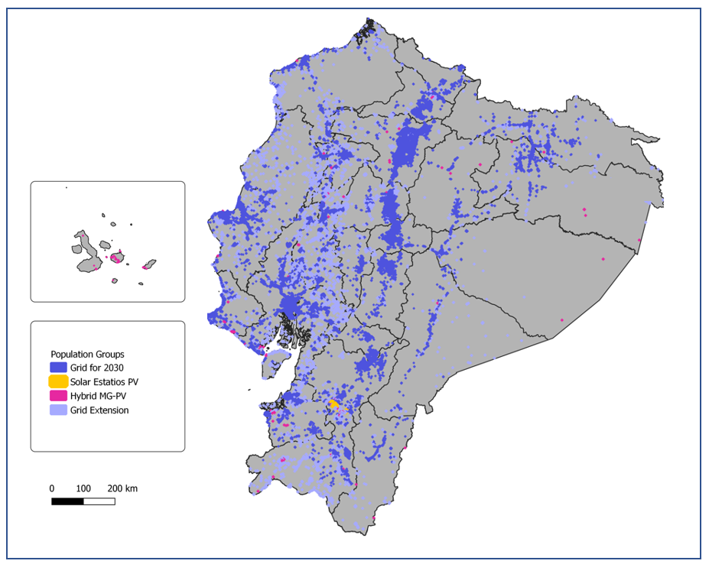
- 2030 Scenario – Ecuador

 | Population2030 | NewConnections2030 | Capacity2030 (MW) |  | Investment2030 (million USD)
Grid_dens | 175901800 | 159849400 |  | 19322,864 |  | 5617767
SA_PV | 150 | 150 |  | 0.038452 |  | 0.27
MG_PV_Hybrid | 392622 | 392622 |  | 147349,107 |  | 28166
Grid_ext | 7967426 | 7967426 |  | 963.115.973 |  | 287973
Total | 184261999 | 168209600 |  | 20433.368 |  | 5933932

- 2030 Scenario – Ecuador low cost USD investment 2030

Galapagos 2030 Scenario.

Within the Galápagos Electric Network today, renewable energy contributes 8.50%, while thermal energy contributes 91.50% to supply the populated centers of the islands. Even considering the nascent renewable generation on the islands, the gallons of diesel saved in 2021 amounted to 363,429, equivalent to avoiding 3,688 tons of CO2 emissions (MEM, 2023).

A notable environmental and energy concern in the Galápagos Islands revolves around the electrical supply, where a significant 83.6% relies on fossil fuels for both generation and distribution. The predominant consumption pattern in the Galápagos Islands today is fueled by various fossil sources, with diesel oil constituting 58%, gasoline 24%, electricity 10%, liquefied gas 5%, and non-energy sources comprising only 1% of the total percentage (Elecgalapagos, 2021).

In the Galápagos Islands and the Sierra region of Ecuador, there exists substantial potential for solar energy production. Despite this, the current technological capacity falls short of meeting national market demands, posing challenges in cost competitiveness. For instance, the Villanueva Wind Park, situated in the province of Loja, stands out as one of the country's largest projects of its kind, boasting an installed capacity of approximately 110 megawatts (MW).

In the case of the Galápagos Islands, the obtained results show significant usage on the main islands about the MiniGrids . It is important to note that not all islands are inhabited, hence the delineated sections are only presented in relation to the population.

- Ecuador actually systems of generation in Galapagos

To obtain results in Galápagos, demand values and population figures (FCD, 2023), were used. The following image illustrates that, for the year 2030, according to the study in OnSSET, the required tool will be the implementation of PV-based hybrid mini-grids in populated areas, taking advantage of the systems offered by the islands (Pacifico, 2020).

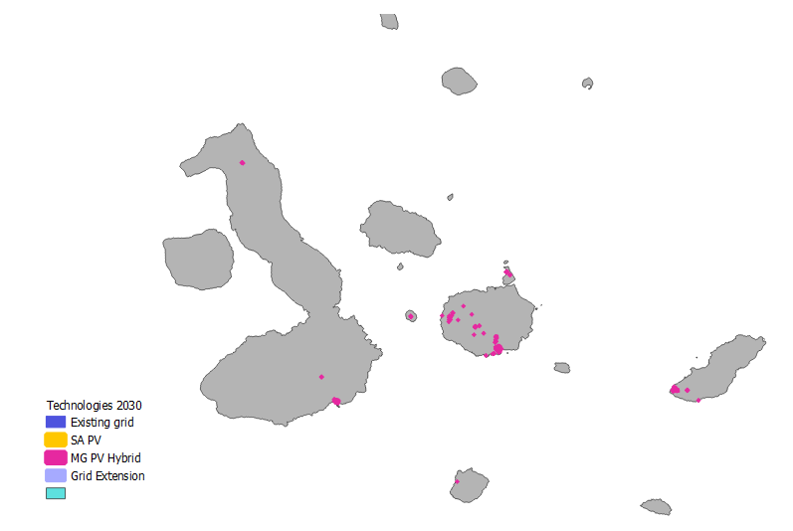
- Region of Galapagos for the scenario 2030

Loja 2030 scenario

In the Ecuadorian province of Loja, there is significant potential for renewable energy, particularly in wind and solar power. Research indicates that around 52% of the exploitable wind resource for electricity production in Ecuador is concentrated in Loja, establishing it as a key center for wind energy. Moreover, the province possesses abundant solar radiation, making it conducive to electricity generation using photovoltaic panels. To address the growing demand anticipated for 2030, the implementation of microgrids in populated areas has been identified as a crucial strategy. Comprehensive studies, led by entities like the Agency for Regulation and Control of Electric Power (Arconel) and the Ministry of Energy, have meticulously examined the wind potential of the region, pinpointing favorable sites for electricity production (FCD, 2023)..

With the prior understanding of the Loja region, the results indicate that for the 2030 scenario, the province of Loja will exhibit the use of extension grid technologies in light blue, microgrid systems, and in the northern part of the country, points for photovoltaic systems are established, capitalizing on the available capacity.

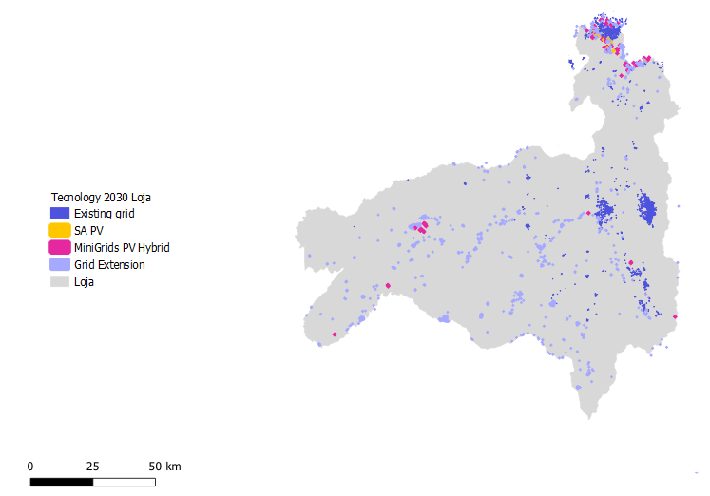
- Region Loja for the scenarios 2030

2050 scenario:

2050 Scenario
Data | Value | Description
end_year | 2050 | Year of the end análisis
start_year | 2023 | Year of the beggin analisis
pop_start_year | 16938985 | Population in the base year
end_year_pop | 184262000 | Expected population in the end year
diesel_price | 0.46 | Diesel price in USD/liter as expected in the end year of the analysis

As in the previous graphs, the same color code is displayed, emphasizing the Amazon region, where the model results indicate an initiation of microgrid use.

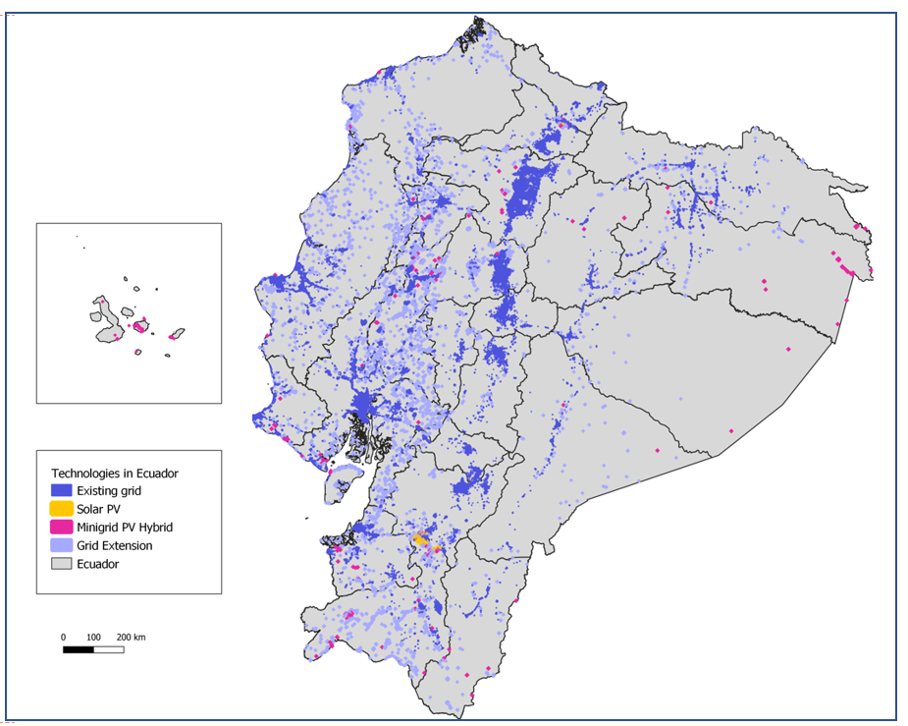
- 2050 Scenario - Ecuador

 | Population2050 | NewConnections2050 | Capacity2050 (MW) | Investment2050 (million USD)
Grid_dens | 228131359 | 212078959 | 21216,382 | 62804.91
SA_PV | 459 | 459 | 0.098105 | 0.90
MG_PV_Hybrid | 534285 | 534285 | 196,713616 | 1328.71
Grid_ext | 5595894 | 5595894 | 559,813 | 1724.26
Total | 234261999 | 218209599 | 21973,007 | 65858.78

- 2050 Scenario Investment 2050

Galapagos 2050 scenario.

In the Galápagos scenario, the MiniGrids generation system continues to be maintained. These data reflect that over 80% of the generation and utilization of the technology are established in population settlements.

Loja 2050 scenario

The results obtained for the Loja sector generate various points of discussion by expanding the electrical grid and promoting the development of renewable technologies, according to the cost study. The color code for interpretation remains the same, and there is an increase in photovoltaic (PV) generation systems in the northern zone.

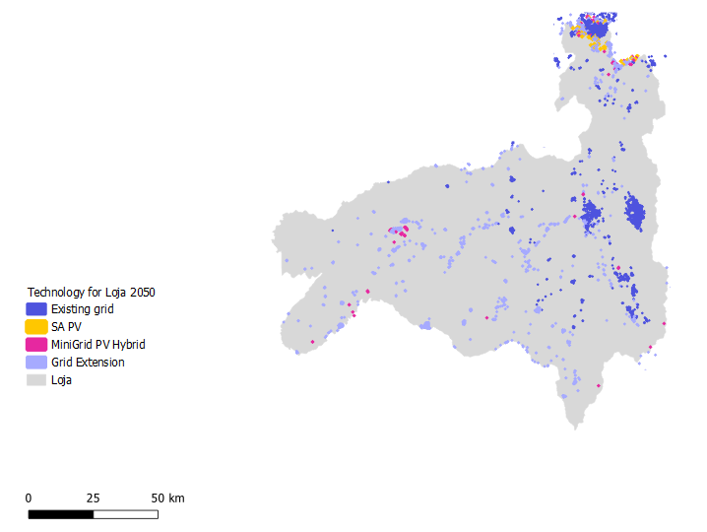
- Lojas´s scenario 2050

**5. Discussion

Conclusions from the study highlight the importance of the Open Source Spatial Electrification Toolkit (OnSSET) in determining Ecuador's optimal electrification approach, aligning with the national commitment towards affordable, reliable, sustainable, and modern energy access (SDG 7). OnSSET, acting as a bridge between energy research and global planning, significantly contributes to estimating the most cost-effective electrification option. Implications of the results reveal significant growth in technologies in Ecuador for 2030 and 2050, emphasizing the crucial role of the existing electrical grid and its extensions, In both scenarios most areas that will not be supplied by the grid will be supplied by PV-based mini-grids

In the Galápagos Islands, a significant environmental and energy concern is evident, with 83.6% of the electrical supply relying on fossil fuels. Recommendations include exploring and investing in technologies that improve electrification rates in urban and rural areas, considering various electricity generation systems and evaluating the levelized cost of energy (LCOE).

The focus should be on enhancing electrical infrastructure and prioritizing technologies for achieving optimal future electrification rates. Potential areas for future research could include refining and expanding electrification strategies, with interventions driving the adoption of renewable energy technologies. Implementation challenges may arise due to technological capacity limitations, especially in areas like the Galápagos Islands and the Sierra region, where solar energy production potential is significant, but current technological capabilities fall short of national market demands. Exploring innovative financial mechanisms and addressing socio-economic factors could be crucial for overcoming implementation challenges and promoting sustainable energy transitions.

**7. Conclusion

the Open Source Spatial Electrification Toolkit (OnSSET) emerges as a crucial resource in defining the optimal electrification strategy in Ecuador, aligning with the vision of affordable, reliable, and sustainable energy access (SDG 7). By bridging energy research with global planning, OnSSET facilitates the identification of cost-effective electrification options tailored to Ecuador's unique geography.

The study, focused on urban and rural areas, projects electrification rates for 2030 and 2050. Furthermore, conservation initiatives like "Galápagos Verde 2050" and "Galápagos Energy Transition 2050" showcase the country's active commitment to sustainable practices.

At the regional level, the detailed analysis of Loja and Galápagos provides valuable insights. The continuity of MiniGrids in Galápagos underscores its pivotal role in technology generation and usage, while the evolving technological landscape in both scenarios emphasizes strategic pathways for energy development in these specific regions. These findings will inform future decisions towards a more sustainable energy future in Ecuador

Referencias
Dimitrios Mentis, M. H. (2017). Lighting the World: the first application of an open source, spatial electrification tool (OnSSET) on Sub-Saharan Africa.
Ecudatanalytics. (2022). Obtenido de https://censoecuador.ecudatanalytics.com/
Eogdata. (2023). Obtenido de https://eogdata.mines.edu/products/vnl/#annual_v2
FCD. (2023). Fundacion Charles Darwin . Obtenido de Programa Galapagos Verde 2050: http://www.galapagosverde2050.com/
MEM. (11 de Mayo de 2023). Ministerio de Energía y Minas. Obtenido de https://www.recursosyenergia.gob.ec/ministerio-de-energia-y-minas-presento-plan-de-transicion-energetica-para-galapagos/
MTRD. (2021). Hoja de ruta del autoconsumo. In M. p. Demográfico, Hoja de ruta del autoconsumo (pp. 23-25). Madrid: IDAE.

