Annex 9: Detailed analysis of the Measures and their Sub-measures
Table of Contents
Annex 9: Detailed analysis of the Measures and their Sub-measures 0
Introduction 136
Glossary 141
Measure 1: Classification and definition 145
Measure 2: Second-life of EV and industrial batteries 156
Measure 3: Collection rate for portable batteries 168
Measure 4: Collection rates for automotive, EV and industrial batteries 183
Measure 5: Recycling efficiencies and recovery of materials 197
Measure 6: Carbon footprint for industrial and EV batteries 216
Measure 7: Performance and durability of rechargeable industrial and EV batteries 224
Measure 8: Non-rechargeable portable batteries 231
Measure 9: Recycled content in Electric Vehicle batteries, industrial batteries and automotive batteries 241
Measure 10: Extended Producer Responsibility 257
Measure 11: Design requirements for portable batteries 272
Measure 12: Reliable information 280
Measure 13: Supply chain due diligence for raw materials for industrial and EV batteries 294
Clarification of the management system of chemicals in batteries 305
Enabler: Safety 308
Enabler: Green public procurement and batteries 315

Introduction
This Impact Assessment includes an analysis of 13 measures set out in the proposal for a Regulation on batteries and waste batteries.
Table 1 includes an overview of the 13 measures and their sub-measures that have been analysed in detail.
Overall, more than 50 sub-measures have been considered. These sub-measures are in some cases alternative (e.g. collection rate targets for portable batteries can be 65% or 75% but not both). In other cases, they are designed to be additional and cumulative or can work alongside other sub-measures for different categories of batteries without replacing the other sub-measures entirely (e.g. a requirement on battery replaceability can come on top of a requirement on removability).
For each of these sub-measures this Annex includes a detailed analysis of their effectiveness, economic impacts, administrative burden, environmental impacts, social impacts and of stakeholders' views. For every measure, these impacts are summarised at the end of each chapter in a summary table that indicates which are the preferred sub-measures.

Unless specified otherwise, the data used in this Impact Assessment originate from the support studies that were commissioned for this purpose. These studies are referenced in Annex 1.

Table 1: Overview of the sub-measures for the different measures ( italic = sub-measure discarded in an early stage; (+) = cumulative)
 | Baseline | Sub-measures
 |  | a | b | c | d | e
1. Classification and definition | Current classification of batteries based on their use | New category for EV batteries or new sub-category in industrial batteries | Weight limit of 2 Kg to differentiate portable from industrial batteries (with exceptions) | Weight limit of 5 Kg to differentiate portable from industrial batteries (with exceptions) | New calculation methodology for collection rates of portable batteries
2. Second-life of industrial batteries | No provisions at present | At the end of the first life, batteries are considered waste (except for reuse) and therefore the EPR and product compliance requirements restart when they ceased to be waste and a new product is placed on the market | At the end of the first life, batteries are not waste, second life batteries are considered new products, and therefore the EPR and product compliance requirements restart | At the end of the first use cycle, batteries are not waste but second life batteries would not be considered a new product and the EPR and product compliance requirements would be kept by the producer | Mandatory Second life readiness
3. Collection rate for portable batteries | 45 % collection rate | 55% collection rate in 2025 | 65% collection rate in 2025 | 75% collection target rate in 2025 | Deposit and refund schemes | A new set of collection targets per chemistry of batteries
4. Collection rate for automotive and industrial batteries | No losses of automotive and industrial batteries | New reporting system for automotive and industrial batteries | Explicit collection target for industrial, EV and automotive batteries | Collection target for batteries powering light means of transport
5. Recycling efficiencies and recovery of materials | Recycling Efficiencies defined for lead-acid (65%), nickel-cadmium (75%) and other batteries (50%)  ‘Highest degree of material recovery’ obligation for lead and cadmium without quantified targets | Recycling efficiency lithium-ion batteries: 60% in 2025  Material recovery rates for Co, Ni, Li, Cu: resp. 90%, 90%, 35% and 90% in 2023  95%, 95%, 70% and 95% in 2028 (+) | Recycling efficiency lead-acid batteries: 75% in 2025  Material recovery for lead: 95% (+) | Recycling conditions for lithium-batteries | Add Co, Ni, Li, Cu and Graphite to the list of substances to be recovered to the highest possible technical degree (without quantified targets) | Multi-metal quantified target values for the degree of recovery
6. Carbon footprint for industrial and EV batteries | No provisions at present | Mandatory declaration of carbon intensity | Maximum carbon intensity thresholds
7. Performance and durability of rechargeable industrial and EV batteries | No provisions at present | Information requirements on performance and durability | Minimum performance and durability requirements
8. Non-rechargeable portable batteries | No provisions at present | Partial restrictions applicable to primary batteries aimed at ensuring minimum quality levels (measured as performance or durability) | Total restriction of primary batteries | Restrictions of general purpose primary batteries, (namely AA and AAA models)
9. Recycled content in industrial batteries | No provisions at present | Information requirements on levels of recycled content for industrial batteries in 2025 (+) | Mandatory levels of recycled content for industrial batteries in 2030 and 2035* (+) | Adding graphite and / or auxiliary materials to the list
10. Extended Producer Responsibility | EPRs and PROs obligations reflect the provisions of the WFD, as amended. | Clear specifications for Extended Producer Responsibility obligations for all batteries that are currently classified as industrial (+) | Minimum standards for Producer Responsibility Organisations (PROs) (+)
11. Design requirements for portable batteries | Obligations on removability | Strengthened obligation on removability (+) | Additional requirement on replaceability (+) | Requirements on interoperability
12. Reliable information | Specifications on information and labelling | Providing basic information, technical parameters, end-of-life information and general compliance with EU legislation (as labels, technical documentation or online) (+) | Providing specialised information to customers and economic operators (end-of-life, refurbishment and repurposing, energy efficiency) (+) | Setting up a battery open dataspace and a passport scheme (+)
13. Supply chain due diligence for raw materials in industrial and EV batteries | No provisions at present | Voluntary supply chain due diligence policy | Mandatory supply chain due diligence policy  b1) Self-certification of supply chain partners  b2) Third-party auditing  b3) Third-party verification based on Notified Bodies

Glossary
Term or acronym | Meaning or definition
1,4-DB eq. | Human Toxicity Potentials of toxic substances are expressed using the reference unit, kg 1,4-dichlorobenzene (1,4-DB) equivalent
3C sector | Computer, communications and consumer electronics
AA | Standard size single cell cylindrical dry battery, R6 in IEC 60086 system
AAA | Standard size single cell cylindrical dry battery, R03 in IEC 60086 system
ADP | Abiotic depletion potential
Ah | Ampere-hour, a unit of electric charge, used in measure of battery capacity
‘alkaline batteries’ | Batteries that contain Zinc, Zinc oxide, Manganese dioxide and potassium hydroxide, as the main components.
‘automotive battery’ | Any battery used for automotive starter lighting or ignition power.
‘batteries placed on the market’ | Batteries made available, whether in return for payment or free of charge, to a third party within the European Union market.
‘battery’ or ‘accumulator’ | Any source of electrical energy generated by direct conversion of chemical energy. They may be non-rechargeable (primary) or rechargeable (secondary).  The terms ‘batteries’ and ‘accumulators’ are considered synonyms and used indiscriminately in this report.
‘battery collection point/ battery return point’ | A designated collection place where consumers can bring their waste batteries for recycling. Return points usually include a container or box where consumers can drop their spent batteries. The Batteries Directive requires that return points for portable batteries be free of charge.
‘battery pack’ | Any set of batteries or accumulators that are connected together and/or encapsulated within an outer casing so as to form a complete unit that the end-user is not intended to split up or open.
BEV | Battery Electric Vehicle
BMS | Battery Management System
‘button cell’ | Any small round portable battery or accumulator whose diameter is greater than its height and which is used for special purposes such as hearing aids, watches, small portable equipment and back-up power.
Cd | Cadmium
Co | Cobalt
CO₂-eq | metric measure used to compare the emissions from various greenhouse gases on the basis of their global-warming potential (GWP), by converting amounts of other gases to the equivalent amount of carbon dioxide with the same global warming potential.
Cu | Copper
‘collection rate’ | For a given Member State in a given calendar year, it is defined as the percentage obtained by dividing the weight of waste portable batteries and accumulators collected in that year by the average weight of portable batteries and accumulators placed on the market during that year and the preceding 2 years.
ELV | End-of-life vehicle
‘end-of-life’ batteries | Batteries that are unable to deliver electricity any longer or that are unable to be recharged.
EPR | Extended Producer Responsibility
EV | Electric Vehicle
‘durability’ | The ability of a product to perform its function at the anticipated performance level over a given period (number of cycles-uses-hours in use), under the expected conditions of use and under foreseeable actions.
FCEV | Fuel Cell Electric Vehicle
FTE | Full Time Equivalent
GHG | Greenhouse gas
GPP | Green Public Procurement
GWh | Giga Watt hour, a unit of energy representing one billion Watt hours
GWP | Global Warming Potential
HEV | Hybrid Electric Vehicle
IEC | International Electro technical Committee
‘industrial battery’ | Battery (primary or secondary) designed for exclusively industrial or professional use or used in any type of electric vehicle.
ISO | International Organisation for Standardisation
‘JRC - Joint Research Centre’ | The European Commission's science and knowledge service.
LCA | Life Cycle Analysis
LCO | Lithium-cobalt oxide batteries
‘lead-acid batteries’ | Any battery where the generation of electricity is due to chemicals reaction involving lead, lead ions, lead salts or other lead compounds, having an acid solution as electrolyte.
Li | Lithium
LIBs | Lithium-ion batteries
‘lithium batteries’ | Any battery where the generation of electricity is due to chemical reactions involving lithium, lithium ions or lithium compounds.
LiPF6 | Lithium hexafluorophosphate
LME | London Metal Exchange
LMO | Lithium-manganese batteries
‘material recovery’ | Any operation the principal result of which is waste serving a useful purpose by replacing other materials that would otherwise have been used to fulfil a particular function, or waste being prepared to fulfil that function, in the plant or in the wider economy.
Ni | Nickel
NMC | Nickel, manganese and cobalt
NMC 111 | Nickel, manganese and cobalt in a combination of one-third nickel, one-third manganese and one-third cobalt
NMC 622 | Nickel, manganese and cobalt 60% nickel, 10% manganese, and 10% cobalt.
NMC 811 | Nickel, manganese and cobalt in a combination of  80% nickel, 10% manganese, and 10% cobalt.
OEM | Original Equipment Manufacturer
OSH | Occupational Safety and Health
Pb | Lead
PEFCR | Product Environmental Footprint Category Rules
PHEV | Plug-in hybrid electric vehicle
PoM | Placed on the Market
‘portable battery’ | Any battery, button cell, battery pack or accumulator that:  (a) is sealed; and  (b) can be hand-carried; and  (c) is neither an industrial battery or accumulator nor an automotive battery or accumulator
PRO | Producer Responsibility Organisation
PVDF | Polyvinylidene fluoride
‘recycling’ | Any operation, which reprocesses waste materials into useful products, materials or substances.
‘recycling efficiency’ | A measurement of the amount of material recovered in a recycling process. The Batteries Directive sets minimum material return levels (in % weight) resulting from the recycling of lead and nickel-cadmium batteries. The rules for calculating recycling efficiencies of processes are established by Commission Regulation (EU) No 493/2012 of 11 June 2012.
Sb eq | Unit of measure of Abiotic depletion - kilograms of Antimony (Sb) equivalents
‘second-life’ | Status of batteries that are used in a context different to the one for which they were designed and placed on the market.
SoH | State of Health
‘state-of-health’ | Reflects the battery performance. It is measured in % and it is related to three main indicators:  Capacity - the ability to store energy;  Internal resistance - the capability to deliver current; and  Self-discharge - reflecting the mechanical integrity and stress-related conditions.
‘treatment’ | Any activity carried out on waste batteries after they have been handed over to a facility for sorting, preparation for recycling or preparation for disposal.
'waste batteries available for collection' | In broad terms, calculated weight of generated waste batteries, taking into account the differing life cycles of products in the Member States, of non-saturated markets and of batteries with a long life cycle.
WEEE | Waste Electric and Electronic Equipment
WFD | Waste Framework Directive

Measure 1: Classification and definition

Introduction

>> What is the problem and why is it a problem?
The Batteries Directive classifies batteries based on their use (portable, automotive or industrial). The lack of detailed criteria to distinguish different battery types creates problems in ensuring the implementation of the classifications. It is, for example, the case with portable and industrial lead-acid batteries, which may be disposed of in different waste streams. Additionally, new types of batteries such as printed/thin films batteries or batteries for mild hybrids cars do not fit into this classification and call into question the suitability of the approach.
In this regard, the evaluation of the directive concluded that it could be preferable to keep the current classification while introducing certain improvements and flexibility. For example, weight or chemistries could be an additional element of classification, allowing establishing more specific targets on collection or recycling, and drawing better, more logical and more precise, demarcation lines between different battery types.
The battery classification determines the applicable obligations for producers and requirements for battery types (e.g. cadmium is prohibited in portable batteries but not in industrial ones, even if they have the same weight or are used in the same way), and establishes reporting obligations for national authorities. In particular, definitions for portable and industrial batteries are not detailed enough or not practicable.
Some batteries may be placed on the market as part of a class and be collected and recycled as part of other, which distorts markets and induces erroneous collection rate figures. The Batteries Directive establishes that a portable battery “can be hand-carried” but does not provide any quantified limit for the weight. To avoid this situation, some Member States have developed additional criteria at national level, such as weight thresholds. However, this may create further issues due to the lack of harmonisation of criteria across EU.
Industrial batteries that are unduly disposed of as portable and collected by portable batteries collecting schemes, may create a funding problem since their producers have not financially contributed to these schemes.
In the absence of clearer criteria and demarcation lines, the steady increase in quantities of lithium-ion batteries and applications might lead to an even more complicated situation, due to the number of batteries that cannot be allocated to any of the types in the Batteries Directive.

>> What is the objective?
A general objective of this measure is to update the current system classification of batteries. On an operational level, this translates into more precise and better applicable definitions of existing battery types and the possible inclusion of new ones, e.g. electric vehicle batteries, in the existing categories or as a subcategory the industrial one.
That means that a more logical, clearer but also solid demarcation lines between categories will be drawn as well as to better define specific obligations for subcategory of batteries within the same battery type.
Additionally, the reliability of data on waste portable batteries collected will be increased, and thus, the distortion of the collection rate of portable batteries shall be reduced.

>> What are the sub-measures?
Two sub-measures, which are not alternatives to each other, are considered:
- Giving a specific treatment to EV batteries, i.e. defining a new battery category or as sub-category in industrial batteries,
• Completing the definition of portable batteries with weight thresholds: 2 kg or 5 kg, with or without exceptions, to distinguish portable from industrial batteries. Stakeholders proposed the 2 and 5 kg limits for consideration.
The new classifications are intended to ensure that individual categories and/or sub-categories are well defined, allowing that specific provisions applicable to particular batteries are clearly identified and that the obligations on collection are clearly set, and thus guarantee a consistent and harmonized reporting of collection rates.
Automotive batteries, i.e. those batteries used for automotive starter, lighting or ignition power are not affected by these sub-measures.

>> Baseline
The expected evolution of the amount of industrial batteries placed on the market in the EU is shown in Figure 1.

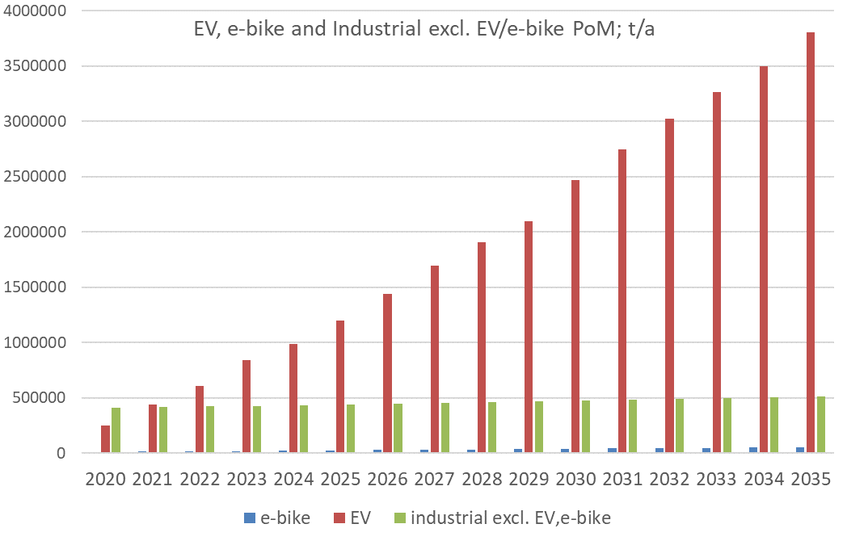
Figure 1: Expected evolution of industrial batteries placed on the EU market.
The total industrial batteries (incl. EV and e-bikes) are estimated to increase from about 0.7 million tonnes in 2020 to about 4.4 million tonnes in 2035. In 2020, the share of EV batteries accounts for roughly one third of the total industrial batteries. In 2030, EV batteries are expected to already dominate the industrial batteries category and to reach a share of about 87% of the total industrial batteries placed on the market in 2035. The expected predominant chemistry of EV traction batteries is lithium-ion.
Overall, the quantity of EV batteries placed on the market is expected to increase fifteen times between 2020 and 2035. The ‘remaining’ industrial batteries (total industrial excl. EV and e-bike) displays only a slight increase between 2020 and 2035 and remain roughly at the same level of about 0.5 million tonnes. In the baseline scenario, due to the high share of EV batteries within the industrial batteries class, any information about other industrial batteries and their mass flows are overridden by EV batteries.
The e-bike share of the total industrial batteries category is about 1% to 2% throughout the period under consideration.
Figure 2 below presents the estimated future development of the quantities of portable batteries placed on the market. The total (incl. power tools) would increase from about 0.19 million tonnes in 2020 to about 0.23 million tonnes in 2035. During the same period, the total industrial batteries excl. EV batteries increase from about 0.42 million tonnes to about 0.57 million tonnes. E-bike batteries increase from about 12 000 tonnes in 2020 to about 56 000 tonnes in 2035. Batteries of power tools represent a comparatively small group of batteries and are estimated to be in a range from about 7 000 tonnes to about 15 000 tonnes per year.
In weight, the total portable batteries (incl. power tools) account for about 40% (2035) to 46% (2020) of the total industrial batteries excl. EV batteries.
The share of e-bike batteries of the total industrial batteries excl. EV batteries accounts for about 3% in 2020 and increases to about 10% in 2035. In comparison with total portable batteries (incl. power tools), e-bikes correspond to about 6% in 2020 and 25% in 2035.
The share of batteries of power tools compared to the total portable batteries is in a range between 4% and 7%.

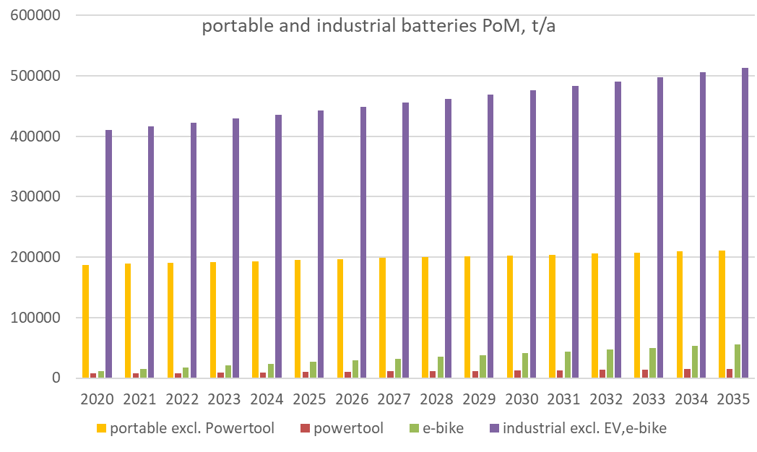
Figure 2: Evolution of portable, power tools, e-bikes and other industrial batteries placed on the market

Sub-measure a: Giving specific treatment to EV batteries (establishing a new battery type or a sub-category of industrial batteries);
This sub-measure considers creating a new battery type or subdividing the industrial class into a group of all EV batteries, (BEV, HEV, PHEV, FCEV), plus another one for energy storage systems and e-bikes, e-scooters and other non-EV industrial batteries.
If retained, this sub-measure will allow establishing differentiated obligations on e.g. sustainability requirements, reporting, etc. This sub-measure does not affect the EPR obligations of the producers concerned.
Assessment
The introduction of this sub-measure would have consequences at different levels.
It would allow the adoption of provisions specifically targeting EV batteries (or other batteries within this battery type).
It would also improve the quality of the information obtained through reporting. If a new battery type (or a subclass inside industrial batteries) is established, with differentiated obligations, the reporting information obtained would be more specific and targeted and mass flows would be more granular and transparent. This will allow better use of the information by national authorities and economic operators.
On the other hand, it should be noted that grouping all ‘large’ batteries, i.e. EVs, energy storage systems and those used in heavy-duty machinery, would also allow to adopt more targeted measures, as well as to enhance the quality of the reporting information. In any case, acknowledging the prominent role of EV batteries and giving them a specific treatment appears to be part of the solution.
Specific reporting systems are needed, but linking them to the existing EU-wide reporting system for vehicles will lower the possible additional administrative burden for economic operators, national authorities and other stakeholders. An initial investment in surveys to provide basic information on material flows will nevertheless be needed. The associated costs are small compared to production costs of the battery itself.
The development of a digital passport system at EU level for EV and energy storage batteries, considered in Measure 12, would contribute strongly to making available the information gathered via reporting mechanisms. Some costs for the digital passport will arise for battery manufacturers.

Sub-measure b: Completing the definition of portable batteries with a weight limit of 2 kg, to differentiate portable from industrial batteries, with possible exceptions
In this sub-measure, a 2 kg threshold is introduced to differentiate portable from industrial batteries, so, all batteries of 2 kg and less are categorized as portable. All batteries of more than 2 kg are industrial batteries, including from e-bikes and other light mean of transport.
A 2 kg threshold implies that certain small and light batteries currently considered industrial are shifted to portable. Examples are pay-terminals, warning lights/lighting from construction sites, emergency lights, mobile ordering tools (restaurants etc.), smart meters, back-up electronic circuits, etc. Collection schemes for portable batteries should take care of these small / light batteries, when they become waste. Likewise, these light batteries have to be taken into account for the calculation of the collection rate of portable batteries.
To avoid practical problems, the introduction of a mandatory labelling (e.g. bar or QR code) should be considered.
Assessment
Positive impacts
Setting a 2 kg limit would affect light batteries. Even in the absence of detailed information, it can be assumed that the total weight of batteries affected will not be very high. For that reason, no significant effect on the collection rate is expected. New data will still be comparable to existing ones and no new target setting is required. However, increased harmonisation due to the existence of a clearer demarcation line would result in higher quality of the reported data. Distortion of the reported values for the collection rate of portable batteries would be avoided or at least significantly reduced.
Better and more realistic data also support a level playing field between Member States. ‘Light’ industrial batteries incorrectly collected by schemes for portable batteries, create a funding problem, since these batteries are not subject to a collection and recycling fee. A 2kg threshold could solve or at least reduce this problem. The risk that small ‘industrial’ batteries (e.g. pay-terminals, mobile ordering tools; so far industrial) are not collected will be reduced.
The current infrastructure and cost structure of collecting schemes and producers organisations could be kept without changes, given the minor effects on the overall amounts concerned. The reporting system for data on collection and the collection rate would remain the same.
The costs for the producers to change the labelling of these batteries is considered negligible. An IT labelling (e.g. bar or QR code) could support a clear assignment to the categories portable and industrial.
Negative impacts
A possible negative aspect is given by the relevant amounts of industrial NiCd batteries with a weight lower than 2kg. Although the importance of this chemistry has diminished in recent years, they still play an important role in some niche uses. Re-classifying these batteries as portable would lead to their prohibition, since the Batteries Directive prohibits cadmium containing portable batteries.
A 2 kg threshold would classify only small industrial batteries as portable and could artificially split product lines, i.e. batteries using the same chemistry and placed on the market by the same producer would be classified differently, making the management of the system more difficult (batteries of e-scooters and of power tools are examples).
A 2 kg threshold would result in changes to the respective EPR requirements. Producers of batteries newly classified as industrial would have to participate in PROs of portable batteries and fees would apply.
Exemptions
This sub-measure could be combined with the definition of some exceptions. One example could be that a 2 kg weight threshold is established, but excluding batteries designed for industrial use or containing cadmium. This could be accompanied by a general norm classifying all NiCd batteries as industrial, independent of their weight shall in any case be classified batteries. Not all batteries whose weight is smaller or equal to 2 kg would be considered portable.
Another exemption should be made to exempt some batteries whose weight is below 2 kg but are intended exclusively for use in industrial applications (sensors, safety lighting) and that could still be considered industrial.
The downside of these possible exceptions would be that they would reduce the clarity and simplicity of the sub-measure or at least require more rules for their implementation.

Sub-measure c: Completing the definition of portable batteries with a weight limit of 5 kg to differentiate portable from industrial batteries, with possible excemptions
In this sub-measure, batteries of 5 kg and less are categorised as portable. All batteries of more than 5 kg are industrial batteries. Thus, batteries of e-bikes and other light means of transport no longer belong to the category of industrial batteries. Instead, these batteries are shifted to the category of portable batteries.
Due to the 5 kg threshold, additional batteries could shift from industrial to portable: e.g. pasture fences and e-scooter batteries (these have a large range from even less than 2 kg to far more than 5 kg). The actual quantities of batteries that would be shifted to another category are unknown as no data is available on the weight of different batteries.
To avoid confusion for those disposing of the battery, a mandatory labelling (e.g. bar or QR code) should be introduced.
Assessment
A 5 kg threshold implies that all industrial batteries of 5 kg and less would be classified as portable, with possible exceptions in relation to the strict industrial use of the batteries or their composition.
E-bike batteries, scooters would be re-classified to portable batteries. The share of e-bike batteries of the total portable batteries would account for about 6% in 2020 and 25% in 2035. No data is available on the quantities of these additional batteries. Overall, this would have an impact on the total amounts of batteries classified as portable.
Positive impacts
The large majority of batteries that can be hand held would belong to the same category now, no matter their use. This would provide the same treatment to all producers and products.
Better-harmonized data and better data quality for portable batteries are expected. The distortion of the collection rate of portable batteries could be avoided or at least significantly reduced. Better and more realistic data also support a level playing field between Member States.
A 5 kg threshold could solve or at least significantly reduce the problem of ‘light’ industrial batteries being collected and hence funded via portable batteries schemes. The reporting system for data on collection and the collection rate would have to be adapted.
The risk that a 5 kg threshold artificially splits product lines (batteries of e-scooters, power tools are examples) would be reduced.
The costs for the producers to change the labelling of these batteries would be negligible, as indicated by stakeholders. An IT labelling (e.g. bar or QR code) could support a clear assignment to the categories portable and industrial.
The risk that small batteries considered so far industrial and other batteries of 5 kg and less are not collected (or not payed for if collected via collection schemes of portable battery) will be reduced.
Consumer applications (in particular e-bikes and similar) would be more logically allocated to portable batteries. According to the scarce information available, the collection rate of e-bikes and similar batteries is low. Shifting them from industrial to portable will enlarge the number of collection points and increase the collection rate.
Negative impacts
There are relevant amounts of industrial NiCd batteries with a weight lower than 5 kg. Re-classifying these batteries as portable would lead to the prohibition of these batteries. A specific exemption should then be introduced.
Likewise, exemptions for small batteries intended only for industrial use should be considered.
Transport (carrying) of batteries with a weight of about 5 kg to collection points of portable batteries might become challenging. Today's common collection boxes for portable batteries in shops would probably not be suitable for larger batteries weighing up to 5 kg. The current organisation of producers and their collecting schemes should be adapted to accommodate new models of batteries, and new producers. Additional costs could arise, and surely additional revenues too. These batteries are (or will be) most of them based on lithium chemistries, with a higher recycling value.
A 5 kg threshold would result in changes to the respective extended producers responsibility requirements. Producers would have to participate in collecting schemes for portable batteries and fees would apply. In principle, it is a substitution, since these batteries were covered by the EPR obligations of industrial batteries.
Re-classifying e-bike batteries, e-scooters and additional batteries of 5 kg and less as portable batteries would affect the values of collection rates, since the total amounts of portable batteries placed on the market and collected would significantly change. Since the producers are different, the waste streams are separated, and the nature of losses quite different, a differentiated collection rate for this type of batteries should be established.
E-bike and similar batteries are mainly used by private end-consumers and should be returned to shops at the end of their service life. The problem is that retailers might not be prepared to take back batteries and handling them. The new classification system should be accompanied with well-allocated responsibilities and avoid grey zones.
Excemptions
This sub-measure could be combined with the definition of some excemptions. One example could be that a 5 kg weight threshold is established, but excluding batteries designed for industrial use or containing cadmium. This could be accompanied by a general norm classifying all NiCd batteries as industrial, independent of their weight shall in any case be classified batteries. As a result, not all batteries whose weight is smaller or equal to 5 kg are considered portable.
Another exemption could be made to exempt some batteries whose weight is below 5 kg but that are intended exclusively for use in industrial applications (long life power supply) and could still be considered industrial.
The downside of these possible exceptions would be that they would reduce the clarity and simplicity of the sub-measure, or at least require more rules for their implementation.

>> Links to other measures
If sub-measure c was retained, this could have consequences on Measures 3, 4, 5, and 10, since the amount of batteries categorised as "industrial batteries placed on the market and collected" would change. However, since the total class of currently defined industrial batteries will remain clearly dominated by EV batteries in the future, this reclassification would have a minor impact on measures targeting these.
Given the specific problems related to the collection of batteries powering light means of transport, a sub-measure that proposes a specific collection target is included under Measure 4.

Sub-measure d: New calculation methodology for collection rates of portable batteries based on batteries available for collection

>>What is the problem?
Stakeholders consider the calculation methodology of collection rates for portable batteries laid down by the Batteries Directive unsuitable.
Stakeholders argue that the increasing average lifespan of portable batteries strongly influences the results. The 3-year average currently in the directive was based on the ‘normal’ lifespan of batteries at the time of its adoption (2006). They argue that that the current methodology is only able to describe properly the results of collection activities when the market is stable, i.e. when there is no variation of the total amounts placed on the market.
>>What is the objective?
The objective is to implement a new system for the calculation of collection rates that better reflects the efficiency of collecting activities for waste portable batteries. To this end, it is proposed to consider making use of the ‘available for collection’ approach, which takes into account the expected lifetime of the batteries concerned and the losses due to exports and hoarding.

>> Baseline
Collectors and national authorities consider that the figures obtained applying the currently established methodology would not reflect their actual efficiency. In addition, hoarding behaviours also impact collection rates as the batteries concerned are neither collected nor recycled. Other stakeholders underline the distortion of the results created by the influence of portable batteries incorporated in electric and electronic equipment, which are sometimes recycled or exported with the batteries still inside.
Hence, the calculated collection rates would not reflect the efficiency of collection activities. The lack of reliability in the calculation of collection rates prevents stakeholders from having a trustworthy picture of the mass flows of waste portable batteries. This is a problem because it prevents collecting schemes from properly planning and executing collection and recycling activities. National authorities are also affected since the lack of suitable information increases the difficulties to assess compliance.

>> What is this sub-measure about?
This sub-measure proposes to introduce changes into the current definition of collection rate:
- Modifying the definition of collection rates for portable batteries to take account of their longer lifespan, and
- Establishing the approach based on the weight of batteries available for collection to calculate collection rates, taking into account both the losses in the mass flows of the batteries and the longer lifespan.
These sub-measures are to be applied to portable batteries, first. The new methodology based on the ‘available for collection approach’ will also be used for any new provision involving the calculation of collection rates.

>> Effectiveness and feasibility
The advantage of the changes proposed above (larger periods to calculate the average collection rate or the ‘available for collection approach’) is that both deliver results that present more reliably the waste stream, clarifying the mass flows and allowing operators to better plan their activities.
A comparison of results using a more extended period to calculate the average collection rate, as requested in point 1 above and using the current methodology, was carried out during the evaluation of the Batteries Directive. No significant changes were found as regards the compliance status of Member States as regards the collection target. It was, in any case, acknowledged that the EU collection rate, as it is currently computed, is appropriate only when the weight of the batteries placed on the market is stable in the long term.
The concept of ‘available for collection’ is similar to the ‘generated waste’ applied by the WEEE Directive. A methodology for the calculation of collection rates would have to be developed, which requires the collection of information on the main sources of losses, including hoarding, exports and WEEE disposal. The development of the new methodology will include the definition of an equivalent collection target.

>> Administrative burden
Establishing a reporting system based upon a new methodology would require one-off administrative efforts to build and maintain a system of collection of information. Furthermore, producers and national authorities should therefore change and adapt their existing systems. The annual cost of these activities would be negligible.

>> Legal approach
Building upon the experience gathered in the implementation of the WEEE Directive, the legal instrument should set in motion a process of adaptation of the methodology to calculate collection rates based on the methodology ‘available for collection,’ including for the setting of new targets.

Summary and comparison of impacts
Table 2 provides a synthetic overview of the impacts assessed for the different sub-measures. Based on the analysis presented above sub-measures a, c and d are considered to be the preferred option.
The objective of both sub-measures is to clarify the current provisions on the categories of batteries and to update them to include the latest technological developments (as e.g. specific category for EV batteries, e-bikes batteries to be classified as portable). This is expected to facilitate the definition of more targeted provisions, along with more efficient approaches for their management at the end of their life.
Sub-measure a is proposed to be retained. It introduces a new battery type for EV batteries and give flexibility to deal with other batteries inside the type ‘industrial’ would allow more specific and targeted provisions, including on reporting. This sub-measure does not affect the EPR obligations for the producers concerned.
Sub-measure c is preferred over sub-measure b. A 2kg threshold (sub-measure b) would classify only small industrial batteries as portable and could artificially split product lines, i.e. batteries using the same chemistry and placed on the market by the same producer would be classified differently, making the management of the system more difficult (batteries of e-scooters and of power tools are examples). A 5 kg limit on the other hand (sub-measure c) will make the portable battery type to cover almost all devices that can be hand-carried. It will also group batteries jn product lines composed by typical handheld devices (as e.g. video cameras), that differ on the weight of the battery, into the same battery type. Moreover, it will place in the same category almost identical batteries that at present belong to different categories (as e.g. those in cordless power tools and on gardening devices).
This sub-measure will induce changes to Extended Producer Responsibility obligations for producers of batteries newly considered portables. Shifting batteries in light means of transport from industrial to portable for example will increase the number of collection points available, which will contribute to increasing the actual collection rate.
In addition, the analysis also confirmed the need to update the current methodology for the calculation of collection rates, as proposed in sub-measure d. Given that batteries now have longer service lives and that this trend is expected to continue and accentuate, sub-measure d proposes to consider longer periods to average the amounts of waste batteries collected. The results will clarify the mass flows and allow operators to better plan their activities.
No significant additional administrative burden is expected from the preferred sub-measures, given that they mostly concern administrative changes to existing provisions.
Table 2: Measure 1 - Overview and conclusions for Measure 1
 | Sub-measure a:  A new category or a subcategory for EV batteries | Sub-measure b:  2 kg threshold for portables (with possible exceptions) | Sub-measure c:  5 kg threshold for portables (with possible exceptions) | Sub-measure d:  New calculation method for collection rates based on "available for collection"
Effectiveness and feasibility of the sub-measure | Administrative change to an existing provision, therefore fully feasible. | Clear demarcation line, but with possible implementation problems due to possible difficulties with identification | Clearest demarcation line, as the new resulting category would encompass all similar batteries. Risks of confusion avoided, coherent treatment for almost all battery types | Information on collection rates becomes more realistic, describing reliably the waste stream, clarifying the mass flows and allowing operators to better plan their activities.
Environmental impacts | Allows the definition of measures targeting specific subclasses, increasing the efficiency. | Affects light batteries above all: no relevant effect on the value of the collection rate is expected. | Likely to increase the amount of waste batteries collected.  Changes in collection rate values, also due to the weight of the batteries affected. | Better information will allow addressing losses in a more efficient way.
Economic impacts | No significant economic impacts expected | Producers of reclassified batteries will have to participate in the existing portable batteries collection schemes.  Better and more realistic data will be generated. | Collecting schemes to be adapted to accommodate new batteries and producers. These new producers should contribute with fees.  Better-harmonized data and better data quality | Administrative change without significant economic impacts.
Administrative burden | Low, given that it concerns an administrative change to an existing provision.  No changes in the EPR status of the batteries affected.  Specific reporting systems are needed, | In principle low, given that it concerns an administrative change to an existing provision.  Small changes to the respective extended producer requirements applicable to industrial batteries  More complexity expected when exceptions are defined. | In principle low, given that it concerns an administrative change to an existing provision.  Small changes to the respective extended producer requirements applicable to industrial batteries  More complexity expected when exceptions are defined. | One-off administrative change that will not lead to additional administrative burden compared to the current system.
Stakeholders’ views | Clear support from stakeholders | Some stakeholders support this sub-measure because lighter batteries would be considered as portable which are seen as more appropriate from the collection point of view. | Some stakeholders support this sub-measure since it classes together batteries that being similar, currently belong to different types.  Other stakeholders, underline that this sub-measure could affect a large number of batteries and that their implementation could present difficulties. | Strongly supported by collecting schemes and, to a lesser extent, by Member States.
Preferred sub-measures | X |  | X | X

Measure 2: Second-life of EV and industrial batteries

Introduction
The performance of industrial lithium-ion batteries diminishes with their use. In the case of electric vehicle batteries, when the charging capacity drops to 75-80 % of its original value, the battery is no longer able to perform as expected for its original purpose. However, this does not mean that the battery has no value left.
At the end of a ‘use-cycle’ the battery might be repaired or refurbished to recover its initial functionality and then be reused. It may also be adapted i.e. be repurposed, to perform new functions in a ‘second-life’.
Some pilot projects prove that giving these batteries a second-life is technically feasible and could be economically viable, which raises high expectations . Research has shown that the state-of-health of batteries when retired from EVs directly affects their salvage value and that the global second life battery market could reach 26 GWh by 2025 .
However, some issues about second-life batteries remain under discussion. Life-cycle assessments indicate that, only under certain conditions, second-life batteries used for energy storage could help to offset the environmental impact of their manufacturing processes by assuring a longer and more efficient use of resources. It can also be argued that extended product lifetimes do not always result in a net reduction of environmental impact and that this extension can in the case of batteries, postpone the availability of secondary raw materials from the short to the medium term, affecting the functioning of the markets.
It is in any case widely accepted that the environmental impact of using second-life batteries, as well as the economic viability of this approach, depends on scientific, technical, social and economic conditions. One of them, and by no means the less important, is the regulatory framework.

>> What is the problem and why is it a problem?
Most stakeholders consulted during the evaluation of the Batteries Directive considered that the directive does not specify the legal framework within which second-life of batteries can develop. In the view of the Commission, in the absence of specific provisions for the second-life of batteries, general rules laid down in the Waste Framework Directive (WFD), 2008/98/EC, would apply (e.g. on re-use or on preparation for re-use). Therefore, batteries for re-use are not considered waste whereas batteries to be prepared for re-use are considered waste.
Battery producers underline that this legal situation is unclear and uncertain. They also argue that extended responsibility issues should be addressed to avoid the current situation whereby the producers that place the battery on the market for the first time would remain responsible until the battery is eventually scrapped or recycled, independently of the number of ‘use-cycles’ that it may have had.
Other market barriers due to information asymmetries could be operating too. If, to make possible the development of second life, access to the information stored in the Battery Management System should have to be facilitated, then some OEMs could perceive risks of intellectual property rights infringement, security issues and misuse.
The Commission is aware of the complexity of the situation. The outcomes of the evaluation of the Batteries Directive indicate that the legal treatment given to second-life batteries might not be optimal. The Commission signed an Innovation Deal on batteries with a group of innovators, intended to address specifically this issue.
The market for second life applications is only just emerging. At this early stage, data and forecasts show large discrepancies and projections of the future development of stocks and flows of batteries in the market are very uncertain. An estimation of the stocks and flows of the second life market is even more uncertain. The market for second life applications is very pre-mature and in nascent state.
The expected size of the market asks for a clear regulatory framework and the provision of certainty for operators.

>> What is the objective?
The legal provisions should remove any barriers, set clear provisions and leave to the economic actors the decision on whether to make use of second life batteries while ensuring consistency with relevant EU policies and legislation.

>> What are the sub-measures?
Two main sub-measures consider whether batteries reach the waste status at the end of their first life or not. This will have significant consequences on the rest of provisions applicable to the battery. In particular, obligations stemming from the Extended Producer Responsibility have to be assessed.

>> Baseline
Under current legislation, collected waste batteries must undergo a treatment process, either recycling or preparation for re-use. The removal of the battery from the vehicle and handling, safe storage, shipment and treatment are subject to waste legislation (inter alia ELV Directive, Waste Shipment Regulation and the Batteries Directive itself). If the refurbished battery is placed again in an EV, all needed processes are considered ‘preparation for re-use’. The ‘new’ product needs to meet the specifications and requirements of the target market.
The share of second life batteries increased every year since 2005 and is expected to display a linear growth to reach a 20% of repurposed batteries by 2030.
Figure 3 shows an estimation based on existing literature. Looking at the energy stored by these second life batteries, the conclusions are similar, as shown in Figure 4 below.
This market development would take place under the current challenges in the EU legal provisions mentioned above. Additional provisions would continue to be defined, de jure or de facto, to regulate the activity at Member State level. This would risk of creating differences in the treatment given to this activity and would constitute a distortion of the internal market.
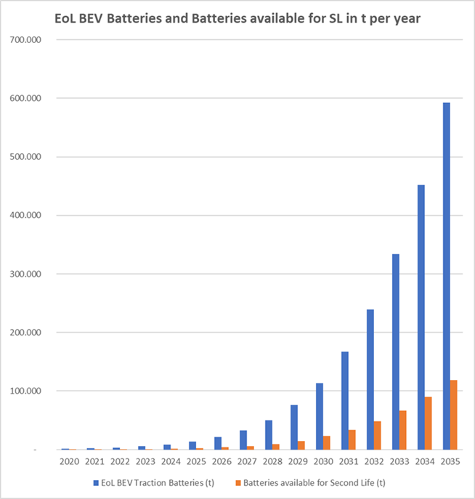
Figure 3: Batteries reaching the end of first use cycle (EoL) and batteries available for second life (tons per year)

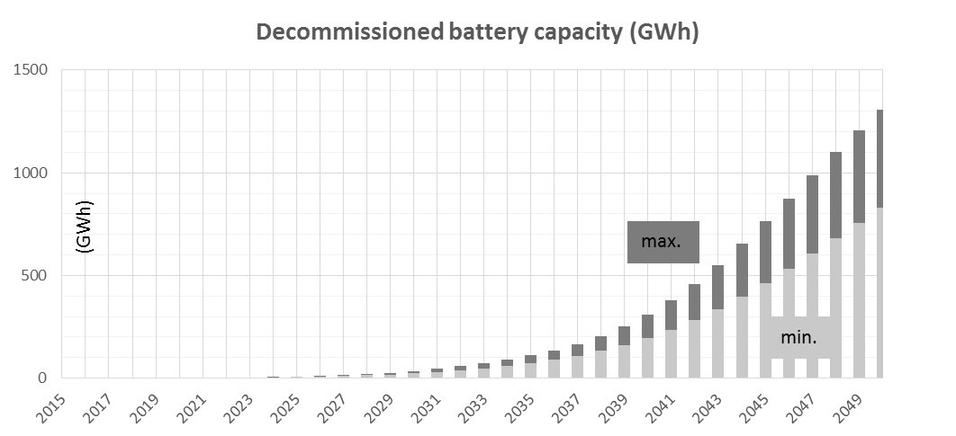
Figure 4: Expected growth in battery capacity available for second life (in GWh)

Sub-measure a: at the end of the first life, batteries are considered waste (except for reuse) and therefore the EPR and product compliance requirements restart when they ceased to be waste and a new product is placed on the market
In this sub-measure, all batteries acquire waste status after their first life, if the conditions set in the WFD are met. These batteries can cease to be waste if specific end-of-waste (EOW) criteria are in place. Generic EOW criteria are listed by the WFD. Applied to second life batteries, these would result in:
- the battery should be used for specific purposes;
- a market or demand exists for this type of batteries;
- the battery fulfils the technical requirements for the specific purposes and meets the existing legislation and applicable standards;
- the use of the battery will not lead to overall adverse environmental or human health impacts.
EPR obligations will restart at every time the battery is placed on the market as a new product. This is the case when the waste battery has been prepared for reuse or has undergone other transformations allowing it to have a second life.
To provide clarity and legal certainty, legal provisions embodying this sub-measure should clearly integrate the actors in the whole value chain and define their role. The liabilities of EPR must be clearly allocated to the respective actors. Parameters like lifespan of usage or the turnover in a certain application could be used to allocate costs.

Sub-measure b: at the end of the first life, batteries are not waste, second life batteries are considered new products, and therefore the EPR and product compliance requirements restart
In this sub-measure, batteries are not necessarily considered waste at the end of their first life. They will become waste only when the battery holder decides to discard the battery. EPR and product compliance requirements restart when the battery starts its second life, so EPR obligations are split between the producer and the downstream economic operators.
A battery that has been taken out from electric vehicles would not be subject to waste legislation. The status of the battery as a dangerous good, if it was so classified, will not change. Likewise, any other technical obligation continues to be applicable. As a ‘new’ product, the battery will need to be reassessed for conformity.
At every restart of a new use cycle, EPR obligations would become applicable to the new battery holder. This does not mean that the original producer of the battery (for its first life) fully recovers its contribution to the collection, treatment and recycling of the battery. Producers and downstream economic operators should have shared EPR obligations instead. Under this policy setting, EPR costs could be, for instance, shared proportionally to the respective lifespan in the first and the second life to the respective operator, (OEM or producer of the second life battery). This could be organised by PROs).
To avoid putting at risks possible environmental advantages, this sub-measure should be accompanied by conditions preventing that true waste batteries are classified as susceptible of having a second life, only with the aim of circumventing heavier administrative and technical procedures.
In addition, a ‘quick’ mechanism allowing battery holders to decide the next stages in the life of the battery will contribute to the effectiveness of this sub-measure.
If the technical conditions for the ‘new’ battery are unambiguously specified and the sharing of relevant EPR obligations clearly organized, uncertainties can be avoided throughout the system and operational costs can be reduced.

Assessment of the sub-measures

>> Effectiveness of the sub-measures
Two main criteria can be used to assess the effectiveness of the sub-measure: allocation of responsibilities and operationalisation of EPR obligations.
Under certain conditions sub-measure a allows general EPR obligations to be clearly allocated to the respective actor.
In sub-measure b, the technical conditions for the ‘new’ battery should be unambiguously specified and the sharing of relevant EPR liabilities clearly organised. These provisions lower existing barriers and avoid uncertainties with a consequent reduction in costs.
The need to ensure safety of reconditioning or refurbishment operations and of the use of second life batteries leads to the discussion about the access to information on the state-of-health of the Battery. The safety of this technology cannot be ensured unless there is access to that information. The ELV Directive already contains provisions in this respect that can be implemented by any of the two sub-measures considered.
Exports and imports
Traction batteries that will are no longer used for that purpose as well as waste batteries, can be traded internationally as a commodity. The legal regime that applies to the two trades, however, differs greatly.
Stakeholders expect that a certain amount of used batteries from the stocks of EU Member States EVs will be shipped to non-EU countries for reuse / repurpose / recycling / dismantling (and vice-versa).
In the case of imports into the EU, the concern exists as to whether the incoming batteries will meet EU requirements. The demand from non-EU countries will depend on their price. The concern is that substandard (and less expensive) refurbishing or recycling process are applied overseas, potentially distorting the market and draining valuable materials from the EU economy. Recycling could take place abroad in conditions that are not equivalent to those applicable within the EU.
While it is not possible to predict the volume of such exports for traction batteries after their first life, it is possible to identify the factors that would result in increased undue export and suboptimal treatment and recycling. Taking into account that advanced recovery process are not always available in developing countries, there is a risk certain that most valuable fractions (lithium, cobalt, nickel) will be lost, and this will lead to negative implications for human health and the environment.
Sub-measure a is to some extent safer as regards transboundary movements since both EU legislation and International Agreements have provisions to ensure that waste shipments take place with all possible guarantees as regards environmental and health protection.
Sub-measure b will not necessarily result in increased amounts of exports for batteries after their first life because the better regulated possibility of having a second life within the EU would facilitate their permanence in the EU market (see comments on administrative costs below). To avoid the risks mentioned above, provisions for sub-measure b should incorporate provisions to strengthen the traceability of the batteries concerned, with a view to ensuring that proper conditions are established for their trade.
Transfer of information
A technical certification process is needed to ascertain that new batteries fulfil the technical requirements for the specific purposes and meets the existing legislation and applicable standards, as requested by the WFD. For the batteries to be certified, access to information on the performance and state-of-health of the battery concerned is required.
Moreover, stakeholders representing the interests of reconditionners and repurposers have clearly indicated that the success of their approach depends on the information on the state- of-health of the of batteries susceptible of having a second life.
Producers have expressed their reluctance to facilitate the access of downstream operators to the information stored in the Battery Management System (BMS) alleging intellectual property rights and safety issues. Conversely, reconditioners and users have insisted on the need to have reliable information on the status of the batteries, not only to lower business risks, but also in relation to safety.
There is a lot of experience gained in the implementation of the end-of-life vehicles directive on the ‘transfer’ of information. Moreover, some of the relevant legal provisions are applicable. Even if stakeholders are aware of this, some propose to promote contractual relations between OEMs and downstream operators. The (private) contract would frame the transfer of information and liabilities.
In any event, for both sub-measures considered, a mechanism providing downstream economic operators access to the information needed to ensure the safe handling and reconditioning/repurposing activities is necessary.

>> Economic and social impacts
Economic and social impacts will depend on the level of penetration of second life batteries, rather than on the two sub-measures being considered. Figure 5 below shows the turnover and the number of FTE posts triggered if that level reaches 25 %.
In 2030, according to the results of the model used, around EUR 200 million would have been generated and 2000 FTE posts have been created.
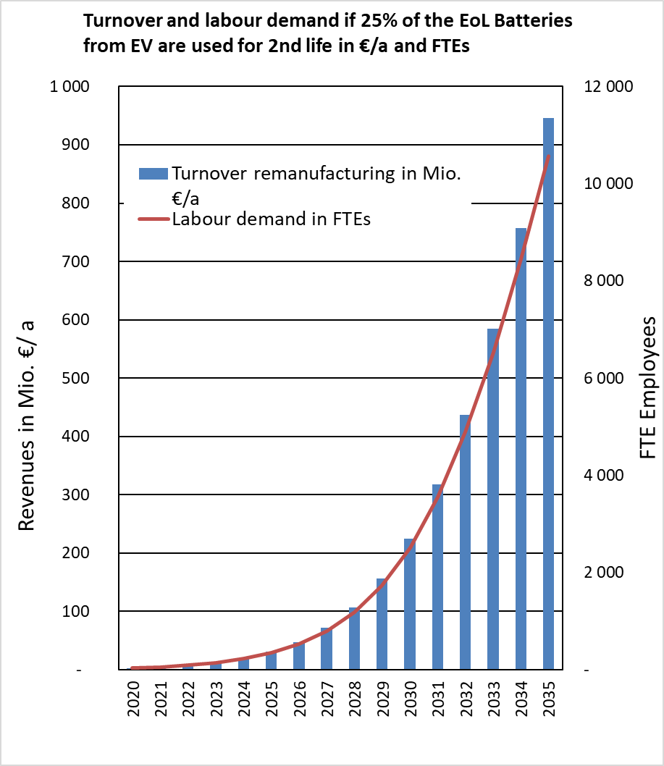
Figure 5: Turnover and labour demand at a level of penetration of 25 %, as from the model.
Some authors point out that retired batteries from EVs have the potential to perform in the ‘behind-the-meter’ application market, due to the small storage system size typically recommended (less than 15.5 kWh and 30.5 kW), but also in storage solutions for electricity companies in order to storing energy for use at a different moment, mainly generated by renewable sources (‘peaks shaving’) , which can then be released by the battery at a moment of higher demand.
It has also been suggested that reusing batteries from retired EVs, depending on their salvage value, could reduce the upfront cost of vehicles, particularly in certain business models such as leasing.
In any case, the level of penetration will also depend on the ease to accomplish all needed technical and administrative processes (see below).

>> Administrative costs
This measure is intended to provide legal certainty to economic operators as well as guaranteeing the safety of the activities concerned. Ensuring the proper management of batteries when they are changing use cycles is an obligation under current EU legislation. As such, this measure is not introducing any new obligation.
The administrative costs of sub-measure a are high because considering these batteries as waste implies that specific procedures need to be respected for their management. Operators must be registered and licensed as waste managers (they will likely also need a qualification for hazardous waste), which increases the treatment costs for the batteries (be it for reuse or recycling), compared to handling used batteries that are considered products. The shipment batteries susceptible of having a second life would be much more cumbersome.
The administrative costs of sub-measure b are lower than those for sub-measure a because the applicable procedures are the ones for the management and shipment of dangerous goods, which are less cumbersome. The lower costs of this sub-measure could therefore encourage the market uptake of second life batteries, which in turn would result in increased positive environmental and socioeconomic effects.
The two options imply equivalent costs to place the battery again on the market, i.e. those related to the certification processes. A possible advantage of sub-measure b is that it could allow the consideration of some initial characteristics of the battery as being still valid and therefore not needing new certification processes.

>> Environmental impacts
The environmental impact of the use of second life batteries has been extensively discussed in the literature but the results are not conclusive.
Figure 6 below presents an estimation, based on the model used by the Oeko Institut of Global Warming Potential (GWP) savings, depending of the level of penetration of second life. For a market penetration level of 25 %, in 2035 GWP savings would reach 400 000 tonnes of CO₂ per year.
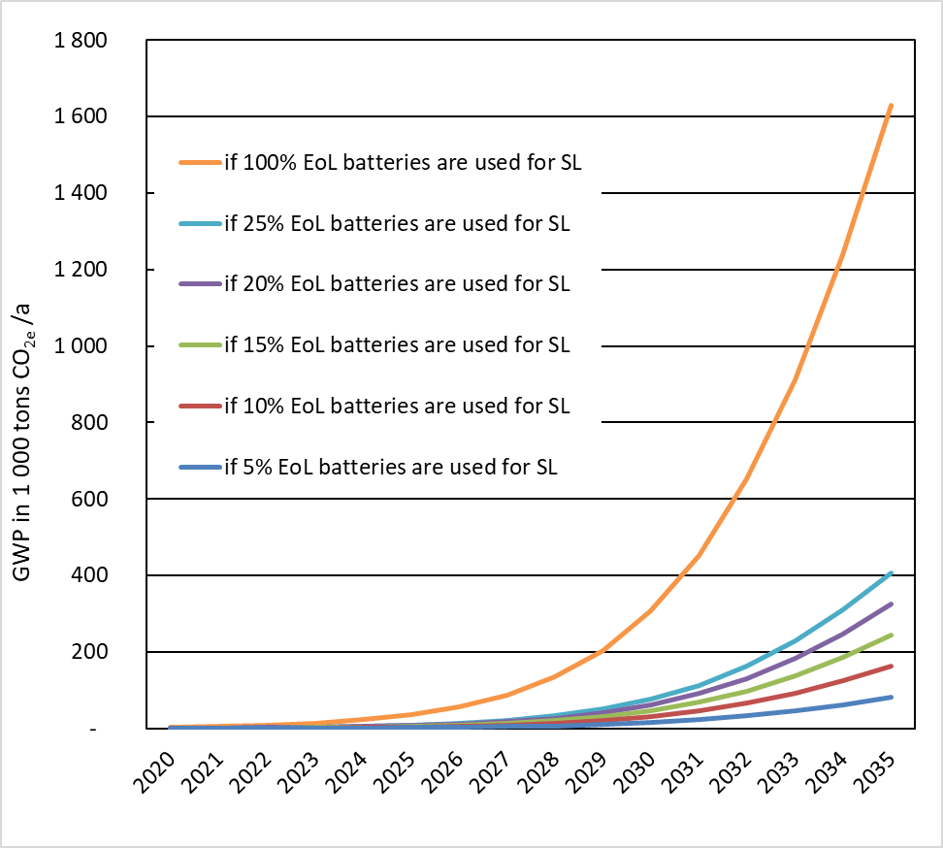
Figure 6: Possible GWP savings triggered by the use of second life batteries
In principle, enlarging the life of products should entail a more efficient use of resources, as reflected by the EU waste hierarchy. In this particular case, however, the final environmental balance depends on
- Differences in efficiency with respect to ‘new’ batteries placed on the market when the second life one starts its new life.
- Delays in the arrival of these batteries to recycling could cause a sub-optimal utilisation of the materials included in the battery (e.g. cobalt, nickel, etc).
Holding other conditions unchanged, both sub-measures considered present a significant advantage in these two points. Therefore, from an environmental point of view, the two sub-measures are equivalent.

>> Stakeholders' views
No sub-measure received full support from stakeholders. Key players and actors which are affected by these sub-measures comprise end-users, OEMs, second life economic operators, recyclers, car repair shops, authorized technical facilities, electric system integrators and service providers.
Passing through a waste status, as in sub-measure a, even if waived, raises many concerns for both producers and repurposers, since it would entail additional costs and responsibilities. However, it is recognised that this sub-measure could make the restart of product compliance obligations easier, and would not require a detailed set of provisions in the regulation since it has been dealt with by the WFD.
Many stakeholders (carmakers in particular) have shown clear preference for sub-measure b. However, some economic operators, namely recyclers, underline that not passing through the waste status, as in sub-measure b, would increase the risk of losses. Batteries at the end of their first life could be considered still as products and be exported, something that could affect the availability of materials for recycling. Likewise, some recyclers insisted on the need to take into account the possible effect of second life markets on this availability.
An ‘Innovation Deal’ was signed by the Commission and a group of ‘innovators’ led by Renault. This deal aims at exchanging information and discussing possible ways to facilitate second life uses. This process allowed to assess in-depth the views of an important part of the industry, as well as to identify advantages and weaknesses of possible solutions. The work carried out within the Innovation Deal constitutes a valuable input for the Impact Assessment process.

Sub-measures discarded in an early stage
Sub-measure c: at the end of the first use cycle, batteries are not waste but second life batteries would not be considered a new product and the EPR and product compliance requirements would be kept by the producer. Being neither a waste nor a new product leads to some contradictions and possible divergent interpretations, which would not provide legal certainty to economic operators. In this sub-measure, batteries are considered waste at the end of their life(s) when they enter a recycling processes. As batteries do not become waste before entering recycling, no ‘new’ product is placed on the market and hence EPR obligations remain with the producers. Even if batteries undergo transformation and perform a second life, the OEMs would have to be responsible also for the end of life of the second life battery. This is not acceptable to producers, as the associated risks would be very difficult to manage since the battery would be entirely out of their control. Therefore, producers would likely reduce to a minimum the batteries available to have a second life to limit this risk. Moreover, to hedge the remaining risks from persisting EPR responsibilities (e.g. by insurances) these costs would be factored in the price of the transactions, increasing the cost for consumers and economic operators.
For these reasons, this sub-measure was discarded and has not been assessed in depth.
Sub-measure d: Mandatory Second life readiness
Under this sub-measure, all EV batteries placed on the EU market should be able to be deployed as second life batteries after undergoing minimal changes. The ‘purpose’ of batteries as products would be defined in very large terms, in order to avoid administrative complexities in the transitions between use cycles.
This sub-measure introduces significant obligations into the design and manufacturing processes of batteries. Stakeholders and academic scientists appear to diverge on what the result of these obligations would be, making it difficult to assess possible economic and environmental effects. Such an intervention could prevent market forces to find the right allocation of resources, making it difficult for the best performing economic operators to be duly rewarded by the market.
This sub-measure, which entails a serious intervention on the market, does not address the questions underlying legal certainty issues (waste status and continuity of product compliance obligations). For all these reasons, this sub-measure was discarded and has not been assessed in depth.

Summary and conclusions
Table 3 provides a synthetic overview of the impacts assessed for the different sub-measures. Based on the analysis presented above sub-measure b is considered to be the preferred one.
This measure aims at providing legal certainty to allow for the development of a market for the refurbishment of industrial batteries.
The economic and environmental benefits of the two sub-measures considered depend on the technology's market penetration, which could be around 25 % in 2035. However, sub-measure a could lead to producers limiting availability of batteries for second life. The estimated 25% could only therefore be achieved with sub-measure b.
The expected costs of the two measures are different. This is due to the administrative costs they would entail. The administrative costs for sub-measure a would be higher, because operators would need specific licences for the management of hazardous waste. The administrative costs for sub-measure b on the other hand would be lower, because in the applicable procedures for hazardous goods are less cumbersome. The lower costs of sub-measure b would thus be more likely to facilitate the market uptake of this technology.
Table 3: Measure 2 - Overview and comparison of impacts
 | Sub-measure a:  Batteries are waste (except for reuse) and therefore the liabilities restart when they ceased to be waste (and become new products) and start their second life | Sub-measure b:  At the end of the first life, batteries are not waste; second life batteries are considered new products, and the product compliance obligations restart
Effectiveness of the Sub-measure | Under certain conditions this sub-measure allows general responsibilities and EPR obligations to be clearly allocated to the respective actors. | If the technical conditions for the ‘new’ battery are unambiguously specified and the sharing of relevant EPR obligations clearly organized, existing barriers can be lowered. Uncertainties can be avoided throughout the system and costs can be reduced.
Economic and social impacts | Economic impacts will depend on the level of market penetration. If that level reaches 25%, estimations show that in 2030 around €200 million would be generated and 2000 FTE jobs would be created, for both sub-measures.  Sub-measure a could lead to producers limiting availability of batteries for second life. The estimated 25% could only be achieved with sub-measure b.
Environmental impact | For the same level of market uptake, any of the two sub-measures considered present a significant advantage. Estimations show an overall positive balance with regard to GWP savings (up to 400.000 tonnes of CO₂ per year by 2035), which would be equivalent for sub-measures a and b.  However, sub-measure a could lead to producers limiting availability of these batteries.
Administrative impact | High.  Considering these batteries as waste requires the adoption of particular measures for its management. Operators could have to be registered as waste managers, with the subsequent administrative costs.  The shipment batteries susceptible of having a second life would be much more cumbersome. | Medium.  Only usual measures for e.g. the management and shipment of ‘dangerous goods,’ would be needed, without imposing high administrative costs. This may help the level of penetration of the technology, facilitating the materialisation of positive environmental and economic impacts.
Stakeholders’ views | Dealing with second life batteries as if they were waste batteries would for many prevent the development of this technology since it would make it non-viable from an economic point of view, mainly due to the administrative impact. | Many stakeholders (carmakers in particular) have shown clear preference for this sub-measure.  Some nevertheless indicate possible risks of losses of batteries due to e.g. undue exports.
Preferred sub-measure |  | X

Measure 3: Collection rate for portable batteries

Introduction

>> What is the problem and why is it a problem?
The Batteries Directive links the environmental impacts of batteries to the materials they contain. Due to the presence of hazardous components, in particular mercury, cadmium and lead, the mismanagement of batteries at the end of their life is the key concern. Batteries do not present a particular environmental risk when they are used or stored safely, but if spent batteries are landfilled, incinerated or improperly disposed of, the substances they contain risk entering the environment, affecting its quality and affecting human health.
As part of the provisions dealing with the end-of-life status of batteries, the Batteries Directive requires Member States to ensure that appropriate collection schemes are in place for waste batteries. It also sets targets for the collection rates of portable batteries (25 % in weight of the amount placed on the market by September 2012 and 45 % by September 2016). The Directive does not actively address disposal of batteries in municipal waste (there are no reporting obligations associated to batteries in municipal waste).
In 2012, 20 Member States had achieved the 2012 target of 25 %. In 2018, 17 Member States met the 2016 target of 45 %. The historical data series shows that the amount of batteries placed on the market has increased and that the amount of waste batteries collected has increased even further (see Figure 7 below).
However, considering the amount of portable batteries placed on the market and of waste batteries collected for the EU, too many waste portable batteries still end up in the wrong waste stream or are lost.
Several causes explain the losses of waste portable batteries,
- batteries are disposed of in municipal waste;
- batteries are hoarded by the end user , due to the longer lifetime of batteries or to the increase of the number of electric appliances with batteries incorporated);
- batteries are not removed from Waste Electrical and Electronic Equipment and end up being shredded together with the appliances that contained them; and
- batteries are exported (outside the EU) as part of used electric and electronic devices.
The high rate of losses is worrying, since it increases the risk of pollution by hazardous components of waste batteries (Stahl et al. 2018).

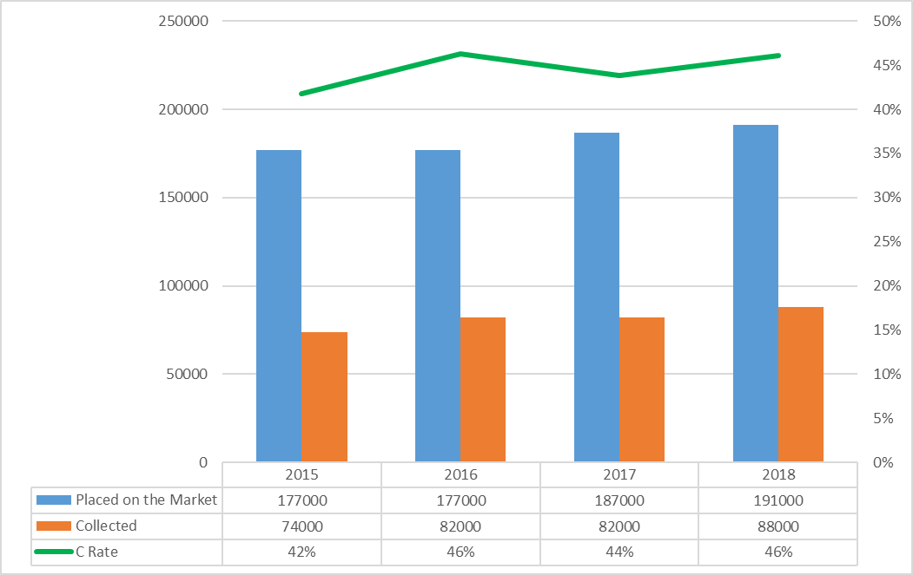
Figure 7: Portable batteries placed on the EU market, waste portable batteries collected and collection rate 2015 – 2018 (EU 27)

The Commission concluded that the current minimum collection targets for waste portable batteries are not sufficient and that further targets for collection should be considered.

>> What is the objective?
In order to protect the environment and to maximise resource efficiency, as many waste portable batteries should be collected as possible to minimise the amounts of these batteries wrongly disposed of.
Experience has identified actions that increase the collection rate of waste portable batteries. The objective of this measure is to set increased targets for the collection rate of waste portable batteries.

>> What are the sub-measures?
Sub-measures a, b, c and d: 55%, 65%, 70% or 75% collection rate for portable batteries

>> Baseline
Based on Eurostat data for 2018, 17 Member States met the 2016 target of 45 % (of the five Member States that have not reported 2018 yet, two had achieved the 45% target in 2017). This is illustrated in Figure 8 below.
Available evidence indicates two main factors that are associated to the likelihood of meeting the target for the collection rate:
- The length of time since when the collection measures have been in force as the experience gained in implementation often translates in improved collection rates,
- The quality and the reach of awareness raising campaigns as in the well-known case of Belgium.
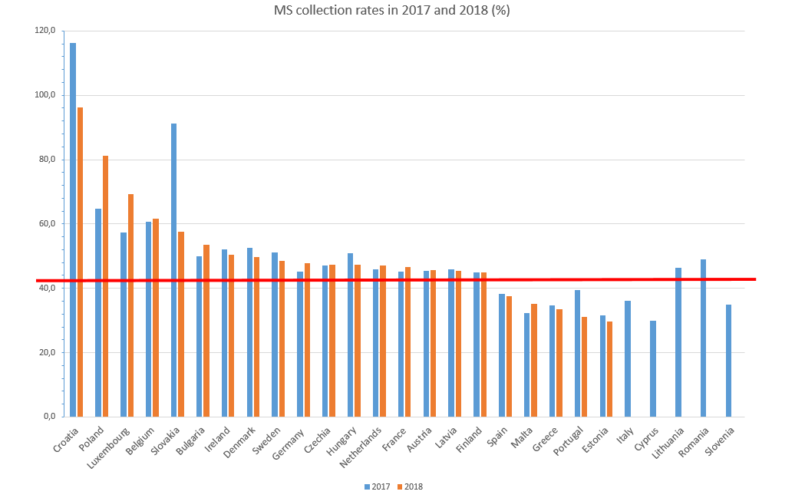
Figure 8: Collection rates of portable batteries in EU Member States, 2017 and 2018
Figure 9 below shows the forecast evolution of the amount of batteries placed on the market and of the uncollected waste batteries, based on the assumption that there is a trend towards meeting the current collection rate target of 45%. Even though the amount of collected waste batteries is estimated to grow, the amount of uncollected and untreated waste batteries will still increase since the expected increase in portable batteries placed on the market is higher than the increase in collection, in particular due to the development of the 3C sector (computing, communication and consumer electronics).
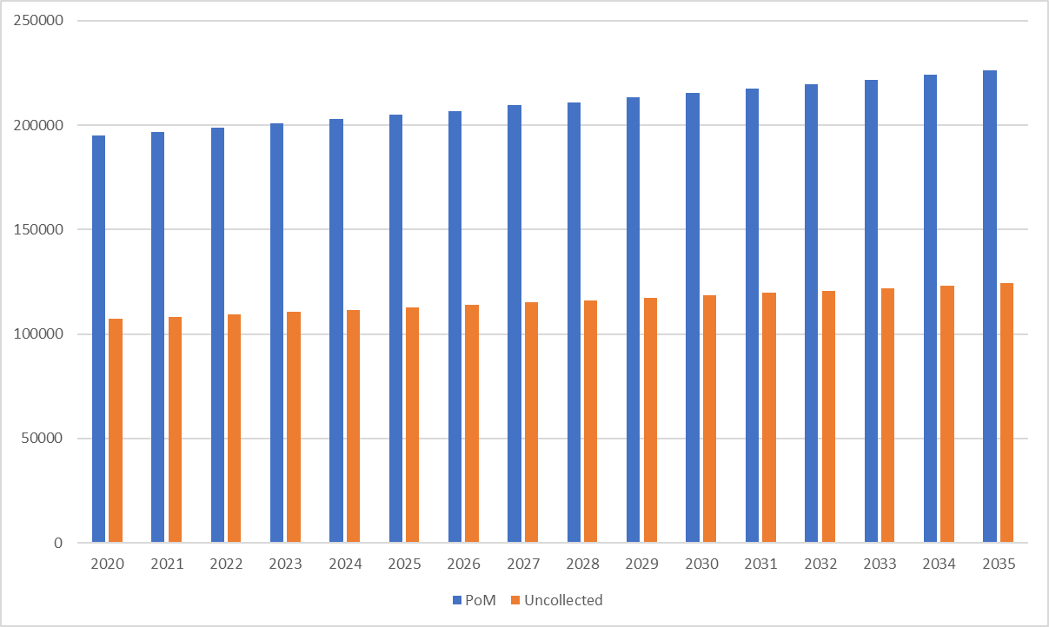
Figure 9: Portable batteries placed on the market and waste portable batteries that could remain uncollected.
The amount of collected waste batteries is not sufficient to establish the circularity of the materials flow of the substances concerned (e.g. manganese, cobalt or lithium).

Sub-measures a, b, c and d: 55%, 65%, 70% or 75% collection rate target for portable batteries
For the collection target for portable batteries sub-measures a, b, c and d propose four different target collection rates, 55%, 65% or 75% by 2025 or (sub-measure d) 70% by 2030. In the four cases, there will be a linear increase of the weight of portable waste batteries collected assuming that the target is met. Figure 10 below presents the evolution of those increases.
Gains in collection rates are mainly due to the reduction of losses. Table 4 illustrates how the proposed targets could be met through actions aimed at improving different types of waste batteries collected. The collection rate can be increased by reducing the losses of alkaline batteries, which are the first to arrive to end of life due to their shorter lifetime. Further increases in the collection rate can only be achieved if lithium batteries are also collected (since they have a longer lifetime, the risk of hoarding and/or littering of these batteries is higher). Therefore, the higher the collection target to be achieved, the more the losses of lithium batteries should be reduced.

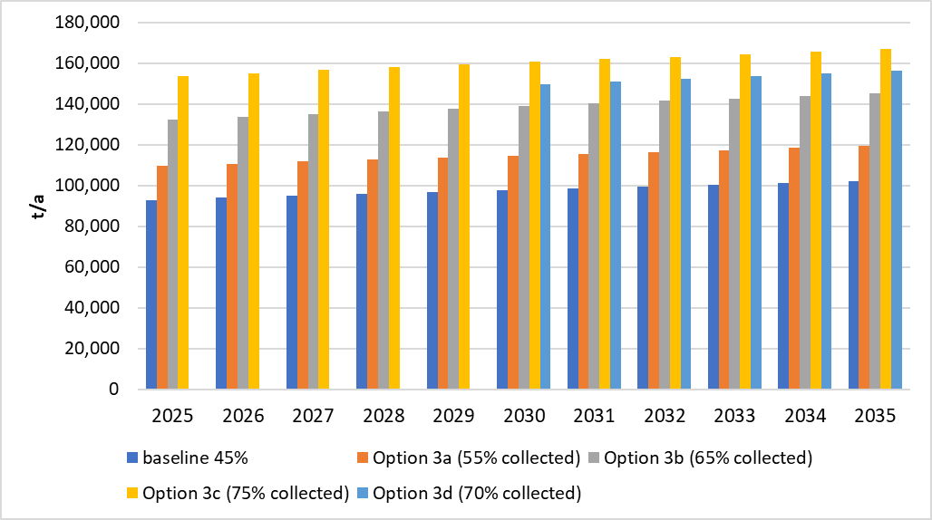
Figure 10: Evolution of the collection of waste portable batteries, depending on the target (in tonnes)

Identifying sources of losses
Addressing the right sources of loss requires knowing if there are waste portable batteries in the different waste streams. Periodical analysis of these streams would allow not only to better quantify losses, but also to identify the most effective ways to meet the collection target. Also, Member States should organize surveys to gather this knowledge and to make collection activities more effective.
Surveys and campaigns should be carried out by producers or producer’ organisations, as one-off exercise and then periodically, for instance every 5 years, , to obtain a reliable picture, first at national level, and then at EU level. A good example is the survey carried out in Belgium in 2017 that, for a population of over 11 million, took 107 samples in 68 municipalities, with an average collected mass of household waste per location of 680 kg.

Table 4: Losses addressed and increased collection rates (EU level estimates)
Target | Additional weight collected | Increased weight roughly equivalent to
Sub-measure a | 17 000 tonnes | - Reducing loss of alkaline batteries in municipal waste by 50%
Sub-measure b | 40 000 to 43 000 tonnes | - Reducing loss of alkaline batteries in municipal waste by 70%, and  - Reducing losses of lithium-based batteries by 25%,
Sub-measure c | 60 000 to 65 000 tonnes | - Reducing loss of alkaline batteries in municipal waste by 80%, and  - Reducing loss of lithium-based batteries and of alkaline batteries in exports and e-waste by 50%
Sub-measure d | 40 000 (2025) to 41 000 (2029), and  51 000 (2030) to 53 000 (2035) tonnes | - Reducing loss of alkaline batteries in municipal waste by 70%, and  - Reducing loss of lithium-based batteries and of alkaline batteries and e-waste by about 40%

There will be differences amongst Member States in the efforts needed to reach the proposed target. The larger the gap to the current target, the greater the challenges will be to meet the new target.

>> Environmental impacts
Assuming that, in line with existing legal provisions, all collected batteries are recycled, then greenhouse gas emissions associated with the production of batteries are reduced by increasing the collection rate and raw materials that otherwise would have been mined would be replaced with recycled materials. The greenhouse gas emissions associated with their use phase are unaffected (and this phase is associated with the most significant emissions).
Figure 11 shows the estimated GHG savings resulting from the different sub-measures. It shows that the annual GHG reductions resulting from a collection target of 65% are much higher than those resulting from a 55% collection target. The annual GHG savings compared to the baseline are estimated to be 4% by 2030 for sub-measure a, 51% for sub-measure b, 53% for sub-measure d and 56% for sub-measure c (see also Figure 12). In absolute amounts this is equivalent to a reduction of around 175 000 CO2 equivalent for sub-measures b, c and d. For sub-measure it amounts to a reduction of around 120 000 tonnes of CO2 equivalent.
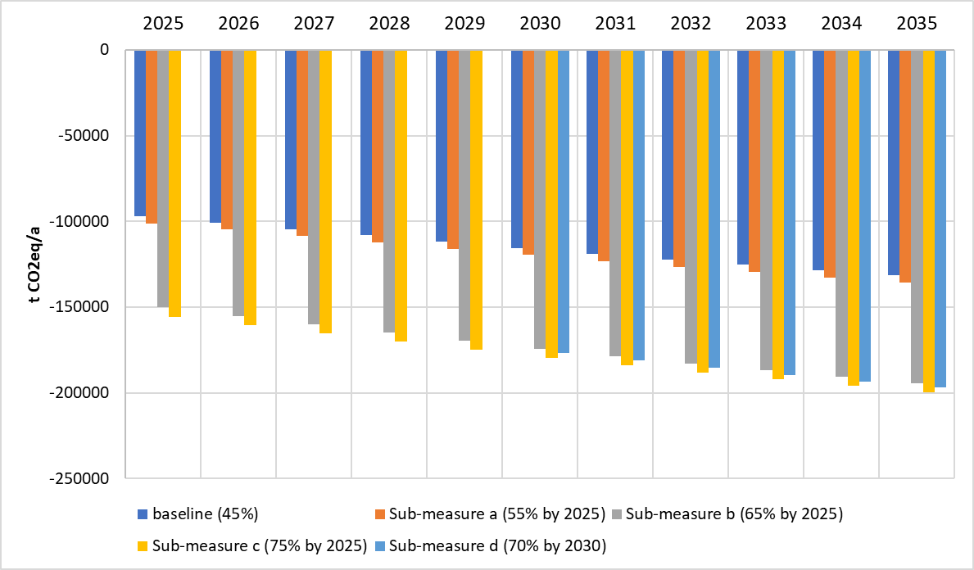
Figure 11: Savings due to the collection (and further recycling) of waste portable batteries, depending on the collection rate (in tonnes of CO ₂-eq per year).
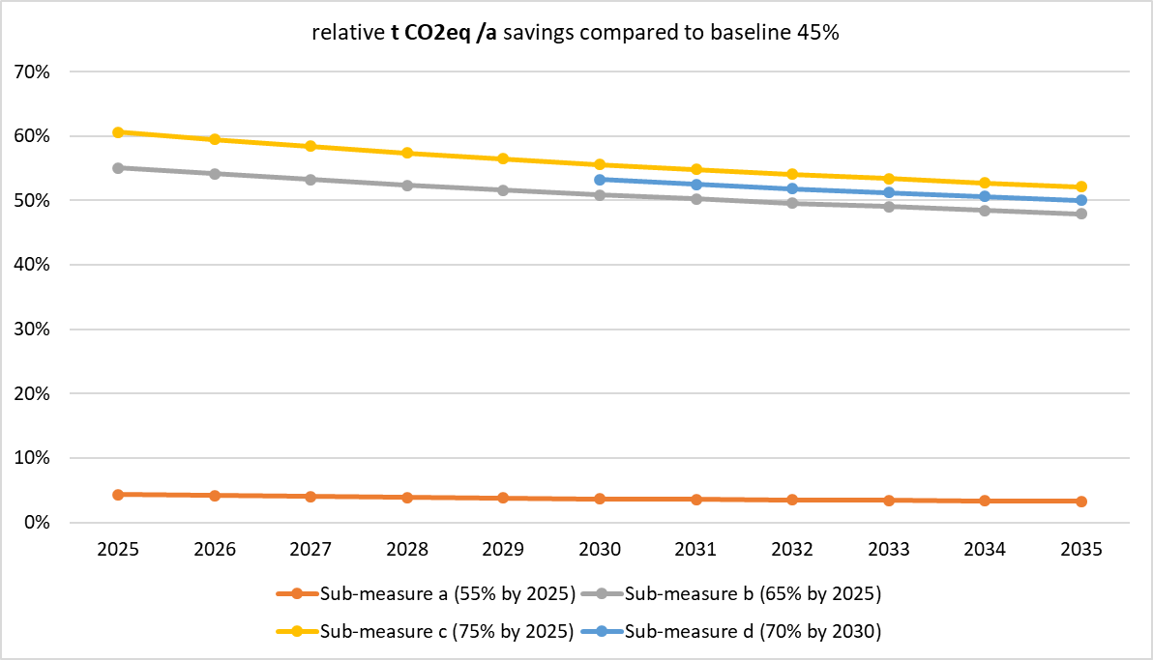
Figure 12: Relative gains in GHG savings, depending on the collection target.
The non-linear increase in reductions is due to the fact that waste lithium-ion batteries represent a higher share of the total waste collected (see Table 4). Due to their different chemistry, lithium batteries have a significantly higher GHG effect than alkaline batteries.
This non-linear effect also appears when looking at other environmental impact categories.
The increased collection rate and recycling, in particular of portable lithium-batteries, produces an estimated decrease of abiotic depletion (ADP), which means non-living resources depletion is slowing down. In 2030, sub-measure a would lead to a 5% reduction in ADP. For sub-measures b, c and d these reductions would amount up to 52%, 59% and 55% respectively. as is shown in Figure 13.
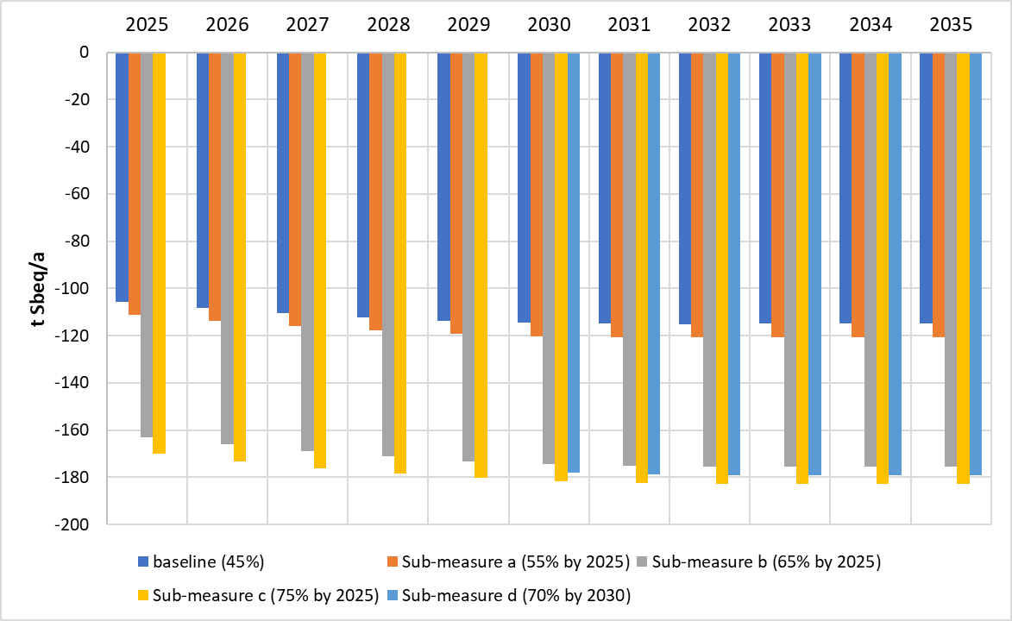
Figure 13: Savings in Abiotic Depletion Potential (in tonnes of Sb eq/year)
A similar pattern can be observed when considered the modelled evolution of the Human Toxicity Potential, as shown in Figure 14. In 2030, sub-measure a would lead to a reduction in HTP of 10%. For sub-measures b, c and these reductions would amount up to 34%, 48% and 41% respectively.
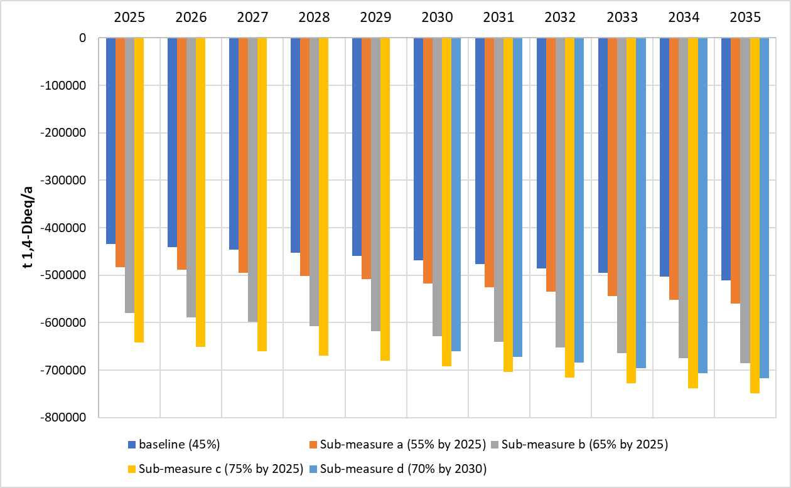
Figure 14: Evolution of the Human Toxicity ¨Potential, depending on collection rates (in tonnes of 1,4- DB eq. per year)
In summary, due to the non-linearity of the reductions in environmental impacts, a combination of a collection rate of 65% in 2025 and 70% in 2030 would maximize the environmental benefits.

>> Economic impacts
The assessment of the economic impact of Measure 3 looks at two aspects: 1) the monetary benefits that can be expected from the avoided GHG emissions and 2) the costs of achieving the collection targets.
For the monetary benefits resulting from the avoided GHG emissions, a reasonable estimate of the cost is EUR 100 per tonne of CO₂ equivalent (CO₂-eq), which would imply monetised values for the avoided carbon emissions in 2030 of:
- EUR 425,000 per annum for a collection rate of 55%,
- EUR 5.9 million per annum for a collection rate of 65%,
- EUR 6.1 million per annum for a collection rate of 70%,
- EUR 6.4 million per annum for a collection rate of 75%.
Estimating the costs of achieving the collection rate targets is a challenging task due to the scarcity of data.
The economic costs include:
- Logistics of collecting waste batteries (e.g. awareness campaigns, collection points, transport etc);
- Sorting of collected waste batteries;
- Cost of the recycling process (such as grinding and metallurgical processing);
- Administrative costs

Collecting Schemes coverage for portable batteries
According to the Batteries Directive, producers shall cover the cost for the collection, treatment and recycling of all waste portable batteries collected. To this end, producers establish collecting schemes. In many cases, producers organize themselves as Producers Organizations and perform the same functions than the collecting schemes. The situation in the Member States differs as some have only one single scheme, others have a competition system, and some Member States established clearing institutions for competing schemes.
Typically, the schemes (or PROs) are commissioning most of the operative works like collection, sorting and recycling to the most economical provider. Schemes often carry out directly activities like design of collection boxes and public information campaigns. The collecting schemes also manage contacts (and contracts) with the operators of the collection points and contracts with the producers and report to the Member States on their activities. Only a few collecting schemes publish their fees, which are different for different kind of batteries.

Estimations of the total costs of the collection rate targets are based on the scarce data on Producer Responsibility Organisations. These data lead to the following estimated cost per capita:
- To reach a collection rate of 45% (i.e. the baseline): EUR 0-23-0.51 per capita
- To reach a collection rate of 65% (sub-measure b): EUR 1.09 per capita
Extrapolation of these cost estimates (see also the Figure 15 below), leads to the following cost estimates for the different sub-measures:
- For sub-measure a: EUR 0.90 per capita
- For sub-measure b: EUR 1.09 per capita
- For sub-measure c: EUR 2.07 per capita
- For sub-measure d: EUR 1.43 per capita
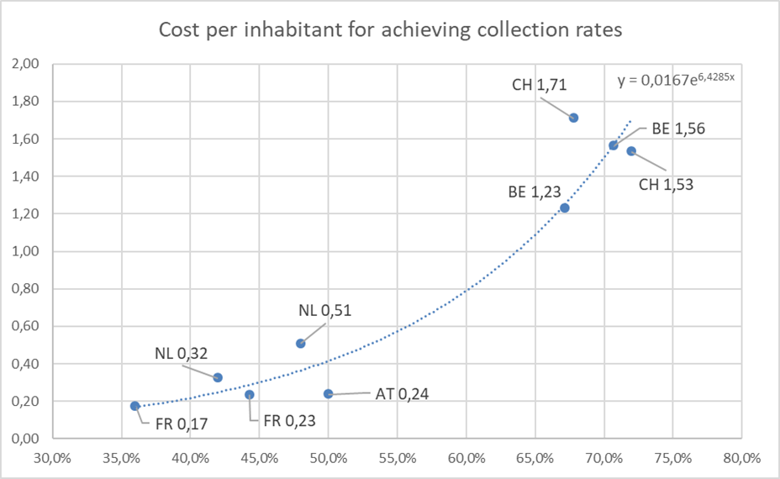
Figure 15: System costs for collection rates of portable batteries (Y-axis = euro per capita per year)
Based on the Polluter Pays Principle, the Batteries Directive requires that these costs are covered through the Extended Producer Responsibility mechanism (see also Measure 10). It is unclear to what extent the cost estimates above, which are expressed in terms of cost per capita, will be passed on from producers to the consumers. If the pass-on rate would be zero (an unlikely assumption), data on the collection of waste portable batteries in Belgium indicate that a 65-70% collection rate can be achieved at a cost of around EUR 0.057 per portable battery placed on the market.
It is noted that the cost estimates presented above are subject to a high degree of uncertainty, given that they are based on only a few data points.
There are a number of indications that the cost estimates for sub-measures c and d should be seen as an overestimate:
- A study commissioned by the European Portable Batteries Association indicates that increases in the collection rate are hindered by the sub-optimal functioning of the market, e.g. due lack of clarity about the definition of portable batteries, lack of clear requirements for PROs (e.g. minimum awareness raising campaigns requirements), distortion of competition between PROs etc. These issues are addressed by Measure 1 and Measure 10, which should facilitate the achievement of higher collection rates.
- Evidence indicates that systems increase their efficiency. The PRO that is active in Belgium for example reports that the fee it charges to its members has decreased by 54% since 2013.
- Evidence also indicates the importance of awareness raising campaigns to increase collection rates. Compared to the costs of setting up the collection points, the costs of these campaigns are low, thus leading to decreasing costs to scale.
- Due to the fact that the higher collection rates (sub-measures b, c and d) will lead to the increased collection of lithium-ion batteries, it is expected that in the long term the revenues from the recovered materials (such as cobalt, copper and nickel) will increase.
On the other hand there are also number of reasons that costs may not go down, and that the estimates can be seen as an underestimate:
- Data points used mostly cover densely populated countries and labour costs that are higher than the EU average;
- As collection targets increase, the share of Li-ion batteries increase, which might have a higher cost.
Costs can be partially compensated through revenues from recycled materials, but for portable batteries (contrary to automotive and industrial batteries) these revenues are currently not sufficient to cover all the costs. Figure 16 shows the amounts of recovered materials for the different sub-measures. In 2030, this would lead to an annual increase compared to the baseline of 15%, 42%, 61% and 51% for sub-measures a, b, c and d respectively. Using average prices for the last 10 years, in 2030 this would lead to revenues of EUR 6.7 million for sub-measure a. For sub-measures b, c and d this would amount up to EUR 72.7 million, EUR 81.3 million and EUR 77 million respectively.
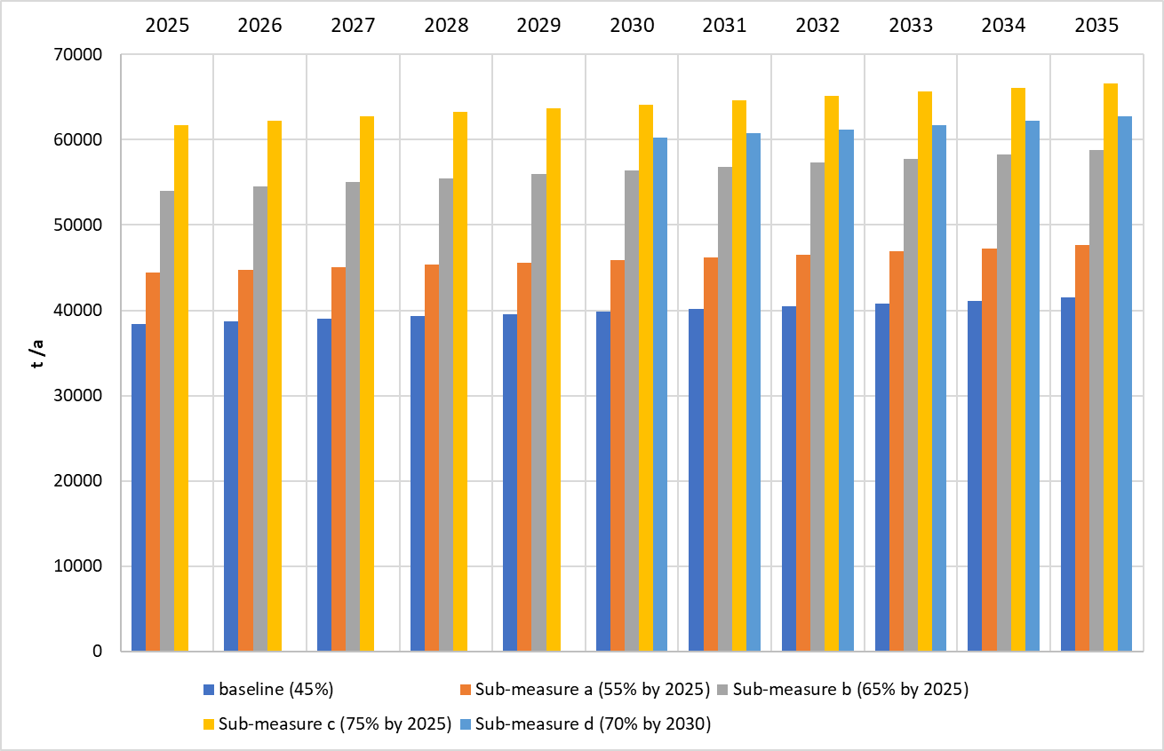
Figure 16: Recovered metals per year (in tonnes).

>> Administrative costs
Administrative activities will be similar to those of today. Some additional administrative effort associated with monitoring and reporting will appear, but most of the administrative effort is already sustained under current requirements.

>> Social impacts
According to the supporting study to this Impact Assessment, achieving a collection rate of 65% results in an additional turnover for recyclers (compared to baseline) of about EUR 290 million per year. The main share of turnover can be allocated to campaigns, collection infrastructure etc. About 1/3 remains for human resources. Therefore, the additional turnover generates about 2500 new jobs, mainly in small and medium sized enterprises taking care of collection, transport, media/advertising.
Similarly, about 850 new jobs are generated when a collection rate of 55% is considered and 5500 new jobs for a collection rate of 75%.

>> Stakeholders' views
Producers, producers’ organisations, collecting schemes, recyclers and national authorities are the most relevant stakeholders involved. Producers are responsible of financing the collection activities necessary to meet the targets. Recyclers have to adapt their capacities to the volume of waste batteries that are collected. National authorities are responsible to ensure that the new targets are met.
Broadly speaking, stakeholders recognise the need to increase the targets even if the opinions as regards possible changes diverge. Producers support the increasing ambition on higher collection rates, which they consider essential to closing the loop on battery materials. In very general terms, recyclers, are in favour of having high collection rate targets, as a mean to ensure that there is enough material input for their activities. Collectors, however, seem reluctant to set too high targets, unless the methodology to calculate these targets changes, reflecting the efficiency of their activity.
Generally, higher collection targets are accepted as long as they are ‘realistic and remain achievable,’ with enough time allowed to meet them. In practical terms, stakeholders would prefer several increases rather than a big change. Roughly, half of Member States have met the current 2016 target (45%), meaning that this figure is achievable. Some countries are currently close to meeting the proposed target for sub-measure b (65%) so the proposed sub-measure seems achievable. Moreover, some Member States suggested using 6 years in the calculation of PoM instead of 3 years that is currently in use. According to them, this would result in a more realistic calculation taking into account the batteries lifetime.

Sub-measures discarded in an early stage

>> Sub-measure d: Deposit and refund schemes.
As part of the analysis underpinning this Impact Assessment, the use of a Deposit Refund Scheme (DRS) for batteries was considered and declined in different approaches , including for different battery categories.
Overall, there does not seem to be a justification for a mandatory DRS for any battery category. Of course, MS can choose voluntarily to implement a DRS but there would be major challenges to doing so related to costs, implementation issues, link to voluntary collection, tourisms deposit and the market of fake batteries.
Therefore, this sub-measure was not assessed in-depth.

>> Sub-measure e: a new set of collection targets per chemistry of batteries
This sub-measure would require establishing individual targets for the collection rates of portable batteries, in terms of the different chemistries present on the market (i.e. alkaline, lithium or nickel based, etc.). After an initial consideration, it became clear that the success of this sub-measure depended on many different factors, which are independent of the sub-measure itself. In practice, the sub-measure requires too many conditions for its implementation as for instance differentiated containers and management measures for the collection of the different types, which would all lead to increasing the costs.
In addition, the multiplicity of targets for different sections within the same class could result in additional difficulties for the organisation of collecting activities (which specific collecting points? where?), etc.
All these reasons put into question the effectiveness of this sub-measure, so it was not assessed in-depth.

Summary and comparison of impacts
Table 5 provides a synthetic overview of the impacts assessed for the different sub-measures.
Based on the analysis sub-measure b, a 65% collection target for portable batteries in 2025, is considered to be the preferred option, together with sub-measure d, a 70% collection target in 2030.
Achieving a collection rate of 65% for portable batteries is feasible. The EU-27 average collection rate in 2018 was 48%. The example of Switzerland (70%) and Belgium (65-70%), shows that a 65% and 70% target can be achieved (sub-measures b and d).
In addition, the analysis show that the environmental benefits of a 65% target are significantly higher than those of 55% target. This non-linear increase in reductions is due to the fact that waste lithium-ion batteries represent a higher share of the total waste collected. The higher the target, the lower the loss of lithium batteries, the higher the environmental benefits.
At the same the analysis shows that these collection targets can be achieved at a reasonable price. Evidence indicates that systems increase their efficiency. The PRO that is active in Belgium for example reports that the fee it charges to its members has decreased by 54% since 2013. Evidence also indicates the importance of awareness raising campaigns to increase collection rates. Compared to the costs of setting up the collection points, the costs of these campaigns are low, thus leading to decreasing costs to scale.
As a generally accepted principle, stakeholders accept higher collection targets as long as they are realistic, with long enough time allowed to meet them. However, there are differences of opinion, not least reflecting countries’ current divergence in performance, from the lowest collection rates around 30% to the highest over 60%.

Table 5: Measure 3 - Summary and comparison of impacts
 | Sub-measure a:  55% collection rate (2025) | Sub-measure b:  65% collection rate (2025) | Sub-measure c:  75% collection rate (2025) | Sub-measure d  70% collection rate (2030)
Effectiveness of the sub-measure | 17 000 tonnes of batteries collected above the baseline. | 40 000 to 43 000 tonnes | 60 000 to 65 000 tonnes | 40 000 (2025) to 41 000 tonnes (2029), and  51 000 (2030) to 53 000 (2035) tonnes
Economic impacts | Monetary benefits due to avoided GHG emissions: EUR 425,000 per annum  Estimated cost per capita: EUR 0.88 | Monetary benefits due to avoided GHG emissions: EUR 5.9 million per annum  Estimated cost per capita: EUR 1.24 | Monetary benefits due to avoided GHG emissions: EUR 6.4 million per annum  Estimated cost per capita: EUR 1.63 | Monetary benefits due to avoided GHG emissions: EUR 6.1 million per annum  Estimated cost per capita: EUR 1.43
Administrative burden | No additional administrative burden, given that a collection target is already in place in the Batteries Directive
Environmental impact: | 4% reduction in GHG emissions compared to the baseline | 51% reduction in GHG emissions compared to the baseline | 53% reduction in GHG emissions compared to the baseline | 56% reduction in GHG emissions compared to the baseline
Social impacts | 800 new jobs | 2000 new jobs | 3000 new jobs | 2300 new jobs
Feasibility and stakeholders’ views | The average collection rate in 2018 was 48%, so this sub-measure is fully feasible. | The example of Belgium (65-70%) shows that this collection rate is feasible.  In principle, stakeholders welcome higher collection targets as long as they are realistic, with long enough time allowed to meet them. | Given that some Member States currently only reach collection rates of around 30%, the distance to target for this measure may limit the acceptability of this sub-measure, given the short timeframe. | The example of Switzerland (70%) shows that this collection rate is feasible.  In principle, stakeholders welcome higher collection targets as long as they are realistic, with long enough time allowed to meet them.
Preferred policy sub-measure |  | X |  | X

Measure 4: Collection rates for automotive, EV and industrial batteries

Introduction

>> What is the problem and why is it a problem?
Current provisions at the Batteries Directive do not establish any explicit collection rate target for automotive and industrial batteries. Nevertheless, a ‘no losses’ policy is established to ensure that such batteries are not disposed of in landfills or incinerated. Since all collected batteries have to undergo proper treatment and recycling, in practice the directive’s measures have an implicit 100% collection rate target.
The absence of an explicit target in the Batteries Directive is based on the assumption that the recycling of industrial batteries is profitable and that economic operators concerned will ensure that these batteries are properly collected and recycled. However, the relevant facts do not substantiate this assumption. Comparing the available data on the amount of industrial batteries placed on the market and the ones collected as waste reveals a gap. On that basis, the evaluation report of the Batteries Directive concluded that 11% of industrial batteries placed on the market are estimated as not being collected at the end of their life, and are hence probably lost.
‘Industrial batteries’ encompasses all batteries intended for exclusively industrial or professional uses or used in any electric vehicle. This group includes several kinds of batteries expected to undergo exponential growth in coming years, including large batteries used in EVs and smaller ones used in e-bikes. The category also includes storage and back-up power supply systems used in connection with renewable energy applications. the high variety of batteries (and powered appliances in this category)makes it difficult to gather the necessary information to ascertain that all industrial batteries are properly collected and recycled.
Automotive batteries, those used for automotive starter, lighting or ignition power, are reportedly collected at very high levels.. However, given the toxicity of lead and its compounds, losses, even if they are small, should be avoided.
Losses of batteries may put at risk the quality of the environment and the human health, and prevents battery value chains from being circular. Dependency on imports therefore increases, and the EU stock of strategically important materials diminishes. Moreover, at both EU and global levels, additional extractive activities are developed to compensate that loses, entailing new impacts on the environment.
In the absence of mandatory collection targets for industrial batteries, there are no data about batteries placed on the market, no collection systems are in place, and there is no reporting and monitoring of relevant mass flows either. EVs on the other hand are registered, and therefore official and reliable statistics exist (for vehicles, however, not for battery masses).
An essential difference should be kept in mind: the current levels of collection of batteries powering e-bikes and other means of transport are included under the category " industrial batteries". A specific approach for this type of batteries, including differentiated collection rates could be needed.

>> What is the objective?
This measure aims to ensure the highest level of collection for batteries that are currently categorised as industrial and automotive, which is key to meet all the objectives of this initiative: preservation of environmental quality, efficient and responsible use of resources and strengthening the market.
In any event, and taking into account the expected growth in the battery sector, this measure also aims at ensuring that the amount of waste industrial and automotive batteries collected is at least at the same level it is at present, both in absolute and relative terms.

>> What are the sub-measures?
Three sub-measures are considered:
a) A new reporting system for automotive, EV and industrial batteries.
b) Explicit collection target for industrial, EV and automotive batteries
c) Collection target for batteries powering light means of transport (and similar)
The possibility of additional EPR obligations is included in the analysis of Measure 10.

>> Baseline
- The expected development from 2020 until 2035 of industrial batteries in the EU, separated into traction (EV) batteries, e-bike batteries and "other", is illustrated in Figure 17 below. In 2020, traction and e-bikes batteries constitute 37% and 2% of the total respectively while in 2035 the situation is expected to have changed considerably since
  - EV batteries are expected to constitute the most important segment by far: 3.8 Million tons of traction batteries placed on the market (about 85% of a much larger total); this increase is due to the increasing amount of electric vehicles sold;
  - E-bike and similar batteries would grow up to 55 000 tons (still less than 2% of the total);
  - All other industrial batteries show a steady growth from ca. 410 000 tons in 2020 to 510 000 tons (around 10%).
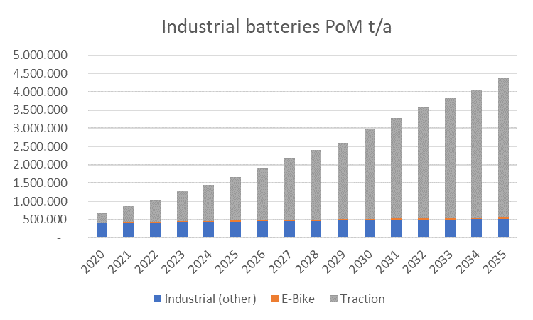
Figure 17: Expected amounts of industrial batteries
For the assessment of this sub-measure, it is assumed that no changes in the classification of EV and the rest of industrial batteries, have taken place.
Figure 18 illustrates the expected evolution of the industrial batteries’ market per chemistries:
- Lithium-based batteries will become increasingly relevant in the short to mid-term;
- In 2020, the market is still dominated by lead-acid batteries;
- Decreasing volumes of NiCd batteries will be placed on the market until 2030;
- Small shares of nickel metal hydride batteries will still be relevant for e-bikes and hybrids (HEVs) and some other industrial applications;
- Lithium batteries will become the dominant cell chemistry in the industrial batteries market from 2021 mainly due to the uptake of electric vehicles.
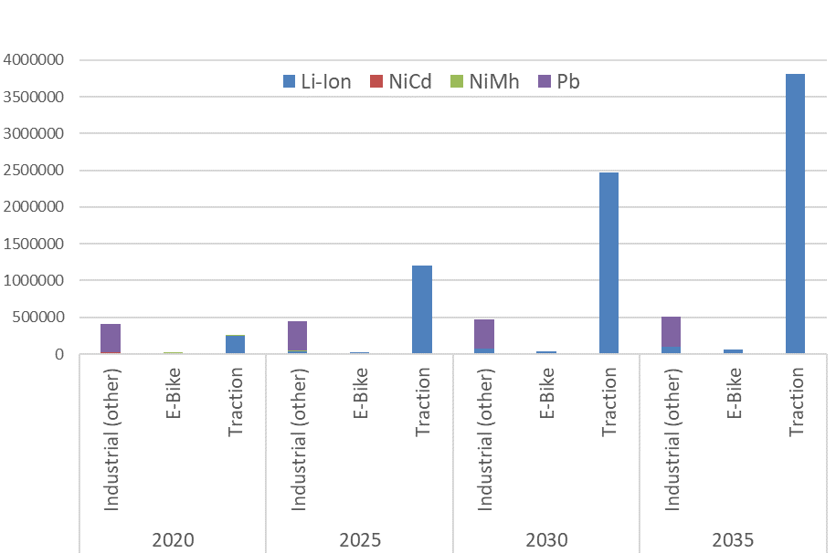
Figure 18: Envisaged amounts (in weight) of chemistries of industrial batteries.
The amount of industrial batteries reaching end-of-life (EoL) status and collected is presented in Figure 19. In 2020, only ca 2 000 tons of waste traction batteries would be generated, of which ca. 1 600 tons collected;
Due to the long lifespan of EV batteries, large volumes batteries become waste only after a long service life as shown below in Figure 19. In 2035, ca. 700 000 tons of waste EV traction batteries would be generated of which ca 608 000 would be collected (or having a second life).
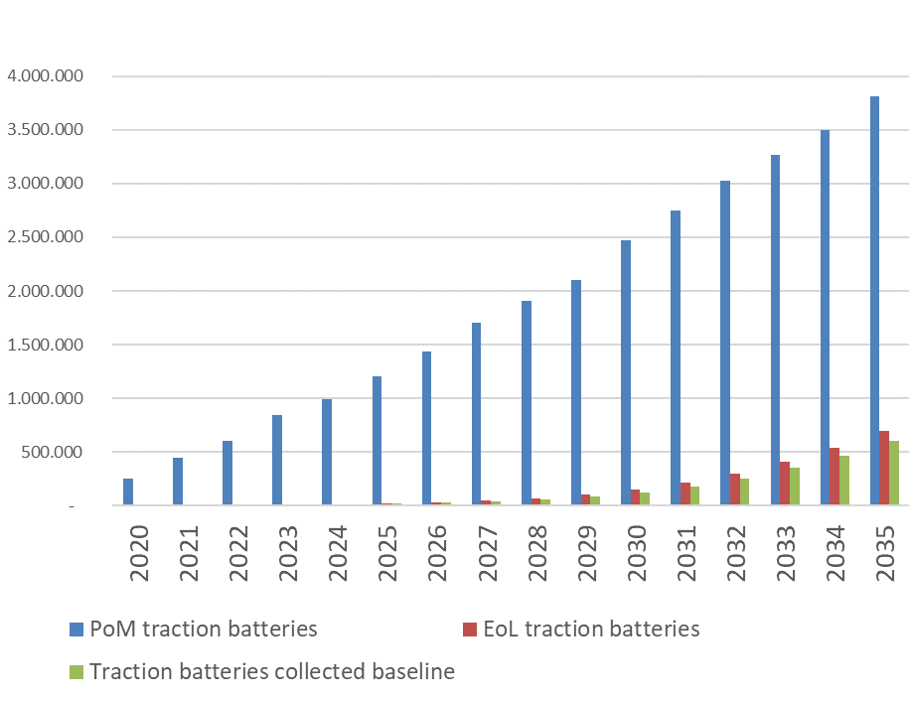
Figure 19: EV traction batteries PoM, calculated EoL and collected in the baseline in t/a
Systems for the registration of vehicles usually reflect the weight of all the components, including automotive and traction batteries. Relevant provisions in the End of Life Vehicles Directive are applicable. Stakeholders consulted stress that producers of batteries for electric vehicles already assure the collection of end-of-life EV batteries without any costs for the end-user, going beyond what is mandated by the Batteries Directive.
Thus far, the vast majority of industrial batteries were based on lead-acid chemistries, with easy and profitable recycling. Since most internal combustion vehicles, now predominant in the market, still use them, it is expected that the demand for these batteries will not drop significantly. If internal combustion vehicles became to use lithium batteries for starting, lighting and ignition, the demand for lead will decrease, potentially making collection of lead containing batteries less economically attractive.
Ascertaining the evolution of the share of automotive lead-acid batteries is particularly difficult. The expected evolution of vehicles’ powertrains, as presented below in Figure 20, indicates that lithium-based batteries will substitute lead-acid ones. This would contribute to lowering the share of lead-acid technologies in the battery sector in the EU.

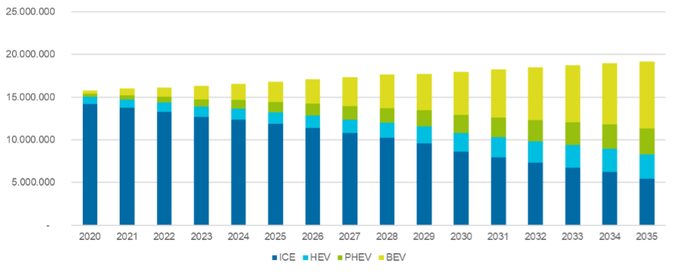
Figure 20: Expected car sales by powertrain (ICE: internal-combustion engine, HEV: hybrid electric vehicle; PHEC: plug-in electric vehicle, BEV: full electric vehicle).
However, the production (in units) of automotive lead-acid batteries in the EU still grown in recent years, until 2018 at least, as shown below in Table 6.
Table 6: Imports, exports and production in units of lead-acid batteries in the EU.
Year | Exports (thousands) | Imports (thousands) | Production (thousands)
2015 | 20.965 | 20.199 | 82.864
2016 | 28.863 | 19.889 | 87.129
2017 | 25.991 | 20.728 | 92.049
2018 | 23.412 | 20.005 | 77.695

It can be concluded that, even if there is a downwards trend in the share of lead-acid automotive batteries, these batteries will remain present within the EU market, either as products or waste in the near future, as shown by Figure 21 below.
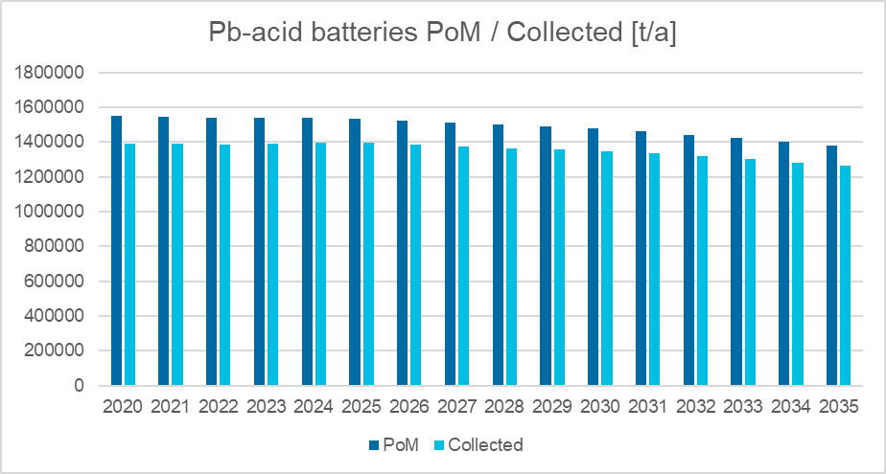
Figure 21: modelled trends for lead-acid batteries, both placed on the market and collected as waste
E-bike and similar batteries pose different challenges due to the fact that the vast majority of end-users are private consumers, who do not necessarily have the same knowledge regarding disposal of waste batteries than industrial users. As part of the baseline, losses are estimated up to 30%. Figure 22 below shows the expected (modelled) development of e-bike batteries. In 2020 a total of ca. 11 500 tons of e-bike batteries are placed on the market, while ca. 4 500 tons of waste batteries are generated, of which 3 200 tons are collected. This would mean that approximately 32% are collected (equivalent to approximately 70% based on the "available for collection" methodology). If no action is taken, the gap between e-bike batteries placed on the market and those collected is expected to close slowly, reaching a collection rate of 54% in 2035 (measured in terms of weight of batteries placed on the market).

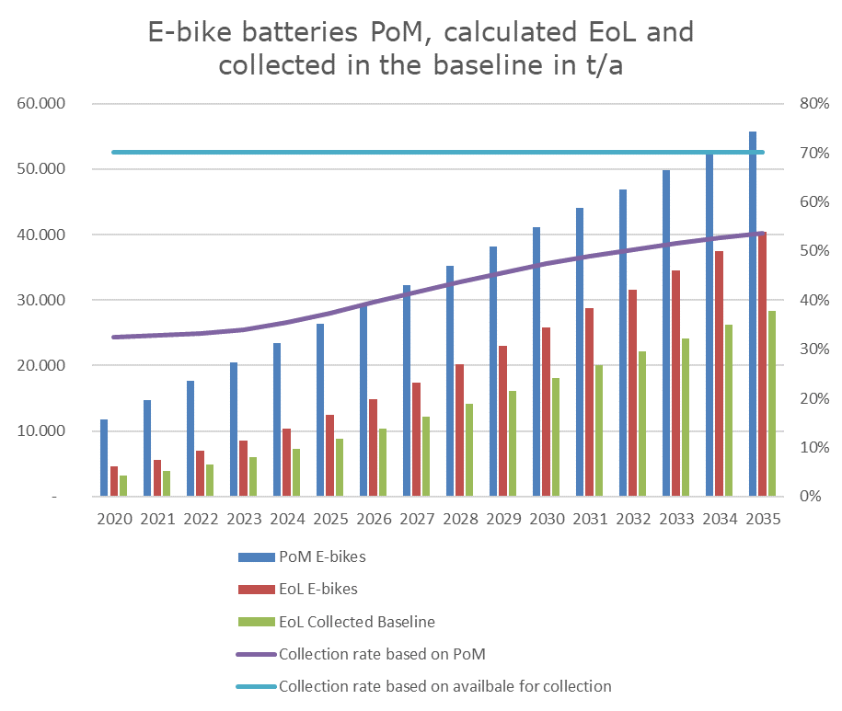
Figure 22: e-bike batteries baseline, amounts placed on the market, end-of-life and collected (left axis for the bar chart, in tonnes; right axis for the trend line, in %)

Sub-measure a – New reporting system for automotive, EVs and industrial batteries
Through this sub-measure, producers and producers’ organisations are made responsible of generating and publishing information on the placing on the market, collection and recycling of waste automotive, EVs and industrial batteries.
Reporting obligations for all industrial batteries should be considered to provide not only a better understanding of mass flows over time but also information on the level of compliance concerning the obligation to collect and recycle all waste automotive, EVs and industrial batteries.

>> Effectiveness of the sub-measure
Reporting systems, when considered over a long period, provide information on whether there is a gap between collected batteries and batteries available for collection, which facilitates addressing insufficiencies in collection schemes. Reporting might also result in higher awareness of the collection of industrial batteries, potentially contributing to increasing collection rates.
The results of the monitoring and reporting activities will allow the development of the information needed to calculate collection rates, paving the way to the assessment of the compliance for the general obligation not to lose any industrial battery.

>> Modelling assumptions
For the purpose of this impact assessment, it has been assumed that the introduction of a reporting system would lead to a 3% increase in the collection of industrial batteries.

>> Environmental impact
Increased levels of collection and recycling of industrial batteries have positive effects for the environment. However, given the high level of collection assumed for these batteries at present, the total gain will not be significant with respect to the baseline.
Figure 23 below shows the difference between the baseline and the results of a 3% increase in the collection rate of lithium industrial batteries, concerning the recovery of cobalt. According to the model, 60 t/a (2020) to 300 t/a (2035) more secondary cobalt could be recovered.
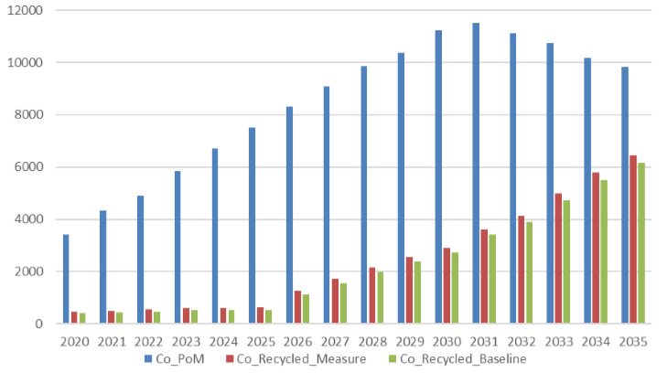
Figure 23: Comparison of cobalt recovered with and without increase of 3% in the collection rate
Likewise, the losses and the risks for the health and environment would be lowered.
Figure 24 below compares the losses with or without the proposed sub-measure. In 2035, 13 000 tonnes of waste industrial lead-acid batteries and 9 000 tonnes of industrial lithium-based batteries would be collected and recycled, in addition to the baseline.
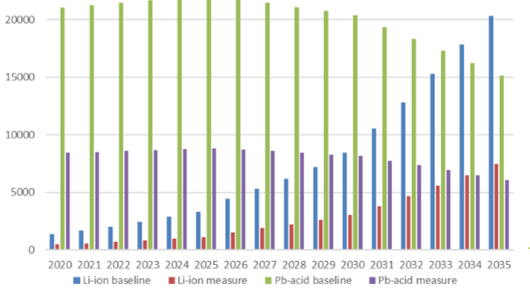
Figure 24: comparison of losses of industrial lithium-based batteries and of lead-acid batteries with and without an increase of 3% in the collection rate

>> Economic impact
If the collection of automotive and industrial batteries increases, the costs associated will also do so, but there will be also additional sources of revenue. Overall, the collection and recycling of industrial and automotive batteries is considered to be cost-neutral at minimum.
Considering only industrial batteries, the turnover of logistics, collection (collected waste industrial batteries) and recycling (secondary Pb, Co, Ni) is estimated to generate between EUR 27 to 50 million per year.
In particular, the model indicates that the recycling of the additional amounts of industrial batteries collected would result in additional revenues for recyclers: about EUR 2 (2020) to 23 (2035) million for secondary Co and Ni and EUR 15 (2020) to 10 (2035) million for lead. The decreasing revenues for lead are due to the slow contraction of the demand for lead-acid batteries.

>> Administrative burden
The Waste Framework Directive lays down a number of obligations for producers and producers’ organisations regarding systems to gather information on products, or on the attainment of waste collection and recycling targets. As such, therefore, the implementation of a reporting system should not have new direct economic consequences for the producers. Preparatory work at national and regional levels should be foreseen to design sampling and ensure data gathering. As suggested by stakeholders, extensive use of IT based technologies should be made (see also Measure 13).
Concerning automotive batteries, the reporting system should be built on the existing for End-of-life Vehicles, which includes specific reporting obligations, also on batteries. The reporting obligation on automotive batteries would then allow drawing synergies and ensuring simplification of the reporting processes and mechanisms.

>> Stakeholders' view of the sub-measure
Producers are aware of the advantages that reliable information on the status of industrial batteries could provide. A large share of them nevertheless insist on the fact that ‘real’ industrial and, to a lesser extent, automotive batteries, are unlikely to be hoarded by customers, or lost in wrong waste streams.
Waste collectors and recyclers are amongst those stakeholders that would appreciate the most having information on the status of industrial batteries. Moreover, some of them consider this information of strategic nature since it would allow them to plan their activities appropriately.
There is a general agreement that any measure should not create any unnecessary administrative burden but should rather be efficient and transparent.

Sub-measure b - Explicit collection target for industrial, EV and automotive batteries

>> Description of the sub-measure
This sub-measure consists in setting targets for the collection rate of automotive, industrial and EV batteries with the aim to ensure the achievement of high levels of collection and recycling.
Instead of the implicit obligation in the directive by which all waste industrial batteries need to be collected and recycled, an explicit rule would be enounced, formulated as a collection target.
This target should have equivalent effects to the currently existing ‘no losses’ policy and should take into account the possible statuses of these batteries (i.e. batteries still in use at their initial appliance/context, batteries in use at a different appliance/context, exported or already recycled).

>> Effectiveness and feasibility
Establishing an explicit 100% collection rate target (to replace the implicit "no losses policy" in the Batteries Directive) is assumed to increase the collection rate of industrial and automotive batteries.
Nevertheless, if collection targets for industrial and EV batteries are developed, several issues may appear, as, for instance,
- The collection rate should englobe a very large variety of industrial applications, as e.g. forklifts, trains, stationary applications, which also vary in terms of chemistries and composition.
- There are huge differences in lifetime distributions, which makes it almost impossible to identify a sensible time span for the batteries placed on the market.
- There are large differences between Member States, which would require the development of specific modelling and targets.
In view of the fact that the environmental and economic impacts would most likely not differ from those obtained with sub-measure a, and bearing in mind the technical issues to set meaningful targets for the collection rates of the batteries concerned, it is questionable whether the benefits expected would justify the requested efforts.
Furthermore, , automotive batteries, as part of end-of-life vehicles, are subject to the relevant obligations in the ELV Directive. There are no difficulties to consider a specific collection rate target for these batteries, since the collection and recycling of vehicles is already regulated by targets.

Sub-measure c - Collection target for batteries powering light means of transport

>> Description of the sub-measure
This measure consists in setting a target for the collection rate of batteries powering light means of transport with the aim to ensure the achievement of high levels of collection and recycling.
These batteries are considered at present as industrial batteries by the Batteries Directive, but Measure 1 proposes to reclassify them as portable batteries.
This collection target would be based on the ‘available for collection’ methodology (see sub-measure 1-d). 'Waste batteries available for collection', could be calculated, for instance, through an approach similar to the one used in the Waste Electric and Electronic Equipment Directive. Using data on the weight of batteries placed on the market, and the expected lifespan (Weibull distributions) of each battery type, the amount of batteries reaching their end of life can be calculated.
The use of this approach requires the collection and assessment of additional information on the mass flows for these batteries (for further details see sub-measure 1 d).

>> Modelling assumptions
For the assessment of the possible impacts, a theoretical calculation has been performed, using amounts of waste available for collection. Modelling has been carried out for a collection rate target of 90% by 2025, based on the "available for collection" methodology. This is compared to the baseline, which is estimated to be 70% in terms of "available for collection" or 32% in terms of "batteries placed on the market".
Estimates are based on data for e-bikes only, given the lack of data on the wider category of "means of light transport". The presented data should thus be seen as an underestimate.

>> Effectiveness and feasibility
There is potential to increase the collection of batteries that are considered industrial, but that are not EV batteries, in particular those with small sizes, as e.g. batteries powering light means of transport. It can be shown that such increase would have positive environmental impacts.
Figure 25: Batteries placed on the market, available for collection and collected under the baseline and a 70% collection target (in tonnes) Shows the amounts of batteries placed on the market, available for collection and collected under the baseline and a 70% collection target. It shows that the target would lead to an increase of 29% in collected batteries.
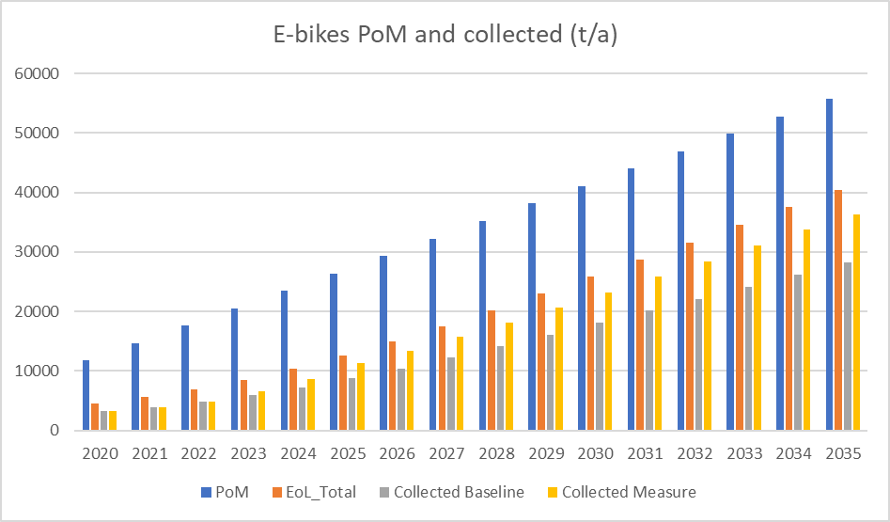
Figure 25: Batteries placed on the market, available for collection and collected under the baseline and a 70% collection target (in tonnes)

>> Environmental impacts
Figure 26 shows the reductions in Global Warming Potential that would be induced by a 70% target for means of light transport. It shows that GHG emissions would decrease by 22% as compared to the baseline, mostly due to the increase in collection of lithium-ion batteries.
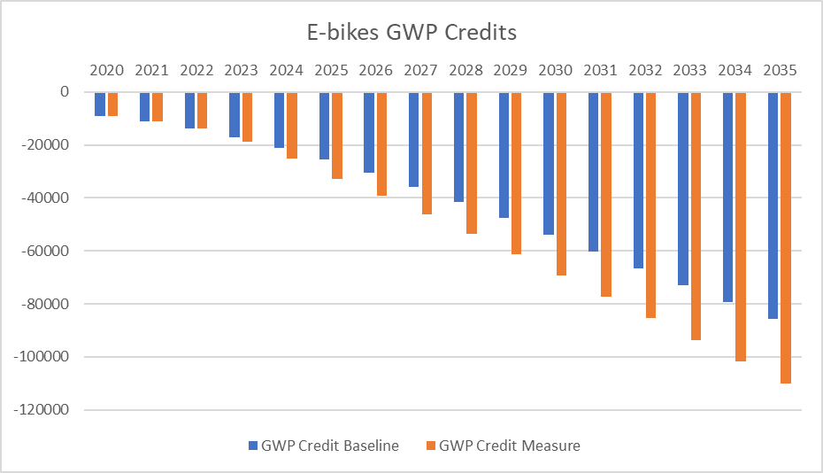
Figure 26: GWP Reduction (CO₂-eq).
Likewise, recycling also has beneficial effects on resource depletion, since secondary materials replace primary production. The target would lead to an annual reduction in Abiotic Depletion Potential of 25%. In 2035, a total reduction of 470 tonnes of Sb eq is achieved when compared to the baseline, mostly due to the increased collection of lithium-ion batteries.
For Human Toxicity the target would lead to a reduction of 28.5%. By 2035 the total avoided t 1,4-DB eq would be around 1 900 000.

>> Administrative burden
Producers, acting alone or collectively, would have to contribute to a new system of collection that would normally be funded via fees. This could entail changes in the financial obligations for producers as regards the coverage of collection and recycling costs, even if they are difficult to quantify at present.
A one-off expenditure for the constitution of reporting systems should also be considered, but the yearly cost of this system would be negligible.

>> Social impacts
The additional collection of other non-EV industrial batteries would create jobs in the collection and recycling industry. Hoarded waste lithium-ion batteries (particularly e-bikes) present a risk of fire and may cause considerable damage. An increase of collection of e-bike batteries (less hoarding at private homes) might reduce the risk of damages at private homes (if awareness and better safety standards are established at bicycle shops) or might simply shift risks and damage costs from private consumers to bicycle shops. Fire risks can potentially require higher insurance costs (similar problem as with the insurance of recyclers).

>> Economic impacts
Collection and transport costs will increase due to the additional amount of batteries powering light means of transport, and other similar ones also considered industrial at present. Because of additional collected and recycled amounts of industrial batteries, additional secondary materials would also be recovered, leading to additional revenues. Given the relatively high content of critical and valuable raw materials in these batteries it can be assumed that this sub-measure would be cost-neutral.

>> Stakeholders' views
In general, producers support increasing ambitions on collection and recycling of batteries.
However, the current no-losses policy seems the adequate tool to many stakeholders to ensure high collection rates for automotive, EV and industrial batteries. For that reason, many stakeholders are opposed to the setting of collection targets for all the different types of batteries now considered industrial. Only for very specific subclasses of industrial batteries, collection rates would be suitable and only if the methodology was based on the ‘available for collection approach’.
As an alternative, most stakeholders would accept the establishment of monitoring and reporting systems aimed at ensuring compliance with the no-losses policy, provided that it is based on the ‘available for collection approach’.
The risks of losses for batteries powering light means of transport are higher. In fact, the obligation to collect and recycle all these batteries is far from being achieved. From this point of view, and accepting the need of role of achieving higher collection rates, stakeholders would not oppose to the setting of specific targets.

Summary and conclusions
The fact that there are no specific collection targets for waste industrial, EVs and automotive batteries is considered as a barrier to achieve the no-losses policy established by the Batteries Directive for this battery type.
Two types of sub-measures have been considered: the establishment of a reporting system and the setting of targets for the collection rate of waste batteries.
The advantages of a reporting system for automotive, EVs and industrial batteries are considered to be sufficient to retain sub-measure a. A better knowledge of the mass flows will allow the operators concerned to identify the losses and better plan collection activities.
No additional benefits have been found in setting a collection rate for automotive, EVs and industrial waste batteries (sub-measure b). This, along with the important technical difficulties to establish such target, justifies that sub-measure b is not proposed.
On the contrary, for a particular type of batteries powering light means of transport there are advantages in setting targets for collection rates (sub-measure c). Even if these batteries are currently classified as industrial batteries, and therefore subject to a no losses policy, available evidence indicates that the collection rates are lower than the rest. Setting collection targets with the aim to increase collection rates appears to be effective and entail economic and environmental benefits.
Sub-measure c is based on the "available for collection" methodology (see sub-measure 1-d) and requires the collection of additional data and further development of the methodology. This is why it may be appropriate to re-assess the details related to setting such a target when more information is available.

Table 7: Measure 4 - Summary and comparison of impacts
 | Sub-measure a:  Reporting mechanisms for industrial and automotive batteries | Sub-measure b :  Explicit collection target for EVs, industrial and automotive batteries | Sub-measure c:  Collection target for batteries powering light means of transport
Effectiveness | Information on the fate of industrial batteries are key to address possible losses. It is reasonable to expect increases for the amounts of waste batteries collected. | No major differences would appear with respect to sub-measure a. It is reasonable to expect increases for the amounts of waste batteries collected. | Compared to the baseline, the additional tonnes collected increase by 29%.
Economic impact | Costs and revenues associated with collection will increase. The turnover of logistics, collection (collected waste industrial batteries) and recycling only for industrial non- automotive is estimated at EUR 27 to 50 million per year.  Recycling of additional industrial batteries collected would result in EUR 15 (2020) to 10 (2035) million for lead, and about EUR 2 (2020) to 23 (2035) million for secondary Co and Ni. | The economic impacts would be similar to sub-measure a since the expected increase would be similar. | Costs for collection and recycling will increase (to be organised through Extended Producer Responsibility. Due to the increased revenues from increased recovered materials it is assumed that this sub-measure will be cost-neutral.
Administrative burden | This sub-measure requires will create a small additional administrative burden. As suggested by stakeholders, extensive use of IT based technologies should be made (see also Measure 13).  Concerning automotive batteries, the reporting system should be built on the existing one set in motion by the End-of-life Vehicles Directive. | Setting a target would lead to a significant number of challenges (e.g. because of the high number of different types of models, as well as the lack of detailed information). | This sub-measure requires will create a small but negligible additional administrative burden.
Environmental impact | Increased levels of collection and recycling of industrial batteries will have positive effects for the environment.  According to the model, 60 t/a (2020) to 300 t/a (2035) more secondary cobalt could be recovered.  The losses and the risks for the health and environment would be lowered. In 2035, 13 000 tonnes of waste industrial lead-acid batteries and 9 000 tonnes of industrial lithium-based batteries would be collected per year and recycled, in addition to the baseline. | The environmental impacts would be similar to those in sub-measure a since the expected increase in the collection would be similar. | GWP: - 22%  ADP: -25%  HTTP: -28.5%
Social impacts | Available information indicates that per thousand tonnes of lithium-ion battery waste, 15 jobs are created for the collection, dismantling and recycling | The social impacts would be similar to those in sub-measure a since the expected increase in the collection would be similar. | Available information indicates that per thousand tonnes of lithium-ion battery waste, 15 jobs are created for the collection, dismantling and recycling
Stakeholders' view | Producers are aware of the advantages that reliable information on the status of industrial batteries provide. A large share of them nevertheless insist on that ‘real’ industrial and automotive batteries, are unlikely to be hoarded by customers, or lost in wrong waste streams.  Waste collectors and recyclers those that appreciate the most having information on the status of industrial batteries. Some of them consider this information of strategic nature since it would allow them to plan their activities appropriately.  There is a general request on that any measure should be efficient and transparent. | Even if the impact is roughly the same than with sub-measure a, stakeholders strongly oppose to the definition of collection rates for automotive and EV batteries. Some argue that the implicit target of 100 %, as requested by the no-losses policy, does not exist.  Such an extreme position is explained by the fear of that the new legal framework increases their obligations if a collection rate is set. | Stakeholders recognise that the risks of losses for these types of batteries is higher than for EVs and that, in fact, the obligation to collect and recycle the entirety of the batteries concerned is far from being achieved. From this point of view, they could accept collection rates that would guide in ensuring the efficiency of collection activities.
Preferred Sub-measure | X |  | X

Measure 5: Recycling efficiencies and recovery of materials

Introduction

>> What is the problem and why is it a problem?
Next to collection rate targets for waste batteries, the Batteries Directive also includes a provision that imposes a minimum recycling efficiency for lead-acid batteries (65%), nickel-cadmium batteries (75%) and "other" batteries (including lithium-ion) (50%). It also sets the obligation to recover lead and cadmium content to the highest degree that is technically feasible while avoiding excessive costs.
At the time of the introduction of the Directive, considering both the input to the recycling process (i.e. the collection rate) and the efficiency of the recycling process was an innovative approach that has stimulated the development and roll-out of state-of-the art metallurgical processes and increased material recovery rates in the EU. Research suggests that the Batteries Directive has this way indirectly contributed to making the EU a global leader in recycling capacity for spent batteries.
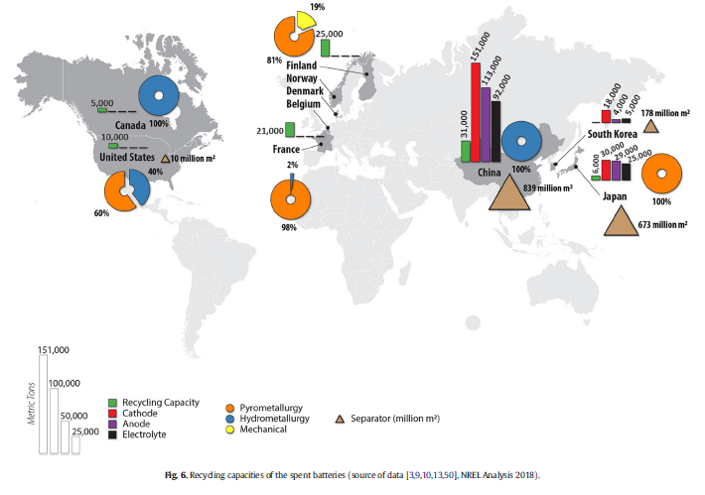
This approach of setting recycling efficiency targets and the obligation to reach high values for material recovery targets has been successful to a very large extent.
- In 2018 nearly all EU Member States achieved 75% recycling efficiency or higher for nickel-cadmium batteries, with some single exceptions, as shown in Figure 27 below.
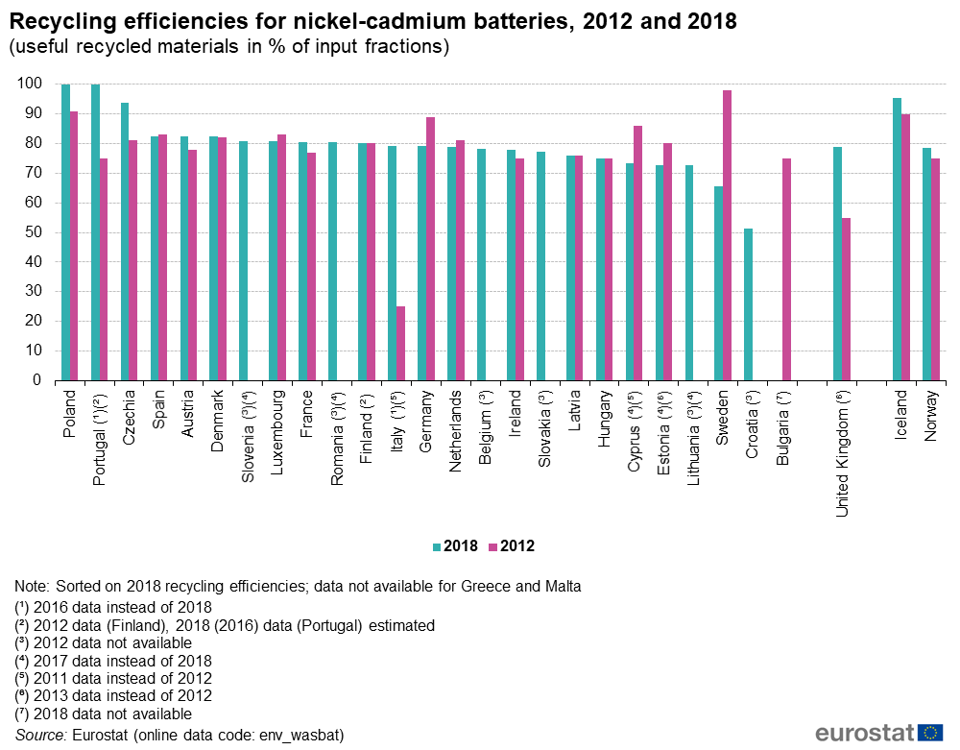
Figure 27: Recycling efficiencies for nickel-cadmium batteries, 2012 and 2018, taken from Eurostat
- For lead-acid batteries nearly all EU Member States achieved 65% recycling efficiency or higher in all reference years from 2012 to 2018. To date, the recycled input to lead-acid battery production in the EU is higher than 80%, making it an almost a fully circular business, as shown in Figure 28 below.

Figure 28: Amounts (in thousands of tons) of secondary and primary refined lead produced within the EU (27), and level of coverage of needs by secondary material (%).
This success can be attributed to the fact that the recycling of lead-acid batteries is a relatively simple process, and that the option of exporting or dumping lead-acid batteries when the market prices of lead were low has been excluded.
- For other batteries, the recycling efficiency target of 50 % was met in 2018 by those EU Member States that reported to EUROSTAT (or the most recent reference year for which data are available). The range of values was however too large, from around 50% to over 90% across the Member States, reflecting the miscellaneous composition of this class.
Despite the success of the approach, to date, the provisions in the Batteries Directive are no longer fit-for-purpose, as pointed out by its evaluation. Even if recycling efficiency targets are largely met, the directive's current provisions have not ensured a high level of material recovery.
The Batteries Directive sets materials recovery targets only for two substances: lead and cadmium, ignoring other valuable components of batteries. With regard to lead-acid and nickel-cadmium batteries the Directive no longer provides an incentive to push for the roll-out of state-of-the art recycling facilities.
For lithium-ion batteries the problem is even more pronounced. There are no specific provisions for lithium batteries, which does not properly reflect their growing market and economic importance, not encouraging their recycling and not taking the opportunity to further develop high-quality recycling processes for these batteries preventing the development of high-quality recycling processes.
For all these reasons, the Commission concluded, in the 2019 Report on the implementation of the directive, that the current recycling requirements are not appropriate, and that further targets for recycling should therefore be considered.

>> What is the objective?
The sub-measures considered in this section aim at ensuring adequate levels of recycling efficiency and material recovery.
In particular, to improve the efficiency of recycling process of waste batteries and the levels of recovery of specific materials.
The sub-measures aim at providing investment certainty and a stable regulatory framework that will support the development of cost-effective recycling technologies with efficient material recovery processes.

>> What are the sub-measures?
Recycling targets are analysed and revised only for lithium-ion and lead-acid batteries, due to their importance in the structure of the EU battery markets. As the importance of NiMH and NiCd is declining and their relevance is expected to further decrease, it is possible to conclude that there is no need to change or adapt existing recycling targets.
The following sub-measures are considered:
- Sub-measure a covers lithium-ion batteries:
  - Defining a recycling efficiency target for lithium-ion batteries
  - Establishing material recovery targets for Ni, Co, Li and Cu
- Sub-measure b covers lead-acid batteries:
  - Increasing the recycling efficiency for lead-acid batteries
  - Establishing quantified targets for the recovery of lead.
Within these sub-measures, different timescales are considered:
- Sub-measure a-1: targets for 2025
- Sub-measure a-2: targets for 2030
- Sub-measure b-1: targets for 2025
- Sub-measure b-2: targets for 2030

>> Baseline
In terms of weight, batteries placed on the market are dominated by lead-acid and lithium-ion batteries. According to many analysts, the former are expected to decline slightly in the coming years while the latter to experience a strong increase. Hence, in 2025, lithium-ion batteries would prevail. Figure 29 below shows the expected evolution of the market in terms of tons of batteries placed on the market.
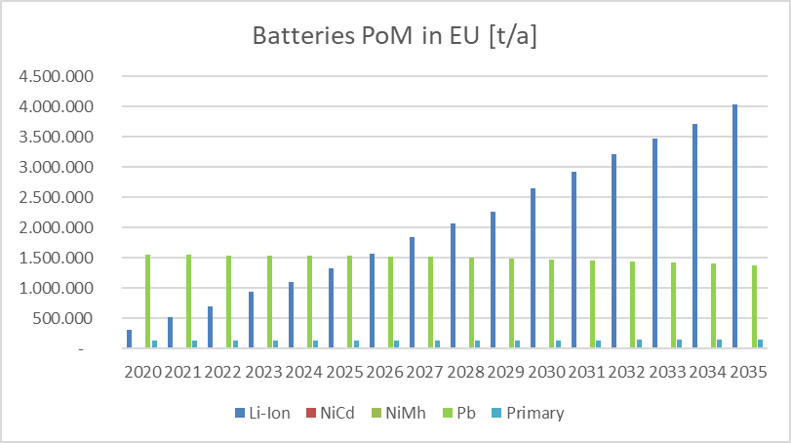
Figure 29: Batteries placed on the EU market (tons)
In terms of collection, at present waste lead-acid batteries represents more than 80% of the total weight of the batteries collected. Large quantities of lithium-ion batteries will only be available for recycling after some years from being placed on the market. Non-rechargeable batteries come in third place with about 4% of the total waste batteries collected, with alkaline batteries making up the majority of non-rechargeables (but their relevance continues to decline). NiMH account for less than 1% and NiCd for less than 0.5%.
The Batteries Directive sets the following minimum recycling efficiencies for recycling processes:
- Recycling of 65% by average weight of lead-acid batteries
- Recycling of 75% by average weight of NiCd batteries
- Recycling of 50% by average weight of other waste batteries and accumulators (where lithium-ion batteries are included).
In addition, the Directive requests the recovery of lead and cadmium to the highest degree that is technically feasible while avoiding excessive costs. No quantitative material recovery targets exist for specific materials.
The lead-acid recycling efficiencies reported by Eurostat range from about 70% to more than 90%, and are therefore significantly higher than the current target values of 65%. Information provided by the industry indicates that material recovery rates for cobalt, nickel and copper are 80%, while for lithium it is 10%.
Table 8: Assumed values for material recovery rates and recycling efficiencies for lithium-ion and lead-acid batteries in 2020below details the material recovery rates for specific substances and the recycling efficiency, which apply in typical recycling processes.
Table 8: Assumed values for material recovery rates and recycling efficiencies for lithium-ion and lead-acid batteries in 2020
 |  | lithium-ion  batteries | lead-acid batteries
Material recovery rates | Aluminium | 80%
 | Iron | 95%
 | Plastics | 0% | 10%
 | Lead |  | 93%
 | Nickel | 80%
 | Cobalt | 80%
 | Manganese | 0%
 | Lithium | 10%
 | Copper | 80%
 | Graphite | 0%
Recycling efficiency |  | n.a. | 83.4%

It needs to be noted that, although manganese is often recycled into ferromanganese and then used for steel alloys, it is reported with a 0% recovery rate, since it is not actually used in the batteries industry. Likewise, graphite is reported with a 0% recovery rate because it is not recovered as a material.

>> Assumptions made for the assessment of the impacts
There are two main assumptions in the assessment, which make the results very conservative:
- The values of material recovery in the baseline are overestimated. These values have been proposed by the stakeholders as the best ones currently in place, and the assessment has assumed that all recycling process meet them. Results obtained are therefore very conservative: the gains in terms of materials recovery or of other environmental improvements are underestimated.
- This assessment makes use of an approach based on closed loops, even if the concept of recycling process within the EU is an open one. Results obtained are therefore very conservative: only the materials recovered with a grade that would allow its use in battery manufacturing processes are considered. In reality, open loop processes yield additional amounts of recovered materials, even if not all at the same level of quality, and are less energy-intensive, resulting in additional environmental gains.

Sub-measure a – Defining a recycling efficiency for lithium-ion batteries and establishing recovery targets for Ni, Co, Li and Cu

>> Setting the targets

Defining a recycling efficiency for lithium-ion batteries
Table 9 presents the composition of typical lithium-ion NMC (nickel, manganese, cobalt oxide) batteries. In particular, from the data on the NMC 811 battery used for fully electric cars, it can be seen that the outer casing (i.e. the whole battery minus the weight of the cells and modules), which includes valuable materials like copper and aluminium, accounts for around 23%. These same materials, account for around 22% of the battery cells and modules while active cathode materials (cobalt, nickel, lithium) constitute around 22%.
Table 9: Composition of typical lithium-ion NMC batteries
 | HEV | PHEV | PHEV | BEV
 | NMC | NMC | NMC | NMC | NMC | NMC
 | 111 | 111 | 111 | 111 | 622 | 811
Cell components (kg)
Active cathode material | 4,89 | 12,58 | 25,19 | 41,52 | 35,01 | 34,93
Graphite | 2,75 | 7 | 13,9 | 23,18 | 22,73 | 23,15
Carbon black | 0,33 | 0,85 | 1,7 | 2,8 | 2,36 | 1,94
Binder (PVDF) | 0,42 | 1,08 | 2,15 | 3,55 | 3,16 | 4,01
Copper | 4,51 | 9,33 | 12,85 | 18,84 | 17,37 | 17,65
Aluminium | 2,33 | 4,73 | 6,76 | 9,8 | 9,03 | 9,25
Electrolyte: LiPF6 | 0,38 | 0,92 | 1,68 | 2,66 | 2,43 | 2,89
Electrolyte: Ethylene Carbonate | 1,05 | 2,56 | 4,68 | 7,43 | 6,79 | 8,07
Electrolyte: Dimethyl Carbonate | 1,05 | 2,56 | 4,68 | 7,43 | 6,79 | 8,07
Plastic: Polypropylene | 0,46 | 0,98 | 1,37 | 1,82 | 1,66 | 1,68
Plastic: Polyethylene | 0,11 | 0,23 | 0,32 | 0,42 | 0,38 | 0,39
Plastic: Polyethylene  Terephthalate | 0,08 | 0,13 | 0,22 | 0,34 | 0,32 | 0,34
Subtotal: Cell | 18,37 | 42,94 | 75,49 | 119,77 | 108,03 | 112,37
Module components without cell (kg)
Copper | 0,21 | 0,2 | 0,2 | 0,43 | 0,43 | 0,44
Aluminium | 0,98 | 2,5 | 3,92 | 7,22 | 6,77 | 7,15
Plastic: Polyethylene | 0,04 | 0,05 | 0,05 | 0,18 | 0,18 | 0,18
Insulation | 0,05 | 0,05 | 0,05 | 0,11 | 0,11 | 0,11
Electronic part | 0,42 | 0,42 | 0,42 | 1,12 | 1,12 | 1,12
Subtotal: Module without cell | 1,69 | 3,22 | 4,63 | 9,06 | 8,6 | 9
Pack components without module (kg)
Copper | 2,26 | 3,88 | 3,66 | 0,09 | 0,09 | 0,09
Aluminium | 2,56 | 4,25 | 8,28 | 22,33 | 21,5 | 22,29
Steel | 0,38 | 0,62 | 1,02 | 1,02 | 0,94 | 1,01
Insulation | 0,23 | 0,32 | 0,4 | 0,69 | 0,67 | 0,69
Coolant | 2,12 | 3,24 | 3,51 | 7,1 | 7,02 | 7,3
Electronic part | 2,46 | 4,66 | 4,64 | 4,91 | 4,9 | 4,93
Subtotal: Pack without module | 10,01 | 16,96 | 21,52 | 36,15 | 35,12 | 36,32
Total: Pack | 30,07 | 63,13 | 101,64 | 164,98 | 151,76 | 157,68

Taking into account the actual efficiencies of recycling processes, presented in Table 8, the recovery of the materials mentioned reaches more than the 50% in weight.
If, in addition, the recycling of aluminium and copper in the outer casing was taken into account, the recycling efficiency so estimated would reach almost 70%. However, the concept of recycling efficiency in Commission Regulation (EU) No 493/2012 excludes the outer casing.
Taking these data into account the following values are considered to be feasible for the proposed sub-measures:
- Sub-measure a-1: recycling efficiency for lithium-ion batteries of 65% by 2025
- Sub-measure a-2: recycling efficiency for lithium-ion batteries of 70% by 2030

Establishing material recovery targets for Co, Ni, Li and Cu
Specific targets for the material recovery of these substances should be established. According to the rules in force at present, at present, the values for the recovery of materials should be calculated for theoretical ‘processes’ in a period of one year.
Two sets of specific material recovery targets to be achieved by 2025 and 2030 have been assessed:
- Sub-measure a-1: Co 90%, Ni 90%, Li 35% and Cu 90% by 2025
- Sub-measure a-2: Co 95%, Ni 95%, Li 70% and Cu 95% by 2030
It is assumed that the 2025 material recovery targets can be met with the current recycling efficiency for lithium batteries (50%). The 2030 material targets could only be met when recycling efficiencies will increase. This is why the targets for recycling efficiency and material recovery are presented together in the main report.
Table 10 below presents an overview of the proposed targets for recycling efficiency and material recovery rates for specific materials of lithium-ion batteries for sub-measure a.
Table 10: Material specific recovery rates used for the estimation of the active materials recovered in the recycling of lithium - ion batteries
 | Baseline | Target | Target
 | recovery rates 2020 | recovery rates 2025 | recovery rates 2030
Aluminium | 80%
Iron | 95%
Plastics | 0%
Nickel | 80% | 90% | 95%
Cobalt | 80% | 90% | 95%
Manganese | 0%
Lithium | 10% | 35% | 70%
Copper | 80% | 90% | 95%
Graphite | 0%

>> Effectiveness
The demand for cobalt is growing very rapidly due to the increase of lithium-ion batteries placed on the market. Due to the delay with which waste lithium-ion batteries are available for recycling, the amount of collected cobalt remains significantly below the quantities of the primary material, i.e. PoM, as in Figure 30 below. Amounts collected increase from about 2 000 tonnes in 2020 to about 15 000 tonnes in 2035.
Figure 31 shows the development of cobalt contained in collected lithium-ion batteries (in t/a) in the EU from 2020 to 2035 and the amount of recovered cobalt in the same periods (baseline versus sub-measure a). By implementing the proposed recycling efficiency and the recovery targets the recovered amount increases from 80% in the baseline to 90% in 2025 and 95% in 2030. In total, about 11 000 tonnes of Co are additionally recovered from 2025 to 2035 if sub-measure a is implemented (260 tonnes in 2025 up to 2200 tonnes in 2035).
A similar effect would occur for lithium, nickel and copper, as summarised below,
- Lithium: increasing amounts would be recovered every year (2025: 170 tonnes; 2035: 5400 tonnes), and a total cumulative amount of 21 500 tons from 2025 to 2035;
- Nickel: increasing amounts would be recovered every year (2025: 230 tonnes; 2035: 8300 tonnes), and a total cumulative amount of 30 700 tonnes from 2025 to 2035.
- Copper: increasing amounts would be recovered every year (2025: 630 tonnes; 2035: 14 000 tonnes ), and a total cumulative amount of about 56 000 tonnes from 2025 to 2030.

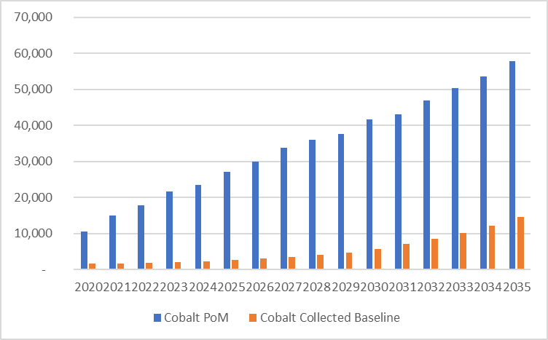
Figure 30: Cobalt in batteries placed on the market and collected.

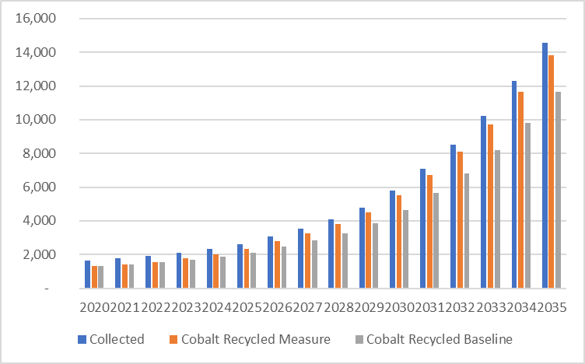
Figure 31: Cobalt collected and recovered (baseline versus sub-measure a)

>> Environmental impacts
The main components of batteries are of mineral origin. Recycling waste batteries keeps raw materials productive for longer periods, by recovering valuable materials and preventing losses. Thus, for instance, secondary production of one ton of lithium could be assured by recycling 28 tons of used batteries (from around 256 electric-vehicles).,
Savings in GHG emissions due to recycling of lithium-ion batteries within the EU from 2020 to 2035 (baseline and measure), under the supposed conditions of recycling efficiency and material recovery are shown in Figure 32.
Negative emissions result from the difference between environmental burden for the recycling process and credits for secondary materials from recycling replacing primary production. About 150 000 (in 2020) to 620 000 tonnes (in 2030) of CO 2-eq are avoided every year compared to the baseline. A cumulated total amount of 9.8 million tonnes of CO 2-eq could be avoided between 2020 and 2035, with the measure compared to the baseline, which corresponds to an overall reduction of 4.3%.
Comparisons with the baseline might not seem impressive. Again, it should be underlined that the assumptions include high rates of recovered materials in the baseline and closed loop approaches to recycling. Both assumptions are useful to provide conservative results, but are not necessarily close to reality.
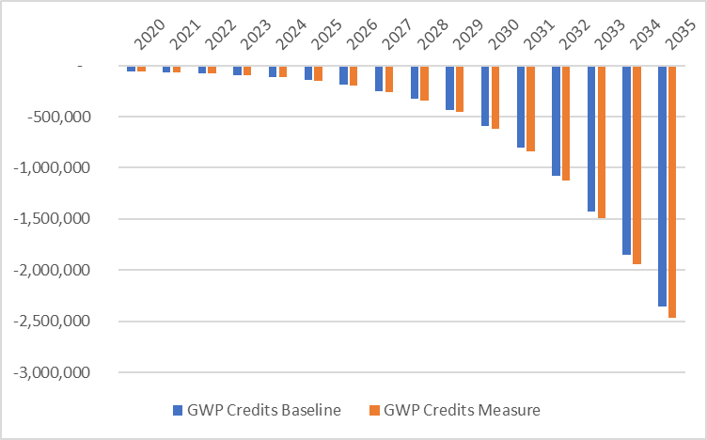
Figure 32: GHG savings due sub-measure a.
Similar conclusions are obtained when assessing the impact on the depletion of abiotic resources (ADP, in t Sb-eq/a) due to recycling of lithium-ion batteries.
The evolution of the emissions affecting human health (Human Toxicity Potential, HTP in t 1.-DB eq/a), following this sub-measure is shown in Figure 33 below. Negative emissions result from the difference between environmental burden for the recycling process and credits for secondary materials from recycling replacing primary production. About 280 000 would be avoided in 2025, increasing to annual savings of 5 600 000 tonnes of 1,4-DB-eq in 2035, compared to the baseline. Between 2025 and 2035 a cumulated total amount of 22 million tonnes of 1,4-DB-eq could be avoided with the measure compared to the baseline, which corresponds to an overall reduction of around 15%.
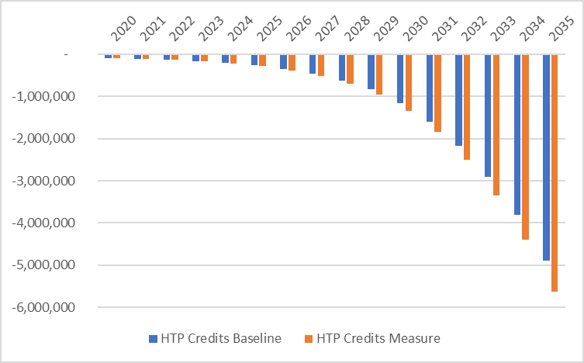
Figure 33: Savings in emissions affecting human health and recycling due to sub-measure a (in t 1,4-DB eq/a)

>> Economic impacts
Higher recycling efficiencies and material recovery rates will result in higher revenues of secondary materials within the EU. If the proposed new recycling efficiency for lithium batteries and recovery targets are implemented, that additional amounts of nickel, copper, cobalt and lithium will be available in the European market, even under truly conservative assumptions.
The recovery of valuable materials is one economic driver for recycling of lithium-batteries, the metals contained in the cathode representing 90% of the total value. At present, cobalt, copper, nickel, steel and aluminium are recycled.
As an indicative result, if the materials recovered following this sub-measure were sold at the average price between 2013 and 2019, additional revenues would be obtained for each substance in the period 2025 – 2035,
- As regards lithium, the revenues would range from 8 million € in 2025 to 255 million € in 2035.
- For cobalt, the revenues would range from 9.5 million € in 2025 to 80 million € in 2035.
- In the case of nickel, the revenues would range from 2,4 million € in 2025 to 90 million € in 2035.
- Finally, the revenues in the case of copper would range from 3.3 million € in 2025 to 72 million € in 2035.
These figures have only an indicative value: in addition to the main assumptions in this assessment, their price is the average of prices in past years, in a context where the market is expanding and the prices increasing.
The proposed increased recycling efficiency and material recovery targets for lithium batteries will require increased recycling capacities and investments. According to the model used, the amounts of collected lithium-ion batteries will increase from 21 000 tonnes in 2020 to about 700 000 tonnes in 2035. In terms of units, the number of lithium batteries ready for recycling would increase 700 times between 2020 and 2040.
The actual cost of recycling for lithium batteries is not publicly available or kept confidential. Recycling costs can be disaggregated into logistic costs (dismantling, collection, transport) and plant specific costs, including investments and operations. The economies of scale present a very important factor to be considered (applies to plants but also to logistics) and future plants will be of much higher capacity. This is not a mature market, although it is growing as companies respond to likely increases in demand for lithium, and likely increases in supply of batteries for recycling.
Economic operators consulted did not disclose precise information on the expected costs of recycling due to business confidentiality, but have provided information to estimate the approximate ranges (in EUR per tonne), as shown below in Table 11.
Table 11: Ranges of recycling costs (EUR per tonne)
 | Min | Max
Logistic costs | 1160 (2020) to about 400 (2035) | 1740 (2020) to about 600 (2035).
Recycling plant costs | 1330 (2020) to about 460 (2035) | 1990 (2020) to about 700 (2035).

It should be noted, that there are a number of ongoing investments (e.g. one important producer is investing €100 million in expanding capacity by 40% at its refining and recycling plant) to allow for higher capacity and increased efficiency, but data on costs is commercially confidential.
Uncertainty regarding the full cost of recycling lithium-ion batteries is however one amongst several of the challenges to be faced in the short term , including the lack of specific regulation for collecting and sorting lithium batteries or the low volumes of collected and recycled batteries.
Recycling-oriented policies, like EPR, will be required to supplement market-based recycling initiatives.

>> Administrative burden
Current reporting systems for recycling efficiencies will have to be modified (including the provisions currently established by the Batteries Directive). A new reporting system for the compliance on material recovery rates has to be developed and implemented. It should be underlined however that the processes intended to deliver the information required, already exist as part of the internal management of recycling companies.

>> Social impacts
Social impacts are dominated by the development of the market that, in the case of lithium batteries, is rapidly growing.
An attempt to calculate the effect of the treatment and recycling of lithium batteries has been made by CEPS. It can be assumed that “per thousand tons of lithium-ion battery waste, 15 jobs are created for the collection, dismantling and recycling of these batteries. Of those 15 jobs, about 80% would be for the collection and dismantling of lithium-ion batteries, while the remaining 20% of jobs would be for the recycling of batteries.” Translated to the expected amount of lithium batteries in the EU, the authors propose a figure between 524 and 654 new jobs in 2030 and between 1 168 and 1 460 in 2035. The differences depend on the actual rate of material recovery.
The impact will also depend on the technologies used for dismantling and recycling. Compared with the effect on jobs due to market trends, the impact of the proposed sub-measure is minor.

Sub-measure b – Increasing the value of the recycling efficiency for lead-acid batteries and establishing quantified targets for the recovery of lead.

>> Setting the targets

Increasing the recycling efficiency for lead-acid batteries
Lead is a hazardous substance and for that reason, the Batteries Directive establishes a recycling efficiency target and a material recovery target to avoid its dissemination into the environment. Recycling processes taking place in the EU largely meet the established recycling efficiency. To support the highest possible recovery of lead, a new efficiency target could be established, along with a new material recovery target.
Only the recovery of lead and plastics are considered in this assessment. Other components can also undergo recycling (e.g. to produce sulphuric acid) but are not taken into account.
The reduction in the environmental impacts of lead-acid batteries is dominated by the recycling of lead. Recycling of plastics (casing) is relevant for savings as regards Global Warming Potential (GWP) (ca. 30%). Abiotic Depletion Potential (ADP) is negligible for plastics.
Table 12 belowError! Reference source not found. shows the composition of lead-acid batteries as well as the potential contribution to the reduction of environmental impacts for recycled materials (GWP and ADP).
Table 12: Material composition of lead-acid batteries and contribution to reduction of the environmental impact
 |  | 100% recovery rate | 100% recovery rate
 | Composition | ADP | GWP
Pb | 68% | 100% | 70%
plastics | 12% | 0% | 30%
Total | 100% | 100% | 100%

Recycling processes for Pb-acid are well established in the EU. Most average Pb-acid recycling efficiencies reported by MS to Eurostat are significantly higher than the current target values of 65% (Eurostat database). For the reference year 2017, an average recycling efficiency of 83.4% was achieved on EU-level. Most Member States range from about 70% to more than 90%.
A target value of 75.0%, with three Member States having to reach the new value, would result in an increase of the average recycling efficiency from 83.4% to 83.6% at EU-level. A target value of 80.0%, with six Member States having to reach the new value, would result in an increase of the average recycling efficiency from 83.4% to 84.4% at EU-level.
Based on this analysis an increase of the recycling efficiency from 65.0% to 75.0% is proposed: the effect obtained would be very similar, at a lower effort.
Taking these data into account the following values are considered to be feasible for the proposed sub-measures:
- Sub-measure b-1: recycling efficiency for lead-acid batteries of 75% by 2025
- Sub-measure b-2: recycling efficiency for lead-acid batteries of 80% by 2030

Setting a quantified target for the material recovery of lead
According to the data reported by Eurostat, on average, material recovery rates for lead, at EU-level were around 93 % between 2014 and 2018. This was used as the baseline figure.
Using the average rate of the reference year 2017 as an example, the target value for the material recovery rate is developed. A target value of 95.0% (which only six Member States do not meet) would result in an increase of the average recovery rate from 95.9% to 97.0% at EU-level. A target value of 96.0% (which only six Member States do not meet) would result in an increase of the average recovery rate from 95.9% to 97.3% at EU-level. A target value of 95 % starting in 2025 is therefore proposed.
Taking these data into account the following values are considered to be feasible for the proposed sub-measures:
- Sub-measure b-1: material recovery target for lead of 90% by 2025
- Sub-measure b-2: material recovery target for lead of 95% by 2025

>> Effectiveness
Figure 34 Error! Reference source not found.shows the modelled development of lead contained in collected lead-acid batteries (in tons per year) in the EU from 2020 to 2035, and the amount of recycled lead in the same period, both as baseline and as result of the implementation of the proposed sub-measure. The average recovery rate for lead increases from 93% to 95% in 2030.
An additional amount of 18 000 tonnes would be recovered every year (from 2025 to 2030). In total, about 191 000 tonnes of lead would be recovered from 2020 to 2035 (cumulative).

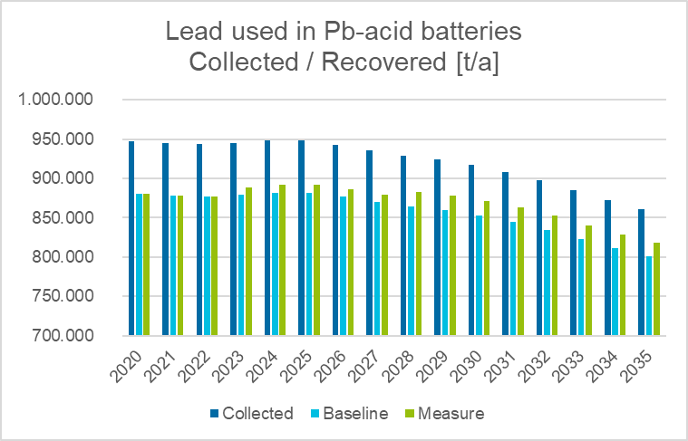
Figure 34: Lead from batteries collected and recycled

>> Environmental impacts
Figure 35 below shows the development of avoided GHG (global warming potential, GPW in CO₂-eq/a) due to the recycling of lead-acid batteries in the EU from 2020 to 2035, for both the baseline and the proposed sub-measure.
About 13 000 tonnes of CO₂-eq are avoided every year (from 2025 to 2035) compared to the baseline. Up to 2035, a cumulative amount of 189 000 tonnes of CO₂-eq could be avoided compared to the baseline, which corresponds to an overall reduction of 2%. In percentage terms this does not seem like a large difference but the quantities involved (189 000 tonnes of CO₂-eq) are relevant.

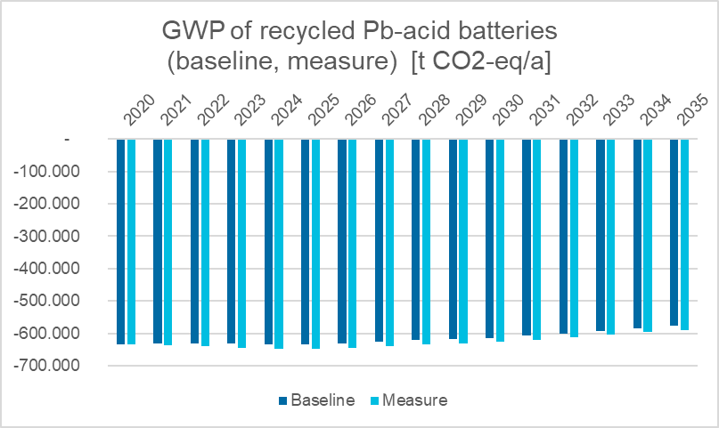
Figure 35: GWP savings due to the recycling of lead – acid batteries (tons of CO₂_eq per year)

>> Administrative burden
The obligation already exists, but not quantified. Strictly speaking, the only difference is that if the proposed sub-measure is implemented, a compliance dimension will be added.
For both national authorities and recyclers, generation of data and processing of information can be similar to the baseline, since he obligation to collect information and report exists already.

>> Economic impacts
Recovery of lead and plastics is the main economic driver for recycling. The proposed increased recycling efficiency and material recovery targets for lead-acid batteries and for lead, respectively, will not require increased capacities but improvements of the processes concerned. Additional investments would only be needed to ensure that the new values are met.
Figure 36 below, shows the additional recovered amounts of lead from 2025 to 2035 and the additional revenues that can be obtained. About 19 000 tonnes of lead are additionally recovered in 2025 compared to the baseline. In total, about 238 000 additional tonnes are recovered from 2025 to 2035 (cumulative) compared to the baseline. Using the average value of recycled lead between 2013 and 2019, the revenues could range from €33 million in 2025 to €30 million in 2035.

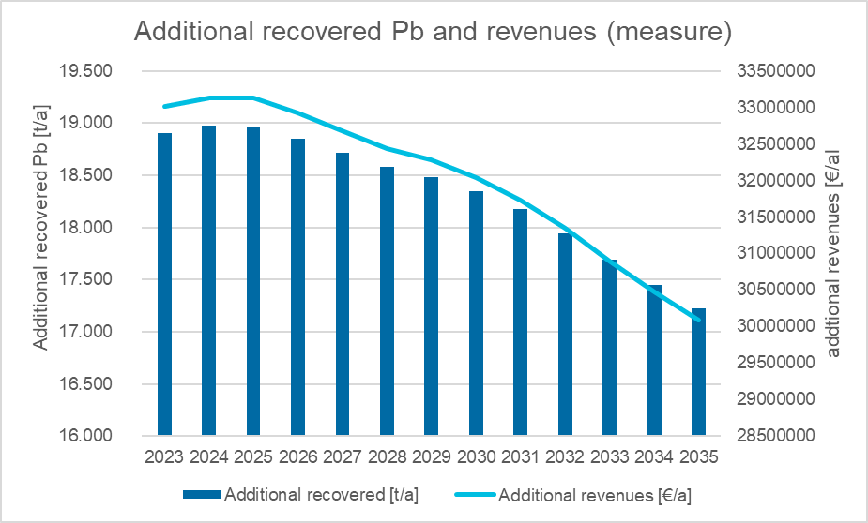
Figure 36: Additional amounts of recovered lead and additional revenues related to sub-measure b

>> Social impacts
Changes in the number of jobs in collection and recycling activities seem to be caused by market trends rather than by the measure considered.
Social impacts are dominated by the development of the market that, in the case of lead-acid batteries, is slowly decreasing. This would be translated into a decrease in the number of jobs in the recycling of lead-acid batteries. However, the proposed increase in efficiency could contribute to keeping current levels of activity.

Stakeholders’ views
There is a recognition that current minimum values of recycling efficiency established in the directive are not driving recycling activities upwards. Moreover, stakeholders find that the absence of a specific recycling efficiency value for lithium batteries is not supporting the deployment of this sector of activity.
For many stakeholders, legal obligations constitute a driver for a sought innovation and, at the same time, an effective means to facilitate the functioning of the internal market.
Stakeholders underline the importance of ensuring high levels of material recovery even if the amounts concerned will be unable to meet the demand of the EU battery industry.
Three main approaches have been proposed by stakeholders in order to ensure that the amount of materials recovered grows:
- Update the values that are no longer sufficiently demanding for the industry.
- Specify conditions for the recycling of lithium batteries.
- Quantify the degree of material recovery for a number of important substances.
Stakeholders underlined that the recycling efficiencies and the material recovery targets are two sides of the same coin and that they should be considered together. Splitting them in the assessment would provide incomplete views.
As regards the establishment of material recovery rates, some stakeholders indicated that the impact on specific industrial activities would depend on the capabilities of current facilities to incorporate new processes or updating existing ones.
In any case, European producers of (industrial) batteries support the increasing ambitions on recycling of lithium-ion batteries. One producer stated that they are already scaling up efforts in battery recycling and so they welcome the initiative in closing the loop on battery materials.
Some stakeholders proposed that quantified recovery targets for the recovery of materials were defined in a way that allowed their joint calculation for some substances, and not individually. There was no evidence available to judge the viability of this approach within the EU, in terms of increasing the materials recovered. In any case, this issue could be addressed at a further stage, since the methodology to calculate the amounts of materials recovered remains to be defined in detail.

Sub-measures discarded in an early stage

>> Sub-measure c: Recyclability conditions
The proposed sub-measure consists in the definition of design conditions for batteries that make recycling easier. The easier the dismantling, for instance, the higher the level of material recovery.
Without discrediting such an approach, it was considered that Measure 11 on design requirements is more suitable to establish conditions to make the removability of e.g. portable batteries from WEEE easier, with expected positive results in the collection and recycling of portable waste batteries.
It was also considered that the product policy that is currently in preparation will result in provisions that could be applied in the future to batteries.
Finally, the setting of specific conditions in this respect for batteries was considered a strong intervention on the market, that could have unexpected negative results.

>> Sub-measure d: Add cobalt, nickel, lithium and graphite to the substances to be recovered to the highest possible technical degree (without quantified targets)
After initial consideration and discussion with stakeholders, this sub-measure was considered not to be sufficiently strong as to promote sufficiently recycling activities within the EU.

Summary and conclusions
Measure 5 aims at ensuring adequate levels of recycling efficiency and material recovery levels, so as to give a regulatory incentive for the roll-out of state-of-the art recycling technologies.
Based on the analysis above, the preferred sub-measures are sub-measures a-1, a-2, b-1 and b-2. These sub-measures are considered to be technically feasible, now or in the near-future. They will require some investments in technology and capacity, which should lead to revenues from increased recovered materials. The environmental benefits are expected to be positive.

Table 13: Measure 5 – Summary and comparison of impacts.
 | Sub-measure a: Lithium-ion batteries  Recycling efficiency lithium-ion batteries: 65% in 2025 (a-1), 70% in 2030 (a-2)  Material recovery rates for Co, Ni, Li, Cu: resp. 90%, 90%, 35% and 90% in 2025 (a-1), 95%, 95%, 70% and 95% in 2030 (a-2) | Sub-measure b: Lead-acid batteries  Recycling efficiency lead-acid batteries: 75% in 2025 (b-1), 80% in 2030 (b-2)  Material recovery for lead: 90% in 2025 (b-1), 95% in 2030 (b-2)
Effectiveness | In total, around 11000 t of Co, 30700 t of Ni, 21500 t of Li and 56000 tons of Cu are additionally recovered from 2025 to 2035 (cumulative) compared to the baseline. | An additional amount of 18 000 tonnes would be recovered every year (from 2025 to 2030). In total, about 191 000 tonnes of lead would be recovered from 2020 to 2035 (cumulative).
Economic impact | Under very conservative assumptions, estimated revenues range from € 23 million per year at present to € 497 million per year in 2035.  There is some uncertainty as regards costs of recycling. Available information underlines the important investments that are needed to increase recycling capacities (700 times), but information indicates the importance of | Under very conservative assumptions, about 32 million € per year until 2035 are estimated, in a context where the use of lead in batteries is believed to continue decreasing slowly.
Administrative burden | Similar obligations exist already..  Mechanisms to gather compliance information should be in place but will have to be modified. A new reporting system for the compliance on material recovery rates has to be developed and introduced.
Environmental impact | Under very conservative assumptions, up to 2035 a cumulative amount of 9.8 million tonnes of CO₂-eq could be avoided compared to the baseline, which represents a reduction of around 4%. | Under very conservative assumptions, up to 2035, a cumulated total amount of 189 000 tonnes of CO₂-eq could be avoided compared to the baseline, which corresponds to a reduction of 2%.
Social impacts | Employment impact of the collection and recycling of EV lithium batteries has also been estimated. In 2030, between 2168 and 3272 new jobs would have been created. In 2035, between 5481 and 7302 new jobs.  Social impacts are dominated by the development of the market that, in the case of lithium batteries, is rapidly growing. This would necessary be translated into additional jobs in lithium-ion recycling: the demand will be much higher than the supply. | The sub-measure could contribute to mitigate the expected negative impact of current market trends as regards lead-acid batteries, expected to diminish its importance in coming years.
Stakeholders’ view | The sub-measures receive a broad stakeholders’ support, which appreciate the importance of concerned provisions to boost recycling activities within the EU.  Stakeholders underline the importance establishing a separate recycling efficiency target for lithium-ion batteries and quantifying material recovery targets for some of their valuable components.  In the case of lead-acid batteries, there is a general recognition that the current value is no longer driving the innovation efforts of the companies.  Concerning the establishment of material recovery rates, some stakeholders indicated that the impact on specific industrial activities would depend on the capabilities of current facilities to incorporate new processes or updating existing ones.
Preferred Sub-measure | X | X

Measure 6: Carbon footprint for industrial and EV batteries

Introduction

>> What is the problem and why is it a problem?
The massive deployment of batteries in transport and energy storage holds the promise of being a key factor in helping decarbonise mobility. However, the manufacturing of batteries requires energy and natural resources, from the extraction of raw materials to the electricity consumed in their production and during their use and end-of-life treatment further energy losses and environmental impacts may occur. Therefore, as the uptake of batteries increases, their life cycle environmental impacts should be further reduced, so as to ensure that decarbonisation becomes a reality. In a recent LCA meta-study Ellingsen et al concluded that the production phase is the main contributor to life cycle GHG emissions of lithium-ion batteries, while the use phase and end-of-life treatment hold much smaller contributions.
According to the Product Environmental Footprint Category Rules (PEFCR) for rechargeable batteries for mobile applications, climate change is the second highest impact category after the use of minerals and metals.
Currently however, the data needed to calculate carbon impacts is not always readily available and often not comparable. This hampers fair and transparent competition for battery manufacturers in terms of sustainability claims. Likewise, it hampers sustainable choices in the transitions underway in the mobility and energy storage sectors.
From a geographical perspective, the decarbonisation of transport and energy storage should not take place at the expense of social and environmental impacts domestically, or elsewhere.
Given the complexity and length of battery value chains, it is unlikely that the market, left to its own devices, will ensure that all costs associated to battery manufacturing are properly identified and internalised.

>> What is the objective?
The measure aims to contribute to the Union’s objective of reaching climate neutrality by 2050 and fight climate change. Making available reliable, comparable and verifiable information on the carbon footprint associated with battery manufacturing will promote cleaner electric vehicles .It may also enable other policies at EU and national level fostering the production of batteries with lower environmental impacts, such as environmental labels, reduced VAT for electric vehicles or eco-modulated fees in battery take-back schemes. It might also inform Green Public Procurement criteria for electric vehicles, as is already being done in France for the public tendering of photovoltaic panels.

>> Baseline
Available evidence indicates that greenhouse gas emissions from the production of electro-mobility batteries have been declining in recent years, due to the scaling up of cell manufacturing and the gradual decarbonisation of the electricity grid. Numerous battery and car manufacturers have already taken public commitments to produce or purchase batteries with the lowest possible carbon and environmental footprint. Given the current social and political context, it is very likely that the market will, to a certain extent, increasingly reward low carbon batteries.
A recent literature review study for batteries with Nickel Manganese Cobalt chemistry identified a range between 61 and 106 kg C02-eq/kWh battery capacity. This is in line with the values (65 kgC02/kWh) in a recent article performing regional life cycle analysis of automotive lithium-ion nickel manganese cobalt batteries based on the US Argonne National Lab GREET model and the values in the ecodesign study carried out in support of this regulatory proposal (77kgC02/kWh). The variance within the referred range is primarily dependent on the energy mix used to manufacture the batteries.
Based on the current market and political context, it is reasonable to assume that manufacturers will continue to reduce gradually the carbon footprint associated with the batteries they place on the market.
However, the lack of common rules to calculate batteries carbon footprint prevents taking these green claims at face value. In the absence of clear, comparable and verifiable rules to calculate the carbon footprint of the batteries lifecycle, economic operators will not be able to reap the full benefits of their efforts to reduce their batteries’ footprint.
The establishment of commonly accepted carbon footprint rules and datasets will also provide an incentive for market differentiation based on the relative carbon intensity of batteries.
The baseline scenario will therefore be characterised by piecemeal efforts to reduce batteries’ carbon footprint, but without effective means for buyers or end users to ascertain such environmental claims.

>> What are the sub-measures?
- Sub-measure a, would consist in establishing a mandatory carbon footprint declaration for all rechargeable industrial and EV battery models with internal storage placed in the Union market..
- A more ambitious sub-measure b, would consist in putting in place a mechanism for setting carbon footprint performance classes and maximum carbon footprint thresholds.
For the main battery chemistries currently found in the market, the PEFCR define how to calculate a number of impact categories, including climate change. Therefore, a mandatory requirement is being proposed to report the carbon footprint calculated according to a set of agreed rules, for which the existing PEFCR would be the starting point. It is anticipated that a free web-based tool and free secondary data access will be available to facilitate this calculation to economic operators affected by the regulation.
The calculation of the carbon footprint requires information on the residual electricity mix used in the production of the battery. The PEFCR allow factoring in information on supplier-specific electricity mixes, which may improve the carbon footprint results compared to the ones obtained with the use of default country residual grid mixes.
Before mandating the rules for the calculation of the carbon footprint, a consultation process with industry and Member States seems necessary to fine-tune those rules and clarify how they will be maintained over time. A proper enforcement of the regulatory proposal will most likely require putting in place a third party verification system rather than relying on self-declarations, so that fair and verifiable mechanism is established.. The use of a common calculation tool and same secondary datasets will contribute to reduce the costs of the carbon footprint calculation and of the independent third party verification.

>> Enablers / review clause / changes to definitions
The development of the detailed carbon rules in a technology neutral way will most probably require proposing secondary legislation to complement provisions in the basic act. This is also likely to be the case for the development of incentives, such as carbon performance classes and/or green public procurement criteria, as well for market restrictive measures like thresholds.

>> Links to other measures
The further elaboration of the sub-measures being described below relies on the availability of a battery database or a battery passport, or both, that will enable the collection of market information on the relative carbon content of battery cells/modules being placed on the market. Therefore there is a link with Measure 12, as the carbon footprint declaration should be publicly available and form part of the battery passport.

Sub-measure a – Mandatory carbon footprint declaration

>> Effectiveness
This policy sub-measure would introduce a mandatory carbon footprint declaration for industrial and EV batteries. Bringing about this transparency should have a limited impact on the carbon footprint associated to the battery’s life cycle, and, in particular, to the production phase, which is where manufacturers may make the largest difference, as this will effectively grade the different battery models being placed in the Union market.

>> Economic impact
It has not been feasible to quantify any possible impacts of the proposed obligation on battery prices since no methodology is available to estimate the effect of this regulatory proposal in isolation from other cost drivers. As a proxy indication, manufacturer feedback indicates that they would be ready to pay premium prices to secure renewable electricity generation for their factories in order to lower the carbon footprint of battery production and thus attain green credentials.

>> Administrative burden
For industry
To estimate the total costs that would be imposed on industry, it is necessary before to understand the nature of the obligation this sub-measure consists in. Generally speaking, batteries for automotive applications can be placed on the market as battery cells, modules or packs. Battery cell manufacturers are better placed to understand and calculate the carbon footprint associated to their production, so it would make sense to place the obligation at that level. However, battery cells can be placed directly in the EU internal market as part of a battery pack within a finished product. This implies that the obligation would have to be extended to vehicle manufacturers placing finished products on the market, which contain battery cells.
Furthermore, the obligation would be imposed per battery cell or module type, not per physical battery, as the obligation seeks to highlight the differentials in the relative carbon footprint associated to their manufacturing.
The introduction of a new obligation on carbon footprint reporting will require companies to collect necessary data (which in some cases may already be collected for other reporting exercises) including from upstream supply chain partners and carry out certain calculations. If a third party verification is established, there will be additional external costs.
This obligation is not likely to enter into application before 2024. By that time, it is estimated that there will be around 20 battery factories in the EU producing battery cells for electro-mobility applications. Typically, each factory will be producing, on average, 5 different types of cells, which means there could be around 100 different battery cell carbon footprint declarations. This figure needs to be corrected to account for the number of battery cells/modules which are likely to be introduced in the EU market directly as part of finished products. If we assume that up to 30 vehicle manufacturers will be importing models into the EU and that each manufacturer uses 5 different types of battery cell/modules, this represents an additional 150 carbon footprint declarations. The total number of battery cell/module declarations could therefore be in the region of 250.
The declaration of the carbon footprint associated to the battery’s life cycle will require skilled resources. The Commission intends to offer a web-based tool to facilitate the process of calculation of the carbon footprint following the adopted rules.
The costs for performing the calculation of the carbon footprint for each type of battery cell/module are expected to be relatively low, especially for companies that are already collecting the information due to internal environmental policies, company CSR reporting and other purposes. This was concluded based on information collected on a confidential basis with companies that are already implementing the Commission PEF method based on existing PEFCRs.
If we assume the availability of an IT-tool and secondary data, then the expected calculation costs per “battery type” would be in the range 100 – 5000 €, depending on the availability of the company specific data needed and the consultancy costs.
Additional costs associated will the third party verification of the carbon declaration are expected. The relevant cost reduction possible through the use of the PEFCR and supporting tools may lead to a situation where the verification costs (usually a lower part of the costs related to a life cycle assessment study) may become the prevailing external costs for a company. Based on the data gathered during the Environmental Footprint pilot phase, it is plausible to expect the verification costs to be included in the range 2000€-7000€ per battery type (+250€ per year to follow-up).
Combining all the above figures, the total initial one-off cost of this obligation for industry would be in a range between 500.000€ and 3.000.000€.
For public authorities
This sub-measure would require Member States to devote resources for the enforcement of a new obligation of a very technical nature. The market surveillance authorities of Member States will have to invest in developing the necessary skills to ensure that the carbon footprint declarations, as well as the third party verifications, are performed properly. This may entail training and/or hiring costs.
The Commission will have to assign resources to support the implementation of this new obligation: this means an IT tool tailored around the implementation of the PEFCR and additional requirements introduced in the legislation, the availability of high-quality PEF compliant secondary datasets, and some helpdesk/training support activities. Moreover, the Commission will have to periodically revise the rules and keep the secondary datasets updated.
It is estimated that these tasks will require at least 2 additional FTE staff. Additionally, the cost of the IT tool is estimated at €60.000 plus €20.000 for periodic maintenance. The cost of the necessary secondary data has been estimated at €125.000 every four years.

>> Social and environmental impacts
Depending on the strategy to be followed by EU battery manufacturers, this sub-measure may alter the relative balance of manufacturing jobs inside the EU, as companies seek production sites that allow them to achieve lower carbon footprints. Some EU manufacturers are placing battery production facilities in locations with access to low carbon electricity mixes, suggesting that such locations would reap some competitive advantage. However, this advantage may be offset by the possibility to purchase green certificates, depending on whether such possibility will be permitted by the secondary legislation adoption the rules for the calculation of the carbon footprint declaration..
In any case, the obligation for a carbon footprint declaration will bring about transparency and comparability across battery manufacturers. It is likely that this prompts manufacturers to choose greener electricity providers/contracts, which will contribute to decarbonising electricity generation.

>> Stakeholders’ views
In general, most stakeholders support the introduction of a mandatory carbon footprint declaration. Almost 54% of the respondents to the public consultation supported a reporting obligation on all environmental impact categories of batteries’ life cycle, including climate change.
Battery manufacturers are supportive of this policy sub-measure, as long as the carbon declaration rules are clear and widely accepted, and are already taking steps to be ready for carbon transparency. Environmental NGOs view this policy sub-measure as a lever to push further for the decarbonisation of economic activity.

Sub-measure b – Carbon footprint performance classes and maximum carbon thresholds for batteries
A more ambitious sub-measure would consist in elaborating a system of carbon performance classes that would allow both a market differentiation mechanism and setting maximum carbon footprint thresholds for EV and industrial batteries being placed in the EU internal market. Building on the carbon footprint methodology referred to in sub-measure a, batteries would be labelled according to their carbon footprint intensity in an A-G scale, or similar. Only batteries attaining the specified carbon thresholds, which could correspond to the limit values of the lower or lowest classes in the scale, would be allowed to be placed in the Union market. Economic operators should be given sufficient time to adjust their production facilities.
In principle, this sub-measure would steer manufacturers to reduce the carbon footprint associated with the manufacturing of their batteries and would ban from the market those batteries with the relative highest carbon intensity.
As there is not yet sufficient knowledge on the specific GHG emissions related to the production of batteries, it might be advisable to consider introducing carbon footprint performance classes and maximum thresholds only after sufficient market knowledge is acquired through the carbon footprint declarations proposed in sub-measure a. The contribution of these two provisions to the Union’s objective for climate neutrality in 2050 will obviously depend on the stringency of the maximum thresholds. For batteries manufactured outside the EU, these provisions will have beneficial spill-overs for other jurisdictions, in terms of avoided CO₂ emissions..
In any case, the introduction of maximum carbon thresholds via secondary legislation will be accompanied by a proportionate and dedicated impact assessment.
Due to the importance of climate change mitigation, the use of carbon footprint based classes of performance could also be leveraged through green public procurement criteria.

>> Effectiveness
This sub-measure would constitute a market differentiation mechanism, as well as a market restrictive measure. As such, it could be very effective in fostering the production of batteries with low carbon content. . However, given the expected growth in the demand for batteries in numerous sectors, notably mobility and energy storage, maximum thresholds would need to be carefully considered, not to created unintended supply restrictions.
The calculation of the maximum carbon thresholds would be based on the same methodology explained above for sub-measure a. These maximum thresholds could coincide with the threshold for some of the carbon intensity performance classes referred to above. The impact of this sub-measure would clearly depend on the design of the scale for the carbon footprint performance classes, and, even more, on how strict the maximum thresholds are set.

>> Economic impacts
On top of the economic impact described for sub-measure a, the introduction of minimum thresholds may induce additional costs for economic operators, as certain manufacturing processes need to be adapted and electricity supply needs to be reconsidered, in order to reduce the carbon footprint. Depending on the stringency of the proposed thresholds, manufacturing processes for battery models farthest from best-in-class might need substantial investments. Manufacturer feedback indicates that they would be ready to pay premium prices to secure renewable electricity generation for their factories in order to lower the carbon footprint of battery production and thus attain green credentials.

>> Administrative burden
For industry, the administrative impact is expected to be fairly similar to the one described in sub-measure a. Market access would become conditional on the carbon declaration demonstrating that certain carbon thresholds have been attained, but the effort for the declaration itself would remain the same. If performance classes are introduced, the third party verification costs may slightly increase, as the number of data points to be verified would be higher in order to increase precision.
For public authorities, the administrative impact is expected to be similar to the one in sub-measure a.

>> Social and environmental impacts
The impacts described for sub-measure a could be more pronounced for sub-measure b, as companies are confronted with the risk of batteries not being allowed in the Union market if certain carbon thresholds are not attained.

>> Stakeholders’ views
In general, environmental NGOs and some battery manufacturers are supportive of this sub-measure, as they see an opportunity for market differentiation. However, a number of stakeholders outside the EU have expressed concerns about the potential compatibility of this measure with international WTO obligations.

Summary and conclusions
Table 14 below presents an overview of the sub-measures and the associated impacts. Based on all the considerations above, the preferred option would be a combination of sub-measures a and b, in the understanding that the provisions foreseen in sub-measure b, carbon footprint performance classes and maximum thresholds, would need to be introduced only once sufficient market knowledge has been acquired. Such combination will first bring about carbon footprint transparency and later on enable a verifiable regulatory framework to reward batteries with relatively lower carbon emissions.

Table 14: Summary and comparison of impacts for Measure 6 - Carbon footprint
 | Sub-measure a:  Mandatory carbon footprint declaration for batteries | Sub-measure b:  Carbon footprint performance classes and maximum carbon thresholds for batteries
Effectiveness Sub-measure | Will bring about carbon transparency and comparability in battery manufacturing  Limited effect in pushing the market towards low carbon batteries | Could be very effective in allowing market differentiation and removing from the market batteries with the worst carbon intensity  Only seems feasible after sufficient market knowledge has been acquired
Economic impacts | It has not been feasible to quantify any possible impacts of the proposed obligation on battery prices since no methodology is available to estimate the effect of this regulatory proposal in isolation from other cost drivers. | Idem as for sub-measure a + costs for possible adaptation of manufacturing process and changes in electricity supply to reduce carbon footprint
Administrative burden | For industry: cost of producing carbon declaration and third party verification  - Data collection in the supply chain will be required  - Calculation of the carbon footprint requires technical skills and its cost is estimated to be in the range €100 to €5000  - Third party verification costs in the range €2000 to €7000  - Overall costs for industry in the range between 500k€ and 3000k€.  For MS: hiring/training costs for checking declarations and third party verification  For the Commission, at least 2 FTE additional staff + IT tool €60.000 upfront plus €125.000 for secondary data every four years
Social and environmental impacts | Some job migration to low carbon production facilities  Contribution to decarbonisation of electricity generation | Some job migration to low carbon production facilities, yet more pronounced than for sub-measure a  Contribution to decarbonisation of electricity generation, yet bigger than sub-measure a
Stakeholders’ views Sub-measure | Broad support for the introduction of an obligation for carbon footprint transparency | Limited support for the introduction of carbon thresholds in the short term, but broader support to consider it in the medium term.
Preferred Sub-measure | X | X

Measure 7: Performance and durability of rechargeable industrial and EV batteries

Introduction

>> What is the problem and why is it a problem?
Batteries that last longer and display higher performance deliver more energy throughout their useful lifetime. In general terms, this represents a reduction in their overall environmental impact. In other words, batteries that last longer and perform better are more sustainable.
On the other hand, even if consumer awareness about sustainable consumption is rising, making informed purchasing decisions is difficult because of the lack of harmonised rules and requirements.
Market competition is currently largely based on price differentiation, without sufficient incentives or rewards for economic operators who produce longer lasting, more performing batteries, with a corresponding lower environmental impact
Battery performance is related to their capacity, which is a measure (typically in Ah) of the charge stored by the battery, and is determined by the mass of active material contained in the battery. The battery capacity represents the maximum amount of energy that can be extracted from the battery under certain specified conditions.
Battery performance, measured by the retained capacity, degrades over time and usage. There are several performance indicators:
- For rechargeable batteries, the capacity fade is the degree of degradation over time in the charge it can deliver at the rated voltage. In most cases, the decrease is linear and capacity fade is mostly a function of cycle count and age, but non-linear behaviours are also possible. Batteries with lower capacity fade, and therefore higher capacity retention, are expected to have longer service lives, in both electro-mobility and stationary applications. This, in turn, results in minimising energy waste, creating economic value in potential second-life applications, and in reducing their overall environmental footprint.
- The energy round-trip efficiency is also a performance indicator which from the beginning of operative life influences energy consumption. The higher the efficiency the less energy losses occur at every charging-discharging cycle.
Measuring these performance indicators serves to establish predictive aging rates of rechargeable batteries and is notoriously complex, as testing protocols need, ideally, to reproduce real life situations. There are various ways to estimate capacity fade and degradation, including ISO/IEC and other international standards. In general, specialised literature often distinguishes between calendar and cycling aging, when describing testing protocols. The current lack of accurate and comparable information does not contribute to a level playing field for economic operators.
Depending on the application, market-based incentives can play a significant role in ensuring that batteries placed on the market display adequate levels of performance and durability. For instance, in the automotive sector, driving range is directly related to the battery’s performance and durability, and already constitutes a competitive factor amongst vehicle manufacturers. This however doesn't hold through for all markets or applications, which justifies the establishment of a set of common rules.

>> What is the objective?
Rechargeable batteries placed in the EU internal market should display satisfactory levels of performance and durability. In cases where market-based incentives are not enough to ensure this, regulatory interventions should be considered.
Information on battery performance and durability, in first applications as well as in second lives, is essential for economic operators to take informed decisions about the choices they are making. The provision of reliable information on battery performance and durability removes uncertainty from transactions and helps generate economic value.

>> What are the sub-measures?
The main sub-measures would be to establish minimum values for technical parameters related to the battery’s performance and durability, sub-measure b, or to set merely information requirements on these parameters, sub-measure a.

>> Enablers / review clause / changes to definitions
In the case of sub-measure a, the regulation should include a review clause to introduce, if necessary, minimum performance and durability requirements, once adequate measurement methods are in place.

Sub-measure a – Information requirements on performance and durability
A cautious approach would consist in the obligation to declare information on the technical parameters related to performance, for rechargeable batteries placed in the EU internal market, without setting minimum thresholds.
Manufacturers would have to declare the following performance and durability information:
- Capacity (in Ah) and capacity fade (in %)
- Internal resistance (in ꭥ) and internal resistance increase (in %)
- Energy round trip efficiency (in %) and its fade (in %)
- Estimated lifetime according to a predefined end-of-life condition
The values for these performance parameters would be measured after a given number of cycles, which would depend on the application. Typical values are 750 cycles for BEVs and 1500 cycles for PHHDVs. The estimated lifetime before significant degradation should include the conditions under which the estimate was carried out.
Supporting harmonised standards or technical specifications would be required to describe in detail the necessary steps and conditions for the proper measurement of these parameters. For capacity fade, a related standardisation request should recommend the use of mixed calendar/aging protocol(s) to reflect real life situations as much as possible.

>> Effectiveness
This sub-measure entailing information requirements only is designed as a first step for the definition of minimum performance requirements at a later stage. In itself, it is unlikely to make a significant difference in the market in the short term.
Standardisation work triggered in parallel should enable the establishment of minimum requirements in the medium term (3 to 5 years), once proper measurement methods for performance are in place. In the same timeframe, it will be possible to build a publicly accessible data bank of real life performance data, which will enable fit for purpose measurement methods and accurate minimum requirements.
For passenger and goods vehicles, battery durability requirements are being defined by the UNECE Working Group on Electric Vehicles and the Environment. These requirements are likely to be expressed in terms of minimum expected driving range and battery capacity values for the vehicles and are expected to be adopted into EU law sometime in 2021.

>> Economic impacts sub-measure
This sub-measure introduces information requirements that are unlikely to cause any additional economic impact for battery manufacturers/importers. The performance tests typically used by manufacturers to measure the required parameters are normally quite lengthy. These need to be simulated in laboratory conditions, through accelerated tests, the expected behaviour in the applications for which the batteries have been designed.
Based on stakeholder feedback during the preparatory process, it is assumed that manufacturers already measure these parameters as part of their internal quality controls, as well as for contractual obligations.

>> Administrative burden
For industry
The administrative burden for economic operators is expected to be relatively low. The obligation would mainly consist in disclosing technical information, which manufacturers already produce for other purposes.
For public authorities
For public authorities, the administrative impact is related to the verification of the information requirements, which may involve the testing of batteries in laboratories. This may require training of existing staff in designated control bodies or hiring of new staff. On average, it is estimated that this will require 1 FTE staff for each Member State.
For the Commission, this sub-measure will require the follow up of related standardisation work in the relevant Technical Committee(s) of CEN/CENELEC. It is assumed that this workload will be absorbed by existing staff.

>> Social and environmental impacts sub-measure
No significant direct social and environmental impacts are expected as a result of the introduction of the information requirements foreseen in this sub-measure. Indirectly however this sub-measure will help switch the market to better performing batteries, and so lead to a shift towards reduced environmental impacts.

>> Stakeholders’ views
The public consultation included a question on the most relevant parameters to set minimum performance requirements for batteries placed on the EU market. Almost two thirds of respondents (63%) stated that round-trip efficiency would be a rather relevant or very relevant parameter to consider, while more than 74% of respondents claimed that durability would be a relevant parameter to set performance requirements.
However, battery manufacturers generally prefer information requirements over minimum performance requirements, as they claim this provides them more degrees of freedom in the design of batteries for different applications.

Sub-measure b – Minimum performance and durability requirements
This Sub-measure would consist in a set of requirements aiming at ensuring minimum guaranteed levels of performance and durability for (certain types of) rechargeable batteries placed in the EU internal market. The difference with Sub-measure a is that minimum values of the performance requirements would be required for placing (certain types of rechargeable) batteries in the EU internal market.
The feasibility studies carried out in support of the regulatory proposal have informed the choice of the minimum (or maximum) values that batteries should attain, when first placed on the market. The number and type of cycles at which these parameters should be defined by supporting harmonised standards.
Table 15 below shows a proposal for the limit values for performance requirements.
Table 15: Performance requirements for rechargeable batteries
Application | Capacity retention | Maximum internal resistance increase | Minimum round trip efficiency | Measured at (*)
Battery Electric Vehicle | 90% | 30% | 90% | 750 cycles
Battery Plug-in Hybrid Vehicle | 90% | 30% | 90% | 1000 cycles
Electric Heavy Duty Vehicles | 90% | 30% | 90% | 1000 cycles
Plug in Heavy Duty Vehicles | 90% | 30% | 90% | 1000 cycles
Rechargeable Energy Storage Systems | 90% | 30% | 94% | 2000 cycles
(*) Cycle-life test according to ISO 12405-4:2018 for BEV and PHEV and to IEC 61427-2 for ESS
Durability requirements would also be proposed in the form of a minimum period of time, during which batteries should display a minimum capacity retention of 80%. Table 16 below displays the proposed battery lifetime requirements for different applications.
Table 16: Lifetime requirements for rechargeable batteries
Application | Minimum capacity retention (*) | Lifetime guarantee period
Battery Electric Vehicle | 80% | 10 years
Battery Plug-in Hybrid Vehicle | 80% | 10 years
Electric Heavy Duty Vehicle | 80% | 10 years
Plug in Heavy Duty Vehicles | 80% | 10 years
Rechargeable Energy Storage Systems | 80% | 12 years
(*) relative to the declared value.

>> Effectiveness
This sub-measure represents a market restrictive measure. Only batteries attaining the required values would be allowed in the market. This sub-measure would effectively ban from the market the worst performing batteries and ensure a minimum guaranteed lifetime.
The fact the batteries market is evolving rapidly in many sectors and the lack of adequate measurement standards for performance warn against setting minimum requirements in a first stage. A number of battery and car manufacturers have also warned that fixing minimum values of technical parameters related to performance (such as capacity fade or internal resistance) may have a detrimental effect on other design parameters, such as charging time or specific power.
Furthermore, for electro-mobility applications, the market seems to be making efforts to use batteries that display adequate performance and durability, as this is directly related to the autonomy of electric vehicles, which is one of the main sales arguments.

>> Economic impacts
Depending on the stringency of the minimum requirements that are finally proposed, this sub-measure may impose non-negligible economic costs on battery manufacturers, which may need to adapt certain manufacturing processes and choice of materials. Battery manufacturers have not been very willing to engage in the discussions on such impacts, as they consider some of the related information commercially sensitive.

>> Social and environmental impacts
No significant direct social and environmental impacts are expected as a result of the introduction of the minimum performance requirements foreseen in this sub-measure. If anything, more performant and durable batteries should have lower overall environmental impacts, as they would deliver more energy for longer periods.

>> Administrative impacts
For industry
The administrative burden would be quite similar to that expected for sub-measure a. Depending on the complexity of the measurement method of choice to ensure compliance with minimum requirements, the associated costs could be higher.
For public authorities
Given the market restrictions that this sub-measure would introduce, it is expected that designated control bodies in Member States would be performing more laboratory tests to verify compliance. It is estimated that this would require at least 2 FTE staff for each Member State.
For the Commission, this sub-measure will require the follow up of related standardisation work in the relevant Technical Committee(s) of CEN/CENELEC. It is assumed that this workload will be absorbed by existing staff.

>> Stakeholders’ views
As stated for sub-measure a, a majority of stakeholders would be in favour of setting minimum performance and durability requirements for batteries. Most environmental NGOs are supportive of this type of requirements. However, an influential environmental NGO, has repeatedly stated that setting minimum performance would entail some risks of stifling the market and that setting other sustainability requirements, such as carbon footprint or supply chain due diligence would be more important to start with.
Battery manufacturers also claim that, in this rapidly evolving market, setting minimum performance requirements may interfere with other design parameters (e.g., cost, safety, lifespan, specific power, specific energy) and that producers are better placed than regulators to arbitrate these trade-offs, which they claim, should be market driven.

Summary and conclusions
Table 17 below presents an overview of the sub-measures and the associated impacts. Based on all the considerations above, Sub-measure a is the preferred one in the current situation Sub-measure, imposing information requirements on performance and durability, with the possibility to introduce minimum requirements via secondary legislation, if justified in the future.
The implementation of sub-measure a and standardisation work triggered in parallel should enable the possibility to set such minimum requirements in the medium term. Sub-measure b would be more effective in terms of removing the worst performing batteries from the market, but the lack of adequate measurement methods suggests it would be premature to set minimum requirements at this stage.
There are no significant impacts expected in terms of administrative burden.
Most environmental NGOs are supportive of setting minimum performance requirements. Battery manufacturers on the other hand generally prefer information requirements over minimum performance requirements, as they claim this provides them more degrees of freedom in the design of batteries for different applications.
Table 17: Summary and comparison of impacts - Performance and durability
 | Sub-measure a:  Information requirements on performance and durability | Sub-measure b:  Minimum performance and durability requirements
Effectiveness Sub-measure | Little leverage on markets in the short term  Standardisation work triggered in parallel should enable the possibility to set minimum requirements in the medium term | Removing worst performing batteries from the market  Risk of interfering with other design parameters  The lack of adequate measurement standards may have unintended consequences and make verification challenging
Economic impacts | No major economic impacts expected | Non-negligible economic costs (manufacturing changes, choice of materials) are possible depending on the stringency of the requirements
Social and environmental impacts | No major social and environmental impacts are expected | More performing and durable batteries should reduce their overall environmental impact
Administrative burden | No major administrative burden for economic operators expected  1 additional FTE for Member States | No major administrative burden for economic operators expected  2 additional FTE for Member States
Stakeholders’ views Sub-measure | General support amongst stakeholders for the introduction of minimum performance requirements.  Battery manufacturer prefer information requirements over minimum performance requirements to retain design freedom
Preferred Sub-measure | X | X

Measure 8: Non-rechargeable portable batteries

Introduction

>> What is the problem and why is it a problem?
The volume of portable batteries placed on the market is increasing, and primary (non-rechargeable) batteries make up over 70% of that market.
The most significant environmental impact of primary batteries relates to their manufacture, including the sourcing and processing of raw materials. For non-rechargeable batteries, the potential to offset the environmental impacts related to their manufacturing is more limited compared to rechargeable batteries.
For that reason, it has been suggested that substituting the use of non-rechargeable batteries by rechargeable ones could contribute to lower the environmental impact associated with the manufacturing and use of portable batteries.
In certain cases primary batteries are preferable for functional reasons, for example in devices with low or medium power demand (also expressed as low or medium drain applications) as well as in some specialised equipment and instruments.
However, in some cases consumers choose to use primary batteries because they are considered less expensive or because instant replacements are more convenient than recharging a battery. In other cases, it can also be that rechargeable replacements are not available for the device in question (e.g. specific size or format such as button cells).

>> What is the objective?
The objective of this measure is to decrease the environmental impacts associated with the use of primary batteries.

>> What are the sub-measures?
The following sub-measures are considered:
- Sub-measure a: Technical parameters that set out minimum performance and durability requirements:
This sub-measure proposes to set of criteria that primary batteries would need to fulfil to be placed on the EU market. It takes into account the fact that non-rechargeable batteries can be the preferred option in certain cases, including functional reasons (medical equipment, devices with low or medium power drain or demand) or because of requirements related to form and dimension (e.g. devices of very small size such as quartz watches, button cells for which there is currently no non-rechargeable alternative).
Several parameters can be taken into consideration for the definition of these criteria, amongst which charging capacity, performance, minimum average duration, shelf self-discharge, etc. Such criteria would need to be assessed for each type of primary batteries and developed through secondary legislation. Existing standards or technical norms would also be taken into consideration.

- Sub-measure b: Phasing out primary portable batteries of general use:
This sub-measure proposes the prohibition of batteries of general use. According to the information provided by the European Portable Batteries Association (EPBA), primary cylindrical batteries (including the so-called AA, AAA, C and D sizes) make the 89% of all primary batteries. In particular, AA and AAA sizes take up by far the biggest part of this market since they are the 96% of the total amount of primary cylindrical cells placed on the market. Primary non-cylindrical (button cells and 9V) constitutes the 11%.
- Sub-measure c: Phasing out all primary batteries:
This sub-measure proposes a prohibition of primary batteries with a transition period. Primary batteries would still be placed on the market for a short period to allow the development of alternatives. The length of the transition period could be established based on the time needed to ensure that alternatives are available for most types of primary batteries.

>> Baseline
The baseline scenario is that no new provision is added to the currently existing ones on primary batteries.
Two main assumptions are made:
- The number of portable batteries placed on the market continues to grow, including primary batteries
- There is, however, a market trend to shift from primary to rechargeable batteries.

Overall, the share of primary batteries placed on the market of all portables shows a slight decrease in terms of units, but the tonnage shows a slight increase. This applies to the various forms of primary batteries (round cell, block cell, button cell) in a similar way.
The collection rate of waste portable batteries in some Member States remains lower than the target set by the Batteries Directive (45%). Since primary batteries dominate this sector and impacts related to their improper disposal can only be associated with one cycle of use (no recharge cycles undertaken), it is assumed that they have a larger weight on the total impact of portable batteries on the environment from a life cycle perspective. This is particularly the case when primary batteries are used in applications for which they are less suitable (high drain) or when low quality batteries are used, in terms of the length of time they provide a device with energy for.

>> Scope and modelling assumptions
To facilitate the analysis, a number of assumptions have been made. This is because the complexity of the issues related the environmental impact of primary batteries.
Restricting the placing on the market of primary batteries - a total prohibition or restrictions in terms of their quality or durability – would affect the number of primary batteries, as well as the appliances in which they are used in terms of performance, service-life and future design. For that reason, the scope of this assessment includes primary batteries as well as the rechargeable batteries that would be used as replacements.
In the study report in support of this impact assessment it is assumed y, in the modelling of impacts that when primary batteries reach end-of-life, 30% will be replaced with drop-in alternatives and 70% will lead to a device replacement:
- Drop-in replacement; a primary battery is replaced with a rechargeable of the same format (e.g., NiMH);
- Device replacement: instead of replacing the battery the customer purchases a new device (e.g. with a lithium-Ion battery that can be replaced or that is integrated and recharged through a cable connection) and the old device is discarded;
It is assumed that non-replacement does not happen.
In the case of a drop-in replacement it is assumed that some customers will purchase a charger for the battery (some will already have one in their possession). Likewise, in the case of a device replacement, new devices will be purchased, some with an external charger and some with an internal charging system.
In the modelling of impacts, only alkaline batteries are considered in light of their market dominance. Once they reach EoL they are replaced with NiMH (usually drop-in) and with lithium-ion batteries (assumed to require a device replacement). This means that 30% of primary operated devices are assumed to remain in operation and 70% become obsolete once the last stocked primary is no longer useful.
Quantification of impacts is only possible for sub-measures b and c. For sub-measure a quantification is more difficult, since the impacts will depend on the criteria established to allow access to the EU market.
The model is based on the lifetime (Weibull curve) of the batteries. This applies to primary and to rechargeable portable batteries as well. Thus, the recharge cycles are not taken into account and therefore the electricity consumption for recharging is also not taken into account when calculating the environmental impacts (e.g. the GWP).
In the study report it is assumed that the restriction would come into force in 2025 and that all replacements start in 2025.

Assessment of sub-measure a: Technical parameters that set out minimum performance and durability requirements

>> Effectiveness
If this sub-measure is implemented, some primary batteries can no longer be placed on the EU internal market. They could be replaced by either rechargeable batteries, or by primary batteries that meet the minimum conditions of performance and durability.

>> Economic impacts
As changes in the amounts of non-rechargeable and rechargeable batteries are expected to be minor, impacts on the waste management industry will also be minor. Likewise, the impacts on manufacturers are estimated to be negligible.
Sub-measure a could reinforce the benefits of rechargeable batteries in high drain products (through additional consumer information) and lead more users to shift to such batteries in these products, where consumers have a financial benefit. In parallel, in low drain products, where primary batteries result in lower costs for consumers, consumers could use higher quality batteries that may cost more but also last longer. Overall, there should be savings for the consumer.

>> Administrative costs
This is a new measure, which will require actions from national market authorities. The development of some kind of standards, as well as marking and labels systems should nevertheless make market surveillance relatively straightforward.

>> Environmental impacts
While it is unclear how many batteries would be removed from the market should such criteria be applied, similar experiences with for example eco-design requirements show that this can be a very effective measure to push the market towards products with better environmental performance.
The eventual environmental impacts will depend on the performance criteria to be set, which will determine which type of "low performance batteries" will no longer be allowed on the EU market. These criteria should aim at lowering environmental impacts, e.g. based on LCA impact categories.

>> Social impacts
This sub-measure would only lead to a small reduction in the sales of primary batteries and is thus not expected to have any significant impacts on employment.

>> Stakeholders' views
During the public consultation, several producers explained that primary batteries, particularly alkaline batteries, are the best choice in several situations for example for low/medium drain appliances in which they are much more energy-efficient and last longer than rechargeable batteries. Moreover, for some appliances, there are currently no rechargeable alternatives.
The quality/performance of the batteries was also a point of concern of the consulted stakeholders. They consider the low-quality batteries available in the European market as the main reason for the bad reputation of primary batteries and for their impact on the environment.

Assessment of sub-measure b: Phasing out primary portable batteries of general use

>> Effectiveness
Primary cylindrical batteries (including the so-called AA, AAA, C and D sizes) make the 89% of all primary batteries. Therefore, only targeting primary batteries of general use can be a highly impactful measure.

>> Economic impacts
This sub-measure will have a negative impact on producers and recyclers of primary batteries. It will also lead to additional costs for the redesign of products and to the sale of new devices and chargers. It would also affect negatively some manufacturers of devices using primary batteries where rechargeable batteries are almost completely unsuitable as, for instance quartz watches.
To assess the impact on consumers in terms of energy savings (and the avoided costs related that), the study report in support of this impact assessment carried out a calculation for a camera (as an example of a high drain appliance) and a hearing aid (as an example of a low drain appliance).
The calculations made use of conservative assumptions in terms of energy as to the number of recharge cycles of NiMH (10 cycles prior to replacement) and Li-Ion batteries (20 cycles).
To assess the consumption of batteries in cameras (high drain device) it is assumed that:
- An alkaline battery provides enough energy to photograph 200 photos, a NiMH battery provides sufficient energy to photograph 650 photos when fully charged and a Li-Ion battery 950 photos.
- For alkaline and NiMH the camera requires two AA batteries to operate. Only one Li-Ion battery is needed.
- Assuming the average lifetime of a camera is 20,000 photos, a user will need ca. 200 AA alkaline batteries, 6.2 NiMH AA batteries recharged 10 times each and 1.1 Li-Ion batteries recharged 20 times each.
Using average costs for batteries and chargers (0.96-24 € for batteries; 18-36€ for chargers), and energy costs of 0.22 € per kWh for 2025, the total service cost per user was calculated as follows:
- Using alkaline batteries total service costs are 192.00 €;
- Using NiMH batteries total service costs are 48.73 €;
- Using Li-Ion batteries total service costs are 56.51 €.
It is concluded that in the case of high drain products, though the initial cost of a single rechargeable battery is more expensive than a primary battery, the consumer saves costs through recharging and reduced purchases of further batteries.
The low drain devices were modelled using the batteries for hearing aids, although comparing only bottom NiMH batteries and primary batteries, since lithium rechargeable batteries are not available in these typical hearing aid devices. Assuming a 5-year lifetime of hearing aids, the total service costs of a primary battery for hearing aid and a rechargeable battery (NiMH) model are 43 € and 220 €, respectively. Costs for the energy needed for recharge are included.
In the case of a low drain device, it can be concluded that the use of non-rechargeable batteries is, in general, more convenient for consumers.

>> Social impacts
See sub-measure c.

>> Environmental impacts
The assessment of the environmental impacts of phasing out batteries of general purpose is a complex matter, because it depends on a multitude of factors, such as the appliances they are used in (high drain vs use drain), the batteries' chemistries, the number of recharge cycles. For this reason, the evidence and data on this topic is relatively scarce.
One study compared, with a life cycle perspective, the use of disposable alkaline batteries to that of rechargeable NiMH batteries, considering the AA and AAA sizes. For waste generation, the study found that 20 charge cycles allow for a 90 % reduction of waste, while for 150 charge cycles the reduction raises up to 98 %. For the environmental impact indicators however, the results are less straightforward, with rechargeable batteries not necessarily having less environmental impacts. For some indicators the study found that an inefficient use of rechargeable devices (for only 20 charge cycles or less) could cause higher impacts than the use of alkaline batteries. This is due to the high impact of NiMH batteries production and end of life treatments that can be compensated only by extending the use phase. According to the study, consumers should therefore use NiMH batteries to their full potential or at least for 50 times, which allow for a robust decrease of the potential impacts.
The study concludes that the use of rechargeable batteries should be mostly encouraged for high consumption devices such as cameras, torches, and electronic toys, because they should allow for a minimum number of 50 charge cycles that would lead to a significant reduction of the environmental impact indicators.

>> Administrative costs
This is a new measure, which will require actions from national market authorities. The development of some kind of standards, as well as marking and labels systems should nevertheless make market surveillance relatively straightforward.

>> Stakeholders' views
See sub-measure c.

Assessment of sub-measure c: Phasing out all primary batteries
Assuming that a possible phase out of all primary batteries would enter into force in 2025, a strong increase in sales of rechargeable batteries can be expected in 2025, which slowly decrease and stabilise in later years. In the model used for the assessment, this means that large amounts of NiMH and lithium-Ion batteries are placed on the market starting in 2025, and this slowly decreases and stabilises in the later years.
Figure 37 below shows the likely evolution of the market.
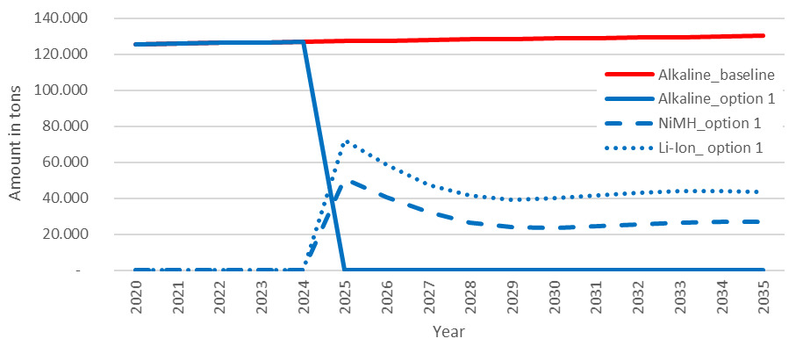
Figure 37: Evolution of primary batteries placed on the market (legend: "option 1" = sub-measure c)
Under sub-measure c, each primary battery would be replaced by a rechargeable one in the first years (30% with NiMH and 70% with lithium-ion in the model), which will have longer lifetimes, and thus become waste later. The total waste battery collected (and recycled) over the period observed in sub-measure c is about 25% lower than in the baseline. In particular, alkaline batteries arriving at end-of-life decrease quickly after the phase out and are expected to disappear almost completely around 2035. In their place, NiMH and lithium-Ion batteries increase slowly from 2025 onwards, stabilising in 2032.

>> Effectiveness
Phasing out all primary batteries is a sub-measure that might have far-reaching consequences. Due to the difficulties to assess the environmental impacts (see sub-measure b) it is unclear whether this sub-measure would be effective in view of the objective it aims to achieve.

>> Economic impacts
The economic impacts of sub-measure c are similar to those of sub-measure b, yet more pronounced.
Estimates indicate that sub-measure c could reduce the tonnage of batteries available for collection by about 25% in comparison to the baseline.
Overall, the shift will affect the resources that can be recovered, leading to higher revenues for recyclers of rechargeable batteries. However, this will have a minor impact in comparison to the eventual complete loss of business of primary battery recyclers.
Any change in the market composition of general purpose batteries will affect consumers. As this assessment shows, the availability of the two types of batteries (rechargeable and non- rechargeable) in the market offers the best combination of economic advantages and convenience for consumers. The consumer will have the possibility to choice the battery that performs better in a given appliance without being economically penalised, and will still have access to general purpose, interoperable and commonly used batteries. The substitutions of non-rechargeable batteries by rechargeable batteries in low and mid drain devices (52% of all battery-operated devices) would likely result in higher costs for consumers.

>> Social impacts
The introduction of a restriction of primary batteries can be expected to affect the level of employment. Producers argue that manufacturing companies located in the EU that employ 5200 individuals would have to close their activities. Additional losses would take place in the various collection schemes, retail, transport, supply chain, recyclers and other related sectors.
Recyclers also raised their concern that changes in the type of batteries placed on the market will only lead to a minor increase in business for rechargeable batteries, while having a large impact on primary recyclers. A survey among the members of the European Battery Recycling Association (EBRA) indicates a loss of 20-40 jobs per recycler of alkaline batteries. Seven members of EBRA recycle alkaline batteries. The total impact on losses is estimated by EBRA to be between 140 and 200 direct jobs. However, it was also stated that there are additional alkaline recyclers in the EU that do not process lithium-ion batteries, so this figure is an underestimation.

>> Environmental impacts
The study in support of this impact assessment looked into the impact of phasing out all primary batteries across a number of LCA impact categories. It did not consider however the impact of the number of recharging cycles, given that this depends on the appliance and on consumer behaviour.
The study finds that with the exception of "freshwater toxicity", sub-measure c would perform worse across the other LCA impact categories as compared to the baseline.

>> Administrative costs
This is a new measure, which will require actions from national market authorities. The development of some kind of standards, as well as marking and labels systems should nevertheless make market surveillance relatively straightforward.

>> Stakeholders’ views
Most stakeholders agree that the total prohibition of primary batteries, or of even only cylindrical portable batteries, is not the right approach to deal with the environmental issues triggered by their production and use. Only environmental NGOs considered that this measure could significantly contribute to improving the footprint of this industrial sector.
Various stakeholders (including Duracell, EPBA, Recharge or the Standing Committee on European Watchmaking-CPHE) stated that there are areas where primary batteries have advantages over rechargeable batteries (particularly in low drain applications), as well as areas where rechargeable batteries are preferable and where a shift in this direction is already observed. Stakeholders stated that both battery types are needed, though available information still makes a demarcation of high-performant batteries difficult. Emphasis was given to the cases of appliances to reach end-of-life early where replacement batteries will not be available.
In relation to employment, aside from obvious impacts on manufacturers of batteries and battery-operated devices, it was also pointed out that recyclers of alkaline batteries would be impacted as many of them will lose business related to primary batteries, which will not be compensated by increased amounts of rechargeable batteries being available for recycling.
Producers, for instance their association EPBA, consider setting minimum quality standards for primary batteries (sub-measure a) an alternative that should be explored. In this respect, EPBA proposes the IEC standard 60068-2 (Physical and electrical specifications of primary batteries) as a good starting point since it includes Minimum Average Duration (MAD) values, minimum performance standards set in relation to a selected number of applications, with which primary batteries have to comply.

Links to other measures
This issue is also addressed by Measure 12 on labelling and the provision of reliable information.

Summary and conclusions
The assessment of sub-measures that can address the environmental impacts of primary batteries is a complex matter that depends on many factors.
Sub-measure a, technical parameters on performance and durability, allows a more nuanced and targeted intervention on the market. It would address both rechargeable and non-rechargeable batteries and would avoid that those scoring the lowest in terms of durability or performance enter the EU market. The environmental impacts will depend on the parameters that are set, but are estimated to be positive.
Sub-measures b and c respectively considered phasing out general purpose and all primary batteries. The conclusion from this impact assessment is that more analysis is needed, due to the high degree of complexity of the matter. This complexity is the result of the different battery chemistries, the impact of the number of recharge cycles and the kind of device (high drain vs low drain), inter alia.
For these reasons, the sub-measure proposed to be retained is the sub-measure a. Sub-measure b is proposed to subject to further analysis in the future.

Table 18: Measure 8 - Summary and comparison of impacts
 | Sub-measure a:  Technical parameters for performance and durability for portable primary batteries | Sub-measure b:  Phase out of general purpose batteries | Sub-measure c:  Phase out of all primary batteries
Effectiveness | Likely to contribute to minimising the negative environmental impacts of primary batteries | Dependent on many factors and thus difficult to assess. Possible that negative impacts would outweigh the benefits | Similar to sub-measure b but more pronounced.
Economic impacts | Negligible | Significant impacts on industry and consumers. | Similar to sub-measure b but more pronounced.
Administrative burden | A new obligation. Costs due to market surveillance activities not expected to be significant. | A new obligation. Market surveillance relatively straightforward.. | Similar to sub-measure b
Environmental impacts | Will depend on the parameters to be set, but overall expected to be positive. | Needs further analysis | Needs further analysis
Social impacts | Negligible | Significant impact on producers and recyclers of primary batteries | Similar to sub-measure b. Job loss estimated to be at least 5000 jobs
Stakeholders’ view | European manufacturers support this option. | European producers and recyclers are against this option.  Only some environmental NGOs consider that this sub-measure could have a positive effect. | Similar to sub-measure b
Preferred sub-measure | x

Measure 9: Recycled content in Electric Vehicle batteries, industrial batteries and automotive batteries

Introduction

>> What is the problem and why is it a problem?
The manufacturing of batteries using recycled materials results in lower environmental impacts, when compared to the use of virgin resources. However, at present, the potential of battery recycling within the EU remains untapped and therefore only a small part of materials used in battery manufacturing are secondary materials.
Today, almost no lithium is recovered in the EU because it is not economical. In the EU, the only recycling technology for the recovery of lithium on an industrial scale is pyrolysis, where lithium remains in the slag and the costs of recovering it are higher than the costs of extraction from mineral deposits.
The quality of the recovered materials from battery recycling processes is decisive for its utilization. In cases where e.g. lithium is recovered, its quality is mostly insufficient to be used in batteries. Instead, it is used in other sectors such as ceramics, glass and alloys. The same is likely to happen, although to a lower extent, with other valuable materials in lithium batteries like cobalt or nickel. The demand for these substances from non-battery sectors will however grow at a much lower rate than that of the demand for batteries.
Therefore, when waste EV batteries start to become available for recycling, scientific research indicates that as soon as from 2021, for lithium, the supply of recovered (low-grade) materials would exceed its demand.
If secondary materials from the recycling of waste batteries only substitute a relatively small quantity of the virgin material used, in a context where the total demand keeps rising, the production of virgin materials will have to increase strongly to meet the demand. This will have higher environmental impacts and will present a barrier to the development of cost-efficient technologies that can deliver battery-grade recycled materials.
Based on the experience with the recycling and recovery of other materials, it has been shown that legislative requirements can be a means to overcome the so-called "valley of death" by providing legal certainty to the market so that investments are made in technologies that would otherwise remain undeveloped due to market failures.

>> What is the objective?
In operational terms, the sub-measures presented are intended to boost the development of cost-efficient technologies that can deliver battery-grade recycled material, with a view to ensuring their use for the manufacturing of lithium and lead-acid batteries.
In the long term, by helping to close the materials loop, the sub-measures considered will contribute to reducing the environmental burdens from the production of new battery materials. The increased use of secondary materials in the production of new batteries is intended to support the deployment of a circular economy, the efficient use of resources and the preservation of the quality of the environment.

>> What are the sub-measures?
Two sub-measures have been assessed with the aim to achieve the objectives above.
- Sub-measure a: information requirements for EV and industrial batteries placed on the EU market;
- Sub-measure b: mandatory levels of recycled content for key materials in EV and industrial lithium-ion and lead-acid batteries.

>> Baseline
Figure 38 below presents the expected evolution of the EU battery market, modelled from 2020 to 2035, in tons of batteries placed on the market.
Although with a slow decrease, lead-acid batteries will prevail for some years (from 1.6 million tonnes in 2020 to 1,4 million tonnes in 2035). Lithium batteries are expected to steadily increase (from 0.3 million tonnes in 2020 to more than 4 million tonnes in 2035). The share of lithium-ion batteries is increasing from around 15% in 2020 to around 73% in 2035, while the proportion of lead-acid batteries decreases from 77% in 2020 to 25% in 2035.
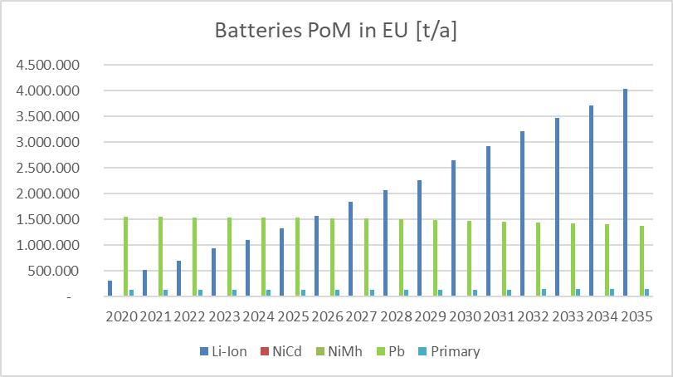
Figure 38: Batteries Placed on the Market in the EU (tons per year)
Figure 39 shows how the amounts of waste batteries collected in the EU from 2020 to 2035 follows the evolution of the market, with some delay. Lead-acid and lithium-ion batteries are by far the most relevant batteries for recycling. These two battery types dominate the amounts of new batteries and waste batteries collected.
Up to 2030 waste lead-acid batteries account for more than 80% of the total weight of batteries collected. Only around 2030 significant quantities of waste lithium batteries are expected to be collected.
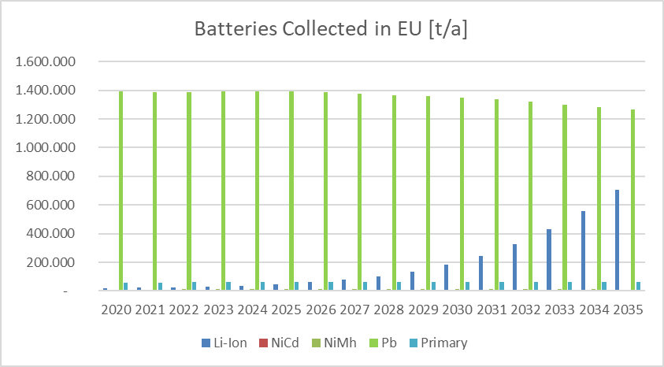
Figure 39: Waste batteries collected in the EU 2020 -2035 (modelled)
The evolution presented above shows the baseline situation, without any legal obligation for recyclers to ensure that processes deliver high-grade materials, or for manufacturers to ensure that new batteries contain a certain level of secondary materials. Table 19 gives the shares of recycled content for key materials in new batteries in the EU market.
Table 19: Assumptions on recycled content of key materials in new batteries in 2020 used in the assessment
 | Recycled content (de facto) in 2020
Lead | 67%
Nickel | <1%
Cobalt | <1%
Manganese | 0%
Lithium | <1%
Graphite | 0%

Recycled lead is mostly used for the production of new batteries. Nickel and manganese recovered from batteries are often used for other applications in open loop, e.g. steel alloys, and therefore not used for new batteries. Cobalt recovered from batteries is mostly battery grade and used for new batteries. Graphite is often used in pyrometallurgic processes as a reduction agent. Today there is no established process in the EU to recover it as material.
There are some important assumptions in this assessment:
- This assessment uses a closed loops approach, even if the concept of recycling process within the EU is an open one. This assumption ensures the conservative nature of results, but also takes into account the risks of oversupply if recycling processes do not yield battery-grade materials.
- It is assumed that the sub-measures will not provoke distortions in the international markets for metals. In other words, that any increased demand triggered by these sub-measures should be met by the supply of secondary materials, not by the increase in the production of raw materials.
- The values of material recovery in the baseline are overestimated. These values have been proposed by the stakeholders as the best ones currently available, and the assessment has assumed that all recycling process meet them. Results obtained are therefore very conservative: the gains in terms of materials recovery or of other environmental improvements are underestimated.

Analysis of sub-measure a – Mandatory declaration of the level of recycled content in industrial batteries

>> Effectiveness
This sub-measure would introduce a mandatory declaration of the level of recycled content in industrial batteries. Based on the current market and political context, it is reasonable to assume that producers will continue to increase the level of recycled content in the industrial batteries they place on the market.
The establishment of a level playing field by using commonly accepted measurement methods will provide an incentive for market differentiation based on the level of recycled content.
After some years, the implementation of this sub-measure should allow assessing whether the proposed targets for the recycled content could realistically be achieved.

>> Economic impacts
The introduction of a new obligation will require companies to collect necessary data (which in some cases may already be collected for other reporting exercises) including from upstream supply chain partners and carry out certain calculations. If a third party verification is established, there will be additional external costs (see below on administrative impact).
It has not been feasible to quantify any possible impacts of the proposed obligation on battery prices.

>> Administrative costs
For industry
The declaration will require skilled resources.
The unitary costs for performing the calculation for each type of battery cell/module are expected to be relatively low, in particular for companies that are already collecting the information due to internal environmental policies, company CSR reporting and other purposes.
There are no precedents for cost estimates for a declaration of recycled content in a regulatory context. If we consider that this presents a similar level of complexity as the carbon footprint declaration referred to for the Measure 6, expected calculation costs per “battery type” would be in the range € 100 – 5000, depending on the availability of the company specific data needed and the consultancy costs.
Additional costs associated with the third party verification should be expected. The relevant cost reduction possible through the use of the existing tools may lead to a situation where the verification costs (usually a lower part of the costs related to a life cycle assessment study) may become the prevailing external costs for a company. Based on the data gathered during the Environmental Footprint pilot phase, it is plausible to expect the verification costs to be included in the range € 2000€-7000 per battery type (+€ 250 per year to follow-up).
To estimate the total costs that imposed on industry, it is necessary to consider that batteries are normally placed on the EU market as a whole, as a finished product or incorporated to a different system (as e.g. an EV). Battery secondary materials cannot be distinguished from primary ones. Therefore, an auditing and reporting system has to be established, which ensures and certifies the share of secondary materials in new batteries.
Each production process (or even each factory) would have to be audited. Principally, the mass flows of the relevant battery materials in the plant and process would need to be checked (input into plant/process, content of material in the battery, potential stocks, share of secondary and primary material). The target of the auditing must be that the information provided by the producers is duly certified, even considering materials that are often produced by different companies in a complex supply chain.
This obligation is not likely to enter into application before 2025. By that time, it is estimated that there will be around 20 battery factories in the EU producing lithium-ion batteries for electro-mobility applications, typically lithium-based, and other 28 for industrial lead-acid.
The obligation would be imposed per battery type. For lithium-ion, each factory will be producing, on average, 5 different types of batteries, which means there could be around 100 different battery declarations. This figure needs to be corrected to account for the number of batteries that are likely to be introduced in the EU market directly as part of finished products. If we assume that up to 30 product manufacturers will be importing into the EU and that each manufacturer uses 5 different types of battery cell/modules, this represents an additional 150 declarations. The total number could therefore be in the region of 250.
As regards lead-acid batteries, assuming that each production site will manufacture on average 5 different types of batteries, this means 140 declarations. Introducing a correction, like it was done above, adding 40 manufacturers-importers, with five types each, it makes a total of 340 declarations.
Combining all the above figures, the total cost of this obligation for industry would be in a range between € 1 180 000 and € 7 080 000.
For public authorities
This sub-measure would require Member States to devote resources for the enforcement of a new obligation of a very technical nature. The market surveillance authorities of Member States will have to invest in developing the necessary skills to ensure that the recycled content declarations, as well as the third party verifications, are performed properly. This may entail training and/or hiring costs.
The Commission will have to assign resources to support the implementation of this new obligation via secondary legislation. For the development of a common methodology for the calculation of the level of recycled content in industrial batteries.

Analysis of sub-measure b – Mandatory levels of recycled content for key materials in industrial batteries
Only electroactive materials for which recovery targets have been proposed, i.e. cobalt, lead, lithium and nickel (see Measure 5), are considered in this section. Otherwise, the demand for secondary materials could trigger additional extraction of primary materials to substitute recycled ones.
This section first presents an analysis for lithium-ion batteries, and then for lead-acid batteries.

Lithium – ion batteries: mass flows and availability for recycling
The market for nickel in lithium-ion batteries is developing very rapidly due to the increase in the number of these batteries placed on the market and the fact that the battery chemistry is shifting towards higher nickel contents (from NMC 111 to NMC 811). Due to the time delay until they are recycled, it will take several years before recovered nickel can cover a significant percentage of the nickel used for manufacturing of new batteries (share of recovered Ni with a recovery rate of 80% in 2025: 1.8% ; 2030: 4.3%; 2035: 12.4%).
The values presented is for nickel becoming available from lithium-ion batteries. This corresponds to the ‘closed loop’ assumptions. There is substantial Ni available in past NiCd and NiMH (portable) batteries, also becoming available for recycling to lithium-ion battery grade qualities.
If second life applications of lithium-ion batteries are also taken into account the available quantities of Ni further decrease due to the longer use of the batteries and the resulting delay until the batteries goes to recycling. Available amounts of 2025: 1.7%; 2030: 4%; 2035: 10,4% would result when including second life.
Even if, due to the implementation of other sub-measures being assessed, the rate of material recovery rate for nickel were 90% from 2023 and 95% from 2030, the available amount would be 4.4% of in 2030 and 12.2% in 2035 (considering second life).
Figure 40 below shows the amounts of cobalt used in lithium-ion batteries placed on the EU market, modelled from 2020 to 2035 and the amounts of cobalt in batteries collected and recovered in the same period (including second life and material recovery rates).

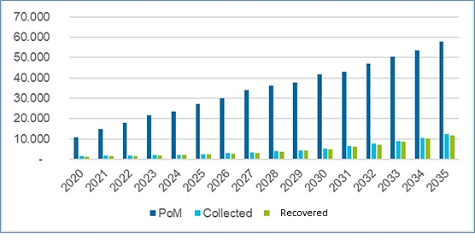
Figure 40: Cobalt used in lithium batteries, collected and recovered
The market for cobalt in lithium-ion batteries is growing very rapidly due to the increase of the number of batteries placed on the market. As the market shifts to batteries with lower cobalt content (from NMC 111 to NMC 811), growth is not as strong as it is estimated for nickel. Due to the time delay until the lithium-ion batteries are recycled, it will take several years before recovered cobalt can cover significantly the demand for the manufacturing of new batteries (2025: 7.7%; 2030: 11.2 %; 2035: 20.1 %).
If second life applications of lithium-ion batteries are also taken into the available quantities of Co further decrease due to the longer use of the batteries and the resulting delay until the batteries goes to recycling (2025: 7.6%; 2030: 10.6%; 2035: 18.9%).
Even if, due to the implementation of other sub-measures being assessed, the rate of material recovery for cobalt were 90% from 2023 and 95% from 2030, the available amounts would cover 12.1 % in 2030 and 20.4 % of in 2035 (including second –life)
Figure 41 below shows the amounts of lithium used in lithium-ion batteries placed on the EU market from 2020 to 2035, based on the model used, and the amounts of lithium collected and recovered (including second life and material recovery rates).
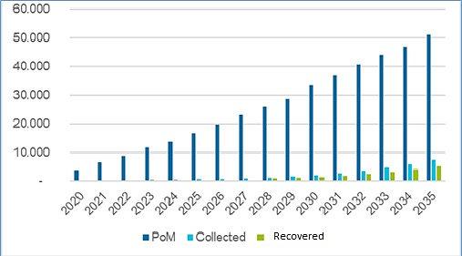
Figure 41: Lithium used in lithium-ion batteries, collected and recovered

Due to the time delay until the lithium-ion batteries are recycled and the low recovery rate for lithium (10% of the Li contained in collected batteries), even in the long term, hardly any lithium is available from recycling in coming years (2025: 0.41% of the demand; 2030: 0.73%; 2035: 1.8%).
If second life applications of lithium-ion batteries are also taken into account (the available quantities of Li further decrease due to the longer use of the batteries and the resulting delay until the batteries goes to recycling. When including second life, the resulting available amounts are: 0.4% in 2025; 1.7% in 2030 and 1.6% in 2035.
Even if, due to the implementation of other sub-measures being assessed, the rate of material recovery rate for lithium were 35% from 2023 and 70% from 2030, the available amounts would cover 4.5% of the demand in 2030 and 10.4% in 2035 (considering second life).
Setting mandatory levels of recycled content for lithium, cobalt and nickel
Establishing a reporting system (sub-measure a) on actual levels of the recycled content for the key materials Ni, Co, Li used in lithium-ion batteries appears to be the first step. In a second phase, minimum levels for nickel, cobalt, and lithium used in the production of new lithium-ion batteries will be introduced.
The proposed targets to be introduced successively over time are:
- Co 12%, Ni 4%, Li 4% (starting in 2030)
- Co 20%, Ni 12%, Li 10% (starting in 2035).
The values for the targets for Co and Ni in 2030 and 2035 are the potential percentages that recovered secondary materials could cover, even taking into account the effect of second life of lithium-ion batteries. The target values are based on rounded maximum amounts of recovered secondary materials.
The results of these targets are summarized in Table 20 below
Table 20: Proposed minimum levels of recycled content in lithium batteries
 | Baseline | Target | Target
 | Recycled content 2020 | Recycled content 2030 | Recycled content 2035
Nickel | 0% | 4% | 12%
Cobalt | 0% | 12% | 20%
Lithium | 0% | 4% | 10%

>> Environmental impacts of a recycled content target for lithium, cobalt and nickel
Figure 42 shows the development of avoided greenhouse gas emissions (t CO₂-eq/a) for lithium-ion batteries in the EU from 2020 to 2035 if the sub-measure on recycled content is implemented. The potential environmental impacts represent a maximum scenario. An increase from zero to a minimum level of recycled content according to the recycled content target is allocated entirely to this sub-measure.
Negative emissions result from the difference between environmental burden for the recycling process and credits for secondary materials from recycling replacing primary materials in the production of new batteries. Since in the baseline the batteries were calculated without recycled content, the avoided greenhouse gas emissions due to recycled content is zero in the baseline. Therefore, the result does not differ from the baseline (related to the recycled content) up to 2029 (in 2030 the effects due to the recycled content targets start).
About 130 000 (initial target in 2030) to 490 000 (increase of the target in 2035) tonnes of CO₂-eq are avoided every year (from 2030 to 2035) compared to the baseline. Up to 2035 a cumulated total amount of about 1.2 million tonnes of CO₂-eq could be avoided with the measure compared to the baseline.
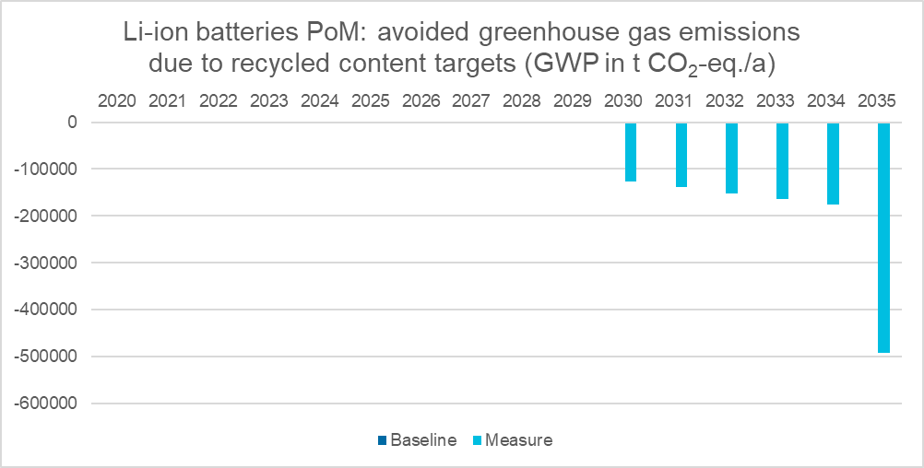
Figure 42: Avoided GHG emissions due to the sub-measures on recycled content for lithium batteries
Similar results are obtained as regards avoided resource depletion (ADP in t Sb-eq/a) for lithium-ion batteries place on the EU market from 2020 to 2035 if the sub-measure was implemented, compared with the baseline (no recycled content targets). Since in the baseline the batteries were calculated without recycled content, the avoided resource depletion due to recycled content is zero. Therefore, the measure does not differ from the baseline (related to the recycled content) up to 2029 (in 2030 the effects due to the recycled content targets start).
About 230 to 650 tonnes of Sb-eq are avoided every year (from 2030 to 2035) compared to the baseline. Up to 2035 a cumulated total amount of about 2 000 tonnes of Sb-eq could be avoided with the measure compared to the baseline.
Likewise, the development of avoided emissions affecting human health (Human Toxicity Potential, HTP measured in t 1.4-DB eq/a) show a similar behaviour from 2020 to 2035. Since in the baseline the batteries were calculated without recycled content, the avoided emissions affecting human health due to recycled content is zero. Therefore, the measure does not differ from the baseline (related to the recycled content) up to 2029 (in 2030 the effects due to the recycled content targets start).
About 530 000 to 2.5 million tonnes of 1.4-DB eq are avoided every year (from 2030 to 2035) compared to the baseline. Up to 2035 a cumulated total amount of about 5.7 million tonnes of 1.4-DB eq could be avoided with the measure compared to the baseline.

Setting mandatory levels of recycled content for lead in lead-acid batteries.
Figure 43 shows the amounts of lead used in acid batteries placed on the market in the EU from 2020 to 2035 and the amounts of lead in batteries collected and recycled in the same period.
According to the model used, the amounts of lead used in acid batteries would decrease from 1.056 million tonnes in 2020 to about 0.94 million tonnes in 2035. Amounts collected decrease from about 0.95 million tonnes in 2020 to about 0.86 million tonnes in 2035. Recovered lead can cover a significant higher share of the lead used for batteries in the future (2025: 84.4% of Pb PoM; 2030: 84.9%; 2035: 85.4%).
When an increase of the material recovery rates of lead from 93% to 95% is taken into account, additional coverage of the demand can be achieved, 2025: 84.4%; 2030: 84.9%; 2035: 85.4%.
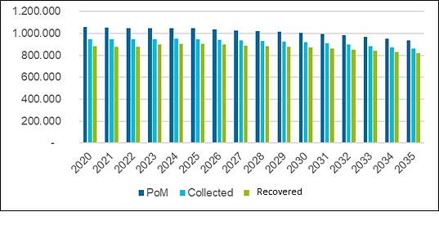
Figure 43: Lead used in batteries, collected and recovered
If a target for recycled content is established, a first step is to set a reporting system on actual levels of the recycled content (sub-measure a) in lead-acid batteries. In a second step a target for lead should be introduced in 2030, 85%.
This value is the potential share of the demand met by the recovered lead. Table 21 compares present situation with the target.
Table 21: levels of recycled content in batteries: existing one and in 2030
 | Baseline | Target
 | Recycled content 2020 | Recycled content 2030
Lead | 67% | 85%

>> Environmental impacts for the sub-measure on recycled content for lead-acid batteries
Figure 44 shows the development of avoided greenhouse gas emissions (global warming potential, GWP in t CO₂-eq/a) for lead-acid batteries placed on the EU market from 2020 to 2035, if the sub-measure was implemented.
The potential environmental impacts represent a maximum scenario. An increase from 67% secondary lead to the minimum level of recycled content according to the recycled content target (85%) is allocated entirely to this sub-measure.
Negative emissions result from the difference between environmental burden for the recycling process and credits for secondary materials from recycling replacing primary production.
About 190 000 to 180 000 tonnes of CO₂-eq are avoided every year (from 2030 to 2035) compared to the baseline. Up to 2035, a cumulated total amount of 1.1 million tonnes of CO₂-eq could be avoided with the measure compared to the baseline, which corresponds to an overall reduction of 27 %.
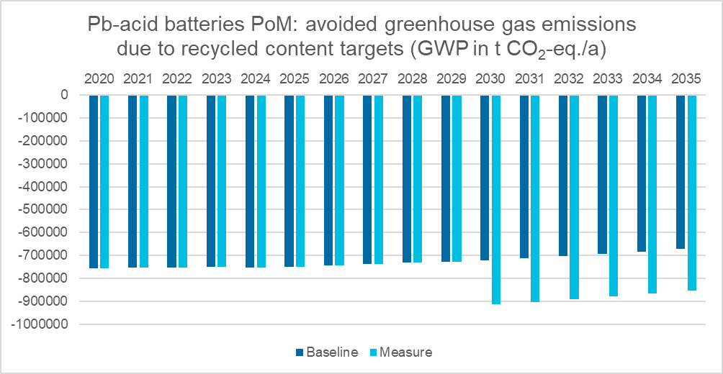
Figure 44: avoided GHG emissions due to recycled content in lead-acid batteries (tons of CO2-eq)
Similar results are obtained as regards the development of avoided resource depletion (ADP, in t Sb-eq/a) for lead-acid batteries placed on the EU market if the sub-measure was implemented. About 450 to 420 tonnes of Sb-eq are avoided every year (from 2030 to 2035) compared to the baseline. Up to 2035 a cumulated total amount of 2 600 tonnes of St-eq could be avoided with the measure compared to the baseline, which corresponds to an overall reduction of 10 %.
Likewise, the development of avoided emissions affecting human health (Human Toxicity Potential, HTP in t 1.4-DB eq/a) for lead-acid batteries if the sub-measure was implemented. About 850 000 to 800 000 tonnes of 1.4-DB eq are avoided every year (from 2030 to 2035) compared to the baseline. Up to 2035 a cumulated total amount of about 5 million tonnes of 1.4-DB eq could be avoided with the measure compared to the baseline, which corresponds to an overall reduction of 10 %.

>> Economic impacts: mandatory levels of recycled content for key materials for lithium-ion and lead-acid batteries
Based on the experience with the recycling efficiency and material recovery targets for lead, research suggests that the Batteries Directive has this way indirectly contributed to making the EU a global leader in recycling capacity for spent batteries. Setting these targets has stimulated the development and roll-out of state-of-the art metallurgical processes and increased material recovery rates in the EU.
A similar effect is expected from the introduction of a target for recycled content. Even if these targets will only enter into force in the medium term, introducing them now, starting with a requirement to declare the current level of recycled content, will provide investment certainty to recyclers that will provide the necessary incentives to invest in recycling technologies that will contribute to mitigating the supply risk for certain materials.
Mandatory levels of recycled content will contribute to the development of cost-efficient recycling activities that can deliver battery-grade recycled materials. These processes are associated with higher costs. Those operators investing in the adequate technologies will stand to reap the additional benefits. The proposed sub-measure will contribute to providing needed legal certainty investments. On the other hand, if higher amounts of secondary materials reach the market, the demand of primary materials in battery-grade would stabilize (or decrease), lowering costs.
The proposed sub-measure (scope, substances and targets) will be assessed before they enter into force, and if needed adjusted in function of the market situation at that time. This assessment has taken into account the amounts of high-grade battery materials likely to be present within the EU market.
If this sub-measure triggers an increase in the demand that is not met, this could potentially lead to additional revenues for recyclers as they can achieve higher prices for their recovered metals and potentially additional amounts of recovered materials. It is nevertheless unclear whether these additional amounts of recovered materials are the result of recycled content targets or of the increased material recovery rates.
As secondary materials cannot be reliably distinguished from primary materials, an auditing and certification system has to be established (see above). Such a system also has also to be implemented for imported batteries.

>> Effectiveness
If the conditions assumed in this assessment are met, i.e. in terms of batteries placed on the market, levels of collection and recovery, the situation in 2030 and 2035 would be the following:
Table 22: Effectiveness
 | Baseline | Target | Target
 | Recycled content 2020 | Recycled content 2030 | Recycled content 2035
Nickel | 0 % | 4 % | 12 %
Cobalt | 0 % | 12 % | 20 %
Lithium | 0 % | 4 % | 10 %
Lead | 67 % | 85 %

The objective of higher resource efficiency and minimising of negative environmental impacts due to recycled content targets can only be achieved under the condition that actual recovery rates for key materials used in battery production are increased.
It could be possible that manufacturers make use of secondary material in the batteries for the EU market and produce batteries for the rest of the world with primary materials without increasing the overall share of secondary materials. In this case, the net effect will be zero. It must be ensured that such ‘double’ standards do not result from the introduction of minimal levels of recycled content.

>> Administrative costs
The new recycled content targets for lithium-ion batteries and lead-acid batteries would require mandatory monitoring of the recycled content in new batteries placed on the EU market (see above). Market surveillance to ensure compliance is also necessary for imported batteries.
Control systems, including auditing must cover the entire supply chain of battery components and materials.

>> Social impacts
Due to market trends (reflected in the baseline), the number of jobs in manufacturing and recycling companies will significantly increase due to the rapidly increasing market for lithium-ion batteries and the recycling of the waste batteries. The influence of the implementation of the sub-measure presented would however be rather limited.
Regarding lead-acid batteries, the number of jobs in manufacturing and recycling companies will decrease due to the decreasing market share for lead-acid batteries. Once again, this can mainly be attributed to the mobility sector. The increase in e-mobility goes hand in hand with a decline in the demand for automotive lead-acid batteries.
It can be assumed that the recycled content target will increase the demand for battery-grade materials. For the establishment of these new refining processes or further processing steps new jobs will be created. However, whether these facilities and thus the jobs will be located in the EU or in third countries outside the EU is unclear.
Overall, the large majority of new jobs in the baseline can be allocated due to the increasing lithium-ion battery market and not to the implementation of this sub-measure.

>> Stakeholders’ views
In general producers support the use of recycled materials in batteries manufacturing. They see advantages in this regard not only to close the loop of the materials but also as a measure to diminish other environmental impacts like e.g. the carbon footprint.
However, there is no a common view on the establishment of a strict regulative criteria on recycled content. Some manufacturers of large EV batteries are against because they consider that there will not be enough secondary raw materials to meet these criteria due to the expected exponential demand for battery materials in the coming years. Other manufacturers, in the same sector, not only accept the positive impact of these measures, but also commit themselves to deliver products that would go beyond the levels discussed here.
A general concern for producers is that market prices could increase and therefore targets of recycled content could become harder to achieve. The interaction of this measure with the possible development of second life applications was also discussed.
Some stakeholders indicated that any measure of this kind should be carefully formulated. Even if vis-à-vis the amounts of raw materials needed by the nascent EU battery industry, the recycled amounts are still low, there are risks of sending wrong signals to markets. Adopting targets only in the long term is considered to be a suitable strategy to avoid market distortions.

Options discarded in an early stage

>> Sub-measure c: adding graphite and / or auxiliary materials to the list
Two main possibilities were considered: adding graphite and / or auxiliary materials to the list.
Graphite is a functional anode material. Graphite is usually burned during recycling processes, substituting coal which otherwise should be used. No recycling process for recovery of high-quality secondary graphite is established on industrial scale. Moreover, battery grade graphite can be artificially made from C-rich waste (e.g. biomass). Nowadays, there is no evidence supporting that the definition of mandatory levels of recycled content for graphite is environmentally beneficial. For that reasons, the possibility was discarded and was not assessed in depth.
The auxiliaries of the battery system (casing and periphery) are made from commodity metals such as steel, copper and aluminium. The electronic components of a battery system, including the Battery Management System, are a complex mixture of precious and special metals in the BMS (battery management system). Once removed from the battery system, they will be recycled because of the positive value.
The environmental benefit of recycling of these parts is relatively large, either because they can be separated and recovered easily without using chemicals or a lot of energy (only for smelting in commercial shapes) or because of the recovered precious metals. These materials are used in large quantities (Cu, Al, steel) in applications other than batteries. Thus, given the volume currently used in batteries, even a 100% recycled content would simply mean a redistribution of recycled content from non-regulated applications to batteries. The quality of recovered secondary materials from recycling will not improve either, as the materials used in batteries for casing and periphery are standard qualities. Copper from cells is recovered and refined to “battery grade“ and then usually used for new batteries. Aluminium from cells is usually not refined to battery grade. In some recycling processes, it is used for other applications after recovery, in other processes Al is downcycled and transferred to the slags. Also, manganese from lithium-ion batteries is usually downcycled and transferred to the slags.

Summary and conclusions
The sub-measures proposed are intended to boost the development and the implementation of cost-efficient technologies that can deliver battery-grade recycled material, with a view to ensuring their use for the manufacturing of lithium-based and lead-acid batteries. Legislative requirements can be a means to provide legal certainty to the market so that investments are made in technologies that would otherwise remain undeveloped due to market failures.
Initially, the processes concerned are associated with higher costs. However, those operators investing in the adequate technologies will stand to reap the additional benefits.
Under assumptions that are truly conservative, this assessment shows benefits in environmental terms if mandatory levels of recycled content are established for cobalt, lead, lithium and nickel. The positive environmental impact can only be achieved under the condition that actual recovery rates for key materials used in battery production are increased.
Stakeholders do not have a common view on the establishment of mandatory levels of recycled content. Some insist on the risks of not having enough secondary raw materials to meet these due to the expected exponential demand for battery materials in the coming years. Other manufacturers not only accept the positive impact of these measures, but also commit themselves to deliver products that would go beyond the levels discussed here. Adopting targets only in the long term is considered a suitable strategy to avoid market distortions
The proposed sub-measure (scope, substances and targets) will be assessed before they enter into force, and if needed adjusted in function of the market situation at that time.
The implementation of this measure requires the development of technical and administrative details, via secondary legislation.

Table 23: Measure 10 - Summary and conclusions
 | Sub-measure a:  Information requirements on mandatory levels of recycled content in 2025 | Sub-measure b:  Mandatory levels of recycled content in 2030 and 2035
Effectiveness | Commonly accepted measurement methods will provide a tool for market differentiation based on the level of recycled content.  After some years, the results of the information requirement should be used to ascertain the feasibility of the mandatory levels established. | The impact sought of higher resource efficiency and minimising of negative environmental impacts due to recycled content targets can only be achieved under the condition that actual recovery rates for key materials used in battery production are increased.  In this respect, the delay in making the level of recycled content mandatory becomes essential.
Economic impacts | Additional cost for auditing and monitoring systems (see administrative costs) | Mandatory levels of recycled content will contribute to the development of cost-efficient recycling activities that can deliver battery-grade recycled materials. The measure will provide legal certainty to the market so that investments are made in technologies that would otherwise remain undeveloped due to market failures.  These additional processes are associated with higher revenues for recyclers.  If, contrary to these assumptions, this sub-measure triggers an increase in the demand of secondary materials that is not met, recyclers can achieve higher prices for their recovered metals.
Administrative burden | Current scientific approaches being used for the assessment of the environmental impact of battery manufacturing should be adapted. | The new mandatory levels require the monitoring of the recycled content in new batteries placed on the EU market.  Market surveillance to ensure compliance is also necessary for imported batteries.
Administrative costs | Low.  Implementation of recycled content targets. Reporting and auditing/controlling system for recycled content.  € 1 180 000 and € 7 080 000. | Low.
Environmental impacts |  | Potentially higher environmental benefits due to higher share of secondary materials  Up to 2035, cumulated 2.3 million t CO₂-eq could be avoided if the sub-measure is implemented. A similar evolution can be expected in other environmental indicators (ADP or HTP).
Social impacts |  | Low. The influence of the implementation of the sub-measure presented would be rather limited.  Social impacts are dominated by the development of the market, i.e. rapidly increasing market for lithium-ion batteries and decreasing market for lead-acid batteries. The proposed measures do not differ too much from the baseline.
Stakeholders’ views | The stakeholder consultation revealed that stakeholders are concerned that market prices could increase and therefore targets of recycled content could become harder to achieve. The interaction of this measure with the possible development of second life applications was discussed.  Some stakeholders indicated that any measure of this kind should be carefully formulated. Even if vis-à-vis the amounts of raw materials needed by the nascent EU battery industry, the recycled amounts are still low, there are risks of sending wrong signals to markets. Adopting targets only in the long term seemed to be a suitable strategy to avoid market distortions.
Preferred sub-measure | X | X

Measure 10: Extended Producer Responsibility

Introduction
Extended Producer Responsibility (EPR) involves giving producers a responsibility for the overall management of post-use batteries and the attainment of legal collection and recycling targets. Assigning such a responsibility to producers provides incentives to prevent wastes at the source, promote better product design for and support the achievement of better recycling. When subject to EPR, producers often work together through Producer Responsibility Organisations (PROs) to deliver their requirements. For example, payments made due to EPR provisions can fund the activities of the PROs in relation to improving collection of portable batteries.

>> What is the problem and why is it a problem?
Extended Producer Responsibility
EPR obligations for industrial batteries are not as well defined and as specific as those for other types of batteries. There are no detailed provisions for collection or setting up national EPR schemes aspects for industrial batteries (due to their ‘business-to-business’ nature). Nevertheless, the Directive mandates producers to accept waste industrial batteries that are collected and returned to them.
Without an EPR scheme, customers are financially responsible for returning batteries, which may lead to improper disposal. With the expected growth in electric passenger cars, scooters, e-bikes etc, as well as power storage for private photovoltaic panels, private customers will increasingly own and (subsequently) need to dispose of industrial batteries. For example, according to the model being used, the e-bike lithium-ion batteries market is expected to grow from 10,000 in 2020 to 52,000 tonnes/year by 2035.
For EVs, stakeholders reported that manufacturers voluntarily take product responsibility for the (currently) limited number of waste traction batteries by providing collection of batteries without any costs for the end-user even though the Batteries Directive has no specific provision for EPR for traction batteries. The underlying reason is that the current categorisation system was based on the assumption that industrial batteries (that at present include traction batteries) would be owned only by business stakeholders. However, with technological innovation, such batteries are increasingly used by private end users in products they own and there are limited EPR obligations (mostly as regards collection) for industrial batteries.
According to the end-of-life vehicle Directive, ELVs should be directed to authorised treatment facilities (ATF), where batteries must be dismantled. However, neither the Batteries Directive nor the ELV Directive identifies which operators are in charge of covering the costs for the dismantling, safe storage and transport to disposal of waste industrial batteries (including EV’ ones). The same happens when outworn batteries are retired from vehicles: the responsibility for the dismantling, safe storage and transport to disposal is not defined by European legislation.
With the arrival of new types of batteries with much longer lifetimes, there is also a need to consider how relevant EPR obligations are to be met in the end. Guaranties are needed to funding of collection and recycling of waste batteries in the future and to avoid free-riding by companies who leave the market.

Producer Responsibility Organisations
The measures in the Batteries Directive are insufficiently precise and leave a large room of manoeuvre to national authorities. This flexibility was introduced with the intention to avoid over-prescription on an issue that presents difficulties to be addressed with a “one-size-fits-all” solution.
However, this lack of detail in the Directive allows a large variation of standards and practices among Member States. One concrete example is the lack of detailed provisions for Producer Responsibility Organisations (PROs), where the Evaluation of the Batteries Directive pointed out several examples of unfair competition, such as PROs that compete for the collection of profitable battery types only (so called "cherry picking"), even by collecting batteries from non-private end-users, while ignoring other types of batteries.
Awareness raising campaigns is another issue pointed out by the Evaluation of the Directive. Information for consumers is still lacking in some Member States. The requirements of public awareness campaigns (funding amount, frequency per year) are not specified by the Directive or by Member States. Consumers are therefore not always aware of the need for separate collection or where to dispose of their batteries (or are not aware of the environmental impacts of their choices).

>> What is the objective?
EPR
The objective of this measure should be to ensure that private end-users do not face the burden of costs for collecting certain industrial and automotive batteries. Furthermore, it should promote maximal collection rates for industrial batteries to ensure that they are properly recycled as part of a circular economy approach.
PROs
The objective of this policy option is to level the playing field for PROs, increase their cost-effectiveness and make sure they sufficiently invest in awareness raising campaigns and collection point coverage. This should facilitate increasing the collection rates across the EU.

>> Links to other measures
EPR and PROs are clearly related to collection and recycling rates and the meeting of targets, and ensuring the proper treatment of batteries at the end of their life.

>> EPR Baseline
The battery type ‘industrial’ in the current Batteries Directive comprises several, and different groups of batteries. From small, very small ones used in industrial contexts and applications, like those in industrial sensors, to real large ones, providing energy storage to isolated, non-connected-, habitations. Batteries powering e-bikes and other light means of transport are included in this battery type.
In terms of weight, analysis of the available data for industrial batteries reveal differences between the amount of industrial batteries placed on the market and the amount of waste batteries collected. Around 10 % of industrial batteries placed on the market are not collected, and hence could be lost. The rather high levels of can be attributed to the economic profitability of lead-acid batteries (the chemistry that dominated the category in the past) and to the fact that disposing of industrial waste batteries to landfills or waste incineration is not allowed.
Private actors increasingly own industrial batteries, both large and small. If these batteries are not correctly disposed of, this could lead to a decrease in the collection rate, to environmental problems and to the loss of resources.
The importance of small batteries powering light means of transport cannot be dismissed. Data from CONEBI highlights the importance of the expected growth in the number of pedal assist and e-bikes powered by lithium-batteries over the next 15 – 20 years throughout the EU, which witnessed an increase of more than two millions units from 2010 and 2018 (2,775,000).
The mass flows for industrial and EV batteries placed on the market are modelled (EVs are only included in the final mass flow):
- EV: 250 000 t/a (2020) to 3 800 000 t/a (2035);
- Other industrial lithium-ion batteries (excl. EV): 67 000 t/a (2020) to 390 000 t/a (2035);
- E-bikes (lithium-ion): 11 736 t/a (2020) to 55 746 t/a (2035).
The assumption for the baseline is that without EPR covering collection specifically, the collection rate of waste industrial batteries hold by private consumers will be undermined, and, in particular, in the case of light means of transport, it will reach a maximum of 70%. In the case of e-bikes and similar batteries, it is estimated that only 32% of these batteries placed on the market would be collected with the current regulatory measures. If no measures are taken, in 2035 the amount collected would be 54%.
Given the longevity of these batteries, it is important to make sure that producers who exit the market contribute to costs of the end-of-life management of the batteries they placed on the market.

>> What are the sub-measures?
The following sub-measures have been analysed in this Impact Assessment:
- a – Extended Producer Responsibility obligations for producers of industrial, automotive and EV batteries
- b – Minimum Standards for Producer Responsibility Organisations
Note that these options are not mutually exclusive: neither, either or both could be proposed.

Analysis of Sub-measure a – Extended Producer Responsibility obligations for industrial, automotive and EV batteries
This sub-measure implies the need to:
- Lay down clear requirements that producers’ organisations take responsibility for the dismantling, collection, transport and recycling of traction batteries of Electric Vehicles (EV) and private energy storage systems placed on the EU market by their members, either at the end-of-life or when replacing batteries. Consequently, the end-user does not directly bear the cost. Instead, the manufacturers must cover all costs arising from battery dismantling, collection, transport and recycling, including safety aspects.
- Specify obligations on a subset of industrial batteries as, for instance, those “sold to private customers and / or used in non-industrial contexts.” (business-to-consumer). This includes small industrial batteries, namely light transport or energy small storage applications.

>> Effectiveness
The main impact of the EPR scheme is that it will establish a lasting level playing field based on a common set of rules to cover the costs of dismantling, safe storage, logistic and recycling of waste industrial batteries. The sub-measure proposed ensures the safe and comprehensive management of EoL industrial batteries, namely for EVs, which are expected to have the largest growth in coming years.
The impacts are difficult to quantify as in principle there are at present legal provisions setting an implicit no-losses policy for these batteries, which must be collected and recycled. An improved scheme, setting more specific obligations and responsibilities will ensure better enforcement, in view of the expected growing volumes of these batteries.
The assumption is that the EPR system will have to ensure that the producers’ organisations cover costs, occurring many years after the battery is placed on the market. It will prevent producers exiting the market in the meantime from avoiding contributing to these costs and therefore ensures a level playing field for all producers.

>> Economic impacts
Traction batteries
Obligations essentially will not change, but will be better specified and clarified. For that reason, additional costs will be limited. Increased costs will only be due to the increased amounts of batteries to be collected at the end of their life.
Car manufacturers currently (voluntarily) cover the cost for dismantling, safe storage, collection, logistics, and recycling of EV batteries. This measure would not require new types of efforts, only those due to the need to increase the capacities in response to the growing volumes that need to be treated. This sub-measure would specify that all these costs have to be covered by producers of industrial batteries.
This sub-measure is to ensure that producers' organisations are organised and constituted in such a way that, if a producer leaves the market, its obligations as regards the end-of-life status of their products are already sufficiently covered.
In any event, the high expenditure expected to materialise due EPR obligations requires that a clear allocation of responsibilities be laid down. Even if the model foresees that activities linked to the collection, treatment and recycling of traction waste batteries (lithium-ion batteries) become profitable before 2030, at the latest by 2035 (see Figure 45 and Figure 46 below), the necessity to have clear responsibilities remains.
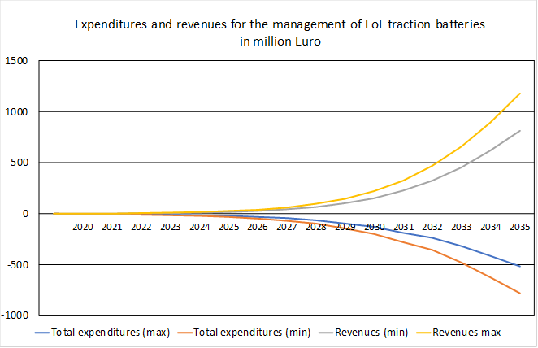
Figure 45: Modelled expenditure and revenues for the management of traction batteries at the end of their life (million €)
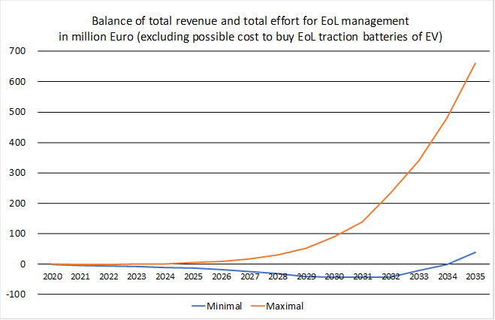
Figure 46: Total revenue and total effort for management of traction batteries at the end of their life (estimation in million €)
In addition, this sub-measure will contribute to avoiding that the operators concerned bypass regulatory requirements (on e.g. dismantling / storage / logistics, recycling or even exporting) and to the establishment of a level playing field for OEMs, dismantlers and recyclers. However, this effect cannot be meaningfully monetised at present.
Light transport means (e-bikes, scooters, etc.)
These batteries, now classified as industrial, constitute another group that requires more specific and adapted EPR provisions. Ensuring the return of these batteries, when they become waste, to specialised professionals (i.e. bike shops) may increase circularity of this market. In many cases, the battery is only replaced and the device (e-bike or any other) returned to its owner. In other cases, the battery is resold to a new consumer, rather than completely disposed of.
For PROs that currently do not collect privately owned industry battery waste, costs will increase as a result of the additional volume of batteries they need to accept (potentially from new collection points, i.e. e-bike shops), although these costs will of course in part be compensated by increased revenues from recycled materials. Some extra administrative costs may arise for data collection, reporting and auditing, but this is expected to be negligible.
Based on the assumptions from this measure and the data from the consultant’s model, namely on the based on cost figures used in the consultant's study an additional 20 % collected amount of these batteries would equate to 8,085 tonnes in 2035. Taking the lowest and highest costs as a basis, the collection of the additional 20% estimated in this sub-measure, results in additional costs between EUR 3.3 and 34.3 million per year.
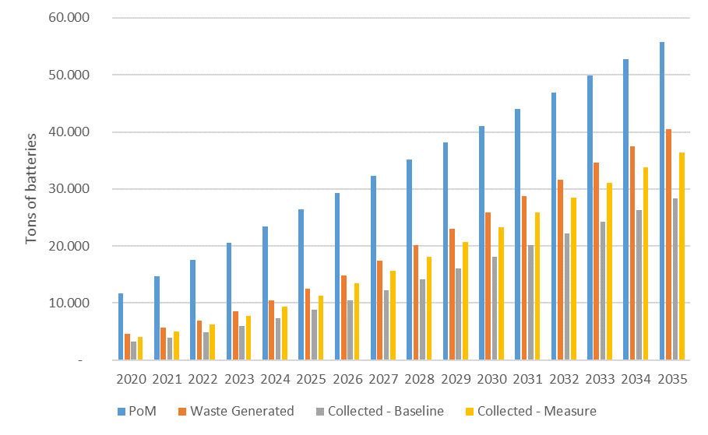
Figure 47 Evolution of e-bikes placed on the market, waste generated, collected (baseline) and collected due to proposed measure

>> Administrative burden
The implementation of resulting obligations should cope with the expected problems created by the growth of traction batteries at the end of their life. In substance, the administrative activities will be similar to what those of today. Some additional administrative effort associated with monitoring and reporting will appear, but most of the administrative effort is already sustained under current requirements.
Such efforts are needed for the establishment and operation of PROs in Member States. Producers may decide to establish a single organisation per Member State. To avoid strategic freeriding, the sector should come to an agreement to define common rules to ensure that producers bear the costs incurred later. The PROs will decide what kind of cost-efficient deposit security / guarantees they will implement to cover the cost for dismantling, safe storage, collection, logistics and recycling. The small extra cost for the management of the PROs will generate a huge benefit to the responsibly acting producers as the future cost can be recovered by a reliable system of contributors already paid in.

>> Environmental impacts
Concerning the large increase in traction batteries placed on the market in the coming years, the related volume of EoL batteries is expected to follow with a delay of several years, and will have a volume of approximately 700 000 tonnes in 2035. The volume of EoL traction batteries will continue to increase after 2035 in line with volumes put on the market in the preceding years. It is important to ensure the collection of such batteries and establish the conditions for EoL management from the very beginning, i.e. when the traction batteries are placed on the market.
According to the model, it can be estimated that approximately 50 000 tonnes of traction batteries in 2035 will be exported during the lifetime of the vehicle (export of used electric vehicles). It can be assumed that HEV and PHEV have export rates similar to combustion motor vehicles. BEV on the other hand are expected to be exported to a lesser extent, since they require a charging infrastructure, which may not be available in all importing markets.
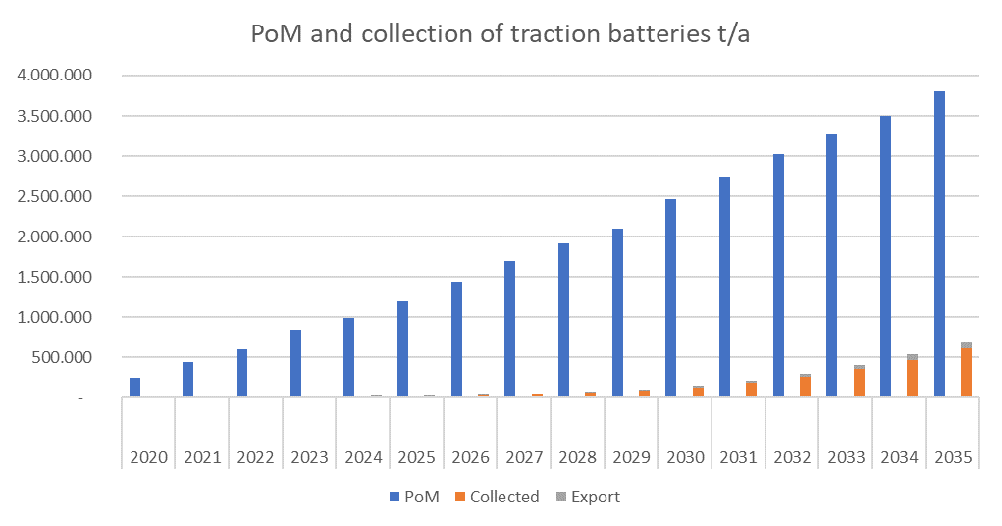
Figure 48: Traction batteries PoM, collected and exported in tonnes per year
The impacts are difficult to quantify as in principle the industrial (traction in this case-) batteries must be collected up to a 100 % and then recycled, or in between to second life reconditioners, and it is not allowed to dispose of them. However, the improved scheme for responsibilities will facilitate more appropriate enforcement and might establish an additional trigger to opt for second life application of traction batteries.
The mass flow model was used to calculate the environmental impact of the sub-measure, assuming that, a specific EPR obligation could increase the collection rate for e-bike batteries by 20%.
As displayed in Figure 49, the achieved reduction of GWP is about 24 473 t CO₂ -eq per year in 2035. Additional positive environmental effects and effects on availability of resources occur in parallel.

Figure 49: additional GHG savings because of the proposed sub-measure
Additionally, as noted by recyclers, the risk of fires for waste and recycling facilities would diminish, due to the fewer incorrect disposals of privately owned industrial batteries (i.e. in municipal waste). Measures 11 and 12 on design and information requirements will also contribute to this.

>> Social impacts
The data gathered do not provide clear social impacts as a result of the measures considered.
In consequence, there is no change in jobs triggered by this sub-measure. The option will reduce environmental and health risk to the population and to sorting facilities’ staff caused by improper and dangerous disposal as the option will strengthen enforcement of the collection of all industrial batteries.

>> Stakeholders’ views
Consumers’ organizations and environmental NGOs have consistently supported the adoption of measures ensuring that industrial batteries held by private actors are collected and recycled properly. This was one of the conclusions of the consultations held in the process of evaluation of the Batteries Directive.
During most recent consultations, there were some disagreements on the need to incorporate specific obligations for producers of industrial batteries. For some, the existing take back schemes voluntarily set in motion and financed by the industry would suffice. According to them, there was no need for EPR systems to take care of the activities needed to ensure the actual return (take-back) of waste batteries held by private customers.
Some stakeholders did not agree with the assessment that end-users were more likely to hold an increased number of industrial batteries in the future, other than for light means of transport. In all other cases in which they will own a product with an industrial battery (EV or wall-boxes), stakeholders recommended that batteries should be accessible to trained professionals, but not for end-users.

Analysis of Sub-measure b – Minimum Standards for Producer Responsibility Organisations

>> Description of the sub-measure
Sub-measure b includes:
- A requirement to coherently coordinate consumer awareness-raising campaigns on portable waste batteries by PROs.
This option would include an obligation for PROs to coordinate and run their campaigns together, in a unified manner. This ensures one approach across the whole of each Member State. This coordinated campaign would be subject to the quality criteria of the WFD legislation. The specificities of how PROs coordinate such an action is left to their discretion. However, previous examples include centralising responsibilities in a clearinghouse or centralised organisation.
- A requirement to improve the distribution of collection points.
The proposed sub-measure goes beyond the WFD and specifies that PROs must assess their collection point densities to address in which locations they are most effective to increase battery collection. This assessment could come periodically, for instance every 3 or 5 years. It would ensure that a sufficient number of collection points are available to fulfil the increased collection targets, focusing on both the amounts (and types) of waste batteries to be generated, and also on the convenience and accessibility for the consumer
PROs need to focus on where it is necessary to collect. This should include the assessment of locations such as retailers, municipal collection centres, schools, companies and other points where the collection is voluntarily carried out. The PROs should be able to justify their distribution of collection points based on this. A good example of the necessary activities for this assessment is the survey carried out in Belgium in 2017 which found that factors which influenced the number of batteries per 100 kg household waste the most are, inter alia the season, population density of a municipality and the cadastral income of the municipality.
The design of this option takes account of the fact that consumer convenience was noted by stakeholder interviews as having a profound effect on collection rates. As noted by EUCOBAT one third of batteries are collected in retail stores. However, it was further noted by EUCOBAT that Member State size and infrastructure is a key component to determine any minimum requirements in this area. Stakeholders noted that a “one size fits all” approach is not suitable, since it would result in a reduction for the most performant Member States and a very large increase for some others.
Therefore, ensuring that qualitative requirements are in place would be beneficial – i.e. ensuring certain locations are not ignored by PROs (i.e. retailers, municipal collection centres, companies and schools), and ensuring that reviews on national collection point coverage are carried out.

>> Effectiveness
Coordinated consumer awareness campaigns
There is evidence that ensuring coordination in the fulfilment of obligations enhances PROs performance and increase their efficiency, for instance as regards consumer awareness campaigns. A study by Perchards and SagisEPR outlined that for waste portable batteries respondents’ awareness of the need for separating disposable waste batteries is typically around double the collection rate (in regard to % of citizens aware of a need for separate disposal and % of collected battery waste).
Furthermore, the study suggests collection point coverage is influential for collection rates of waste batteries. The study showed that retail centres and municipal collection centres are key areas for collection (see Table 24 below).
Table 24: Origin of collected batteries
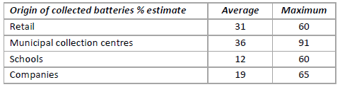
Source: Perchards and Sagis (2016) STUDY FOR EPBA ON WASTE PORTABLE BATTERIES COLLECTION RATES
There are two clear correlations that can be compared 1) longevity/experience of a PRO has an effect on collection rates, and 2) single PROs or coordinated campaigns result in higher collection rates, as shown below in Figure 50.
When there is a strong coordination amongst the actors concerned, even by setting join structures or by lowering the number of actors, synergies and benefits appear. Such organisational models can for instance also benefit from a consistent design and language on collection boxes, which were outlined as a key instrument for consumer awareness campaigns.
Figure 50: Collection rate depending on PRO type and awareness raising obligations
Qualitative collection point criteria
To ensure efficiency in the fulfilment of their obligations, producers should know in some detail how waste batteries are generated in the regions where they contribute to the collection, in particular whether the collections points are able to cope with the volume on types of waste expected.
The experience in Belgium shows how different surveys can be organised to differentiate urban and rural areas and to quantify the amounts of portable waste batteries generated. Even recognising the importance of other factors, one should not forget that collection rates from Belgium have been amongst the highest in recent years.
It is not possible to quantify a precise environmental impact that could be achieved due to a better distribution of collection points, based on the existing evidence. However, if PROs are setting up more bespoke collection point coverage then collection rates should increase.

>> Economic impact
There is limited quantitative on this specific aspect, but the economic impacts of the requirements for PROs are expected to be minimal. At the set-up some additional costs may be incurred by PROs, but this should be compensated by a number of factors, such as increased revenues from increased collection, economies of scale and peer learning. Coordination in a single structure could cause administrative costs for some PROs but this may be offset by the simplification of tasks in common campaigns.
Some data was gathered under the Evaluation study, this provides data for five European countries (Austria, Belgium, France, the Netherlands, and Switzerland) on their PROs collection rates, coverage and associated costs. Table 25 below, displays data from countries that have either a singular active PROs in their country (Belgium, the Netherlands and Switzerland); or have a coordinated clearinghouse for organising campaigns (Austria and France). It shows a variety of costs for such PRO systems. Countries that have higher collection rates (>65%), also have fees per capita of over € 1.5. However, it is also clear from the varying countries that there is a greater complexity than just funding levels to collection rates. Clearly, population size, number of batteries placed on the market, and other factors not displayed below (lifetime/experience of collection systems) play large roles as well.
It is assumed that with increasing collection rates in Member States and the change to coordinated consumer awareness campaigns there could be costs in line with these figures. It is not assumed that the higher end of costs will be required for all Member States to achieve successful collection rates. However, it is plausible that collection costs will increase, likely due to increased collection rates and increased awareness campaign ambition and coverage.

Table 25: PRO data on collection, coverage and associated costs (for five Member States)
 |  | AT | BE | FR | NL | CH
Portable batteries collected in tonnes | 2011 | 1 738 | 2 406 | 17 397 | 3 385 | 2 375
 | 2016 | - | 3 153 | 13 677 | 3 946 | 2 804
Collection rate | 2011 | 49% | 52% | 36% | 42% | 72%
 | 2016 | - | 70.7% | 46.4% | 49.0% | 67.8%
Total fee  in 1000 € | 2011 | 1 987 | 21 810 | 11 300 | 5 400 | 12 050
 | 2016 | - | 17 674 | 15 586 | 8 610 | 14 231
Inhabitants  in 1000 | 2016 | 8 772 | 11 268 | 66 940 | 16 979 | 8 402

Qualitative collection point criteria
The measure would increase monitoring costs for PROs by a small amount, to ensure that they are providing a sufficient collection point coverage on an annual or 5-year basis. The survey in Belgium, mentioned above, required for a population around 11.5 million people, 107 samples in 68 municipalities.
The costs resulting from an increased collection point coverage is less clear. Costs could increase due to increased set-up, (low-level) maintenance, and collection from new collection points. However, the analysis could determine the same/fewer collection points with better collection rates, and a more efficient density of collection points thus reducing costs.

>> Administrative burden
Administrative activities will be similar to those of today. Some additional administrative effort associated with monitoring and reporting will appear, but most of the administrative effort is already sustained under current requirements.

>> Environmental impacts
There is no quantitative data from the literature review that highlights the exact increases to collection as a result of this option. However, the data suggests that there would be an increase in effectiveness and in efficiency from better PRO operation. This increase in effectiveness would result in better disposal of batteries and the resulting environmental benefits.
Increased collection would require greater transportation of waste batteries for PROs. This could slightly increase transportation emissions.

>> Social impacts
There are no clear social impacts. However, it is possible that better design of collection points would reduce inconvenience costs for consumers.

>> Stakeholders’ views
All stakeholders deemed this measure relevant due to its broad nature, even if for each battery type, it should be further developed. Actually, stakeholders were responding to thematically different issues when dealing with different sectors or battery types. Particularly this was the case with the automotive sector, which had a different perception than organisations that had an interest in portable batteries.
For portable batteries and this specific measure, coordinated consumer awareness campaigns and minimum standards were preferred. EUCOBAT, the European association of national collection schemes for batteries, stated that coordinated nationwide campaigns were preferred, owing to their effectiveness without distorting the competitiveness of schemes. EUCOBAT provided collection point density figures but stated that using the data to set minimum standards would not be beneficial, as a “one size fits all” approach would not improve collection rates. Finally, financial information was too sensitive for PROs to provide.
The possibility of setting quantitative figures under each policy option presented above, i.e. “x” euro per year for consumer awareness raising campaigns, or “x” number of collection points per km² was originally envisaged. This was discarded following the stakeholder consultation, which highlighted that precise figures are difficult to justify.

Summary and conclusions
Both sub-measures are proposed.
The two sub-measures address the insufficiency of the level of detail of the EPR obligation set by the Batteries Directive. Obligations for producers are regards the coverage of activities that they should fund will be characterised and defined. Changes in the EPR systems to deal with fast growing battery sectors, like e-bikes or EV batteries will also be required.
Even with the difficulties held to quantify future market trends, it is possible to anticipate that these measures will have a positive environmental impact and will entail some costs. Thus, for instance, assuming that there is a 20% increased collection of e-bike batteries for instance, costs for the collection of e-bike batteries could result in additional costs between EUR 3.3 and 34.3 million per year by 2035. This increased collection could result in savings of GWP of about 24,473 t CO₂-eq per year in 2035.
Secondly, to put in place some requirements for PROs to consider co-ordination of information campaigns and to analyse the performance of their collection points. This would support the achievement of higher collection rates, at a limited or negligible cost and avoid unfair competition between PROs.

Table 26: Summary and comparison of impacts for Measure 10
 | Sub-measure a:  Extended Producer Responsibility obligations for ndustrial, automotive and EV batteries | Sub-measure b:  Minimum Standards for PROs
Effectiveness | The main impact of the EPR scheme is to establish a lasting level playing field, based on a common set of rules, to cover the costs of dismantling, safe storage, logistic and recycling of waste industrial batteries. The sub-measure proposed also ensures the management of EoL industrial batteries, which are expected to have the largest growth in coming years (also in a post-COVID situation).  An improved scheme, setting specific obligations and responsibilities will ensure better enforcement.  This sub-measure will contribute to avoiding that the operators concerned bypass regulatory requirements (on e.g. dismantling / storage / logistics, recycling or even exporting) and to the establishment of a level playing field for OEMs, dismantlers and recyclers. | This measure builds on the evidence that the coordination of PROs in awareness raising campaigns results on increased collection rates.  Harmonising obligations will enhance their performance and increase their efficiency.  Likewise, a better distribution of collection points, taking into account the expected amounts of generated waste batteries, and the convenience for waste holders, will increase the effectiveness of collection activities.
Economic impact | The expected economic impact is limited. Obligations essentially will not change, but will be better specified and clarified. Expected increases will only be due to the increased amounts of batteries to be collected at the end of their life.  In the case of e-bikes, Assuming that there is a 20% increased collection of e-bike batteries, and based on some EU collection schemes for e-bike batteries, costs for the collection of e-bike batteries could result in additional costs between EUR 3.3 and 34.3 million per year by 2035. | Financial information is always considered sensitive by PROs and is not usually provided.  If the number of information campaigns (and their quality) and of collection points increase, there will be an increase in costs, but also an increase in efficiency: unitary cost will decrease.  Additional but always acceptable costs are needed if surveys are carried out to better identify the coverage of collecting points.
Administrative burden | Administrative activities will be similar to those of today. Some additional administrative effort associated with monitoring and reporting will appear, but most of the administrative effort is already sustained under current requirements.
Environmental impact | Reduction in improper disposal (without this measure, collection of batteries for light means of transport could be reduced to 70 %).  The 20% increased collection of e-bike batteries 34.3 million per year by 2035. This increased collection could result in savings of GWP of about 24,473 t CO₂-eq per year in 2035. | There will be increases in collection rates and therefore positive environmental impacts.
Social impacts | The sub-measure will contribute to reducing environmental and health risks to the general population and to sorting facilities’ staff caused by improper and dangerous disposal. | There are no clear social impacts. However, it is possible that better design of collection points would reduce inconvenience costs for consumers.
Stakeholders’ views | Some stakeholders argue that there is no need to set more specific and elaborated obligations, in the light of the current situation, where producers are voluntarily contributing to the collection and recycling, beyond their strict obligations. | There is a clear request from some producer’s organisations to ensure the level playing field, at least at national level.  Coordinated nationwide campaigns and standards were the preferred options, owing to their effectiveness without distorting the competitiveness of national collection schemes or Producer Responsibility Organisations.
Preferred sub-measure | X | X

Measure 11: Design requirements for portable batteries

Introduction

>> What is the problem and why is it a problem?
Removability
In terms of end-of-life treatment, Waste Electric and Electronic Equipment (WEEE) treatment varies largely across Europe. It consists essentially of two methods: manual dismantling-based processes, and mechanical-based processes (using semi-automatic dismantling process or shredding), that are often combined. Ideally, the process starts with a depollution phase where components containing hazardous substances (including batteries) are manually extracted, sometimes after initial mechanical dismantling.
Manual operations are costly, and therefore mechanical treatment of WEEE is expected to grow in the future. An initial depollution step is likely to remain because manual action is the only known process to address the variety of designs and placement of hazardous components (including batteries). Medium-sized batteries used in certain products (e-bikes, e-scooters), can also arrive to WEEE treatment plants. Larger batteries (stationary, EV) would normally be sent to specialised battery treatment plants, or re-directed to such plants from WEEE treatment plants.
Article 11 of the Batteries Directive requires to design of appliances that enables the safe removability of batteries to support their separate collection and treatment. The article does not set out reporting obligations and it is impossible to draw conclusions on compliance with the removability requirements. Moreover, the article sets out a number of exemptions but no detailed criteria on when they can be applied, opening up the possibility for different interpretations. The evaluation of the directive found that this lack of detailed obligations could contribute to distorting the EU market. In addition, the removability prescription of Article 11 faces enforcement issues, and is thus a necessary but not sufficient condition for increased collection and treatment rates.
In addition, because of poor design and lack of detailed obligations on removability and despite the existence of standards, only a small fraction of batteries is removed from appliances at the end-of-life. Data from the ProSUM project estimates that currently on average 1-20% of batteries are removed from electric and electronic equipment at end-of-life.
According to recyclers, there are several reasons why battery removal is becoming more complicated, such as the decreasing size of batteries, a trend to use soft pouch cells, batteries that are glued into devices, etc. Given that around 80% of batteries are removed manually, lack of removability (or the need to use specialised tools) leads to higher sorting and recycling costs and compromises profitability. This reduces the amount of batteries that can be treated separately and subsequently reduces the material recovery focused on battery specific resources. This represents a significant loss of resources to the EU (including of some critical raw materials).
Non-removability has also been reported to increasingly cause explosions and fires in the WEEE value chain and in the management of other waste fractions. This is because batteries and other hazardous components are unnoticed in the first sorting stages of recycling, and pass to the mechanical stages, including shredding. Data on battery-caused incidents and fires are underestimated due to a large number of unreported cases (possibly in part linked to difficulties with the insurability of a recycling plant), but even then, Li-ion batteries are quickly becoming the major cause of fires at waste treatment facilities in developed countries. According to the European Electronics Recycling Association (EERA), the estimated range of costs related to fires in waste treatment plants is between a couple of thousand euro and a few million euro per incident. According to stakeholders, around half of the incidents happen during the removal or treatment phase and half during the storage and transport phase.
Replaceability and interoperability
There are currently no EU legal provisions on replaceability and interoperability.
Non-replaceability can limit the service life of appliances containing the batteries if the durability of the product and the longevity of the battery are not aligned. In such cases, a battery malfunction or battery charging that takes place too frequently will lead the user to replace the product, despite its otherwise possibly intact technical functionality.
Interoperability of batteries is common in appliances operating with non-rechargeable batteries. For appliances using rechargeable batteries, battery dimensions and energy characteristics (voltage, energy density, etc.) differ much more widely between products, which puts a limit to intra- and interoperability to the level of smaller product groups. This situation could result from a justified design option, intended to provide advantages in certain product groups to the environment, to consumers and/or to appliance manufacturers.
When looking at the problems related to removability, replaceability and interoperability it is important to note that these can be different for different product groups due to different functionalities and market dynamics. These differences are summarised in Table 27 below.
Table 27: Overview of trends and specificities per product group
 | Removability | Replaceability | Interoperability
Mobile phones | Trend towards non-removable batteries: 10% in 2012, 27% in 2014, 90% 2017.  Causes: waterproof cases, use of glue, use of solder (integrated batteries increase durability according to some stakeholders) | Replacement by the customer results in loss of guarantee and might damage other parts  Life time of the phone is usually longer than the battery life time  Some manufacturers make replaceability of batteries a feature of equipment | Not common
E-bikes | All batteries easily removable.  Battery life-time 7-10 years | All batteries replaceable. | Some intra-operability but no interoperability.  Interoperability complicated because major implications for safety.
E-scooters | Increasing trend towards removable batteries driven by e-scooter sharing Removability not common for privately owned e-scooters. Removing the battery might cause damage to the device. | Replacement has advantages for e-scooter sharing because it reduces transport costs (ensure availability to consumers by changing the battery instead of the scooter) | Interoperability complicated because major implications for safety.
Power tools | Fast growing market for cordless power tools.  Battery pack mostly removable (external part) | Battery pack mostly replaceable (to allow users to change batteries and continue working) | Intra-operability common (buy one or more batteries for the operation of multiple devices).  Major implications for design (cell adjustments, charging procedures, weight distribution etc)
Other appliances (laptops, wearables, toys, blue tooth devices etc) | Not all batteries are removable | Increasing problems with replaceability | Not common

>> What is the objective?
This measure aims at improving the circularity of portable batteries by addressing the design of the appliances in which they are incorporated, in view of ensuring their removability and their replaceability.
Battery removability should be possible with commonly available tools and using a few simple steps. This will support the separated disposal of waste batteries, making easier for WEEE operators to sort easily waste streams, as well as to ensure that appliances can be repaired or kept functioning.
In addition, more readily removable batteries should also decrease the occurrence of damage to batteries during removal to prevent resulting fires and explosions. This increases the feasibility of safe separate waste treatment of batteries and increase the recovery of battery related resources, contributing to circularity.
Battery replaceability will benefit consumers since it ensures that the appliance’s life is not limited to its battery life. When devices are used for longer, resource efficiency is greater.
Interoperability should only be pursued where it results in benefits for the environment and consumers. This is the case where it decreases the number of batteries and their cost (of acquisition and of recycling), that should contribute to reduce the weight of batteries placed on the market, increasing the efficiency of their use.

>> What are the sub-measures?
The following sub-measures have been considered:
- Strengthening the current obligations on removability, by better defining the scope of the obligation and specifying the conditions for exceptions;
- Adding a new obligation on replaceability.

>> Sub-measures discarded at an early stage
Sub-measures for EV, automotive and large industrial batteries are not considered due to their technical specificities, including as regards safety.
A sub-measure on interoperability (sub-measure c) was disregarded at an early stage of the assessment, given the far-reaching consequences this would have on the design and engineering of appliances, and also in terms of the consequences related to safety of use. The possible negative effect that this is expected to have on innovation is currently unlikely to be outweighed by positive effects to consumers or the environment.

>> Baseline
Article 11 of the Batteries Directive remains unchanged. Under this scenario, it is assumed that the share of integrated batteries continues to increase. Subsequently, the share of non-removable batteries increases from year to year.
Based on information from recyclers the number of explosions and fires is assumed to increase particularly in mixed WEEE and small household appliance fractions. For the purpose of the analysis, it is assumed that the average annual damages per WEEE management facility continues to increase from year to year as battery removability decreases.
Replaceability is expected to decrease further, as more devices are designed with integrated battery. Differences exist however for various product groups:
- Mobile phones – batteries are usually not replaceable because the phone is sealed and battery design can be more innovative when it is integrated. There are different views as to whether the phone lifetime is longer than battery lifetime or not – this also differs between models;
- E-bikes – according to stakeholders, the number of non-replaceability cases is increasing;
- E-scooters – batteries were non replaceable in the first models placed on the market, but this is changing;
- Power and garden tools: no change expected (battery replaceable and in some cases interoperable within the same product line);
- Increased difficulties as regards removability and replaceability have been reported for other appliances such as laptops, wearables, toys or blue tooth devices
Interoperability however is expected to remain low and changes in this situation are expected to be driven by market dynamics. This might lead to small increases in intra-operability (as a means to bind customers to a brand).

Assessment of the impacts
Quantified analysis based on the mass flow model was not performed in light of the difficulty to estimate the type of appliances affected by various provisions and how this translates into battery and appliance flows, material consumption and other impacts. The assessment is thus based on a qualitative analysis.

>> Economic impacts
Giving more specific indications on the current obligation on removability will ensure that Member States share a common understanding, ensuring equal implementation and avoiding distortions of the market.
The increased share of batteries removed would mean that more batteries can be treated separately, allowing treatment to focus more on the recovery of battery specific materials. It is possible that in the first years that operators would have additional costs for acquiring tools and equipment to support battery removal, but these are expected to be offset by the increase in revenues and by reduction of operating costs (i.e. time to extract the batteries). Overall, sub-measure a is thus expected to show some financial benefits for WEEE operators.
In addition, sub-measure a would also result in the decrease in damages related to incidents from batteries for WEEE operators (collection and recycling). Though the degree of improvement is not known, with current damage costs of severe incidents ranging between a couple of thousand euro and a few million euro, this benefit could be considerable across the EU. This may have a positive effect on the insurance of waste management facilities in relation to explosions and fires, which is currently a problem.
For producers whose devices currently do not comply with the removability requirements there will be some additional costs due to the need to redesign the devices. Such changes will largely influence how manufacturers implement safety features on battery cell and system level and hence reduce many degrees of freedom in engineering. While it is possible that these costs might be passed on to consumers, it is important to note that technological approaches on design for assembly/disassembly/maintenance are well known and several manufacturers already routinely implement them.
The economic impacts of sub-measure b (adding requirements on replaceability) are expected to be similar to those of sub-measure a, but larger. As the total number of batteries removed is expected to increase compared to sub-measure a, revenues from material recovery will be higher and costs related to management will be lower, including on safety issues.
Also similar to sub-measure a, sub-measure b will lead to additional costs for redesign, which might be passed on to consumers. Because removing the battery will not destroy the device, the possibilities to continue using it, and even repairing and refurbishing them should also increase.
Since both sub-measures would be a condition for batteries to be placed on the market there is no impact on firms' competitiveness compared to third countries. The fact that requirements will be clearer and enforceable however will establish a level-playing field for companies operating on the EU Internal Market.
Consumers will get net benefits in several ways. The increased removability and replaceablity of batteries will contribute to enlarge the life of appliances. Replacement will be made more affordable (‘do-it-yourself’ instead of specialised services), and repair will be made easier, as batteries easier to remove and replace by aftersales services.

>> Administrative burden
Public authorities will need to verify companies’ compliance, so there may be a small administrative burden associated with this, but it is unlikely to be significant and will instead be integrated inside existing market surveillance.
To improve the enforceability of Article 11 – possibly including a strengthened obligation on removability (sub-measure a) and a new obligation on replaceability (sub-measure b) – it will be necessary to introduce a reporting obligation, which would introduce a small administrative burden on producers.

>> Environmental impacts
The environmental impacts of sub-measure a (strengthened removability requirements) would lead to an increase of batteries recycled. The decrease in the number of safety accidents will lead to a decrease in environmental pollution, such as emissions to air and water.
The environmental impacts of sub-measure b (adding requirements on replaceability) are similar to those of sub-measure a, but higher. This is because the number of batteries collected for recycling will increase because it is easier to remove batteries. In addition, while this sub-measure might lead to a marginal increase in the need of resources to reinforce appliances to ensure removability without causing damages to the device, this is expected to be offset by the extension of product life times.
A 2018 study by the JRC on the material efficiency aspects of personal computers can give some insights in the order of magnitude of the potential material savings. If increased ‘design for recycling’ measures as those considered here were put into practice, the study finds that, with current collection rates, these actions could lead by 2030 to a significant increase in the amount of recovered materials such as cobalt (55-110 tonnes).

>> Social impacts
Given that currently 80% of all the batteries that are removed are removed manually, it is very likely that sub-measures a and b will have an impact on employment in the recycling sector. Because it will be easier to remove batteries, it will take less time to remove a battery and more batteries will be removed. It is difficult to estimate the magnitude of the effect on employment, because this will be a function of the marginal profitability of removing batteries.
Overall, it is expected that the impact will be positive and higher for sub-measure b than for sub-measure a. For sub-measure b this effect could even be significantly higher, given that it would facilitate re-use and repair of appliances and hence facilitate the development of the emerging re-use / repair sector. According to estimations from RREUSE, re-use and repair can create between 5 to 10 times more jobs compared to recycling.
The impacts on employment related to the redesign of devices is estimated to be negligible.

>> Stakeholders’ views
Manufacturers are generally of the opinion that the level of battery integration in a product should be left to their decision based on functionality, durability and safety considerations.
Waste operators see a need to increase battery removability as a means of supporting their separate waste management and more importantly to prevent the increasing number of fires and explosion incidents associated with lithium-Ion batteries and their removability from appliances. The latter is relevant not only for waste battery and WEEE operators but also for operators of other waste sectors (municipal, packaging).
Stakeholders representing consumers emphasise the link between replaceability of batteries and the repairability of products, and are always positive about making this easier for consumers.
Environmental groups emphasise the link to a higher material recovery and a longer product lifetime.

>> Links to other measures
This measure has a strong link to the measure on material recovery, for which it is an enabler. It is also strongly linked to the measure on information requirements, given that these can facilitate removability and replaceability even further. Finally, it is also an enabler for meeting the collection targets for batteries, as it will make it easier for users to remove and recycle.

>> Effectiveness
While these sub-measures will positively contribute to addressing the fact that currently only a low percentage of batteries are removed, it is important to note that their success depends on other measures, namely the provision of information on the battery and the appliances where they are incorporated.

Summary and conclusions
Table 28 belowError! Reference source not found. presents an overview of the impacts as discussed above.
Two sub-measures are proposed to be retained: a and b.
Giving more specific indications on the current obligation on removability, as proposed in sub-measure a, will ensure that Member States share a common understanding, ensuring equal implementation and avoiding distortions of the market.
Additional amounts of collected waste portable batteries will provide additional revenues to recyclers, but also entail additional costs due to logistics. In addition, the increased collection will allow having a more realistic picture of the waste batteries mass flows (in addition to surely improving the collection rates). A better implementation of this obligation will also contribute to ensuring safer handling of waste batteries and electrical and electronic appliances.
Better replaceability will entail the enlargement of the lifetime of the electrical and electronics appliances concerned, with the consequent savings in energy and resources. No replaceability without removability, hence the joint assessment carried out.
While costs for redesign of appliances to make them compliant with the general obligations on removability and replaceability are expected, they are assumed to be negligible, since the relevant design techniques are already being applied.
Both measures are applicable to electrical and electronic appliances, not directly to batteries. For that reason, it is not possible to consider the definition of further technical details via secondary legislation. Guidance could nevertheless be provided, even in the format of standards or technical specifications.
Table 28: Summary and comparison of impacts for Measure 11
 | Sub-measure a:  Strengthened obligation on removability | Sub-measure b:  Additional requirement on replaceability
Effectiveness | Positive contribution to the problems at stake: low % of battery removal => low material recovery + safety incidents.  Collection rates to increase. | Very high, as it will establish an obligation to ensure that the life of the appliance is not made contingent upon the life of the appliance.
Economic impacts | As the total number of batteries removed is expected to increase compared to baseline, revenues from material recovery will be higher and costs related to management will be lower, including on safety issues.  Costs for redesign of appliances expected to be negligible: relevant design techniques are already being applied.  No impact on competitiveness with third country producers | Costs for redesign of appliances expected to be low: relevant design techniques are already being applied.  No impact on competitiveness with third country producers
Administrative burden | For market surveillance authorities: small additional surveillance cost | For market surveillance authorities: small additional surveillance cost
Environmental impacts | Increase in material recovery due to increase in batteries removed  Increase in production of secondary raw materials from/for batteries | Enlarging the lifetime of appliances will entail savings in materials and energy due to more efficient use of resources
Social impacts | Increased employment due to increased number of batteries removed and treated | Increased employment due to increased number of batteries removed and treated.  Increased employment in re-use and repair of appliances.
Preferred Sub-measure | X | X

Measure 12: Reliable information

Introduction

>> What is the problem and why is it a problem?
The evaluation of the Batteries Directive underlined that, even if the information provided to customers had been enhanced since its adoption, information on several aspects of batteries was still not provided.
The lack of static information - information that relates to a model of battery and that is constant throughout its life - makes it difficult for end users to make well-informed purchasing decisions when they buy batteries or equipment containing batteries. For some equipment where the battery life is considered an important element of the product (smartphones and laptops mainly), tests are run by independent organisations and are readily available online. For other products and for portable batteries this information is not readily available. End users are therefore unable to orient their purchase to the batteries that have better performance in the characteristics of interest to them, which can include performance characteristics and/or information on its environmental impacts such as the energy used in its manufacture and other energy or ethical aspects. This issue affects consumers more than professional buyers since the latter are more likely to have better knowledge of the information they may need and professional purchasing processes are usually longer and more objective.
Health and safety information on potential hazards that can occur when using or tampering with batteries (in particular lithium-ion) is also often lacking. Batteries can cause burns if used incorrectly. This includes short-circuiting, contact with fire or water, charging with an unspecified or modified charger, overcharging, soldering, disassembling, using a battery in an equipment it is not adapted for, mixing old and new and different chemistries, overheating or inverting the polarities can all damage the battery. In addition, if swallowed, button batteries can cause internal burns, leading to severe injuries or even death. Lithium-ion button batteries are the most dangerous when swallowed.
A JRC study indicates that according to interviews carried out with a battery-recycling company, the identification of the chemistry type is based on the logo placed on the battery packaging/casing. In practice, however, the logos are sometimes missing, making identification and sorting difficult. Since there is no label at a cell level, these removed cell batteries are classified as not identifiable, can be lost for appropriate recycling and are sent to dedicated landfills.
The lack of detailed information may render the management of Waste Electrical and Electronic waste hazardous if batteries are not removed and result damaged. Wrong sorting of batteries actually causes risks and costs due to fires in recycling facilities (particularly for lithium-ion batteries) as well as a potential loss of resources. A recent report indicates that the increased number of fires occurs mainly in mixed WEEE due to damaged batteries, with an estimated annual cost of the fires at over 500 000 €. An indirect effect of such fires can be increased insurance premium costs for such facilities. Fogelman (2019) reports that a recycling facility’s insurance premium went from 100,000-plus US dollar to more than a million after its first major fire, and the facility operators were told that if there were another incident the plant would be uninsurable.
The so-called dynamic information is not always available, either. This is the information on a specific battery and that change along battery’s life as e.g. the condition of the battery, which evolves over time depending on its quality, composition and use. This type of information is mainly necessary for large industrial and electric vehicle batteries and is mainly relevant for professional retailers, recyclers and other operators, which may need to know for example, the number of charges and charging cycle types in order to consider the possibility of reuse or of a second life.

>> Which objective should be achieved?
The objective of the proposed sub-measures is to guarantee that suitable information to end-users and economic operators for the safe and sustainable use of batteries (and the relevant activities within related value chains) is generated and made available.
As described above, there is a diverse range of information needs. Different types of batteries will have different obligations for the provision of information. In particular, obligations on industrial and EV batteries will include the information that is necessary to facilitate their second lives, as well to trace them throughout their life cyle . It is assumed that all the information items referred to within this Impact Assessment (information requirements, performance and quality parameters, etc,) should be generated and made available by the responsible economic operators. An initial list of the different type of data and information that has been considered is the following:
- Basic information on the products (producers, date of placing in the market, presence of hazardous substances, etc.);
- Technical parameters (use instructions, charging capacity, expected lifetime, energy efficiency, etc.);
- End of life information for consumers (available collecting systems, reminders of the need to dispose of the battery separately, etc.);
- End of life information for economic operators (safety instructions, recycling instructions, list of components of economic interest, etc.);
- General information on compliance with the requirements set in the Regulation (CE marking included);
- Specific information on compliance (due diligence, carbon footprint and recycled content);
- Information on refurbishment and repurposing;

>> Baseline
The baseline maintains the existing labelling requirements of the Batteries Directive. These only apply to portable and automotive batteries and include the following elements (with an exception for batteries that are too small for the symbols to be legible, in this case the symbol is required on the packaging):
- The “crossed out wheeled-bin” symbol to indicate that users should not throw batteries with mixed/municipal waste,
- The capacity of batteries,
- The chemical symbols Hg, Cd and Pb, where appropriate.
The current situation, the baseline, is not the preferred one amongst stakeholders and is subject to several criticism.
Consumers and recyclers have made it clear repeatedly that they expect to have quality information available in order to take informed decisions on purchasing, reuse, repair, reconditioning and recycling of batteries.
Consumers are increasingly aware of the environmental impact of their consumption and it is likely that more and more consumers will wish to know before they purchase batteries what they can expect in terms of performance but also what choices they have in terms of the environmental impact of their purchase. The baseline information requirements would not fulfil this need.
Economic operators criticize the current situation, as there are no obligations to make available what they consider essential information for the development of collection, recycling or repurposing activities.
It is worth mentioning that some manufacturers already include bar and or QR codes on the batteries they place on the market, which provide access to their characteristics and composition. This is a mature technology and within the limitations of the available space, it is to be expected that this practice will become more prevalent amongst manufacturers.
In addition, many individual companies or consortia of several companies, mostly recyclers, already foresee the establishment of a battery passport for certain types of batteries. As a next step, they foresee database creation. There is a risk that these initiatives do not become interoperable and remain partially or totally proprietary and therefore that the data collected cannot be shared with other economic operators with a legitimate interest.
The problem of scrapyard fires is a growing phenomenon. This trend may be enhanced in the future due to the expected growing volumes of batteries as well as the growing share of lithium-ion batteries found in mixed battery collection points. Safety issues related with the lack of provision of adequate information are growing, and the measures in the baseline will not address them.

>> What are the sub-measures?
- providing basic information, technical parameters, end-of-life information and general compliance with EU legislation (as labels, technical documentation or online);
- providing specific information to end-users and economic operators (end-of-life, refurbishment and repurposing, energy efficiency);
- Setting up an electronic information exchange for batteries and a battery passport (for industrial and electric vehicle batteries only);
It is important to point out that these sub-measures were analysed separately to reflect their different objectives and impacts. Given that the identified problems are not the same for all types of batteries, it is likely that a certain sub-measure (excluding the baseline) could be preferred for different types of batteries and/or different information.
As with other labelling regulations or obligations (e.g. energy labelling of appliances), the recommended approach would be to consider the detail of the design and information requirements of each label and develop these via secondary legislation. Therefore, this impact assessment considers the principle and objectives of labelling and information provision, but does not analyse those in detail.

Sub-measure a - Provision of basic information (through labels, technical documentation or online).
As a result of this sub-measure, producers would be obliged to generate and make available to customers (including end-users) information on the batteries they place on the market, for instance:
For all batteries:
- Manufacturer’s name or trade mark;
- Battery’s model identifier;
- Date of placing on the market;
- Hazardous substances present;
- Presence of recycled materials;
- Risks for the use of specific populations;
- Main chemistry;
- Indications on collection (prohibition of disposal and landfilling, available collecting schemes) and costs of collection and recycling.
For automotive, EVs and industrial (in addition to relevant items listed above):
- Charging capacity;
- Capacity retention ;
- Maximum internal resistance increase;
- Minimum round trip efficiency ;
- Battery lifetime;;
- Carbon footprint
General information on compliance:
- Whether all sustainability requirements established by the regulation are duly complied with;
The information could be in the form of text or symbols printed on the battery or the battery package and as part of relevant technical documentation accompanying the battery. Producers would also be obliged to ensure that the same information is published online and made accessible via bar or QR codes.

>> Effectiveness
This sub-measure enlarges the number of items that, by default, battery producers will have to inform about. While the final list will come out from the legislative process, it is possible to assume that, as a minimum, the list presented will be retained.
Depending on the expected use of the battery concerned, additional information about batteries’ composition, expected performance and durability will allow consumers to take informed decisions and possibly reduce their total cost of ownership.
The use of labels and text continues to be the most usual channel to provide information about the characteristics and features of products. Customers are used to handling this type of support and will normally find the information they look for. In addition, basic symbols (like the crossed wheeled trash bin) are well-known and there are no risks of misunderstanding.
Some problems may appear in portable batteries, due to the small surface available to print labels, symbols and information, in the batteries themselves or in their packaging.
The same information will have to be published online. Important sectors of modern societies privilege online access to information and will benefit from this possibility. The websites will be accessible through readers of bar and QR codes. Any end-user can scan a QR code on a battery with their smartphone and gain instant access to the available information. This will allow making more detailed information available .
Labelling a battery with its chemistry is relevant to portable batteries, but also of relevance to automotive, EV and industrial batteries (depending on their disposal / recycling route). The objective is to make the battery type / chemistry easily identifiable to make sorting and recycling easier. This will improve the recovery rates by reducing cross type contamination and reduce the fire risks from lithium-ion batteries during collection, storage, removal and recycling.

>> Economic impacts
This sub-measure will have a minor economic cost on battery manufacturers, although they may have to modify their existing battery production line and/or packaging to accommodate the additional information.
A one-off exercise will have to be considered by producers to establish websites containing the information requested. This impact is also considered to be minor, as several battery manufacturers already provide additional information online to consumers and/or to registered dealers/repairers. The possibility to meet this obligation jointly, as part of a producer’s organisation, can be considered.

>> Stakeholders’ views
Some stakeholders perceive visually available information as having little added value for end users while overcrowding the labels on batteries, even if, for instance, energy labels have been common in appliances for the last 15 years and are accepted as being useful.
Citizen’s organisations, consumer’s organisations, NGOs and some producers agree on that customers have to have easy access to information on the characteristics of the batteries they intend to buy or use. They agree that the costs will be negligible vis-à-vis the positive effects of the provision of higher quality information.

Sub-measure b – Provision of more specific information to end-users and economic operators;
In addition to the information provided following sub-measure a, producers would be obliged to generate and make available to end-users information on the batteries they place on the market, as appropriate. This information would be provided as part of the technical documentation accompanying the battery or the appliance where the battery is incorporated and, in any case, via online, accessible through bar and QR codes.
Access should be made selective, upon justified demand.
Depending on the type of battery, the information items would be for instance:
- Specialised information for the management of batteries at the end-of-life,
- Instructions on how to ensure (safe) handling operations, including risks;
- Detailed list of hazardous chemicals incorporated to the battery, specifying the place where they are located;
- Standards, technical norms or any other guidance for dismantling and sorting parts of the battery.
- Compliance with particular sustainability conditions:
- Due diligence;
- Carbon footprint;
- Recycled content.
- General information on energy efficiency (at model level)
- Original power capability and limits, with temperature range when relevant;
- Initial round trip energy efficiency and round trip energy efficiency at 50% of cycle-life;
- Internal battery cell and pack resistance;
- References to the harmonised standards applied, common specifications or other measurement methods used;
- Specific information for the repurposing and reconditioning of the battery, i.e. initial and usage data on
- Voltage;
- Current;
- Temperature;
- Acceleration/shock/g-force;
- Energy throughput;
- Remaining capacity (individual cell or module degradation);
- Internal resistance increase;
- Power face.

The list above is not exhaustive. Not all these items are relevant for all battery types or for all operations in the life of a battery.

>> Effectiveness
This sub-measure enlarges further the number of items that, by default, battery producers will have to inform about, taking into account the need of economic operators. The effectiveness of this sub-measure depends on the choice of the right support to channel the information.
Stakeholders and national administrations have consistently requested the Commission to consider introducing colour coding to indicate the presence of different chemistries in the battery.
Coloured fluorescent paints or coloured labels could be used on batteries to help improve their identification. The labels / colours should enable identification of the four major battery types: alkaline, lead-acid, NiCd and lithium-ion. This will also allow consumers to dispose of batteries more appropriately and will ease the sorting and recycling process.
According to the European Energy Research Alliance (2016), colouring at the component level is good for recyclers to create awareness and traceability of these components and/or materials and substances that need to be removed; this could be specifically applied to batteries to identify the battery chemistry.
Some recyclers have suggested using a more detailed logo indicating the sub-chemistry to allow more precise sorting and dedicated treatment. This should reduce the risk of fires (and the costs they impose) in the facilities responsible for the collection, storage and treatment of lithium-ion batteries.
As an alternative, the information could also be available via QR or bar codes. Better marking and easy identification, including by electronic means, increase sorting effectiveness and efficiency. Moreover, since battery sorting is increasingly automated, identification system based on bar or QR or similar codes could reach higher levels of efficiency. Supporters of all-electronic means also argue that coloured labels have the potential to degrade or be rendered illegible (scratched or broken off) by the time the battery ends its life. Conversely, it can be stated that QR and bar codes also deteriorate and become illegible.
Finally, recyclers consider the QR codes well suited to the need of treatment operators. The QR code could also provide more precise information related to the battery subtype, concentration of valuable materials as well as a link to material safety sheets. An advantage of using a QR code is that access to some of the information can be limited only to dedicated treatment operators part of the official compliance schemes to mitigate concerns over innovations in battery technologies.

>> Economic impacts
This sub-measure will have minor economic costs on battery manufacturers, which may have to modify their existing battery production line and/or packaging to accommodate any changes to the information required on the battery or packaging. In addition, some initial costs will arise from the provision of additional information on the website. This impact is also considered to be minor, as several battery manufacturers already provide additional information online to consumers and/or to registered dealers/repairers.
Other than that, the economic impacts of sub-measure b are similar to those of sub-measure a:
- Better information about batteries’ composition, expected performance, durability and associated carbon footprint will allow customers to take better-informed decisions and possibly reduce their total cost of ownership.
- The expected reduction in risk of fires would be accompanied by a relative decrease of the costs they impose to the recyclers of lithium-ion batteries.

>> Administrative burden
This sub-measure would impose an obligation on economic operators to make available online certain information about the composition and characteristics of their battery models into a website. It is assumed that most of this information would be readily available to the end-users and economic operators concerned.
This sub-measure entails a high degree of digitalisation in the provision of information. It will therefore contribute to simplifying the process concerned. The limited reliance on the use of physical supports will also contribute to cut the costs of the distribution of information.
For public authorities there would be no significant burden in this sub-measure, as no new IT infrastructure would need to be developed. The main burden would be the need to ascertain that the information made available online by economic operators is factually correct.

>> Environmental impacts
Having more precise information on batteries’ chemistry and characteristics will help make recycling processes more efficient and improve recycling efficiency rates.

>> Social impacts
Fewer injuries from better health hazard labelling and lower prevalence of recycling facility fires.

>> Stakeholders’ views
There is little opposition amongst stakeholders to the provision of additional information on batteries online, because of the economic, social and environmental benefits this would entail. Battery manufacturers are partially supportive of this sub-measure, as long as the information provided is not commercially sensitive for them.
In any event, the publication of information online is a common practice nowadays and many producers are used to making batteries information available online.

Sub-measure c – Setting up an electronic information exchange system for batteries and a battery passport (for industrial and electric vehicle batteries only)
In this sub-measure, a battery dataspace would be implemented to make information available about every battery model placed on the market and a battery individual ‘passport’ would be produced for each individual industrial and EV battery placed on the market.
The introduction of a European common battery dataspace and a battery passport would be in line with the Commission’s Communication “A European Strategy for Data and the introduction of product digital passports foreseen in the Circular Economy Action Plan” adopted on 11 March 2020.
Responsible economic operators (manufacturers, importers, distributors, etc…) would make available in this battery dataspace descriptive information corresponding to the obligations and requirements laid out in the regulatory proposal for each battery category, as described above. For industrial and EV batteries, this would include information on supply chain due diligence of raw materials, recycled content and carbon footprint.
A non-exhaustive list of the information that would be made available in the battery dataspace would include:
- Information on battery producer, type, dates of placing on the market, etc.;
- Description of the material composition by element (including recycled content and presence of valuable materials);
- Information on safe dismantling and recycling (including the producer’s organisation that will finance the cost of collection and recycling);
- Information on safe repurposing of the battery;
- Hazard and safety information;
- Battery efficiency.
In addition, national authorities and the Commission will be required to make use of the data space to fulfil their reporting and assessment obligations under the new regulation..
A dataspace represents a different approach to a conventional database, where information is submitted by economic operators and is hosted in centralised servers. In a dataspace, the required data is made available by economic operators and is harvested by other operators, with the necessary data access, upon demand. There is no need for dedicated servers, but instead the development of the necessary software to make a decentralised dataspace operational is more complex.
The logical components of the dataspace, including the data formats, participants and relationships, the data access policy, as well as the nature of the services that will be developed will have to be defined via secondary legislation.
In terms of the battery passport, a unique digital ID would be assigned to each individual industrial battery when it is first placed on the market. This unique digital ID would ensure that each battery would have an individual (digital) record fed by the static information described in this section, and the dynamic information that would be generated throughout its lifecycle. This would include important transactions (date of placing on the market, repurposing actions and second life, results of maintenance, etc). This sub-measure would only be justified for industrial and EV batteries, because of the costs and the expected benefits of such a system.
In the case of EV batteries, the passport could also include dynamic information on ageing and lifetime to inform choices for potential second lives.
Detailed information on individual batteries would be available on a need to know basis, to manufacturers, battery users (consumers), as well as battery repurporsers, sorters and recyclers.. Member States and battery stakeholders will have to be consulted for the definition of the necessary data policy through secondary legislation.

>> Effectiveness
The two elements of this sub-measure would increase the efficiency in both the provision of information and in the decisions relevant for the management of batteries along its entire value chain.
Data Space
The development of a battery dataspace will entail some costs to both the Commission and economic operators, but the potential advantages to different actors in the battery supply chain will be manifold.
End-users will have at their disposal detailed information about batteries available in the market to inform their purchasing decisions, including, gradually, on sustainability aspects.
Member States authorities and the Commission will have a powerful tool for the enforcement of the obligations in the proposed regulation, as well as a market intelligence tool for the revision and refinement of obligations in the future.
Producers, recyclers and repurposers could have first-hand information on the technical characteristics of the different models, and could cross this information with the expected amounts of batteries reaching the end-of-life, allowing the planning of more efficient recycling activities.
Passport
The battery dataspace could constitute the backbone of the battery passport system, holding all static information that is fixed at the time of placing on the market and that is common to each battery model.
A digital passport could provide all environmental hazard and performance information – in addition to the one visible on the battery or on the packaging - in one place.
The battery passport could in addition facilitate the determination of the state-of-health and remaining capacity of the battery, thus improving its potential for a second life. Additionally, the ability to trace a battery throughout its useful life will allow for a fairer repartition of Extended Producer Responsibility (EPR) fees as transfer(s) of ownership take place.
Big data combined with information on the individual passports will allow national authorities a more detailed picture of the status of the industrial and EV batteries, diminishing the risks of suboptimal (and often illegal) recycling activities.
The establishment of a digital battery passport will require suitable provisions in the basic act, but will have to be developed via secondary legislation, as it will require a dedicated discussion with relevant stakeholders on technical details. The cost of the software development and maintenance of such system will be considerable.
The digital passport for batteries will also have to be aligned, as much as possible, with the development of a generic product passport that the Commission services are currently undertaking as announced in the second Circular Economy Action Plan.

>> Economic impacts
This sub-measure could have a substantial impact through the whole battery value chain. Once implemented, the information exchange system for battery information and the battery passport should enable second life operators to take better business decisions. It should also allow recyclers to better plan their operations and improve their recycling efficiencies..
In addition, this sub-measure would provide to public authorities the information supporting compliance verification and market surveillance activities.

>> Administrative burden
For industry
Most of the information considered for the data space is to be generated by sub-measures a and b. Putting aside a few cases, no paper based support will be requested, which will entail additional simplification and limit implementation costs.
In the case of the passport, a wider range of information is required, most of it dynamic. Actual costs for economic operators and public authorities will depend on how the battery passport and the supporting IT infrastructure is implemented. This will require a dedicated discussion with stakeholders and an assessment of the different implementation options, which goes beyond the scope of this impact assessment.
For public authorities
This sub-measure will have an economic impact on public authorities, in particular on the Commission. Based on internal estimates, the cost of implementing a dataspace could be in the region of 7.8 million € for the period 2021-2026, plus an additional 2.7 million € for maintenance for the whole period 2027-2030. The cost of a centralised database could be in the region of 5.6 million € plus 1.3 million € for maintenance for the same periods. An IT feasibility study, to be undertaken in 2021, should inform which architecture is preferable.

>> Environmental impacts
This sub-measure would allow optimising the generation of information on batteries and its use, in particular as regards the operational life and the use of materials in batteries. Providing information on the status of the battery will allow recyclers to have a clearer picture of the market availability of some materials.

>> Social impacts
No major impacts in terms of jobs are expected from this sub-measure.

>> Stakeholders’ views
Some producers have expressed concerns about the cost of developing and maintaining the battery database and the battery passport system. However, in parallel, the Global Battery Alliance is deploying extensive efforts to implement a battery passport that is globally interoperable.
This more ambitious sub-measure is favoured by those economic operators that stand to reap more gains from the establishment of a battery passport and a traceability management system, such as second life operators and recyclers.

Summary and conclusions
The provision of reliable information is an absolute need to inform consumers’ choices, and an invaluable tool to boost the battery market and the associated economic activities.
This section on measure 12 has discussed how different types of batteries require making available different types of data and information. Industrial and EV batteries require additional levels of information because of their complexity and the possibility to have second lives.
Labelling batteries is a very effective way to provide basic information to end-users and has been used already with the existing Directive.
The cost of providing information online is fairly low, with the advantage that complete information can be provided with no limitations due to the available space on the battery and/or packaging. Consumers with slightly more complex purchasing decision criteria will be able to access additional information easily through a bar code or QR code on the battery or packaging.
Setting a dataspace for batteries and a digital passport can provide both static information as well as dynamic information on the individual battery. This would have a higher administrative cost because more extensive information would be provided at individual battery level.
The battery passport is more appropriate for industrial batteries, including EV traction batteries. The higher cost of these batteries justifies the additional effort required to set-up the battery passport and the latter is the only way that dynamic information on the individual battery can be made available. This is essential to be able to assess the battery’s condition for potential reuse or second life.
It is therefore concluded that the preferred option is a combination of sub-measures a, b and c, in the understanding that sub-measure c would only be applicable to industrial and EV batteries.

Table 29: Summary and comparison of impacts for Measure 12
 | Sub-measure a:  Providing basic information, technical parameters, end-of-life information and general compliance information | Sub-measure b:  Providing specific information to end-users and economic operators | Sub-measure c:  Setting up an electronic information exchange for batteries and a battery passport (for industrial and electric vehicle batteries only)
Effectiveness | This sub-measure enlarges the number of items that, by default, battery producers will have to inform about. Paper based supports and online information should be sufficient to ensure high levels of information. | This sub-measure enlarges further the number of items that, by default, battery producers will have to inform about, taking into account the need of economic operators.  Provision of information ensured by some additional labelling (colour coding) and, mostly by online means. | Increased efficiency in both the provision of information and in the decisions relevant for the management of batteries along its entire value chain.  Public authorities will have a powerful tool for the enforcement of the obligations in the proposed regulation, as well as a market intelligence tool for the revision and refinement of obligations in the future.  Producers, recyclers and repurposers could have first-hand information on the technical characteristics of the different models, and could cross this information with the expected amounts of batteries reaching the end-of-life.
Economic impacts | Manufacturers: minor economic impact for relevant adjustments to production line and/or packaging to be made.  Consumers: possibly reduce cost of ownership.  This publication online is also considered to entail minor costs, as several manufacturers already provide additional information online to consumers and/or to registered dealers/repairers. | Complete static information can be made available.  Better informed purchase decisions.  Manufacturers: minor.  Recyclers: reduced cost of fires.  Consumers: possibly reduce cost of ownership. | This sub-measure is intended to meet the needs of value chains operators to have at hand the information needed to support the economic processes to which batteries can be subject during its entire life cycle.
Administrative burden | Minor . | This sub-measure entails a high degree of digitalisation in the provision of information. It will therefore contribute to simplifying the processes and cutting the costs of the distribution of information. | Initial investments in the preparation of IT systems (namely software) is needed.
Environmental impacts |  | Having more precise information on batteries’ chemistry and characteristics will help make recycling processes more efficient and improve recycling efficiency rates | This sub-measure would allow optimising the generation of information on batteries and its use, in particular as regards the operational life and the use of materials in batteries. Providing information on the status of the battery will allow recyclers to have a clearer picture of the market availability of some materials.
Social impacts |  | Important safety information for recyclers to be made available.  Fewer injuries from better health hazard labelling and lower prevalence of recycling facility fires. | No major impacts in terms of jobs are expected from this sub-measure
Stakeholders’ view | Confusion may arise from excessive labelling.  Labelling mainly useful to improve consumer sorting. | There is little opposition amongst stakeholders to the provision of additional information on batteries online, because of the economic, social and environmental benefits this would entail. Battery manufacturers are partially supportive of this sub-measure, as long as the information provided is not commercially sensitive for them. | Some producers have expressed concerns about the cost of developing and maintaining the battery database and the battery passport system. However, in parallel, the Global Battery Alliance is deploying extensive efforts to implement a battery passport that is globally interoperable.  This most ambitious sub-measure is favoured by those economic operators that stand to reap more gains from the establishment of a battery passport and a traceability management system, such as second life operators and recyclers.
Preferred Sub-measure | X | X | X

Measure 13: Supply chain due diligence for raw materials for industrial and EV batteries

Introduction

>> What is the problem and why is it a problem?
The extraction and trade of natural mineral resources is fundamental in providing the necessary raw materials for the production of batteries, including various Critical Raw Materials. Battery manufacturers, regardless of their position or leverage over suppliers, are not insulated from the risk of contributing to adverse impacts in the mineral supply chain.
Global demand for lithium reached 184.000 tonnes in 2015, with battery demand accounting for 40% of that demand, and expected to increase to 70% in 2025. The electric vehicle industry is already absorbing more than 60% of the battery demand.
For cobalt, world production reached 110.000 tonnes in 2017, increasing at a rate of 8% per year in the period 2010-2017. Cobalt is used in many industrial applications, from smartphones to catalysers, but battery production is responsible for more than half of the demand. The large majority of the world’s cobalt (64%) is mined in the Democratic Republic of Congo, as a by-product of copper or nickel. According to the US Geological Survey, 43% of world cobalt production in 2015 was from copper mining and 44% from nickel.
Most of the current generation lithium-ion batteries use cobalt as a cathode material to help increase energy density. Cobalt-free cathodes are available for certain applications where energy density is not so important. Although efforts to reduce dependency on cobalt in battery production are underway, demand for this chemical element is likely to remain strong in the coming years.
Some of these minerals, like cobalt, are mined in conflict-affected and high-risk areas, where their extraction may contribute, directly or indirectly, to unacceptable social and environmental practices. Concerns on the social and environmental impact of the extraction of certain minerals used in battery production, like cobalt, are regularly voiced by social rights organisations like Amnesty International and Crimewatch. A recent OECD report also examines risks in sourcing cobalt from DRC. One of the studies in support of this impact assessment identified cobalt, nickel, natural graphite and lithium as high-risk battery materials based on the market share of the metal trade used in battery production and the characteristics and prevalence of the risks. The data and criteria on which these materials were identified as high-risk can be seen in Table 30 below.

Table 30: Data for high-risk materials identified for battery production: cobalt, nickel, natural graphite and lithium
 | Lithium, Li | Nickel, Ni | Cobalt, Co | Natural graphite, C
Compounds | Li carbonate  Li hydroxide
Global annual production (metric ton) | 76,000 | 2,252,000 | 141,000 | 1,210,000
EU 2020 demand for EV batteries (metric ton) | 5,000 | 5,000 | 5,000 | 25,000
EU 2030 demand for EV batteries (metric ton) | 90,000 | 210,000 | 60,000 | 550,000
Price (EUR/ton) | 9,900€  11,700€ | 15,400€ | 32,500€ | 2,700€
All batteries share % (2019) | 56% | 6% | 49% | 8%
EV battery share % (2019) | 39% | 3% | 9% | 6%
Battery types | All | NMC, NCA | LCO, NMC, NCA | All
Governance - WGI  2.5(Best); -2.5(Worst) | 0.97 | 0.13 | -0.82 | -0.22
Env. Governance  Low (Best); High (Worst) | Low | Low | High | High
Critical Raw Material (EU) | Critical | Non-critical | Critical | Critical
EU Economic importance | 2.4 | 4.8 | 5.7 | 2.9
EU Supply Risk | 1.0 | 0.3 | 1.6 | 2.9
CO₂-emission (kgCO₂/kg) | 2 (brine)  27 (hard rock) | 5.25-10 | 1,45-10 | 1-4.4
Env. Hazard Potential | Medium | High | High | Low
Environment | Low | Very high | Very high | Low
Working conditions | Low | Low | Very high | Low
Human health | Low | High | Moderate | Moderate
Artisanal Small Mining relevance | No | No | Yes | Yes

>> What is the objective?
There is wide consensus that the social and environmental risks associated with the extraction of raw materials for battery production need to be identified and mitigated, and that the best way to do this is to establish supply chain due diligence policies. There is, however, a debate on how to more effectively achieve this objective and whether this effort should be industry-led or a regulatory intervention making it mandatory is necessary.
The idea of adopting due diligence policies to mitigate the risks associated with the extraction and trade of raw materials going into battery manufacturing is not new, nor it is specific to the batteries sector. Already in 2011, the OECD adopted its first version of the Due Diligence Guidance for Responsible Supply Chains of Minerals from Conflict-Affected and High-Risk Areas to help companies identify and manage risks throughout the entire mineral supply chain. The Guidance serves as the basis of the EU’s Conflict Minerals Regulation adopted in 2017, covering imports of tin, tantalum, tungsten and gold, and is also referenced in the US Conflict Minerals Act.
A number of voluntary efforts from actors in the battery supply chain are already in place in order to facilitate adherence to sustainable sourcing practices. These include:
- IRMA (Initiative for Responsible Mining Assurance) released their global certification program for industrial-scale mine sites in 2018, called Standard for Responsible Mining. The standard is very broad, and developed for all types of mining, including materials used in jewellery industry, electronic equipment and also car and battery manufacturing. The standard has been ten years underway and is based on input from over 100 companies, organizations and individuals worldwide.

- CERA (Certification of Raw Materials) was initiated and funded and is developed by EIT (European Institute of Innovation and Technology) Raw Materials . CERA is a standardised certification scheme that can be used for all minerals on a global scale to ensure economic, social and environmental sustainability in all steps of the supply chain, from extraction to processing of finished metals.

- The RMI (Responsible Minerals Initiative) has as its aim to “enable conditions for companies to perform OECD due diligence”, by “consolidating and representing the downstream voice”. The RMI is used by companies from a range of industries for addressing responsible mineral sourcing issues in their supply chains.

- CIRAF is the Cobalt Industry Responsible Assessment Framework, specifically developed for due diligence of cobalt supply chains. It claims to be aligned with the OECD guidelines and there are plans to align it with the RMI framework as well. The purpose of CIRAF is to assess, mitigate and report on responsible sourcing and production, much in line with the OECD DDG.

- LME (London Metal Exchange) developed a sustainable sourcing framework for their brands, which builds on the OECD DDG. It uses the “red flags” from the guideline to identify high-focus and low-focus brands. However, cobalt and tin are automatically high-focus. The high-focus brands are required to adopt an OECD DDG aligned standard, to which it must demonstrate compliance.
The Commission is also working with the European Battery Alliance to foster the widest possible commitment to voluntary initiatives on responsible sourcing based on the OECD Due Diligence Guidance.

>> Baseline
As mentioned above, voluntary efforts have been underway for some time to bring transparency in the way raw materials are sourced for battery manufacturing. These efforts are motivated both by pressure from stakeholders concerned with the social and environmental impacts of battery manufacturing, as well as by corporate sustainability policies. In the absence of any regulatory intervention, these efforts are like to continue and intensify, driven by the expected growth in demand for batteries and the avoidance of reputational risks.
However, the lack of a regulatory framework with clear obligations on supply chain risk identification and mitigation, as well as on information disclosure, may not ensure that all concerned economic operators display similar levels of transparency and corporate commitment.

>> What are the sub-measures?
The main sub-measures to identify and mitigate the social and environmental risks inevitably associated with the extraction of raw materials for battery manufacturing would to rely on the voluntary efforts listed above, sub-measure a, or to impose the establishment of a supply chain due diligence as an obligation in legislation, sub-measure b. For sub-measure b, a number of more detailed sub-measures would be conceivable, depending on the level of certification of the due diligence process being imposed. Three of these Sub-measures, b-1, b-2 and b-3, are described in the section on the administrative burden of sub-measure b.

>> Enablers / review clause / changes to definitions
In sub-option a, a review clause in the regulation would be necessary to evaluate its effectiveness after a certain period and propose, if necessary, a regulatory intervention.

>> Links to other measures
There are no direct links with other measures in the regulatory proposal.

Sub-measure a - Voluntary supply chain due diligence policy
This sub-measure would rely on such voluntary efforts on the responsible sourcing of raw materials for battery manufacturing. The evaluation of the proposed regulation would consider in due time the effectiveness of this approach, based on the level of uptake and success to voluntary schemes, and inform whether mandatory reporting requirements would be necessary. The EU’s Conflict Minerals Regulation referred to above is due for review by January 2023. This review could offer an opportunity to consider if it is necessary to extend mandatory supply chain due diligence obligations to other metals such as cobalt, and other downstream parts of the value chain.

>> Effectiveness
This submeasure would rely primarily on market forces alone to foster sustainability in battery production and use, including demand from EV producers. Based on the range of initiatives mentioned above, it is expected that most battery manufacturers would be gradually adopting some sort of supply chain due diligence policies on a voluntary basis. However, this option would not avoid the risk for “free riders” not disclosing enough information on their sourcing practices of raw materials.

>> Economic impacts
As a result of a voluntary measure, battery manufacturers putting in place a supply chain due diligence policy would incur costs associated with gathering information and reporting, IT systems and software, strengthening internal management systems, consulting and training and possibly audits.
As an approximation, a survey conducted with users registered for the iPoint Conflict Minerals Platform (iPCMP) to assess the cost of conflict minerals reporting came up with expenditures estimated at €13500 for initial efforts and at €2700 for ongoing efforts (annual basis). Other cost categories of due diligence were not assessed in detail in that exercise.
Given the relatively low economic impact expected and the fact that, as a voluntary measure, companies have the freedom to plan the adoption of their due diligence policies, no significant impact on the competitiveness of battery manufacturers would be expected for this option.

>> Social and environmental impacts
In this sub-measure, it would be expected that EU manufacturers would rely predominantly on existing staff to put in place due diligence policies and resort to external expertise where needed. Some jobs may be created in the areas of audit, consulting and training, but overall the impact on EU jobs is expected to be very limited.
In the absence of mandatory supply chain due diligence policies by battery manufacturers, it is possible that a number of social and environmental risks associated to raw material extraction at origin are not properly identified and mitigated.

>> Administrative impacts
This sub-measure would have the least administrative impact on industry and on public authorities, as no new obligations would be introduced.

>> Stakeholders’ views
In general, feedback from a wide range of stakeholders, in particular social and environmental NGOs, indicates that relying on voluntary efforts may not be the best way to achieve a level playing field to ensure the responsible sourcing of raw materials.
In the public consultation held in 2019, 60% of respondents were in favour of setting reporting obligations on the responsible sourcing of raw materials. The different public stakeholder meetings, as well as the numerous informal meetings held with stakeholders during the regulatory process, point to a fair degree of consensus in introducing mandatory supply chain due diligence obligations for battery manufacturers/importers, rather than relying on voluntary efforts.

Sub-measure b – Mandatory supply chain due diligence policy
In this sub-measure, the proposal is to put in place supply chain due diligence obligations on manufacturers, importers and distributors of industrial batteries, in line with the OECD Due Diligence Guidance for Responsible Mineral Supply Chains, or equivalent.
In particular, Annex I of the referred Guidance establishes a five-step framework for Risk-Based Due Diligence in the Mineral Supply Chain, as follows:
- Establish strong company management systems,
- Identify and assess risks in the supply chain,
- Design and implement a strategy to respond to identified risks,
- Carry out independent third-party audit of supply chain due diligence at identified points in the supply chain,
- Report on supply chain due diligence.
In practice, obligations for manufacturers or distributors of batteries placing them in the EU internal market would fall under four main categories:
- Management system obligation to put in place a supply chain policy,
- Risk management obligations,
- Third-party audit obligations,
- Information disclosure obligations.
The supply chain due diligence obligations would not apply to recycled metals. However, obligations on the use of secondary materials include a declaration on the amount of recycled content and on the presence of Critical Raw Materials.
It is worth noting that the non-binding Guidelines on non-financial reporting adopted by the European Commission in 2017 also refer to the five-step framework in its chapter on supply chains and conflict minerals.

>> Effectiveness
This sub-measure would introduce an obligation for economic operators placing (certain types of) batteries in the EU internal market to put in place a supply chain due diligence policy. A number of mandatory reporting obligations and information disclosures would be associated. Different sub-measures would be possible, depending on the nature of the certification being imposed on supply chain partners.
While this sub-measure would leverage ongoing voluntary efforts, it would impose on all battery manufacturers/importers certain obligations on supply chain policies and reporting, which would be quite likely to achieve a more level playing field and more effective results.
Given that the EU is a net importer of batteries, and that the majority of batteries placed in the EU internal market are manufactured outside the EU, the option of relying on self-certification by manufacturers does not seem to be the most robust to ensure a level playing field. Therefore, an additional layer of conformity assessment via third party verification seems necessary. While this will introduce an additional administrative burden, it will increase the level of environmental compliance.
A relative weakness of this option is that it would not capture risk materials being imported or placed directly in the EU internal market by home manufacturers, as part of finished products other than batteries. This would require considering the extension of the existing Conflict Minerals regulation to, at least, cobalt, nickel, lithium and natural graphite, and reconsidering its intervention logic to address not only imports of metals and raw materials, but also finished products.

>> Economic impacts
Implementing a supply chain due diligence framework, in view of the costs and benefits associated with it, depends on a company’s ability to create strong identification systems that entail a detailed understanding of the operations of the firm and its business partners across geography. Such understanding should enable the company to make informed decisions on effort levels to be deployed for each component of the due-diligence process as the potential costs and the likelihood of the adverse impact becomes more evolved.
Costs related to each component include one-time and recurring costs. One-time costs include the costs of developing and instituting a due diligence policy, procuring and installing necessary IT systems, informing and training staff and supply chain partners. Recurring costs include the costs of employees dedicated for the task, maintenance of systems, costs related to aggregation and analysis of the data. Other recurring costs include the costs of reporting and communicating the findings.
The following table (Table 31) summarises the cost categories and the cost ranges provided by a study on Quantifying the Costs, Benefits and Risks of Due Diligence for Responsible Business Conduct carried out for the OECD.

Table 31: Summary of due diligence cost estimates
Cost category | Typology | Cost ranges | One-off/recurring
Changes to corporate compliance policies and supply chain operating procedures | Staff time  Consultants fees  Training | 3.150€ to 205.000€ | One-off
Setting up the necessary IT systems | Procurement, installation and support of IT systems | 36.000€ to 90.000€ | One-off
Data collection and verification | Staff time  Consultants fees | 12.600€ to 72.000€ | Annual
Audits | Third party fees | 13.500€ to 22.500€ for small companies  90.000€ for large companies | Annual
Carrying out due diligence and reporting | Staff time  Consultants fees | 12.500€ to 365.000€ | Annual

These expected costs are commensurate with those identified by some of the studies carried out to quantify the cost of implementation of the non-financing reporting Directive (NFRD), which imposes obligations wider than due diligence in the supply chain. A report by the Centre for Strategy and Evaluation Services analysed data from 71 companies (financial, food and agriculture, textile, consumer goods, extractive) in eight countries, and found that the cost of non-financial reporting ranged from €155,000 to €604,000 annually.
From the analysis on the policy measure for a carbon footprint declaration, we can assume that the number of economic operators likely to be directly affected by this obligation, battery and vehicle manufacturers, is going to be around 50. Extrapolating the cost estimates in Table 33 to this number of economic operators would yield a range in between 2m€ and 15m€ for the one-off costs associated to a due diligence obligation and in between 2m€ and 20m€ for the annual costs.
There are also benefits associated to the identification process triggered by due diligence, which include the company’s improved knowledge of its operations and supply chain as well as its ability to detect problems and risks early. The prevention or/and mitigation of these risks reduces a company’s exposure to potentially large remediation costs it might incur if the risk were not addressed and protects the company from long-term damage. The accounting component of the due diligence leads to long-term benefits, as the company internalizes the findings of the due diligence process. These benefits may translate into increased transparency, credibility, reputation and public image. The resulting enhanced trust in supply chain partners, as well as better risk management and capital allocation could also bring about additional economic benefits.

>> Administrative burden
Compared to sub-measure a, the additional costs incurred by the European Commission and Member State administrations in sub-measure b are estimated as follows:
- The Regulation would require 1 full-time equivalents (FTE) at the European Commission to deal with the implementation and evaluation issues. Additional financial resources required would be in the region of €250.000 for external support studies and for the cost of an Expert Group with MS.

- In each of the EU MS, the regulation would require at least 1 FTE in designated control bodies to deal with compliance checks and inspections.
For economic operators, the main difference amongst sub-measures b1, b2 and b3 would lie in the level of certification. In option b1, the due diligence process would rely on self-certification, where by definition there would be no third party auditing or verification costs.
Sub-options b2 and b3 would rely on external third party auditing of the due diligence process. This could be done via third party auditing, as in the case of the Conflict Minerals Regulation, where economic operators have relative freedom to choose the auditing entities. Alternatively, Option b3 proposes third party verification via EU notified bodies. A notified body is an organisation designated by a Member State to assess the conformity of products before being placed on the market. If this is the retained option, Member States would have to designate a notified body to deal with the new regulatory proposal on batteries. The European Commission maintains a list of such notified bodies. For lack of any precedents in comparing third party verification costs via independent auditing with notified bodies, it is assumed that these costs are comparable.

>> Social and environmental impacts
The main social and environmental benefit of this sub-measure will be the improvement of political and social stability for local operators and communities in conflict regions and the strengthening of environmental aspects, reducing contamination and health issues. However, in order to not further risk impoverishment and unemployment of local operators and communities in conflict zones through reduced economic activity in the regions concerned, it is important to ensure improvement of the small and artisanal mines, e.g. through formalisation processes, rather than avoid them completely in the supply chains.

>> Stakeholders’ views
As explained for sub-measure a, the prevailing view amongst a broad range of stakeholders is that putting in place mandatory supply chain due diligence obligations is necessary to ensure a responsible sourcing of raw materials and establish a level playing field for economic operators. It is also acknowledged that the OECD Due Diligence Guidance represents the most commonly accepted framework to put in place responsible sourcing strategies.

Summary and conclusions
Awareness amongst battery manufacturers of the need to address social and environmental impacts associated with the extraction of raw materials is clearly raising. This is demonstrated by the number of industry-led initiatives listed above in the introductory section of the annex for this measure.
However, relying solely on voluntary efforts may not achieve the necessary level playing field for a thorough identification and mitigation of these risks. From the sub-measures relying on an obligation to put in place a supply chain due diligence policy, sub-option b3 imposing third party verification via Notified Bodies is the most coherent with the sub-measures being proposed for other policy measures on carbon footprint and recycled content.
Introducing mandatory due diligence through sectorial legislation will require ensuring policy coherence with the existing Conflict Minerals Regulation and its future revisions, with the Non-Financial Reporting Directive and with any horizontal measure on due diligence that the Commission may introduce in the future.
Table 32 below summarises the various expected impacts associated to the different options. The conclusion is to retain sub-option b-3 for this policy measure.
Table 32: Summary and comparison of impacts for Measure 13
 | Sub-measure a:  Voluntary supply chain due diligence policy | Sub-measure b:  Mandatory supply chain due diligence policy
 |  | Sub-measure b1:  Self-certification of supply chain partners | Sub-measure b2:  Third-party auditing of supply chain partners | Sub-measure b3:  Third-party verification based on Notified Bodies
Effectiveness | Reliance on voluntary efforts.  Gradual uptake of due diligence policies expected.  Open to “free-riders” not disclosing enough information on their sourcing of raw materials. | This option would introduce an obligation for economic operators placing (certain types of) batteries in the EU internal market to put in place a supply chain due diligence policy. A number of mandatory reporting obligations and information disclosures would be associated. Different Sub-measures would be possible, depending on the nature of the certification being imposed on supply chain partners.  The options relying on third-party auditing or third party verification by NB seems to be the most robust to ensure a level playing field, given that the EU is a net importer of batteries, and that the majority of batteries placed in the EU internal market are manufactured outside the EU.
Economic impacts | Battery manufacturers putting in place a supply chain due diligence policy would incur costs associated with gathering information and reporting, IT systems and software, strengthening internal management systems, consulting and training and possibly audits. | Costs for economic operators:  Per company:  One-off costs in the region of 40k€ to 300k€  Annual recurring costs in the region of 40k€ to 500k€, of which, audit costs in the region of 13.500€ to 22.500€ for small companies / 90.000€ for large companies  Total cost:  range in between 2m€ and 15m€ for the one-off costs associated to a due diligence obligation and in between 2m€ and 20m€ for the annual costs.  Admin costs, see below
Benefits for economic operators:
Improved knowledge of its operations and supply chain leading to enhanced trust in supply chain partners. it’s a
Ability to detect problems and risks early with better risk management and capital allocation
Increased transparency, credibility, reputation and public image.

Social and environmental impacts | Some social and environmental risks associated to raw material extraction may not properly identified and mitigated. | Improvement of political and social stability for local operators and communities in conflict regions and strengthening of environmental aspects, reducing contamination and health issues.  Small and artisanal mines should undergo formalisation processes rather than avoidance in supply chains  There may be some limited job creation in the area of audit, training and consulting.
Administrative burden | This option would have the least administrative impact on industry, as no new obligations would be introduced. | 1 FTE staff for the Commission + 250k€ for external support studies and managing a MS committee.  1 FTE staff for each MS  For admin burden for economic operators, see above in economic impacts
Stakeholders’ views | In the public consultation, when asked about the type of policy and regulatory interventions most appropriate for the promotion of battery manufacturing in Europe, almost half of respondents (47%) indicated the ethical sourcing of raw materials. The different public stakeholder meetings, as well as the numerous informal meetings held with stakeholders during the regulatory process, point to a fair degree of consensus in introducing mandatory supply chain due diligence obligations for battery manufacturers/importers.
Preferred submeasure |  |  |  | X

Clarification of the management system of chemicals in batteries
Despite its general recommendation to encourage the development of batteries containing smaller quantities of dangerous substances, the Directive does not specify any criteria to identify the substances concerned or the different type of regulatory management measures that could be adopted to allow or restrict the placing on the market of batteries containing chemical substances. Moreover, batteries continue to have hazardous substances and the management of the risks posed by those substances in batteries is a concern for human health and the environment.
Only three substances are at present referred to as dangerous by the Batteries Directive: mercury, lead and cadmium.
Overlap or contradiction between the RoHS Directive and the Batteries directive is practically impossible, since their scope is mutually exclusive, as laid down in recital 14 of the former, and in recital 29 of the latter.
The current Batteries Directive does not provide any link with REACH as it was adopted before the publication of the REACH regulation. Therefore, there is the need to provide clarity in order to ensure predictability on the management of chemicals in batteries.
Today the Regulation concerning the Registration, Evaluation, Authorisation and Restriction of Chemicals (REACH), establishes two regulatory processes that can have an impact on the management of chemicals in Batteries: authorisation and restriction. Both regulatory procedures target chemical substances, their use and their placing on the market on their own, in a mixture or in an article, while only the restriction can also target their manufacturing.
Chemical substances identified to be of very high concern can be subject to the authorisation requirement under REACH, which implies that industry needs to ask for an authorisation in order to continue to use such substances in batteries. Amongst the substances which could be subject to the REACH authorisation regime are, for example, some lead compounds that ECHA has recommended for inclusion by the Commission in the authorisation list.
Restrictions under REACH are a powerful instrument, which allow to address a very wide scope in terms of substances and how and where they are used. The REACH legislation does not exclude batteries specifically from the potential scope of any restriction proposal.
Restrictions under REACH can be proposed by Member States on their own initiative or by ECHA who prepares a proposal upon request from the Commission. In order to propose a Union-wide measure to limit or control the risks of certain chemicals, it has to be demonstrated that such risks exist that are not adequately controlled.
The use of Mercury is severely restricted not only by REACH but also by the Regulation on Mercury 2017/852, which foresees an end to all uses of mercury catalysts and large electrodes in industrial processes. The REACH restriction on Cadmium and its compounds covers a number of situation, including the plating of certain articles, which do not specifically refer to batteries. .
The REACH restriction on Lead and its compounds covers consumer articles that can be placed on the mouth by children and a derogation is provided on portable zinc-carbon batteries and button cell batteries, which is now under ECHA assessment for a review. This derogation was introduced as a consequence of specific concerns expressed for these articles during the negotiation of this very broad restriction.
The examples reported above do not duplicate or contradict the existing prohibitions and exemptions for mercury and cadmium established by the Directive.
It is important to acknowledge that the procedure, as established under REACH Title VIII defines a comprehensive and well functioning, which relies on the expertise of ECHA to draft restriction dossiers, according to defined structure and content, and on the assessment of the proposal in the dossier, which is carried out by ECHA’s Committees for risk assessment and for Socio-economic assessment. Furthermore extensive public consultation and stakeholder engagement built into the process and managed by the Agency.
Notwithstanding not all elements of the process defined in the restriction title of REACH are applicable or consistent with the needs laid out in the proposed Batteries regulation which, for instance, does not envisage restrictions to be initiated by Member States. Furthermore, the diverse nature and volume of different restrictions carried out by ECHA every year and subsequently introduced into the decision-making process of the REACH regulatory Committee risk diluting the battery-specific focus of policy analysis envisaged in decision-making under the Batteries Regulation.
It is therefore proposed to take advantage of the expertise of ECHA and of its established Scientific Committee and public consultation procedures, to deal with the assessment of the risks and socio-economic impacts of potential restrictions of substances in batteries, as this seems the most efficient approach currently available, proving also a unity of action with REACH as regards the methodologies and bodies entrusted with these tasks. However, in order not to further saturate the subsequent decision-making process under REACH, and to preserve the specificity and policy focus that results from keeping decision making under a separate instrument (The Batteries Regulation), it is envisaged that this final part of the process is carried out of REACH decision making, but based on an opinion of ECHA.

>> Administrative burden
Member States will have greater clarity and lower administrative burden by dealing with the technical and socio-economic assessment of the proposals for restrictions under one single common assessment framework, provided by ECHA according to the methodologies developed for chemical risk management under REACH. This is very much in line with the “one-substance, one assessment” approach put forward in the upcoming Chemical Strategy for Sustainability. .
Industry will benefit from the high standards and procedural guarantees in carrying-out chemical risk assessments given by the REACH restriction processed managed by ECHA.

>> Environmental impact
The control of chemical substances through specific management measures based on risk will further protect the environment. The assessment process for restriction of chemical substances entrusted to ECHA under REACH provides a high level of protection from harm caused by hazardous chemicals that pose a risk to human health and to the environment.

>> Stakeholders’ views
Stakeholders generally want the provisions on batteries to be concentrated in fewer legislative acts, particularly for chemicals and end-of-life issues.
The vast majority of the stakeholders consulted and many respondents to the public consultation held during the evaluation of the batteries Directive, agreed that REACH is more suitable for managing chemicals in batteries, even if this instrument has a substance-based approach, not article-based one. Using the assessment process entrusted to ECHA to address restriction of hazardous substances, for the purpose of battery-specific assessments, satisfies this demand.

Enabler: Safety

>> Introduction
As energy storage systems, the use of batteries implies health and safety hazards. These hazards, and their consequent risks, originate from the nature of the materials and the stored energy used in a specific application. In the case of lithium-ion batteries, thermal runaway may happen under certain conditions. When the thermal runaway of a single cell propagates within a module or a pack from one cell to the next, thermal runaway propagation (TP) can lead to severe consequences, including further pressure build-up, casing rupture, release of hot, corrosive and toxic gases, fire and even explosion, under specific circumstances.
More generally, safety issues may take place during the different stages of a batteries lifecycle, including manufacturing, use phase, transport (as waste), disposal and recycling. Safety in manufacturing is covered by an extensive body of health and safety at work legislation at EU and national level. Figure 51 below summarizes safety aspects in the rest of battery’s lifecycle phases.

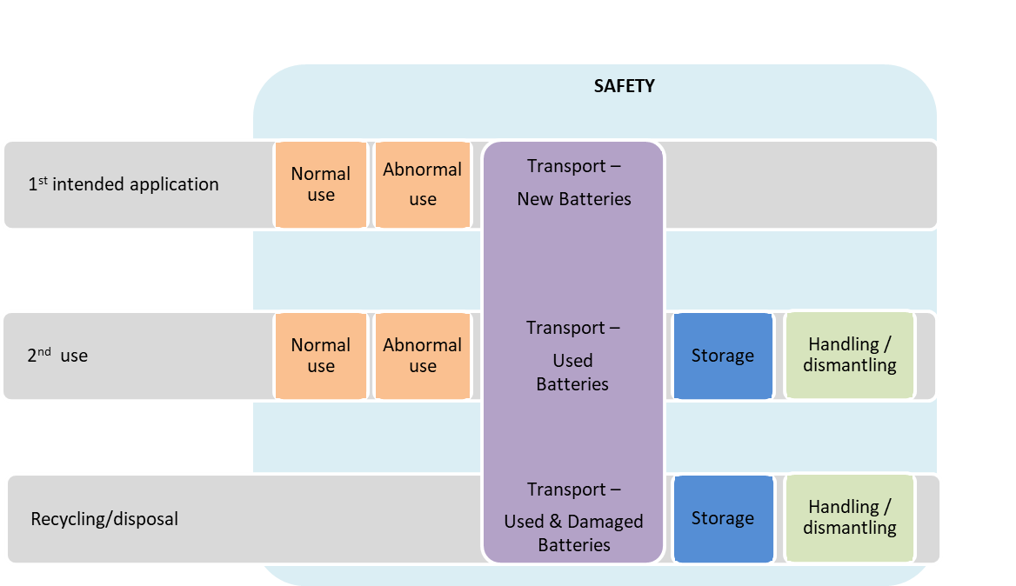
Figure 51: Battery safety aspects in different lifecycle stages

>> Challenges
Enforcing minimum battery safety provision has undeniable advantages for users and workers along the whole battery value chain, as well as for first aid and paramedic staff.
The foreseen massive deployment of battery systems in private and public mobility applications, as well as in energy storage solutions, requires guaranteeing their safe operation to protect users and third parties.
For instance, measures preventing and mitigating the release of toxic materials protect not only human health (by for example ensuring that after a safety event the tenability of the passenger cabin is maintained or ensuring hazard exposure levels remain below certain PAC levels), but has a critical function in protecting the environment as well. Failing to do so will have also a negative effect on the social acceptance of battery technologies. This is of particular importance given the increased use by non-experts of behind the meter storage applications.
As for any other type of technologies, failures can and will occur despite proper design and the adoption of quality control and assurance measures. On top of that, external factors can and will provide additional causes of failure. Therefore, safety testing and requirements are designed not only to guarantee minimal acceptable safety during what is considered the normal operation of a battery, but also during abnormal events which can be caused by internal or external factors.
Ideally, testing requirements must be tailored to the specific applications (e.g. stationary, mobility or freight transport applications), and also differ depending on the level of integration (e.g. cell – module – pack – system). The time and the resources needed for the testing can then become rather substantial.
An additional challenge is the fact that safety requirements can sometimes work against other battery requirements, such as performance (for example causing increase of weight and worsening of efficiency).
Finally, it can also be mentioned the insufficient real-life experience on low-frequency failures and the difficulty to investigate the real cause of the failure. Hence, making it challenging to cover every possible scenario in safety testing protocols.

>> Normal and abnormal use during operation
LIBs (Lithium-ion batteries) are designed to work inside the so-called operational windows, i.e. in predetermined ranges of values of the operative parameters. Hazards are not expected when the battery works inside these operational windows. When the limits of the operative window (and in particularly temperature safe range and voltage safe range) are not respected, a series of run-away events might occur which hazardous potential. It can also occur that even during normal operation a battery may cause a hazardous situation without an evident initiating cause. A flaw in the battery system design or materials and manufacturing defects not detected by quality control may be the cause. These cases may lead to product recalls, when repeatedly occurring in a specific product brand.
Safety provisions are designed to guarantee minimum safe conditions throughout the battery’s operation. The related tests are classified into two types: operative safety tests, aiming at replicating the operating conditions of the battery throughout its life, and abnormal tests (also referred to as abuse tests), which expose the battery to conditions beyond the normal operative windows, aiming at assessing its behaviour during external foreseeable events, such as crashes and fires.
For electro-mobility applications in passenger and goods vehicles, battery safety is regulated by UNECE Global Technical Regulations, which are enacted into EU law as type-approval internal market legislation. Specifically, the following regulations are applicable:
- UN Regulation No. 100.02 [73]: Uniform provisions concerning the approval of vehicles with regard to specific requirements for the electric power train It was published in 2013
- UN-ECE Global Technical Regulation (GTR) No. 20 on the Electric Vehicle Safety (EVS), Working Party on Passive Safety (GRSP), built on the previous one and was published in 2018. A second version is under preparation by an UNECE Informal Working Group Phase 2.
- UN Regulation No. 136: Uniform provisions concerning the approval of vehicles of category L with regard to specific requirements for the electric power train. It was published in 2016.
In addition to this global regulatory framework, the safety of batteries for electro-mobility application is also covered by a number of international standards:
- ISO 6469-1 on Safety specifications of RESS in EV
- IEC 62660-2 on reliability and abuse testing of secondary lithium-ion cells for EV
- IEC 62660-3 on safety requirements of secondary lithium-ion cells for EV
- SAE J2929 on safety of lithium-ion based RESS for electric and hybrid vehicle propulsion
- SAE J2464 on safety and abuse testing of Lithium-ion based RESS for electric and hybrid vehicle propulsion
The IEC technical committee TC 21 on secondary cells and batteries is working on a new part 6 of a series of generic standards on safety requirements for secondary batteries and battery installations: IEC 62485-6 is at the committee draft level and focuses on safe operations of lithium-ion batteries in traction applications.
For stationary energy storage applications, there is no equivalent global regulatory framework. There are however international standards which can be used to assess battery safety. The safety assessment of industrial applications (including stationary applications) relies mainly on the international standard IEC 62619:2017. This standard deals with abuse conditions and is specific to batteries with lithium-ion chemistries. Measures for protections during normal operation conditions and under fault conditions will be available in the future standard IEC 62485-6, which is under preparation by IEC/TC 21.
Generic aspects of safety valid for all applications, such as electrical, mechanical and other hazards (e.g. explosions, fire, chemical) are considered by Technical Specification IEC/TS 62933-5-1, which provides general specifications on hazards identification, risk assessment and risk mitigation for electric energy storage systems (not specific to lithium ion batteries) integrated with the electrical grid. Part 2 of this series (IEC 62933-5-2) covers any electrochemical based systems.
A recent standard dedicated to safety of lithium-ion batteries used in electrical energy storage systems is IEC 63056:2020. While basic safety requirements for industrial applications are contained in IEC 62619, this new document provides specific requirements for electrical energy storage systems used for example for telecommunications, stationary engine starting, photovoltaic systems, residential energy storage systems, and large energy storage, both for on- and off-grid.
A comparative analysis by the JRC of all this existing international standards for battery safety in energy storage applications concluded that in order to set safety criteria for normal and abnormal operation of lithium ion batteries, gaps would need to be covered and a harmonization process would be required.
Provisionally, testing provisions in existing standards would allow imposing the following safety requirements: vibration, thermal shock and cycling, external short circuit protection, overcharge protection, over-discharge protection, over-temperature protection, overcurrent protection, thermal propagation, drop, impact, internal short circuit and thermal abuse, with proper considerations to the risk of toxic gases emitted from non-aqueous electrolytes.

>> Second life
Other sections of this impact assessment report discuss in detail the question of the second life of batteries and its policy implications. The emerging possibility that, at least some, retired batteries from EVs enjoy a second life in other applications, such as energy storage, behind or beyond the meter, raises additional safety questions.
A first consideration when assessing battery safety during its second life is knowing enough about the ageing and use during its first life. This could be partially resolved through the generalization of a battery passport for every unit placed on the market, which would be required to store such information.
A repurposed battery, harvested from a retired EV, and assembled into a stationary storage system should, in principle, undergo the same safety testing as a stationary storage system using new batteries specifically designed for that purpose. However, given the ageing process of some or all of the individual battery cells and modules, unexpected behaviour during safety testing should not be discarded. In terms of performance and durability, a broader spread in results should also to be expected.
In terms of safety standards for the reuse and repurposing of batteries, ANSI/CAN/UL 1974 applicable in the US and Canada, is used for their evaluation and seems to be the only standard existing in this field.
Recent establishment of a new work item proposal (NWIP) by IEC TC 21 (Secondary cells and batteries) on “Requirements for reuse of secondary batteries” is highly relevant. This scope of this document specifies the procedure to evaluate the performance and safety of used batteries and battery systems for the purpose of reuse/repurposing.

>> Transport
The transport of used batteries, for second use or recycling, is another area that deserves particular attention from a safety perspective.
In terms of applicable standards and regulations, UN transport regulation 38.3:2019 presents “Recommendations on the transport of dangerous goods, Manual test and Criteria”, supplements the “Recommendations on the transport of dangerous goods, Model Regulation” and covers cells and batteries (considered in these documents as battery packs, modules or assemblies). Lithium-ion batteries are classified as UN Nos. 3480 and 3481 (lithium-ion batteries and lithium-ion batteries contained in equipment or packed with equipment).
When tests criteria described in the referred to regulation are satisfactorily met, the battery can be shipped as Class 9 regulated battery. Standard IEC 62281 (Safety of primary and secondary lithium cells and batteries during transport) [86] has been recently published with the intention to harmonise the tests and requirements relevant to transport.
Also worth mentioning is SAE J2950 (Recommended Practices (RP) for shipping transport and handling of automotive-type battery systems-Lithium ion) [87]. Although not a standard, it presents recommended practices for shipping automotive-type lithium-ion battery systems; applicable to new and used battery systems uninstalled. It also covers (potentially) damaged systems.
Another aspect somewhat related to safety is the Marking and Packing. Marking requirements are stated in the Model Regulation. Currently, there is a single lithium battery mark, in Part 5 (Consignment procedures) where the UN number shall be indicated, so there is no distinction for the different lithium-ion chemistries. Packing requirements are stated in the ADR (European Agreement concerning the International Carriage of Dangerous Goods by Road) under packaging instruction P903. Protection against short circuit is set as an additional requirement.
Battery based systems that contain used batteries (second use application) would need to comply with the applicable transportation regulations, in an identical way as required for new batteries.
SAE J2950, already mentioned above is also applicable to used batteries. It presents recommendations regarding diagnostic testing to be used by service and shipping personnel for the purpose of determining a used battery system's transportability, and in support of the service and shipping personnel. Remanufactured products are considered as “new” products, for the purposes of this standard.
ANSI/CAN/UL 1974 states that assemblies using repurposed batteries shall comply with the applicable tests in the transportation regulation before shipping. Specifically for battery products carried for disposal or recycling packaging instruction P909 is to be followed. Protection against short circuit is set as an additional requirement
Specific to the transport of damaged or defective batteries, packing instruction P908 in the UN Model Regulation applies, but when the system is liable to lead to a hazardous situation (e.g. produce flame, heat) packing instructions set by special provision P911 are applicable.

>> Storage
Requirements for the storage of batteries in the context of repair, reuse, remanufacture, repurpose, recycling and/or disposal are more related to the facilities where these batteries are kept than to the batteries themselves and are, strictly speaking, not product requirements, and so they would go beyond the remit of the regulatory proposal.
In any case, storage facilities shall be in accordance with local fire and building codes of practice and rules with regard to hazardous materials storage. Special attention needs to be paid when storing damaged or defective batteries. Monitoring and controlling the temperature and the humidity of the storage rooms is critical.
ANSI/CAN/UL 1974 requires for storage that batteries intended for repurposing shall have the ambient temperature and humidity conditions associated with their storage before repurposing monitored and recorded on minimum a daily basis and that charging or discharging shall be recorded as well as the open circuit voltage at the beginning and end of storage.

>> Handling/dismantling
Rationale: Improper handling and care can lead to battery related accidents. Any worker handling batteries at any level of assembly (from system level down to cell level) shall have appropriate training (particularly important for high voltage systems).
The recovery of a battery from an end-of-life battery needs OEM reference and guidance. The International Dismantlers Information System (IDIS) can be a source of information. A related concept is that of 'Stranded Energy'; this refers to a situation following an incident, where the battery system's ability to function (or even to communicate its status) is compromised. Guidelines are needed to disable and / or discharge a battery system after such incidents.
Once the battery system is safely extracted from its fist life environment, further disassembly is, for the time being, being performed manually both in the context of second use and of recycling. As volumes increase, more and more automation is expected in the future. In any case, the repurposing manufacturer or recycler shall have sufficient knowledge so as to disassembly properly battery systems, perform safe sorting/grading and comply with proper quality controls.
Visual examination shall be the first step to carry out when handling a battery cell, module, pack or system. Any signs of damage could impact safety (of workers, surrounding personnel or facilities) and shall trigger proper safety protocols. These are visual clues, which can reveal safety hazards, such as swelled cells, leaked electrolyte, damaged casing or mechanical deformation of any parts of the product.
Standard SAE J2990 is specific to the handling of EV batteries involved in crashes/incidents by emergency responders, tow/recovery personnel, etc. It also touches upon the topic of battery depowering after a vehicle incident. On a related topic, SAE J2974 defines the concept of 'Stranded energy'. This implies a risk of high voltage exposure (as the battery voltage usually remains >60 V) and risk of delayed thermal runaway (as the battery might be damaged).

>> Conclusions
Based on the previous analysis, the following conclusions can be drawn:
For electro-mobility applications (passenger and goods vehicles), the regulatory proposal should refer to existing UNECE Global Technical Regulations and refrain from proposing further safety requirements for batteries during their (first life) operation.
For energy storage solutions, there would be a need to provide legal coverage to the development of technical specifications on to bridge gaps in safety testing and criteria, as well as to harmonize a number of existing international standards. This should be reflected in the standardization request that will be associated with the regulatory proposal. Provisionally, certain safety provisions could be included in the regulatory proposal, which could be further developed via secondary legislation.
For the second life of batteries, there would be a need to develop in the EU a similar standard to the one already existing in the US/Canada, ANSI/CAN/UL 1974. This should be reflected in the standardization request. Recent establishment of a new work item proposal (NWIP) by IEC TC 21 (Secondary cells and batteries) on “Requirements for reuse of secondary batteries” is highly relevant.
For the transport of used batteries, the regulatory proposal should refer to applicable UN regulations and European Agreements (i.e., ADR).
For safe handling of batteries in the context of both second use and recycling, proper guidelines to relevant personnel need to be developed.

Enabler: Green public procurement and batteries
The European Green Deal states that public authorities should lead by example and ensure that their procurement is green. With the new Circular Economy Action Plan, the Commission committed to proposing minimum mandatory green public procurement (GPP) criteria and targets in sectoral legislation.
Public authorities are major consumers in Europe: they represent around 14 % of the EU’s gross domestic product. Their consumption of batteries will also be significant:
- In the road transport sector, public authorities represent around 3% of the market for passenger cars and light-duty vehicles. The share increases to 75% for the bus and coaches market and to almost the totality for waste collection trucks. The use of industrial batteries in the sector will increase steeply in the coming years, also as consequence of the implementation of EU legislation, like the reviewed clean vehicles directive.
- As regards portable batteries, no data are available on the public authorities’ market share in sector like computers, laptops and smartphones, but this is evidently not negligible.
- Public authorities are also likely to have a prominent role in the development of energy storage systems.

Using contracting authorities’ purchasing power to choose more environmentally friendly batteries can make an important contribution to sustainable consumption and production. Firstly, a direct reduction of the environmental impacts related to contracting authorities’ activities can be achieved. Secondly, certainty on the demand of low-impact solutions on the market provides incentives to the industry to innovate. Finally, contracting authorities, as representatives of the collectivity, bear the costs of negative externalities (e.g. as health-care costs or remediation costs) it makes therefore sense that they take an active role in the reduction of these externalities.
GPP requires clear, verifiable, justifiable and ambitious environmental criteria for products, based on a life-cycle approach and scientific evidence base. The criteria used by Member States should be similar to avoid a distortion of the single market and a reduction of EU-wide competition. Having common criteria reduces the administrative burden for economic operators and for public administrations implementing GPP.
Amongst the criteria for developing GPP criteria is the existence of relevant and easy-to-use information including on market availability and economic efficiency. The measures set out above will support the development of the evidence base and hence the development of relevant criteria. Member States could use such criteria in anticipation of the entering into force of some of the requirements set out in the measures. It would also be possible in the development of the criteria to set stricter requirements for public procurement. The development of criteria takes account of information collected from stakeholders of industry, civil society and Member States, adopts a life-cycle approach and engages stakeholders who meet to discuss issues and develop consensus. Reflecting this, the legislation will allow for the Commission to develop mandatory GPP criteria and targets, but as the underpinning work is still to be undertaken any such proposal will be subject to the Better Regulation Guidelines including if appropriate an Impact Assessment process.

Eucobat - Möbius - Batteries Available for Collection - 2018
https://ec.europa.eu/environment/waste/pdf/Published%20Supporting%20Study%20Evaluation.pdf
For this document, second life batteries are those that perform their functions in a different context to the one for which they were initially designed and manufactured. While some transformations intended to recondition or repurposing the battery might be needed (e.g. on wires and connectors, battery management system hardware or software, substitution of failing modules), it is assumed that no change below the ‘module’ level has taken place. Hence, dismantling into cells and reconstituting modules and batteries is considered remanufacturing and not second life.
Sustainability Assessment of Second Life Application of Automotive Batteries (SASLAB). http://publications.jrc.ec.europa.eu/repository/bitstream/JRC112543/saslab_final_report_2018_2018-08-28.pdf
Battery second life: Hype, hope or reality? A critical review of the state of the art, Renewable and Sustainable Energy Reviews 93 (2018) 701-718
Bobba, S. et al. (2018) Life Cycle Assessment of repurposed electric vehicle batteries: an adapted method based on modelling energy flows. Journal of Energy Storage. 19 pp. 213–225. https://doi.org/10.1016/j.est.2018.07.008
Bobba, S. et al (2019) How will second-use of batteries affect stocks and flows in the EU? A model for traction lithium-ion batteries. Resources, Conservation and Recycling, Volume 145, June 2019, Pages 279-29. https://doi.org/10.1016/j.resconrec.2019.02.022
See CSWD (2019) 1300
https://ec.europa.eu/info/research-and-innovation/law-and-regulations/innovation-friendly-legislation/identifying-barriers_en
https://ecodesignbatteries.eu/documents
Neubauer, J., Smith, K., Wood, E., & Pesaran, A. Identifying and Overcoming Critical Barriers to Widespread Second Use of PEV Batteries. United States.- http://dx.doi.org/10.2172/1171780
Battery second life: Hype, hope or reality? A critical review of the state of the art E. Martinez-Lasernaa,⁎, I. Gandiagaa, E. Sarasketa-Zabalaa, J. Badedab,c,d, D.-I. Stroee, M. Swierczynskie, A. Goikoetxeaf, 2018
https://group.renault.com/virtuous-loop-ev/
COM(2019)166
https://ec.europa.eu/eurostat/web/waste/data/database
Pritchards (2018, last update) ‘The collection of waste portable batteries in Europe in view of the achievability of the collection targets set by Batteries Directive 2006/66/EC ‘
Mobius, BEBAT, (2017) “Quantification of batteries in residual household waste”
Prices used by the EIB, converted to 2019 prices.
Based on data for Austria, France and the Netherlands
Based on data for Belgium and Switzerland. Current data for Belgium point to a cost of EUR 1.23 per capita per year (based on a PRO fee of EUR 0,057 per portable battery, except for lithium batteries that weigh more than 150 grams). This fee covers the following: collection, pick-up, sorting, processing and recycling, awareness campaigns and reporting to the authorities. This PRO provides 24 000 collection points, equivalent to 1 per 500 inhabitants. In 2019 it collected 247 million portable batteries, equivalent to 5413 tonnes.
Perchards and SagisEPR (2017) 'The collection of waste portable batteries in Europe in view of the achievability of the collection targets set by Batteries Directive 2006/66/EC – 2017 update'
One survey indicates that an average family owns 131 batteries, of which 26 are non-rechargeable and empty
One survey indicates that an average family owns 131 batteries, of which 26 are non-rechargeable and empty
See the 2020 report from UNICEF ‘The Toxic Truth’, at https://www.unicef.org/reports/toxic-truth-childrens-exposure-to-lead-pollution-2020
Market development based on statistical trends in individual MS derived from ACEA and EUROSTAT. Total growth based on IEA scenarios.
Data taken from PRODCOMM, EUROSTAT
According to Commission Regulation 493/2012, ‘recycling efficiency’ of a recycling process means the ratio obtained by dividing the mass of output fractions accounting for recycling by the mass of the waste batteries and accumulators input fraction, expressed as a percentage;
A. Mayyas, D. Steward and M. Mann (2018) ‘The case for recycling: Overview and challenges in the material supply chain for automotive li-ion batteries’ Sustainable Materials and Technologies 17 (2018) e00087
Data from the International Lead and Zinc Study Group data base, http://stats-database.ilzsg.org/ (accessed on 21.3.2020)
A. Mayyas, D. Steward and M. Mann (2018) ‘The case for recycling: Overview and challenges in the material supply chain for automotive li-ion batteries’ Sustainable Materials and Technologies 17 (2018) e00087
See Avicenne 2019
See CSWD(2019)1300, section 3.1
Q. Dai, J. C. Kelly, J. Dunn, and P.T. Benavides (2018) ‘Update of Bill-of-materials and Cathode Materials Production for Lithium-ion Batteries in the GREET Model’
A recycling process “… starts after collection and possible sorting and/or preparation for recycling of the waste batteries and accumulators received by a recycling facility and finishes when output fractions are produced to be used for their original purpose or for other purposes without undergoing further treatment and have ceased to be waste,” as in Commission Regulation (EU) No 493/2012
Meshram, P., Pandey, B. D. & Mankhand, T. R. Extraction of lithium from primary and secondary sources by pre-treatment, leaching and separation: a comprehensive review. Hydrometallurgy 150, 192–208 (2014).
Tedjar, F. in Challenge for Recycling Advanced EV Batteries https://congresses.icmab.es/ iba2013/images/files/Friday/Morning/Farouk%20Tedjar.pdf (2013).
E Mossali et al., (2020) ‘Lithium-ion batteries towards circular economy: A literature review of opportunities and issues of recycling treatments
Z Wang (2019) ‘The role of battery recycling in raw material supply’, ICBR
X Wange et al., (2014) ‘Economies of scale for future lithium-ion battery recycling infrastructure’
E. Drabik, V. Rizos (2018) ‘Prospects for electric vehicle batteries in a circular economy’ CEPS
Identifying key assumptions and differences in life cycle assessment studies of lithium-ion traction batteries with focus on greenhouse gas emissions, Linda Ager-Wick Ellingse, Christine Roxanne Hung, Aders Hammer Stromman, Transportation Research Part D 55 (2017) 82-90
https://ec.europa.eu/environment/eussd/smgp/pdf/2017_EY_finalrep_verification_public.pdf
Source: Preparatory study on Ecodesign and Energy Labelling of batteries: https://ecodesignbatteries.eu/sites/ecodesignbatteries.eu/files/attachments/ED_Battery_Task%207_V45_final_corrected.pdf
Source: Preparatory study on Ecodesign and Energy Labelling of batteries: https://ecodesignbatteries.eu/sites/ecodesignbatteries.eu/files/attachments/ED_Battery_Task%207_V45_final_corrected.pdf
For instance, the IEC standard 60068-2
I.e. portable batteries of the most common formats such as 4,5 Volts (3R12), D, C, AA, AAA, AAAA, A23, 9 Volts (PP3)
EPBA has also published a description of the main features of general-purpose portable batteries: https://www.epbaeurope.net/wp-content/uploads/2016/12/EPBA_Product-Information_10112015.pdf
Dolci et al (2016) 'Life cycle assessment of consumption choices: a comparison between disposable and rechargeable household batteries' – International Journal of Life Cycle Assessment, DOI 10.1007/s11367-016-1134-5
Resource consumption, acidification, abiotic depletion, global warming, human toxicity, marine water toxicity and energy consumption
S. Ziemanna, D.B. Müllerb, L. Schebekc and Marcel Weila (2020) ‘Modeling the potential impact of lithium recycling from EV batteries on lithium demand: A dynamic MFA approach’ Resources, Conservation & Recycling 133 (2018) 76–85
https://ec.europa.eu/environment/eussd/smgp/pdf/2017_EY_finalrep_verification_public.pdf
A. Mayyas, D. Steward and M. Mann (2018) ‘The case for recycling: Overview and challenges in the material supply chain for automotive li-ion batteries’ Sustainable Materials and Technologies 17 (2018) e00087
CSWD (2019) 1300
Mobius, BEBAT, (2017) “Quantification of batteries in residual household waste”
Perchards and SagisEPR (2016) Study for EPBA on Waste Portable batteries collection rates.
A battery is considered replaceable when after its removal it can be seamlessly substituted by a similar one, without affecting the functioning or the performance of the appliance.
Interoperability means that the same battery can be used in devices from different manufacturers. Intra-operability means that the same battery can be used between different models or devices from the same manufacturer. In cases where the difference between both terms is not relevant, this report uses the term interoperability as a generic term that includes both intra- and interoperability.
It is important to note that the removability is a precondition for replaceability. The difference between both is that replaceability guarantees that the device is not damaged when the battery is removed. Likewise, interoperability is not possible without the condition of replaceability. Thus, the replaceability requirement, compared to the removability requirement, would mean that reversible joints (e.g. no welding, no sealing, no strong gluing) are used in the product to access, remove and replace the battery.
Such changes will largely influence how manufacturers implement safety features on battery cell and system level and hence reduce many degrees of freedom in engineering."
Tecchio, P., Ardente, F., Marwede, M., Christian, C., Dimitrova, G. and Mathieux, F. (2018) 'Analysis of material efficiency aspects of personal computers product group'
RREUSE (2015) 'Briefing on job creation potential in the re-use sector'
Gsmarena.com provides battery tests for mobile phones and avg.com and cnect.com for portable PCs https://www.gsmarena.com/battery-test.php3, https://www.avg.com/fr-fr/avg-pctuneup-test-pc-battery, https://www.cnet.com/news/best-battery-life-laptops-for-2020/
https://ec.europa.eu/consumers/consumers_safety/safety_products/rapex/alerts/?event=buttonBatteries:home&lng=en
Tecchio, P., Ardente, F., Marwede, M., Christian, C., Dimitrova, G. and Mathieux, F., (2018) Analysis of material efficiency aspects of personal computers product group..
Ollion, L., Anta, M., Herreras, L., Characterisation of fires caused by batteries in WEEE (2020), Survey results from the WEEE management chain – part A, a WEEE Forum and EuRIC report.
European Energy Research Alliance, 2016. EERA position paper. Netherlands.
Tecchio, P., Ardente, F., Marwede, M., Christian, C., Dimitrova, G. and Mathieux, F., Analysis of material efficiency aspects of personal computers product group, EUR 28394 EN, Publications Office of the European Union, Luxembourg, 2018, ISBN 978-92-79-64943-1, doi:10.2788/89220, JRC105156.
See for instance https://www.amnesty.org/en/latest/news/2019/03/amnesty-challenges-industry-leaders-to-clean-up-their-batteries/
OECD (2019) Interconnected supply chains: a comprehensive look at due diligence challenges and opportunities sourcing cobalt and copper from the Democratic Republic of the Congo https://mneguidelines.oecd.org/interconnected-supply-chains-a-comprehensive-look-at-due-diligence-challenges-and-opportunities-sourcing-cobalt-and-copper-from-the-drc.htm
https://ecodesignbatteries.eu/documents
Global annual production - The production data corresponds to the average global yearly production in the period 2013-2017. Data from World Mining Data
Mentioned in the SWD(2014) 53 final PART 4 (Second part of Annex III to the Impact Assessment) Accompanying the document Proposal for a Regulation of the European Parliament and of the Council setting up a Union system for supply chain due diligence self-certification of responsible importers of tin, tantalum and tungsten, their ores, and gold originating in conflict affected and high-risk areas {COM(2014) 111} {SWD(2014) 52}
The OECD Due Diligence Guidance for Responsible Mineral Supply Chains is available at: http://mneguidelines.oecd.org/mining.htm
See https://eur-lex.europa.eu/legal-content/EN/TXT/PDF/?uri=CELEX:52017XC0705(01)&from=EN
University of Columbia, School for International Affairs (2016) " Quantifying the Costs, Benefits and Risks of Due Diligence for Responsible Business: Conduct, Framework and Assessment Tool for Companies" – study for the OECD, https://mneguidelines.oecd.org/Quantifying-the-Cost-Benefits-Risks-of-Due-Diligence-for-RBC.pdf
Directive 2014/95/EU lays down the rules on disclosure of non-financial and diversity information by large companies.
https://ec.europa.eu/growth/single-market/goods/building-blocks/notified-bodies_en
As recommended in the JRC Study: Mancini, L., Eslava, N.A., Traverso, M., Mathieux, F., 2020. Responsible and sustainable sourcing of batteries raw materials. Insights from hotspot analysis, corporate disclosures and field research. Publications Office of the European Union, Luxembourg. doi:10.2760/562951.Under publication.
Directive 2011/65/EU, OJ L 174, 1.7.2011
REGULATION (EC) No 1907/2006, OJ L 396, 30.12.2006
https://response.restoration.noaa.gov/oil-and-chemical-spills/chemical-spills/resources/protective-action-criteria-chemicals-pacs.html
JRC Technical reports - Sustainability requirements; potential criteria for lithium-ion batteries, to be published
UN Recommendations on the Transport of Dangerous Goods - Model Regulations 20th revised edition, http://www.unece.org/trans/danger/publi/unrec/rev21/21files_e.html
COM (2020) 98
https://publications.jrc.ec.europa.eu/repository/bitstream/JRC115414/eu_gpp_transport_technical_report_final.pdf, p. 13.
https://eur-lex.europa.eu/legal-content/EN/TXT/PDF/?uri=CELEX:32019L1161&from=EN

