Methods used to set management objectives for nutrients - a comparison of national approaches
draft group
2021-12-06
Table of Contents

As part of its mandate to understand the approaches taken by Member States and associated countries to managing nutrients in order to achieve good ecological status and good environmental status, ECOSTAT circulated a questionnaire to compare national approaches to setting and implementing management objectives for nutrients. The work builds on earlier activities that compared good/moderate boundaries by exploring the linkages between the nutrient boundaries set by a country, and the steps taken to manage nutrient loads in order to bring nutrient loads down in order to achieve these boundary concentrations.
The questionnaire was divided into three sections:
- Part A addressed the methods used to derive management objectives for nutrients and was answered separately for rivers, lakes, transitional, coastal and marine waters.
- Part B addressed the methods used to calculate current nutrient loads, including catchment modelling.
- Part C addressed methods/approaches used for achieving the management objectives for nutrients.
This report presents an overview of responses. In order to keep the report to a manageable length, the detailed responses from countries have not been included except where national practices differ from the main trends identified. Comments that are not referred to directly in the report can be found in the appendix to this report.
[I suggest that the collated responses is retitled as an appendix to this report]

0.0.0.1 Overview of countries participating in questionnaire
Twenty-six countries participated in this survey, five of which are land-locked countries reporting only for freshwater categories.
Table 1. Countries* participating in survey per water category.
Country
Water Category
Acronym
Lakes
Rivers
Transitional
Coastal
Marine
AT
Austria
y
y
BE
Belgium
y
BG
Bulgaria
y
y
CY
Cyprus
y
y
y
y
CZ
Czechia
y
y
DE
Germany
y
y
y
y
y
DK
Denmark
y
y
y
y
EE
Estonia
y
y
y
y
EL
Greece
y
y
y
y
ES
Spain
y
y
y
y
y
FI
Finland
y
y
y
y
FR
France
y
y
y
y
y
HU
Hungary
y
y
IE
Ireland
y
y
y
y
y
IS
Iceland
y
y
y
y
IT
Italy
y
y
y
y
y
LT
Lithuania
y
y
y
y
y
LV
Latvia
y
y
y
y
y
NL
Netherlands
y
y
y
y
y
NO
Norway
y
y
y
PL
Poland
y
y
y
y
y
PT
Portugal
y
y
y
y
RO
Romania
y
y
y
y
y
SE
Sweden
y
y
y
y
SK
Slovakia
y
TR
Turkey
y
y
y
*Iceland and Norway (EFTA Members) and Turkey (EU candidate) are not EU Member States.

0.1 How are management objectives for nutrients derived (methods)? (Part A)

0.2 AQ1. Have you set management objectives for nutrients for waters bodies that are exposed to nutrient pollution?
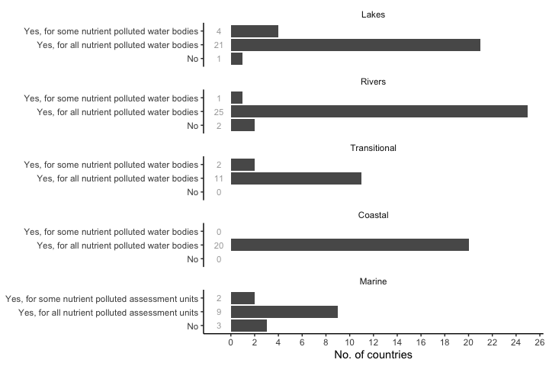
Figure 1. Figure 1. Number of countries responding, overview by water category.
Most countries have set management objectives for all water bodies exposed to nutrient pollution in the different water categories, with few countries considering only some of the nutrient polluted water bodies (DK, ES, FR, CY in lakes; FR rivers; ES, FR in transitional waters; and DE, NL in marine waters). Only FR in lakes, DK, FR in rivers, and FR, IT, CY in marine waters have not set management objectives for water bodies exposed to nutrient pollution. Results show that France (FR) does not follow a standardised national approach, with water agencies each adopting their own policies (but confirm this).

0.3 AQ2. When setting management objectives for nutrients, is there a focus on reduction of phosphorus, nitrogen, or both or on the limiting nutrient?
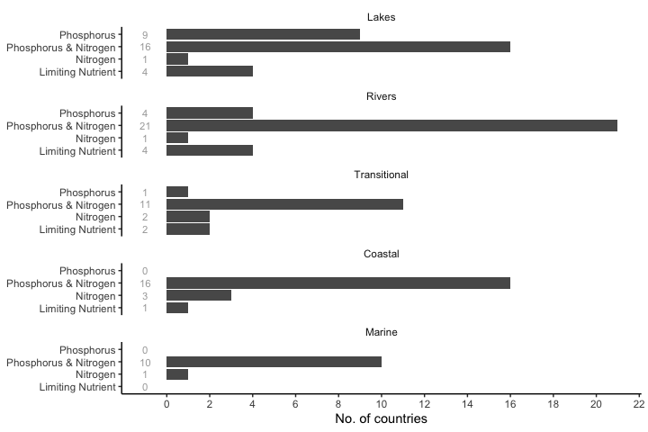
Figure 2. Figure 2. Number of countries responding, overview by water category.
Responses reflect, to a large extent, an interplay between biogeography and local pressures. Most countries focus on reducing both nitrogen and phosphorus whatever the water category considered; those who focussed on one or the other did so because local circumstances meant that this was the most likely reason for problems. That would be, for example, the case of phosphorus reduction in lakes, adopted by nine countries (CZ, DK, IE, ES, FR, NL, AT, FI, SE), or nitrogen in lakes (NL), rivers (FR), coastal (DE, IE, NL) or marine waters (NL). Responses focussed on the consequences of nutrients on transitional water ecosystems, but there was also some acknowledgment of the role of transitional waters as conduits of nutrients to coastal and marine waters too.
The limiting nutrient approach is more commonly assumed in freshwater categories (lakes: DE, ES, IT, FI; rivers: BE, FR, IT, FI) than in marine influenced systems (transitional: FR, IT, coastal: FR). [Heliana: what do you mean in this sentence? Don’t all assume limiting nutrients but differ in whether they focus on N or P? ] What is not clear from the responses is how the limiting nutrient is determined in any given situation. Several responses referred to prevailing dogma that nitrogen and phosphorus are the nutrients most likely to be limiting (and, therefore, responsible for eutrophication when present in excess) and some (e.g. PL) indicated that targets were to achieve concentrations consistent with the good/moderate boundary. This, in turn, presumes a good quantitative understanding of causal relationships between nutrients and measures of the condition of the flora and fauna which can be difficult to obtain for transitional waters (Salas-Herrero et al., 2019). It can probably be assumed that exceeding supporting element standards for nitrogen and phosphorus is the default criterion for recognising a need for nutrient management. However, as Phillips et al. (2018) point out, there are a variety of approaches to setting nutrient standards, with different levels of precaution. No mention is made of more targeted, case specific approaches in the responses; however, this does not mean that they are not used in individual countries.

0.4 AQ3. If you have set management objectives for nutrients, please indicate which methodology has been used.
Figure 3. Number of countries responding, overview by water category.
Figure 3. Number of countries responding, overview by water category.
The most commonly used method to derive nutrient targets in all water categories was based on modeled pressure-response relationships between nutrient(s) and biological quality elements (BQE) (lakes: DK, DE, EE, IE, ES, FR, IT, CY, HU, NL, AT, PL, PT, FI, NO, TR; rivers: BE, DE, EE, IE, ES, FR, IT, CY, HU, NL, AT, PL, PT, FI, NO, TR; transitional: DE, FR, IT, LV, LT, NL, PL; coastal: DK, DE, EE, IE, EL, FR, LV, LT, NL, PL, SE; marine: DK, DE, EE, LV, NL, FI, SE). A wide range of BQEs have been used to establish these relationships, with phytoplankton (including chlorophyll concentrations and, in a few cases, cyanobacteria abundance or bloom frequency) being most widely used, especially in deeper water.
The four possible answers to this question are not exclusive, with several countries using more than one approach. For example, a modelling approach might be combined with historical information by an expert to give a more nuanced target than would be provided by any approach in isolation. The term “modelling”, itself, covers a wide range of possibiltilies. BQE-response relationships are often strong in lakes and are well-suited to deriving standards following the methods in the Best Practice Guide [how should this be cited here?] but a range of other modelling approaches are employed. Few respondents mentioned which BQE was used. Of those who did, phytoplankton, phytobenthos, macrophytes, invertebrates and fish were all mentioned, depending on specific contexts. There is also a distinction between those countries that set targets in terms of concentrations and those who use loads (this will be explored in more detail later in the report). A further distinction is between those who used mass balance models and those who used dynamic process models although details in questionnaire responses did not always explain the mechanisms behind their models. Lakes are well suited to the use of historical information, through the use of palaeoecology; historical information is also used in rivers by eight countries, though none of these provided more information on how this was done.
A wide range of responses were recorded in the “other” category. Several of these overlapped with the other three categories, but some countries appear to have derived management objectives purely from physico-chemical criteria (e.g.EL’S usE of the PCQI index of Bald et al., 2005, in transitional waters).
Descriptions of national approaches for the different water categories can be found in the Appendix.

0.5 AQ4. Do you determine the maximum critical load or a load reduction target that is compatible with good status for nutrient sensitive BQEs?
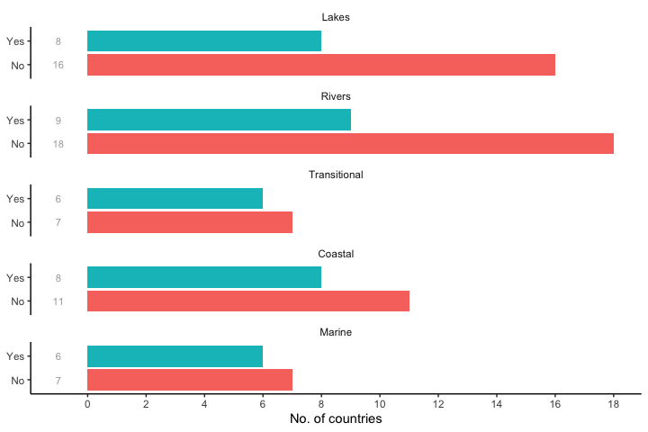
Figure 3. Figure 4. Number of countries responding, overview by water category.
Nutrient critical loads or load reduction targets compatible with good status of nutrient sensitive BQEs are only set by half or less of the reporting countries in lakes (DK, DE, EL, LV, NL, PL, FI, SE), rivers (BE, DE, EL, FR, LV, LT, PL, FI, SE), transitional (DE, IE, EL, LV, NL, PL), coastal (DK, DE, IE, LV, NL, PL, FI, SE) and marine waters (DK, DE, EE, LV, FI, SE).
Detailed responses to this question were ambiguous, particullary for freshwaters, with 16 (lakes) and 18 (rivers) answering “no” to the question, implying that they did not determine the maximum critical load or a load reduction target, whereas some of the more comments send by these same countries suggested that they did. What seems to be clear is that many see target setting as a process that needs to be applied to individual water bodies, rather than derived as a guide value for all water bodies within a broadly-defined type. Where targets are defined as concentrations rather than loads there is an inference that some form of mass balance model is also employed in order to work out how a target may be achieved for any individual water body.
The situation for transitional, coastal and marine waters is similar, though proportionately fewer countries replied “no” in each case. No more than a third of countries who replied “no” offered any explanation.
[I suspect that there was a widespread misunderstanding here: cross-matching with other responses by the same country suggests many of the “no” responses should be “yes” but it would take a lot of effort to unravel every national response. ]

0.6 AQ5. Is there a relationship between the management objectives set for nutrients and the nutrient boundaries set for ecological status?
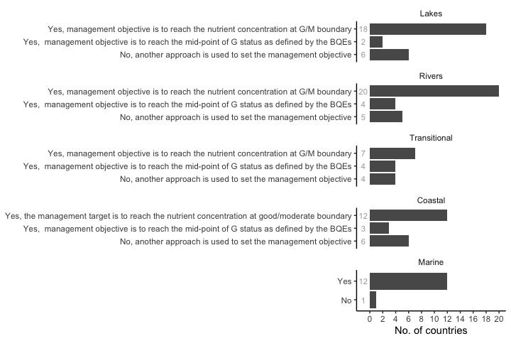
Figure 4. Figure 5. Number of countries responding, overview by water category.
Most countries acknowledge that there is a relationship between the management objectives set for nutrients and the nutrient boundaries set for ecological status, and most commonly the management objective is to reach the nutrient concentration at good/moderate boundary (lakes: BG, CZ, DK, EE, IE, ES, FR, IT, CY, LV, LT, HU, NL, AT, PL, FI, SE, NO, rivers: BE, BG, CZ, EE, IE, EL, ES, FR, IT, CY, LV, LT, HU, NL, AT, PL, SK, FI, SE, NO, transitional: IE, ES, IT, LV, LT, NL, PL, coastal: DE, EE, IE, EL, ES, LV, LT, NL, PL, FI, SE, NO). This would reduce the number of mismataches between ecology and nutrients but good status would be unlikely to be achieved in many cases. In some countries the management objective is slightly more ambitious and aims to reach the mid-point between the high/good and the good/moderate boundary as defined by the biological quality elements (lakes: PT, IS, rivers: FR, NL, PT, IS, transitional: EL, NL, PT, IS, coastal: NL, PT, IS).
Some countries used another approach to set their management objective (lakes: DE, EL, FR, IT, RO, TR, rivers: DE, FR, IT, RO, TR, transitional: DE, FR, IT, RO, coastal: DK, DE, FR, IT, CY, RO, marine: IT)
Setting nutrient boundaries that are consistent with the G/M boundary will not necessarily equate with achieving good status for BQEs, particularly as G/M boundaries are usually type- rather than site-specific. Further questions will need to be asked to elucidate how countries address the inevitable mismatches between chemical and ecological status. If ecology does not achieve good status after nutrient reductions to the G/M boundary, then what actions does each country take? Are targets reassessed or evidence specific to a water body reviewed, or are other solutions (e.g. “less stringent objectives”) considered.
[Heliana: can you make a comment on marine waters here, as the rules for the MSFD are slightly different?)]

0.7 AQ6. If you have set management objectives for nutrients, please specify which policy the management objectives are meant to address.
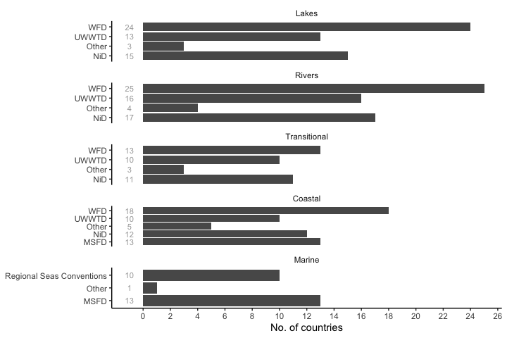
Figure 5. Figure 6. Number of countries responding, overview by water category.
For all water categories except Marine, the WFD is the most important driver, though the Urban Wastewater and Nitrates Directive are also cited by several countries across all water types. For Marine waters the MFSD and Regional Sea Conventions are both important. Those who selected “other” cited the Industrial Emissions Directive, Common Agricultural Policy and EU regulations on phosphate-free detergents as also influencing management directives, along with national legislation (e.g. SE has a policy on “zero eutrophication”: https://www.sverigesmiljomal.se/environmental-objectives/).

0.8 AQ7. Countries which have not set management objectives for nutrients.
Countries which have not set management objectives for nutrients are as follows: lakes (FR, CY, AT, RO, IS), rivers, (DK, FR, RO, IS, transitional (FR, PT, RO, IS), coastal (FR, IS), marine (DE, IE, FR, IT, CY, NL).
A variety of reasons are offered including:
- remote lakes above any human settlement and, therefore, with no eutrophication pressure (AT, IS);
- fish ponds that are eutrophic due to the purpose of the lake (AT);
- flood retention lakes which, again, due to their purpose, are subject to occasional pulses of nutrients (AT);
- no observed effect of nitrogen in a lake (CY);
- “less stringent objectives” have been set (FR);
- management objectives set for water bodies upstream of coastal lagoons but not, specifically, for the lagoon itself (FR); and,
- work to set targets is not yet complete (IT).
A complete list of responses can be found in the Appendix.

0.9 How are the current nutrient loads estimated? (Part B)

0.10 BQ1. Do you calculate current nutrient loads in order to achieve management objectives for nutrients?
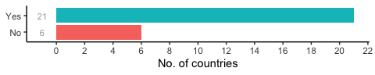
Figure 6. Figure 7. Number of countries responding.
Add here a summary paragraph on the graph results.
6 countries (BG, FR, HU, AT, IS, TR) replied “no” to this question, but none provided any explanation.,

0.11 BQ2. If yes, what methods do you use to calculate nutrient loads?
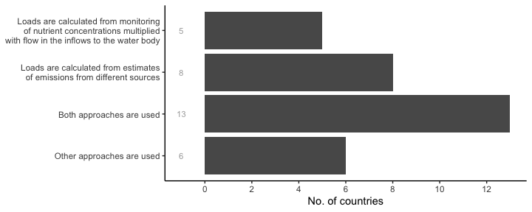
Figure 7. Figure 8. Number of countries responding.
Responses reflect the wide variety of models which are used, each with differing data requirements. 6 countries (EE, IT, NL, FI, SE, NO) selected “other approaches are used”. Four of these countries also selcted at least one of the other three response categories. Of the others, EE does calculate nutrient loads but does not indicate how this is done; whilst FI is a transcription error, with the original questionnaire response indicating “both approaches are used”
[Heliana: should we just correct this mistake? The original FI response is different that in the collated responses]

0.12 BQ3. Do you use catchment models that quantify the nutrient emissions/nutrient losses to surface waters?
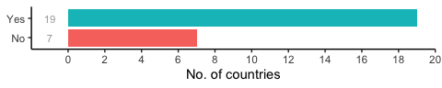
Figure 8. Figure 9. Number of countries responding.
Catchment models that quantify the nutrient emissions/nutrient losses to surface waters are used by 19 countries, namely: BE, CZ, DK, DE, EE, IE, ES, FR, LV, LT, HU, NL, AT, PL, PT, RO, FI, SE, NO. A full list of models cited in this report is given in Table #. Based on information given, most of these are best considered as part of networks of specialised models, each passing estimages to subseqeunt modules (e.g. soil leaching of nutrients is estimated by one model, and these estimates are then passed to a hydrological model). As far as we can tell, few of these are explicitly modelling ecological processes, with the end result being an estimate of surface water concentrations. These are then compared with good-moderate boundary concentrations extimated by emperical models, many of which are based on methods outlined in the BPG.
<<<<<<< HEAD The best way forward might be to include a table that lists all the models used, by country. Some use more than one. Many are specific to one country; a few (e.g. MONERIS) seem to be used more widely. List will exclude emperical models, e.g. Vollenweider, and models covered by BPG. Also a few references to hydrological and atmospheric models whcih appear to form part of decision-support systems but which do not explicitly model nutrients. These have also been excluded.

0.13 BQ4. If yes, at what spatial level do the models operate?
<<<<<<< HEAD 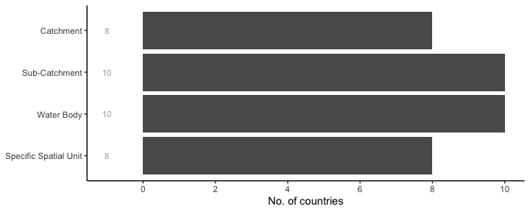
Once again, many countries ticked multiple boxes, perhaps reflecting regional differences within a country or that models are capable of operating at different spatial scales.
Modelling is performed at a range of spatial scales. One problem we have is that definitions of “Water body” are quite vague (eg CIS guidance #2), and can overlap with both “catchment” and “subcatchment”. Different countries may have different understandings of how these terms are applied. There is no indication of whether modelling exercises cross national borders but maybe we didn’t ask the right questions.

0.14 BQ5. If yes, how large are the uncertainties in these models and how do you deal with these uncertainties?
Uncertainties in the models that are used to quantify the nutrient emissions and/or nutrient losses to surface waters were addressed by 16 countries, namely: BE, CZ, DK, DE, EE, IE, FR, LV, LT, HU, NL, PL, RO, FI, SE, NO. Responses to this question can be found in the Appendix. Most acknowledge that there are several different sources of uncertainty in their models whcih, when combined, can lead to considerable uncertainty in final outcomes. The uncertainties themselves depend upon the size of the waterbodies being modelled, the time scale and the quality of the data on which the model is calibrated. Uncertainties are also greater when diffuse sources dominate over point sources. As a result, some countries (e.g. IE) noted that they did not use models for regulatory purposes, but to guide and direct further field assessments, and to target interventions.
Add here a critical analysis paragraph.

0.15 How are measures to reach management objectives for nutrients defined? (Part C)

0.16 CQ1. When is nutrient reduction decided to be necessary?
(note to self) Attention: marine waters less categorical options but merge if possible 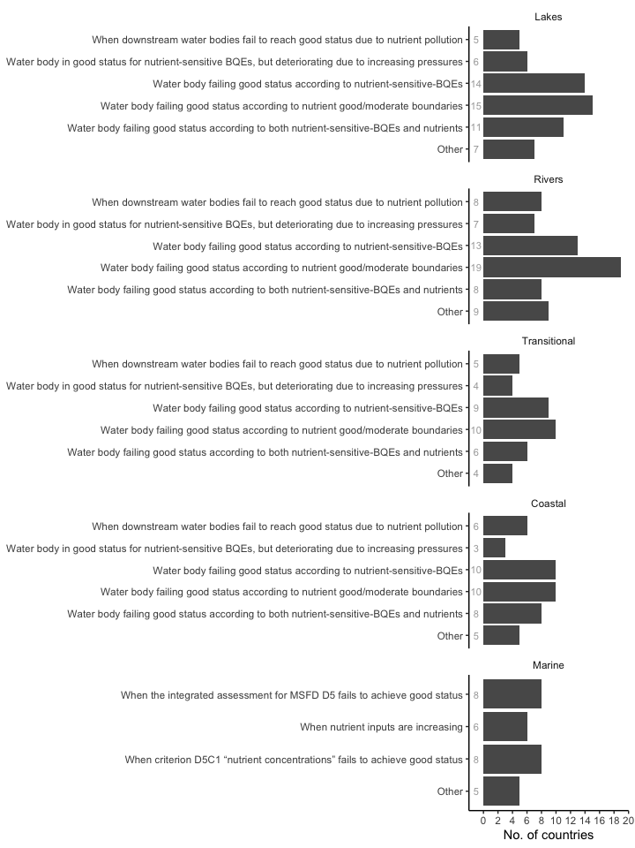
Add here a summary paragraph on the graph overall results.
(paragraph tbc completed yet) Some countries considered that nutrient reduction would be necessary in the case that water bodies failed to achieve good status due to nutrient concentrations at good/moderate (or not good status) boundaries. This approach was referred in all water categories by several countries, namely by BG, CZ, DE, EE, IE, ES, FR, IT, CY, HU, NL, PL, PT, RO, FI in lakes; by BE, BG, CZ, DE, EE, IE, EL, ES, FR, IT, CY, LV, LT, HU, NL, PL, PT, RO, FI in rivers; by DE, IE, EL, ES, IT, LV, NL, PL, PT, RO in transitional waters;, by EE, IE, EL, ES, FR, LV, NL, PL, PT, RO in coastal and by EE, IE, ES, LV, LT, NL, RO, SE in marine waters. (See if, as requested, countries added additional info specifying if this applied to both P and N, or only to the limiting nutrient)
Add here a critical analysis paragraph.

0.17 CQ2. Are you undertaking pollution accounting to identify the sources of nutrient pollution?
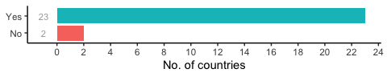
Figure 11. Figure 12. Number of countries responding.
Some kind of pollution accounting is considered by most countries to identify the main sources of nutrient pollution, with the exception of two countries (BG, LV). Iceland did not reply to this question.

0.18 CQ3. If yes, which point and diffuse sources are included?
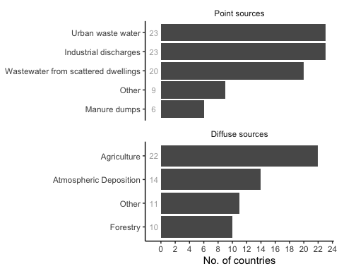
Figure 13. Number of countries responding.
Add here a summary paragraph on the graph results.
Add here a critical analysis paragraph.
(open question) Describe the methodology that is used for the pollution accounting. Add here a summary paragraph on the open answers and add number of countries replying (directly with formula).
Add here a critical analysis paragraph.

0.19 CQ4. What criteria and considerations do you use to select which measures to implement in order to reduce nutrient inputs?
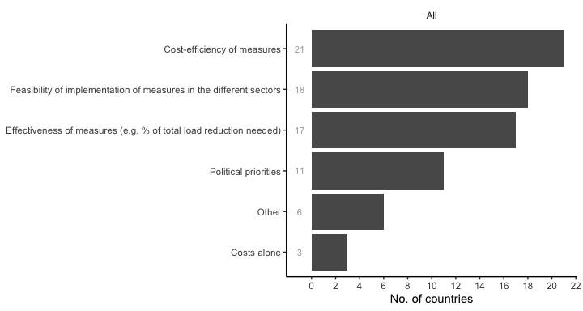
Figure 12. Figure 14. Number of countries responding.
Add here a summary paragraph on the graph results.
Add here a critical analysis paragraph.

0.20 CQ5. Are past policy measures such as a focus on urban waste water treatment plants as opposed to diffuse pollution from agriculture taken into account when planning new measures, e.g. trying to achieve a fair sharing of the nutrient reductions between different sectors according to a pollution account?
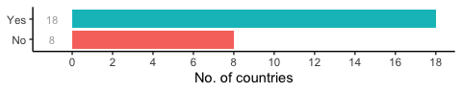
Figure 13. Figure 15. Number of countries responding.
Add here a summary paragraph on the graph results.
Add here a critical analysis paragraph.

0.21 CQ6. Is the delay in the response of the ecosystem to reduced nutrient inputs taken into account when planning new measures?
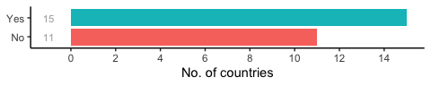
Figure 14. Figure 16. Number of countries responding.
Add here a summary paragraph on the graph results.
Add here a critical analysis paragraph.

0.22 CQ7. Do you estimate the effect of measures on the reduction of the nutrient load or concentration in water?
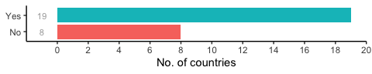
Figure 15. Figure 17. Number of countries responding.
Add here a summary paragraph on the graph results.
Add here a critical analysis paragraph.

0.23 CQ8. Do you have mechanisms for managing management objectives for nutrients across political boundaries (either within or between Member States)?
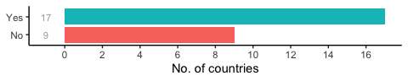
Figure 16. Figure 18. Number of countries responding.
Add here a summary paragraph on the graph results.
Add here a critical analysis paragraph.

0.24 CQ9. Do you consider climate change impacts on nutrient emissions and/or on biological quality elements/MSFD criterion responses to nutrients when planning the nutrient reduction measures?
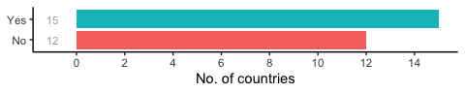
Figure 17. Figure 19. Number of countries responding.
Add here a summary paragraph on the graph results.
Add here a critical analysis paragraph.

0.25 CQ10. Do you consider nature-based solutions (restoring riparian zones, wetlands, flood plains etc.) when planning the nutrient reduction measures?
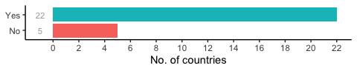
Figure 18. Figure 20. Number of countries responding.
Add here a summary paragraph on the graph results.
Add here a critical analysis paragraph.

0.26 CQ11. Do you consider technical/biological manipulative solutions (removal of nutrient-rich sediment, oxygenation of bottom water, adding chemicals to the sediment to bind phosphorus, extractive aquaculture using mussels or seaweeds, management fisheries) when planning the nutrient reduction measures?
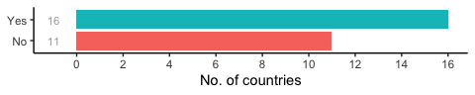
Figure 19. Figure 21. Number of countries responding.
Add here a summary paragraph on the graph results.
Add here a critical analysis paragraph.

