Methods used to set management objectives for nutrients
a comparison of national approaches
Revised draft, 24 February 2022

Martyn Kelly¹ & Heliana Teixeira²
¹ Bowburn Consultancy / University of Nottingham, UK
² CESAM, Biology Dept., University of Aveiro, Portugal

Contents
Contents 1
Summary and challenges 2
Introduction 6
Part A: How are management objectives for nutrients derived? 9
Part B: How are the current nutrient loads estimated? 16
Part C: How are measures to reach management objectives for nutrients defined? 22
References 31

Summary and challenges

Part A: approaches to setting management objectives
- Most countries already set management objectives for all water bodies exposed to nutrient pollution in the different water categories. Depending on local circumstances, objectives are set for nitrogen, phosphorus or both.
  - Do we have a common understanding of what “management objectives for nutrients” means? Many countries seem to use the targets set for nutrient concentrations. Are these sufficient for management or should targets be expressed as nutrient loads? In this respect, do we need further guidance on how to set management objectives? Alternatively, do these differences reflect a need to clarify terminology rather than fundamental disagreements in overall objectives?
  - A variety of reasons were cited for not setting management objectives. What hampers the setting of management objectives for nutrient-polluted water bodies (this seems to be a particular problem in marine waters)? How can the process be facilitated?
We may be dealing with issues of “Terminology” here. “Management objectives” may legitimately mean different things to different people. Those with a broad policy remit may think in terms of achieving good ecological status; others tasked with policy delivery may think in terms of achieving nutrient thresholds, which may be specific to particular waterbody types. Finally, those tasked with managing individual water bodies may think in terms of the load reductions necessary to achieve a threshold nutrient concentration. In theory, all these different “management objectives” should be linked, and also the link between thresholds and ecological status should be largely covered by our earlier work. So our key foci should be on clarifying terminology and on improving understanding of how load reductions to achieve a particular nutrient thresholds are set.
- A variety of approaches are used to set targets, with modelling based on BQE-response relationships being used most widely. Many countries support this modelling with other evidence.
  - expert judgement still plays a large role when setting management objectives and might be valid in order to reach more nuanced decision. Is there a need to develop more objective approaches?

“Expert judgement” was too often used as a synonym for “guesswork” in earlier work, as many countries had plucked figures from the literature without (it seems) testing these against their own monitoring data. However, when dealing with individual catchments, maybe there should be scope for an experienced person to interpret different strands of evidence (each often with considerable uncertainty) in order to reach a nuanced conclusion? The alternative would be that local staff use “black boxes” provided by distant experts who lack an understanding of local context, which seems to me to be equally problematic. There is a need to balance rigour with appropriate experience. In the UK, for example, there are modelling tools similar to those listed later in the report, but it is also expected that the people who use these belong to professional bodies (CIWEM, CIEEM) which ensures that they have the necessary experience and a holistic understanding of the systems they manage. Your family doctor almost certainly uses “expert judgement” several times every day, not instead of diagnostic tests, but because s/he knows the limitations of those tests.

- There is some ambiguity about how critical load or load reduction targets are set by individual countries, and no detailed analysis of these responses was possible; further information is needed to allow a more detailed analysis on approaches used to estimate critical loads and load reduction targets. It would also be useful to know more about approaches used outside of Europe.
  - We assume that determining the maximum critical load is an essential prerequisite for efficient nutrient management. Based on questionnaire responses, several countries appear not to use this approach. How could we ensure that this approach is more widely used?
There is a long list of “models” reported, which seems to suggest that most countries are relating target concentrations to loads. This needs to be explored in more detail in the workshop.

- Most countries set targets to achieve the nutrient concentration at the good/moderate boundary. The effectiveness of this approach will depend upon how precautionary these boundaries are. Other ECOSTAT-sponsored work suggests that many boundaries are relatively lenient, so the effectiveness of this strategy may be limited in many countries and needs to be discussed in detail;
  - There should be a clear relationship between the management objective set for nutrients and the nutrient thresholds set for ecological status. However, some countries reported that this is not the case (see A4). How can management objectives for nutrients be set if the link to biology is not considered? (It needs to be clarified whether this is actually the case, or whether the question was misunderstood.)
- A variety of policy drivers were cited, with the WFD as the most widely used, but UWWTD, Nitrates Directive, MSFD and Regional Seas Conventions, along with national legislation, all cited;
  - Do countries use the same objectives for these and are there contradictions between these policies concerning nutrient management that need to be tackled?
- A variety of reasons were cited for not setting management objectives. Some of these may need further discussion. For example, is “less stringent objectives” alone sufficient reason for not setting objectives? Justifications for setting less stringent objectives include situations where achieving good status is “infeasible or disproportionately expensive”, both of which imply a need to set objectives as a precursor to evaluating their feasibility.

Part B: approaches to calculating nutrient loads
- Most countries calculate loads either from monitoring data or from estimates of emissions or both;
  - Why do so many MS calculate nutrients loads while at the same time not having set maximum load targets?
This might answer the question above about why many countries appear not to use critical loads. They do, but are using a different terminology and/or the question was not clear.

- Most also link these to catchment models. A large number of models are used, with relatively few used by more than one country. Many responses indicated that several models needed to be linked in order to provide a holistic insights into nutrient dynamics.
  - Is there a need to establish minimum requirements for these models?
- More significantly, there was little evidence of models operating across national boundaries (although responses elsewhere in the report – C8 - indicate considerable trans-national interaction);
  - Do you see a need to harmonise catchment models, particularly when these need to be applied in catchments that cross national borders?
  - Do you see any benefits from developing a catchment model that can be applied across the EU?
- Most responses recognised that there was considerable uncertainty in these models.
  - How does statistical confidence influence decision-making?
  - This high uncertainty might also explain why expert judgement is often considered alongside other more objective approaches.
  - Should we also be considering how the precautionary principle is applied to model outputs?

Part C: methods and approaches for achieving management objectives
- A wide variety of measures are used to achieve management objectives for nutrients;
  - Selecting measures is often done based partly on their effectiveness at reducing nutrient loads but also on their cost. Do we have enough knowledge on the effectiveness of measures at addressing point and diffuse sources? How could our knowledge be improved?
  - How should the effectiveness of measures be evaluated? In theory, it should be possible to compare nutrients removed as a proportion of the total amount that needs to be removed. Judging restoration success, however, will also depend on the statistical power of monitoring data (pre- and post-measures). Is this a topic where guidance is needed?
  - Past policy measures are often taken into account when deciding on new measures, with the aim of achieving a fair balance between sectors. How could this be improved, especially with a view on the difficulties in establishing measures in agriculture?
  - It is essential that nutrient contributions from all upstream water bodies are taken into account when considering appropriate measures in downstream waters. Several countries seem to lack such mechanisms. How could such mechanism be set up?
While dealing with nutrient targets, this is a legitimate question to raise, despite sensitivities around this topic.

  - What is the future role of technical/biological manipulative solutions, i.e., interventions in the water body (i.e., manipulate aquatic environments with e.g., oxygenation, management of fisheries, treating sediments with aluminum) vs. preventative measures in the wider catchment, to reduce eutrophication? Will we need more of these to achieve our objectives?
- To what extent to which decision making is influenced by other sectors (e.g. agriculture, tourism, fisheries)?
- Pollution accounting is widely used. Would it be helpful to define common categories for the major point and diffuse sources, in order to achieve comparability across Europe?
- The ultimate measure of success is a change in the biota but this will happen over different timescales for different BQEs. In many cases improvements may not be achieved within a single WFD cycles and adjustments to PoMs may be required in light of experience. Would it be helpful to develop guidance on likely response times?
Managing expectations is an important “Governance” issue that seems too important to overlook entirely, albeit beyond the scope of this working group.
- Countries are devoting great efforts to developing new measures that can better accommodate climate change effects and which will be more effective in restoring ecosystems, namely focussing on nature-based and technical/biological manipulative solutions.
  - What do we need to be better able to account for climate change when planning nutrient reduction measures?

Introduction
As part of its mandate to understand the approaches taken by Member States and associated countries to managing nutrients in order to achieve good ecological status (Water Framewokr Directive: WFD) and good environmental status (Marine Strategy Framework Directive: MSFD), ECOSTAT circulated a questionnaire to compare national approaches to setting and implementing management objectives for nutrients. The work builds on earlier activities that compared good/moderate thresholds set by different countries for different water categories (Phillips et al., 2018) by exploring the linkages between the nutrient boundaries set by a country, and the steps taken to reduce nutrient loads to achieve these boundary concentrations.
The questionnaire was divided into three sections:
- Part A addressed the methods used to derive management objectives for nutrients and was answered separately for rivers, lakes, transitional, coastal and marine waters.
- Part B addressed the methods used to calculate current nutrient loads, including catchment modelling.
- Part C addressed methods/approaches used for achieving the management objectives for nutrients.
This report presents an overview of responses. In order to keep the report to a manageable length, the detailed responses from countries have not been included except where national practices differ from the main trends identified. Comments that are not referred to directly in the report can be found in the appendix to this report.

Overview of countries participating in questionnaire
26 countries participated in this survey (Table 1), five of which are land-locked countries reporting only for freshwater categories. Belgium and Bulgaria also only reported for inland waters. All countries reported on rivers, 24 on lakes, 13 on transitional waters, and 20 and 15 on coastal and marine waters respectively.
For more detail see the Appendix.

Table 1. Countries participating in survey per water category (n). Iceland and Norway (EFTA Members) and Turkey (EU candidate) are not EU Member States. NR not reported; -- not applicable; NP not participating in survey.
Country |  | Water Category
 |  | Lakes  (24) | Rivers  (26) | Transitional  (13) | Coastal  (20) | Marine  (15)
AT | Austria | y | y | -- | -- | --
BE | Belgium | NR | y | NR | NR | NR
BG | Bulgaria | y | y | NR | NR | NR
CY | Cyprus | y | y | -- | y | y
CZ | Czech Republic | y | y | -- | -- | --
DE | Germany | y | y | y | y | y
DK | Denmark | y | y | -- | y | y
EE | Estonia | y | y | -- | y | y
EL | Greece | y | y | y | y | NR
ES | Spain | y | y | y | y | y
FI | Finland | y | y | -- | y | y
FR | France | y | y | y | y | y
HR | Croatia | NP | NP | NP | NP | NP
HU | Hungary | y | y | -- | -- | --
IE | Ireland | y | y | y | y | y
IS | Iceland | y | y | y | y | --
IT | Italy | y | y | y | y | y
LT | Lithuania | y | y | y | y | y
LU | Luxembourg | NP | NP | -- | -- | --
LV | Latvia | y | y | y | y | y
MT | Malta | NP | NP | NP | NP | NP
NL | Netherlands | y | y | y | y | y
NO | Norway | y | y | -- | y | NR
PL | Poland | y | y | y | y | y
PT | Portugal | y | y | y | y | NR
RO | Romania | y | y | y | y | y
SE | Sweden | y | y | -- | y | y
Sl | Slovenia | NP | NP | -- | NP | NP
SK | Slovakia | NR | y | -- | -- | --
TR | Turkey | y | y | -- | y | NR

Part A: How are management objectives for nutrients derived?

A1. Have you set management objectives for nutrients for waters bodies that are exposed to nutrient pollution?
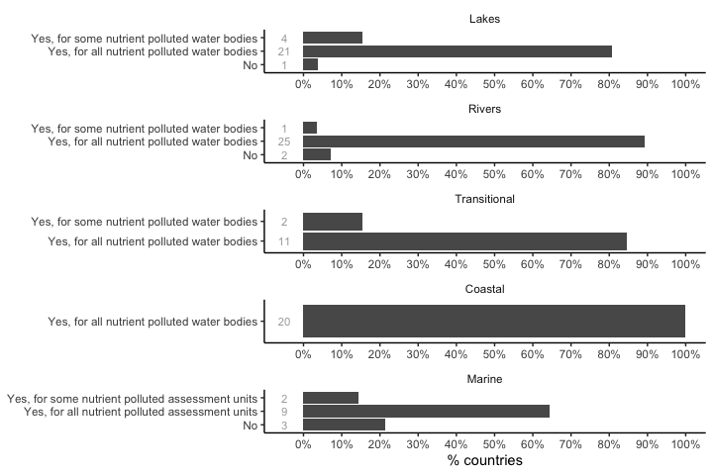
Figure 1. Resposes to question A1 by water category and summarized as a percentage.
Most countries have set management objectives for all water bodies exposed to nutrient pollution in the different water categories, with few countries considering only some of their nutrient polluted water bodies (DK, ES, FR, CY in lakes; FR rivers; ES, FR in transitional waters; and DE, NL in marine waters. No reasons for this were given but, for marine waters this most likely reflects the situation in OSPAR where reduction target deriviation is still in progress). Only FR in lakes, DK, FR in rivers, and FR, IT, CY in marine waters have not set management objectives for water bodies exposed to nutrient pollution. Judging from responses, France (FR) does not have a standardised national approach, with water agencies each adopting their own policies.

A2. When setting management objectives for nutrients, is there a focus on reduction of phosphorus, nitrogen, or both or on the limiting nutrient?
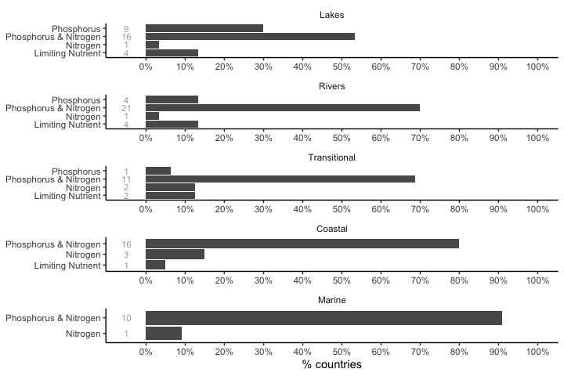
Figure 2. Resposes to question A2 by water category and summarized as a percentage.
Responses reflect, to a large extent, an interplay between biogeography and local pressures. Most countries focus on reducing both nitrogen and phosphorus irrespective of the water category considered; those who focussed on one or the other did so because local circumstances meant that this was the most likely reason for problems. This is the case, for example, for phosphorus reduction in lakes, adopted by nine countries (CZ, DK, IE, ES, FR, NL, AT, FI, SE), or nitrogen in lakes (NL), rivers (FR), coastal (DE, IE, NL) or marine waters (NL). A few responses acknowledged the need to set objectives to protect downstream water bodies, recognizing the role of rivers and transitional waters as conduits of nutrients to coastal and marine waters.
The limiting nutrient approach is more commonly assumed in freshwater categories (lakes: DE, ES, IT, FI; rivers: BE, FR, IT, FI) than in marine influenced systems (transitional: FR, IT, coastal: FR). What is not clear from the responses is how the limiting nutrient is determined in any given situation. Several responses referred to prevailing understanding that nitrogen and phosphorus are the nutrients most likely to be limiting (and, therefore, responsible for eutrophication when present in excess) and some (e.g. PL) indicated that targets were set to achieve concentrations consistent with the good/moderate boundary. This, in turn, presumes a good quantitative understanding of causal relationships between nutrient inputs and nutrient concentrations, metrics measuring status which can be difficult to obtain for transitional waters (Salas-Herrero et al., 2019). It can probably be assumed that exceeding supporting element standards for nitrogen and phosphorus is the default criterion for recognising a need for nutrient management. However, as Phillips et al. (2018) point out, there are a variety of approaches to setting nutrient standards, with different levels of precaution. No mention is made of more targeted, case-specific approaches in the responses; however, this does not mean that they are not used in individual countries.

A3. If you have set management objectives for nutrients, please indicate which method has been used.
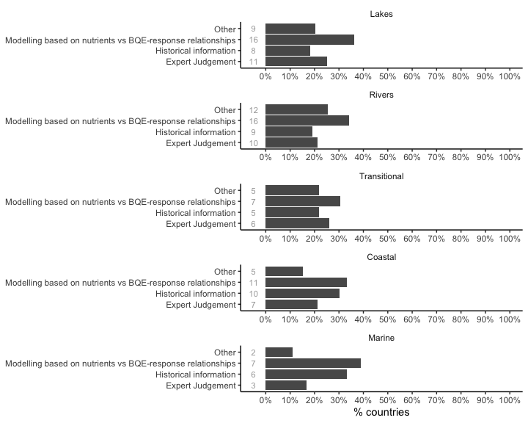
Figure 3. Resposes to question A3 by water category and summarized as a percentage.
The approach most commonly used to derive nutrient targets across all water categories was based on modeled pressure-response relationships between nutrient(s) and biological quality elements (BQE) (lakes: DK, DE, EE, IE, ES, FR, IT, CY, HU, NL, AT, PL, PT, FI, NO, TR; rivers: BE, DE, EE, IE, ES, FR, IT, CY, HU, NL, AT, PL, PT, FI, NO, TR; transitional: DE, FR, IT, LV, LT, NL, PL; coastal: DK, DE, EE, IE, EL, FR, LV, LT, NL, PL, SE; marine: DK, DE, EE, LV, NL, FI, SE). A wide range of BQEs have been used to establish these relationships, with phytoplankton (including chlorophyll concentrations and, in a few cases, cyanobacteria abundance or bloom frequency) being most widely used, especially in deeper water.
The four possible answers to this question are not exclusive, with several countries using more than one approach. For example, a modelling approach might be combined with historical information and the outcomes of each evaluated by an expert to give a more nuanced target than would be provided by any approach in isolation. The term “modelling”itself covers a wide range of possibiltilies. BQE-response relationships are often strong in lakes and are well-suited to deriving standards following the methods in Phillips et al. (2018) but a range of other modelling approaches are applied.
There is also a distinction between those countries that set targets in terms of concentrations and those who use loads (this will be explored in more detail later in the report). A further distinction is between those who used mass balance models and those who used dynamic process models although questionnaire responses did not always give details of the mechanisms behind their models (this will be considered in more detail later in the report). Lakes are well suited to the use of historical information, through the use of palaeoecology; historical information is also used in rivers by nine countries, though none of these provided more information on how this was done.
A wide range of responses were recorded in the “other” category. Several of these overlapped with the other three categories, but some countries appear to have derived management objectives purely from physico-chemical criteria (e.g., EL’s use of the PCQI index of Bald et al., 2005, in transitional waters).
Descriptions of national approaches for the different water categories can be found in the Appendix.

A4. Do you determine the maximum critical load or a load reduction target that is compatible with good status for nutrient sensitive BQEs?
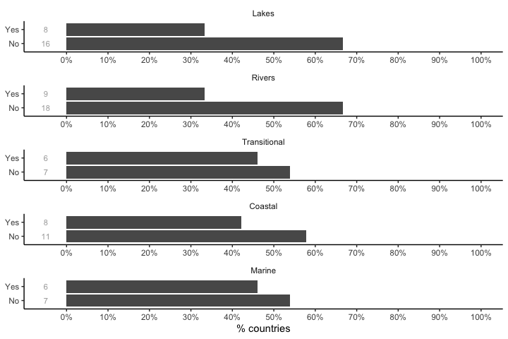
Figure 4. Resposes to question A4 by water category and summarized as a percentage.
Nutrient critical loads or load reduction targets compatible with good status of nutrient sensitive BQEs are set by no more than half of the reporting countries in lakes (DK, DE, EL, LV, NL, PL, FI, SE), rivers (BE, DE, EL, FR, LV, LT, PL, FI, SE), transitional (DE, IE, EL, LV, NL, PL), coastal (DK, DE, IE, LV, NL, PL, FI, SE) and marine waters (DK, DE, EE, LV, FI, SE).
Detailed responses to this question were ambiguous, particularly for freshwaters, with 16 (lakes) and 18 (rivers) answering “no” to the question, implying that they did not determine the maximum critical load or a load reduction target, whereas some of the responses to later questions made by these same countries suggested that they did. What seems to be clear is that many see target setting as a process that needs to be applied to individual water bodies, rather than adopting a guide value for all water bodies within a broadly-defined type. Where targets are defined as concentrations rather than loads we assume that some form of mass balance model is also used in order to work out how a target may be achieved for any individual water body.
The situation for transitional, coastal and marine waters is similar, though proportionately fewer countries replied “no” in each case. No more than a third of countries who replied “no” offered any explanation.

A5. Is there a relationship between the management objectives set for nutrients and the nutrient boundaries set for ecological status?
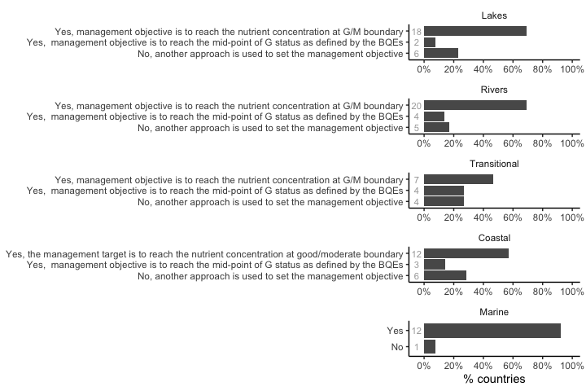
Figure 5. Resposes to question A5 by water category and summarized as a percentage.
Most countries acknowledge that there is a relationship between the management objectives set for nutrients and the nutrient boundaries set for ecological status. The most common management objective is to reach the nutrient concentration at good/moderate boundary (lakes: BG, CZ, DK, EE, IE, ES, FR, IT, CY, LV, LT, HU, NL, AT, PL, FI, SE, NO, rivers: BE, BG, CZ, EE, IE, EL, ES, FR, IT, CY, LV, LT, HU, NL, AT, PL, SK, FI, SE, NO, transitional: IE, ES, IT, LV, LT, NL, PL, coastal: DE, EE, IE, EL, ES, LV, LT, NL, PL, FI, SE, NO). This would reduce the number of mismatches between ecology and nutrient classificationss but, because many national nutrient standards are not sufficiently precautionary, good status would not be achieved in many cases if this approach was followed (Kelly et al., 2021; Texeira et al., 2021). In a few countries the management objective is slightly more ambitious, aiming to reach the mid-point between the high/good and good/moderate boundaries (lakes: PT, IS, rivers: FR, NL, PT, IS, transitional: EL, NL, PT, IS, coastal: NL, PT, IS).
Some countries used other approaches to set their management objective (lakes: DE, EL, FR, IT, RO, TR, rivers: DE, FR, IT, RO, TR, transitional: DE, FR, IT, RO, coastal: DK, DE, FR, IT, CY, RO, marine: IT). More details can be found in the Appendix.
Setting nutrient management objectives that are consistent with the nutrient good/moderate thresholds will not necessarily equate with achieving good status for BQEs. This partly relates to how the threshold was derived and partly to the uncertainty that is inherent in the threshold setting process (Phillips et al., 2018). Further questions will need to be asked to elucidate how countries address the inevitable mismatches between nutrient and ecological thresholds. If ecology does not attain good status after nutrient reductions to the good/moderate boundary, then what actions does each country take? Are targets reassessed or is the evidence specific to a water body reviewed, or are other solutions (e.g. “less stringent objectives”) considered.

A6. If you have set management objectives for nutrients, please specify which policy the management objectives are meant to address.
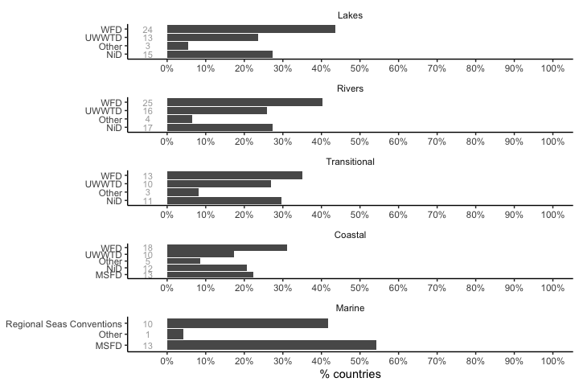
Figure 6. Resposes to question A6 by water category and summarized as a percentage.
For all water categories except Marine, the WFD is the most important driver, though the Urban Wastewater and Nitrates Directive are also cited by several countries across all water categories. For Marine waters the MSFD and Regional Sea Conventions are both important. Those who selected “other” cited the Industrial Emissions Directive, Common Agricultural Policy and EU regulations on phosphate-free detergents as also influencing management objectives, along with national legislation (e.g. SE has a policy on “zero eutrophication” www.sverigesmiljomal.se/environmental-objectives/).

A7. If you have not set management objectives for nutrients, please explain the reasons. In addition, please provide information on how you achieve the MSFD objectives for descriptor 5 “eutrophication” instead for water bodies exposed to nutrient pollution.
Countries which have not set management objectives for nutrients are: lakes (FR, CY, AT, RO, IS), rivers, (DK, FR, RO, IS, transitional (FR, PT, RO, IS), coastal (FR, IS), marine (DE, IE, FR, IT, CY, NL).
A variety of reasons were offered including:
- remote lakes above any human settlement and, therefore, with no eutrophication pressure (AT, IS);
- fish ponds that are eutrophic due to the purpose of the lake (AT);
- flood retention lakes which, again, due to their purpose, are subject to occasional pulses of nutrients (AT);
- no observed effect of nitrogen in a lake (CY);
- “less stringent objectives” have been set (FR);
- management objectives set for water bodies upstream of coastal lagoons but not, specifically, for the lagoon itself (FR); and,
- work to set targets is not yet complete (IT, DE).
A complete list of responses can be found in the Appendix.

Part B: How are the current nutrient loads estimated?

B1. Do you calculate current nutrient loads in order to achieve management objectives for nutrients?
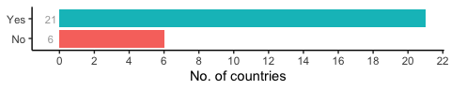
Figure 7. Responses to question B1.
6 countries (BG, FR, HU, AT, IS, TR) replied “no” to this question, but none gave any explanation. Responses to this question are in contrast to responses to A4, where many countries indicated that they did not calculate critical loads for nutrients. The mismatch between responses to the two questions needs to be explored further.

B2. If yes, what methods do you use to calculate nutrient loads?
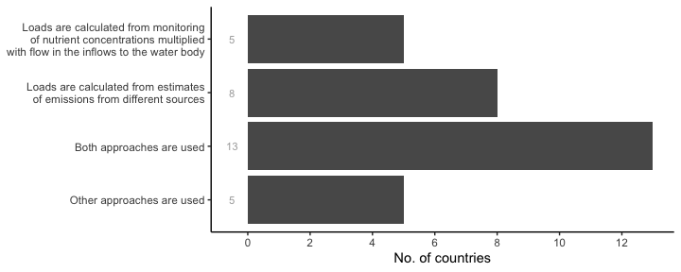
Figure 8. Responses to question B2.
Responses reflect the wide variety of methods, each with differing data requirements. 5 countries (EE, IT, NL, SE, NO) selected “other approaches are used”. However, these 5 countries also selected at least one of the other three response categories.
A combination of both approaches is usually applied, in which loads are based on measured concentrations and water discharges/flows and then combined with model estimates for different purposes. With a few exceptions (CZ, FR, DE, IE, FI, SE), little detail is given on how nutrient loads are actually calculated. However, the source and type of pollution, i.e. point or diffuse and urban/industrial or agricultural (including animal husbandry and fish farms), dictate the type of data used and the methods adopted (DK, EE, FR, CY, LT). Loads derived from estimates (e.g. from land use/land cover models, coupled with soil indices) are often used when larger assessment scales or diffuse sources are considered (CZ, DE, NL, FR, FI, SE), while for specific water uses or large watercourses as well as for point source emissions countries often include direct monitoring data (CZ, DK, FR, IE). In other cases, nutrient load is only considered if the water body status is poor or bad (EE).
Details on approaches used by specific countries are provided in the Appendix.

B3. Do you use catchment models that quantify the nutrient emissions/nutrient losses to surface waters?
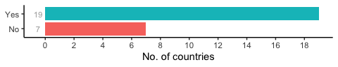
Figure 9. Responses to question B3.
Catchment models that quantify the nutrient emissions/nutrient losses to surface waters are used by 19 countries, namely: BE, CZ, DK, DE, EE, IE, ES, FR, LV, LT, HU, NL, AT, PL, PT, RO, FI, SE, NO. A full list of models cited in this report is given in Table 2. Based on information given, many of the “models” are best considered as part of networks of specialised models, each passing estimates to subsequent modules (e.g. soil leaching of nutrients is estimated by one model, and these estimates are then passed to a hydrological model). As far as we can tell, few of these are explicitly modelling ecological processes, with the end result being an estimate of surface water concentrations. These are then compared with good-moderate boundary concentrations estimated by empirical models, many of which are based on methods outlined in Phillips et al. (2018).
Table 2. List of models used to determine nutrient emissions and nutrient losses in Europe. References and links are those provided in questionnaire responses (see Appendix).
Name | Water category | Countries | Reference / link
VEMALA | L R C | FI | https://www.syke.fi/en-US/Research__Development/Water/Models_and_tools/Models_for_river_basin_management_planning
POLUPA | R | FR | https://www.shf-lhb.org/articles/lhb/pdf/1990/03/lhb1990011.pdf
PEGASE | R | FR BE | https://www.pegase.ulg.ac.be/?pg=4
MONERIS | R T C M | AT DE HU RO | https://www.icpdr.org/main/activities-projects/moneris-modelling-nutrient-emissions-river-systems
SWAT | R | LT PL | https://swat.tamu.edu/
ECOMARS | T C | FR | https://www.sciencedirect.com/science/article/abs/pii/S1463500318303767
GAMELAG | T C M | FR | https://www.sciencedirect.com/science/article/abs/pii/S0304380020301216
SLAM | R T C | IE | https://link.springer.com/article/10.1007%2Fs12237-015-0009-5
C-GEM | T | FR | https://gmd.copernicus.org/preprints/6/5645/2013/gmdd-6-5645-2013.pdf
unnamed | T C | DK | https://mst.dk/media/174168/dokumentationsrapport_marine-modeller-og-metoder-til-vp2_2017.pdf
S-HYPE | C | SE | https://www.smhi.se/en/research/research-departments/hydrology/hype-our-hydrological-model-1.7994
EstModel | R T C | EE | https://wbwb.eu/wp-content/uploads/2019/02/estmodel_2018.05.10_ennet.pdf
BALTSEM | M | DE | https://www.su.se/polopoly_fs/1.417215.1544611358!/menu/standard/file/TR%207_BALTSEM_Report_Final.pdf
AGRUM-DE | R T C M | DE | https://hal.archives-ouvertes.fr/hal-01509651
MoRE | R T C M | DE | https://isww.iwg.kit.edu/english/MoRE.php
NUTTING-N | R | FR | https://ui.adsabs.harvard.edu/abs/2016EGUGA..18.9875L/abstract
CASSIS_N | R T C | FR | https://geosciences.univ-tours.fr/images/media/20171205133909-rapport1_my_thode_de_calcul_des_surplus.pdf
PRESSAGRIDOM | ? | FR | ?
STONE | R (T C?) | NL | https://www.sciencedirect.com/science/article/abs/pii/S1364815203000367
TEOTIL | R | NO | https://niva.brage.unit.no/niva-xmlui/bitstream/handle/11250/214825/5914-2010_200dpi.pdf?sequence=2
EPICgrid | R | BE | https://www.sciencedirect.com/science/article/abs/pii/S1462901110001097
MOSQUITEAU | R | FR | https://tel.archives-ouvertes.fr/tel-01496899/document
FYRIS NP | L R | LV | https://www.cabdirect.org/cabdirect/abstract/20113017200
CEQUAL-W2 | L | PT | https://www.icevirtuallibrary.com/doi/abs/10.1680/wama.11.00117
QUAL2E | R | PT | https://ascelibrary.org/doi/abs/10.1061/(ASCE)0733-9496(1996)122:2(105)
ICECREAM | R | SE | https://www.sciencedirect.com/science/article/abs/pii/S030438000700083X (leaching model which links to S-HYPE)
SOIL-NDB | R | SE | https://iwaponline.com/hr/article/39/1/63/1085/Changes-in-nutrient-leaching-and-groundwater (leaching model which links to S-HYPE)
CCT | R | IE | https://link.springer.com/article/10.1007%2Fs10666-019-09683-9

B4. If yes, at what spatial level do the models operate?
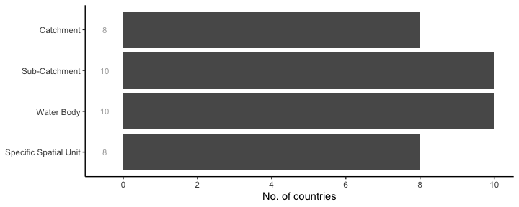
Figure 10. Responses to question B4.
Once again, many countries ticked multiple boxes, perhaps reflecting regional differences within a country or that models are capable of operating at different spatial scales. There was no indication that modelling exercises crossed national borders.

B5. If yes, how large are the uncertainties in these models and how do you deal with these uncertainties?
Uncertainties in the models that are used to quantify the nutrient emissions and/or nutrient losses to surface waters were addressed by 16 countries (BE, CZ, DK, DE, EE, IE, FR, LV, LT, HU, NL, PL, RO, FI, SE, NO). Most acknowledge that there are several different sources of uncertainty in their models which, when combined, can lead to considerable uncertainty in final outcomes. Some countries (e.g. IE) noted that they did not use models for regulatory purposes, but to guide and direct further field assessments, and to target interventions.
The main sources of uncertainty in the models as identified by respondents are:
- the quality of model input data (e.g. use of parameters estimates versus field measurements; quality control data);
- uncertainty on reference or baseline values, due to natural variability (e.g. geological substrates);
- biogeographic variability when using extrapolated or transferred values;
- no information or variability associated with impact(s) of relevant pressures (e.g. LULC; variability across agricultural practices; pressure intensity);
- uncertainty related with the model type; - potentially higher uncertainty for diffuse sources than point sources of nutrients; - associated with individual emission pathways;
- scale and/or size of the system modeled;
- temporal fluctuations (yearly variation, daily variation);
- hydrological and biogeochemical processes not explicitly represented in the models.
Dealing with uncertainty in model outputs is acknowledged by most countries as a difficult task, and even when the sources of uncertainty can be identified they are not always possible to be quantified. Nonetheless, respondents mentioned several ways in which they attempt to reduce uncertainty associated with the main identified sources in their models. In the majority of cases these include: continuous validation of model outputs with new data; applying regional corrections; the use of experimental data, meaningful time series and long-term mean monitoring data to validate model results; run sensitivity analysis of model individual parameters; perform some pressure/impact characterization to guide expectations on model results; and compare model outputs with other evidence data.
Country specific uncertainty approaches can be found in the Appendix.

Part C: How are measures to reach management objectives for nutrients defined?

C1. When is nutrient reduction decided to be necessary?
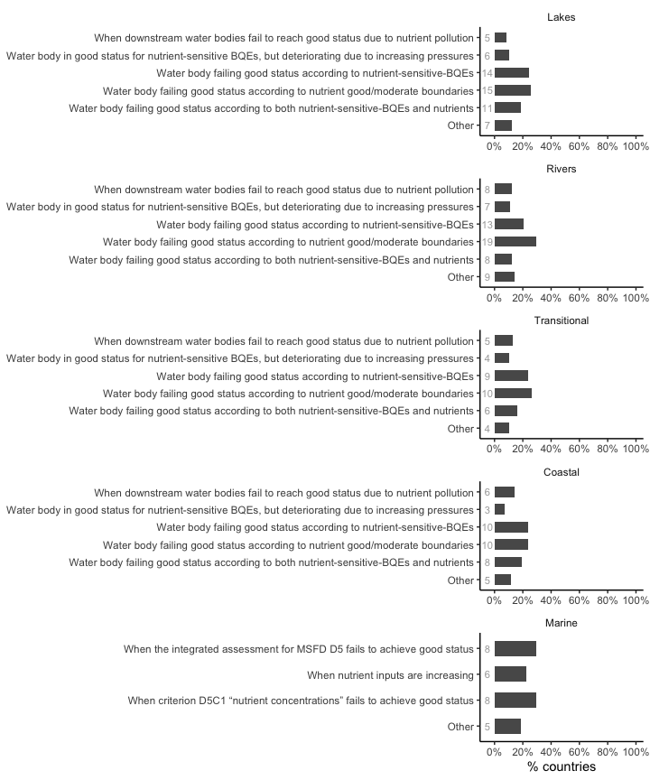
Figure 11. Resposes to question C1 by water category and summarized as a percentage.
A very wide range of responses to this question were received. The majority of countries considered that nutrient reduction would be necessary in the case that water bodies in any water category fail to achieve good status due to one of the two following criteria: nutrient concentrations not in good status or nutrient-sensitive-biological quality elements (BQEs) below good status. Some countries consider, however, that both these criteria should apply before nutrient reduction measures are needed.
Failing to reach good status due to nutrient concentrations at good/moderate (or not good status) boundaries is nonetheless the dominant approach in all water categories, and is used by BG, CZ, DE, EE, IE, ES, FR, IT, CY, HU, NL, PL, PT, RO, FI in lakes; by BE, BG, CZ, DE, EE, IE, EL, ES, FR, IT, CY, LV, LT, HU, NL, PL, PT, RO, FI in rivers; by DE, IE, EL, ES, IT, LV, NL, PL, PT, RO in transitional waters; by EE, IE, EL, ES, FR, LV, NL, PL, PT, RO in coastal waters and by EE, IE, ES, LV, LT, NL, RO, SE in marine waters. Not all countries provided details but when they did this criterion was usually applied to both nitrogen and phosphorus. However, few countries clearly specified that nutrient reduction is considered when any of the nutrients exceeds the proposed good/moderate boundaries, be it phosphorus or nitrogen, following a “One Out, All Out” approach. In some cases phosphorus or nitrogen may be preferentially targeted, depending on the water category (e.g. TP in lakes) and the relevant anthropogenic pressures (e.g. phosphorus compounds for point sources of pollution from discharges of wastewater from settlements and some industrial plants; nitrogen for diffuse loads from agriculture). Very few countries use the limiting nutrient as guidance, and then only for specific water categories (e.g. lakes, transitional) and often dependent on information availability (e.g. BE, EE, CY, IE).
Where countries selected the “Other” option when deciding whether or not nutrient reduction was necessary, it was often related to the implementation of other nutrient policy regulations (e.g. UWWT and Nitrate Directive) or with specific environmental and conservation objectives such as waste water re-use in agriculture or enhancement of riparian zones. The integration of nutrients with other evidence or criteria was also mentioned (e.g. eutrophication symptoms leading to primary producers shifts; compliance with additional RSC’s criteria; pressure analysis). The absence of nutrient-related issues was very rarely cited as a reason for not taking action (e.g. IS or marine waters in IE).
Finally, results also showed that increasing pressures or downstream water bodies failing to reach good status due to nutrient pollution are less likely to trigger nutrient reduction actions showing that the precautionary principle is not widely applied in the management of aquatic ecosystems in general. However, some countries expressed concerns regarding this aspect and an intention to adjust measures either targeting upstream water categories or sectoral measures to promote reduction at source and downstream aquatic systems protection (e.g. DK, FR, NL, CZ).

C2. Are you undertaking pollution accounting to identify the sources of nutrient pollution?
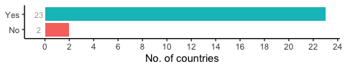
Figure 12. Resposes to question C2 by water category and summarized as a percentage.
Most countries undertake some kind of pollution accounting to identify the main sources of nutrient pollution, with the exception of two countries (BG, LV). Iceland did not reply to this question, as nutrient pollution is not considered an issue in their water bodies (see C1).

C3. If yes, which point and diffuse sources are included?
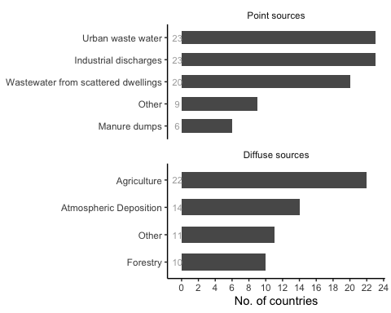
Figure 13. Resposes to question C3.
Beside the main sources identified in Figure 13, other point sources such as aquaculture/fish farming, rain water management and peat production were also idenified as significant sources to be considered. Regarding diffuse sources, countries identified, in addition, other unspecified discharges and urban/rural settlements run off, in particular triggered by rainfall events, sewage systems leakage, non-collective waste water management, erosion. Particular agricultural practices such as the use of manure as well as pasture areas were also highlighted as important contributors that needed to be considered.
Methods for pollution accounting vary greatly across the 22 countries that provided details on their approaches, which may also differ by region or RBMP. Methods presented usually rely on a wide range of distinct information but they can primarily be distinguished according to whether a point or diffuse source of pollution is being considered. Point sources accounting takes complementary data and /or information often gathered from national databases, historical data, administrative information (such as sectoral declared emissions, user’s permits data, type of discharge characteristics), discharge monitoring or measured loads from point sources, as well as land use and land cover typologies, areal info, which are all integrated into a final account. Modeling approaches are more frequently considered to account for diffuse pollution sources and used to:
- model rainwater flows;
- -predict atmospheric deposition from monitoring data incorporated into transport and diffusion models coupled with atmospheric hindcasting modeling;
- -estimate nutrient flows and/ or loads from diffuse source (e.g. agriculture) considering data such as user’s permit values and discharge monitoring data, LU classes for determining characteristic exportation values through run off, etc.
The spatial scale of the models also varies greatly. Other approaches include RBMP risk analysis and the identification of anthropogenic pressures and their impacts, and expert analysis is also often considered.
Details on each country approach are available in the Appendix.

C4. What criteria and considerations do you use to select which measures to implement in order to reduce nutrient inputs?
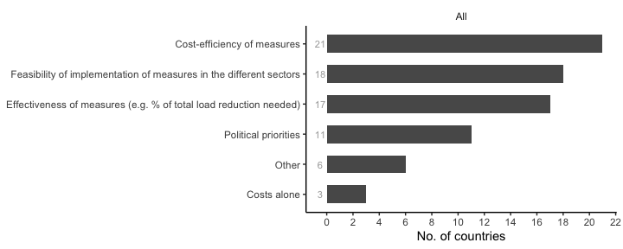
Figure 14. Resposes to question C4.
Cost-efficiency analysis helps to prioritise measures to be included in the PoMs of RBMPs and is a formal requirement of the WFD and also of the MSFD, so it is no surprise that most countries consider this criterion when selecting which measures to implement in order to reduce nutrient inputs. Nonetheless countries often selected more than one option, reflecting the need to consider other criteria driven by constraints associated with sectoral priorities, economic context, institutional capacity to implement measures, full implementation and synergies across European Union Directives, but also with regional and national policies, and with the need to adapt to climate change. The scope of the measure such as the impact on other waterbodies or the fact that a measure is likely to impact more than one target are also mentioned as positive criteria influencing measure selection.
Details on each country’s approach are available in the Appendix.

C5. Are past policy measures taken into account when planning new measures?
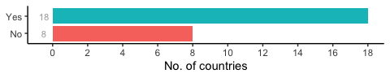
Figure 15. Responses to question C5
Most countries consider the influence of past policy measures (e.g. a focus on urban waste water treatment plants as opposed to diffuse pollution from agriculture) when planning new measures (Figure 15), in an attempt to achieve a fair sharing of the nutrient reductions between different sectors in a pollution account system. While seeking to share responsibility across sectors for managing reduction efforts and achieve environmental objectives, countries recognise that the main efforts are still mainly focused on measures for industrial sectors and urban waste water treatment and in optimizing the contribution of WWTP to further reduce inputs from these point sources. Although many also recognise that the agriculture sector is a major source of nutrient inputs in aquatic ecosystems, the difficulties in putting into practice measures targeting agricultural areas were often mentioned. Despite this challenge, and given the observed improvement on point source management, many countries expressed an intention to shift efforts to focus more on treating diffuse sources of pollution, through, for example, increasing the number of potential reduction measures, or revising fertiliser ordinances.
Even countries replying “No” still agreed that past policies were important, if not to meet specific environmental objectives on a policy-by-policy basis, then as part of a consideration of all sources of pollution and for selecting measures based on the most relevant criteria (see Figure 14 for details).

C6. Is the delay in the response of the ecosystem to reduced nutrient inputs taken into account when planning new measures?
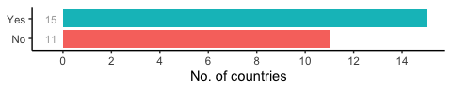
Figure 16. Responses to question C6.
Overall, most countries acknowledge a time-lag in the ecological response following nutrient reduction measures, which can differ widely across water categories (e.g. lakes vs. rivers) and typologies. This may be less important in well-studied/monitored systems but may produce unexpected outcomes in other water bodies. In addition, the six-year reporting cycles of the WFD mean that effects of measures may only be reflected in water body improvement in the subsequent cycle(s). Expected biophysical recovery delays should be considered at the water body status assessment and reporting stages and also when reviewing of the next programme of measures (PoMs).
Countries noted that delays in response was highly system-dependent, and this was cited as a reason to disregard time-lag of responses when planning new measures. The geographical scope of the actions to be carried out and their economic and social impacts were additional aspects mentioned as interfering with implementation of PoMs and influencing system recovery time.
Given the status of EU waters, the abovementioned factors need to be considered when evaluating whether adequate and effective measures are being put forward to reverse the current situation across Europe within the expected time-frame. If not, then a greater focus should be placed on the implementation of measures, as inadequate and ineffective measures are not likely to restore Europe’s waters. Likewise, planning of adequate and effective measures is of little help if they are not implemented.

C7. Do you estimate the effect of measures on the reduction of the nutrient load or concentration in water?
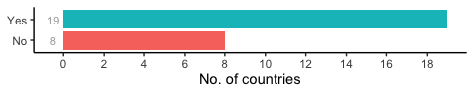
Figure 17. Responses to question C7.
Most countries say they estimate the effect of the measures implemented on the reduction of the nutrient load or concentration in water. Most state that the observed result (e.g. loads and/or concentrations, or other measure-specific targets such as BQE improvement) should be measured and compared with the value predicted at the planning stages; however the effect of measures is difficult to quantify. Predicting the effectiveness of measures is a complex exercise as it depends on multiple factors which may be difficult to understand due to a lack of reliable data or the effects of multiple (interacting) stressors masking the biological effects of nutrient reduction. To better deal with this, some countries run models with different scenarios to better understand the impact of measures on overall water quality. For these reasons, many countries adopt a holistic approach, within which nutrient reduction is an integral part, to achieve the biggest effects and, eventually, attain all environmental objectives.
Besides evaluating measures to achieve environmental targets, other countries are developing additional methods to evaluate measures themselves. HELCOM, for example, uses a “sufficiency of measures” (SOM) analysis which seeks to gain understanding of where measures have failed; or proposing a scale of effectiveness of the measure (e.g. “very effective”, “moderately effective”, etc.).

C8. Do you have mechanisms for managing management objectives for nutrients across political boundaries (either within or between Member States)?
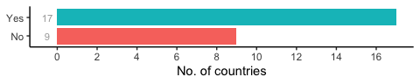
Figure 18. Responses to question C8.
Most countries emphasise the relevance of the role and the importance of the work done by many and diverse cross-border working groups within international initiatives (e.g. international commissions for transboundary rivers and lakes; cross border catchment R&D projects; countries special agreements within transboundary river basins; international catchment co-governance; regional sea conventions; bilateral cooperation) and within nationally coordinated working groups (e.g. in federal states, across RBMPs). This cooperation is critical to discuss and evaluate management objectives across political-administrative borders that influence the status of water bodies. Within these working groups, management targets at the “limnic-marine boundary” have also been set by some countries to protect downstream waters.
Island countries may not need to consider international transboundary issues (with the exception of Marine Waters), and those with centralised administrations may not need to consider internal co-ordination. Non-EU Member States such as TR also do not consider transboundary issues. Other countries not referring to explicit mechanisms to deal with transboundary issues were: BE (WA region), BG, DK, EE, 3 water agencies in FR for continental waters, IT, and LV. This could be explained by the fact that some of these countries do not have larger transnational rivers, but it is astonishing for those countries that have such rivers (e.g. LV-Daugava).

C9. Do you consider climate change impacts on nutrient emissions and/or on biological quality elements/MSFD criterion responses to nutrients when planning the nutrient reduction measures?
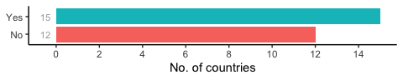
Figure 19. Responses to question C9.
Climate change is an emerging priority of the EU. It is expected to have significant influence in shaping environmental conditions in aquatic ecosystems and influence phenomena relevant to water quality such as sea-level rise, flash floods and run-off. Despite being a challenging issue, 15 countries already consider climate change impacts on nutrient emissions and/or on biological quality elements/MSFD criterion responses to nutrients when planning their nutrient reduction measures. Approaches are quite diverse, with some built into existing approaches (e.g. revisions of targets/quality objectives; including climate change in models) whilst others foresee new measures for dealing with draining large amounts of torrential rainwater and control with pollution loads. Most countries are still at the stage of developing approaches to accommodate climate change.

C10. Do you consider nature-based solutions (restoring riparian zones, wetlands, flood plains etc.) when planning the nutrient reduction measures?
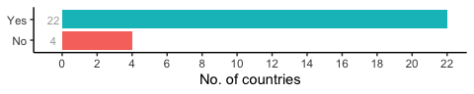
Figure 20. Responses to question C10.
Nature-based solutions are considered by most countries, and a wide variety of approaches has been described. Landscape interventions that go from green strips along the rivers to temporary flood zones; riparian and wetlands rehabilitation; grass belts; river course re-shape; anti-erosion sediment reservoirs are all mentioned. Regulating the use of fertilizers and pesticides, though not technically a nature-based solution, was also mentioned in the responses to this question.;
Details of country-specific solutions are described in the Appendix.

C11. Do you consider technical/biological manipulative solutions when planning the nutrient reduction measures?
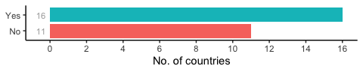
Figure 21. Responses to question C11.
Examples of such approaches include the removal of nutrient-rich sediment, oxygenation of bottom water, adding chemicals to sediment to bind phosphorus, extractive aquaculture using mussels or seaweeds, fisheries management etc.
Slightly more than half of the countries answered “yes” to this question, which might reflect the technically challenging and expensive nature of these manipulative solutions. These approaches can also carry risks for the environment and, as a result, can be controversial and possibly restricted by legislation. Among the most common solutions considered by countries are:
- Aeration and/or destratification of bottom waters;
- Precipitation of phosphorus in the tributaries of the reservoir
- Biomanipulation with fish stock (e.g. removal of planktivore fish; introducing predatory fish)
- Addition of phosphorus-binding chemical (although some consider this to be a politically unacceptable measure)
- Removal of nutrient rich sediment
- Removal of macrophyte vegetation periodically
- Mussel substrate introduction
- Extractive aquaculture (again using mussels or seaweeds)
- Liming measures, adding Gypsum (CaO or Ca(OH)2) in soil/agricultural areas
- Floating wetlands
Details of country specific solutions are described in the Appendix.

References
Bald, J., Borja, A., Muxika, I., Franco, J., Valencia, V. (2005). Assessing reference conditions and physico-chemical status according to the European Water Framework Directive: a case-study from the Basque Country (Northern Spain). Marine Pollution Bulletin 50: 1508-1522
Kelly, M.G., Phillips, G., Teixeria, H., Salas-Herrero, F., Varbiro, G., Lyche Solheim, A., Poikane, S. (2021). Physico-chemical supporting elements in inland waters: a review of national standards to support good ecological status. Publications Office of the European Union (in press)
Phillips G., Kelly, M.G., Teixara, H., Salas-Herrero, F., Free, G., Leujak, W., Lyche Solheim, A., Varbiro, G., Poikane, S. (2018). Best practice for establishing nutrient concentrations to support good ecological status. EUR 29329 EN, JRC112667. Publications Office of the European Union. ISSN 1831-9424 ISBN 978-92-79-92906-9. 142 p.
Salas Herrero, F., Teixara, H., Poikane, S. (2018). A novel approach for deriving nutrient criteria to support good ecological status: application to coastal and transitional waters and indications for use. Frontiers in Marine Science https://doi.org/10.3389/fmars.2019.00255
Teixeria, H., Salas-Herrero, F., Kelly, M.G., Phillips, G., Lyche Solheim, A., Poikane, S. (2022). Physico-chemical supporting elements, transitional and coastal waters: a review of national standards to support good ecological status. EUR 30958 EN, JRC128071 Publications Office of the European Union. ISBN 978-92-76-46489-1. 122pp

