**LAB 03**

**Write webpage to display the screens below when opened in a browser**

**Ex1:** *Photo Shoot Effect*

You are given a HTML file. Create a Web page like the screenshot on the right

Constraints: You are NOT allowed to change the HTML file, Just write the missing CSS.

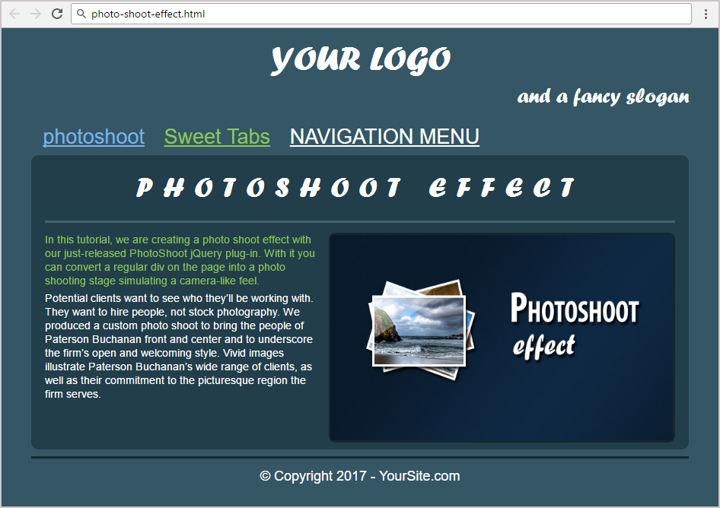

**Ex2:** *Ancient Architecture*

You are given a HTML file. Create a Web page like the screenshot on the right

Constraints: You are NOT allowed to change the HTML file, Just write the missing CSS.

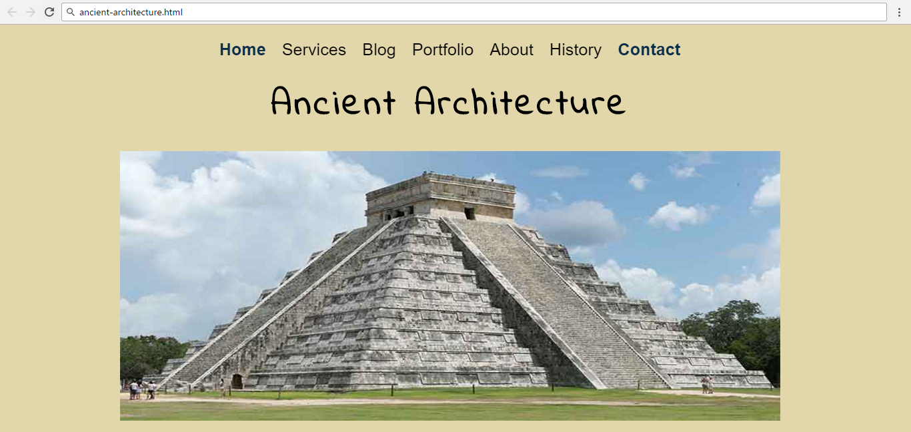

**Ex3:** *Plan Page*

You are given a HTML file. Create a Web page like the screenshot on the right

Constraints: You are NOT allowed to change the HTML file, Just write the missing CSS.

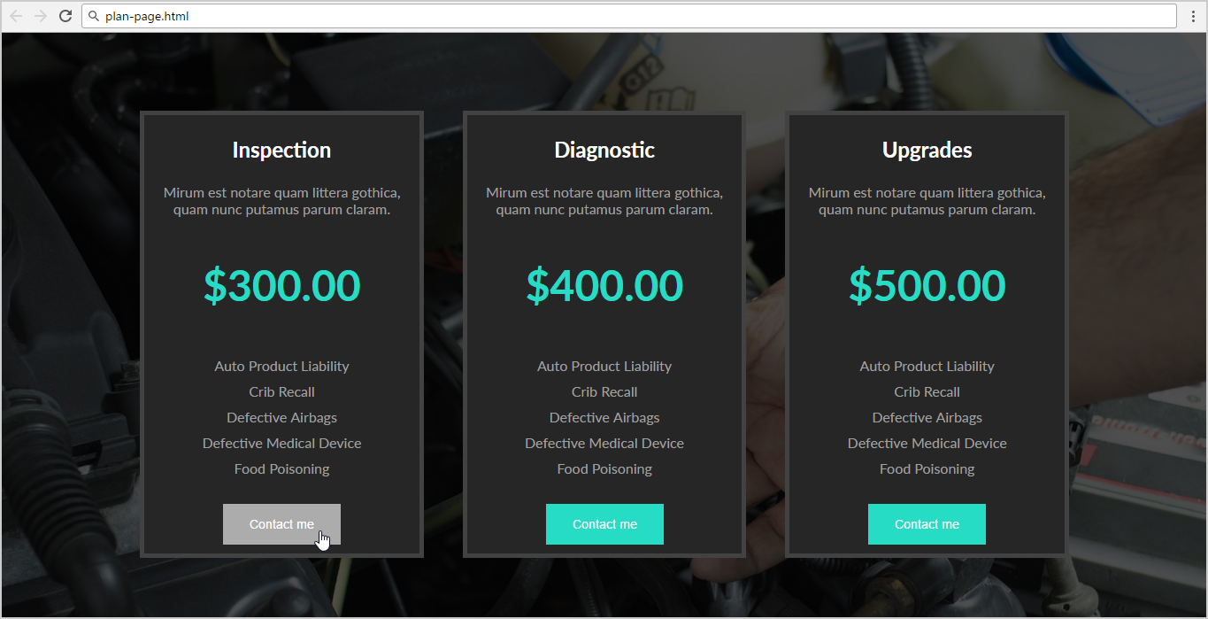

**Ex4:** *To Do List*

Create a Web page like the screenshot on the right

Constraints: You are NOT allowed to change the HTML file, Just write the missing CSS.

