

**BAHIR DAR INSTITUTE OF TECHNOLOGY**

**Software Engineering Department**

**Individual assignment**

**Name:Helina Leul Bekele**

**ID:1601742**

**Submitted to :Lecturer Wendmu Baye**

**Submission date :16/08/2017 EC**

**Contents**

1. Introduction(background ,motivation)…………………………..2
2. Objectives for installation of Mac OS Sonoma……………….5
3. Requirements ……………………………………………………………….6
4. Installation steps……………………………………………………………8
5. Issues (problems) with their solutions……………………………29
6. File system supports………………………………………………………32
7. Advantages and Disadvantages……………………………………..33
8. Conclusion…………………………………………………………………….35
9. Future outlook/recommendations………………………………..36
10. What is virtualization? .....................................................37
11. Why do we use virtualization? .........................................38
12. How do we use virtualization? ………………………………….....39
13. References…………………………………………………………………….42

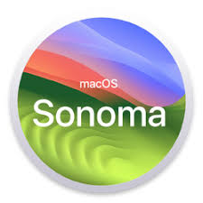

**Introduction (background ,motivation)**

**Of Mac OS Sonoma**

**Introduction**

macOS Sonoma: Elevate Your Mac Experience

• Stunning Visuals:

* Enjoy beautiful new wallpapers that breathe fresh life into your desktop.
* Choose from a variety of dynamic options to reflect your mood or style.

• Customizable Widgets:

* Personalize your desktop with widgets that provide quick access to the information you care about.
* Arrange them to fit your workflow, making your Mac truly yours.

• Enhanced Video Conferencing:

* Experience improved video call features, including Presenter Overlay for a more engaging presentation.
* Use new effects to make your meetings feel more interactive and professional.

• Focus on Productivity:

* Take advantage of new tools designed to help you stay organized and efficient.
* Easily manage multiple tasks with intuitive window arrangements and updates.

• Seamless Integration:

* Enjoy better connectivity with your other Apple devices, creating a cohesive ecosystem.
* Share content effortlessly across devices, enhancing your workflow.

• User-Friendly Design:

* Navigate with ease thanks to a refined interface that prioritizes user experience.
* Discover features that are intuitive and straightforward, making everyday tasks simpler.

• Community Creativity:

* Join a community of users who inspire each other with creative uses of the new features.
* Explore new ways to express yourself through your Mac.

Why Upgrade?

Embrace the latest technology and enjoy a more personalized, productive, and visually appealing experience. macOS Sonoma is not just an update; it’s an invitation to make your Mac feel like home.

**Background**

macOS Sonoma is the latest gem from Apple, designed to enhance our Mac experience in delightful ways. Launched in 2023, it brings a fresh look with stunning wallpapers and customizable widgets that let you personalize our desktop to match our style.

One of the standout features is the improved video conferencing tools, making our virtual meetings more engaging and interactive. Plus, it offers seamless integration with your other Apple devices, ensuring everything works together effortlessly.

With a focus on user-friendly design and productivity, macOS Sonoma invites us to explore new possibilities and express our creativity. It’s not just an update; it’s a chance to make our Mac feel more like home. Enjoy the journey!

**Motivation**

macOS Sonoma brings a fresh wave of creativity and productivity to your Mac. Imagine a workspace that feels more personal and intuitive, where you can easily customize your desktop with beautiful widgets and live wallpapers. The new features make multitasking a breeze, allowing you to focus on what truly matters.

With enhanced video conferencing tools, connecting with friends and colleagues feels more natural than ever. Plus, the seamless integration with your other Apple devices means everything just works—no hassle, no fuss.

In short, Sonoma is all about making our digital life smoother and more enjoyable. It’s designed to inspire us, whether we’re working on a project or just unwinding with our favorite content. Dive in and experience a Mac that feels like it was made just for you!

**Objective for Installation of Mac OS Sonoma**

To set up Mac OS Sonoma in a virtual environment for the purpose of testing and evaluating its features, performance, and compatibility with applications, while ensuring a secure and isolated space for development and experimentation without affecting the host operating system. This installation aims to leverage the latest enhancements in productivity, creativity, and security offered by Sonoma. To install Mac OS Sonoma, you'll need to meet specific hardware and software requirements.

To successfully install Mac OS Sonoma on compatible apple devices ,ensuring a seamless transition to the latest operating system while preserving user data, enhancing system performance and providing access to new features and security improvements.

**Key goals**

1. **Preparation:** verify system compatibly and backup all critical data to prevent loss during installation process.
2. **Installation:** execute the installation process efficiently, following best practices to minimize down time and ensure a smooth upgrade.
3. **Configuration:** post installation, configure system setting and preference to optimize user experience and functionality.
4. **Testing:** conduct through testing of application and system features to ensure all functionalities operate as expected after the upgrade.
5. **Documentation:** provide clear documentation of the installation process and any troubleshooting steps for future reference.

This objective encapsulates the purpose and scope of installation process while outlining important steps to achieve a successful outcome.

**Requirements**

* Hardware Requirements

1. Compatible Mac Models:

* MacBook (2018 or later)
* MacBook Air (2018 or later)
* MacBook Pro (2018 or later)
* Mac mini (2018 or later)
* iMac (2019 or later)
* iMac Pro (2017)
* Mac Pro (2019 or later)

1. Processor:

Apple silicon (M1, M2) or Intel processor.

1. RAM

Minimum of 4 GB of RAM (8 GB recommended for optimal performance).

4. Storage:

* At least 20 GB of available storage space for installation.
* SSD is recommended for better performance.

1. Graphics:

Metal-compatible graphics card.

* Software Requirements

1. Operating System:

A compatible version of Mac OS (e.g., Mac OS Monterey or later) is typically required for upgrading.

1. Virtualization Software (if applicable):

If installing Mac OS Sonoma in a virtual machine, ensure you have virtualization software that supports Mac OS installations, such as: Parallels Desktop

• VMware Fusion

• Virtual Box (with additional configuration)

1. Internet Connection:

An internet connection is required for downloading the installation files and any updates during the installation process.

Additional Notes:

• Always back up our data before performing a new installation or upgrade.

• Ensure that our hardware is compatible with virtualization if we're planning to run Mac OS Sonoma in a virtual environment.

• Check for any firmware updates for our Mac to ensure compatibility with the latest Mac OS version.

**Installation steps**

To install the latest version of Mac OS Sonoma on VMware :

* 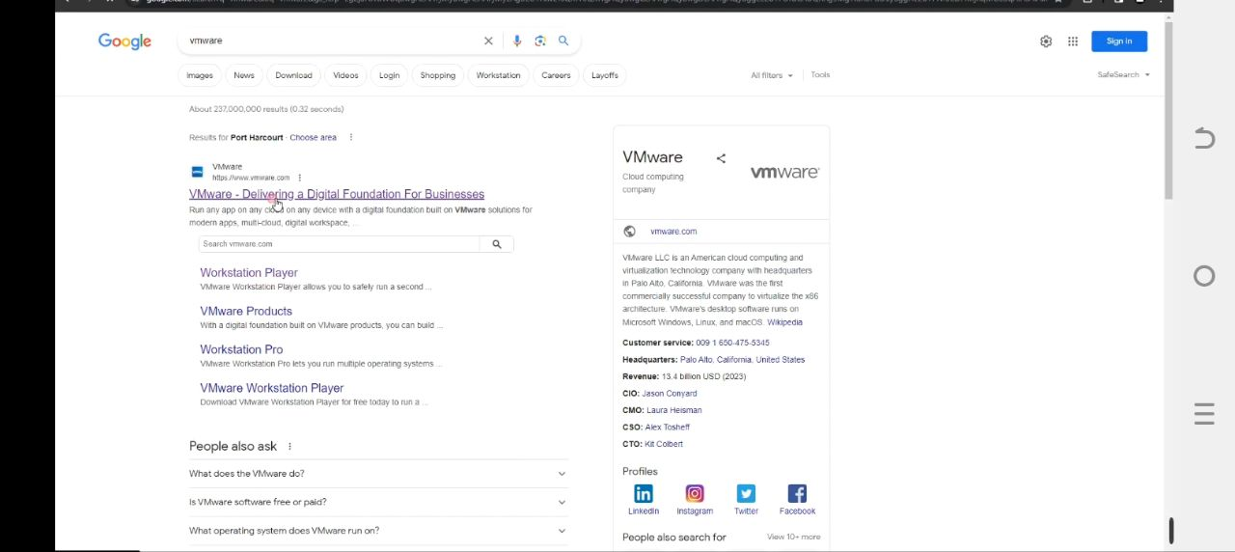The first thing that we have to do is downloading the required files so head to our chrome
* First we have to download VMware ,lets search for VMware

Click on the link to VMware.com, then click on products, and then select VMware workstation player under desktop hypervisor.

* Click on download for free, and here we can see the version of VMware available, now click on go to downloads at the bottom.

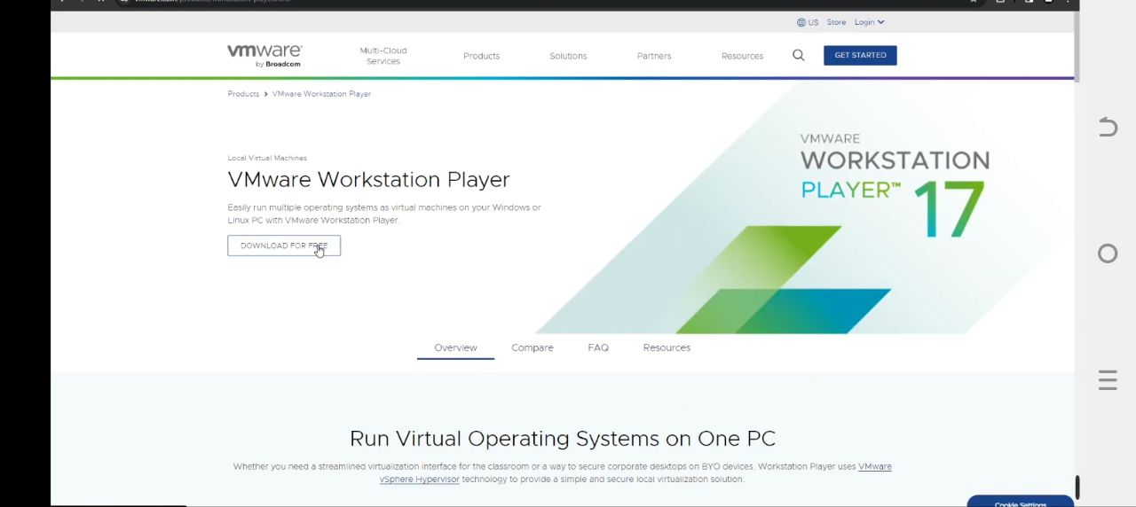

* 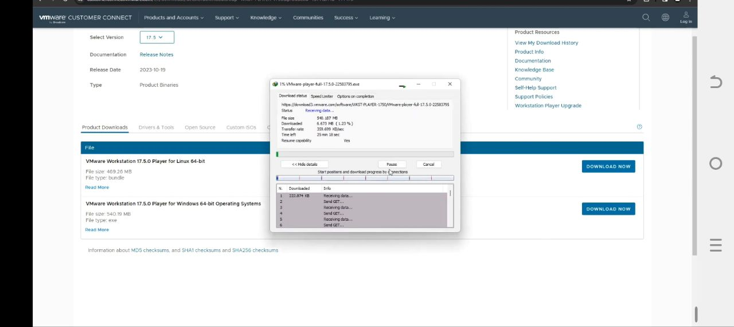Here you should see VMware for Linux and for windows so we’re going to download for windows since we’re using a windows computer, so click on download now under windows and it should start downloading.
* 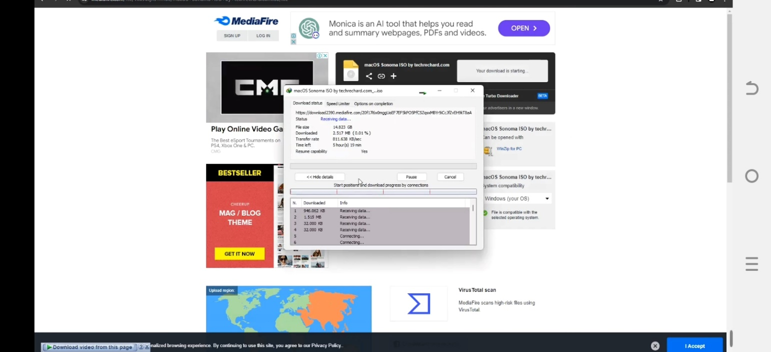Next after downloading VMware we also have to download Mac OS ISO file which we going to use for the installation. clicking on the download button and it should start downloading.

The file size is about 14.8 gig, it would recommend we use n internet download manager if our internet is not stable.

* Lastly we have to download Auto un locker for VMware so let’s open a new tab and then search for auto un locker for VMware ,
* Now we can see polo projects Auto un locker, and let’s click on it.
* Now this two is going to allow us to run Mac OS on our VMware smoothly.
* Look by the right and we would see the latest release, which we’re going to click on and then scroll down and then and we should see un locker and download the zip.

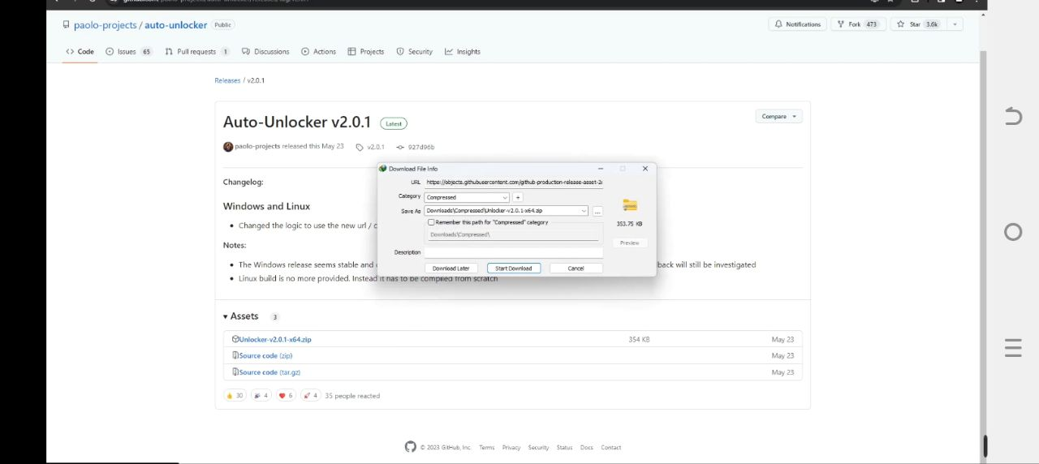

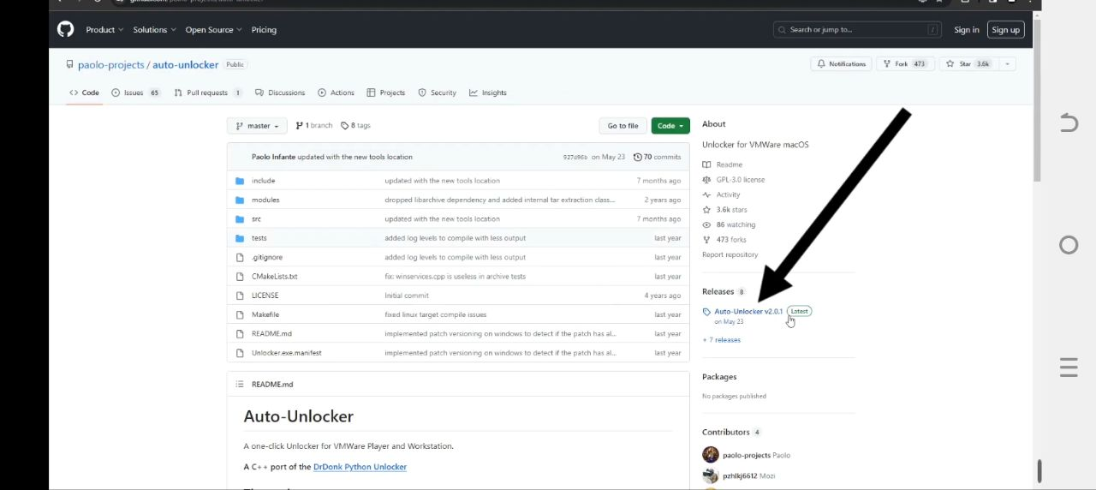

* So after downloading VMware mac OS Sonoma ISO file and unlocker we can close our browser and head to download.
* Then in downloads ,we found VMware ,unlocker ,and macOS ISO file .
* First we have to install VMware by clicking on it.

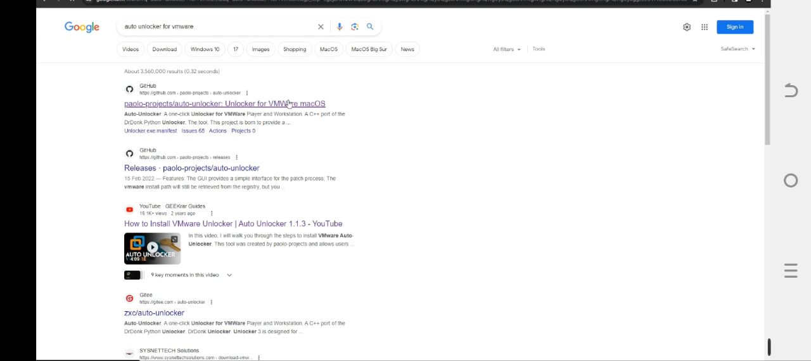

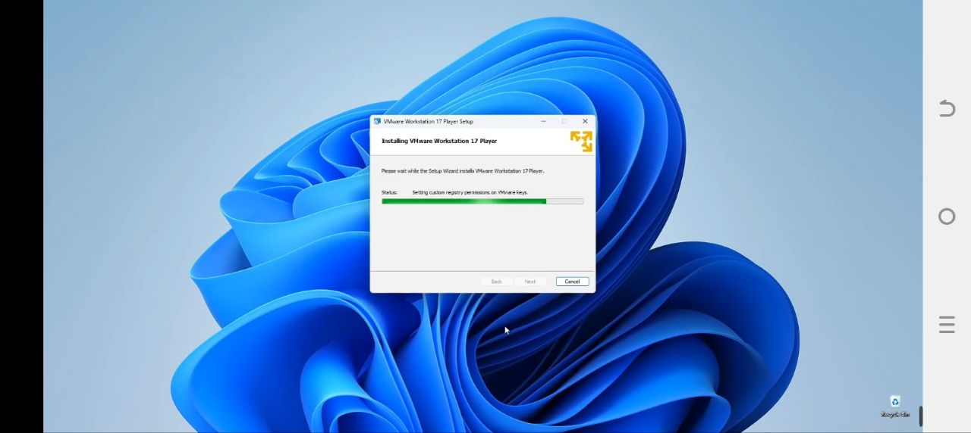

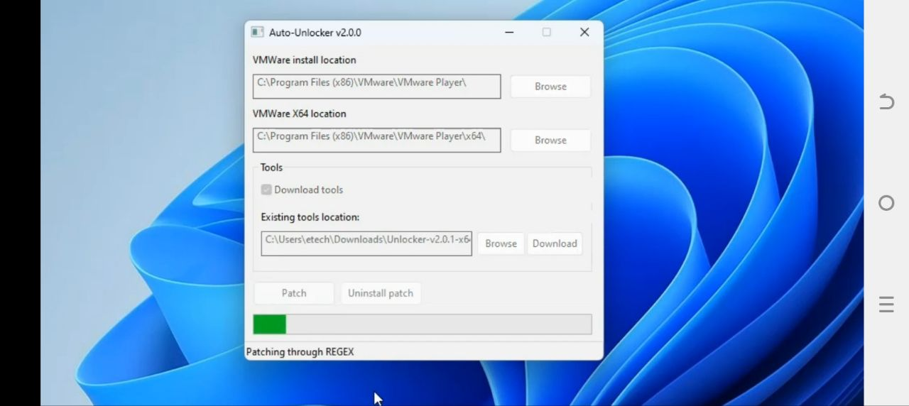

* After installing VMware now we have to run unlocker so let’s head back to our download folder and then extract unlocker
* Now let’s open the extracted folder, right click and click on run as administrator.
* Now let’s click on patch ,it’s going to apply patch to VMware so we can run mac OS Sonoma, so let’s click on patch this should take a while to download the required files and run the patch.
* After we are done with the patch ,now click on ok and then we can close this.
* 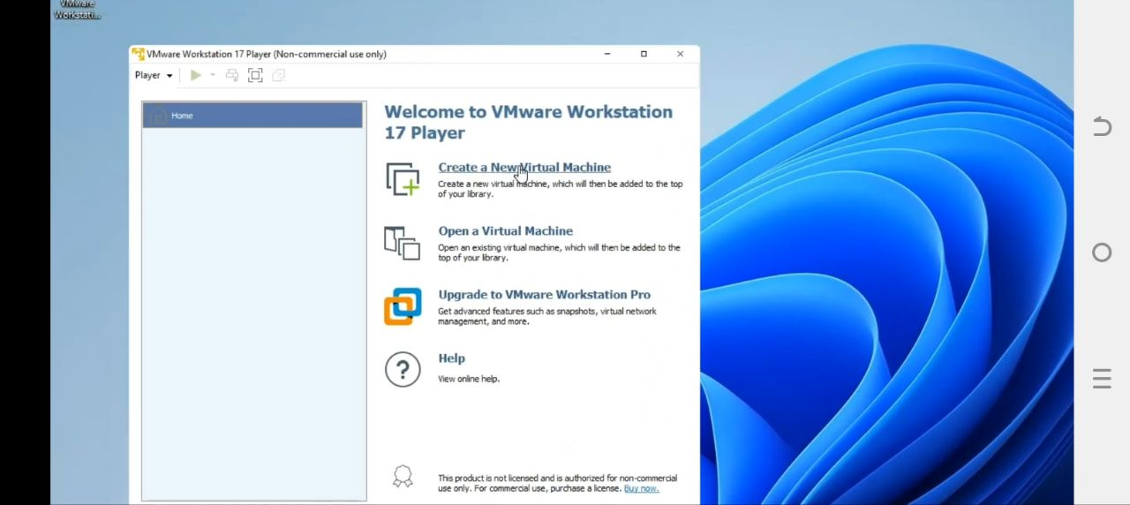now let’s open VMware from our desktop, and then create a new virtual machine.
* We’re going to select installer disk image file and then click on browse now we select our Mac OS Sonoma ISO file from our download folder ,open, and then next…,now this was the reason we used auto unlocker patch if we don’t run that we won’t get an option for Mac OS X.
* Now we set the version to Mac OS 14 and then enter our machine name, then I’m going to call this Mac OS Sonoma, and we’re going to leave the location where to install as it is.
* Now we set the version to Mac OS 14 and then enter our machine name ,then I’m going to say it Mac OS Sonoma and we are going to set the location to install as it is.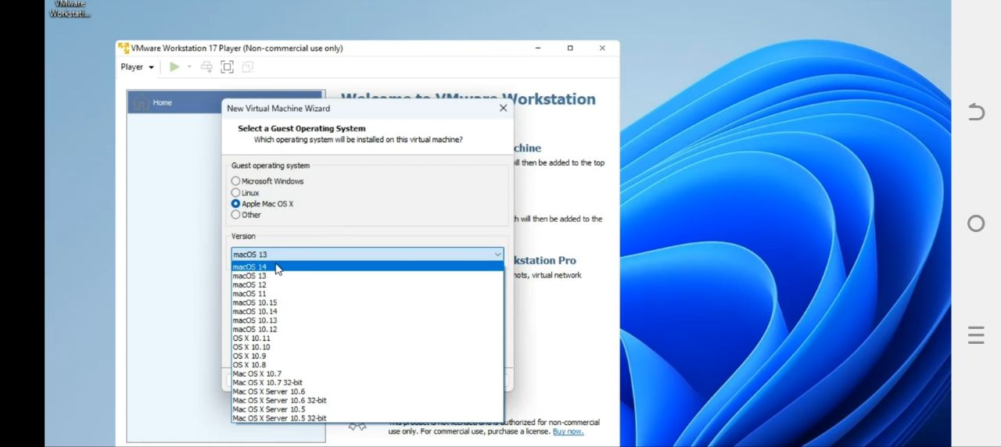

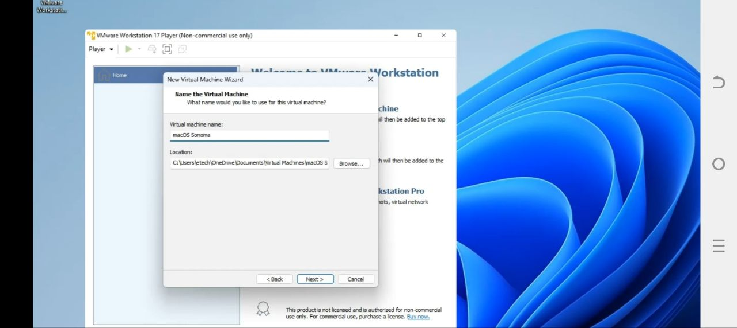

* Then set a size for our installation,it is recommended any thing above 80GB,so I just leave it on 80GB.

We leave it at split virtual disk in to multiple file so if we want to transfer it into another system it will be easy.

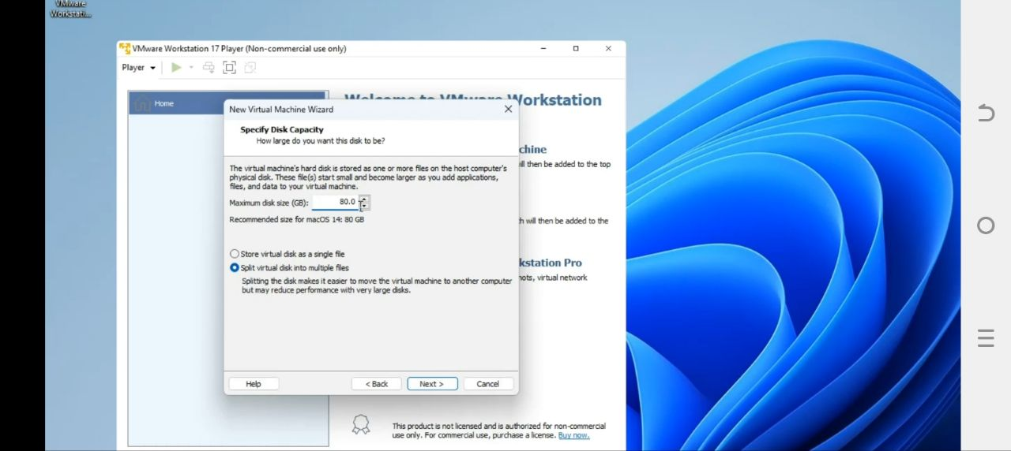

* Click on next and click on customize Hardware ,so we can make few changes .

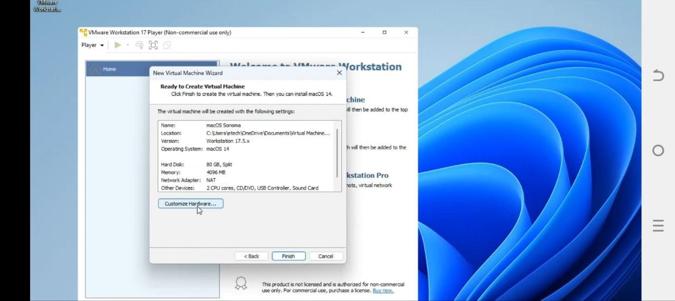

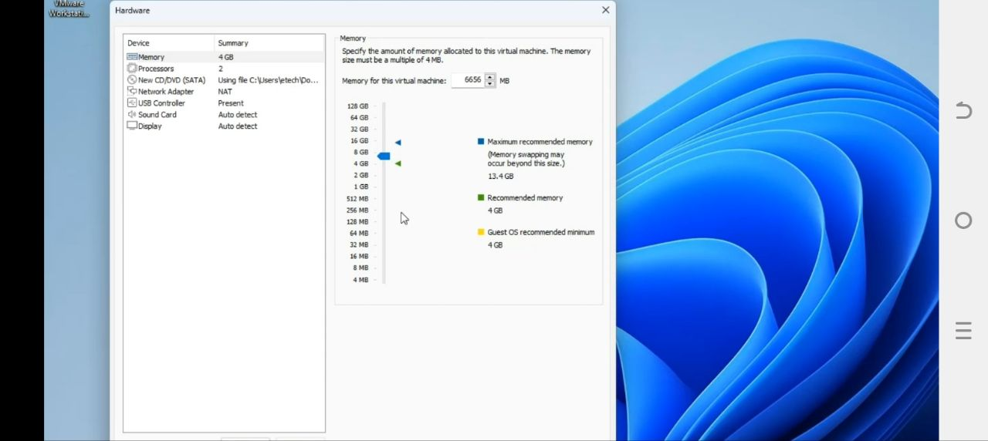

* We can increase the RAM to whatever we want, now in my case I’m going to give it about 6.5GB,we shouldn’t allocate more than 50% of our RAM tour virtual machine else it to slow down our computer.
* Same for processor as well, I’m going to give it 3 CES and then every thing else we can leave as it is, and then we click on close ,and click on finish.
* And we are almost to start the installation, next click on edits virtual machine settings, so we can get the directory where this machine is going to be running from.
* Go to the hard disk and copy the disk file, then we need to copy it to place where it says the name of our virtual machine which is Mac OS Sonoma in my case.

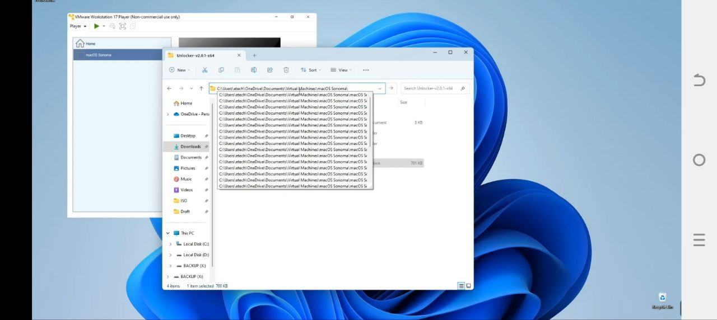

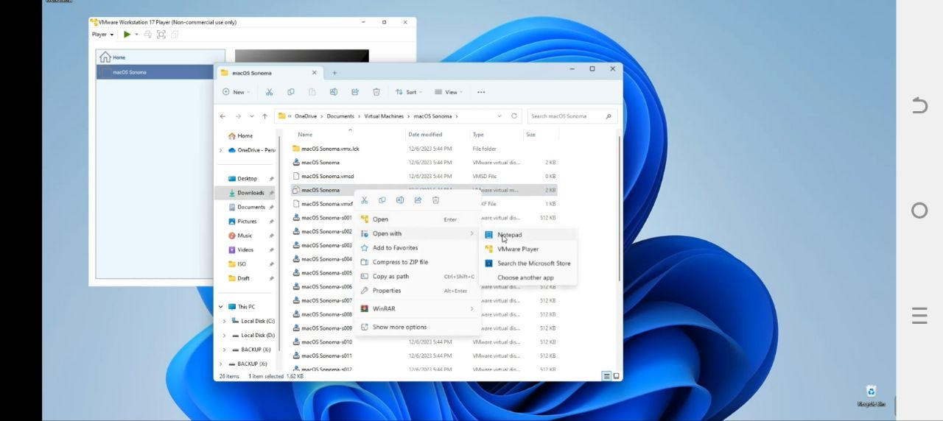

* Then we have to edit the configeration file and if we look closely we would see a file with a type called VMware virtual mahcine configuration.right click on that file and tthen open with notpad.

We have to make changes here,and scroll down and write “smc.version=”0””,and go to file and save it.then close notepad.

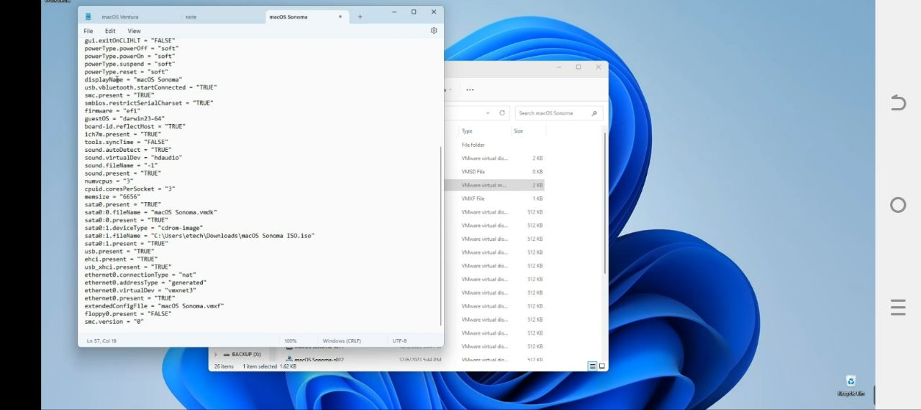

* Now we can start our virtual machine and begin the installation .click on play virtual machine.

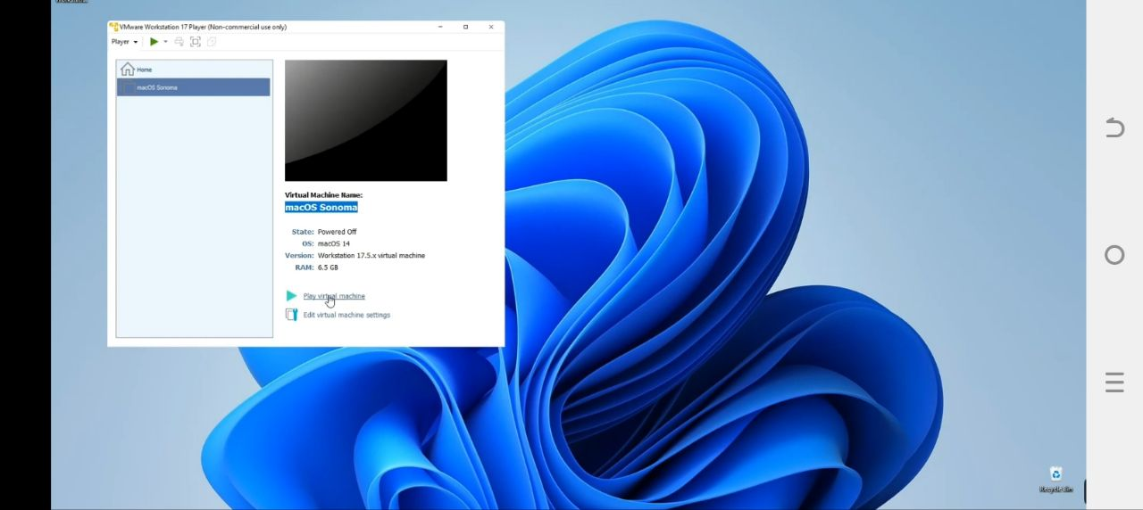

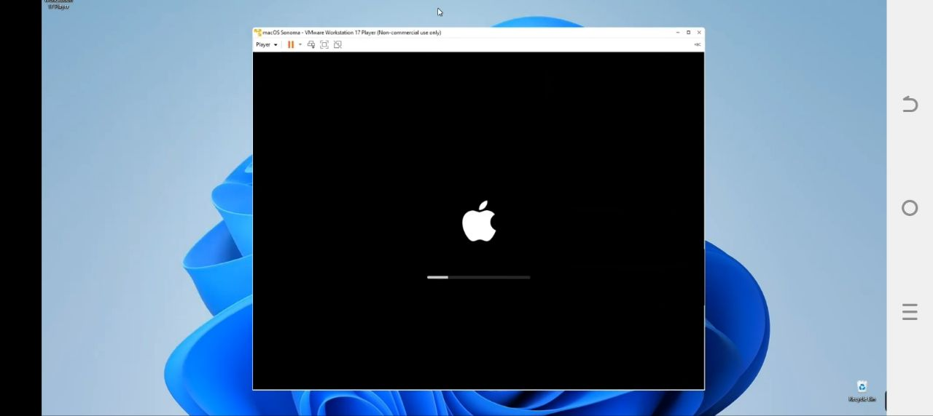

* Now set language for installation and then ,first we have erased the disk we assigned and then install Mac OS.

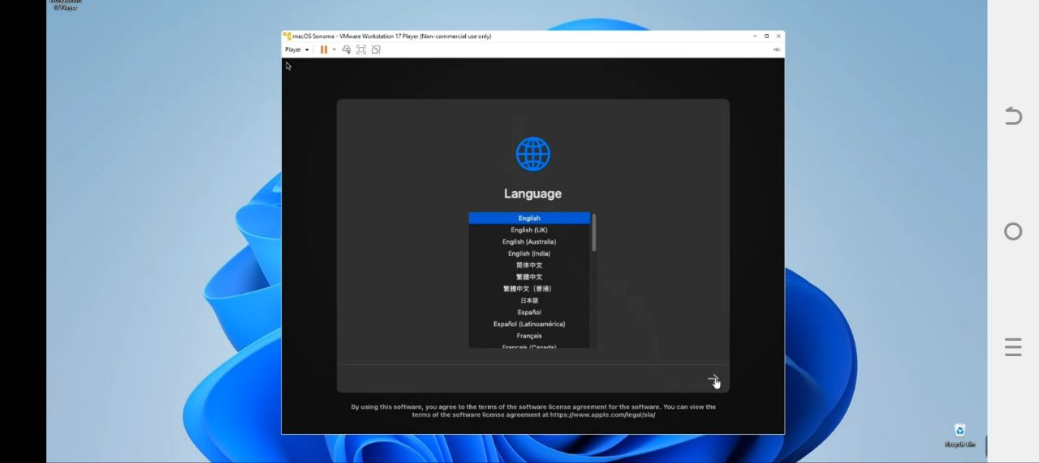

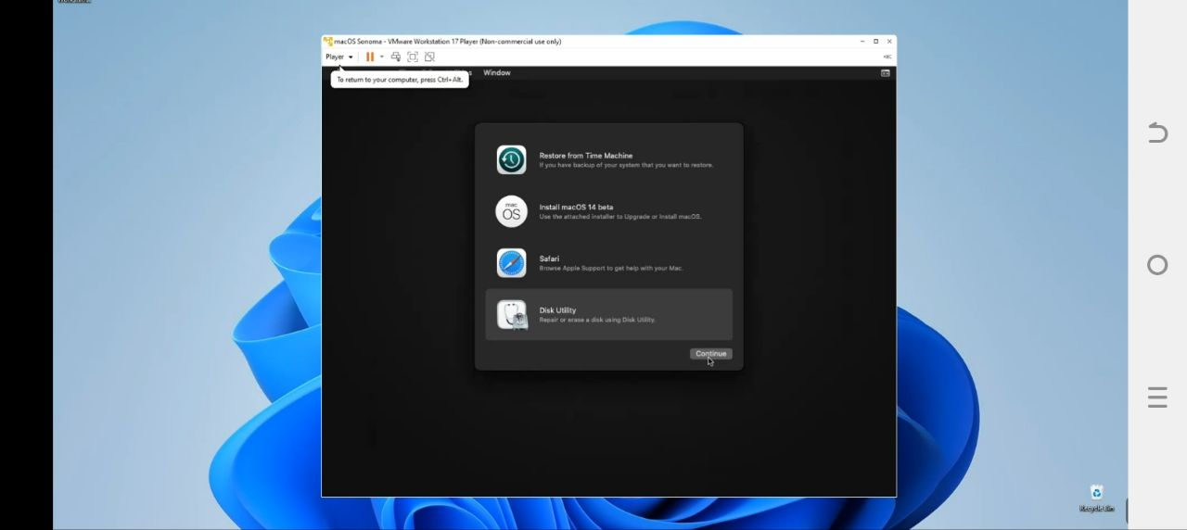

* Go to disk utility ,then we can see under internal drives VMware virtual SATA hard drive ,and I’m going to call it Mac OS 14.

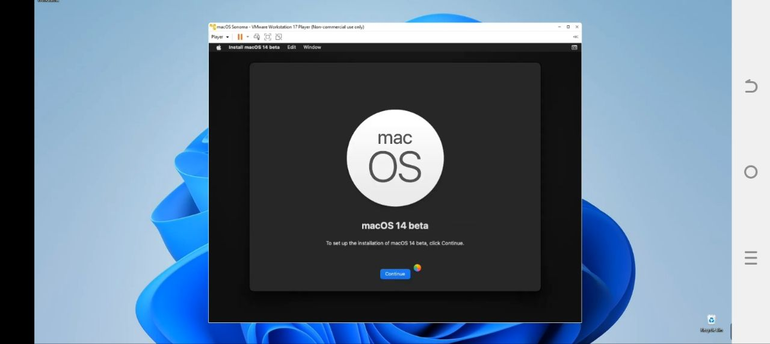

* click on(continue…continue…and agree to the terms)and then select our device and click continue .And it should begin installing ,it will take about an hour to install or it may restart severally while installing.

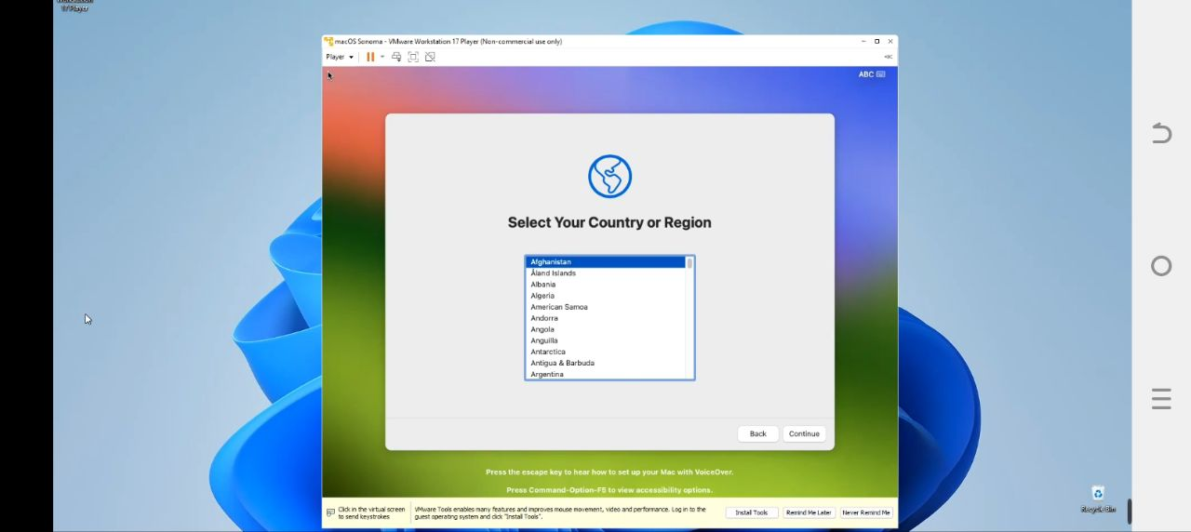

* Installation is completed .now we can set up based on our personal preference, enter username and password which we going to access our machine .

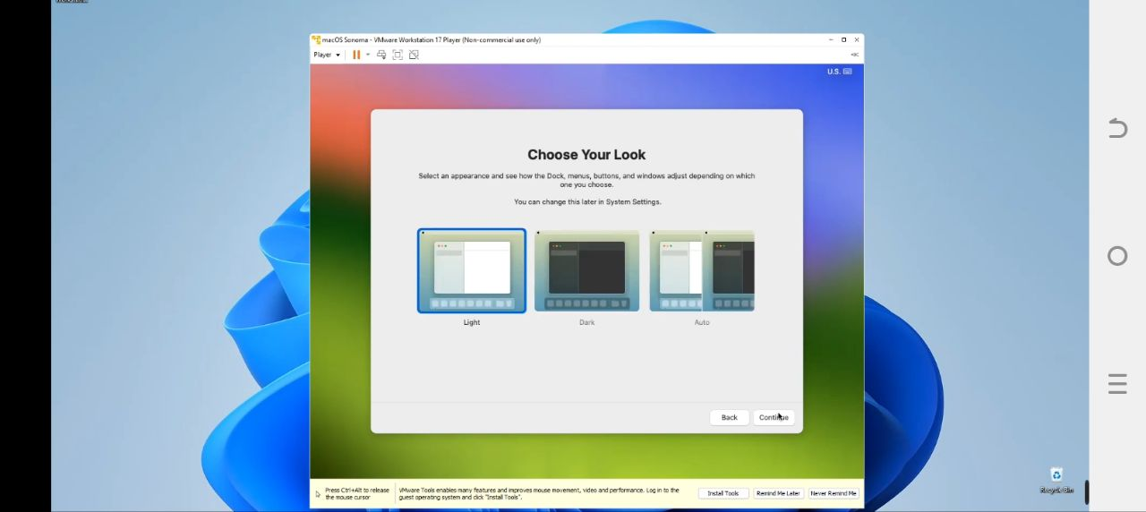

* Here we can choose between light mood or dark mood ,or we can also change this later in settings and we are done with the installation.

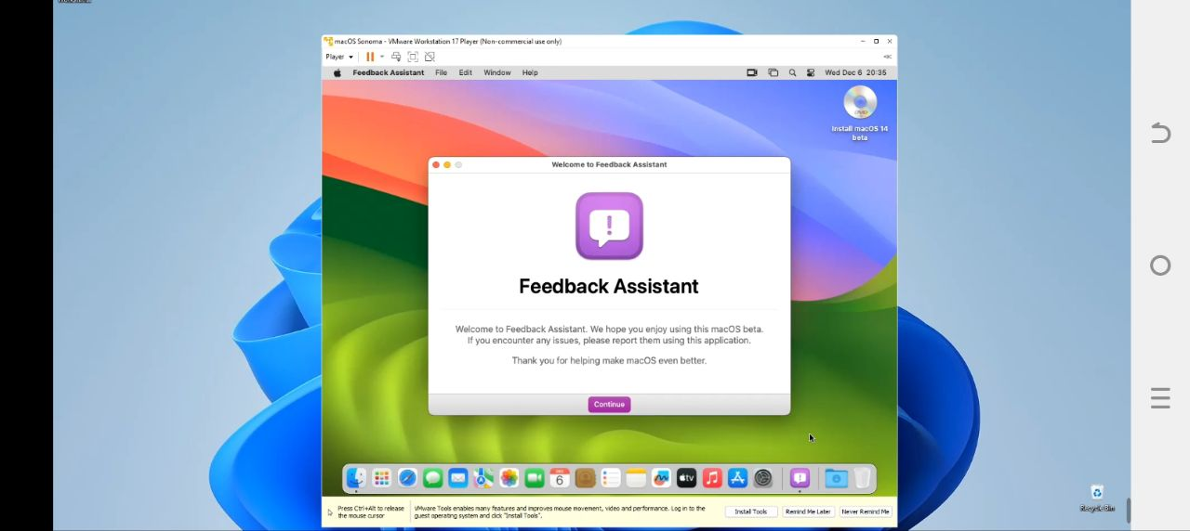

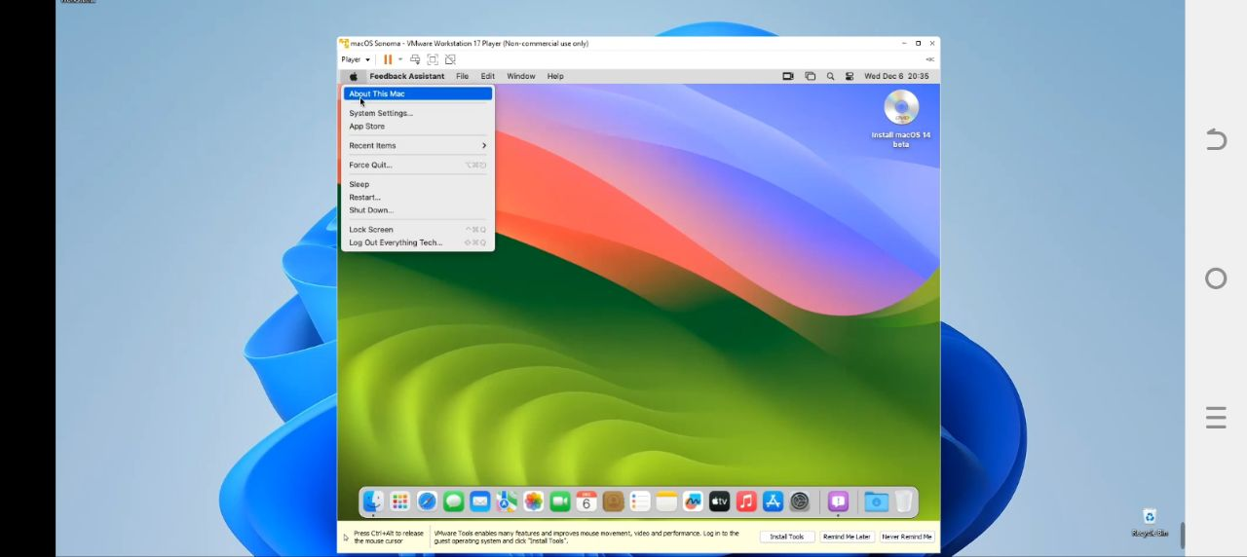

* There are few issues we need to take in to consideration :
* Our machine is running quite slow ,that is because of graphics so we click on about this Mac, here we can increase the graphics in which is given in megabyte.
* The other issue is ,if we want to resize the machine’s wallpaper it doesn’t work, and to view it in full screen mode still doesn’t work.
* To fix that in graphics issue we need to install VMware tools and to install that we just have to go to player and then click on manage and click install VMware tools .
* Restart our PC, then use our password to sign in again. now the graphics has increased to 128mega byte and we could also drag the screen and make it full screen. now everything is working without any issue.

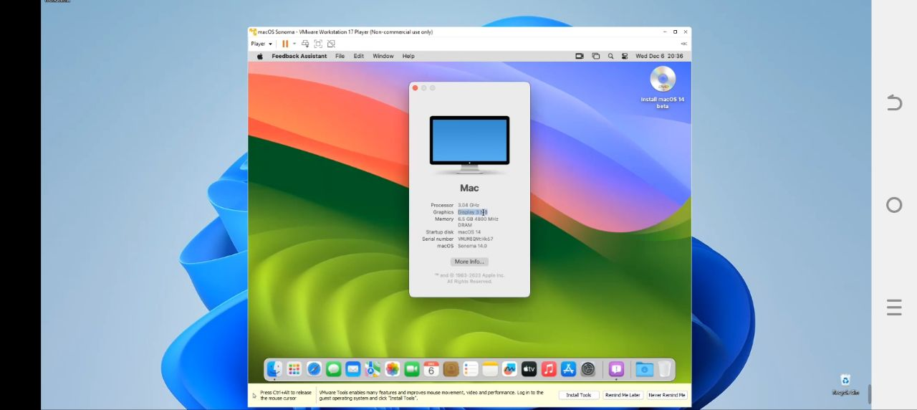

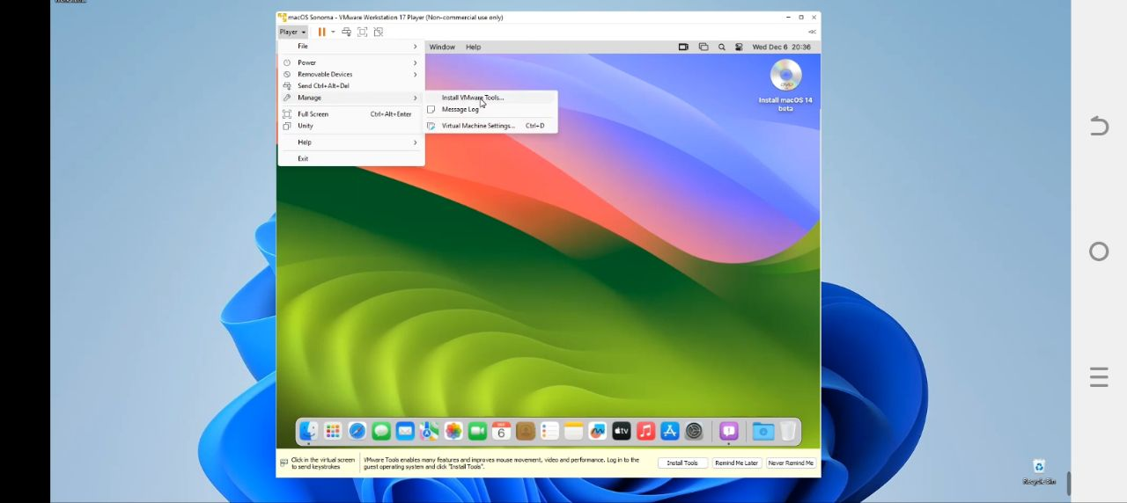

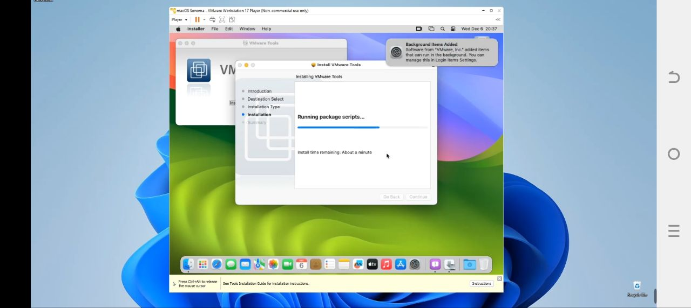

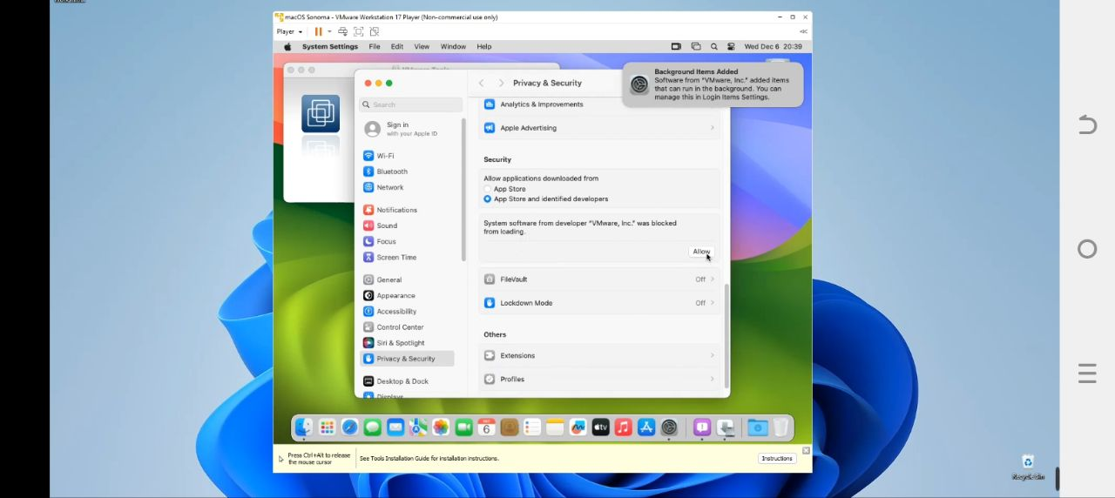

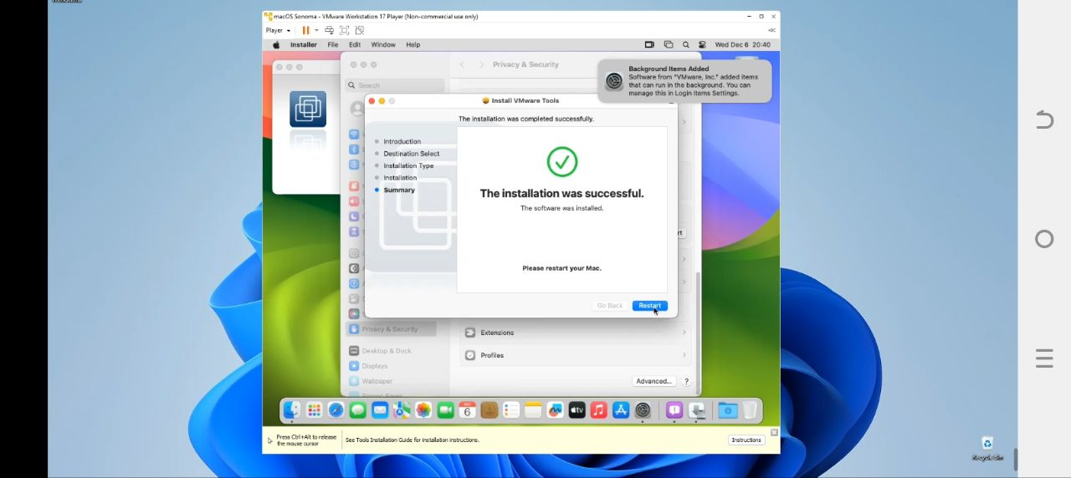

* After installation has been completed ,when we restart our PC we will get such kind of environment of Mac operating system:

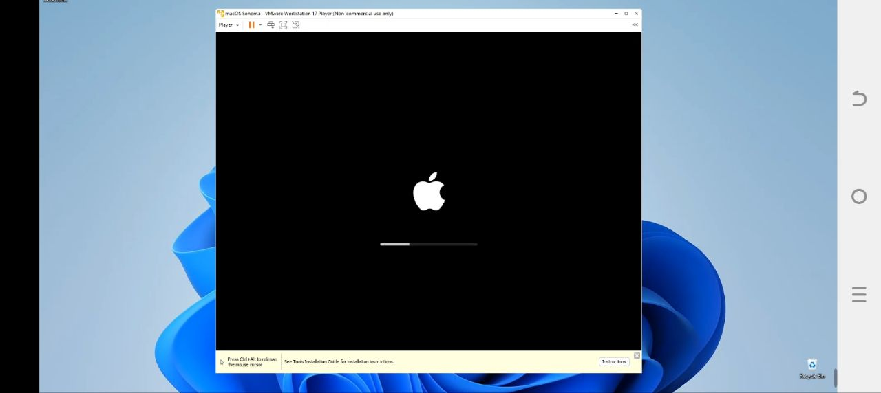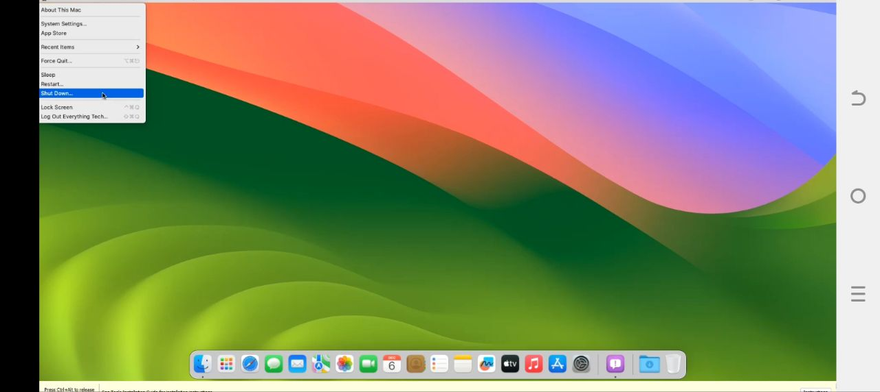

* All the above are the installation processes that we need to follow in order to install Mac OS Sonoma on our PC.

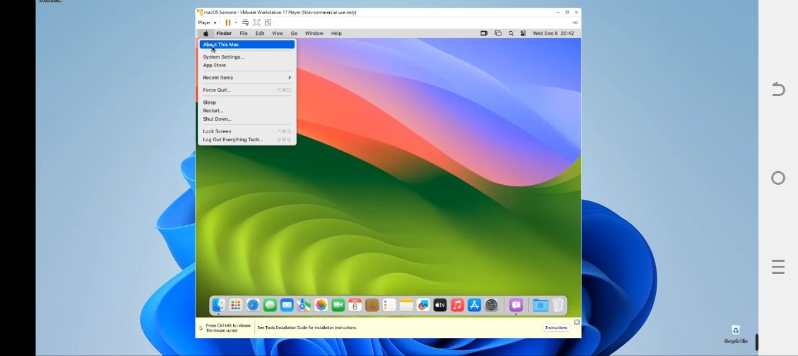

**Issues (problems) with their solutions**

**1. Installation Fails or Freezes**

Symptoms: The installation process stops, or the progress bar does not move.

Solutions:

• Restart your Mac and try the installation again.

• Ensure you have enough free disk space (at least 20 GB is recommended).

• Use Disk Utility to check and repair your disk.

**2. Incompatible Software**

Symptoms: Applications crash or do not work correctly after installation.

Solutions

• Check for compatibility of your applications with Mac OS Sonoma before upgrading.

• Update your apps to their latest versions after the installation.

**3. Boot Loop**

Symptoms: Your Mac keeps restarting without reaching the desktop.

Solutions:

• Boot into Recovery Mode (hold Command + R during startup) and use Disk Utility to repair your disk.

• Reinstall Mac OS from Recovery Mode.

**4. Wi-Fi Connectivity Issues**

Symptoms: Unable to connect to Wi-Fi after installation.

Solutions:

• Restart your router and Mac.

• Forget the network and reconnect by entering the password again.

• Reset your network settings in System Preferences.

**5. Slow Performance**

Symptoms: The system runs slowly after installation.

Solutions:

• Check Activity Monitor for any applications consuming excessive resources.

• Consider resetting the NVRAM/PRAM (hold Option + Command + P + R during startup).

• Ensure all apps are updated.

**6. Data Migration Issues**

Symptoms: Problems transferring data from a Time Machine backup or another Mac.

Solutions:

• Ensure your backup is intact and accessible.

• Try using Migration Assistant again after the installation is complete.

**7. Error Messages During Installation**

Symptoms: Specific error codes appear during the installation process.

Solutions:

• Look up the specific error code on Apple's support website for tailored troubleshooting steps.

• Ensure that your Mac meets the system requirements for Mac OS Sonoma.

**8. External Device Compatibility Issues**

Symptoms: Peripherals (like printers, scanners, etc.) do not work after installation.

Solutions:

• Check for driver updates from the manufacturer’s website.

• Remove and re-add the devices in System Preferences.

**9. User Account Issues**

Symptoms: Issues logging into your user account or missing user data.

Solutions:

• If you can't log in, try booting into Safe Mode (hold Shift during startup) and troubleshoot from there.

• If data is missing, check if it’s stored in a different user account or in a backup. **10. System Preferences Not Responding**

Symptoms: System Preferences crashes or does not open.

Solutions:

• Restart your Mac and try again.

• Reset System Preferences by deleting preference files (use caution and back up important data).

**General Tips**

• Always ensure that our Mac is compatible with Mac OS Sonoma before attempting an upgrade.

• Backup all important data before starting the installation process to prevent data loss.

• If problems persist, consider reaching out to Apple Support for further assistance. By being aware of these potential issues, we can better prepare for a smoother installation experience with Mac OS Sonoma.

**File system supports**

Mac OS Sonoma primarily supports the APFS (Apple File System), which is the default file system for Mac OS since Mac OS High Sierra (10.13). APFS is designed specifically for flash and solid-state drives (SSDs), which are commonly used in modern Macs. Here are some key reasons why APFS is the preferred file system for Mac OS Sonoma:

**1. Performance**

• APFS is optimized for speed and efficiency, particularly with SSDs. It allows for faster file access and improved overall system performance compared to older file systems like HFS+.

**2. Space Efficiency**

• APFS uses a feature called copy-on-write, which means that when you modify a file, the system does not overwrite the original data immediately. Instead, it creates a new copy of the modified data and updates the reference. This method helps save disk space and reduces fragmentation.

**3. Snapshots**

• APFS supports snapshots, allowing users to capture the state of the file system at a specific point in time. This feature is useful for backups and restoring files to previous states without affecting other data.

**4. Encryption**

• APFS provides built-in encryption options, allowing users to encrypt their entire drive or specific files easily. This enhances security and protects sensitive data.

**5. Improved Reliability**

• The design of APFS includes features that improve data integrity and reliability, such as checksums for metadata, which help detect and correct errors.

**6. Cloning**

• APFS allows for efficient cloning of files and directories. When you clone a file, the system creates a new reference to the original data instead of duplicating it, which saves space and time.

**7. Multi-Volume Support**

• APFS can manage multiple volumes within a single container, allowing for better organization of data and easier management of different partitions on the same physical drive.

**Advantages and disadvantages**

**Advantages of Mac OS Sonoma**

1. Enhanced Performance: Sonoma is optimized for better performance, especially on newer hardware, leading to improved spe4N

2. User Interface Improvements: The update introduces a refined user interface with new design elements that enhance the overall aesthetic and usability of the system.

3. Widgets on Desktop: Users can now place widgets directly on their desktop, providing quick access to information without needing to open applications.

4. Improved Privacy Features: Sonoma includes enhanced privacy controls and features that help protect user data and improve security.

5. Safari Enhancements: The latest version of Safari includes improved tab management, better privacy features, and enhanced performance, making browsing smoother and safer.

6. Gaming Features: With improved support for gaming, including features like Game Mode, Sonoma aims to provide a better experience for gamers on Mac.

7. Continuity Features: Improved integration with other Apple devices allows for seamless transitions between devices, enhancing productivity.

8. Video Conferencing Tools: New features for video calls, such as Presenter Overlay and improved screen sharing options, make remote work and communication more effective.

**Disadvantages of Mac OS Sonoma**

1. Compatibility Issues: Some older applications or peripherals may not be fully compatible with Sonoma, leading to potential disruptions for users reliant on legacy software.

2. Hardware Requirements: Sonoma may require newer hardware to run optimally, which could necessitate upgrades for some users.

3. Learning Curve: Users accustomed to previous versions of Mac OS may face a learning curve with new features and changes in the interface.

4. Bugs and Stability Issues: As with any new operating system release, initial versions may have bugs or stability issues that can affect user experience.

5. Resource Usage: Some users may find that newer features consume more system resources, which could impact performance on older machines.

6. Focus on Aesthetics Over Functionality: Some users may feel that design changes prioritize aesthetics over practical functionality, which could detract from productivity.

7. Limited Customization: While Apple focuses on a streamlined user experience, this can sometimes limit customization options compared to other operating systems.

**Conclusion**

macOS Sonoma enhances the Mac experience with a blend of aesthetics and functionality. Here are the key highlights:

Key Features

* New Wallpapers

A collection of stunning wallpapers to personalize our desktop.

* Customizable Widgets

Widgets can be placed on the desktop for quick access to information like weather, calendar events, and reminders.

Enhanced Video Conferencing

* Improved Features

Tools like Presenter Overlay allow us to share your screen while remaining visible.

* Reactions and Effects

Add visual effects during meetings for a more engaging experience.

Productivity Enhancements

* Focus Modes

Better integration of Focus modes to minimize distractions based on activities.

* Safari Updates

Enhanced privacy features and Tab Groups for better organization of browsing sessions.

Creative Tools

* Application Updates

Refined features in apps like Photos and Music to enhance creativity.

* Collaboration

Improved Share Play for real-time collaboration on projects with others.

macOS Sonoma offers a fresh take on productivity and personalization, making our Mac experience more efficient and inspiring.

**Future outlook/recommendation**

The future outlook for recommendations regarding Mac OS Sonoma is generally positive, with several key considerations for users contemplating the upgrade:

1. Enhanced Features: As more users adopt Mac OS Sonoma, ongoing updates and refinements are expected to improve existing features and introduce new functionalities. Users can anticipate enhancements in performance, security, and usability, making it a compelling choice for those seeking a modern operating system.

2. Application Compatibility: Developers are likely to continue optimizing their applications for Mac OS Sonoma, which will enhance compatibility and performance over time. Users should keep an eye on updates from their essential software providers to ensure seamless integration with the new OS.

3. Hardware Evolution: As Apple continues to release new hardware, the synergy between Mac OS Sonoma and the latest Macs will likely improve, offering enhanced performance and capabilities. Users with older hardware may eventually need to consider upgrading their devices to fully benefit from Sonoma’s features.

4. User Adoption: As the user base grows, community feedback and user-generated content will provide valuable insights and tips for maximizing the potential of Mac OS Sonoma. This can lead to a richer ecosystem of resources for both new and experienced users.

5. Focus on Privacy and Security: With increasing concerns about privacy and data security, Mac OS Sonoma’s focus on these areas may make it a preferred choice for users prioritizing these aspects in their computing experience.

The outlook for Mac OS Sonoma is promising, with expectations of continued improvements and support. Users considering the upgrade should stay informed about developments and weigh the benefits against their specific needs and hardware capabilities. Overall, Mac OS Sonoma is poised to be a strong recommendation for users looking to enhance their Mac experience.

**What is virtualization?**

Virtualization in modern operating systems refers to the creation of a virtual version of computing resources, such as hardware platforms, storage devices, and network resources. This technology enables multiple operating systems (OS) or instances of applications to run concurrently on a single physical machine, effectively utilizing hardware resources more efficiently.

**Types of Virtualization**

1. Hardware Virtualization: This involves creating virtual machines (VMs) that simulate physical hardware. Each VM runs its own operating system and applications as if it were a separate physical computer. Hypervisors, such as VMware ESXi, Microsoft Hyper-V, and KVM (Kernel- based Virtual Machine), manage these VMs.

2. Operating System-Level Virtualization: Also known as containerization, this approach allows multiple isolated user-space instances (containers) to run on a single OS kernel. Examples include Docker and LXC (Linux Containers). Containers share the same OS but have isolated environments for applications.

3. Storage Virtualization: This abstracts the physical storage resources to create a unified view of storage devices. It allows for better management and allocation of storage resources across multiple servers.

4. Network Virtualization: This creates a virtualized network environment that can be managed independently from the physical network infrastructure. It allows for the creation of virtual networks, enhancing flexibility and scalability.

**Why do we use virtualization?**

Virtualization in modern operating systems is important for several reasons:

**1. Resource Utilization:** Virtualization allows multiple virtual machines (VMs) to run on a single physical server, maximizing hardware resource utilization. This leads to better performance and efficiency, as resources can be allocated dynamically based on demand.

**2. Isolation:** Each VM operates in its own environment, providing strong isolation between different workloads. This means that issues in one VM (such as crashes or security breaches) do not affect others, enhancing security and stability.

**3. Scalability:** Virtualization makes it easier to scale applications and services. New VMs can be quickly provisioned to handle increased loads, allowing organizations to respond rapidly to changing demands.

**4. Simplified Management:** Virtualization simplifies the management of IT resources. Administrators can manage multiple VMs from a single interface, automate deployment, and streamline backup and recovery processes.

**5. Cost Efficiency:** By consolidating workloads onto fewer physical servers, organizations can reduce hardware costs, energy consumption, and data center space. This leads to lower operational costs over time.

**6. Testing and Development:** Virtualization allows developers to create isolated environments for testing applications without the risk of affecting production systems. This facilitates rapid development cycles and enhances software quality. **7. Disaster Recovery:** Virtual machines can be easily backed up and replicated, making disaster recovery processes more efficient. In case of hardware failure, VMs can be quickly restored on different physical machines.

**8. Legacy Support:** Virtualization enables organizations to run legacy applications that may not be compatible with modern hardware or operating systems by encapsulating them in a VM.

**How do we use virtualization?**

Virtualization in modern operating systems involves creating virtual instances of

computing resources, such as servers, storage devices, and networks, allowing multiple operating systems and applications to run on a single physical machine. This is achieved through various technologies and methods. Here’s how virtualization works in modern operating systems:

**1. Hypervisors**

• Type 1 Hypervisor (Bare-Metal): This runs directly on the host hardware and manages the guest operating systems. Examples include VMware ESXi, Microsoft Hyper-V, and Xen. Type 1 hypervisors are typically used in data centers for server virtualization.

• Type 2 Hypervisor (Hosted): This runs on top of a conventional operating system and relies on that OS for resource management. Examples include VMware Workstation, Oracle Virtual Box, and Parallels Desktop. Type 2 hypervisors are often used for desktop virtualization.

**2. Virtual Machines (VMs)**

• Each VM operates as an independent computer with its own operating system (guest OS), applications, and virtualized hardware resources (CPU, memory, disk, network interfaces). The hypervisor allocates physical resources from the host machine to each VM as needed.

**3. Virtualization Techniques**

• Full Virtualization: The hypervisor provides a complete simulation of the underlying hardware, allowing unmodified guest operating systems to run. This is common in Type 1 hypervisors.

• Para virtualization: The guest OS is modified to be aware of the hypervisor, allowing for more efficient communication between the guest and host, reducing overhead.

• Hardware-Assisted Virtualization: Modern CPUs (like Intel VT-x and AMD-V) provide hardware support for virtualization, improving performance by allowing the hypervisor to execute certain tasks directly on the CPU.

1. **Resource Management**

• The hypervisor manages the allocation of physical resources (CPU, memory, I/O) to VMs. It can dynamically adjust resources based on demand, allowing for efficient utilization of hardware.

**5. Isolation and Security**

• Each VM is isolated from others, meaning that processes running in one VM cannot directly interact with processes in another VM. This isolation enhances security and stability.

**6. Snapshots and Cloning**

• Virtualization allows administrators to take snapshots of VMs at a specific point in time, enabling easy rollback to previous states. Cloning allows for rapid deployment of new VMs based on existing configurations.

**7. Network Virtualization**

• Virtual networks can be created to allow VMs to communicate with each other and with external networks while maintaining isolation. Technologies such as virtual switches and routers facilitate this.

**8. Storage Virtualization**

• Storage resources can be pooled together and presented as virtual disks to VMs. This allows for easier management of storage resources and can improve performance through techniques like thin provisioning.

**9. Management Tools**

• Various management tools and platforms exist to monitor, manage, and automate the deployment of VMs. Examples include VMware v Center, Microsoft System Center, and open- source solutions like Open Stack.

**10. Use Cases**

• Virtualization is widely used for server consolidation, development and testing environments, disaster recovery solutions, cloud computing services, and running legacy applications.

**References:**

1. *Apple’s official Website*
2. *Apple support documentation*
3. *Developer documentation*
4. *Tech blogs*
5. *Google*
6. *You tube Tutorials*