
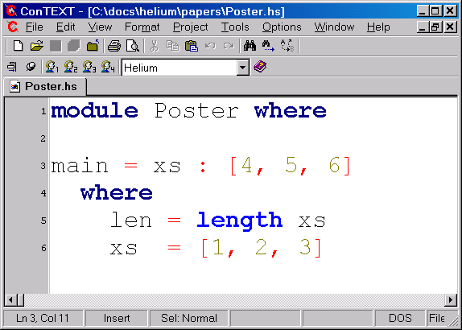
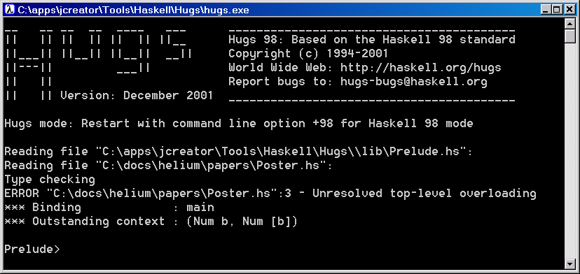
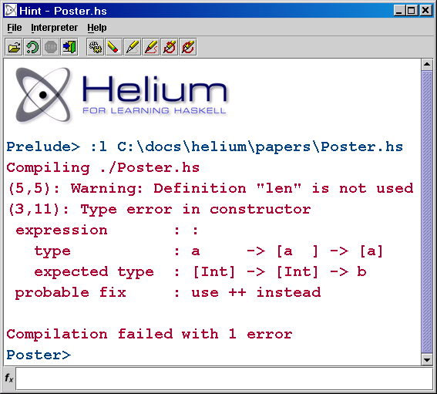
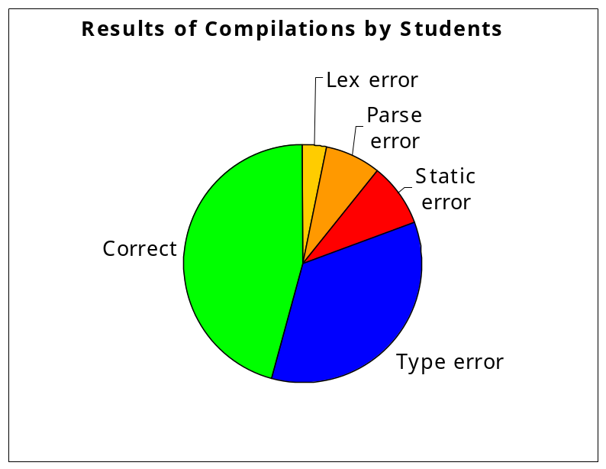


Introduction

Helium is a functional programming language and a compiler designed especially for learning Haskell. Quality of the error messages has been the main concern both in the choice of the language features and in the implementation of the compiler. Our goal is to let students learn functional programming more quickly and with more fun.

Features

- Warnings for common mistakes
- Positions of error messages are exact
- Hints and suggestions for fixes
- Graphical interpreter
- Logging of compilation results

Future Work

- Type classes
- GUI library
- Test for incomplete patterns
- Recognising standard functions

Bastiaan Heeren, Arjan van IJzendoorn, Daan Leijen
Rijk-Jan van Haaften, Arie Middelkoop

