

**NAME : JOSHUA DIAMOND DANIEL**

**COURSE: CSC 302**

**MATRIC NO: VUG/CSC/22/7443**

**DEPARTMENT: COMPUTER AND INFORMATION TECHNOLOGY**

**Amazon Web Services (AWS) - A Deep Dive**

**Introduction**

Amazon Web Services (AWS) is the largest cloud computing platform globally with a comprehensive set of cloud-based services. AWS was introduced by Amazon in 2006 and has since emerged as the most utilized cloud provider by businesses of all shapes and sizes, from small startups to Fortune 500 corporations.

AWS provides Infrastructure as a Service (IaaS), Platform as a Service (PaaS), and Software as a Service (SaaS) solutions. AWS provides companies with the ability to scale applications, store data, process workloads, and secure infrastructure with minimal operational overhead.

**AWS Global Infrastructure**

AWS operates 30+ regions and 99+ availability zones globally, which ensures redundancy, high availability, and fault tolerance.

**Key aspects of AWS infrastructure:**

* Regions: A geographic area where AWS services are located (e.g., US-East-1 in Virginia).

* Availability Zones (AZs): There are several AZs, each an independent data center, that make up a region.

* Edge Locations: They enable fast content delivery via Amazon CloudFront (CDN).

**AWS Core Services**

1. Compute Services

* AWS offers several compute services that help businesses run applications, host websites, and process data.

* Amazon EC2 (Elastic Compute Cloud): Virtual machines (VMs) to run applications.

* AWS Lambda: Serverless computing service for executing code in response to events.

* Amazon ECS (Elastic Container Service): Container orchestration managed by AWS.

* Amazon EKS (Elastic Kubernetes Service): Container management based on Kubernetes.

*AWS Fargate: Serverless computing for containers.

2. Storage Services

AWS provides scalable and secure storage solutions:

* Amazon S3 (Simple Storage Service): Object storage for files, media, and backups.

* Amazon EBS (Elastic Block Store): Persistent storage for EC2 instances.

*Amazon Glacier: Low-cost cold storage for long-term data archiving.

*AWS Storage Gateway: Hybrid cloud storage for on-premises environments.

3. Database Services

AWS offers a variety of managed databases:

* Amazon RDS (Relational Database Service): MySQL, PostgreSQL, SQL Server, etc.

* Amazon DynamoDB: Serverless NoSQL database for high-throughput applications.

* Amazon Redshift: Cloud data warehouse for analytics.

* Amazon Aurora: Scalable, high-performance relational database.

4. Networking and Security

AWS provides networking and security services for cloud applications:

* Amazon VPC (Virtual Private Cloud): Secure, customizable networking environments.

* AWS Route 53: Scalable Domain Name System (DNS) service.

* AWS Shield: Protection of applications from DDoS.

* AWS IAM (Identity and Access Management): Controls permissions and security policies.

5. AI and Machine Learning

AWS leads the way with artificial intelligence and machine learning (AI/ML) services:

* Amazon SageMaker: All-inclusive ML model training and deployment platform.

* AWS Rekognition: Image and facial recognition.

* AWS Polly: Text-to-speech.

* AWS Lex: Natural language chatbots.

6. Cost Management and Pricing

AWS is on a pay-as-you-go pricing scheme, and clients only pay for what they use. It also offers:

* Free Tier: Free limited use of AWS services.

* Reserved Instances (RIs): Long-term EC2 savings.

* Spot Instances: Low-cost temporary compute power solution.

**Advantages of AWS**

* Largest service catalog – AWS boasts over 200 services, making it the feature-rich cloud provider.

* Most worldwide availability – AWS is available in more locations than any other cloud provider.

* Strong security and compliance – AWS complies with regulations such as GDPR, HIPAA, and SOC 2.

* High scalability and reliability – AWS can support companies that handle billions of transactions daily.

**Disadvantages of AWS**

* Complexity of cost – AWS products are difficult to plan for.

* Steep learning curve – A broad range of services can be overwhelming for beginners.

**Use Cases of AWS**

AWS powers companies such as Netflix, Airbnb, Twitter, and NASA. Some key use cases include:

* Hosting websites and applications

* Big data processing and analytics

* Machine learning and AI workloads

* Enterprise cloud migrations

**Google Cloud Platform (GCP)**

**Introduction**

Google Cloud Platform (GCP) is Google's cloud platform, providing a highly scalable, AI-first, and big data-friendly cloud environment for enterprises. GCP was launched in 2008 and has been expanding rapidly ever since to become the third-largest cloud provider behind AWS and Microsoft Azure.

GCP stands out for its advanced AI/ML capabilities, large data processing, and worldwide network infrastructure, earning it a provider of choice for companies needing effective data analytics and scalable cloud computing.

**GCP Global Infrastructure**

GCP covers 38 regions and 114 availability zones, providing fast and secure cloud access worldwide.

Most Critical Components of GCP Infrastructure:

* Regions: Locations of data centers worldwide (e.g., us-west1 in Oregon).

* Zones: Sub-regions of regions for redundancy and availability.

* Edge Locations: GCP's worldwide fiber-optic network, providing low-latency access to applications.

**GCP Core Services**

1. Compute Services

GCP offers dependable compute services to execute workloads at scale.

*Compute Engine: Virtual machines (VMs) such as AWS EC2.

* Kubernetes Engine (GKE): A managed Kubernetes service.

* Cloud Functions: Serverless computation to execute event-driven applications.

* Cloud Run: Serverless computing for containerized apps.

2. Storage Services

* Cloud Storage: Unstructured object storage for media content and backup data.

* Persistent Disk: High-performance SSD/HDD block storage for VMs.

* Filestore: Managed file storage with high availability.

3. Database Services

* Cloud SQL: Managed relational databases (MySQL, PostgreSQL, SQL Server).

* Cloud Spanner: A consistent, globally distributed SQL database service.

* Firestore: A NoSQL document database for real-time applications.

4. Networking and Security

* VPC (Virtual Private Cloud): Private, isolated networking areas.

* Cloud Load Balancing: Automatic distribution of traffic across regions.

* Cloud Armor: DDoS and web attack security service.

5. Artificial Intelligence and Machine Learning

GCP is a pioneer in AI and ML services, providing:

* Vertex AI: End-to-end AI development platform.

* AutoML: Training AI models using no-code/low-code.

* TensorFlow Enterprise: Managed machine learning framework.

6. Pricing and Cost Management

GCP provides pay-as-you-go pricing, sustained usage discounts, and preemptible VMs (low-cost computation) to save companies money.

Benefits of GCP

* Superior AI and ML services – Google's AI capabilities are unbeatable.

* Global network infrastructure – Low-latency cloud services.

* Competitive pricing – Persistent use discounts.

* Green – Powered by 100% renewable energy.

**Disadvantages of GCP**

* Less market share – Lower enterprise adoptions than AWS/Azure.

* Enterprise-oriented services are scarce – Lacks some enterprise integrations.

**Use Cases of GCP**

GCP is powering Spotify, Twitter, and Target, and it's ideal for:

* Big data processing and analysis

* AI/ML model training

* Containerized applications

**Microsoft Azure**

**Introduction**

Microsoft Azure is among the big three cloud computing providers, providing a broad set of cloud services for institutions, developers, and businesses. Azure, which was introduced in 2010, has quickly developed into the second-largest cloud provider after AWS.

Azure is renowned for its easy integration with Microsoft products, high adoption among enterprises, and broad hybrid cloud features. Companies invested in Windows Server, Active Directory, Office 365, and SQL Server consider Azure the most suitable option to transition to the cloud.

Microsoft Azure provides services in Infrastructure as a Service (IaaS), Platform as a Service (PaaS), and Software as a Service (SaaS). It allows companies to deploy, manage, and scale applications worldwide with more security, compliance, and AI-powered automation.

**Azure Global Infrastructure**

Azure boasts the highest number of regions globally among AWS and GCP, delivering high availability, low latency, and in-region compliance.

**Major Elements of Azure's Infrastructure:**

* Regions: More than 60 regions across the globe for Microsoft Azure (e.g., East US, West Europe, Southeast Asia).

* Availability Zones (AZs): Each region contains several AZs, which are isolated data centers.

* Azure Edge Zones: They are used for low-latency computing, supporting real-time applications.

* Azure Global Network: A global cloud network that is among the fastest and most secure.

-- Special Feature: Azure provides specialized datacenters, including government cloud regions and sovereign clouds, that adhere to national legislation.

**Core Azure Services**

1. Compute Services (For Hosting Workloads & Applications)

* Azure Virtual Machines (VMs) – Scalable Linux & Windows VMs in the cloud.

* Azure Kubernetes Service (AKS) – Managed Kubernetes orchestration.

* Azure Functions – Serverless event-driven computing for apps.

* Azure Batch – Executes compute-intensive batch workloads cost-effectively.

* Azure Service Fabric – Supports microservices-based applications.

2. Storage Services (For Data Management & Backup)

* Azure Blob Storage – Object storage similar to AWS S3, best for unstructured data.

* Azure Files – File storage in the cloud with SMB and NFS support.

* Azure Data Lake Storage – Optimized big data workloads.

* Azure Archive Storage – Low-cost solution for long-term data retention.

3. Database Services (For Data Storage & Management)

* Azure SQL Database – Managed SQL Server database with AI optimization built in.

* Azure Cosmos DB – A globally distributed NoSQL database for high-throughput transactions.

* Azure Database for MySQL/PostgreSQL – Fully managed relational databases.

* Azure Synapse Analytics – Analytics and enterprise data warehousing.

4. Networking & Security (For Cloud Connectivity & Protection)

* Azure Virtual Network (VNet) – Custom networking environments in the cloud.

* Azure Load Balancer – Routes traffic for high availability and performance.

* Azure Firewall – Application security in the cloud through AI-driven firewall.

* Azure DDoS Protection – Safeguards applications from denial-of-service attacks.

* Azure Active Directory (Azure AD) – User authentication and access control identity management system.

5. Hybrid Cloud & Edge Computing

Azure is the hybrid cloud solution leader, providing companies with the ability to connect their on-premises data centers to the cloud.

* Azure Arc – Hybrid cloud management across edge, multi-cloud, and on-premises.

* Azure Stack – Hosts Azure services on-premises in private data centers, perfect for governments and enterprises.

* Azure ExpressRoute – Private, high-speed, and secured connections from a private network to Azure.

6. AI, Machine Learning & Analytics (For Smart Applications)

Azure supports the latest AI and ML services, which makes it highly suitable for business intelligence and automation.

* Azure AI – AI services suite for computer vision, speech, and NLP.

* Azure Machine Learning – Development, training, and deployment of AI models.

* Azure Cognitive Services – Prebuilt AI models for chatbots, facial recognition, and sentiment analysis.

*Power BI – Business intelligence software for data reports and visualization.

7. Application Development & DevOps

* Azure DevOps – DevOps platform for CI/CD pipelines.

* Azure Logic Apps – Automates integrations and business workflows.

* GitHub Enterprise (Azure-hosted) – Integration of CI/CD and version control.

**Advantages of Microsoft Azure**

* Ideal for Enterprises – Strong integration with Microsoft 365, Active Directory, and Windows Server.

* Strong Hybrid Cloud Capabilities – Co-exists easily with on-premise IT infrastructure.

* Powerful AI & ML Tools – Enterprise AI with Power BI and Azure AI.

* Global Presence – Most number of regions and compliance certifications.

* Security & Compliance – caters to government and financial institutions that have stringent regulations.

**Disadvantages of Microsoft Azure**

* Can be costly – Pricier than GCP in certain aspects.

* Complexity – Needs experience in Microsoft services and licensing models.

* Steeper Learning Curve – Not as user-friendly as AWS for novice developers.

**Use Cases of Microsoft Azure**

Azure powers giant firms like BMW, Adobe, and LinkedIn. Common scenarios include:

* On-premises workloads with enterprise hybrid cloud deployment.

* AI and analytics solutions powered by Power BI and Cognitive Services.

* Enterprise-grade security and compliance for regulated enterprise.

*Interoperability with Microsoft ecosystem and Windows-based applications.

COMPARISON BETWEEN AWS, GCP, MICROSOFT AZURE.

1. Market Share & Adoption

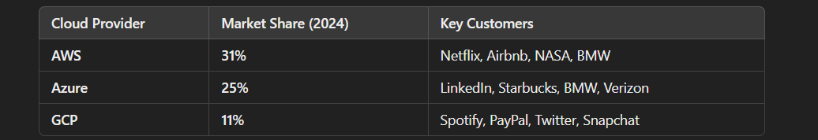

- AWS has the largest market share, but Azure is growing fast in enterprise markets.

- GCP is strong in AI & analytics, but has a lower share than AWS & Azure.

1. Global Infrastructure & Network Performance

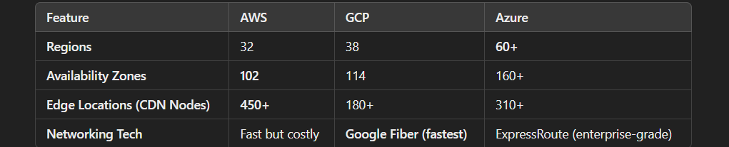

- AWS has the largest global reach.

- GCP has the fastest network due to its private fiber-optic backbone.

- Azure has the most regions, hence ideal for multinational corporations.

1. Compute Services (Virtual Machines & Containers)

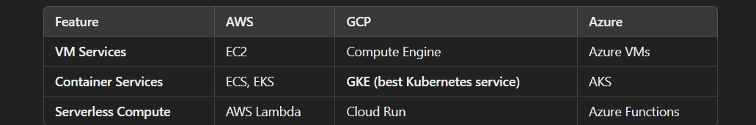

- AWS EC2 has the most instance types (for AI, gaming, high-performance computing).

- GCP's GKE is the best-managed Kubernetes service.

- Azure's AKS is deeply integrated with Windows workloads.

✅ Best for Containers: GCP (Google Kubernetes Engine - GKE).

✅ Best for Windows-based VMs: Azure.

✅ Best for Scalable Compute: AWS.

1. Storage Services

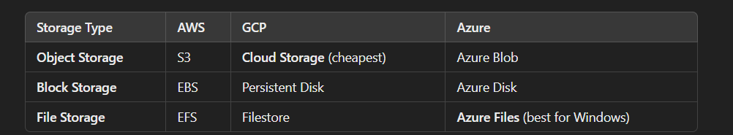

- GCP has the lowest-cost object storage with Coldline & Archive tiers.

- Azure Files is the best cloud-based file storage for Windows-based companies.

- AWS S3 is the most widely used object storage service.

✅ Best for Cost-Efficiency: GCP.

✅ Best for Windows-based File Storage: Azure.

✅ Best for General-Purpose Storage: AWS.

5. Database Services

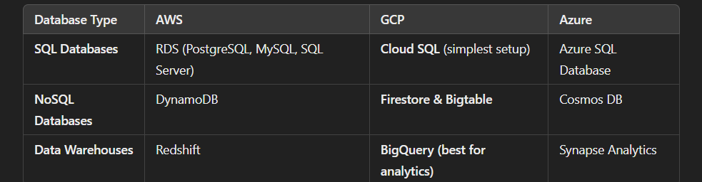

- GCP's BigQuery is the best one for big data analytics (better than AWS Redshift).

- Azure Cosmos DB is a distributed NoSQL database.

- AWS RDS is used most for enterprise applications.

✅ Best for Big Data: GCP (BigQuery).

✅ Best for NoSQL & Global Scaling: Azure (Cosmos DB).

✅ Best for Relational Databases: AWS (RDS, Aurora).

6. Pricing Comparison

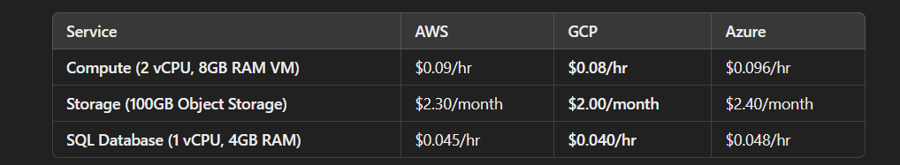

- GCP is least expensive overall, with automatic sustained-use discounts.

- Azure is ideal for hybrid pricing (discounts for existing Windows licenses).

- AWS offers the most flexible pricing, but can be expensive without cost optimization.

✅ Best for Cost-Sensitive Workloads: GCP.

✅ Best for Hybrid Cloud Cost Savings: Azure.

✅ Best for Pay-as-You-Go Flexibility: AWS.