README

Solutions — Mechanical Seams, Instruments, and Closable Gaps
Field | Value
Revision | 2
Created | 2026-07-22T20:25:00Z
Last modified | 2026-07-22T22:10:00Z
Status | COMPLETE — 10 solutions, 10 runnable POCs, all RED-first, 65/65 cases GREEN on a deterministic second iteration (poc/FULL_SWEEP.txt)
Author | (T1/main - claude4) solutions-synthesis subagent, Fable, §11.4.182
Inputs | ../ROOT_CAUSE_ANALYSIS.md (PC-1..PC-9, MU-1..MU-6, M1..M19) · ../EXTERNAL_RESEARCH.md (R1–R7, SYN-1..5, S1–S76 via ../SOURCES.md) · ../CROSS_PROJECT_CLAUDE_TOOLKIT.md (corpus 2) · ../CROSS_PROJECT_HELIX_CODE.md + ../helix_code_repo_classification.tsv (corpus 3)
Mandate | Operator directive 2026-07-22 (verbatim in §0) — exact, rock-solid, non-error-prone, fully safe, risk-free solutions to all causes, with POCs, code, diagrams, stats
Classification | universal (§11.4.17) — mechanisms carry no project literals; consumers supply paths/registries as DATA per §11.4.35

0. The operator's mandate (verbatim)
"Based on analysis done, materials gathered, knowledge we have acquired, create another deep exhaustive documentation under the same directory under subdir called: solutions. There we MUST create deep technical documentation with all possible materials, whole POCs, code snippets with exact solutions, diagrams, graphs, stats and charts, and all other relevant related materials which will represent exact rock-solid, non error prone, fully safe and risk-free solutions to all issues and reasons / causes of them so once incorporated we ALWAYS get fully working product with no bluff like we used to get so far!"

1. The design law every solution obeys (the convergent finding)
Four independent evidence lines (internal forensics; 76-source external literature; corpus 2 without machinery; corpus 3 with machinery) agree on one sentence:
Machinery is signal/custody, not prevention. What predicts whether a fix holds is the EVIDENCE CLASS AT CLOSURE (runtime vs source) under real DETECTION PRESSURE. Prose does not bind; seams do. Coverage has a blind complement at any maturity.
Therefore no solution below is a new anchor. Every solution is a mechanism at a seam (commit / build / status-write / release / dispatch / intake), shipped with working POC code, golden-good + golden-bad + negative-control fixtures per §11.4.107(10), a RED-before-GREEN transcript per §11.4.224, a precise statement of the failure it makes IMPOSSIBLE, and an honest statement of what it still does NOT catch. Where a piece is unproven it is marked so — a documented gap beats a confident non-solution.
The evidence for "every fully-mechanised rule in the record worked" (ROOT_CAUSE §5.6): the suite PENDING-semantics + release verdict-coverage seam landed within a day of diagnosis and now block [M9, M10]; the audited mutation tool's fingerprints made the custody forensics possible; the control-needle rule caught real traps within days of adoption. The evidence for "anchor #225 fails": 241/413 named gates unimplemented (58%) [M12], 85 explicit gate-code deferrals [M12], Ontario-null (R6.1, S65), corpus-2 §5 (doctrine in 4 files, zero hooks, zero CI, release shipped bricked with everything green).

2. Seam topology — where the solutions sit
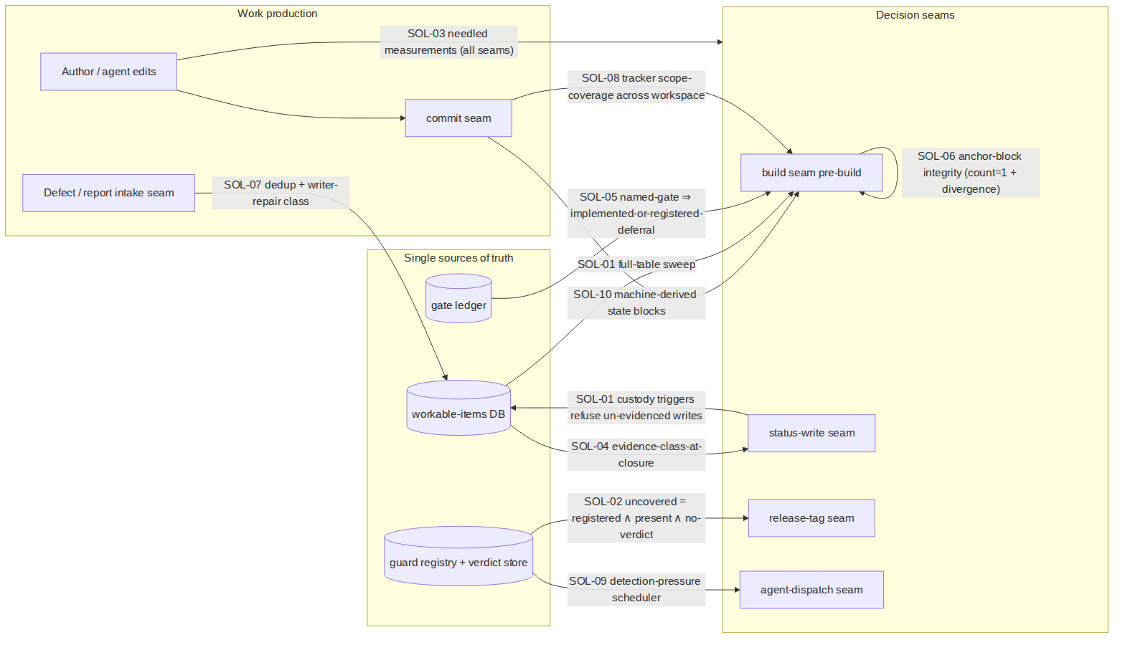

3. Ranked solutions by measured leverage
Ranking key: how many of the MEASURED recurrences/false-beliefs in the four inputs the mechanism would have refused or exposed, weighted by the positive control (the discriminator that held in both directions across corpora with zero counter-cases). Full rationale per solution in its doc.
# | Solution | Seam | Closes (causes) | Measured leverage (from the inputs) | POC | Status
1 | SOL-01 — Status custody at the database layer | status-write + build | PC-1, PC-9, M6 operator-channel | 52/108 terminal items zero-history (48%) [M2]; 13/26 Reopened without event [M4]; R1 4 reopens/0 terminals [M5]; 25/25 reopen events "AI" while 6 operator reopens left NO events [M6]; raw-SQL bypass proven by 3 fingerprints [PC-1] | trigger pack + sweep + fixtures | LANDED
2 | SOL-04 — Evidence-class-at-closure enforcement | status-write | PC-3, PC-8 (+ the discriminator itself) | 69 PENDING-BUILD claim-moves [M16]; 1/25 items user-layer-validated at QA entry [M14]; corpus-3's ONLY bouncing family = wrong-layer echo-assertion (n=1, sign right, no counter-case); pixel defect "verified" by 5 greps [PC-8] | class-matcher + fixtures | LANDED
3 | SOL-02 — Coverage-aware verdict semantics at release | release-tag | PC-2, PC-7 | 61 guards → 0 PASS/5 FAIL/56 PENDING → exit 0 [M9]; release tooling consulted suite 0 times [M10]; 79 guards never write evidence [M18]; GitHub skipped=Success is the industry-scale same bug (R3.1) | coverage verdict + fixtures | LANDED
4 | SOL-03 — Needled measurement primitive | every measurement | PC-5, MU-5, MU-6 | 22 traps/1 cycle, ≥10 corrupted findings, 4 agents [M17]; corpus-2: 6 historical + 2 live instances (§6); live here: pipefail+grep -q false-absent 400/400 at 2 MB payload (0/400 without pipefail); 60 files / 414 exposed sites in the consuming tree | needle lib + SIGPIPE repro + fixtures | LANDED
5 | SOL-05 — Gate ledger + implementation ratchet | build | PC-4 | 241/413 named gates unimplemented (58%), 85 explicit deferrals [M12]; custody seam designed 07-17 still unimplemented on 07-22 [M11]; Ontario null (R6.1) | ledger generator + ratchet + fixtures | LANDED
6 | SOL-07 — Recurrence intake: dedup + writer-repair classification | intake | PC-6 (+ corpus-2 writer rule) | 15 tickets ≈ 9 root causes [M15]; ≥5 new-id recurrence chains; corpus-2: 11 chains, median 3, max 7 attempts, 38 same-scope <24 h fix-pairs; fossil defect −7 h horizon (§3) | dedup + fix-kind checker + fixtures | LANDED
7 | SOL-06 — Anchor-block integrity gate | build (governance) | M13, MU-4 | two anchors duplicated verbatim-divergently in ALL FOUR mirrors, GREEN under presence≥1 gates [M13 + CLAUDE.md F7]; 1,953 orphan docs; two entry-point mandates contradict [M19] | block-counter + divergence + fixtures | LANDED
8 | SOL-08 — Tracker scope-coverage gate | build (workspace) | corpus-3 scope gap (no existing anchor checks it) | ~80% of corpus-3 commit volume (≈11,000 of 13,704 submodule commits → 15 tracked items) ran untracked beside an exemplary tracker (corpus 3 §4.1) | workspace walker + fixtures | LANDED
9 | SOL-09 — Detection-pressure scheduler | dispatch/schedule | PC-7 (execution half), §11.4.118 | corpus-3 recurrence latency = 24 days = the NEXT SWEEP not the next use; two standing guards emitted latent FAILs on first real execution [PC-7]; corpus-1 ~0.3%-vs-52% split explained by detection pressure (corpus 3 §5.2) | staleness queue + fixtures | LANDED
10 | SOL-10 — Misunderstanding-layer mechanics | commit + dispatch | MU-1, MU-2, MU-3, MU-6 (partial) | 22→45 stale design count, stale anchor number consumed in flight [MU-1]; true verdict cited 6 weeks beyond its scope [MU-2]; gate imposed on wrong seam [MU-3]; counts read as state twice in one cycle [MU-6] | state-block verifier + fence linter + fixtures | LANDED
Which subset prevents the most measured recurrences: SOL-01 + SOL-04 + SOL-02 (the custody chain: no terminal status without class-matched evidence, no release while a registered guard has no verdict on the candidate). Every measured first-touch escape in the record crossed at least one of those three seams unimpeded; the positive control (§7 of ROOT_CAUSE) is exactly the population that had all three de-facto. SOL-03 is the meta-solution — it protects the truth of every other solution's own measurements. Detailed subset analysis: §5 below.

4. Cause → solution coverage matrix
Cause | Primary solution | Secondary
PC-1 status-without-custody | SOL-01 | SOL-04
PC-2 absence ≡ verification | SOL-02 | SOL-01 (sweep)
PC-3 source-green read as done | SOL-04 | SOL-02
PC-4 rules as prose, not seams | SOL-05 | all (each converts one prose rule to a seam)
PC-5 instruments produce false findings | SOL-03 | —
PC-6 recurrence fragmentation | SOL-07 | SOL-01 (reopen intake)
PC-7 guards never executed | SOL-02 (blocking half) | SOL-09 (execution half)
PC-8 wrong-layer oracles | SOL-04 | SOL-02 (class-matched verdicts)
PC-9 ambiguous done-vocabulary | SOL-01 + SOL-04 (evidence preconditions per state) | —
MU-1 premises inherited without re-measurement | SOL-10 (machine-derived blocks) | SOL-03
MU-2 verdict leaking beyond scope | SOL-10 (citation fencing) | —
MU-3 gate on the wrong seam | SOL-10 (seam declaration; honest partial) | SOL-05
MU-4 contradicting canonical rules | SOL-06 | SOL-10
MU-5 right behaviour, wrong mechanism | SOL-03 (mechanism proven by needle before remedy) | —
MU-6 counts read as state | SOL-03 (count ⇒ sample lines) | SOL-10

5. Prevented-recurrence analysis, POC results, and stats

5.1 POC results (all under poc/; every suite RED before its implementation existed)
POC | Cases | RED transcript | GREEN | Live runs on real data
sol01_status_custody | 10/10 | evidence/RED.txt (exit 1, 3 missing artifacts) | 10/10 | — (DB-layer; integration is a tracked follow-up)
sol02_verdict_coverage | 5/5 | exit 1 | 5/5 | fixture B replays the exact M9 incident (61 guards, 5 FAIL, 56 no-verdict): historical exit 0 → POC exit 1 + uncovered=56
sol03_needled_measurement | 8/8 | exit 1 | 8/8 | pipefail SIGPIPE hazard measured live: 400/400 false-absent at 2 MB (0/400 without pipefail); exposure census: 60 files / 414 piped grep -q sites in the consuming tree
sol04_evidence_class | 5/5 | exit 1 | 5/5 | —
sol05_gate_ledger | 7/7 | exit 1 (+ preserved first-GREEN-attempt trap transcript) | 7/7 | real corpus: 413 named gates (M12 exact), 234 unimplemented by this instrument (vs M12's 241 — methodological delta stated in SOL-05 §1)
sol06_anchor_integrity | 5/5 | exit 1 (+ second RED for the dotted-anchor case) | 5/5 | four mirrors clean (F7 reconciliation confirmed held); Constitution.md: §11.4.140 + §11.4.141 each head two mandates — the known collision independently re-detected
sol07_intake_dedup | 5/5 | exit 1 | 5/5 | negative control encodes the real HXC-052/053 pair
sol08_scope_coverage | 5/5 | exit 1 | 5/5 | fixtures are real git init repos
sol09_detection_pressure | 8/8 | exit 1 | 8/8 | —
sol10_mu_layer | 7/7 | exit 1 | 7/7 | fixture S2 replays the MU-1 22-vs-45 case verbatim
Total | 65/65 | 10× RED-first | 65/65 (iteration 2 identical — §11.4.50) | 20/20 scripts bash -n clean (§11.4.67)

5.2 Live instrument-trap ledger of THIS session (recorded per §11.4.6 — the base rate applies to us too)
# | Trap | Where | Caught by
1 | test | tee RED.txt; echo exit=$? recorded tee's exit (0) as the test's — the pipeline-exit class, while capturing anti-bluff evidence | SOL-01 RED capture | immediate re-check of the recorded value against the visible RED output
2 | grep -rlE -- "$g" dir --include='*.sh' — the -- terminator turned --include into a filename; a prose .md carrier counted as a gate implementation | SOL-05 first GREEN attempt | the test's own carrier-control case F (transcript preserved: evidence/GREEN_attempt1_option_terminator_trap.txt)
3 | anchor-id prefix match: §11.4.10.A false-flagged as a duplicate of §11.4.10 — a §11.4.201(1) false positive in the very tool built against false verdicts | SOL-06 live mirror scan | new failing test case FIRST (evidence/RED_case_E.txt), then the extractor fix
4 | (deliberate reproduction) cat 2MB | grep -q under pipefail: present literal read as absent 400/400 | SOL-03 measurement | designed-in; became POC case F1
Three accidental traps in one authoring session, by an agent applying §11.4.201 deliberately — consistent with M17 (22 traps/cycle, 4 agents) and corpus 2 §6.7 (2 live during analysis). The conclusion is the design law itself: per-measurement controls, not vigilance.

5.3 Measured magnitudes the solutions are sized against
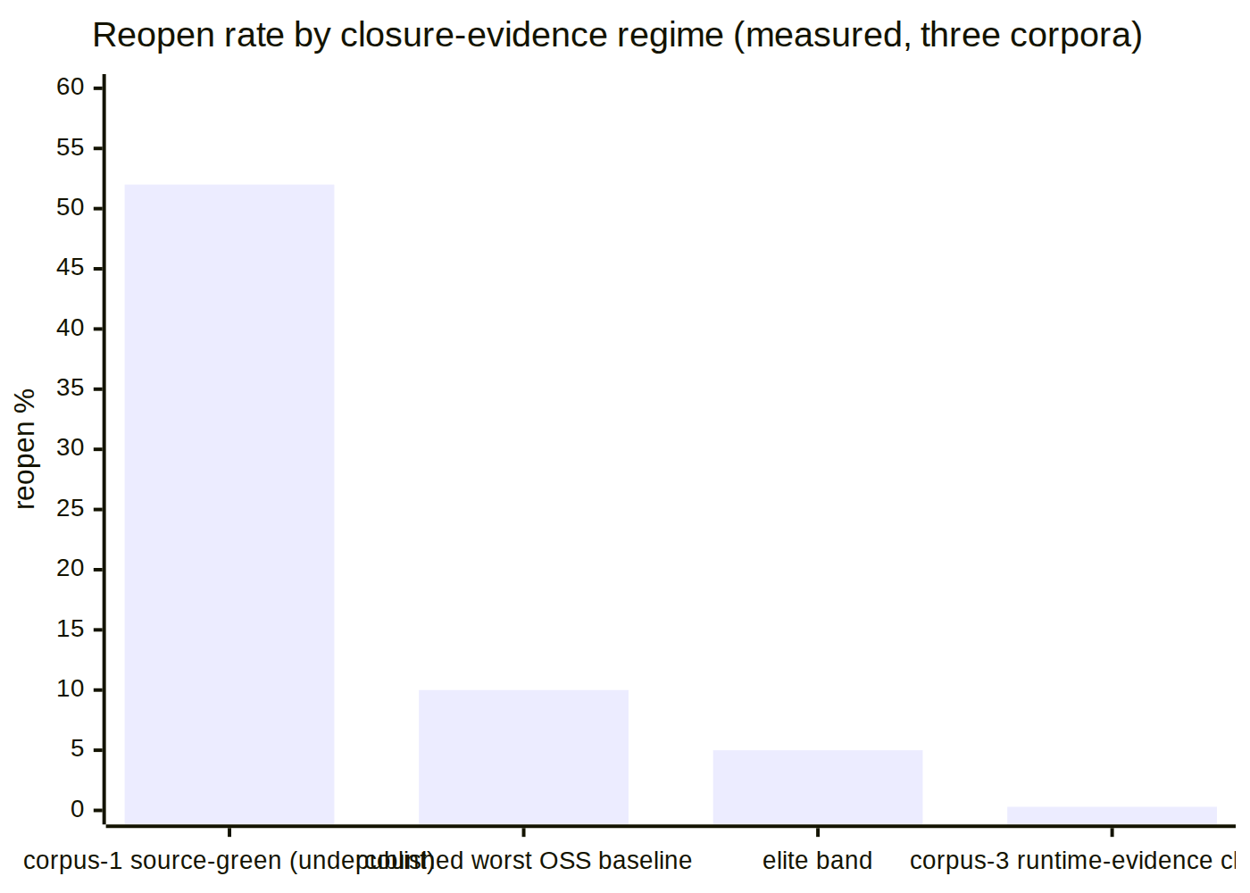
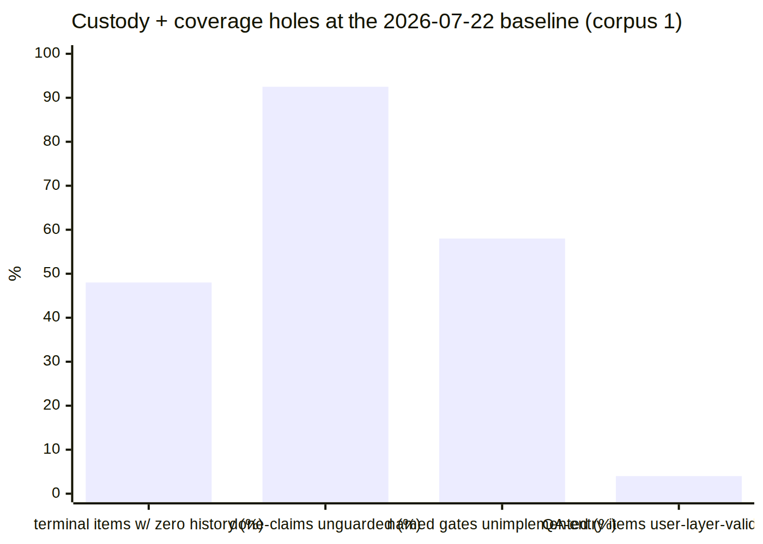
(52% [M3 baseline], 5–10% (R1.1, S1–S5), <10 % elite (R1.6), ~0.3% (corpus 3 §2.3 — a floor under weak detection pressure, per its own UNKNOWN-1). 48% [M2], 92.5% [M7], 58% [M12], 4% = 1/25 [M14].)

5.4 Which subset would have prevented the most measured recurrences
Walking the measured escape population against the seams:
- SOL-01 + SOL-04 (status-write custody with class-matched evidence) intercept: the 52 zero-history terminal items [M2], the R1 impossible sequence [M5], the 25/25-"AI" attribution bias [M6], the 69 PENDING-BUILD claim-moves [M16], the pixel-defect-by-five-greps closure [PC-8], and — by construction — the population from which the operator drew the 6/6-broken sample: none of those items could have reached a terminal status. Corpus-3's natural experiment predicts the payoff: where closures carried runtime evidence, median attempts-to-stick was 1 and the corrected reopen rate ~0.3%.
- SOL-02 (release coverage) intercepts the release-shaped escapes: the M9 exit-0 incident, the never-consulted suite [M10], and corpus-2's "fully working" release ~11 h before a total field brick — each becomes a refused tag.
- SOL-03 does not intercept product escapes directly; it protects the measurements the other nine make — ≥10 corrupted findings in one cycle [M17] is the measured cost of not having it, and three live traps in this very session (§5.2) are the demonstration.
- SOL-07's fix-kind check intercepts the corpus-2 chain shape (11 chains, median 3 attempts; the ~7 h fossil horizon): every state-only fix in those chains would have been refused as a mitigation at closure.
The honest complement: SOL-05/06/08/09/10 close systemic channels (prose-gates, governance drift, scope holes, latency, premise decay) whose per-incident attribution is diffuse — their leverage is preventing the conditions under which the first four seams get bypassed or starved.

5.5 Consolidated UNPROVEN / gap register (every solution's §5, gathered)
- UNPROVEN: SOL-01 trigger throughput under ≥10 concurrent writers (§11.4.85 stress owed at integration).
- UNPROVEN: SOL-07's 50% similarity threshold against the historical 15→9 recurrence set (§11.4.201(8)-style calibration owed).
- UNPROVEN: SOL-10 checks against real corpus docs — adoption (blocks/fences/declarations) precedes measurement by construction.
- NOT CLOSED (stated per solution): fabricated evidence rows (SOL-01/04 — mitigated by layering, not eliminated); DROP TRIGGER (SOL-01 — detective via tracked-DB diff + sweep); semantic contradiction between different anchors (SOL-06/10 — only the decidable projections are mechanized); textually-dissimilar duplicates below token overlap (SOL-07 — literature says up to 23% of true duplicates); oracle quality everywhere (R1.2/R2.2 — assertions and mutations, not execution, carry detection power).
- UNKNOWN (inherited from the inputs, unresolvable here): the true corpus-1 reopen rate (PC-6 undercount); whether corpus-3's 341 closures work today (its UNKNOWN-1); the governance-context crowding effect (ROOT_CAUSE §5.1).
- Per §11.4.205, nothing in this directory carries force until its seam is wired by a separate tracked work item — these are proven mechanisms with fixtures, not landed gates. The wiring items are the deliberate next step, and SOL-05's own ledger is the instrument that will keep them from joining the 241.

6. Anti-bluff certification for THIS document set
- Every number traces to one of the four inputs (cited as [M#], PC-#, R#.#, corpus-2 §, corpus-3 §) or to a live measurement taken in this session whose command is printed beside it.
- Every reported absence in this session ran a control needle first; find -newermt was not used anywhere (known-unreliable on this host — ROOT_CAUSE Appendix A instrument notes).
- Every POC ships golden-good / golden-bad / negative-control fixtures; each POC's test was written and run RED before the implementation existed (§11.4.224), transcripts under poc/<name>/evidence/.
- Nothing here edits any governance file, any gate site, the workable-items DB, or any file outside solutions/. These are POCs + designs; per §11.4.205 they carry no force until their seams are wired by a separate, tracked work item — that boundary is stated per solution.

