SOL-01_status_custody

SOL-01 — Status Custody at the Database Layer
Field | Value
Revision | 1
Last modified | 2026-07-22T20:40:00Z
Rank | 1 (highest measured leverage)
Closes | PC-1 (status-without-custody), PC-9 (partial — evidence preconditions per state), the M6 operator-reopen recording bias
Seams | status-write (Seam A, in-database triggers) + build (Seam B, full-table sweep)
POC | poc/sol01_status_custody/ — GREEN 10/10, RED-first transcript in evidence/RED.txt → evidence/GREEN.txt
Anchors mechanized (no new anchor) | §11.4.146(D3), §11.4.115(F), §11.4.34, §11.4.205

1. The measured problem this closes
Measurement | Value | Source
Terminal-status items with ZERO history rows | 52 / 108 (48%) | [M2]
Currently-Reopened items with no Reopened event | 13 / 26 | [M4]
Worst item R1: reopen events / terminal events | 4 / 0 — an impossible sequence proving ledger bypass | [M5]
Reopen-event attribution | 25/25 = "AI", 0 = "User" — while the six operator-driven reopens (the highest-severity escapes in the record) left NO events at all | [M6]
Raw-SQL bypass of the sanctioned mutation tool | proven by 3 independent forensic fingerprints | PC-1
Custody seam designed 2026-07-17, status 2026-07-22 | still prose — sweep absent, gate absent from both canonical gate sites, ratchet file absent (needled) | [M11]
Corpus 3 (best-disciplined corpus): terminal statuses without terminal history events | ~88% — and its one real reopen got no Reopened event either | corpus 3 §2.1, §2.3
The class (ROOT_CAUSE PC-1): any SSoT writable outside its audited mutation path will, under deadline pressure, be written outside its audited mutation path. Corpus 3 proves the failure is not a discipline problem — the best-disciplined corpus in the record still has an 88% history-gap, because the event-writing seam was advisory there too (§11.4.205 test fails in both corpora).

2. The mechanism
Move the seam INTO the database file. Three cooperating layers:
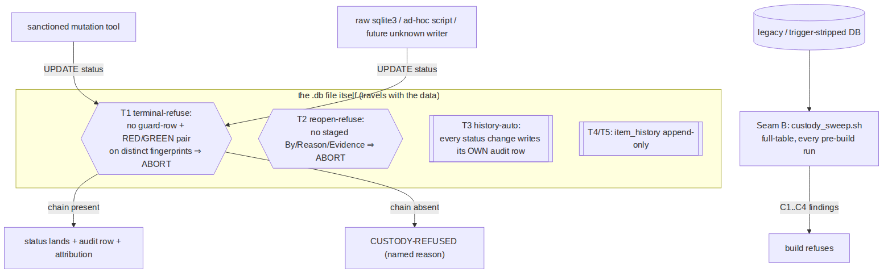
- Seam A — refusal triggers in the DB file (custody_triggers.sql). A terminal status (Fixed/Implemented/Completed) is unwritable unless the custody chain exists AS ROWS: registry row keyed by the exact item id → RED verdict (exit≠0) → GREEN verdict (exit=0) on a different artifact fingerprint (identical fingerprints = fix never deployed, §11.4.115(F)). A Reopened flip is unwritable without a staged attribution row (By ∈ {AI, User} + Reason + Evidence, §11.4.34).
- The historian is the database, not the writer (trigger T3). Every status change writes its own item_history row as a side effect of the UPDATE itself. "Status moved with zero history rows" becomes impossible by construction on a triggered DB — including for raw sqlite3 writers, ad-hoc scripts, and writers that do not exist yet. T4/T5 make the ledger append-only.
- Seam B — full-table sweep at every build (custody_sweep.sh). Catches what triggers cannot: legacy DBs predating the triggers, or DBs whose triggers were dropped (dropping a trigger IS possible for a determined writer — see §5). Four checks, each mapped to a measured class: C1 = the M2 zero-history class, C2 = the M4 no-reopen-event class, C3 = the M5 impossible-sequence class, C4 = the M7 unguarded-done class. The sweep control-needles itself (an empty/unreadable items table exits 2 SWEEP-BLIND, never PASS — §11.4.201(7)(b)).
Why the database layer and not the tool layer: PC-1's forensics proved the sanctioned tool was already structurally incapable of the custody-free write — and the write happened anyway, because the tool is optional and raw SQL is not. A trigger binds every connection to the file. This is the §11.4.205 "if I documented this and nobody implemented the hook, would anything catch it?" test answered at the strongest available layer: the enforcement travels with the data, through clones, copies, and CoW tracks.

The M6 operator-channel fix specifically
The highest-value detection channel (operator reopens — 6/6 of the worst escapes) was the least recorded (0 events). Under SOL-01 that inverts: the operator (or the agent acting on the operator's report) stages one row —
INSERT INTO reopen_intake(atm_id, by_actor, reason, evidence_path)
VALUES('ATM-XXX', 'User', 'manual-testing-detected', 'qa/operator_note.md');
UPDATE items SET status='Reopened' WHERE atm_id='ATM-XXX';
— and the flip both requires and consumes the attribution. No staged row ⇒ the flip itself fails loudly at the point of work, which is the only moment the attribution is still knowable.

3. POC results (all in poc/sol01_status_custody/)
RED first (§11.4.224): evidence/RED.txt — test run before any implementation existed, exit 1, 3 missing artifacts. Then implementation; evidence/GREEN.txt — 10/10 PASS, exit 0:
Case | Kind | Result
A1–A3 | golden-good: full chain → write succeeds, history auto-row, sweep PASS | PASS
B1 | golden-bad: raw un-evidenced terminal UPDATE → CUSTODY-REFUSED | PASS
C1 | golden-bad: legacy DB, terminal item, zero history → sweep FAILs naming the item | PASS
D1 | negative-control: ordinary open item → sweep does NOT flag (§11.4.201(1) guard) | PASS
E1/E2 | reopen path: un-staged flip refused; staged User flip recorded by_actor=User | PASS
F1 | append-only ledger: history UPDATE refused | PASS
G1 | golden-bad: identical RED/GREEN fingerprints → terminal refused (§11.4.115(F)) | PASS

4. The failure this makes IMPOSSIBLE
On a triggered database:
- A terminal status with no history row cannot exist (T3 writes it in the same statement).
- A terminal status without a registered guard + distinct-fingerprint RED/GREEN pair cannot be written — by any writer, sanctioned or not (T1).
- A reopen without By/Reason/Evidence attribution cannot be written (T2) — the M6 bias channel (operator reopens leaving no trail) is closed at the only seam it crosses.
- The audit ledger cannot be edited or pruned (T4/T5).
- A legacy or trigger-stripped DB cannot pass the build while holding any of the four measured violation classes (Seam B sweep, wired at pre-build).
Had this existed during the measured window: all 52 zero-history terminal items [M2], the R1 4/0 impossible sequence [M5], and the 25/25-"AI" attribution bias [M6] are refused at write time; the 6/6-broken operator sample [ROOT_CAUSE §1] becomes structurally impossible to reach because the items could never have carried terminal statuses without verdict pairs.

5. What it still does NOT catch (honest boundary, §11.4.6)
- Fabricated evidence rows. A writer can INSERT fake verdict rows (a RED that never ran) and then close the item. The triggers verify chain shape, not chain truth — truth is SOL-04's job (evidence-class matching) + SOL-02's (verdicts keyed to real artifact fingerprints consumed at release) + the §1.1 mutation discipline (a guard never observed failing mints nothing). Layered, not duplicated.
- DROP TRIGGER. SQLite has no in-file privilege separation; a determined writer can drop the triggers. That act is (a) loud in git diff of the tracked DB (§11.4.95 — the DB is tracked), (b) caught by Seam B, whose first check on a supposedly-triggered DB can assert trigger presence (SELECT count(*) FROM sqlite_master WHERE type='trigger' — a consumer integration should add this; the POC sweep catches the consequences instead). Defense in depth, not a wall.
- Semantic quality of the closure. The chain proves custody, not that the guard's oracle is calibrated (§11.4.107(10) goldens remain necessary-not-sufficient — §11.4.146(D3) honest boundary carried forward verbatim).
- The Obsolete path — different evidence shape (obsolete-details), out of POC scope, stated here; the same trigger pattern extends to it mechanically.
- WAL/concurrency behaviour under many writers was not stress-tested in this POC (UNPROVEN: trigger throughput under 10 concurrent writers; the §11.4.85 stress suite is owed at integration time).

6. Integration path (separate tracked work item — this POC carries no force per §11.4.205)
- Apply the trigger pack to the consuming project's tracked DB in the same commit as wiring custody_sweep.sh into the pre-build suite (the §11.4.205 construction order: the executable sweep + its golden-bad fixture land WITH the governance text citing them).
- Adoption of the legacy backlog (52 zero-history items already terminal) is an OPERATOR decision per §11.4.66 — options: retro-annotate with UNATTRIBUTED-LEGACY history rows, or a one-time §11.4.135-style monotone ratchet on C1 findings. Never an invented ratchet.
- Map real vocabulary (the (→ Fixed.md) suffixed literals) and the real verdict store paths as consumer DATA (§11.4.35).

