SOL-02_verdict_coverage

SOL-02 — Coverage-Aware Verdict Semantics at the Release Seam
Field | Value
Revision | 1
Last modified | 2026-07-22T20:50:00Z
Rank | 3
Closes | PC-2 (absence ≡ verification), PC-7 (blocking half — registered-but-never-executed guards can no longer satisfy a release)
Seam | release-tag (blocking) · build (advisory reporting of the same computation)
POC | poc/sol02_verdict_coverage/ — GREEN 5/5, RED-first (evidence/RED.txt → evidence/GREEN.txt)
Anchors mechanized (no new anchor) | §11.4.135 (verdict-coverage extension), §11.4.69 artifact_not_yet_built, §11.4.3, §11.4.201(1)

1. The measured problem
- The live incident [M9]: 61 registered guards → PASS 0 / FAIL 5 / PENDING 56 → exit 0 "not blocked" — the suite's exit code read only its FAIL count, so "never verified" and "verified good" were the same colour.
- The release-tag tooling consulted the guard suite zero times [M10] — even the FAIL count had no consumer at the moment of tagging.
- 79 guards omit the evidence-init call, so their evidence artifact is silently never written [M18] — evidence-absence again reading as no-signal.
- Industry-scale twin (R3.1, S31–S33): GitHub treats a skipped required status check as "Success" — the identical defect class in the world's largest CI platform, patched by the ecosystem with exactly this design (declare the required set independently of execution).
- Corpus 2 limit case: with no registry at all, a release titled "fully working" shipped ~11 h before every router alias was measured bricked (corpus 2 §2.3) — nothing enumerated what was supposed to have been verified.

2. The mechanism
One computation, consumed at two seams:
uncovered = registered ∧ topology-present ∧ no-verdict-for-the-CANDIDATE-fingerprint
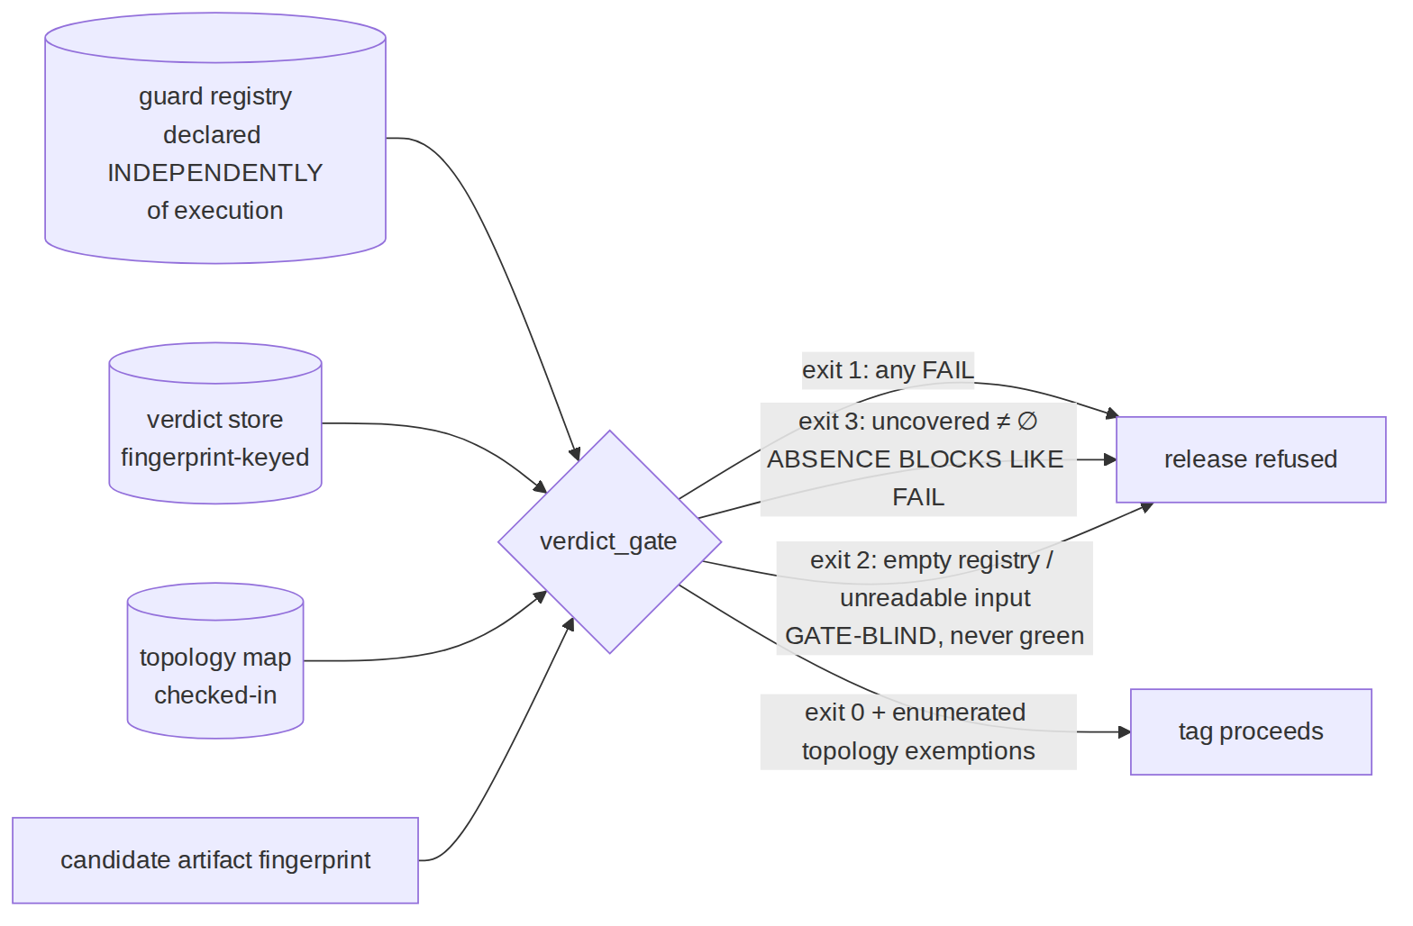
Load-bearing properties, each fixed to a measured failure:
- The required set is declared independently of execution (the registry), so absence is computable — the R3.1 lesson. A guard that never ran cannot vanish from the requirement.
- Verdicts are keyed to the candidate's artifact fingerprint. A verdict on an older build is absence for this candidate (self-clearing, §11.4.135) — closing the PC-3 sub-case where re-fixes landed in artifacts that were never flashed while old green carried forward.
- Exit vocabulary keeps three states three colours: FAIL (1) ≠ uncovered (3) ≠ green (0), and a blind gate (empty registry, unreadable store) is 2 — never 0. The gate control-needles its own inputs (§11.4.201(7)(b)).
- Topology-absent guards are enumerated exemptions, never blockers and never silence — the POC's negative-control case proves the gate does not commit the §11.4.201(1) FAIL-bluff that a flat "PENDING always blocks" would be (the exact framing §11.4.135 rejected).
- The release seam must CALL it. M10's zero-references is why this is specified as a blocking call inside the tag tool, not a parallel report. (The consuming project landed this wiring 2026-07-18 [M9/M10 remediation column]; the POC generalizes it for every consumer.)

3. POC results
test_sol02.sh: RED (exit 1, artifact missing) → GREEN 5/5:
- B is the exact M9 incident replayed: 61 registered, 5 FAIL verdicts, 56 no-verdict — the historical suite exited 0; the POC exits 1 and reports uncovered=56.
- D proves stale-fingerprint verdicts read as absence; E proves topology exemptions are enumerated-not-blocking.

4. The failure this makes IMPOSSIBLE
A release can no longer be tagged while any registered, topology-present guard lacks a verdict on the candidate artifact — the 0-PASS/56-PENDING/exit-0 state and the "release tool never asked" state are both unreachable once the tag tool's only path to a tag runs through this gate. Combined with SOL-01 (an item cannot be done without a verdict pair) the two seams close the pincer: no done-claim without evidence, no release while evidence is missing for the candidate.

5. What it still does NOT catch (honest boundary)
- Guard quality. A weak guard with a green verdict passes; oracle strength is SOL-04 + §1.1 mutation territory (R1.2/R2.2: execution metrics don't predict detection — checking metrics do).
- Registry completeness. uncovered is computed against what is registered; a defect class with no registered guard is invisible here (that is SOL-01's C4 sweep + §11.4.135 adoption, and discovery pressure is SOL-09/§11.4.118).
- Fingerprint integrity. The gate trusts the candidate fingerprint it is handed; a caller passing a stale fingerprint re-opens the hole. Integration must derive the fingerprint from the artifact itself (read-from-target, §11.4.115(F)) — stated, not solved here.
- The topology map is trusted data. A wrong map silently exempts a runnable guard; the map is checked-in + reviewed (§11.4.135), and exemptions are enumerated in the release changelog so a human can catch a wrong one — detective, not preventive.

