SOL-03_needled_measurement

SOL-03 — The Needled Measurement Primitive
Field | Value
Revision | 1
Last modified | 2026-07-22T20:55:00Z
Rank | 4 (and meta — it protects every other solution's own measurements)
Closes | PC-5 (instruments produce false findings), MU-5 (wrong mechanism → wrong remedy), MU-6 (counts read as state)
Seam | every load-bearing measurement, in every gate/guard/sweep/report
POC | poc/sol03_needled_measurement/ — GREEN 8/8, RED-first; the SIGPIPE hazard reproduced INSIDE the test
Anchors mechanized (no new anchor) | §11.4.201(6)(7)(8), §11.4.6
Prior art status | The literature has NO named SE discipline for this (EXTERNAL_RESEARCH SYN-3 item 2). Closest prior art: epidemiology's negative/positive-control methodology (R5.3, S60–S62), which independently derives the needle-class-matching condition.

1. The measured problem
- 22 instrument traps catalogued from one release cycle, hit by 4 independent agents; ≥10 produced reported findings, in both directions [M17]. One environmental root cause (host grep is a different regex engine) unified ≥4 "independent" mistakes.
- Corpus 2: 6 historical + 2 live-during-analysis instances (§6) — swallowed restart failures serving the wrong provider while the config read back correct; a test runner with silent false-greens; a BRE guard dropping a function; SIGPIPE aborting session resolution; a $-token eaten from a commit subject; a Verified count off by 111.
- Live in THIS session (instance #1): the first RED-evidence capture for SOL-01 recorded exit=0 — the exit status of tee, not of the test (pipeline-exit trap). Caught and re-captured; recorded here because it demonstrates the base rate even under §11.4.201 discipline (the same honesty corpus 2 §6.7 practiced).
- Live measurement, this host, this session (commands in the POC test):
Measurement | Result
cat 2MB-payload | grep -q NEEDLE under set -o pipefail, needle on line 1, 400 iterations | 400/400 read the PRESENT literal as ABSENT
Same, without pipefail | 0/400
Files in the consuming tree carrying BOTH pipefail and | grep -q | 60 files, 414 piped grep -q sites (scripts/, tests/, constitution/scripts/; control-needled)
The dispatch brief's figure (8/400, 56 latent sites) was measured earlier at a different payload size/scope; this session's re-measurement shows the hazard saturates to deterministic (400/400) as payload grows — the worst possible scaling: the bigger the corpus being checked, the more certainly a present token reads as absent. The 414 sites are the exposure surface (upper bound): a site is only exploitable when the producer writes more than a pipe buffer after the match — but which sites those are changes with data volume, which is exactly why a per-site audit cannot close this class and a primitive can.
- External confirmation (R5.1, S53–S56): shell instruments' dominant failure mode is a clean, plausible, wrong answer — and no strict-mode configuration fixes it; pipefail itself introduces the class above.

2. The mechanism
A measurement is never a bare command; it is a primitive that carries its own controls:
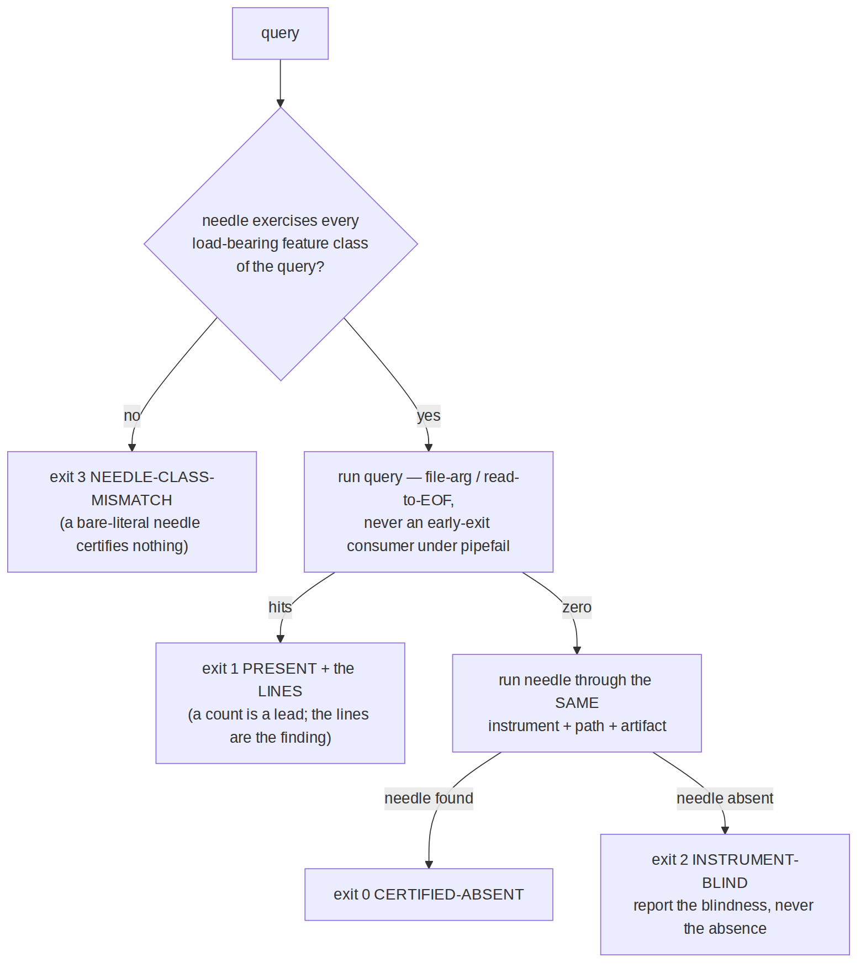
Four rules, each pinned to a measured failure:
- A null is not evidence until a needle traverses the same path (nq_absent) — the M17 false-null class. Positive control, per R5.3.
- The needle must share the query's load-bearing feature classes (alternation, grouping, anchors, escapes — _nq_features). A literal needle sails through the dialect layer that is eating the query (the host-grep \| incident) and would "certify" a blind zero — the exact epidemiology validity condition (S62): a control certifies only the error sources it shares.
- Presence output carries the lines, not just the count (MU-6: twice in one cycle a count was converted into a finding without reading the lines).
- Consumers read producers to EOF (nq_stream_contains uses grep -c on a captured stream, never grep -q on a live pipe) — the SIGPIPE/pipefail class is closed by construction, not by auditing 414 sites.
- The instrument is injectable (NQ_GREP) so the blind-instrument path is itself testable — an unfalsifiable validator is unvalidated instrumentation (§11.4.115(F) applied to measurements). The POC's golden-bad case injects a see-nothing grep and asserts the primitive says INSTRUMENT-BLIND, never CERTIFIED-ABSENT.

3. POC results
RED (missing lib, exit 1) → GREEN 8/8, including: blind-instrument returns 2 never 0; carrier prose does not false-match a structure-anchored query (negative control); featureless needle on an alternation query refused (exit 3) while a class-matched needle certifies; and the pipefail hazard reproduced live inside the test (F1) with the primitive returning PRESENT on the same payload (F2).

4. The failure this makes IMPOSSIBLE
For any measurement routed through the primitive: an unverified null cannot be reported — the API has no code path that emits "absent" without a sighted, class-matched needle; a SIGPIPE-truncated stream cannot produce a false absence (the producer is always drained); a blind instrument yields a loud INSTRUMENT-BLIND, which is a finding about the instrument (MU-5's requirement: prove the mechanism before choosing the remedy).

5. What it still does NOT catch (honest boundary)
- False-MATCH beyond structure. The primitive enforces structure-anchored queries by making carriers a first-class test case, but a poorly chosen query pattern can still match a carrier; the negative-control fixture discipline (per query class) is the countermeasure, and choosing the pattern remains authorship.
- Measurements not routed through it. This is a library, not an interception layer; the 414 existing sites stay exposed until migrated. Adoption mechanics (a lint that flags bare | grep -q under pipefail as a migration queue) are a consumer follow-up — a count-visible queue, not claimed here.
- Non-grep instruments (jq, awk, sqlite, curl) need the same wrapper pattern per tool; the POC ships the grep instance and the design generalizes, but each tool's blind-modes are its own (e.g. find's exit-0-on-no-match, -newermt host unreliability) — per-tool needles are owed at integration.
- Feature-class extractor is a closed approximation — it covers {alternation, group, anchors, escapes}; exotic PCRE features are outside the set and would need extending. Stated, not hidden.

