SOL-04_evidence_class

SOL-04 — Evidence-Class-at-Closure Enforcement (the Discriminator as a Seam)
Field | Value
Revision | 1
Last modified | 2026-07-22T21:05:00Z
Rank | 2 (the highest prevention leverage — it mechanizes the one predictor that held in every corpus)
Closes | PC-3 (source-green read as done), PC-8 (wrong-layer oracles), PC-9 (with SOL-01 — evidence preconditions per status)
Seam | status-write (composes with SOL-01: the custody chain's evidence files are class-checked before the terminal write is permitted)
POC | poc/sol04_evidence_class/ — GREEN 5/5, RED-first
Anchors mechanized (no new anchor) | §11.4.115(F) evidence-class clause, §11.4.108 layers, §11.4.123

1. The measured problem — and the discriminator
The single strongest empirical result across all four inputs:
Every fix whose done-claim was preceded by an on-target RED→GREEN polarity flip that held recorded ZERO reopens; every fix confirmed at source-green bounced. (ROOT_CAUSE §7 — the positive control; re-verified against the live ledger; no counter-case found in any corpus.)
Cross-corpus confirmation:
Corpus | Closure evidence class | Outcome
Corpus 1 (ATMOSphere) | historically source-green | 52% recorded reopen rate (undercount); 6/6 operator-sampled "done" items broken; 69 PENDING-BUILD claim-moves [M16]; QA entered with 1/25 validated past layer 1 [M14]
Corpus 2 (claude_toolkit) | hermetic sandbox (wrong layer) | "whole suite green while EVERY router alias on the real host was bricked" (its own forensic note); median 3, max 7 attempts per defect
Corpus 3 (helix_code root) | 76% of fix commits cite a test, 46% runtime evidence, closures cite RED→GREEN + mutation | median attempts-to-stick = 1; ~0.3% git-corrected reopen rate
Corpus 3's ONLY bouncing family | i18n — original PASS was a unit test asserting the Noop echo (wrong-layer oracle) | the corpus's biggest fix (74 packages) AND its only silent reopen — the discriminator's predicted loser, n=1, sign right
External mechanism (R2.1/R2.2/R2.5, S18/S19/S27): fault-detection power lives in the ORACLE; execution metrics don't predict detection, checking metrics do; the oracle problem is the field's named central difficulty. PC-8's canonical instance: a pixel-layer defect "verified" by a file-existence check plus five greps.

2. The mechanism
Make the evidence CLASS a refusable property of the closure, verified by machine fields — never by a label:
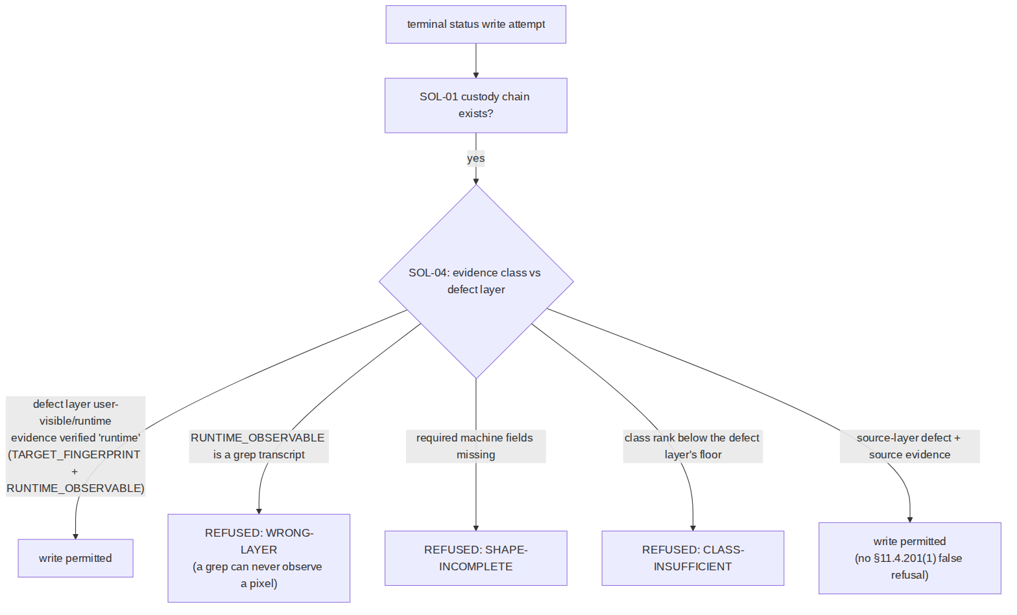
- Closed sets. Defect layers {user-visible, runtime, artifact, source}; evidence classes {runtime > artifact > source} with a rank floor per layer. Source evidence can close only a source-layer item; a user-visible defect requires runtime-class evidence.
- Class is proven by machine fields, not asserted: runtime requires TARGET_FINGERPRINT (read from the target, §11.4.115(F)) + RUNTIME_OBSERVABLE; artifact requires ARTIFACT_PATH + ARTIFACT_SHA256; source requires SOURCE_REF. A label without its fields is SHAPE-INCOMPLETE.
- The anti-echo rule kills the exact PC-8 shape: a RUNTIME_OBSERVABLE that is a grep transcript is refused as WRONG-LAYER — the wrong-layer oracle dies by construction, which is precisely what corpus 3's one bouncing family lacked.
- Composition with SOL-01/SOL-02: SOL-01 requires the chain to exist; SOL-04 requires its evidence to be of the right class; SOL-02 requires it to exist for the release candidate. Three refusals, one custody pipeline.

3. POC results
RED (exit 1, artifact missing) → GREEN 5/5: real runtime evidence accepted; grep-transcript- wearing-a-runtime-label refused (WRONG-LAYER); fieldless label refused; source-on-source accepted (negative control — legitimate source-layer work is not false-refused); unreadable evidence is BLIND(2), never accepted.

4. The failure this makes IMPOSSIBLE
A terminal status backed only by source-layer evidence cannot be written for a defect whose layer is runtime/user-visible — the 69 PENDING-BUILD claim-moves [M16], the pixel-defect-by-five- greps closure [PC-8], and the corpus-2 "sandbox-green, host-bricked" release pattern all cross this seam and are refused at it. PC-9's ambiguity dissolves as a side effect: each status's evidence precondition is now a checked property, not a vocabulary argument.

5. What it still does NOT catch (honest boundary)
- Fabricated runtime fields. A writer can invent TARGET_FINGERPRINT. The checker proves shape and layer, not provenance; provenance is the §11.4.115(F) harness-written-verdict rule (verdict files written by the harness, fingerprint read from the target at run time) + SOL-02's candidate-fingerprint join, where an invented fingerprint fails to match the real candidate and reads as absence. Layered.
- Oracle calibration. Runtime-class evidence from a mis-calibrated analyzer still passes; §11.4.107(10) goldens remain necessary-not-sufficient (stated boundary carried from §11.4.146(D3)).
- The layer taxonomy is authored data. Mislabelling a defect as source-layer to lower the floor is possible; countermeasure is review of the layer field (cheap to spot: the item's own description names user symptoms) — detective, not preventive. UNPROVEN: an automatic layer classifier from item text was not attempted.
- Echo-detection is a closed pattern list (grep: / source-grep prefixes in the POC); a determined writer can phrase an echo differently. The negative pressure comes from the §1.1 mutation pairing (a guard whose evidence cannot fail its golden-bad is refused there), not from string-matching alone.

