SOL-07_intake_dedup_writer

SOL-07 — Recurrence Intake: Dedup Verdict + Writer-Repair Classification
Field | Value
Revision | 1
Last modified | 2026-07-22T21:40:00Z
Rank | 6
Closes | PC-6 (recurrence fragmentation silencing the fragility signal) + the corpus-2 writer-repair rule (value-fix vs invariant-fix)
Seam | intake (before an id is minted) + status-write (closure-kind check, composing with SOL-01)
POC | poc/sol07_intake_dedup/ — GREEN 5/5, RED-first
Anchors mechanized (no new anchor) | §11.4.214 (recurrence-links-not-mints), §11.4.186 keying, corpus-2 §7.3 (writer-repair — distilled, not yet an anchor)

1. The measured problem
- 15 first-touch tickets ≈ 9 root causes; 4 high-confidence recurrences of "done" items entered as NEW ids [M15]; ≥5 recurrence chains re-entered under fresh ids, so the reopens-count — the exact signal §11.4.132(d)/§11.4.189 rank fragility by — stayed quiet precisely on the items that kept breaking. The 52% reopen rate is a proven undercount [M3].
- Corpus 2 (no tracker): 11 multi-attempt chains, median 3, max 7 attempts; 38 same-scope fix→fix pairs within 24 h — half of all fixes were followed within a day by another fix to the same subsystem. "A fix is, empirically, a ~50%-probability hypothesis until it survives its first day in the field" (corpus 2 §7.2).
- The fossil case (corpus 2 §3): a value-fix (repointed the stored endpoint) held ~7 hours — the recurrence horizon of the defective writer that kept re-stamping it. Same-day siblings: a regen-lost setting, a stale bundled artifact. General law: a fix that repairs the artifact a defective writer produced, without repairing the writer, has a guaranteed recurrence horizon equal to the writer's next execution.
- The false-merge counter-case that bounds the design: one suspected same-defect pair was proven distinct on close reading [M15]; corpus 3's only fuzzy-title match (HXC-052/053) is two genuinely distinct instances of one class in two modules — auto-merge would have silently deleted a real defect.
- External baseline (R4.5, S51/S52): tracker duplicate rates run 10–30%, and up to 23% of true duplicates are textually dissimilar — bare-substring keying is known-broken; the ~40% duplication here exceeds every published band.

2. The mechanism
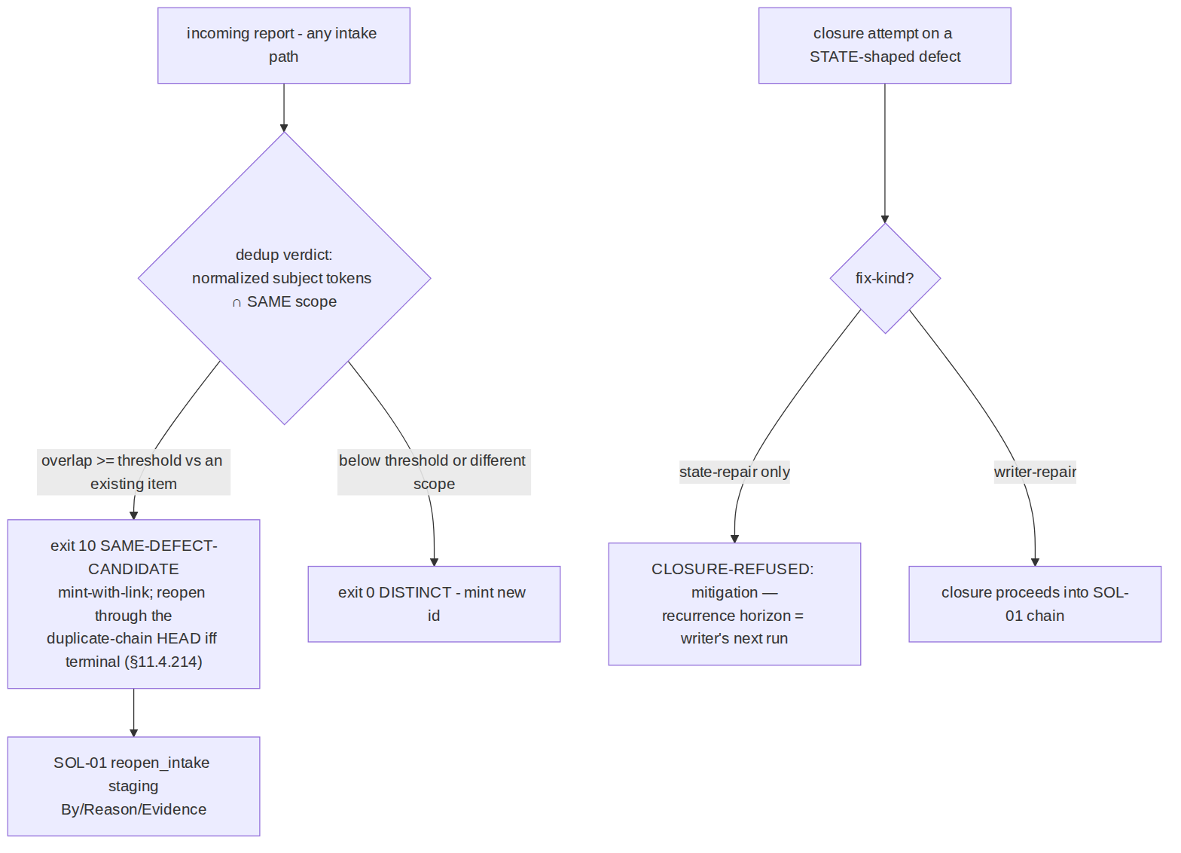
- Dedup at intake, keyed on normalized (subject-tokens, scope) — never bare substring (§11.4.186). The verdict is three-valued by construction: DISTINCT → mint; SAME-DEFECT-CANDIDATE → mint-with-link (the §11.4.214(3) autonomous default: a spurious id is recoverable, a wrongly-merged defect is LOST — the tool never auto-merges); blind input → exit 2. Reopening flows through SOL-01's staged-attribution seam, so the restored signal is also a custodied signal.
- Fix-kind classification at closure: a defect whose shape is state (wrong config value / generated artifact / cache entry / route / marker) cannot be closed by a state-repair alone — the closure is refused with the recurrence-horizon message; writer-repair (the writer fixed + the state corrected + a seam asserting the invariant) closes normally. This is corpus 2's §7.3 rule as a refusing check instead of a distillation.

3. POC results
RED → GREEN 5/5: new item mints; recurrence of a closed overlay defect returns SAME-DEFECT-CANDIDATE: ATM-100 (link + reopen-head, not a silent new id); the HXC-052/053 archetype (same class, different scope) stays DISTINCT — the false-merge guard; state+state- repair closure refused with the horizon message; state+writer-repair closes.

4. The failure this makes IMPOSSIBLE
A recurrence can no longer silently enter as an unlinked new id through a wired intake path — every mint above the similarity threshold carries a candidate link, and reopens of terminal heads increment the counter that feeds risk-ordering. A state-shaped defect can no longer be marked terminal on a value-fix — the ~7-hour-horizon closure class is refused at the seam.

5. What it still does NOT catch (honest boundary)
- Textually-dissimilar duplicates (up to 23% in the literature) fall below any token threshold — the tool reduces, not eliminates, fragmentation; the negative pressure for the remainder is SOL-09's re-look scheduling plus human triage on the linked candidates. UNPROVEN: threshold calibration (50% Jaccard in the POC) against a real corpus — a §11.4.201(8)-style calibration run on the historical 15→9 set is owed at integration.
- Defect-shape labelling is authored — declaring a state defect "behaviour" evades the fix-kind check; detective countermeasure only (review sees the item description).
- Cross-scope recurrences of one defect (scope moved between modules) read DISTINCT by design — the exact trade the HXC-052/053 negative control demands; the linked-candidate output for near-threshold cross-scope pairs is a possible extension, not claimed.

