SOL-10_mu_layer

SOL-10 — Misunderstanding-Layer Mechanics
Field | Value
Revision | 1
Last modified | 2026-07-22T21:55:00Z
Rank | 10
Closes | MU-1 (machine-derived state blocks), MU-2 (verdict citation-fencing), MU-3 (seam declarations) — the DECIDABLE subset of the misunderstanding layer; MU-6 shares SOL-03's count⇒lines rule
Seam | commit (state blocks + fences in docs) + dispatch (seam check on plans)
POC | poc/sol10_mu_layer/ — GREEN 7/7, RED-first
Anchors mechanized (no new anchor) | §11.4.205(4)(5), §11.4.112(5), §11.4.120 seam-placement clause

1. The measured problem
ROOT_CAUSE §4: misunderstandings are manufactured at composition seams between honest components, and all six shapes worsen superlinearly with corpus volume and session turnover.
- MU-1 — a design doc asserted "22 edit points"; the measured count at execution was 45. A "next free anchor number" was consumed between measurement and use (duplicate-numbering near-miss). A live-state table carried three stale rows. Mechanism: a fact is measured once, becomes text, and text does not expire.
- MU-2 — a structurally-TRUE impossibility verdict was cited for six weeks against an adjacent, viable goal, while the platform's own docs prescribed a public API for that goal. The rule fired where verdicts are minted; the failure happened where one was cited.
- MU-3 — work was ordered "run E1–E4, then implement P1" while the gate's own definition required E2 to run on a P1-gated build: a restatement moved the gate from its declared seam (enabling) to authorship, manufacturing a deadlock that read as "blocked".

2. The mechanism — three refusing checks
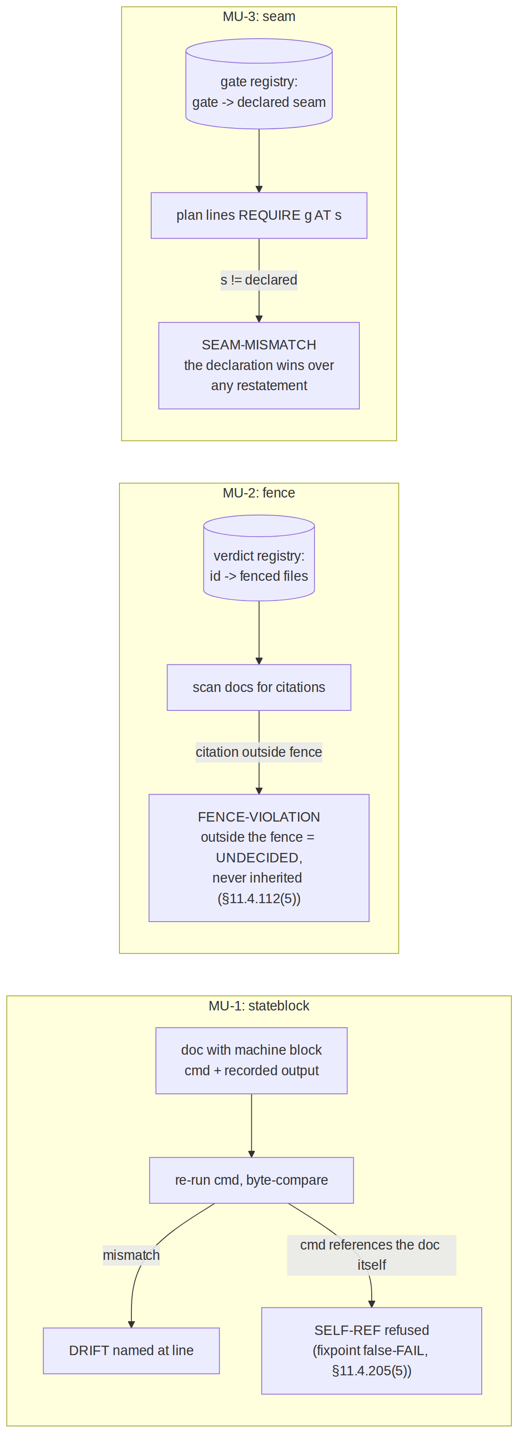
- stateblock (MU-1): any measured fact carried in a document lives inside a machine-derived block declaring its generator command; verification re-runs the generator and byte-compares (§11.4.205(4)) — the 22-vs-45 case is a refused commit, not a discovered surprise. Blocks whose generator reads the document itself are refused (SELF-REF) — the real §11.4.205(5) fixpoint bug where a self-fingerprint makes verify a permanent false-FAIL.
- fence (MU-2): a verdict's registry row enumerates the files that may cite it; a citation anywhere else is a violation naming the citing file. The six-week leak becomes a same-day build failure at the first out-of-fence citation.
- seam (MU-3): every gate's registry row declares its seam; a plan/dispatch line requiring the gate at any other seam (or requiring an unregistered gate) fails. Restatement drift of the load-bearing qualifier is caught where it happens — in the restating document.

3. POC results
RED → GREEN 7/7: fresh block verifies; the MU-1 22-vs-45 case reproduced as DRIFT; self-referencing block refused; in-fence citation clean; out-of-fence citation named; declared- seam plan clean; moved-seam plan SEAM-MISMATCH.

4. The failure this makes IMPOSSIBLE
A machine-measurable fact carried as prose can no longer silently expire (its block either re-verifies or fails the commit); a fenced verdict cannot be cited beyond its scope without a named violation; a plan cannot require a gate at a seam its declaration does not seat it at.

5. What it still does NOT catch (honest boundary — the largest of any solution here)
- MU-4 semantic contradiction between anchors remains undecidable in general; only its duplication/divergence projection (SOL-06) and these fence/seam projections are mechanized.
- MU-5 (wrong mechanism → wrong remedy) is a reasoning failure; SOL-03's INSTRUMENT-BLIND-before-remedy discipline narrows it, nothing closes it.
- Adoption cost is real: facts must be authored into machine blocks, verdicts into the registry, gates into seam declarations — un-registered instances are invisible to all three checks. This is the same declared-set trade every solution here makes; the honest statement is that SOL-10 converts unbounded misunderstanding surface into a bounded registration discipline, not into zero.
- stateblock executes embedded generator commands — integration MUST allowlist the command vocabulary before wiring at any seam (an unconstrained cmd field is an injection surface). Stated in the tool header; not solved in a POC.
- UNPROVEN: none of the three checks has run against the real corpus's docs (the real corpus has no machine blocks / fences / seam declarations yet to check — adoption precedes measurement, by construction).

