HelixSkills incorporation — architecture & diagrams (HXC-159 T-P8.03)
Revision: 1 · Last modified: 2026-09-23 · Status: current
Four diagrams covering the skills system this project incorporates (HXC-159 Phases P0–P9). A fifth diagram — the corrected Bridge layer-health map — lives embedded in the Bridge design corpus itself (constitution/docs/research/extensions/speckit_superpowers/implementation/README.md) rather than duplicated here, since that is where a reader of the Bridge corpus needs it (§11.4.258 — diagrams belong at their point of use, not in an orphan gallery).
See also: docs/CAPABILITIES.md (§4/§10.5), docs/guides/skills_user_manual.md, docs/guides/skills_faq.md, submodules/helix_agent/docs/skills/SKILLS_SYSTEM.md.

1. Three-layer architecture — source / graph service / generated catalogue
This is the skills system's own internal architecture, as implemented in the shared submodules/skills library (internal/skillsource, internal/skill, internal/codegraph, internal/skillscatalog). Skill content flows from raw sources (filesystem or GitHub), through a parse-and-map pipeline into a persistent dependency graph enriched with CodeGraph-sourced evidence, and out to a deterministic, byte-stable generated Markdown catalogue with a drift-proof fingerprint sidecar.
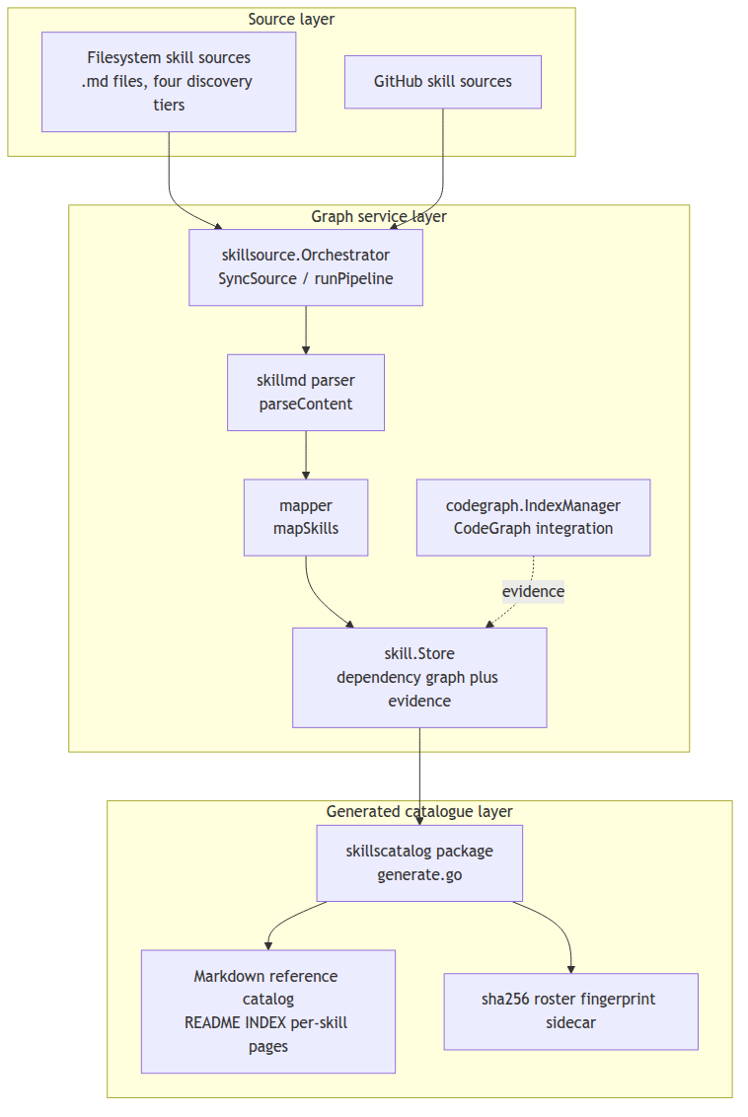
Sources: submodules/skills/internal/skillsource/sync.go (Orchestrator, SyncSource, runPipeline, fetchSource, parseContent, mapSkills); submodules/skills/internal/skill/store.go (Store, AddDependency, GetDependents); submodules/skills/internal/codegraph/index.go (IndexManager, SymbolsToEvidence); submodules/skills/internal/skillscatalog/ (doc.go, generate.go, fingerprint.go — computeRosterFingerprint, writeFingerprintSidecar).

2. Registration-path sequence — constitution → registrar → .claude/skills/ → consumer
How a constitution-owned governance skill actually gets from source to being usable by an agent, for both HelixCode (external discovery tier) and HelixAgent (external tool source).
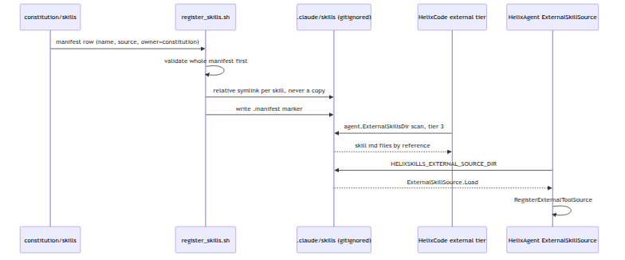
Sources: scripts/register_skills.sh (manifest-driven, idempotent, prefix-scoped registrar, HXC-159 T-P1.04 — symlinks by reference, never copies, per §11.4.28/§11.4.80; refuses fail-closed on any filesystem collision it did not itself create); helix_code/internal/agent/skill_dirs.go (ExternalSkillsDir, tier 3 of AllSkillsDirs); submodules/helix_agent/internal/skills/external_source.go (ExternalSkillSource.Load, RegisterWith); submodules/helix_agent/internal/router/router.go:353,373 (HELIXSKILLS_EXTERNAL_SOURCE_DIR).

3. The measured shadowing curve (Phase P2, real data)
A real plot of the actual Phase P2 shadowing-benchmark measurement — not a hypothetical or illustrative curve. Source data: docs/qa/p2_shadowing_20260914/curve.csv (three repetitions per size, 12 tasks per repetition).
size | n_active | pass_rate | mis-selection
small | 12 | 0.8333 | 2.0
mid | 16 | 0.8333 | 2.0
large | 20 | 0.8333 | 2.0
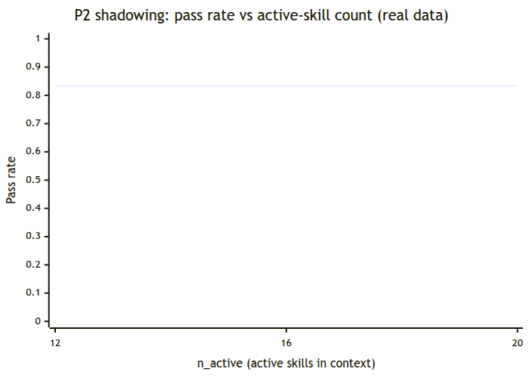
Honest finding, stated exactly as the source data states it (§11.4.6 — never smoothed over): the measured curve is FLAT across n_active ∈ {12, 16, 20} — no knee was observed (spread 0.000 < the 0.05 flat-detection threshold). Per the derivation record (docs/qa/p2_shadowing_20260914/derivation.md): "shadowing not observed on this corpus/model in N∈{12,16,20}". The reported ceiling (N=20) is provisional — the largest tested N, not a proven upper bound — an honest gap per T-P2.03.3, not a buried one.

4. Trust-tier and capability-enforcement flow
How a skill's declared capabilities are actually enforced at the call boundary — the sandbox-precondition gate (trust tier) feeding into the per-call AllowedTools authorization decision (HelixAgent side; see submodules/helix_agent/docs/skills/SKILLS_SYSTEM.md §3/§6 for the full narrative).
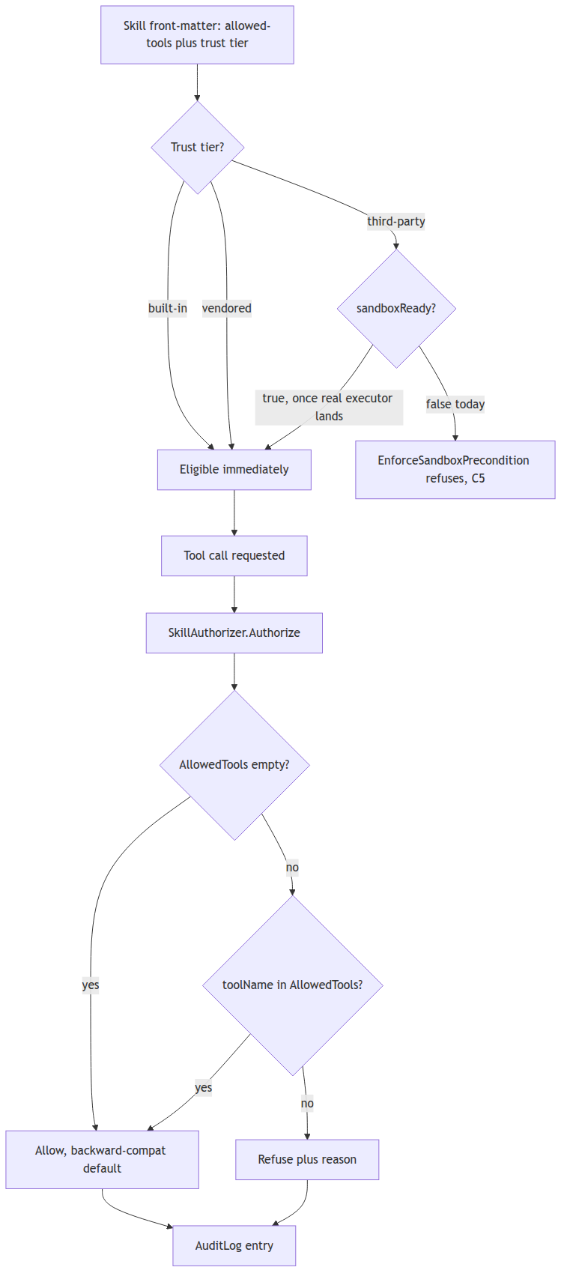
Sources: submodules/skills/pkg/skills/sandbox_gate.go (EnforceSandboxPrecondition, ThirdPartyActivationBlockedError); submodules/helix_agent/internal/skills/authorizer.go (SkillAuthorizer.Authorize, skillDeclaresTool, AuditLog); submodules/helix_agent/internal/skills/types.go (AllowedTools, ParseAllowedTools).

Sources verified 2026-09-23
Every source citation above was cross-checked against the live wiring code — see submodules/helix_agent/docs/skills/SKILLS_SYSTEM.md's own "Sources verified" footer and qa-results/hxc159/docs_update/<run-id>/ for the mechanical citation-checker output covering the same trees.

