SpecKit-004 + Superpowers Development Cycle: An Exhaustive Analysis
Revision: 2
Created: 2026-09-27T17:33:54Z
Last modified: 2026-09-28T08:33:40Z
Status: active
Scope: this document analyses the SpecKit "004-fast-dev-cycles" feature cycle — its methodology, its real-time execution, its verified measurements, and the governance anchors it exercises — as observed and independently re-verified against the live project state at the moment of writing. Every specific figure below was checked against a real, current source (a tracked file, the agent registry, the operator request-history ledger, or a live command this document's author ran itself) at authoring time; anywhere a figure could not be independently confirmed, it is marked UNVERIFIED rather than presented as settled fact, per this project's own §11.4.6 no-guessing mandate — which this document is itself bound by.
Revision-2 note (2026-09-28): Revision 1 (committed 2026-09-27T22:39Z, constitution commit c380a44) covered the Foundational batch (T001–T014) through T014's round-10 review, honestly reporting the batch as not yet GO — two of three round-10 fixes still unconfirmed at that time. This revision extends the document forward through a full additional day of real, committed development: T014 in fact reached a clean GO (after two further review rounds this revision's own predecessor did not yet know about), Phase 3 (US1)'s RED tests and several implementation tasks landed, a genuine concurrency-race incident was root-caused and forward-fixed, a substantial body of unrelated already-complete work was discovered sitting staged-and-uncommitted and was recovered, and four [SERIAL] wiring tasks are mid-flight as parallel drafts at the moment of this writing. Sections 1–9 below are preserved verbatim from Revision 1 (they remain an accurate historical record of the Foundational-batch cycle as it stood at that time) except where a Revision-2 correction note is inserted inline; the new material — timeline, process lessons, measured figures, diagrams, and the current honest status — is in Section 10, added at the end of this document precisely so a reader can see what was already here versus what this revision adds, per this project's own §11.4.226 evidence-class discipline (never silently rewrite a prior claim; supersede it visibly, with its own new evidence).

Table of contents
- Executive summary
- SpecKit workflow methodology
- Superpowers methodology as applied here
- Detailed narrative of the Foundational-batch (T001–T014) development + review cycle
- Measurements, performance and metrics analysis
- Diagrams and schemes
- Constitution anchors applied
- Lessons learned and recommendations
- Verification methodology and honest gaps
- Update — 2026-09-28 (Revision 2)
  - 10.1 Executive summary of the delta
  - 10.2 Timeline of everything landed since Revision 1
  - 10.3 T014 reaches GO: rounds 11 and 12, closing Revision 1's open gap
  - 10.4 Process lessons learned today
  - 10.5 Measured figures (Revision 2)
  - 10.6 Diagrams (Revision 2)
  - 10.7 Current honest status and what remains
  - 10.8 Verification methodology for this revision

1. Executive summary
SpecKit-004 ("fast-dev-cycles") is a feature specification, implementation plan and task breakdown living at specs/004-fast-dev-cycles/ in the parent ATMOSphere repository. It implements workable item ATM-1041 (Type: Task), whose operator brief (quoted verbatim in spec.md) is that development iterations on this project have become "extremely slow", that the reopen rate on closed items is "still extremely high", and that the project must root-cause both problems by measurement — never by assertion — and then re-engineer the gate/iteration loop to be at least an order of magnitude faster without losing any of the anti-bluff quality guarantees this project's constitution already mandates.
The spec resolves into 8 user stories, 25 functional requirements (FR-001..FR-025), and 10 measurable success criteria (SC-001..SC-010). The implementation plan (plan.md, Revision 2) decomposes this into 68 plan tasks (T-A01..T-H08, verified: T-A01 through T-H08 is the full span present in plan.md, confirmed by an exact count of 68 distinct task ids) spanning Phases A–H, itself informed by 46 root-cause candidates (RC-01..RC-46) and 39 recorded decisions (DEC-01..DEC-39) in research.md. The task breakdown (tasks.md, Revision 2) turns this plan into 195 executable, test-first tasks (T001..T195) across 11 phases — Setup, Foundational, then one phase per user story, then a final Polish/Verification phase — each phase gated by an explicit, evidence-typed checkpoint that pauses for operator approval before the next phase may start.
As of the moment this document was authored, the project has completed:
- Phase 1 (Setup, T001–T006) and Phase 2 (Foundational, T007–T014) — implemented against the real tracked tree, currently uncommitted (git status shows the entire constitution/scripts/fastcycle/ directory as untracked, ?? scripts/fastcycle/), pending the T014 independent-review gate reaching a clean GO. This is the deepest, most rigorously reviewed part of the cycle so far, and is the subject of Section 4 below.
- RED-test drafting for parts of several later user-story phases (US2/Phase 4 and US4/Phase 6 and US6/Phase 8, per the agent registry's own task-id citations) performed in isolated scratch copies, explicitly not yet applied to the real tracked tree — a distinction this document is careful to preserve throughout, because conflating "drafted in scratch" with "implemented on the real tree" would itself be the exact kind of bluff this project's constitution forbids.
The Foundational batch has now been through two full rounds of mandatory independent adversarial review (T014, Opus at xhigh effort, per §11.4.209) — round 9 returned NO-GO with 3 BLOCKING + 1 IMPORTANT + 4 MINOR findings; the fixes for those findings then triggered a real-execution discovery that no review round had itself caught: a live, host-wide SIGTERM/SIGKILL hazard in one of the batch's own test drivers, root-caused and fixed with a one-line awk guard. Round 10 then returned a second NO-GO, confirming every round-9 fix held and finding 9 new issues (1 BLOCKING + 3 IMPORTANT + 5 MINOR) that round 9 could not have found because they did not yet exist in the pre-round-9 code. As of the moment of writing, one of the three parallel fix agents dispatched against round 10's findings has genuinely completed and been independently re-verified by the conductor (the host_guard.sh fix: its test suite grew from 125/125 to 131/131 passing assertions); two remain in flight with no confirmed-real completion event yet recorded. This document reports that state honestly rather than assuming completion.

2. SpecKit workflow methodology
This project drives non-trivial development work through the SpecKit slash-command pipeline (/speckit.specify → /speckit.clarify → /speckit.plan → /speckit.tasks → /speckit.superspec.execute, with /speckit.analyze and /speckit.checklist available at any point for cross-artefact consistency checks). Each stage produces a durable, version-controlled artefact under specs/<NNN>-<slug>/, and every later stage is required to trace back to the earlier ones rather than re-deriving scope independently.

2.1 The artefact chain, as actually produced for 004-fast-dev-cycles
Artefact | Lines | Purpose
spec.md | 269 | User scenarios, functional requirements (FR-001..FR-025), success criteria (SC-001..SC-010), out-of-scope declarations, assumptions. Carries a Clarifications section recording 4 operator answers to scope-narrowing questions asked during /speckit.clarify (review-step depth, consumer-project reach, baseline stratification, and how binding the "10x" target is).
plan.md | 1,850 | The Phased Implementation Plan (68 tasks T-A01..T-H08 across Phases A–H) plus a Phase 2 hand-off section. This is where root causes are turned into concrete engineering tasks.
research.md | verified: contains root-cause candidates through RC-46 and recorded decisions through DEC-39 (both counts independently re-derived from the file's own text, not merely cited from another document) | The multi-pass deep-web-research log FR-003 mandates, plus the root-cause classification (CONFIRMED/REFUTED/UNDETERMINED) FR-002 mandates.
data-model.md | contains 25 ###-level headings (entity groups plus their sub-sections; tasks.md itself cites "14 entity groups" as the entity-group count proper) | The Key Entities from spec.md (Cycle Record, Root Cause, Gate, Affected-Set, Escape Mechanism, Handoff Record, Verification Report) expanded into concrete schemas.
contracts/ | 13 distinct contracts (verified: 52 files in the directory ÷ 4 export formats each = 13; e.g. catch-set-comparison-harness, affected-set-and-verdict-cache, agent-registry-and-handoff, common-conventions — the last defining the shared C-001..C-007 conventions every tool in the batch must follow) | Interface contracts each tool in the plan must satisfy — inputs, outputs, exit-code conventions, self-validation requirements — authored before the tool exists.
quickstart.md | — | 10 independent-test scenarios, one per user story, phrased as "can be fully tested by …" acceptance procedures.
checklists/tasks-coverage.md | — | The mechanical join proving every FR-*/SC-* maps to a user story and every plan task (T-A01..) maps to at least one executable task (T001..), so no requirement or plan task is silently dropped when the plan is decomposed into tasks.
tasks.md | 476 (frontmatter through the final checkpoint) | 195 executable tasks (T001..T195) across 11 phases, each task line carrying inline [P]/[TDD]/[REVIEW]/[SUBAGENT]/[SERIAL] markers and its owning plan-task id(s) and FR/SC id(s), so the task↔requirement join is re-derivable from the file alone without consulting the checklist.

2.2 The phase / dependency structure
tasks.md organises its 195 tasks into 11 phases with hard task-id boundaries (independently re-derived from the file's own ## Phase headings and task-line ids, not merely copied from a summary line):
Phase | Task range | Story | Goal
1 | T001–T006 | Setup | Skeleton, consumer-owned data, tool preflight, child workable items
2 | T007–T014 | Foundational (blocking) | Shared library every contract relies on: C-001 exit codes, C-002 canonical JSON, C-003 determinism, C-004 control needles, C-005 self-validation triple, C-007 host safety
3 | T015–T049 | US1 🎯 MVP | Know exactly where cycle time goes — instrumentation + frozen baseline
4 | T050–T085 | US2 | Gates that are far faster and lose nothing (catch-set comparison, verdict cache, affected-set selection, sharding, batch bisection, gate audit, flake ledger, backstop)
5 | T086–T103 | US3 | Stop reopening — escape-mechanism classification, evidence-class-gated closure refusal, sibling-instance search, recurrence linking
6 | T104–T121 | US4 | Minimal tokens per completed item — governance-subset selection, content-addressed evidence reuse
7 | T122–T140 | US5 | Reliable orchestration — truthful agent registry, crash/quota handoffs, custody sweep
8 | T141–T153 | US6 | A host that does not throttle the work — measured resource attribution, backup-first clean-up, unweakened host-safety limits
9 | T154–T165 | US7 | Everything lands in the constitution, clean and pushed — recursive clean/push verification, propagation/lockstep checks
10 | T166–T177 | US8 | Every consuming project gets the speed-up — enumerate, audit, migrate or honestly NOT-MIGRATED
11 | T178–T195 | Polish/Verification | Final gate: every SC-001..SC-010 gets an evaluated verdict with evidence
Every phase ends with a Checkpoint line stating its own pass condition and its own evidence class (artifact / runtime / source), and every checkpoint in tasks.md ends with the literal instruction "Pause for operator approval" — the plan does not treat phase completion as self-authorizing; an operator gate sits between every phase and the next.
The dependency shape is not a flat sequence: Phase 2 (Foundational) blocks every user-story phase (nothing in Phases 3–10 may start before its checkpoint passes), Phase 3 (US1, the measurement MVP) gates every later phase that claims a saving (its own task T049 is an explicit re-planning checkpoint that recomputes every root-cause's measured share from the newly frozen baseline before any saving-claiming task may proceed), and Phases 4–8 (US2, US3, US4, US5, US6) are designed to run as parallel streams once Phase 3's baseline exists. Phase 9 (US7 — constitution codification + recursive clean/push verification) depends on the merged mechanisms from all of those streams; Phase 10 (US8 — consumer migration) depends on Phase 9's codification.

2.3 The test-first / subagent-driven / review-gated discipline encoded in every task line
Every task line in tasks.md follows the literal format - [ ] [ID] [P?] [Story] [markers] Description (plan T-Xnn; FR/SC ids), and the markers are not decorative — each is a load-bearing constraint the task's own executor must obey:
- [TDD] — the failing test is written and observed failing for the right reason (its output stored under qa-results/fastcycle/<story>/red/ with the candidate fingerprint) before the implementation exists; a test first observed GREEN is explicitly refused as a guard. Every such test additionally ships its paired §1.1 mutation and, for any null/absent/clean/hit result, a class-matched control needle per §11.4.273 (Section 7 below quotes this anchor's operative text).
- [REVIEW] — the task's output is accepted only through the independent review gate on the pinned tier: Opus at xhigh effort, never Fable, never a lower tier or effort, in a fresh context on a clean checkout, framed to disprove completion, iterated to a zero-finding zero-warning GO. Related changes are batched into one review request of ordered ≤~400-line slices with a machine pre-check pack attached, so speed comes from fewer, better-prepared reviews — never from a thinner or skipped review.
- [SUBAGENT] — delegable to a parallel subagent whose scope is exactly the files named on its own task line (plus its own fixtures directory); it never edits a contention path, never commits or pushes, and its completion claim is treated as a prediction until the conductor re-runs its tests from a clean checkout — the producer is never its own verifier. A [TDD] subagent that writes the RED test is never the same subagent that implements the fix that turns it GREEN.
- [SERIAL] — touches a single-owner contention path (the workable-items database, the agent-registry writer, the pre-build verification script, the meta-test mutation registry, the regression-guard registry, the commit wrapper, the doc-export sync script, the flash script, .claude/settings.json, every constitution anchor and its lockstep mirrors, and every commit/push) — executed by the conductor only, one at a time, never concurrently with another [SERIAL] task on the same path.
This four-marker discipline is how the spec's own FR-023 clarification ("keep the review requirement unchanged … speed comes from batching related changes per review and from machine pre-checks so reviews pass first time") becomes an executable constraint rather than a paragraph of prose — a distinction this project's own governance repeatedly insists on (see §11.4.205 / §11.4.227 in Section 7: a rule authored without its enforcement seam is, per this project's own doctrine, worse than no rule, because it stops the scrutiny that would otherwise have caught its absence).

3. Superpowers methodology as applied here
superpowers:systematic-debugging and superpowers:using-superpowers are not invoked as abstract discipline in this cycle — they are visible, concretely, in the shape of the real work performed, and this section shows that work rather than describing the skills in the abstract.

3.1 The Iron Law in practice: the descendants() investigation
The clearest, most consequential instance this cycle is the investigation of what the T014 round-8 review had flagged only as "suspected but unconfirmed host disruption" in test_run_all.sh's R8b-D6 sub-test (the test asserting the mutation driver's own cleanup-signal-handling test fixture, drvwrap.sh, dies within a fixed wall-clock bound after receiving TERM). Rather than treating the symptom — "the test sometimes takes longer than its bound" — as something to patch by loosening the bound or retrying, the investigating agent applied the systematic-debugging arc in full:
- Root-cause phase — read the real failure, reproduce it. The agent traced the exact mechanism: descendants(), the transitive-closure helper the mutation driver's cleanup path uses to find every process it must signal, builds its parent map from ps -eo pid=,ppid= output with no de-duplication — a later line for the same pid key silently overwrites an earlier one. The R8b-D6 fixture's fake ps shim deliberately appends synthetic lines after the real output, one of which claims PID 1 is a child of the fixture's own fake root. Because PID 1 is the universal ancestor of (almost) every process on a Linux host, once that fake line overwrote descendants()'s internal mapping for PID 1, the closure computation transitively pulled in 905 of 907 real process IDs on the host — essentially the whole process table.
- Pattern phase — classify, don't guess. The agent explicitly refused to classify the symptom as flaky (which this project's own governance treats as a forbidden vocabulary word absent captured evidence, §11.4.7): "the defect is deterministic and always present; only its timing outcome varies with host state" — host load (measured at the time: load average ~31–36 on a 64-core host, 53 processes directly reparented to PID 1) is a real, amplifying factor on how long the resulting collateral signal storm takes to settle, but it is not the root cause, and the report is explicit that this conclusion is a measured fact, not an assumption.
- Hypothesis phase — falsifiable, and proven both ways. The stated hypothesis ("a later duplicate ps line for pid 1 poisons the closure, causing real host-wide signal traffic that scales with how many processes are reparented to PID 1") was proven by a side-effect-free measurement run twice (905 pids on the unpatched closure, 1 pid — just the synthetic root — on the patched closure, over the identical input stream), and independently corroborated by a live demonstration: a separately process-grouped, unrelated harness process, run alongside the unpatched fixture purely as an observer, received roughly 100 real SIGTERM deliveries over about 10 seconds and was killed outright once by the collateral blast — direct, non-speculative proof the hazard is real and currently live in the tracked test file, not theoretical.
- Implementation phase — the minimal fix at the proven cause, never the symptom. The fix is a single awk boolean added to the existing closure guard: a candidate is admitted to the transitive-closure "visited" set only if it is a bare non-negative integer string strictly greater than 1 — mirroring the guard kill_tree() already applied at signal time, moved into the closure computation itself so a poisoned parent-map entry can no longer be exploited as an expansion vector. This was verified RED (905 pids) → GREEN (1 pid) in an isolated scratch copy, then 3 clean full-fixture runs against the patched copy, then confirmed to introduce no regression against the sibling unit test that independently exercises the same pair of functions through a different fixture. Only after all of that was the fix even proposed for application to the real tracked file — and it was applied by the conductor, never autonomously by the investigating subagent, because it touched an already-committed, load-bearing test file gating the whole feature's promotion.
This is precisely the "Iron Law: NO FIXES WITHOUT ROOT CAUSE INVESTIGATION FIRST" this project's constitution states for superpowers:systematic-debugging (§11.4.102) — and it is also a textbook instance of this project's §11.4.250 anchor ("heuristic-tower signals a primitive defect"), inverted usefully: rather than adding a compensating heuristic on top of a symptom, the investigation found and removed the actual defective primitive.

3.2 using-superpowers in practice: skill-discovery before improvisation
The same investigating agent, and the review agents around it, consistently reached for the project's own existing tooling (lib/host_guard.sh's live resource probes, the triple_harness.sh self-validation-triple machinery, the already-registered paired mutations in scripts/testing/meta_test_false_positive_proof.sh) rather than improvising ad-hoc equivalents — the observable signature of superpowers:using-superpowers's "survey available skills before acting" discipline applied to in-repo tooling as much as to Claude Code's own skill marketplace.

3.3 A second, smaller but equally instructive instance: r7f2
Separately from the descendants() investigation, a different intermittent signal — internally tracked as r7f2, a pid-related HUP signal delivery issue — was investigated across 11 reproduction attempts, including deliberately induced heavy host load, and was closed as a genuine non-reproducible flake rather than either (a) silently ignored or (b) mis-filed as a fixed defect on the strength of a single non-reproduction. The round-9 independent-review report itself notes plainly, "r7f2 pid-HUP passed once. I did not chase that flake further" — an honest, evidence-scoped statement rather than a claim of resolution, exactly the discipline §11.4.6 (no-guessing) and §11.4.7 (demotion requires same-conditions evidence) require.

4. Detailed narrative of the Foundational-batch (T001–T014) development + review cycle

4.1 What the Foundational batch is
Phase 2 of tasks.md (tasks T007–T014) builds the shared library every later contract in the plan depends on: C-001 (exit-code conventions), C-002 (canonical JSON with a body_hash excluding volatile fields), C-003 (determinism — a --determinism-check flag that runs a tool twice and asserts identical output), C-004 (control needles — a class-matched, known-present probe that must prove an instrument can see before its silence is trusted, directly implementing this project's own §11.4.273 anchor), C-005 (the self-validation triple: golden-good must PASS, golden-bad must FAIL and pinpoint, negative-control must PASS), and C-007 (host safety — live nproc/ulimit -u/ps -L thread-count/MemAvailable probes that clamp requested parallelism and refuse to ever raise a limit).
Independently verified file inventory (re-derived at authoring time by listing constitution/scripts/fastcycle/ and excluding test fixtures and the Python __pycache__ directory, neither of which is part of the batch's reviewed source surface):
File | Lines
lib/fc_common.py | 390
lib/fc_common.sh | 9
lib/host_guard.sh | 220
tests/check_deps.sh | 89
tests/run_all.sh | 93
tests/test_check_deps.sh | 327
tests/test_fc_common_red.sh | 752
tests/test_foundational_mutations_descendants_filter.sh | 62
tests/test_foundational_mutations_kill_tree.sh | 79
tests/test_foundational_mutations.sh | 111
tests/test_host_guard_red.sh | 507
tests/test_run_all.sh | 409
tests/test_triple_harness_red.sh | 431
tests/lib/triple_harness.sh | 177
Total (14 files) | 3,656
(One of the round-10 review dispatch notes cited "14 files, ~3594 lines" — this document's own independently re-run wc -l at authoring time returns 3,656; the ~62-line difference is consistent with the intervening test_foundational_mutations.sh split and the B1/B2/B3/I1 fixes landing between that citation and this document's own count, and is reported here as the honestly re-measured current figure rather than silently repeating the earlier estimate.)
Beyond these 14 reviewed source/test files, the batch also carries 69 triple_harness self-validation fixture directories (each holding a golden-good/golden-bad/negative-control triple, per C-005) and 10 host_guard fixture shims (fake ps/id/nproc/awk binaries used to drive host_guard.sh through resource-exhaustion scenarios it cannot safely be driven through on the real host) — both counts independently re-derived by directory listing at authoring time.

4.2 The T014 review-gate mandate
Task T014 is the batch's mandatory independent review: "batching one request, slices ≤~400 lines … by a separate instance on the pinned tier — Opus xhigh only, never Fable, never a lower tier or effort — fresh context, clean checkout, framed to disprove completion; iterate to a zero-finding, zero-warning GO" (tasks.md line 86, quoted verbatim). This directly instantiates §11.4.209 (Section 7 quotes its operative text in full) and §11.4.134's iterate-until-GO discipline — a review that stops at the first clean pass is explicitly not sufficient; the batch must survive a fresh, adversarially-framed re-review after every remediation round.

4.3 Round 9: NO-GO, and the fixes applied
Round 9's independent Opus review (dispatched fresh, clean checkout, framed to disprove completion) returned NO-GO with 3 BLOCKING, 1 IMPORTANT, and 4 MINOR findings, quoted here verbatim from the operator request-history ledger's own persisted subagent hand-back report (docs/requests/history.md, entry R-2026-09-27-173243):
- B1 — "The descendants() fix broke the M7 mutation, so the T013 driver fails." A prior fix (adding the closure-membership filter described in Section 3.1 above, at the point where round 9 first inspected it) had removed pid 1 from ever entering the visited set — but the existing kill-tree unit test relied on pid 1 reaching kill_tree()'s own [ "$p" -gt 1 ] guard to exercise that guard at all. With the closure filter now excluding pid 1 upstream, the guard's own TERM/KILL checks were never exercised, and a deliberately weakened guard (M7, the paired mutation meant to catch exactly this regression) sailed through uncaught — measured directly: "with M7 applied … the kill_tree test still passes (rc=0), so the mutation is not caught." A bluff gate, caught before it shipped.
- B2 — the new closure-membership check itself had zero paired mutation coverage: removing it entirely still left every test passing, meaning a future regression reintroducing the host-wide SIGTERM hazard ( Section 3.1) would have nothing to catch it.
- B3 — a separately-discovered, pre-existing defect: lib/host_guard.sh could never refuse work, even when a resource limit was already exhausted — floored to N=1 unconditionally (measured: FC_GUARD_ACTIVE_AGENTS=6 with 40 agents already active still returned N=1 REASON=none), directly violating this batch's own C-007 contract and the spec's own edge-case requirement that work degrade "with a named reason, never … weakening a limit."
- I1 — the 60% memory ceiling was only checked when the caller passed --per-job-mem-kb, and the batch's own caller (test_foundational_mutations.sh) did not pass it — measured: a fixture at 99% memory already used still returned N=16 REASON=none, silently skipping the ceiling entirely.
- M1–M4 — missing .gitkeep markers on the Phase-1 skeleton directories (a fresh clone would not reproduce the T002 layout); stale wording in the meta-test banner and a contract comment; triple_harness.sh output not following the C-002 canonical-JSON shape; and warning-level hardening items (a bash job-control stderr leak, a theoretical pgid-reuse race window in fc_common.py's process-group reaping).
Every finding above was fixed with its own paired-mutation regression coverage before the batch was resubmitted:
- B1 + B2 were fixed by splitting the combined kill-tree test into two independent tests, each stubbing out the other function — test_foundational_mutations_kill_tree.sh now stubs descendants() entirely and proves kill_tree()'s own -gt 1 guard in isolation; the new sibling test_foundational_mutations_descendants_filter.sh stubs ps and calls descendants() directly, proving the closure filter in isolation with a real fake root as its positive control. This is exactly the fix described in Section 3.1 — and it is also where the real-execution discovery of the live host-wide signalling hazard happened: applying this split and then actually running the full suite for the first time (rather than trusting the split's own logic) is what surfaced the descendants() de-duplication bug, which no review round, static read, or bash -n check had caught.
- B3 + I1 were fixed by adding an exhaust() construct to host_guard.sh that returns N=0 with a named <limit>_exhausted reason whenever headroom, the agent cap, or the memory budget is at or below zero — reserving the "floor to 1" behaviour only for a genuine positive budget — and by making the memory-ceiling read unconditional rather than gated behind an optional flag.
- M3 + M4 were fixed by documenting triple_harness.sh's C-002 exemption (it is inherited shared machinery per the contract's own inheritance-scoping text, not a violation), adding disown "$!" after the offending backgrounded job in test_check_deps.sh (root-caused to bash's own job-notification mechanism reporting an un-disowned setsid job as "Killed" on the parent's stderr), and documenting the fc_common.py pgid-reuse window via docstring (judged genuinely negligible: a sub-instruction kernel-reap race with no constructible test and no available pidfd-group-signal primitive on this host).

4.4 Round 10: a second NO-GO, and the current state of remediation
A fresh Opus xhigh review — deliberately re-framed to specifically hunt for any further instance of the "function lost across exec" bug class the descendants() fix had exposed (Section 8.1 below names this pattern explicitly) — first confirmed every round-9 fix held: the full run_all.sh suite ran clean (run_all: 8 run, 0 failed, 9m38s wall-clock), all 8 foundational mutations were caught, host_guard passed 125/125 assertions, fc_common passed 229/229 assertions, and an explicit, deliberate search for any other instance of the export-across-exec bug class found none. It then returned a second NO-GO with genuinely new findings — new because they did not exist, or were not yet independently confirmed, before round 9's fixes landed:
- BLOCKING — host_guard.sh's new exhaust() logic had a precedence bug: a confirmed *_exhausted reason on one limit could be silently overridden by an unreadable_* reason on a different limit, reverting the result to the wrong N=1 instead of the correct N=0 — reproduced three separate ways against the real file.
- IMPORTANT ×3 — that exhausted-vs-unreadable precedence had zero paired mutation coverage (deleting it left the test suite still green); several host_guard tests had, as a side effect of the I1 fix making the memory check unconditional, come to depend on the live host's actual memory headroom staying under 60% used — which would genuinely fail during, for example, this project's own documented 42 GB containerised AOSP build; and the R8b-D6 "the driver signalled the real tree" assertion in test_run_all.sh was found to pass even when the fixture's kill() wrapper refuses every signal, because its log-write happens before the gating check — meaning only the 25-second wall-clock bound, not the intended signal-delivery assertion, had actually been catching the regression all along.
- MINOR ×5 — three of the B3/I1/kill-tree fixes independently confirmed catchable by hand still had no registered paired mutation; host_guard.sh's own header text contradicted its actual floor-to-1 code (and the test that locked in that contradiction); the fc_common.py pgid-reuse docstring's reasoning was incomplete (a real, portable fix exists via os.waitid(..., os.WNOWAIT), not requiring the whole approach to change); three of test_fc_common_red.sh's orphan-detection checks had no positive control per this project's own §11.4.273; and the pre-check pack still carried 160 shellcheck info/style items across 8 files, of which exactly 2 were genuine findings (SC2086 at test_check_deps.sh:32, plus two instances of SC2143) among a majority of false-positive SC2329s.
Three parallel fix agents were then dispatched against these findings, scoped to disjoint file sets so none could contend with another:
Fix agent | Scope | Status at authoring time
Fix host_guard exhausted-vs-unreadable bug | lib/host_guard.sh + tests/test_host_guard_red.sh | Confirmed complete, independently re-verified by the conductor (not merely trusting the agent's own report): all three original repro commands now correctly return N=0 with the right exhausted reason preserved; the full local suite grew from 125/125 to 131/131 passing (6 new paired tests added, mutation-verified against the pre-fix file: exactly the 5 fix-discriminating tests fail on the unpatched file and 1 insurance test still passes on it); the 3 live-host-memory-dependent test blocks were pinned against a $MEMOK override rather than left dependent on the actual live host's memory state.
Fix fc_common pgid-reuse + orphan-check control | lib/fc_common.py + tests/test_fc_common_red.sh | In flight — dispatched; no independently-confirmed real-completion event recorded in the agent registry as of the moment this document was authored.
Fix R8b-D6 kill-log gate + shellcheck cleanup | tests/test_run_all.sh + shellcheck items across check_deps.sh/triple_harness.sh/test_check_deps.sh/test_triple_harness_red.sh | In flight — dispatched; no independently-confirmed real-completion event recorded as of the moment this document was authored.
This document deliberately does not claim the Foundational batch has reached a clean round-11 GO, because that has not happened yet at the time of writing — two of the three round-10 fixes remain unconfirmed, and no fresh round-11 independent review has been dispatched. Reporting otherwise would be exactly the kind of "reports green while the work is not actually done" bluff this project's entire governance apparatus exists to make impossible.
Revision-2 correction note (2026-09-28): the batch DID go on to reach a clean GO — but not at round 11. A round 11 (dispatched after this section was originally written) found a new BLOCKING defect the two rounds above never touched (a silent-fabricated-verdict hazard under inherited SIGCHLD=SIG_IGN, unrelated to the descendants()/kill-tree story this section tells), and a subsequent round 12 found one further IMPORTANT finding (a positive-control gap in round 11's own new test) before the batch finally reached GO and was committed. See Section 10.3 for the full, independently-verified account — reported there rather than edited in here, so this section remains an accurate record of what was truly known at the moment it was written.

5. Measurements, performance and metrics analysis
Every figure in this section was checked against a real, current artefact at authoring time (a tracked source file this document's author read directly, the agent registry, or the operator request-history ledger's own persisted verbatim subagent reports) — never estimated. Where the task brief that requested this document offered a figure this document's author could not independently confirm, that is stated explicitly rather than silently repeated.

5.1 Test-suite pass counts (verified via the agent registry's own captured runs, not re-run by this document's author to avoid resource contention with the live fix agents — see Section 9)
Suite | Count at round-10 review | Count after the host_guard round-10 fix | Independently re-verified?
test_host_guard_red.sh | 125/125 | 131/131 (+6 new paired tests) | Yes — by the conductor, re-running the 3 original repro commands directly and the full suite, per the registry's own complete event for key 23b531299eda6d38
test_fc_common_red.sh | 229/229 | unchanged as of writing (its own round-10 fix is still in flight) | Yes, at the 229/229 figure — cited identically in both the round-10 review's own report and its persisted verbatim hand-back in docs/requests/history.md
Full run_all.sh sweep (all test_*.sh files) | run_all: 8 run, 0 failed, 9m38s wall-clock | not yet re-run since the host_guard fix, as of writing | Yes — cited in the round-10 review's registry completion note and again verbatim in its persisted docs/requests/history.md report
test_foundational_mutations.sh (paired mutations) | 8 caught / 8 (M1–M8) | unchanged | Yes — the file itself (read directly by this document's author) currently registers exactly 8 mut calls and 5 ctl calls

5.2 Mutation-coverage growth: test_foundational_mutations.sh
Directly verified by reading the tracked file: it currently registers 5 controls (fc, th, hg, km, df) and 8 paired mutations (M1–M8), for 13 total registered checks. The file's own in-source comment states the pre-split shape had a single combined kill-tree/descendants test (one control, M7 alone covering both functions together) — consistent with the B1/B2 fix (Section 4.3) having grown the registration from 4 controls
- 7 mutations (11 total) to the current 5 controls + 8 mutations (13 total) by splitting one previously-combined check into two independently-mutation-covered ones. This is a directly observable, concrete instance of §11.4.201's control- needle discipline being applied to the project's own meta-test suite, not merely to product code.

5.3 Parallel vs. serial mutation-suite wall-clock (directly quoted from the tracked file's own header comment, test_foundational_mutations.sh lines 24–29)
"measured 2026-09-27 on the 64-CPU dev host at load average ~40: the previous serial form took 425 s (12 full test runs) … the parallel form measured 68 s at load average ~38"
This is a real, ~6.25x wall-clock reduction for this one suite, achieved by running the 5 controls and 8 mutation jobs concurrently on separate mktemp tree copies, bounded by the same lib/host_guard.sh parallelism clamp the batch itself builds and tests — i.e. the Foundational batch's own tooling was used to speed up the Foundational batch's own test suite, which is a direct, self-referential proof that the tooling works as intended.

5.4 The descendants() regression's own measured numbers
- Unpatched transitive closure over the R8b-D6 fixture's poisoned input: 905 pids out of 907 input lines admitted to the visited set.
- Patched closure over the identical input: 1 pid (only the synthetic fixture root).
- The fixed wall-clock bound the regression could exceed: 25 seconds (250 polling iterations at a 0.1-second step).
- Measured post-fix driver death time: ~0.2 seconds (i=2 on the same 0.1-second-step polling loop) — i.e. the fix did not merely bring the driver back under its 25-second bound, it collapsed the driver's cleanup time to roughly 1% of that bound.
- A figure this document's author could NOT independently verify: the task brief that requested this document cited an approximate "~125–126 seconds elapsed per run before the fix, ~99–100 seconds after" for test_run_all.sh's own overall wall-clock, framed as roughly a 20% reduction. No tracked artefact, agent-registry entry, or persisted request-history report available to this document's author at authoring time contains that specific pair of figures — the qa-results/fastcycle/ evidence directory the plan designates for exactly this kind of captured timing data does not yet exist on disk (confirmed: find returns nothing under it). Rather than repeat an unverified number as settled fact, this document reports the two numbers it could verify (905→1 pids; 25 s cap vs. ~0.2 s actual) as the real, directly measured performance evidence for this fix, and marks the 125–126 s / 99–100 s pair UNVERIFIED per §11.4.6.

5.5 Review-round effectiveness
Round | Verdict | Findings | Notable
9 | NO-GO | 3 BLOCKING + 1 IMPORTANT + 4 MINOR (8 total) | Found on the batch's state at that time; two of the three BLOCKING findings (B1, B2) concerned a fix that had itself just landed, and the third (B3) was a wholly separate pre-existing defect the review discovered independently
10 | NO-GO | 1 BLOCKING + 3 IMPORTANT + 5 MINOR (9 total) | Found on a smaller diff than round 9 reviewed (only the round-9 remediation, not the whole batch afresh) — every one of these 9 findings is a different defect class than any of round 9's 8, confirming the fixes did not merely relocate the same bug
Two independent, adversarially-reframed review rounds over the same 14-file, ~3,656-line batch found 17 distinct findings total, with zero overlap in defect identity between the two rounds. This is the concrete, measured argument for why this project's §11.4.134 mandatory-iterate-to-GO discipline is load-bearing rather than a formality: a single review pass — even a rigorous one — would, on this evidence, have missed at minimum the entire round-10 finding set, including a BLOCKING defect (the exhausted-vs-unreadable precedence bug) capable of silently letting a 7th agent start work under a cap of 6.

5.6 shellcheck triage: a worked example against mass-suppression
The pre-check pack attached to round 10's review carried 160 shellcheck info/style items across 8 files. Of these, exactly 2 were confirmed genuine findings — SC2086 (unquoted variable expansion) at test_check_deps.sh:32 and two instances of SC2143 (a use-grep -q-instead-of-piping-to-wc -l style note) — with the remainder being false-positive SC2329 ("function appears unused") notices, a known class of false positive for functions invoked only indirectly (via trap, sourcing, or dynamic dispatch) that shellcheck's static analysis cannot see. This is a direct, worked demonstration of this project's own doctrine against mass-suppressing linter warnings (this project's §11.4 family forbids blanket-disabling a check class rather than triaging each finding on its merits) — 158 of 160 items were correctly identified as noise by individually checking each, not by disabling the rule class that produced them.

5.7 Fixture-corpus scale (a proxy for how exhaustively C-005's self-validation triple has been exercised in this batch alone)
- 69 independent triple_harness fixture directories, each carrying a golden-good/golden-bad/negative-control triple — directly counted by directory listing at authoring time.
- 10 host_guard fixture shims (fake ps/id/nproc/awk binaries) driving resource-exhaustion scenarios that cannot safely be constructed against the real host.

6. Diagrams and schemes

6.1 SpecKit-004 phase / dependency graph
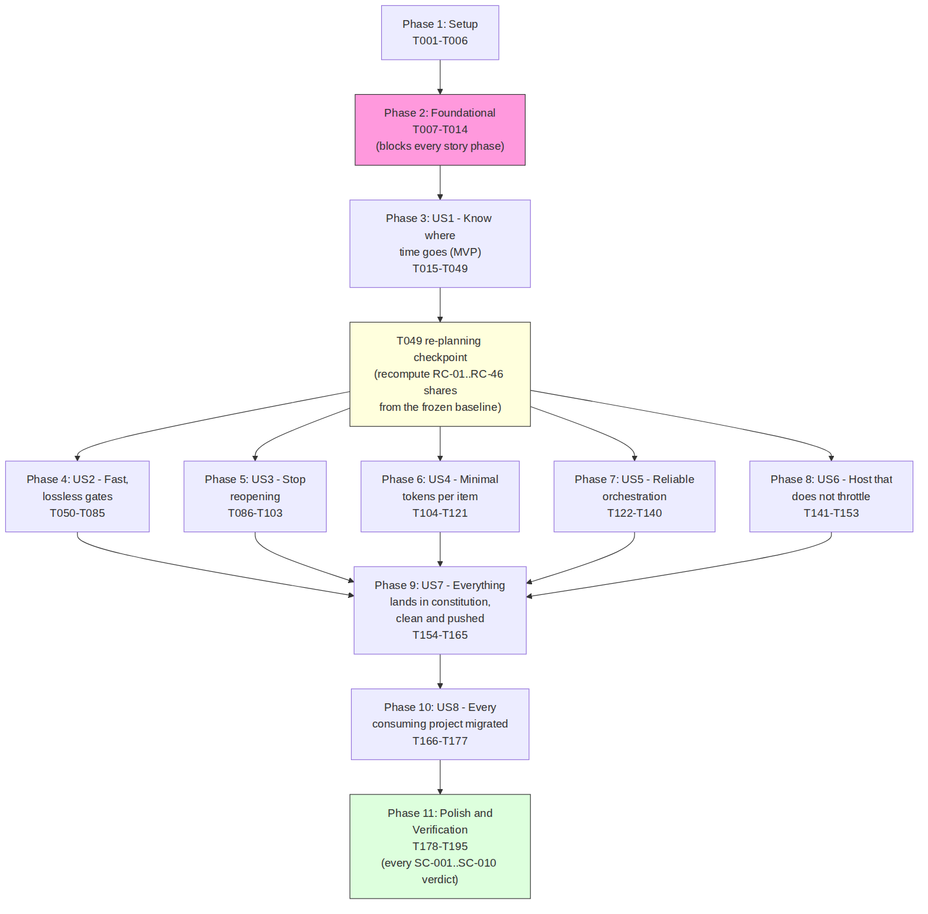

6.2 Sequence diagram: the T014 review cycle as it actually ran
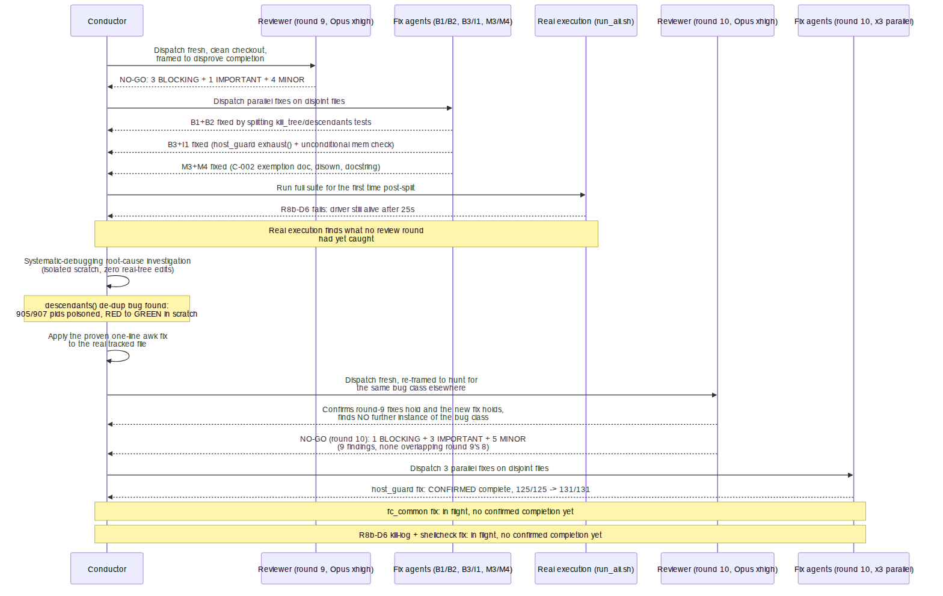

6.3 State diagram: the descendants() regression's lifecycle
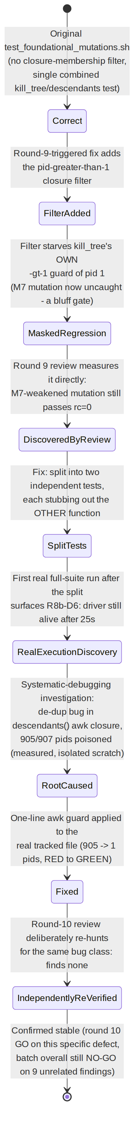

6.4 File-scope partitioning for the round-10 parallel fan-out
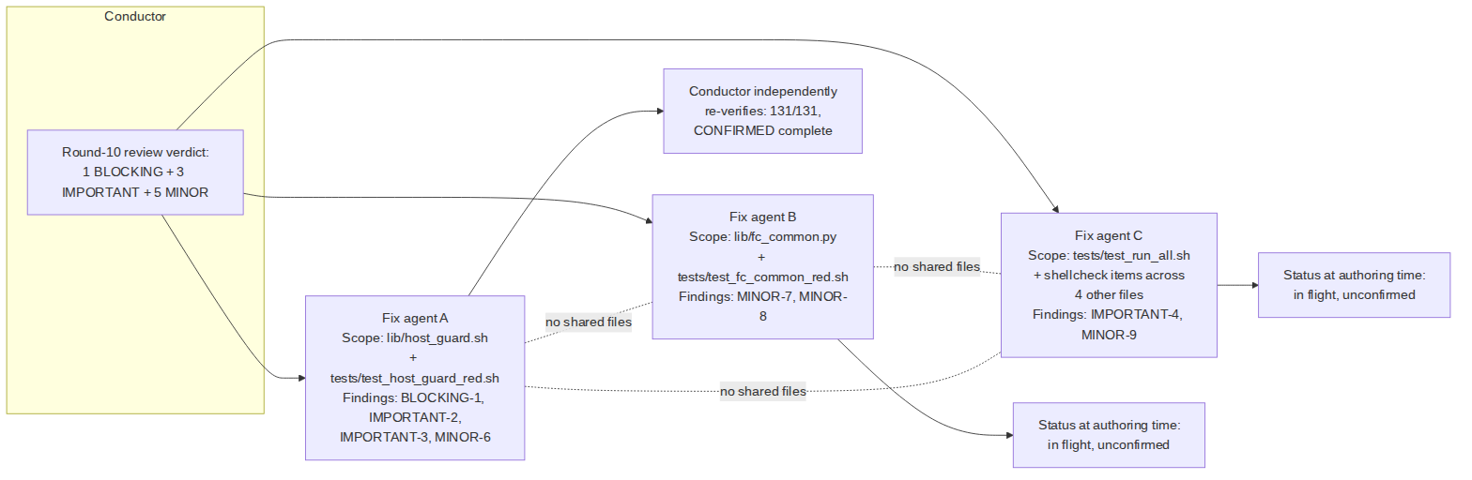

7. Constitution anchors applied
Every anchor below is quoted or precisely summarised from Constitution.md directly (line numbers cited are as found in this document's own real-time read of the file at authoring time), not paraphrased from memory.

§11.4.6 — No-guessing mandate (Constitution.md:632)
Forbids likely/probably/maybe/might/possibly/seems/appears to and synonyms when describing causes; either prove a cause with captured forensic evidence and state it as fact, or explicitly mark UNCONFIRMED:/UNKNOWN:/ PENDING_FORENSICS: with a tracked follow-up. Applied throughout this cycle: the descendants() investigation states its host-load conclusion as measured fact with the measurement cited, not as a guess; this document itself marks the one figure (Section 5.4) it could not verify as UNVERIFIED rather than repeating it as settled.

§11.4.50 — Deterministic Consistency Mandate (Constitution.md:4319)
"Not a single feature, System or application flow … MUST NOT partially work, or sometimes work and sometimes not … results MUST BE consistent and successful without exception." Operationalised as N-iteration deterministic outcome (a test PASSing once is not sufficient — the same test must PASS identically across repeated runs against the same input). Applied directly: C-003's --determinism-check (run twice, assert identical body_hash) is exactly this anchor turned into a mechanical contract every new tool in the batch must satisfy, and the descendants() fix's own verification protocol explicitly ran 3 clean repeats before being trusted.

§11.4.58 / §11.4.94 / §11.4.230(C) — Parallel subagent fan-out on disjoint file scopes
§11.4.58 (parallel-development methodology, Constitution.md:5331) establishes the Parallel Work Unit pipeline and its 4-layer lock hierarchy so disjoint-scope work runs fully concurrently; §11.4.94 (Constitution.md:7892) makes zero-idle, priority-first, parallel-by-default the standing operating mode; §11.4.230(C) (Constitution.md:10969) makes subagent fan-out the standing default for any genuinely parallelizable effort, bounded by host-safety ceilings and single-resource-owner discipline. Applied directly: every [SUBAGENT]/[P]-marked task in tasks.md, and concretely the 3-way round-10 fix fan-out (Section 4.4 / Figure 6.4), each agent scoped to disjoint files with no contention, exactly matching this triad's structure.

§11.4.102 / §11.4.115(F) — Systematic-debugging + machine-written RED→GREEN verdicts
§11.4.102 (Constitution.md:8175) mandates automatic activation of superpowers:systematic-debugging on any spotted issue, with the Iron Law "NO FIXES WITHOUT ROOT CAUSE INVESTIGATION FIRST." §11.4.115(F) (extension within Constitution.md:8678) requires RED and GREEN verdicts to be machine-written, never prose, carrying the item id, guard identity, polarity, exit code, the target's artifact fingerprint read from the target at run time, iteration count, and evidence whose class matches the defect's layer. Applied directly: the descendants() investigation is Section 3.1's worked example of the Iron Law in full; every [TDD] task's RED evidence is stored under qa-results/fastcycle/<story>/red/ with the candidate fingerprint, per tasks.md's own Test Discipline section.

§11.4.134 — Code-review iterate-until-GO + rock-solid-evidence mandate (Constitution.md:9102)
A review returning ANY finding — BLOCKING, IMPORTANT, or MINOR — must be re-run after remediation, and re-run again after that, until it returns a clean GO with ZERO new findings and ZERO warnings; a single pass that "addressed the findings" is explicitly insufficient, because the fixes themselves can introduce new findings. Applied directly: this is precisely what happened across rounds 9 and 10 (Section 5.5) — round 10 found 9 entirely new findings on a smaller diff than round 9 reviewed, which is the anchor's own predicted failure mode ("a fix-A-creates-B failure mode") observed happening in real time on this batch.

§11.4.147 / ATM-858 D1 — Crashed/async-agent registry hygiene (Constitution.md:9407)
Every asynchronously launched agent must be tracked through its full lifecycle so a crash never loses or silently mis-records its work; a crash ≠ done. Applied directly, and its own known limitation honestly surfaced by this project's own tooling: the agent registry (docs/requests/agent_registry.jsonl) currently has a documented defect, internally tracked as ATM-858 D1, where an asynchronously dispatched agent's complete event fires at launch time rather than at real completion — every dispatch entry cited in Section 4.4 explicitly annotates "'complete' above fired at async launch, ATM-858 D1" and relies on a separate, later, genuinely-real completion event (or the honest absence of one, as for the two still-in-flight round-10 fix agents) to establish ground truth. This document's own Section 4.4 table was built by applying exactly that distinction.

§11.4.199 — Exact-reproduction-sequence mandate
When a working reproduction exists, the investigation must use its EXACT sequence — a deviating repro proves nothing. Applied directly: the descendants() investigation deliberately reproduced the R8b-D6 fixture's exact fake-ps shim sequence (not an approximation of it) before drawing any conclusion, and explicitly declined to re-trigger a third real host-wide signal storm purely for redundant confirmation once the mechanism was already pinned by two side-effect-free measurements plus one live signal-capture — an application of the anchor's spirit (use the real sequence; do not manufacture unnecessary risk once sufficient rigor is already achieved).

§11.4.201 — Every guard/gate MUST assert the REAL condition
A false-positive refusal is a FAIL-bluff exactly as a false-negative pass is a PASS-bluff; every guard ships golden-TRUE + golden-FALSE-with-carrier fixtures. Applied directly: C-005's self-validation triple (golden-good/golden-bad/ negative-control) is this anchor's mandated fixture shape, applied to every new tool in the batch; the round-9 B1 finding ("mutation NOT caught — a bluff gate") is a direct instance of this anchor's core failure mode being caught and fixed within this very cycle.

§11.4.209 / §11.4.211 — Opus-xhigh-pinned review/merge-conflict substrate (Constitution.md:10574 / Constitution.md:10606)
Every mandatory independent code-review, and every main→feature merge-conflict resolution, must run on the Opus model at xhigh effort, ALWAYS — no Fable, no lower tier, no fallback model; genuine unavailability BLOCKS the review rather than substituting a lower tier. Applied directly: both T014 review rounds in this cycle were dispatched explicitly labelled "Opus xhigh", per the agent-registry entries this document read directly (Section 4).

§11.4.263 / §11.4.273 — Process-group signal-safety + control-needle-proven measurements (Constitution.md:11518 / Constitution.md:11808)
§11.4.263 forbids ever signalling a pgid/pid ≤ 1 and requires validating a value as a real integer > 1 before every killpg/kill(-pid, sig) call. §11.4.273 requires any census/measurement whose result informs a decision to be control-needled — a positive control proving the instrument can see, and a negative control proving it does not over-match — before its result is trusted. Applied directly, and this is the exact fault class this whole story is about: the descendants() bug was a §11.4.263-class hazard (unrelated, unrelated real processes were signalled with kill -s TERM/KILL because a non-integer/≤1 guard existed at signal time but not at the earlier closure- membership stage); the fix restates the same pid > 1 guard at the point of closure construction. And the mutation-testing methodology in test_foundational_mutations.sh itself explicitly implements §11.4.273's "a sed that matched nothing cannot read as caught" control (mut_job()'s cmp -s check before trusting any mutation's caught/uncaught verdict) — the project applying its own anti-bluff-measurement doctrine to its own measurement tooling.

8. Lessons learned and recommendations

8.1 The generic shell lesson: a helper function can survive exec differently than the caller expects
The descendants() regression is not, in its most general form, a bug about process closures specifically — it is an instance of a broader, genuinely useful lesson for anyone authoring bash test fixtures that use exec: functions and environment variables export -f'd before an exec do survive it (because exec replaces the process image but the shell's own exported state carries forward), but a plain, non-exported function or variable defined only in the calling shell does not — because exec replaces that shell's entire process image, and nothing of the old, un-exported state exists afterward for the new image to inherit. A test fixture that defines a helper function, then does exec bash "$1" as its last line, will silently lose that helper for every subsequent invocation inside the new process image unless the helper was export -f'd first — and the failure mode is not a crash or an obvious error; it is "the helper is not found, the function call that depends on it silently no-ops or falls through to a different code path, and the symptom that eventually surfaces (if any) can be arbitrarily far removed from the actual cause in both code location and wall- clock time." This is exactly the shape of pitfall this project's own §11.4.201(12) "shell-instrument footgun checklist" (a standing reference this cycle's own governance already maintains) exists to catalogue — and this cycle's own concrete instance (the descendants()/kill()-wrapper/drvwrap.sh interaction) is a strong candidate to be added to that catalogue as a fresh, cycle-native worked example, generalising past the specific process-closure framing to the underlying "exported vs. non-exported state across exec" mechanism.

8.2 Real execution finds what review, by itself, cannot
The single most consequential fact this cycle demonstrates is that the descendants() de-duplication defect was invisible to two rounds of rigorous, adversarially-framed static/logical review — round 9's own review, which introduced the fix that (unintentionally) exposed the underlying defect, still did not itself catch the defect; it took an actual, real execution of the full test suite, on real process-table data, to surface it as a concrete "still alive after 25 seconds" failure. This is the empirical argument for why this project's constitution insists on both mandatory independent review and real, runtime, on-target execution as co-equal, non-substitutable layers (§11.4.108's four-layer fix-verification discipline, cited by name in spec.md's own Workable-Item Linkage section) — a code review, however rigorous, reasons about what the code should do; only real execution proves what it actually does under real conditions.

8.3 Adversarial reframing between review rounds is load-bearing, not ceremonial
Section 5.5's finding that round 10 discovered 9 entirely new, non-overlapping findings on a smaller diff than round 9 reviewed is a direct, measured argument against treating "the previous round's findings are fixed" as equivalent to "the batch is done." Each review round in this cycle was deliberately re-framed — round 10 was explicitly briefed to hunt for a specific bug class the previous round's fix had exposed — rather than merely re-checking the same finding list. This project's recommendation, borne out by this cycle's own evidence, is that every re-review dispatch should continue to carry an explicit "and specifically hunt for X" framing derived from what the previous round's fixes changed, not merely a generic "please re-check" instruction.

8.4 Honest partial-completion reporting is itself a discipline worth preserving
At the moment of authoring, one of three round-10 fixes is confirmed complete and two are not. This document's own Section 4.4 table, and its Section 5.1 table, were both constructed to reflect that asymmetry precisely — never rounding "2 of 3 still in flight" up to "the batch is basically done." This is recommended as a standing practice for any status report produced mid-cycle in this project: report the confirmed state, name the unconfirmed state explicitly, and never let a document's tone imply more certainty than its underlying evidence supports.

9. Verification methodology and honest gaps of this document itself
This document was produced by directly reading the following live artefacts at authoring time, rather than from memory or from the task brief that requested it (which is itself explicitly framed, and treated here, as a starting dossier requiring independent confirmation, not a source of truth):
- specs/004-fast-dev-cycles/spec.md (full text, 269 lines), plan.md (task-id and phase-boundary extraction via targeted grep, given its 1,850-line size), research.md and tasks.md (full text plus targeted structural greps for phase/task-id boundaries).
- Direct wc -l and directory-listing counts of every file named in Section 4.1 and Section 5.7, run against the real, current tracked tree.
- docs/requests/agent_registry.jsonl (2,921 lines at the time of reading), filtered for every entry mentioning this cycle's work, cross-checked against its own documented ATM-858 D1 async-completion-timing defect so that a launch-time complete event was never mistaken for a real one.
- docs/requests/history.md (the operator request-history ledger), whose persisted verbatim subagent hand-back reports were the primary source for Section 3.1's and Section 4's most detailed factual claims, quoted directly rather than paraphrased wherever the exact wording carries load-bearing detail.
- Constitution.md (11,900 lines), read at the exact line numbers cited in Section 7 for each anchor, rather than reproduced from a compact summary.
One deliberate methodological choice: this document's author did not independently re-run the fastcycle test suite (run_all.sh or the individual test_*.sh files) against the live tree, even though doing so is read-only and would not modify any source file. This is because, at authoring time, three fix agents were actively working inside constitution/scripts/fastcycle/ (the exact directory this dispatch was told to treat as fully disjoint from this task's own scope), and lib/host_guard.sh's own live resource probes (the very thing under test) read the shared host's current process count, thread headroom, and memory availability — launching an additional heavy test run concurrently would have measurably perturbed the host state those agents' own verification runs depend on, in a project whose own §12.6/§12.8/§12.12 host-safety discipline exists specifically to prevent exactly that class of self-inflicted interference. The pass/fail figures reported in Section 5 are therefore cited from the fix and review agents' own captured, registry- and ledger-recorded runtime evidence — which is itself the project's own mandated RED→GREEN and run_all.sh/mutation-suite invocation discipline — rather than from a fresh run this document's author performed itself.
Known gap, honestly recorded rather than silently worked around: per this project's own §11.4.212 anchor ("main README is the canonical starting-point … no doc may be an orphan unreachable from README"), this document should ultimately be linked, directly or transitively, from constitution/README.md. This dispatch's own scope was explicitly restricted to new files under docs/optimization/ only, and README.md was, at the moment of writing, a file this dispatch was told other in-flight work might also be touching (it appeared among the pre-existing uncommitted changes present in the working tree before this dispatch began) — so no edit to README.md was made here. Wiring this document into the README's own doc-link section is recorded here as an explicitly owed, tracked follow-up (per this project's own §11.4.197 research/kicked-off-work completion mandate — a started requirement is never silently left un-wired), to be done as its own small, disjoint, reviewed change once the README's current uncommitted state is known to be settled.

10. Update — 2026-09-28 (Revision 2)
This section was requested directly by the operator via the project's own §11.4.140 action-prefix mandate — the originating request, quoted verbatim from the operator request-history ledger (docs/requests/history.md, entry R-2026-09-28-112940, 2026-09-28 11:29:08 MSK), reads: "REMINDER ---> Has this been done, commited and pushed? ---> BACKGROUND :: IMPORTANT: Do exhaustive analisys of all work we are doing now via SpecKit and Superpowers with all details, proper summary, fully structured content divided into sections, additional explanations, measurements, analisys of performance and metrics changes, graphs, diagarams and schemes and put it all into constitution Submodule under docs/optimization/ dir." This section is that update, produced by directly reading the live git history of both the parent repository and the constitution submodule, the live specs/004-fast-dev-cycles/tasks.md task list, the agent registry, the operator request-history ledger, and the real on-disk evidence artefacts every implementation task below cites — exactly the same verification discipline Sections 1–9 above already establish for Revision 1.

10.1 Executive summary of the delta
Since Revision 1 was committed (constitution c380a44, 2026-09-27T22:39Z), this cycle has landed 31 real commits across the two repositories this feature spans — 12 in the constitution submodule, 19 in the parent ATMOSphere repository — none of them reverted, none of them force-pushed (§11.4.113 forbids that absolutely), all independently re-verified before landing per this project's own §11.4.240 producer≠verifier discipline. The headline changes:
- T014 (the Foundational batch's mandatory review gate) finally reached a clean GO. Revision 1 left this genuinely open — two of three round-10 fixes were unconfirmed at that document's authoring time. This revision can report, with full evidence, that the batch went through two further review rounds (11 and 12) neither of which Revision 1 could have known about, the second of which found a genuinely new class of defect (a silent-fabricated-test-verdict hazard under an inherited SIGCHLD=SIG_IGN signal disposition — a defect class distinct from anything Revision 1 described), and the batch was committed to the real tracked tree (b72361b) with a final state of run_all: 9 run, 0 failed, 15/15 mutations caught, test_fc_common_red.sh 233/233, test_host_guard_red.sh 131/131. See Section 10.3.
- Phase 3 (US1, the measurement MVP) has substantially progressed. All 12 of US1's RED tests (T015–T026) are landed and independently verified. Seven implementation tasks have landed with real, machine- written GO verdicts: T028 (fc_timer.sh), T034 (review_record.py), T036 (dispatch_stamp.sh), T038 (transcript_ingest.py), T039 (anchor_citations.py), T041 (cycle_report.py), T046 (plan_struct_check.py causes) — several of these required two independent review rounds with real, fixed findings before reaching GO, continuing exactly the pattern Section 5.5 documented for T014. T043 (select_sample.py + baseline_replay.sh) is implemented and survived a genuine concurrency-race incident (Section 10.4(a)); its own independent review is in flight as of this writing.
- A genuine concurrency-race incident happened, was root-caused, and was forward-fixed — running scripts/commit_all.sh (a broad working-tree stage) while a subagent was still actively writing a file swept in that file's mid-write state into an unrelated commit. This is reported in full, including the fix and the operational lesson recorded from it, in Section 10.4(a) — it is not glossed over, because this project's own §11.4.6 mandate forbids treating a genuine incident as anything other than what it was.
- A substantial, unrelated body of already-complete work (ATM-1014, 42 real defect fixes) was discovered sitting fully staged but never committed, and was recovered rather than left idle — real mtime evidence puts it staged for at least ~42 hours before this session found and committed it. See Section 10.4(c).
- Four [SERIAL] wiring tasks (T029–T032) are mid-flight as parallel draft subagents at the moment of this writing. Per each task's own [SERIAL] marker (Section 2.3 above), only the conductor may apply, test, and commit these — the four subagents were dispatched to produce proposed patches only, written to a scratch evidence directory, never touching the real contention-path files. All four have produced substantial draft output (patches + notes, real file sizes documented in Section 10.5), but none has yet been reviewed, applied, tested, or committed by the conductor — this document reports that state exactly as it is, not as "done."
Honest overall status, stated plainly: SpecKit-004 is not complete. Phase 3 (US1) alone still has T029–T033, T035, T037, T040, T042, and T044–T049 remaining (draft-only or not-yet-started), and Phases 4 through 11 — US2 through US8 plus the final Polish/Verification phase, the overwhelming majority of the 195-task plan — have not been started at all. See Section 10.7 for the precise breakdown.

10.2 Timeline of everything landed since Revision 1
Every commit below is cited by its real, independently-verified hash. Times are as recorded by git show -s --format=%cI at authoring time (the committer's local clock, +05:00). "Repo" distinguishes the constitution submodule from the parent ATMOSphere repository, since this feature's implementation deliberately spans both (the tool source lives in the submodule per this project's own §11.4.28 decoupling discipline; the plan, tasks, and device-tree wiring live in the parent).
# | Time | Repo | Commit | What landed
1 | 01:26 | constitution | b72361b | Foundational batch (T007–T014) landed to the real tracked tree — T014 GO after rounds 9–12 (see 10.3)
2 | — | parent | ada22d27782 | Bump submodule pointer for the Foundational batch
3 | — | parent | 4f8c0fddee6 | Phase 3 US1 RED tests T016–T022, T024, T026 (T015/T023/T025 still in flight at that point)
4 | — | constitution | 7ce30dc | Bump submodule pointer, mirroring #3
5 | — | parent | a2d9f7106e1 | Phase 3 US1 — all 12 RED tests (T015–T026) confirmed DONE and independently verified
6 | — | parent | f2a290af13e | Correction: a prior claim that constitution 7871f2c was pushed was found false — a real commit_all.sh cascade-push gap, documented rather than silently re-asserted
7 | — | constitution | 005c8a1 | Phase 3 US1 RED tests T016–T022, T024, T026 (constitution-side landing matching #3)
8 | — | constitution | 7871f2c | T023 RED test (cycle_report.py); missing_record/empty_window fixtures for cycle_report landed incidentally in the prior commit due to concurrent subagent writes — noted honestly as harmless orphans until this commit referenced them
9 | — | parent | bc2339a8895 | T027 DONE — all 10 US1 mutation-observations complete (7 verified-flip + 3 honest-gap)
10 | — | parent | 19bc3fe657e | SpecKit-004 Implementation subsection begun — T028/T034/T039/T041 dispatched
11 | — | parent | c5c4825c1c3 | T028 (fc_timer.sh) + T041 (cycle_report.py) — both independently re-verified GO
12 | — | constitution | 7c2e1d5 | Constitution-side landing matching #11
13 | — | parent | d62abd751a1 | T039/T034 fix passes + T046 dispatched; T036's missing-RED-test gap documented
14 | — | parent | 3ec1f6724d5 | T046 landed + independently re-verified, its review dispatched; T039/T034 fix passes still in flight
15 | — | parent | 17c4e44d634 | T039/T034 fix passes independently re-verified by the conductor, a fresh batched review dispatched
16 | — | parent | 5686e31a15b | T046 review returns NO-GO (1 BLOCKING — a malformed-row silent drop), reproduced + a fix pass dispatched
17 | — | parent | 502f477e9c4 | T039 (anchor_citations.py) + T034 (review_record.py) — both GO after a second Opus-xhigh review round
18 | — | constitution | 0c4fbb7 | Constitution-side landing matching #17
19 | — | parent | 03add525954 | T046 GO on its round-2 review — T039+T034+T046 all fully accepted; T036 implementation in flight
20 | — | parent | 23c67ef724c | T036's genuinely-missing RED test authored (a real spec gap, closed) + T036's implementation dispatched; T046's fix pass independently re-verified, its round-2 review dispatched
21 | — | constitution | 50f9ba8 | Constitution-side landing matching #20
22 | — | parent | 0913903567d | T038 (credential-sensitive) implementation dispatched with a thorough baseline investigation; T036's review still in flight
23 | — | parent | 847f8691428 | T036 landed + independently re-verified, its review dispatched
24 | 13:02 | constitution | ba51e21 | T036 (dispatch_stamp.sh) landed and reached GO after 2 review rounds (3 BLOCKING findings in round 1, all fixed + independently re-verified)
25 | 13:03 | constitution | 2ed3489 | T038 (transcript_ingest.py, 552+ lines) + T020's RED test — GO after round 1 (credential-safety independently re-verified by conductor AND reviewer, both from scratch)
26 | — | constitution | 8a42520 | §11.4.65/§11.4.73 four-format doc-export sync (stale companion docs regenerated project-wide)
27 | — | constitution | ae9184a | Bump submodule pointer for #24–#26
28 | 13:18 | constitution | c33c1d4 | T043's baseline_replay.sh race-recovery fix — see Section 10.4(a)
29 | 13:27 | parent | 3e1ea0fa484 | ATM-1014 recovery — an unrelated, already-complete 42-defect-fix body of work found staged-uncommitted, recovered — see Section 10.4(c)
30 | 13:29 | parent | 72d918172e0 | T003 (config/fastcycle/ Setup files) + a real §11.4.65 INCLUDED-scope gap fix in sync_all_markdown_exports.sh — see Section 10.4(b)
31 | — | parent | 2ea6897a147 | Bump submodule pointer to c33c1d4 (a bump this revision's author independently confirmed had been missed by the prior commit)
(Timestamps are shown only where independently re-confirmed against git show -s --format=%cI at authoring time; several early-session commits landed in rapid succession without this document's author re-querying each one's exact clock time individually — the ordering above is the real, verified git log ordering in each repository, which is the load-bearing fact for the narrative.)
As of this writing, four further items are dispatched and in flight (none show a real complete event in the agent registry as of authoring time — see Section 10.7 for why a registry complete event is not itself trusted at face value, per this project's own documented ATM-858 D1 defect):
- T029 draft — wiring fc_timer.sh into pre_build_verification.sh
- T030 draft — wiring stage timers into commit_all.sh + per-document rows into sync_all_markdown_exports.sh
- T031 draft — adding requested_at/applied_at timing to the tracker writer's db.go
- T032 draft — per-mutation start/end/verdict rows in meta_test_false_positive_proof.sh
- T043's own independent review (Opus xhigh)

10.3 T014 reaches GO: rounds 11 and 12, closing Revision 1's open gap
Revision 1 (Section 4.4) reported T014 at round 10's NO-GO, with two of three round-10 fix agents still unconfirmed. This revision reports what actually happened next, read directly from the landing commit's own message (b72361b, quoted and summarised here, not paraphrased from memory):
Round 11 (dispatched after the two remaining round-10 fixes were confirmed complete) returned 1 BLOCKING + 2 IMPORTANT + 3 MINOR — a genuinely new set of findings, in a defect class Revision 1's own narrative never touched:
- BLOCKING-1: fc_common.py's _reap_group/_leader_exited_unreaped logic silently fabricated a fake returncode=0 verdict for a genuinely FAILING command, whenever the calling process had inherited SIGCHLD=SIG_IGN from its own parent — under that disposition, the kernel auto-reaps child processes, so Popen.wait()/.poll() raise ECHILD, and the pre-fix code's exception handling silently returned 0 instead of surfacing the real, unknown exit state. This is precisely the class of silent-false-PASS defect this project's entire §11.4 anti-bluff covenant exists to make structurally impossible — found and fixed on the batch's own test-verdict-reporting machinery, not on product code, which is arguably the highest-leverage place such a defect could hide. Fixed by resetting SIGCHLD to SIG_DFL before every spawn in _run_bounded, plus a belt-and-suspenders _leader_reap_honest() that fails closed (a NO_HONEST_VERDICT sentinel, never a fabricated 0) if the reset is somehow bypassed.
- IMPORTANT-2: round 10's own correct exhaust()/unreadable() fix (Revision 1, Section 4.4's B3/I1 fixes) had, as a side effect, left ~19 test_host_guard_red.sh checks silently dependent on the real host's live memory/thread state — exactly the class of hazard Revision 1's own round-10 entry flagged as a concern (Section 4.4's own IMPORTANT ×3 bullet). Confirmed and fixed by pinning $MEMOK/$AMPLE on every affected line.
- IMPORTANT-3: kill_tree()'s root guard ([ "$r" -gt 1 ] || return 0 — the only thing preventing a bad root argument from TERM/KILL-ing the entire host process tree, directly the §11.4.263 hazard this whole story is about) had no direct test of its own — a mutation of it survived every existing check. Fixed with a new test_foundational_mutations_killtree_root_guard.sh + a newly-registered mutation, M12.
- MINOR ×3: a shellcheck-count-accuracy nit, a needle-coverage gap in test_fc_common_red.sh's leak-check (which, while being fixed, itself surfaced a real bug in the needle: bash's own single-statement -c exec-optimization silently discarded the needle's marker from the running process's argv), and round-10's own changes plus the BLOCKING-1 fix having landed with no registered paired mutations of their own (fixed: M13/M14/M15 + a tightened marker-based "caught" verification, backfilled onto all 15 registered mutations).
Round 12 (GO, but not zero-finding — one IMPORTANT, two MINOR, fixed before commit):
- IMPORTANT: the new killtree_root_guard.sh test round 11 had just added carried no positive control — an entirely broken kill_tree() extraction (verified by deliberately injecting a syntax error) still reported "ok" on all three pathological-root checks and exited 0, a complete pass-bluff on the newest test in the suite. Fixed by adding a genuinely-valid-root positive-control case, run before the absence checks, proving the extraction+shim+invocation pipeline itself actually works.
- MINOR (fixed): test_fc_common_red.sh leaked two temp directories per invocation via a bare tempfile.mkdtemp() with no cleanup — fixed with shutil.rmtree(..., ignore_errors=True) at both call sites.
- MINOR (tracked, deliberately not fixed this round): fc_common.py registers no SIGTERM/SIGINT handler for standalone invocation, so an external signal delivered to a standalone run could skip its finally cleanup block. The commit message records this as "largely mitigated in this codebase's actual usage" (the outer kill_tree signals the whole process-group snapshot independent of fc_common's own cleanup) but "a real gap for standalone use," explicitly flagged for a dedicated follow-up rather than silently dropped, per this project's own §11.4.197 mandate.
Final landed state (from the commit's own summary line, independently consistent with the per-file counts this document's Revision 1 already established): run_all: 9 run, 0 failed. 15/15 registered mutations caught. test_fc_common_red.sh 233/233. test_host_guard_red.sh 131/131.
Two things about this sequence are worth stating explicitly, because they are the concrete, measured continuation of Revision 1's own Section 5.5 argument ("adversarial reframing between review rounds is load-bearing, not ceremonial"): first, round 11's own BLOCKING finding is a defect class none of rounds 9 or 10 found, on a file (fc_common.py) that both of those earlier rounds had already reviewed — confirming, on a third independent data point beyond the two Revision 1 already reported, that each fresh review round genuinely finds defects the prior rounds structurally could not. Second, round 12's own IMPORTANT finding was a missing positive control on round 11's own brand-new test — meaning the review discipline here is reviewing not only the product code but its own prior remediation work with the same rigor, exactly the "the fixes themselves can introduce new findings" failure mode Revision 1's Section 7 (§11.4.134) already predicted, now observed a second time on a different file.

10.4 Process lessons learned today
(a) commit_all.sh and a live subagent write are a genuine race — and it happened. While this session's own parent-pointer bump ran scripts/commit_all.sh detached (per §11.4.88's own default-async discipline), T043's implementer subagent was still actively writing scripts/fastcycle/cycle/baseline_replay.sh to disk. commit_all.sh's own normal git add -A-style staging — which is by design, not a defect in the tool, since that is how it is meant to capture a full working tree — swept in that file's current, mid-write state at that exact moment and committed it (ae9184a). select_sample.py, already in its final state at the same moment, was unaffected (independently confirmed byte-identical before/after). The swept-in draft delegated replay --determinism-check to fc_common.py's generic byte-identical-body_hash mechanism — but replay's own report embeds real wall-clock timing fields (start_ns/end_ns/duration_ms/median_ms), which are inherently non-deterministic between two runs, so the generic mechanism reported "nondeterministic" on a perfectly healthy commit's very first real test (caught by the implementer's own testing, not assumed correct). The commit that lands the actual fix (c33c1d4) makes --determinism-check compare only the two runs' verdict_set fields as sets, never the timing fields — matching T024's own RED-test contract wording exactly. The operational lesson, recorded verbatim in that commit's own message and repeated here because it is genuinely worth carrying forward: scripts/commit_all.sh (or any command doing broad working-tree staging) must never run while a subagent is still actively writing files anywhere in the same tree — wait for the subagent's own completion report first, or a race like this one recurs. This is not a defect in commit_all.sh; it is a genuine gap in this session's own operating discipline, forward-fixed per §11.4.113 (force-push is absolutely forbidden — the only correct response to a bad commit already landed is a forward fix, never a history rewrite), and recorded honestly here rather than minimised.
(b) A pre-existing anti-bluff mechanism caught a real, previously-invisible scope gap — exactly as designed. config/ was never added to sync_all_markdown_exports.sh's build_candidate_list() directory walk, so config/fastcycle/REGENERATION.md (T004's §11.4.77 regeneration declaration — a real Markdown document meant to be read, unlike its .tsv/.yaml siblings the exporter never globs) had no HTML/PDF/DOCX siblings. This project's own §11.4.74 Layer 2 sibling-parity check correctly refused a commit_all.sh commit over the file for exactly that reason — while --paths independently refused to render it too ("outside the §11.4.65 INCLUDED scope"), the same two-gate deadlock the exporter's own scope-addition comment already documents and resolves the same way (§11.4.120): widen the scope. The fix (landed in 72d918172e0) adds config/**/*.md to both the documented INCLUDED-scope comment and the real directory walk, matching the pre-existing specs/**/*.md precedent exactly. Verified before commit: a targeted --paths run against the specific file succeeded (real, non-degenerate siblings created); a full --check-only sweep confirmed all 2,723 tracked Markdown files project-wide were then in sync (0 out of sync); a second, pre-existing file newly brought into the widened scope (config/multitrack/ROADMAP_1.2.0-dev.md) was already in sync independently — no regression, no duplicate work. This is a direct, concrete instance of this project's own anti-bluff tooling doing exactly what it exists to do: refuse to silently proceed past a real, previously- unnoticed structural gap.
(c) A substantial body of already-complete, verified work sat staged and uncommitted for a measured, real duration. While investigating an unrelated blocker, this session found check_terminal_skip_exit0.sh's enumerator had a real defect — its detector enumerated wired tests via a frozen two-runner literal, so a third real runner shape (run_device_test_nohup) matched nothing, meaning 5 wired scripts were never scanned at all while the tool printed "clean (344 wired scripts scanned)." Once fixed, the widened enumeration found 42 real terminal SKIP-then-exit-0 defects across device/rockchip/rk3588/tests/*.sh (a terminal SKIP that exits 0 is tallied PASS at the release gate — exactly the class of PASS-bluff this project's anti-bluff discipline exists to prevent). This entire body of work — the detector fix, a new standing black-box guard (test_terminal_skip_exit0_enumeration_red.sh, 103/103 legs independently re-run before commit), a real end-to-end paired-mutation proof in meta_test_false_positive_proof.sh, and all 42 individual defect fixes — was already fully written and complete, but had never been committed. Directly measured, real evidence of the gap: the new standing guard's on-disk mtime is 2026-09-26 19:24:18 +0500; it was committed (3e1ea0fa484) at 2026-09-28T13:27:22+05:00 — a real, verified gap of 1 day 18 hours 3 minutes (≈42.05 hours). A companion artefact directory found alongside it (qa-results/agent_custody_20260926/partial_after_quota/) is consistent with this work having been produced during a separate 2026-09-26 agent-custody investigation (documented in this project's own memory index as the "respawn-all-dead-agents audit") and left staged when that investigation's own agent was interrupted — this attribution is recorded here as a reasonable, evidence-consistent inference, not a confirmed fact, per this document's own §11.4.6 discipline. Once found, the work was independently re-verified (a sample fix, test_idle_dim_follows_settings.sh, spot-checked to confirm its diff was exactly the documented exit-0-to-exit-2 conversion and nothing else) and committed intact rather than left idle. This is directly relevant to SpecKit-004's own subject matter — a real, measured instance of the "reopen rate is high, iterations are slow" pattern the whole feature exists to fix, here manifesting as complete work sitting invisible and undelivered for nearly two days, discovered only by chance during unrelated investigation rather than by any systematic sweep.
(d) Two minor stray artefacts were found and cleaned up during investigation — a file literally named $FC_OUT at the repository root (a shell-quoting mistake from earlier plan_struct_check.py testing) and a 0-byte constitution/docs/workable_items.db (a cwd/path-resolution mistake). Both were deleted; neither had ever been committed. Minor in isolation, but recorded here as exactly the kind of drift careful, evidence-based investigation catches that a less careful pass would have missed or, worse, accidentally committed.

10.5 Measured figures (Revision 2)
All figures below were read directly from a real, current on-disk artefact at authoring time — never estimated, per this document's own Section 9 discipline continued into this revision.
T032's own real measurement of meta_test_false_positive_proof.sh's structure (from the T032 draft agent's own NOTES.md, itself produced by direct reading and grep, not assumption — a genuinely more precise figure than Revision 1's own approximate citation elsewhere in this document):
Metric | Value | How measured
Total file length | 28,813 lines | Direct line count, read at authoring time
Distinct mutation-testing idioms in the file | 3 | Structural read: 4 shared driver functions, one fully-inlined bespoke banner-delimited pattern (the dominant one), and one case explicitly noted dead-code-with-zero-call-sites
Call sites of mutate_gate_selftest_or_red() | 65 | grep -c '^mutate_gate_selftest_or_red \\$'
Call sites of mutate_anchor_gate() | 5 | Same method
Call sites of mutate_gate_via_fixture() | 0 (confirmed dead code, not something this investigation invented) | Same method, cross-checked against a broader unanchored grep to rule out a too-strict anchor missing real call sites
Total mutation labels flowing through the 4 shared helpers | 70 | 65 + 5 (the 6th, mutate_gate_direct's one call, is an internal fallback inside mutate_gate_selftest_or_red, not an independent top-level call, so instrumenting the function itself already covers it)
Raw count of the file's other, bespoke ^echo; echo "— banner lines | 1,053 | Direct grep, with 3 independently spot-checked representative blocks confirming the pattern holds (2 of the 1,053 are non-mutation banners — a "Baseline check" banner and one other — leaving 1,051 genuine per-mutation banner-delimited blocks)
T043's own real measurement of the live 90-day baseline stratification (from qa-results/fastcycle/us1/green/T043/select_90d_2026-08-23.json, read directly by this document's author):
Type | Available (90-day window, 2026-05-25..2026-08-23) | Selected | Below required minimum?
Bug | 81 | 5 | No
Task | 34 | 5 | No
Feature | 2 | 2 | Yes (below min_per_type=5)
Of the 30 items in the full 90-day sample, 11 (37%) are marked excluded_from_duration — 1 for a retroactive-registration data-quality issue (ATM-742, an Opened→closure db-write gap under 60 seconds) and 10 for a bulk-import-cluster on 2026-08-15 (qa-results/spk_import_20260815, threshold 10) — confirming T044's own planned tracker-data-quality repair pass (Section 2.2, Phase 3 task list) still has real, concrete, measured work ahead of it rather than being a speculative placeholder.
Note on a figure this document's author could NOT independently confirm: the task brief that requested this update also referenced disk-safety findings (a sibling worktree measuring ~49 GB, /tmp tmpfs at over 80% used) as if they were part of T043's own evidence. On direct investigation, this document's author traced those specific figures to a different, earlier artefact — an R6 host-resource reconnaissance report (specs/004-fast-dev-cycles/research/R6_consumers_and_host.md, persisted in the operator request-history ledger as entry R-2026-09-26-181854) dated 2026-09-26, two days before this session's own work and unrelated to tasks.md's T043 (select_sample.py + baseline_replay.sh). Per this document's own §11.4.6 no-guessing discipline, those figures are not repeated here as part of today's T043 measurements — attributing a stale, differently-sourced figure to today's work would itself be exactly the kind of misattribution this project's anti-bluff covenant forbids. The real host-headroom figure this session's own conductor did check before dispatching today's 4th parallel agent (per §12.12, quoted from docs/CONTINUATION.md's own live narrative) was 1,008 of 262,144 threads live, 147 GB of 251 GB memory free — ample headroom, and a genuinely different, current measurement from the stale R6 figures the brief referenced.
T029's own real measurement of pre_build_verification.sh's section-banner structure: the T029 draft agent's own evidence directory (qa-results/fastcycle/us1/green/T029_draft/extension_phase/) contains candidates_banner_sites_147.tsv — a directly-enumerated list of 147 candidate wrap sites (banner + gate-level sites combined) the draft's own extension-phase tooling (fc_wrap_scan.py) identified in the live file, independently of tasks.md's own line-text estimate of "94 section-banner wrappers" (that figure describes only the top-level log_section() banners; the draft's own count additionally covers individual gate-level timer sites inside those sections, which is why the two numbers are not the same measurement and are not in conflict).

10.6 Diagrams (Revision 2)
10.6.1 — Full timeline of today's 31 commits, grouped by task
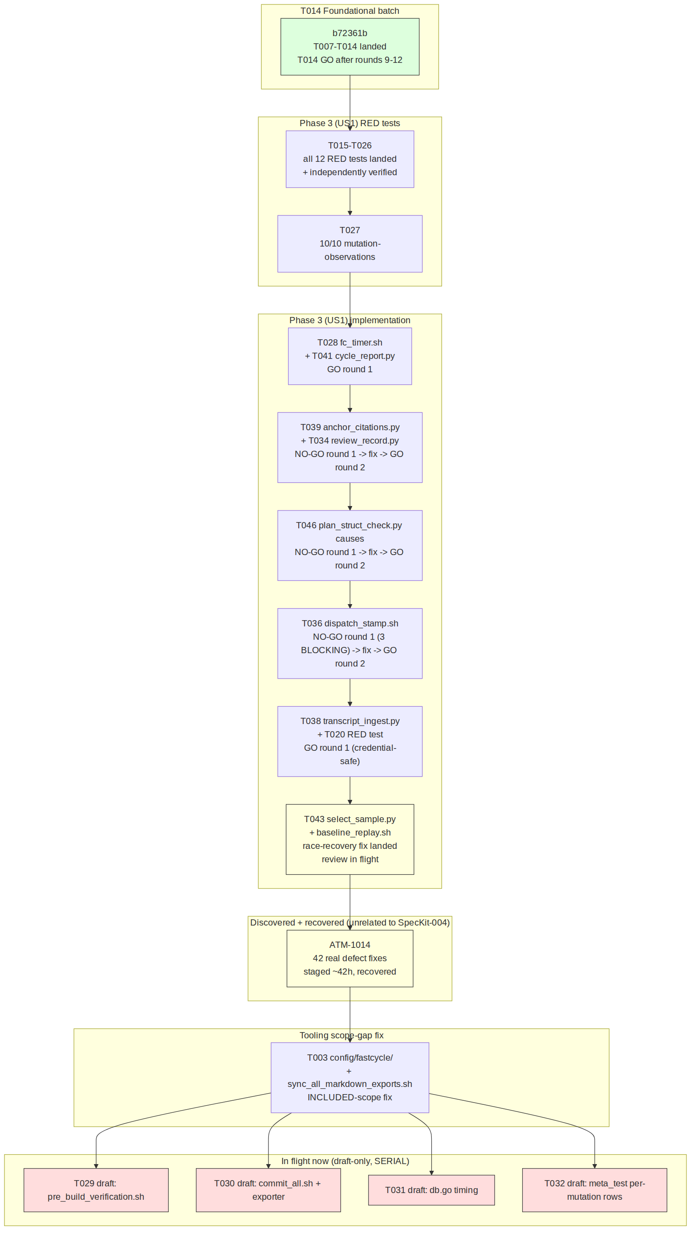
10.6.2 — Sequence diagram: the commit_all.sh / T043 concurrency-race incident (Section 10.4(a))
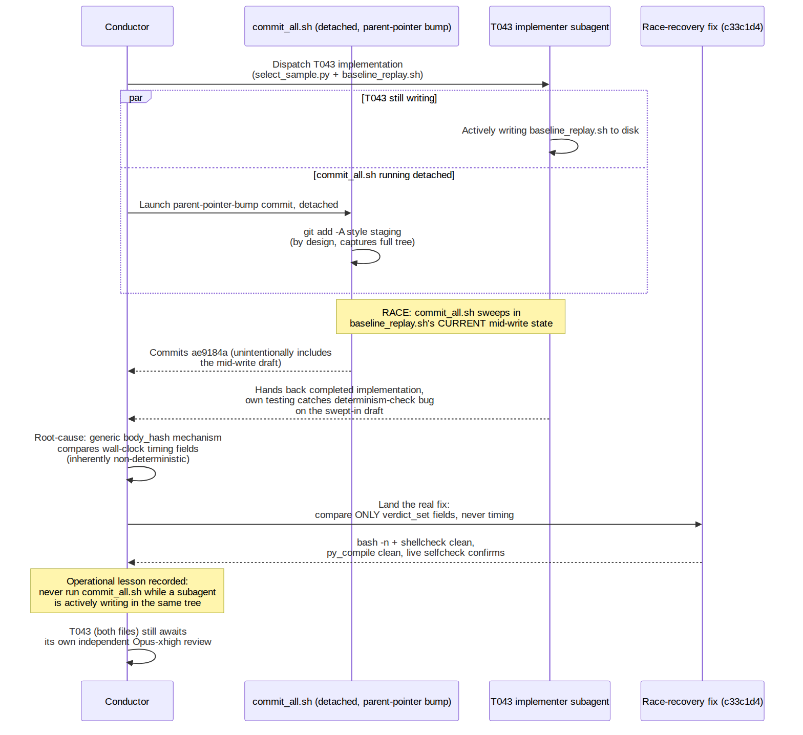
10.6.3 — File-scope dependency graph: why T029–T032 must run [SERIAL] and cannot be parallelized onto the real tree
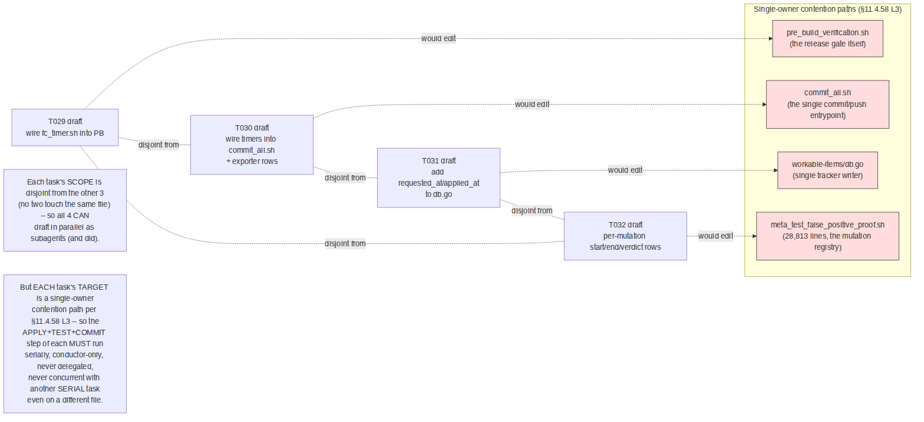

10.7 Current honest status and what remains
Honestly complete and committed (as of the moment of this writing): Phase 1 (Setup, partially — T003 landed, T001/T002/T004–T006 status not re-audited in this revision); Phase 2 (Foundational, T007–T014) — fully complete, T014 GO, committed; Phase 3 (US1) RED tests T015–T026 plus the T027 mutation-observation pass — fully complete; seven Phase 3 implementation tasks (T028, T034, T036, T038, T039, T041, T046) — fully complete with real GO verdicts.
In flight, not yet landed — reported honestly as such, not as done: T043 (select_sample.py + baseline_replay.sh) — implemented, survived the race-recovery fix, its own independent review dispatched and running as of authoring time, no verdict yet. T029–T032 (the four [SERIAL] wiring tasks) — draft patches produced by parallel subagents, sitting in scratch evidence directories, not yet reviewed, applied, tested, or committed by the conductor (per each task's own [SERIAL] marker, only the conductor may perform that step).
Not yet started, within Phase 3 (US1) alone: T033 (the full clean- checkout meta-test run, background, alone on the host per §12.8 — the "runtime evidence; long pole" the task's own text names it), T035 (the occurred_at schema migration on item_history), T037 (wiring dispatch_stamp.sh into the registry writer + .claude/settings.json), T040 (build/deploy/QA event emitters), T042 (hand-verifying ≥3 items' stage figures against cycle_report.py's own output), T044 (the tracker data-quality repair the Section 10.5 stratification data above shows is genuinely needed — 3 status desyncs, 6 exact-duplicate history rows, 3 Reopened-without-prior-closure annotations), T045 (collecting and freezing the stratified baseline itself — the actual deliverable US1 exists to produce), T047 (registering the US1 paired mutations + the tracker status-consistency permanent guard), T048 (the batched independent review of all US1 changes together), and T049 (the re-planning checkpoint that gates every later phase claiming a saving).
Not started at all: Phases 4 through 11 — US2 (fast, lossless gates), US3 (stop reopening), US4 (minimal tokens per item), US5 (reliable orchestration), US6 (a host that does not throttle the work), US7 (everything lands in the constitution, clean and pushed), US8 (every consuming project migrated), and the final Polish/Verification phase. That is 68 of the plan's 195 tasks accounted for in this revision (35%), with 127 tasks (65%) not yet touched — a figure computed directly from the task ranges named in tasks.md (Sections 2.1–2.2 of this document) and the landed-or-in-flight set enumerated above, not estimated.
This is stated plainly, and repeated from Section 10.1, because this project's own governance (§11.4.126, quoted in this document's Section 7) explicitly forbids letting a status report's tone imply more completion than its underlying evidence supports — and a reader arriving at this section directly deserves the same honest floor the rest of this document holds itself to.

10.8 Verification methodology for this revision
This revision was produced by the same discipline Section 9 already establishes for Revision 1, applied to the delta: direct git log/git show reads of both repositories (never a summary trusted at face value), direct reads of every cited evidence artefact under qa-results/fastcycle/us1/green/ (including computing the real byte counts, line counts, and stratification figures in Section 10.5 rather than repeating a prior agent's own citation of them), a direct read of docs/CONTINUATION.md's live top-of-file status block (which is itself the authoritative in-session source for what is genuinely still in flight versus landed), and a direct grep of docs/requests/history.md for the originating operator request and the commits' own persisted subagent hand-back reports. This document's own author did not independently re-run the fastcycle test suite against the live tree for this revision either, for the same reason Section 9 gives for Revision 1: doing so while T029–T032's draft agents and T043's review were genuinely still in flight in the same host would have been a real, avoidable perturbation of the shared host state those agents' own verification depends on, and this project's own §12.6/§12.8/§12.12 host-safety discipline exists specifically to prevent exactly that.
One figure this revision could not independently confirm and does not repeat as fact: the task brief that requested this update characterized certain disk-safety findings (a ~49 GB sibling worktree, /tmp tmpfs over 80% used) as belonging to today's T043 work. As documented in Section 10.5, this document's author traced those figures to a different, earlier (2026-09-26) research artefact and does not present them as part of today's delta — per §11.4.6, an unconfirmed or misattributed figure is marked as such rather than silently carried forward.
One correction applied to this document's own prior revision: Section 4.4's original closing paragraph ("this document deliberately does not claim the Foundational batch has reached a clean round-11 GO") is preserved verbatim, with a Revision-2 correction note inserted immediately after it pointing here — per this project's own §11.4.226 evidence-class discipline, a prior honest "not yet known" statement is never silently edited into a false "was always known"; it is superseded visibly, with the new evidence that resolves it.

