Action-Prefix System — Diagrams
Field | Value
Revision | 2
Created | 2026-06-09
Last modified | 2026-07-02T00:00:00Z
Status | active
Scope | Mermaid diagrams for the §11.4.140 action-prefix system
Audience | maintainers + engineers (companion to USER_GUIDE.md + MANUAL.md)
Inputs | docs/research/action_prefix_system/{DESIGN.md,GRAMMAR_ADDENDUM.md,IMPLEMENTATION_REPORT.md}
Anti-bluff (§11.4.6): the diagrams depict only the design + the verified implementation. All five forms — including the DEFAULT:: namespace forms 2/4 and the arrow form 5 (--->) — are implemented and verified (grammar suite 166/0, paired-mutation meta-test 6/0); none remain spec-only.

1. Expansion flow (prompt → prefix match → registry lookup → expand → execute)
How a single prompt is processed: detect the prefix on the first non-blank line, handle the escape, look the token up in the registry, replace the prefix with the expansion, then execute the residual task. This is the C-preprocessor expand-then-rescan model applied to prompts (DESIGN.md §4).
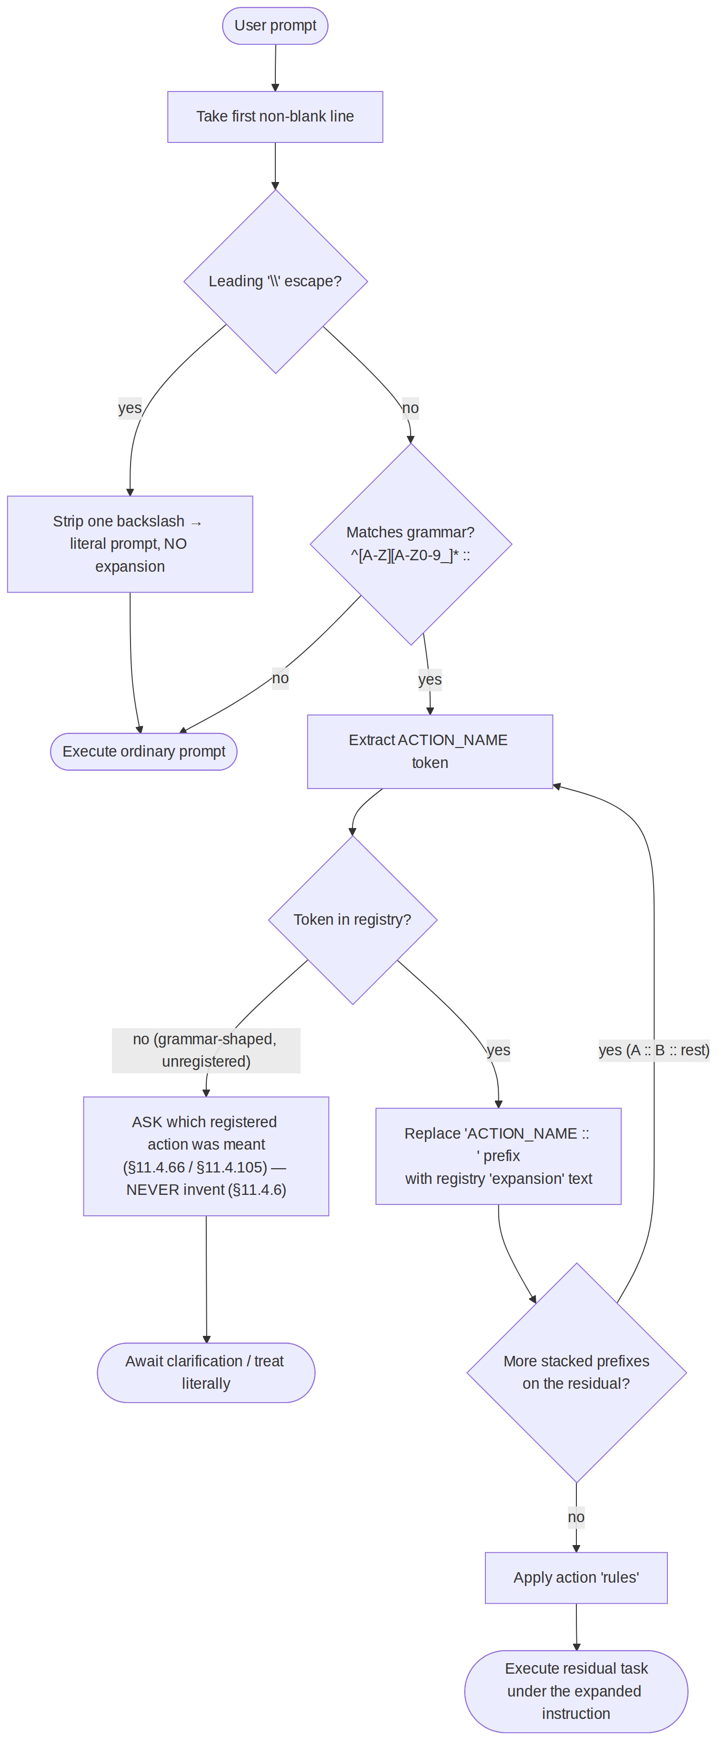

2. Two-layer architecture across CLI agents
One shared registry feeds both layers. LAYER 1 (the recognition instruction in every context carrier) is the universal floor; LAYER 2 is the mechanical upgrade where an agent exposes a pre-submit seam. Only Claude Code has transparent mechanical free-form interception (the honest §11.4.3 boundary).
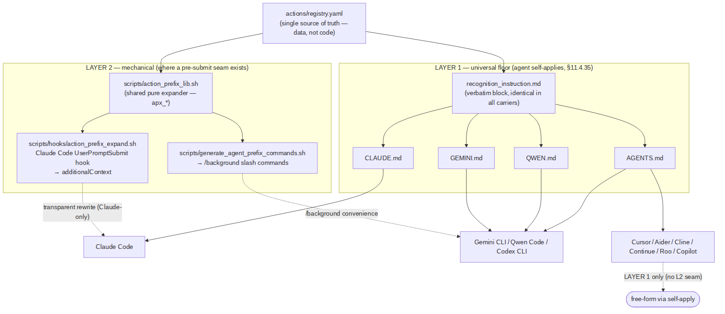

3. The 5-form grammar decision tree
Which form of the first non-blank line was used. All five forms are implemented and verified (grammar suite 166/0, paired-mutation meta-test 6/0) per the GRAMMAR_ADDENDUM; forms 2 and 4 (the DEFAULT:: namespace) and form 5 (the arrow --->) are no longer spec-only. All five resolve to the same action + expansion by design.
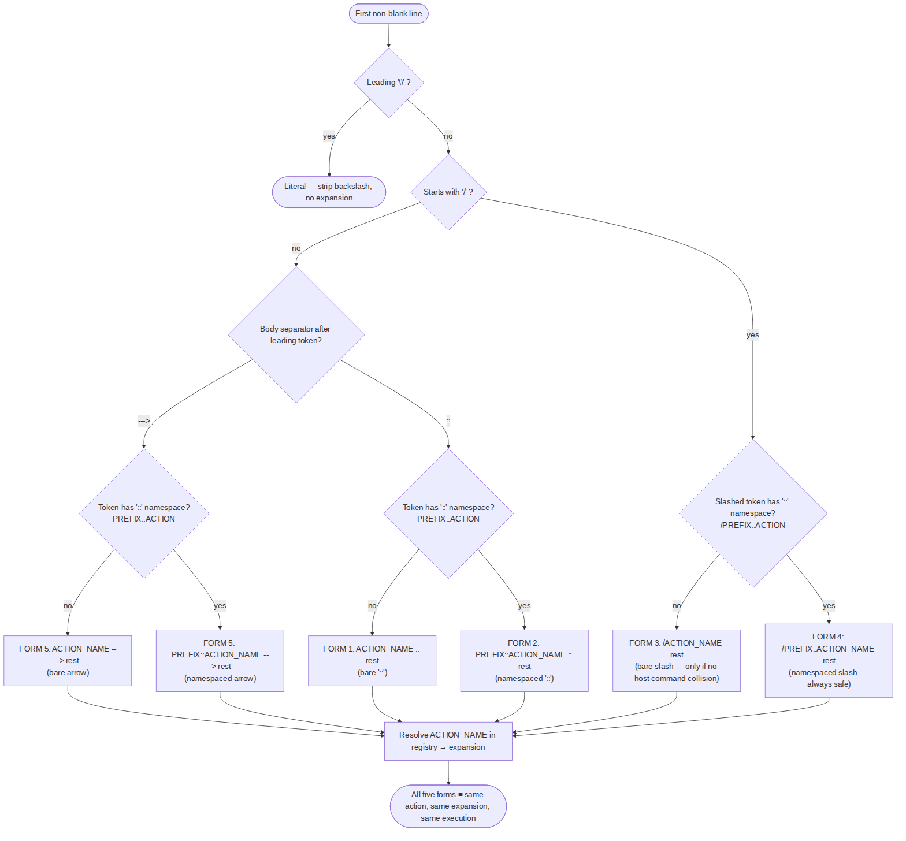
Legend: all nodes/edges = implemented + verified (forms 1, 2, 3, 4, 5; grammar suite 166/0, paired-mutation meta-test 6/0). The DEFAULT:: namespace registry keys (default_namespace/namespace_separator/slash_prefix/namespaces/ slash_bare) plus the arrow keys (arrow_form_regex/arrow_body_separator) are present and apx_parse_prefix returns matched_form ∈ {colon, slash, arrow} for all five forms. A mid-line ---> after a :: token parses as the colon form (the arrow branch falls through). See MANUAL.md §4.3 / §7.

4. Add-a-new-action sequence
Adding an action is a one-row registry edit plus a generator re-run — no code change in either layer. (DESIGN.md §9 / MANUAL.md §6.)
NOTE — diagram 4 could not be auto-rendered to an image. The data is shown below as a table for readability. (Source-level mermaid render failed; see the source .md for the original diagram definition.)
actor Dev as Maintainer
participant Reg as actions/registry.yaml
participant Gen as generate_agent_prefix_commands.sh
participant Out as actions/generated/*
participant Lib as action_prefix_lib.sh
participant Test as unit test + §1.1 mutation
participant Doc as docs (§11.4.44 / §11.4.65)
Dev->>Reg: add one actions[] row\n(name, version, summary≥6 words §11.4.91, expansion, rules?, composes_with?)
Dev->>Gen: bash scripts/generate_agent_prefix_commands.sh
Gen->>Lib: apx_validate_registry + apx_lookup_expansion(NEWACTION)
Lib-->>Gen: expansion (verbatim)
Gen->>Out: write gemini/newaction.toml, qwen/newaction.toml, codex/newaction.md\n(/newaction = form 3)
Note over Reg,Out: No edit to the hook OR the library — registry is data, not code.\nLAYER 1 already knows to consult the registry.
Dev->>Test: add unit test (parses + grammar match + expansion correct)\n+ paired mutation (corrupt expansion → gate FAILs)
Dev->>Doc: bump revision header; export .html/.pdf at commit time (conductor)
Note over Dev: Optional — inline the expansion in the LAYER-1 block\nONLY if it must work without registry-file access (like BACKGROUND).

5. Related documents
- USER_GUIDE.md — end-user guide.
- MANUAL.md — developer/maintainer manual.
- docs/research/action_prefix_system/{RESEARCH.md, DESIGN.md, GRAMMAR_ADDENDUM.md, IMPLEMENTATION_REPORT.md, RULE_DRAFT.md} — source design.
- Canonical authority: Constitution.md §11.4.140.

